**Project Meeting Notes and Minutes**

**Team 24**

**Team members** 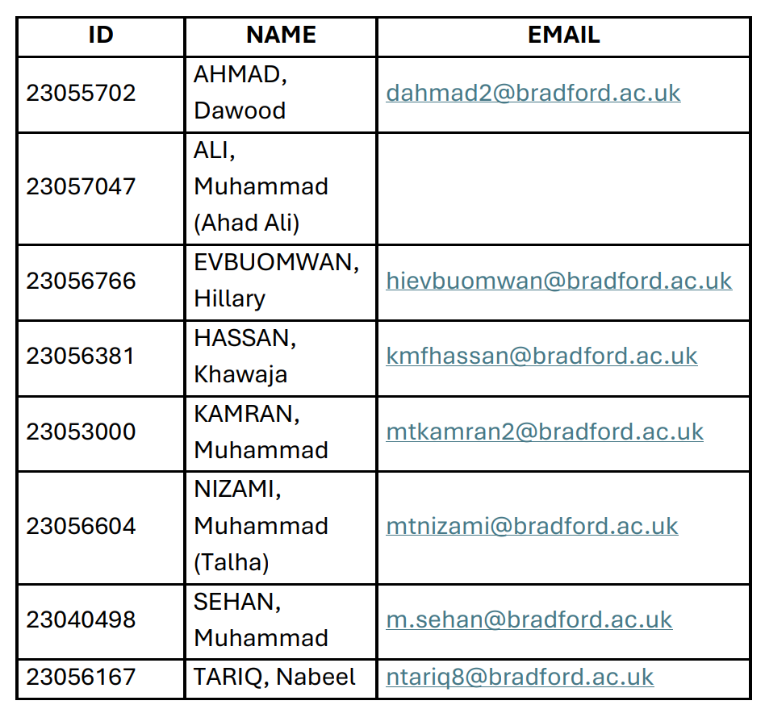

**Roles:**

* **Dawood Ahmad (Team Leader)** – Client Communication, Requirement Specification
* **Muhammad Ali** – No participation
* **Hillary Evbuomwan (Secretary)** – Organizing meetings, maintaining minutes
* **Muhammad Nizami** – Backend Development (PHP, MySQL)
* **Muhammad Sehan** – Frontend Development (React/Vue, Leaflet.js)
* **Khawaja Hassan** – Database Design & Data Validation
* **Muhammad Kamran** – System Testing, Bug Fixing & Documentation
* **Tariq Nabeel** – Assisted in Backend and Frontend Development

**Meetings:**

|  |  |  |
| --- | --- | --- |
| **Date** | **Discussion Points** | **Attendees** |
| 31 Jan  2025 | Initial Planning, Requirement Discussion | Dawood, Hillary, Nizami, Sehan, Kamran , Tariq |
| 7 Feb  2025 | Tech Stack Finalization | All except Ali |
| 14 Feb  2025 | UI/UX Prototype Approval | All except Ali |
| 28 Feb  2025 | Backend Progress Review | Dawood, Nizami, Hassan, Hillary, Sehan ,Tariq |
| 1 Mar  2025 | Frontend & Integration Review | All except Ali |
| 5 Mar  2025 | Testing & Deployment Discussion | All except Ali |

**Project Meeting Notes**

# Meeting on: January 31, 2025

* **Topic:** Initial Planning & Requirements Discussion
* • **Summary:**
* Discussed project scope, main objectives, and deliverables.
* Defined main features and key requirements.
* Assigned roles and responsibilities to team members.
* Outlined the project timeline and established key milestones.

# • Meeting on: February 7, 2025

* **Topic:** Tech Stack Finalization
* **Summary:**
* Explored different options for frontend and backend technologies.
* Finalized a tech stack focused on performance and scalability.
* Discussed the best database solution and API strategy.
* Agreed on coding standards and version control procedures.

•

# • Meeting on: February 14, 2025

* **Topic:** UI/UX Prototype Approval

**Summary:**

* Reviewed UI/UX wireframes and mockups.
* Gathered feedback and refined designs to improve user experience.
* Finalized the design requirements for the next development phase.
* Approved the UI/UX prototype for implementation.

# • Meeting on: February 28, 2025

* **Topic:** Backend Progress Review

**Summary:**

* Reviewed backend development progress.
* Identified and resolved issues in API development.
* Discussed database integration and performance improvements.
* Outlined action steps for backend completion.

# • Meeting on: March 1, 2025

* **Topic:** Frontend & Integration Review

**Summary:**

* Assessed frontend development progress and integration with the backend.
* Addressed inconsistencies in UI and responsiveness.
* Ensured API connections were properly established.
* Planned next steps for feature completion.

# • Meeting on: March 5, 2025

* **Topic:** Testing & Deployment Discussion

• **Summary:**

* Finalized the testing plan, including unit, integration, and user testing.
* Established a deployment strategy, covering both staging and production environments.
* Identified potential risks and mitigation strategies.
* Defined final testing and release schedules.