# Short Answer:

Answer the following questions with complete sentences in **your own words**. You are encouraged to conduct your own research online or through other methods before answering the questions. If you research online, please consult multiple sources before you write down your answers.

1. What is HTML?
2. What is block element? How is it diﬀerent from inline elements?
3. What is the importance of the meta tag?
4. What would happen if you clicked on a link created using <a href=‘javascript:void(0)’ />?
5. What is iframe?
6. What is CSS?
7. How do you import CSS?
8. What are the diﬀerent types of CSS selectors?
9. What are the diﬀerent types of attribute selectors?
10. What is a pseudo-class?
11. What is a pseudo-element?
12. What are two ways that we can make an element invisible? What is the diﬀerence?
13. What is SVG and why do we use it?
14. What is the Box Model? Describe each part.
15. What is the diﬀerence between margin and padding?
    1. Can padding be negative? Can margin be negative?
16. Assume an element has the following properties. What is the element size (width & height)? Please explain how you arrived at your solution.

*width: 100px; height: 100px; margin: 20px 50px; padding: 10px 10px;*

*border: 2px;*

1. Assume an element has the following properties. What is the element size (width & height)? Please explain how you arrived at your solution.

*width: 100px; height: 100px; margin: 20px 50px; padding: 10px 10px;*

*border: 2px;*

*box-sizing: border-box;*

1. Assume a parent element has *width = 200px* and one child element*.* If the child element’s width is set to ‘auto’, what are the values of its width, left-margin, & right-margin?
2. Assume a parent element has *width = 200px* and one child element with width=100px*.* If the child element’s margin-right is set to ‘auto’, what is the child element’s left-margin & right-margin values?
3. Assume a parent element has *width = 200px* and one child element with width=100px*.* If the child’s margin is set to ‘auto’, what is its left-margin & right-margin values?
   1. What is the left & right margin values if the child’s width was 300px?

# Coding Questions:

Use HTML and CSS to solve the following problems. You are highly encouraged to present more than one way to answer the questions. Please follow best practices when you write the code so that it would be easily readable, maintainable, and eﬃcient. Clearly state your assumptions if you have any. You may discuss with others on the questions, but please write your own code.

1. Implement the following table. (Hint: colspan & rowspan)

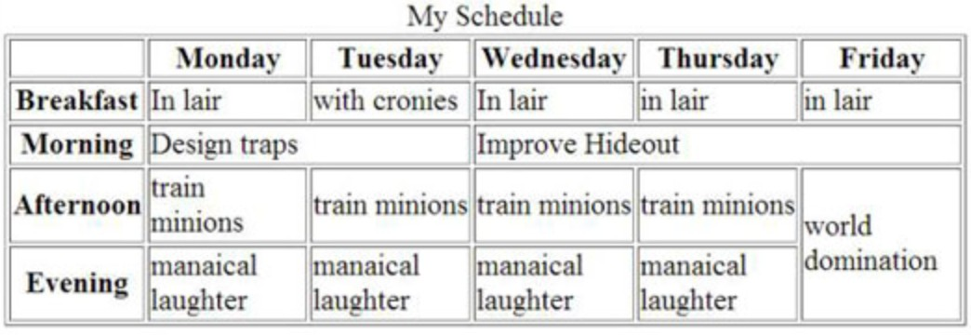

1. Implement the following list. (Hint: pseudo classes & pseudo elements)
   * When an odd item (I,III, A,C, etc.) is hovered over, its background color should turn yellow.
   * When an even item (II,IV, B,D, etc.) is hovered over, its first character should turn red and

increase in font size to 35px.

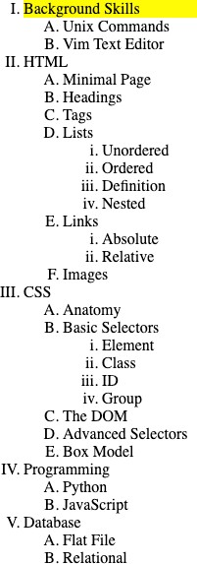 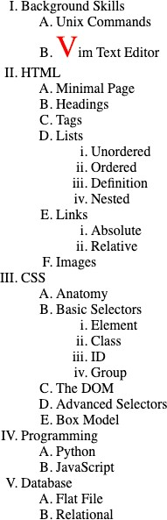

1. Given the following directory structure and sample UI, create a simple file manager or file browser for navigating this directory. No JS is needed.
   * When the user clicks on a folder (web, css, images…), it will redirect you to a page that

displays all of the folder’s subfolders & files. Each of these are hyperlinks that redirect to their own HTML pages.

* + When the user clicks on a file, nothing happens.
  + Size can be any file size.
  + Date Modified can be any timestamp.
  + Icons do not need to be exactly as shown below.

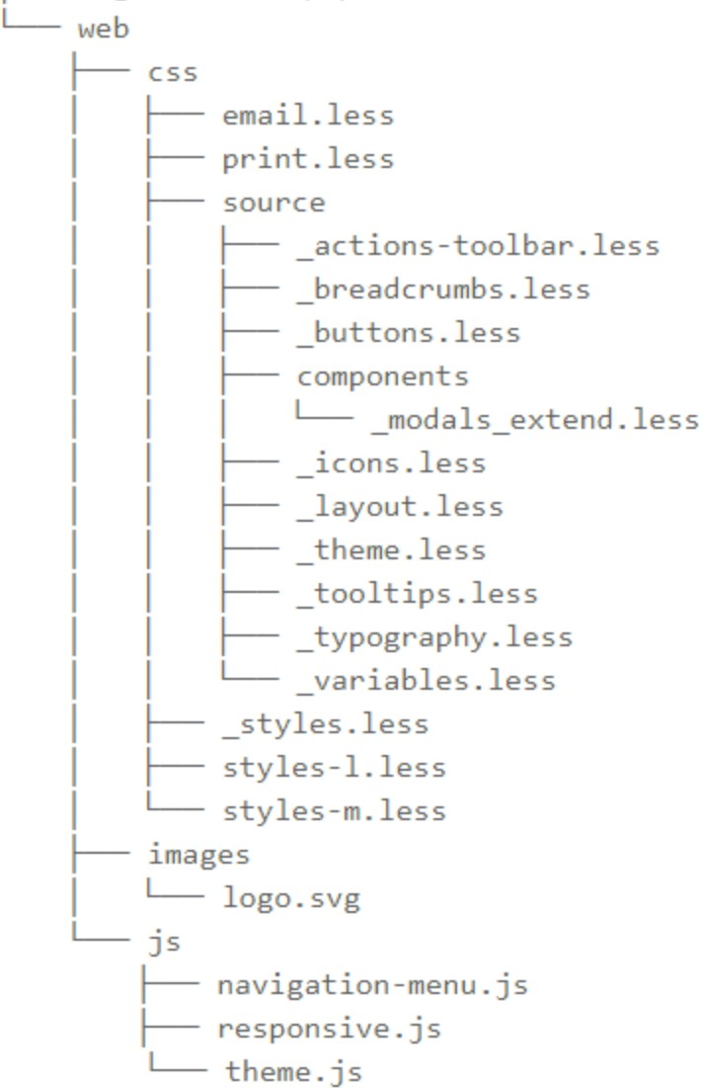

1. When you first load the page.



1. When you click web, it redirects you to this new page.

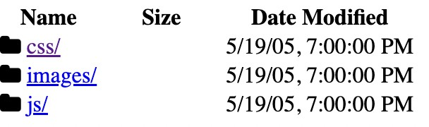

1. Click css to redirect you to the new page.

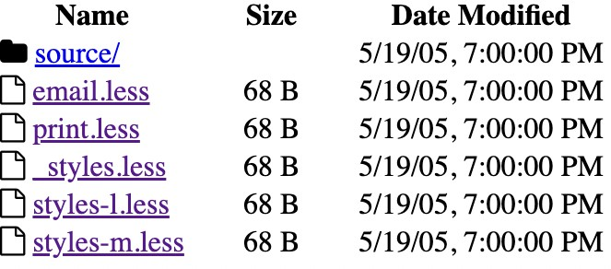

1. Implement the following questionnaire.
   * You are only able to select one gender.
   * Users should be able to upload a file when clicking ‘Attach Files’.
   * Political Persuasion (dropdown with options: Left Wing, Right Wing, Conservative)
   * Education Level Completed (dropdown with options: University/College, High School, None)

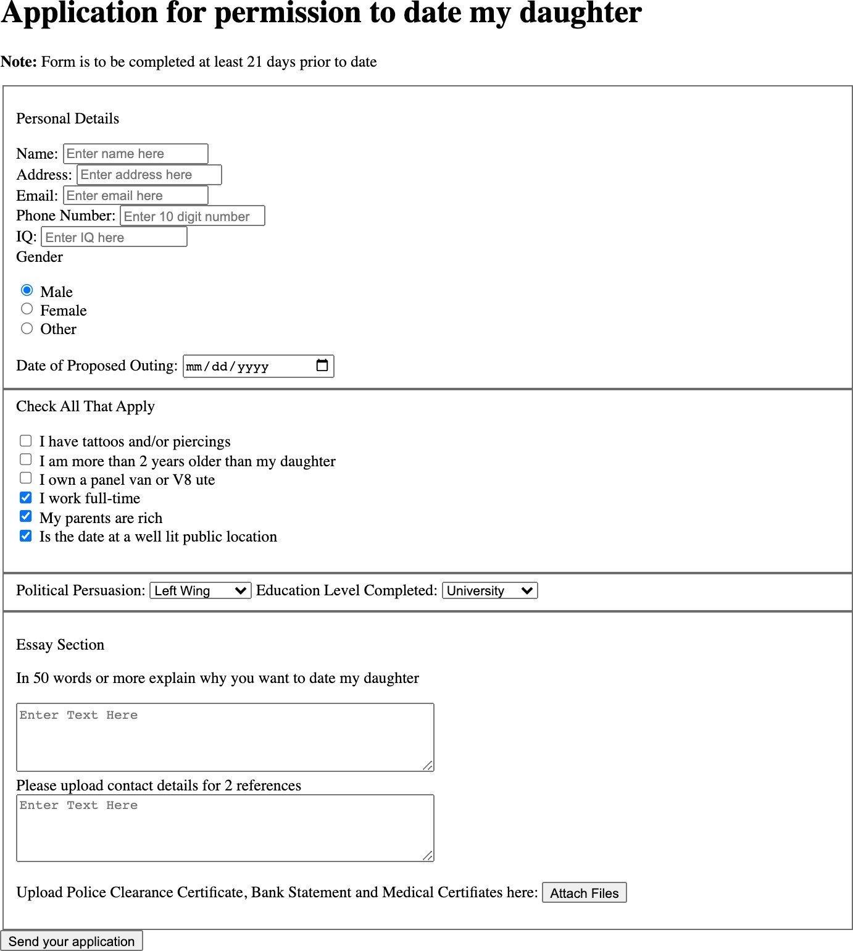

1. W3 schools HTML Quiz

Finish the HTML Quiz from [https://www.w3schools.com/html/html_quiz.asp.](http://www.w3schools.com/html/html_quiz.asp) Please attach the screenshot of your results.