**Git**

**Github Desktop**

**Github**

**What is Git?**

- Git is a popular version control system.

- Git helps you keep track of code changes.

- Git is used to collaborate on code.

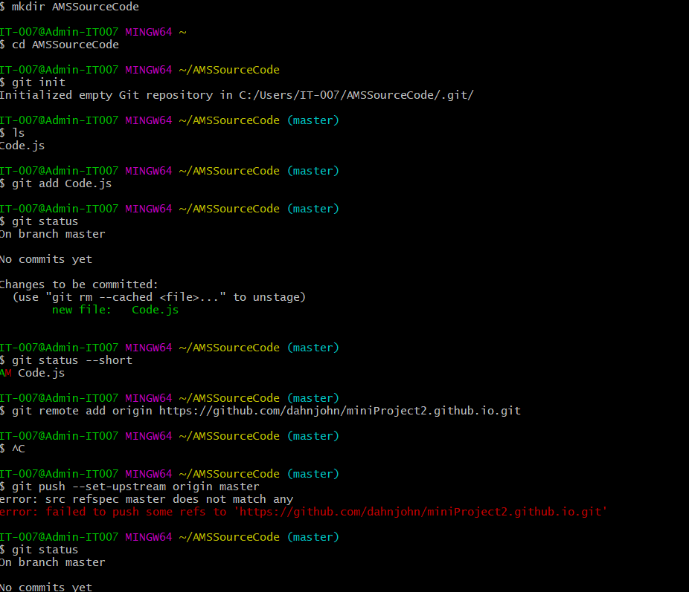

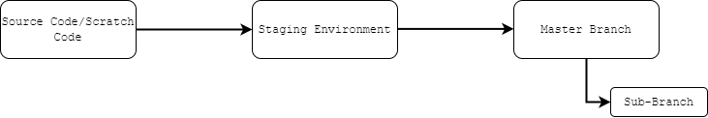

**Commands**

git -–version –to know the version of your Git Bash.

**Configure Git**

git config --global user.name “dahn john”

git config --global user.email “[johnarrymagno@gmail.com](mailto:johnarrymagno@gmail.com)”

**Creating Git Folder**

mkdir myproject

cd myproject

**Initialize Git**

git init –Git knows that it should watch the folder you initiated it on.

**Git Adding New Files**

ls -list items

git status -Tracked/untracked files

**Git Staging Environment**

git add “filename.extension”

git status

--create more files—-

**Git Add More than One File**

git add –-all

git status

**Git Commit**

git commit -m "First release of Code/Version 1!"

**Working with Git Branches**

**-**In Git, a branch is a new/separate version of the main repository.

--master branch/live server –-

--Version 2 branch/ongoing development --

--emergency fix bug branch/new created –

**New Git Branch**

git branch emergency fix bug

git branch -check if we have a branch

git checkout “branch name” -to navigate branch

git add –all

--fixed bug/ edited codes-—

git status

git commit -m "Added codes to fix bug"

**Emergency Branch**

git checkout -b “branch name” system crash -shortcut commands

**Git**Branch Merge

git checkout master

git merge “branch name” emergency fix bug

**Delete Git**Branch

git branch -d “branch name” emergency fix bug

## Merge Conflict

git checkout Version 2

--let say working na yong version 2--

git add –-all -add staging environment

git commit -m "Updated codes"

git checkout master

git merge Version 2

--conflict content—-

git status -check status conflict

## Solution for Merge Conflict

git add “filename.extension”

git status - All conflicts fixed

git commit -m "merged with version 2”

git branch -d version 2 -delete branch

## Push & Pull to GitHub

## --need account on github--

## git remote add origin “link” -- you are adding a remote repository

## git push --set-upstream origin master

**--error—-**

**GitHub Desktop**

* is an application that enables you to interact with GitHub using a GUI instead of the command line

**GitHub**

 is a code hosting platform for version control and collaboration. It lets you and others work together on projects from anywhere.

git clone <https://github.com/dahnjohn/farmstation.github.io.git>

cd “folder name”

git checkout -b “branch name local” ex. tix-3

--you may fix the bug/code on your local IDE—

git status

git add -A

git commit -m “fixed ticket #3”

git push -u origin “branch name” ex. tix-3

Best practices to copy the file from the main branch

git pull origin main

Goto to github > branches > new pull request

--Done—

You may delete the tix-3 local repo

git checkout main

git pull

git branch -D “branch name” ex. tix-3

--Done—

Possible conflict merge

git branch “branch name” ex. tix-1

--you may fix the bug on tix-1 /code on your local IDE—

git add -A

git commit -m “fixed ticket #1”

git push -u origin “branch name” ex. tix-1

Goto to github > compare and pull request > pull request

This branch has conflicts that must be resolved

To solve the conflict

git pull origin main

CONFLICT (content): Merge conflict in mainForm.js

Code .

Fix the erro

git add -A

git commit -m “fixed ticket #1”

git push -u origin “branch name” ex. tix-1

Goto to github > merge update

You may delete the tix-1 local repo

git checkout main

git pull

git branch -D “branch name” ex. tix-1

--Done—