We need to update below:
- In case assign ticket in below groups [group will be selected from criteria fields before assign] to certain users, will ignore count rule [assign new tickets to the user regardless count of already assigned tickets].
- Above will be added to current deployed [as below] TTS -CR#30681

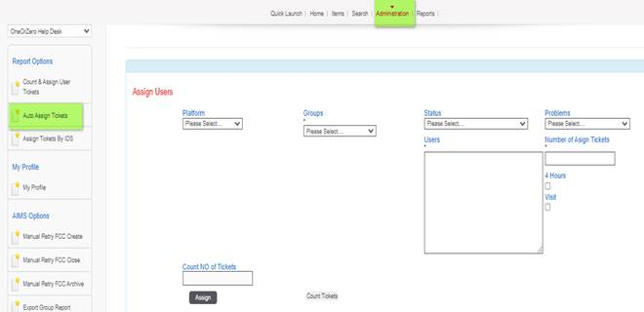

TTS Pool name
Second Level Advanced BulkUpdate
Pilot-SLS Bulk Update
SLS Bulk Update
SLS- IVR Automation Report
Customer 360 Report
SLS Archive Bulk Update
SLS-FTTH Report
SLS Archive BulkUpdate

- Transfer from status to another
- Will Create drop down list contain all 9 groups [Groups attached]
- In the same page create drop down list named “ From Status” contain all attached status.
- In the same page create drop down list named “ To Status” contain all attached status.
- Will create Text box that accept TTS user name [Unlimited and multiple users] that will be entered manually by dispatcher.
- Create Box that accept manual input number with limit 1000 digit per transaction.
- Page contain Assign button to apply needed action.
- Above topic scope is to transfer tickets from status to another for a certain group elected from group dropdown list.

- Depending on CR# 30699 that already deployed on production as below screenshot,
- while assign tickets from user to another, must assign all ticket without excluding any ticket status specially [call back & Waiting for customer]

