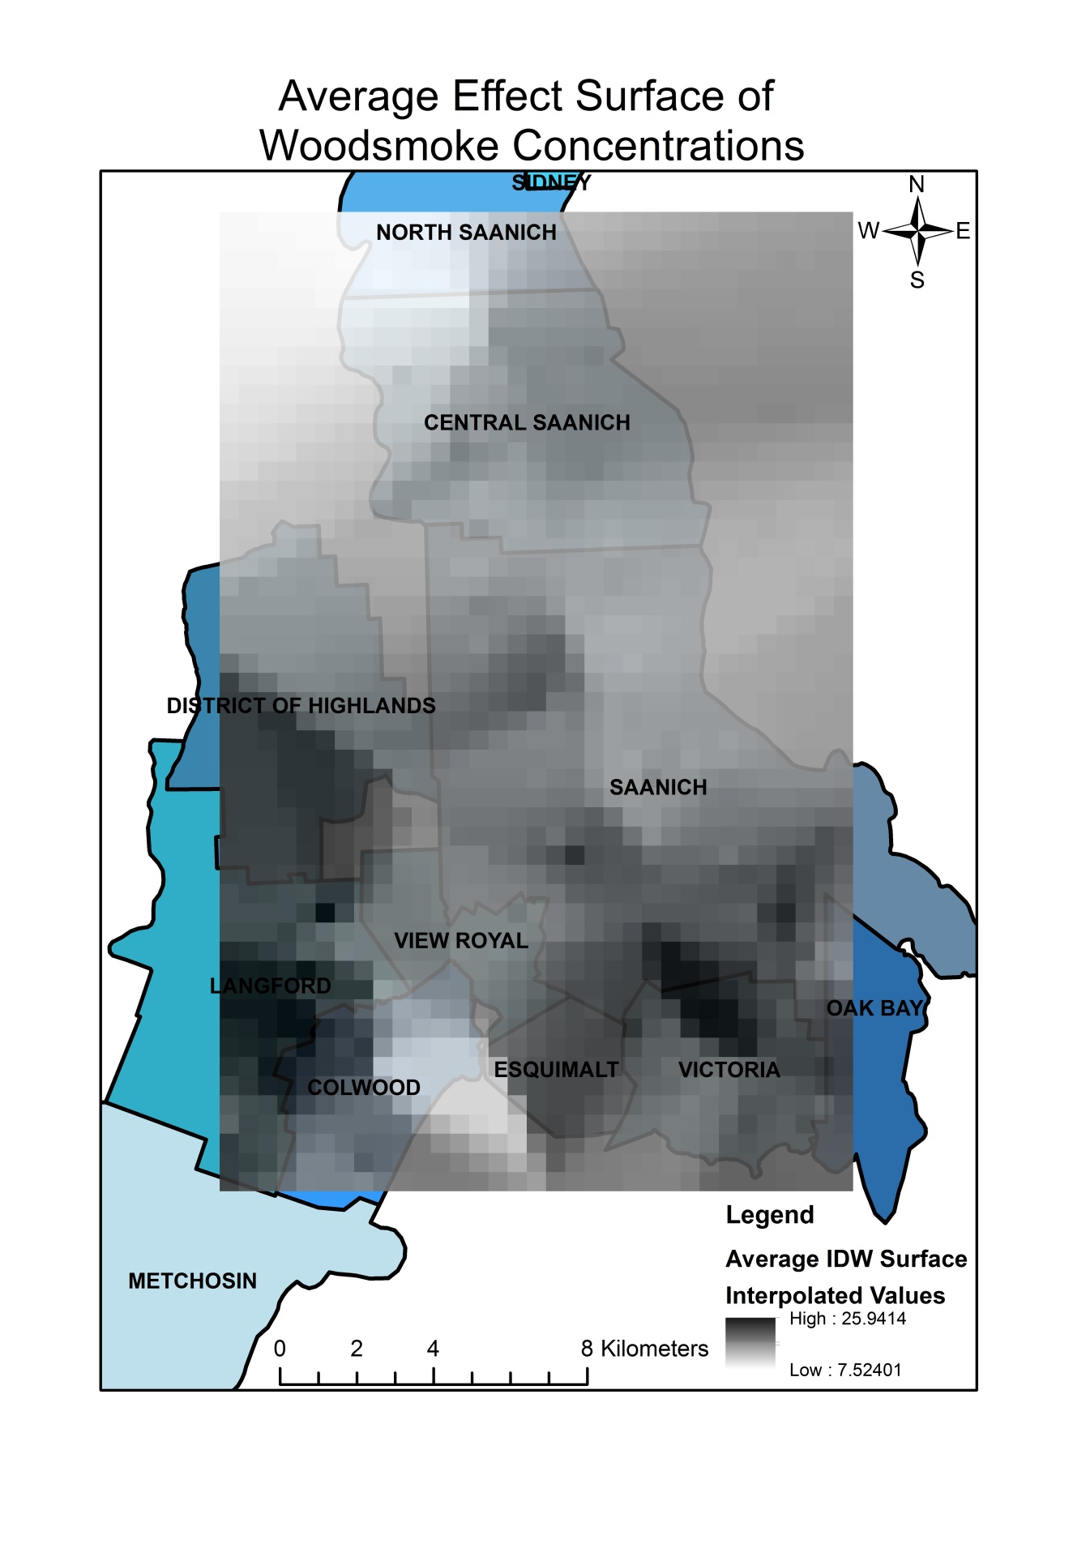

**Figure 6.** Average effect surface of woodsmoke concentration.

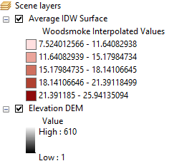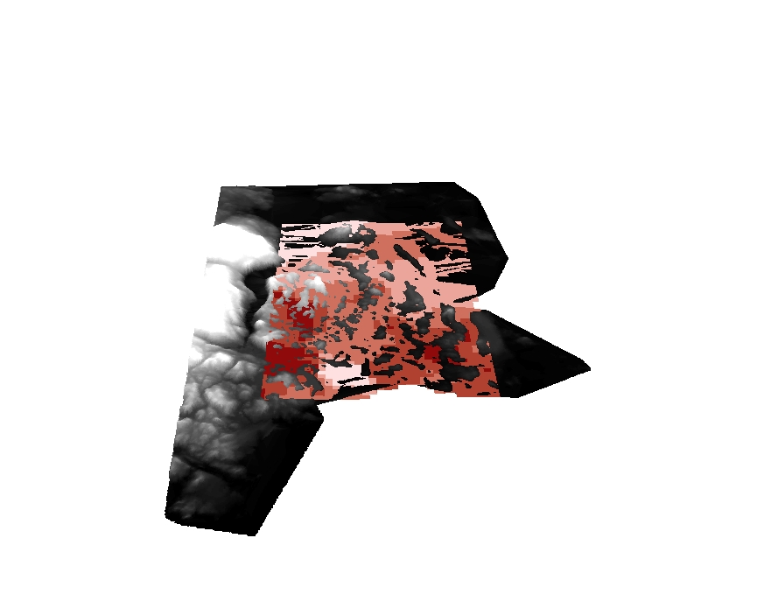

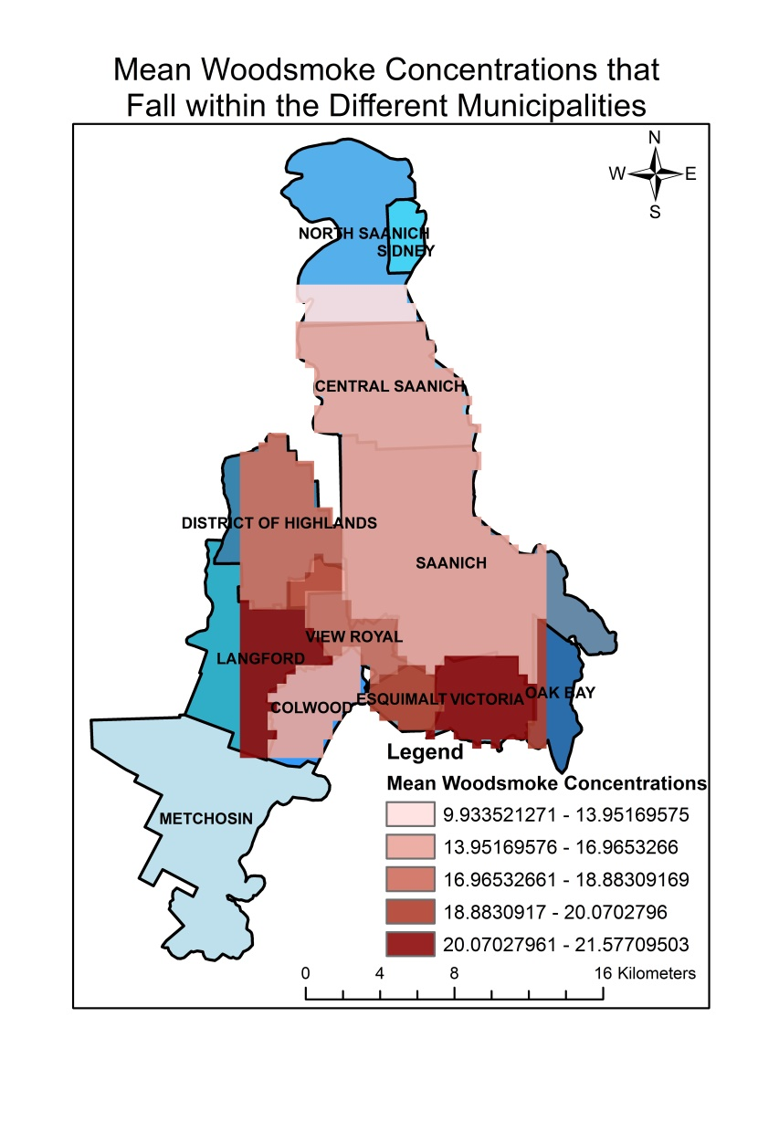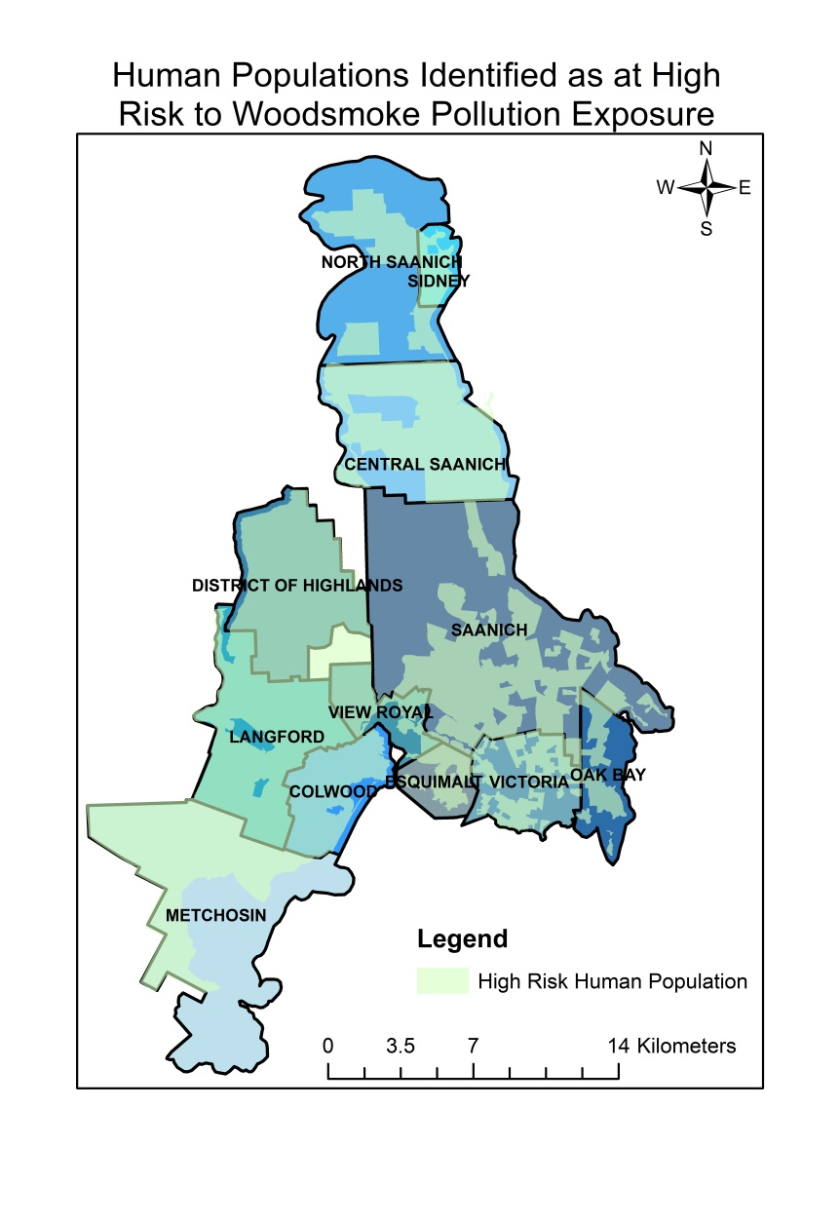**Figure 7.** ArcScene image of averaged woodsmoke IDW surface raster layer draped over an elevation DEM showing a 3D view of the woodsmoke interpolated concentrations.

**Figure 8.** Mean woodsmoke concentrations **Figure 9.** Map of specific human

that fall within the different municipalities. populations identified as at high risk of

woodsmoke exposure (below the age of five and over the age of seventy).