BioChemInsight: An Online Platform for Automated Extraction of Chemical Structures and Activity Data from Patents
Zhe Wang^{†1,2}, Fangtian Fu^{†3}, Wei Zhang^{†1,3}, Lige Yan⁴, Nan Li⁴, Wenxia Deng⁴, Yan Meng¹, Jianping Wu^{1,5}, Hui Wu², Wenting Wu⁶, Gang Xu^{*1}, Xiang Li*⁷, Si Chen*⁴
¹Institute of Bioengineering, College of Chemical and Biological Engineering, Zhejiang University, Hangzhou, China
²Huadong Medicine Co., Ltd., 866 Moganshan Road, Hangzhou 310011, China
³Hangzhou VicrobX Biotech Co., Ltd., Hangzhou, China
⁴School of Medicine, Shanghai University, Shanghai, China
⁵ZJU-Hangzhou Global Scientific and Technological Innovation Center, Hangzhou, China
⁶Key Laboratory of Modern Chinese Medicine Preparations Ministry of Education, Jiangxi University of Chinese Medicine, Nanchang, Jiangxi, China
⁷School of Pharmacy, Second Military Medical University, Shanghai 200433, China

*Please address correspondence to Dr. Si Chen at caroline-sisi-chen@hotmail.com, Dr. Xiang Li at xiangli@smmu.edu.cn and Dr. Gang Xu at xugang_1030@zju.edu.cn

Abstract
The automated extraction of chemical structures and their corresponding bioactivity data is essential for accelerating drug discovery and enabling data-driven research. Current optical chemical structure recognition (OCSR) tools lack the capability to autonomously link molecular structures with their bioactivity profiles, posing a significant bottleneck in structure–activity relationship (SAR) analysis. To address this, we present BioChemInsight, an open-source pipeline that couples DECIMER Segmentation with a mixture-of-experts extension of MolNexTR for structure decoding, a vision–language model for compound-identifier association, and PaddleOCR combined with a large language model for bioactivity extraction and unit normalization, all served through model-agnostic, OpenAI-compatible endpoints. We evaluated BioChemInsight on 296 patents spanning 15 therapeutic targets, yielding 23,218 structure records and 7,110 bioactivity values. Of 507 compound-level extractions presented for expert human adjudication against the original patent segments, 505 were adjudicated and 98.8% of these sampled decodings were confirmed correct (6 errors, 1.2%), with errors concentrated in the lowest-quality tier (0% in the highest-quality tier); 87.3% of all 23,218 extracted structure records yielded valid SMILES. Our analysis further indicates that the chemical space covered by patents is largely complementary to that of the established public database ChEMBL. By enabling systematic patent mining, BioChemInsight expands the landscape of explorable compound–target interactions and enriches the data foundation for quantitative SAR modelling and targeted screening. BioChemInsight is available at https://github.com/dahuilangda/BioChemInsight.
Keywords: optical chemical structure recognition (OCSR); bioactivity data extraction; structure-activity relationship (SAR); pipeline; drug discovery
Graphical Abstract
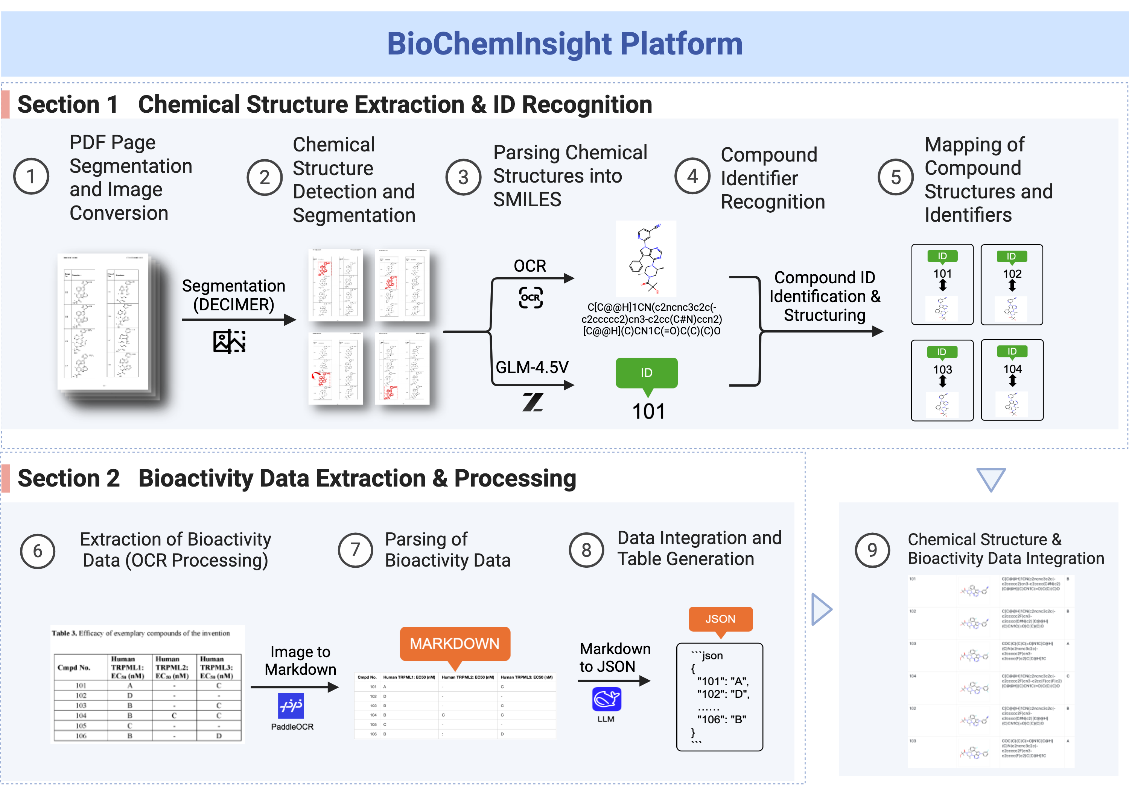

Introduction
Recent advances in literature mining technologies have accelerated discoveries in chemistry^{1–3}. Systematically extracting chemical data from literature and standardizing it into machine-readable formats serves not only chemistry but also interdisciplinary research in biomedicine, materials engineering, and systems biology, regardless of manual or automated approaches^{4,5}. However, manual extraction remains time-consuming, error-prone, and labor-intensive.
Optical Chemical Structure Recognition (OCSR) automates the conversion of chemical depictions in scientific documents into machine-readable formats, overcoming the limitations of manual extraction through superior processing speed, objective interpretation, and scalable document analysis^{6,7}. However, the field of OCSR faces three fundamental challenges: (1) the inability of traditional rule-based systems to accurately process diverse chemical depictions, (2) growing volumes of unprocessed scientific literature, and (3) the need for practical applications in research workflows.
Deep learning has addressed these limitations through specialized solutions: DECIMER.ai overcomes publication variability with its proprietary segmentation-classification pipeline³, while ChemReco solves hand-drawn diagram recognition with 96.9% accuracy via EfficientNet-Transformer hybridization⁸. MolScribe tackles stereochemical complexity through geometric analysis⁹, and MolMiner's integrated framework (MobileNetv2/YOLOv5/EasyOCR) delivers benchmark-leading performance with batch PDF processing - directly addressing literature backlogs¹⁰. Supplementary advances include ChemGrapher's bond-order precision¹¹, SwinOCSR's 98.58% recognition rate¹², and ABC-Net's efficient molecular reconstruction via atomic center-point detection¹³. This generation of tools collectively enables: (i) accurate digitization of legacy publications, (ii) efficient processing of contemporary literature, and (iii) seamless integration with research pipelines through real-time editing interfaces.
Despite these remarkable technological achievements, current OCSR systems exhibit a critical functional limitation: the inability to autonomously associate recognized molecular structures with their corresponding bioactivity profiles. This capability gap fundamentally constrains applications in drug discovery, where the integration of structural and pharmacological data is essential for target identification, rational compound design, high-throughput drug screening, and mechanism elucidation. The development of next-generation OCSR platforms capable of bridging this structure-activity divide represents both a significant challenge and opportunity for the field.
To operationalize this capability, we present BioChemInsight—an integrated pipeline that combines chemical structure recognition with bioactivity data extraction to automatically extract and associate structural information with bioactivity data from publications, enabling the subsequent derivation of structure–activity relationships. Our system employs a multi-component pipeline: (1) DECIMER Segmentation for accurate chemical structure detection from PDFs, followed by conversion to SMILES format using a mixture-of-experts (MoE) extension of MolNexTR in which the frozen base network handles complete molecules while dedicated sidecar experts handle Markush scaffolds, fragments and attachment atoms, guided by a calibrated confidence head with visual re-verification of low-confidence decodings; (2) a vision–language model, accessed through an OpenAI-compatible endpoint (GLM-4.5V recommended; a Gemma-class model in the production deployment), processes red-boxed regions annotated by DECIMER Segmentation—containing structures and their labels—to associate each structure with its identifier through spatial and page-scheme analysis; and (3) PaddleOCR converts PDFs to structured Markdown, after which an OpenAI-compatible large language model parses this Markdown to extract experimentally measured bioactivity data (e.g., IC₅₀, EC₅₀, Ki) with normalized units (nM/µM), while explicitly rejecting computationally predicted values such as docking scores. BioChemInsight generates structured data files that systematically associate compound IDs with their corresponding SMILES structures and bioactivity metrics, providing curated datasets for drug optimization, drug screening, and machine learning applications.
The complete BioChemInsight suite is publicly hosted on GitHub (https://github.com/dahuilangda/BioChemInsight), enabling easy deployment and modular customization. By automating the association between chemical structures and bioactivity profiles, the platform markedly reduces manual data-preprocessing effort while generating datasets whose per-record reliability has been quantified against expert human review. These curated datasets provide high-quality training data for machine learning and deep learning models and enable robust structure–activity relationship analysis. BioChemInsight represents a significant step toward data-centric pharmaceutical research by enabling end-to-end automation of structure–activity data extraction with guided human checkpoints.
Results and Discussion
- Front-end Interface and Workflow for Interactive SAR Data Extraction
The BioChemInsight Workbench’s front-end interface empowers researchers to curate SAR data from patents through a modular, interactive workflow that emphasizes manual, page-level control. As shown in Figure 2A, a four-step navigation (Upload PDF→Structures→Bioactivity→Review) guides users with progress tracking (e.g., upload percentage) and clear step labels, while automatic thumbnail generation for the uploaded PDF reduces technical overhead in preprocessing. Figure 2B and 2C highlight the platform’s focus on user-driven page curation. In the “Structure Explorer” (Figure 2B), users manually select pages that contain chemical structures, which are presented as grid-based thumbnails with clear page numbering. In the “Bioactivity Page Selection” module (Figure 2C), users identify pages holding bioactivity data (e.g., assay tables) and manually enter corresponding assay names. This design acknowledges the heterogeneous layout of patent documents, where chemical structures, text, and tables are often scattered; manual page-level selection ensures that relevant content is accurately targeted—a critical prerequisite for high-quality SAR extraction.
The visual layout of both modules (grid-based thumbnails, clear labeling) enables efficient browsing of multi-modal patent content. By separating structure-page and bioactivity-page selection into dedicated modules, the interface reduces cognitive load and supports precise, step-wise curation. For instance, a researcher working on a kinase-inhibitor patent can use the Structure Explorer to isolate pages showing compound structures, then switch to the Bioactivity Page Selection to locate pages containing dose-response or enzyme-activity data, and finally input assay names (e.g., “Kinase Inhibition Assay”) to contextualize the extracted values. While this manual curation approach gives users full control, it may introduce inter-user variability or become tedious for large document sets. Future versions could incorporate AI-assisted page classification (e.g., automatically detecting structure-rich or assay-rich pages) to complement—rather than replace—user judgment. Overall, the interface’s explicit manual page selection (as embodied in Figure 2B and 2C) ensures that SAR curation remains both user-directed and visually intuitive, laying a robust foundation for subsequent structure extraction and bioactivity validation.

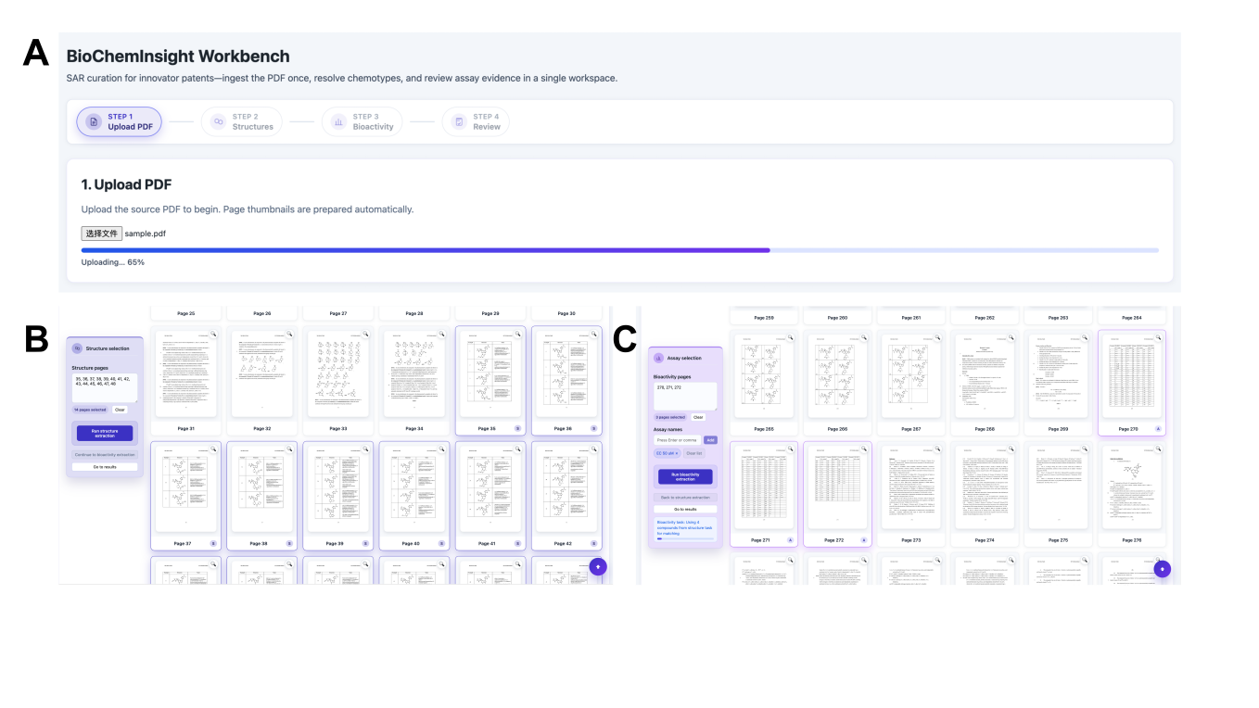
Figure 2 User Interface of the BioChemInsight Workbench for Interactive Curation of Structure-Activity Relationship (SAR) Data from Patent Documents. The interface streamlines the workflow from PDF ingestion to data review via modular navigation and visual components. (A) displays the four-stage workflow (Upload PDF → Structures → Bioactivity → Review) with a progress indicator for PDF upload (e.g., “Uploading: 65%”) and automatic thumbnail generation for source pages. (B) shows the “Structure Explorer” module, where users manually select pages containing chemical structures (visualized as thumbnails). After manual page selection, the system automatically extracts the chemical structures. (C) presents the “Bioactivity Page Selection” module, where users manually identify pages with bioactivity data (e.g., assay tables) and input assay names. Following page identification, the system automatically extracts the corresponding bioactivity information. This integrated workspace enables sequential navigation and manual curation of chemical structures and bioactivity evidence at the page level, supporting efficient SAR dataset construction.

The Review interface (Figure 3) provides the final, human-supervised checkpoint in the BioChemInsight workflow, designed to ensure the accuracy of extracted SAR data before export. As shown in figure 3A, it offers retrospective control (“Adjust extractions”) and one-click export functionality. Its core component is an interactive data table that displays Compound IDs, source and extracted structures (preserved in their original patent orientation for reliable visual cross-checking), and editable bioactivity values. This design enables efficient validation; for instance, a user can swiftly confirm that an extracted structure matches its hand-drawn counterpart in the patent PDF. As illustrated in Figure 3B, users can also manually edit any incorrect structure directly within the table to ensure data fidelity.
However, the current validation occurs primarily at the end of the workflow. A potential limitation is that errors originating from earlier steps (e.g., incorrect page selection or structure mis-extraction) are only detectable at this review stage, which may require users to navigate back to previous modules for correction. Future implementations could enhance efficiency by integrating real-time, inline validation cues. For example, by automatically highlighting discrepancies between an extracted structure and its source image directly within the review table, allowing for immediate correction. Despite this opportunity for improvement, the present interface, with its editable fields, customizable layout, and quality-control annotations, establishes a robust foundation for manual verification, effectively marrying automated extraction with expert-driven data curation.

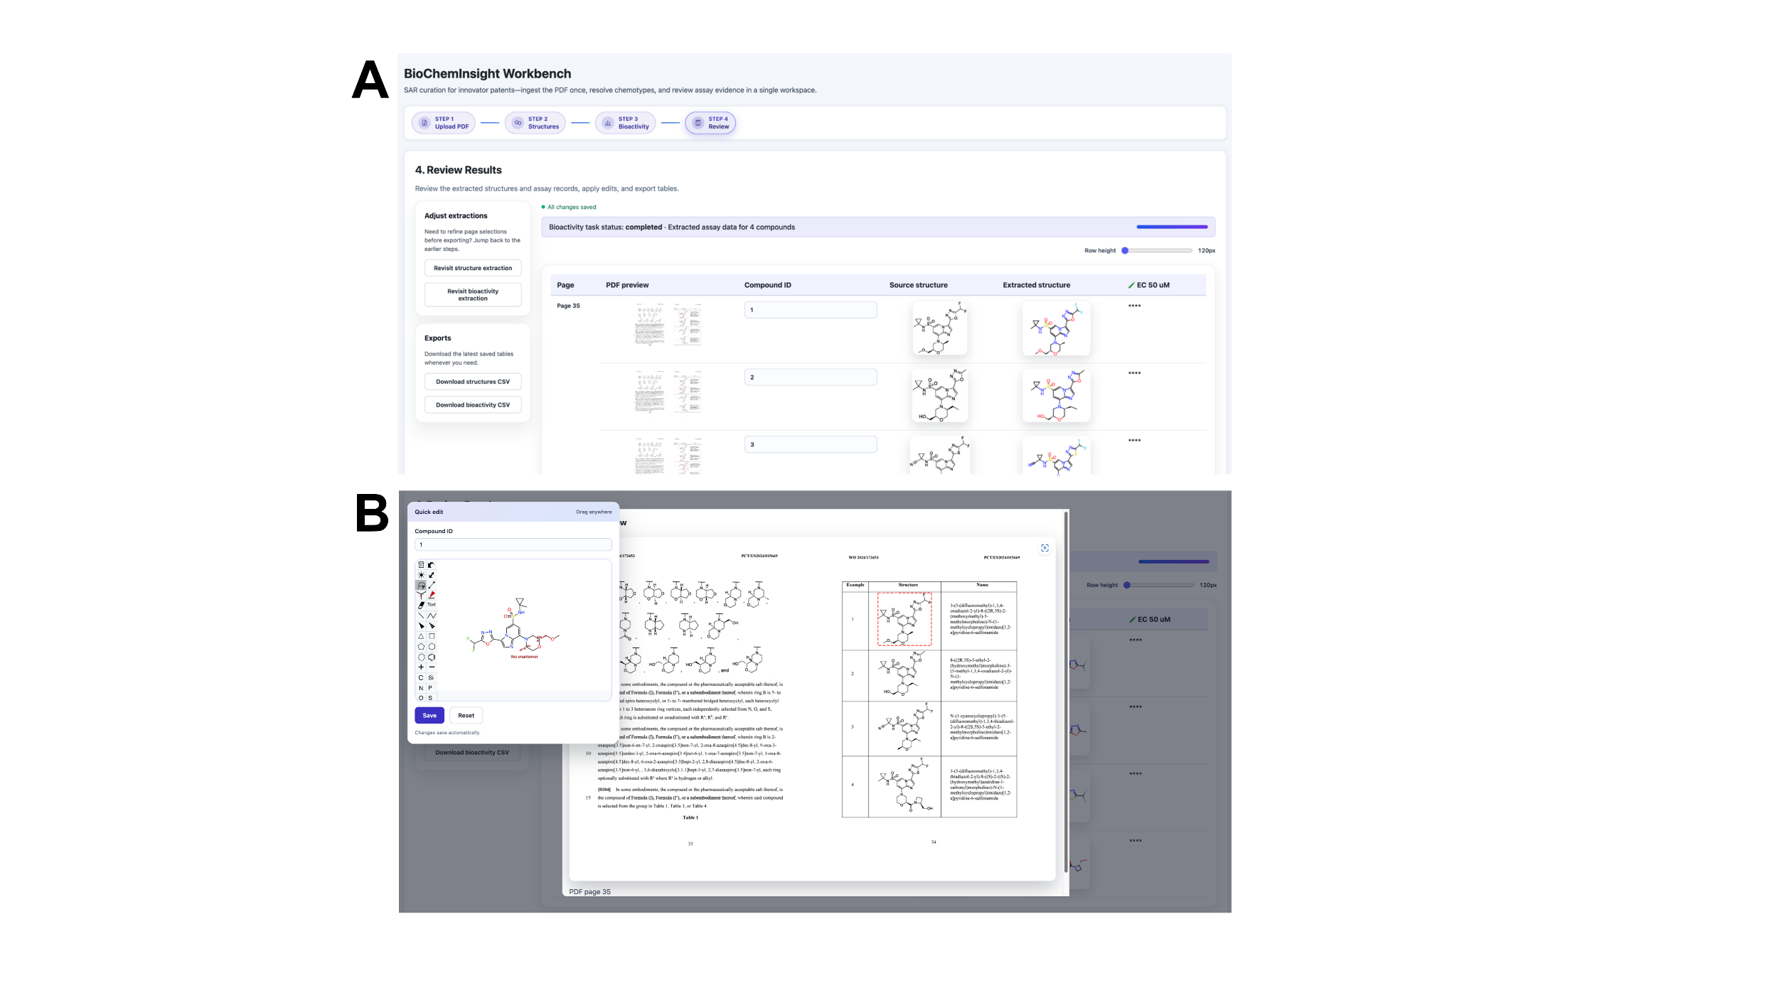
Figure 3 Manual Validation and Editing Interface of the BioChemInsight Workbench for Curated SAR Data. This interface enables users to inspect, refine, and export structured SAR results following initial extraction. (A) The “Review Results” panel allows users to adjust page selections via the “Adjust extractions” module (e.g., revert or reassign pages) and export curated datasets with one-click downloads (CSV/Excel). The main data table displays compound IDs, source structures, extracted structures (preserved in original patent orientation for cross-checking), bioactivity values (e.g., EC₅₀ in μM), and editable fields for manual correction. (B) Users can interactively edit entries for customized viewing. Together, these features support rigorous, user-driven quality control over extracted SAR data.

Performance of BioChemInsight in Extracting SAR Information Across Therapeutic Targets
As shown in Figure 4, BioChemInsight demonstrated robust and consistent performance in extracting SAR data from patents across 15 diverse therapeutic targets (pipeline-reported per-target accuracies), achieving high extraction accuracy (>0.8) for chemical structures, biological assay data, and compound identifiers, with most metrics exceeding 0.9 and several biological assays reaching 100% accuracy. Independent recomputation over the complete 296-patent corpus corroborated this picture: 87.3% of all 23,218 extracted structure records yielded valid SMILES, 100% carried compound identifiers, and per-patent SMILES validity averaged 85.7% (median 91.5%). Most importantly, expert human adjudication of 505 compound-level extractions—each compared directly against its original patent segment—confirmed 98.8% of decoded structures as chemically correct (6 errors, 1.2%), with the error rate strongly stratified by document quality (0% in the highest-quality tier versus 12.0% in the lowest). This performance was achieved despite substantial variation in dataset size across targets, and extraction accuracy did not correlate with the number of patents processed, indicating that performance depends primarily on the inherent characteristics of the patent content (e.g., clarity of structural depictions, uniformity of assay tables) rather than on dataset volume. A provenance spot-check traced 71% (20/28) of sampled numeric activity values to the OCR source text, with unresolved cases attributable to OCR digit corruption rather than fabricated values. Together, these analyses complement the pipeline-reported per-target metrics with independent recomputation and human-ground-truth adjudication, validating BioChemInsight as an effective and scalable tool for accelerating SAR data curation whose per-record reliability has been quantified against human ground truth rather than self-reported pipeline output.
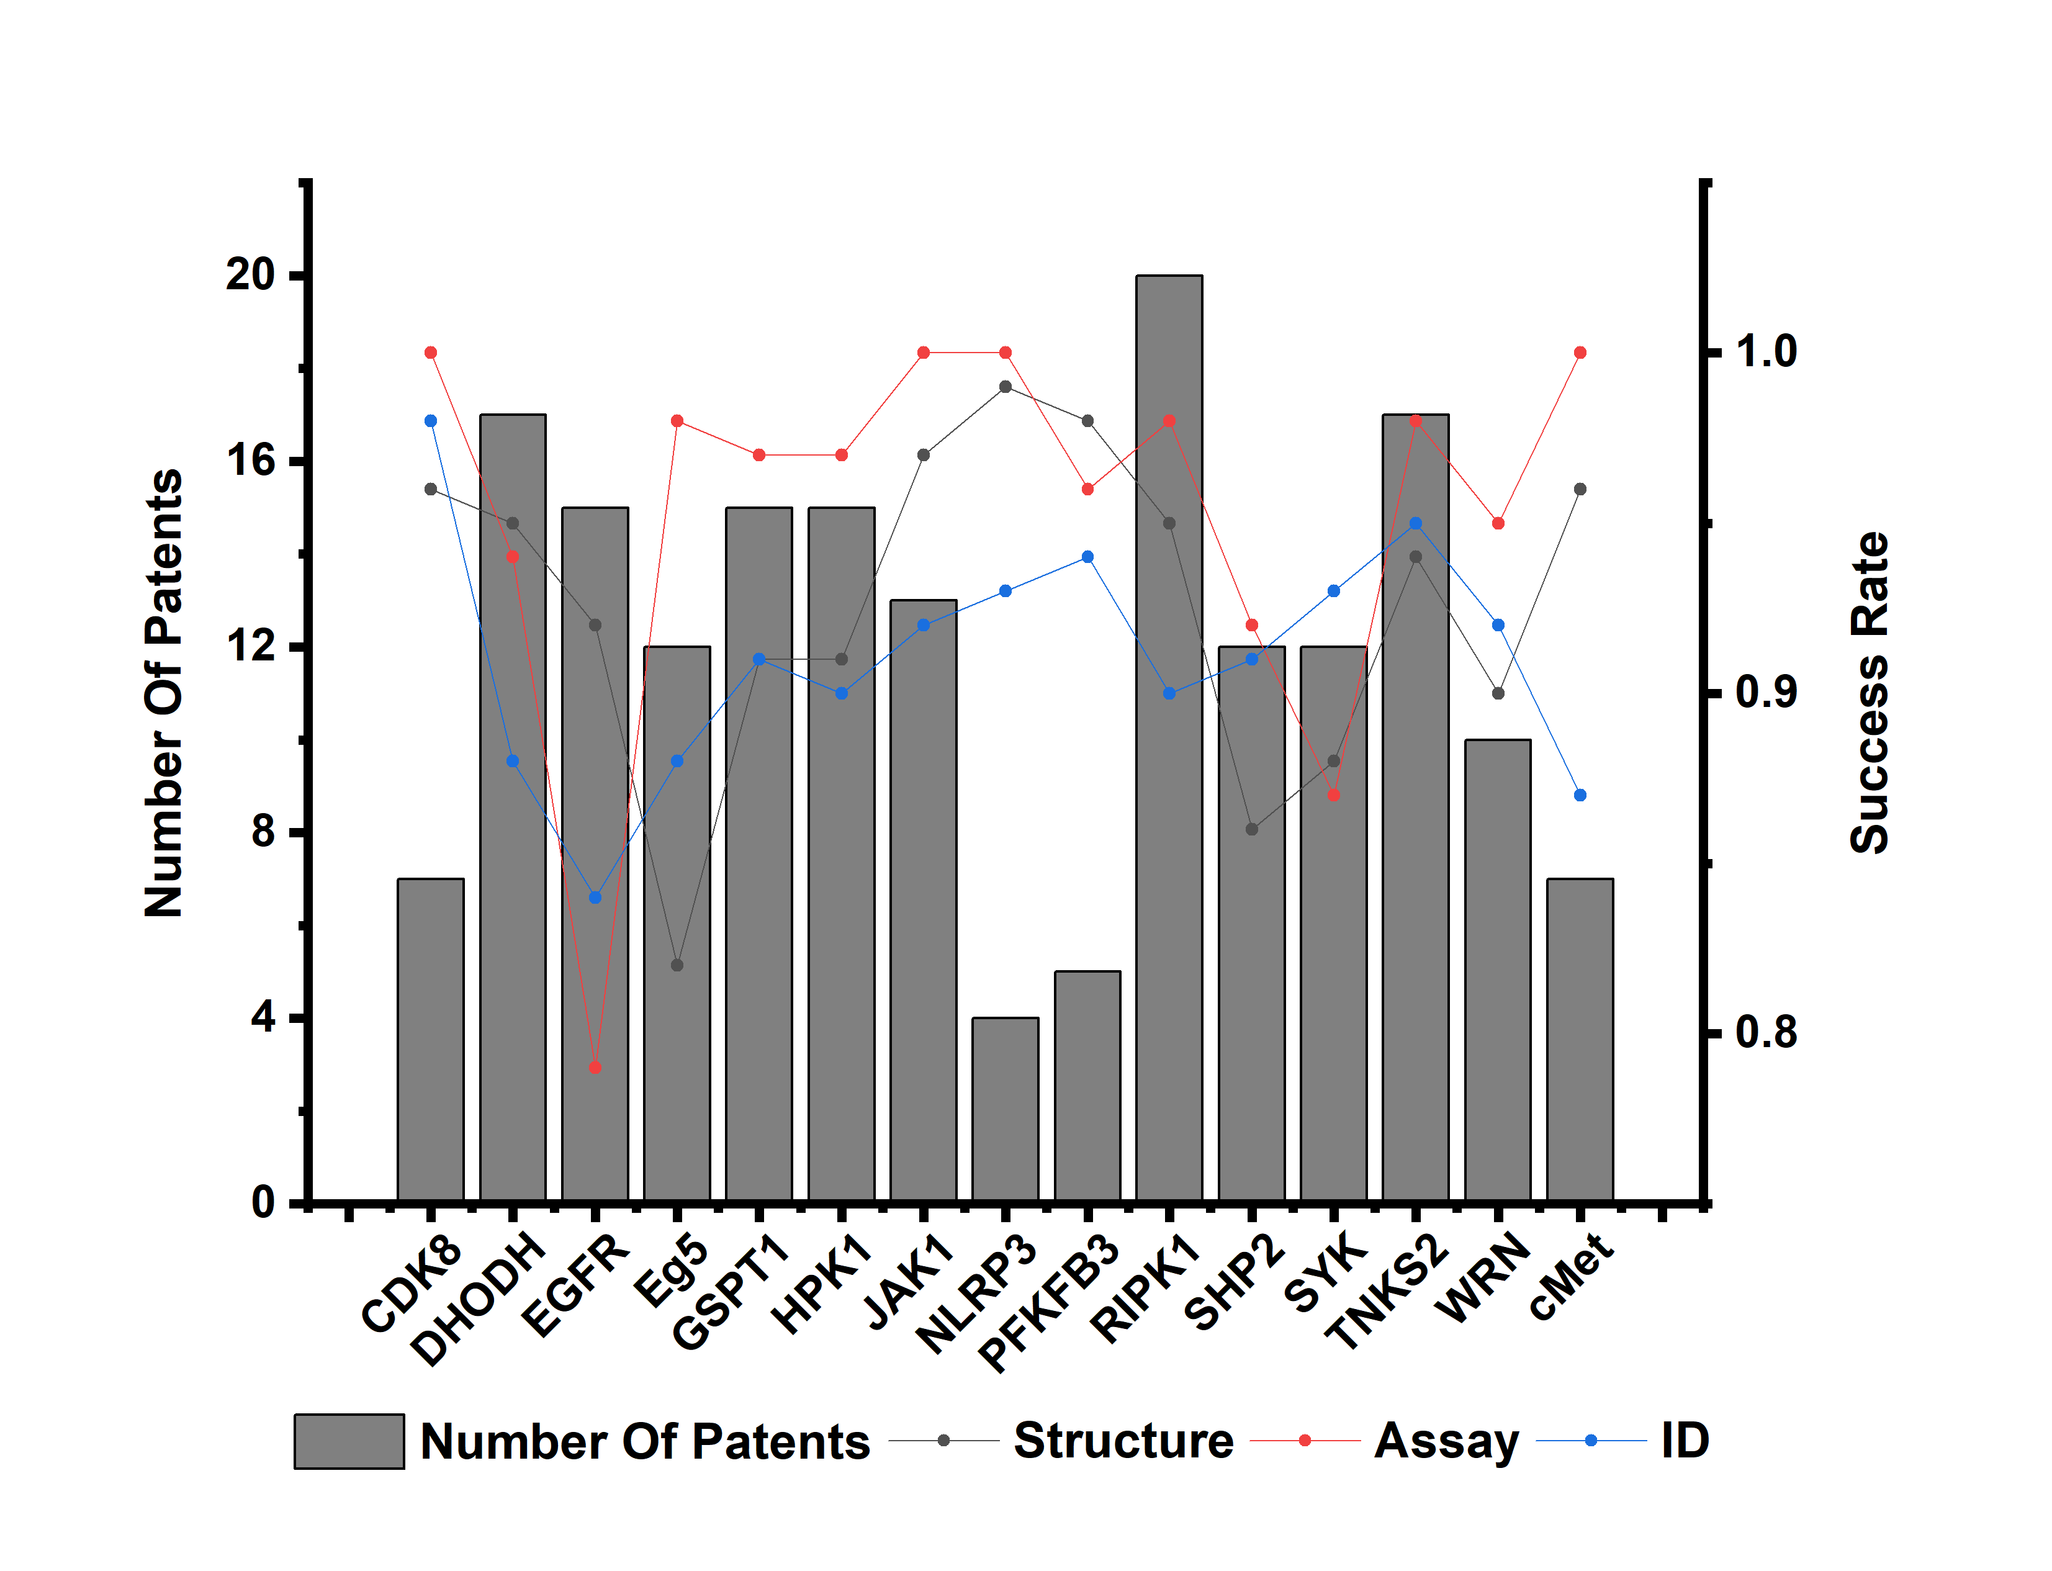
Figure 4. BioChemInsight performance in extracting structure-activity relationship (SAR) information from patents for 15 therapeutic targets. The bar chart (left y-axis) shows the number of patents analyzed per target. The three line plots (right y-axis) indicate the extraction accuracy of chemical structure recognition (Structure), biological assay data extraction (Assay), and compound identifier (ID). Accuracy scores range from 0 to 1.

Figure 5 illustrates representative error cases encountered during the automated extraction of chemical information from patents using BioChemInsight. While the tool generally demonstrates competence in parsing structured data, certain systematic limitations were identified. Two primary sources of error are highlighted, as exemplified in panel (B) of the figure. First, structural extraction accuracy can be compromised by image quality issues inherent in the source documents. As seen in the provided patent excerpt (WO 2007096393), the molecular structures are presented as embedded images. In some patents, these images are subjected to blurring, down-sampling, or other forms of quality degradation, either intentionally or as a byproduct of document processing. This reduction in resolution directly impacts the performance of the optical character recognition (OCR) and structure segmentation models, leading to misinterpretations of bond connectivity, stereochemistry, or functional groups. The discrepancies highlighted by the red boxes in Figure 5B—such as misidentified functional groups or incorrect bond assignments—are often traceable to ambiguous or low-fidelity graphical representations in the original patent figures, which challenge even robust vision-based extraction algorithms.
Second, the multi-stage processing pipeline, which involves converting image-based text to structured records, introduces a critical point of failure in data alignment. Our methodology employs PaddleOCR for text recognition, followed by a large language model for structuring the output. As shown in the patent table excerpt, the association between a compound identifier (ID), its molecular structure, and its corresponding assay data (Assay) is defined by their precise spatial arrangement in the original document layout. However, when OCR processing results in table cell misalignment or erroneous text block segmentation, the subsequent language model may incorrectly associate a compound's ID with another's assay value or structure. This parsing error propagates through the pipeline, generating records in which the semantic relationships between data fields are corrupted. Our expert review quantified the residual impact of these failure modes: 6 of 505 adjudicated compound-level extractions (1.2%) were judged incorrect, concentrated in lower-quality documents; these residual error modes are consistent with the rationale for the three-stage identifier, assay-membership and value verification embedded in the pipeline.
These findings underscore a fundamental challenge in chemical patent mining: the reliance on converting unstructured or semi-structured document layouts into fully structured, machine-readable data. Future improvements to BioChemInsight will need to address these specific vulnerabilities. This could involve developing pre-processing algorithms to enhance low-quality chemical images, implementing more sophisticated layout analysis models that are specifically trained on diverse patent table formats, and designing post-extraction validation heuristics to cross-check the consistency between extracted structures, identifiers, and numerical assay values. Addressing these limitations is crucial for achieving high-fidelity, fully automated extraction suitable for large-scale chemical information retrieval and analysis.

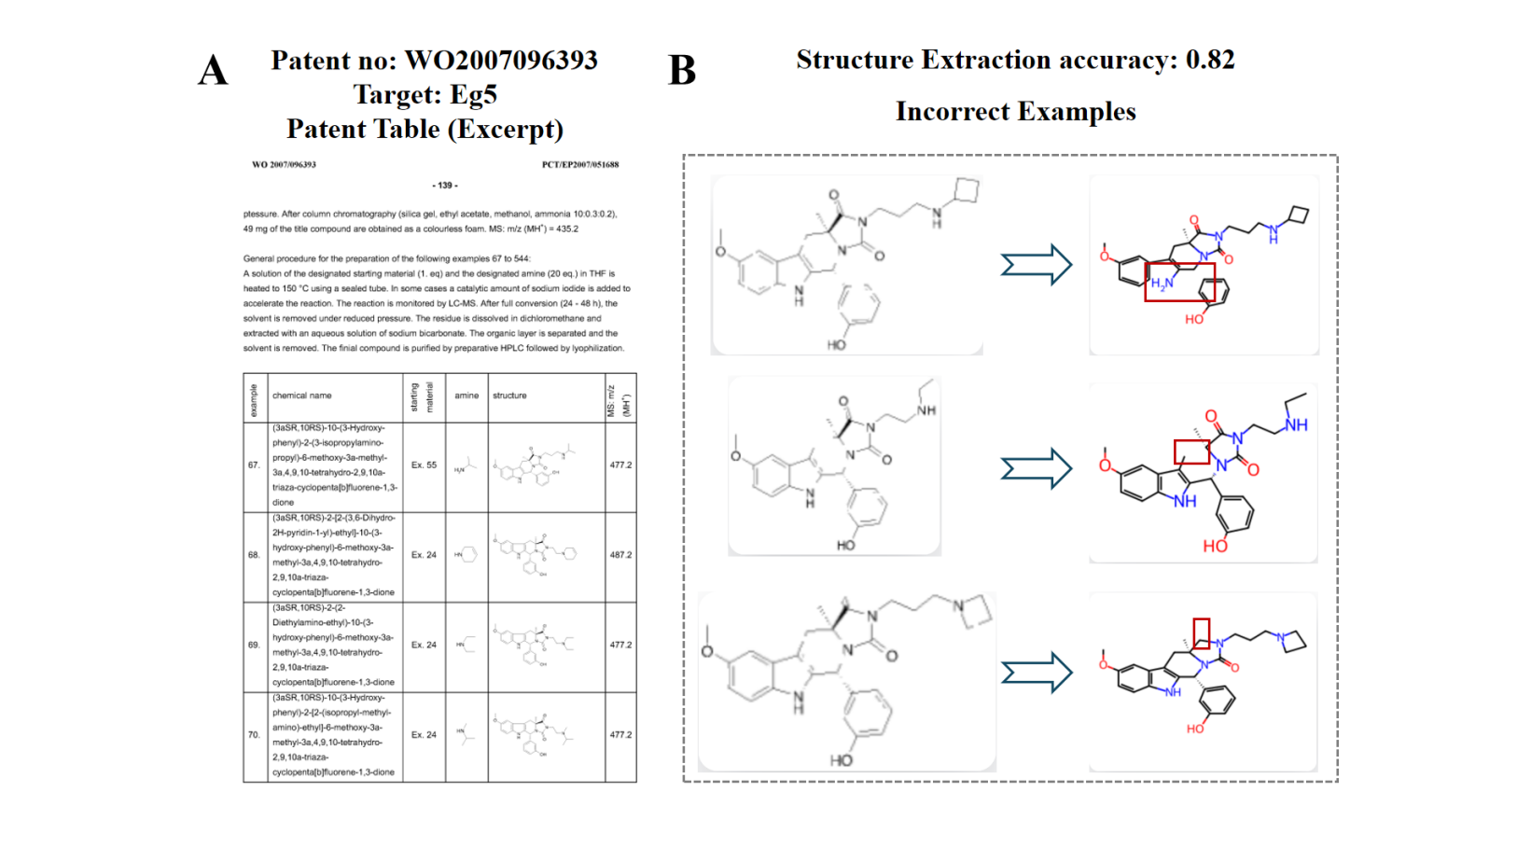
Figure 5. Representative error cases in chemical structure extraction from patents by BioChemInsight. (A) A representative excerpt from patent WO 2007096393, showing a table that lists compound identifiers, molecular structures, and assay activity data for Eg5 inhibitors. (B) Three representative failure cases in structure extraction. For each compound, the Original Structure (left) from the patent is compared with the Extracted Structure (right) generated by BioChemInsight. Discrepancies are highlighted with red boxes, illustrating typical error modes in automated parsing, such as misidentification of functional groups or bond connectivity.

Patent-Derived Chemical Space Exhibits Strong Complementarity to ChEMBL database
To assess the novelty and complementarity of patent-derived structure–activity relationship (SAR) data, we compared compound–target associations extracted by BioChemInsight with those from ChEMBL, a major public repository of bioactive molecules and SAR data. For each target, compounds from both sources were pooled and encoded as Morgan fingerprints (radius = 2; 2048 bits), and the resulting target-level chemical spaces were compared by dimensionality reduction using Uniform Manifold Approximation and Projection (UMAP). As shown in Figure 6, targets characterized from patent documents and targets characterized from ChEMBL occupy distinct, minimally overlapping regions of the projected chemical space—a trend consistent across all 15 targets analysed. This indicates that the chemical space associated with a given target in the patent literature is substantially different from that represented in public databases (UMAP parameters are listed in the ESI).
This divergence stems from fundamental differences in data sources and curation mechanisms. ChEMBL, as a manually curated, high-quality, and large-scale open database of bioactive molecules, primarily aggregates data from peer-reviewed publications and publicly disclosed bioactivity assays. The patent-derived compounds included in ChEMBL are typically representative subsets rather than exhaustive extractions, constrained by its manual curation workflow. In contrast, patent literature itself serves as a primary source of novel chemical matter, often containing proprietary compounds that are structurally distinct and not yet deposited in public repositories. This is especially evident for emerging targets (e.g., NLRP3, PFKFB3), where patent disclosures commonly precede comprehensive academic reporting by several years.
Thus, patents and ChEMBL cover complementary regions of chemical space. This underscores the value of systematic patent mining in early-stage drug discovery: BioChemInsight facilitates access to chemical information underrepresented in established public databases. By doing so, it expands the landscape of explorable compound-target interactions and enriches the data foundation for subsequent quantitative structure-activity relationship (QSAR) modeling and targeted screening efforts.
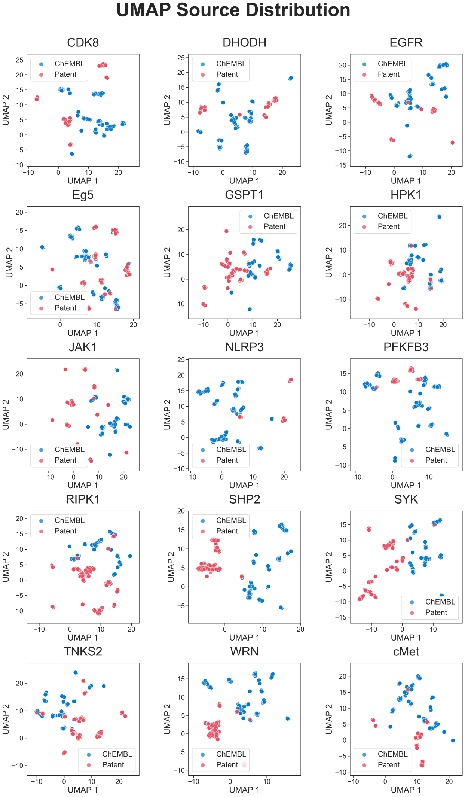
Figure 6. Comparison of target representation spaces derived from BioChemInsight patent data and the ChEMBL database. Each point corresponds to a therapeutic target, projected into two dimensions using UMAP (UMAP1 and UMAP2) based on feature vectors generated from Morgan fingerprints of compounds associated with each target. Red circles represent targets characterized from patent documents processed by BioChemInsight. Blue circles represent targets characterized from curated bioactivity records in the ChEMBL database. The minimal overlap between the two clusters indicates substantial differences in the chemical and biological information captured by patent literature versus the ChEMBL database.
Conclusion
Methods
- BioChemInsight framework overview
BioChemInsight is a computational suite built with a React frontend and a Python 3.12 backend, designed for the automated extraction of structure–activity relationship (SAR) data from chemical literature. The system implements a modular pipeline that integrates computer vision, natural language processing, and cheminformatics tools to transform PDF documents into structured chemical–bioactivity networks, with pinned dependencies (PyTorch 2.11.0, CUDA 12.9) managed through Conda environments and Docker deployment. Complete validation datasets and installation guidelines are available through the project's GitHub repository at https://github.com/dahuilangda/BioChemInsight.
- Automated processing pipeline
The workflow executes through four sequential stages, each handling specific aspects of chemical information extraction (Figure 1).

Figure 1. Schematic overview of the BioChemInsight platform for automated extraction of structure–activity relationship (SAR) information from patent documents, depicting the four processing stages. Section 1 outlines the workflow for chemical structure extraction—DECIMER Segmentation followed by mixture-of-experts MolNexTR decoding—and compound identifier recognition by a vision–language model, culminating in the mapping of structures to their corresponding identifiers. Section 2 depicts the pipeline for bioactivity data extraction and processing, including OCR-based text conversion, parsing via an OpenAI-compatible large language model, and integration into structured tables. The final output combines chemical structures with associated bioactivity data to generate a comprehensive SAR dataset.

  - Document preprocessing
Input PDFs are converted into high-resolution PNG images per page (2× native resolution) using PyMuPDF (v1.28.0), ensuring resolution adequacy for structure detection. This step normalizes document formats and handles potential PDF rendering inconsistencies across operating systems.
  - Chemical structure recognition
Chemical structure depictions are identified through DECIMER Segmentation's Mask R-CNN, which detects and crops them with 99% bounding-box accuracy while correctly excluding nearly 100% of non-chemical images3. The cropped structures are converted into SMILES strings by MolNexTR,14 extended here with a three-expert mixture-of-experts decoder in which the frozen base network serves as the complete-molecule expert while two trained sidecar experts specialize in Markush scaffolds and substituent fragments; an attention-pooled router blends the experts per depiction, a calibrated confidence head estimates the expected graph-level Tanimoto similarity to the true structure and triggers visual re-verification of low-confidence predictions, and Markush scaffolds carrying detached fragments are assembled into complete molecules through dummy-atom attachment under pose-preserving geometric constraints, with any inconsistency leading to exclusion of the assembly (fail-closed).
  - Markush structure and fragment assembly
Patent claims frequently depict a scaffold together with variable substituents (R-groups) and detached fragments connected by wavy bonds or asterisked attachment points. BioChemInsight assembles such depictions into complete molecules using the explicit dummy attachment atoms emitted by the MoE decoder: assembly is authorized only when the decoded graph contains a real attachment atom, after which the scaffold and fragment are reconnected at the corresponding anchor positions using RDKit and re-laid out while preserving the original scaffold pose. Three independent evidence streams guide and validate each assembly: textual variable assignment parsed from the OCR text, visual attachment cues (visible asterisks, wavy bonds, and R-group labels) identified by the vision-language model, and the decoded MolNexTR graph, of which only the graph layer authorizes assembly. Finally, every assembled product is rendered alongside its source scaffold and fragment crops in a three-panel image and re-examined by the vision-language model; any visible contradiction in the scaffold region, fragment region, or attachment position blocks the assembly, so that only verified structures reach the final output.
  - Compound identifier recognition
A vision–language model, accessed through an OpenAI-compatible endpoint (GLM-4.5V recommended; a Gemma-class model serves this role in the production deployment), extracts raw compound labels (e.g., “Ex.1”) from DECIMER-annotated red regions through spatial correlation and whole-page scheme analysis. A text large language model then standardizes these identifiers into consistent nomenclature (e.g., “Compound 1”) using regular-expression matching and synonym resolution, and every identifier assignment is independently verified against the allowlist of recognized identifiers before acceptance. Finally, the system cross-validates identifiers against page coordinates and filename metadata to ensure precise matching between standardized IDs and their corresponding SMILES strings.
  - Bioactivity data extraction
PaddleOCR, deployed as a containerized microservice, converts a separate render of the page images (1.3× native resolution, matching the OCR model's training distribution) into structured Markdown. An OpenAI-compatible large language model is then applied to extract bioactivity metrics (IC₅₀/EC₅₀/Ki) from both tabular data and contextual mentions (e.g., ‘IC₅₀ = 12.5 µM for Compound 5’). Each extraction passes through three independent verification stages—compound-identifier assignment, assay membership, and value validation—so that only experimentally measured values are retained; quantities produced by computational procedures such as docking scores or in-silico ADMET predictions are explicitly rejected. Pattern matching with contextual unit normalization (nM/µM resolution) ensures standardized output, and every accepted value retains page-level provenance for traceability.
  - Data integration and output
The data integration phase joins decoded SMILES with standardized compound identifiers and their verified bioactivity values to generate a structured matrix, keyed by the identifier allowlist established during extraction. Every record retains page numbers and source-image references so that any value can be traced back to its location in the original patent.
- Dataset Construction for Cross-Source Validation
We compiled a specialized dataset comprising 296 patents associated with 15 therapeutic targets, selected from the Cortellis Drug Discovery Intelligence database based on inclusion criteria (e.g., ≥20 chemical depictions, small-molecule claims). Using BioChemInsight, we systematically extracted compound identifiers, SMILES strings, and biological activity values (including IC₅₀, EC₅₀, and Ki), yielding 23,218 structure records and 7,110 bioactivity values. All extracted activity values were normalized to a consistent unit convention (nM/µM). Extraction quality was assessed through a tiered verification protocol: (i) independent recomputation of corpus statistics (SMILES validity, identifier coverage) outside the pipeline using RDKit (v2026.03.3); (ii) automated visual cross-checking of source-versus-extraction comparison sheets for 282 of the 296 patents; and (iii) expert human review of 507 compound-level extractions presented as side-by-side comparisons of the original patent segment crop and the decoded molecule. Picks were drawn by stratified random sampling across per-patent SMILES-validity tiers (highest-quality tier n = 87; good n = 305; mid n = 88; lowest-quality tier n = 25; 2 picks were not adjudicated), and the confirmed correctness of 499/505 carries a Wilson 95% confidence interval of 97.4–99.5%. The complete adjudication set and per-target statistics are provided in the Electronic Supplementary Information (ESI).
- Statistical analysis and output
The final matrix integrates SMILES, standardized IDs, and bioactivity values (IC₅₀/EC₅₀/Ki), exported as CSV/JSON for downstream analysis and supporting batch processing across document repositories. Data preprocessing and statistical analysis were implemented in Python 3.12 using pandas (v2.2.2); results were visualized via matplotlib (v3.9.2).
BioChemInsight provides a unified, open-source pipeline that integrates recent models for optical chemical structure recognition—extended with mixture-of-experts decoding for Markush and fragment chemistries—compound identifier association, and bioactivity extraction with unit normalization, effectively converting unstructured patent documents into machine-readable SAR datasets. Our systematic evaluation on 296 patents across 15 therapeutic targets demonstrates robust performance: 87.3% of 23,218 extracted structure records yielded valid SMILES with complete identifier coverage, and expert human adjudication of 505 compound-level extractions against original patent segments confirmed 98.8% structural correctness, with errors concentrated in a small, quality-predictable subset of documents. Analysis of the extracted data further indicates that the chemical information from patents occupies a space largely complementary to that of the established public repository ChEMBL. BioChemInsight thereby unlocks access to previously underrepresented chemical and bioactivity data, expanding the landscape of explorable compound–target interactions and enriching the foundation for quantitative modelling and targeted screening. Requiring guided, page-level human curation limited to page selection and final review, the platform is well-suited for high-throughput applications, including automated SAR dataset construction, knowledge graph expansion, and data-driven hit identification. The pipeline is publicly available at https://github.com/dahuilangda/BioChemInsight to support reproducible, scalable chemical data mining.
Code availability
The source code for BioChemInsight implementation and data analysis is available on GitHub (https://github.com/dahuilangda/BioChemInsight), Git tag v1.0.0.
The 296-patent extraction outputs (23,218 structure records, 7,110 bioactivity values), the complete 507-item human-adjudication set with embedded segment comparisons, and all verification statistics are deposited in the project repository and archived with the code under Git tag v1.0.0; permanent DOI-minted archival (Zenodo) of the identical snapshot accompanies the submission.
Author contributions
Zhe Wang, Si Chen, Fangtian Fu, Wei Zhang, Gang Xu, and Xiang Li developed the concepts for the manuscript and proposed the method. Zhe Wang, Fangtian Fu, Wei Zhang, Lige Yan, Nan Li, Wenxia Deng, Yan Meng, Jianping Wu, Hui Wu, and Wenting Wu collected the data. Zhe Wang, Fangtian Fu, Wei Zhang, Gang Xu, Xiang Li, and Si Chen designed the analyses and applications and discussed the results. Zhe Wang, Fangtian Fu, Wei Zhang, and Si Chen conducted the analyses. Gang Xu and Xiang Li helped interpret the results of the real data analyses. Zhe Wang, Fangtian Fu, Wei Zhang, Gang Xu, Xiang Li, and Si Chen prepared the manuscript and contributed to editing the paper.
Funding
This study was supported by the National Natural Science Foundation of China (NSFC) under Grant No. 82404509.
Conflict of interest statement
None declared.

References
(1) Cruse, K.; Baibakova, V.; Abdelsamie, M.; Hong, K.; Bartel, C. J.; Trewartha, A.; Jain, A.; Sutter-Fella, C. M.; Ceder, G. Text Mining the Literature to Inform Experiments and Rationalize Impurity Phase Formation for BiFeO3. Chem Mater 2023, 36 (2), 772–785. https://doi.org/10.1021/acs.chemmater.3c02203.
(2) Unsupervised word embeddings capture latent knowledge from materials science literature | Nature. https://www.nature.com/articles/s41586-019-1335-8 (accessed 2025-04-02).
(3) Rajan, K.; Brinkhaus, H. O.; Agea, M. I.; Zielesny, A.; Steinbeck, C. DECIMER.Ai: An Open Platform for Automated Optical Chemical Structure Identification, Segmentation and Recognition in Scientific Publications. Nat Commun 2023, 14 (1), 5045. https://doi.org/10.1038/s41467-023-40782-0.
(4) Morin, L.; Weber, V.; Meijer, G. I.; Yu, F.; Staar, P. W. J. PatCID: An Open-Access Dataset of Chemical Structures in Patent Documents. Nat Commun 2024, 15 (1), 6532. https://doi.org/10.1038/s41467-024-50779-y.
(5) Tang, B.; Niu, Z.; Wang, X.; Huang, J.; Ma, C.; Peng, J.; Jiang, Y.; Ge, R.; Hu, H.; Lin, L.; Yang, G. Automated Molecular Structure Segmentation from Documents Using ChemSAM. J Cheminform 2024, 16, 29. https://doi.org/10.1186/s13321-024-00823-2.
(6) Rajan, K.; Brinkhaus, H. O.; Zielesny, A.; Steinbeck, C. A Review of Optical Chemical Structure Recognition Tools. Journal of Cheminformatics 2020, 12 (1), 1–13. https://doi.org/10.1186/s13321-020-00465-0.
(7) Weber, L.; Krasnov, A.; Barnabas, S.; Böhme, T.; Boyer, S. Comparing Optical Chemical Structure Recognition Tools. Chemistry November 21, 2023. https://doi.org/10.26434/chemrxiv-2023-d6kmg.
(8) Ouyang, H.; Liu, W.; Tao, J.; Luo, Y.; Zhang, W.; Zhou, J.; Geng, S.; Zhang, C. ChemReco: Automated Recognition of Hand-Drawn Carbon-Hydrogen-Oxygen Structures Using Deep Learning. Sci Rep 2024, 14 (1), 17126. https://doi.org/10.1038/s41598-024-67496-7.
(9) Qian, Y.; Guo, J.; Tu, Z.; Li, Z.; Coley, C. W.; Barzilay, R. MolScribe: Robust Molecular Structure Recognition with Image-to-Graph Generation. J. Chem. Inf. Model. 2023, 63 (7), 1925–1934. https://doi.org/10.1021/acs.jcim.2c01480.
(10) Xu, Y.; Xiao, J.; Chou, C.-H.; Zhang, J.; Zhu, J.; Hu, Q.; Li, H.; Han, N.; Liu, B.; Zhang, S.; Han, J.; Zhang, Z.; Zhang, S.; Zhang, W.; Lai, L.; Pei, J. MolMiner: You Only Look Once for Chemical Structure Recognition. J Chem Inf Model 2022, 62 (22), 5321–5328. https://doi.org/10.1021/acs.jcim.2c00733.
(11) Oldenhof, M.; Arany, A.; Moreau, Y.; Simm, J. ChemGrapher: Optical Graph Recognition of Chemical Compounds by Deep Learning. J Chem Inf Model 2020, 60 (10), 4506–4517. https://doi.org/10.1021/acs.jcim.0c00459.
(12) Xu, Z.; Li, J.; Yang, Z.; Li, S.; Li, H. SwinOCSR: End-to-End Optical Chemical Structure Recognition Using a Swin Transformer. Journal of cheminformatics 2022, 14 (1), 41. https://doi.org/10.1186/s13321-022-00624-5.
(13) Zhang, X.-C.; Yi, J.-C.; Yang, G.-P.; Wu, C.-K.; Hou, T.-J.; Cao, D.-S. ABC-Net: A Divide-and-Conquer Based Deep Learning Architecture for SMILES Recognition from Molecular Images. Brief Bioinform 2022, 23 (2), bbac033. https://doi.org/10.1093/bib/bbac033.
(14) Chen, Y.; Leung, C. T.; Huang, Y.; Sun, J.; Chen, H.; Gao, H. MolNexTR: A Generalized Deep Learning Model for Molecular Image Recognition. J Cheminform 2024, 16 (1), 141. https://doi.org/10.1186/s13321-024-00926-w.
(15) Mendez, D.; Gaulton, A.; Bento, A. P.; Chambers, J.; De Veij, M.; Félix, E.; Magariños, M. P.; Mosquera, J. F.; Mutowo, P.; Nowotka, M.; Gordillo-Marañón, M.; Hunter, F.; Junco, L.; Mugumbate, G.; Rodriguez-Lopez, M.; Atkinson, F.; Bosc, N.; Radoux, C. J.; Segura-Cabrera, A.; Hersey, A.; Leach, A. R. ChEMBL: Towards Direct Deposition of Bioassay Data. Nucleic acids research 2019, 47 (D1), D930–D940. https://doi.org/10.1093/nar/gky1075.

