

Statement for December 13, 2022

**Forward Service Requested**

DENNIS SIMPSON II

1405 W MICHIGAN ST

ORLANDO, FL 32805-6123

Bank Of America, N. A.

101 South Tryon Street

Charlotte, North Carolina 28255



**Bank of America Consumer Refunds and Payments**

|  |  |
| --- | --- |
| C u s t o m e r S e r v i c e : | 833-896-7979 |
| C a r d N u m b e r : | **** **** **** 3997 |
| P e r i o d S t a r t D a t e : | 11/14/2022 |
| P e r i o d E n d D a t e : | 12/13/2022 |

|  |  |  |  |  |  |  |  |
| --- | --- | --- | --- | --- | --- | --- | --- |
| Summary of Transactions | | SSN: | | 229-59-6576 |  |  |  |
|  |  |  |  |  |  |
| **Previous Balance** | **(+) Credits and Adjustments** | **(-) Purchases and Adjustments** | | | **New Balance** |  |  |
| $ 5.53 | $ 730.00 | $ -737.23 | |  | $ -1.70 |  |  |
| Account Transaction Activity | |  |  |  |  |  |  |
| **Merchant Name** |  | **Posted** | **Reference** | **Transaction Details** | **Credit** | **Debit** |  |
|  | **Date** | **Number** |  |
|  |  |  |  |  |  |
| GOODWILL S.OBT #1 ORLANDO, Florida 32809 United States | | 12/11/2022 | 234525900013 | Purchase of Goods or Services |  | $ -10.77 |  |
| CANTEEN VENDING ALTAMONTE SPR, Florida 32701 United States | | 12/11/2022 | 234525400508 | Purchase of Goods or Services |  | $ -2.35 |  |
| CANTEEN VENDING ALTAMONTE SPR, Florida 32701 United States | | 12/11/2022 | 234526400508 | Purchase of Goods or Services |  | $ -2.35 |  |
| WAWA 5138 WAWA 5138 ORLANDO, Florida 32809 United States | | 12/10/2022 | 234442727601 | Purchase of Goods or Services |  | $ -1.13 |  |
| ISPA/PIMDS PAI ISO ORLANDO, Florida 000000000 United States | | 12/09/2022 | 000000005786 | ATM Cash Withdrawal Fee - |  | $ -2.50 |  |
| Domestic |  |  |
|  |  |  |  |  |  |  |
| ISPA/PIMDS PAI ISO ORLANDO, Florida 000000000 United States | | 12/09/2022 | 000000005786 | ATM Cash Withdrawal |  | $ -82.99 |  |
| BIU - Orlando - 097 2364 W. Oak Ridge Rd Orlando, Florida 32809 United | | 12/09/2022 | 358383480731 | Manual Card Reload | $ 100.00 |  |  |
| States |  |  |  |
|  |  |  |  |  |  |  |
| MURPHY7669ATWAL MURPHY7669ATWAL ORLANDO, Florida 32839 | | 12/06/2022 | 234028005020 | Purchase of Goods or Services |  | $ -3.61 |  |
| United States |  |  |  |
|  |  |  |  |  |  |  |
| TD BANK TD BANK KISSIMMEE, Florida 34744 United States | | 12/06/2022 | 000000007537 | ATM Cash Withdrawal Fee - |  | $ -2.50 |  |
| Domestic |  |  |
|  |  |  |  |  |  |  |
| TD BANK TD BANK KISSIMMEE, Florida 34744 United States | | 12/06/2022 | 000000007537 | ATM Cash Withdrawal |  | $ -93.50 |  |
| BIU - Orlando - 097 2364 W. Oak Ridge Rd Orlando, Florida 32809 United | | 12/06/2022 | 064261961017 | Manual Card Reload | $ 100.00 |  |  |
| States |  |  |  |
|  |  |  |  |  |  |  |
| WAWA 5138 WAWA 5138 ORLANDO, Florida 32809 United States | | 12/05/2022 | 233942726790 | Purchase of Goods or Services |  | $ -0.32 |  |
| SHELL SERVICE S SHELL SERVICE S ORLANDO, Florida 32809 United | | 12/05/2022 | 233978605305 | Purchase of Goods or Services |  | $ -1.59 |  |
| States |  |  |  |
|  |  |  |  |  |  |  |
| 7-ELEVEN 7-ELEVEN WINTER PARK, Florida 32792-0000 United States | | 12/05/2022 | 190059 | Purchase of Goods or Services |  | $ -3.20 |  |
| ISPA/PIMDS PAI ISO ORLANDO, Florida 000000000 United States | | 12/05/2022 | 000000005709 | ATM Cash Withdrawal Fee - |  | $ -2.50 |  |
| Domestic |  |  |
|  |  |  |  |  |  |  |
| ISPA/PIMDS PAI ISO ORLANDO, Florida 000000000 United States | | 12/05/2022 | 000000005709 | ATM Cash Withdrawal |  | $ -42.99 |  |
| BIU - Orlando - 097 2364 W. Oak Ridge Rd Orlando, Florida 32809 United | | 12/05/2022 | 978005759061 | Manual Card Reload | $ 50.00 |  |  |
| States |  |  |  |
|  |  |  |  |  |  |  |
| 255PEPSIVEN9147678600 ORLANDO, Florida 32809 United States | | 12/01/2022 | 233522100717 | Purchase of Goods or Services |  | $ -0.75 |  |
| LYNX-MOBILE ORLANDO, Florida 32801 United States | | 12/01/2022 | 233524200190 | Purchase of Goods or Services |  | $ -2.25 |  |

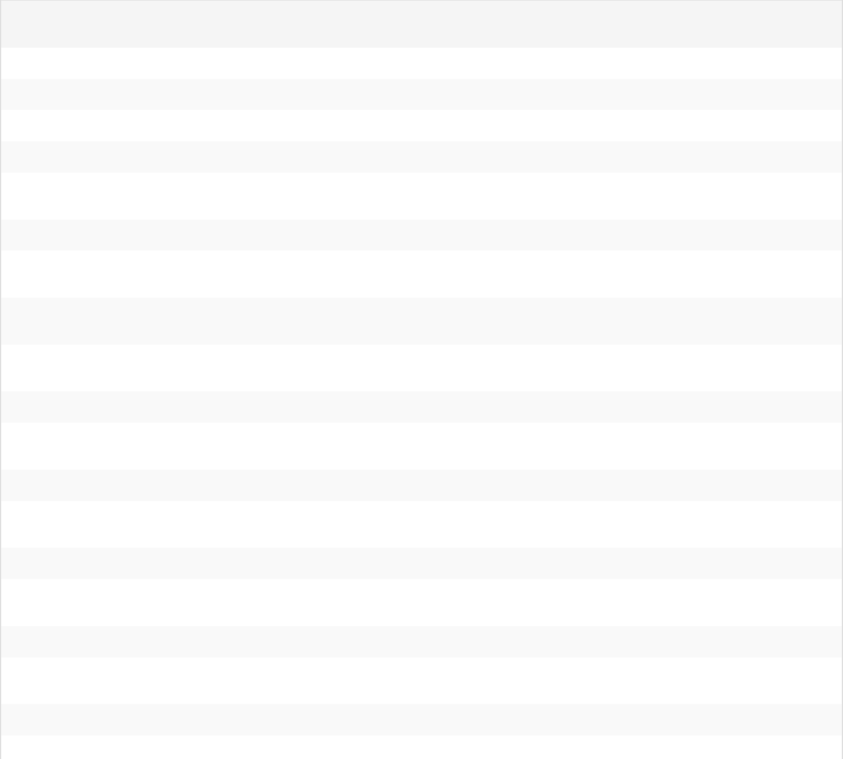



|  |  |  |  |  |  |  |
| --- | --- | --- | --- | --- | --- | --- |
| **Merchant Name** | **Posted** | **Reference** | **Transaction Details** | **Credit** | **Debit** |  |
| **Date** | **Number** |  |
|  |  |  |  |  |
| 7-ELEVEN 7-ELEVEN ORLANDO, Florida 32839-0000 United States | 11/30/2022 | 740035 | Purchase of Goods or Services |  | $ -1.05 |  |
| 7-ELEVEN 7-ELEVEN ORLANDO, Florida 32809-0000 United States | 11/30/2022 | 723545 | Purchase of Goods or Services |  | $ -5.52 |  |
| BIU - Orlando - 097 2364 W. Oak Ridge Rd Orlando, Florida 32809 United | 11/30/2022 | 549800783132 | Manual Card Reload | $ 10.00 |  |  |
| States |  |  |
|  |  |  |  |  |  |
| APPLE.COM/BILL 866-712-7753, California 95014 United States | 11/30/2022 | 233426109677 | Purchase of Goods or Services |  | $ -4.99 |  |
| PNC BANK 8574 S ORNGE BLSM ORLANDO, Florida United States | 11/28/2022 | 00004383 | ATM Cash Withdrawal |  | $ -100.00 |  |
| BIU - Orlando - 097 2364 W. Oak Ridge Rd Orlando, Florida 32809 United | 11/28/2022 | 413709929332 | Manual Card Reload | $ 100.00 |  |  |
| States |  |  |
|  |  |  |  |  |  |
| ISPA/PIMDS PAI ISO ORLANDO, Florida 000000000 United States | 11/28/2022 | 000000005577 | ATM Cash Withdrawal Fee - |  | $ -2.50 |  |
| Domestic |  |  |
|  |  |  |  |  |  |
| ISPA/PIMDS PAI ISO ORLANDO, Florida 000000000 United States | 11/28/2022 | 000000005577 | ATM Cash Withdrawal |  | $ -42.99 |  |
| BIU - Orlando - 097 2364 W. Oak Ridge Rd Orlando, Florida 32809 United | 11/28/2022 | 406433378416 | Manual Card Reload | $ 50.00 |  |  |
| States |  |  |
|  |  |  |  |  |  |
| LYNX-MOBILE ORLANDO, Florida 32801 United States | 11/27/2022 | 233120200190 | Purchase of Goods or Services |  | $ -1.00 |  |
| LYNX-MOBILE ORLANDO, Florida 32801 United States | 11/26/2022 | 233024200190 | Purchase of Goods or Services |  | $ -2.25 |  |
| CANTEEN VENDING ALTAMONTE SPR, Florida 32701 United States | 11/26/2022 | 233029400503 | Purchase of Goods or Services |  | $ -2.35 |  |
| WAWA 5105 WAWA 5105 ORLANDO, Florida 32809 United States | 11/26/2022 | 233048668733 | Purchase of Goods or Services |  | $ -2.11 |  |
| CHEVRON 0301140 ORLANDO, Florida 32809 United States | 11/25/2022 | 232925106184 | Purchase of Goods or Services |  | $ -9.55 |  |
| ISPA/PIMDS PAI ISO ORLANDO, Florida 000000000 United States | 11/25/2022 | 000000005527 | ATM Cash Withdrawal Fee - |  | $ -2.50 |  |
| Domestic |  |  |
|  |  |  |  |  |  |
| ISPA/PIMDS PAI ISO ORLANDO, Florida 000000000 United States | 11/25/2022 | 000000005527 | ATM Cash Withdrawal |  | $ -102.99 |  |
| BIU - Orlando - 097 2364 W. Oak Ridge Rd Orlando, Florida 32809 United | 11/25/2022 | 144317104067 | Manual Card Reload | $ 120.00 |  |  |
| States |  |  |
|  |  |  |  |  |  |
| PNC BANK 7030 S ORNGE BL TR ORLANDO, Florida United States | 11/21/2022 | 00005965 | ATM Cash Withdrawal |  | $ -50.00 |  |
| BIU - Orlando - 097 2364 W. Oak Ridge Rd Orlando, Florida 32809 United | 11/21/2022 | 802881203721 | Manual Card Reload | $ 50.00 |  |  |
| States |  |  |
|  |  |  |  |  |  |
| APPLE.COM/BILL 866-712-7753, California 95014 United States | 11/21/2022 | 232525103028 | Purchase of Goods or Services |  | $ -9.99 |  |
| SERVICE FEE2*SCI-SCGOV EGOV.COM, South Carolina 29201 United | 11/20/2022 | 232427091712 | Purchase of Goods or Services |  | $ -1.17 |  |
| States |  |  |
|  |  |  |  |  |  |
| SCGOV 866-340-7105 DMV EGOV.COM, South Carolina 29016 United | 11/20/2022 | 232424400785 | Purchase of Goods or Services |  | $ -10.00 |  |
| States |  |  |
|  |  |  |  |  |  |
| APPLE.COM/BILL 866-712-7753, California 95014 United States | 11/19/2022 | 232325101511 | Purchase of Goods or Services |  | $ -19.99 |  |
| 7ELEVEN-FCTI 7309 S ORANGE BLOSS ORLANDO, Florida 32809-0000 | 11/18/2022 | 002104 | ATM Cash Withdrawal Fee - |  | $ -2.50 |  |
| United States | Domestic |  |  |
|  |  |  |  |  |
| 7ELEVEN-FCTI 7309 S ORANGE BLOSS ORLANDO, Florida 32809-0000 | 11/18/2022 | 002104 | ATM Cash Withdrawal |  | $ -103.50 |  |
| United States |  |  |
|  |  |  |  |  |  |
| BIU - Orlando - 097 2364 W. Oak Ridge Rd Orlando, Florida 32809 United | 11/18/2022 | 548635330302 | Manual Card Reload | $ 150.00 |  |  |
| States |  |  |
|  |  |  |  |  |  |
| APPLE.COM/BILL 866-712-7753, California 95014 United States | 11/14/2022 | 231820107673 | Purchase of Goods or Services |  | $ -1.99 |  |
| APPLE.COM/BILL 866-712-7753, California 95014 United States | 11/14/2022 | 231821107673 | Purchase of Goods or Services |  | $ -2.99 |  |
|  |  |  | T o t a l s | $ 730.00 | $ -737.23 |  |



Summary of Fees



**Fees for Current Statement** **Year-To-Date Fees**



**Fees for Current Statement**



**Year-To-Date Fees**

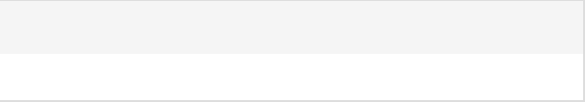

$ 15.00

$ 47.50

**PRIVACY NOTICE - Federal law requires us to tell you how we collect, share, and protect your personal information. Our privacy policy has not changed and you may review our policy and practices with respect to your personal information at** [**www.bankofamerica.com/prepaidprivacynotice**](https://www.bofaml.com/content/dam/boamlimages/documents/articles/D3_076/prepaid_debit_notice.pdf) **or we will mail you a free copy upon request if you call us at (855) 333-4896 (English), (855) 355-5057 (Spanish).**

**CARDHOLDERS WHO RECEIVE MONTHLY ACCOUNT STATEMENTS BY MAIL**

In Case of Errors or Questions About Your Electronic Transfers:

Telephone us at 1.833.896.7979, 1.866.656.5913 TTY, or 423.262.1650 (Collect when calling outside the U.S.), or write to us at Bank of America, P.O. Box 8488, Gray, Tennessee 37615-8488.

Call or write us as soon as you can if you think your statement or receipt is wrong or if you need more information about a transfer on the statement or receipt.

We must hear from you no later than 60 days after we sent you the FIRST statement on which the error or problem appeared:

1. Tell us your name and Account number.
2. Describe the error or the transfer you are unsure about, and explain as clearly as you can why you believe it is an error or why you need more information.
3. Tell us the dollar amount of the suspected error.

We will investigate your complaint and will correct any error promptly. If we take more than 10 business days to do this, we will credit your Account for the amount you think is in error, so that you will have the use of the money during the time it takes us to complete our investigation.

**CARDHOLDERS WHO DO NOT RECEIVE MONTHLY ACCOUNT STATEMENTS BY MAIL**

In Case of Errors or Questions About Your Electronic Transfers:

Telephone us at 1.833.896.7979, 1.866.656.5913 TTY, or 423.262.1650 (Collect when calling outside the U.S.), or write to us at Bank of America, P.O. Box 8488, Gray, Tennessee 37615-8488.

Call or write us as soon as you can if you think in your statement or receipt is wrong or if you need more information about a transfer on the statement or receipt. We must hear from you no later than 60 days after the earlier of the date you electronically access your Account, if the error could be viewed in your electronic history, or the date we sent the FIRST written history on which the error appeared; but in any event you must report the error no more than 120 days after the transaction allegedly in error was credited or debited to your Account:

1. Tell us your name and Account number.
2. Describe the error or the transfer you are unsure about, and explain as clearly as you can why you believe it is an error or why you need more information.
3. Tell us the dollar amount of the suspected error.

We will investigate your complaint and will correct any error promptly. If we take more than 10 business days to do this, we will credit your Account for the amount you think is in error, so that you will have the use of the money during the time it takes us to complete our investigation.

**eCommunications**

You may request that rather than receiving your monthly Account statement or notices by mail, you can review them on this website. Monthly Account statements posted to this website will be available for at least 12 months. You can withdraw this request to not receive your monthly Account statement or notices by mail by calling us at 1.833.896.7979. You may also obtain copies of your statements by calling us at 1.833.896.7979. A fee may apply for copies.