# 第二章C#语言基础

## 程序分析

1. x=1,y=2,z=0,s=true

2. a=1,b=2,a=0,b=5

3. Hb is 26 Lb is 52  
4. ^

5. 1 3 5 7 9 11 13 15 17 19

6.(1)i<10 (2)j%3!=0.

7. s1 after call changel is Hello

s1 after call change2 is HelloChange2

s1 after call change3 is HelloChange2

s2 after call change3 is HelloChange2Change3

## 编程题

### 题目1.

using System;

using System.Collections.Generic;

using System.Linq;

using System.Text;

using System.Threading.Tasks;

namespace homework

{

public class Test

{

static void Main(string[] args)

{

int[] arr=new int[30];

arr[0] = arr[1] = 1;

Console.Write("{0,-6} ", 1);

Console.Write("{0,-6} ", 1);

for (int i = 2; i < 30; i++)

{

arr[i] = arr[i - 1] + arr[i - 2];

Console.Write("{0,-6} ", arr[i]);

if ((i+1) % 5 == 0)

{

Console.WriteLine();

}

}

Console.Read();

}

}

}

运行结果如下：

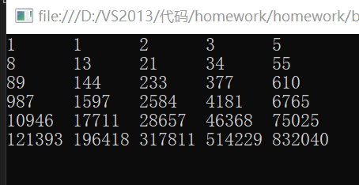

### 题目2.

using System;

using System.Collections.Generic;

using System.Linq;

using System.Text;

using System.Threading.Tasks;

namespace 计算n和y的值

{

class Program

{

public static int factorial(int n)

{

int m = 1;

while (n > 1)

{

m *= n--;

}

return m;

}

static void Main(string[] args)

{

String s = Console.ReadLine();

int n = Convert.ToInt32(s);

double y = 0;

for (int i = 1; i <= n; i++)

{

y += factorial(i);

}

Console.Write("n={0},y={1}", n, y);

Console.Read();

}

}

}

程序运行结果如下：

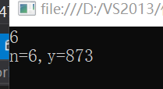

### 题目3.

源代码：

using System;

using System.Collections.Generic;

using System.Linq;

using System.Text;

using System.Threading.Tasks;

namespace Homework1_3

{

class Program

{

static void Main(string[] args)

{

for (int i = 100; i < 1000; i++)

{

int j = i, num = 0;

while (j > 0)

{

int k = j % 10;

num += k * k * k;

j /= 10;

}

if (num == i)

{

Console.WriteLine(i);

}

}

Console.Read();

}

}

}

程序运行结果如下：

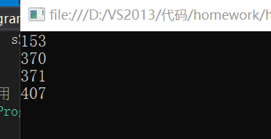

### 题目4

using System;

using System.Collections.Generic;

using System.Linq;

using System.Text;

using System.Threading.Tasks;

namespace Homework1_4

{

class Program

{

static void Main(string[] args)

{

String s = Console.ReadLine();

int n = Convert.ToInt32(s);

int num = 0, i = 1000;

while (n > 0)

{

int m = n % 10;

num += m * i;

i /= 10;

n /= 10;

}

Console.WriteLine(num);

Console.Read();

}

}

}

程序运行结果如下：

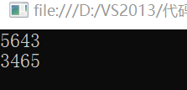

### 题目5.

using System;

using System.Collections.Generic;

using System.Linq;

using System.Text;

using System.Threading.Tasks;

namespace homework

{

class Program

{

static void Main(string[] args)

{

double num = 1;

for (int i = 1; i <= 1000; i++)

{

num = num * 4 * i * i / ((2 * i - 1) * (2 * i + 1));

}

Console.WriteLine("PI的近似值为：{0}", 2 * num);

Console.Read();

}

}

}

程序运行结果如下：

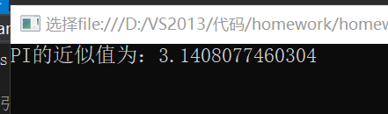

### 题目6

using System;

using System.Collections.Generic;

using System.Linq;

using System.Text;

using System.Threading.Tasks;

namespace Homework1_3

{

class Program

{

static void Main(string[] args)

{

String s = Console.ReadLine();

int n = Convert.ToInt32(s);

String num = " ";

while (n > 0)

{

int m = n % 16;

if (m < 10)

{

int j = m + 48;

char c = (char)j;

num = c + num;

}

if (m >= 10)

{

int k = m + 55;

char c1 = (char)k;

num = c1 + num;

}

n /= 16;

}

Console.WriteLine("{0}十六进制为{1}", s, num);

Console.Read();

}

}

}

程序运行结果如下：

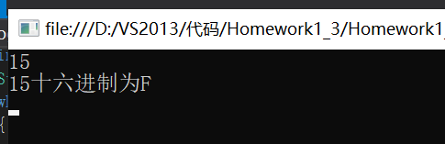

### 题目7

源程序：

using System;

using System.Collections.Generic;

using System.Linq;

using System.Text;

using System.Threading.Tasks;

namespace Homework1_7

{

class Program

{

static void Main(string[] args)

{

String s1 = Console.ReadLine();

String s2 = Console.ReadLine();

double x = Convert.ToDouble(s1);

double n = Convert.ToDouble(s2);

Console.WriteLine(hermite(n, x));

Console.Read();

}

public static double hermite(double n, double x)

{

if (n == 0)

{

return 1;

}

else if (n == 1)

{

return 2 * x;

}

return 2 * x * hermite(n - 1, x) - 2 * (n - 1) * hermite(n - 2, x);

}

}

}

程序运行结果如下：

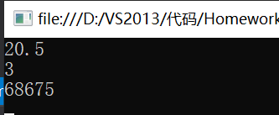

### 题目8

源程序：

using System;

using System.Collections.Generic;

using System.Linq;

using System.Text;

using System.Threading.Tasks;

namespace Homework1_8

{

class Program

{

static void Main(string[] args)

{

int[] a = { 12,45,87,24,52,34,76,847 };

int max = a[0], index = 0;

for (int i = 0; i < a.Length; i++)

{

if (a[i] > max)

{

max = a[i];

index = i;

}

}

Console.WriteLine("数组a中的最大值为：{0}，下标为：{1}", max, index);

Console.Read();

}

}

}

程序运行结果如下：

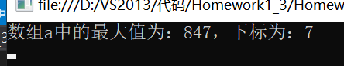

### 题目9

using System;

using System.Collections.Generic;

using System.Linq;

using System.Text;

using System.Threading.Tasks;

namespace Homework1_3

{

class Program

{

static void Main(string[] args)

{

String str = Console.ReadLine();

Boolean flg = true;

for (int i = 0, j = str.Length - 1; i < str.Length / 2; i++, j--)

{

char m = str[i], n = str[j];

if (m != n)

{

flg = false;

}

}

if (flg)

{

Console.WriteLine("是回文");

}

else

{

Console.WriteLine("不是回文");

}

Console.Read();

}

}

}

程序运行结果如下：

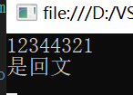

### 题目10

using System;

using System.Collections.Generic;

using System.Linq;

using System.Text;

using System.Threading.Tasks;

using System.Collections;

namespace Homework1_3

{

class Program

{

static void Main(string[] args) {

ArrayList a = new ArrayList();

int fuNumber = 0, zhengNumber = 0, sum = 0;

int i;

do{

String s = Console.ReadLine();

i = Convert.ToInt32(s);

if (i > 0) {

zhengNumber++; sum += i;

}if (i < 0) {

fuNumber++;

sum += i;

}

a.Add(i);

}while (i != 0);

Console.WriteLine(" 正 数 个 数 {0} 负 数 个 数 {1} 平 均 值 {2}", zhengNumber, fuNumber, sum / a.Count);

Console.Read(); }

}

}

程序运行结果如下：

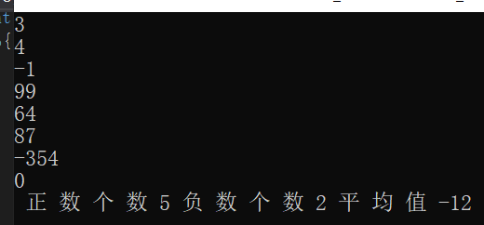

### 题目11

源程序：

using System;

using System.Collections.Generic;

using System.Linq;

using System.Text;

using System.Threading.Tasks;

using System.Collections;

namespace Homework1_3

{

class Program

{

static void Main(string[] args)

{

int[,] a = new int[4, 4] { { 1, 1, 1, 1 }, { 1, 1, 1, 1 }, { 1, 1, 1, 1 }, { 1, 1, 1, 1 } };

//i=j || i+j=3是对角线元素

int num = a[0, 0] + a[0, 3] + a[1, 1] + a[1, 2] + a[2, 1] + a[2, 2] + a[3, 0] + a[3, 3];

Console.WriteLine(num);

Console.Read();

}

}

}

程序运行结果如下：

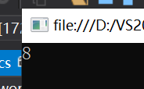

### 题目12

源程序：

using System;

using System.Collections.Generic;

using System.Linq;

using System.Text;

using System.Threading.Tasks;

using System.Collections;

namespace Homework1_3

{

class Program

{

static void Main(string[] args)

{

ArrayList a = new ArrayList();

String s = Console.ReadLine();

int num = 0;

Boolean b = false;

for (int i = 0; i < s.Length; i++)

{

if ((int)(s[i]) >= 48 && (int)(s[i]) <= 58)

{

b = true;

num = num * 10 + s[i] - 48;

}

else if (b)

{

a.Add(num);

b = false;

num = 0;

}

if ((int)(s[i]) >= 48 && (int)(s[i]) <= 58 && i == s.Length - 1)

{

a.Add(num);

}

}

Console.WriteLine(a.Count);

foreach (int i in a)

{

Console.WriteLine(i + " ");

}

Console.Read();

}

}

}

程序运行结果如下：

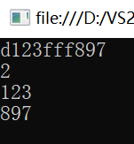

# 第三章C#面对对象编程

## 编程题

### 题目1

源程序：

using System;

using System.Collections.Generic;

using System.Text;

namespace 作业

{

class Complex

{

public double RealPart;

public double ImaginPart;

public Complex()

{

this.RealPart = 0;

this.ImaginPart = 0;

}

public Complex(double r, double i)

{

this.RealPart = r;

this.ImaginPart = i;

}

public double getReal()

{

return RealPart;

}

public double getImagine()

{

return ImaginPart;

}

public Complex complexAdd(Complex a)

{

a.RealPart = a.RealPart + this.RealPart;

a.ImaginPart = a.ImaginPart + this.ImaginPart;

return a;

}

public Complex complexSub(Complex a)

{

Complex temp = new Complex();

a.RealPart = a.RealPart - temp.RealPart;

a.ImaginPart = a.ImaginPart - temp.ImaginPart;

return temp;

}

public Complex complexMulti(Complex a)

{

Complex temp = new Complex();

a.RealPart = a.RealPart * temp.RealPart;

a.ImaginPart = a.RealPart * temp.ImaginPart;

return a;

}

public static Complex operator +(Complex a, Complex b)

{

return new Complex(a.RealPart + b.RealPart, a.ImaginPart + b.ImaginPart);

}

public static Complex operator -(Complex a, Complex b)

{

return new Complex(a.RealPart - b.RealPart, a.ImaginPart - b.ImaginPart);

}

public static Complex operator *(Complex a, Complex b)

{

return new Complex(a.RealPart * b.RealPart, a.ImaginPart * b.ImaginPart);

}

public void input()

{

Console.WriteLine("请输入复数的实数部分");

this.RealPart = double.Parse(Console.ReadLine());

Console.WriteLine("请输入复数的虚数部分");

this.ImaginPart = double.Parse(Console.ReadLine());

Console.WriteLine("您输入的复数是：{0}", this.ToString());

}

public override string ToString()

{

return RealPart + "+" + ImaginPart + "i";

}

}

class ZY3_1

{

static void Main(string[] args)

{

Complex c1 = new Complex();

Complex c2 = new Complex();

Complex c3 = new Complex();

c1.input();

c2.input();

c3 = c1 + c2;

Console.WriteLine("({0})+({1})={2}", c1.ToString(), c2.ToString(), c3.ToString());

c3 = c1 - c2;

Console.WriteLine("({0})-({1})={2}", c1.ToString(), c2.ToString(), c3.ToString());

c3 = c1 * c2;

Console.WriteLine("({0})*({1})={2}", c1.ToString(), c2.ToString(), c3.ToString());

Console.ReadKey();

}

}

}

程序结果如下：

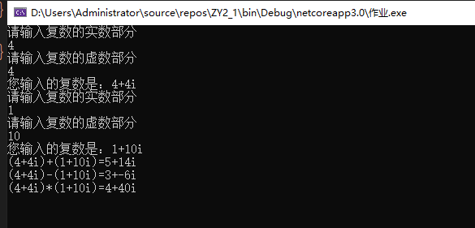

### 题目2

源程序：

using System;

using System.Collections.Generic;

using System.Linq;

using System.Text;

namespace 作业

{

class ZY3_2

{

static void Main(string[] args)

{

Student.InPutAllScore();

Student.Students.Sort();

Student.ListAllInfo();

Console.ReadLine();

}

}

public enum ClassName

{

CPP, Eng, Math

}

public class Score

{

public ClassName ItemName { get; set; }

public Decimal ScoreNum { get; set; }

}

public class Student : IComparable

{

public string ID { get; set; }

public string Name { get; set; }

public Dictionary<ClassName, Score> Score = new Dictionary<ClassName, Score>();

public Decimal AvgSocre

{

get

{

var a = (from s in this.Score.Values

select s.ScoreNum).Average();

return a;

}

}

public void SetScore(ClassName c, decimal dcScore)

{

this.Score[c] = new Score() { ItemName = c, ScoreNum = dcScore };

}

public decimal GetScore(ClassName c)

{

Score s = this.Score[c];

return s == null ? 0m : s.ScoreNum;

}

public static List<Student> Students = new List<Student>();

public static void InPutAllScore()

{

int i = 0;

while (true)

{

i++;

Console.WriteLine("请输入第{0}个学生的信息, 学号输入end表示结束", i);

Console.Write("学号:");

string sID = Console.ReadLine();

if (sID == "end")

break;

Student s = new Student();

s.ID = sID;

Console.Write("姓名:");

string sName = Console.ReadLine();

s.Name = sName;

Console.Write("C++成绩:");

string sScore = Console.ReadLine();

s.SetScore(ClassName.CPP, decimal.Parse(sScore));

s.Name = sName;

Console.Write("英语成绩:");

sScore = Console.ReadLine();

s.SetScore(ClassName.Eng, decimal.Parse(sScore));

s.Name = sName;

Console.Write("数学成绩:");

sScore = Console.ReadLine();

s.SetScore(ClassName.Math, decimal.Parse(sScore));

s.Name = sName;

Console.WriteLine("此学生的平均分数为:{0}", s.AvgSocre);

Students.Add(s);

}

}

#region IComparable 成员, 用于排序

int IComparable.CompareTo(object obj)

{

Student s = obj as Student;

return -(int)(this.AvgSocre - s.AvgSocre);

}

#endregion

public static void ListAllInfo()

{

Console.WriteLine("");

for (int i = 0; i < Students.Count; i++)

{

Student s = Students[i];

Console.WriteLine(

"第{0}名：{1, -10} {2, -10} C++: {3,5:#.0} 英语: {4,5:#.0} 数学: {5,5:#.0} 平均分: {6,5:#.0}",

i + 1, s.ID, s.Name, s.GetScore(ClassName.CPP),

s.GetScore(ClassName.Eng), s.GetScore(ClassName.Math), s.AvgSocre);

}

}

}

}

程序结果如下：

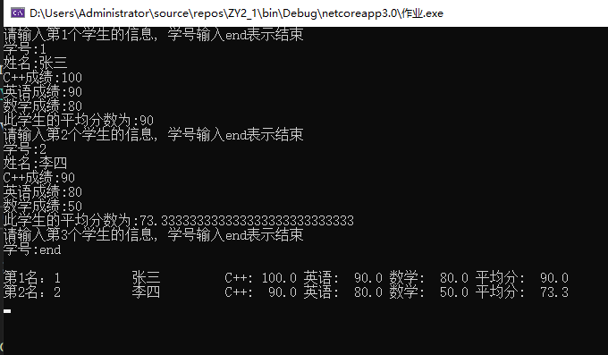

### 题目3

源程序：

using System;

using System.Collections.Generic;

using System.Text;

namespace 作业

{

class ZY3_3

{

static void Main(string[] args)

{

score stu = new score();

Console.WriteLine("请输入一个同学信息:");

stu.init();

Console.WriteLine(" 姓名 学号 C++ 英语 数学");

stu.display();

stu.AVG();

stu.Sum();

Console.Read();

}

}

class score

{

private string name;

private int ID;

private double c;

private double english;

private double math;

public string Name

{ get { return name; } set { name = value; } }

public int id

{ get { return ID; } set { ID = value; } }

public double C

{ get { return c; } set { c = value; } }

public double English

{ get { return english; } set { english = value; } }

public double Math

{ get { return math; } set { math = value; } }

public void init()

{

Console.Write("学号:");

this.ID = Convert.ToInt32(Console.ReadLine());

Console.Write("姓名:");

this.name = Convert.ToString(Console.ReadLine());

Console.Out.Write("c++:");

this.c = Convert.ToDouble(Console.ReadLine());

Console.Write("英语:");

this.english = Convert.ToDouble(Console.ReadLine());

Console.Write("数学:");

this.math = Convert.ToDouble(Console.ReadLine());

}

public void AVG()

{

double avg;

avg = (this.math + this.english + this.c) / 3;

Console.WriteLine("学生的平均成绩:{0}", avg);

}

public void Sum()

{

double sum;

sum = this.math + this.c + this.english;

Console.WriteLine("学生的总成绩:{0}", sum);

}

public void display()

{

Console.WriteLine("{0,5}{1,5}{2,6}{3,6}{4,6}", name, ID, c, english, math);

}

}

}

程序结果如下：

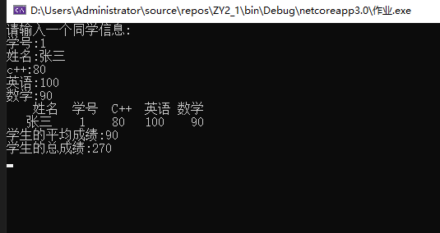

### 题目4

源程序：

using System;

using System.Collections.Generic;

using System.Text;

namespace 作业

{

public class ZY3_4

{

public static void Main()

{

CPoint cp = new CPoint();

cp.Display();

cp.SetPoint(80, 150);

cp.Display();

Console.ReadLine();

}

}

public class CPoint

{

private int x = 60;

private int y = 75;

public CPoint()

{

}

public CPoint(int x, int y)

{

this.x = x;

this.y = y;

}

public void Display()

{

Console.WriteLine("x={0},y={1}", x, y);

}

public void SetPoint(int x, int y)

{

this.x = x;

this.y = y;

}

}

}

程序结果如下：

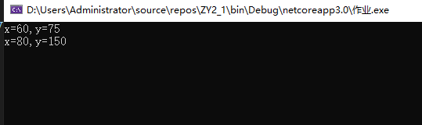

### 题目5

源程序：

using System;

using System.Collections.Generic;

using System.Text;

namespace 作业

{

public class Person

{

public Person() { }

public Person(string _name, int _number, int _age)

{

this.Name = _name;

this.Number = _number;

this.Age = _age;

}

string name; public string Name

{

get { return name; }

set { name = value; }

}

int number; public int Number

{

get { return number; }

set { number = value; }

}

int age; public int Age

{

get { return age; }

set

{

age = value;

}

}

public virtual void SayHi()

{

Console.WriteLine("大家好！我叫{0},今年{1}岁,我的编号是{2}",

Name, Age, Number);

}

}

public class Student : Person

{

public Student() { }

public Student(string _name, int _number, int _age, double _score)

: base(_name, _number, _age)

{

this.Score = _score;

}

double score; public double Score

{

get { return score; }

set { score = value; }

}

public override void SayHi()

{

Console.WriteLine("大家好！我是{0}同学，今年{1}岁,我的编号{2},今天考试的成绩为{3}",

base.Name, base.Age, base.Number, this.Score);

}

}

public class Teacher : Person

{

public Teacher() { }

public Teacher(string _name, int _number, int _age, int _yearsOfService)

: base(_name, _number, _age)

{

this.YearsOfService = _yearsOfService;

}

int yearsOfService; public int YearsOfService

{

get { return yearsOfService; }

set { yearsOfService = value; }

}

public override void SayHi()

{

Console.WriteLine("大家好！我是{0}老师，今年{1}岁,我的编号{2},我工作{3}年了",

base.Name, base.Age, base.Number, this.YearsOfService);

}

}

public class ZY3_5

{

static void Main(string[] args)

{

Person student = new Student("赵", 1, 27, 87.00);

student.SayHi();

Person teacher = new Teacher("黄", 2, 48, 20);

teacher.SayHi();

Console.ReadLine();

}

}

}

程序结果如下：

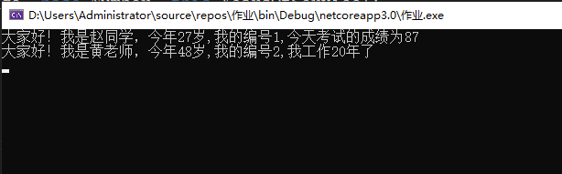

### 题目6

源程序：

using System;

using System.Collections.Generic;

using System.Text;

namespace 作业

{

class ZY3_6

{

static void Main(string[] args)

{

CPoint p1 = new CPoint(8, 4), p2 = new CPoint(3, 3), p3 = new CPoint(1, 2);

Cline cl1 = new Cline();

Cline cl2 = new Cline();

Console.WriteLine("两点间的距离为：{0}", cl1.distance(p1, p2));

cl1.set_length(p1, p2);

cl2.set_length(p1, p3);

CRect cr = new CRect();

Console.WriteLine("矩形的周长为：{0}", cr.perimeter(cl1, cl2));

Console.WriteLine("矩形的面积为：{0}", cr.area(cl1, cl2));

Console.ReadKey();

}

}

class CPoint

{

private double x;

private double y;

public CPoint() { }

public CPoint(double x, double y)

{

this.x = x;

this.y = y;

}

public double get_x()

{

return x;

}

public double get_y()

{

return y;

}

}

class Cline : CPoint

{

public double d;

public Cline() { d = 0; }

public Cline(double d)

{

this.d = d;

}

public double distance(CPoint a, CPoint b)

{

d = Math.Sqrt((a.get_x() - b.get_x()) * (a.get_x() - b.get_x()) + (a.get_y() - b.get_y()) * (a.get_y() - b.get_y()));

return d;

}

public double get_length()

{

return d;

}

public void set_length(CPoint a, CPoint b)

{

d = distance(a, b);

}

}

class CRect : Cline

{

double z;

double m;

public CRect() { }

public CRect(double a, double b)

{

z = a;

m = b;

}

public double perimeter(Cline c1, Cline c2)

{

return z = 2 * (c1.get_length() + c2.get_length());

}

public double area(Cline c1, Cline c2)

{

return m = c1.get_length() * c2.get_length();

}

}

}

程序结果如下：

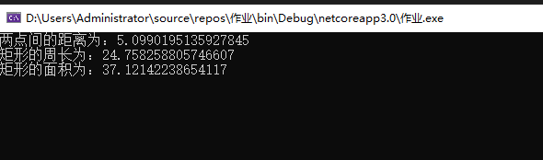

### 题目7

源程序：

using System;

using System.Collections.Generic;

using System.Text;

namespace 作业

{

public class CStrOne

{

protected string m_str1 = string.Empty;

public CStrOne(string str1)

{

this.m_str1 = str1;

}

public void ShowStringOne()

{

Console.WriteLine(m_str1);

}

}

public class CStrTwo : CStrOne

{

private string m_str2 = string.Empty;

public CStrTwo(string str, string str2) : base(str)

{

this.m_str2 = str2;

}

public void ShowStringTwo()

{

Console.WriteLine("{0}{1}", m_str1, m_str2);

}

}

class ZY3_7

{

static void Main(string[] args)

{

CStrOne cs1 = new CStrOne("不喜欢 ");

cs1.ShowStringOne();

CStrTwo cs2 = new CStrTwo("我喜欢", "打篮球");

cs2.ShowStringTwo();

Console.ReadKey();

}

}

}

程序结果如下：  
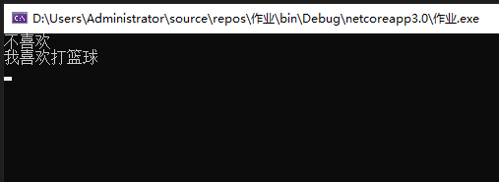

using System;

using System.Collections.Generic;

using System.ComponentModel;

using System.Data;

using System.Drawing;

using System.Linq;

using System.Text;

using System.Threading.Tasks;

using System.Windows.Forms;

namespace Ex7_12

{

public partial class Form1 : Form

{

Graphics g;

Point pStart, pEnd; // 定义画图的起始终点

int ChoiceGraph; // 所选择图形枚举

int penWidth; // 画笔宽度

enum mySelected

{

Pencil, // 铅笔

Line, // 直线

Ellipse, // 空心椭圆

FillEllipse, // 填充椭圆

Rec, // 空心矩形

FillRec, // 填充矩形

Eraser // 橡皮擦

};

public Form1()

{

InitializeComponent();

}

private void Form1_Load(object sender, EventArgs e)

{

g = this.pictureBox1.CreateGraphics();

ChoiceGraph = (int)mySelected.Pencil; // 默认选择为铅笔工具

penWidth = 3; // 初始化画笔宽度

btnControl.BackColor = btnBlack.BackColor; // 默认黑色笔

}

private void btnPencil_Click(object sender, EventArgs e)

{

ChoiceGraph = Convert.ToInt32(((Button)sender).Tag);

}

private void btnLine_Click(object sender, EventArgs e)

{

ChoiceGraph = Convert.ToInt32(((Button)sender).Tag);

}

private void btnEllipse_Click(object sender, EventArgs e)

{

ChoiceGraph = Convert.ToInt32(((Button)sender).Tag);

}

private void btnFillEllipse_Click(object sender, EventArgs e)

{

ChoiceGraph = Convert.ToInt32(((Button)sender).Tag);

}

private void btnRec_Click(object sender, EventArgs e)

{

ChoiceGraph = Convert.ToInt32(((Button)sender).Tag);

}

private void btnFillRec_Click(object sender, EventArgs e)

{

ChoiceGraph = Convert.ToInt32(((Button)sender).Tag);

}

private void btnEraser_Click(object sender, EventArgs e)

{

ChoiceGraph = Convert.ToInt32(((Button)sender).Tag);

}

private void btnLine1_Click(object sender, EventArgs e)

{

//把所有按钮的背景色都设为 White

btnLine1.BackColor = Color.White;

btnLine2.BackColor = Color.White;

btnLine3.BackColor = Color.White;

btnLine4.BackColor = Color.White;

btnLine5.BackColor = Color.White;

((Button)sender).BackColor = Color.Black; // 选中的按钮背景色为黑色

penWidth = Convert.ToInt32(((Button)sender).Tag); // 将宽度按钮的 Tag 值设为画笔宽度

}

private void button11_Click(object sender, EventArgs e)

{

//把所有按钮的背景色都设为 White

btnLine1.BackColor = Color.White;

btnLine2.BackColor = Color.White;

btnLine3.BackColor = Color.White;

btnLine4.BackColor = Color.White;

btnLine5.BackColor = Color.White;

((Button)sender).BackColor = Color.Black; // 选中的按钮背景色为黑色

penWidth = Convert.ToInt32(((Button)sender).Tag); // 将宽度按钮的 Tag 值设为画笔宽度

}

private void button12_Click(object sender, EventArgs e)

{

//把所有按钮的背景色都设为 White

btnLine1.BackColor = Color.White;

btnLine2.BackColor = Color.White;

btnLine3.BackColor = Color.White;

btnLine4.BackColor = Color.White;

btnLine5.BackColor = Color.White;

((Button)sender).BackColor = Color.Black; // 选中的按钮背景色为黑色

penWidth = Convert.ToInt32(((Button)sender).Tag); // 将宽度按钮的 Tag 值设为画笔宽度

}

private void btnLine4_Click(object sender, EventArgs e)

{

//把所有按钮的背景色都设为 White

btnLine1.BackColor = Color.White;

btnLine2.BackColor = Color.White;

btnLine3.BackColor = Color.White;

btnLine4.BackColor = Color.White;

btnLine5.BackColor = Color.White;

((Button)sender).BackColor = Color.Black; // 选中的按钮背景色为黑色

penWidth = Convert.ToInt32(((Button)sender).Tag); // 将宽度按钮的 Tag 值设为画笔宽度

}

private void btnLine5_Click(object sender, EventArgs e)

{

//把所有按钮的背景色都设为 White

btnLine1.BackColor = Color.White;

btnLine2.BackColor = Color.White;

btnLine3.BackColor = Color.White;

btnLine4.BackColor = Color.White;

btnLine5.BackColor = Color.White;

((Button)sender).BackColor = Color.Black; // 选中的按钮背景色为黑色

penWidth = Convert.ToInt32(((Button)sender).Tag); // 将宽度按钮的 Tag 值设为画笔宽度

}

private void btnControl_Click(object sender, EventArgs e)

{

if (((Button)sender).Text == "C")

{

if (colorDialog1.ShowDialog() == DialogResult.OK)

{

btnControl.BackColor = colorDialog1.Color;

}

}

else

{

btnControl.BackColor = ((Button)sender).BackColor;

}

}

private void btnRed_Click(object sender, EventArgs e)

{

if (((Button)sender).Text == "C")

{

if (colorDialog1.ShowDialog() == DialogResult.OK)

{

btnControl.BackColor = colorDialog1.Color;

}

}

else

{

btnControl.BackColor = ((Button)sender).BackColor;

}

}

private void btnYellow_Click(object sender, EventArgs e)

{

if (((Button)sender).Text == "C")

{

if (colorDialog1.ShowDialog() == DialogResult.OK)

{

btnControl.BackColor = colorDialog1.Color;

}

}

else

{

btnControl.BackColor = ((Button)sender).BackColor;

}

}

private void btnGreen_Click(object sender, EventArgs e)

{

if (((Button)sender).Text == "C")

{

if (colorDialog1.ShowDialog() == DialogResult.OK)

{

btnControl.BackColor = colorDialog1.Color;

}

}

else

{

btnControl.BackColor = ((Button)sender).BackColor;

}

}

private void btnPink_Click(object sender, EventArgs e)

{

if (((Button)sender).Text == "C")

{

if (colorDialog1.ShowDialog() == DialogResult.OK)

{

btnControl.BackColor = colorDialog1.Color;

}

}

else

{

btnControl.BackColor = ((Button)sender).BackColor;

}

}

private void btnPurple_Click(object sender, EventArgs e)

{

if (((Button)sender).Text == "C")

{

if (colorDialog1.ShowDialog() == DialogResult.OK)

{

btnControl.BackColor = colorDialog1.Color;

}

}

else

{

btnControl.BackColor = ((Button)sender).BackColor;

}

}

private void btnBlack_Click(object sender, EventArgs e)

{

if (((Button)sender).Text == "C")

{

if (colorDialog1.ShowDialog() == DialogResult.OK)

{

btnControl.BackColor = colorDialog1.Color;

}

}

else

{

btnControl.BackColor = ((Button)sender).BackColor;

}

}

private void pictureBox1_MouseMove(object sender, MouseEventArgs e)

{

toolStripStatusLabel1.Text = "X:" + e.X.ToString() + ",Y:" + e.Y.ToString();

if (e.Button == MouseButtons.Left)

{

switch (ChoiceGraph)

{

case (int)mySelected.Pencil: // 选择的是铅笔

Pen pen1 = new Pen(btnControl.BackColor, penWidth);

pEnd.X = e.X;

pEnd.Y = e.Y;

g.DrawLine(pen1, pStart, pEnd);

pStart = pEnd; // 将已经绘制的终点作为下一次绘制的起点

break;

case (int)mySelected.Eraser:

Pen pen2 = new Pen(Color.White, penWidth); // 定义白色画笔作为擦除效果

pEnd.X = e.X;

pEnd.Y = e.Y;

g.DrawLine(pen2, pStart, pEnd);

pStart = pEnd; // 将已经绘制的终点作为下一次绘制的起点

break;

default:

break;

}

}

}

private void pictureBox1_MouseDown(object sender, MouseEventArgs e)

{

if (e.Button == MouseButtons.Left) // 如果单击鼠标左键，则将当前点坐标赋给起始点

{

pStart.X = e.X;

pStart.Y = e.Y;

}

}

private void pictureBox1_MouseUp(object sender, MouseEventArgs e)

{

if (e.Button == MouseButtons.Left) // 如果用户按下的是鼠标左键，记录终点坐标

{

pEnd.X = e.X;

pEnd.Y = e.Y;

switch (ChoiceGraph)

{

case (int)mySelected.Line: // 如果选择的是直线

Pen pen1 = new Pen(btnControl.BackColor, penWidth);

g.DrawLine(pen1, pStart, pEnd);

break;

case (int)mySelected.Ellipse: // 如果选择的是空心椭圆

Change_Point();

Pen pen2 = new Pen(btnControl.BackColor, penWidth);

g.DrawEllipse(pen2, pStart.X, pStart.Y, pEnd.X - pStart.X, pEnd.Y - pStart.Y);

break;

case (int)mySelected.FillEllipse: // 如果选择的是实心椭圆

Change_Point();

SolidBrush myBrush1 = new SolidBrush(btnControl.BackColor);

Rectangle rec1 = new Rectangle(pStart.X, pStart.Y, pEnd.X - pStart.X, pEnd.Y - pStart.Y);

g.FillEllipse(myBrush1, rec1);

break;

case (int)mySelected.Rec: // 如果选择的是矩形

Change_Point();

Pen pen3 = new Pen(btnControl.BackColor, penWidth);

g.DrawRectangle(pen3, pStart.X, pStart.Y, pEnd.X - pStart.X, pEnd.Y - pStart.Y);

break;

case (int)mySelected.FillRec: // 如果选择的是实心矩形

Change_Point();

SolidBrush myBrush2 = new SolidBrush(btnControl.BackColor);

Rectangle rec2 = new Rectangle(pStart.X, pStart.Y, pEnd.X - pStart.X, pEnd.Y - pStart.Y);

g.FillRectangle(myBrush2, rec2);

break;

default:

break;

}

}

}

private void button8_Click(object sender, EventArgs e)

{

pictureBox1.Refresh(); // 刷新

}

private void Exit_Click(object sender, EventArgs e)

{

this.Close();

}

private void Change_Point()

{

Point pTemp = new Point(); // 定义临时点

if (pStart.X < pEnd.X)

{

if (pStart.Y > pEnd.Y)

{

pTemp.Y = pStart.Y;

pStart.Y = pEnd.Y;

pEnd.Y = pTemp.Y;

}

}

if (pStart.X > pEnd.X)

{

if (pStart.Y < pEnd.Y)

{

pTemp.X = pStart.X;

pStart.X = pEnd.X;

pEnd.X = pTemp.X;

}

if (pStart.Y > pEnd.Y)

{

pTemp = pStart;

pStart = pEnd;

pEnd = pTemp;

}

}

}

private void pictureBox1_Click(object sender, EventArgs e)

{

}

}

}

