Design Document: Cmput 291 Group Project 1
Contributors: Dai Dao, Matteo MacKinnon, Mitchell Messerschmidt

User Guide Overview:

The python files contained within our program are as follows: userauthen.py, admin.py, db_utility.py, doctor.py, nurse.py. Userauthen.py handles the start of the program with a user log-in screen, which helps to verify which user is logging in and prevents anyone else from accessing the database by checking against the database for users that are in the database and protects it against sql injections by checking if the user entered a certain set of characters. Once the user is signed in they are given their own set of commands that their roles should handle.
The roles of the database are handled by their respective Python files which the userauthen.py starts upon logging in. Admin.py handles all the roles of an administrator for the database, which also includes adding a new user to the database. Doctor.py handles the roles of the doctors in the database and the nurse.py handles all of the roles that the nurse has in the database.
db_utility.py is a helper file that allows the output of the data on to the screen to follow a format that is easy to follow and is consistent throughout the data base queries. See figure 1 for a higher level interpretation.
Figure 1. (left) Higher level diagram.

Shows that the nurse, doctor and admin classes are started from the userauthen class. The db_utility is an interface in which the userauthen implements and userauthen is also associated with the database.
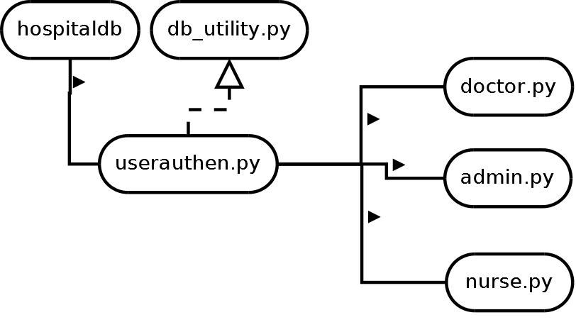

Our testing strategy involved the use of functional testing by which we worked through the code base one query at a time that followed the users role, much like following a user story or following a use case for the roles in the database. Upon each finished use case we fixed any issues along the way that prevented the user role from going from start to finish. Most bugs in our system involved user entering the wrong date or fixing up the code after trying to make the whole program loop until the user exits, signs out or enters the data wrong to be entered. Before implementation of the queries in python we tested them out on a database using sqlite to be sure that they called what they were supposed to. After the correct output was observed we merged in into our python code base and tested it again.

Group Work Strategy:

Dai Dao: Worked on the code base for the doctor, nurse and administrator roles. Also built the db_utility to help present the data from the database. Also general bug fixing. Estimated time of work: 7 hours

Matteo MacKinnon: Made up the data for the project, date time function, worked on some of the administrator code base, fixed code to handle errors and general testing for all the roles, added log outs to all roles. Estimated time of work: 6 hours

Mitchell Messerschmidt: Worked on the userauthen to log into the database, helped build part of the code base for the administrator role, general bug testing and fixing for all the roles. Estimated time of work: 7 hours

ALL USERS HAD A PART IN DETERMINING THE QUERIES

