Table of contents

I. Architecture & Set-up environment 2

Architecture 2

Tools 2

High level solution 3

Steps to run 3

II. Database 6

III. Results 8

[Get] – Products 8

[Get] – Product/{id} 10

[Post] – Products 11

[Delete] – Products 11

[Put] – Products/{id} 12

IV. Unit Test 13

Structure 13

Result 13

Temporary DB in memory 14

Assessment for **Simpson Strong-Tie Vietnam**

1. **Architecture & Set-up environment**

Architecture: base micro-services, DDD pattern, reference(s):

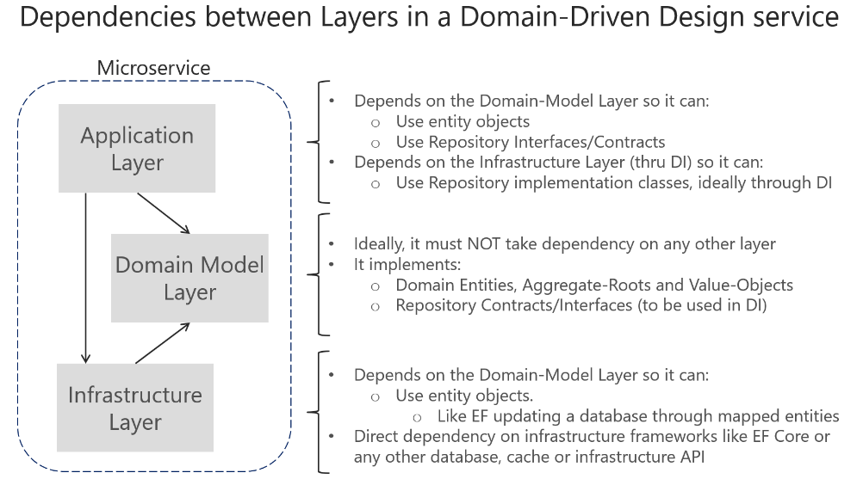

Reference [here](https://docs.microsoft.com/en-us/dotnet/architecture/microservices/microservice-ddd-cqrs-patterns/ddd-oriented-microservice)

Tools:

Visual Studio 2022, .net 6.0

SQL Server V18.9.1

Framework: ABP framework (Installation instruction(s) [here](https://docs.abp.io/en/abp/4.4/Tutorials/Todo/Index?UI=MVC&DB=EF)), reference [here](https://docs.abp.io/en/abp/4.4/Microservice-Architecture)

Source: <https://github.com/nghiaphantrong/Assessment>

High level solution

D

**Docker**

Authentication Server

Internal Gateway

Identity Service

Event Bus (Rabbit MQ)

Product Service

Tenant Service

Product Website

Product Website Gateway

AlasticSearch

Redis

Steps to run

**Step 1:** Open solution with visual studio 2022

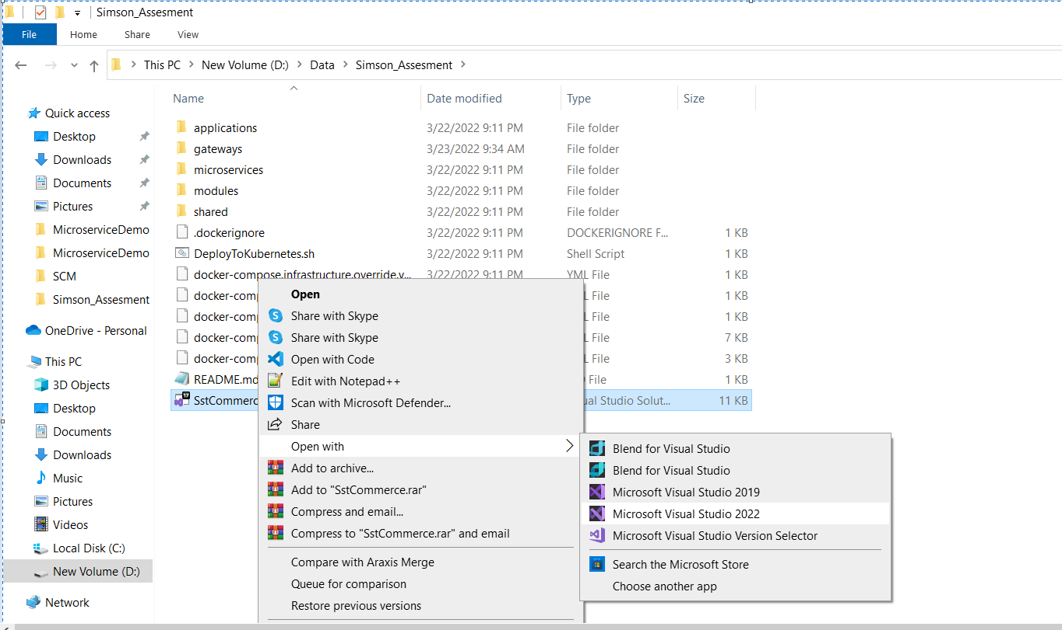

**Step 2:** Configure **AuthServer.Host** and **ProductService.Host**

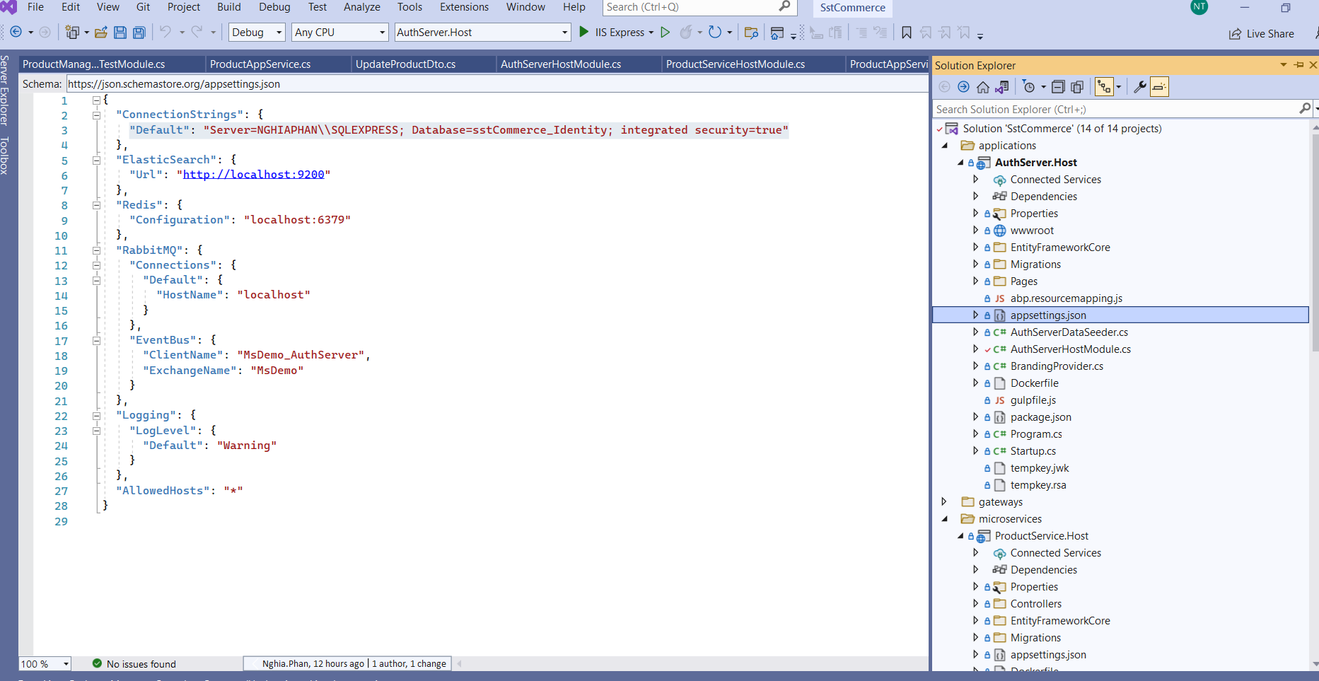

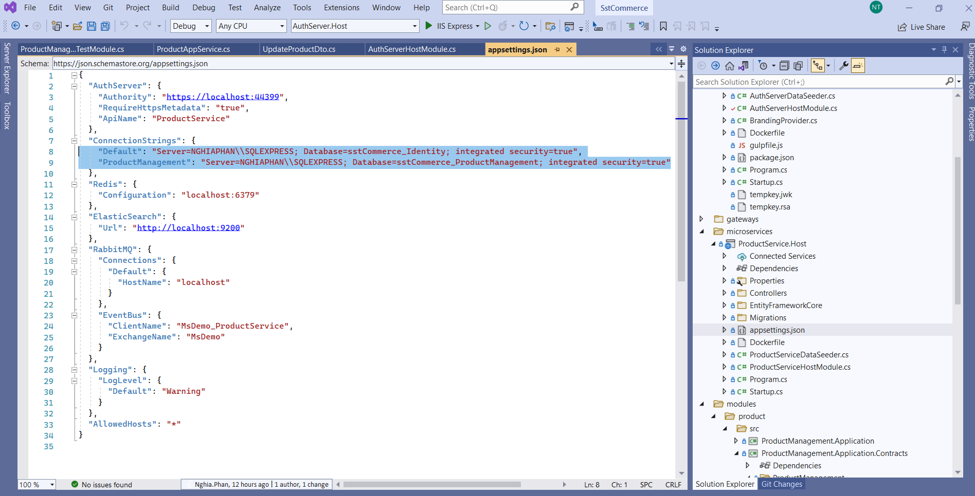

**Step 3:** Update migration **AuthServer.Host** and **ProductService.Host**

**Step 3.1**: **Set As Startup Project** for **AuthServer.Host** => Open **Package Management Console** => Types command: **update-database**

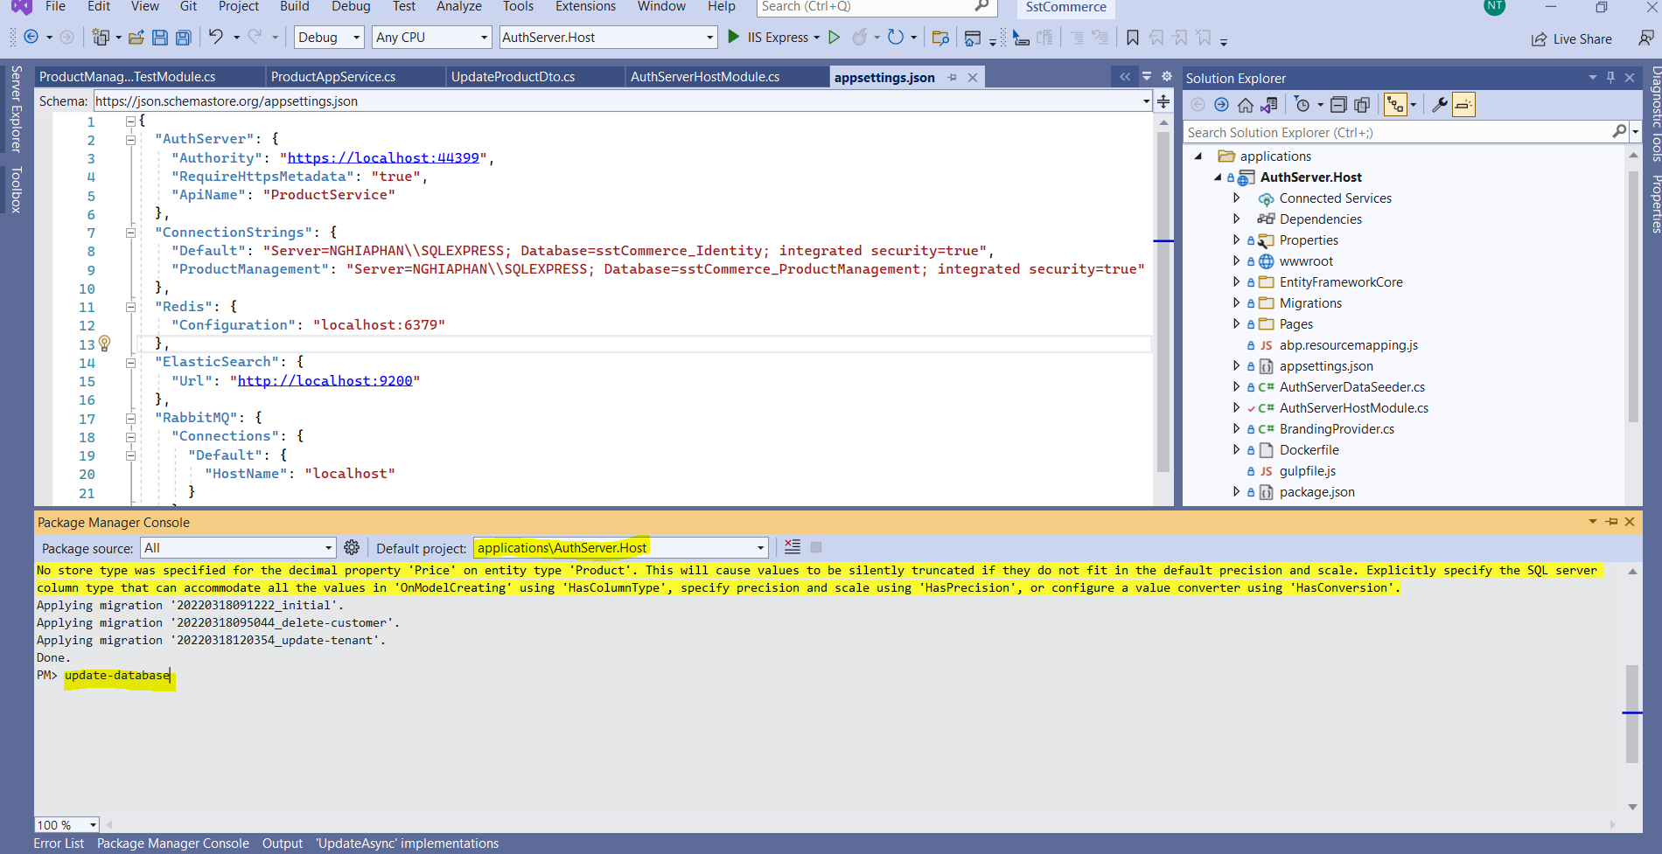

**Step 3.2**: Similar as above for **ProductService.Host**

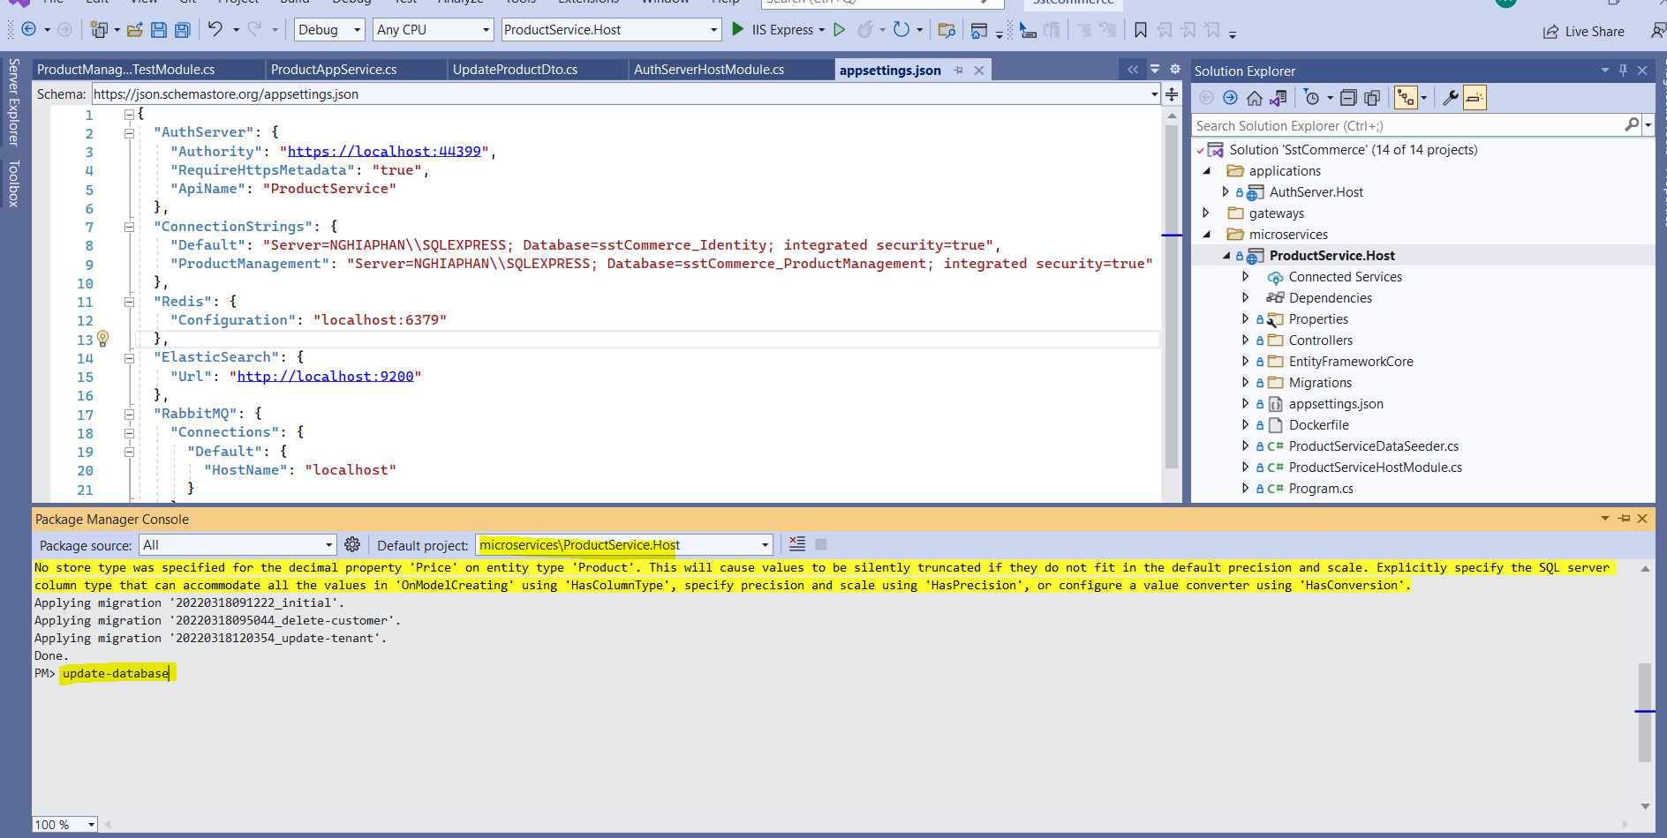

**Step 4:** Data seed for **AuthServer.Host** & **ProductService.Host**

**Set As Startup Project** for **AuthServer.Host => Run (Ctrn + F5)**

**Set As Startup Project** for **ProductService.Host => Run (Ctrn + F5)**

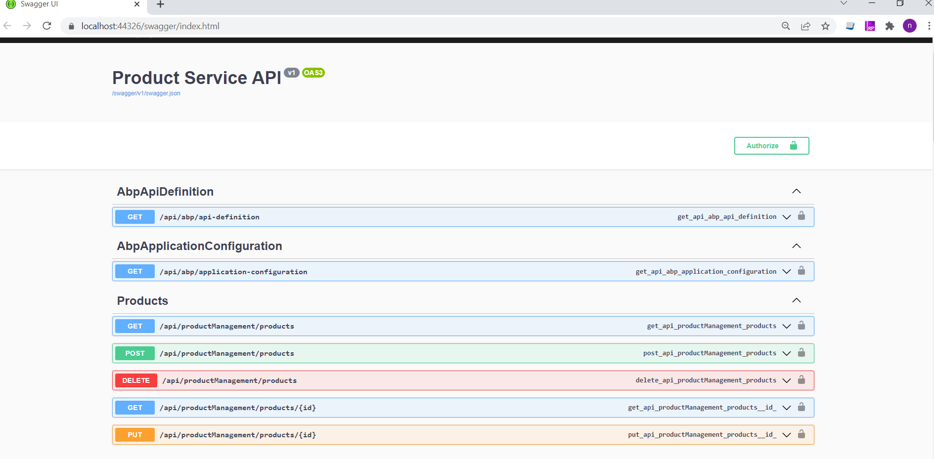

1. **Database**

Because this is micro-service architecture, User & Product store in separate database(s), this is multi-tenant architecture

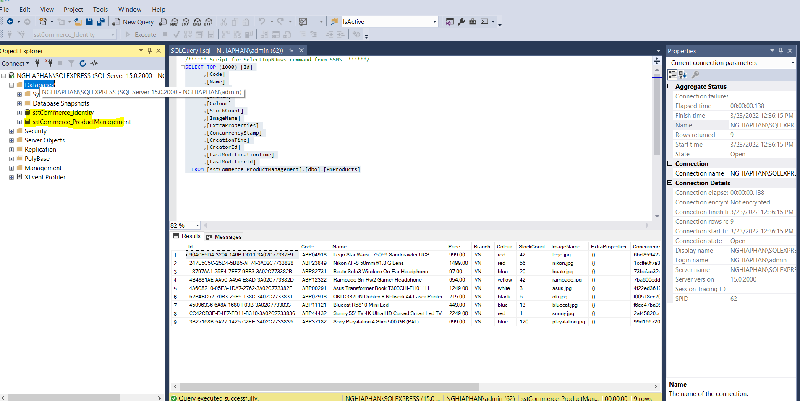

A simple diagram

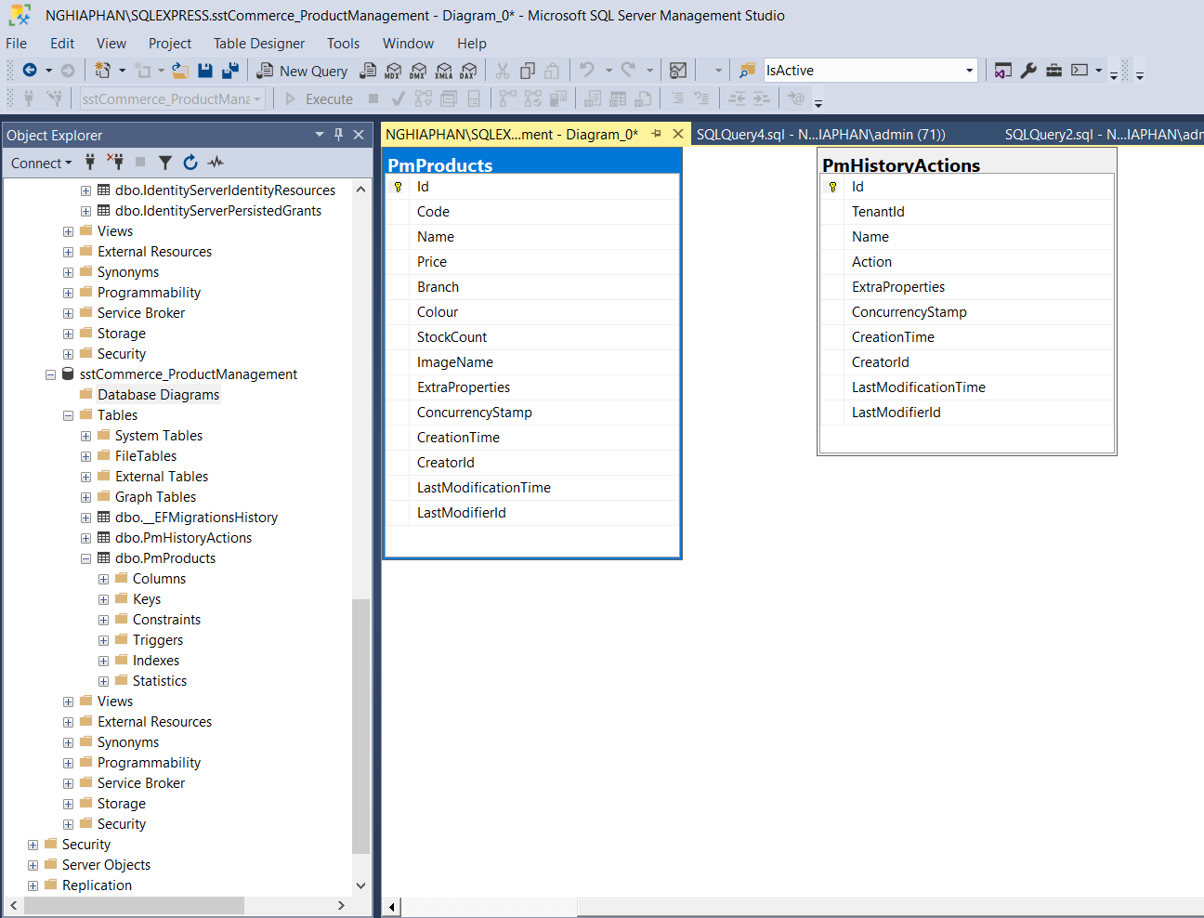

1. **Results**

This assessment is only API for product, not authorization & authorize

This is CRUP API

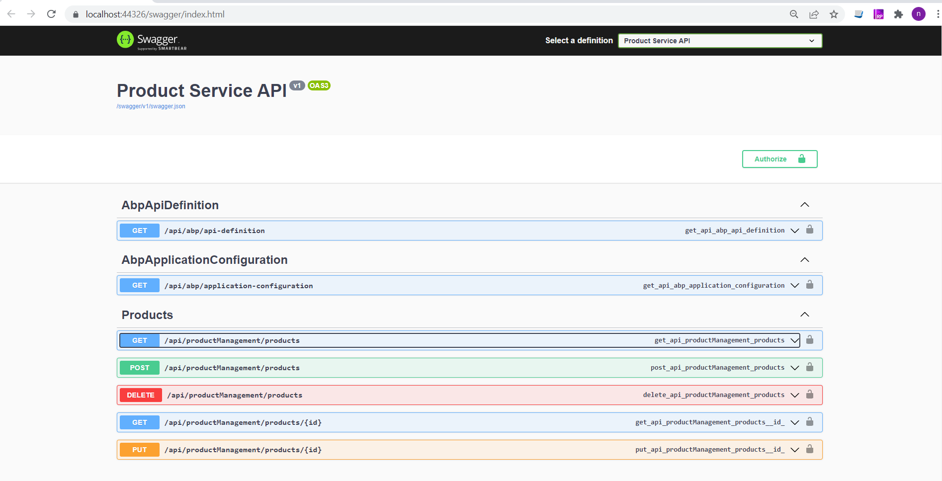

[Get] – Products: Get products based on parameters (Name, Branch, Price), Pagging & Sorting

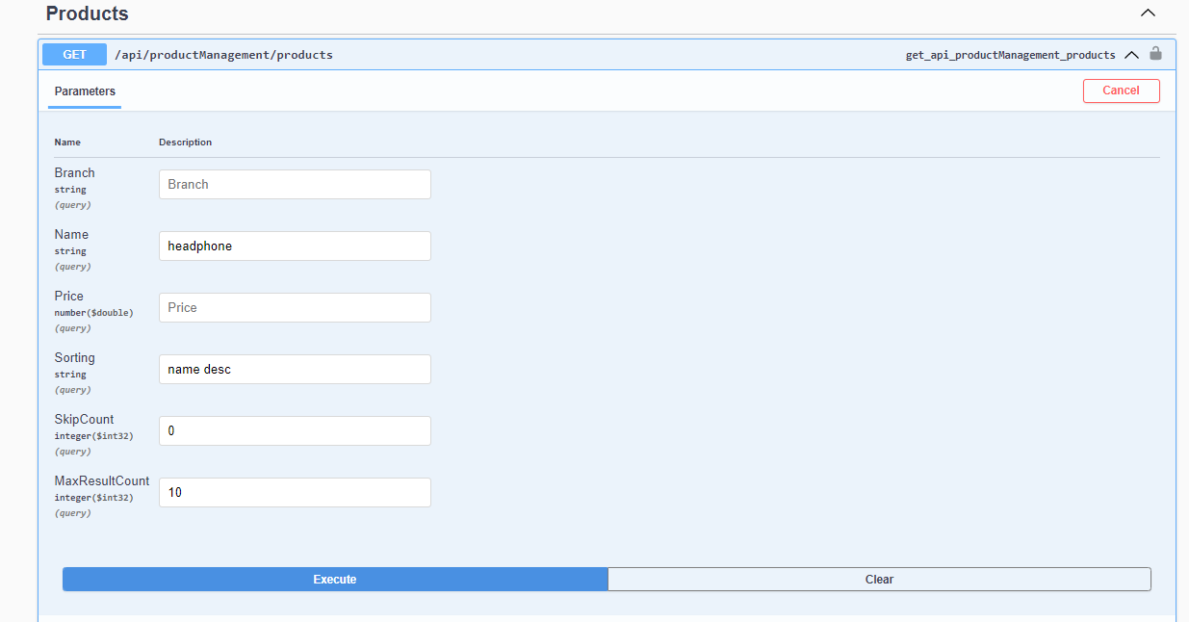

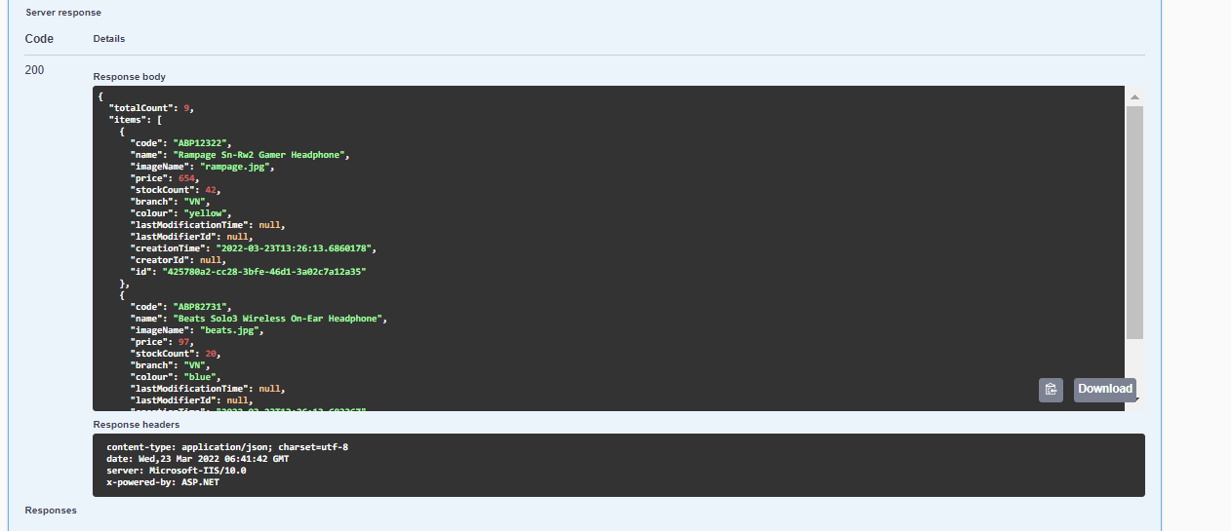

* Parameters(s) are stored in table **PmHistoryActions**

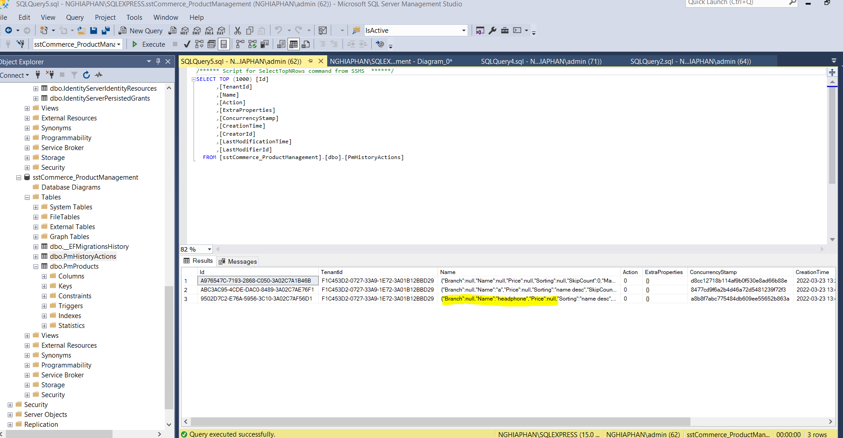

[Get] – Product/{id}: Get product based on id

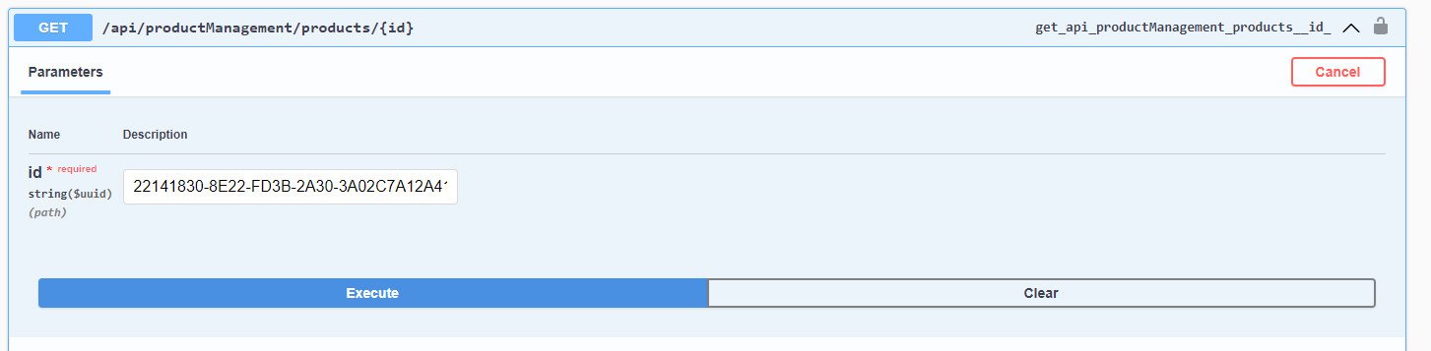

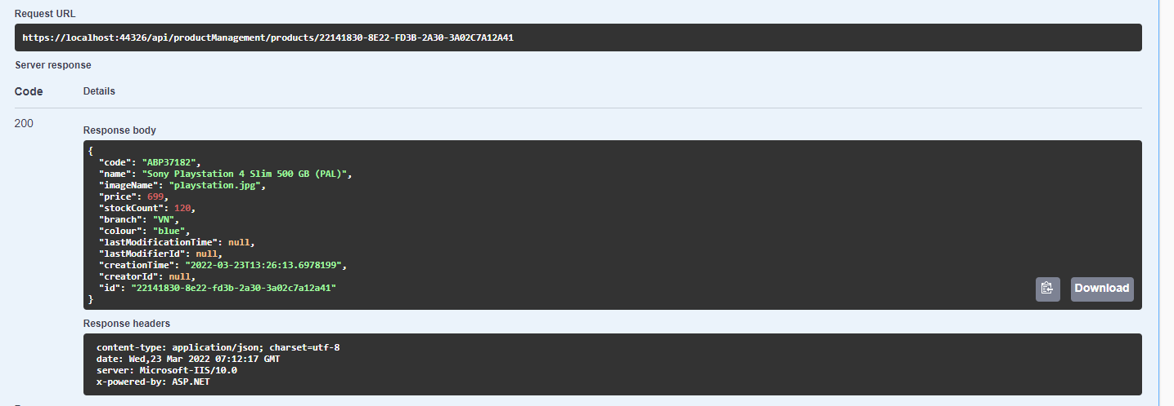

[Post] – Products: Create product with entry product DTO

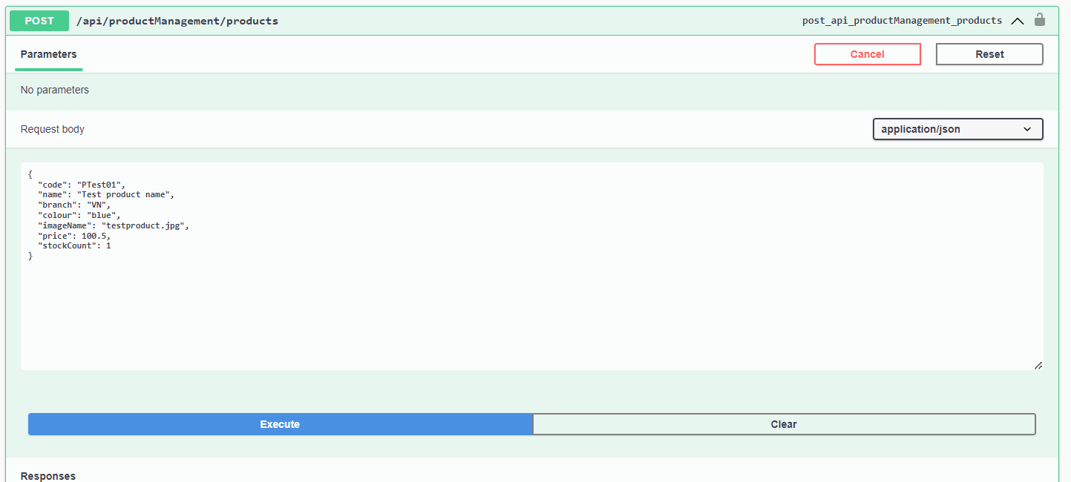

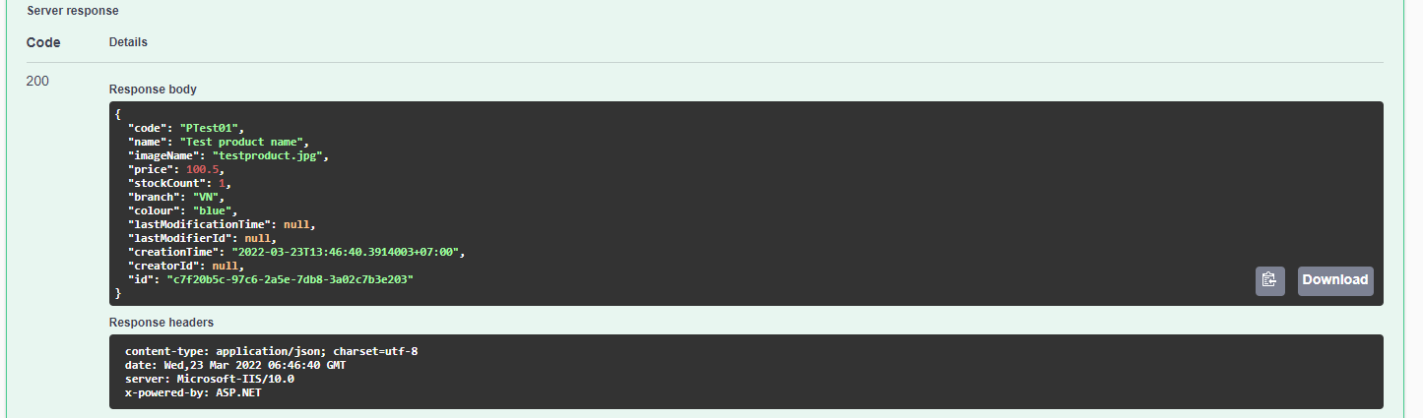

[Delete] – Products: Delete a product with id

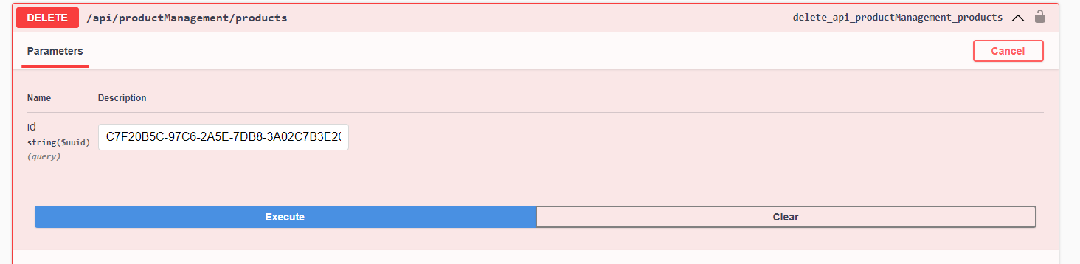

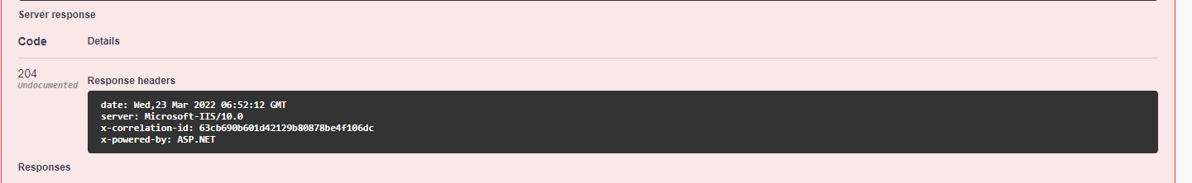

[Put] – Products/{id}: Update a product with id & product entry DTO

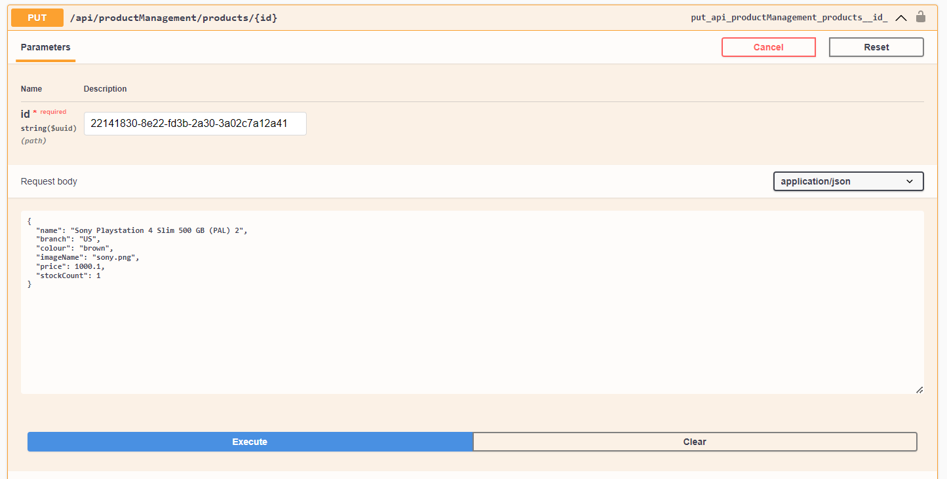

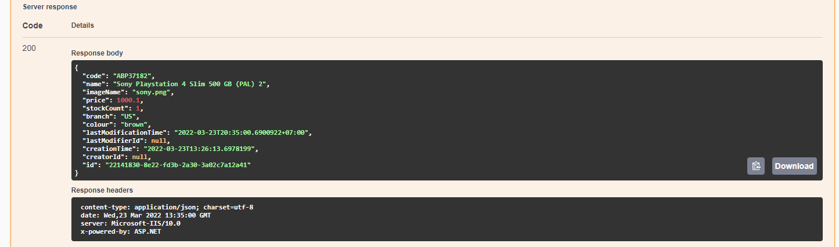

1. **Unit Test**

Using X-Unit for testing

Structure

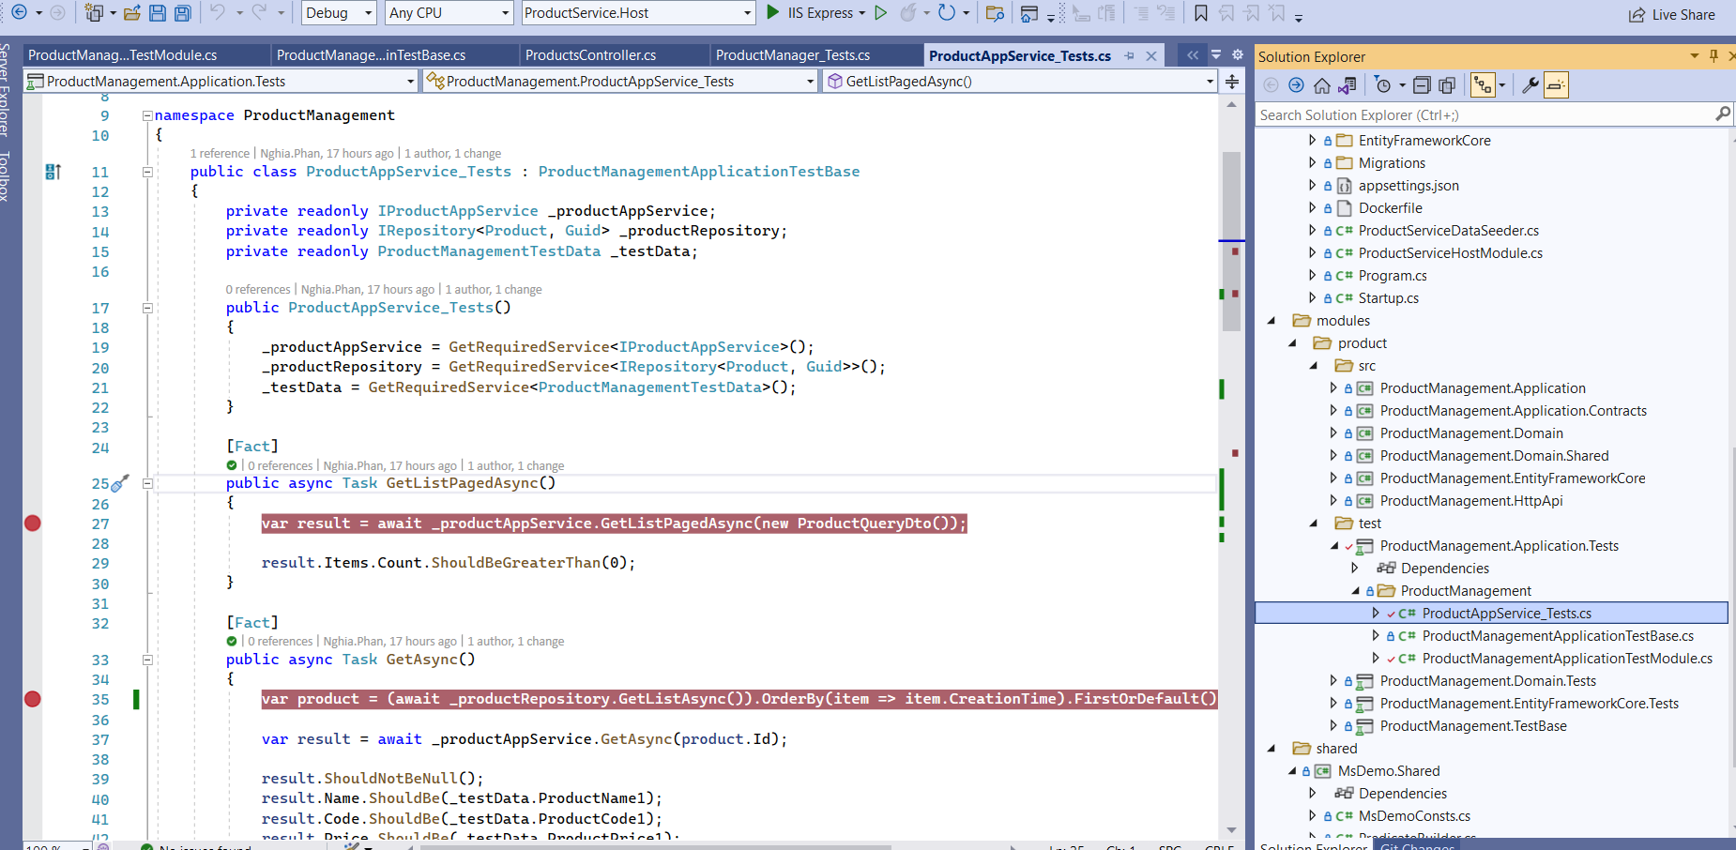

Result

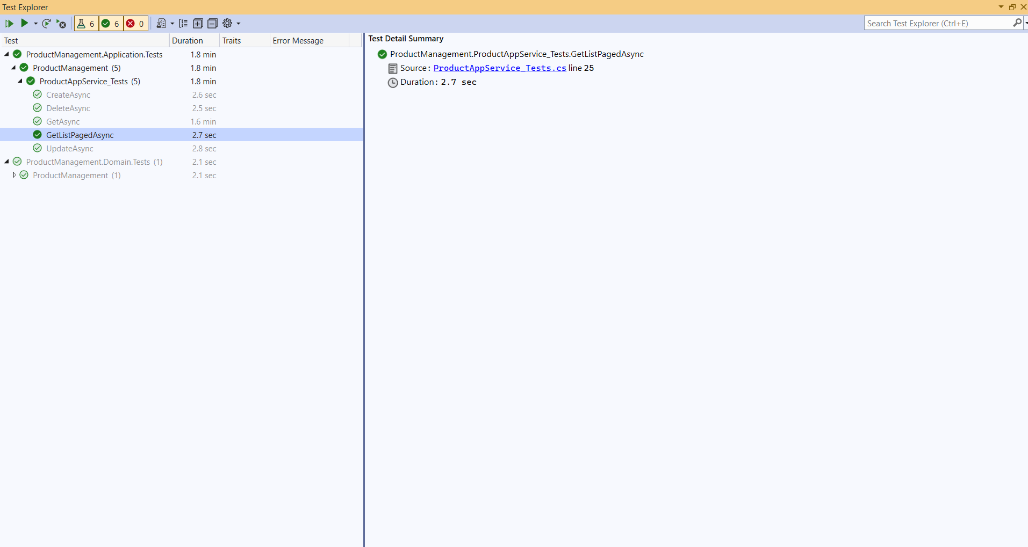

Temporary DB in memory

