**4.1 实验目的**

加深对于操作系统设备管理技术的了解，体验磁盘移臂调度算法的重要性；掌握几种重要的磁盘移臂调度算法，练习模拟算法的编程技巧，锻炼研究分析试验数据的能力。

**4.2 实验说明**

1. 示例实验程序中模拟两种磁盘移臂调度算法：SSTF算法和SCAN算法

2. 能对两种算法给定任意序列不同的磁盘请求序列，显示响应磁盘请求的过程。

3. 能统计和报告不同算法情况下响应请求的顺序、移臂的总量。

# 实验结果

1. 初始界面

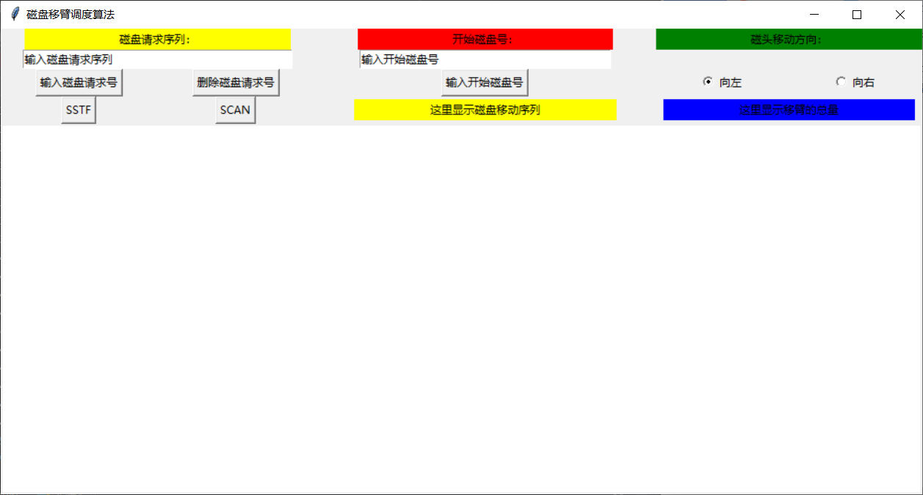

1. 输入磁盘请求序列（可以单个输入，也可以按照[1,2,3,4]形式输入，英文逗号，输入除了数字外的其他字符自动略过）

输入单个数字

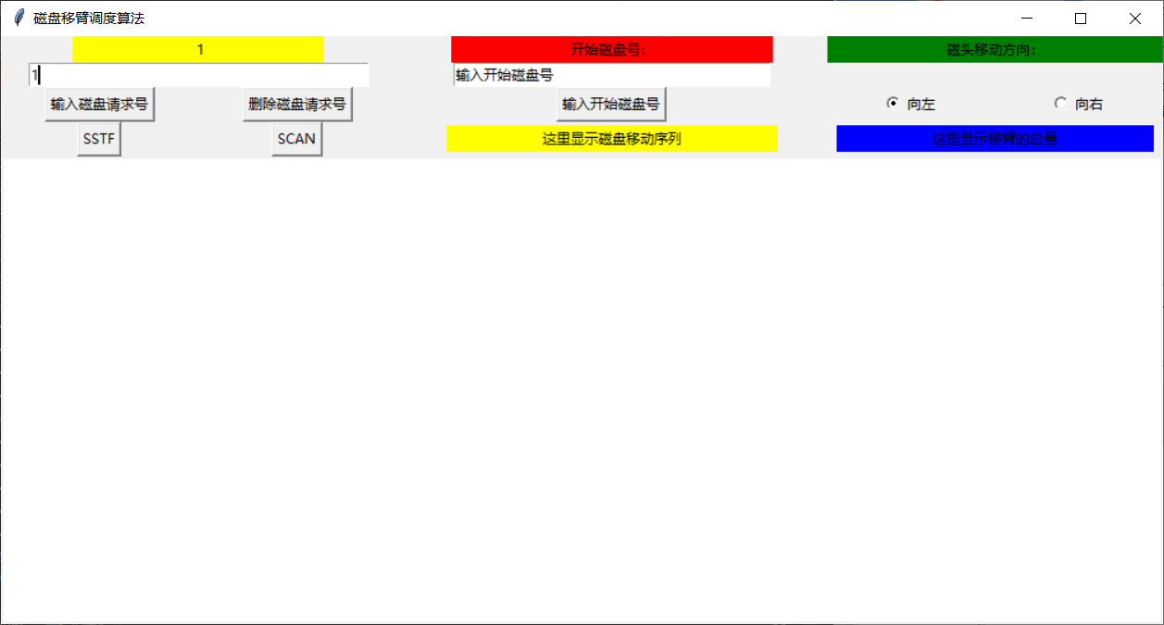

输入序列

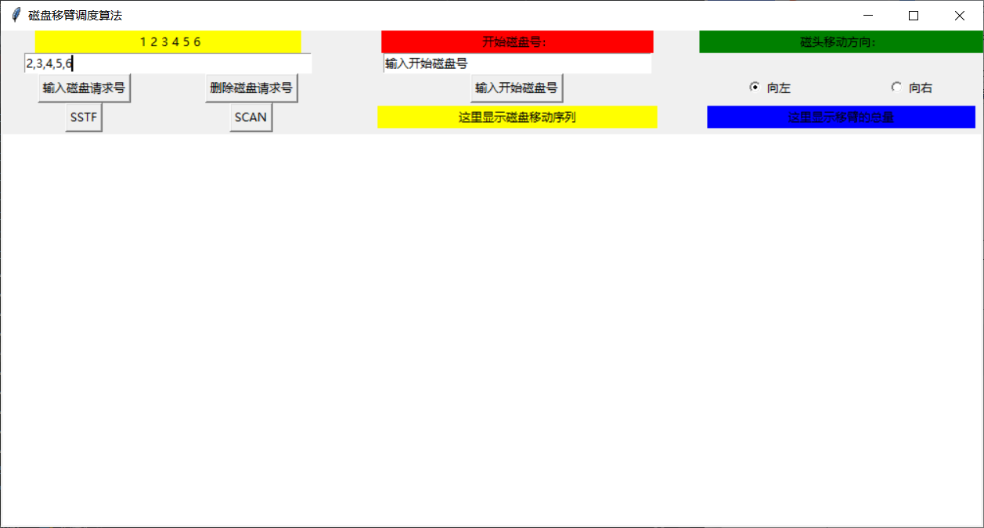

输入除了数字外的其他字符，无反应

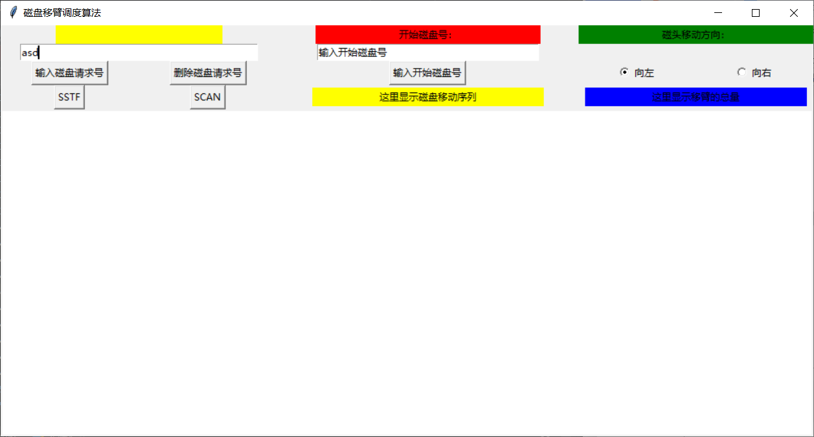

1. 删除磁盘请求号

单击，可以看到磁盘号6被删除

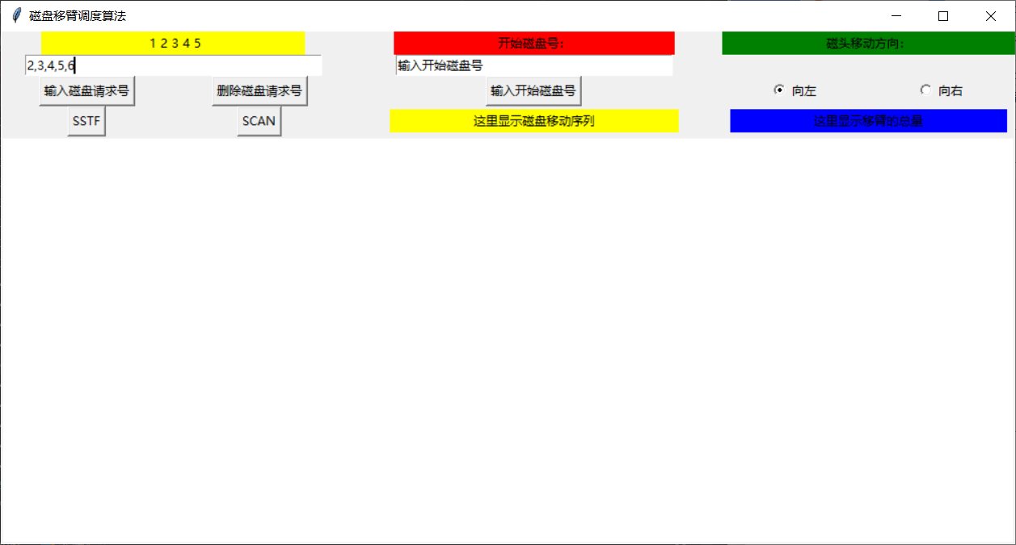

当全部删除时，显示默认文字“输入磁盘请求序列”

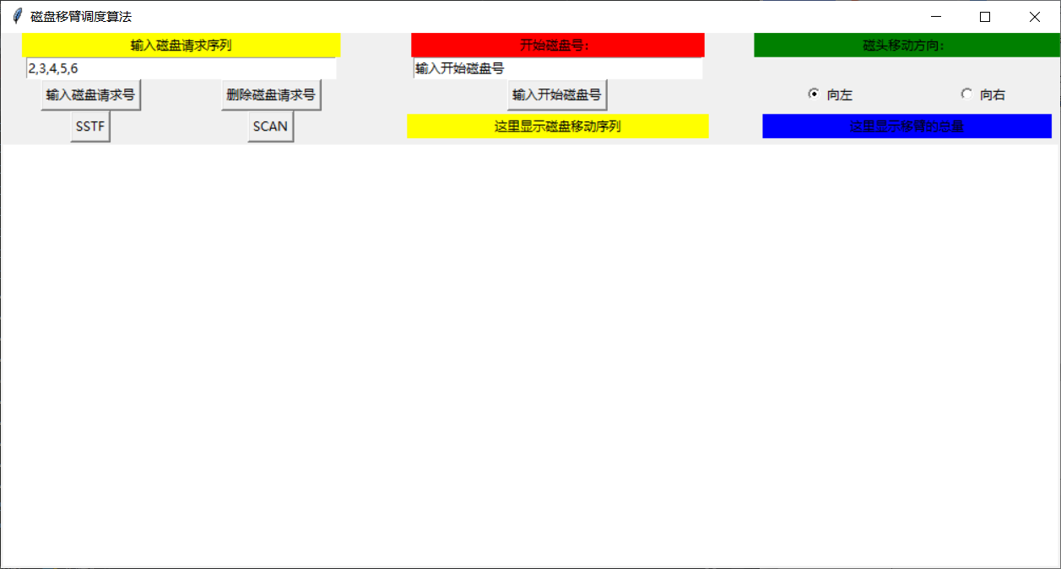

1. 输入开始磁盘号，默认为0，输入除了数字外的其他字符无效

输入200，显示“开始序号：200”

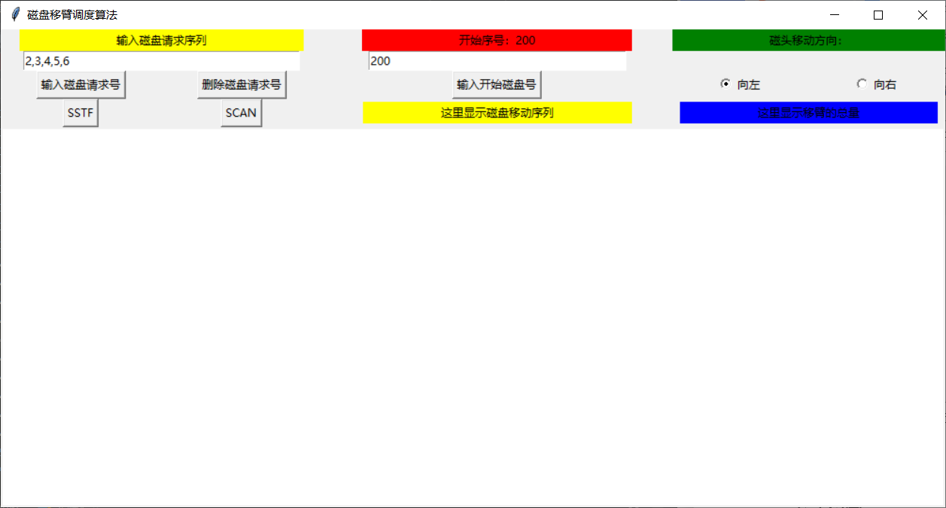

1. 设置磁头移动方向，默认向左（数字变小方向）

点击“向右”，显示“数字变大方向”

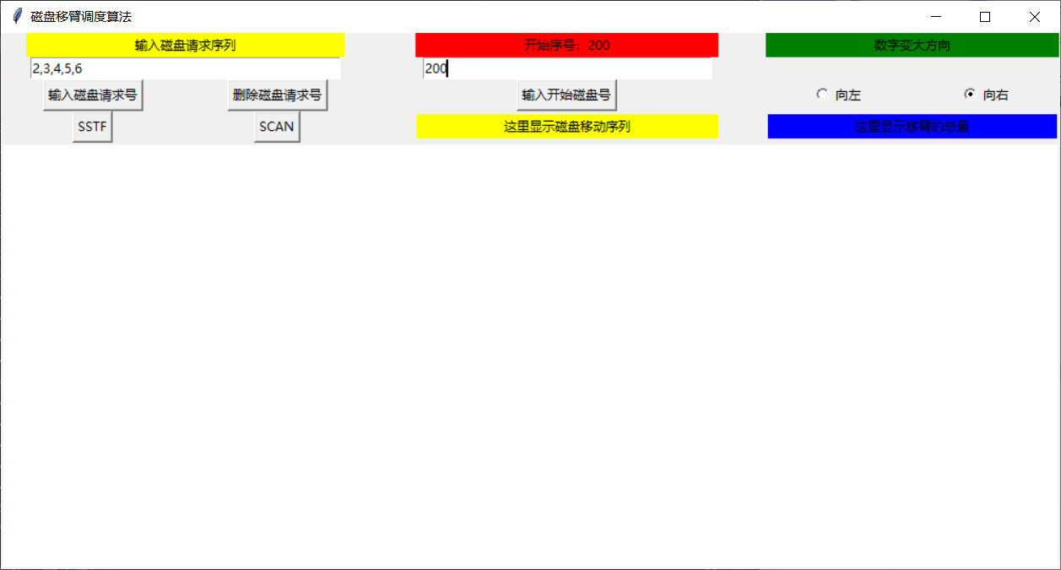

1. 点击SSTF或SCAN，显示算法实施过程，圆圈表示开始序号

当数字相离太近，自动左右移动，如3839

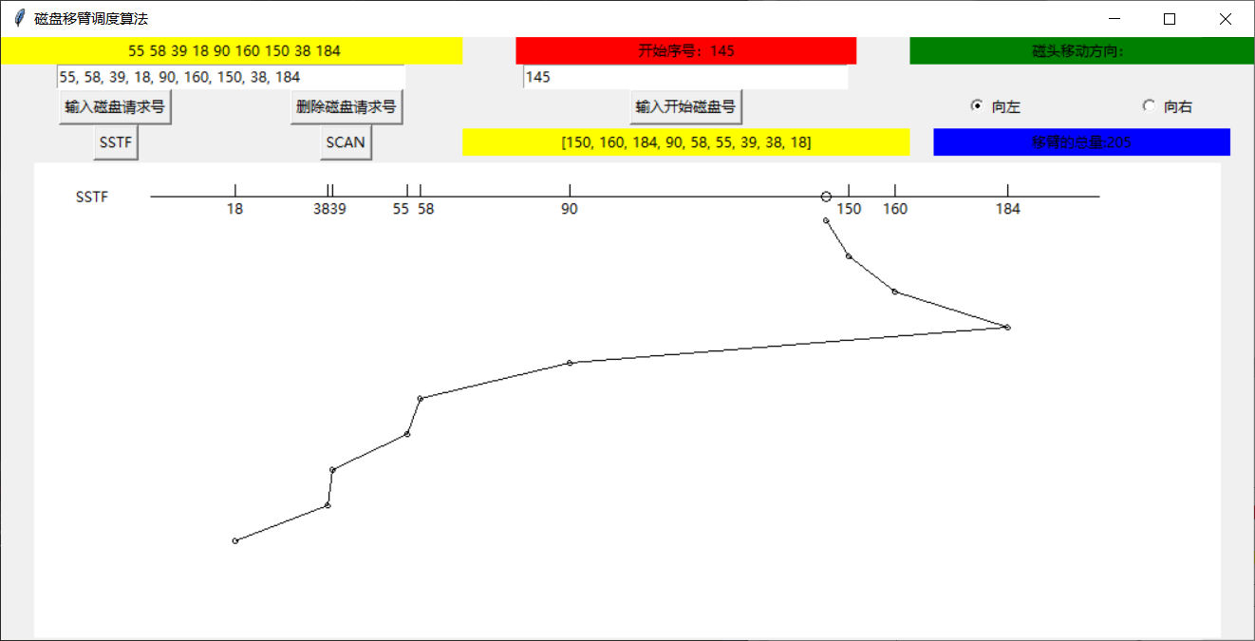

当请求磁盘号过长或开始磁盘号过大，自动调整比例

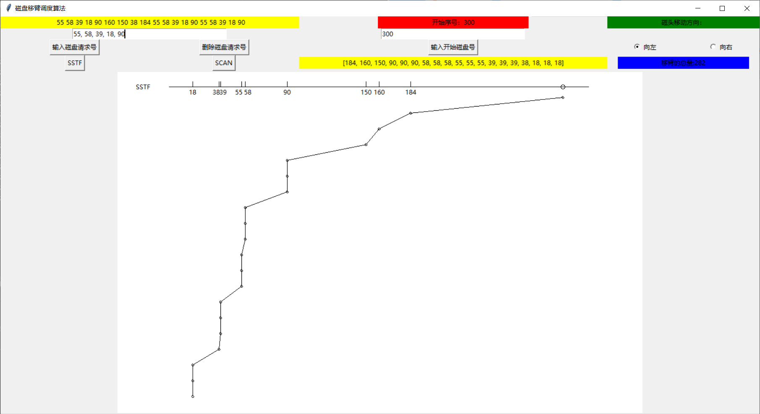

1. 结果展示

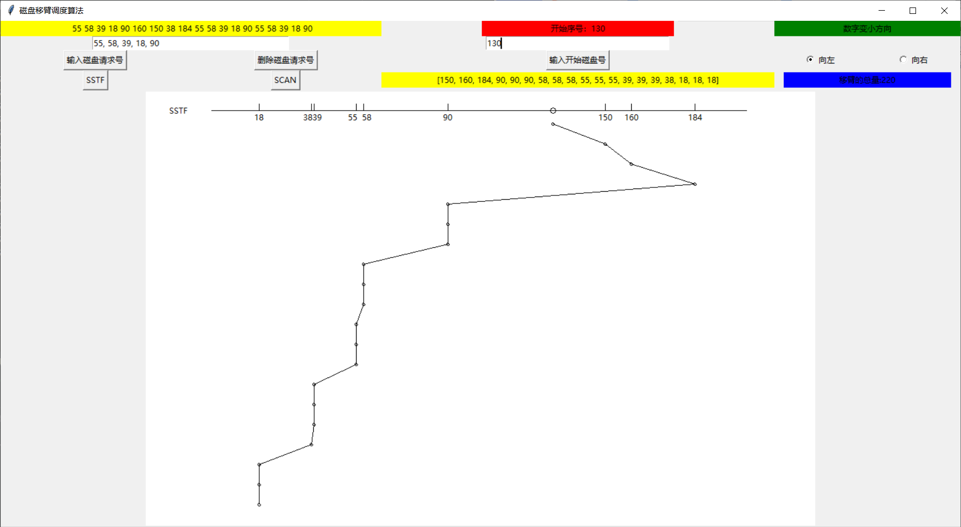

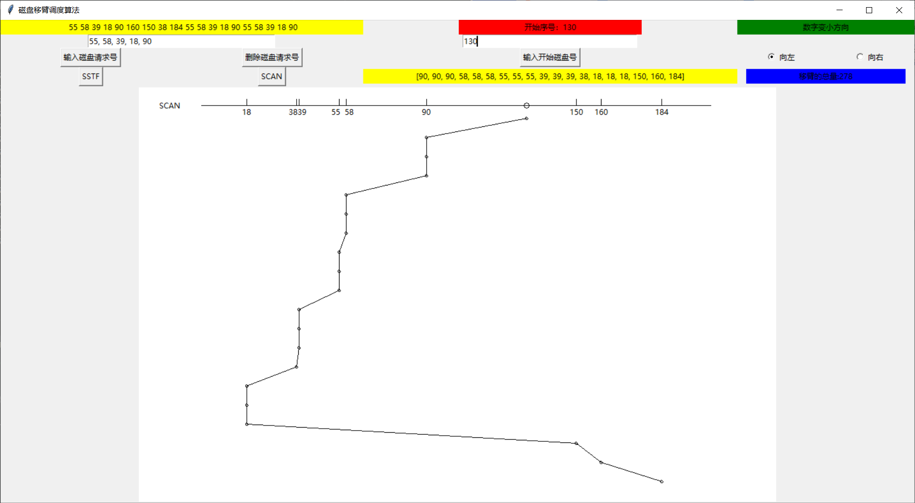

# 代码

（python3.7）

*from* tkinter *import* *  
*import* tkinter.font *as* tf  
  
*def* is_number(*s*):  
 *try*:  
 float(*s*)  
 *return True  
 except* ValueError:  
 *pass  
 try*:  
 *import* unicodedata  
 unicodedata.numeric(*s*)  
 *return True  
 except* (TypeError, ValueError):  
 *pass  
 return False  
  
def* GUI():  
 start = 0  
 disk_num = []  
 direction = 0 # 0表示向数字减小的方向，1表示向数字增大的方向  
 record = []  
 ##整体窗口参数#################################################################  
 root_window = Tk()  
 root_window.title('磁盘移臂调度算法')  
 root_window.resizable(width=*True*, height=*True*)  
 ft = tf.Font(size=6)  
 ##############################################################################  
  
 ##第一层三个标签###############################################################  
 disk_label_str = StringVar()  
 disk_label_str.set('磁盘请求序列：')  
 disk_label = Label(root_window, textvariable=disk_label_str, bg='yellow')  
 disk_label.grid(row=0, column=0, columnspan=4, ipadx=100)  
 start_label_str = StringVar()  
 start_label_str.set('开始磁盘号：')  
 start_label = Label(root_window, textvariable=start_label_str, bg='red')  
 start_label.grid(row=0, column=4, ipadx=100)  
 direction_label_str = StringVar()  
 direction_label_str.set('磁头移动方向：')  
 direction_label = Label(root_window, textvariable=direction_label_str, bg='green')  
 direction_label.grid(row=0, column=5, ipadx=100, columnspan=2)  
 ##############################################################################  
  
 ##第二层三个输入框##############################################################  
 disk_entry_str = StringVar()  
 disk_entry_str.set('输入磁盘请求序列')  
 Entry(root_window, textvariable=disk_entry_str).grid(row=1, column=0, columnspan=4, ipadx=75)  
 start_entry_str = StringVar()  
 start_entry_str.set('输入开始磁盘号')  
 Entry(root_window, textvariable=start_entry_str).grid(row=1, column=4, ipadx=65)  
 # direction_entry_str = StringVar()  
 # direction_entry_str.set('输入磁头移动方向')  
 # Entry(root_window, textvariable=direction_entry_str).grid(row=1, column=5, ipadx=70, columnspan=2)  
 ###############################################################################  
  
 ##第三层的四个按钮###############################################################  
 *def* get_disk():  
 *nonlocal* disk_num  
 new_disk_num = disk_entry_str.get()  
 *if* (is_number(new_disk_num)):  
 disk_num.append(int(new_disk_num))  
 *elif* (',' *in* new_disk_num):  
 new_disk_nums = new_disk_num.split(',')  
 *for* i *in* new_disk_nums:  
 disk_num.append(int(i))  
 string = ''  
 *for* i *in* disk_num:  
 string = string + ' ' + str(i)  
 disk_label_str.set(string)  
 *def* delete_disk():  
 *nonlocal* disk_num  
 *if* len(disk_num) == 0:  
 *return  
 del* disk_num[len(disk_num) - 1]  
 *if* len(disk_num) >= 1:  
 string = ''  
 *for* i *in* disk_num:  
 string = string + ' ' + str(i)  
 disk_label_str.set(string)  
 *else*:  
 disk_label_str.set('输入磁盘请求序列')  
 *def* get_start():  
 *nonlocal* start  
 new_start = start_entry_str.get()  
 *if* (is_number(new_start)):  
 start = int(new_start)  
 string = '开始序号：' + str(start)  
 start_label_str.set(string)  
 # def get_direction():  
 # nonlocal direction  
 # new_direction = direction_entry_str.get()  
 # if(is_number(new_direction)):  
 # if(int(new_direction)==0 or int(new_direction)==1):  
 # direction = int(new_direction)  
 # if(int(direction) == 0):  
 # string = '数字变小方向'  
 # elif(int(direction) == 1):  
 # string = '数字变大方向'  
 # direction_label_str.set(string)  
 Button(root_window, text='输入磁盘请求号', command=get_disk).grid(row=2, column=0, columnspan=2)  
 Button(root_window, text='删除磁盘请求号', command=delete_disk).grid(row=2, column=2, columnspan=2)  
 Button(root_window, text='输入开始磁盘号', command=get_start).grid(row=2, column=4)  
 # Button(root_window, text='输入磁头移动方向', command=get_direction).grid(row=2, column=5)  
  
 *def* set_direction_left():  
 *nonlocal* direction  
 direction = v.get()  
 direction_label_str.set('数字变小方向')  
 *def* set_direction_right():  
 *nonlocal* direction  
 direction = v.get()  
 direction_label_str.set('数字变大方向')  
 v = IntVar()  
 Radiobutton(root_window, text="向左", variable=v, value=0, command=set_direction_left).grid(row=2, column=5)  
 Radiobutton(root_window, text="向右", variable=v, value=1, command=set_direction_right).grid(row=2, column=6)  
  
 ################################################################################  
  
 ##第五层帆布显示算法##############################################################  
 line_start = 100  
 line_end = 900  
 Height = 400 *if* len(disk_num) * 30 + 50 < 400 *else* len(disk_num) * 30 + 80  
 canvas = Canvas(root_window, bg='white', confine=*False*)  
 canvas.config(width=1000, height=Height)  
 canvas.grid(row=4, column=0, columnspan=7, rowspan=2)  
  
 *def* create_disk_num_line(*y*):  
 *nonlocal* disk_num, line_start, line_end, start  
 *if* len(disk_num) == 0:  
 *return* sorted_disk_num = sorted(list(set(disk_num)))  
 canvas.create_line(line_start, *y*, line_end, *y*)  
 *if* start <= max(sorted_disk_num) + 20:  
 start_x = (line_end-line_start) * (start / (max(sorted_disk_num) + 20)) + line_start  
 canvas.create_oval(start_x-4, *y*-4, start_x+4, *y*+4)  
 disk_num_x = []  
 *for* i *in* range(len(sorted_disk_num)):  
 disk_num_x.append((line_end-line_start) * (sorted_disk_num[i] / (max(sorted_disk_num) + 20)) + line_start)  
 str_x = disk_num_x.copy()  
 *for* i *in* range(len(str_x)):  
 *if* i != len(str_x) - 1 *and* str_x[i + 1] - str_x[i] <= 15:  
 str_x[i] -= 5  
 str_x[i + 1] += 5  
 *for* i *in* range(len(str_x)):  
 canvas.create_line(disk_num_x[i], *y* - 10, disk_num_x[i], *y*)  
 canvas.create_text(str_x[i], *y* + 10, text=str(sorted_disk_num[i]))  
 *else*:  
 start_x = (line_end - line_start) * (start / (start + 20)) + line_start  
 canvas.create_oval(start_x - 4, *y* - 4, start_x + 4, *y* + 4)  
 disk_num_x = []  
 *for* i *in* range(len(sorted_disk_num)):  
 disk_num_x.append(  
 (line_end - line_start) * (sorted_disk_num[i] / (start + 20)) + line_start)  
 str_x = disk_num_x.copy()  
 *for* i *in* range(len(str_x)):  
 *if* i != len(str_x) - 1 *and* str_x[i + 1] - str_x[i] <= 15:  
 str_x[i] -= 5  
 str_x[i + 1] += 5  
 *for* i *in* range(len(str_x)):  
 canvas.create_line(disk_num_x[i], *y* - 10, disk_num_x[i], *y*)  
 canvas.create_text(str_x[i], *y* + 10, text=str(sorted_disk_num[i]))  
 *def* create_disk_move(*y*):  
 *nonlocal* record, line_start, line_end, start  
 *if* len(record)==0:  
 *return  
 if* start <= max(record) + 20:  
 SSTF_record_x = [(line_end-line_start) * (start / (max(record) + 20)) + line_start]  
 *for* i *in* range(len(record)):  
 SSTF_record_x.append((line_end-line_start) * (record[i] / (max(record) + 20)) + line_start)  
 SSTF_line = []  
 *for* i *in* range(len(SSTF_record_x)):  
 x = SSTF_record_x[i]  
 SSTF_line.append([x, *y*])  
 canvas.create_oval(x-2, *y*-2, x+2, *y*+2)  
 *y* += 30  
 *for* i *in* range(len(SSTF_line)-1):  
 canvas.create_line(tuple(SSTF_line[i]), tuple(SSTF_line[i+1]))  
 *else*:  
 SSTF_record_x = [(line_end - line_start) * (start / (start + 20)) + line_start]  
 *for* i *in* range(len(record)):  
 SSTF_record_x.append((line_end - line_start) * (record[i] / (start + 20)) + line_start)  
 SSTF_line = []  
 *for* i *in* range(len(SSTF_record_x)):  
 x = SSTF_record_x[i]  
 SSTF_line.append([x, *y*])  
 canvas.create_oval(x - 2, *y* - 2, x + 2, *y* + 2)  
 *y* += 30  
 *for* i *in* range(len(SSTF_line) - 1):  
 canvas.create_line(tuple(SSTF_line[i]), tuple(SSTF_line[i + 1]))  
 ################################################################################  
  
 ##第四层两个算法按钮##############################################################  
 record_label_var = StringVar()  
 record_label_var.set('这里显示磁盘移动序列')  
 Label(root_window, textvariable=record_label_var, bg='yellow').grid(row=3, column=4, ipadx=80)  
 move_label_var = StringVar()  
 move_label_var.set('这里显示移臂的总量')  
 Label(root_window, textvariable=move_label_var, bg='blue').grid(row=3, column=5, columnspan=2, ipadx=80)  
  
 *def* show_SSTF():  
 *nonlocal* record, start, disk_num, line_start  
 x = ALL  
 canvas.delete(x)  
 Height = 400 *if* len(disk_num) * 30 + 50 < 400 *else* len(disk_num) * 30 + 80  
 canvas.config(width=1000, height=Height)  
 canvas.create_text(50, 30, text='SSTF')  
 record = SSTF(start, disk_num.copy())  
 record_label_var.set(str(record))  
 last_num = start  
 sum_move = 0  
 *for* i *in* range(len(record)):  
 sum_move += abs(record[i] - last_num)  
 last_num = record[i]  
 move_label_var.set('移臂的总量:' + str(sum_move))  
 create_disk_num_line(30)  
 create_disk_move(50)  
 *def* show_SCAN():  
 *nonlocal* record, start, disk_num, direction  
 x = ALL  
 canvas.delete(x)  
 Height = 400 *if* len(disk_num) * 30 + 50 < 400 *else* len(disk_num) * 30 + 80  
 canvas.config(width=1000, height=Height)  
 canvas.create_text(50, 30, text='SCAN')  
 record = SCAN(start, disk_num.copy(), direction)  
 record_label_var.set(str(record))  
 last_num = start  
 sum_move = 0  
 *for* i *in* range(len(record)):  
 sum_move += abs(record[i] - last_num)  
 last_num = record[i]  
 move_label_var.set('移臂的总量:' + str(sum_move))  
 create_disk_num_line(30)  
 create_disk_move(50)  
 Button(root_window, text='SSTF', command=show_SSTF).grid(row=3, column=0, columnspan=2)  
 Button(root_window, text='SCAN', command=show_SCAN).grid(row=3, column=2, columnspan=2)  
 ################################################################################  
  
 root_window.mainloop()  
*def* SSTF(*start*, *disk_num*):  
 disk_record = []  
 *for* i *in* range(len(*disk_num*)):  
 next_disk = sorted(*disk_num*, key=*lambda x*:abs(x-*start*))[0]  
 disk_record.append(next_disk)  
 *disk_num*.remove(next_disk)  
 start = next_disk  
 *return* disk_record  
*def* SCAN(*start*, *disk_num*, *direction*):  
 disk_record = []  
 left_num = []  
 right_num = []  
 *for* i *in disk_num*:  
 *if* i <= *start*:  
 left_num.append(i)  
 *else*:  
 right_num.append(i)  
 *if direction* == 0:  
 disk_record = disk_record + sorted(left_num, reverse=*True*)  
 disk_record = disk_record + sorted(right_num)  
 *elif direction* == 1:  
 disk_record = disk_record + sorted(right_num)  
 disk_record = disk_record + sorted(left_num, reverse=*True*)  
 *return* disk_record  
  
  
  
  
  
*if* __name__ == '__main__':  
 # start = 100  
 # disk_num = [55, 58, 39, 18, 90, 160, 150, 38, 184]  
 # direction = 0 # 0表示向数字减小的方向，1表示向数字增大的方向  
 # print(SSTF(start, disk_num.copy()))  
 # print(SCAN(start, disk_num.copy(), 0))  
 # print(SCAN(start, disk_num.copy(), 1))  
  
 GUI()