# 实验结果

1. 初始化界面

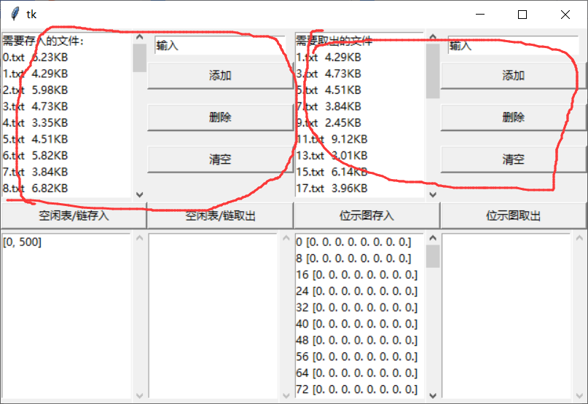

在左上角显示要存入的文件名和文件大小，旁边可以输入（形如1.txt,12，单位默认为KB），删除（删除最新添加的），清空

在右上角显示要取出的文件名和文件大小，旁边可以输入（形如1.txt,12，单位默认为KB），删除（删除最新添加的），清空

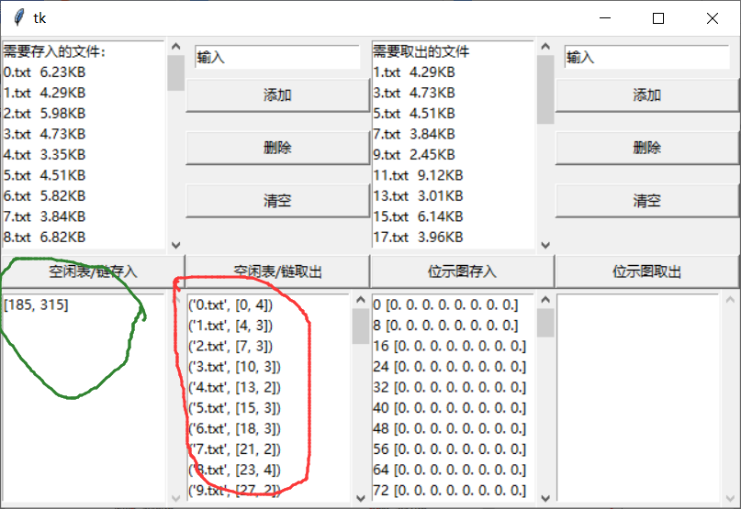

左下角显示空闲表/空闲盘区链（因为我使用的是python，Python对指针已经做了良性封装，任何对象都可以被引用，所以Python一般并不需要指针或者链表，因而我也没有单独去编写链表结构，而是统一使用Python自带的list结构存储），显示是形式如图（图中绿色）所示：[0, 500]表示第一块空闲块块号为0，有连续500个空闲块。图中红色表示文件存储状态：如(‘0.txt’, [0, 4])表示文件0.txt存储在第0块，用了包括第0块在内的4个块（即0,1,2,3块）。

位示图的显示同空闲表类似。

1. 存入50个2~10KB的文件

50个文件初始已经创建好了

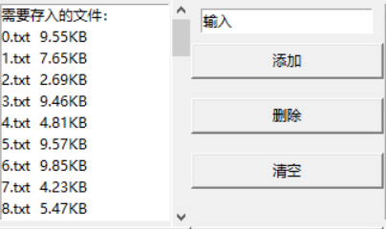

点击空闲表/链存入，存入空闲表：

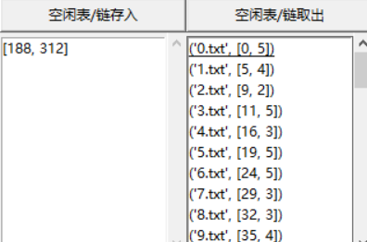

点击位示图存入：

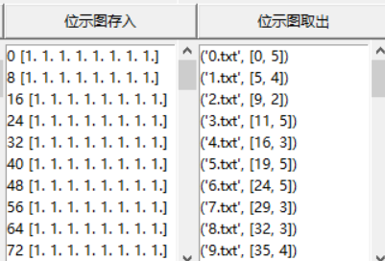

1. 删除奇数文件

需要删除的奇数文件也已经在初始化时创建好了

点击空闲表/链取出：

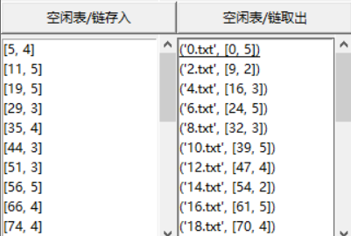

点击位示图取出

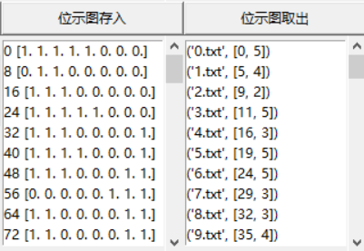

1. 新建文件并存入

点击清空，清空需要存入的文件：

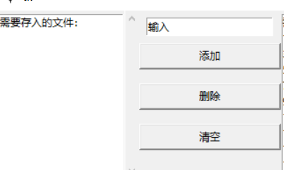

分别输入A.txt、B.txt、C.txt、D.txt、E.txt，大小为：7k、5k、2k、9k、3.5k，

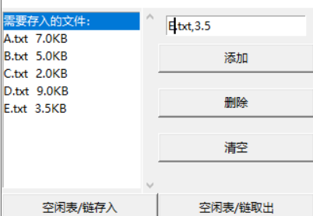

存入空闲表/链：

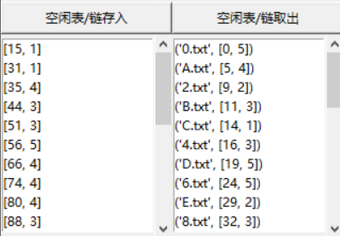

存入位示图：

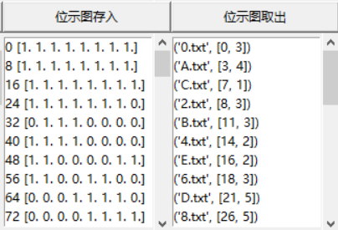

（5）给出文件A.txt、B.txt、C.txt、D.txt、E.txt的盘块存储状态和所有空闲区块的状态。

空闲表：

[[22, 1],

[28, 4],

[36, 2],

[40, 3],

[46, 2],

[51, 3],

[58, 4],

[66, 4],

[74, 3],

[79, 3],

[85, 4],

[93, 3],

[98, 4],

[104, 4],

[120, 5],

[127, 3],

[135, 5],

[142, 5],

[151, 2],

[156, 3],

[162, 5],

[171, 329]]

文件存储状态：

('A.txt', [4, 4]),

('B.txt', [11, 3]),

('C.txt', [14, 1]),

('D.txt', [113, 5]),

('E.txt', [20, 2])

空闲盘区链：

[[22, 1],

[28, 4],

[36, 2],

[40, 3],

[46, 2],

[51, 3],

[58, 4],

[66, 4],

[74, 3],

[79, 3],

[85, 4],

[93, 3],

[98, 4],

[104, 4],

[120, 5],

[127, 3],

[135, 5],

[142, 5],

[151, 2],

[156, 3],

[162, 5],

[171, 329]]

文件存储状态：

('A.txt', [4, 4]),

('B.txt', [11, 3]),

('C.txt', [14, 1]),

('D.txt', [113, 5]),

('E.txt', [20, 2])

位示图：

array([[1., 1., 1., 1., 1., 1., 1., 1.],

[1., 1., 1., 1., 1., 1., 1., 1.],

[1., 1., 1., 1., 1., 1., 0., 1.],

[1., 1., 1., 1., 0., 0., 0., 0.],

[1., 1., 1., 1., 0., 0., 1., 1.],

[0., 0., 0., 1., 1., 1., 0., 0.],

[1., 1., 1., 0., 0., 0., 1., 1.],

[1., 1., 0., 0., 0., 0., 1., 1.],

[1., 1., 0., 0., 0., 0., 1., 1.],

[1., 1., 0., 0., 0., 1., 1., 0.],

[0., 0., 1., 1., 1., 0., 0., 0.],

[0., 1., 1., 1., 1., 0., 0., 0.],

[1., 1., 0., 0., 0., 0., 1., 1.],

[0., 0., 0., 0., 1., 1., 1., 1.],

[1., 1., 1., 1., 1., 1., 1., 1.],

[0., 0., 0., 0., 0., 1., 1., 0.],

[0., 0., 1., 1., 1., 1., 1., 0.],

[0., 0., 0., 0., 1., 1., 0., 0.],

[0., 0., 0., 1., 1., 1., 1., 0.],

[0., 1., 1., 1., 0., 0., 0., 1.],

[1., 1., 0., 0., 0., 0., 0., 1.],

[1., 1., 1., 0., 0., 0., 0., 0.],

[0., 0., 0., 0., 0., 0., 0., 0.],

[0., 0., 0., 0., 0., 0., 0., 0.],

[0., 0., 0., 0., 0., 0., 0., 0.],

[0., 0., 0., 0., 0., 0., 0., 0.],

[0., 0., 0., 0., 0., 0., 0., 0.],

[0., 0., 0., 0., 0., 0., 0., 0.],

[0., 0., 0., 0., 0., 0., 0., 0.],

[0., 0., 0., 0., 0., 0., 0., 0.],

[0., 0., 0., 0., 0., 0., 0., 0.],

[0., 0., 0., 0., 0., 0., 0., 0.],

[0., 0., 0., 0., 0., 0., 0., 0.],

[0., 0., 0., 0., 0., 0., 0., 0.],

[0., 0., 0., 0., 0., 0., 0., 0.],

[0., 0., 0., 0., 0., 0., 0., 0.],

[0., 0., 0., 0., 0., 0., 0., 0.],

[0., 0., 0., 0., 0., 0., 0., 0.],

[0., 0., 0., 0., 0., 0., 0., 0.],

[0., 0., 0., 0., 0., 0., 0., 0.],

[0., 0., 0., 0., 0., 0., 0., 0.],

[0., 0., 0., 0., 0., 0., 0., 0.],

[0., 0., 0., 0., 0., 0., 0., 0.],

[0., 0., 0., 0., 0., 0., 0., 0.],

[0., 0., 0., 0., 0., 0., 0., 0.],

[0., 0., 0., 0., 0., 0., 0., 0.],

[0., 0., 0., 0., 0., 0., 0., 0.],

[0., 0., 0., 0., 0., 0., 0., 0.],

[0., 0., 0., 0., 0., 0., 0., 0.],

[0., 0., 0., 0., 0., 0., 0., 0.],

[0., 0., 0., 0., 0., 0., 0., 0.],

[0., 0., 0., 0., 0., 0., 0., 0.],

[0., 0., 0., 0., 0., 0., 0., 0.],

[0., 0., 0., 0., 0., 0., 0., 0.],

[0., 0., 0., 0., 0., 0., 0., 0.],

[0., 0., 0., 0., 0., 0., 0., 0.],

[0., 0., 0., 0., 0., 0., 0., 0.],

[0., 0., 0., 0., 0., 0., 0., 0.],

[0., 0., 0., 0., 0., 0., 0., 0.],

[0., 0., 0., 0., 0., 0., 0., 0.],

[0., 0., 0., 0., 0., 0., 0., 0.],

[0., 0., 0., 0., 0., 0., 0., 0.],

[0., 0., 0., 0., 0., 0., 0., 0.]])

文件存储状态：

('A.txt', [4, 4]),

('B.txt', [11, 3]),

('C.txt', [14, 1]),

('D.txt', [113, 5]),

('E.txt', [20, 2])

# 代码

*import* numpy *as* np  
*from* tkinter *import* *  
*from* pprint *import* pprint  
# 参数  
KB = 2048  
size_of_disk_block = 2*KB  
num_of_disk_block = 500  
num_of_file = 50  
# 结构  
free_table = [[0, num_of_disk_block]]  
bitmap = np.zeros(num_of_disk_block)  
# 磁盘  
disk = np.zeros((num_of_disk_block, size_of_disk_block))  
#########################################################################################  
*def* GUI(*num_file_dict*, *delete_file_dict*):  
 *global* free_table, bitmap, KB, num_of_file, num_of_disk_block  
 free_table_file_table = {}  
 bitmap_file_table = {}  
 add_file_dict = *num_file_dict* delete_file_dict = *delete_file_dict* input_scrollbar_row = 0  
 button_row = 1  
 show_scrollbar_row = 6  
  
 root_window = Tk()  
 #################################################################################  
 # 第一层两个滑动窗口  
 add_file_scrollbar = Scrollbar(root_window)  
 add_file_scrollbar.grid(row=input_scrollbar_row, column=1, sticky=N + E + W, ipady=70, rowspan=5)  
 add_file_listbox = Listbox(root_window, yscrollcommand=add_file_scrollbar.set)  
 add_file_listbox.insert(END, '需要存入的文件：')  
 *for* file_name, file_text *in* add_file_dict.items():  
 file_size = np.round(len(file_text) / KB, 2)  
 add_file_listbox.insert(END, file_name + ' ' + str(file_size) + 'KB')  
 add_file_listbox.grid(row=input_scrollbar_row, column=0, rowspan=5)  
 ###############  
 delete_file_scrollbar = Scrollbar(root_window)  
 delete_file_scrollbar.grid(row=input_scrollbar_row, column=5, sticky=N + E + W, ipady=70, rowspan=5)  
 delete_file_listbox = Listbox(root_window, yscrollcommand=delete_file_scrollbar.set)  
 delete_file_listbox.insert(END, '需要取出的文件')  
 *for* file_name, file_text *in delete_file_dict*.items():  
 file_size = np.round(len(file_text) / KB, 2)  
 delete_file_listbox.insert(END, file_name + ' ' + str(file_size) + 'KB')  
 delete_file_listbox.grid(row=input_scrollbar_row, column=4, rowspan=5)  
 ###########################################################################################  
  
  
 #########################################################################################################  
 # 左边四个  
 input_add_file_entry_str = StringVar()  
 input_add_file_entry_str.set('输入')  
 Entry(root_window, textvariable=input_add_file_entry_str).grid(row=0, column=2, columnspan=2)  
  
 *def* get_add_file():  
 *nonlocal* add_file_dict  
 new_file = input_add_file_entry_str.get()  
 file_name = new_file.split(',')[0]  
 file_size = float(new_file.split(',')[1])  
 file_text = np.random.randint(0, 2, size=int(file_size*KB))  
 add_file_dict[file_name] = file_text  
 add_file_listbox.insert(END, file_name + ' ' + str(round(file_size, 2)) + 'KB')  
 *def* delete_add_file():  
 all_key = list(add_file_dict.keys())  
 # print(all_key[1])  
 add_file_dict.pop(all_key[-1])  
 add_file_listbox.delete(END)  
 *def* clear_add_file():  
 add_file_listbox.delete(0,END)  
 add_file_dict.clear()  
 add_file_listbox.insert(END, '需要存入的文件：')  
  
 Button(root_window, text='添加', command=get_add_file).grid(row=button_row, column=2, sticky=N + E + W, columnspan=2)  
 Button(root_window, text='删除', command=delete_add_file).grid(row=button_row+1, column=2, sticky=N + E + W, columnspan=2)  
 Button(root_window, text='清空', command=clear_add_file).grid(row=button_row+2, column=2, sticky=N + E + W, columnspan=2)  
 ################################################################################################################  
  
 #########################################################################################################  
 # 右边4个  
 input_delete_file_entry_str = StringVar()  
 input_delete_file_entry_str.set('输入')  
 Entry(root_window, textvariable=input_delete_file_entry_str).grid(row=0, column=6, columnspan=2)  
  
 *def* get_delete_file():  
 *nonlocal* delete_file_dict  
 new_file = input_add_file_entry_str.get()  
 file_name = new_file.split(',')[0]  
 file_size = float(new_file.split(',')[1])  
 file_text = np.random.randint(0, 2, size=int(file_size * KB))  
 delete_file_dict[file_name] = file_text  
 delete_file_listbox.insert(END, file_name + ' ' + str(round(file_size, 2)) + 'KB')  
 *def* delete_delete_file():  
 all_key = list(delete_file_dict.keys())  
 # print(all_key[1])  
 delete_file_dict.pop(all_key[-1])  
 delete_file_listbox.delete(END)  
 *def* clear_delete_file():  
 delete_file_listbox.delete(0,END)  
 delete_file_dict.clear()  
 delete_file_listbox.insert(END, '需要取出的文件：')  
  
 Button(root_window, text='添加', command=get_delete_file).grid(row=button_row, column=6, sticky=N + E + W, columnspan=2)  
 Button(root_window, text='删除', command=delete_delete_file).grid(row=button_row + 1, column=6, sticky=N + E + W,  
 columnspan=2)  
 Button(root_window, text='清空', command=clear_delete_file).grid(row=button_row + 2, column=6, sticky=N + E + W,  
 columnspan=2)  
 ###############################################################################################################  
  
  
 # free_table####################################################################  
 # 空闲表  
  
 free_table_scrollbar = Scrollbar(root_window)  
 free_table_scrollbar.grid(row=show_scrollbar_row, column=1, sticky=N + E + W, ipady=70)  
 free_table_listbox = Listbox(root_window, yscrollcommand=free_table_scrollbar.set)  
 *for* i *in* range(len(free_table)):  
 row = free_table[i]  
 free_table_listbox.insert(END, str(row))  
 free_table_listbox.grid(row=show_scrollbar_row, column=0)  
 # file_table####################################################################  
 free_table_file_table_scrollbar = Scrollbar(root_window)  
 free_table_file_table_scrollbar.grid(row=show_scrollbar_row, column=3, sticky=N + E + W, ipady=70)  
 free_table_file_table_listbox = Listbox(root_window, yscrollcommand=free_table_file_table_scrollbar.set)  
 new_free_table_file_table = sorted(free_table_file_table.items(), key=*lambda x*:x[1][0])  
 *for* row *in* new_free_table_file_table:  
 free_table_file_table_listbox.insert(END, str(row))  
 free_table_file_table_listbox.grid(row=show_scrollbar_row, column=2)  
 free_table_file_table_scrollbar.config(command=free_table_file_table_listbox.yview)  
 ############################################################################  
  
  
 # bitmap####################################################################  
  
 add_num_of_bitmap = 8 - (num_of_disk_block % 8)  
 add_zeros = np.zeros(add_num_of_bitmap)  
 new_bitmap = np.hstack((bitmap, add_zeros))  
 new_bitmap = np.reshape(new_bitmap, (len(new_bitmap) // 8, 8))  
  
 bitmap_scrollbar = Scrollbar(root_window)  
 bitmap_scrollbar.grid(row=show_scrollbar_row, column=5, sticky=N + E + W, ipady=70)  
 bitmap_listbox = Listbox(root_window, yscrollcommand=bitmap_scrollbar.set)  
 *for* i *in* range(len(new_bitmap)):  
 row = new_bitmap[i]  
 bitmap_listbox.insert(END, str(i * 8) + ' ' + str(row))  
 bitmap_listbox.grid(row=show_scrollbar_row, column=4)  
 # file_table####################################################################  
 bitmap_file_table_scrollbar = Scrollbar(root_window)  
 bitmap_file_table_scrollbar.grid(row=show_scrollbar_row, column=7, sticky=N + E + W, ipady=70)  
 bitmap_file_table_listbox = Listbox(root_window, yscrollcommand=bitmap_file_table_scrollbar.set)  
 new_bitmap_file_table = sorted(bitmap_file_table.items(), key=*lambda x*: x[1][0])  
 *for* row *in* new_bitmap_file_table:  
 bitmap_file_table_listbox.insert(END, str(row) + ' ' + str())  
 bitmap_file_table_listbox.grid(row=show_scrollbar_row, column=6)  
 bitmap_file_table_scrollbar.config(command=bitmap_file_table_listbox.yview)  
 ###################################################################################  
  
 *def* free_table_add():  
 *for* file_name, file_text *in* add_file_dict.items():  
 AddFile2FreeTable(file_name, file_text, free_table_file_table)  
  
 free_table_listbox.delete(0, END)  
 *for* i *in* range(len(free_table)):  
 row = free_table[i]  
 free_table_listbox.insert(END, str(row))  
  
 free_table_file_table_listbox.delete(0, END)  
 new_free_table_file_table = sorted(free_table_file_table.items(), key=*lambda x*: x[1][0])  
 *for* row *in* new_free_table_file_table:  
 free_table_file_table_listbox.insert(END, str(row))  
  
 *def* free_table_delete():  
 *for* file_name, file_size *in* delete_file_dict.items():  
 DeleteFileInFreeTable(file_name, free_table_file_table)  
  
 free_table_listbox.delete(0, END)  
 *for* i *in* range(len(free_table)):  
 row = free_table[i]  
 free_table_listbox.insert(END, str(row))  
  
 free_table_file_table_listbox.delete(0, END)  
 new_free_table_file_table = sorted(free_table_file_table.items(), key=*lambda x*: x[1][0])  
 *for* row *in* new_free_table_file_table:  
 free_table_file_table_listbox.insert(END, str(row))  
  
 *def* bitmap_add():  
 *for* file_name, file_text *in* add_file_dict.items():  
 AddFile2BitMap(file_name, file_text, bitmap_file_table)  
  
 add_num_of_bitmap = 8 - (num_of_disk_block % 8)  
 add_zeros = np.zeros(add_num_of_bitmap)  
 new_bitmap = np.hstack((bitmap, add_zeros))  
 new_bitmap = np.reshape(new_bitmap, (len(new_bitmap) // 8, 8))  
 bitmap_listbox.delete(0, END)  
 *for* i *in* range(len(new_bitmap)):  
 row = new_bitmap[i]  
 bitmap_listbox.insert(END, str(i * 8) + ' ' + str(row))  
  
 new_bitmap_file_table = sorted(bitmap_file_table.items(), key=*lambda x*: x[1][0])  
 bitmap_file_table_listbox.delete(0, END)  
 *for* row *in* new_bitmap_file_table:  
 bitmap_file_table_listbox.insert(END, str(row) + ' ' + str())  
  
 *def* bitmap_delete():  
 *for* file_name, file_size *in* delete_file_dict.items():  
 DeleteFileInBitMap(file_name, bitmap_file_table)  
  
 add_num_of_bitmap = 8 - (num_of_disk_block % 8)  
 add_zeros = np.zeros(add_num_of_bitmap)  
 new_bitmap = np.hstack((bitmap, add_zeros))  
 new_bitmap = np.reshape(new_bitmap, (len(new_bitmap) // 8, 8))  
 bitmap_listbox.delete(0, END)  
 *for* i *in* range(len(new_bitmap)):  
 row = new_bitmap[i]  
 bitmap_listbox.insert(END, str(i * 8) + ' ' + str(row))  
  
 new_bitmap_file_table = sorted(bitmap_file_table.items(), key=*lambda x*: x[1][0])  
 # print(len(bitmap_file_table))  
 bitmap_file_table_listbox.delete(0, END)  
 *for* row *in* new_bitmap_file_table:  
 bitmap_file_table_listbox.insert(END, str(row) + ' ' + str())  
  
 Button(root_window, text='空闲表/链存入', command=free_table_add).grid(row=5, column=0, sticky=N + E + W, columnspan=2)  
 Button(root_window, text='空闲表/链取出', command=free_table_delete).grid(row=5, column=2, sticky=N + E + W,  
 columnspan=2)  
 Button(root_window, text='位示图存入', command=bitmap_add).grid(row=5, column=4, sticky=N + E + W, columnspan=2)  
 Button(root_window, text='位示图取出', command=bitmap_delete).grid(row=5, column=6, sticky=N + E + W,  
 columnspan=2)  
  
  
   
  
 root_window.mainloop()  
#########################################################################################  
*def* AddFile2FreeTable(*file_name*, *file_text*, *file_table*):  
 *global* KB, size_of_disk_block, num_of_disk_block, free_table, disk  
 *if* len(*file_text*) % size_of_disk_block == 0:  
 file_size = len(*file_text*) // size_of_disk_block  
 new_file_text = *file_text  
 else*:  
 raw_file_size = len(*file_text*) // size_of_disk_block  
 file_size = raw_file_size + 1  
 add_text_size = file_size * size_of_disk_block - len(*file_text*)  
 add_text = np.ones(add_text_size) * -1  
 new_file_text = np.hstack((*file_text*, add_text))  
 can_save = 0  
 *for* i *in* range(len(free_table)):  
 *if* free_table[i][1] >= file_size:  
 can_save = 1  
 disk_start_num = free_table[i][0]  
 free_table[i][0] += file_size  
 free_table[i][1] -= file_size  
 # print(':', disk_start_num, disk_start_num + file_size)  
 # file_table.append([file_name, disk_start_num, file_size])  
 *file_table*[*file_name*] = [disk_start_num, file_size]  
 *for* j *in* range(disk_start_num, disk_start_num + file_size):  
 # print('j:', j)  
 # print('start:', (j - disk_start_num) * size_of_disk_block)  
 # print('end:', ((j - disk_start_num) + 1) * size_of_disk_block)  
 # print('len:', len(new_file_text))  
 disk[j] = new_file_text[(j - disk_start_num) * size_of_disk_block:((j - disk_start_num) + 1) * size_of_disk_block]  
 *break  
 if* can_save == 0:  
 # print(free_table[i], file_size)  
 # pprint(free_table)  
 # pprint(file_table)  
 print(*file_name*, ' can not find enough block ', file_size)  
 *return* new_free_table = []  
 *for* node *in* free_table:  
 *if* node[1] != 0:  
 new_free_table.append(node)  
 free_table = new_free_table  
  
  
*def* DeleteFileInFreeTable(*file_name*, *file_table*):  
 *global* KB, size_of_disk_block, num_of_disk_block, free_table, disk  
 # pprint(free_table)  
 *if file_name not in file_table*.keys():  
 # print(file_name)  
 print('can not find ', *file_name*)  
 *return* free_table.append(*file_table*[*file_name*])  
 free_table = sorted(free_table)  
 new_free_table = []  
 *for* i *in* range(len(free_table) - 1):  
 # pprint('*')  
 # print(i)  
 # pprint(free_table)  
 *if* free_table[i][0] + free_table[i][1] == free_table[i + 1][0]:  
 free_table[i][1] = free_table[i][1] + free_table[i + 1][1]  
 free_table[i + 1][0] = -1  
 # free_table[i][0] = -1  
 # free_table.append([free_table[i][0], free_table[i][1] + free_table[i + 1][1]])  
 *for* i *in* range(len(free_table)):  
 *if* free_table[i][0] != -1:  
 new_free_table.append(free_table[i])  
 free_table = new_free_table  
 *del file_table*[*file_name*]  
  
  
*def* AddFile2BitMap(*file_name*, *file_text*, *file_table*):  
 *global* KB, size_of_disk_block, num_of_disk_block, bitmap, disk  
 *if* len(*file_text*) % size_of_disk_block == 0:  
 file_size = len(*file_text*) // size_of_disk_block  
 new_file_text = *file_text  
 else*:  
 raw_file_size = len(*file_text*) // size_of_disk_block  
 file_size = raw_file_size + 1  
 add_text_size = file_size * size_of_disk_block - len(*file_text*)  
 add_text = np.ones(add_text_size) * -1  
 new_file_text = np.hstack((*file_text*, add_text))  
 can_save = 0  
 num_of_zero = 0  
 start_of_zero = 0  
 *for* i *in* range(num_of_disk_block):  
 *if* bitmap[i] == 0:  
 num_of_zero += 1  
 *else*:  
 num_of_zero = 0  
 start_of_zero = i + 1  
 *if* num_of_zero >= file_size:  
 can_save = 1  
 bitmap[start_of_zero:start_of_zero + num_of_zero] = np.ones(num_of_zero)  
 *file_table*[*file_name*] = [start_of_zero, num_of_zero]  
 *for* j *in* range(start_of_zero, start_of_zero + num_of_zero):  
 disk[j] = new_file_text[(j - start_of_zero) * size_of_disk_block:((j - start_of_zero) + 1) * size_of_disk_block]  
 *break  
 if* can_save == 0:  
 print(*file_name*, ' can not find enough block ', file_size)  
 *return  
 return  
  
  
def* DeleteFileInBitMap(*file_name*, *file_table*):  
 *global* KB, size_of_disk_block, num_of_disk_block, bitmap, disk  
 *if file_name not in file_table*.keys():  
 # print(file_name)  
 print('can not find ', *file_name*)  
 *return* file_node = *file_table*[*file_name*]  
 bitmap[file_node[0]:file_node[0] + file_node[1]] = np.zeros(file_node[1])  
 *del file_table*[*file_name*]  
  
  
  
*if* __name__ == '__main__':  
  
 # 创建50个新文件  
 file_table = {}  
 num_file_dict = {}  
 delete_file_dict = {}  
 *for* i *in* range(num_of_file):  
 file_size = np.random.randint(2*KB, 10*KB, size=1)  
 file_text = np.random.randint(0, 2, size=file_size)  
 num_file_dict[str(i) + '.txt'] = file_text  
 *if* i % 2 != 0:  
 delete_file_dict[str(i) + '.txt'] = file_text  
 # 创建5个新文件  
 alpha_file_dict = {}  
 *for* file_name, file_size *in* zip(['A', 'B', 'C', 'D', 'E'], [7 * KB, 5 * KB, 2 * KB, 9 * KB, 3.5 * KB]):  
 file_text = np.random.randint(0, 2, size=int(file_size))  
 alpha_file_dict[file_name + '.txt'] = file_text  
  
 # # 空闲表/空闲盘区链测试  
 # for file_name, file_text in num_file_dict.items():  
 # AddFile2FreeTable(file_name, file_text, file_table)  
 # # print('-'*30)  
 # # pprint(free_table)  
 # # pprint(sorted(file_table.items(), key=lambda x: x[1]))  
 # for i in range(1, num_of_file, 2):  
 # DeleteFileInFreeTable(str(i) + '.txt', file_table)  
 # # print('-' * 30)  
 # # pprint(free_table)  
 # # pprint(sorted(file_table.items(), key=lambda x: x[1]))  
 # for file_name, file_text in alpha_file_dict.items():  
 # AddFile2FreeTable(file_name, file_text, file_table)  
 # print('-' * 30)  
 # pprint(free_table)  
 # pprint(sorted(file_table.items(), key=lambda x:x[1]))  
 #   
 # # 位示图测试  
 # file_table.clear()  
 # for file_name, file_text in num_file_dict.items():  
 # AddFile2BitMap(file_name, file_text, file_table)  
 # for i in range(1, num_of_file, 2):  
 # DeleteFileInBitMap(str(i) + '.txt', file_table)  
 # for file_name, file_text in alpha_file_dict.items():  
 # AddFile2BitMap(file_name, file_text, file_table)  
 # add_num_of_bitmap = 8 - (num_of_disk_block % 8)  
 # add_zeros = np.zeros(add_num_of_bitmap)  
 # new_bitmap = np.hstack((bitmap, add_zeros))  
 # pprint(np.reshape(new_bitmap, (len(new_bitmap) // 8, 8)))  
 # pprint(sorted(file_table.items(), key=lambda x:x[1]))  
  
  
 # # 界面  
 GUI(num_file_dict, delete_file_dict)