# Problem 0

There are door A, door B, door C. Suppose door A is selected for the first time, the door B has been opened.

### Define events：

Event A/C：There is a car behind door A/C

Event Open_B：Host opens door B

Event A^/C^：There is not a car behind door A/C

### Calculate probability：

（1）Calculate  at this time:



mean the probability of car behind door A when the host opens door B.

,mean the probability that the car is behind door A

,mean the probability that the car is not behind door A

If the car is behind door A and there is no car behind door B and door C, the probability of the host opening door B is 

If the car is not behind door A and there is a car behind door B or door C, the probability of having a car behind door B or door C is 1/2, and the host can only open another door, the probability of the host opening door B is 



（2）Calculate  at this time：

mean the probability of car behind door C when the host opens door B.

,mean the probability that the car is behind door A

,mean the probability that the car is not behind door A

If the car is behind door C and there is no car behind door B(the door A must not be opened), the probability of the host opening door B is 

If the car is not behind door C , the probability of having a car behind door A or door B is 1/2. If the car is behind the door B, then the probability for the host to open door B is 1/2. If the car is behind the door A, there is no car behind door B and door C at this time. The probability for the host to open door B is 1/2.





So, we should change the door C.

# Problem 1

Event：

x：Get two black and one white

A：All balls from bag A

B：All balls from bag B

（a）



（b）



（c）



# Problem 2

（a）





(As shown in the red part of the figure below.is a known number, so it can be put in front of the formula)



(As shown in the yellow part of the figure below.is a known number, so it can be put in front of the formula)

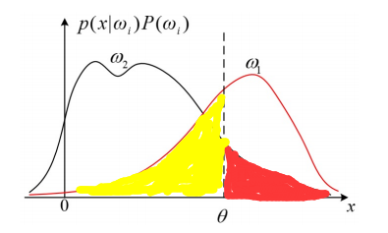

So,

（b）

As shown in the figure below：





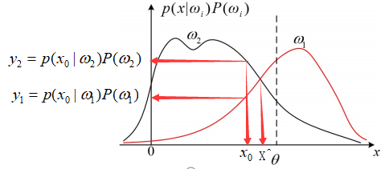

So,MAP：

and 



(As shown in the red part of the figure below.)



(As shown in the red part of the figure below.)

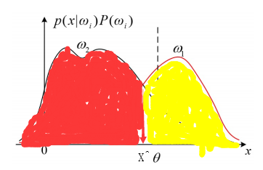



So,

（c）

When ,the two decision rules are equivalent.

（d）



Only when ,

In addition,

So, 





So，

# Problem 3

（a）



So， and 





（b）





（c）

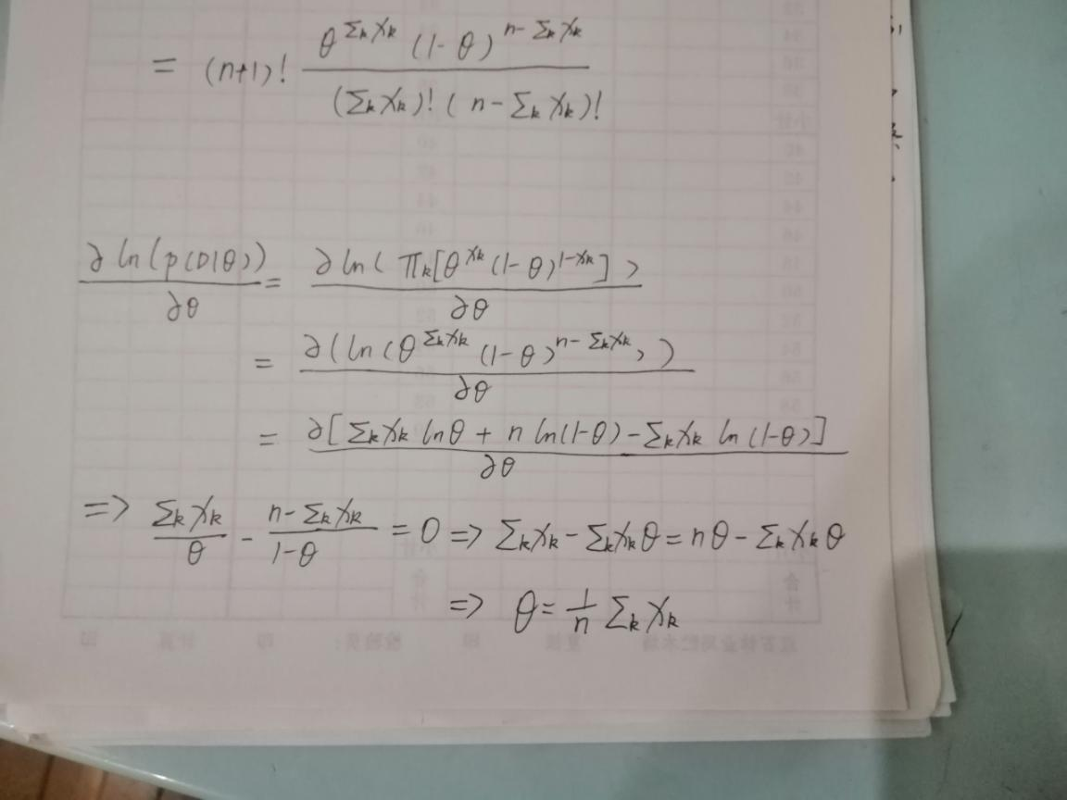

（d）

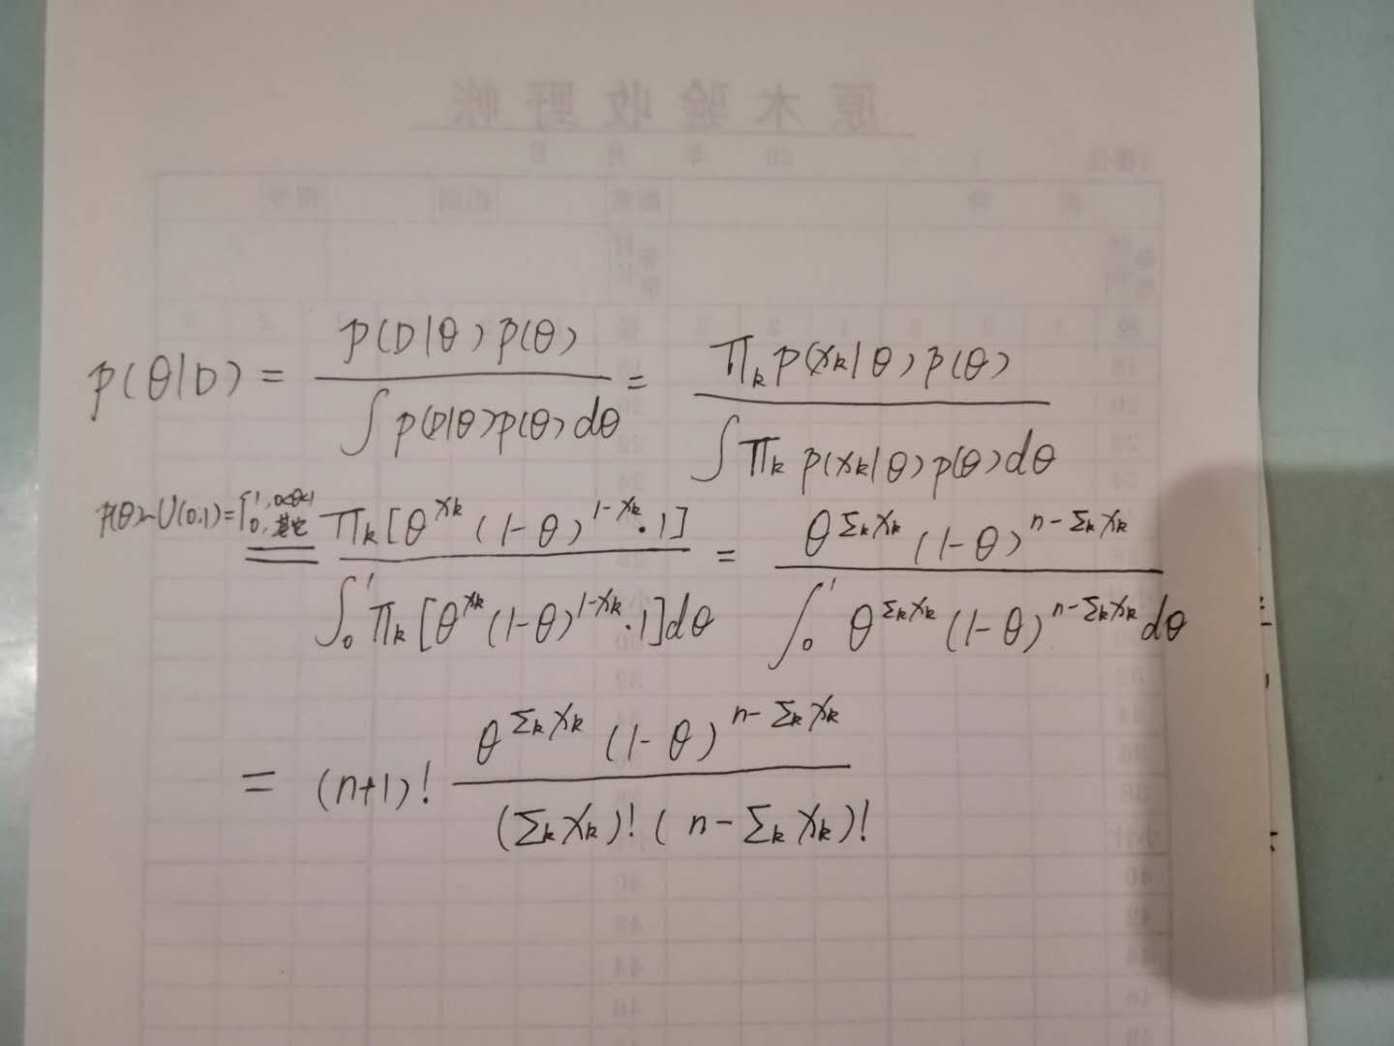

（e）

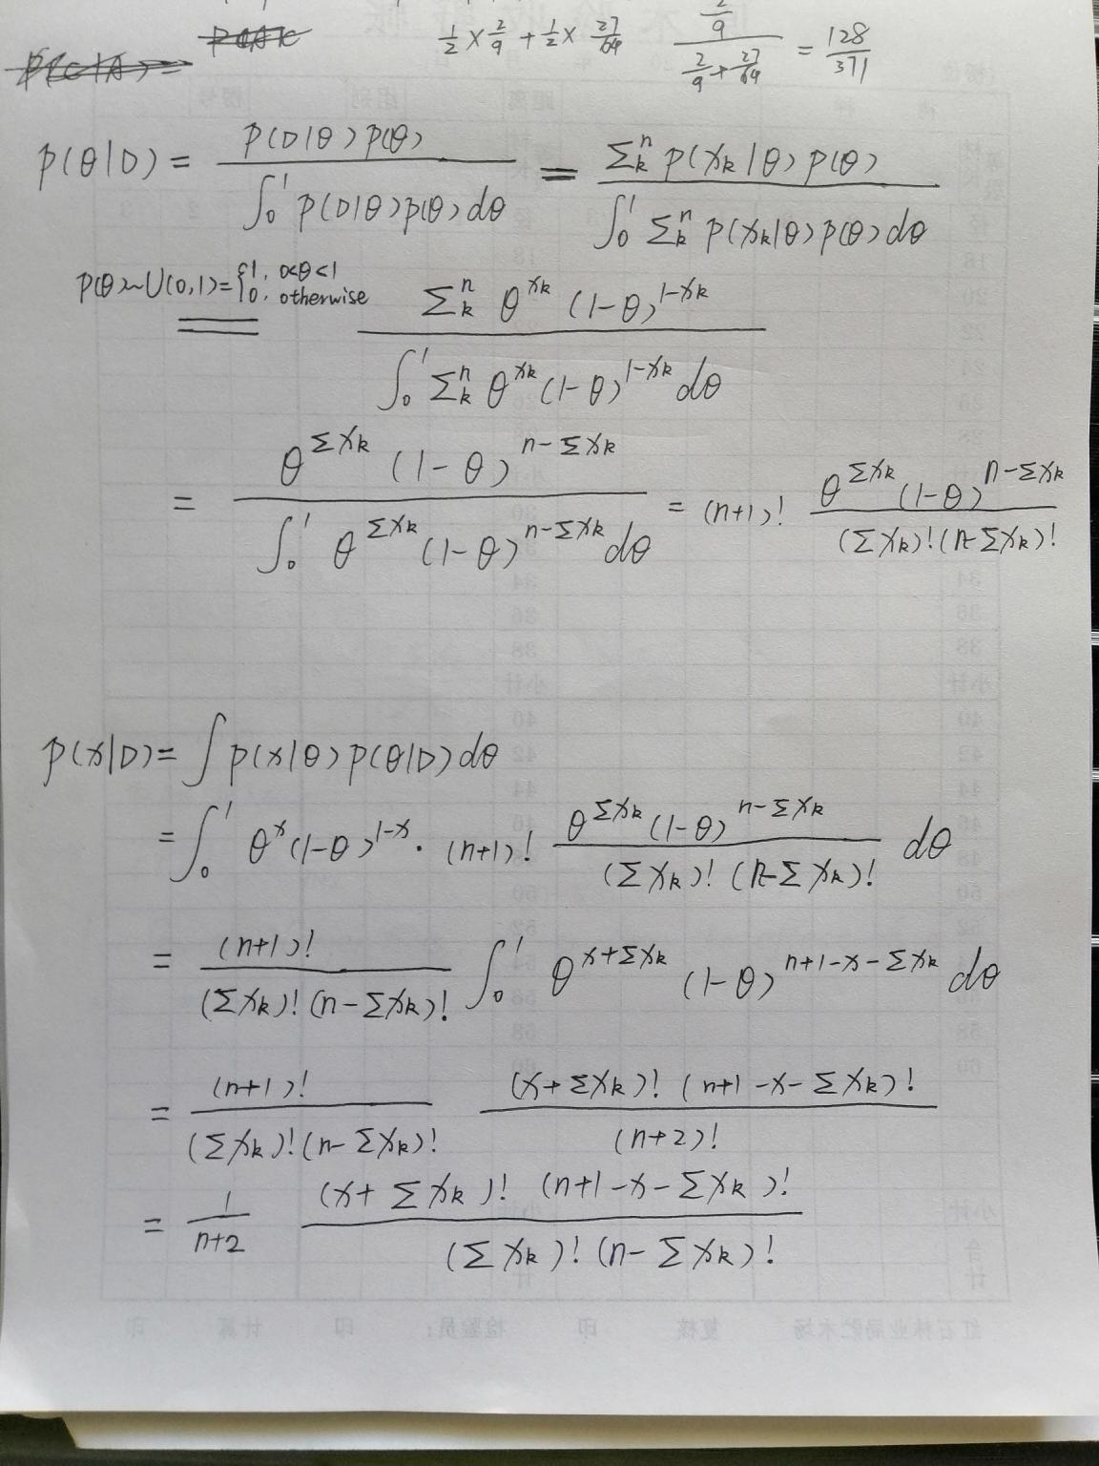

（f）

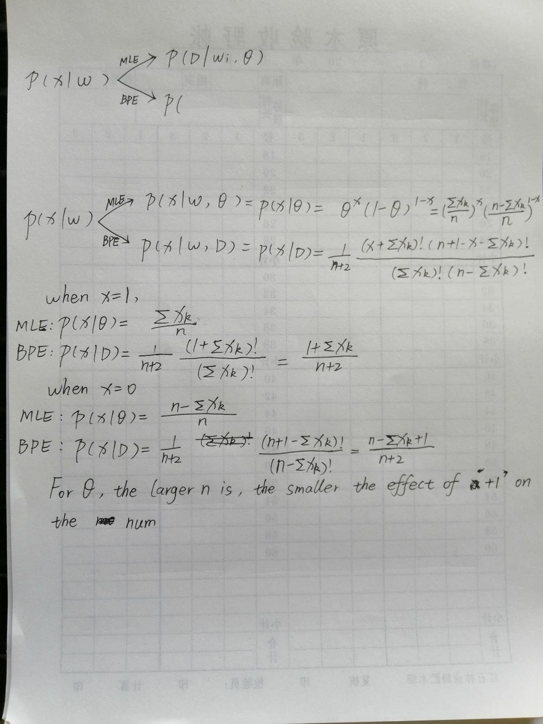

For , the larger n is, the smaller the effect of ‘+1’ on the numerator and ‘+2’ terms on the denominator is.

So,a large number of samples is the effective Bayesian estimate for .

（g）

1.MLE has lower computational complexity.

2.MLE is easier to interpret and understand because it returns the single best model form the set the designer provided.Take this question as an example.  is just the mean value.

3.BPE use more information.MLE just use

BPE use  and ,because  is a variable.

4.The larger number of samples n is, the smaller the effect of ‘+1’ on the numerator and ‘+2’ terms on the denominator is, and the closer the results of MLE and BPE.

# 附加题1

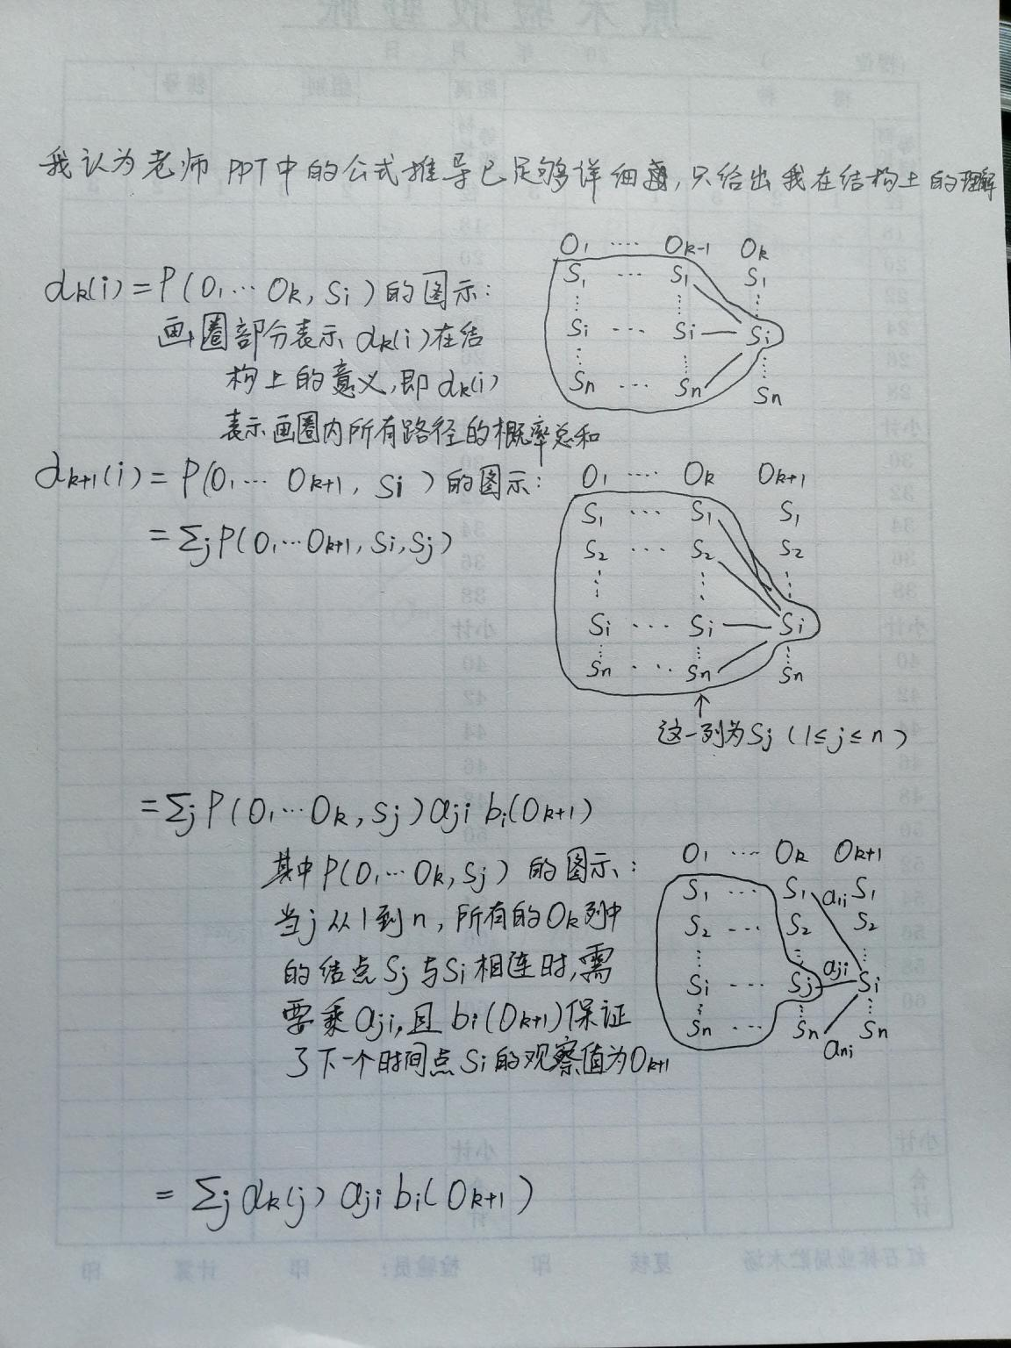

# 附加题2

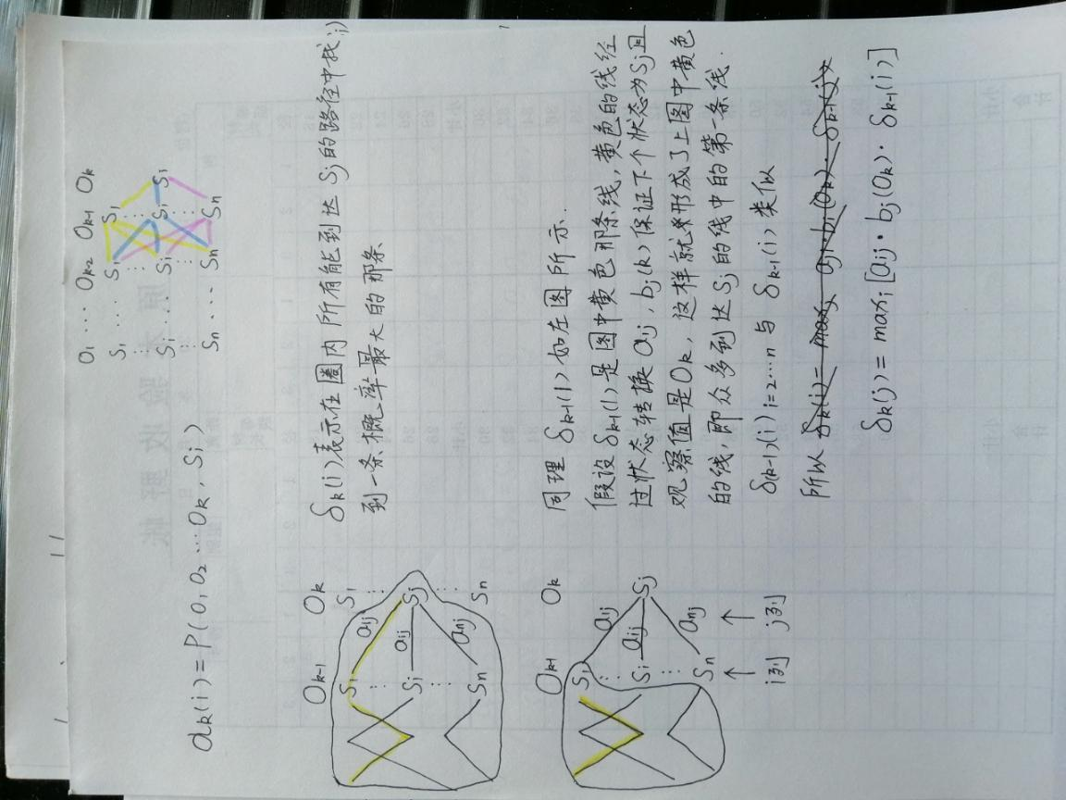

# 附加题3

