# Eigenfaces

K is the dimension of data after dimension reduction.

|  |  |  |  |
| --- | --- | --- | --- |
| k | N=3 | N=5 | N=7 |
| 1 | 0.933 | 0.933 | 0.933 |
| 2 | 0.613 | 0.564 | 0.588 |
| 3 | 0.486 | 0.487 | 0.420 |
| 4 | 0.411 | 0.371 | 0.315 |
| 5 | 0.335 | 0.313 | 0.318 |
| 6 | 0.333 | 0.270 | 0.258 |
| 7 | 0.302 | 0.264 | 0.257 |
| 8 | 0.292 | 0.252 | 0.228 |
| 9 | 0.270 | 0.247 | 0.227 |
| 10 | 0.243 | 0.212 | 0.182 |
| 11 | 0.233 | 0.214 | 0.217 |
| 12 | 0.248 | 0.209 | 0.185 |
| 13 | 0.242 | 0.210 | 0.215 |
| 14 | 0.248 | 0.208 | 0.153 |
| 15 | 0.231 | 0.219 | 0.178 |
| 20 | 0.225 | 0.189 | 0.160 |
| 25 | 0.217 | 0.208 | 0.188 |
| 30 | 0.213 | 0.186 | 0.197 |
| 35 | 0.213 | 0.193 | 0.180 |
| 40 | 0.210 | 0.168 | 0.170 |

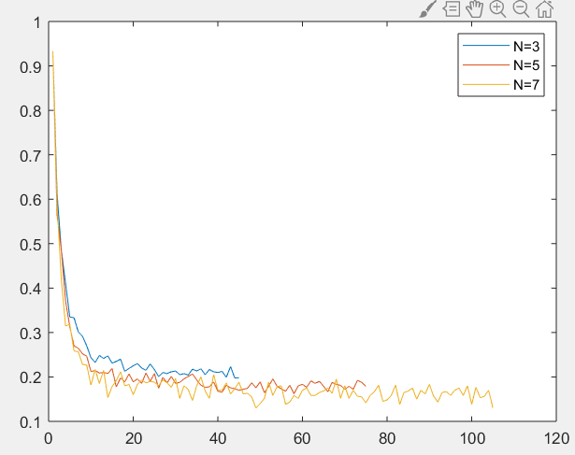

# Fisherfaces

K is the dimension of data after dimension reduction.

|  |  |  |  |
| --- | --- | --- | --- |
| k | N=3 | N=5 | N=7 |
| 1 | 0.933 | 0.933 | 0.933 |
| 2 | 0.484 | 0.422 | 0.372 |
| 3 | 0.372 | 0.287 | 0.273 |
| 4 | 0.289 | 0.233 | 0.170 |
| 5 | 0.253 | 0.192 | 0.108 |
| 6 | 0.198 | 0.140 | 0.117 |
| 7 | 0.175 | 0.140 | 0.077 |
| 8 | 0.170 | 0.101 | 0.065 |
| 9 | 0.140 | 0.078 | 0.057 |
| 10 | 0.113 | 0.057 | 0.047 |
| 11 | 0.116 | 0.040 | 0.027 |
| 12 | 0.106 | 0.051 | 0.033 |
| 13 | 0.092 | 0.043 | 0.020 |
| 14 | 0.093 | 0.034 | 0.020 |
| min | 0.092 | 0.034 | 0.020 |

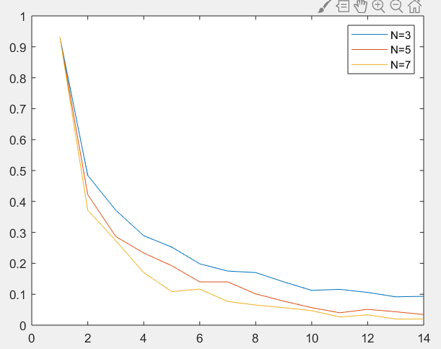

**My findings**

‘PCA takes advantage of the fact that, under admittedly idealized conditions, the variation within class lies in a linear subspace of the image space. Hence, the classes are convex, and, therefore, linearly separable. One can perform dimensionality reduction using linear projection and still preserve linear separability. This is a strong argument in favor of using linear methods for dimensionality reduction in the face recognition problem, at least when one seeks insensitivity to lighting conditions.’Through the comparison results, it can be found that FLD makes good use of the classifiable lines among the inner classes, which greatly reduces the recognition error rate.

# Detection

## Overall process

1. Preprocessing training pictures(LBP)
2. Calculate Eigenfaces.
3. Preprocessing test pictures(resize+LBP)
4. Calculate the distance and make artificial correction
5. Take the average distance that meets the conditions as the score

## Details

（1）Dimension selection

In find_best_dim_of_PCA.m, it can be seen that the dimension after dimensionality reduction(PCA) is about 65, which can contain 95% of the main information.

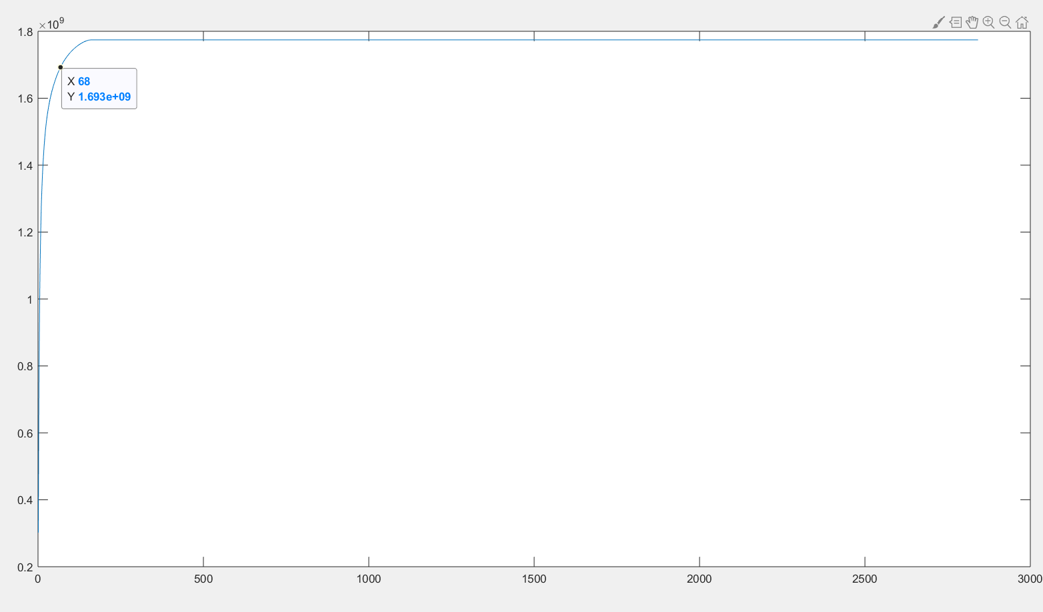

1. LBP

The most obvious difference between the training picture and the picture to be detected is that the background of the training picture is white, while the background of the picture to be detected is relatively complex, and the light intensity is also different. So I decided to use LBP and add the normal distribution random number to the white part of the training picture as noise, so that the training picture and the picture to be detected are more focused on texture than light or background color.

Original picture：

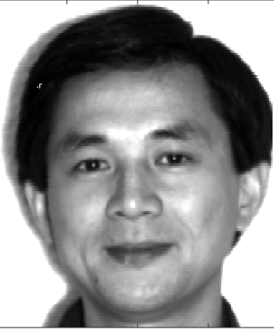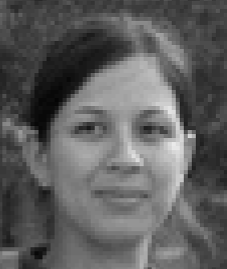

Picture after preprocessing：

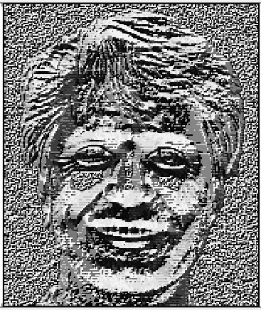

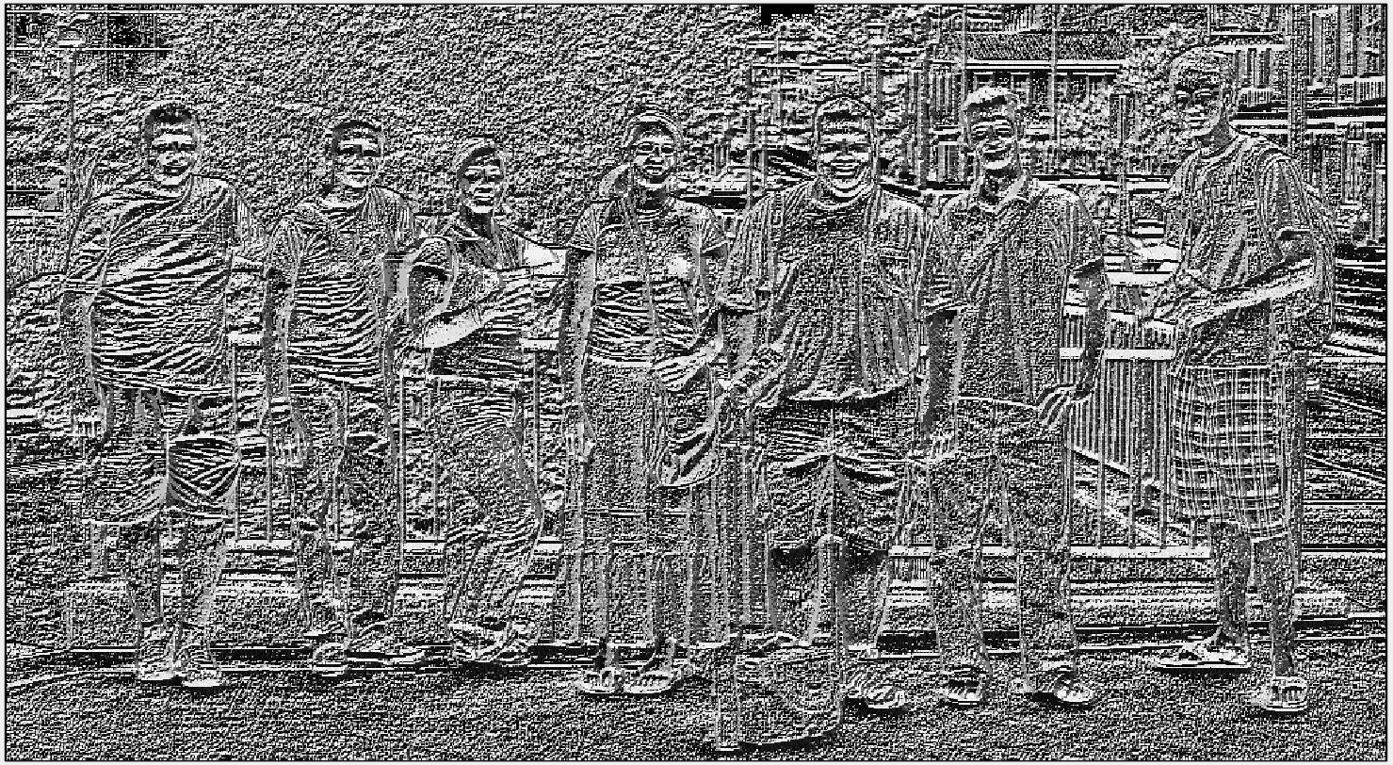

1. Selection of window size

The length width ratio of the window is equal to the length width ratio of the training image to prevent the face from stretching and deforming.

1. Artificial correction

Find the face picture and the picture with the lowest score in all the pictures, compare the difference between the two, and judge before calculating the score

## Result

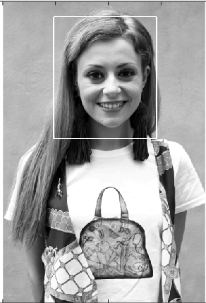



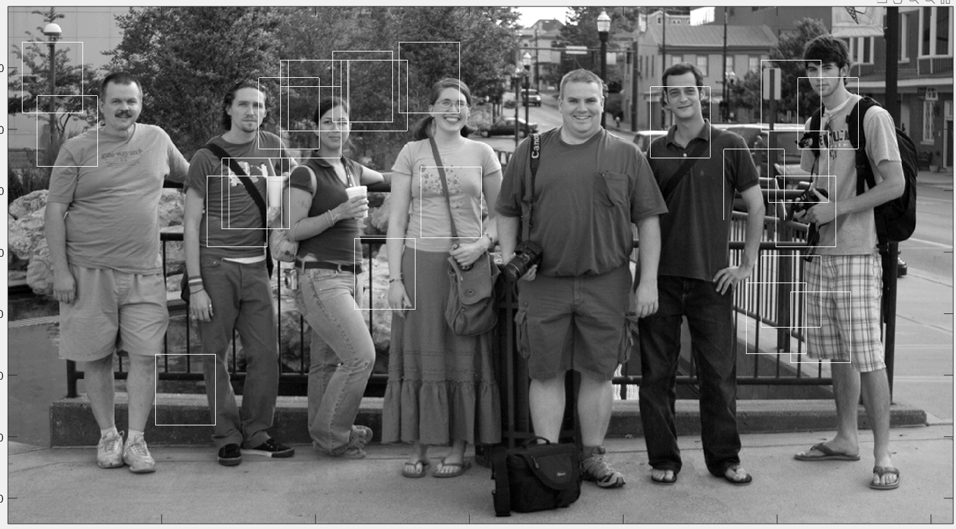

## Summary

The recognition effect is not good. I think there may be some problems as follows:

（1）I didn't write the sliding window function, because the sliding window needs a threshold value, and I intended to find the approximate value of this threshold value under the fixed window now, but I failed to find it. I find that if I calculate the L2 distance, many non face windows often calculate a smaller distance.

（2）The teacher asked to use the results of the previous four questions. The first four questions only get the Eigenfaces and Fisherfaces of the dataset, using Eigenfaces or Fisherfaces as features. Fisherfaces is more inclined to inter class classification, and the experimental results are not good. So I chose Eigenfaces.

But Eigenfaces uses PCA, PCA is to choose the main direction of data projection in the dataset, and try to ensure the main information of data projection in the dataset. When PCA is used for data outside the dataset, the main information of new data may not be well preserved in the direction of projection.

1. In the future, I think it's possible to partition the pictures and find out the window with the highest number of votes in the way of voting by weight.Or together with other methods, become boosting methods.I think the boosting effect is very good. Here are the pictures detected by the boosting function of MATLAB

