**HW [2], [01/23/2019] MCS 253P**

**Name: Yu Qin**

**Results Screenshots**

===========================start of the write-up====================

Q1: string

Test command:

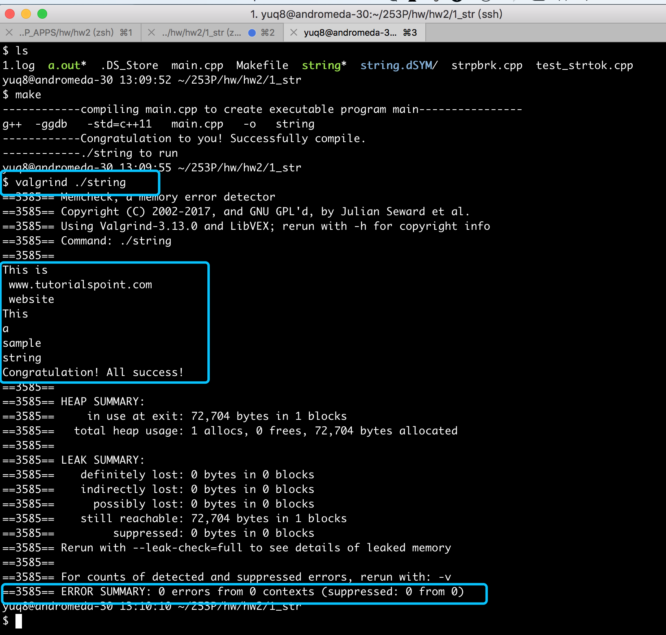

Conclusion: right result, 0 error in memory leak.

Q2: parse

Test command:

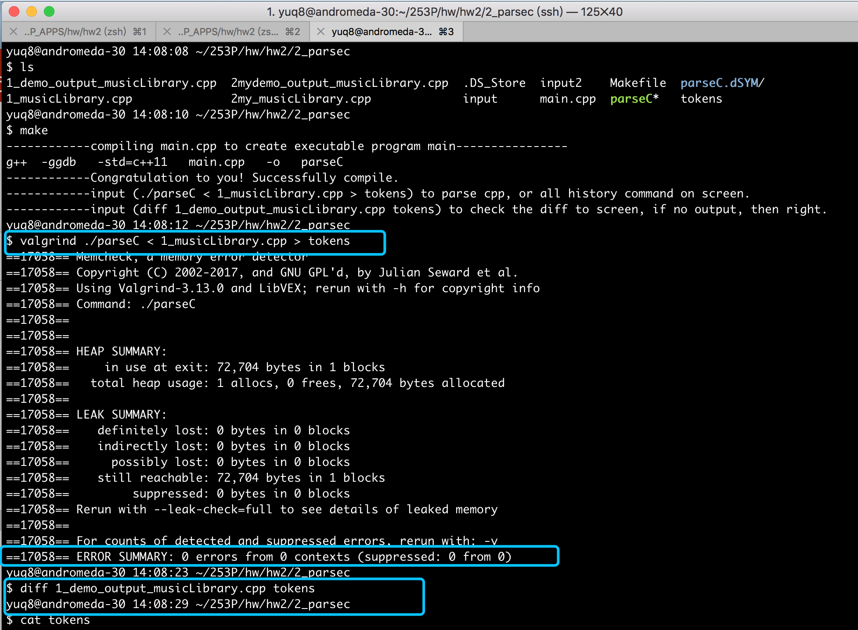

detail results:

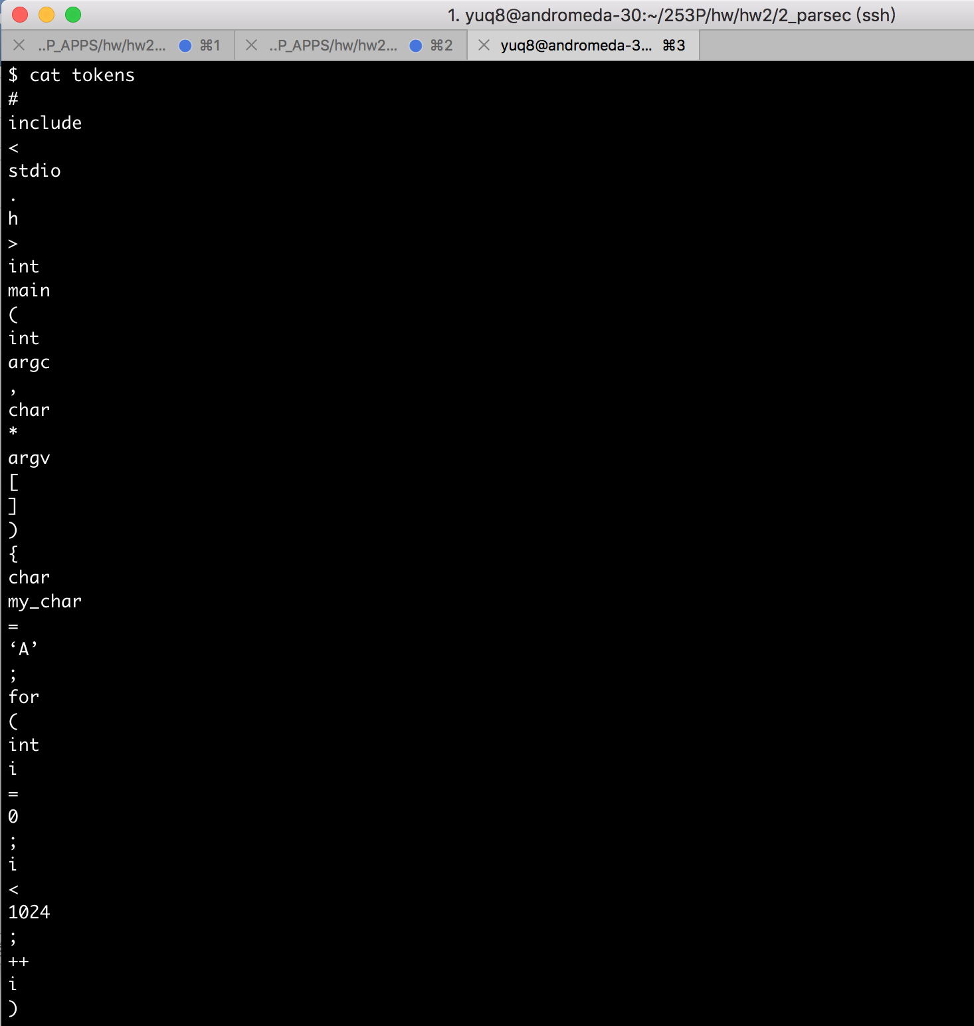

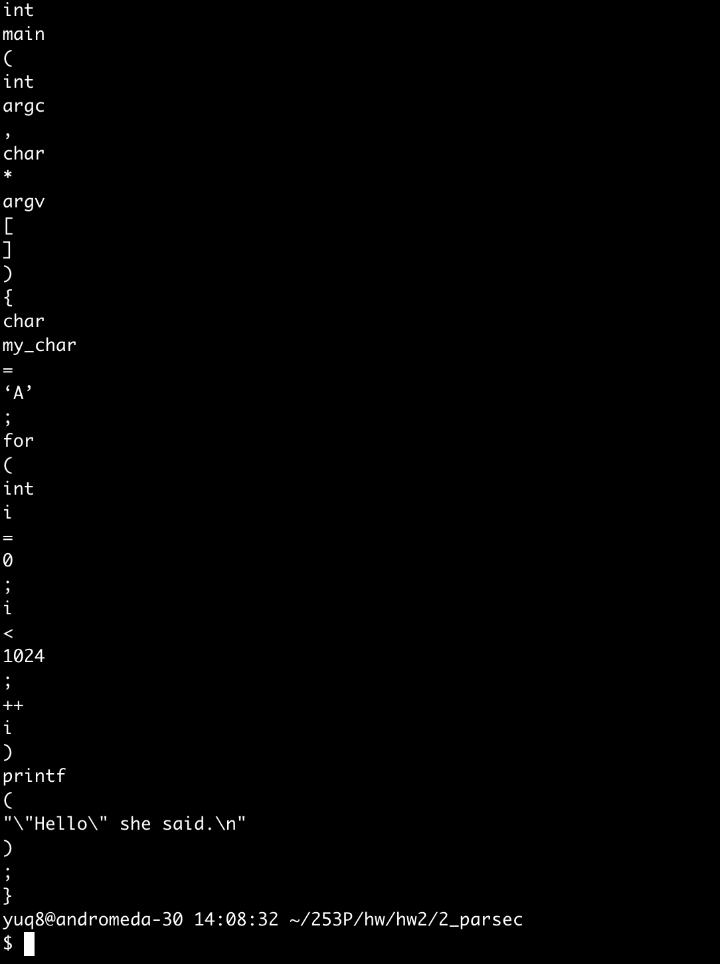

Conclusion: right result, 0 error in memory leak.