**HW [4], [2/6/2019] MCS 253P**

**Name: Yu Qin**

**Results Screenshots**

===========================start of the write-up====================

**Lab 1**

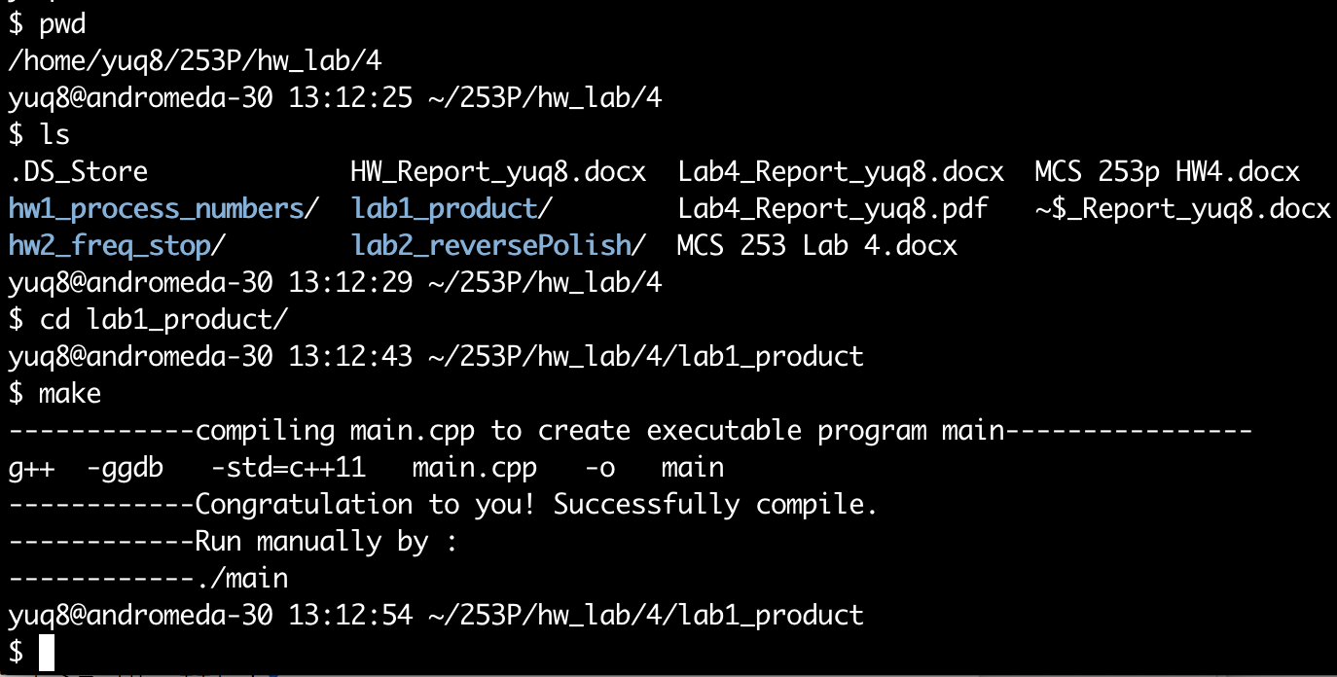

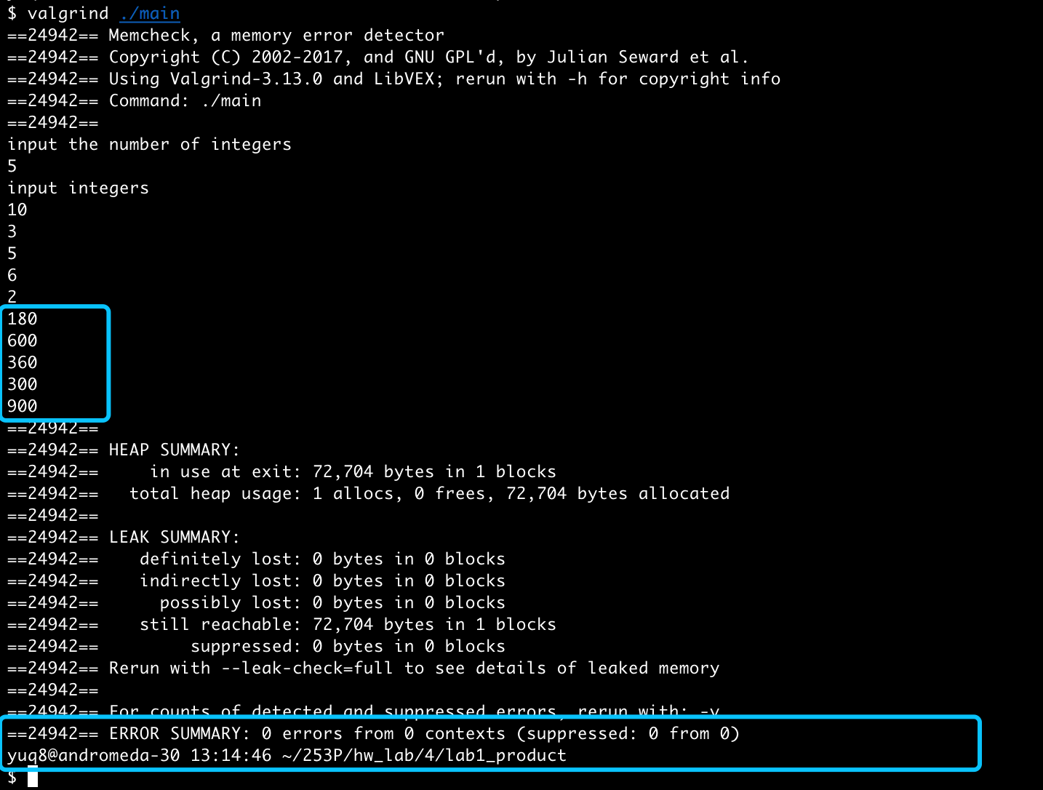

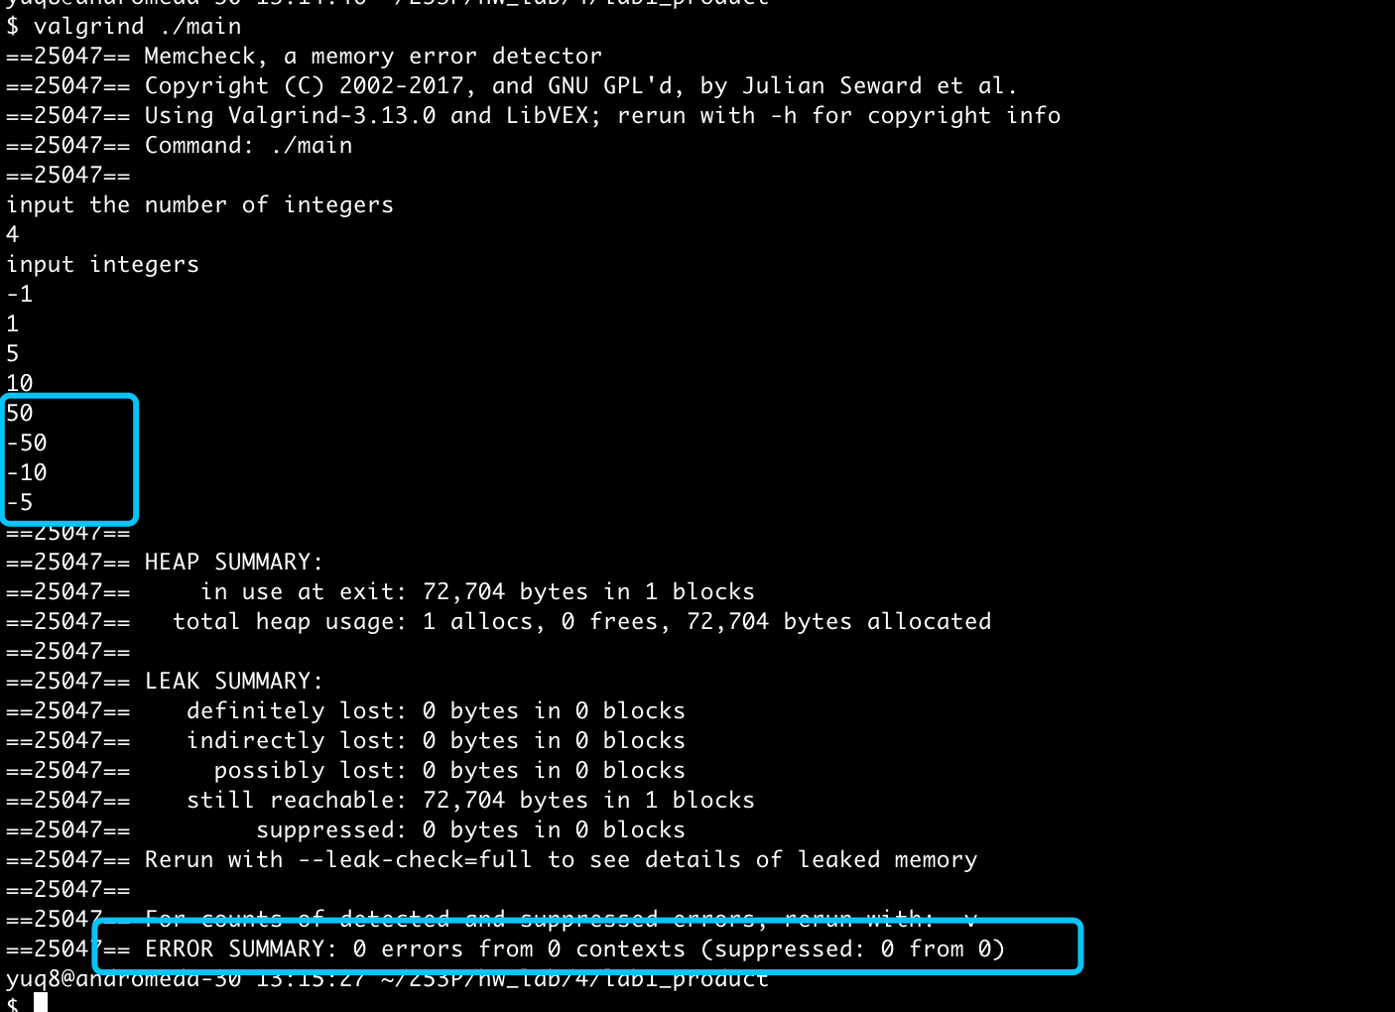

Conclusion: right result, 0 error in memory leak.

**Lab 2**

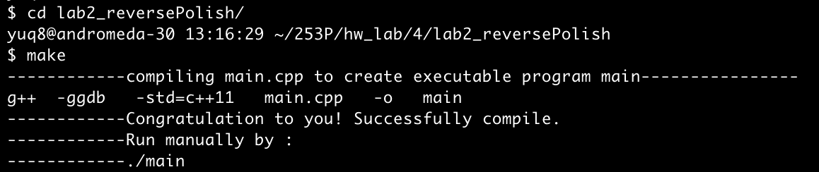

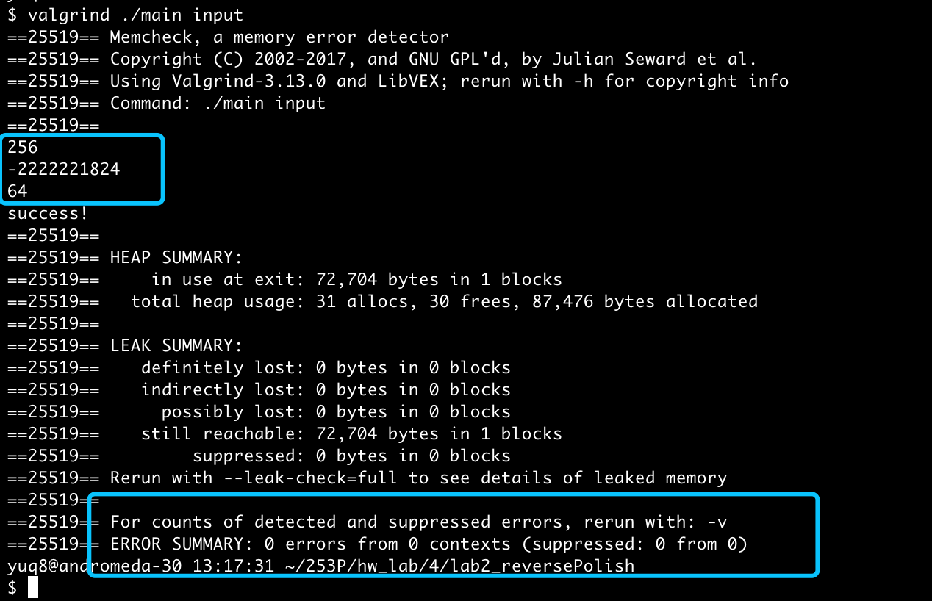

Conclusion: right result, 0 error in memory leak.

Little Notes:

1. Future work can be taken in transforming the prefix notation to RPN, plus the question of taking parenthesis into consideration.

**HW1**

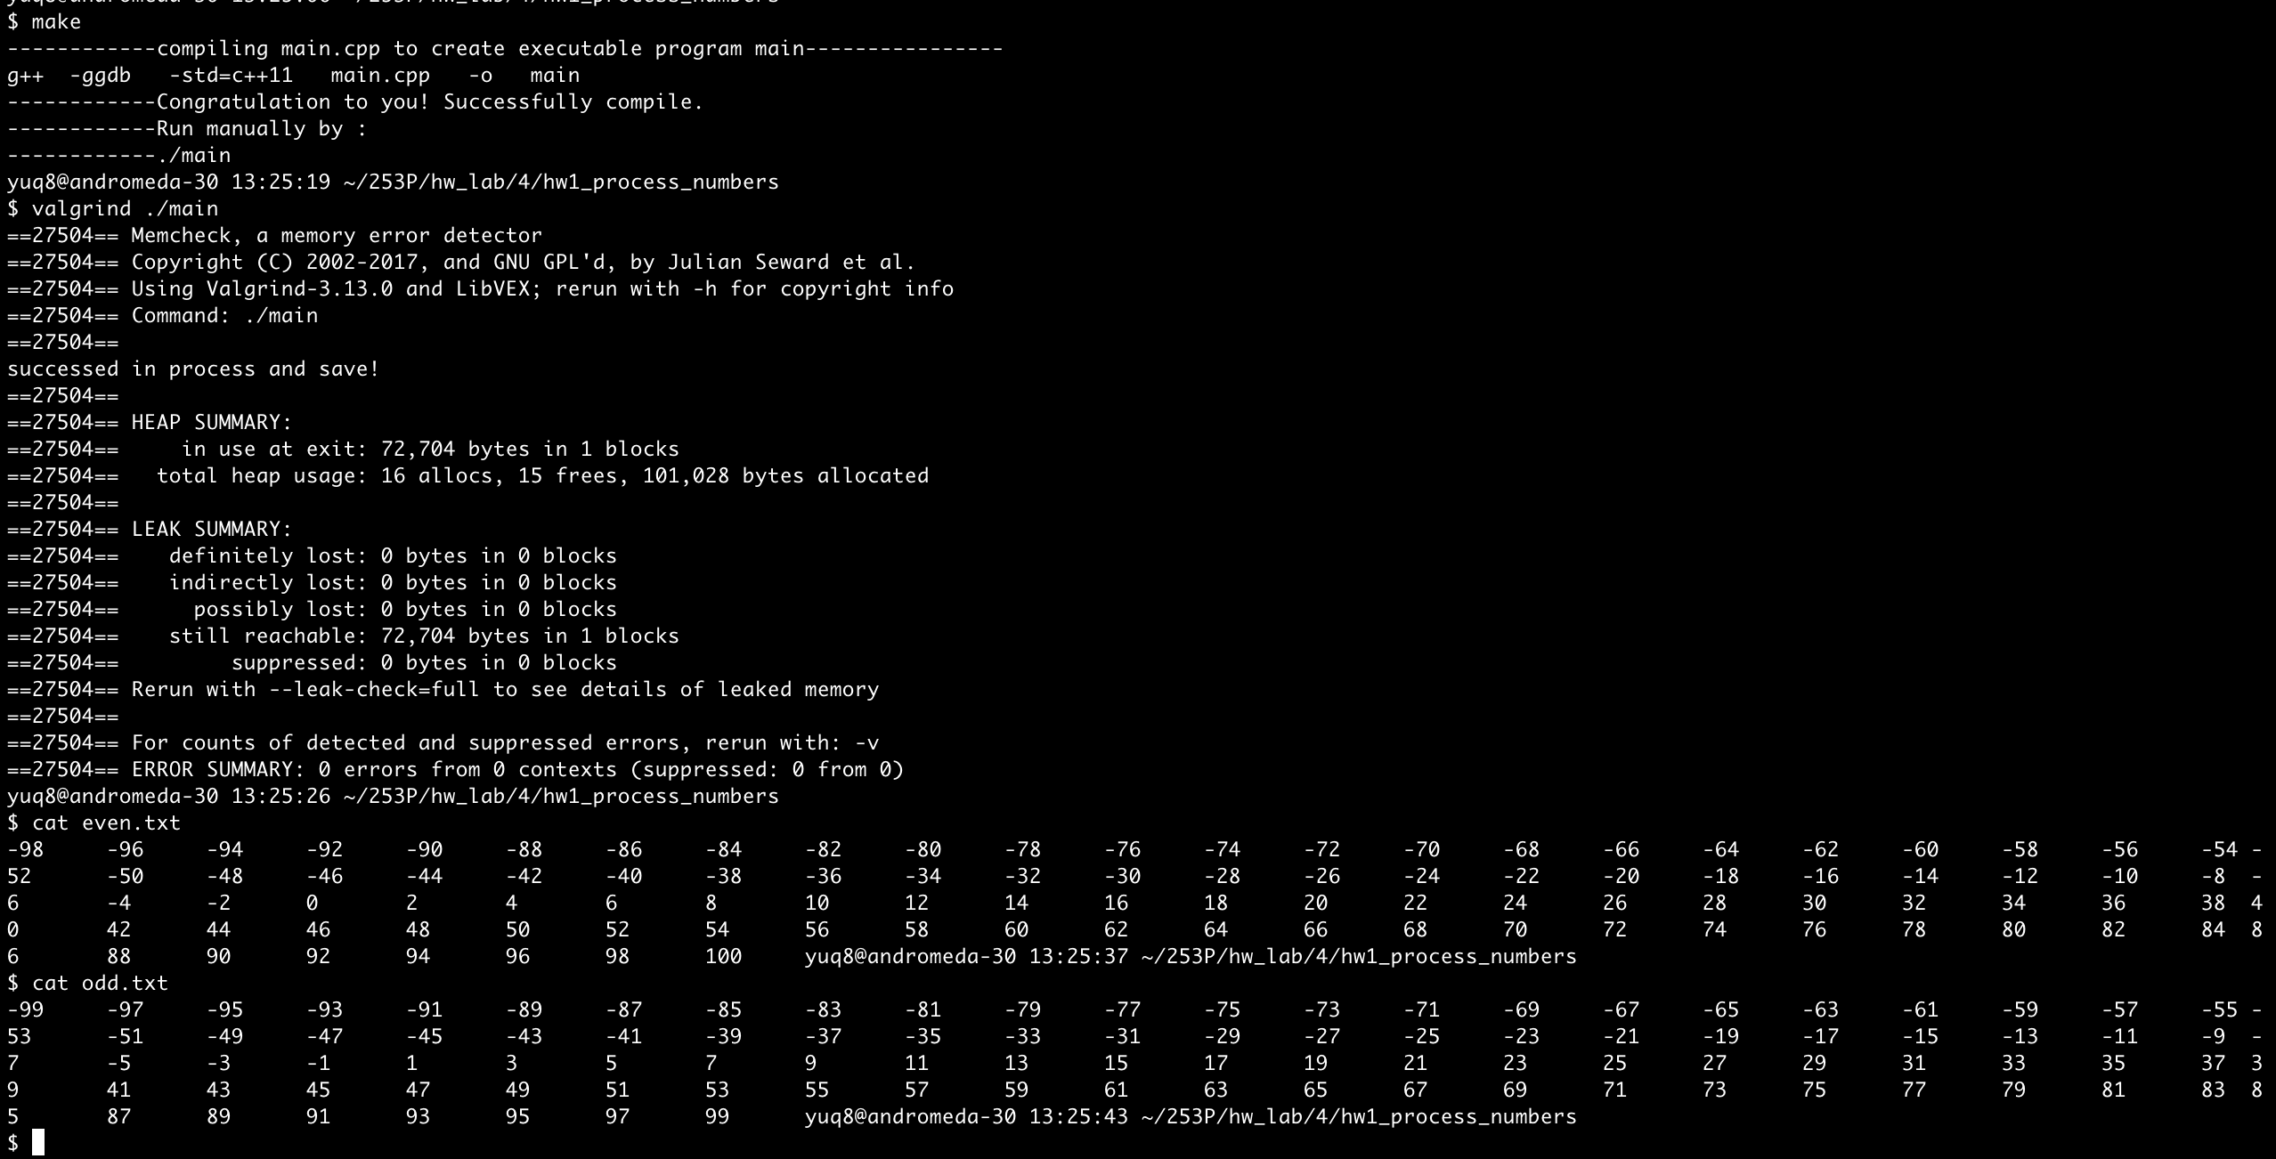

Conclusion: right result, 0 error in memory leak.

Little Notes:

1. Interesting and useful of using complex c++ STL.