**HW [5], [2/10/2019] MCS 253P**

**Name: Yu Qin**

**Results Screenshots**

===========================start of the write-up====================

# **Lab 1: S-W gene align**

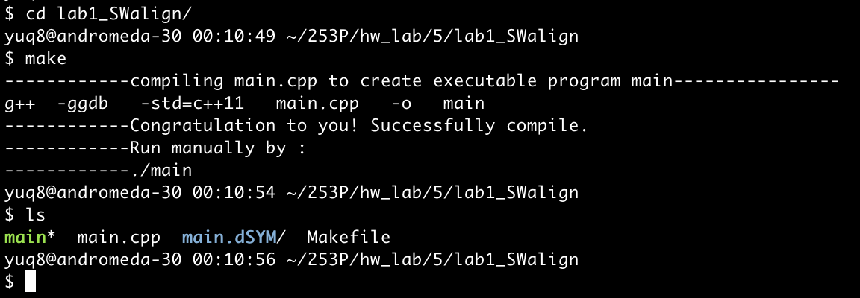

test case 1:

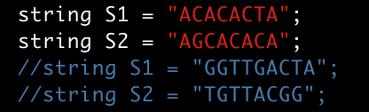

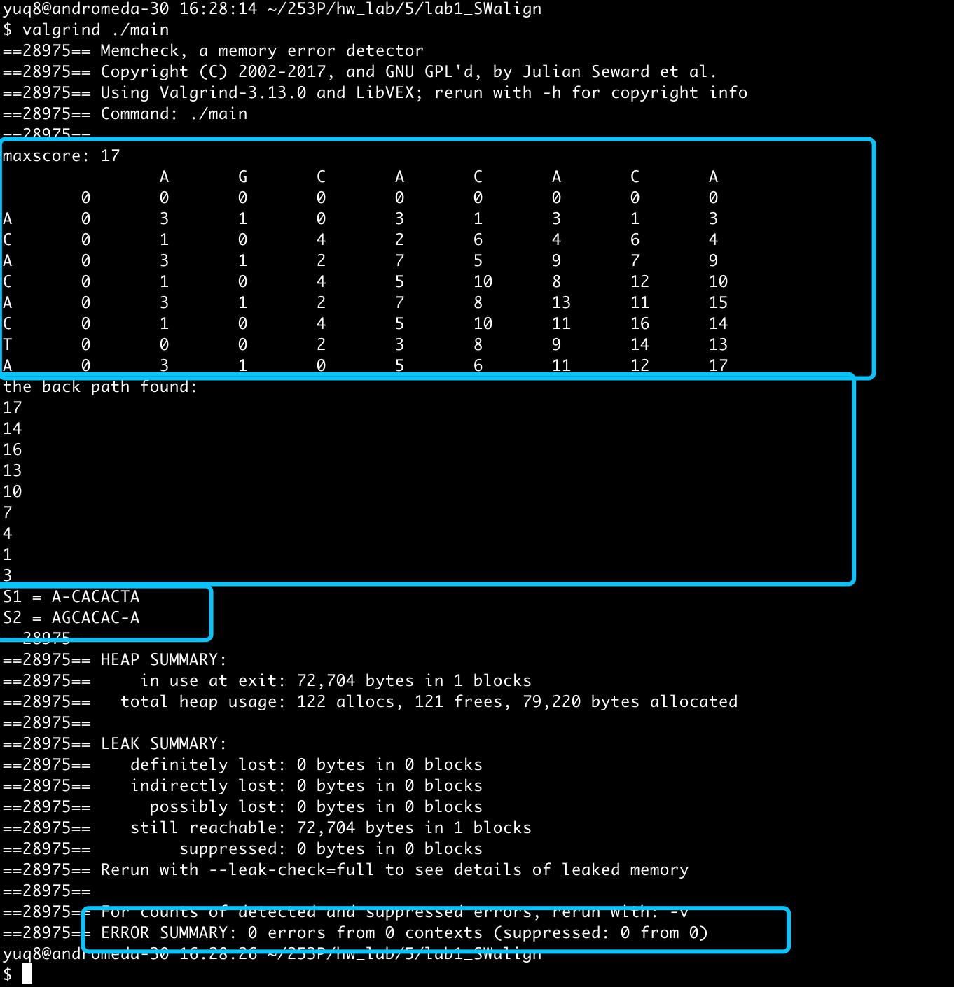

test case 2:



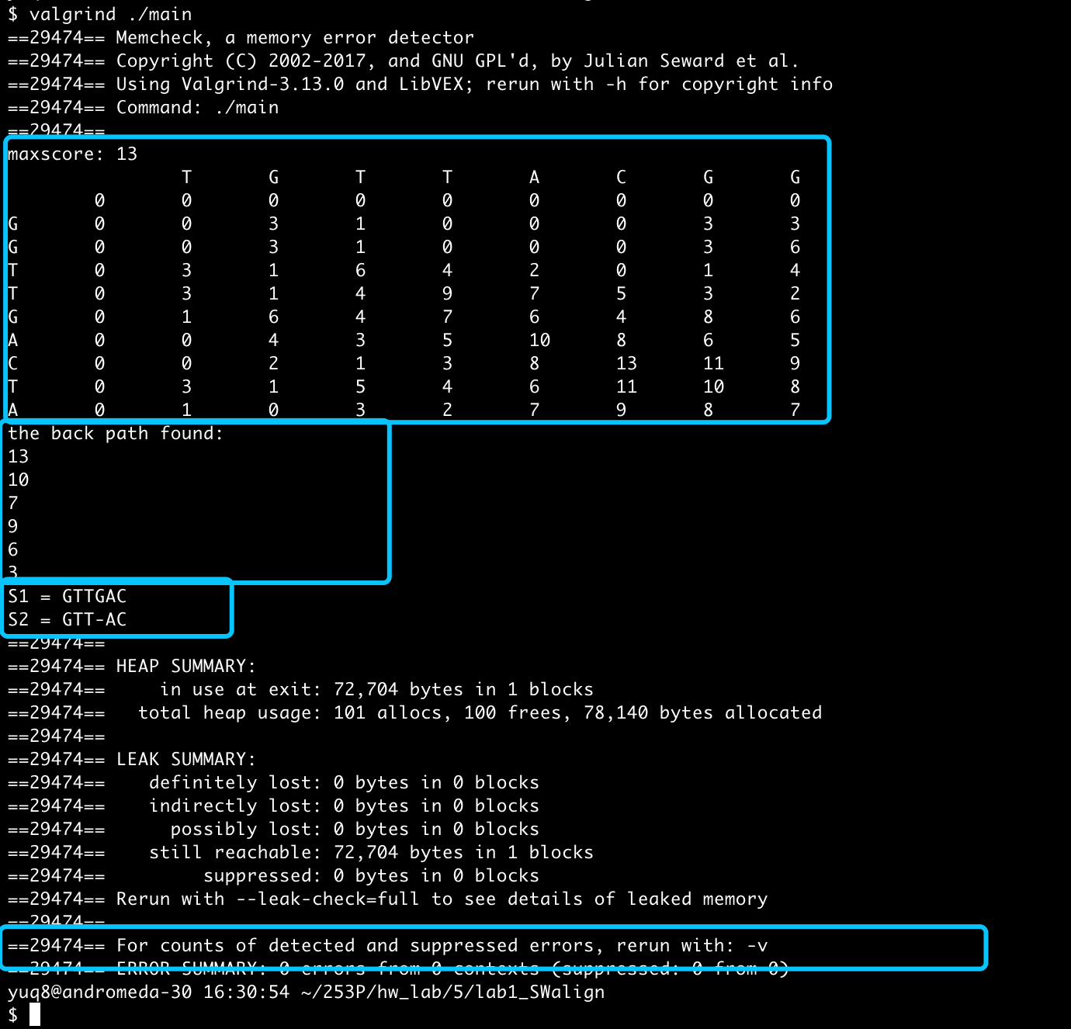

compare with the right answer:

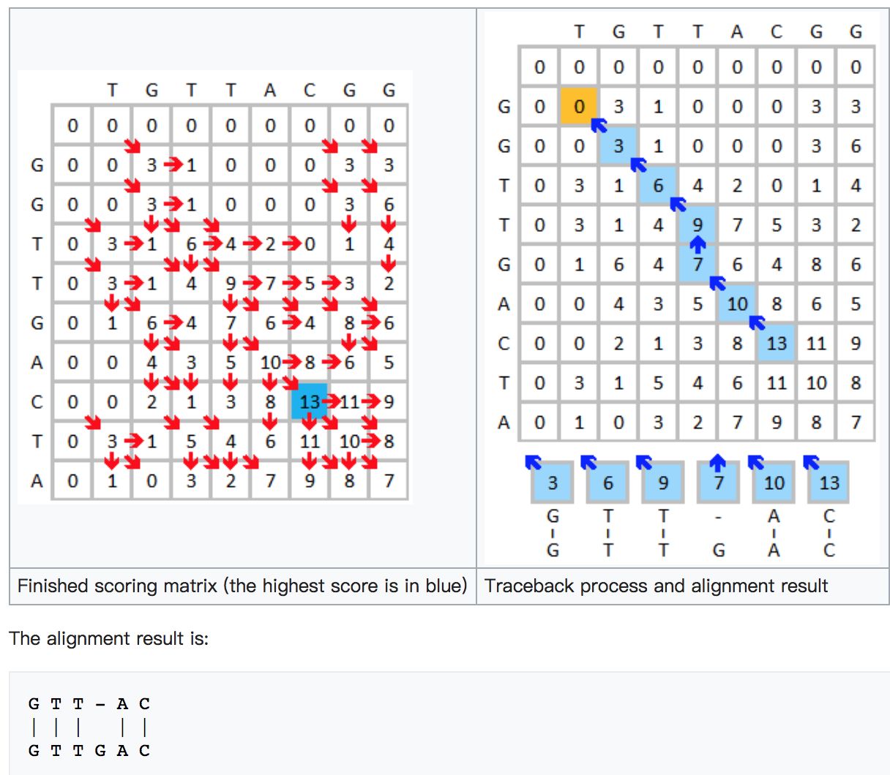

Conclusion: right result, 0 error in memory leak.

Little Notes:

1. Interesting and useful of DP.
2. The trace back method should be based on the feedforward, but in future work it may be simplified using memory since there are some common things.
3. S-W algorithm is different with N-W algorithm. I think future hw could be put them together as 2 problems.

# Lab 2: Levenshtein distance

Test cases 1, 2, 3:

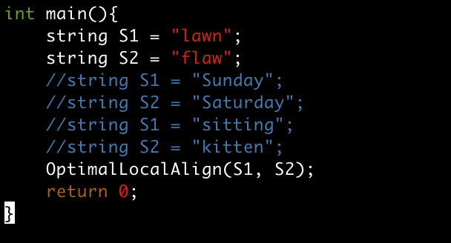

Test case 1:

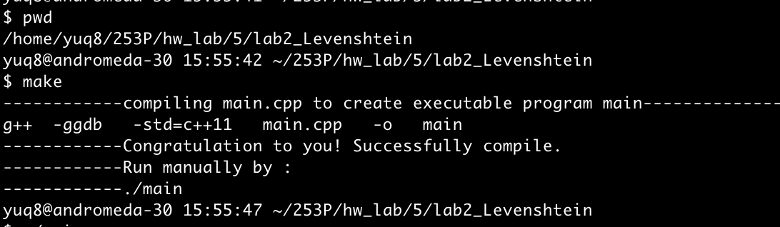

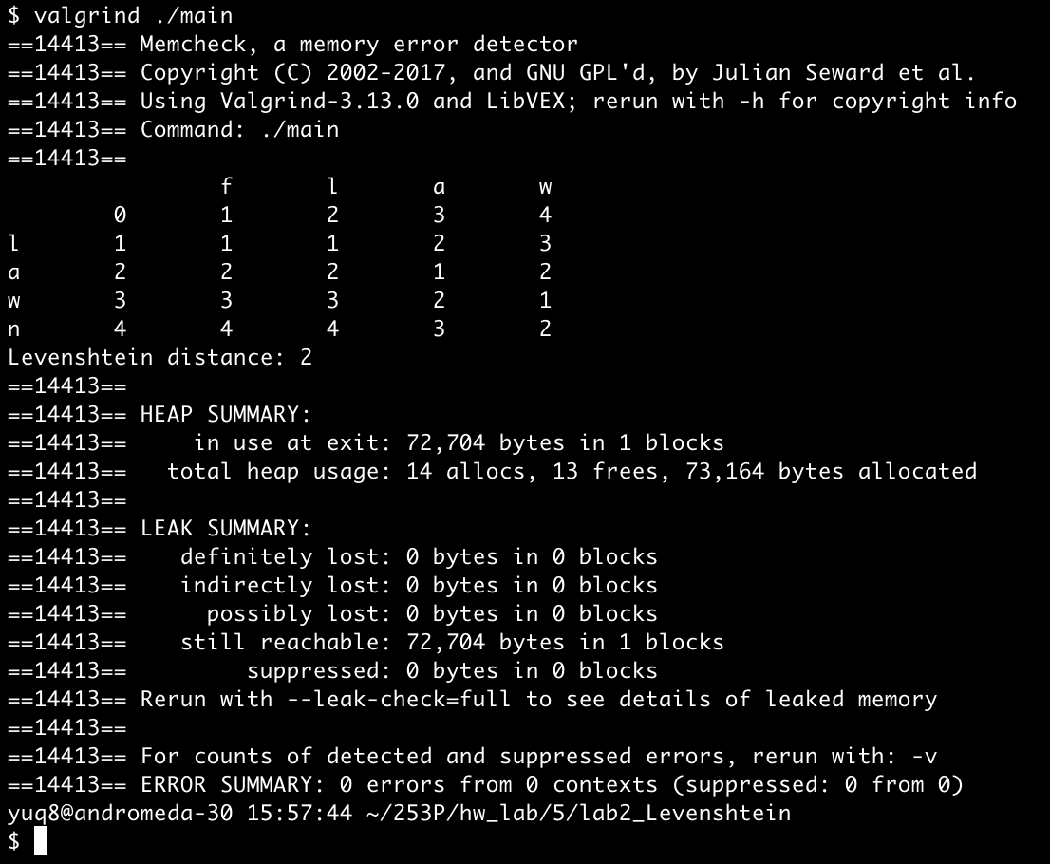

Test case 2:

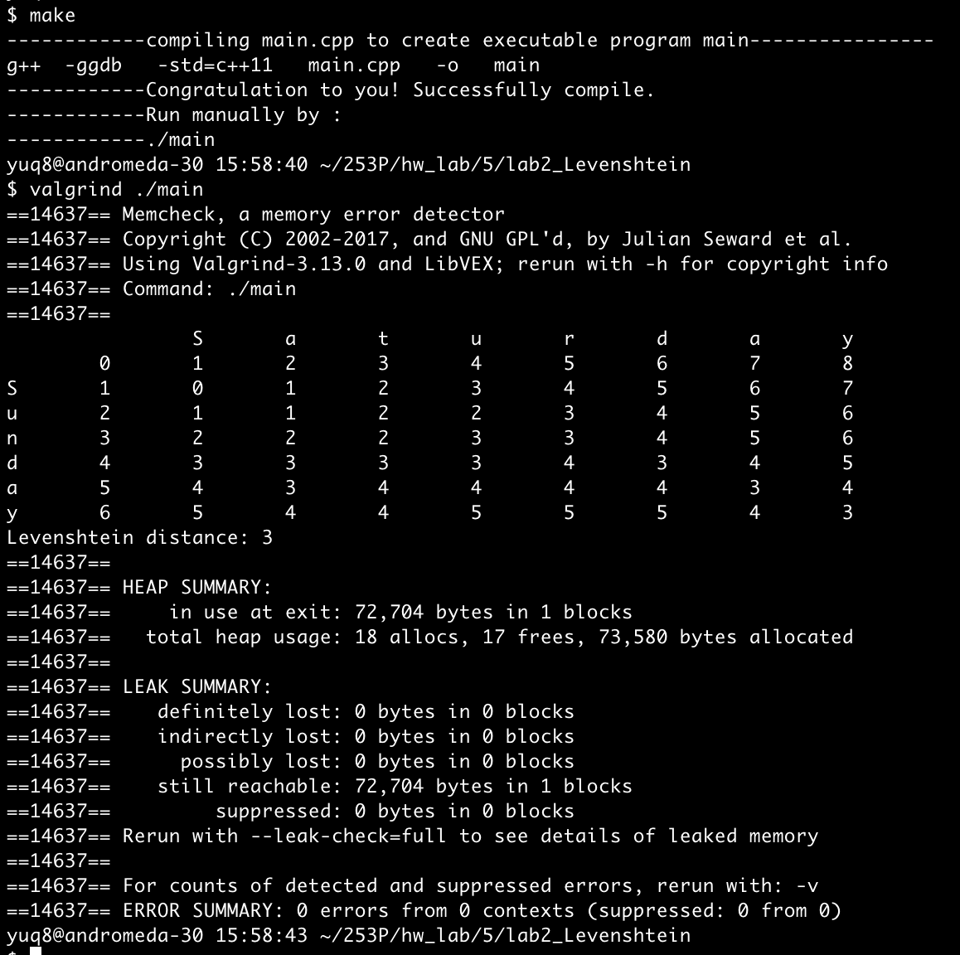

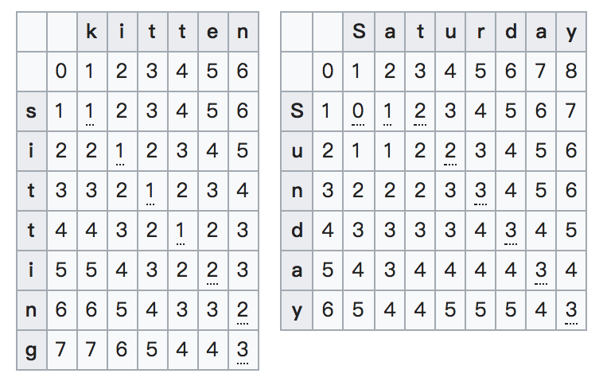

Test case 3:

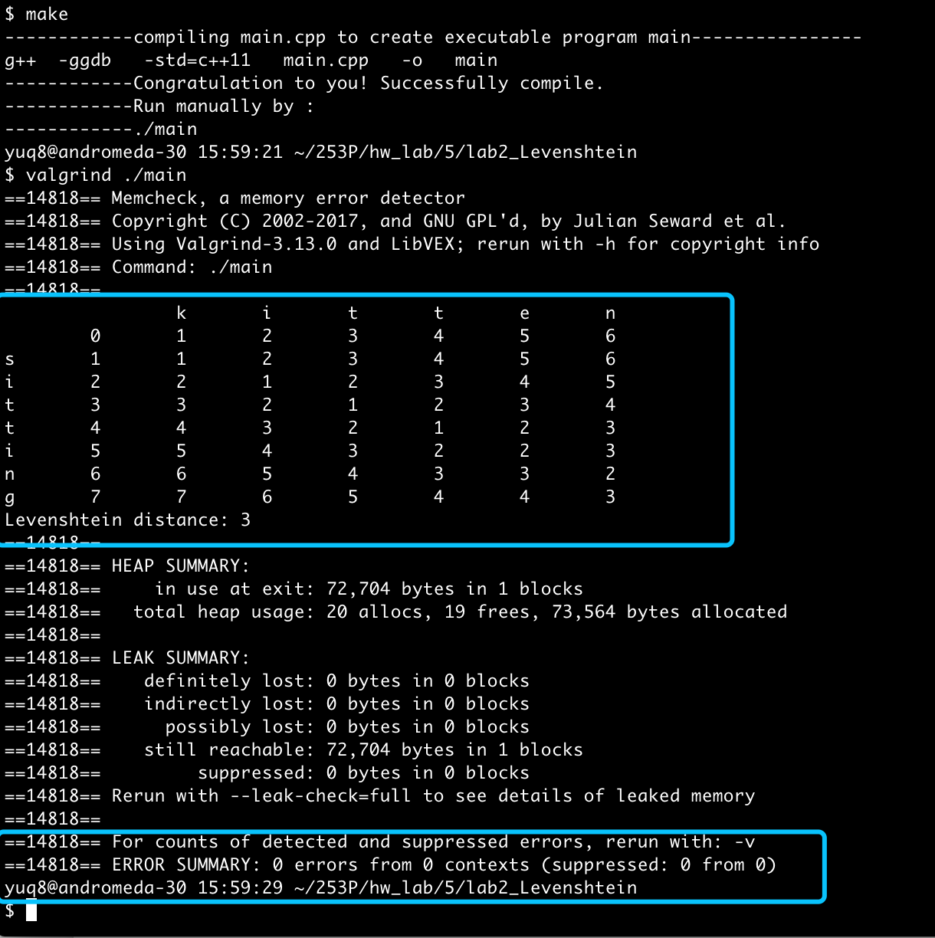

Conclusion: right result, 0 error in memory leak.

Little Notes:

1. Levenshtein distance allows for insertions, deletions or substitutions. With different allowable edit operation rules, other edit distance are :
   1. Hamming Distance: only substitution, hence, it only applies to strings of the same length.
   2. [Damerau–Levenshtein distance](https://en.wikipedia.org/wiki/Damerau%E2%80%93Levenshtein_distance): allows insertion, deletion, substitution, and the [transposition](https://en.wikipedia.org/wiki/Transposition_(mathematics)) of two adjacent characters;
   3. [longest common subsequence](https://en.wikipedia.org/wiki/Longest_common_subsequence_problem) (LCS) distance: allows only insertion and deletion, not substitution;
   4. [Jaro distance](https://en.wikipedia.org/wiki/Jaro_distance): allows only [transposition](https://en.wikipedia.org/wiki/Transposition_(mathematics))
2. Levenshtein distance is mainly for short strings in many longer texts, for instance, spell checkers, correction systems for optical character recognition, and software to assist natural language translation based on translation memory. For long comparison, the compared strings are usually shortened to help improve speed of comparisons, eg. fuzzy string searching in applications such as record linkage.

# Lab3:

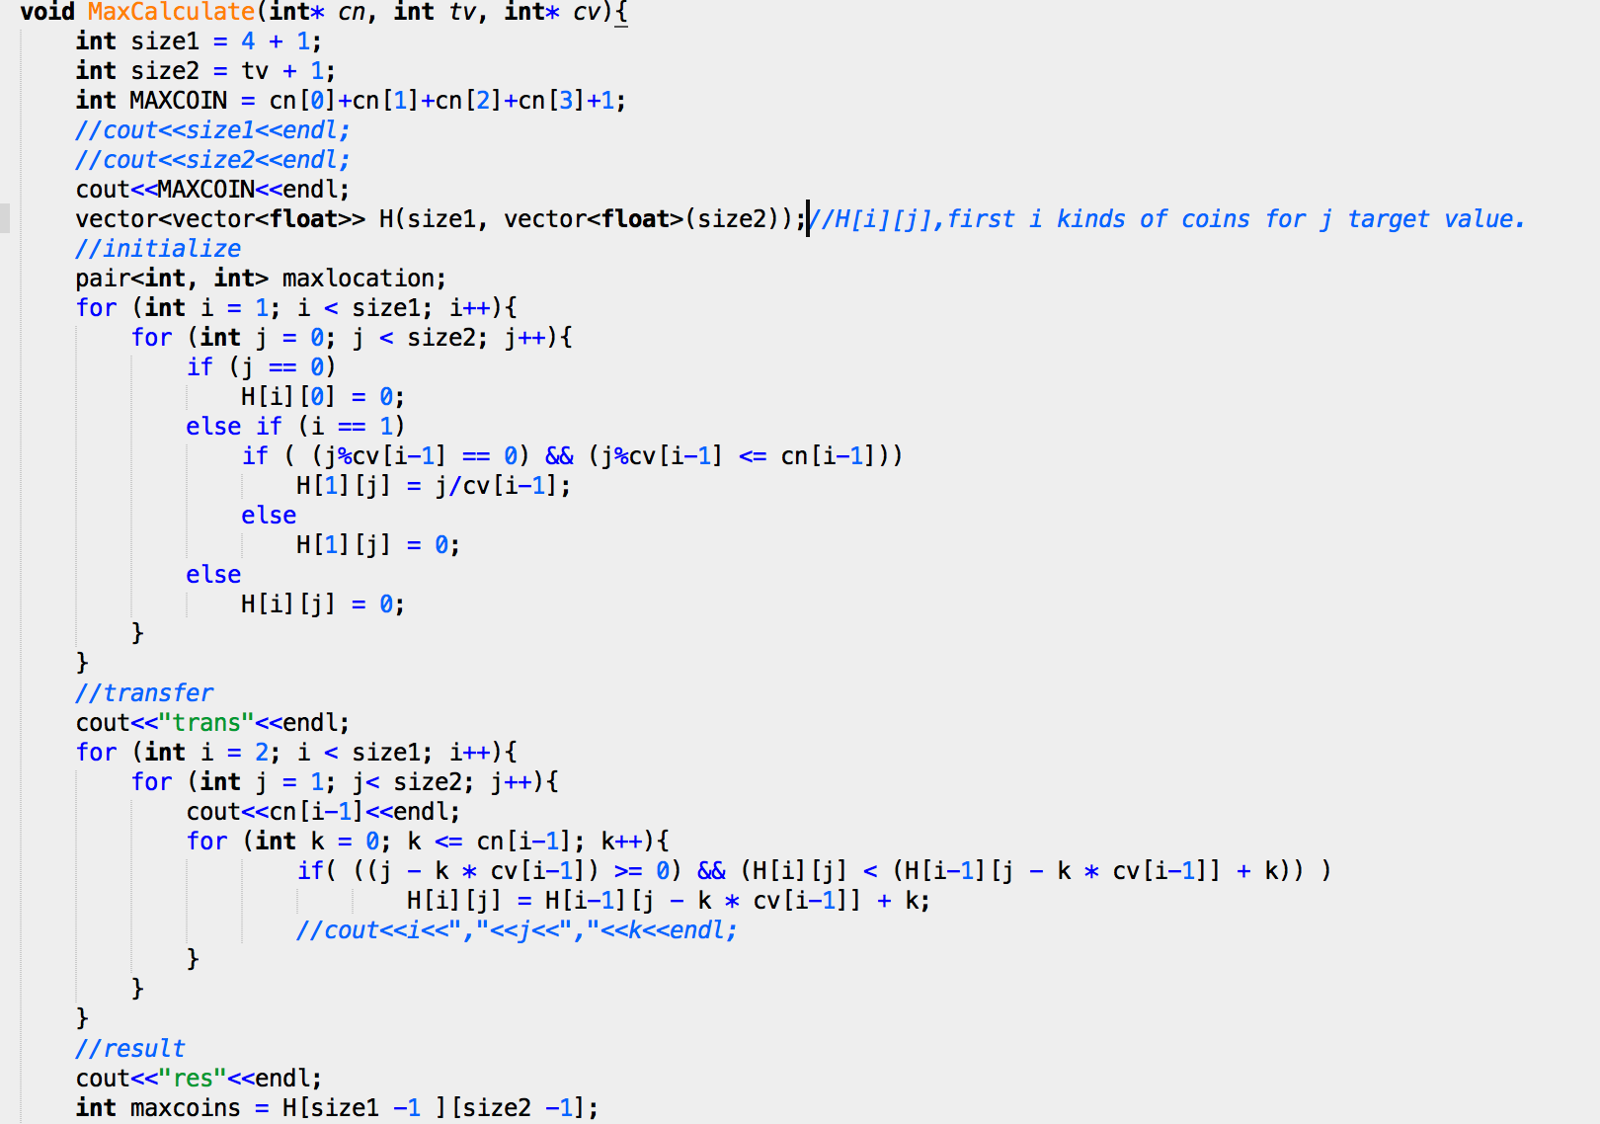

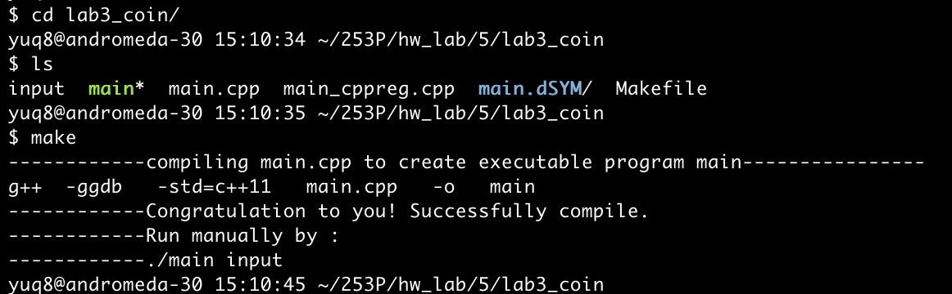

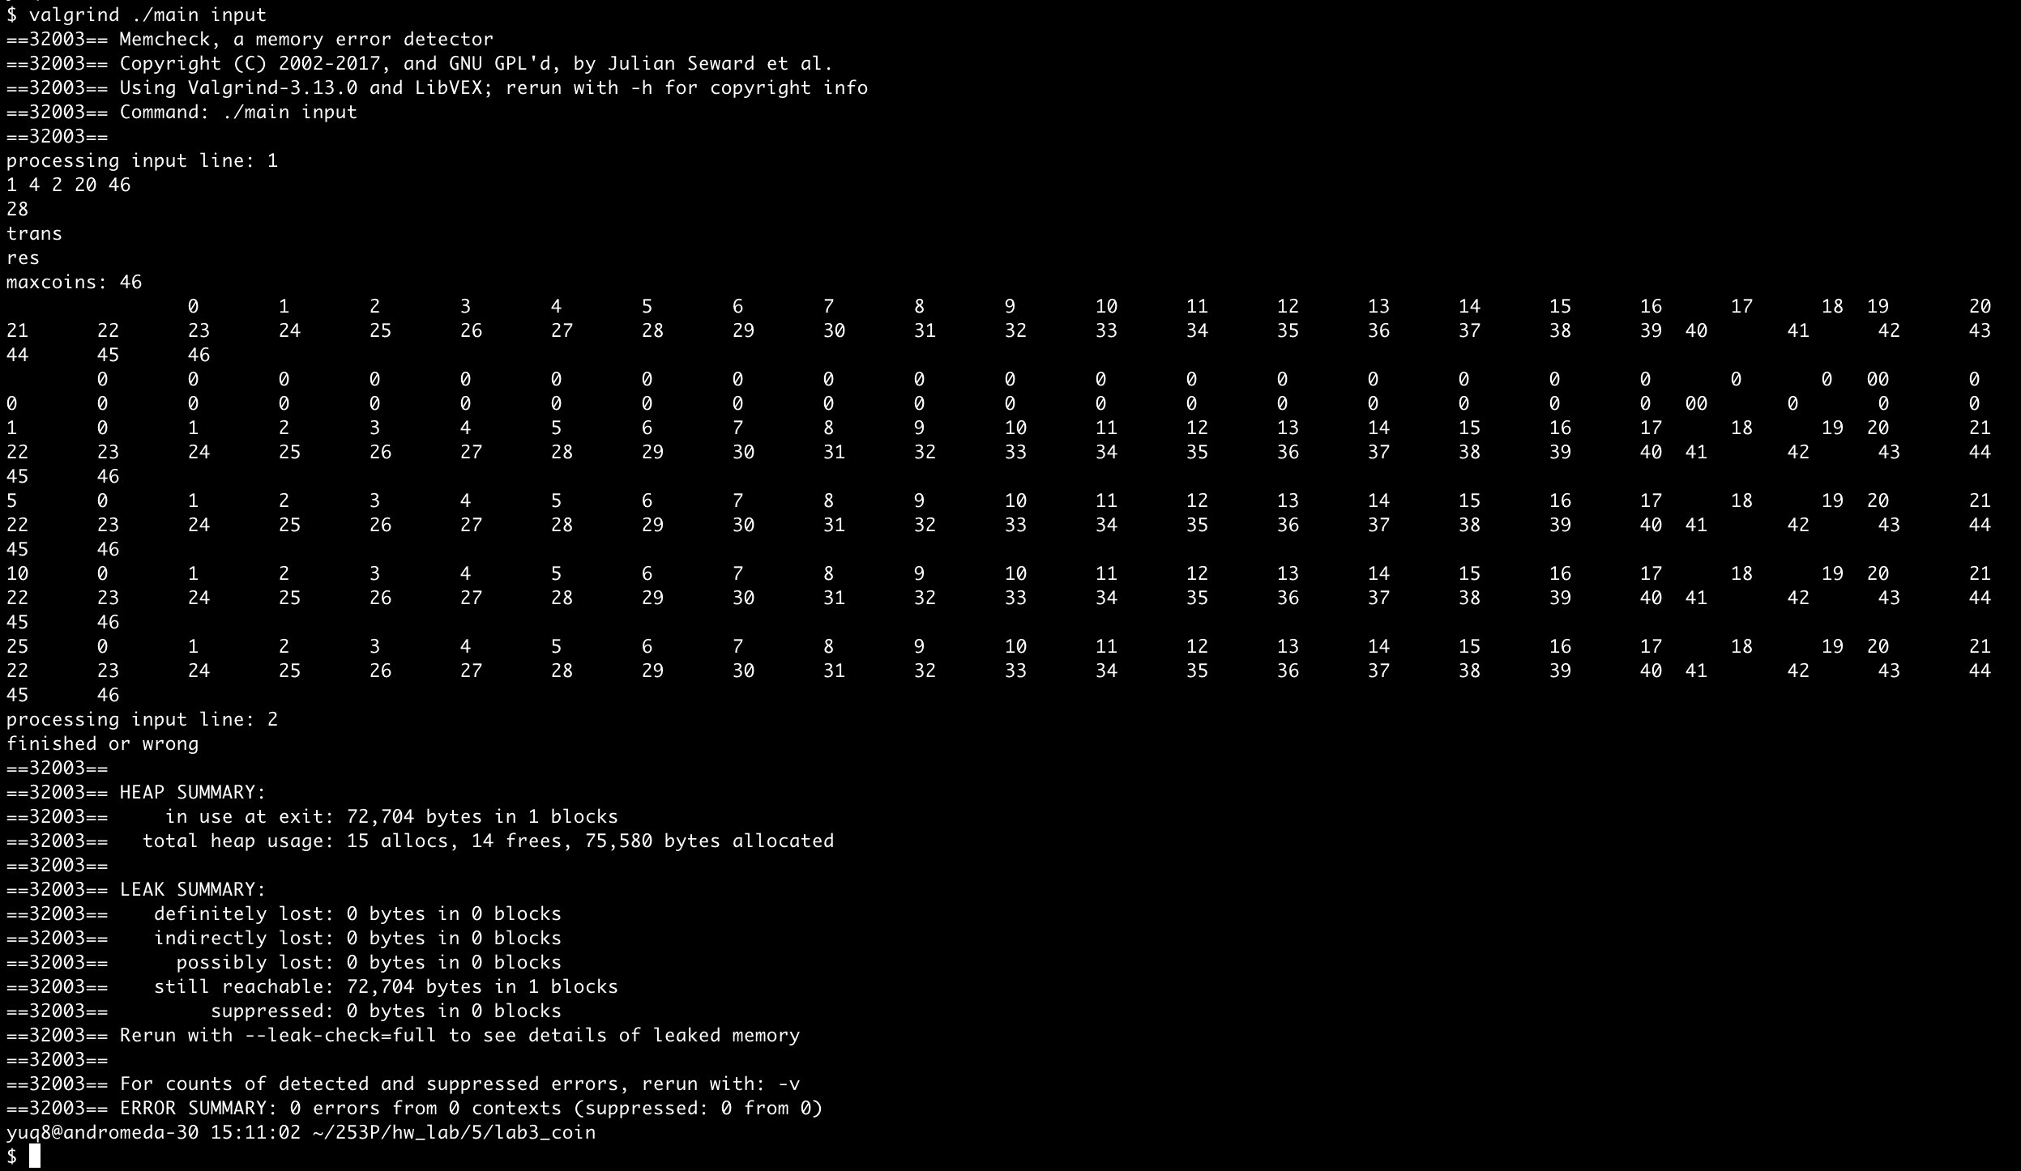

Conclusion: right result, 0 error in memory leak.

Little Notes:

1. Different parameters for min, max coin numbers.
2. There’s something not finished, I’d like to finish it in some time.