**HW [7], [2/28/2019] MCS 253P**

**Name: Yu Qin**

**Results Screenshots**

===========================start of the write-up====================

# **MCSOS**

There are many parts of java scripts in the OS:

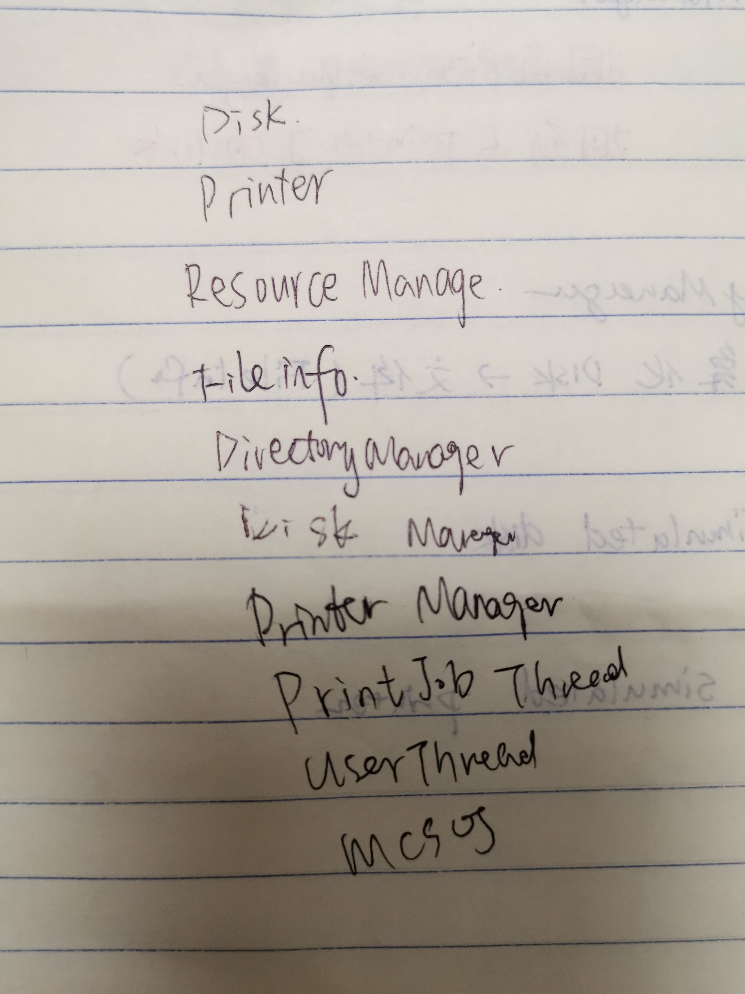

and when javac them all:

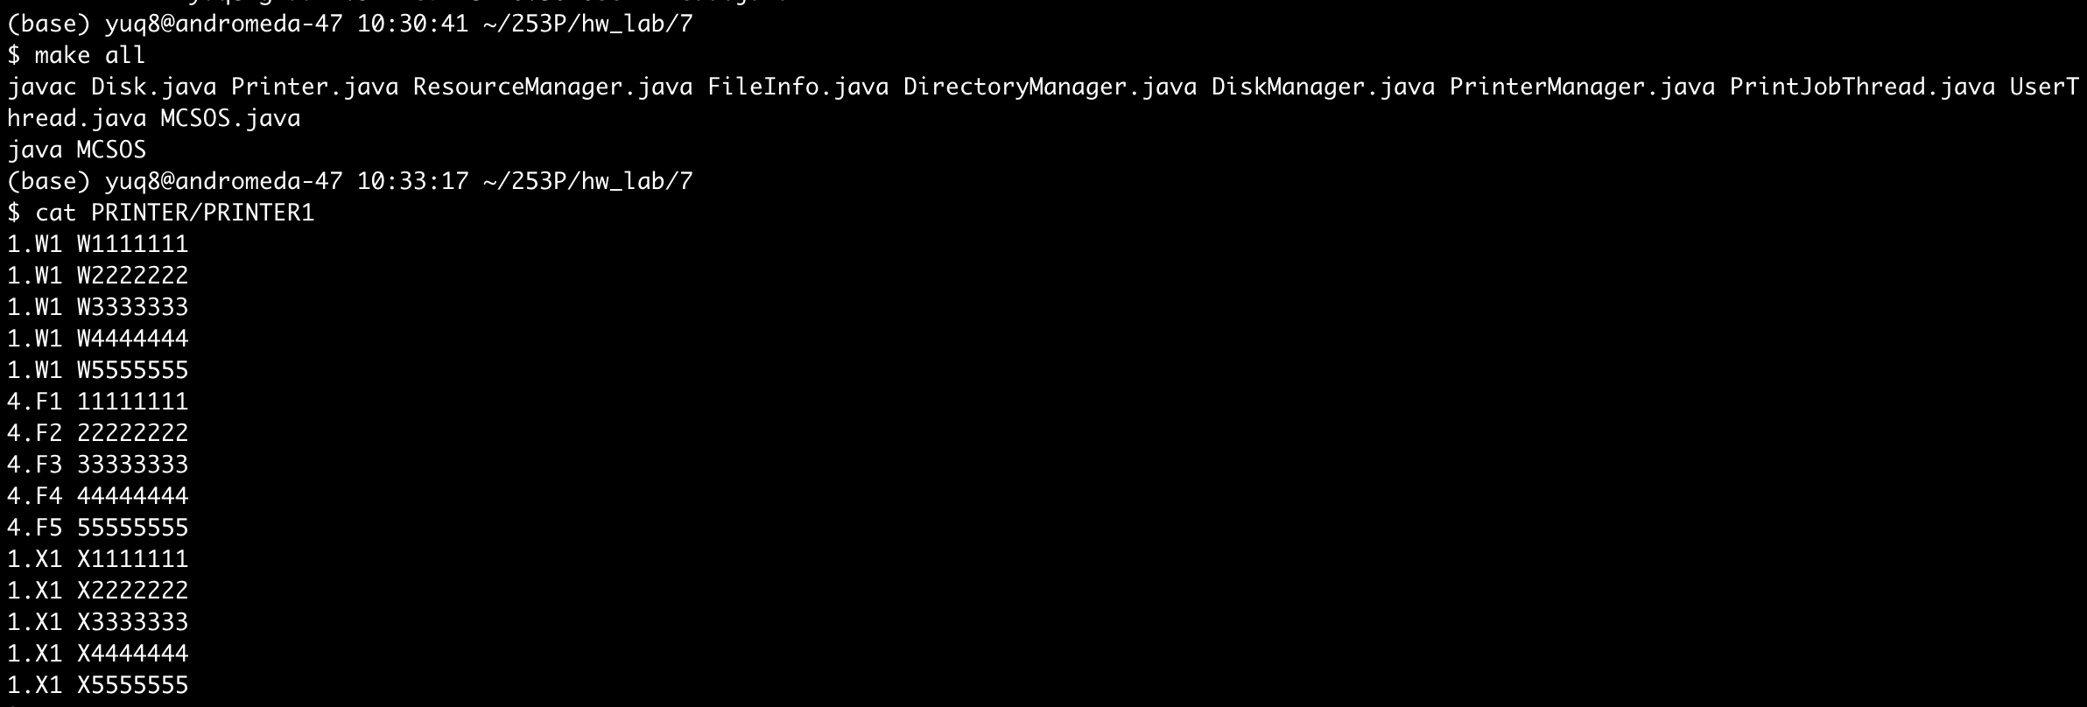

the output is the printers are as following:

