**HW [8], [3/7/2019] MCS 253P**

**Name: Yu Qin**

**Results Screenshots**

===========================start of the write-up====================

# **Lab 1: K-Cluster**

Code:

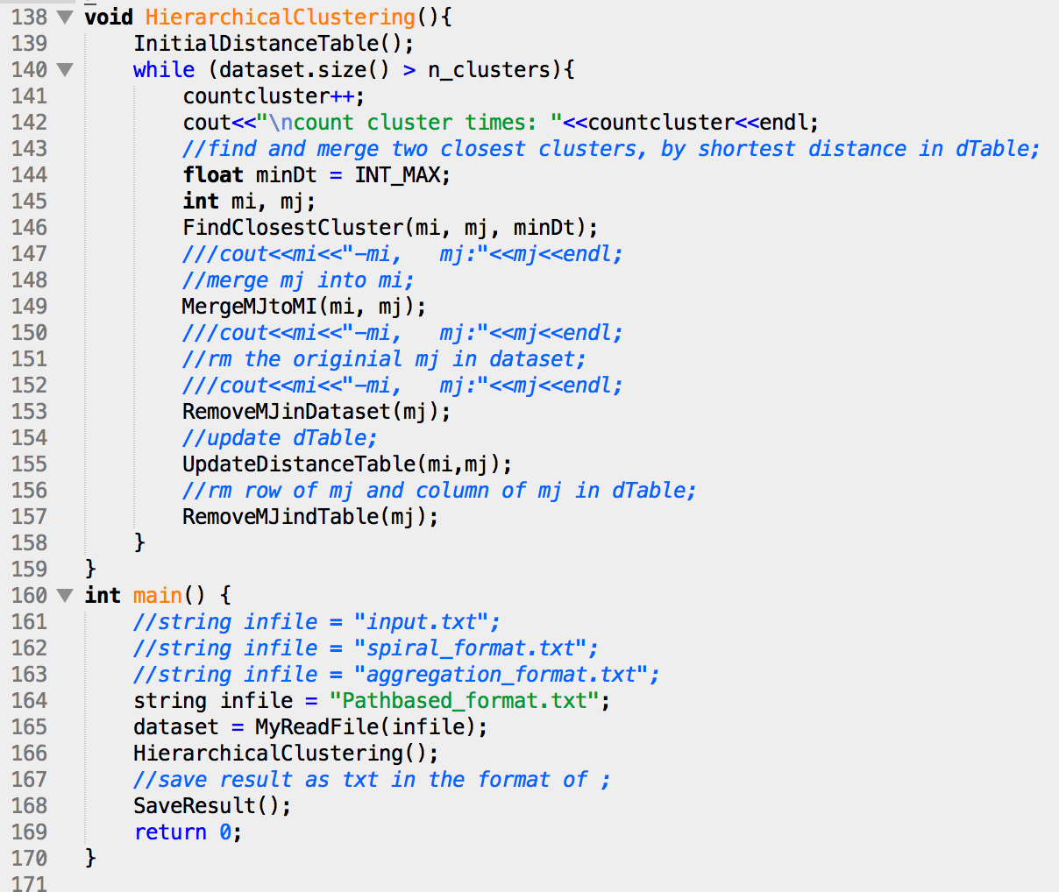

test case 1 and 2: with the std input given by prof, but different clusters of 2 and 3:

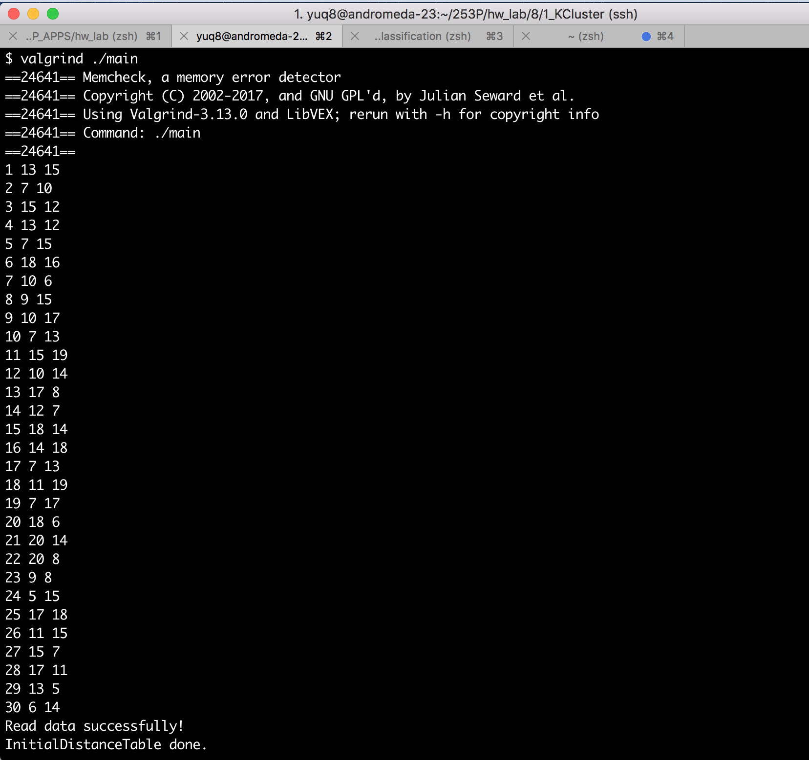

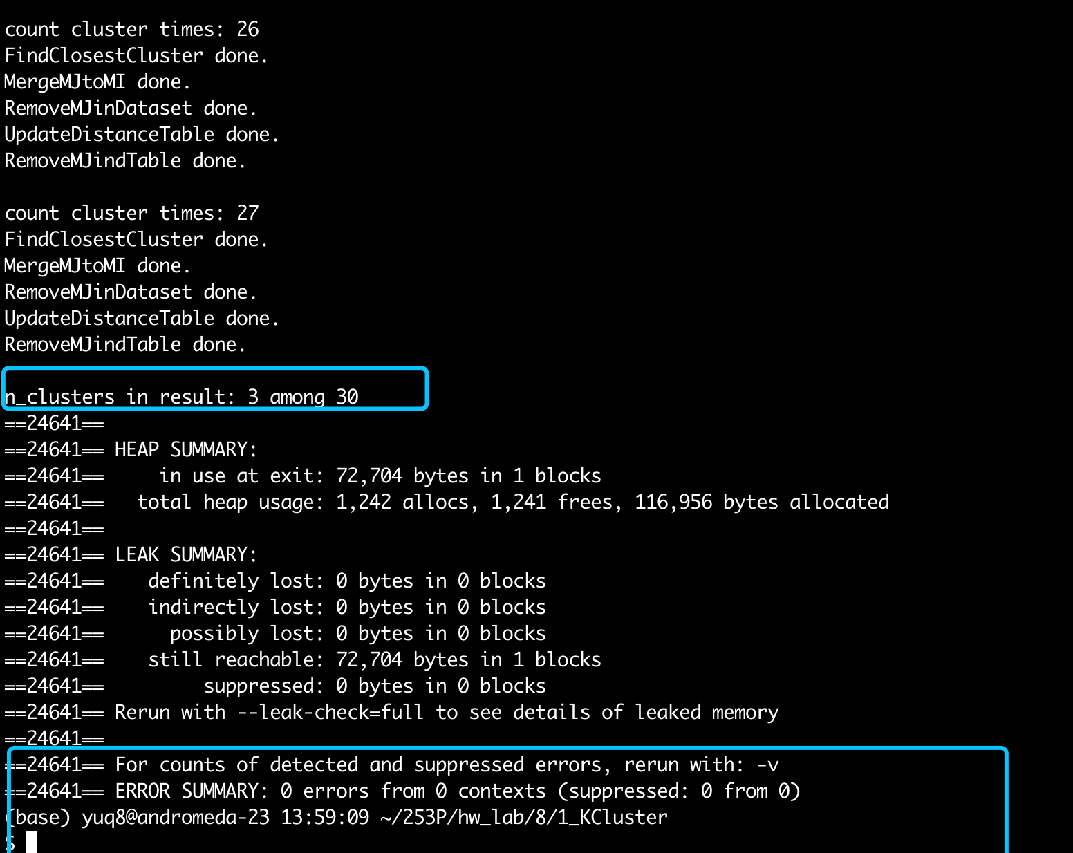

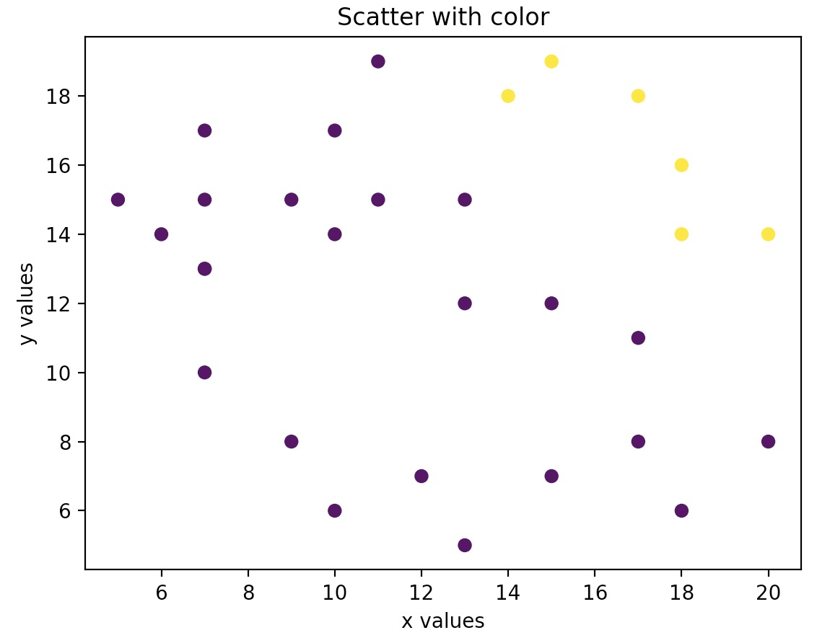

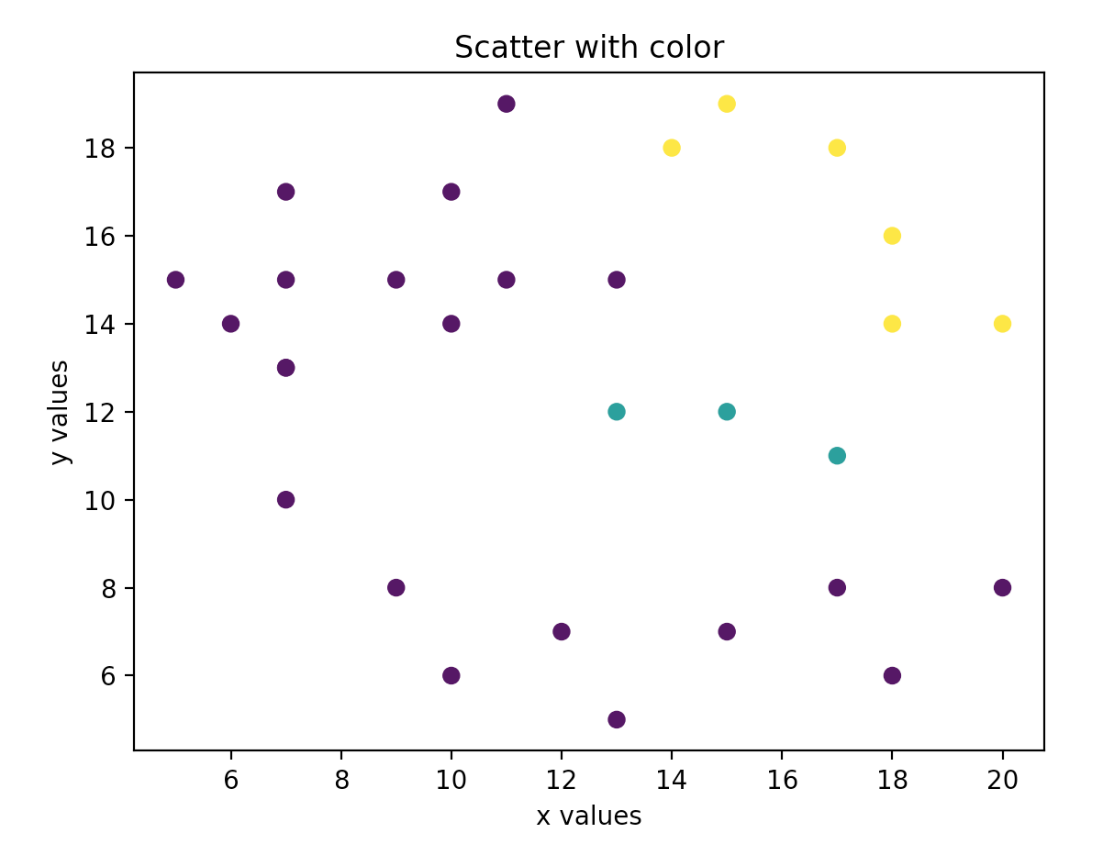

Stepping further, I find some test set in : <http://cs.joensuu.fi/sipu/datasets/> , for example:

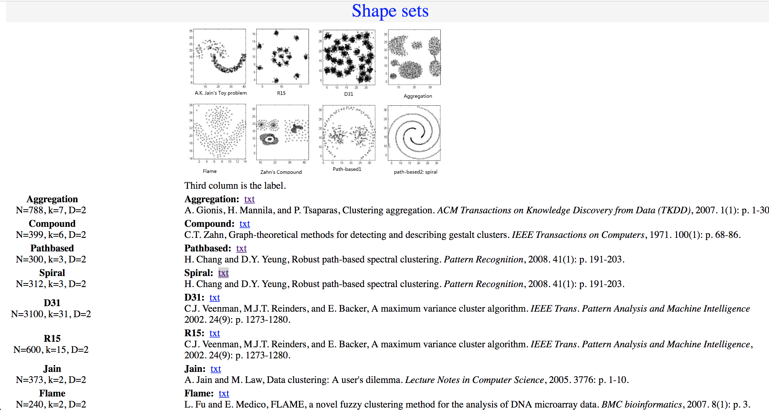

and I transferred them to the desires format as our std input:

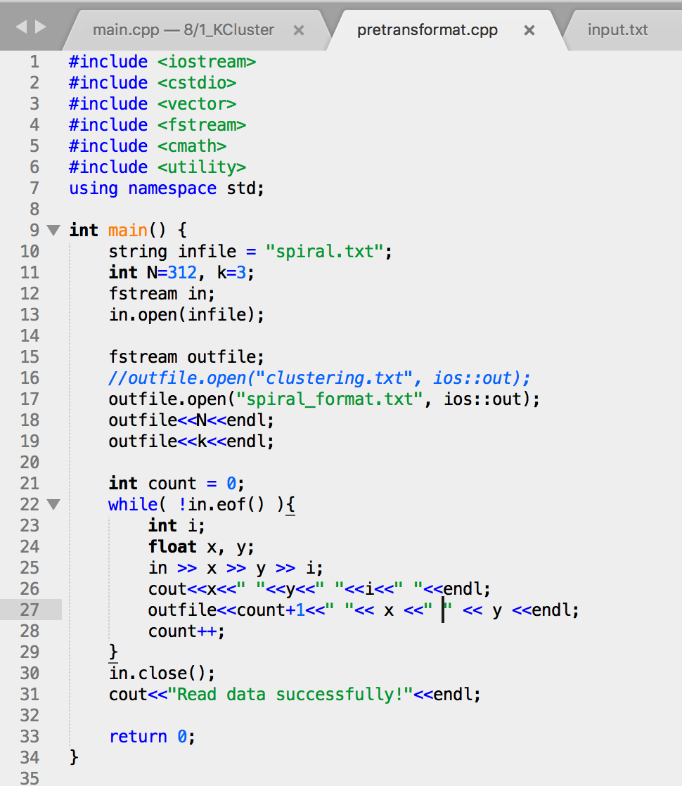

and the testcase 3 result are as follow:

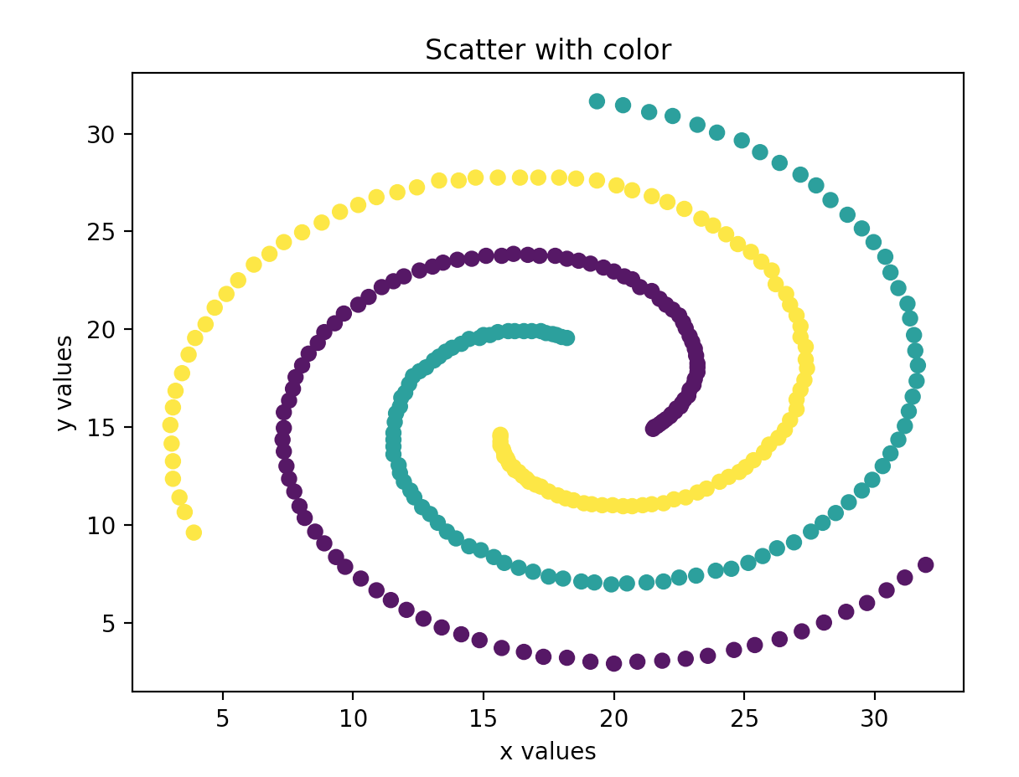

Conclusion: right result, 0 error in memory leak.

Little Notes:

1. The different clustering critierion will make different results, like shortest, mean, longest.

# Lab 2: closest product pair

Code:

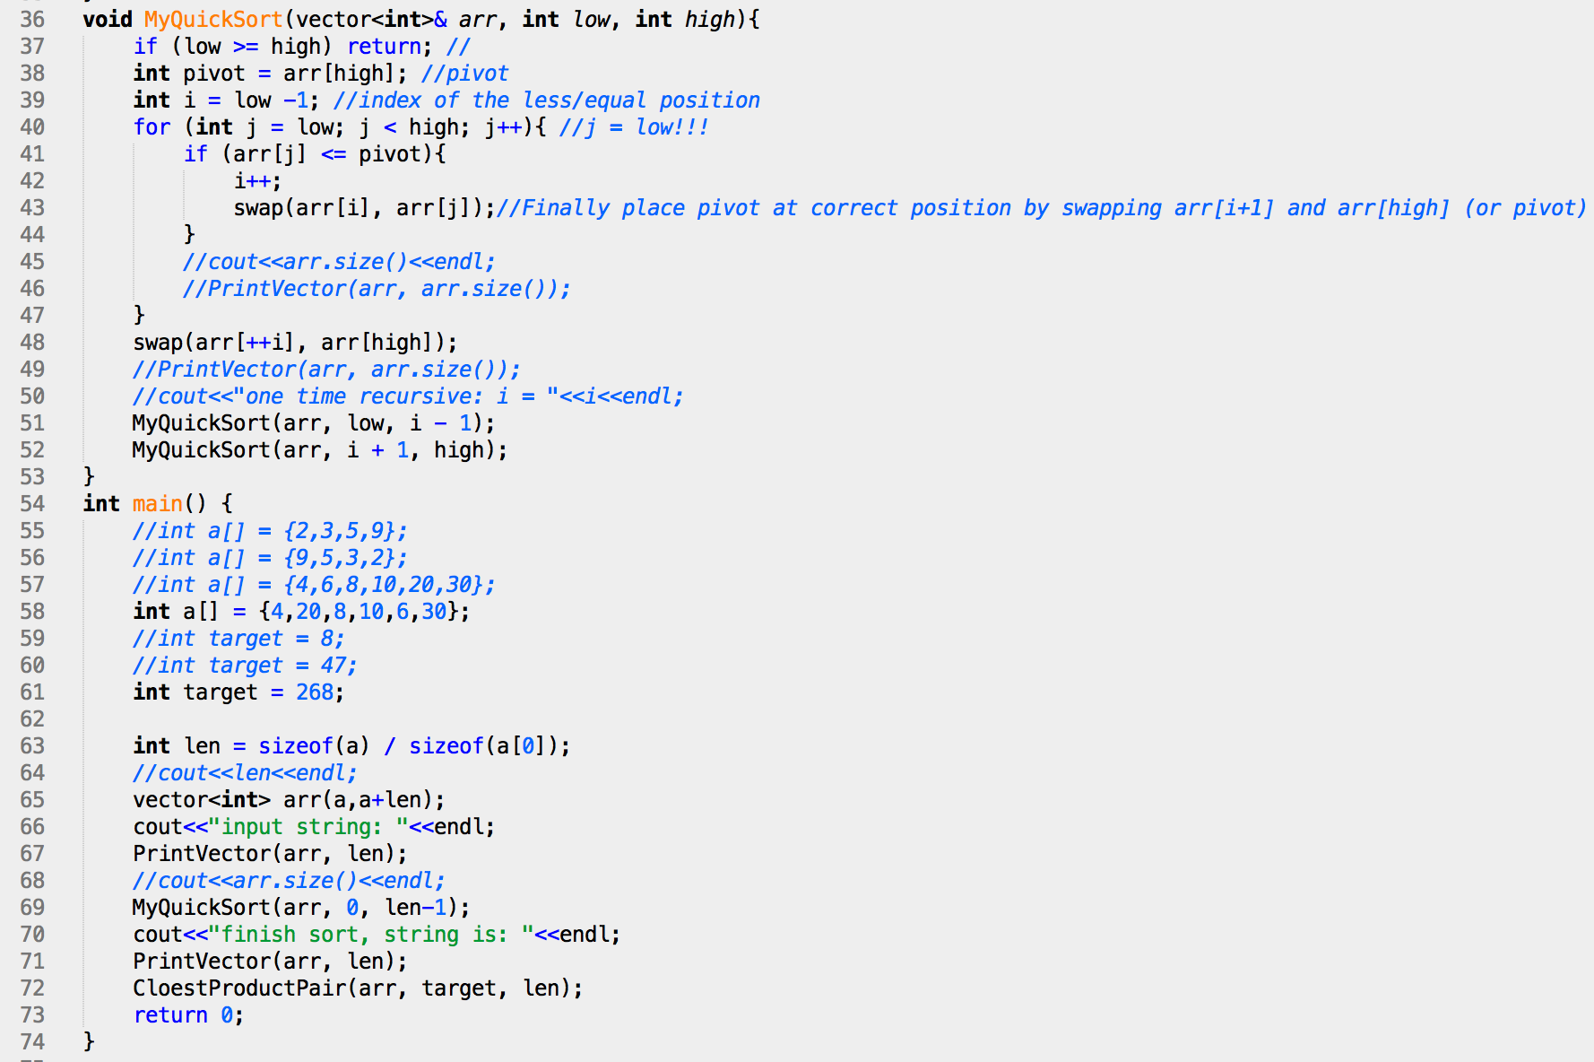

Test cases 1, 2, 3 :

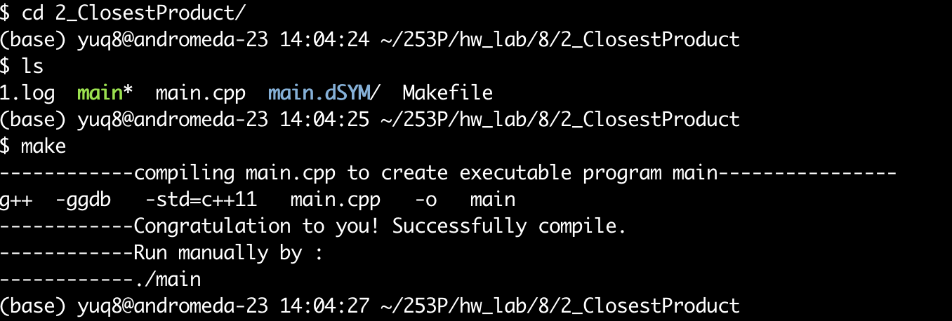

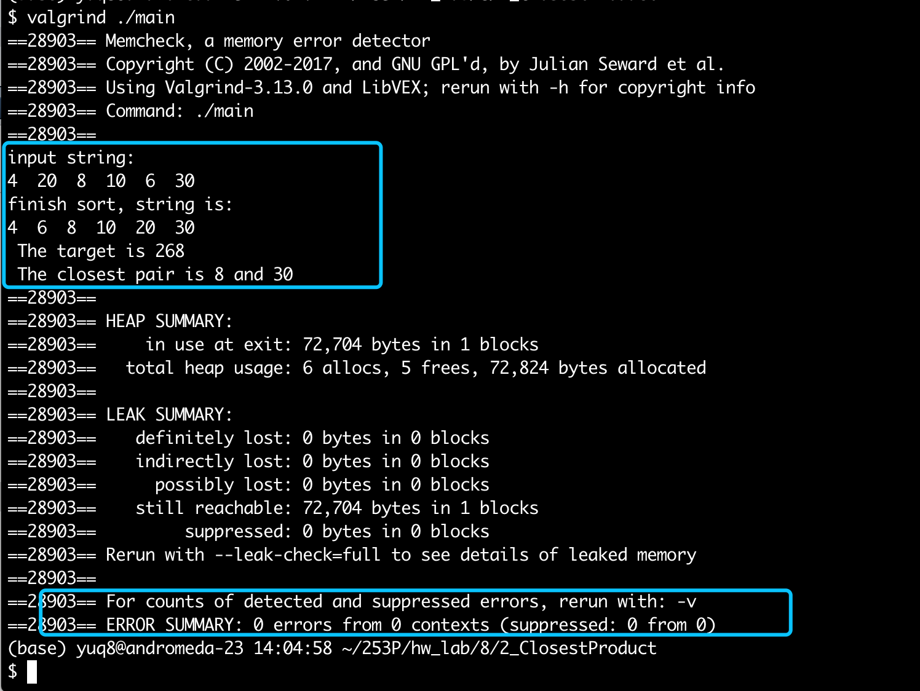

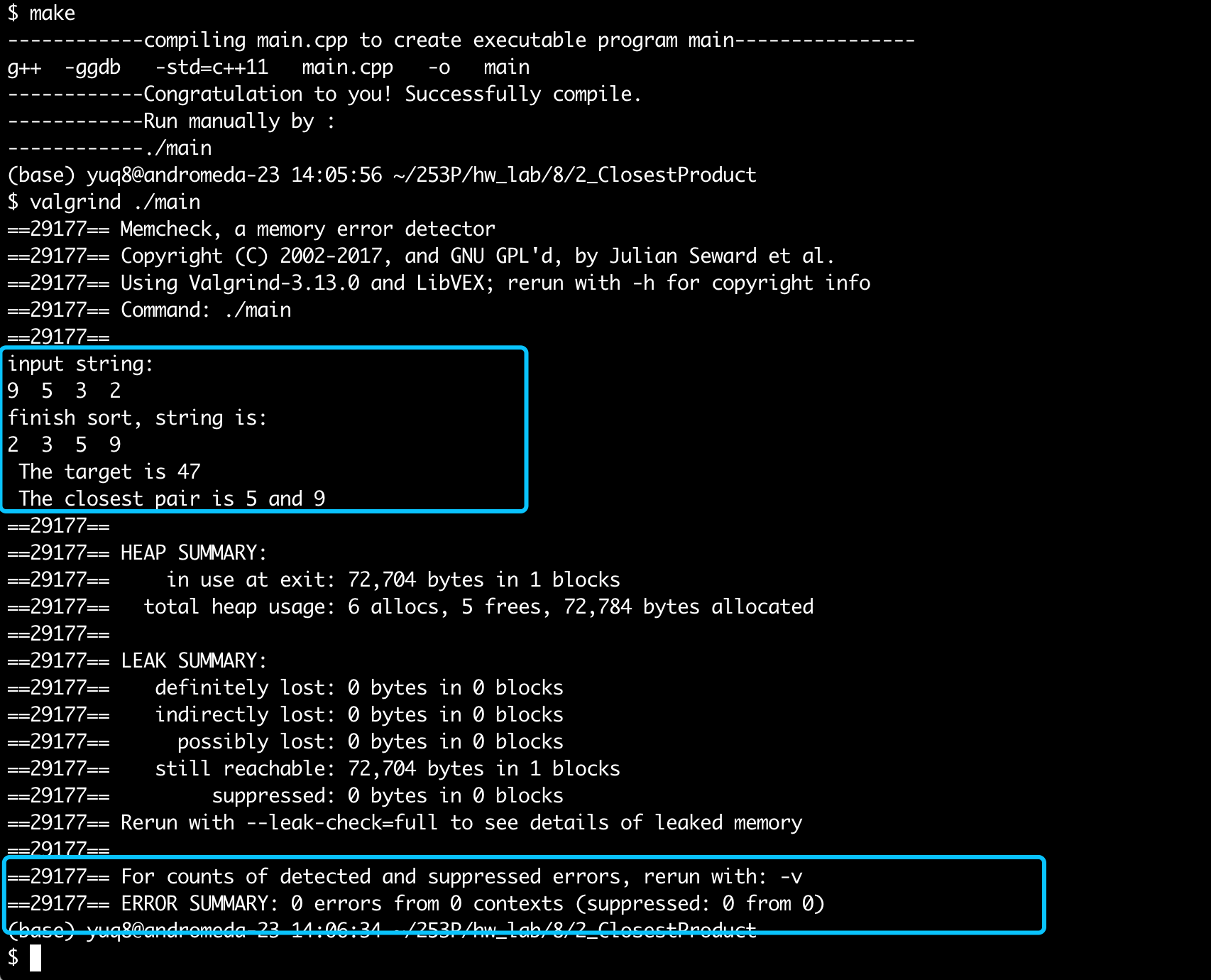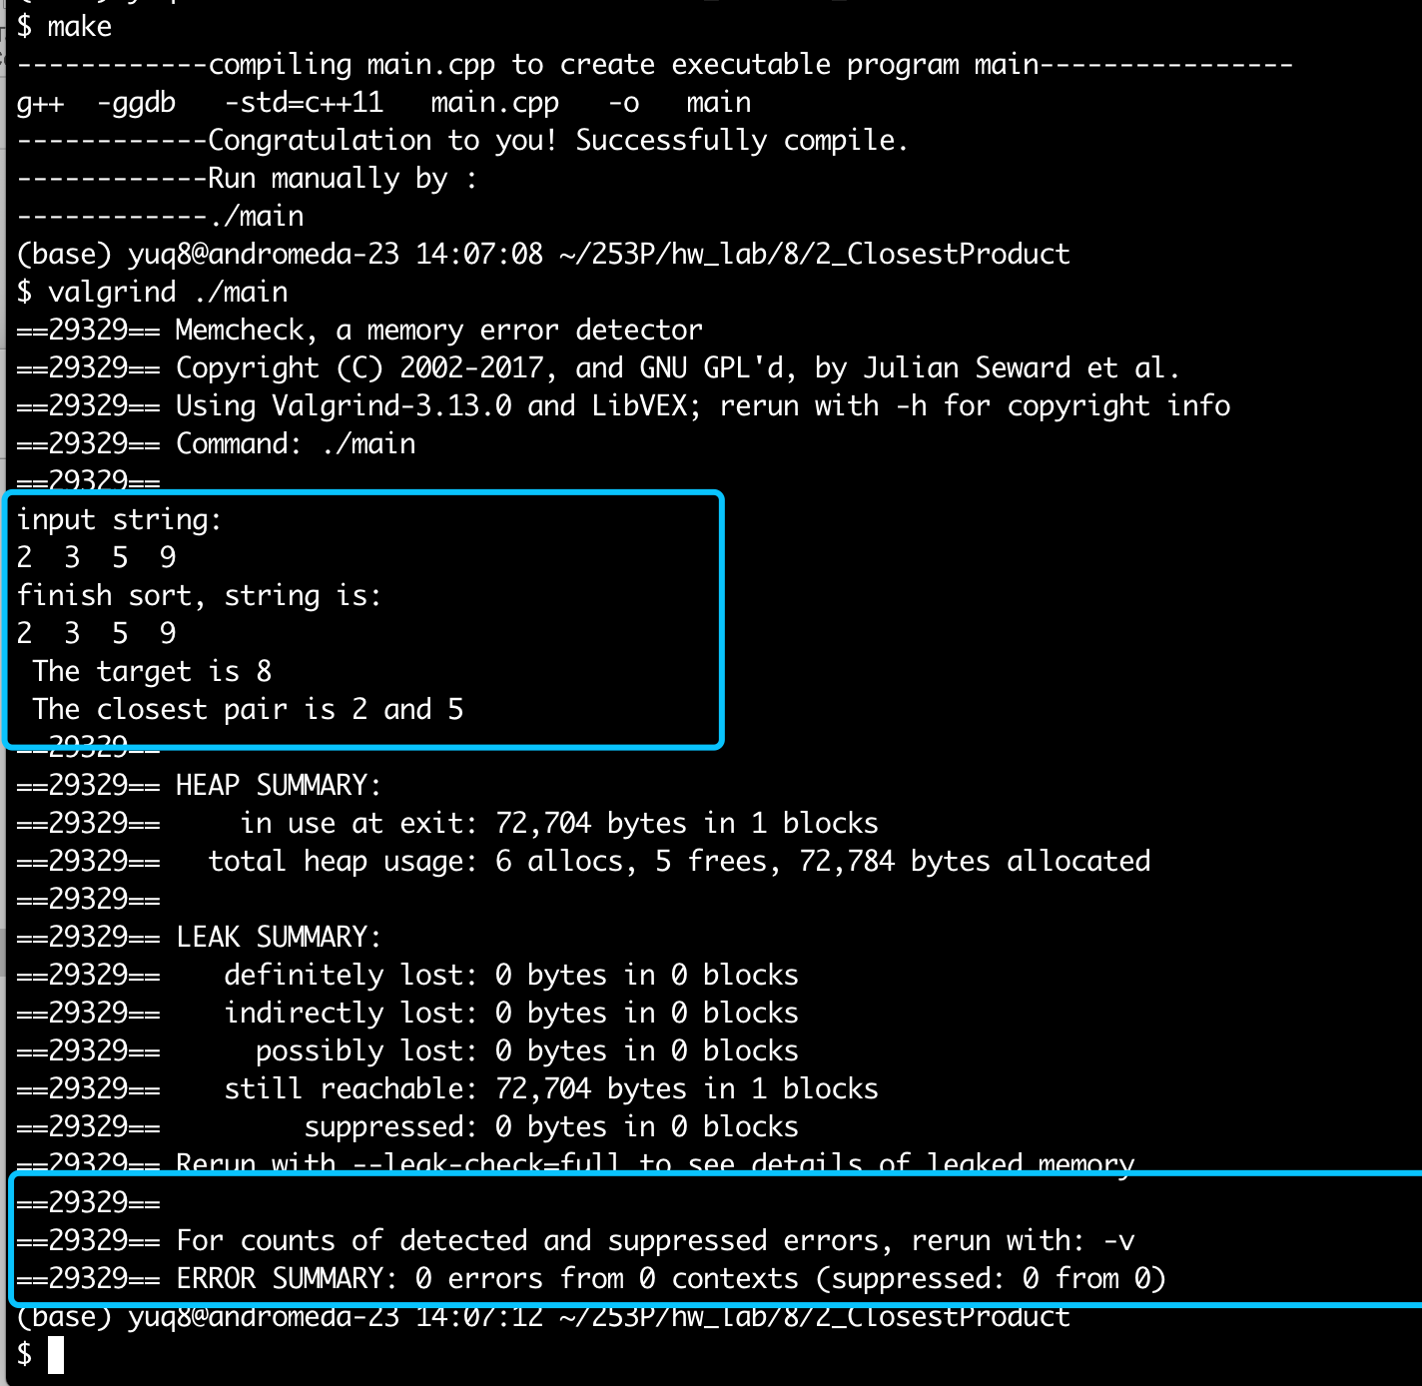

Conclusion: right result, 0 error in memory leak.

Little Notes:

1. At this lab, when encountered with the same diff distance, the results are given by larger distance. Furthur work can be done to output both.

# Lab4:Longest K

**Code：**

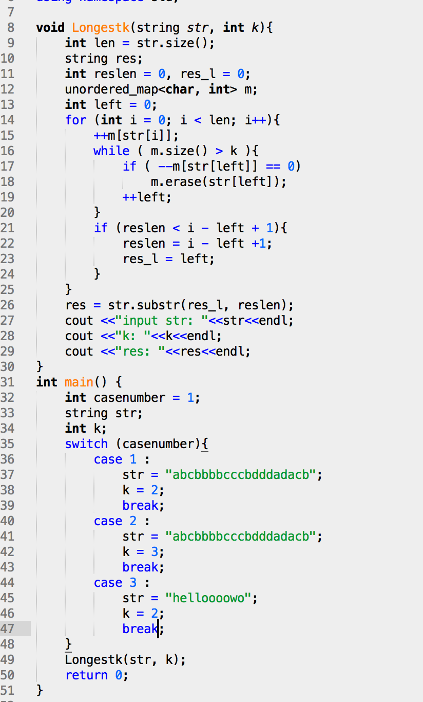

**test cases 1,2, 3:**

