**HW [9], [3/14/2019] MCS 253P**

**Name: Yu Qin**

**Results Screenshots**

===========================start of the write-up====================

# **Lab 1: Next permutation**

Code:

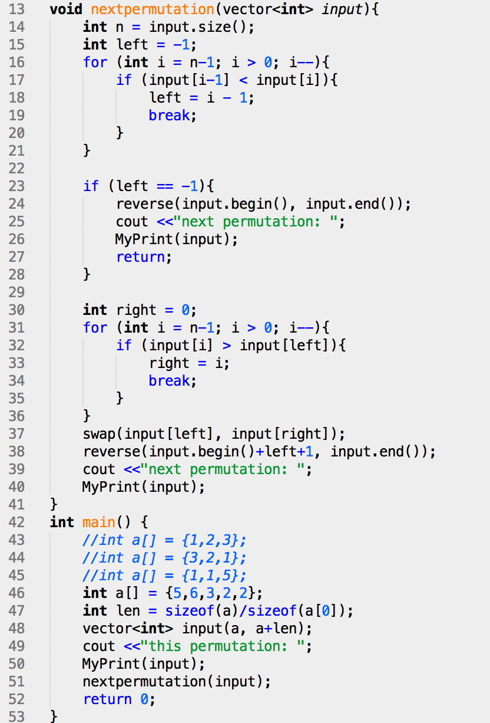

test case 1, 2 , 3, 4:

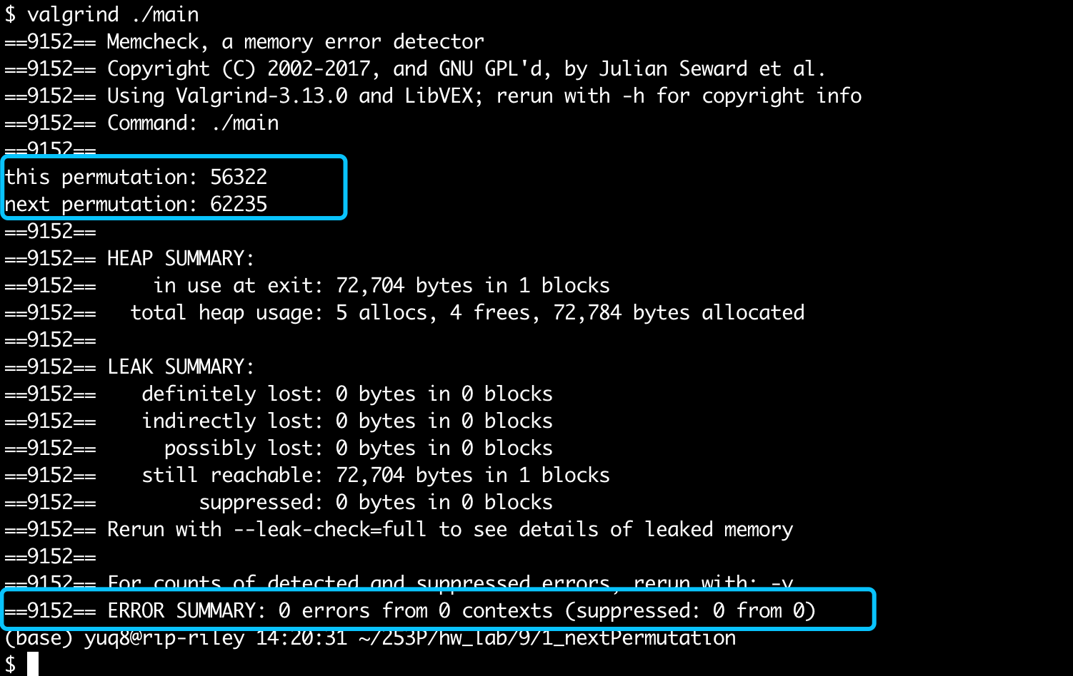

2:

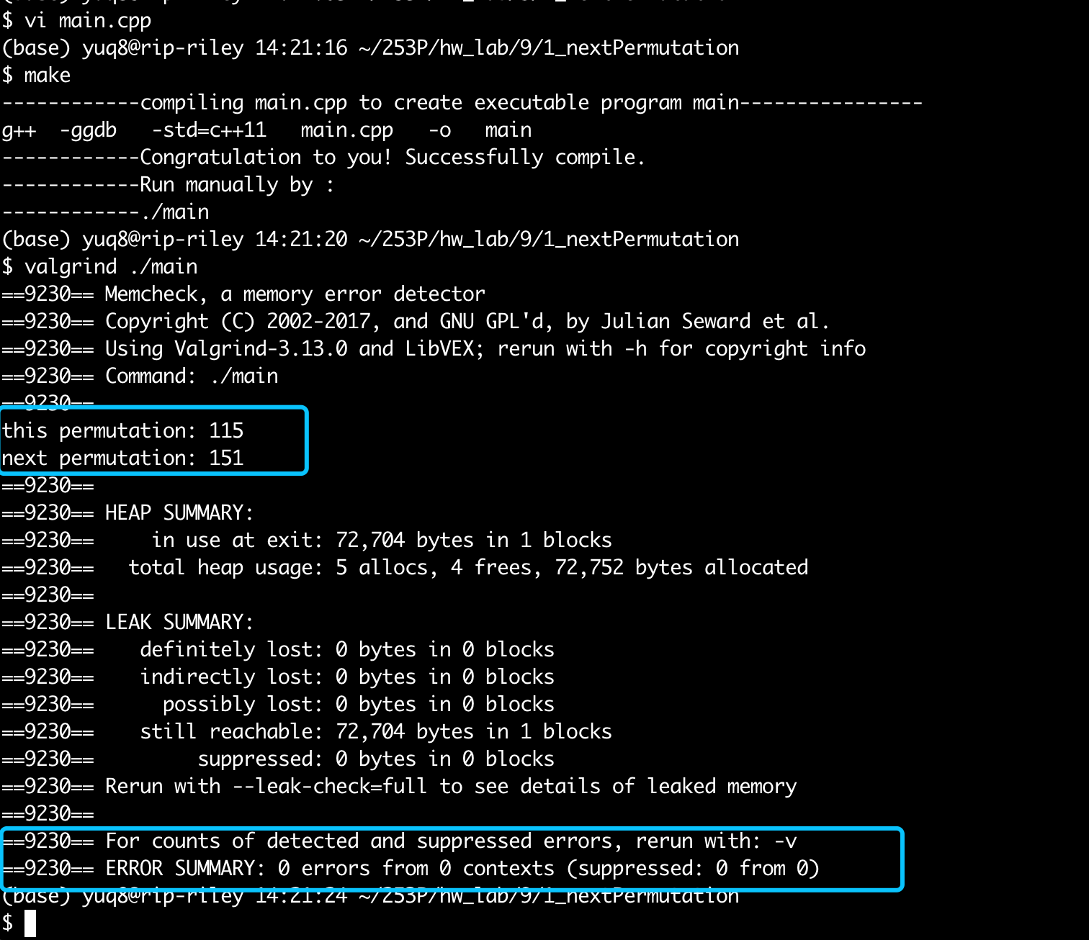

3:

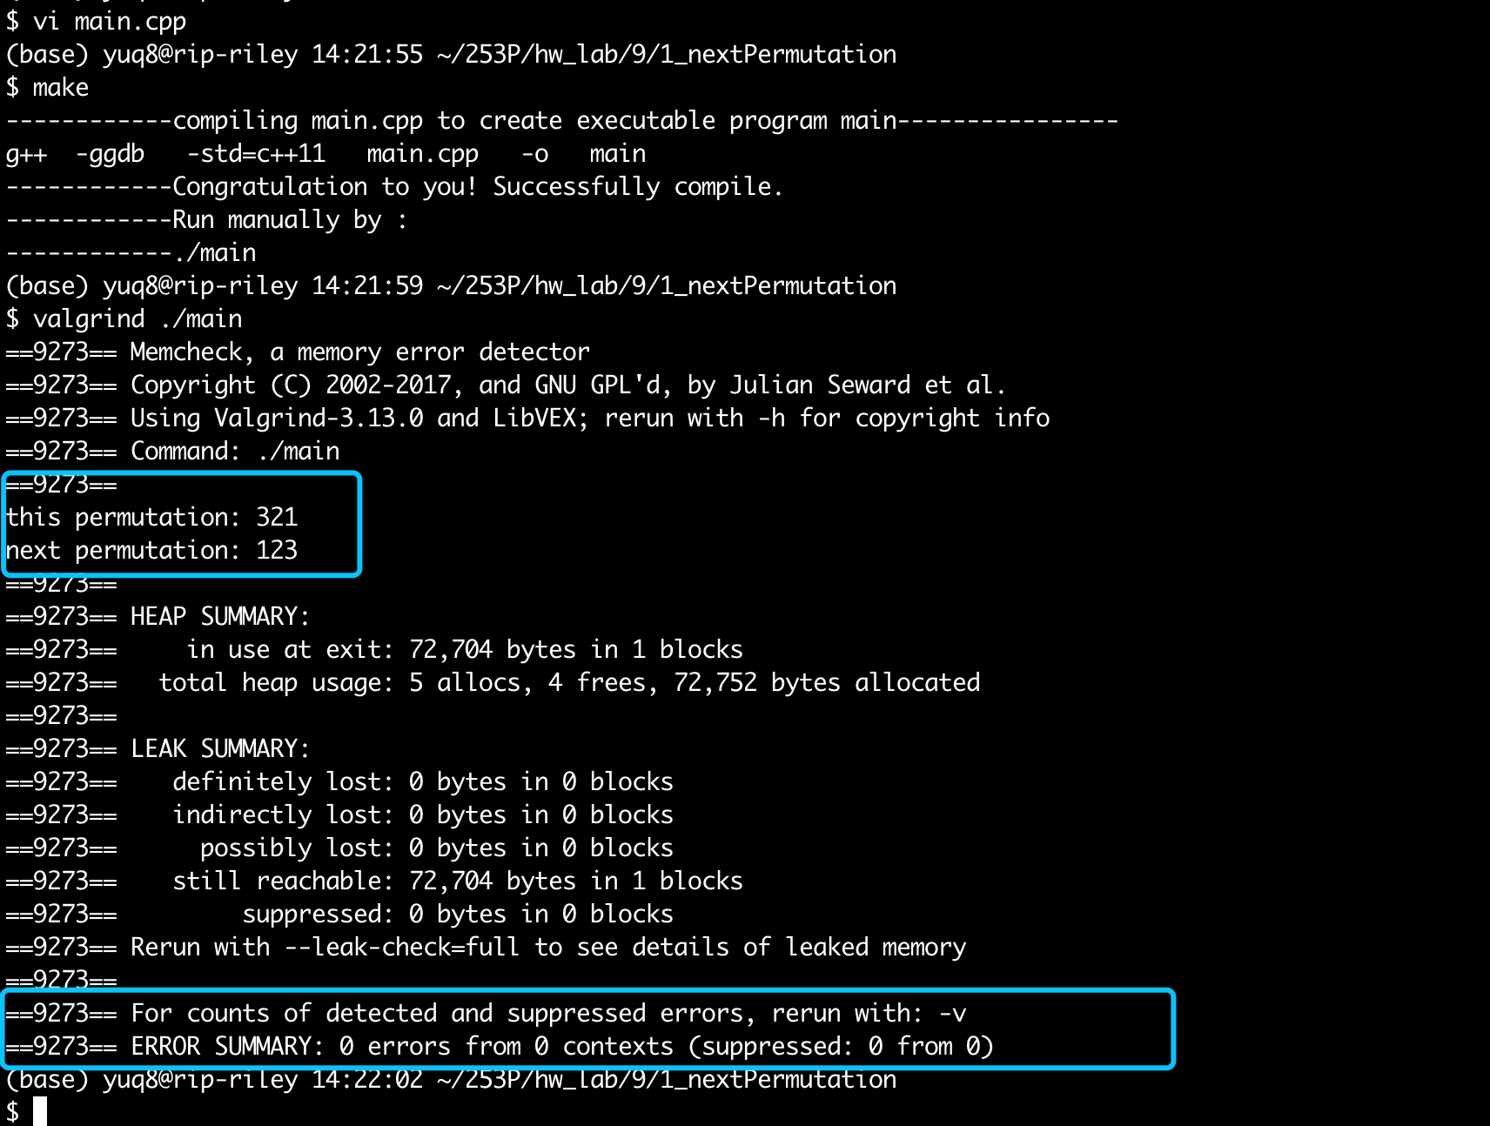

4:

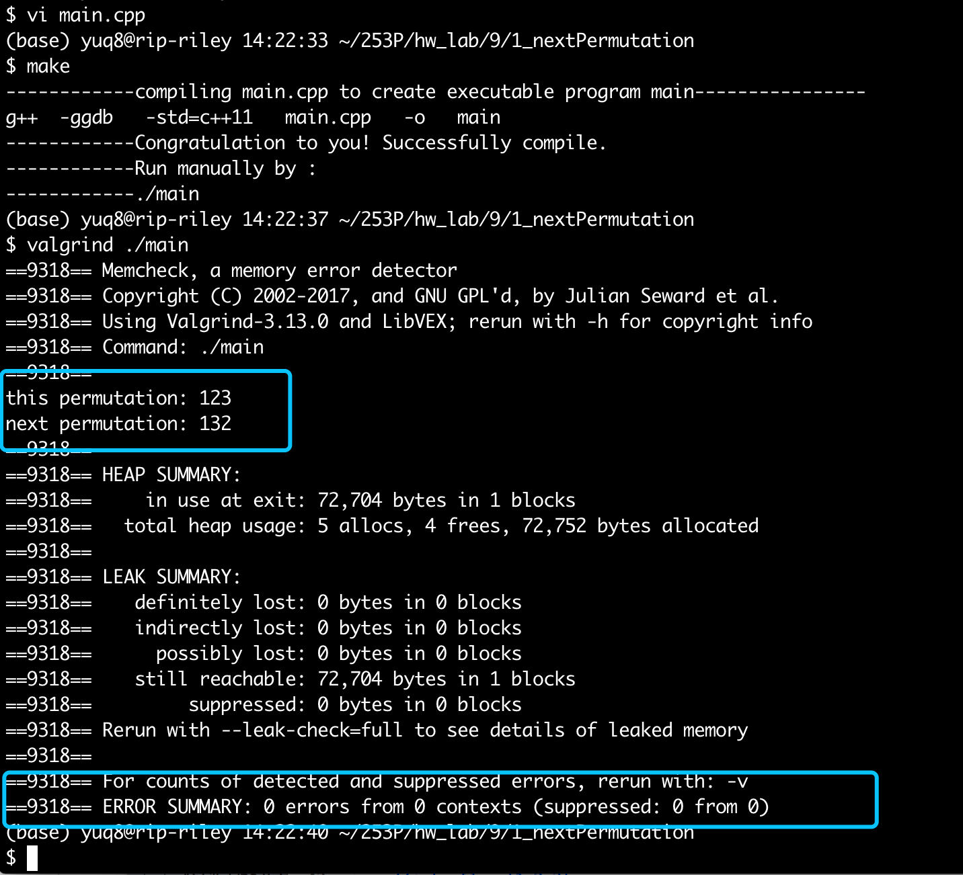

Conclusion: right result, 0 error in memory leak.

# Lab 2: spiral Matrix

Test cases 1, 2, 3, 4 :

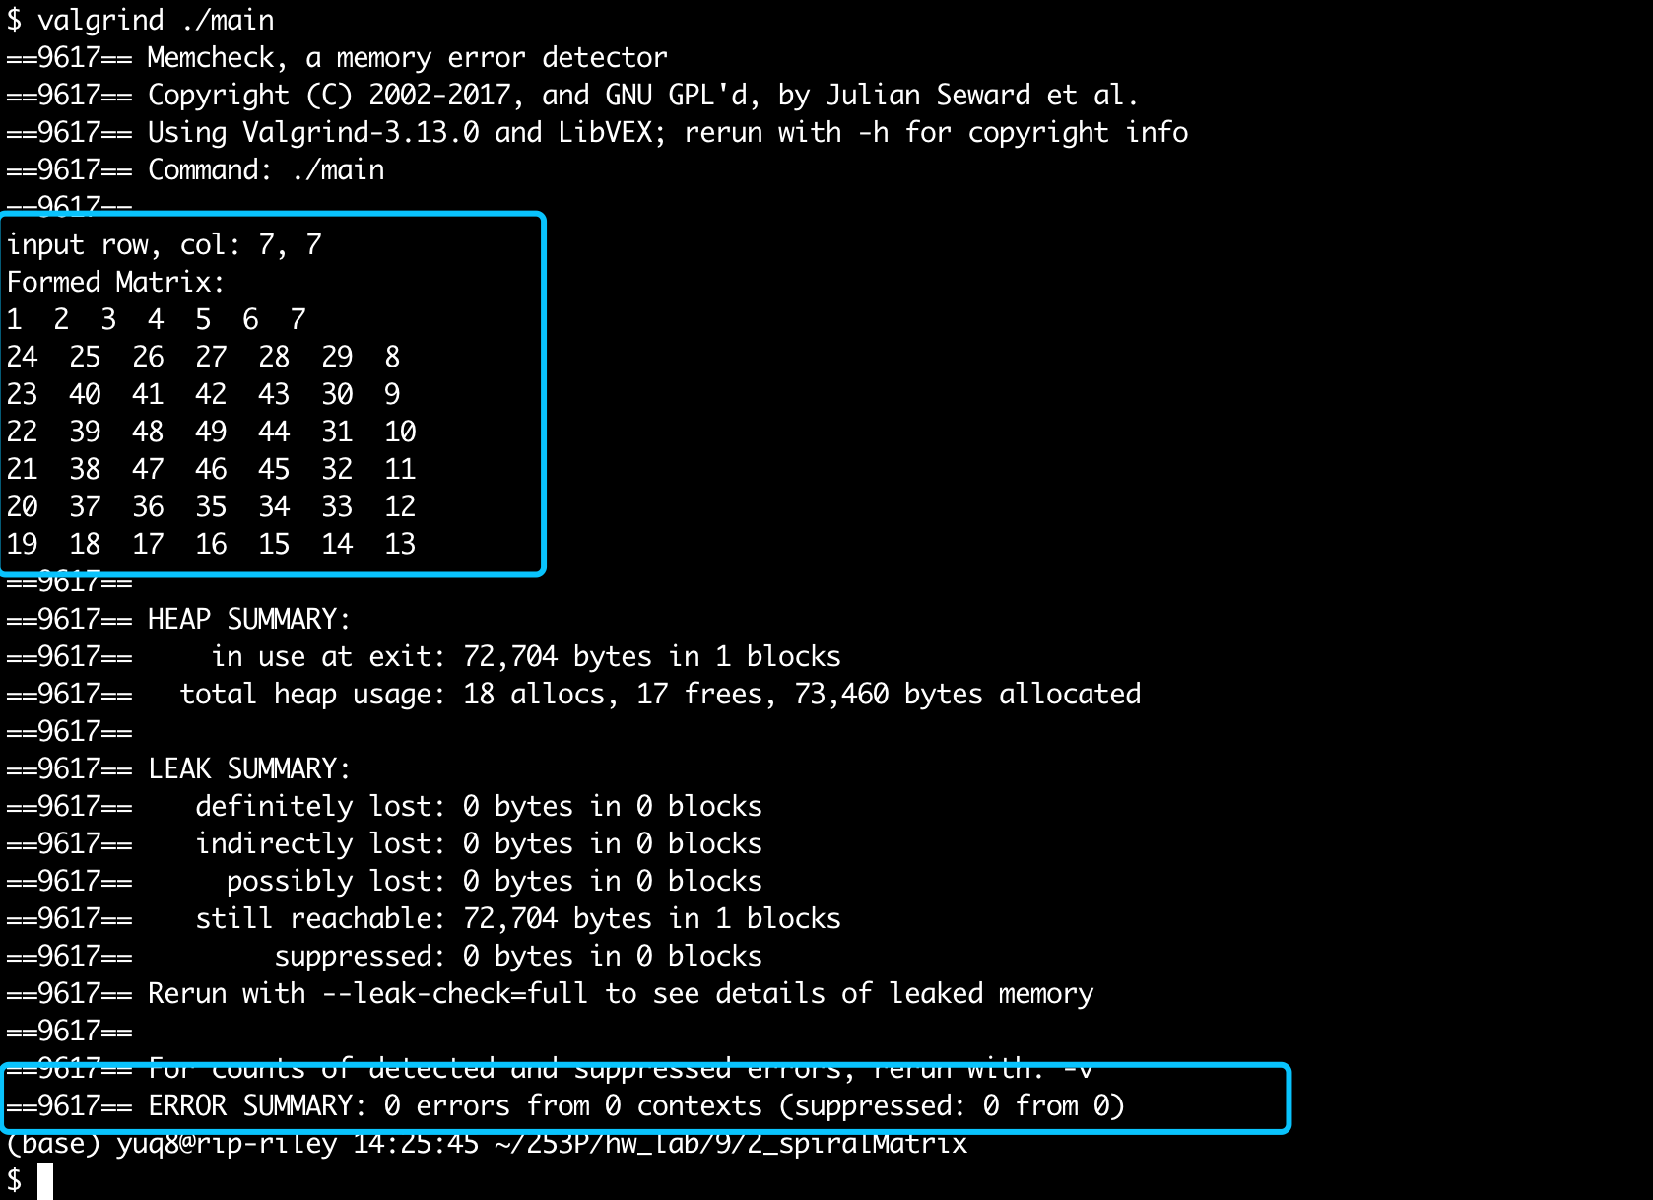

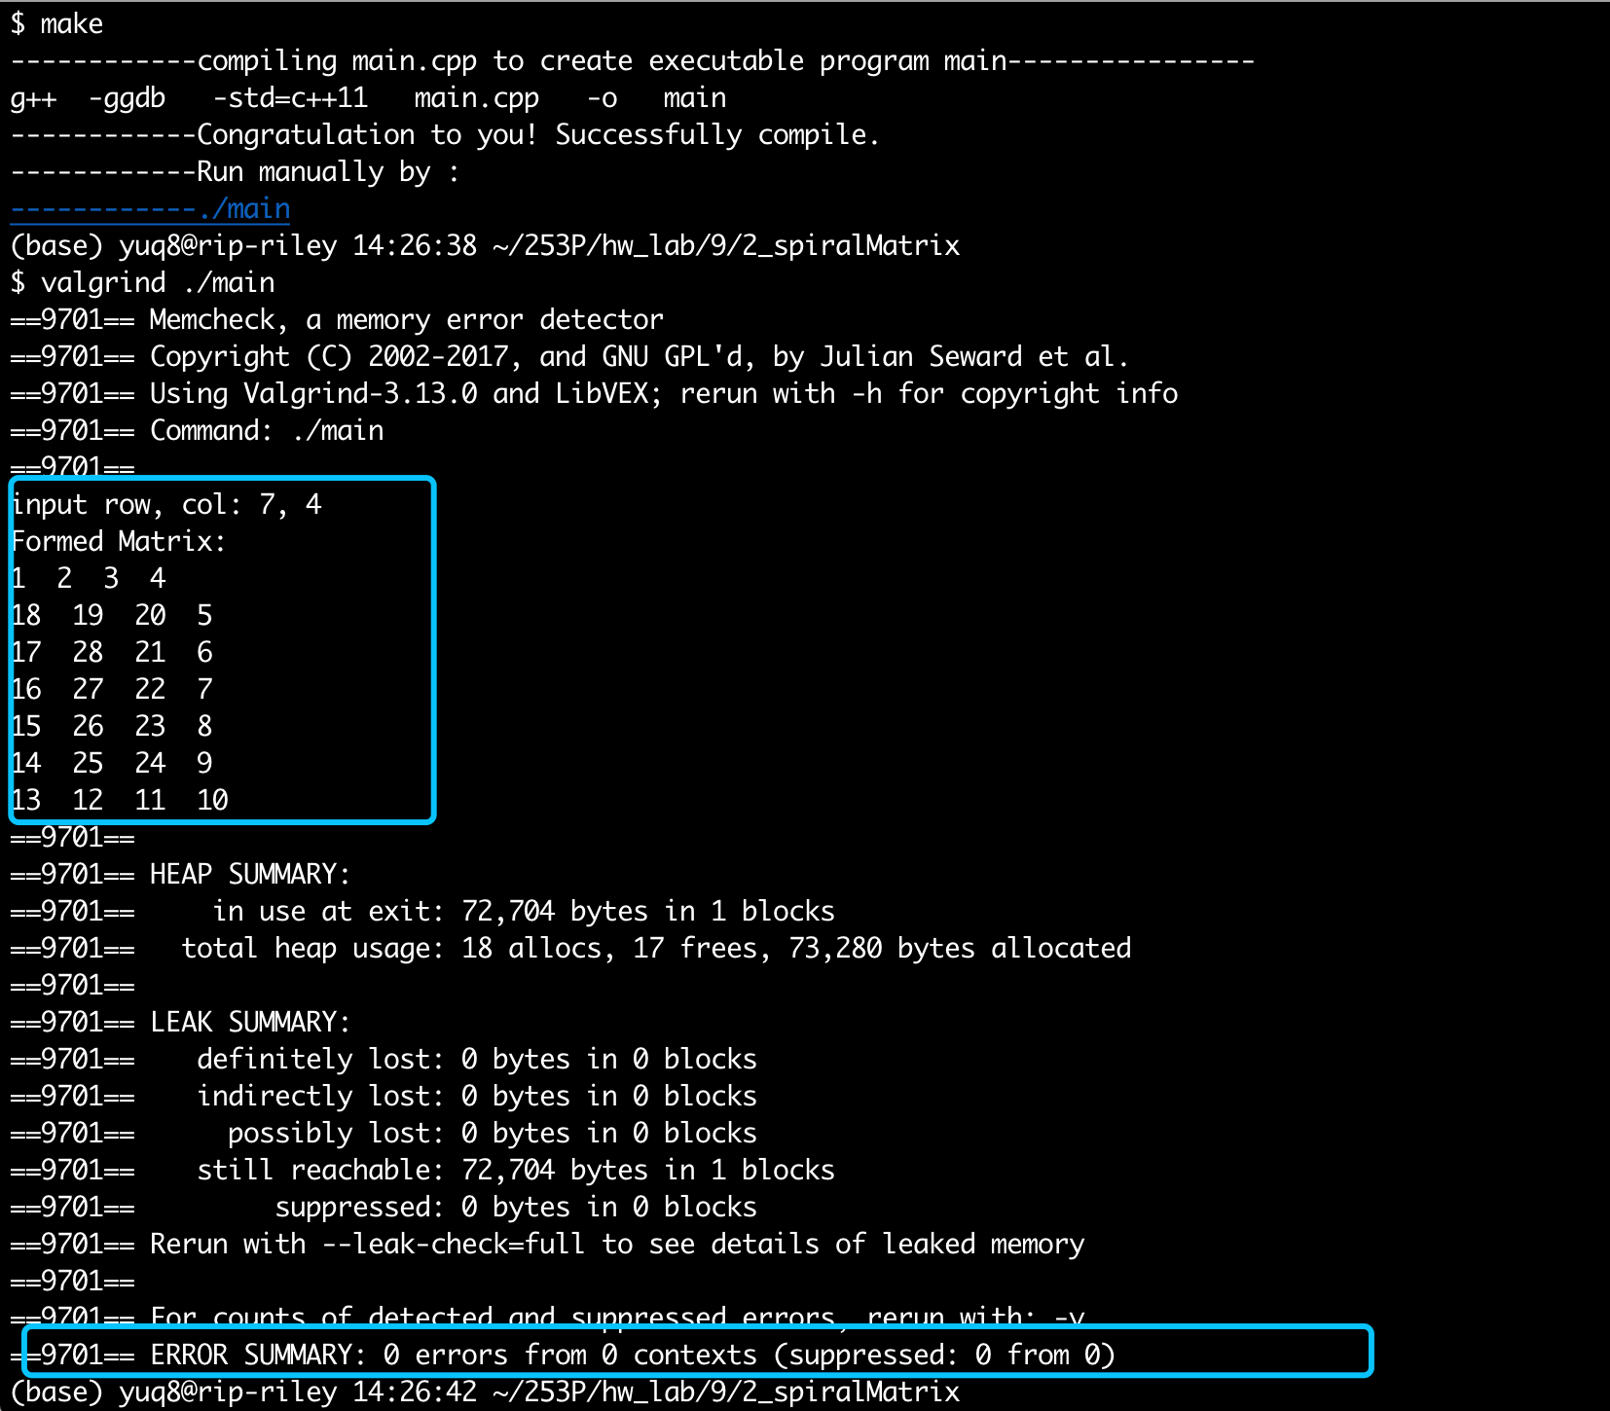

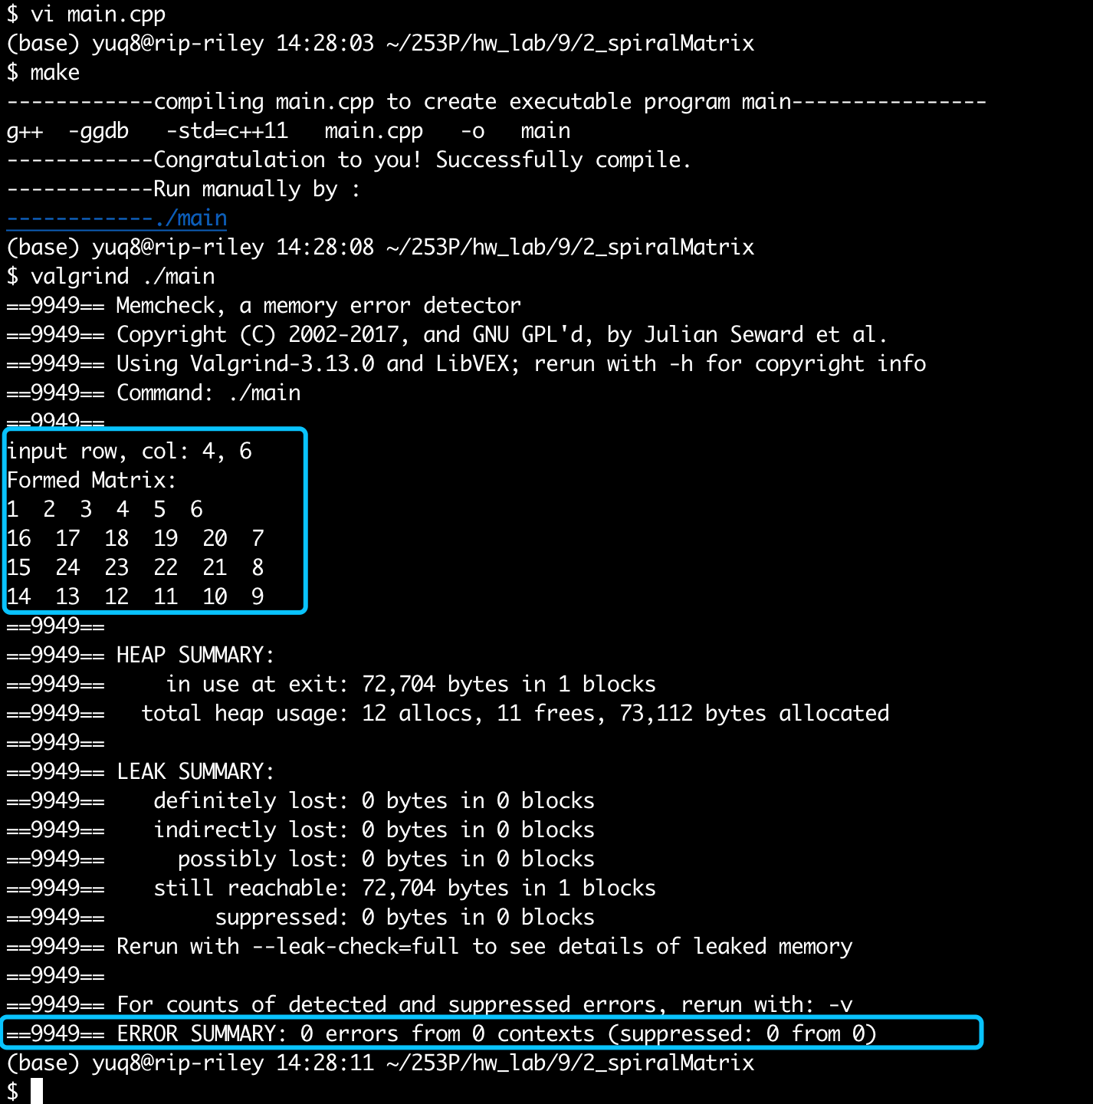

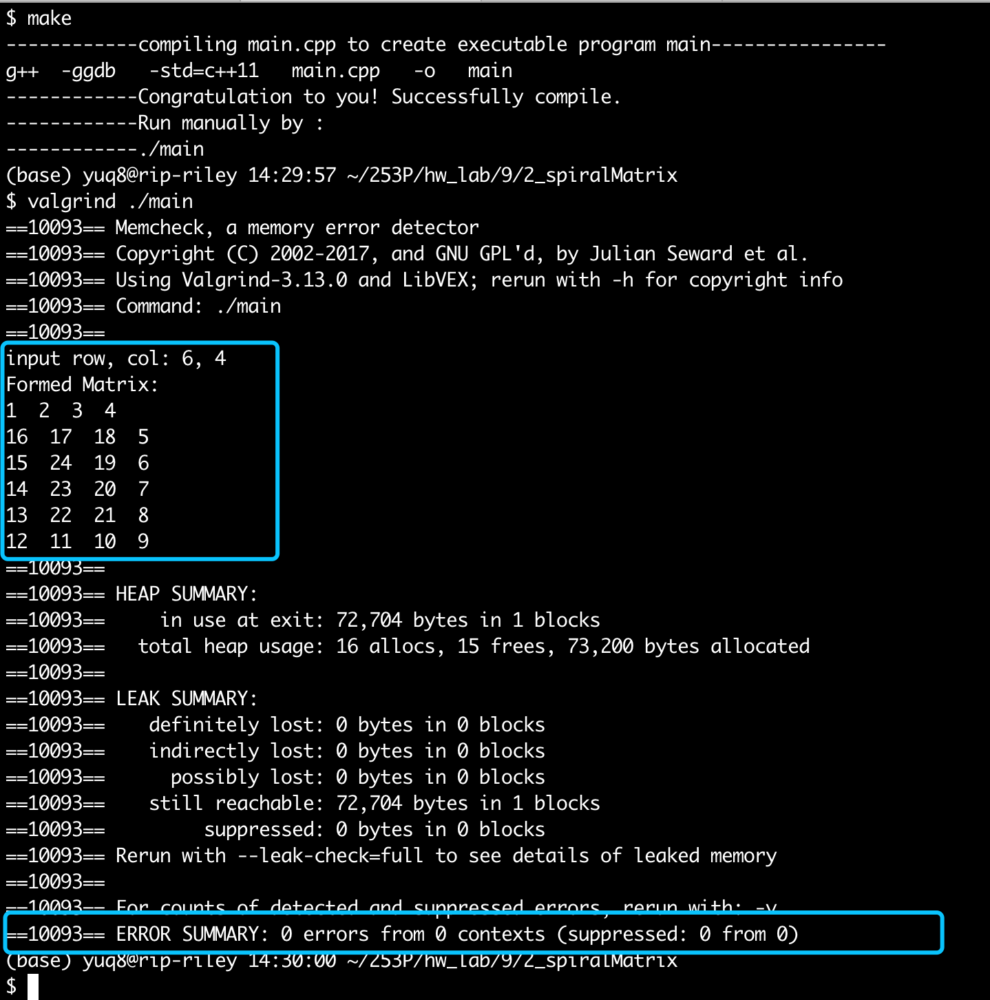

Conclusion: right result, 0 error in memory leak.

Little Notes:

1. At this lab, when encountered with different length in width and heighth, there are a little bit difference in tackling.

# Lab4: sort Color

**test cases 1,2, 3:**

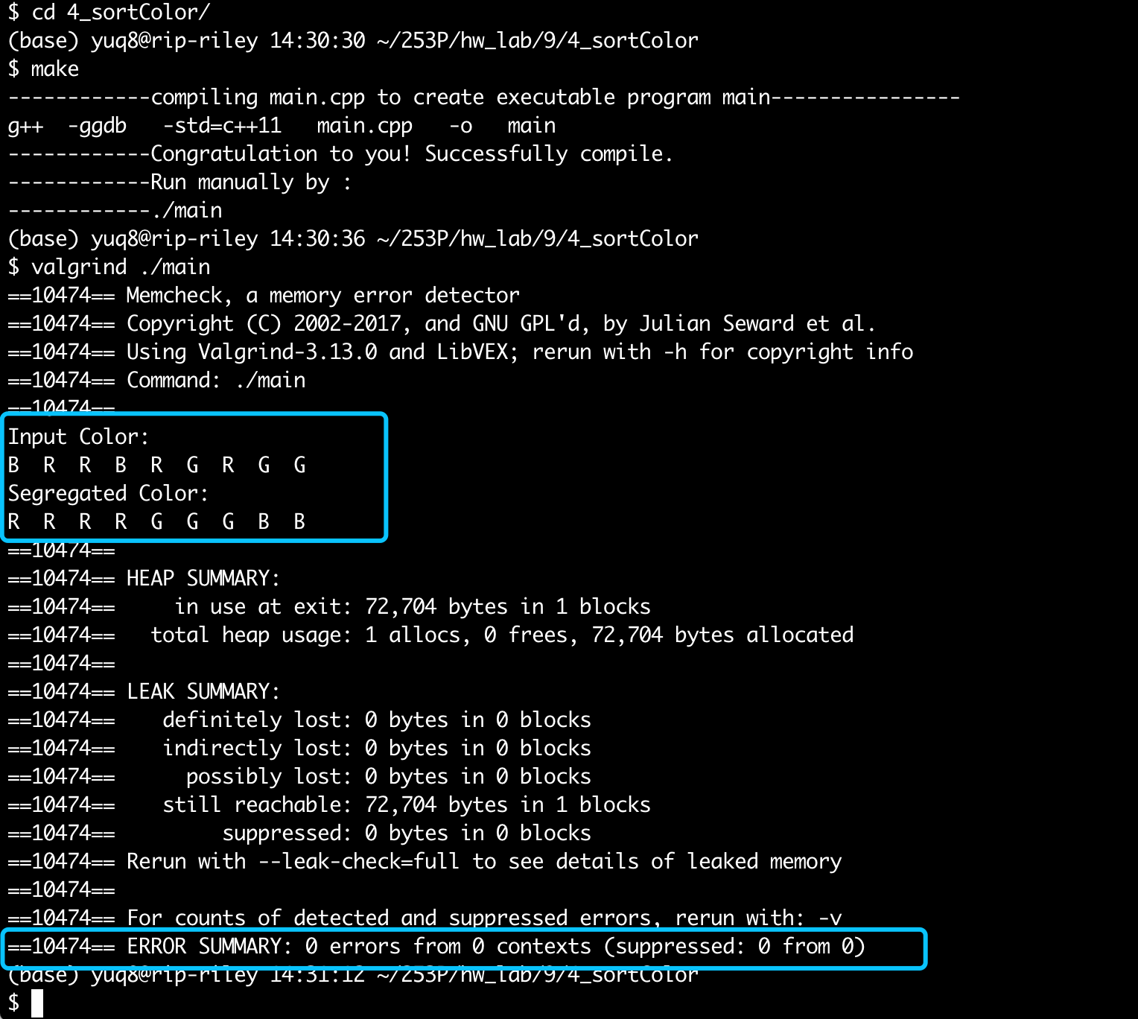

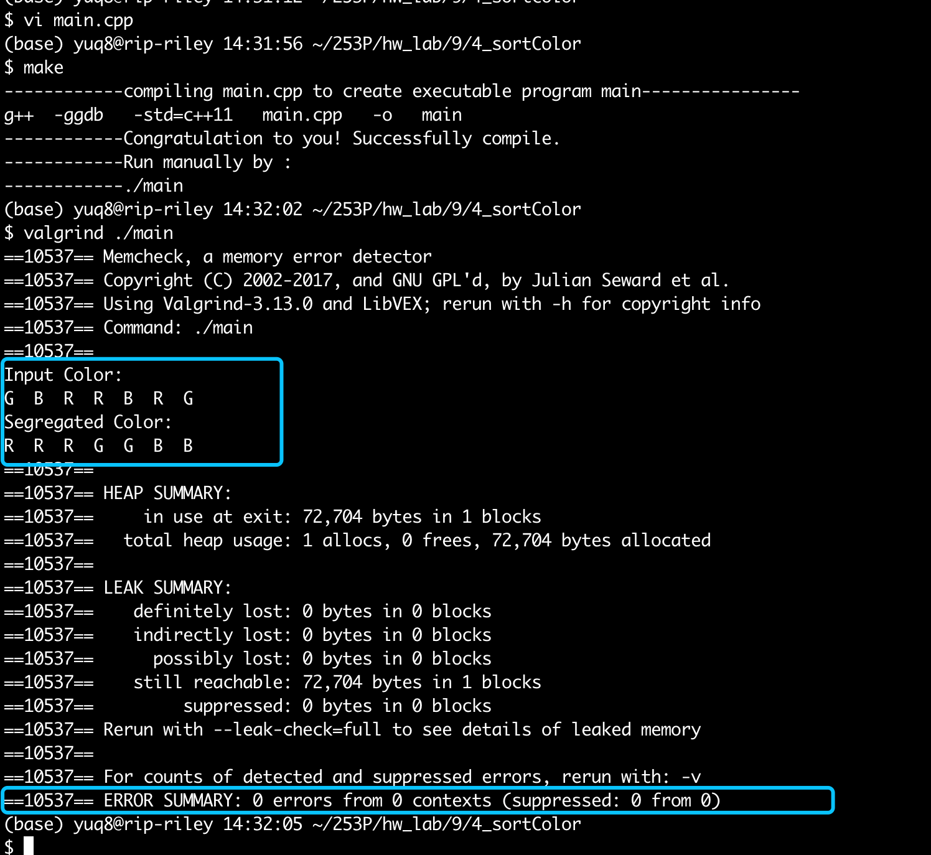

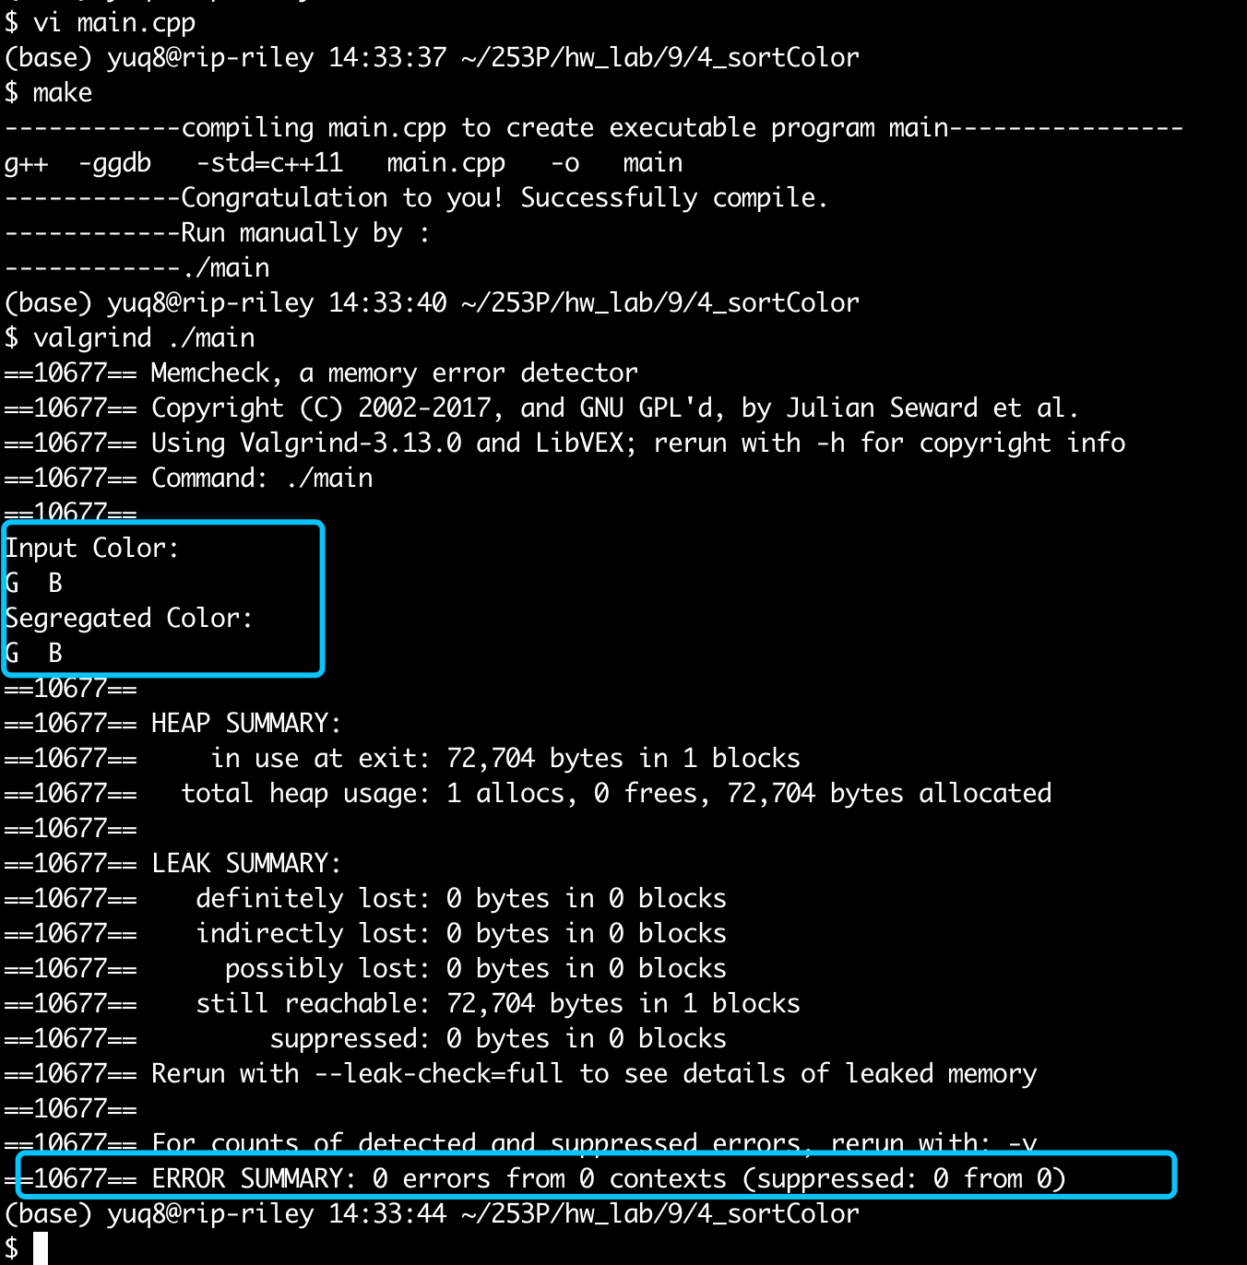

# Lab 6: rotatedSearch

**test cases 1,2, 3:**

