HW [makeup], [spring/2019] MCS 253P

Name: Yu Qin

Table of Contents

Lab 8.3: Max Avg Subtree 1

Lab 9.3: saving/loading_bt 5

Previous Quiz: Prime Factorization 8

HW 2: Problem 1 c-String Functions 11

===========================Results Screenshots====================

===========================start of the write-up====================

# **Lab 8.3: Max Avg Subtree**

Code: mainly by divide and conquer:

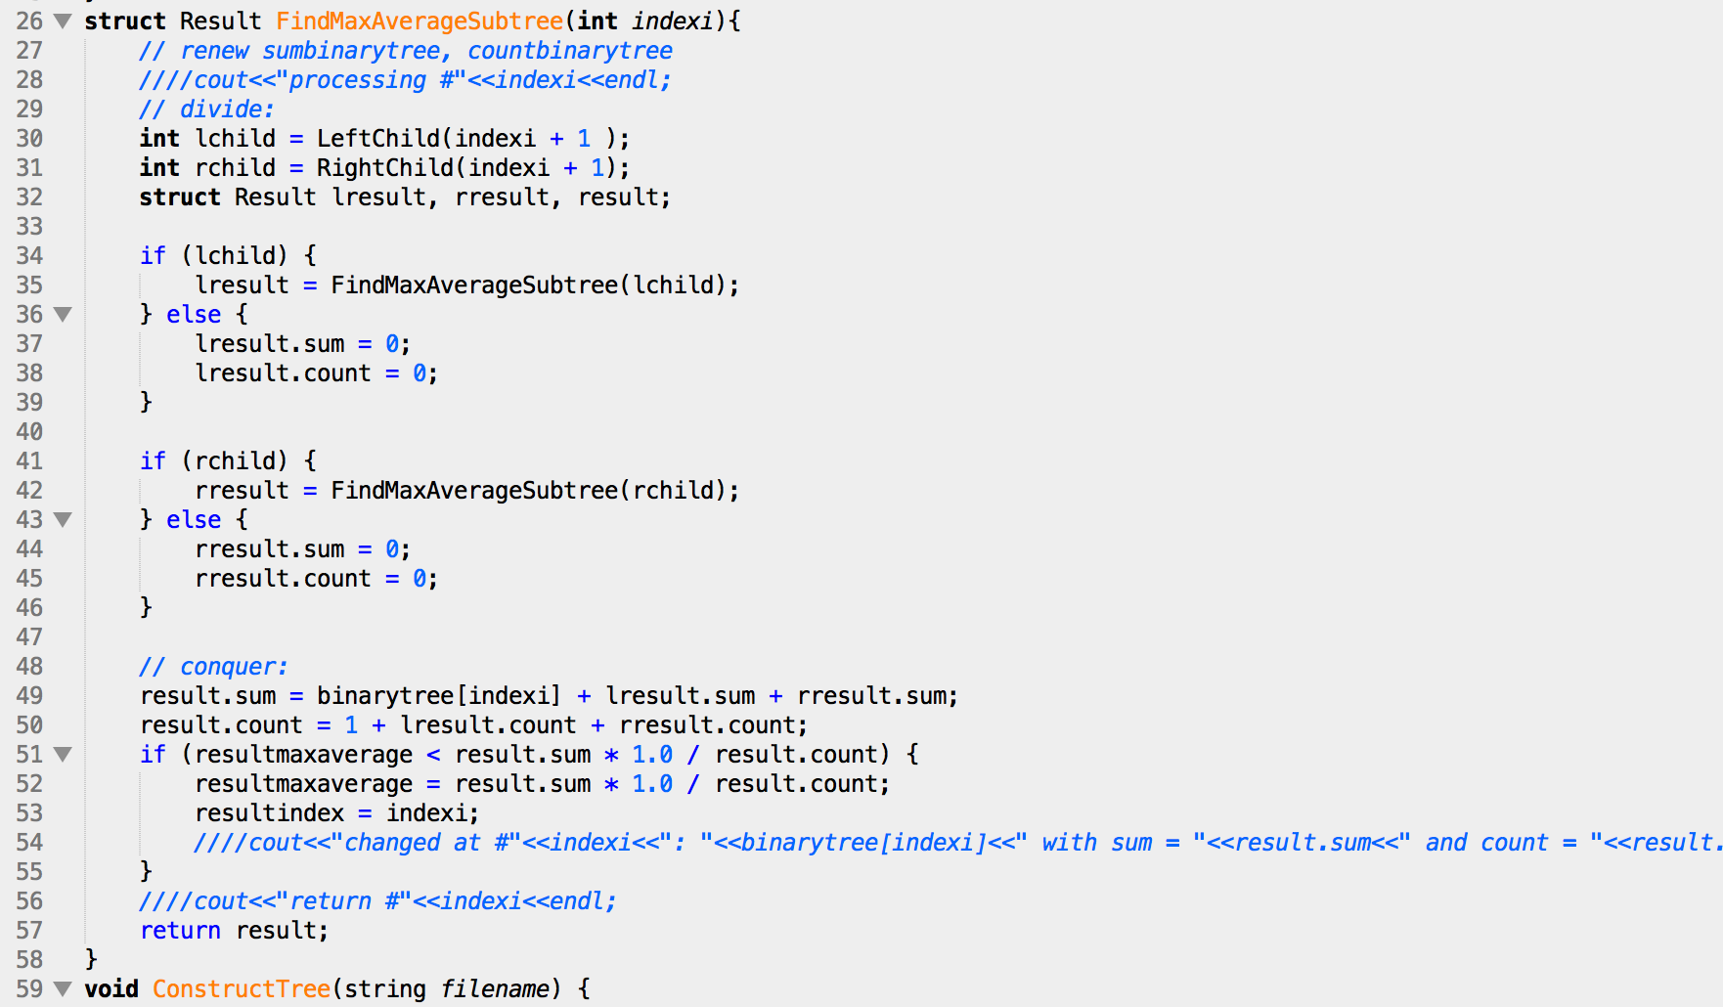

test case 1, 2 , 3:

1:

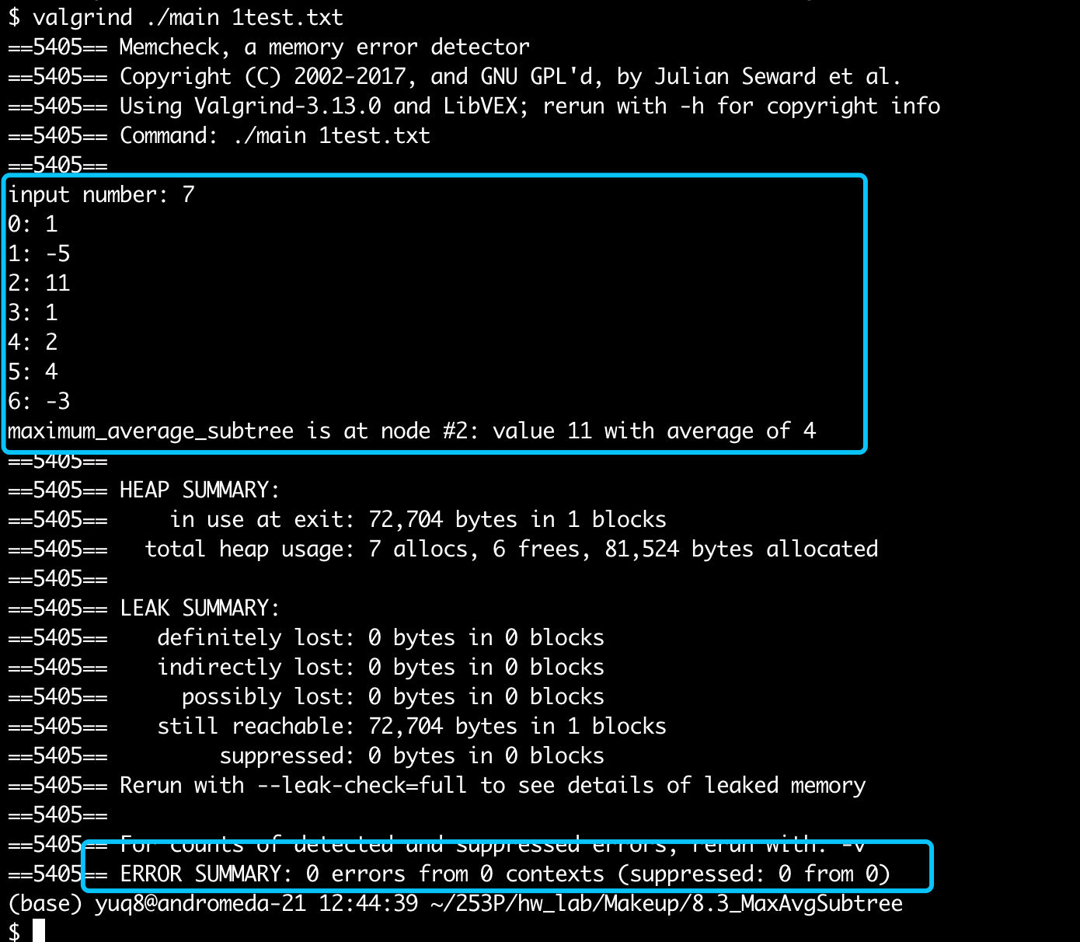

2:

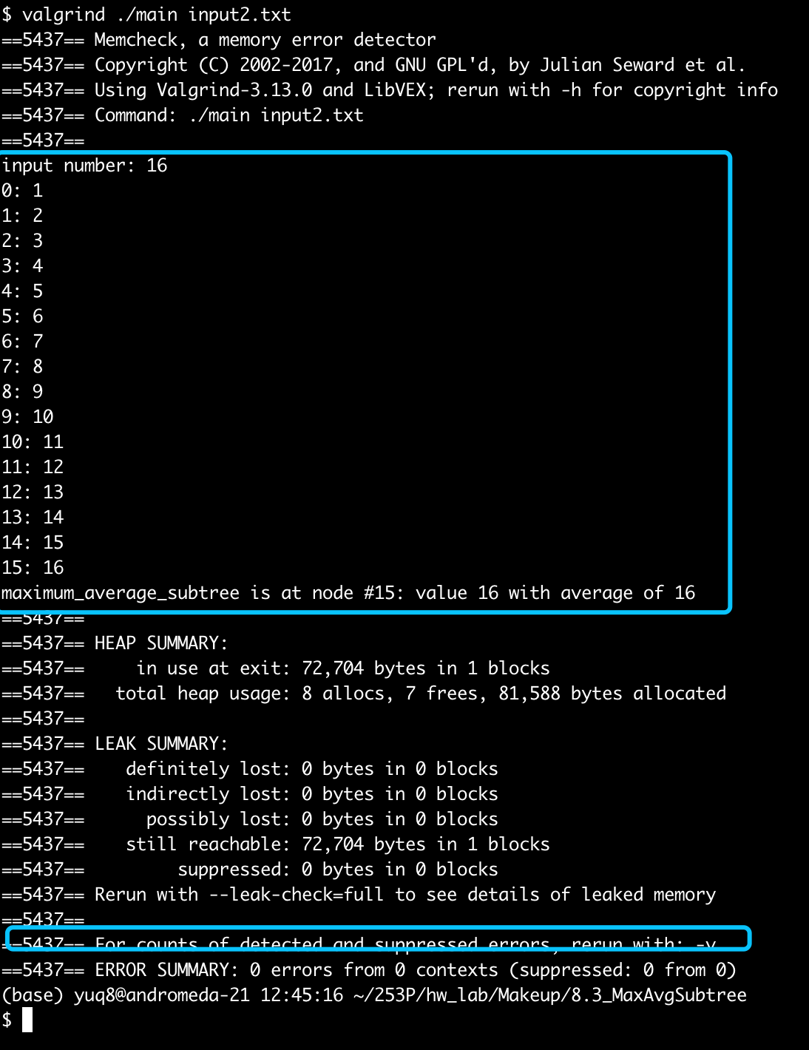

3:

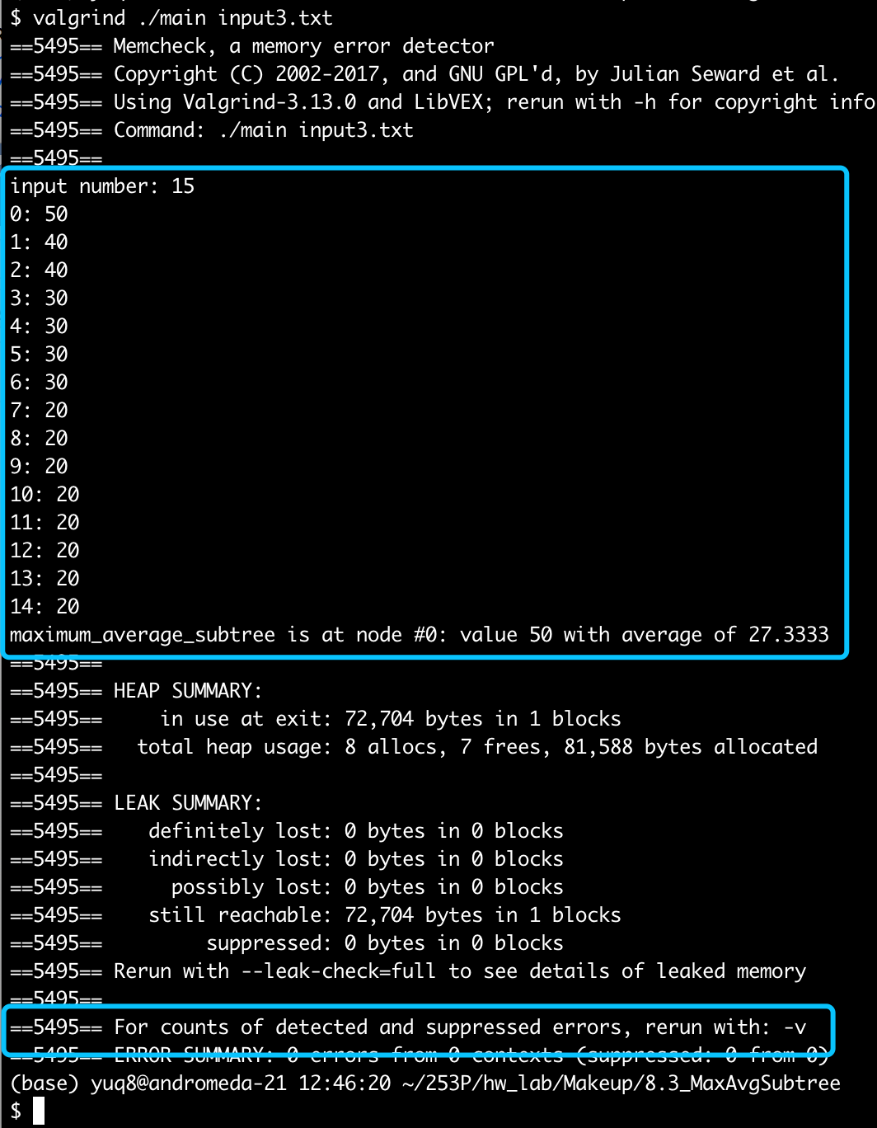

Conclusion: right result, 0 error in memory leak.

Little notes:

1. If encounter with 2 equal, prefers to the lower level node

# Lab 9.3: savingandloading_bt

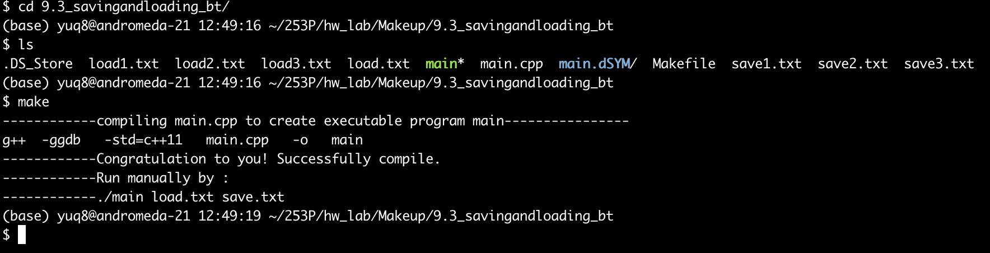

Test cases 1, 2, 3:

1:

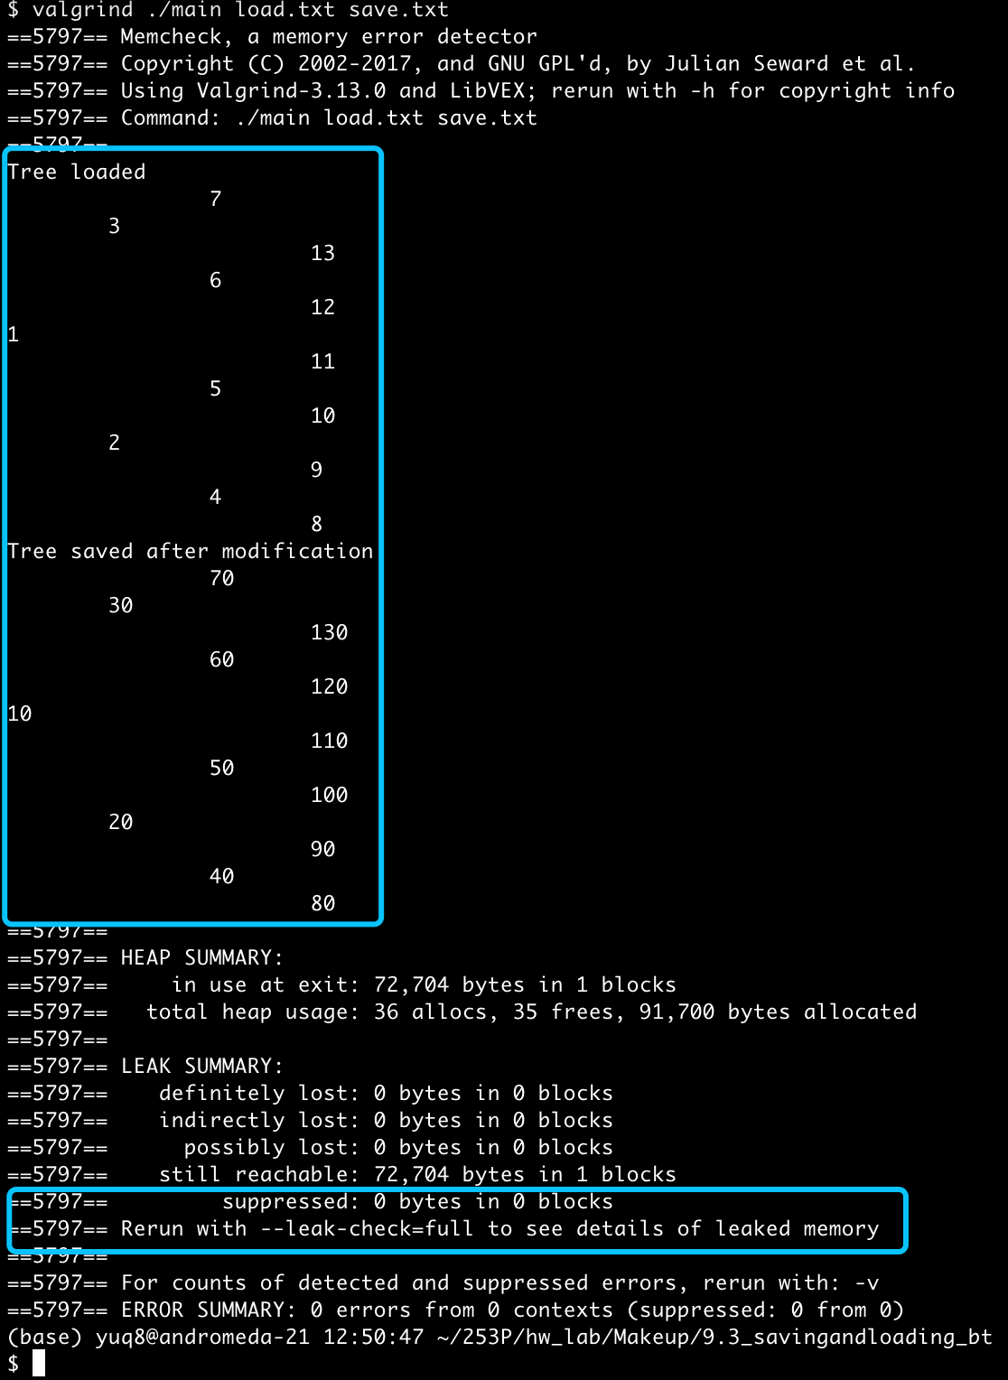

2:

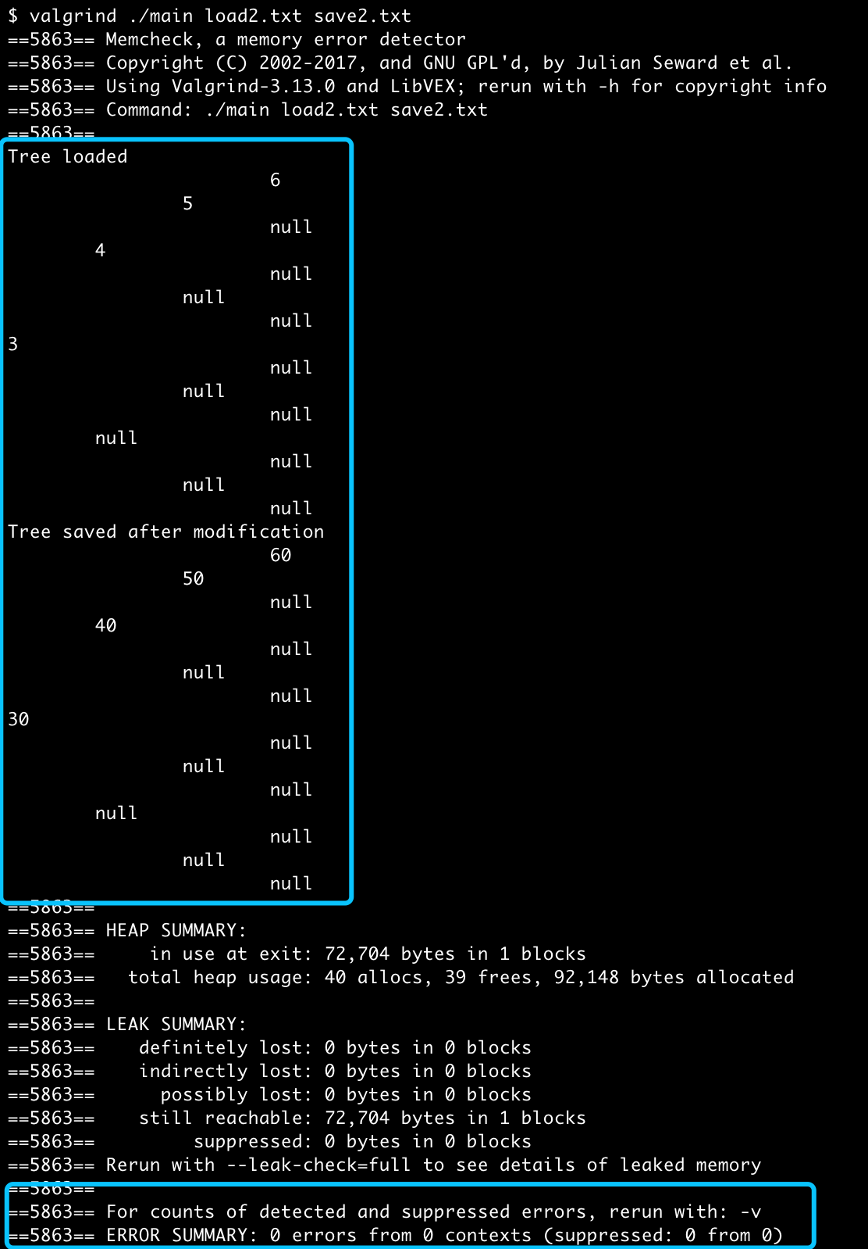

3:

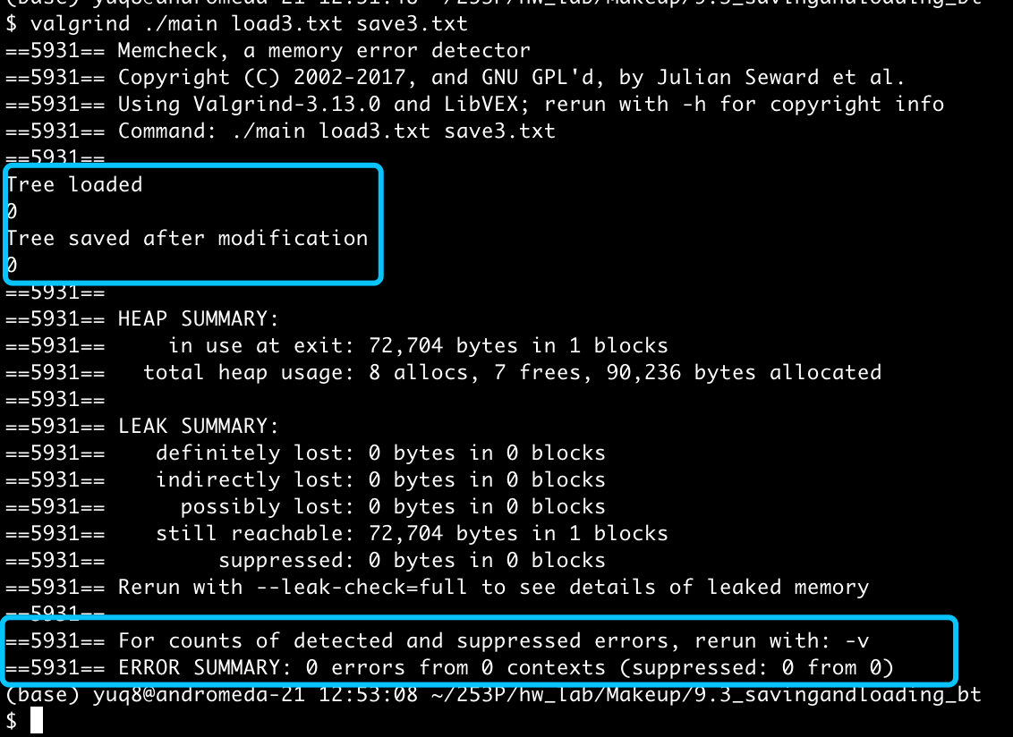

Conclusion: right result, 0 error in memory leak.

# Previous Quiz: Prime Factorization

Dear TA,

I have studied and re-wrote a file of code. It would be nice if you decide it's enough for some make-up of the quiz.

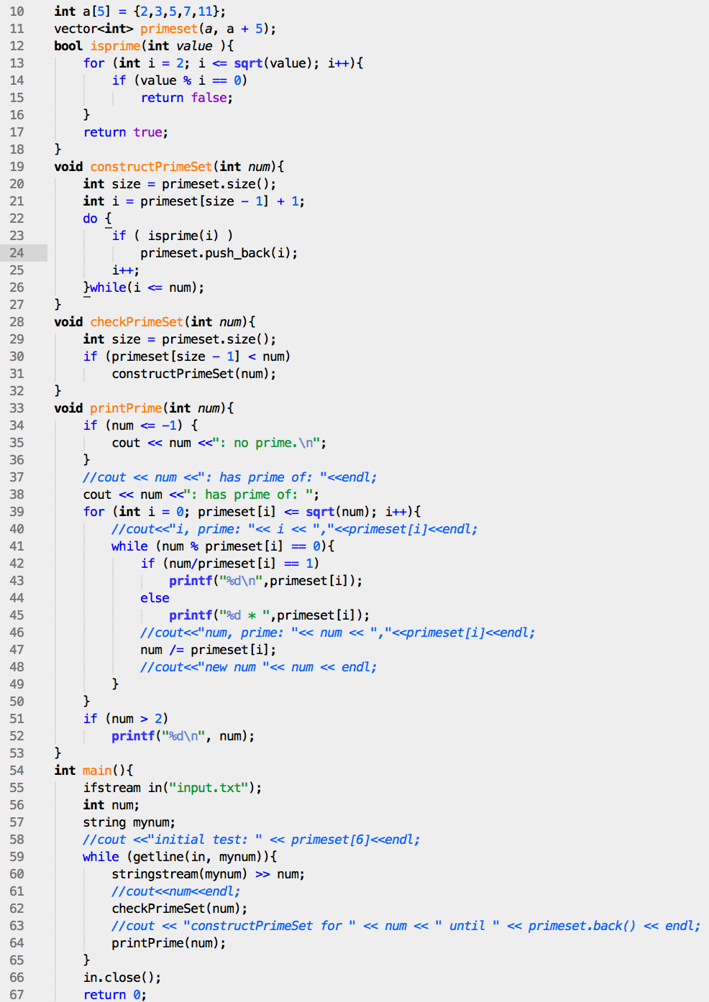

test cases 1, 2, 3, 4:

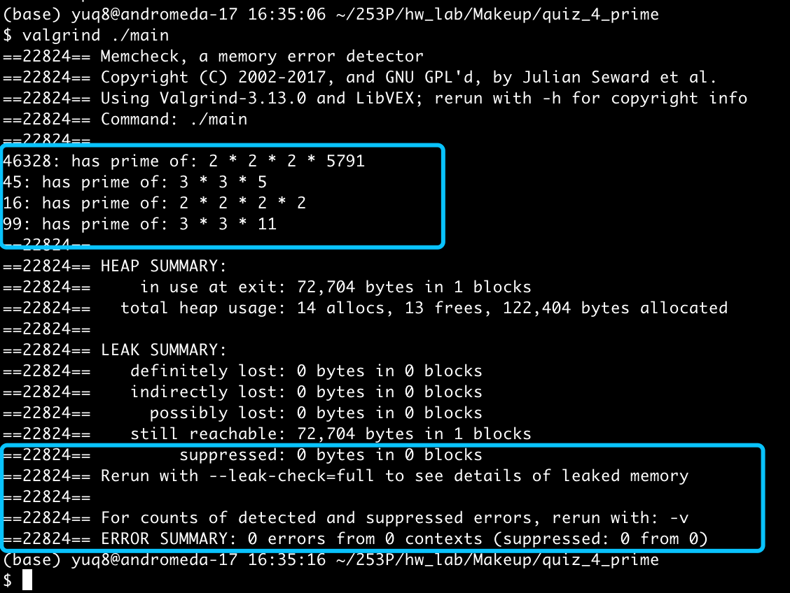

Little Notes:

1. In the original quiz, the main problem I’m hesitating on is how to test the primality and construct the set of prime, efficiently.
2. There is actually a problem of NP primality test. And I learned some method on this:
3. sieve of Eratosthenes: delete out the multiply from the small known prime number, 2, 3, 5… Until the sqrt() of the wanted number. O(n log log n)

But since our job here can reuse the former result of prime number, this method will have some replicated work.

1. According to the rule: If is number is not in the form of 6x+1 of 6x+5, it must be not a prime number. So we can eliminate a series of number that are not prime.
2. Here, I firstly decide to use the most intuitive way, simplify the range from the former prime dataset.
3. But since the primeset should be maintained till the wanted number, which might be large, so I adopt the (b) method with the rule that composite number must be multiply of prime. Here’s the optimized function of judging a prime number:

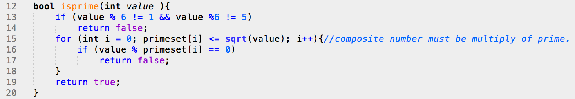

# HW 2: Problem 1 c-String Functions

Dear TA,

You did not give me the scores for report since you said you cannot see the details. I have emailed you to supply for information, but you did not reply to me. So I re-emailed again.

If there are any problems, please contact me at [yuq8@uci.edu](mailto:yuq8@uci.edu)

Thanks for you work~ Have a nice weekend!

Yu Qin