**LAB [3], [1/29/2019] MCS 253P**

**Name: Yu Qin**

**Results Screenshots**

===========================start of the write-up====================

**Lab 1**

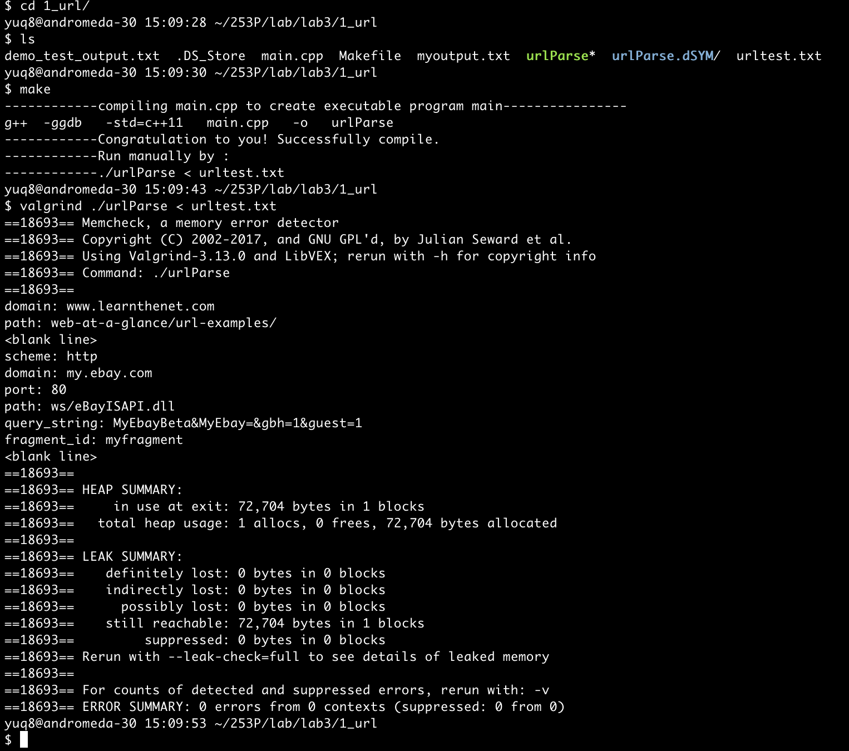

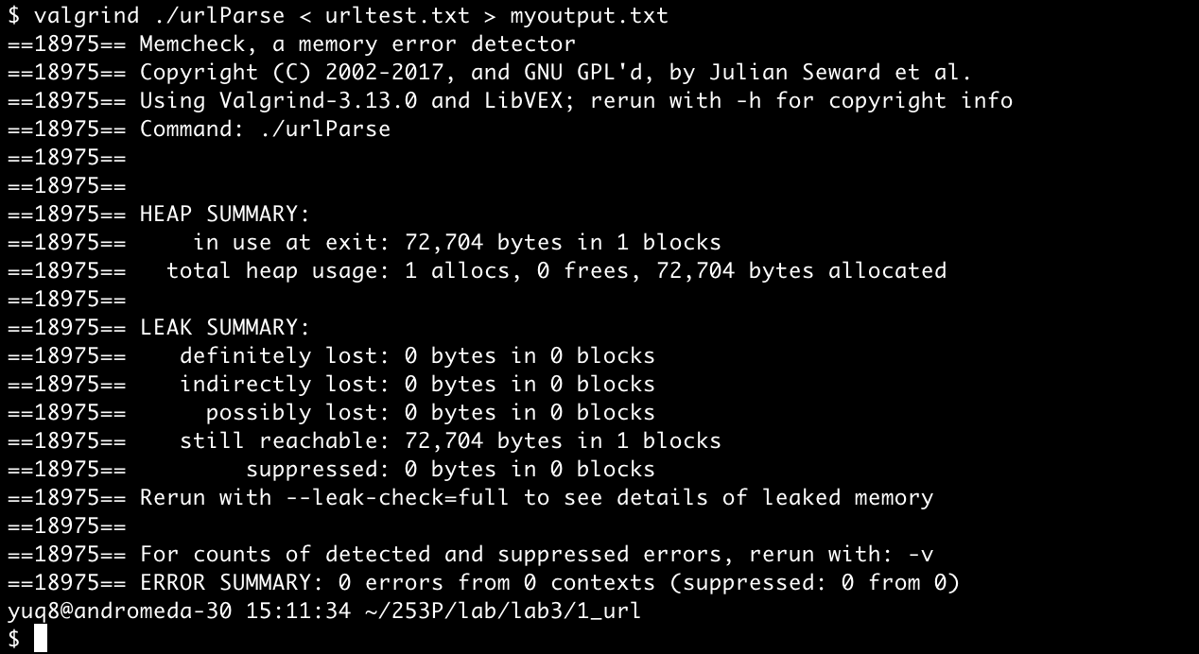

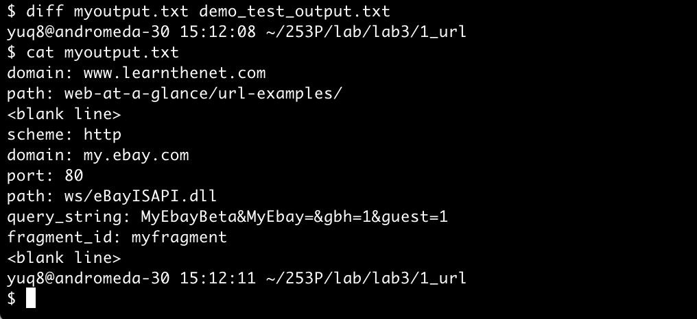

Conclusion: right result, 0 error in memory leak.

Little Notes: Implemented with the function of checking some invalid input. Further valid check could include the valid roman char sequence and times.

**Lab 2**

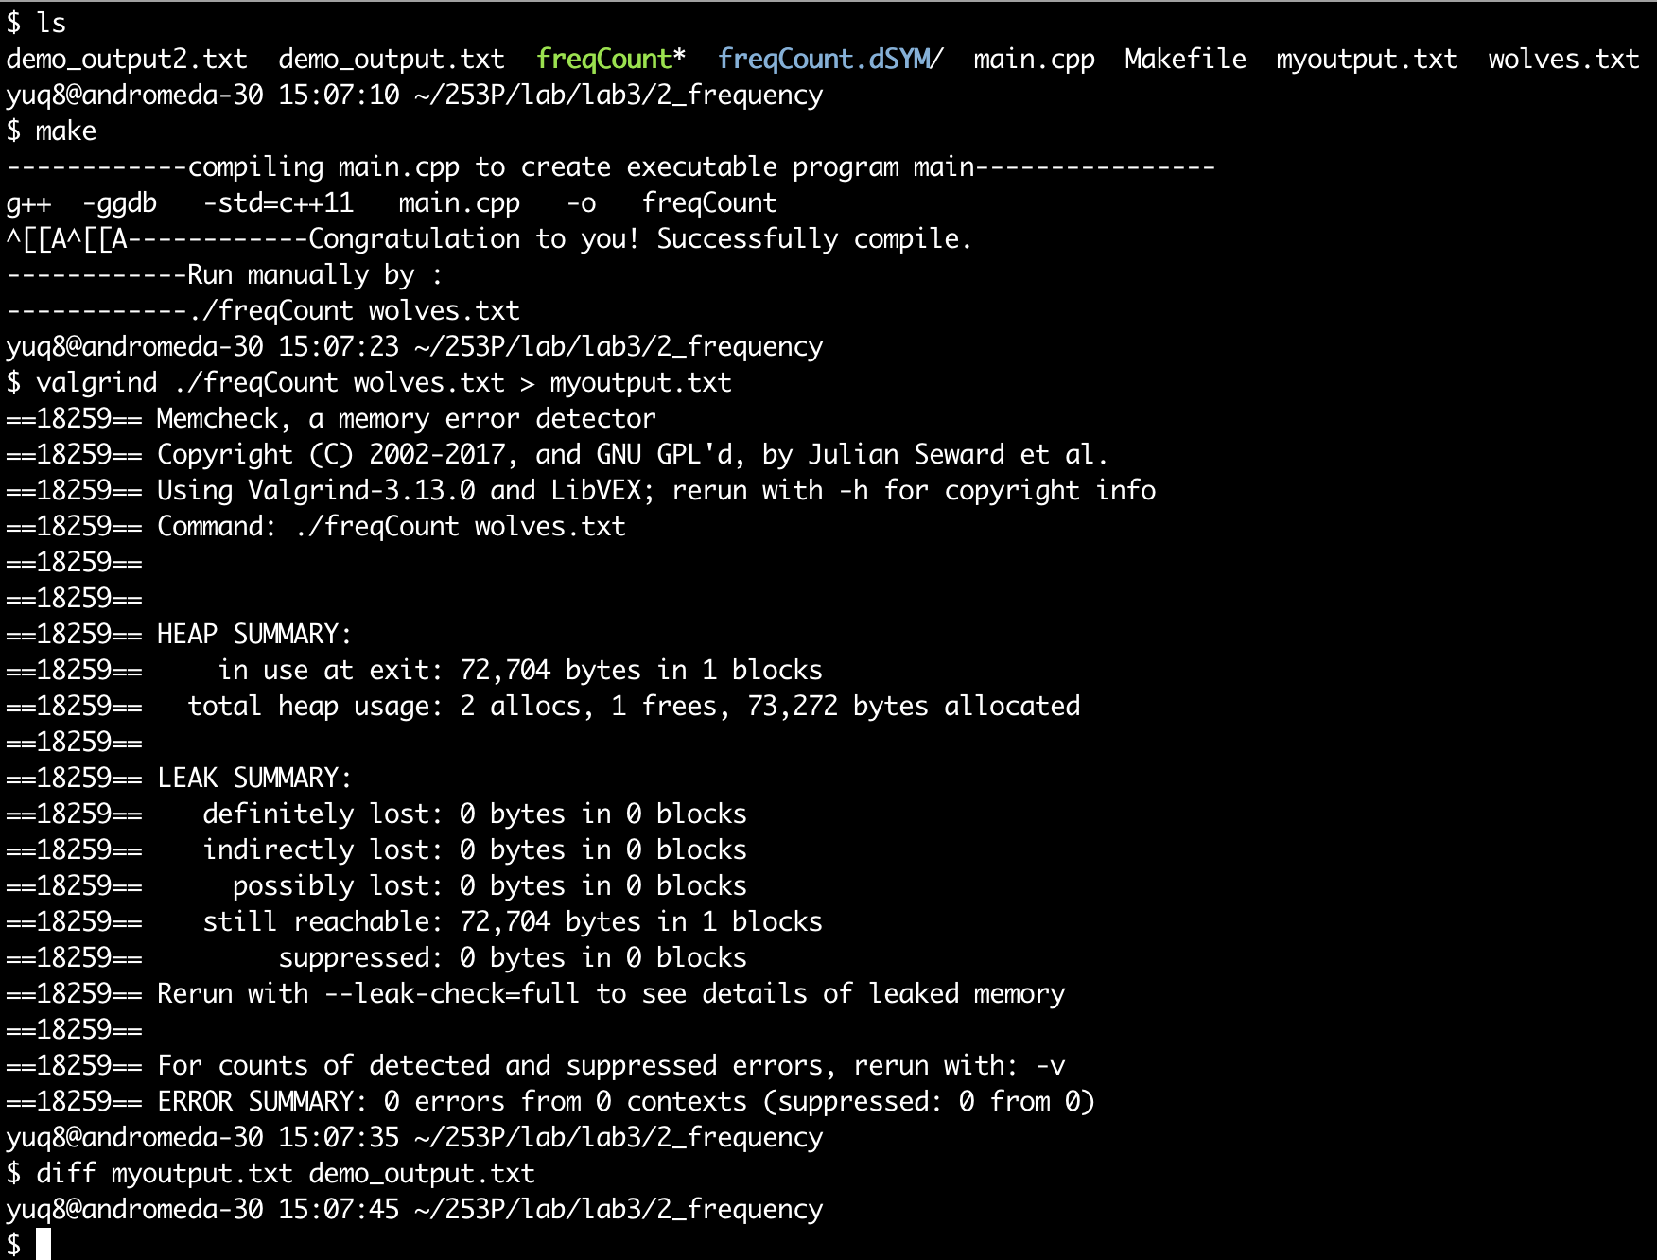

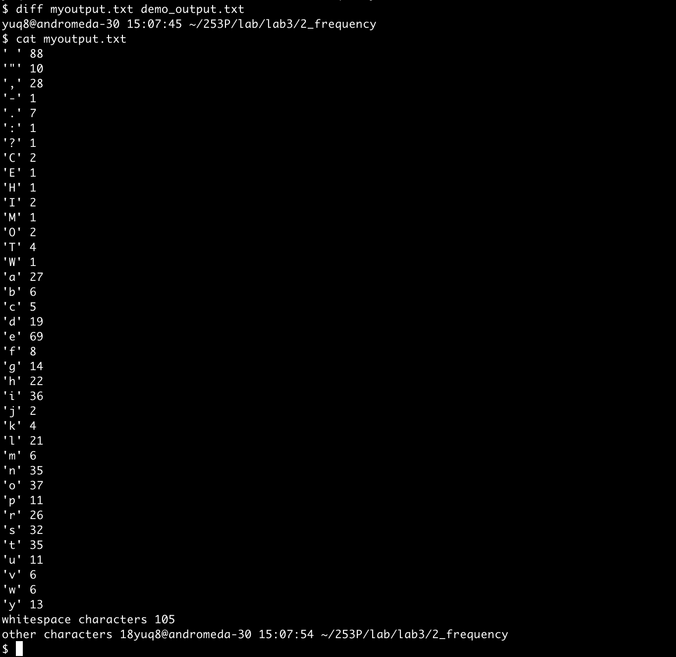

Conclusion: right result, 0 error in memory leak.

Little Notes:

1. Inputs are from a file, thus to avoid the treat of line changing ‘\n’. Further input form can take this into consideration.

**Lab 3**

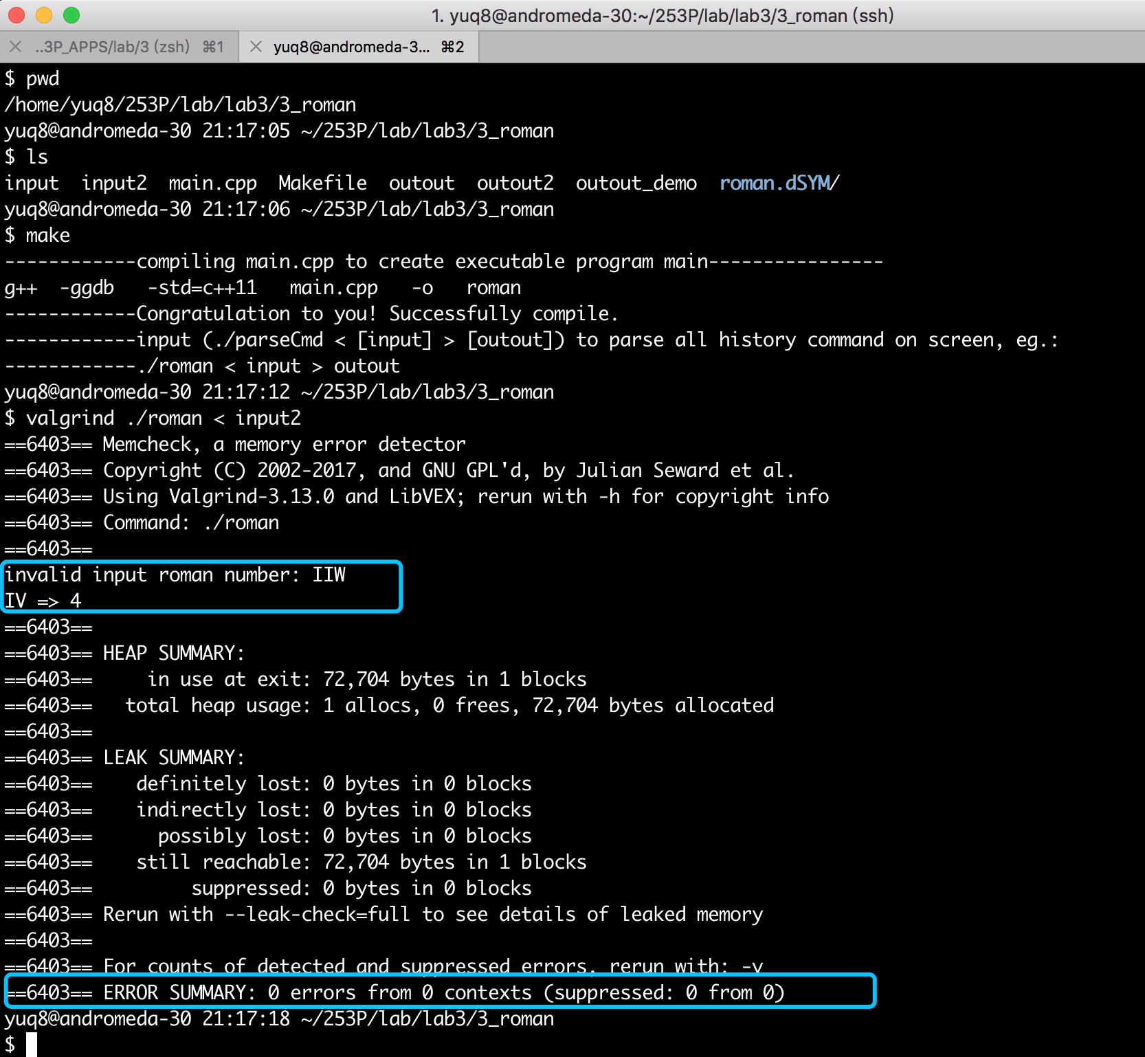

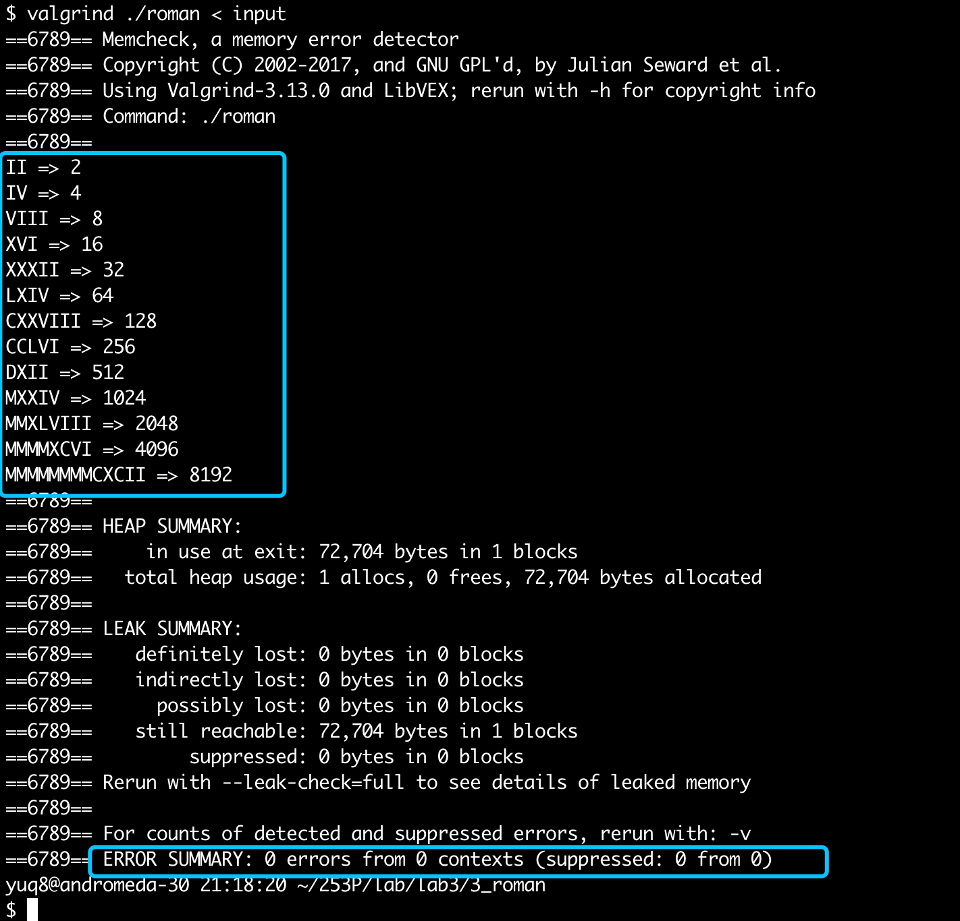

Conclusion: right result, 0 error in memory leak.

Little Notes: Implemented with the function of checking some invalid input. Further valid check could include the valid roman char sequence and times.

**Hw 3.1**

1. Create a subdirectory under your hw directory called hw3 and put all files related to this homework in that directory.

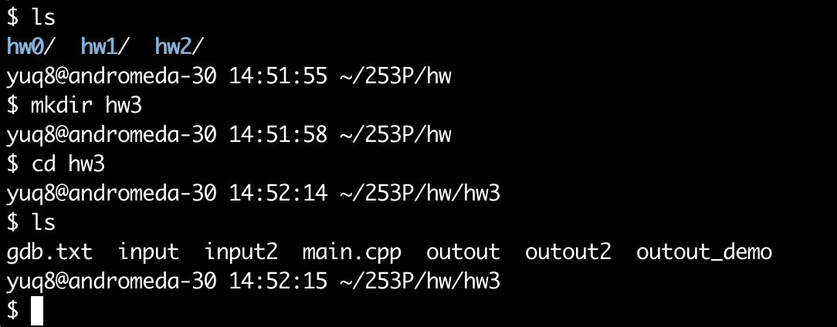

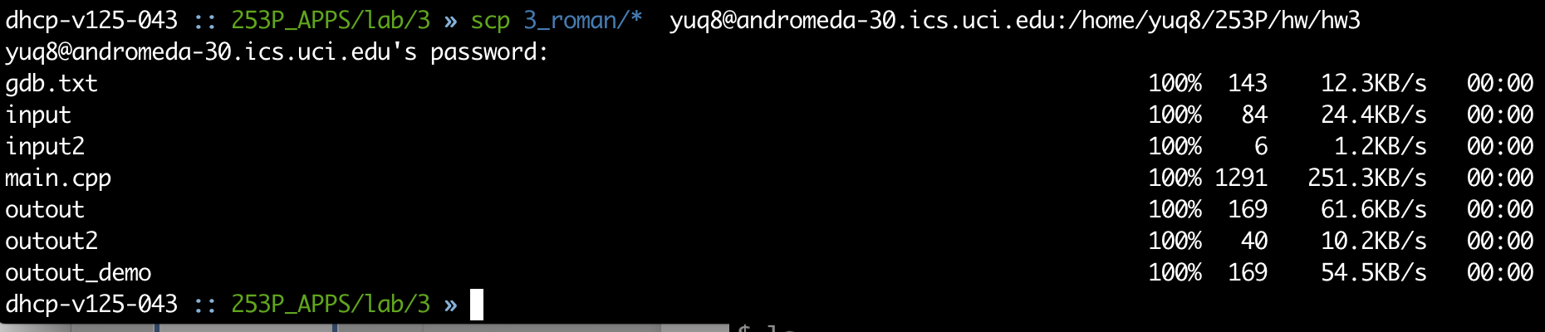

1. Define a Makefile in hw3, the default target should make executable and include gdb debugging information in the executable. Define clean.

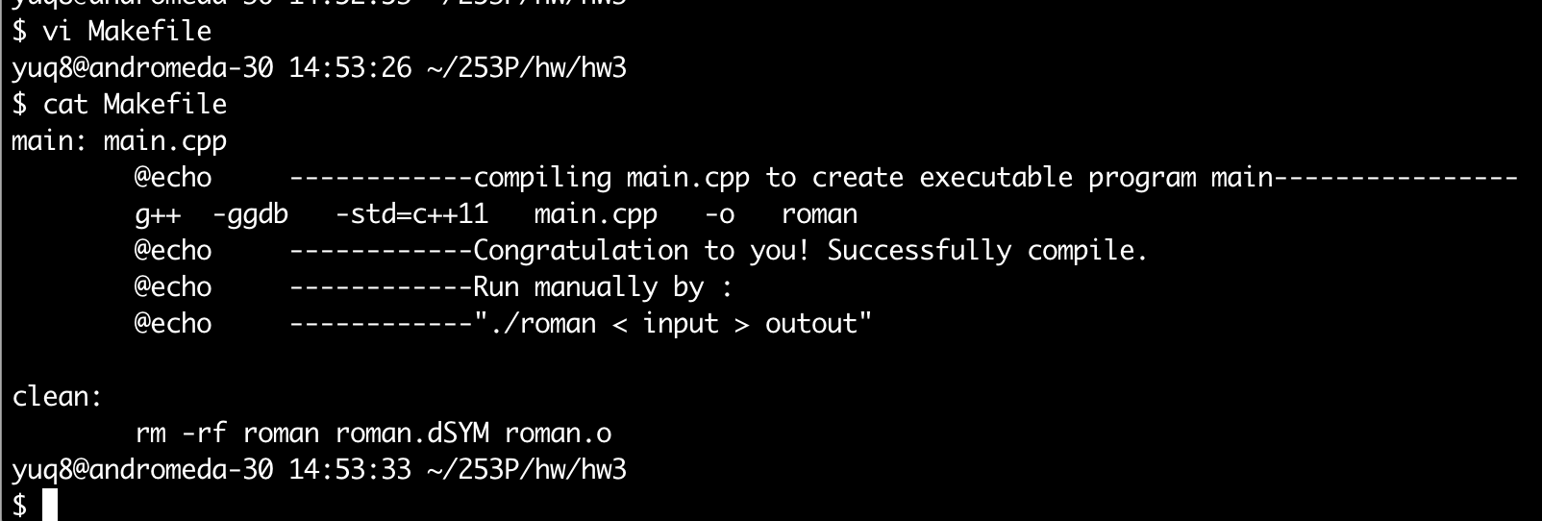

1. Use the debugger and script.

