**LAB [3], [1/24/2019] MCS 253P**

**Name: Yu Qin**

**General Problem Description**

convert Roman Numerals into equivalent Decimal Numerals

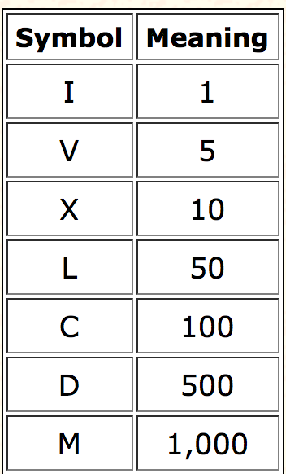

**Additional Problem Specifics**

Input valid:

Else:

1. Not in roman is invalid
2. More than 3 roman is invalid
3. Invalid subtraction except:

* I can be placed before V (5) and X (10) to make 4 and 9.
* X can be placed before L (50) and C (100) to make 40 and 90.
* C can be placed before D (500) and M (1000) to make 400 and 900.

**Proposed Algorithm**

#include <iostream>

#include <string.h>

int romanToInt(){

char roman_dict[] = "IVXLCDM";

int int_dict[] = {1,5,10,50,100,500,1000};

}

int main(){

char input_string[50];

int len = strlen(input_string);

int sum = input_string(len);

for (int i = len - 2; i >= 0; --i)

{

if (romanToInt(input_string[i]) < romanToInt(input_string[i+1]))

{

sum -= romanToInt(input_string[i]);

}

else

{

sum += romanToInt(input_string[i]);

}

}

return sum;

}

}