Autonomous Exploration for Mobile Robots
May 15th, 2017.
Version 1

Student | Daiem Nadir Ali
E-mail | daiem.ali@smail.inf.h-brs.de
Matrikel number | 9023581

University of Applied Sciences Bonn-Rhein-Sieg
Master of Autonomous Systems
Sankt Augustin, Germany.



Advised by

Prof. Dr. Paul G. Plöger
University of Applied Sciences
Bonn-Rhein-Sieg
Sankt Augustin, Germany.
mailto:paul.ploeger@h-brs.de
1 Description of the project

1.1 Introduction

1.2 State of the art analysis

1.3 Problem Formulation
Our objective is to implement exploration scheme for ground mobile robot, which enables it to autonomously explore the given indoor environment using its perception sensors (e.g laser scanners or Ultrasonic Range finder). Using these laser scans the robot should be able to build a 2D map of the surroundings . The end result of this endeavor will be a module which is able to devise an exploration strategy. The efficiency of the exploration strategy is also a concern which can be measured using matrices proposed in [1].
An exploration strategy is simply a series of nodes of a graph connected by straight line, In which each node represents a position(which is a pair of Cartesian-Coordinates in a 2D map) to be visited by the robot. If the robot visits all nodes in the given sequence, it has completed exploration according to given strategy(Fro example look at Figure 1). On the low-level these coordinates can be translated to the series of commands which are to be executed by drive of the robot, which can vary from robot to robot.

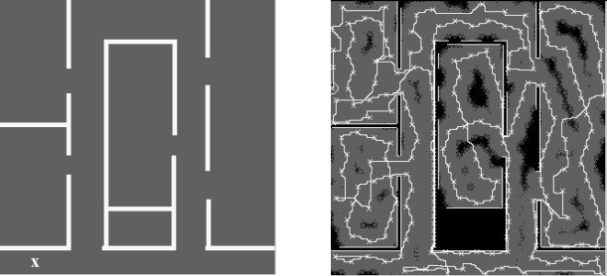
(a) (b)
Figure 1: Example of an in-door environment [2] (a) original structure of the real in-door environment with x representing the starting position of the robot. (b) explored map: with crosses representing the visited positions by the robot.

1.4 Work to be done

1.5 Evaluation

2 Detailed Project Plan

2.1 Tasks
- Study the literature for exploration
2.2 Deliverables

2.3 Gantt Chart

3 References
[1] Juliá, Miguel, Arturo Gil, and Oscar Reinoso. "A comparison of path planning strategies for autonomous exploration and mapping of unknown environments." Autonomous Robots 33.4 (2012): 427-444.

[2] Moorehead, Stewart J., Reid Simmons, and William L. Whittaker. "Autonomous exploration using multiple sources of information." Robotics and Automation, 2001. Proceedings 2001 ICRA. IEEE International Conference on. Vol. 3. IEEE, 2001.

