Scientific Experimentation and Evaluation
Exercise 9
Introduction to Classifiers

This week we downloaded and assessed the a handwritten digits dataset MNIST. We downloaded the dataset from the given website in literature yann.lecun.com/exdb/mnist/ the dataset comprise of 70,000 images of all the digits from 0 to 9. The dataset is saved in a binary file and is readable using script from http://g.sweyla.com/blog/2012/mnist-numpy/mnist.py the dataset is per-distributed among training and testing set, number of images in the dataset for each digit is uneven as shown in Fig 1 and 2

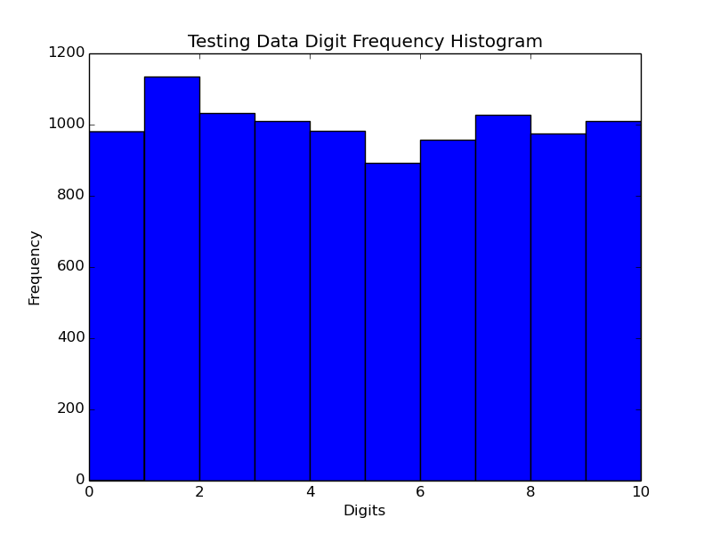
Fig 1.

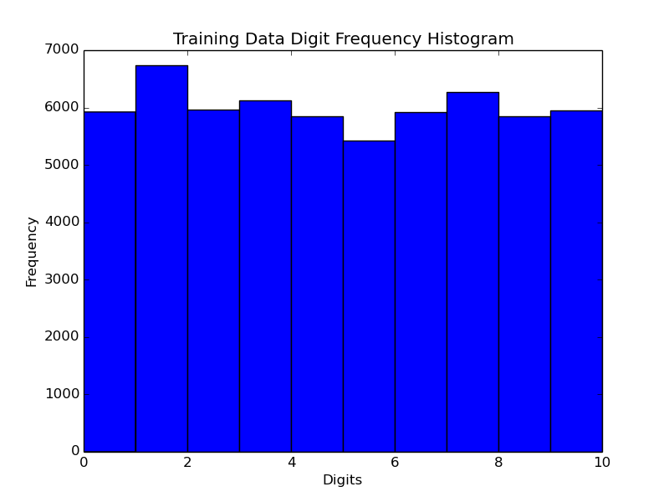
Fig 2.

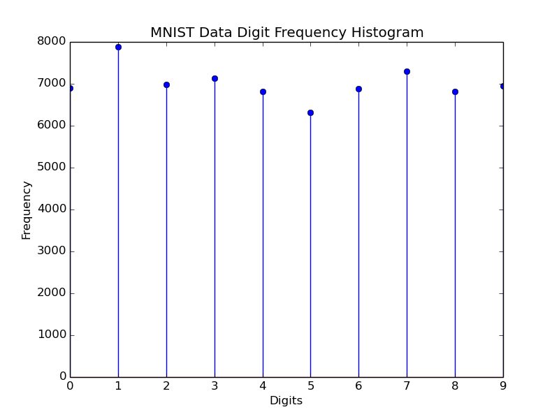
We combined the data to view the complete dataset, the distribution of the data is in Fig 3.

the number of examples for each digit varies from 6000 to 8000 approximately, we wrote a script to redistribute these images evenly such that each class will have equal number of samples. For this we take the class with the minimum number of images available(i.e digit 5) and make testing and traing sets with equal amount of images in each class. As in Fig 4 and 5
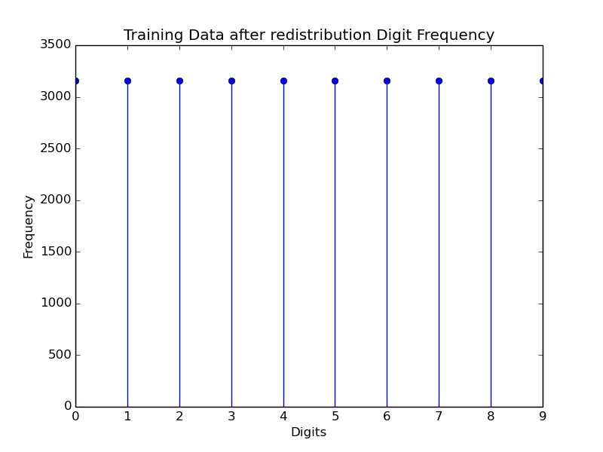
Fig 4
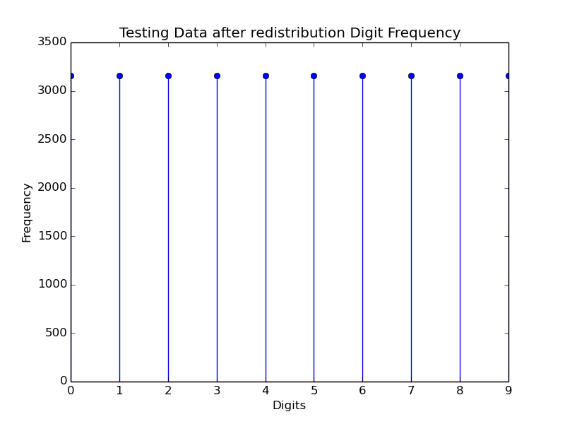
Fig 5

