Scientific Experimentation and Evaluation
Arka Mallick, Daiem Ali,Chun Kwang Tan
Hochschule Bonn-Rhien-Sieg
15.06.2015

- Divide the whole motions to small time steps:
  - The experiments are separately divided into small time steps one by one.
  - The total time was calculated from the recorded time values for each experiments.
  - It was found that forward, left and right experiments have different run times hence were divided into 150 , 160 and 161 time steps respectively.

- Velocity estimations:
  - Based on the time steps the step-wise linear and angular velocities were estimated for each experiments.
  - Estimated velocities are as follows:

 | Forward | Left Arc | Right Arc
Linear velocity (mm/sec) | 99.9 | 92.9 | 93.0
Angular velocity(rad/sec) | 0 | -0.11 | 0.11
Discretization Inverval (ms) | 66 | 67 | 67
Linear velocity (mm/timestep) | 6.67 | 6.25 | 6.21
Angular velocity (rad/timestep) | 0 | -0.0078 | 0.0078

- There is a difference between the step-wise linear velocities in all the experiments. For forward experiment it is justified as there is no angular velocity. But for the left and right arc experiments the difference probably caused by presence of systematic error.

Linear model

We performed a Least square circle fitting [1] to the experimental data last week, the visualization of the result is also corroborating to the presence of the systematic error.

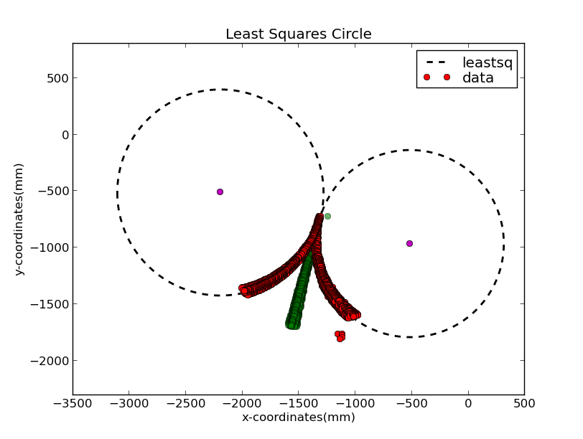
The details of the projected circles are having radius as follows:

Detected Right Radius: 828.680544881 mm
Detected Left Radius: 912.347451658 mm

We know the commanded motion had the radius of 800 mm. But there is definitely difference between commanded motion and actual motion because of several possible reasons including
- Different wheel radius
- Slippage
- Different distance between wheels and wheel center etc

In our case too we can clearly see the robot has a bias as there is a large difference between the detected radius of Right-arc experiment and Left arc experiment.

To amend this systematic error we are using different internal parameter values used are different. We fitted the internal parameters (k, b) with the measured data. We assume a linear transformation of the commanded velocities according to the equations below:

where and are the effective velocities that are applied and and are the linear and angular velocities respectively.

By the use of a curve fitting algorithm that minimizes the least mean square error between the expected values and measured data, we obtained:

This linear model parameters are then used to discover the values of the alphas in the next section.

- Alphas estimation:
  - Initial guess of the values:
    - The initial guess of the four values of alpha were but time taking and cumbersome.
    - So we automated the process.
    - We ran the experiment 100 times and randomly generated Alpha initial guesses in the range of 0 and 1.
    - Based on the minimum cumulative distance we have selected the combination which gives the best result.
    - We have used the Mahalanobis distance here.
    - Minimize a function using the downhill simplex algorithm. We are using the scipy optimization fmin implementation[2].
    - The minimum Mahalanobis distance found after 100 trials were, 29870.582
    - We tried each trials for 40 iterations. The values of alphas during the best trial are as follows.

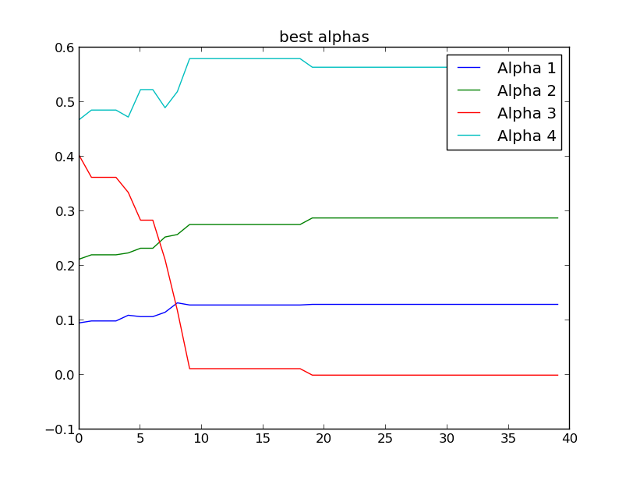
    - X-axis values represents number of trials, Y-values are value of alphas.
    - The details of the trails can be found in the attached “Exhaustive_search_results.txt” file. The result for the best trial was as follows
    - Alphas : [ 0.09 0.21 0.40 0.46]
    - min_dist : 29870.582
    - This minimum distance signifies the covergence error of the modeled motion and actual motion.

Reference:
[1] http://wiki.scipy.org/Cookbook/Least_Squares_Circle
[2] http://docs.scipy.org/doc/scipy-0.15.1/reference/generated/scipy.optimize.fmin.html
[3] http://docs.scipy.org/doc/scipy-0.15.1/reference/generated/scipy.optimize.curve_fit.html

