Scientific Experimentation and Evaluation
Handwritten character recognition
Daiem Ali,Arka Mallick,Chun Kwang Tan

For 'Handwritten Character Recognition' for MNIST dataset we used the Histogram of Oriented Gradients(HOG) features by Dalal and Triggs[1] and tested three classifiers i.e Support Vector Machines, AdaBoost and Decision Trees. The features are spatially descriptive and able to extract good information, as seen by the Fig. 1
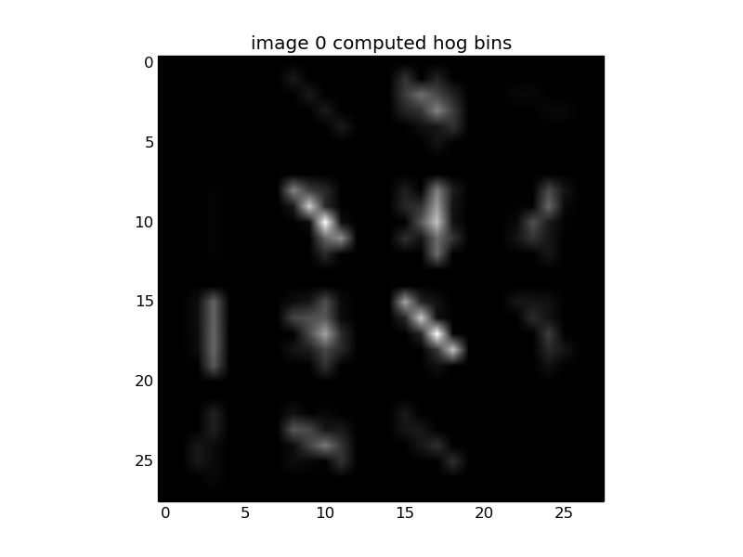
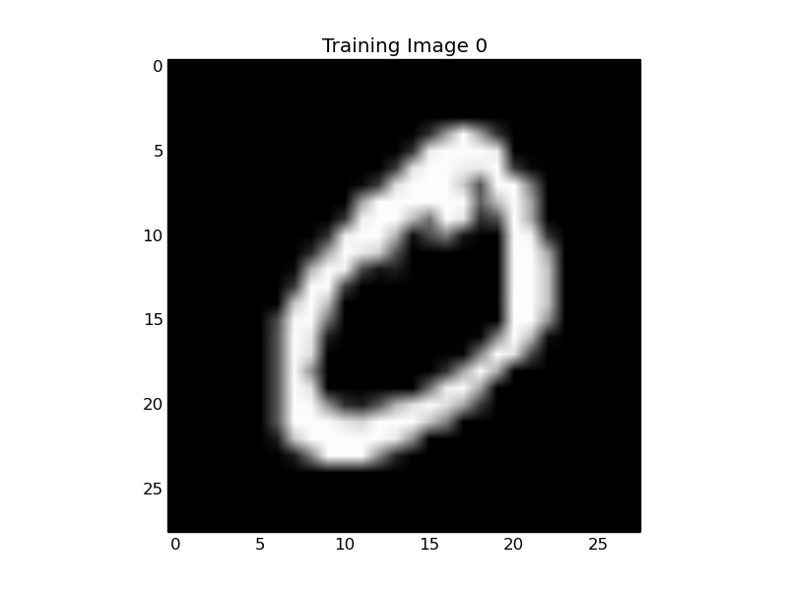
Figure 1
the feature parameters described in [1] are good for Pedestrian Detection but they had to be fine tuned for Character Recognition. Their are three parameters angle bins, number of pixels per cell and number of cells per blocks. All the three were tuned to produce good descriptor, the found parameters are 9 angle bins, 4 pixel per cell and 1 cell per block.

P.T.O
Following are some results of the SVM classification with aforementioned parameters. These give us about 95% average accuracy. The confusion matrix shows some miss classifications.
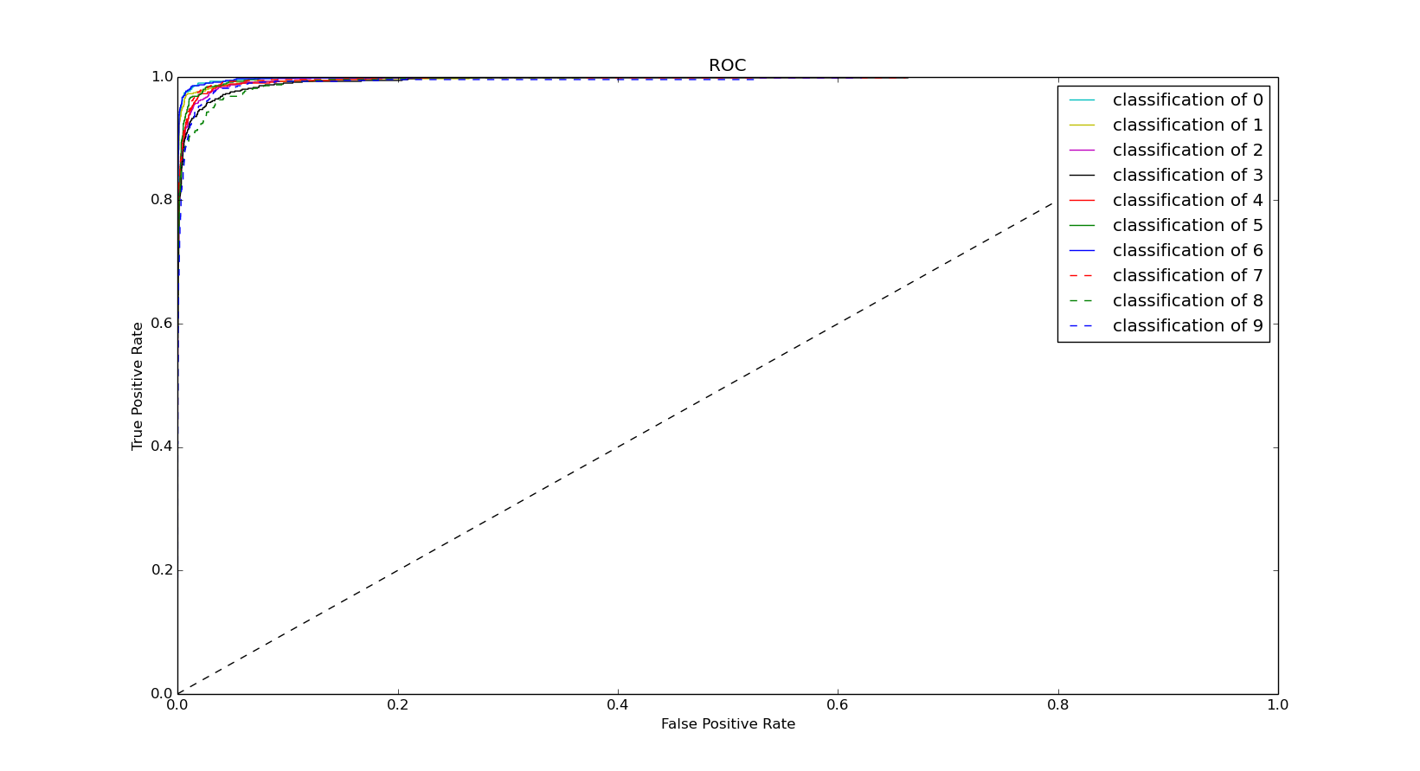
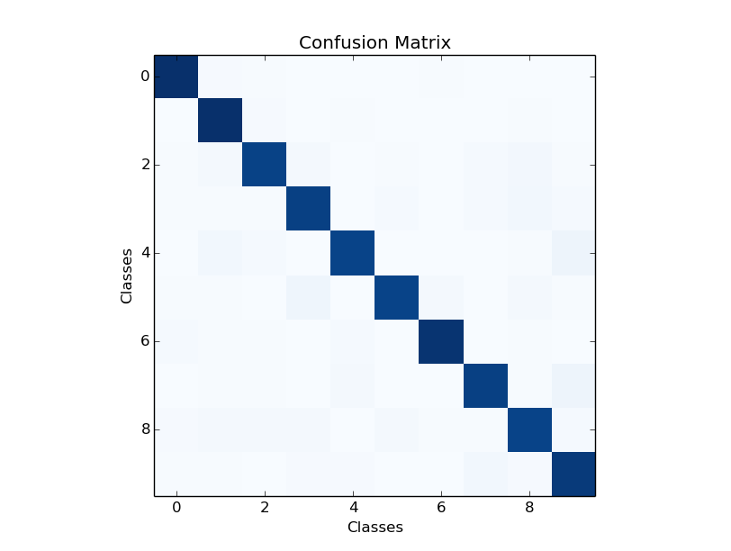
Out of seven hundred classifications for each character the most miss classifications were 4 vs 9 and 7 vs 9 and 5 vs 3.

P.T.O
So, we fine tuned the SVM classifier using grid search and found the following parameter are best for the classification, the kernel with 2nd degree polynomial, gamma of 0.3 and panalty value of 0.2 were the best to perform, the whole process took 6 hours for fine tuning.
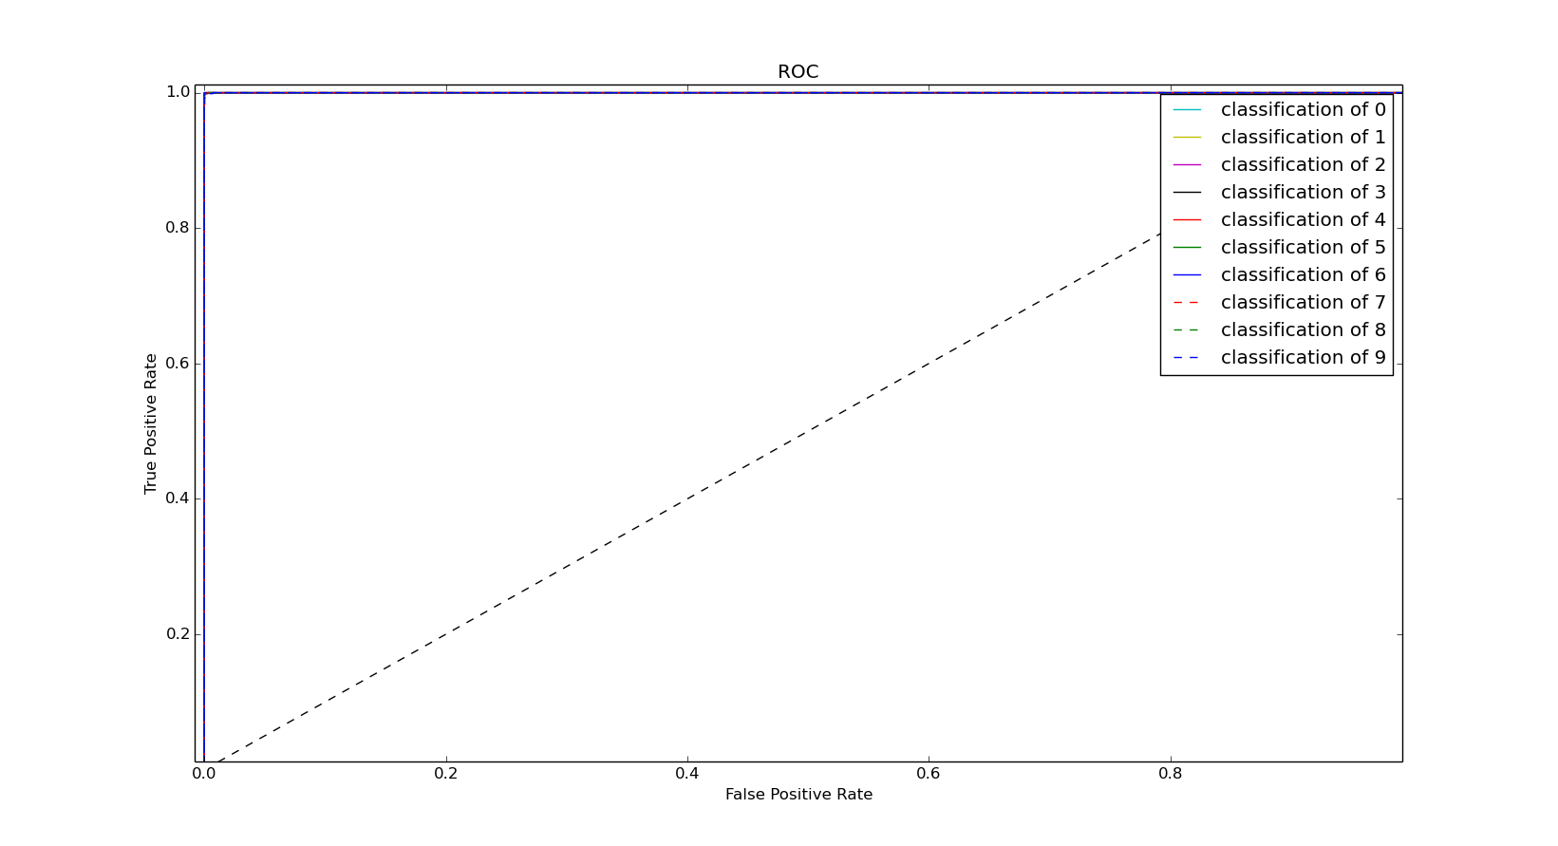
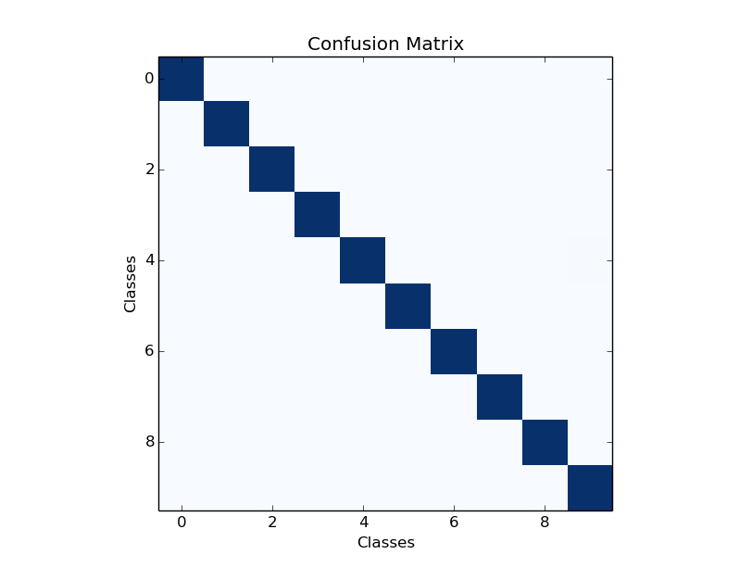
After fine tuning the most miss-classification were 3. The classification accuracy was about 98%.

P.T.O
The Decision Trees performed the best without any fine tuning.
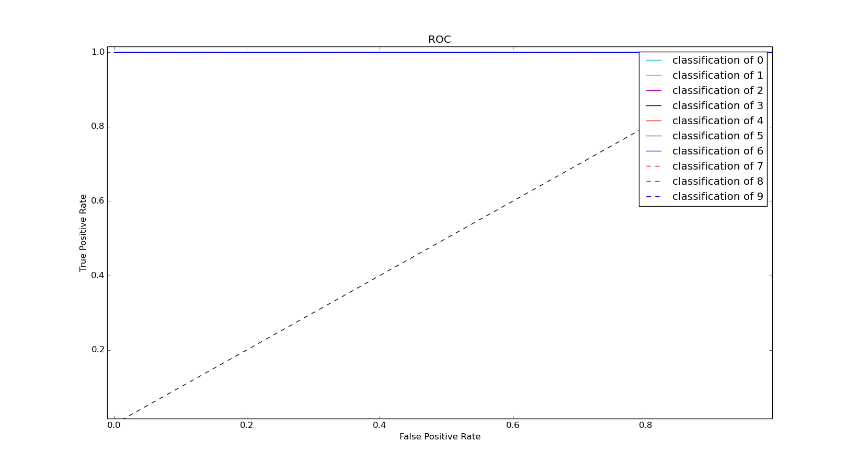
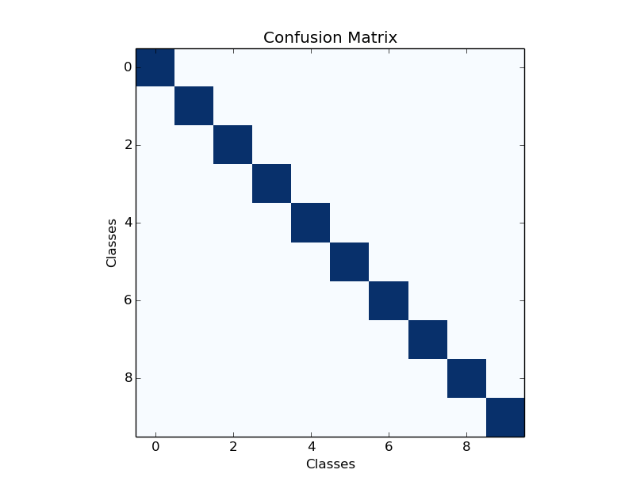
[4200 0 0 0 0 0 0 0 0 0]
[ 0 4200 0 0 0 0 0 0 0 0]
[ 0 0 4200 0 0 0 0 0 0 0]
[ 0 0 0 4200 0 0 0 0 0 0]
[ 0 0 0 0 4200 0 0 0 0 0]
[ 0 0 0 0 0 4200 0 0 0 0]
[ 0 0 0 0 0 0 4200 0 0 0]
[ 0 0 0 0 0 0 0 4200 0 0]
[ 0 0 0 0 0 0 0 0 4200 0]
[ 0 0 0 0 0 0 0 0 0 4200]

P.T.O
The worst performer was AdaBoost. The average accuracy was about 83%.
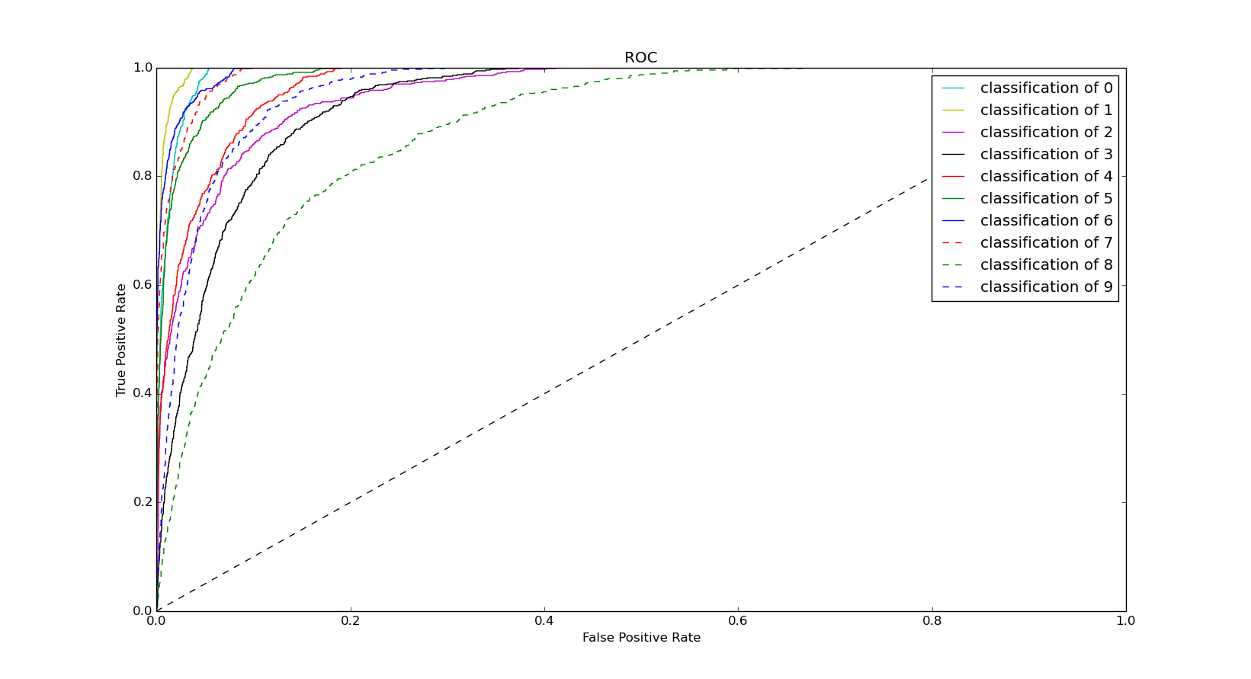
[648 0 14 14 0 3 7 0 9 5]
[ 1 649 18 2 11 1 0 6 11 1]
[ 8 8 546 79 12 1 1 7 31 7]
[ 10 1 24 526 0 45 5 4 80 5]
[ 1 8 22 0 574 0 1 1 12 81]
[ 4 1 4 33 0 569 42 1 45 1]
[ 31 4 3 1 3 8 635 0 15 0]
[ 0 9 9 10 9 0 0 627 7 29]
[ 2 10 36 104 6 36 2 2 478 24]
[ 4 2 5 10 83 0 0 47 24 525]

