# Problem 3

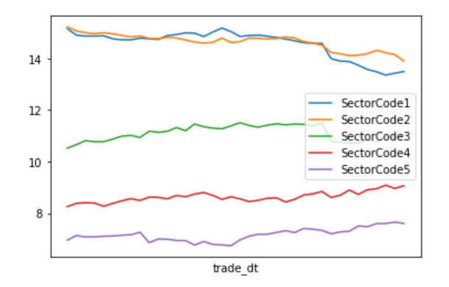

* We can see from the figure that although the weight of the 5 sectors fluctuates, the amplitude is not large and basically stable at a certain level.
* Banking and non-banking financial industries have similar weights, possibly because their businesses are relatively similar.
* The weights of the food and beverage, medical and biological, and electronics industries decrease sequentially, and the fluctuations in the weights between the two are similar.