1. Main.css
2. Main.js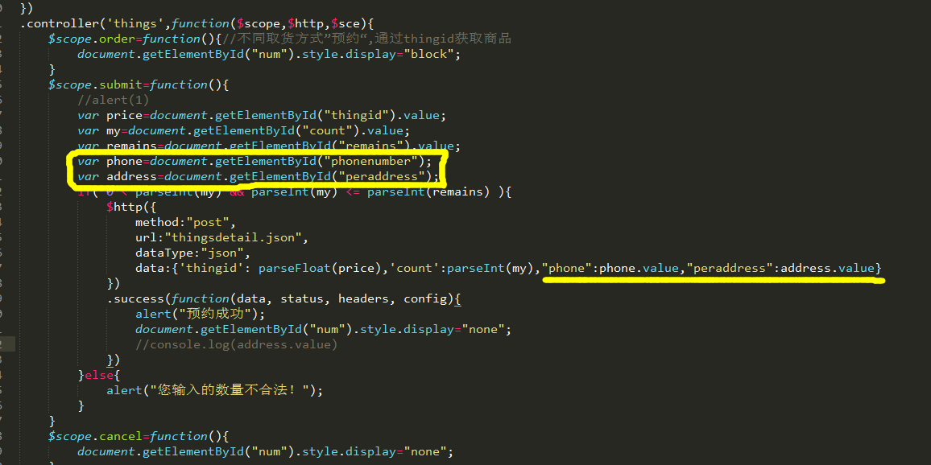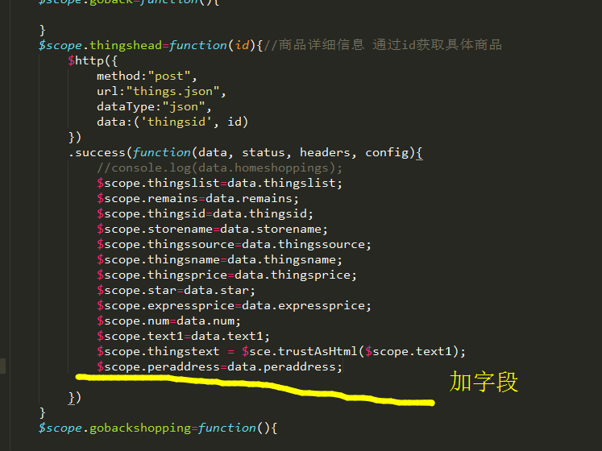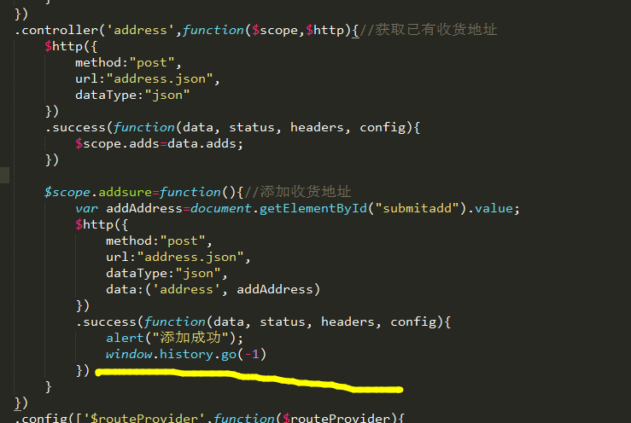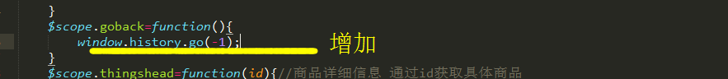
3. myCenter.html
4. thingsdetail.html address—storeaddress
5. things.html