Widespread Loss of Spatial Taxonomic but not Phylogenetic Diversity in the Anthropocene

Daijiang Li, Anthony Ives, Julian D. Olden, Julie L. Lockwood, Sydne Record, Michael L. McKinney, and Benjamin Baiser

22 June, 2018

**Summary**: The reshuffling of biodiversity due to human-induced invasions and extinctions has greatly changed Earth’s ecosystems. No continents, islands, or biological realms have escaped these anthropogenic alterations of biodiversity. The importance of assessing and predicting these changes in biodiversity has produced several global efforts at synthesis, largely focused on tracking changes in species richness within site (α diversity)1–3. The results have sparked controversy both in terms of the underlying data used, and in terms of the limitations of assessing biodiversity from strictly counting species numbers4,5. Meaningful assessments of biodiversity should consider both within site (α diversity) and across site (β diversity) measurements of multiple facets of biodiversity6,7. Here, we evaluate how taxonomic and phylogenetic spatial (β) diversity of birds, fishes, and plants have changed globally in the wake of anthropogenic pressure, and directly evaluate if loss of spatial diversity (biotic homogenization) coincides with losses in species richness at local and regional scales (γ diversity). Our database is composed of 162 unique datasets and tracks changes in 2,903 species of birds, 13,236 species of fish, and 32,382 species of plants either through time or across land-use gradients from heavily human-impacted to more natural. Across all datasets, species α diversity increased 6.05% whereas species β diversity decreased 6.44%, suggesting consistent biotic homogenization despite local increases in species richness. Phylogenetic α and β diversity, on the other hand, both did not substantially change. Importantly, land use changes significantly reduced taxonomic and phylogenetic α diversity (10.22% and 3.31%, respectively). The decoupling of taxonomic and phylogenetic diversity as well as α and β diversity highlights the need to study multiple scales and facets of biodiversity to gain a better understanding of contemporary changes. This decoupling may also have different effects on ecosystem functioning and services, a pressing research challenge in the 21st century.

Habitat loss, biological invasions, and climate change are progressively altering ecological communities through the processes of species extirpations and invasion. At the global scale, arguably the greatest extinction rate the Earth has ever seen8 has resulted in a net biodiversity loss as extinctions have outpaced speciation events9. At local and regional scales, however, taxonomic diversity within assemblages (i.e., α-diversity) has increased or remained unchanged as the establishment of nonnative species has either equaled or exceeded species losses1,2,10, although there has been recent debate whether these changes have manifested at smaller spatial scales4,5. Species losses and gains also have implications for compositional similarity among assemblages (i.e., β-diversity). The loss of endemic or rare species coupled with the establishment of cosmopolitan nonnative species has resulted in the widely documented process of taxonomic homogenization11–14. Yet, a better quantification of the magnitude of biotic homogenization across taxonomic groups at the global scale is still needed.

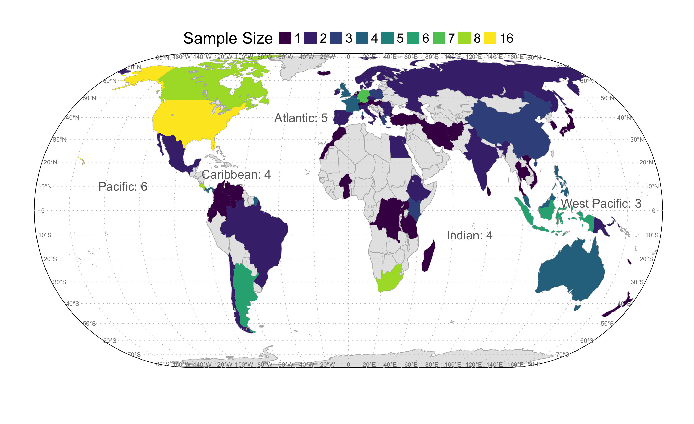

**Figure 1 |** **World map of countries represented by datasets used in this analysis.** Countries are color-coded to reflect the number of datasets within them. The number of datasets per ocean are in text. See Supporting Information for details and sources of the datasets.

# Methods

## Effects of urbanization on leaf senescence

**Data collection**. Based on the dataset compiled by Baiser et al12, we collected additional data following the same protocol. We searched the literature and online databases of plants, birds.

# References

1. Vellend, M. et al. Global meta-analysis reveals no net change in local-scale plant biodiversity over time. Proceedings of the National Academy of Sciences 110, 19456–19459 (2013).

2. Dornelas, M. et al. Assemblage time series reveal biodiversity change but not systematic loss. Science 344, 296–299 (2014).

3. Newbold, T. et al. Global effects of land use on local terrestrial biodiversity. Nature 520, 45–50 (2015).

4. Gonzalez, A. et al. Estimating local biodiversity change: A critique of papers claiming no net loss of local diversity. Ecology 97, 1949–1960 (2016).

5. Cardinale, B. J., Gonzalez, A., Allington, G. R. & Loreau, M. Is local biodiversity declining or not? A summary of the debate over analysis of species richness time trends. Biological Conservation (2018).