UTravel   
“Your personal travel guide”

Banda, Gilwyn Angelo  
Deza, John Abe  
Duran, Dayne Michael  
Relato, Christian Joy

Prof. Jay Ryan N. Mapanao

December 2016

**PROOFS**

**Statement of the Problem**

what factors are the factors that delays travelling

* How some factors are going to affect travel?

**Travel Delays**

* **Flight Delays**

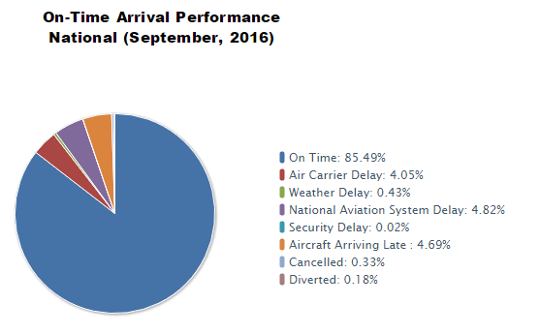

### Source of the article below

### http://www.abc.net.au/environment/articles/2014/06/23/4012110.htm

### 1. Natural disasters

While scientists know that climate change will affect traditional weather patterns, exactly how is not always clear. Floods, droughts, fires, and cyclones all have the potential to increase in some locations, and all have the ability to force a traveller to cancel their trip.

Washed out roads, missed connections, incinerated hotels are just some of the ways a natural disaster could muck up your holiday plans.

"We used to [tell tourists that to] avoid cyclones don't travel to North Queensland from late November to early March," David Beirman, senior lecturer in tourism at the University of Technology Sydney says. But he notes that events like April's Cyclone Ita means that type of advice will have to change.

And while storms and weather events get lots of press, what doesn't is the more medium-term impact these events can have.

"Access is the constraint. If fires become more common or intense, parks may close down," says Professor Ralf Buckley, director of the International Centre for Ecotourism at Griffith University.

Buckley cites the hangover from January 2013's storms in Queensland and Northern NSW as a recent example. "At Mount Warning there's only one road, and one [main] track. People like to hike to the summit and back...but the track was closed for five months. Parks [staff] were serious about the closure; there were signs about strict fines, so people didn't go," says Buckley.

### 2. Flying fares?

It seems inevitable that the price of aviation fuel will only continue to increase. But the way airlines will respond may not directly impact fares. According to Professor Buckley, most airlines' current strategy depends on the audience's price sensitivity. In business class, prices are cranked up; "You can see what the effect of fuel costs on air travel costs is by looking at business class," he says.

In economy, it's a different story: "They've reduced what they provide for the ticket."

Many tourists will undoubtedly remain committed to flying away for a break regardless, but government policy decisions may already be making more travellers think twice about where they fly.

The British Government's "airline passenger duty", for example, was in large part justified politically as being in environmental interests given that flying is a greenhouse intensive activity.

"[The duty is] very controversial in tourism circles," says Beirman. "If you have a family of Brits travelling to Australia each pays around GBP£180 per person [on top of their ticket price]. The money goes into consolidated revenue. It's making long haul destinations like Australia a lot less affordable," he says.

### 3. Disease creep

Changing weather patterns mean we're already seeing disease creep at work. "Epidemiologists have made analyses of how major diseases would change their distribution if temperature and rainfall in various places change," says Buckley. Vector-borne diseases like dengue fever are likely to be prime examples which impact travellers.

"Dengue already exists in Darwin, and it could easily move down the Queensland coast," says Buckley.

Malaria is another mosquito-borne disease not generally found outside the tropics. And while anti-malarial medications mean travellers are somewhat protected travelling in malarial areas, vector born diseases without treatments may mean a different approach.

"If dengue mosquitos reached Brisbane, the council would probably engage in huge mosquito spraying activities, just like the Gold Coast City Council does now [where canals are sprayed twice a week for residents]," Buckley says.

### 4. Dangerous creatures

While Bierman agrees mosquito-borne diseases are probably one of the most likely shifts we'll see in terms of disease patterns, changing temperatures may also impact 'threats' which most travellers currently view as regional or seasonal.

"Creatures like box jellyfish thrive in warm water. Normally you can go to Cairns quite safely in the winter months, and you won't get stung. If the water temperature rises, they'll hang around for a lot longer," he says.

Meanwhile University of Queensland zoologist Professor Craig Franklin [recently](http://www.abc.net.au/news/2014-06-10/climate-change-may-see-more-crocs-head-south/5511462)issued a warning that crocodiles may explore further south as water temperatures warm.

"A key part of it is that their distribution is very strongly limited by temperature or by low temperatures and as we see our temperatures increase then we might see more sightings of crocodiles here in south-east Queensland," he says.

### 5. Nature-based travel

An IPCC [report](http://ipcc-wg2.gov/AR5/)highlighting "hotspots of high vulnerability by 2050" mentioned the likelihood of a significant loss of biodiversity in Wet Tropics, Kakadu's wetlands and the sub-Antarctic islands, changes that spell bad news for those travelling in order to connect with nature.

It's also likely that booking a trip to coincide with the flowering of WA's wildflowers or the migrating of the monarch butterflies will become more challenging.

Perennially popular with international visitors and local tourism bodies, and on the bucket list of most Australians, the Great Barrier Reef is often held up as a poster child for negative impacts of climate change. Ocean acidification, coral bleaching and the resultant shift in biodiversity, seem likely to eventually take their toll.

According to David Beirman, it's a shift that tourism operators are watching closely: "I was at a global eco tourism conference in November 2013. Many resort operators from Queensland, Malaysia and the Philippines, commented that climate change has had an impact on coral bleaching…this is seen as a big problem for them," he says.

And it's not just looking at natural beauty that might be affected, any holiday that relies on particular weather conditions could be problematic.

Ski field operators, for example, were one of the first groups to lead in practical adaptation for climate change. But snowmaking — currently making up the shortfall — isn't a long term solution.

"Snowmaking requires a lot of water, and freezing nights. If there aren't enough cold days, you can't make snow…the smaller, lower altitude ski resorts won't survive," says Buckley.

### 6. Destinations

The place you've saved up your pennies to visit may not be the same by the time you've scraped together enough for the airfare.

Everything from a humble beachside shack being inundated by rising sea levels to the snows of Kilimanjaro not surviving the next 20 years have been touted as possible effects of climate change.

Places on the [frequently](http://www.scientificamerican.com/article/top-10-places-already-affected-by-climate-change/)[published](http://grist.org/climate-energy/10-places-to-visit-before-theyre-gone/)[lists](http://www.mnn.com/lifestyle/eco-tourism/photos/10-places-to-visit-before-they-vanish/bright-spots)on the web include the Statue of Liberty, Venice, Pacific islands and Glacier National Park.

In fact a [recent study](http://www.abc.net.au/environment/articles/2014/03/06/3958080.htm)found that of 700 places on the World Heritage list, 140 won't survive the next 2,000 years. That may seem like a long time frame, but tourists of today in the Valley of the Kings are admiring handiwork from more than 3,000 years ago, proving that a favourable review from another tourist is an enduring legacy.

* What are the causes that limits your communication while on other places?

**Physical objects:** Trees, masonry, buildings, and other physical structures are some of the most common sources of interference. The density of the materials used in a building’s construction determines the number of walls the RF signal can pass through and still maintain adequate coverage. Concrete and steel walls are particularly difficult for a signal to pass through. These structures will weaken or at times completely prevent wireless signals.

**Radio frequency interference:** Wireless technologies such as 802.11b/g use an RF range of 2.4GHz, and so do many other devices, such as cordless phones, microwaves, and so on. Devices that share the channel can cause noise and weaken the signals.

**Electrical interference:** Electrical interference comes from devices such as computers, refrigerators, fans, lighting fixtures, or any other motorized devices. The impact that electrical interference has on the signal depends on the proximity of the electrical device to the wireless access point. Advances in wireless technologies and in electrical devices have reduced the impact that these types of devices have on wireless transmissions.

**Environmental factors:** Weather conditions can have a huge impact on wireless signal integrity. Lightning, for example, can cause electrical interference, and fog can weaken signals as they pass through.

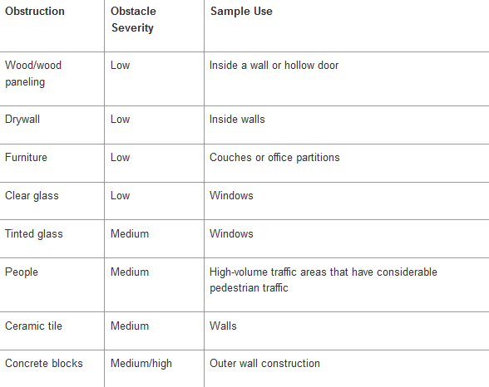

* What are the factors that affects the availability of slots in Hotel accommodation?

This statistic shows the factors affecting accommodation booking worldwide as of July 2016. During the survey, 80 percent of respondents stated that proximity to key attractions was an important factor in their final decision when booking accommodation.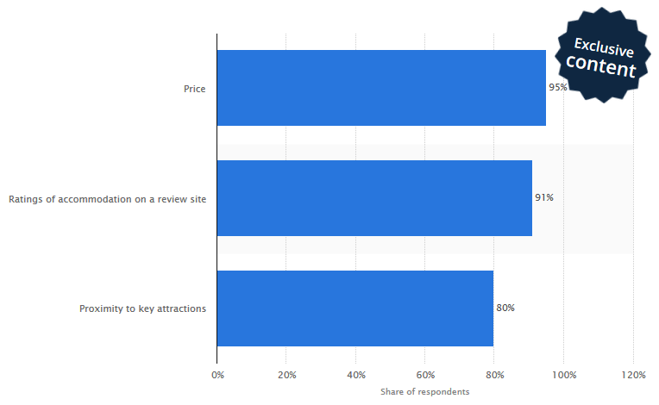

**1. Don't forget to check the exact hotel location.**

I once stayed in a great hotel that seemed to be in an ideal location -- except that it was surrounded by extremely busy roads, including an on-ramp and off-ramp to a highway on either side of the hotel. It felt like I was staying in an interstate rest stop. I couldn't really walk anywhere, and just stepping outside was not just annoying but borderline dangerous.

There were fine restaurants a block away, and a running trail a half-mile away, and a great riverwalk another half-mile from there. When I booked the hotel, I knew it was close to all those cool things, but did not check closely enough to realize that the hotel was pretty much on a highway median, and that you couldn't get to any of them without risking life and limb. Yeesh.

The easiest way to prevent this sort of problem is to see the site for yourself. Most booking websites include a map view of some kind, and you might also take a look at Google Street View or Bing's Bird's Eye view to get a good look at the lay of the land.

**2. Don't skip the review sites.**

Knowing as much as possible about any given property is your best strategy for getting a hotel and room that you actually enjoy staying in. When checking review sites such as TripAdvisor and Yelp over the years, almost inevitably I have switched my preferred hotel after a bit of research, as there is always something you would never know without the help of folks who have already stayed at a property. These might include noise, lousy food, iffy Internet, dated rooms and more -- even the fact that the hotel is pretty much on a highway median.

And you might find out a lot of good things as well. Before a recent stay, I learned about an affordable bike rental program at one hotel I was researching that tipped the balance toward staying there. We had some great bike rides around the area, saw a lot of things we would not have seen otherwise and saved money on public transportation and car rentals.

**3. Don't forget to check if the hotel has an airport shuttle.**

I am a big fan of using public transportation when zooming around at your destination, as it puts you among the locals in a simple, straightforward way.

I'm not a huge fan of public transportation to and from the airport, however. Starting and (especially) ending a trip by hauling massive bags through an unfamiliar subway system can be a grueling experience, especially when you are trying to get some rare R&R.

But unless you are renting a car, getting to and from your hotel in a taxi can be really expensive, especially since most airports are quite a distance from the nearest city center. For example, it'll cost you $55 - $70 to get to downtown [**Denver**](http://www.independenttraveler.com/destinations/rockies/denver) from the airport -- small beans compared to [**Tokyo**](http://www.independenttraveler.com/destinations/asia/tokyo), where an airport taxi will set you back anywhere from $150 - $200 or beyond. Remembering that you have to pay that both coming and going, you could pay more for transportation to the hotel than you do for the stay itself.

When considering the cost of one hotel vs. another, you will want to know whether the airport offers a complimentary hotel shuttle.

**4. Don't fail to check parking availability and cost.**

If you will have your own car, you will want to check both availability and pricing on parking at the hotel. Even if the hotel has parking available, it often comes with a price tag, and can add anywhere from $10 to $35 or more to your daily hotel cost (the last two hotels I stayed at with a rental car cost $31 and $36 per day, respectively). If a hotel doesn't have its own parking, the cost can be even higher in some places where you are forced to use private lots, and you have to worry about the car getting dinged or broken into -- not to mention the hassle of having to find a spot every day.

**5. Don't forget to factor in the cost of breakfast.**

The actual per-night difference between a hotel that offers a solid continental (or even full) breakfast included in the rate compared to one that offers a 23-euro buffet can be significant, to say the least.

You can usually find out this information on the hotel website or by calling the front desk directly. Since most folks prefer to breakfast at their hotel, this is an important question if you are concerned about your budget. Sure, you can always try to find an affordable cafe nearby, but you can't beat a free hotel breakfast for convenience.

**6. Don't take Internet access for granted.**

As with breakfast, parking and a shuttle, if you absolutely need Internet access, you also need to consider it part of your nightly hotel budget when comparing prices. A hotel where you save $10/night but then pay $19.95 for Internet is no savings at all.

This is a tricky one, though, so make sure you check this closely; Internet access may be free for some but not all. Properties in the InterContinental Hotel Group, for example, offer free Internet access only to IHG Rewards Club members. For everyone else, access is commonly priced from $9.95 up to $19.95 per 24 hours. That adds up over a few nights' stay, for sure.

Additionally, some hotels have started charging for access per device, or sometimes allowing only two devices per paying customer. If more than one person is staying in the room, this can become a problem very quickly, as most folks connect with at least two devices these days (e.g., a laptop and a smartphone). Check the fine print.

**7. Program members, don't book anywhere but directly through the hotel.**

This applies mainly if you belong to a loyalty club and hope to have [**hotel points**](http://www.independenttraveler.com/travel-tips/travelers-ed/smart-tactics-to-get-more-from-your-hotel-points) awarded to your account -- because if you book through pretty much any third party, hotels won't pony up the points. This includes well-known booking sites, group bookings, bookings by your travel agent, bookings by the hotel's own vacation club and even bookings at conference rates. Read more in [**The Trouble with Hotel Reward Programs**](http://www.independenttraveler.com/travel-tips/travelers-ed/the-trouble-with-hotel-reward-programs).

**8. Don't fail to sign up for the rewards program.**

It is often free to sign up for a hotel's loyalty program, and in some cases significant rewards kick in almost immediately. These can include complimentary Wi-Fi, as mentioned above, but also many "soft" benefits that you might not even be aware of; front desk agents might give you a slightly better room, for example.

**9. Don't be afraid to ask for a better rate.**

One of the simplest but most effective tactics for getting a better rate is to ask for one. I usually recommend an open-ended approach, something like "are there any better special rates available?" This usually prompts the reservations person to ask if you are a member of a travel or other association (AAA or AARP), a member of a loyalty program, etc. From there they will often offer a better rate one way or another, simply for the asking.

**10. Don't be afraid to call the hotel directly.**

If you have a hotel that is showing no rooms available, or really high rates, or lack of availability of certain special needs rooms (pet-friendly, accessible, kid-friendly, etc.), you should call the hotel and ask them directly. The front desk often has information about cancellations, additional rooms and more that may not immediately show up on hotel or booking sites.

Even if you have a simple question, such as "How much does Internet access cost?" or "Is breakfast included?" a quick call to the hotel will usually settle pretty much any doubts you might have.

**11. Don't forget to ask.**

You would be surprised what a hotel can and will do for you if you simply ask politely. Many front desk folks will lend common toiletries, make restaurant recommendations and even reservations, call for taxis, give directions, help with public transportation and handle other logistical items without even flinching.

Additionally, you can often request a room on a certain side of the hotel, on an upper floor, away from the main road, closer to the elevator if you are disabled and more. Simply ask, and ye may receive.

**FLOWCHART**

**The Main Page**

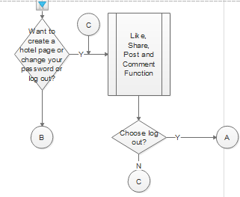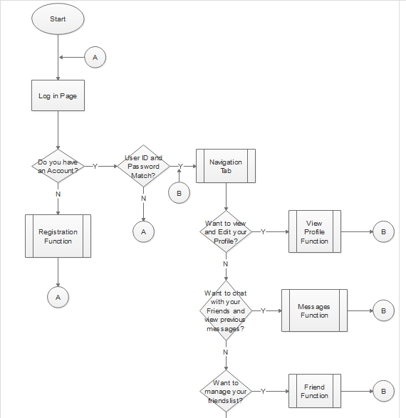

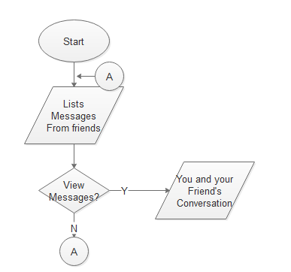**Message Friend**

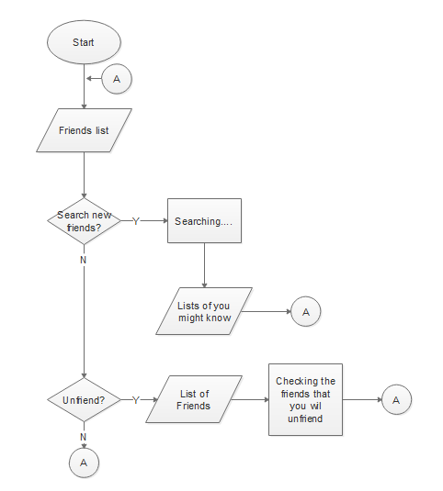

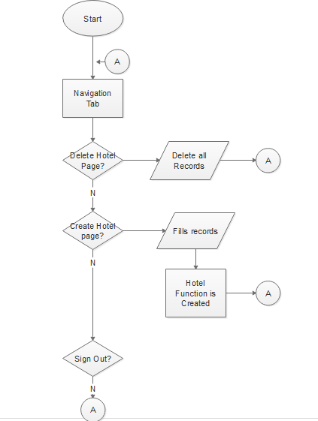**Account Profile**

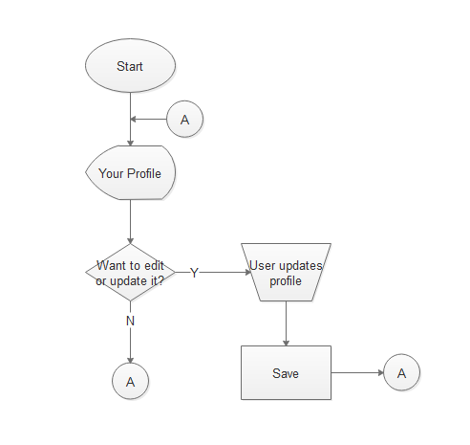

**Register**

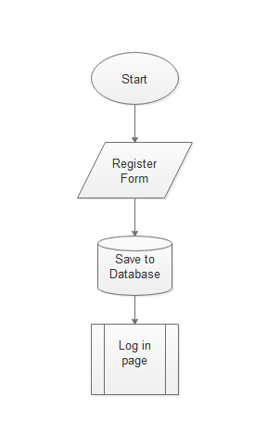

**Travel**

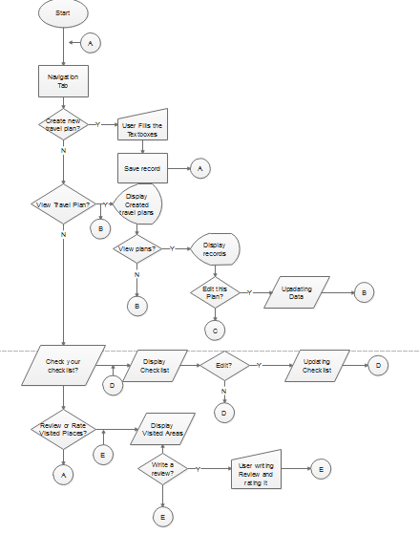

**Homepage**

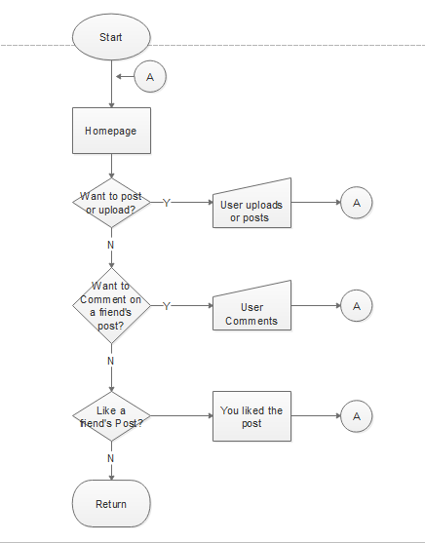

|  |  |
| --- | --- |
| C:\Users\XY\Desktop\UI\LOGIN\uTravel Login.png | **LOG IN Page**   * The first page you’ll see when you open the app where you can log in or create an account. You can see the Utravel logo at the top. Below is the textbox for your username and password which is needed for you to log in. Then the log in button for proceeding after you enter your username and password. Below is a link you can choose if you don’t have an account yet and it will move you to the register page. And lastly, a link for the users that have forgotten their password.the application will send your forgotten password to the email you have given in the register page. |
|  | **Register Page**   * The register page for the users where they can create their own account for them to use the application. The Utravel logo is at the top of the page. Below is the needed field for the users to be filled out for them to go the next step. The field username and email address has a circle next to it. It will turn red if the input is wrong or it is already taken by other users, otherwise it will turn green. |
|  | * The second step of the register page. It has three fields that requires the users info and needed to be filled out to go the last step of register page. |
|  | * The Last page of register page. It has two fields, the password and the confirmation password. It is needed to be filled out by the user. Below is a button for the users to proceed and log in to their newly created account. Below is a button to go back to the previous step if you need something to change. |
|  | **Home Page**   * The first tab of the home page after you log in. This is the page where you can post your travel plans. You can also add a photo or video to your travel post. You can also see here all your friends travel post. On the bottom left of a post, there is a button for the like and comment. You can click on a post to see all the comments on that post. |
|  | * The second tab of the homepage or the profile page. You can see all your posts here and review your previous posts. Clicking on your profile on the upper most will show additional details of the user. |
|  | * The third tab of the homepage or the messages tab. This page will show you all your private messages with the other users. At the upper top you can search a user for you to quickly send a message. |
|  | * In this tab, you can see all your friends here or add someone. In your friend list the photo border of your friend will show green if they are online and it will show grey if they are offline. Finding a friend will move you to their profile. you can then add them and wait for them to accept your request. |
|  | * In the Travel tab there is a four options you can choose. The first is you can create a new travel plan. The second one, you can view or edit your created travel plans. Next, you can check your Travel checklist, you can review or add in your checklist. Laastly, you can review or rate visited places for you to help other travelers to plan their travel. |
|  | * The last tab which is the account tab, you have three options . The first one is for the hotel owners. You can create your own hotel page to help the travelers about your hotel. The second one is for the users who want to change their password. And the last is Sign out to go back to the log in page. |
|  | * In the messages tab, after clicking to a profile. You can see and reply to that conversation. |
|  | * When finding a friend , you can see their profile and some of their travel plans. You can add them by clicking the “add person” button or message them by clicking the “message” button. |
|  | * This the checklist option found in the Travel tab. You can view all your travel list here or edit it by clicking the button below and save it. |
|  | * This is the review option found inside the travel tab. You can search for a place and rate or review about that place. |
|  | * This is a sample of a place after clicking on the review option. You can view all the reviews. You can add your rate or review by clicking on the buttons. |
|  | * This is the sample of reviewing and giving a rating to a place to help other travelers what will they expect and not to expect about that place. |
|  | * This is the Creation of your own hotel. The user needed to filled out all the info about their hotel. |
|  | * After Creating a hotel, a Hotel tab will appear on the tabs section. Clicking it will sho you all the details about you hotel and the total views. You can click the button “view hotel messages” to view the messages sent by users about your hotel. |
|  | * This is the page where you can see all the messages about your hotel and reply to them. |
|  | * After adding a travel plan, you need to specify all the details about your plan before the app record it as a complete plan. |

**STORYBOARD**