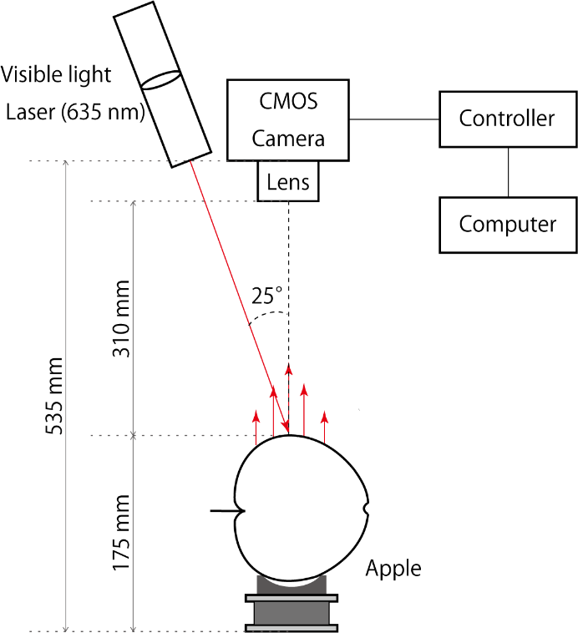

Fig. 1 Schematic diagram of the laser scattering measuring device