ALZHEIMER'S DISEASE PREDICTION
(TABULAR EDA + BINARY CLASSIFICATION + MULTI-STAGE PREDICTION)
Step-by-Step Student Guide

ABSTRACT
This project develops a machine-learning pipeline for Alzheimer's disease prediction using a tabular patient dataset containing demographic, lifestyle, cardiovascular, cognitive, behavioral, and functional variables. The supplied dataset contains 2,149 patient records and 35 columns, including the binary Diagnosis target and a DoctorInCharge field that is excluded from modelling.
The notebook performs dataset inspection, missing-value and duplicate checks, correlation analysis, diagnosis-proportion analysis, univariate distributions, MMSE-versus-age analysis, and boxplot analysis. It then trains Logistic Regression, Random Forest, Gradient Boosting, and XGBoost classifiers for binary prediction.
A second modelling workflow derives four dementia stages from MMSE thresholds — Non Demented, Very Mild Demented, Mild Demented, and Moderate Demented — and evaluates Logistic Regression, Random Forest, and XGBoost. The best binary model reported in the notebook is Gradient Boosting at approximately 95% accuracy, while the deployed Streamlit application uses saved binary and multi-stage model artifacts to provide an interactive prediction interface.

1. INTRODUCTION
Alzheimer's disease prediction is a classification problem in which heterogeneous patient attributes are used to estimate a target outcome. This project treats the supplied dataset as a supervised tabular-learning problem rather than a time-series problem.
- Demographic variables such as age, gender, ethnicity, and education level.
- Lifestyle variables such as smoking, alcohol consumption, physical activity, diet quality, and sleep quality.
- Medical risk factors including family history, cardiovascular disease, diabetes, depression, head injury, and hypertension.
- Clinical measurements including blood pressure and cholesterol.
- Cognitive and functional indicators including MMSE, FunctionalAssessment, ADL, memory complaints, confusion, disorientation, and related behavioural indicators.
The project also separates binary dementia detection from a four-stage MMSE-derived classification workflow.

2. PROBLEM STATEMENT
The objective is to build a classification pipeline that can use patient-level features to predict whether dementia is detected and, in a secondary workflow, assign a dementia stage based on the MMSE-derived labels used in the notebook.
- The dataset contains multiple heterogeneous numerical and categorical-style variables.
- The target Diagnosis must be separated from model inputs.
- PatientID and DoctorInCharge should not be used as predictive features.
- Model performance must be compared across multiple classification algorithms.
- The deployment layer must preserve the exact feature order expected by the saved models.

3. OBJECTIVES OF THE PROJECT
- Load and inspect the Alzheimer's disease dataset.
- Check dimensions, data types, descriptive statistics, missing values, and duplicates.
- Analyze correlations among selected clinical and lifestyle variables.
- Visualize diagnosis proportions and important feature distributions.
- Study the relationship between age and MMSE.
- Train and compare Logistic Regression, Random Forest, Gradient Boosting, and XGBoost for binary prediction.
- Create MMSE-based four-stage labels.
- Train and compare multi-stage classification models.
- Perform five-fold cross-validation for the multi-stage XGBoost workflow.
- Save model artifacts using pickle.
- Deploy the prediction workflow through a Streamlit interface.

4. TOOLS AND TECHNOLOGIES USED
Tool / Technology | Purpose
Python | Core programming language
Pandas | Dataset loading, inspection, transformation
NumPy | Numerical operations
Matplotlib | Visualization
Seaborn | Statistical plots and heatmaps
Scikit-learn | Train/test split, classification models, metrics, encoding, cross-validation
XGBoost | Gradient-boosted classification
Pickle | Model and label-encoder serialization
Jupyter Notebook | EDA, modelling, and evaluation
Streamlit | Interactive prediction dashboard
CSV Dataset | Alzheimer's patient data

5. DATASET DESCRIPTION
The supplied alzheimers_disease_data.csv contains 2,149 records and 35 columns.
Category | Columns
Identifiers | PatientID, DoctorInCharge
Demographics | Age, Gender, Ethnicity, EducationLevel
Lifestyle | BMI, Smoking, AlcoholConsumption, PhysicalActivity, DietQuality, SleepQuality
Medical Risk | FamilyHistoryAlzheimers, CardiovascularDisease, Diabetes, Depression, HeadInjury, Hypertension
Clinical Measurements | SystolicBP, DiastolicBP, CholesterolTotal, CholesterolLDL, CholesterolHDL, CholesterolTriglycerides
Cognitive / Functional | MMSE, FunctionalAssessment, MemoryComplaints, BehavioralProblems, ADL, Confusion, Disorientation, PersonalityChanges, DifficultyCompletingTasks, Forgetfulness
Target | Diagnosis

5.1 Dataset Quality
Missing-value check: 0 missing cells across the supplied dataset.
Duplicate-row check: 0 duplicate rows.
Binary diagnosis distribution: {0: 1389, 1: 760}.

6. SYSTEM ARCHITECTURE
Raw Alzheimer's Patient CSV
↓
Data Loading & Inspection
↓
Missing Value & Duplicate Check
↓
Correlation + Distribution EDA
↓
Feature/Target Separation
↓
Binary Train-Test Split (Stratified 80/20)
↓
Binary Model Training — Logistic Regression / Random Forest / Gradient Boosting / XGBoost
↓
Binary Model Comparison
↓
MMSE-Based Four-Stage Label Construction
↓
Categorical Encoding + Stratified Train-Test Split
↓
Multi-Class Model Training & Evaluation
↓
Five-Fold Cross-Validation
↓
Model Artifact Saving
↓
Streamlit Prediction Application

7. DATASET SCALE & COMPLEXITY ANALYSIS
The dataset is moderate in size but contains a broad mix of demographic, behavioural, medical, and cognitive predictors.
- 2,149 patient records and 35 columns.
- Multiple feature domains are combined into a single tabular model.
- Binary diagnosis and MMSE-derived multi-stage prediction are treated as separate targets.
- The Streamlit application requires the same feature ordering used during training.
- The notebook uses both native numeric features and explicit encoding for the multi-stage workflow.

8. EXPLORATORY DATA ANALYSIS (EDA)
- data.head(), data.columns, data.shape, data.info(), and data.describe().
- Missing-value and duplicate checks.
- Correlation heatmap for MMSE, FunctionalAssessment, ADL, SleepQuality, PhysicalActivity, Diabetes, Hypertension, CholesterolTotal, and Diagnosis.
- Diagnosis proportion pie chart.
- Histograms for Age, BMI, AlcoholConsumption, PhysicalActivity, SleepQuality, MMSE, and CholesterolTotal.
- Scatter plot of MMSE versus Age coloured by Diagnosis.
- Boxplot of MMSE by Diagnosis.

9. CORRELATION & DIAGNOSTIC VISUALIZATION
The notebook constructs a correlation matrix from selected clinical, lifestyle, and target variables and displays it as a heatmap. This is used for exploratory understanding rather than as a direct feature-selection mechanism.
The diagnosis proportion chart provides a visual view of class balance, while the MMSE-versus-age scatter plot and MMSE boxplot provide a direct view of cognitive-score relationships with diagnosis.

10. DATA PREPROCESSING
- The notebook checks missing values using data.isnull().sum().
- Forward filling is applied using data.ffill(inplace=True).
- Duplicate rows are checked with data.duplicated().sum().
- PatientID and DoctorInCharge are excluded from modelling.
- Diagnosis is used as the binary target.
- For the multi-stage workflow, Diagnosis_Multi is created from MMSE thresholds.
- Categorical columns are encoded in the multi-stage preparation.

11. BINARY CLASSIFICATION
The binary workflow defines X by dropping DoctorInCharge, PatientID, and Diagnosis. The target y is Diagnosis. The data is split using train_test_split with stratification, test_size=0.2, and random_state=42.

11.1 Models
- Logistic Regression
- Random Forest
- Gradient Boosting
- XGBoost (n_estimators=200, random_state=42)
The notebook's try_model() function fits each classifier, generates predictions, prints a classification report, and displays a confusion matrix.

12. BINARY MODEL EVALUATION
Model | Accuracy | F1 — Class 0 | F1 — Class 1
Logistic Regression | 0.81 | 0.86 | 0.73
Random Forest | 0.94 | 0.95 | 0.91
Gradient Boosting | 0.95 | 0.96 | 0.92
XGBoost | 0.94 | 0.96 | 0.92
The notebook's recorded comparison identifies Gradient Boosting as the strongest binary model by accuracy at 0.95, with Random Forest and XGBoost at approximately 0.94 and Logistic Regression at approximately 0.81.
The binary comparison values above are reproduced from the notebook's explicit model-comparison cell rather than recalculated or silently changed.

13. MODEL ARTIFACT — BINARY MODEL
The notebook creates an XGBClassifier with n_estimators=200 and random_state=42, fits it on the binary training data, and saves it as model_binary.pkl using pickle.
model_binary = XGBClassifier(n_estimators=200, random_state=42)
model_binary.fit(X_train_bin, y_train_bin)

import pickle
pickle.dump(model_binary, open("model_binary.pkl", "wb"))

14. MMSE-BASED MULTI-STAGE CLASSIFICATION
The notebook creates Diagnosis_Multi directly from MMSE using the following rule:
MMSE Range | Stage
MMSE ≥ 26 | Non Demented
21 ≤ MMSE < 26 | Very Mild Demented
11 ≤ MMSE < 21 | Mild Demented
MMSE < 11 | Moderate Demented
This is an MMSE-derived staging rule implemented by the project. It should not be interpreted as a clinical diagnostic standard.

15. MULTI-STAGE FEATURE PREPARATION
- The Diagnosis_Multi target is label encoded with LabelEncoder.
- DoctorInCharge, PatientID, Diagnosis, and Diagnosis_Multi are removed from the multi-stage feature matrix.
- pd.get_dummies(..., drop_first=True) is used for categorical feature encoding.
- A stratified 80/20 train-test split is performed with random_state=42.
- Logistic Regression, Random Forest, and XGBoost are evaluated.

16. MULTI-STAGE MODEL EVALUATION
Model | Accuracy — Reproduced Execution
Logistic Regression | 0.8953
Random Forest | 0.9953
XGBoost | 0.9930
Reproduced execution on the supplied CSV produced the above holdout results. The strongest observed model was Random Forest at 0.9953, followed closely by XGBoost at 0.9930.
The notebook also performs five-fold cross-validation using the multi-class XGBoost configuration. Reproduced execution gave mean accuracy ≈ 0.9963. These reproduced figures are included as execution results and are not claimed to be printed outputs from the original notebook file.

17. MULTI-STAGE MODEL ARTIFACTS
- model_multi.pkl — saved after fitting GradientBoostingClassifier(random_state=42) on the multi-stage training data.
- label_encoder.pkl — stores the LabelEncoder used for the Diagnosis_Multi target.
An important implementation detail is that the notebook evaluates several multi-stage models but saves GradientBoostingClassifier as model_multi.pkl. The deployed app therefore uses the saved Gradient Boosting model rather than automatically selecting the highest-accuracy model from the comparison.

18. STREAMLIT APPLICATION
The uploaded app(2).py implements a centered Streamlit interface titled "Alzheimer's Disease Prediction". It loads three serialized artifacts: model_binary.pkl, model_multi.pkl, and label_encoder.pkl.

18.1 Feature Order
The application explicitly defines FEATURE_ORDER so that the input vector is assembled in the same expected order before prediction.

18.2 User Inputs
- Age, gender, ethnicity, education level, BMI.
- Smoking, alcohol use, physical activity, diet quality, sleep quality.
- Family history, cardiovascular disease, diabetes, depression, head injury, hypertension.
- Systolic/diastolic blood pressure and cholesterol measures.
- MMSE, functional assessment, ADL.
- Memory complaints, behavioural problems, confusion, disorientation, personality changes, difficulty completing tasks, and forgetfulness.

18.3 Prediction Logic
- The input dictionary is converted to a NumPy array using FEATURE_ORDER.
- The binary model predicts whether dementia is detected.
- If the binary result is 0, the application returns Non Demented.
- If the binary result is 1, the multi-stage model predicts a stage code and label_encoder converts it back to the stage name.
- A fallback MMSE rule can replace a returned Non Demented stage with Very Mild, Mild, or Moderate Demented according to the MMSE thresholds.

18.4 User Interface Output
- "Dementia Detected" is displayed for binary prediction 1.
- "No Dementia Detected" is displayed for binary prediction 0.
- The predicted stage is shown using an informational message.

19. BEFORE VS AFTER DATA PROCESSING
Aspect | Before Processing | After Processing
Data | Raw patient CSV | Model-ready feature matrices
Quality | Needs verification | 0 missing cells and 0 duplicate rows in supplied CSV
Target | Diagnosis | Binary Diagnosis + MMSE-derived Diagnosis_Multi
Identifiers | PatientID / DoctorInCharge present | Excluded from model features
Categorical Features | Raw encoded representations | Label encoding / one-hot encoding used
Models | None | Multiple classifiers trained and evaluated
Deployment | No interface | Streamlit prediction dashboard

20. PROJECT LIMITATIONS & IMPLEMENTATION CONSIDERATIONS
- The MMSE thresholds used to create Diagnosis_Multi are project-defined rules from the notebook and should not be treated as a clinical diagnostic protocol.
- The deployed app depends on three pickle artifacts being present in the same working directory.
- The application uses the saved Gradient Boosting model for the multi-stage prediction even though the notebook's multi-stage comparison includes other models.
- The binary artifact saved by the notebook is XGBoost, whereas Gradient Boosting has the best reported binary accuracy in the comparison table. Therefore, the deployed binary model is not automatically the notebook's highest-scoring binary model.
- The notebook's multi-stage model uses one-hot encoding during training; deployment assumes the resulting 32-feature order matches the app's FEATURE_ORDER.
- The Logistic Regression multi-stage implementation may produce convergence warnings with the unscaled feature set.
- Classification accuracy alone is insufficient to establish clinical usefulness.
- The dataset is a modelling dataset and the project does not establish causal relationships between individual factors and Alzheimer's disease.

21. ETHICAL & RESPONSIBLE USE
- This application should be treated as an educational machine-learning demonstration, not a medical diagnostic device.
- Predictions should not be used as the sole basis for medical decisions.
- Clinical assessment requires qualified healthcare professionals and appropriate validated diagnostic procedures.
- Model performance on this dataset does not establish generalization to a different population, hospital, or clinical setting.
- Any real deployment would require clinical validation, bias analysis, privacy controls, model monitoring, and appropriate regulatory review.

22. REAL-WORLD APPLICATIONS
- Educational demonstration of supervised classification on healthcare-style tabular data.
- Prototype risk-screening interface for research workflows.
- Benchmarking tree-based classifiers against linear classification.
- Exploration of cognitive and functional variables in predictive modelling.
- Foundation for a more rigorous clinical decision-support research project.

23. FUTURE SCOPE
- Use a formal preprocessing pipeline with fitted encoders and consistent feature schemas.
- Add feature scaling where appropriate for linear and distance-based models.
- Perform stratified cross-validation for all candidate models.
- Report precision, recall, F1, ROC-AUC, PR-AUC, and calibration rather than accuracy alone.
- Perform class-imbalance analysis and threshold optimization.
- Use explainability methods such as SHAP for tree-based models.
- Validate on an independent external dataset.
- Add uncertainty estimates and clinically meaningful decision thresholds.
- Containerize the Streamlit application and model artifacts for reproducible deployment.

24. LEARNING OUTCOMES
- Loading and inspecting a real-world healthcare-style tabular dataset.
- Performing missing-value and duplicate analysis.
- Building correlation and distribution visualizations.
- Separating identifiers, features, and targets.
- Training and comparing multiple classification algorithms.
- Using stratified train-test splits.
- Creating a secondary multi-stage target from an explicit project rule.
- Encoding categorical variables with LabelEncoder and one-hot encoding.
- Using cross-validation for model assessment.
- Serializing models with pickle.
- Connecting trained models to a Streamlit prediction interface.

25. INSTALLATION & HOW TO RUN THE PROJECT
Recommended project structure:
Alzheimers-Disease-Prediction/
├── alz_tablular (2).ipynb
├── app.py
├── alzheimers_disease_data.csv
├── model_binary.pkl
├── model_multi.pkl
└── label_encoder.pkl
Install dependencies:
pip install pandas numpy matplotlib seaborn scikit-learn xgboost streamlit jupyter
Run the notebook:
jupyter notebook
# Open: alz_tablular (2).ipynb
# Run cells from top to bottom
The notebook generates the serialized model artifacts after the corresponding training cells execute.
Rename app(2).py to app.py if required, then launch:
streamlit run app.py
Open the local Streamlit URL shown in the terminal, normally:
http://localhost:8501
The application requires model_binary.pkl, model_multi.pkl, and label_encoder.pkl to be available in the working directory.

26. STREAMLIT DASHBOARD — INTERFACE SNAPSHOTS
The uploaded application contains the interactive input form and prediction output. Screenshot placeholders can be inserted here for the final project submission.
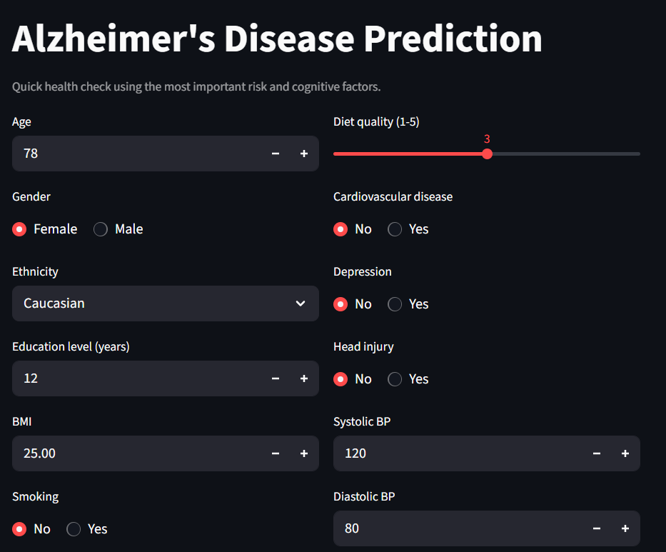
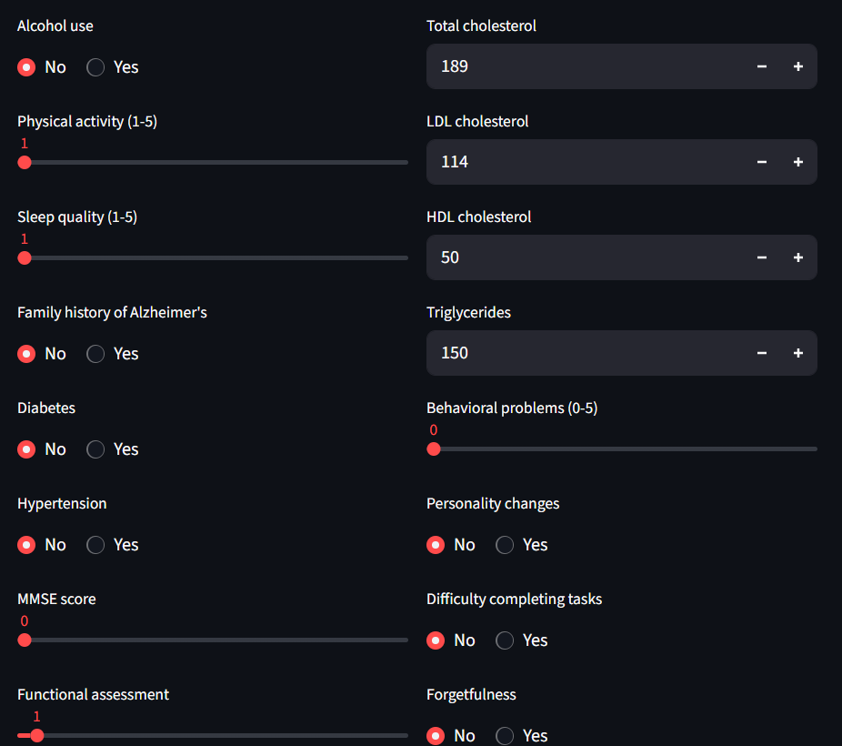
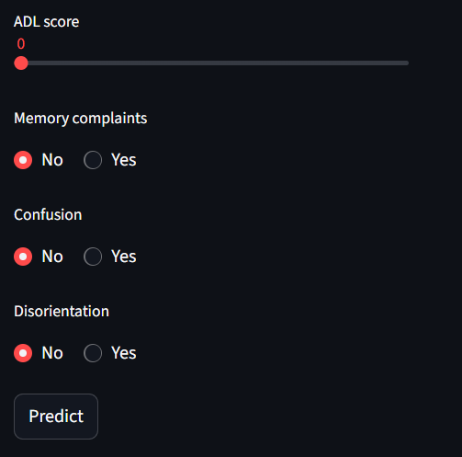
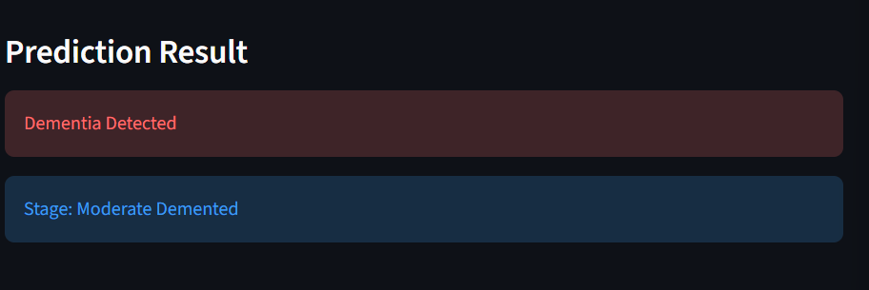

27. FINAL CONCLUSION
The Alzheimer's Disease Prediction project demonstrates an end-to-end tabular machine-learning workflow from raw patient data to exploratory analysis, binary classification, MMSE-derived multi-stage classification, model serialization, and Streamlit deployment.
The notebook reports approximately 95% accuracy for Gradient Boosting in binary classification, with Random Forest and XGBoost close behind. The multi-stage workflow adds a four-class prediction layer based on explicit MMSE thresholds, while the Streamlit application operationalizes the saved binary and multi-stage models through a user-facing interface.
The strongest strategic next step is not simply increasing model complexity; it is tightening the ML pipeline around reproducible preprocessing, clinically appropriate validation, external testing, calibration, explainability, and responsible-use controls before making any claim of real-world clinical utility.

APPENDIX A — COMPLETE JUPYTER NOTEBOOK SOURCE CODE
The complete source code below is reproduced directly from the uploaded alz_tablular (2).ipynb notebook, preserving the notebook's cell order and implementation.
Notebook Cell 0: laod the data
import pandas as pd
data = pd.read_csv(r'C:\Users\mayank manjhi\Downloads\list_projects\Alzheimers-Disease-Prediction-main\alzheimers_disease_data.csv')
## Explore Data
data.head()
data.columns
data.shape
data.info()
data.head()
data.describe()
data.isnull().sum()
data.duplicated().sum()
import matplotlib.pyplot as plt
import seaborn as sns
import warnings
warnings.simplefilter(action='ignore')
## Data Analysis
corr_columns = [ 'MMSE', 'FunctionalAssessment', 'ADL', 'SleepQuality', 'PhysicalActivity','Diabetes', 'Hypertension', 'CholesterolTotal','Diagnosis']
corr = data[corr_columns].corr()
sns.set_palette("husl")
plt.figure(figsize=(10, 8))
sns.heatmap(corr, annot=True, fmt=".2f", linewidths=0.5)
plt.title('Correlation Heatmap')
plt.show()
sns.set_palette("husl")
diagnosis_counts = data['Diagnosis'].value_counts()
plt.figure(figsize=(4, 6))
plt.pie(diagnosis_counts, labels=diagnosis_counts.index, autopct='%1.1f%%')
plt.title('Diagnosis Proportion')
plt.show()

columns = ['Age', 'BMI', 'AlcoholConsumption', 'PhysicalActivity', 'SleepQuality', 'MMSE', 'CholesterolTotal']
titles = {
'Age': 'Age Distribution',
'BMI': 'BMI Distribution',
'AlcoholConsumption': 'Alcohol Consumption',
'PhysicalActivity': 'Physical Activity',
'SleepQuality': 'Sleep Quality',
'MMSE': 'MMSE Score',
'CholesterolTotal': 'Total Cholesterol'
}
sns.set_palette("husl")
plt.figure(figsize=(12, 10))
for i, col in enumerate(columns):
plt.subplot(3, 3, i + 1)
plt.hist(data[col], bins=20, color='pink', edgecolor='black')
plt.title(titles[col])
plt.xlabel(col)
plt.ylabel('Number of Patients')
plt.tight_layout()
plt.show()
sns.set_palette("husl")
sns.scatterplot(data=data, x='Age', y='MMSE', hue='Diagnosis')
plt.title('MMSE vs Age')
plt.xlabel('Age')
plt.ylabel('MMSE Score')
plt.show()
sns.set_palette("husl")
sns.boxplot(data=data, x='Diagnosis', y='MMSE', hue='Diagnosis')
plt.show()
import numpy as np
from sklearn.model_selection import train_test_split
from sklearn.linear_model import LogisticRegression
from sklearn.ensemble import RandomForestClassifier, GradientBoostingClassifier
from xgboost import XGBClassifier
from sklearn.svm import SVC
from sklearn.metrics import confusion_matrix, classification_report, accuracy_score
import warnings
warnings.filterwarnings("ignore", category=UserWarning)
## Modeling and Evaluation
X=data.drop(["DoctorInCharge","PatientID","Diagnosis"],axis=1)
y=data["Diagnosis"]
X_train_bin, X_test_bin, y_train_bin, y_test_bin = train_test_split(X, y, stratify=y, test_size=0.2, random_state=42)
def try_model(model):
model.fit(X_train_bin, y_train_bin)
y_pred = model.predict(X_test_bin)
print(classification_report(y_test_bin, y_pred))
plt.figure(figsize=(4, 2))
sns.set_palette("husl")
sns.heatmap(confusion_matrix(y_test_bin, y_pred),annot=True,fmt='d',linewidths=0.5,linecolor='white')
LogisticRegressionModel = LogisticRegression(solver='liblinear', max_iter=1000)
try_model(LogisticRegressionModel)
RandomForestClassifierModel=RandomForestClassifier()
try_model(RandomForestClassifierModel)
GradientBoostingClassifierModel=GradientBoostingClassifier()
try_model(GradientBoostingClassifierModel)
XGBClassifierModel = XGBClassifier(n_estimators=200,random_state=42)
try_model(XGBClassifierModel)
models = ['Logistic Regression', 'Random Forest', 'Gradient Boosting', 'XGBoost']
accuracy = [0.81, 0.94, 0.95, 0.94]
f1_class_0 = [0.86, 0.95, 0.96, 0.96]
f1_class_1 = [0.73, 0.91, 0.92, 0.92]
x = np.arange(len(models))
width = 0.25

fig, ax = plt.subplots(figsize=(10, 4))
ax.bar(x - width, accuracy, width, label='Accuracy')
ax.bar(x, f1_class_0, width, label='F1-Score (Class 0)')
ax.bar(x + width, f1_class_1, width, label='F1-Score (Class 1)')

ax.set_ylabel('Score', fontsize=12)
ax.set_title('Model Performance Comparison', fontsize=14)
ax.set_xticks(x)
ax.set_xticklabels(models, rotation=15, fontsize=11)
ax.legend()
ax.grid(axis='y', linestyle='--', alpha=0.7)

for i in range(len(models)):
ax.text(x[i] - width, accuracy[i] + 0.01, f"{accuracy[i]:.2f}", ha='center', fontsize=10)
ax.text(x[i], f1_class_0[i] + 0.01, f"{f1_class_0[i]:.2f}", ha='center', fontsize=10)
ax.text(x[i] + width, f1_class_1[i] + 0.01, f"{f1_class_1[i]:.2f}", ha='center', fontsize=10)
plt.show()
model_binary = XGBClassifier(n_estimators=200, random_state=42)
model_binary.fit(X_train_bin, y_train_bin)

# After training
import pickle
pickle.dump(model_binary, open("model_binary.pkl", "wb"))
def classify_multistage(score):
if score >= 26:
return "Non Demented"
elif 21 <= score < 26:
return "Very Mild Demented"
elif 11 <= score < 21:
return "Mild Demented"
else:
return "Moderate Demented"

# Create new multi-class column
data["Diagnosis_Multi"] = data["MMSE"].apply(classify_multistage)

print(data["Diagnosis_Multi"].value_counts())
from sklearn.preprocessing import LabelEncoder

X = data.drop(["DoctorInCharge", "PatientID", "Diagnosis"], axis=1)
y = data["Diagnosis"]

# --- Encode categorical columns in X ---
for col in X.columns:
if X[col].dtype == 'object': # If column is string/categorical
le = LabelEncoder()
X[col] = le.fit_transform(X[col])

# --- Encode target variable ---
le_y = LabelEncoder()
y_encoded = le_y.fit_transform(y)

# --- Train/Test Split ---
X_train_multi, X_test_multi, y_train_multi, y_test_multi = train_test_split(
X, y_encoded, stratify=y_encoded, test_size=0.2, random_state=42
)
models = {
"Logistic Regression": LogisticRegression(max_iter=1000, solver='lbfgs', multi_class='auto'),
"Random Forest": RandomForestClassifier(n_estimators=200, random_state=42),
"XGBoost": XGBClassifier(objective='multi:softmax', num_class=len(le_y.classes_), random_state=42),
"SVM": SVC(kernel='rbf', C=1, gamma='scale')
}
# Label encode the target
le_y = LabelEncoder()
y_multi = le_y.fit_transform(data["Diagnosis_Multi"]) # 4 classes

# Encode categorical features
X = pd.get_dummies(
data.drop(["DoctorInCharge", "PatientID", "Diagnosis", "Diagnosis_Multi"], axis=1),
drop_first=True
)

# Split data
X_train_multi, X_test_multi, y_train_multi, y_test_multi = train_test_split(
X, y_multi, test_size=0.2, random_state=42, stratify=y_multi
)

# Define models
models = {
"Logistic Regression": LogisticRegression(
multi_class="multinomial", solver="lbfgs", max_iter=1000
),
"Random Forest": RandomForestClassifier(random_state=42),
"XGBoost": XGBClassifier(
objective='multi:softmax', num_class=4, eval_metric='mlogloss', random_state=42
),
}

# Train, evaluate, and plot confusion matrices
results = []
plt.figure(figsize=(14, 10))

for i, (name, model) in enumerate(models.items()):
print(f"\n=== {name} ===")
model.fit(X_train_multi, y_train_multi)
y_pred = model.predict(X_test_multi)
acc = accuracy_score(y_test_multi, y_pred)
results.append((name, acc))
print(f"Accuracy: {acc:.4f}")
print(classification_report(y_test_multi, y_pred, target_names=le_y.classes_))

plt.subplot(2, 2, i + 1)
sns.heatmap(
confusion_matrix(y_test_multi, y_pred),
annot=True, fmt='d', cmap='Blues',
xticklabels=le_y.classes_,
yticklabels=le_y.classes_
)
plt.title(name)

plt.tight_layout()
plt.show()

# Create DataFrame for results
results_df = pd.DataFrame(results, columns=["Model", "Accuracy"])
print("\nModel Comparison:\n", results_df)

# Plot accuracies dynamically
plt.figure(figsize=(8, 5))
plt.bar(results_df["Model"], results_df["Accuracy"],
color=['#F7CAC9', '#92A8D1', '#88B04B'])
plt.ylim(0.85, 1.02)
plt.title("Model Comparison for Multi-Class Alzheimer’s Prediction", fontsize=14)
plt.ylabel("Accuracy")
plt.grid(axis='y', linestyle='--', alpha=0.7)
plt.show()
from sklearn.model_selection import cross_val_score
scores = cross_val_score(XGBClassifier(objective='multi:softmax', num_class=4, eval_metric='mlogloss'), X, y_multi, cv=5)
print("Cross-Validation Accuracy:", scores.mean())
model_multi = GradientBoostingClassifier(random_state=42)
model_multi.fit(X_train_multi, y_train_multi)

pickle.dump(model_multi, open("model_multi.pkl", "wb"))
pickle.dump(le_y, open("label_encoder.pkl", "wb"))

APPENDIX B — COMPLETE STREAMLIT APP SOURCE CODE
The complete app(2).py source is reproduced below exactly as supplied.
import pickle

import numpy as np
import streamlit as st

FEATURE_ORDER = [
"Age",
"Gender",
"Ethnicity",
"EducationLevel",
"BMI",
"Smoking",
"AlcoholConsumption",
"PhysicalActivity",
"DietQuality",
"SleepQuality",
"FamilyHistoryAlzheimers",
"CardiovascularDisease",
"Diabetes",
"Depression",
"HeadInjury",
"Hypertension",
"SystolicBP",
"DiastolicBP",
"CholesterolTotal",
"CholesterolLDL",
"CholesterolHDL",
"CholesterolTriglycerides",
"MMSE",
"FunctionalAssessment",
"MemoryComplaints",
"BehavioralProblems",
"ADL",
"Confusion",
"Disorientation",
"PersonalityChanges",
"DifficultyCompletingTasks",
"Forgetfulness",
]

DEFAULT_VALUES = {
"Age": 65,
"Gender": 0,
"Ethnicity": 0,
"EducationLevel": 12,
"BMI": 25.0,
"Smoking": 0,
"AlcoholConsumption": 0,
"PhysicalActivity": 2,
"DietQuality": 3,
"SleepQuality": 3,
"FamilyHistoryAlzheimers": 0,
"CardiovascularDisease": 0,
"Diabetes": 0,
"Depression": 0,
"HeadInjury": 0,
"Hypertension": 0,
"SystolicBP": 120,
"DiastolicBP": 80,
"CholesterolTotal": 180,
"CholesterolLDL": 100,
"CholesterolHDL": 50,
"CholesterolTriglycerides": 150,
"MMSE": 20,
"FunctionalAssessment": 20,
"MemoryComplaints": 0,
"BehavioralProblems": 0,
"ADL": 20,
"Confusion": 0,
"Disorientation": 0,
"PersonalityChanges": 0,
"DifficultyCompletingTasks": 0,
"Forgetfulness": 0,
}

with open("model_binary.pkl", "rb") as f:
model_binary = pickle.load(f)

with open("model_multi.pkl", "rb") as f:
model_multi = pickle.load(f)

with open("label_encoder.pkl", "rb") as f:
label_encoder = pickle.load(f)

st.set_page_config(page_title="Alzheimer's Prediction", layout="centered")

def get_feature_input():
values = DEFAULT_VALUES.copy()

st.title("Alzheimer's Disease Prediction")
st.caption("Quick health check using the most important risk and cognitive factors.")

col1, col2 = st.columns(2)

with col1:
values["Age"] = st.number_input("Age", 40, 100, 65)
values["Gender"] = 1 if st.radio("Gender", ["Female", "Male"], horizontal=True) == "Male" else 0
values["Ethnicity"] = ["Caucasian", "African American", "Asian", "Other"].index(
st.selectbox("Ethnicity", ["Caucasian", "African American", "Asian", "Other"])
)
values["EducationLevel"] = st.number_input("Education level (years)", 0, 25, 12)
values["BMI"] = st.number_input("BMI", 10.0, 45.0, 25.0)
values["Smoking"] = 1 if st.radio("Smoking", ["No", "Yes"], horizontal=True) == "Yes" else 0
values["AlcoholConsumption"] = 1 if st.radio("Alcohol use", ["No", "Yes"], horizontal=True) == "Yes" else 0
values["PhysicalActivity"] = st.slider("Physical activity (1-5)", 1, 5, 2)
values["SleepQuality"] = st.slider("Sleep quality (1-5)", 1, 5, 3)
values["FamilyHistoryAlzheimers"] = 1 if st.radio("Family history of Alzheimer's", ["No", "Yes"], horizontal=True) == "Yes" else 0
values["Diabetes"] = 1 if st.radio("Diabetes", ["No", "Yes"], horizontal=True) == "Yes" else 0
values["Hypertension"] = 1 if st.radio("Hypertension", ["No", "Yes"], horizontal=True) == "Yes" else 0
values["MMSE"] = st.slider("MMSE score", 0, 30, 20)
values["FunctionalAssessment"] = st.slider("Functional assessment", 0, 30, 20)
values["ADL"] = st.slider("ADL score", 0, 30, 20)
values["MemoryComplaints"] = 1 if st.radio("Memory complaints", ["No", "Yes"], horizontal=True) == "Yes" else 0
values["Confusion"] = 1 if st.radio("Confusion", ["No", "Yes"], horizontal=True) == "Yes" else 0
values["Disorientation"] = 1 if st.radio("Disorientation", ["No", "Yes"], horizontal=True) == "Yes" else 0

with col2:
values["DietQuality"] = st.slider("Diet quality (1-5)", 1, 5, 3)
values["CardiovascularDisease"] = 1 if st.radio("Cardiovascular disease", ["No", "Yes"], horizontal=True) == "Yes" else 0
values["Depression"] = 1 if st.radio("Depression", ["No", "Yes"], horizontal=True) == "Yes" else 0
values["HeadInjury"] = 1 if st.radio("Head injury", ["No", "Yes"], horizontal=True) == "Yes" else 0
values["SystolicBP"] = st.number_input("Systolic BP", 80, 200, 120)
values["DiastolicBP"] = st.number_input("Diastolic BP", 50, 120, 80)
values["CholesterolTotal"] = st.number_input("Total cholesterol", 100, 300, 180)
values["CholesterolLDL"] = st.number_input("LDL cholesterol", 50, 200, 100)
values["CholesterolHDL"] = st.number_input("HDL cholesterol", 20, 100, 50)
values["CholesterolTriglycerides"] = st.number_input("Triglycerides", 50, 300, 150)
values["BehavioralProblems"] = st.slider("Behavioral problems (0-5)", 0, 5, 0)
values["PersonalityChanges"] = 1 if st.radio("Personality changes", ["No", "Yes"], horizontal=True) == "Yes" else 0
values["DifficultyCompletingTasks"] = 1 if st.radio("Difficulty completing tasks", ["No", "Yes"], horizontal=True) == "Yes" else 0
values["Forgetfulness"] = 1 if st.radio("Forgetfulness", ["No", "Yes"], horizontal=True) == "Yes" else 0

return values

def predict_stage(values):
X = np.array([[values[col] for col in FEATURE_ORDER]], dtype=float)

binary_pred = int(model_binary.predict(X)[0])

if binary_pred == 0:
stage = "Non Demented"
else:
stage_code = model_multi.predict(X)[0]
stage = label_encoder.inverse_transform([stage_code])[0]

if stage == "Non Demented":
if values["MMSE"] >= 21:
stage = "Very Mild Demented"
elif values["MMSE"] >= 11:
stage = "Mild Demented"
else:
stage = "Moderate Demented"

return binary_pred, stage

def main():
values = get_feature_input()

if st.button("Predict"):
binary_pred, stage = predict_stage(values)

st.markdown("---")
st.subheader("Prediction Result")

if binary_pred == 1:
st.error("Dementia Detected")
else:
st.success("No Dementia Detected")

st.info(f"Stage: {stage}")

if __name__ == "__main__":
main()

APPENDIX C — SOURCE FILES USED
- alz_tablular (2).ipynb — EDA, binary classification, multi-stage classification, evaluation, and model serialization.
- alzheimers_disease_data.csv — source patient dataset.
- app(2).py — Streamlit deployment and prediction interface.
Source fidelity note: the implementation is reproduced from the supplied files. Existing modelling decisions, saved-artifact choices, feature ordering, and application logic have not been silently corrected in the source-code appendix.

