REPORT 2
DATA UNDERSTANDING & EDA REPORT
Vehicle Behavior Analysis Using Real-World Trajectory Data
Full SinD multi-city trajectory dataset
Group 3 | Class IS1904 | FPT University HCM
Lê Hữu Đại (SE184118), Nguyễn Quốc Cường (SE193612), Thái Nhật Hoàng (SE196438), Đặng Quang Phú (SE184468), Tô Ngọc Anh Tuấn (SE190681)

1. Dataset Overview
Content | Description
Dataset name | Signalized Intersection Dataset (SinD) – full academic package
Source | Official SOTIF-AVLab SinD project / academic-access full package
Initial rows | 12,052,293 vehicle frame-level rows
Initial columns | 19 per vehicle CSV: 18 analytical fields plus one export index
File format | 56 recording ZIPs containing 236 CSV files; map/support files supplied separately
Observation unit | Raw: one vehicle at one timestamp. Modeling: one complete passenger-car trajectory.
Analysis objective | Discover interpretable, stable behavior profiles across recordings and cities.

2. Data Dictionary
Variable | Type | Meaning | Unit | Role
trajectory_uid | String | Globally unique city + recording + track identifier | — | Identifier
timestamp_ms | Numeric | Observation time within recording | ms | Temporal
x, y | Numeric | Ground-plane vehicle center coordinates | m | Feature derivation
vx, vy | Numeric | Horizontal velocity components | m/s | Feature derivation
a_lon | Numeric | Longitudinal acceleration | m/s² | Feature derivation
mean_speed_mps | Numeric | Average trajectory speed | m/s | Model feature
max_speed_mps | Numeric | Maximum observed speed | m/s | Model feature
speed_std_mps | Numeric | Within-trajectory speed variability | m/s | Model feature
max_acceleration_mps2 | Numeric | Strongest positive acceleration | m/s² | Model feature
max_deceleration_mps2 | Numeric | Strongest braking magnitude | m/s² | Model feature
mean_abs_jerk_mps3 | Numeric | Average abruptness of acceleration change | m/s³ | Model feature
observed_stop_transition_count | Integer | Observed moving-to-stopped transitions | count | Model feature
stopped_time_ratio | Numeric | Share of frames below 0.5 m/s | 0–1 | Model feature
CrossType | Categorical | Straight, left, right, other (Tianjin only) | — | Post-cluster reference
Signal_Violation_Behavior | Categorical | Recorded signal behavior (Tianjin only) | — | Post-cluster reference

3. Data Quality Assessment
Issue | Finding | Handling | Reason
Missing values | 0 in required vehicle columns | No imputation | Core inputs are complete.
Duplicate records | 0 duplicate track-frame and track-timestamp rows | No removal | Prevents repeated observations from biasing features.
Timestamp order | 0 non-positive steps inside vehicle tracks | No correction | Jerk and duration can be computed reliably.
Short trajectories | 368 flags under 5 seconds | Exclude | Too little history for stable trajectory summaries.
Full-record stationary | 442 flags; 54 overlap with short trajectories | Exclude conservatively | No meaningful movement for behavior profiling.
Unique exclusions | 756 trajectories | Log every removal | Avoid double-counting overlapping flags.
Extreme values | Strong tails in speed/acceleration/jerk | Audit; do not delete automatically | May be rare behavior or tracking artifacts.
Traffic-light files | 55/56 recordings; schema varies | Separate pipeline | Do not contaminate core movement clustering.

4. Data Cleaning Process
1. Discover and validate all 56 recording archives and required vehicle files.
2. Drop the CSV export-index column and verify the common 18-field analytical schema.
3. Retain agent_type = car and sort frames by track_id, timestamp_ms, and frame_id.
4. Create trajectory_uid = city + recording_id + track_id to prevent cross-recording ID collisions.
5. Exclude trajectories shorter than 5 seconds or stationary for the complete observation.
6. Aggregate frames into one row per trajectory and compute ten behavior features.
7. Write a transparent exclusion log and validate no missing, infinite, or duplicate modeling rows.
Data funnel
20,704 passenger-car trajectories → 756 unique exclusions → 19,948 modeling-eligible trajectories. Sampling interval is approximately 100.1001 ms (9.99 Hz) across all four cities.
City | Recordings | Passenger cars | Excluded | Eligible
Changchun | 8 | 8,774 | 109 | 8,665
Chongqing | 10 | 2,171 | 243 | 1,928
Tianjin | 23 | 4,752 | 219 | 4,533
Xi'an | 15 | 5,007 | 185 | 4,822
Total | 56 | 20,704 | 756 | 19,948

5. Exploratory Data Analysis
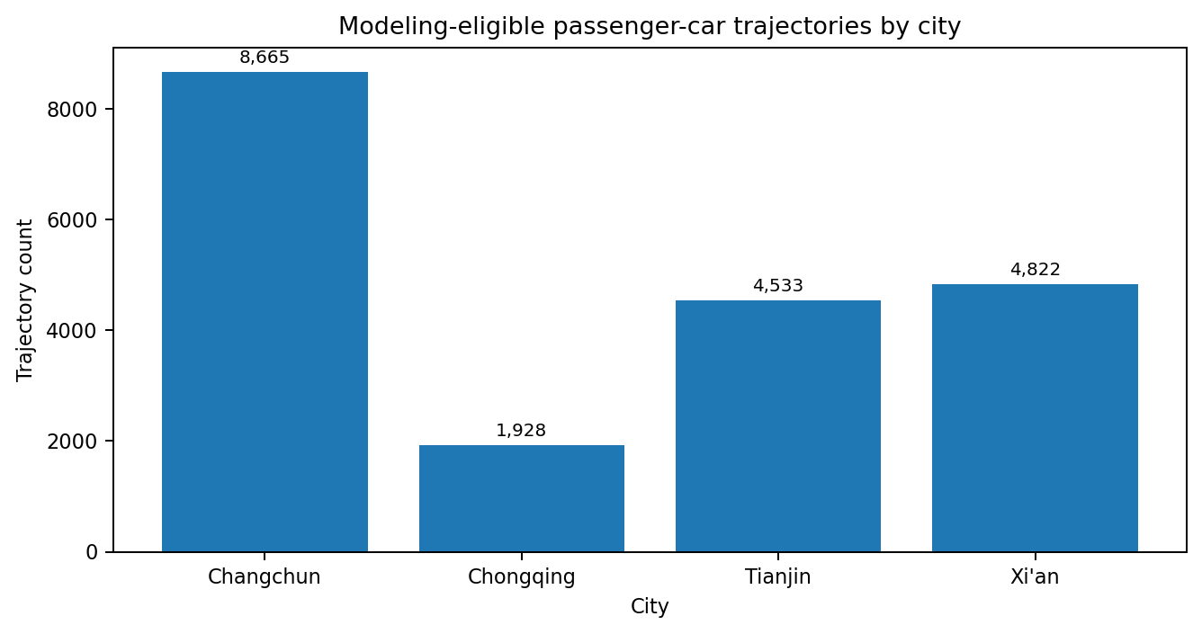
Figure 1. City contributions are unequal; pooled clustering must be validated by city and recording.
Feature | Mean | Median | 99th percentile | Maximum
mean_speed_mps | 5.354 | 5.217 | 13.975 | 22.373
max_speed_mps | 10.085 | 9.966 | 16.607 | 99.467
speed_std_mps | 2.101 | 2.040 | 4.523 | 6.264
max_acceleration_mps2 | 1.960 | 1.556 | 9.346 | 126.185
max_deceleration_mps2 | 1.533 | 1.426 | 4.256 | 115.736
mean_abs_jerk_mps3 | 0.555 | 0.479 | 1.655 | 6.552
stopped_time_ratio | 0.208 | 0.000 | 0.831 | 0.995

Interpretation: maximum speed, acceleration, and deceleration are much larger than their 99th percentiles. These observations were traced by trajectory_uid rather than automatically removed.

EDA Visualizations and Modeling Implications
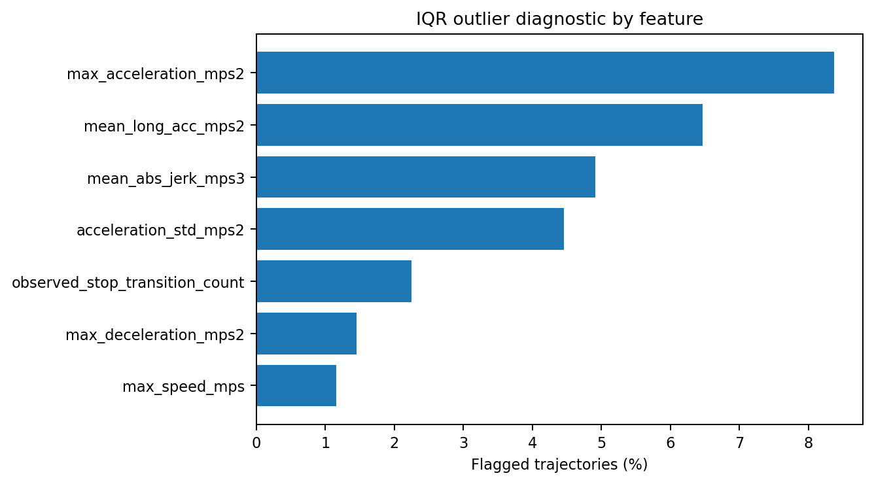
Figure 2. Acceleration-related variables have the highest IQR outlier percentages.
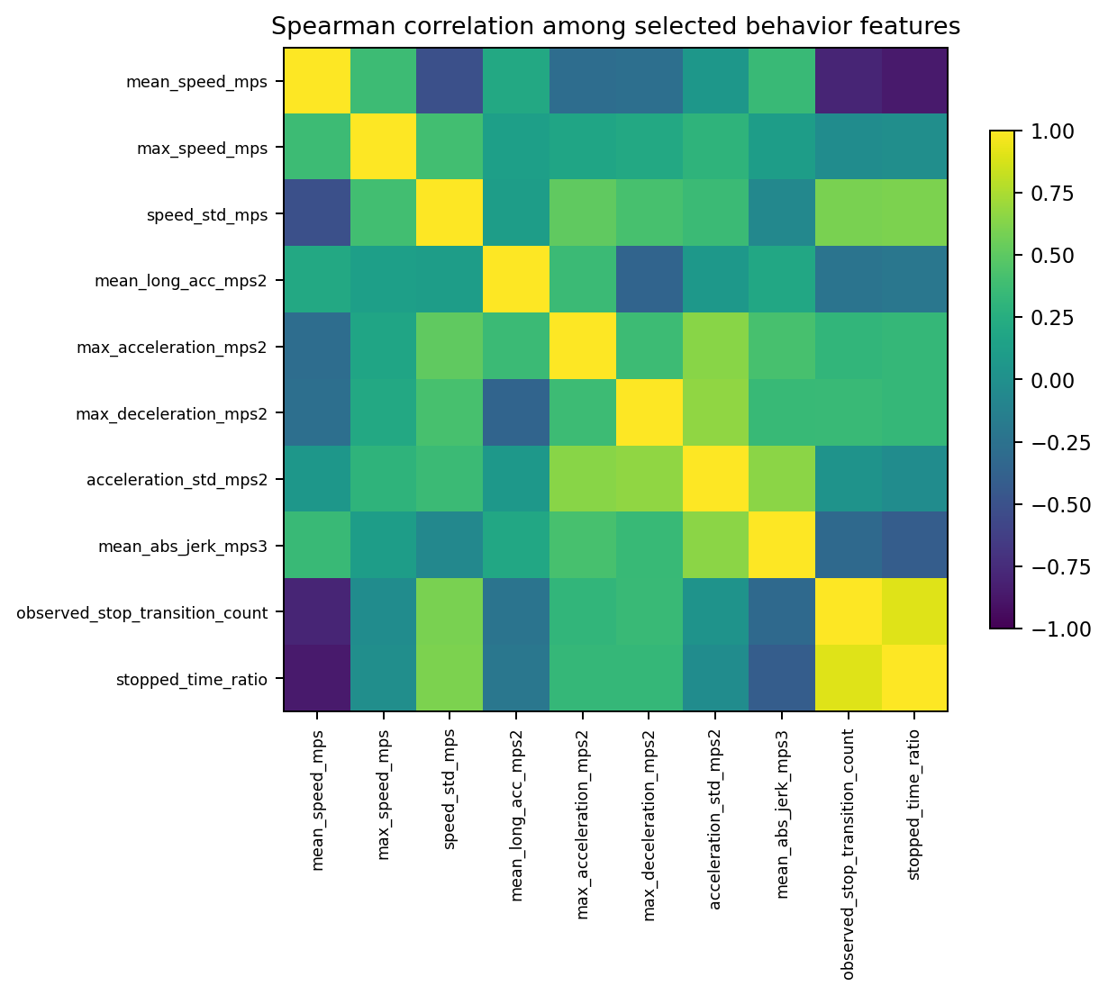
Figure 3. Spearman correlation highlights related but behaviorally distinct stopping and speed variables.
Key correlation findings
Stop-transition count and stopped-time ratio have strong positive correlation (about 0.91), while mean speed and stopped-time ratio have strong negative correlation (about −0.85). Both stopping variables are retained because frequency and duration of stopping describe different behaviors.

6. Key Insights from EDA
Insight | Evidence | Project meaning
City imbalance | Changchun contributes 8,665 eligible trajectories (43.4%), while Chongqing contributes 1,928 (9.7%). | Use pooled results together with cross-city and cross-recording validation.
Heavy-tailed dynamics | Maximum acceleration has 8.37% IQR outliers and a maximum of 126.19 m/s². | Compare winsorization and robust scaling; audit raw trajectories.
Stopping is structurally important | 61.8% of trajectories have zero observed stop transitions, while some have up to 15. | Preserve stop count and stopped-time ratio instead of treating zeros as missing.
City effect | Maximum speed shows the strongest city-related rank effect. | Do not normalize each city independently; fit preprocessing on training contexts only.
Metadata availability | CrossType and signal behavior exist for Tianjin only. | Use these variables after clustering, not as multi-city model inputs.

7. Features Selected for Modeling
Feature | Reason selected | Note
mean_speed_mps | General movement level | Continuous
max_speed_mps | Speed ceiling | Continuous
speed_std_mps | Speed adjustment variability | Continuous
mean_long_acc_mps2 | Acceleration/deceleration tendency | Continuous
max_acceleration_mps2 | Positive dynamic intensity | Continuous
max_deceleration_mps2 | Braking intensity | Continuous
acceleration_std_mps2 | Variation in longitudinal control | Continuous
mean_abs_jerk_mps3 | Abruptness of acceleration change | Continuous
observed_stop_transition_count | Number of observed stops | Discrete; preserve
stopped_time_ratio | Share of observed time stopped | Bounded 0–1; preserve

8. Dataset after Processing
Content | Value
Rows after cleaning | 19,948 trajectory-level observations
Columns in processed feature file | 22 columns: identifiers/support fields, 10 model features, and optional metadata
Model input columns | 10 numerical behavior features
Cleaned file | data/processed/sind_full_core_behavior_features.csv
Exclusion log | data/processed/trajectory_exclusion_log.csv
Storage | Local reproducible project package; license-safe files may be pushed to GitHub. Raw full SinD archives remain private.

