REPORT 3
BASELINE MODEL REPORT
Vehicle Behavior Analysis Using Real-World Trajectory Data
K-Means clustering on the full multi-city trajectory dataset
Group 3 | Class IS1904 | FPT University HCM
Lê Hữu Đại (SE184118), Nguyễn Quốc Cường (SE193612), Thái Nhật Hoàng (SE196438), Đặng Quang Phú (SE184468), Tô Ngọc Anh Tuấn (SE190681)

1. Baseline Model Objective
The baseline establishes a simple, interpretable reference for clustering complete passenger-car trajectories. It must assign all valid trajectories, support physical interpretation through feature profiles, and provide a stable reference partition for later comparison models.

2. Problem Type
Content | Description
Problem type | Clustering / unsupervised learning
Target variable | None
Input features | 10 trajectory-level numerical behavior features
Analysis unit | One complete passenger-car trajectory
Reason | Behavior-profile labels are not predefined; the study aims to discover natural groups from movement characteristics.

3. Baseline Model
Content | Description
Model | K-Means clustering
Library | Python / scikit-learn
Selected clusters | k = 4
Random seed | 42
Initializations | n_init = 50
Input representation | 5 PCA components retaining 91.71% variance
Distance | Euclidean
Train/test split | Not applied as a conventional 80/20 split
Validation replacement | Internal metrics, seed stability, bootstrap, leave-one-city-out, and leave-one-recording-out

Why no conventional train/test split?
This is unsupervised cluster discovery without known labels. A random trajectory split would not provide a supervised error target and could mix highly related recording contexts. The project instead validates reproducibility by withholding complete cities and recordings.

4. Procedure
1. Read the 19,948-row trajectory feature table.
2. Winsorize the eight continuous features at the training 1st and 99th percentiles.
3. Preserve stop-transition count and stopped-time ratio as valid behavior variables.
4. Fit RobustScaler and PCA; retain the minimum number of components explaining at least 90% variance.
5. Evaluate K-Means candidates from k=2 through k=12.
6. Select k=4 using coverage, stability, behavioral granularity, and interpretability—not Silhouette alone.
7. Fit the final baseline with random_state=42 and n_init=50.
8. Save metrics, cluster assignments, profile medians, and experiment logs.

Candidate K Results
k | Silhouette | DBI | CH | Smallest cluster
2 | 0.4837 | 0.9771 | 8966.2 | 9.94%
3 | 0.2858 | 1.2239 | 8830.2 | 9.38%
4 | 0.2862 | 1.2762 | 8298.6 | 6.34%
5 | 0.2831 | 1.1677 | 7894.5 | 5.45%
6 | 0.2652 | 1.1859 | 7369.0 | 4.82%

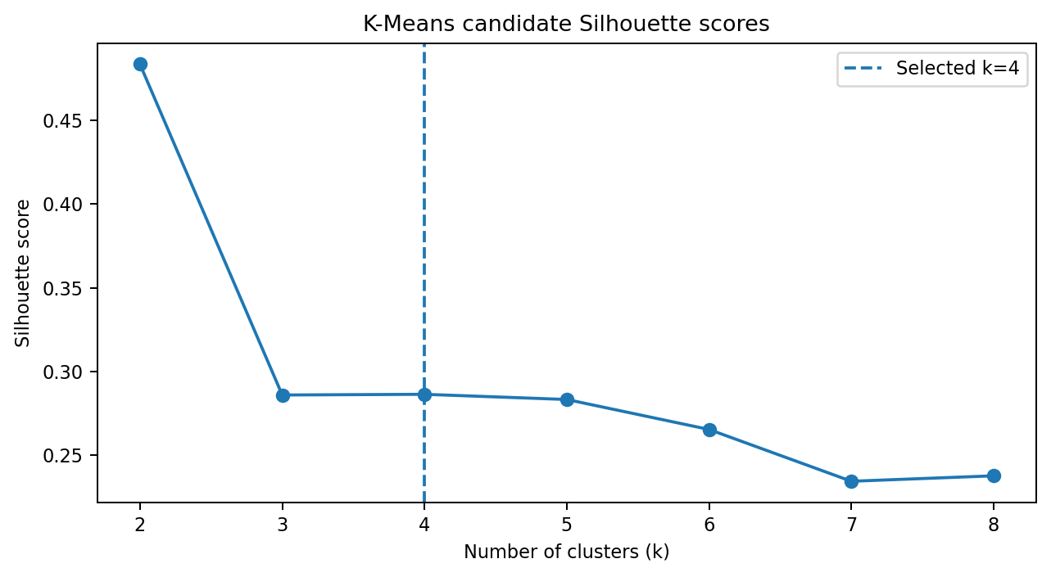
Figure 1. k=2 has stronger compactness but produces an overly broad two-group structure; k=4 is selected for richer and more robust profiles.

5. Baseline Evaluation Results
Metric | Result
Trajectories | 19,948
Clusters | 4
Coverage | 100%
PCA retained variance | 91.71%
Silhouette (sample 5,000) | 0.2963
Davies–Bouldin | 1.2791
Calinski–Harabasz | 8298.68
Seed ARI mean / minimum | 0.9850 / 0.9776
Bootstrap ARI mean / minimum | 0.8847 / 0.8047

ID | Profile | n | Share | Defining median evidence
1 | Smooth and Steady | 7,477 | 37.48% | Low variability; max accel 0.99; stopped ratio 0.00
2 | Stop-and-Go | 6,866 | 34.42% | Mean speed 2.08; stop count 1; stopped ratio 0.59
3 | Dynamic Speed Adjustment | 4,338 | 21.75% | Acceleration SD 0.97; jerk 0.78; braking 1.93
4 | Acceleration-Intensive | 1,267 | 6.35% | Max accel 6.84; acceleration SD 1.53; jerk 1.11

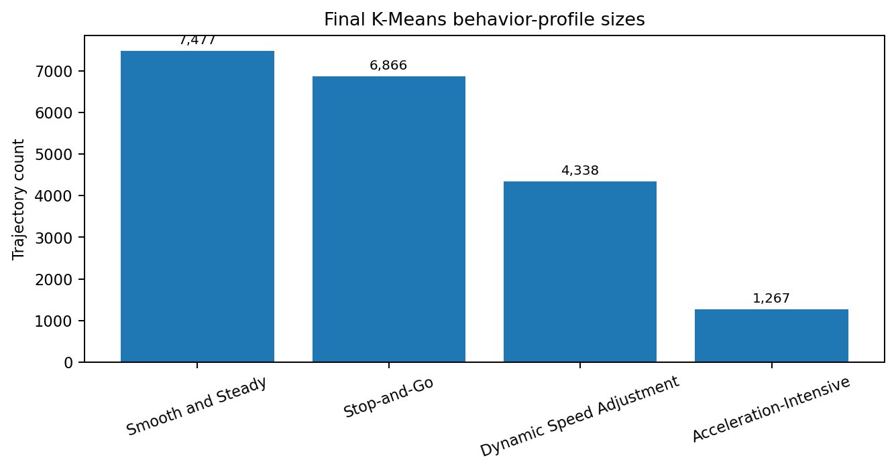
Figure 2. The four profiles cover all trajectories; the smallest profile still contains 1,267 observations.

6. Baseline Remarks
- Strength: complete coverage and physically interpretable profiles.
- Strength: very high stability to random initialization (minimum pairwise ARI 0.9776).
- Strength: profile sizes are usable; the smallest cluster is 6.35% rather than a handful of isolated points.
- Limitation: moderate Silhouette indicates continuous overlap between behaviors.
- Limitation: K-Means assumes compact centroid-based groups and requires a predefined k.
- Overfitting/underfitting language is not directly applicable because no supervised target exists; stability and held-out-context agreement are used instead.
- Next improvement: compare probabilistic, hierarchical, and density-based alternatives, and test cross-context generalization.

7. Experiment Log
Run | Date | Dataset | Model | Parameters | Metrics | By
1 | 23 Jul 2026 | v2 full multi-city | K-Means | k=2, n_init=30 | Sil. 0.4837; DBI 0.9771 | Group 3
2 | 23 Jul 2026 | v2 full multi-city | K-Means | k=3, n_init=30 | Sil. 0.2858; DBI 1.2239 | Group 3
3 | 23 Jul 2026 | v2 full multi-city | K-Means | k=4, n_init=30 | Sil. 0.2862; DBI 1.2762 | Group 3
4 | 23 Jul 2026 | v2 full multi-city | Final K-Means | k=4, seed=42, n_init=50 | Sil. 0.2963; DBI 1.2791; CH 8298.68 | Group 3
5 | 23 Jul 2026 | v2 full multi-city | Seed test | k=4, repeated seeds | ARI mean 0.9850; min 0.9776 | Group 3

Baseline conclusion
K-Means k=4 is a strong interpretable reference model. It is not selected because it maximizes a single metric; it is selected because it provides full assignment, stable four-profile granularity, and a clear basis for comparison.

