REPORT 4
EXPERIMENT & EVALUATION REPORT
Vehicle Behavior Analysis Using Real-World Trajectory Data
Clustering-family comparison and stability validation
Group 3 | Class IS1904 | FPT University HCM
Lê Hữu Đại (SE184118), Nguyễn Quốc Cường (SE193612), Thái Nhật Hoàng (SE196438), Đặng Quang Phú (SE184468), Tô Ngọc Anh Tuấn (SE190681)

1. Experimental Objective
The experiment compares the K-Means baseline with scalable centroid, probabilistic, hierarchical, and density-based alternatives. The goal is to identify the model that best answers the research question while balancing separation, complete coverage, stability, interpretability, computational feasibility, and cross-context transferability.

2. Compared Models
Model | Role | Reason selected
K-Means k=4 | Baseline / primary candidate | Full assignment, explicit centroids, interpretable profile summaries.
MiniBatch K-Means k=4 | Scalability comparison | Tests whether approximate centroid updates retain similar structure.
Gaussian Mixture k=4 | Probabilistic comparison | Allows different covariance structures and soft membership.
Agglomerative k=4 | Hierarchical sample benchmark | Tests a non-centroid hierarchy; full Ward fit is memory-intensive.
DBSCAN | Density sample benchmark | Detects dense regions and noise without predefined cluster count.
HDBSCAN | Variable-density sample benchmark | Tests broader density structure and variable noise.

Fairness note
K-Means, MiniBatch K-Means, and GMM were fitted on all 19,948 trajectories. Agglomerative and density models were explicitly reported as city-stratified sample benchmarks because of memory/neighborhood scaling; their metrics are not treated as directly equivalent full-data results.

3. Experimental Design
Content | Description
Dataset version | v2 full SinD multi-city, 19,948 eligible passenger-car trajectories
Train/test split | No random 80/20 split; complete-context validation used
Cross-validation | Leave-one-city-out (4 splits) and leave-one-recording-out (56 splits)
Bootstrap | 80% resampling with refit and full-data prediction
Random seed | 42 for reference models; repeated seeds for stability
Input | 5 PCA components from 10 behavior features; 91.71% retained variance
Metrics | Silhouette, Davies–Bouldin, Calinski–Harabasz, coverage/noise, balance, ARI, profile semantics
Tools | Python, pandas, SciPy, scikit-learn, Matplotlib, Jupyter

Evaluation Principles
- A density model cannot be preferred solely because it removes difficult observations and reports higher non-noise metrics.
- Higher Silhouette is valuable but must be weighed against coverage, cluster granularity, and resampling stability.
- Cluster IDs are arbitrary; ARI and training-only Hungarian alignment are used for reproducibility checks.
- Tianjin metadata is used after clustering and does not determine the model selection.

4. Model Comparison Results
Model | Clusters | Coverage | Noise | Silhouette | DBI | Scope
K-Means k=4 | 4 | 100.0% | 0.0% | 0.2862 | 1.2762 | Full data
MiniBatch k=4 | 4 | 100.0% | 0.0% | 0.2777 | 1.3064 | Full data
GMM k=4 | 4 | 100.0% | 0.0% | 0.2288 | 1.6459 | Full data
DBSCAN sample | 2 | 88.8% | 11.2% | 0.6461 | 0.3428 | Sample benchmark
HDBSCAN sample | 2 | 60.4% | 39.6% | 0.3845 | 1.0619 | Sample benchmark

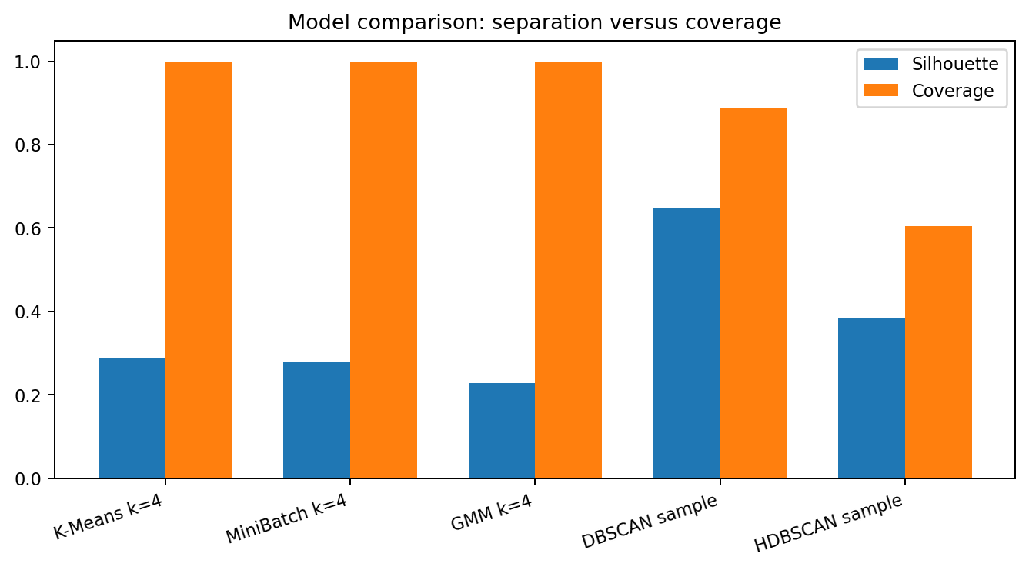
Figure 1. Density benchmarks have strong non-noise separation but substantially lower or uneven coverage.

Selected K-Means Evidence
Criterion | Result
Coverage | 100%
Final profiles | 4
Silhouette | 0.2963
DBI | 1.2791
Seed ARI mean/min | 0.9850 / 0.9776
Bootstrap ARI mean/min | 0.8847 / 0.8047
LOCO ARI mean/min | 0.8533 / 0.6858
LORO ARI median/min | 0.9774 / 0.6082

5. Statistical Validation
Method | When used | Result
Repeated random seeds | Initialization sensitivity | Pairwise ARI mean 0.9850; minimum 0.9776 for production K-Means k=4.
Bootstrap refits | Trajectory-composition stability | ARI mean 0.8847; minimum 0.8047.
Leave-one-city-out | Cross-city transfer | Mean ARI 0.8533; all four profiles recovered in every city.
Leave-one-recording-out | Recording robustness | Median ARI 0.9774; 55/56 recordings have ARI ≥ 0.80.
Confidence interval | Tianjin post-cluster proportions | Wilson intervals used later for profile-specific signal-violation rates.
t-test / Wilcoxon | Not used | Repeated cluster metrics and partitions are dependent; ARI and context-level validation are more appropriate.

6. Error Analysis
Case | Description | Possible cause | Improvement
k=2 overly broad | High Silhouette but 90% of rows in one cluster and only broad stop/non-stop separation. | Compactness objective favors a coarse split. | Retain as structural reference, not final behavioral taxonomy.
k=5 unstable detail | Higher feature separation but weaker bootstrap/city/recording stability. | Fifth cluster divides a profile along a context-sensitive boundary. | Use as sensitivity analysis only.
Density cluster imbalance | DBSCAN sample smallest cluster 0.37%; 11.17% noise. | One dominant density region plus sparse fragments. | Report as complementary noise/density evidence.
HDBSCAN low coverage | 39.63% noise in representative sample configuration. | Variable density and strict core definition. | Not suitable for full-coverage profile assignment.
Changchun shift | Held-out Changchun ARI 0.6858; one recording ARI 0.6082. | Context-dependent feature distributions/boundaries. | Report city sensitivity and retain context fields.

7. Trade-off Discussion
Criterion | K-Means k=4 | GMM k=4 | Density models | Conclusion
Internal separation | Moderate | Lower | High on non-noise sample | Density metric advantage is partly linked to selective coverage.
Coverage | 100% | 100% | 88.8% / 60.4% | K-Means and GMM assign every trajectory.
Interpretability | High; clear centroids and four profiles | Moderate; probabilistic groups | Broad density regions/noise | K-Means best supports physical profile summaries.
Stability evidence | Strong seed, bootstrap, city, recording tests | Weaker internal quality; limited validation priority | Parameter sensitive | K-Means has the most complete validation evidence.
Complexity | Low–moderate | Higher covariance complexity | High parameter/context sensitivity | K-Means is easiest to reproduce and explain.
Practical fit | Primary model | Not selected | Complementary diagnostic | Use density models to flag sparse structure, not replace full profiling.

8. Experimental Conclusion
K-Means k=4 is selected as the primary model because it provides the best overall balance of full coverage, stable four-profile granularity, recording robustness, and interpretability. MiniBatch K-Means offers no necessary scalability advantage at this dataset size, GMM produces weaker separation, and density models identify useful broad structure/noise but sacrifice coverage and cluster balance.
Direct answer
The best model is not the configuration with the highest standalone Silhouette. The selected model is the one that most reliably converts all valid trajectories into meaningful, reproducible behavior profiles across different recordings and cities.

