REPORT 5
FINAL TECHNICAL PAPER
Vehicle Behavior Analysis Using Real-World Trajectory Data
IMRaD structure · full SinD multi-city study
Group 3 | Class IS1904 | FPT University HCM
Lê Hữu Đại (SE184118), Nguyễn Quốc Cường (SE193612), Thái Nhật Hoàng (SE196438), Đặng Quang Phú (SE184468), Tô Ngọc Anh Tuấn (SE190681)

Abstract
Understanding vehicle behavior at signalized intersections is important for autonomous-driving simulation, traffic analysis, and behavior-aware prediction. This study develops an explainable unsupervised pipeline for profiling passenger-car trajectories from the full academic SinD package. The dataset contains 56 recordings from Changchun, Chongqing, Tianjin, and Xi’an, totaling 12,052,293 vehicle-frame observations and 20,704 passenger-car trajectories. After conservative duration and stationary-trajectory filtering, 19,948 trajectories were represented by ten features describing speed, longitudinal dynamics, jerk, and stopping behavior. A benchmark of three preprocessing strategies selected 1%–99% winsorization, RobustScaler, and five PCA components retaining 91.71% variance. Thirty-nine clustering configurations were compared. K-Means with four clusters was selected because it provided complete coverage, high initialization stability, strong recording robustness, and interpretable profiles: Smooth and Steady, Stop-and-Go, Dynamic Speed Adjustment, and Acceleration-Intensive. Mean leave-one-city-out ARI was 0.8533 and median leave-one-recording-out ARI was 0.9774. Tianjin metadata showed a moderate profile–crossing-type association but only a weak profile–signal-violation association. The framework supports explainable monitoring and review prioritization, not crash-risk prediction.
Keywords— trajectory clustering; vehicle behavior profiling; signalized intersection; K-Means; autonomous systems.

1. Introduction
Signalized intersections contain diverse movement patterns. Cars may stop for a signal, restart, maintain a stable speed, adjust speed repeatedly, brake, or accelerate strongly. Autonomous vehicles and advanced traffic-analysis systems therefore need interpretable descriptions of surrounding behavior, not only object positions.
The project treats one complete passenger-car trajectory as one analytical observation. No predefined behavior-profile label is used. The main research question is: What distinct passenger-car behavior profiles emerge across real-world signalized-intersection trajectories, and how consistently can they be interpreted across recordings and cities?
The study contributes a multi-recording processing pipeline, a physically interpretable ten-feature representation, a stability-focused model-selection framework, cross-city and cross-recording validation, and a cautious decision-support interpretation using Tianjin metadata that was not used during clustering.

2. Related Work / Background
SinD was introduced as a drone-based trajectory dataset for signalized-intersection research [1]. Its frame-level positions and kinematics make it suitable for trajectory aggregation and context analysis. Related work has explored autonomous-driving scenario clustering through self-supervised representations [2], unsupervised behavior analysis [3], event discovery from vehicle data [4], and driving-pattern interpretation through clustered action phases [5].
Many advanced approaches emphasize representation learning or large-scale scenario retrieval. This project instead prioritizes reproducibility and direct physical interpretation: speed, acceleration, braking, jerk, and stopping summaries remain visible throughout the pipeline.

Research Questions
- RQ1: Which trajectory-level features distinguish the discovered passenger-car behavior profiles?
- RQ2: Which preprocessing and clustering approach provides the best balance of separation, coverage, stability, and interpretability?
- RQ3: How reproducible are the profiles across random initialization, resampling, recordings, and cities?
- RQ4: How are the profiles descriptively associated with Tianjin crossing type and recorded signal violations?

Study Scope
Important scope
The study analyzes observed trajectories, not permanent driver identities. Clusters are descriptive behavior profiles. Raw full SinD archives remain private under academic-use conditions; only license-safe code, instructions, and derived outputs should be published.

3. Methodology

3.1 Research Design and Dataset
The design is exploratory, quantitative, and unsupervised. The full package includes 56 recordings from four Chinese cities, 12,052,293 vehicle-frame rows, 30,369 vehicle trajectories, and approximately 17.22 hours of recording. The passenger-car subset contains 20,704 trajectories.
City | Recordings | Vehicle rows | Passenger cars | Eligible
Changchun | 8 | 3,158,641 | 8,774 | 8,665
Chongqing | 10 | 3,080,096 | 2,171 | 1,928
Tianjin | 23 | 3,182,723 | 4,752 | 4,533
Xi'an | 15 | 2,630,833 | 5,007 | 4,822
Total | 56 | 12,052,293 | 20,704 | 19,948

3.2 Cleaning and Feature Engineering
The pipeline validates every recording, retains passenger cars, creates a globally unique trajectory_uid, orders frames by time, and excludes trajectories shorter than five seconds or nearly stationary for the full observation. The two exclusion flags overlap; 756 unique trajectories were excluded, leaving 19,948 modeling rows. No missing, infinite, duplicate-ID, or invalid-time values remained in the core modeling table.
Group | Features | Behavioral meaning
Speed | mean_speed_mps; max_speed_mps; speed_std_mps | Level, ceiling, and variation of speed.
Longitudinal dynamics | mean_long_acc_mps2; max_acceleration_mps2; max_deceleration_mps2 | Average tendency, positive acceleration, and braking intensity.
Dynamic variability | acceleration_std_mps2; mean_abs_jerk_mps3 | Variation and abruptness of longitudinal control.
Stopping | observed_stop_transition_count; stopped_time_ratio | Observed moving-to-stopped events and share of time stopped.

3.3 Preprocessing, Models, and Evaluation
Three preprocessing candidates were compared. The selected pipeline clips only the eight continuous features at the training 1st and 99th percentiles, preserves stop count and stopped-time ratio, applies RobustScaler, and retains five PCA components explaining 91.71% variance. K-Means, MiniBatch K-Means, Gaussian Mixture, Agglomerative, DBSCAN, and HDBSCAN configurations were benchmarked.
Evaluation design
Internal metrics + coverage/noise + cluster balance + seed ARI + bootstrap ARI + leave-one-city-out + leave-one-recording-out + original-unit semantic interpretation.

4. Results

4.1 Model Selection
Model | Scope | Clusters | Coverage | Silhouette | DBI | Decision
K-Means k=4 | Full | 4 | 100% | 0.2963 | 1.2791 | Selected primary
MiniBatch k=4 | Full | 4 | 100% | 0.2777 | 1.3064 | Similar but unnecessary approximation
GMM k=4 | Full | 4 | 100% | 0.2288 | 1.6459 | Weaker separation
DBSCAN best sample | 7,000 | 2 | 88.8% | 0.6461 | 0.3428 | Complementary; tiny secondary cluster
HDBSCAN sample | 7,000 | 2 | 60.4% | 0.3845 | 1.0619 | Complementary; high noise

K-Means k=2 had higher compactness but collapsed behavior into a broad two-group split and showed weaker recording-group stability. k=5 added less stable detail. The four-cluster solution provided the best balance of full coverage, granularity, stability, and interpretation.

4.2 Final Behavior Profiles
Profile | Trajectories | Share | Defining median characteristics
Smooth and Steady | 7,477 | 37.48% | Speed SD 1.20; max accel 0.99; stopped ratio 0.00
Stop-and-Go | 6,866 | 34.42% | Mean speed 2.08; stop count 1; stopped ratio 0.59
Dynamic Speed Adjustment | 4,338 | 21.75% | Accel SD 0.97; jerk 0.78; decel 1.93
Acceleration-Intensive | 1,267 | 6.35% | Max accel 6.84; accel SD 1.53; jerk 1.11

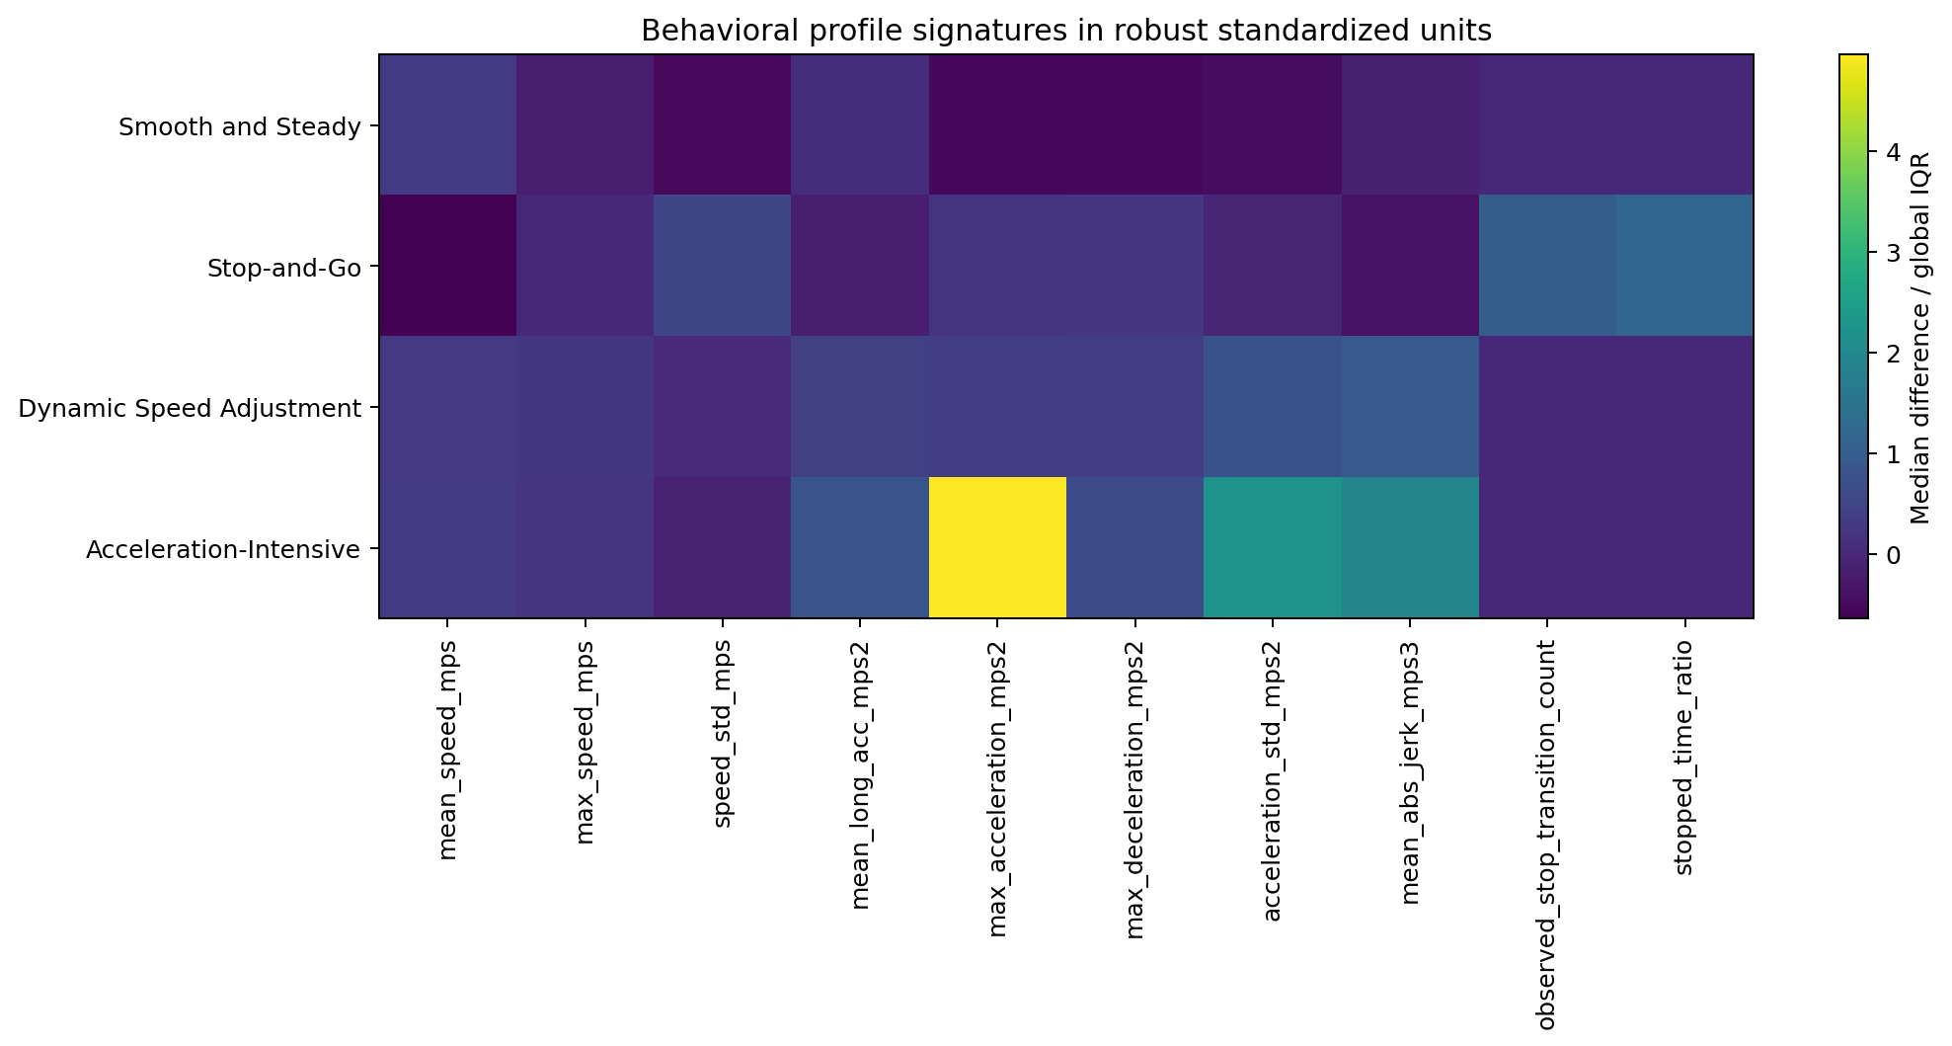
Figure 1. Robust profile signatures relative to the global median and IQR.

4.3 Stability and Cross-Context Validation
Validation | Result
Production seed pairwise ARI | Mean 0.9850; minimum 0.9776
Bootstrap ARI | Mean 0.8847; minimum 0.8047
Leave-one-city-out | Mean ARI 0.8533; minimum 0.6858; all four profiles recovered in every city
Leave-one-recording-out | Median ARI 0.9774; 55/56 recordings ≥ 0.80; minimum 0.6082

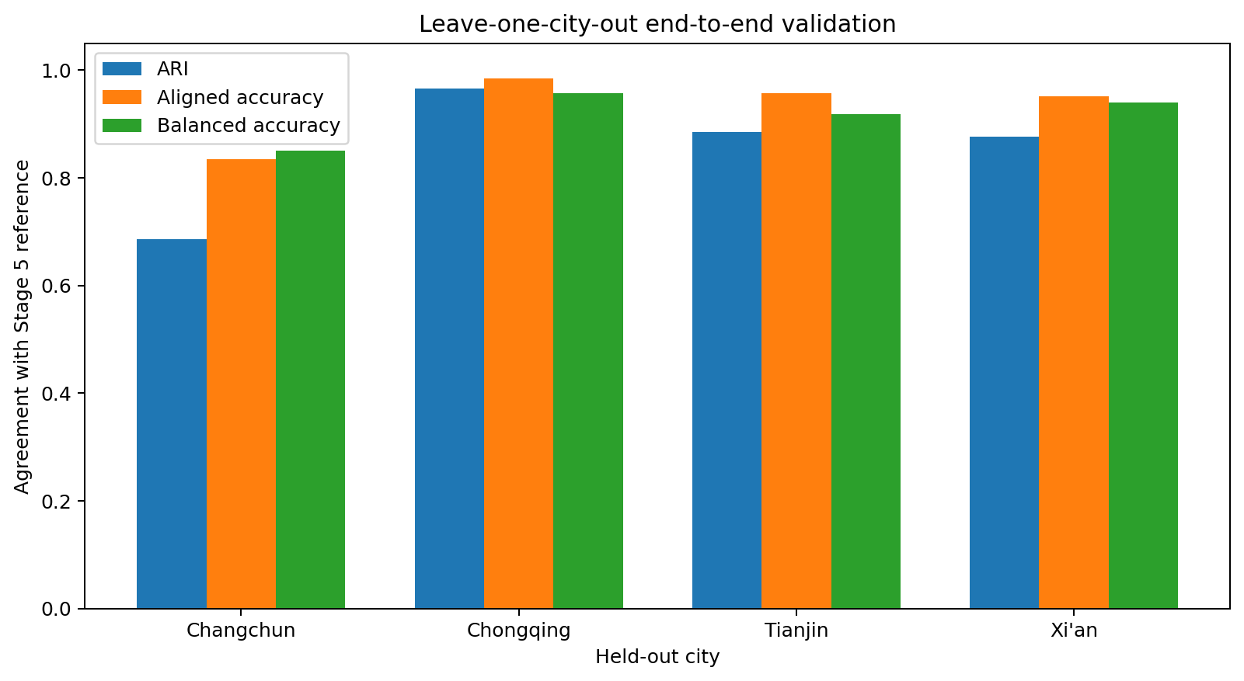
Figure 2. End-to-end held-out-city agreement after fitting winsorization, scaling, PCA, and K-Means on training cities only.
Changchun is the most context-sensitive city, but all four profiles remain present and aligned agreement is 83.5%. The result supports transferability with context sensitivity rather than identical behavior across cities.

4.4 Tianjin Contextual Interpretation
CrossType was available for 4,533 Tianjin trajectories and was not a clustering input. Excluding the sparse Others category, profile and crossing type were associated (chi-square=428.15, p<0.001, bias-corrected Cramer’s V=0.217). Stop-and-Go was overrepresented in straight crossings and underrepresented in right turns, while Smooth and Steady was overrepresented in right turns.
Profile | Tianjin n | Violations | Rate | vs. overall
Smooth and Steady | 2527 | 91 | 3.60% | 1.18×
Stop-and-Go | 1127 | 11 | 0.98% | 0.32×
Dynamic Speed Adjustment | 633 | 26 | 4.11% | 1.35×
Acceleration-Intensive | 246 | 10 | 4.07% | 1.34×

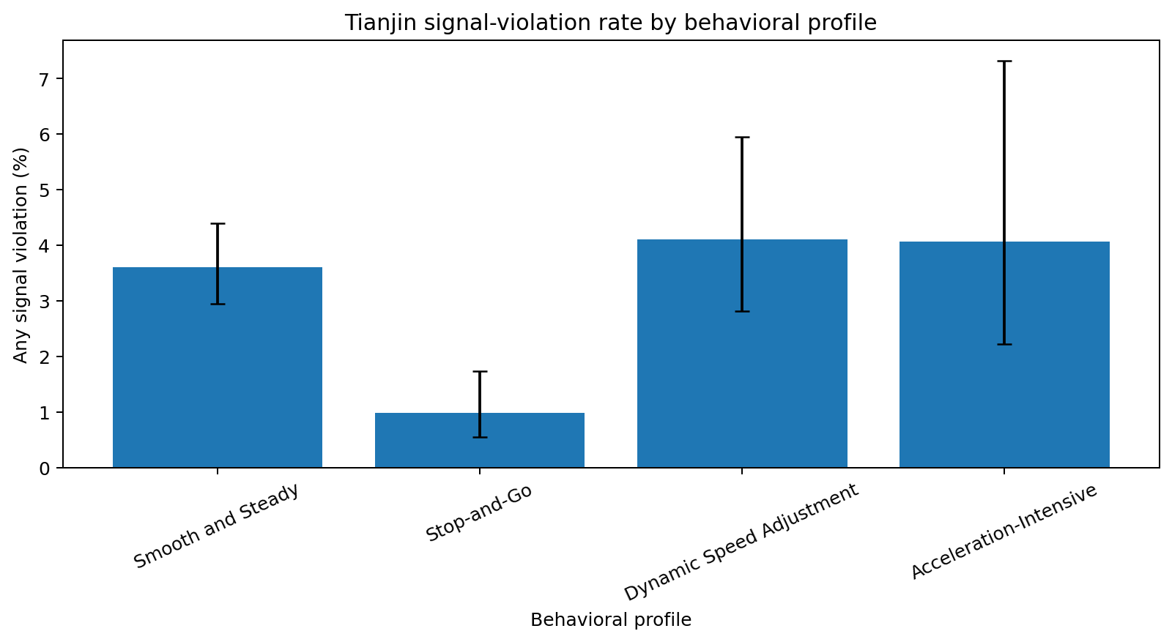
Figure 3. Tianjin signal-violation rates with Wilson 95% intervals.
The profile–any-violation association is statistically significant but weak (chi-square=22.28, p=0.000057, Cramer’s V=0.065). Therefore, the clusters must not be presented as violation predictors or safety classes.

5. Discussion

5.1 Answers to the Research Questions
- RQ1: stopping duration/frequency, acceleration intensity, dynamic variability, braking, and jerk distinguish the profiles. Smooth and Steady is the low-dynamic baseline; Stop-and-Go is the queue/stopping profile; Dynamic Speed Adjustment captures continuous but variable control; Acceleration-Intensive captures strong positive dynamics.
- RQ2: winsorization + RobustScaler + PCA + K-Means k=4 gives the best overall trade-off. It does not maximize every internal metric, but it preserves complete coverage and stable, interpretable granularity.
- RQ3: the partition is highly stable across seeds and recordings and transfers across cities, with stronger context sensitivity in Changchun.
- RQ4: Tianjin crossing type has a moderate association with profiles, while signal-violation behavior has only a weak association.

5.2 Trade-offs and Error Analysis
The moderate Silhouette score reflects continuous transitions between driving behaviors rather than perfectly separated classes. Density methods can improve non-noise compactness by excluding difficult rows, but their lower coverage and imbalanced density groups reduce suitability for complete behavior profiling. The weakest held-out recording and the Changchun city shift demonstrate that context must remain explicit.

5.3 Decision Support
Profile | Attention tier | Operational focus
Smooth and Steady | Baseline reference | Use as the baseline flow profile; monitor prevalence and large context shifts rather than intervene by default.
Stop-and-Go | Operational priority | Review signal timing, queue formation, stop frequency, and possible spillback conditions.
Dynamic Speed Adjustment | High review priority | Review approach-speed consistency, braking zones, and locations where repeated speed adjustment occurs.
Acceleration-Intensive | High review priority | Prioritize trajectory-quality verification and review high-acceleration/high-jerk maneuvers.

These priorities are descriptive rankings, not crash probabilities. The framework can guide queue review, approach-speed analysis, and trajectory-quality inspection, but it cannot prove causality, issue enforcement decisions, or replace traffic-engineering expertise.

5.4 Limitations
- Profiles summarize complete trajectories and compress temporal sequence detail.
- K-Means imposes centroid-based boundaries on behavior that is partly continuous.
- Intersection geometry, interactions, headway, weather, and exact signal phase were not included in the core multi-city features.
- Tianjin metadata is not available equivalently for the other cities.
- The full raw dataset is restricted and cannot be redistributed through a public repository.

6. Conclusion
The study demonstrates that large-scale real-world SinD trajectories can be transformed into four interpretable passenger-car behavior profiles without predefined behavior labels. The selected K-Means solution covers all 19,948 valid trajectories and remains reproducible across random initialization, resampling, recordings, and cities. Its profiles provide a practical summary of stable flow, stopping/queue behavior, speed adjustment, and high acceleration.
Future work should add interaction and geometry features, develop sequence-aware representations, validate against external safety or operational outcomes, and reproduce the pipeline on additional intersections and newly released annotations.

7. Reproducibility Statement
Content | Status | Note
Code uploaded to GitHub | Partial | Repository exists; the full v2 license-safe package must still be pushed and clone-tested.
README instructions | Yes | Local README documents project structure and stages.
Dataset or link | Yes, link/instructions only | Raw full SinD archives are restricted and intentionally excluded.
Random seed | Yes | Reference seed 42; repeated seeds documented.
Library versions | Yes locally | Exact environment versions documented in the analysis package; refresh before final GitHub push.
requirements.txt / environment | Needs final refresh | Create/push a pinned environment file matching the final execution environment.
Notebooks run in order | Yes | Stages 2–7 produce processed tables, figures, model, and validation outputs.

8. AI Usage Declaration
AI tool | Purpose | Supported content | Used by
ChatGPT (OpenAI) | Research-structure refinement, code assistance, explanations, consistency checks, language editing, report preparation | Proposal, methodology explanations, notebook/code scaffolding, report drafting | Group 3

All numerical results were generated by executed Python workflows and verified against saved output tables. The group remains responsible for research design, data access conditions, execution, interpretation, citations, and academic integrity.

References
[1] Y. Xu, W. Shao, J. Li, K. Yang, W. Wang, H. Huang, C. Lv, and H. Wang, “SIND: A Drone Dataset at Signalized Intersection in China,” Proc. IEEE ITSC, pp. 2471–2478, 2022.
[2] J. Zhao, J. Fang, Z. Ye, and L. Zhang, “Large Scale Autonomous Driving Scenarios Clustering with Self-supervised Feature Extraction,” arXiv:2103.16101, 2021.
[3] S. Bandyopadhyay, A. Datta, S. Sachan, and A. Pal, “Unsupervised Driving Behavior Analysis Using Representation Learning and Exploiting Group-Based Training,” arXiv:2205.07870, 2022.
[4] T. Kreutz, O. Esbel, M. Mühlhäuser, and A. Sanchez Guinea, “Unsupervised Driving Event Discovery Based on Vehicle CAN-data,” arXiv:2301.04988, 2023.
[5] X. Yao, S. C. Calvert, and S. P. Hoogendoorn, “Driving Pattern Interpretation Based on Action Phases Clustering,” arXiv:2407.17518, 2024.

