### Case 2

**Version**

RocketMQ: 5.X

Flink Engine: vvr-6.0.0-flink-1.15

**Filter Config**

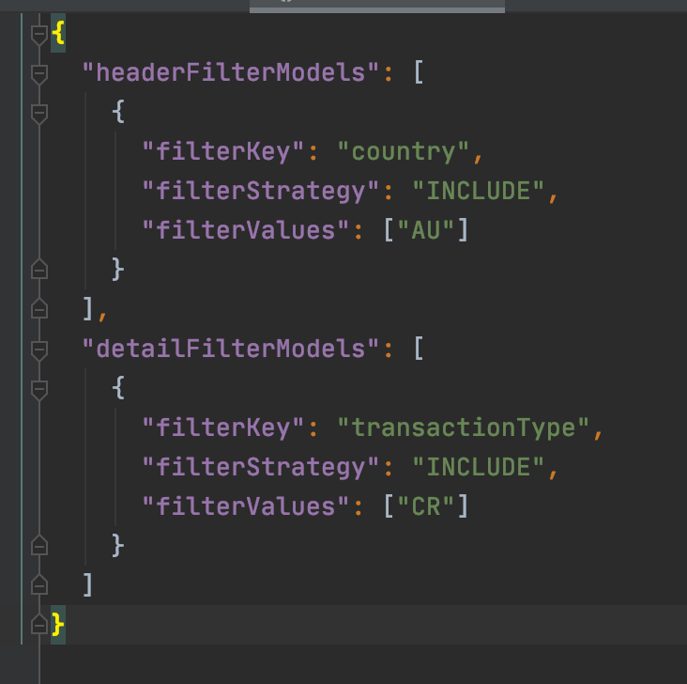

**Result**

Fetched 2 records from RocketMQ

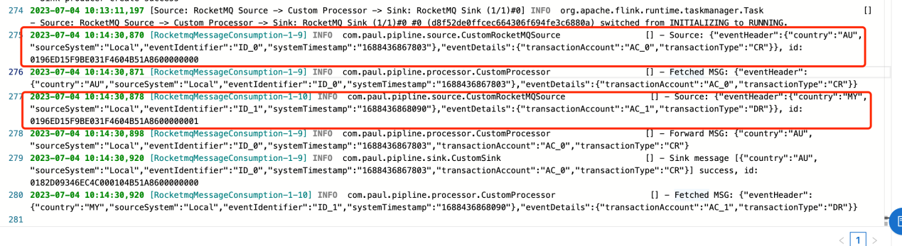

Forwarded 1 record

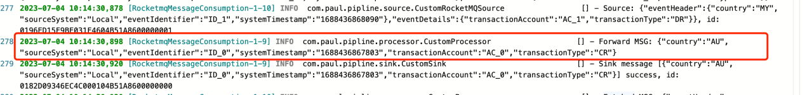

### Case 3

**Version:**

Kafka: 2.13

Engine: vvr-4.0.15-flink-1.13

Filter Config: same as above

**Result**

Fetched 2 records from kafka input topic

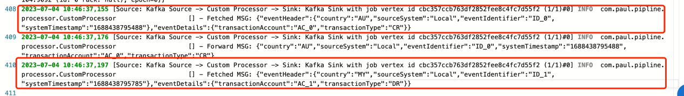

Forwarded 1 record

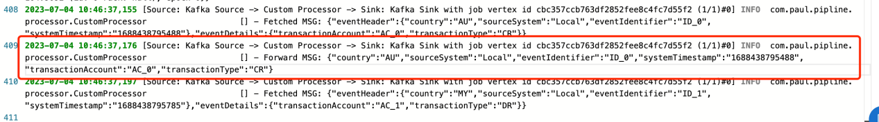

### Case 6

**Version:**

Kafka: 2.13

Engine: vvr-4.0.15-flink-1.13

**Result**

**count**

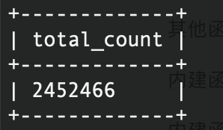

Time(ms)

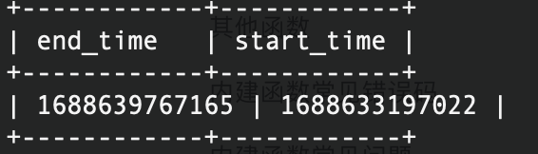

Avg: 373/s

No record loss or duplicate.