|  |  |  |  |  |  |  |  |  |
| --- | --- | --- | --- | --- | --- | --- | --- | --- |
|  | |  |  |  | | --- | --- | --- | |  |  |  | | Министерство образования и науки РОССИЙСКОЙ ФЕДЕРАЦИИ | | |  Федеральное государственное бюджетное образовательное учреждение высшего образования  **«МИРЭА – Российский технологический университет»** | |
|  | |
|  | |
|  |  |

ИНСТИТУТ КИБЕРНЕТИКИ

КАФЕДРА ВЫСШЕЙ МАТЕМАТИКИ

Лабораторная работа 3

 по курсу «**Случайные процессы**»

Тема: **Процесс роста и мутации популяции**

Выполнил:

Студент 4-го курса

Жолковский Д.А.

Группа: КМБО-01-16

МОСКВА 2019

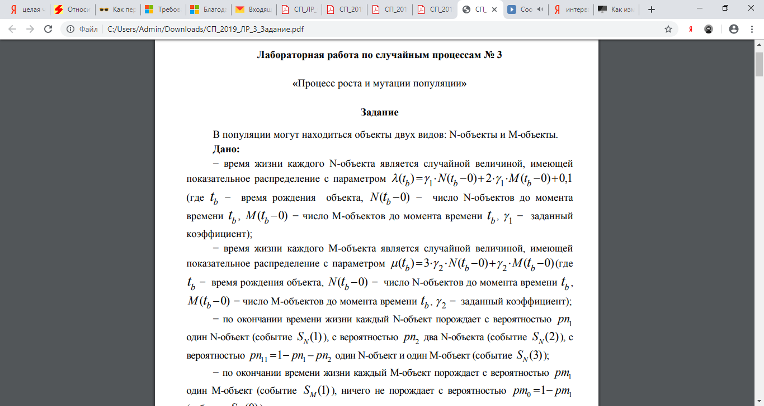

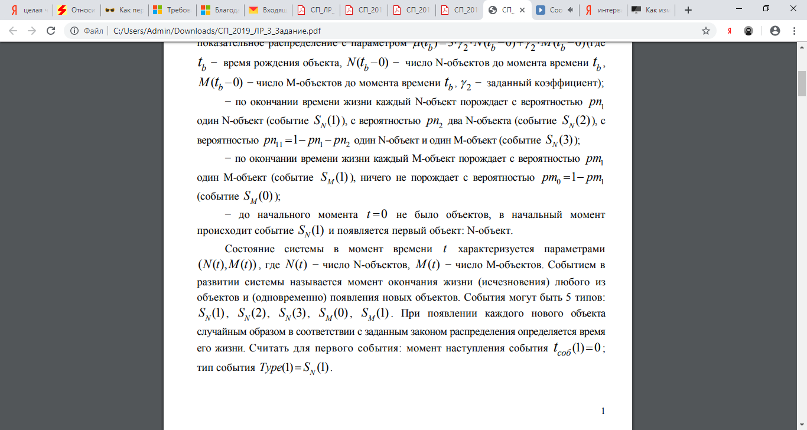

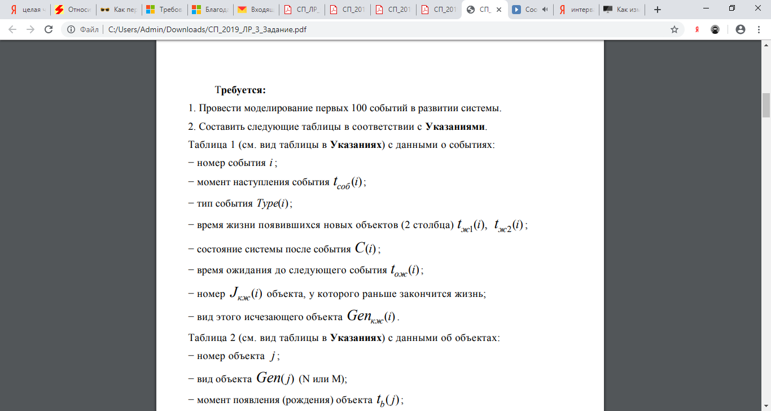

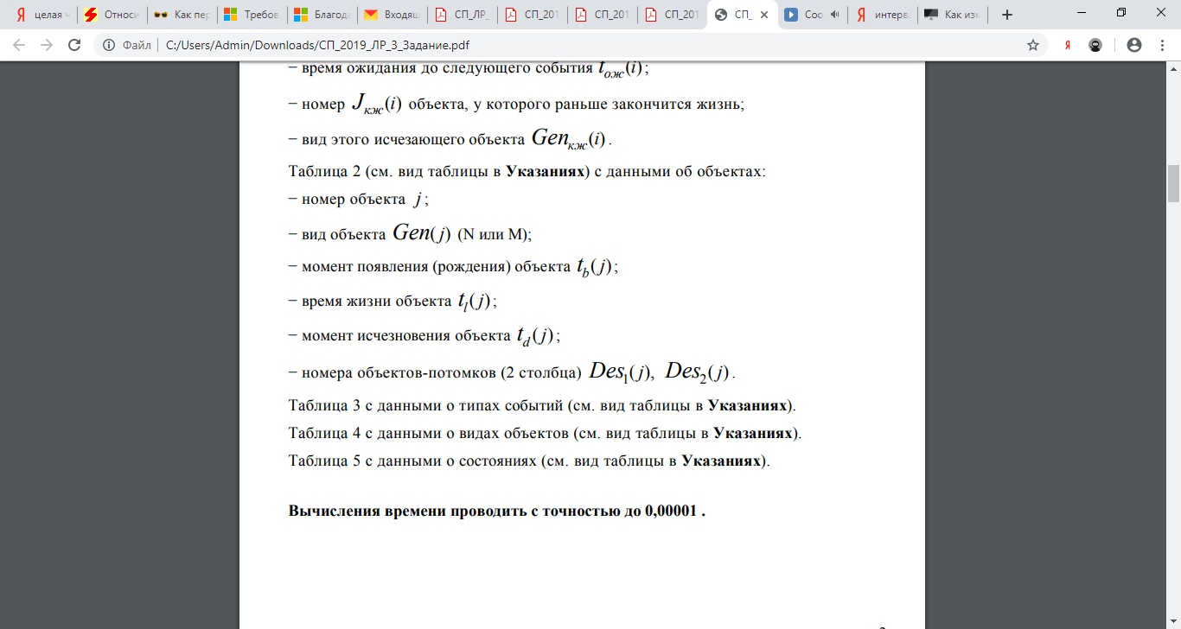

**Краткие теоретические сведения**

Процессом гибели и размножения называется марковский процесс с непрерывным временем, граф состояний которого изображён на рисунке:



…

…



– интенсивность размножения



интенсивность гибели



Система уравнений Колмогорова для вероятностей состояний процесса гибели и размножения имеет вид:

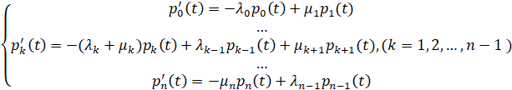

В том случае, когда у процесса гибели и рождения все интенсивности положительны а число состояний конечно, процесс является эргодическим, и существуют предельные вероятности состояний

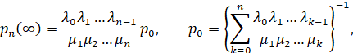

являющиеся также и стационарными вероятностями.

**Средства высокоуровневого интерпретируемого языка программирования Python, которые использованы в программе расчета**

scipy.stats.expon – класс для работы с экспоненциальным распределением

max(x) – выбор максимального значения в массиве х;

mix(x) – выбор минимального значения в массиве х;

np.zeros(m,n) – создание нулевой матрицы размера m х n;

abs(x) – модуль числа х;

np.rand -  генерация равномерного псевдослучайного числа в диапазоне 0..1

np.random.exponential – генерация N псевдослучайных чисел, распределенных по показательному закону с параметром λ = lambda;

sorted(x) – упорядочение по возрастанию массива x;

**Результаты расчетов**

Вариант №10

Исходные данные

0,318



0,318



0,25



0,35



0,21



Таблица 1

|  |  |  |  |  |  |  |  |  |
| --- | --- | --- | --- | --- | --- | --- | --- | --- |
| № события |  |  |  |  | С |  |  |  |
| 1 | 0 |  | 6.64915 | -1 | (1,0) | 6.64915 | 1 | N |
| 2 | 6.64915 |  | 0.09554 | 2.83492 | (2,0) | 0.09554 | 2 | N |
| 3 | 6.74469 |  | 0.40989 | 0.8441 | (2,1) | 0.40989 | 4 | N |
| 4 | 7.15458 |  | 0.00775 | 0.03357 | (3,1) | 0.00775 | 6 | N |
| 5 | 7.16233 |  | 0.1076 | 0.4915 | (4,1) | 0.02582 | 7 | N |
| 6 | 7.18815 |  | 0.04375 | 0.58323 | (4,2) | 0.04375 | 10 | M |
| 7 | 7.2319 |  | -1 | -1 | (4,1) | 0.03803 | 8 | N |
| 8 | 7.26993 |  | 0.20504 | 0.51793 | (5,1) | 0.20504 | 12 | N |
| 9 | 7.47497 |  | 0.06481 | 1.15915 | (5,2) | 0.06481 | 14 | M |
| 10 | 7.53978 |  | -1 | -1 | (5,1) | 0.04901 | 5 | M |
| 11 | 7.58879 |  | 0.38379 | -1 | (5,1) | 0.06504 | 9 | N |
| 12 | 7.65383 |  | 0.39782 | 0.51644 | (6,1) | 0.11755 | 11 | N |
| 13 | 7.77138 |  | 0.19322 | -1 | (6,1) | 0.01648 | 13 | N |
| 14 | 7.78786 |  | 0.02582 | 0.06851 | (7,1) | 0.02582 | 20 | N |
| 15 | 7.81368 |  | 0.25677 | 0.43915 | (7,2) | 0.04269 | 21 | N |
| 16 | 7.85637 |  | 0.13855 | -1 | (7,2) | 0.10823 | 19 | N |
| 17 | 7.9646 |  | 0.12213 | 0.56656 | (8,2) | 0.00798 | 16 | M |
| 18 | 7.97258 |  | -1 | -1 | (8,1) | 0.02234 | 24 | N |
| 19 | 7.99492 |  | 0.01396 | 0.172 | (9,1) | 0.01396 | 27 | N |
| 20 | 8.00888 |  | 0.00363 | 0.00679 | (10,1) | 0.00363 | 29 | N |
| 21 | 8.01251 |  | 0.1874 | 0.26046 | (11,1) | 0.00316 | 30 | N |
| 22 | 8.01567 |  | 0.47083 | 0.50479 | (12,1) | 0.03598 | 17 | N |
| 23 | 8.05165 |  | 0.47137 | -1 | (12,1) | 0.0188 | 22 | M |
| 24 | 8.07045 |  | 0.03263 | -1 | (12,1) | 0.01628 | 25 | N |
| 25 | 8.08673 |  | 0.06125 | 0.12362 | (12,2) | 0.01635 | 36 | M |
| 26 | 8.10308 |  | -1 | -1 | (12,1) | 0.0449 | 37 | N |
| 27 | 8.14798 |  | 0.27266 | -1 | (12,1) | 0.01894 | 28 | N |
| 28 | 8.16692 |  | 0.10938 | 0.50261 | (12,2) | 0.00335 | 18 | N |
| 29 | 8.17027 |  | 0.16493 | -1 | (12,2) | 0.02964 | 31 | N |
| 30 | 8.19991 |  | 0.10686 | 0.53546 | (13,2) | 0.01044 | 38 | M |
| 31 | 8.21035 |  | -1 | -1 | (13,1) | 0.04248 | 23 | N |
| 32 | 8.25283 |  | 0.01913 | -1 | (13,1) | 0.01913 | 45 | N |
| 33 | 8.27196 |  | 0.00317 | 0.30067 | (14,1) | 0.00101 | 32 | N |
| 34 | 8.27297 |  | 0.00722 | 0.15491 | (14,2) | 0.00216 | 46 | N |
| 35 | 8.27513 |  | 0.04413 | -1 | (14,2) | 0.00117 | 40 | M |
| 36 | 8.2763 |  | -1 | -1 | (14,1) | 0.00389 | 48 | M |
| 37 | 8.28019 |  | -1 | -1 | (14,0) | 0.02658 | 43 | N |
| 38 | 8.30677 |  | 0.02846 | 0.3388 | (14,1) | 0.01249 | 50 | N |
| 39 | 8.31926 |  | 0.00247 | 0.21346 | (14,2) | 0.00247 | 53 | M |
| 40 | 8.32173 |  | -1 | -1 | (14,1) | 0.01347 | 42 | N |
| 41 | 8.3352 |  | 0.0008 | 0.19234 | (15,1) | 3e-05 | 51 | N |
| 42 | 8.33523 |  | 0.01268 | 0.08333 | (16,1) | 0.00077 | 55 | N |
| 43 | 8.336 |  | 0.05211 | -1 | (16,1) | 0.01191 | 57 | N |
| 44 | 8.34791 |  | 0.03693 | 0.19265 | (16,2) | 0.03693 | 60 | M |
| 45 | 8.38484 |  | -1 | -1 | (16,1) | 0.00327 | 59 | N |
| 46 | 8.38811 |  | 0.30824 | -1 | (16,1) | 0.03045 | 58 | N |
| 47 | 8.41856 |  | 0.08658 | 0.10593 | (16,2) | 0.00208 | 39 | N |
| 48 | 8.42064 |  | 0.17674 | 0.48851 | (17,2) | 0.00724 | 49 | N |
| 49 | 8.42788 |  | 0.07656 | 0.22754 | (18,2) | 0.05862 | 33 | N |
| 50 | 8.4865 |  | 0.0464 | 0.17112 | (19,2) | 0.01794 | 67 | N |
| 51 | 8.50444 |  | 0.05958 | 0.33443 | (20,2) | 0.0007 | 63 | N |
| 52 | 8.50514 |  | 0.01549 | 0.032 | (20,3) | 0.01532 | 34 | N |
| 53 | 8.52046 |  | 0.04698 | 0.06799 | (20,4) | 0.00017 | 73 | N |
| 54 | 8.52063 |  | 0.02806 | -1 | (20,4) | 0.00239 | 35 | N |
| 55 | 8.52302 |  | 0.11685 | -1 | (20,4) | 0.00147 | 64 | M |
| 56 | 8.52449 |  | -1 | -1 | (20,3) | 0.00305 | 56 | N |
| 57 | 8.52754 |  | 0.02731 | 0.05932 | (20,4) | 0.00362 | 26 | N |
| 58 | 8.53116 |  | 0.1798 | -1 | (20,4) | 0.00156 | 54 | N |
| 59 | 8.53272 |  | 0.01178 | 0.08637 | (20,5) | 0.00018 | 69 | N |
| 60 | 8.5329 |  | 0.14056 | -1 | (20,5) | 0.00424 | 74 | M |
| 61 | 8.53714 |  | 0.14127 | -1 | (20,5) | 0.00342 | 61 | N |
| 62 | 8.54056 |  | 0.01914 | 0.08257 | (21,5) | 0.00394 | 82 | N |
| 63 | 8.5445 |  | 0.23829 | -1 | (21,5) | 0.00419 | 77 | N |
| 64 | 8.54869 |  | 0.05653 | 0.08447 | (22,5) | 0.00616 | 79 | M |
| 65 | 8.55485 |  | -1 | -1 | (22,4) | 0.00485 | 86 | N |
| 66 | 8.5597 |  | 0.52953 | -1 | (22,4) | 0.00432 | 71 | N |
| 67 | 8.56402 |  | 0.03716 | -1 | (22,4) | 0.00342 | 75 | N |
| 68 | 8.56744 |  | 0.04961 | 0.15757 | (22,5) | 0.00519 | 47 | N |
| 69 | 8.57263 |  | 0.05779 | 0.11153 | (22,6) | 0.01423 | 80 | N |
| 70 | 8.58686 |  | 0.04805 | -1 | (22,6) | 0.00159 | 76 | M |
| 71 | 8.58845 |  | 0.06961 | -1 | (22,6) | 0.00893 | 65 | N |
| 72 | 8.59738 |  | 0.10442 | 0.1619 | (23,6) | 0.0038 | 92 | N |
| 73 | 8.60118 |  | 0.01916 | 0.0586 | (23,7) | 0.00404 | 89 | N |
| 74 | 8.60522 |  | 0.09245 | 0.23269 | (24,7) | 0.01183 | 93 | M |
| 75 | 8.61705 |  | -1 | -1 | (24,6) | 0.00204 | 83 | M |
| 76 | 8.61909 |  | -1 | -1 | (24,5) | 0.00125 | 101 | N |
| 77 | 8.62034 |  | 0.03758 | 0.09307 | (25,5) | 0.00279 | 87 | N |
| 78 | 8.62313 |  | 0.01363 | -1 | (25,5) | 0.00729 | 95 | M |
| 79 | 8.63042 |  | -1 | -1 | (25,4) | 0.00274 | 90 | N |
| 80 | 8.63316 |  | 0.03207 | 0.03241 | (25,5) | 0.00096 | 15 | N |
| 81 | 8.63412 |  | 0.01434 | 0.19302 | (26,5) | 0.00079 | 97 | N |
| 82 | 8.63491 |  | 0.00218 | 0.03477 | (26,6) | 0.00185 | 107 | N |
| 83 | 8.63676 |  | 0.00804 | -1 | (26,6) | 0.00033 | 112 | N |
| 84 | 8.63709 |  | 0.00337 | 0.05425 | (27,6) | 0.00278 | 78 | N |
| 85 | 8.63987 |  | 0.08546 | 0.08666 | (27,7) | 0.00059 | 115 | N |
| 86 | 8.64046 |  | 0.11119 | 0.12149 | (27,8) | 0.00434 | 114 | N |
| 87 | 8.6448 |  | 0.08946 | -1 | (27,8) | 0.00077 | 52 | M |
| 88 | 8.64557 |  | -1 | -1 | (27,7) | 0.00289 | 110 | N |
| 89 | 8.64846 |  | 0.05146 | 0.08298 | (27,8) | 0.00696 | 68 | N |
| 90 | 8.65542 |  | 0.00104 | -1 | (27,8) | 0.00104 | 124 | N |
| 91 | 8.65646 |  | 0.05484 | 0.27359 | (27,9) | 0.00116 | 70 | N |
| 92 | 8.65762 |  | 0.03498 | -1 | (27,9) | 0.0003 | 105 | N |
| 93 | 8.65792 |  | 0.13386 | -1 | (27,9) | 0.00014 | 98 | M |
| 94 | 8.65806 |  | 0.0256 | -1 | (27,9) | 0.00172 | 102 | M |
| 95 | 8.65978 |  | -1 | -1 | (27,8) | 0.00545 | 108 | M |
| 96 | 8.66523 |  | -1 | -1 | (27,7) | 0.00034 | 109 | N |
| 97 | 8.66557 |  | 0.02451 | 0.04799 | (28,7) | 0.00396 | 41 | N |
| 98 | 8.66953 |  | 0.02545 | -1 | (28,7) | 0.00015 | 113 | M |
| 99 | 8.66968 |  | -1 | -1 | (28,6) | 0.00378 | 84 | N |
| 100 | 8.67346 |  | 0.0422 | 0.17393 | (28,7) | 0.00495 | 85 | M |

Таблица 2

|  |  |  |  |  |  |  |
| --- | --- | --- | --- | --- | --- | --- |
| № объекта |  |  |  |  |  |  |
| 1 | N | 0 | 6.64915 | 6.64915 | 2 | 3 |
| 2 | N | 6.64915 | 0.09554 | 6.74469 | 4 | 5 |
| 3 | N | 6.64915 | 2.83492 | 9.48407 | -1 | -1 |
| 4 | N | 6.74469 | 0.40989 | 7.15458 | 6 | 7 |
| 5 | M | 6.74469 | 0.8441 | 7.58879 | 16 | -1 |
| 6 | N | 7.15458 | 0.00775 | 7.16233 | 8 | 9 |
| 7 | N | 7.15458 | 0.03357 | 7.18815 | 10 | 11 |
| 8 | N | 7.16233 | 0.1076 | 7.26993 | 12 | 13 |
| 9 | N | 7.16233 | 0.4915 | 7.65383 | 17 | 18 |
| 10 | M | 7.18815 | 0.04375 | 7.2319 | -1 | -1 |
| 11 | N | 7.18815 | 0.58323 | 7.77138 | 19 | -1 |
| 12 | N | 7.26993 | 0.20504 | 7.47497 | 14 | 15 |
| 13 | N | 7.26993 | 0.51793 | 7.78786 | 20 | 21 |
| 14 | M | 7.47497 | 0.06481 | 7.53978 | -1 | -1 |
| 15 | N | 7.47497 | 1.15915 | 8.63412 | 110 | 111 |
| 16 | M | 7.58879 | 0.38379 | 7.97258 | -1 | -1 |
| 17 | N | 7.65383 | 0.39782 | 8.05165 | 35 | -1 |
| 18 | N | 7.65383 | 0.51644 | 8.17027 | 42 | -1 |
| 19 | N | 7.77138 | 0.19322 | 7.9646 | 25 | 26 |
| 20 | N | 7.78786 | 0.02582 | 7.81368 | 22 | 23 |
| 21 | N | 7.78786 | 0.06851 | 7.85637 | 24 | -1 |
| 22 | M | 7.81368 | 0.25677 | 8.07045 | 36 | -1 |
| 23 | N | 7.81368 | 0.43915 | 8.25283 | 45 | -1 |
| 24 | N | 7.85637 | 0.13855 | 7.99492 | 27 | 28 |
| 25 | N | 7.9646 | 0.12213 | 8.08673 | 37 | 38 |
| 26 | N | 7.9646 | 0.56656 | 8.53116 | 81 | -1 |
| 27 | N | 7.99492 | 0.01396 | 8.00888 | 29 | 30 |
| 28 | N | 7.99492 | 0.172 | 8.16692 | 40 | 41 |
| 29 | N | 8.00888 | 0.00363 | 8.01251 | 31 | 32 |
| 30 | N | 8.00888 | 0.00679 | 8.01567 | 33 | 34 |
| 31 | N | 8.01251 | 0.1874 | 8.19991 | 43 | 44 |
| 32 | N | 8.01251 | 0.26046 | 8.27297 | 48 | 49 |
| 33 | N | 8.01567 | 0.47083 | 8.4865 | 69 | 70 |
| 34 | N | 8.01567 | 0.50479 | 8.52046 | 75 | 76 |
| 35 | N | 8.05165 | 0.47137 | 8.52302 | 78 | -1 |
| 36 | M | 8.07045 | 0.03263 | 8.10308 | -1 | -1 |
| 37 | N | 8.08673 | 0.06125 | 8.14798 | 39 | -1 |
| 38 | M | 8.08673 | 0.12362 | 8.21035 | -1 | -1 |
| 39 | N | 8.14798 | 0.27266 | 8.42064 | 65 | 66 |
| 40 | M | 8.16692 | 0.10938 | 8.2763 | -1 | -1 |
| 41 | N | 8.16692 | 0.50261 | 8.66953 | 132 | -1 |
| 42 | N | 8.17027 | 0.16493 | 8.3352 | 55 | 56 |
| 43 | N | 8.19991 | 0.10686 | 8.30677 | 51 | 52 |
| 44 | N | 8.19991 | 0.53546 | 8.73537 | -1 | -1 |
| 45 | N | 8.25283 | 0.01913 | 8.27196 | 46 | 47 |
| 46 | N | 8.27196 | 0.00317 | 8.27513 | 50 | -1 |
| 47 | N | 8.27196 | 0.30067 | 8.57263 | 95 | 96 |
| 48 | M | 8.27297 | 0.00722 | 8.28019 | -1 | -1 |
| 49 | N | 8.27297 | 0.15491 | 8.42788 | 67 | 68 |
| 50 | N | 8.27513 | 0.04413 | 8.31926 | 53 | 54 |
| 51 | N | 8.30677 | 0.02846 | 8.33523 | 57 | 58 |
| 52 | M | 8.30677 | 0.3388 | 8.64557 | -1 | -1 |
| 53 | M | 8.31926 | 0.00247 | 8.32173 | -1 | -1 |
| 54 | N | 8.31926 | 0.21346 | 8.53272 | 82 | 83 |
| 55 | N | 8.3352 | 0.0008 | 8.336 | 59 | -1 |
| 56 | N | 8.3352 | 0.19234 | 8.52754 | 79 | 80 |
| 57 | N | 8.33523 | 0.01268 | 8.34791 | 60 | 61 |
| 58 | N | 8.33523 | 0.08333 | 8.41856 | 63 | 64 |
| 59 | N | 8.336 | 0.05211 | 8.38811 | 62 | -1 |
| 60 | M | 8.34791 | 0.03693 | 8.38484 | -1 | -1 |
| 61 | N | 8.34791 | 0.19265 | 8.54056 | 86 | 87 |
| 62 | N | 8.38811 | 0.30824 | 8.69635 | -1 | -1 |
| 63 | N | 8.41856 | 0.08658 | 8.50514 | 73 | 74 |
| 64 | M | 8.41856 | 0.10593 | 8.52449 | -1 | -1 |
| 65 | N | 8.42064 | 0.17674 | 8.59738 | 99 | 100 |
| 66 | N | 8.42064 | 0.48851 | 8.90915 | -1 | -1 |
| 67 | N | 8.42788 | 0.07656 | 8.50444 | 71 | 72 |
| 68 | N | 8.42788 | 0.22754 | 8.65542 | 124 | -1 |
| 69 | N | 8.4865 | 0.0464 | 8.5329 | 84 | -1 |
| 70 | N | 8.4865 | 0.17112 | 8.65762 | 127 | -1 |
| 71 | N | 8.50444 | 0.05958 | 8.56402 | 92 | -1 |
| 72 | N | 8.50444 | 0.33443 | 8.83887 | -1 | -1 |
| 73 | N | 8.50514 | 0.01549 | 8.52063 | 77 | -1 |
| 74 | M | 8.50514 | 0.032 | 8.53714 | 85 | -1 |
| 75 | N | 8.52046 | 0.04698 | 8.56744 | 93 | 94 |
| 76 | M | 8.52046 | 0.06799 | 8.58845 | 98 | -1 |
| 77 | N | 8.52063 | 0.02806 | 8.54869 | 89 | 90 |
| 78 | N | 8.52302 | 0.11685 | 8.63987 | 117 | 118 |
| 79 | M | 8.52754 | 0.02731 | 8.55485 | -1 | -1 |
| 80 | N | 8.52754 | 0.05932 | 8.58686 | 97 | -1 |
| 81 | N | 8.53116 | 0.1798 | 8.71096 | -1 | -1 |
| 82 | N | 8.53272 | 0.01178 | 8.5445 | 88 | -1 |
| 83 | M | 8.53272 | 0.08637 | 8.61909 | -1 | -1 |
| 84 | N | 8.5329 | 0.14056 | 8.67346 | 133 | 134 |
| 85 | M | 8.53714 | 0.14127 | 8.67841 | -1 | -1 |
| 86 | N | 8.54056 | 0.01914 | 8.5597 | 91 | -1 |
| 87 | N | 8.54056 | 0.08257 | 8.62313 | 107 | -1 |
| 88 | N | 8.5445 | 0.23829 | 8.78279 | -1 | -1 |
| 89 | N | 8.54869 | 0.05653 | 8.60522 | 103 | 104 |
| 90 | N | 8.54869 | 0.08447 | 8.63316 | 108 | 109 |
| 91 | N | 8.5597 | 0.52953 | 9.08923 | -1 | -1 |
| 92 | N | 8.56402 | 0.03716 | 8.60118 | 101 | 102 |
| 93 | M | 8.56744 | 0.04961 | 8.61705 | -1 | -1 |
| 94 | N | 8.56744 | 0.15757 | 8.72501 | -1 | -1 |
| 95 | M | 8.57263 | 0.05779 | 8.63042 | -1 | -1 |
| 96 | N | 8.57263 | 0.11153 | 8.68416 | -1 | -1 |
| 97 | N | 8.58686 | 0.04805 | 8.63491 | 112 | 113 |
| 98 | M | 8.58845 | 0.06961 | 8.65806 | 129 | -1 |
| 99 | N | 8.59738 | 0.10442 | 8.7018 | -1 | -1 |
| 100 | N | 8.59738 | 0.1619 | 8.75928 | -1 | -1 |
| 101 | N | 8.60118 | 0.01916 | 8.62034 | 105 | 106 |
| 102 | M | 8.60118 | 0.0586 | 8.65978 | -1 | -1 |
| 103 | N | 8.60522 | 0.09245 | 8.69767 | -1 | -1 |
| 104 | N | 8.60522 | 0.23269 | 8.83791 | -1 | -1 |
| 105 | N | 8.62034 | 0.03758 | 8.65792 | 128 | -1 |
| 106 | N | 8.62034 | 0.09307 | 8.71341 | -1 | -1 |
| 107 | N | 8.62313 | 0.01363 | 8.63676 | 114 | -1 |
| 108 | M | 8.63316 | 0.03207 | 8.66523 | -1 | -1 |
| 109 | N | 8.63316 | 0.03241 | 8.66557 | 130 | 131 |
| 110 | N | 8.63412 | 0.01434 | 8.64846 | 122 | 123 |
| 111 | N | 8.63412 | 0.19302 | 8.82714 | -1 | -1 |
| 112 | N | 8.63491 | 0.00218 | 8.63709 | 115 | 116 |
| 113 | M | 8.63491 | 0.03477 | 8.66968 | -1 | -1 |
| 114 | N | 8.63676 | 0.00804 | 8.6448 | 121 | -1 |
| 115 | N | 8.63709 | 0.00337 | 8.64046 | 119 | 120 |
| 116 | N | 8.63709 | 0.05425 | 8.69134 | -1 | -1 |
| 117 | N | 8.63987 | 0.08546 | 8.72533 | -1 | -1 |
| 118 | M | 8.63987 | 0.08666 | 8.72653 | -1 | -1 |
| 119 | N | 8.64046 | 0.11119 | 8.75165 | -1 | -1 |
| 120 | M | 8.64046 | 0.12149 | 8.76195 | -1 | -1 |
| 121 | N | 8.6448 | 0.08946 | 8.73426 | -1 | -1 |
| 122 | N | 8.64846 | 0.05146 | 8.69992 | -1 | -1 |
| 123 | M | 8.64846 | 0.08298 | 8.73144 | -1 | -1 |
| 124 | N | 8.65542 | 0.00104 | 8.65646 | 125 | 126 |
| 125 | M | 8.65646 | 0.05484 | 8.7113 | -1 | -1 |
| 126 | N | 8.65646 | 0.27359 | 8.93005 | -1 | -1 |
| 127 | N | 8.65762 | 0.03498 | 8.6926 | -1 | -1 |
| 128 | N | 8.65792 | 0.13386 | 8.79178 | -1 | -1 |
| 129 | M | 8.65806 | 0.0256 | 8.68366 | -1 | -1 |
| 130 | N | 8.66557 | 0.02451 | 8.69008 | -1 | -1 |
| 131 | N | 8.66557 | 0.04799 | 8.71356 | -1 | -1 |
| 132 | N | 8.66953 | 0.02545 | 8.69498 | -1 | -1 |
| 133 | M | 8.67346 | 0.0422 | 8.71566 | -1 | -1 |
| 134 | N | 8.67346 | 0.17393 | 8.84739 | -1 | -1 |

**Анализ результатов и выводы**

Таблица 3

|  |  |  |  |  |  |  |
| --- | --- | --- | --- | --- | --- | --- |
| Тип события |  |  |  |  |  |  |
| Число событий | 25 | 27 | 25 | 18 | 5 | 100 |
| Относительная частота | 0.25000 | 0.27000 | 0.25000 | 0.18000 | 0.05000 | 1 |

Таблица 4

|  |  |  |
| --- | --- | --- |
| Вид объекта | Число появившихся объектов за время  [0, ] | Число объектов в момент |
| N | 104 | 28 |
| M | 30 | 7 |

Таблица 5

|  |  |  |  |  |
| --- | --- | --- | --- | --- |
| Состояние |  |  |  |  |
| (1,0) | 1 | 0.01 | 6.64915 | 0.76661 |
| (2,0) | 1 | 0.01 | 0.09554 | 0.01102 |
| (2,1) | 1 | 0.01 | 0.40989 | 0.04726 |
| (3,1) | 1 | 0.01 | 0.00775 | 0.00089 |
| (4,1) | 2 | 0.02 | 0.06385 | 0.00736 |
| (4,2) | 1 | 0.01 | 0.04375 | 0.00504 |
| (5,1) | 3 | 0.03 | 0.31909 | 0.03679 |
| (5,2) | 1 | 0.01 | 0.06481 | 0.00747 |
| (6,1) | 2 | 0.02 | 0.13403 | 0.01545 |
| (7,1) | 1 | 0.01 | 0.02582 | 0.00298 |
| (7,2) | 2 | 0.02 | 0.15092 | 0.0174 |
| (8,2) | 1 | 0.01 | 0.00798 | 0.00092 |
| (8,1) | 1 | 0.01 | 0.02234 | 0.00258 |
| (9,1) | 1 | 0.01 | 0.01396 | 0.00161 |
| (10,1) | 1 | 0.01 | 0.00363 | 0.00042 |
| (11,1) | 1 | 0.01 | 0.00316 | 0.00036 |
| (12,1) | 5 | 0.05 | 0.1349 | 0.01555 |
| (12,2) | 3 | 0.03 | 0.04934 | 0.00569 |
| (13,2) | 1 | 0.01 | 0.01044 | 0.0012 |
| (13,1) | 2 | 0.02 | 0.06161 | 0.0071 |
| (14,1) | 4 | 0.04 | 0.03086 | 0.00356 |
| (14,2) | 3 | 0.03 | 0.0058 | 0.00067 |
| (14,0) | 1 | 0.01 | 0.02658 | 0.00306 |
| (15,1) | 1 | 0.01 | 3e-05 | 0.0 |
| (16,1) | 4 | 0.04 | 0.0464 | 0.00535 |
| (16,2) | 2 | 0.02 | 0.03901 | 0.0045 |
| (17,2) | 1 | 0.01 | 0.00724 | 0.00083 |
| (18,2) | 1 | 0.01 | 0.05862 | 0.00676 |
| (19,2) | 1 | 0.01 | 0.01794 | 0.00207 |
| (20,2) | 1 | 0.01 | 0.0007 | 8e-05 |
| (20,3) | 2 | 0.02 | 0.01837 | 0.00212 |
| (20,4) | 5 | 0.05 | 0.00921 | 0.00106 |
| (20,5) | 3 | 0.03 | 0.00784 | 0.0009 |
| (21,5) | 2 | 0.02 | 0.00813 | 0.00094 |
| (22,5) | 2 | 0.02 | 0.01135 | 0.00131 |
| (22,4) | 3 | 0.03 | 0.01259 | 0.00145 |
| (22,6) | 3 | 0.03 | 0.02475 | 0.00285 |
| (23,6) | 1 | 0.01 | 0.0038 | 0.00044 |
| (23,7) | 1 | 0.01 | 0.00404 | 0.00047 |
| (24,7) | 1 | 0.01 | 0.01183 | 0.00136 |
| (24,6) | 1 | 0.01 | 0.00204 | 0.00024 |
| (24,5) | 1 | 0.01 | 0.00125 | 0.00014 |
| (25,5) | 3 | 0.03 | 0.01104 | 0.00127 |
| (25,4) | 1 | 0.01 | 0.00274 | 0.00032 |
| (26,5) | 1 | 0.01 | 0.00079 | 9e-05 |
| (26,6) | 2 | 0.02 | 0.00218 | 0.00025 |
| (27,6) | 1 | 0.01 | 0.00278 | 0.00032 |
| (27,7) | 3 | 0.03 | 0.00382 | 0.00044 |
| (27,8) | 5 | 0.05 | 0.01856 | 0.00214 |
| (27,9) | 4 | 0.04 | 0.00332 | 0.00038 |
| (28,7) | 3 | 0.03 | 0.00906 | 0.00104 |
| (28,6) | 1 | 0.01 | 0.00378 | 0.00044 |
|  | 100 | 1.00000 | 8.67841 | 1.00000 |

**Список литературы**

1. Лобузов А.А., Гумляева С.Д., Норин Н.В. Задачи по теории случайных процессов. — М.: МИРЭА, 1993.
2. Булинский А. В., А. Н. Ширяев А. Н. Теория случайных процессов: Учебник для вузов. — М.: ФИЗМАТЛИТ, 2005
3. Вентцель Е. С., Овчаров Л. А. Теория случайных процессов и ее инженерные приложения: Учеб. пособие для вузов. — М.: Высшая школа, 2007.

**Приложение (Листинг программы)**

# coding: utf-8

**import** **numpy** **as** **np**

**from** **scipy.stats** **import** expon

**import** **random**

#################################################

pn1 = **0.318**

pn2 = **0.318**

pm1 = **0.250**

gamma1 = **0.35**

gamma2 = **0.21**

#################################################

Objects_arr = []

Num_of_N_objects = **0**

Num_of_M_objects = **0**

Type = 'S_n(1)'

t_life = round(np.random.exponential(**1**/**0.1**), **5**)

Objects_arr.append([**1**, **0**, t_life, t_life, 'N'])

Num_of_N_objects += **1**

t_wait = t_life

total_num = **1**

Arr_of_types = [**1**,**0**,**0**,**0**,**0**]

Total_N_objects = **1**

Total_M_objects = **0**

#################################################

**def** **add_to_arr_objects**(obj):

**global** Num_of_N_objects

**global** Num_of_M_objects

**if**(obj[-**1**] == 'N'):

Num_of_N_objects += **1**

**else**:

Num_of_M_objects += **1**

Objects_arr.append(obj)

j = len(Objects_arr) - **1**

**while**(j > **0** **and** Objects_arr[j - **1**][-**2**] > Objects_arr[j][-**2**]):

temp = Objects_arr[j-**1**]

Objects_arr[j - **1**] = Objects_arr[j]

Objects_arr[j] = temp

j -= **1**

**def** **delete_object**():

**global** Num_of_N_objects

**global** Num_of_M_objects

**if**(Objects_arr[**0**][-**1**] == 'N'):

Num_of_N_objects -= **1**

**else**:

Num_of_M_objects -= **1**

Objects_arr.pop(**0**)

#################################################

table1 = open('Data/table1.txt', 'w')

table5 = dict()

table5['(1,0)'] = [**1**,t_life]

table2 = []

table2.append([**1**,'N',**0**,Objects_arr[**0**][**2**],Objects_arr[**0**][**2**], -**1**, -**1**])

table1.write('1 ' + str(Objects_arr[**0**][**1**]) +' '+ Type +' '+ str(Objects_arr[**0**][**2**]) +' - (1,0) '+ str(Objects_arr[**0**][**3**]) +' '+ '1 ' + 'N ')

Total_events = **1**

Total_time = t_life

**while**(Total_events < **100**):

Time_spent = **0** #сколько времени проведено в данном состоянии

**print**(Objects_arr)

Total_events += **1**

p = np.random.rand()

**if**(Objects_arr[**0**][-**1**] == 'N'):

**if**(**0** <= p <= pn1):

Type = 'S_n(1)'

Arr_of_types[**0**] += **1**

total_num += **1**

#создание нового объекта

t_life = round(np.random.exponential(**1**/(gamma1*Num_of_N_objects + **2**\*gamma1*Num_of_M_objects + **0.1**)), **5**)

new_obj = [total_num, Objects_arr[**0**][-**2**], t_life, round(Objects_arr[**0**][-**2**]+t_life,**5**), 'N']

Total_N_objects += **1**

#добавление предков во 2 таблицу

table2[Objects_arr[**0**][**0**] - **1**][-**2**] = (new_obj[**0**])

#table2[Objects_arr[0][0] - 1].append(-1)

delete_object()

add_to_arr_objects(new_obj)

table1.write(str(Total_events)+' '+str(new_obj[**1**])+' '+ Type +' '+str(new_obj[**2**])+' - ('+ str(Num_of_N_objects)+','+str(Num_of_M_objects)+') ')

table1.write(str(round(Objects_arr[**0**][-**2**] - new_obj[**1**],**5**)) +' '+str(Objects_arr[**0**][**0**])+' '+str(Objects_arr[**0**][-**1**])+' ')

Total_spent = round(Objects_arr[**0**][-**2**] - new_obj[**1**],**5**)

Total_time = new_obj[**1**]

table2.append([total_num, new_obj[-**1**], new_obj[**1**], new_obj[**2**], new_obj[**3**], -**1**, -**1**])

**elif**(pn1 < p <= pn1+pn2):

Type = 'S_n(2)'

Arr_of_types[**1**] += **1**

first_t_life = round(np.random.exponential(**1**/(gamma1*Num_of_N_objects + **2**\*gamma1*Num_of_M_objects + **0.1**)), **5**)

second_t_life = round(np.random.exponential(**1**/(gamma1*Num_of_N_objects + **2**\*gamma1*Num_of_M_objects + **0.1**)), **5**)

Total_N_objects += **2**

**if**(second_t_life < first_t_life):

first_t_life, second_t_life = second_t_life, first_t_life

total_num += **1**

first_obj = [total_num, Objects_arr[**0**][-**2**], first_t_life, round(Objects_arr[**0**][-**2**]+first_t_life,**5**), 'N']

total_num += **1**

second_obj = [total_num, Objects_arr[**0**][-**2**], second_t_life, round(Objects_arr[**0**][-**2**] + second_t_life,**5**), 'N']

table2[Objects_arr[**0**][**0**] - **1**][-**2**] = (first_obj[**0**])

table2[Objects_arr[**0**][**0**] - **1**][-**1**] = (second_obj[**0**])

delete_object()

add_to_arr_objects(first_obj)

add_to_arr_objects(second_obj)

table1.write(str(Total_events)+' '+str(first_obj[**1**])+' '+Type+' '+str(first_obj[**2**])+' '+str(second_obj[**2**])+' ('+str(Num_of_N_objects)+','+str(Num_of_M_objects)+') ')

table1.write(str(round(Objects_arr[**0**][-**2**] - first_obj[**1**],**5**))+' '+str(Objects_arr[**0**][**0**])+' '+str(Objects_arr[**0**][-**1**])+' ')

Total_spent = round(Objects_arr[**0**][-**2**] - first_obj[**1**],**5**)

Total_time = first_obj[**1**]

table2.append([total_num - **1**, first_obj[-**1**], first_obj[**1**], first_obj[**2**], first_obj[**3**], -**1**, -**1**])

table2.append([total_num, second_obj[-**1**], second_obj[**1**],second_obj[**2**],second_obj[**3**],-**1**,-**1**])

**else**:

Type = 'S_n(3)'

Arr_of_types[**2**] += **1**

first_t_life = [round(np.random.exponential(**1**/(gamma1*Num_of_N_objects + **2**\*gamma1*Num_of_M_objects + **0.1**)), **5**), 'N']

second_t_life = [round(np.random.exponential(**1**/(**3**\*gamma2*Num_of_N_objects+gamma2*Num_of_M_objects)),**5**), 'M']

**if**(second_t_life[**0**] < first_t_life[**0**]):

first_t_life, second_t_life = second_t_life, first_t_life

Total_N_objects += **1**

Total_M_objects += **1**

total_num += **1**

first_obj = [total_num, Objects_arr[**0**][-**2**], first_t_life[**0**], round(Objects_arr[**0**][-**2**]+first_t_life[**0**],**5**), first_t_life[**1**]]

total_num += **1**

second_obj = [total_num, Objects_arr[**0**][-**2**], second_t_life[**0**], round(Objects_arr[**0**][-**2**] + second_t_life[**0**],**5**), second_t_life[**1**]]

table2[Objects_arr[**0**][**0**] - **1**][-**2**] = (first_obj[**0**])

table2[Objects_arr[**0**][**0**] - **1**][-**1**] = (second_obj[**0**])

delete_object()

add_to_arr_objects(first_obj)

add_to_arr_objects(second_obj)

table1.write(str(Total_events)+' '+str(first_obj[**1**])+' '+Type+' '+str(first_obj[**2**])+' '+str(second_obj[**2**])+' ('+str(Num_of_N_objects)+','+str(Num_of_M_objects)+') ')

table1.write(str(round(Objects_arr[**0**][-**2**] - first_obj[**1**],**5**))+' '+str(Objects_arr[**0**][**0**])+' '+str(Objects_arr[**0**][-**1**])+' ')

Total_spent = round(Objects_arr[**0**][-**2**] - first_obj[**1**],**5**)

Total_time = first_obj[**1**]

table2.append([total_num - **1**, first_obj[-**1**], first_obj[**1**], first_obj[**2**], first_obj[**3**], -**1**, -**1**])

table2.append([total_num, second_obj[-**1**], second_obj[**1**],second_obj[**2**],second_obj[**3**],-**1**,-**1**])

**else**:

**if**(**0** <= p <= pm1):

Type = 'S_m(1)'

Arr_of_types[**4**] += **1**

total_num+=**1**

t_life = round(np.random.exponential(**1**/(**3**\*gamma2*Num_of_N_objects+gamma2*Num_of_M_objects)), **5**)

Total_M_objects += **1**

new_obj = [total_num, Objects_arr[**0**][-**2**], t_life, round(Objects_arr[**0**][-**2**]+t_life,**5**), 'M']

table2[Objects_arr[**0**][**0**] - **1**][-**2**] = (new_obj[**0**])

delete_object()

add_to_arr_objects(new_obj)

table1.write(str(Total_events)+' '+str(new_obj[**1**])+' '+ Type +' '+str(new_obj[**2**])+' - ('+ str(Num_of_N_objects)+','+str(Num_of_M_objects)+') ')

table1.write(str(round(Objects_arr[**0**][-**2**] - new_obj[**1**],**5**)) +' '+str(Objects_arr[**0**][**0**])+' '+str(Objects_arr[**0**][-**1**])+' ')

Total_spent = round(Objects_arr[**0**][-**2**] - new_obj[**1**],**5**)

Total_time = new_obj[**1**]

table2.append([total_num, new_obj[-**1**], new_obj[**1**], new_obj[**2**], new_obj[**3**], -**1**, -**1**])

**else**:

Type = 'S_m(0)'

Arr_of_types[**3**] += **1**

table1.write(str(Total_events)+' '+str(Objects_arr[**0**][**3**])+' '+Type+' '+str(-**1**)+' '+str(-**1**)+' ('+str(Num_of_N_objects)+','+str(Num_of_M_objects - **1**)+') ')

table1.write(str(round(Objects_arr[**1**][-**2**] - Objects_arr[**0**][**3**],**5**))+' '+str(Objects_arr[**1**][**0**])+' '+str(Objects_arr[**1**][-**1**])+' ')

Total_spent = round(Objects_arr[**1**][-**2**] - Objects_arr[**0**][**3**],**5**)

Total_time = Objects_arr[**0**][**3**]

delete_object()

**if**(table5.get('('+str(Num_of_N_objects)+','+str(Num_of_M_objects)+')') != None):

table5['('+str(Num_of_N_objects)+','+str(Num_of_M_objects)+')'][**0**] += **1**

table5['('+str(Num_of_N_objects)+','+str(Num_of_M_objects)+')'][**1**] = round(table5['('+str(Num_of_N_objects)+','+str(Num_of_M_objects)+')'][**1**]+Total_spent,**5**)

**else**:

table5['('+str(Num_of_N_objects)+','+str(Num_of_M_objects)+')'] = [**1**,Total_spent]

table1.close()

file2 = open('Data/table2.txt','w')

**for** item **in** table2:

**for** i **in** item:

file2.write(str(i)+' ')

file2.close()

#################################################

**print**(Arr_of_types)

table3 = open('Data/table3.txt','w')

**for** item **in** Arr_of_types:

table3.write(str(item)+ ' ')

table3.close()

table4 = open('Data/table4.txt','w')

table4.write(str(Total_N_objects)+' '+str(Num_of_N_objects)+' '+str(Total_M_objects)+' '+str(Num_of_M_objects))

table4.close()

**for** i **in** table5:

table5[i].append(round(table5[i][-**1**] / Total_time,**5**))

table5[i].append(table5[i][**0**]/**100**)

file5 = open('Data/table5.txt','w')

**for** key, value **in** table5.items():

file5.write(str(key)+' '+str(value[**0**])+' '+str(value[**1**])+' '+str(value[**2**])+' '+str(value[**3**])+' ')

file5.close()

**print**('Total_time: ', Total_time)