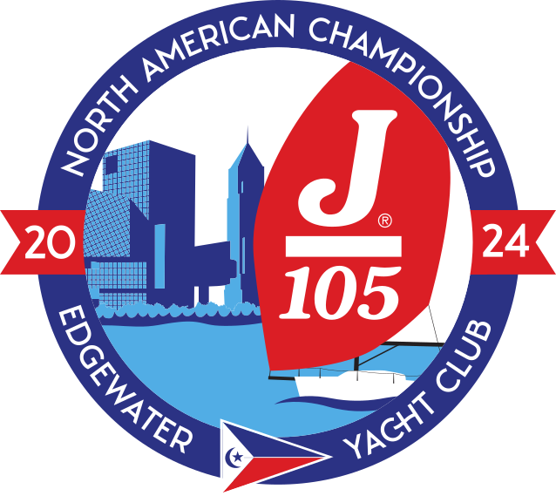

2024 J/105 North American Championship  
Sail Declaration

This form is to list all the sails you will use for the 2024 J/105 North American Championship.

|  |  |
| --- | --- |
| Name | E-mail |
| Boat Name | Sail Number |
| Mobile number | Note (for organizer) |

|  |  |  |  |  |
| --- | --- | --- | --- | --- |
| **Sail** | **Sailmaker** | **Royalty Tag number** | **Color** | **Notes**  **(for organizer)** |
| Main |  |  |  |  |
| Jib |  |  |  |  |
| Jib |  |  |  |  |
| Spinnaker |  |  |  |  |
| Spinnaker |  |  |  |  |

By signing this form, I declare that my sails will be in compliance with the J/105 Class Rules at all times.

Owner/Charterer

Name___________________________________Signature__________________________________________