Lab3

* 1. Trang chu

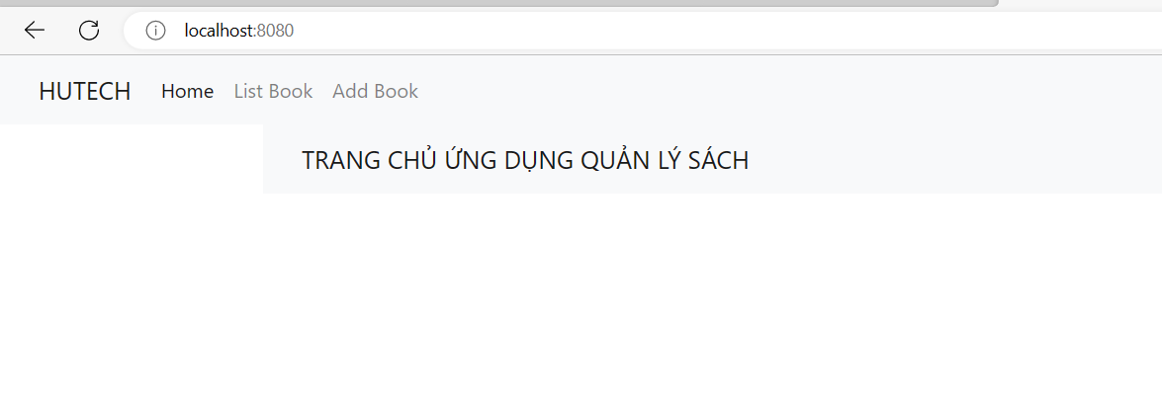

1.2 Trang danh sach sach

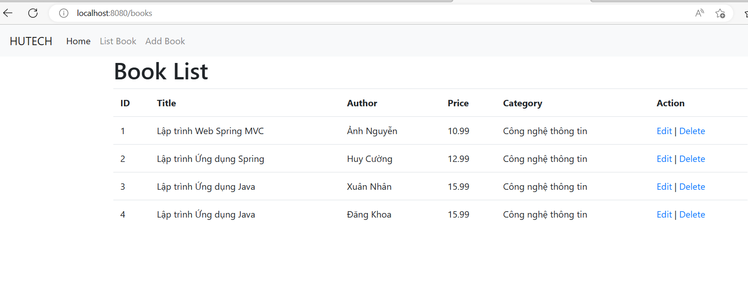

1.3 Trang them sach

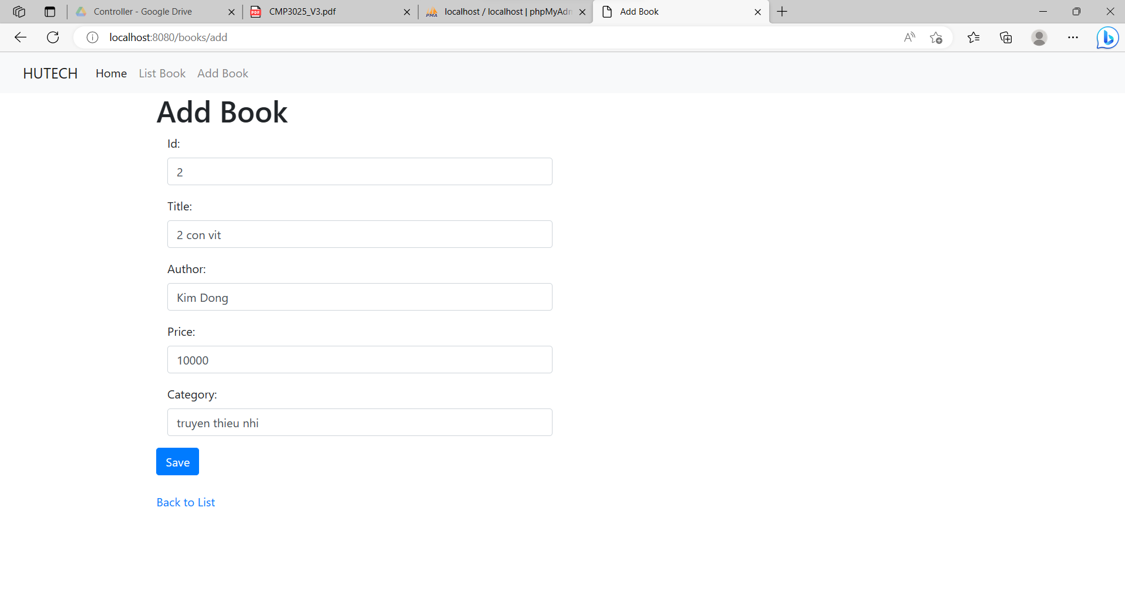

1.4 trang edit sach

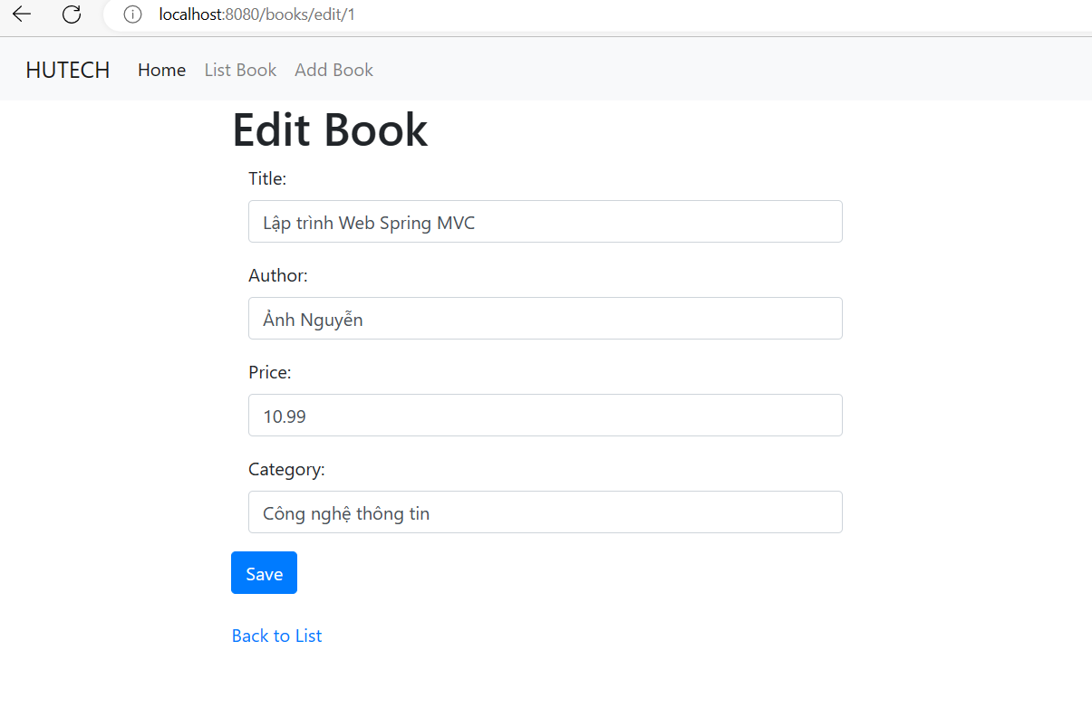

1.5 Trang xoa sach



