Implementation of Explainable AI for Classification using Probabilistic Logic Inference

Daim Abbas Kazmi
Department of electrical engineering and computer sciences (SEECS)
National University of Sciences & Technology (NUST),Pakistan

Abstract
Explainable AI has been the field involved in explaining the results from machine learning models. Not only focusing on the accuracy of the models but also the rationale behind the answers. In accordance to this, researchers from Swansea university, UK and university of Utah, US collaborated to come up with a model that achieves similar accuracies compared to traditional models using probabilistic inferences. In this paper we implement their approach in python on a dataset from Kaggle called stroke prediction dataset. We also implemented a probabilistic model of neural nets to explain its result using the above-mentioned approach. This was all done in accordance to research aptitude test set up by CureMD (CureMD, n.d.).

Introduction

The need of Explainable AI increases as AI is integrated in more and more fields which requires human understanding and that not act like a black box model. The ability to make machine-led decision making transparent, explainable, and therefore accountable is critical in building trustworthy systems. However, the issue with this is intrinsically interpretable models have weak predictions and cannot be compared to complex models such as deep convolutional neural networks (Krizhevsky, 2017). So, researchers from UK and US provided a classification approach that produces accurate predictions and explanations as well as supports domain knowledge incorporation (Xiuyi Fan, 2020). The authors of this paper have used the idea of knowledge base(KB). They introduced two algorithms of creating KB, the first one using trees and second one directly from data.
Definition 1. A Knowledge Base (KB) {hp1, c1i, . . . , hpm, cmi} is a set of pairs of clauses ci and probability of clauses pi = P(ci), 1 ≤ i ≤ m. Each clause is a disjunction of literals and each literal is a propositional variable or its negation. (Xiuyi Fan, 2020)
This idea was the cornerstone of their approch. Then they move forward by using some concepts of probablistic logic (Nilsson., 1986). For inference of results authors showed that the KB created problems such as requiring to solve the probability distribution and also sometimes the query being inconsistent with KB. They overcome the problem by using set of probability laws and linear programming. The last part of the approch involves knowledge incorporation into the KB so better results can be produced.
So in this paper we talk about using this apporach on dataset called ‘Stoke prediction dataset’ (Stroke Prediction Dataset, n.d.). The dataset contained 10 feature columns and 1 target column with 5110 rows. So, this presented a binary classification problem as discussed in the paper.
I was asked to create a probablistic model first and then implement the suggested approch to explain the results of the previous model. So I decided to use a Nueral network with softmax activation at the end to provide us with probabilities of the classes. I used python, sklearn, keras and other data manipulation libraries for this.

Data engineering

Taking the dataset information

The dataset consisted of 10 feature columns named 'gender', 'age', 'hypertension', 'heart_disease', 'ever_married', 'work_type', 'Residence_type', 'avg_glucose_level', 'bmi',
Figure 1
and 'smoking_status'. Out of these bmi, age and avg_glucose_level was numerical while all other were categorical features so I have to one hot encode them so they can be used in our model. The target column named stroke is in the form of 0 and 1 for stroke happening or not.
Early analysis showed around 5% of data results in class 1.

Feature Engineering

As we one hot encoded the categorical features, the number of total features reached around 20 and we knew that (Xiuyi Fan, 2020) approach required having powersets. So, using all features may become computationally too expensive to run. So, I decided to use five features. 3 of them being the most important ones named bmi, age and avg_glucose_level. The least important one was also included named work_type_encoded_children. I also decided to include hypertension as there is a common understanding that hypertension leads to having stroke so it was interesting how much it contributed in leading causes of having a stroke.

Creating Train and Test datasets

I used sklearn method of train_test_split to split the dataset randomly with 70% as train and 30% as test. That means 3577 training samples and 1533 testing samples.
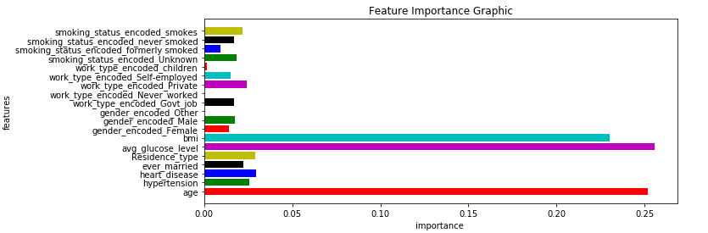

Probablistic Model

The recruiters at CureMD asked us to first implement a probabilistic model so it was very important to understand what that means. The Wikipedia quotes ‘A probabilistic classifier is a classifier that is able to predict, given an observation of an input, a probability distribution over a set of classes, rather than only outputting the most likely class that the observation should belong to’ (Probabilistic classification, n.d.).
So, I decided to implement a simple neural network with 4 layers. Intermediate layers use relu activation function however the last layer uses a softmax fuction which outputs probability of each class thus fulfilling the purpose of a probabilistic machine learning model. The architecture is [5,32,16,8,2]. The batch size was 32 and model was allowed to train for 10 epochs. After the first two epochs it seemed like it has reached the local minima as loss and accuracy started to fluctuate around 0.16 and 0.95 respectively.
The decision to use this model was purely on the reason that neural net’s results are hardly explainable. It is every difficult to point out that which features were used in calculating the output. So, it sets up the proposed approach for an interesting matchup with a complete black box machine learning model.

Proposed Approch

Probabilistic Logic Inference approach mentioned in the paper was for binary problems so there was no need to change anything related to that in my implemented model. The logic in the paper however was pretty advanced so I divided it into 3 sections for building KB, finding relevant KB, and Querying as Probabilistic Inference.

Building KB

The authors proposed two algorithms for building a KB. One was using the decision tree and the other one was directly using the data. The data approach created significantly more clauses than tree one.

In decision tree algorithm, a decision tree is created with feature value as nodes and you move through each of the paths of the tree to find the clauses.
The data algorithm was a more direct method and, in the results, shown in the paper (Xiuyi Fan, 2020), it had far more better results than for KB created using decision trees. For example, in HIV-1 dataset data KB gave f-1 score of 0.97 compared to tree KB score of 0.87. In the synthetic datasets, data approach was the superior one. So in my implementation I decided to go with this method to create KB.
The process was to take rows from the training data and create feature value pairs. Assign the label value with the value from the target column. Finding powerset takes great amount of computational time as it takes 31 iterations to find all sets for each of the row. Once all of the sets are gathered then it is placed as key in the counts dictionary and value is set as two elements list with 1 and label. Whenever same key occurs element wise addition occurs to these elements in the list. Once the count is calculated, the percentage of positive samples from total samples is calculated and if greater than zero placed in a dictionary which in the is returned. 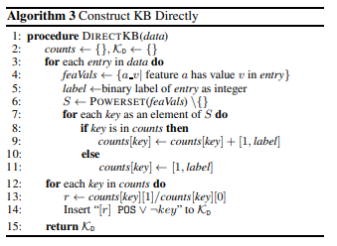
Figure 2

Constructing relevant KB from query

This was straight forward to implement as we used the feature value pairs from the query and cross checked them with the KB made earlier with the data. The remaining clauses are the ones that will used while making inference about the result.
However, for the first testing sample, I have applied this and results are something like this:

{(('bmi', 0.6205493387589014),): 0.9285714285714286, (('age', 0.37744140625),): 0.9818181818181818, (('work_type_encoded_children', 0.0),): 0.9996786632390745, (('hypertension', 0.0),): 0.9996923076923077, (('bmi', 0.6205493387589014), ('work_type_encoded_children', 0.0)): 0.9090909090909091, (('bmi', 0.6205493387589014), ('hypertension', 0.0)): 0.9285714285714286, (('age', 0.37744140625), ('work_type_encoded_children', 0.0)): 0.9818181818181818, (('age', 0.37744140625), ('hypertension', 0.0)): 0.9814814814814815, (('work_type_encoded_children', 0.0), ('hypertension', 0.0)): 0.999640933572711, (('bmi', 0.6205493387589014), ('work_type_encoded_children', 0.0), ('hypertension', 0.0)): 0.9090909090909091, (('age', 0.37744140625), ('work_type_encoded_children', 0.0), ('hypertension', 0.0)): 0.9814814814814815}

Querying from KB

They paper proposed a linear system to find probabilities of literals from clauses. This is because of the fact that probability distribution over the whole cannot be calculated for two reason it is np-hard problem and second the KB appears to be inconsistent in some of the cases. 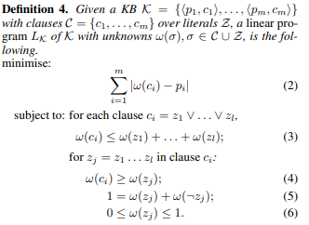
Figure 3

The idea is to take a query and create a string of 0’s and 1’s for the features in the query and their values. This string is passed on to the linear programming solver. In my case I used pulp to solve the linear equation shown in figure 3.
Since the solution from linear solver can be a range, they compute the upper and lower bounds of the solution by maximizing and minimizing ω(POS) subject to minimizing objective equation in the system, respectively, and use
the average of the two. The sampled returns positive when the average is greater than 0.5.
There was another concept of sub-query computation to calculate the k most important features. Due to shortage of time, I was unable to implement this in my project. In this the query is to be divided into set so each set contains k features and each set act as a query. So, each set act as a different query and maximum or minimum sub-query depending on the classification is used to explain the k most important features. In this the importance of k-grouped features is calculated rather than calculating importance of each feature and displaying the top k features

Conclusion

This implementation of Classification using Probabilistic Logic Inference (Xiuyi Fan, 2020) shows us the difference between explainable AI and black box models. How in the neural network probabilities for the classes is calculated using weights and biases that is not understandable to me but the scores were very good even for the small number of epochs.
However, in suggested model we were able to see how each feature contributed in the calculation of results and also showed how using probabilistic logic strong classifiers can be produced.
However, the production of KB is very computationally expensive so we have to decrease the number of features in order to produce KB for the data. Also, the whole process was visibly slower than the neural network. This may be due to the fact that support or libraries was not present in Python for such model so developers of such libraries can implement this model as it gave such good results compared to SHAP (Scott M. Lundberg, 2017) which is seen as state of the art in this field.

Future Work

First of all, I wanted to complete the whole model and apply it to check whether my model stands on mathematical proofs and theorems given in the paper.
The authors also floated the idea of knowledge incorporation in the model as I have no medical experience to add to my KB of what may or may not cause strokes. It will be interesting to research about this and add it to my model.
I would also like it apply on datasets related to other domains such as finance, timeseries etc. and check how this explainable model works on those datasets and what type of features are preferred on those models.

The link to my github repo is: https://github.com/daim-cell/Rat_project

The link of my YouTube video is:
https://youtu.be/iseGImVwqjs

Acknowledgment

I like to thank the authors of the paper ‘Explainable AI for Classification using Probabilistic Logic Inference’ for providing me with such an insightful paper that surely increased my knowledge on explainable AI, probabilistic inference and linear programming. I would also like to thank the recruiters at CureMD for making me part of this hiring process.

References
(n.d.). Retrieved from CureMD: https://www.curemd.com/
Krizhevsky, A. (2017). ImageNet Classification with Deep Convolutional Nueral Networks.
Nilsson., N. J. (1986). Probabilistic logic. Artificial Intelligence, 71 -87.
Probabilistic classification. (n.d.). Retrieved from wikipedia.org: https://en.wikipedia.org/wiki/Probabilistic_classification
Scott M. Lundberg, S.-I. L. (2017). A Unified Approach to Interpreting Model.
Stroke Prediction Dataset. (n.d.). Retrieved from Kaggle.com: https://www.kaggle.com/fedesoriano/stroke-prediction-dataset/tasks?taskId=3281
Xiuyi Fan, S. L. (2020). Explainable AI for Classification using Probabilistic Logic Inference.

We will be using KB for mentioning knowledge base from now on.

