CONSTRUCTORS MANUAL | ANG-01  AIRCRAFT
 | 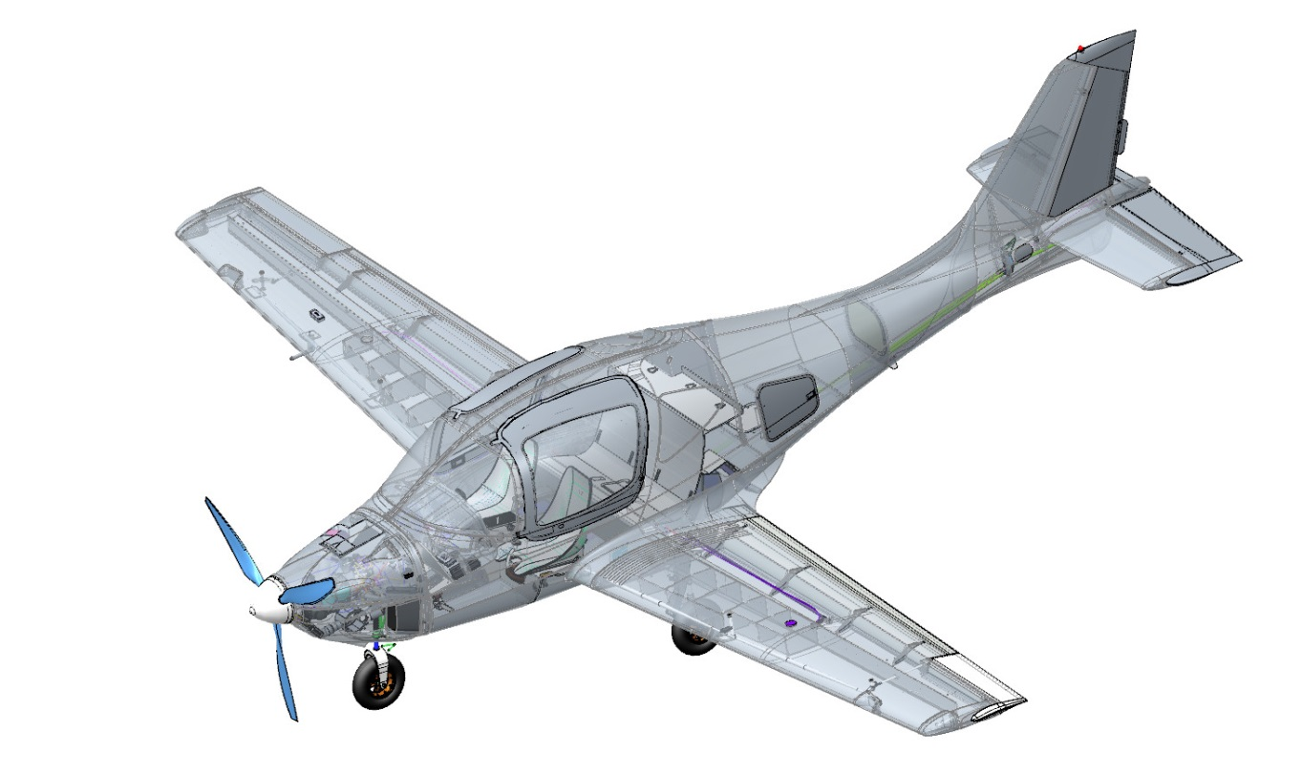
 | CONSTRUCTORS MANUAL
ANG.01.CМ.01
Edition 1
Copy. # ___
(verified with check copy ________)
Date

PART 1 INTRODUCTION
This Constructors Manual (hereinafter referred to as the CM) establishes specific procedures, sequence, equipment, materials and technology for completing the ANG-01 aircraft.
The CM is issued in Russian and English. The builder can translate the CM into another language on his own responsibility.
The CM is not a substitute for an appropriate theoretical and practical training. Failure to comply with the CM provisions, as well as the lack of proper training of the builders can result in damage to the aircraft, its components or injury to the builders.
Builders can start completing the aircraft solely upon a thorough perusal of this CM.
The CM holder and the owner of all the rights to the intellectual property that is set forth hererin is the Developer and Manufacturer of the ANG-01 aircraft kit ANG Patriot-Ukraine (Brovary, Kyiv region, Ukraine), which is fully responsible for the timely and appropriate implementation of all revisions and supplements to the CM.
If you have any questions regarding this Manual, please contact the Developer's support service via the website http://www.angpatriotua.com/
All revisions and supplements to the CM are issued in lieu of, or in addition to the material contained in the Manual in a form of separate standard pattern sheets.
These revisions or supplements are specified in the Record of Revisions, besides the text "Edition ..." is added to the footer of each revised page (in case of revisions concerning more than 25% of the material) or "Revision ..." with the specified date of the revision. The previous revision of these pages is to be withdrawn and deleted by the user.
All numerical values ​​are presented in metric units.
It is required to regularly check the Developer's website (at least once a month) for CM updates.
The overall scope of assembly, fitting, testing and adjustment operations to be performed in conformity with this Manual in the course of buiding the ANG-01 kit aircraft, varies from 65% to 55%. The number of building operations may vary depending on a specific order and is determined by the Specification of a particular kit (for example, a subassembly of individual items).
Upon completion of the operations, the builder is obliged to personnally fill the associated sections of the ANG.01.LB.01Log-book, which is supplied within the operational documentation set attached to the kit.
IMPORTANT! It is FORBIDDEN to carry out the ANG-01 building tasks using the equipment, materials, tools, procedures not provided for by this Manual.

Record of revisions
Reg.  No. | Number of section,  Paragraph | Page number |  |  | Reason for revision | Signature | Date
 |  | Rev. | New | Anulled
Edition 1  Revision 0 | Initial edition | n/a | n/a | n/a | n/a |  | 00/ 06/2020

Abbreviations
ACB  ACS  ADAHRS  AFM  AIL  AMM  ANL | -  -  -  -  -  - | Automatic circuit breaker  Aircraft control stick;  Air Data, Attitude and Heading Reference System;  Aircraft Flight Manual  Aileron  Aircraft Maintenance Manual  Aircraft navigation (position) lights;
CAA | - | Civil Aviation Authority;
CAS | - | Calibrated airspeed;
CG  CHT | -  - | Center of gravity;  Cylinder head temperature
ECU/EMS  ELV  EOC  GNSS  MAC | -  -  -  -  - | Engine control unit/Engine monitoring system;  Elevator  Engine operating condition;  Satellite Navigation System (Global Navigation Satellite System)  Mean aerodynamic chord;
PVC | - | Paint and varnish coating;
PSS | - | The plane of symmetry of the aircraft;
RDR | - | Rudder;
SW  TAA | -  - | Software;  Testing and adjustment activities;
TCL | - | Throttle control lever;
V_{NO} | - | Never exceed speed;
V_{R}  V₂  V_{Ref} | -  - | Rotation speed;  Takeoff safety speed;  Landing reference speed or threshold crossing speed;
V_{Y} | - | Speed that will allow for the best rate of climb;
VPP | - | Variable pitch propeller

CONTENTS
PART 1 INTRODUCTION 2
Record of revisions 3
Abbreviations 4
PART 2 GENERAL RECOMMENDATIONS 7
PART 3 TYPICAL OPERATIONS 8
PART 4 ASSEMBLE LANDING GEAR 9
4.1 Assemble brake master cylinders 9
4.2 Assemble brake caliper 12
4.3 Assemble the main landing gear shock absorbers 14
4.4 Assemble nose landing gear shock absorbers 21
4.5 Assemble main landing gear legs 30
4.6 Assemble nose landing gear leg 36
4.7 Assemble landing gear retract cylinders 43
4.8 Fit nose landing gear leg 55
4.9 Fit main landing gear legs 58
PART 5 ASSEMBLE CONTROL SYSTEM 63
5.1 Assemble rudder pushrod 63
5.2 Assemble composite pushrods 65
5.3 Assemble aileron control 70
5.4 Assemble and fit foot control unit 74
5.5 Assemble and fit manual control unit 80
5.6 Assemble the elevator and rudder control elements 88
5.7 Assemble and fit the throttle control lever 96
PART 6 ASSEMBLE THE AIRFRAME 99
6.1 Fit stabilizer 99
6.2 Fit elevator and trim tab 103
6.3 Fit rudder 110
6.4 Fit ailerons 113
6.5 Fit flaps 117
6.6 Fit glazing 126
6.7 Fit doors 129
6.8 Fit hatches 134
6.9 Fit engine mount 136
6.10 Assemble and fit cowlings 139
6.11 Fit wing panels 146
PART 7 FIT ACCESSORIES TO ENGINE COMPARTMENT 151
PART 8 ASSEMBLE POWER PLANT 158
8.1 Assemble and fit engine accessories 158
8.2 Fit propeller 167
8.3 Assemble and fit feed tanks 168
PART 9 ASSEMBLE CIRCUITRY 169
9.1 Route harness 169
9.2 Fit lighting equipment 170
9.3 Fit light annunciators 171
9.4 Fit toggle switches, ACBs 172
9.5 Fit seat adjustment system 175
PART 10 FIT INSTRUMENTATION 176
10.1 Route pneumatic tubing 176
10.2 Fit Pitot Probe 176
10.3 Fit Dynon SW 1100 system 176
10.4 Fit redundant (backup) flight instruments 177
10.5 Fit landing gear and footstep control system 179
10.6 Fit intercom system 180
PART 11 FIT PARACHUTE RESCUE SYSTEM 181
PART12 FIT INTERIOR FURNISHINGS 182
12.1 Cabin upholstery 182
12.2 Luggage compartment padding 182
12.3 Seats and fittings 182
PART 13 PAINT AIRCRAFT 183
13.1 Paint external surfaces 183
13.2 Paint interior elements 183
13.3 Affix placards 183
13.4 Fit plates 183
PART 14 PRE-COMMISSIONING ACTIVITIES 184
14.1 General provisions 184
14.2 Safety measures 184
14.3 Pre-commissioning checklist 185
SECTION 15 FLIGHT-TEST PROGRAM 196
15.1 Conditions and procedure for performing flights, safety measures 196
15.2 FLIGHT-TESTING SCOPE AND TECHNIQUES 197

PART 2 GENERAL RECOMMENDATIONS
We recommend to assemble the aircraft parts, as well as the whole aircraft, on a site of at least 11 m long, 14 m wide, with a height from floor to ceiling of at least 3 m. It should be arranged in an properly ventilated space (or equipped with microclimate control system), with hard floors and adequate lighting.
We recommend to perform the work at ambient temperatures from 16°C to 30°C, and a relative air humidity not exceeding 75%.
For performing the assembly of aircraft parts, we recommend to place next to the aircraft assembly area a movable table with the dimensions of 1.5m width, 3m length, 0.75 to 1m height. Provide a removable soft cover for the table top to avoid inadvertant damaging and scratching of aircraft parts placed on the table.
IMPORTANT! Avoid prolonged exposure of unpainted (unprotected) composite aircraft parts to direct sunlight. Ultraviolet light degrades epoxy polymers and in some cases aircraft parts may become unusable. Be sure to cover in such cases the aircraft parts with non-transparent fabrics.
It is recommended to use the following tools for assembling the aircraft,
1.5-10 mm hex keys (Allen wrench) - 1 set;
5 to 19 mm combination wrenches - 1 set;
5 to 19 mm sockets- 1 set;
Phillips screwdrivers with PH1 and PH2 bits- 1 set;
Slotted (flat-tip) screwdrivers - 2 pieces;
Pliers, long nose pliers, side cutting pliers - 1 set;
10 to 32 mm adjustable wrench - 1 piece;
600 g bench hammer - 1 tool;
Clamps ranging from 50 to 100 mm - 1 set;
1 to 10 mm HSS drill bits - 1 set;
Electric 750 Watt drill - 1 piece;
Vernier caliper with 150 mm depth gauge - 1 piece;
4 to 12 mm manual pipe cutter for non-ferrous metals - 1 piece;
Circlip (retaining ring) pliers - 1 set;
500 mm ruler - 1 tool;
10 meter measuring tape - 1 tool;
Tool for routing electrical wires - 1 piece;
Terminal crimper - 1 tool;
Electric 40 W soldering iron – 1 piece;
100 mm tweezers - 1 piece;
Digital kitchen scale up to 5 kg with 2 gram increments - 1 piece.
1-25 Nm torque wrench – 1 piece.
1.5-10mm hexagonal socket bits - 1 set.
IMPORTANT! It is imperative to wear personal protective equipment. Be sure to use safety goggles with clear glasses, a respirator, fabric gloves, latex gloves.

PART 3 TYPICAL OPERATIONS
Олегу написать раздел
PART 4 ASSEMBLE LANDING GEAR

4.1 Assemble brake master cylinders
The objective of this operation: to assemble the brake master cylinders.
To carry out this task you will need:
Movable table;
DOT-4 brake fluid 30 grams;
Plastic cup 100 ml;
Latex gloves 1 pair;
0.8mm/150mm welding wire 2 pieces.
12 mm combination wrench.
Move the soft covering of the table aside to provide a surface of about 1 m2. Place on the cleared surface a 0.5x0.5m plastic film, secure its edges with small pieces of masking tape (also known as painter's tape).
IMPORTANT! Do not allow any foreign materials and liquids to come into contact with rubber and metal parts. This will result in loss of their serviceability or impossibility to assemble an item.
Unpack and place on the table:
4 brake master cylinder housings marked ANG-2700-00031980-001;
4 stems marked ANG-2700-00031980-002;
4 covers marked ANG-2700-00031980-003;
4 rings marked ANG-2700-00031980-004.
Count and place on the table:
four T1 collars marked 3243_MANZH_8X13X3_2;
four Т2 collars marked 3243_MANZH_8X13X3_3;
4 springs marked prch-00032013;
two S6520-6 1/8 fittings;
six S6520-4 1/8 fittings.
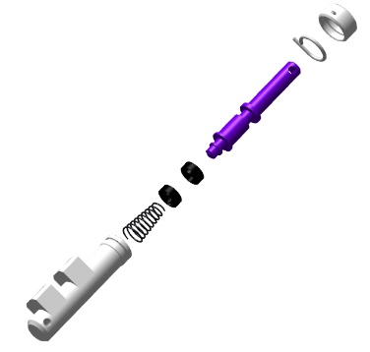
Put on latex gloves. Place T1 and T2 collars in a cup. Add to the cup 30 grams of DOT-4 brake fluid. Let the collars stay in the cup with brake fluid for 30 minutes.
IMPORTANT! Do not confuse the position and placement of the collars. This will render the system unserviceable. Avoid touching collars with sharp objects.
Place a wire through the hole in the T1 collar. Take the ANG-2700-00031980-002 stem, prefit to it the T1 collar, pressing down the wire on the stem, with the recess facing away from the edge, pull it on the thin edge into the near groove. Extract the wire. Spread the T1 collar in the groove. Place the wire through the hole in the T2 collar. Take the ANG-2700-00031980-002 stem, prefit to it the collar T2, pressing down the wire on the stem, with the recess facing away the edge, pull it on the thin edge into the near groove. Extract the wires successively. Spread the T2 collar in the groove.
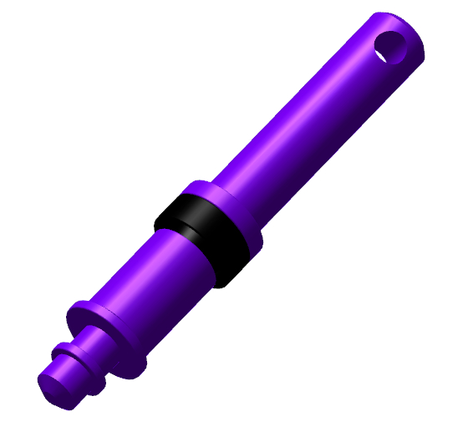 | 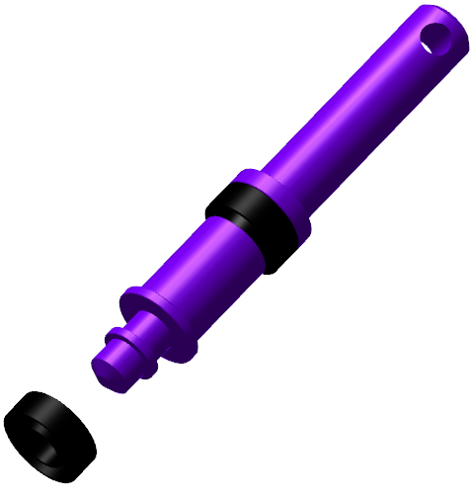 | 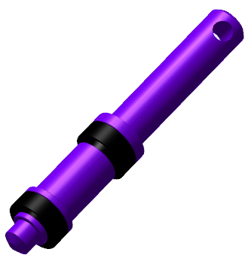
Run the wire through the hole in the T2 collar. Take the ANG01-0-3242-4002-00 pushrod (stem), prefit to it the T2 collar, pressing down the wire on the pushrod (stem), the recess away from the edge, pull it from the thin edge into the near groove. Extract alternately the wires. Spread the T2 collar in the groove.
IMPORTANT! Take care to prevent the ingress of any foreign objects and liquids into the inner cavity. This will result in loss of serviceability of the item or impossibility to assemble it.
Push-fit the spring onto the thin end of the ANG-2700-00031980-002 stem, placing the smaller diameter side of the spring onto the stem. Insert the assembled stem into the ANG-2700-00031980-001 housing untill the T2 collar encounters a hards stop.
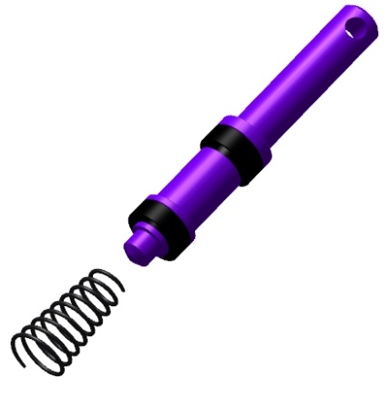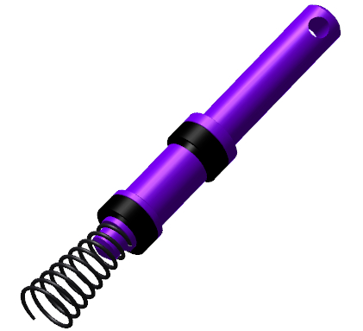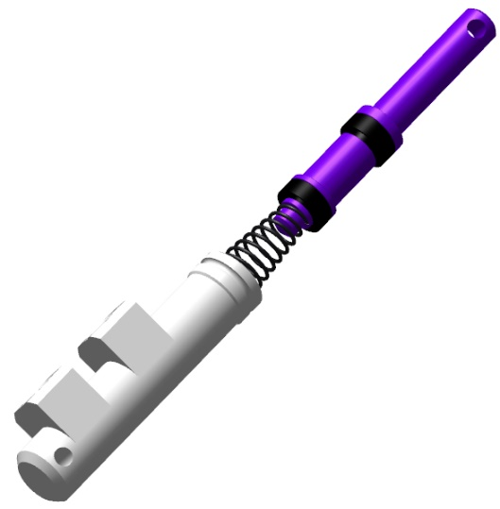
Insert the ANG-2700-00031980-002 stem into the ANG-2700-00031980-001 housing with gentle movements, tilting it left and right at a small angle. As soon as the T1 collar enters the housing, press on the stem untill encountering a hard stop. Place the ANG-2700-00031980-003 cover onto the stem, move it until encountering a hard stop. Press the cover against the body and push on the stemseveral times until encountering a hard stop.The stem should travel fore and aft without binding.
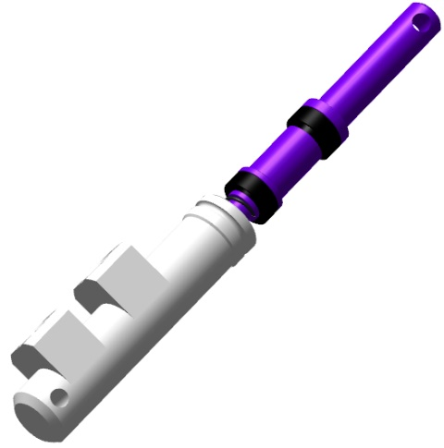 | 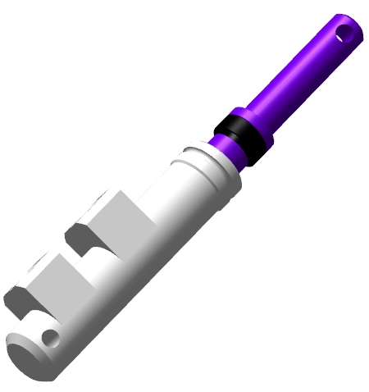 | 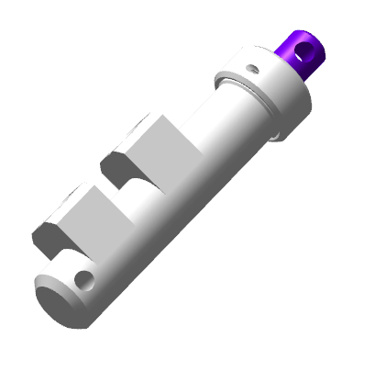
Find the ANG-2700-00031980-004 ring and fit it into the bore of the ANG-2700-00031980-003 cover, which is pressed against the housing. Depress the stem several times until encountering a hard stop. The stem must travel both ways easily and without binding.
Find the S6520-6 1/8 fitting. Hand-screw it into the hole, positioned closer to the stem in the ANG-2700-00031980-001 housing. Find the S6520-4 1/8 fitting. Hand-screw it into the bore in the ANG-2700-00031980-001 housing, positioned further from the stem. Tighten the fittings with a 12 mm wrench to seat the fitting skirt (bottom edge) snugly into the housing. Find the S6520-6 1/8 fitting. Hand-screw into the hole in the housing, positioned closer to the stem.
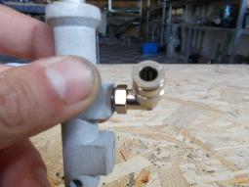 | 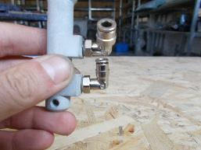 | 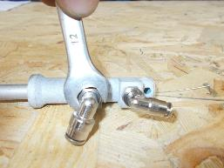
Repeat the above procedure to assemble the remaining brake master cylinders.
Note. Two master cylinders accommodate S6520-4 1/8 fittings in all threaded bores.
Checkout operations:
Нужно добавить: люфты, обжатие и пр. ???

4.2 Assemble brake caliper
To carry out this task you will need:
Movable table;
DOT-4 brake fluid 30 grams;
Plastic cup 100 ml;
Bench hammer weighing 600 grams;
LOCTITE 648 retaining compound;
Methyl acetate solvent 50 grams;
Clean 100x100 mm rag 1 piece;
12 mm combination wrench;
10 mm combination wrench;
Combination wrench 8 mm;
Latex gloves - 1 pair;
Unpack and place on the table:
2 brake calipers marked ANG-3200-00031000-051;
4 heat-insulating bushes marked ANG-3200-00031000-002;
4 pistons marked ANG-3200-00031000-003;
4 piston seals marked ANG-3200-00031000-004.
Put on latex gloves. Place into a cup the ANG-3200-00031000-004 piston seals. Add to the cup 30 grams of DOT-4 brake fluid. Let the collars stay in the cup with brake fluid for 30 minutes.
Find the ANG-3200-00031000-051 brake caliper. Apply a smear of DOT-4 brake fluid to the inner cavities of the caliper to lubricate them.
Insert into the inner groove of the ANG-3200-00031000-051 brake caliper the part of the ANG-3200-00031000-004 piston seal and spread it in the groove. Spread successively the remaining part of the ANG-3200-00031000-004 piston seal in the groove of the ANG-3200-00031000-051 brake caliper, securing with your finger the part of the seal, already placed in the groove. Repeat the process above to fit the second ANG-3200-00031000-004 piston seal into the groove of the ANG-3200-00031000-051 brake caliper.
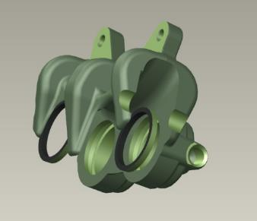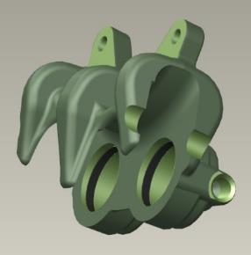
Find the ANG-3200-00031000-003 piston. Apply a smear of DOT-4 brake fluid to the outer surface of the ANG-3200-00031000-003 piston to lubricate it. Fit the ANG-3200-00031000-003 piston into the bore, holding the hollow portion away from the caliper.
Move the ANG-3200-00031000-003 piston all the way down till encountering a hard stop. It may require a significant effort. Repeat the process above to fit the second ANG-3200-00031000-003 piston into the caliper of the ANG-3200-00031000-051 brake.
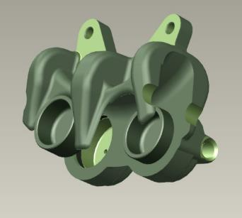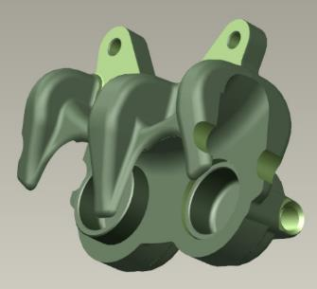
Find the ANG-3200-00031000-002 heat-insulating bush. Fit the ANG-3200-00031000-002 heat insulating bush to the piston, with a recess away from the caliper, press it down by hand. Drive the bush fully home with a hammer using a mandrel.
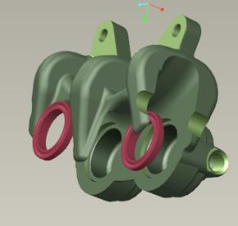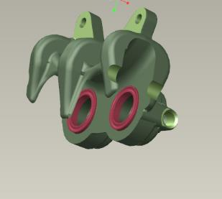
Repeat the process above to fit the second ANG-3200-00031000-002 heat insulating bush. Set the assembled caliper aside for later use, and repeat the above steps to assemble the second caliper.
Place the calipers on the table with pistons facing each other, the same parts down. Find two S6520-4 1/8 fittings. Place the S6520-4 1/8 fittings into the two adjacent bores, hand-screw them until encountering a hard stop. Tighten the fittings of each caliper with a 12 mm combination wrench to seat the skirt (bottom portion) of the fitting onto the caliper.
Note... The described operations pertain to the left brake caliper. The assembly of the right brake caliper is to be carried out in the same sequence.

4.3 Assemble main landing gear shock absorbers
4.3.1 Assemble shock absorbers
Note. Described below operations pertain to one of the shock absorbers.
To carry out this task you will need:
Movable table;
Bent nose pliers for removing circlips;
11 mm combination wrench;
LOCTITE 648 retaining compound;
Methyl acetate solvent 100 grams;
100x100 mm clean rag 2 pieces;
S-size mounting pliers;
Latex gloves 1 pair;
400 gram bench hammer;
Bench vice 100 mm;
Aluminum viсe pads 2 pieces;
Plastic cup 50 ml;
TE Shock absorber wrench;
Unpack and place on the table:
2 turrets (shells) marked ANG-3200-00034213-001;
2 covers marked ANG-3200-00034213-002;
2 guide bushes marked ANG-3220-028483-005;
2 rods marked ANG-3200-00034213-003;
2 valve housings marked ANG-3200-00034213-004;
2 valves marked ANG-3200-00034213-005;
2 ANG-3200-00034213-00 6 pipes;
Count and place on the table:
2 charging valves marked prch-00027867;
2 wipers marked std-00028223;
2 collars marked std-00028224;
2 rings marked 038_042_30;
2 А14 DIN 471 circlips (retaining rings);
2 rings marked 26.58X3.53 XR.
Move the soft covering of the table aside to provide a surface of about 1 m².
Put on latex gloves and a respirator. Find the ANG-3200-00034213-002 cover. Moisten a rag with solvent. Degrease all inner cavities of the ANG-3200-00034213-002 cover. Using mounting pliers, fit the std-00028224 collar into the wide groove inside the ANG-3200-00034213-002 cover with the recess away from the hexagonal portion of the cover. Spread the collar in the groove with your fingers. Fit the std-00028223 wiper into the upper groove inside the ANG-3200-00034213-002 cover with bevel (oblique portion) towards the outside of the cover. Align the wiper in the groove with your fingers.
Squeeze the ANG-3220-028483-005 guide bush to the smallest possible diameter and retain this position with your fingers. Fit the compressed bush from the threaded side as deep as possible into the ANG-3200-00034213-002 cover. Spread the bush in the groove of the cover. Slide the 038_042_30 ring onto the outer part of the ANG-3200-00034213-002 cover from threaded side. Slide the ring carefully over the threads and fit it into the groove. Set the ANG-3200-00034213-002 cover aside in a vacant part of the table.
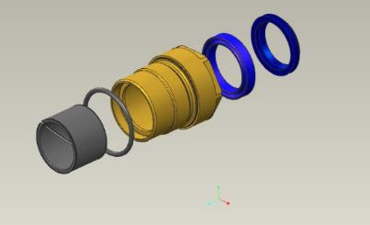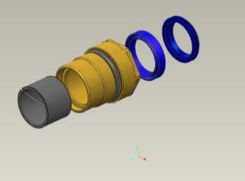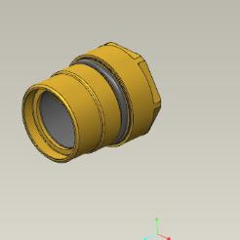
Find the ANG-3200-00034213-004 valve housing and the ANG-3200-00034213-005 valve. Fit the ANG-3200-00034213-005 valve into the bore of the ANG-3200-00034213-004 housing on its the recess side. Push it until encountering a hard stop. Check the ANG-3200-00034213-005 valve for freedom of movement in the ANG-3200-00034213-004 housing about its axis of rotation. It should move easily, without any jerks and binding. Remove the ANG-3200-00034213-004 valve from the ANG-3200-00034213-005 housing and place it on the table. Find the 26.58X3.53 XR ring. Fit the ring onto the ANG-3200-00034213-004 housing at the thread side.
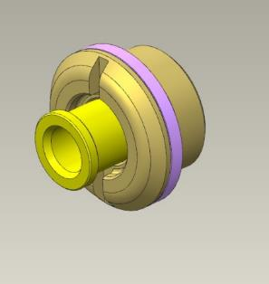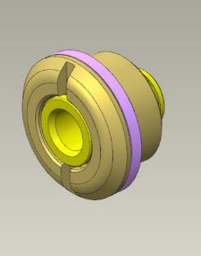
Find the ANG-3200-00034213-006 tube. Hand-screw the ANG-3200-00034213-004 housing into the tube at any side, until the 26.58X3.53 XR ring encounters a hard stop at the end of the tube.
Find the ANG-3200-00034213-003 pushrod and the ANG-3200-00034213-006 tube. Screw the ANG-3200-00034213-006 tube onto the ANG-3200-00034213-003 rod to take out the clerance between the edges of the parts. The rod should easily screw into the pipe until encountering a hard stop without any clearance between the edges. Detach the rod from the tube and set the parts aside on the table for later use.
Put on latex gloves and a respirator. Moisten a rag with solvent. Degrease the following items:
Male thread of the ANG-3200-00034213-003 rod;
Female thread of the ANG-3200-00034213-006 tube without hole.
IMPORTANT! Take care not to apply any retaining compound to the degreased surface immediately. The retaining adhesive can be applied in 5-10 minutes after degreasing.
Apply an even thin layer of the LOCTITE 648 retaining compound to the degreased threaded surface of the ANG-3200-00034213-006 tube. Set the tube aside on the table for later use.
Apply an even thin layer of LOCTITE 648 retaining compound to the degreased threaded surface of the ANG-3200-00034213-003 rod. Screw the rod into the pipe to take out the clearance between the edges of the parts.
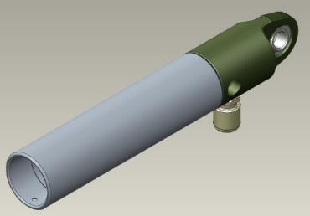
Clean your workplace and tools as per the standard operation 7.
Find the prch-00027867 charging valve. Hand-screw the valve into the lateral orifice of the ANG-3200-00034213-003 rod. The valve should screw into the orifice easily. Unscrew the valve, moisten a rag with solvent to degrease the following items:
Male thread of the prch-00027867 charging valve;
Female thread on the ANG-3200-00034213-003 rod.
IMPORTANT! Take care not to apply any retaining compound to the degreased surface immediately. The retaining adhesive can be applied in 5-10 minutes after degreasing.
Apply an even thin layer of LOCTITE 648 retaining compound to the degreased threaded surface of the ANG-3200-00034213-003 rod.
Set the tube aside on the table for later use. Apply an even thin layer of LOCTITE 648 retaining compound to the degreased threaded surface of the prch-00027867 charging valve. Screw the valve into the rod, tighten it with an 11 mm wrench until the threads fully enter the rod.
Clean the workplace and tools as per the standard operation 7.
Set the parts aside on the table for later use. Find the ANG-3200-00034213-004 valve housing and the ANG-3200-00034213-005 valve.
Fit the ANG-3200-00034213-005 valve into the orifice of the ANG-3200-00034213-004 housing on the the recess side. Push it forward until encountering a hard stop. Check the ANG-3200-00034213-005 valve for freedom of movement in the ANG-3200-00034213-004 housing about its axis of rotation. It should move smoothly, without any jerks or binding. Slide the valve home into the housing seat until encountering a hard stop. Fit the circlip (retaining ring) into the groove of the ANG-3200-00034213-005 valve, using the circlip angle pliers.
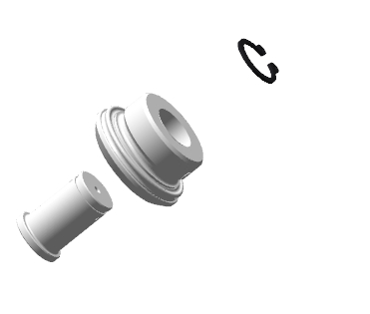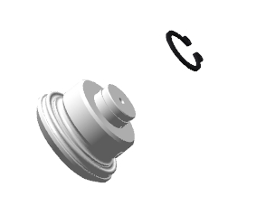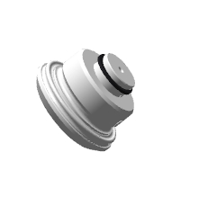
Find the ANG-3200-00034213-002 cover (with seals fitted in) and the ANG-3200-00034213-003 rod (with parts fitted in). Verify the cover for the absence of foreign objects in its inner cavities. There should be no foreign objects.
Fit, with orifice part the ANG-3200-00034213-006 tube into the wiper on the ANG-3200-00034213-002 cover. Slide the ANG-3200-00034213-002 cover approximately halfway along the ANG-3200-00034213-006 tube, take care to avoid misalignment.
Screw the ANG-3200-00034213-004 housing into the tube until the 26.58X3.53 XR ring encounters a hard stop against the tube edge.
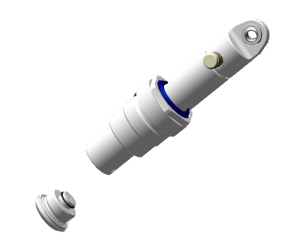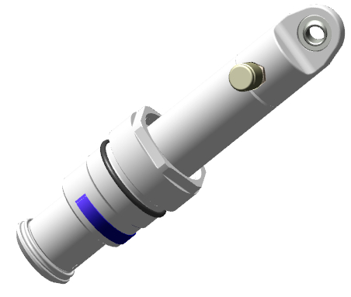
Unscrew the parts, moisten a rag with solvent. Degrease the following items:
Male thread of the ANG-3200-00034213-004 housing;
Female thread of the ANG-3200-00034213-003 rod.
IMPORTANT! Take care not to apply any retaining compound to the degreased surface immediately. The retaining compound can be applied 5-10 minutes after degreasing.
Apply an even thin layer of LOCTITE 648 retaining compound to the degreased threaded surface of the ANG-3200-00034213-003 rod. Set the tube aside on the table for later use. Apply an even thin layer of LOCTITE 648 retaining compound to the degreased threaded surface of the ANG-3200-00034213-004 housing. Screw the housing into the rod, tighten it through the full thread length.
Clean your workplace and tools as per the the standard operation 7.
Find the ANG-3200-00034213-001 turret (shell). Verify the turret (shell) for the absence of foreign objects in its inner cavities. There should be no foreign objects therein. Clamp the turret in a vice, using aluminum pads. Place the tube with fitted parts into the turret (shell). Hand-screw the ANG-3200-00034213-002 cover into the ANG-3200-00034213-001 turret (shell).
IMPORTANT! When screwing on the cover, take care to avoid misalignment of the ring fitted onto the sleeve. If a misalignment occurs, unscrew the cover until the ring aligns in the groove and start over. The misalignment of a seal will result in a fluid leak.
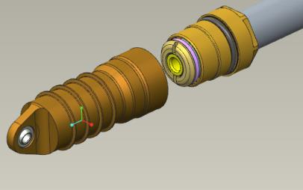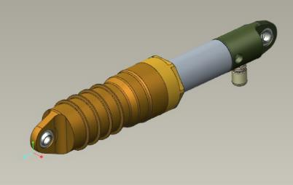
Tighten the cover with a shock absorber wrench until the edge of the cover encounters a hard stop against the edge of the turret (shell). Check the shock absorber stroke by pressing on the top of the rod, then retract it. The shock absorber stroke should be smooth, with an average effort (5-10 kg). Unclamp the shock absorber from the vice, place it on the table.
Reapeat the process above to assemble the second shock absorber.
IMPORTANT! It is forbidden to fill in liquids and to charge the units with gas earlier than 2 hours after applying the retaining compound.
4.3.2 Charging of the shock absorber with working fluid and gas
Note. The operations described below pertain to one of the shock absorbers.
To carry out this task you will need:
Movable table;
Landing gear shock absorbers (assembled earlier) 2 pieces;
PMS-20 silicone oil 150 ml;
200 ml plastic cup 3 pieces;
60 ml disposable medical syringe with a needle 1 piece;
Valve core installer wrench;
Bench vice 100 mm;
Aluminum vice pads (jaw lining) 2 pieces;
Industrial nitrogen in a pressure-bottle (cylinder);
Shock absorber charging device;
Liquid soap;
Latex gloves 1 pair;
100x100 mm clean rag 2 pieces;
Turn the top of the shock to align the position of the charging valve with the turret (shell) lug. Compress the shock absorber until encountering a hard stop. Clamp it in the vice in a tilted position, using the aluminum pads (jaw lining), with the coupling facing upwards. Remove the cap from the charging valve and put it in a сup. Detach the core from the coupling with a valve core wrench, put it in a cup.
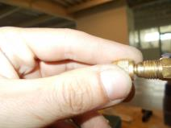
Put on latex gloves.
IMPORTANT! Do not place any small-sized aircraft parts on the table. They can be lost. Use a container. Fill the syringe with the needle removed. This will allow you to draw in the fluid without cavitation effects.
Draw into the syringe 60 ml of PMS-20 silicone oil. Attach the needle to the syringe, insert the syringe needle into the orifice of the charging valve, until the needle encounters a hard stop against the wall. Push the syringe plunger gently and slowly to inject silicone oil. Extract smoothly the needle out of the charging valve.
IMPORTANT! The needle of the syringe, due to its small diameter, allows to escape the air which is displaced out of the inner cavities of the shock absorber when filled with fluid. Do not apply any undue force to the syringe plunger. This will dislodge the needle from the syringe and result in spilling the fluid.
Screw the cap onto the charging valve. Extend the shock absorber for its full stroke. Push gently on the top of the shock absorber, compress the shock absorber for about its half stroke. Unscrew and remove the charging valve cap slowly. The air must bleed out. Extend the shock absorber for its full stroke.
Draw 60 ml of PMS-20 Silicone oil into the syringe. Attach the needle to the syringe, insert the syringe with the needle into the orifice of the charging valve, until the needle encounters a hard stop against the wall. Push the syringe plunger gently and slowly to inject silicone oil. Extract smoothly the needle out of the charging valve. Be mindful that the PMS-20 silicone oil may spill.
Screw the cap onto the charging valve. Push gently on the top of the shock absorber, compress the shock absorber until encountering a hard stop. The shock absorber rod may recoil from the bottom point when the hand is removed. Extend the shock absorber for its full stroke.
Unscrew and remove the charging valve cap slowly. The air must bleed out. Be mindful that the PMS-20 Silicone oil may spill. Use the wrench to screw the core into the charging valve.
Turn the rod to align the shock absorber lugs and to position the charging valve either on the right or on the left. Unclamp the shock absorber from the vice. Wipe off with a dry, clean rag any silicone oil, spilt out during the refilling process.
Make sure the bottle is closed and the needles on both gauges point to "0". Set the nitrogen pressure regulator to position "0", make sure that the valves of the charging device are closed.
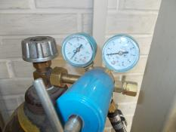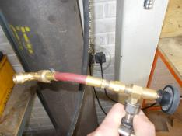
IMPORTANT! Do not leave the cylinder valve open for a long time and the hose under pressure.
Fit the charging device coupling to the shock absorber charging valve through the full thread length.
Open the cylinder (pressure-bottle) valve, set the pressure on the second pressure gauge to 20 atm (2 MPa). Open (screw in) the core valve. Open the gas feed valve on the charging device. Close (unscrew) the core valve, close the gas feed valve on the charging device. Detach the chraging device coupling from the charging valve. Replace the cap on the charging valve.
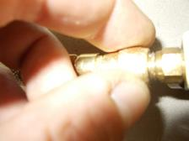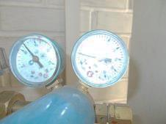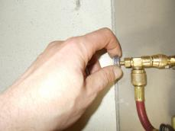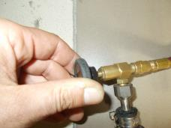
Checkout operations:
Verify the shock absorber for likely silicone oil leaks. There should be no oil leaks.
Set the shock absorber vertically on the floor, with its turret (shell) down, and push hard on its the top. There should be no shock absorber stroke.
Take the shock absorber in your hand. Apply a continuous thin layer of liquid soap around the charging valve. In case of leak, there will appear the bubbles. The bubbles should be absent. Apply a continuous, thin layer of soap to the tube near the wiper, along the line of contact between the turret (shell) and cover. The bubbles should be absent. Wipe away the liquid soap from the check areas with a dry, clean rag.
Repeat the process above to charge the second shock absorber.

4.4 Assemble the shock absorber of the nose landing gear leg
4.4.1 Assemble the shock absorber
To carry out this task you will need:
Movable table;
Angled pliers for removing circlips (retaining rings);
2 mm hex key (Allen wrench);
11 mm combination wrench;
LOCTITE 648 retaining compound;
Methyl acetate solvent 100 grams;
100x100 mm clean rag 2 pieces;
S-size mounting pliers;
Latex gloves 1 pair;
V-block;
Desktop boring machine;
2.5mm drill bit;
3.0 mm drill bit;
M3 tap;
5.0 mm drill bit;
Tap wrench;
Ф3 angle 90° countersink drill;
Bench hammer 400 grams;
Center punch;
Slotted (flat tip) screwdriver №2;
Bench vice 100 mm;
Aluminum vice pads 2 pieces;
Kerosene 20 ml;
Plastic cup 50 ml;
TE shock absorber rod wrench;
Unpack and place on the table:
Nose landing gear shock absorber housing marked ANG-3220-028483-001;
Upper turret (shell) marked ANG-3220-028483-002;
Polyamide bush marked ANG-3220-028483-003;
4 threaded buses (sleeves) marked ANG-3220-028483-004;
2 guide bushs marked ANG-3220-028483-005;
Rod marked ANG-3220-028484-001;
Mount (support) marked ANG-3220-028484-002;
Bush marked ANG-3220-028484-003;
Thrust bush marked ANG-3220-028484-004;
Damper marked ANG-3220-028484-005;
Tube - rod marked ANG-3220-028485-001;
Bush marked ANG-3220-028485-002;
Lower bush marked ANG-3220-028485-003;
Thrust bush marked ANG-3220-028485-004;
Piston marked ANG-3220-028485-005;
Nut marked ANG-3220-028485-006;
Valve marked ANG-3220-028485-007;

Count and place on the table:
Charging valve marked prch-00027867;
Wiper marked std-00028223;
Collar marked std-00028224;
Ring marked 010_014_25;
Ring marked 034_037_19;
А8 DIN 471 circlip (retaining ring);
Two 80025 bearings;
Move the soft covering of the table aside to provide a surface of about 1 m2. Find the ANG-3220-028483-001 nose landing gear shock absorber housing.
Be sure to wear latex gloves and respirator. Moisten a rag with solvent. Degrease all inner cavities of the ANG-3220-028483-001 nose landing gear shock absorber housing. Compress the ANG-3220-028483-005 guide bush to the smallest possible diameter and retain the position with your fingers.
Push the compressed ANG-3220-028483-005 bush on the thread side as deep as possible into the ANG-3220-028483-001 nose landing gear shock absorber housing. Spread the ANG-3220-028483-005 bush in the ANG-3220-028483-001 nose landing gear shock absorber housing.
Repeat the procedure above to fit on the opposite side the ANG-3220-028483-005 bush into the groove of the ANG-3220-028483-001 nose landing gear shock absorber housing.
Fit, using mounting pliers, the std-00028224 collar, into the wide groove of the of the ANG-3220-028483-001 nose landing gear shock absorber housing with its recess facing inwards the housing. Spread the std-00028224 collar in the groove with your fingers. Fit the std-00028223 wiper, with its bevel (oblique) portion facing outwards the cover, into the upper groove of the ANG-3220-028483-001 nose landing gear shock absorber housing. Spread the std-00028223 wiper in the groove with your fingers.
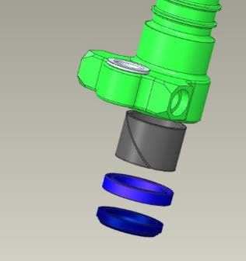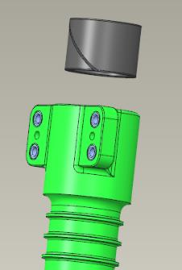
Degrease the following items:
The outer surface of the two 80025 bearings;
The outer surface of the ANG-3220-028483-003 polyamide bush;
Male thread of the four ANG-3220-028483-004 threaded buses (sleeves);
Inner seat of the ANG-3220-028483-003 polyamide bush in the ANG-3220-028483-001 nose landing gear shock absorber housing;
Inner bearing seats in the ANG-3220-028483-001 nose landing gear shock absorber housing.
IMPORTANT! Take care not to apply any retaining compound to the degreased surface immediately. The retaining compound may be applied in 5-10 minutes after degreasing. Do not allow the ingress of the retaining compound inside the bearing. This will render the bearing unserviceable.
Apply an even thin layer of LOCTITE 648 retaining compound to the degreased bearing surface.
Place the bearing into the bore and drive it home, lightly tapping on it with a hammer, with use of a mandrel (pad). The bearing should sit flush with the housing. Clean up any excess or squeeze-out with a rag.
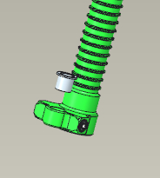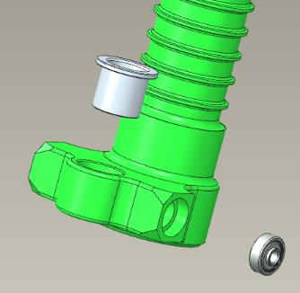
IMPORTANT! Do not tap any part of the bearing other than the outer ring (race).
Invert the housing of the ANG-3220-028483-001 nose landing gear shock absorber housing, turning the fitted bearing down. Apply an even thin layer of LOCTITE 648 retaining compound to the degreased bearing surface.
Place the bearing in the bore and drive it home, lightly tapping on it with a hammer using a mandrel. The bearing should sit flush with the housing. Clean up with a rag any excess or squeeze-out of the retaining compound.
.Apply an even thin layer of LOCTITE 648 retaining compound to the degreased surface of the ANG-3220-028483-003 polyamide (nylon) bush.
Place the ANG-3220-028483-003 polyamide (nylon) bush into the bore, with its shoulder on the side of the long portion of the housing, and drive the bush home, lightly tapping on it with hammer, using a mandrel. The bush should be seated in the housing, encountering a hard stop. Clean up with a rag any excess or squeeze-out. Apply an even thin layer of LOCTITE 648 retaining compound to the degreased surface of the ANG-3220-028483-004 threaded bus (sleeve). Fit it to the upper part, into the M8 bore, the slot facing away from the housing. Hand-screw it for 2-3 turns, tighten with a screwdriver. The threaded sleeve must be seated level with the housing. Clean up with a rag any excess or squeeze-out of the retaining compound.
Repeat the process above to fit the rest of the ANG-3220-028483-004 threaded bushes (sleeves). Set the ANG-3220-028483-001 landing gear shock absorber housing aside on the table for later use.
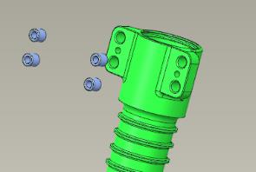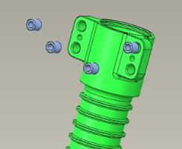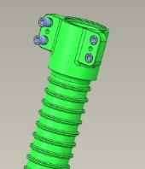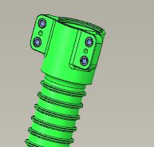
Find the ANG-3220-028485-003 lower bush and the ANG-3220-028485-007 valve. Fit the ANG-3220-028485-007 valve into the bore of the ANG-3220-028485-003 lower bush on the recess side. Push it in until encountering a hard stop.
Check for freedom of movement of the ANG-3220-028485-007 valve in the ANG-3220-028485-003 lower bush about its axis of rotation. The movement should be smooth, without jerks or bonding. Fit a circlip (retaining ring) into the groove of the ANG-3220-028485-007 valve with the angled retaining ring (circlip) pliers.
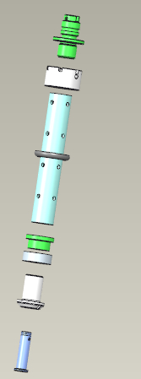
Find the ANG-3220-028485-001 tube-rod, the ANG-3220-028485-004 thrust bush, the ANG-3220-028485-005 piston.
Fit the ANG-3220-028485-004 thrust bush, the ANG-3220-028485-005 piston. Fit the bush with the piston, with the shoulder facing away from the thread, onto the ANG-3220-028485-003 lower bush.
Screw in, on the side with the bores located away from the edge, the ANG-3220-028485-003 lower bush into the ANG-3220-028485-001 tube-rod, until the edge of the ANG-3220-028485-004 thrust bush encounters a hard stop against the edge of the ANG -3220-028485-001 tube-rod. The bush should easily screw into the tube-rod until encountering a hard stop, without any clearance between the edges. Unscrew the bush from the tube-rod and set the parts aside on the table for later use.
Put on latex gloves and a respirator. Moisten a rag with solvent. Degrease the following items:
The male thread of the lower ANG-3220-028485-003 bush;
The female thread of the ANG-3220-028485-001 tube-rod;
IMPORTANT! Take care not apply the retaining compound to the degreased surface immediately. The retaining compound may be applied 5-10 minutes after degreasing.
Apply an even thin layer of LOCTITE 648 retaining compound to the degreased threaded surface of the ANG-3220-028485-001 tube-rod. Place the tube-rod on the table. Apply a uniform thin layer of LOCTITE 648 retaining compound onto the degreased threaded surface of the ANG-3220-028485- 003 lower bushing. Screw the lower bushing into the rod tube to take out the clearance between the edges of the parts.
Clean your workplace and tools as per the standard operation 7.
Set the tube-rod aside on the table for later use. Find the ANG-3220-028484-001 rod and the ANG-3220-028484-002 mount (support).
Screw the ANG-3220-028484-002 mount (support) onto the male thread of the ANG-3220-028484-001 rod. The mount (support) should screw onto the rod over the entire length of the thread until encountering a hard stop. Unscrew the ANG-3220-028484-002 mount (support) from the ANG-3220-028484-001 rod, place the parts on the table. Moisten a rag with solvent. Degrease the following items:
the male thread of the ANG-3220-028484-001 rod;
the female thread of the ANG-3220-028484-002 mount (support).
Apply an even thin layer of LOCTITE 648 retaining compound to the degreased threaded surface of the ANG-3220-028484-002 mount (support). Set the mount (support) aside for later use.
Apply an even thin layer of LOCTITE 648 retaining compound to the degreased threaded surface of the rod.
Screw the ANG-3220-028484-002 mount (support) onto the male thread of the ANG-3220-028484-001 rod. The mount support should easily screw onto the rod, over the entire length of the thread until encountering a hard stop.
Clean the work area and tools as per the typical operation 7.
Set the parts aside on the table for later use. Find the ANG-3220-028484-003 bush. Screw the ANG-3220-028484-003 bush into the ANG-3220-028484-001 rod with the rod wrench on the side opposite to the mount (support). The bush should easily screw into the rod for about 10 turns until encountering a hard stop.
Unscrew the bush from the rod and place the parts on the table. Put on latex gloves and a respirator. Moisten a rag with solvent. Degrease the following items:
The male thread of the ANG-3220-028484-003 bush;
The female thread of the ANG-3220-028484-001 rod;
IMPORTANT! Take care not to apply the retaining compound to the degreased surface immediately. The retaining compound may be applied 5-10 minutes after degreasing.
Apply an even thin layer of LOCTITE 648 retaining compound to the degreased threaded surface of the ANG-3220-028484-003 bush. Screw the ANG-3220-028484-003 bush into the ANG-3220-028484-001 rod with a rod wrench, on the side opposite to the mount (support). The bush should easily screw into the rod for 10 turns until encountering a hard stop.
Find the ANG-3220-028484-004 thrust bush and the ANG-3220-028484-005 damper. Fit the ANG-3220-028484-005 damper into the ANG-3220-028484-001 rod groove on the female thread side. Spread it out in the groove. Screw the ANG-3220-028484-004 thrust bush into the female thread of the ANG-3220-028484-004 rod, with the slits facing outwards the rod, until their edges are squarely aligned. The bush should easily screw into the rod until encountering a hard stop.
Find the ANG-3220-028485-002 bush and the 010_014_25 ring. Fit the 010_014_25 ring into the groove of the ANG-3220-028485-002 bush on the side opposite to the thread. Fit the ANG-3220-028484-005 damper and the ANG-3220-028484-004 thrust bush onto the ANG-3220-028485-001 tube-rod. Screw the ANG-3220-028485-002 bush into the thread of the rod-tube ANG-3220-028485-001. The bush should easily screw in through the thread length until encountering a hard stop.
Unscrew the bush from the rod-tube and place the parts on the table. Put on latex gloves and a respirator. Moisten a rag with solvent. Degrease the following items:
Male thread of the ANG-3220-028485-002;
Female thread of the ANG-3220-028485-001tube-rod;
IMPORTANT! Take care not to apply any retaining compound to the degreased surface immediately. The retaining compound can be applied 5-10 minutes after degreasing.
Apply an even thin layer of LOCTITE 648 retaining compound to the degreased threaded surface of the ANG-3220-028485-001rod-tube. Set the tube-rod aside on the table for later use. Apply an even thin layer of LOCTITE 648 retaining compound to the degreased threaded surface of the ANG-3220-028485-002 bush. Screw the bush into the rod tube to take out the clearance between the edges of the parts.
Clean your workplace and tools as per the typical operation 7.
Feed a 0.8 mm, 200 mm long safety wire through a locking hole in the ANG-3220-028485-002 bush. Make in the safety wire 3-4 twists.
Find the ANG-3220-028484-001 rod and the ANG-3220-028483-001 landing gear shock absorber housing. Verify the shock absorber housing for the absence of foreign objects in its inner cavities. There should be no foreign objects.
Fit the the holed part of ANG-3220-028484-001 rod into the wiper on the ANG-3220-028483-001 landing gear shock absorber housing. Avoiding misalignment, carefully slide the rod into the housing for its full travel. Clamp it in a vice, using aluminum pads, the bearing portion of the shock absorber housing, with its rod facing downwards.
Fit the rod-tube with its parts into the rod. Fit the ANG-3220-028484-005 damper into the groove of the ANG-3220-028484-001 rod on the female thread side. Spread it out in the groove. Screw the ANG-3220-028484-004 thrust bush into the female thread of the ANG-3220-028484-001 rod. The bush should screw easily into the rod.
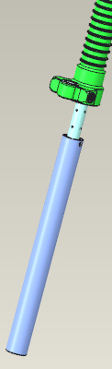 | 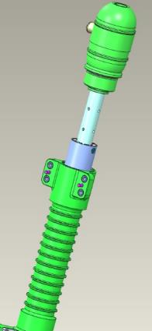
Clean your workplace and tools as per the standard operation 7.
Find the ANG-3220-028483-002 upper turret and the ANG-3220-028485-006 nut. Approach the threaded part of the ANG-3220-028483-002 upper turret to the landing gear leg. Feed the wire on the ANG-3220-028485-002 bush through the upper hole of the turret. Screw the turret into the shock absorber housing by several turns.
Pull the ANG-3220-028485-002 bush through the turret hole with the wire until the thread projects over the turret. Place the ANG-3220-028485-006 nut on the wire, and hand-screw it on the ANG-3220-028485-002 bush until encountering a hard stop. Remove the wire.
IMPORTANT! When screwing on the cover, take care not to deform the ring fitted onto the sleeve. If deforming occurs, unscrew the cap until the ring aligns in the groove and start over. Misalignment of seal will result in fluid leak.
Tighten the ANG-3220-028483-002 upper turret with a strap wrench into the shock absorber housing until the edges of the turret encounter a hard stop against the housing and the clearance between them is closed. Tighten the ANG-3220-028485-006 nut with a 19 mm combination wrench until the protrusion of one thread, securing the connection from turning with a flat bit screwdriver No. 3 behind the ANG-3220-028485-002 bush.
Check the shock absorber travel by pressing the top of the landing gear leg then extend it. The shock absorber stroke should be smooth, with an average effort (5-10 kg).
Feed 0.8mm safety wire into the hole in the ANG-3220-028485-002 bush. Pull the wire through, bend and route it into the ANG-3220-028485-006 nut hole. Pull firmly at both ends of the wire to align it. Make a 6-8 twists near the nut, sever the remaining parts of the wire, bend the twist towards the ANG-3220-028485-002 bush.
Find the prch-00027867 charging valve. Hand-screw the valve into the side orifice in the ANG-3220-028483-002 upper turret. The valve should easily screw into the orifice. Unscrew the valve, moisten a rag with solvent. Degrease the following items:
Male thread of the prch-00027867charging valve;
Female thread of the ANG-3220-028483-002 upper turret.
IMPORTANT! Take care not to apply any retaining compound to a degreased surface immediately. The retaining compound can be applied 5-10 minutes after degreasing.
Apply a level thin layer of LOCTITE 648 retaining compound to the degreased threaded surface of the ANG-3220-028483-002 upper turret. Apply a level thin layer of LOCTITE 648 retaining compound to the degreased threaded surface of the prch-00027867 charging valve. Screw the valve into the upper turret, tighten it with a 11 mm combination wrench to seat it fully home.
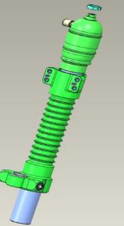 | 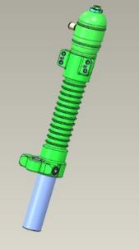
Clean your workplace and tools as per the standard operation 7.
IMPORTANT! It is forbidden to fill in the fluids and to charge the units with gas earlier than 2 hours after applying retaining compound.
4.4.2 Charging the shock absorber with working fluid and gas
To carry out this task you will need:
Movable table;
Nose landing gear shock absorber (assembled earlier);
PMS-20 silicone oil 100 ml;
Plastic cup 200 ml 3 pieces;
Disposable medical syringe with a 60 ml needle 1 piece;
Valve core installer wrench;
Bench vice 100 mm;
Aluminum vice pads 2 pieces;
Industrial nitrogen in a cylinder (pressure bottle);
Shock absorber charging device;
Liquid soap;
Latex gloves 1 pair;
Clean rags 100x100 mm 2 pieces;
Compress the shock absorber until encountering a hard stop. Clamp it in the vice in a tilted position, using the aluminum pads (jaw lining), with its coupling facing upwards. Unscrew the cap from the charging valve and put it in a cup. Detach the core from the coupling with a valve core wrench, put it in a cup.

IMPORTANT! Do not put any small-sized aircraft parts on the table. They can be lost. Use a container. Fill the syringe with the needle removed. This will allow you to draw in the fluid without cavitation effects.
Put on latex gloves. Draw 60 ml of PMS-20 silicone oil into the syringe. Attach the needle to the syringe, insert the syringe needle into the orifice of the charging valve, until the needle encounters a hard stop against the wall. Push the syringe plunger smoothly and slowly to inject silicone oil. Extract the needle smoothly out of the charging valve.
IMPORTANT! The needle of the syringe, due to its small diameter, allows to escape the air which is displaced out of the inner cavities of the shock absorber when filled with liquid. Do not apply any undue force to the syringe plunger. This will dislodge the needle from the syringe and result in spilling the fluid.
Screw the cap onto the charging valve. Extend the shock absorber for its full stroke. Push gently on the top of the shock absorber, compress the shock absorber for about its half stroke. Unscrew slowly and remove the charging valve cap. The air must bleed out. Extend the shock absorber for its full stroke.
Unscrew and slowly remove the cap from the charging valve. The air must bleed out. Extend the shock absorber for its full stroke. Draw 40 ml of PMS-20 Silicone oil into the syringe. Attach the needle to the syringe, insert the needle syringe into the orifice of the charging valve, until the needle encounters a hard stop against the wall.
Push the syringe plunger gently and slowly to inject silicone oil. Extract smoothly the needle out of the charging valve. PMS-20 silicone oil may spill. Screw the cap onto the charging valve.
Push gently on the top of the shock absorber, compress the shock absorber until encountering a hard stop. The shock absorber rod may recoil from the bottom point after removing the hand. Extend the shock absorber for its full stroke. Unscrew slowly and remove the charging valve cap. The air must bleed out. PMS-20 Silicone oil may spill. Use the wrench to screw the core into the charging valve.
Turn the rod to align shock absorber lugs and to position the charging valve either on the right or on the left side. Unclamp the shock absorber from the vice. Wipe off with a dry, clean rag any excess silicone oil, spilt during the recharging process.
Make sure that the bottle is closed and the arrows on both gauges read "0". Set the nitrogen pressure regulator to position "0", make sure that the valves of the charging device are closed.

IMPORTANT! Do not leave the cylinder valve open for a long time and the hose under pressure.
Screw the charging device coupling to the shock absorber charging valve through the full thread length. Open the cylinder valve, set the pressure on the second pressure gauge to 10 atm (1 MPa). Open (screw in) the core valve. Open the gas feed valve on the charging device. Close (unscrew) the core valve, close the gas feed valve on the charging device.
Open (screw in) the core valve. Open the gas feed valve on the charging device. Close (unscrew) the core valve, close the gas feed valve on the charging device. Detach the charging device coupling from the charging valve. Replace the cap on the charging valve.


Checkup operations:
Verify the shock absorber for likely silicone oil leak. There should be no oil leak. Set the shock absorber vertically on the floor, with its turret down, and push hard on its the top. There should be no shock absorber stroke.
Take the shock absorber in your hand. Apply a continuous thin layer of liquid soap around the charging valve. In case of leak, there will appear the bubbles. There should be no bubbles.
Apply a continuous, thin layer of soap to the rod near the wiper, along the line of contact between the turret and the housing. The bubbles should be absent. Wipe off the liquid soap from the test areas with a dry, clean cloth.

4.5 Assemble the main landing gear legs
- Note. The operations described below pertain to the left main landing gear leg. The assembly of the right landing gear is to be performed in the same sequence.
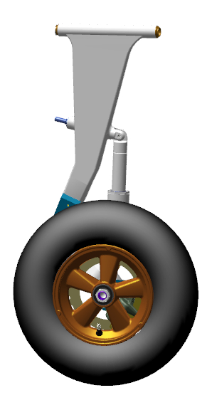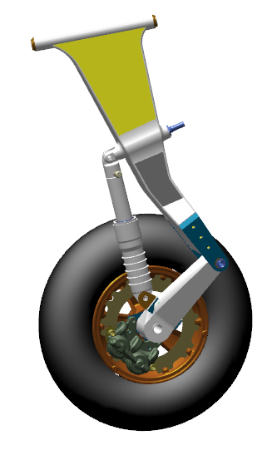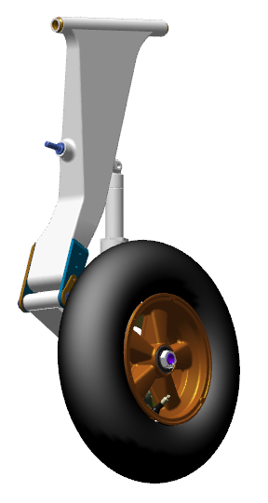
To carry out this task you will need:
Movable table;
13 mm combination wrench 2 pieces;
10 mm combination wrench 2 pieces;
Slotted screwdriver №1;
600 gram bench hammer;
Litol-24 lubricant 10 grams;
Latex gloves 1 pair;
Methyl acetate solvent 100 grams;
Clean rag 100x100 mm 2 pieces;
Adjustable wrench from 10 to 32 mm;
Combination wrench 17 mm;
LOCTITE 648 retaining compound.
Unpack and place on the table:
Upper leg marked ANG-3200-00030921-00;
Upper leg marked ANG-3200-00030921-00Z;
Lower arm marked ANG-3200-00030922-00;
Lower arm marked ANG-3200-00030922-00Z;
2 ANG-3200-00031005-00 tubeless wheels;
2 bolts marked ANG-3200-00030920-009;
2 nuts marked ANG-3200-00030920-008;
4 bolts marked ANG-3200-00052570-021;
8 bolts marked ANG-3200-00052570-011;
2 shock absorbers (assembled earlier);
2 wheel nuts marked ANG-3200-00034065-004;
2 brake discs marked ANG-3200-00031000-011;
Left brake caliper (assembled earlier);
Right brake caliper (assembled earlier);
2 movable pads marked ANG-3200-00031000-01;
2 fixed pads marked ANG-3200-00031000-02;
Count and place on the table:
8 М6 DIN 985 nuts;
eight 6 DIN 127 washers;
eight 6 DIN 125 washers;
4 М8 DIN 935 nuts;
four 8 DIN 127 washers;
four 1,6x30 DIN 94 cotter pins;
IMPORTANT! Take care to avoid prolonged exposure of shock absorbers to direct sunlight. The shock absorbers are charged with high pressure nitrogen.
Find the ANG-3200-00030922-00 lower arm, the ANG-3200-00030921-00 upper leg, the ANG-3200-00030920-009 bolt, the ANG-3200-00030920-008 nut. Place the upper part of the arm into the gear fork (yoke), align the bores. Fit into the aligning holes the ANG-3200-00030920-009 bolt, with its head on the side of the hexagonal recess on the arm fork (yoke). Push the bolt through until it shows completely out and its head is aligned in the recess. Place the ANG-3200-00030920-008 nut on, tighten it with a 17mm wrench.
Move the arm several times relative to the leg. It should move smoothly, without any binding and play (backlash).
IMPORTANT! A play (backlash) may result in rapid wearing of the bushes and collapse of the assembly.
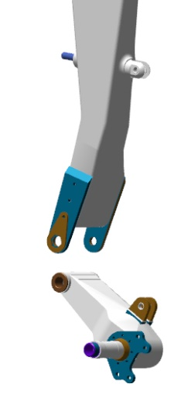 | 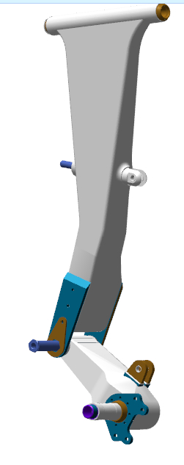 | 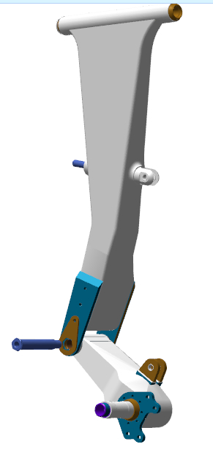

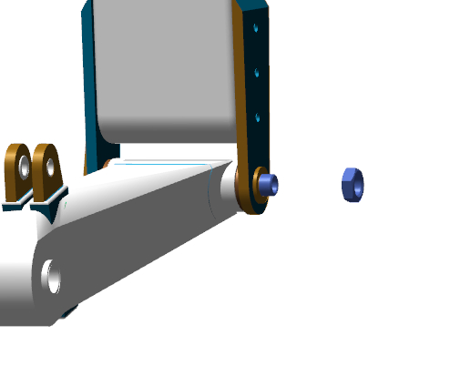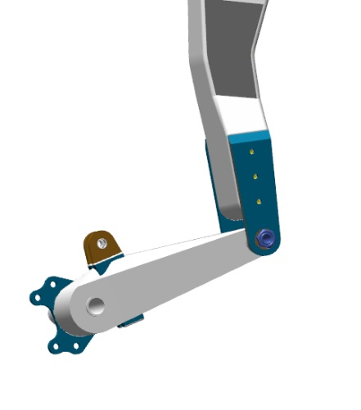
Find the shock absorber. Turn the shock absorber so that the charging nipple faces towards the wheel axle, place the lower part of the shock absorber into the lugs of the ANG-3200-00030922-00 lower arm, align the bores. Insert into the bores the ANG-3200-00052570-021 bolt with the head on the wheel axle side. Place the 8 DIN 127 washer onto the bolt, screw the M8 DIN 935 nut on, tighten the nut to seat it fully and firmly onto the 8 DIN 127 washer. Find a bore in the bolt, which is supposed to align with the slot of the M8 DIN 935 nut. If the hole is not visible, tighten slightly the nut to align the bore with the slot.
IMPORTANT! Do not loosen the nut to align the hole with the slot. This will result in quick failure of the assembly and its play.
Fit the cotter pin 1.6x30 DIN 94 into the slot of the M8 DIN 935 nut aligning with the holes in the bolt. Secure the connection by bending the cotterpin ends aside with a slotted (flat-tip) screwdriver №1.
Fit the upper part of the shock absorber into the shock absorber lugs on the ANG-3200-00030921-00 leg, to align the holes by sliding the strut onto the shock absorber.
Place the bolt through the holes, with its head on the wheel axle side. Place the 8 DIN 127 washer onto the bolt, screw the M8 DIN 935 nut on. Tighten the nut to seat it fully and firmly onto the 8 DIN 127 washer. Find a hole in the bolt, which is supposed to align with the slot of the M8 DIN 935 nut. If the hole is not visible, tighten slightly the nut to align the bore with the slot.
IMPORTANT! Do not loosen the nut to align the bore with the slot. This will result in quick failure of the assembly and its play.
Fit the 1.6x30 DIN 94 cotter pin into the slot of the M8 DIN 935 nut aligning with the bores in the bolt. Secure the connection by bending the cotter pin ends with a slotted (flat-tip) screwdriver №1.
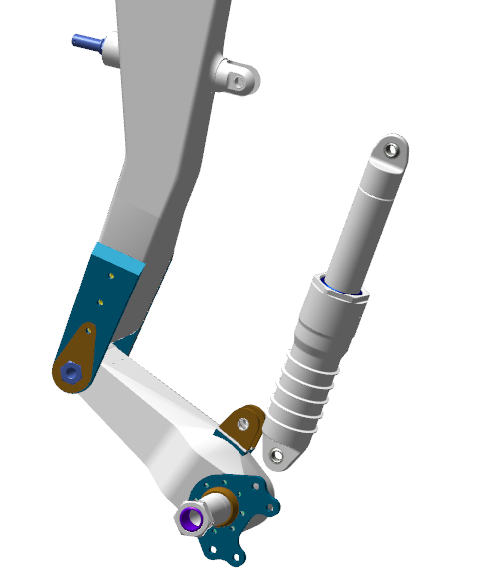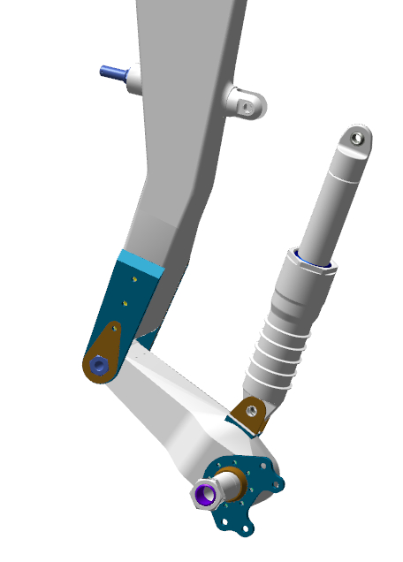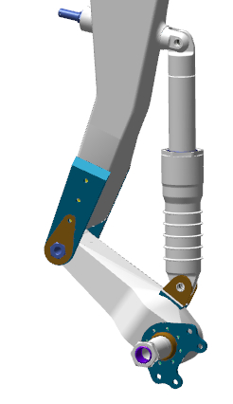
Find the ANG-3200-00030922-00 lower arm, the brake caliper, 4 ANG-3200-00052570-011 bolts, 6 DIN 127 and 6 DIN 125 washers, 4 pieces each, 4 M6 DIN 985 nuts. Fit the brake caliper to bracket on the right of the wheel axle. Align the bracket and caliper bores. Fit into aligning bores 4 ANG-3200-00052570-011 bolts, with their heads on the wheel axle side.
Place the 6 DIN 125 and 6 DIN 127 washers and the M6 DIN 985 nuts onto the bolts, tighten them with a wrench.
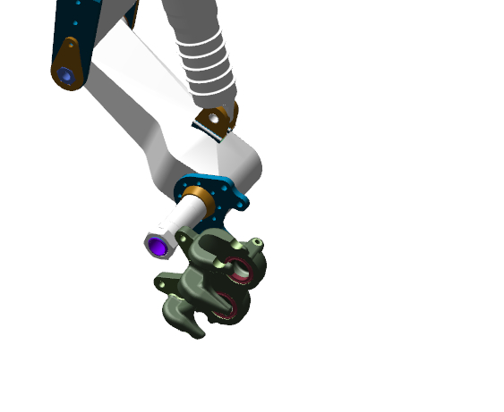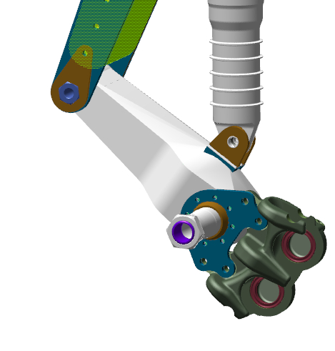

Find the ANG-3200-00031000-01 moveable brake pad and the ANG-3200-00031000-02 fixed brake pad. Fit the ANG-3200-00031000-01 movable brake pad into the grooves of the brake caliper. ANG-3200-00031000-01, with its lining facing towards the wheel axle. Slide the pad until encountering a hard stop. Fit the ANG-3200-00031000-02 fixed brake pad into the grooves of the brake caliper, with lining facing away from the wheel axle. Slide the pad on until encountering a hard stop.
Find the ANG-3200-00031000-011 brake disc.
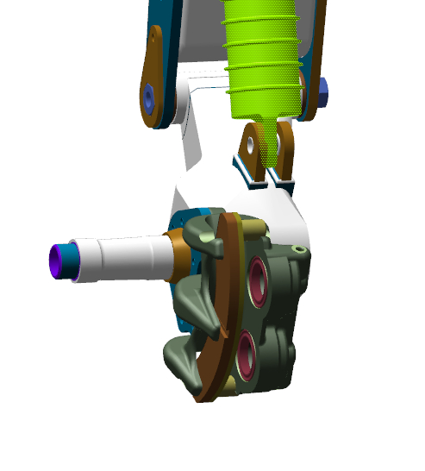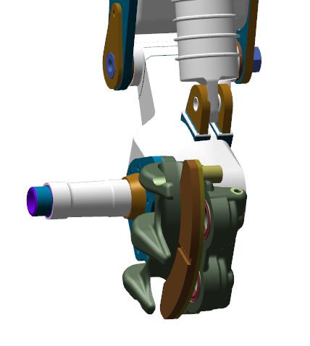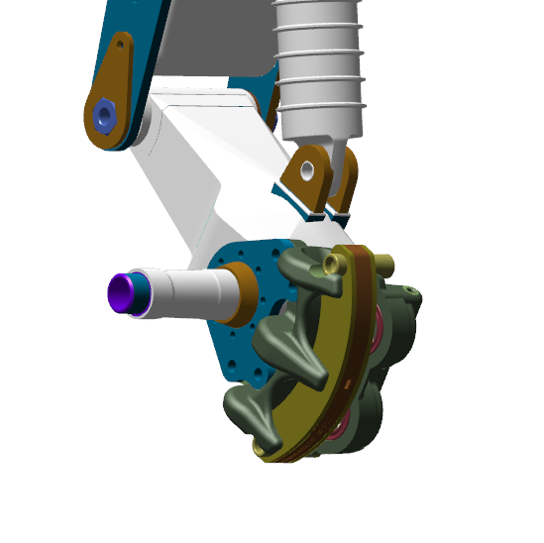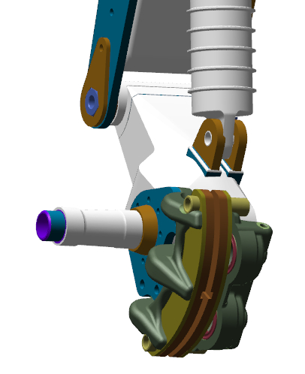
Place the disc through the axle, fit it between the pads in the caliper. Place the landing gear leg on the table with the wheel axle up. Fit a tubeless wheel to the ANG-3200-00031005-00 axle, with the charging valve facing away from the landing gear.
Slide the ANG-3200-00031005-00 tubeless wheel along the axis, to align its protrusion level with the wheel. Guide the ANG-3200-00031000-011brake disc grooves to the ridges (bosses) on the ANG-3200-00031005-00 wheel hub.
Push the wheel all the way down till encountering a hard stop. Stand the landing gear leg on the wheel, check if the brake disc ANG-3200-00031000-011 is properly fitted into the grooves of the ANG-3200-00031005-00 tubeless wheel hub. Place the landing gear leg on the table with the wheel facing up. Check the wheel for freedom of movement. It should rotate smoothly without jerks or binding.
IMPORTANT! Over-tightening of wheel nuts may damage the bearings.
Find the ANG-3200-00034065-004 wheel nut. Place on the wheel axle the ANG-3200-00034065-004 landing gear wheel nut, hand-tighten it until encountring a hard stop.
Set the adjustable wrench to 32 mm. Tighten the ANG-3200-00034065-004 landing gear wheel nut with the adjustable wrench until its hexagonal portion encounters a hard stop against the wheel collar.
Checkup operations:
Check the wheel for freedom of movement. It should rotate smoothly without any jerks or binding.
Нужно добавить контрольные операции: зазоры между колесом и амортизатором, между диском и суппортом, контровка, люфты

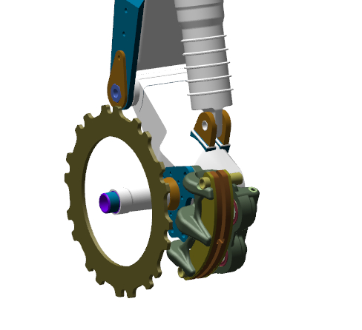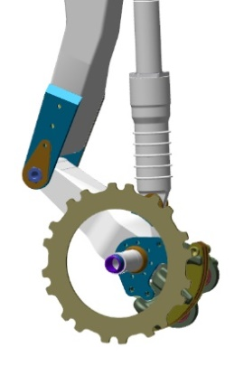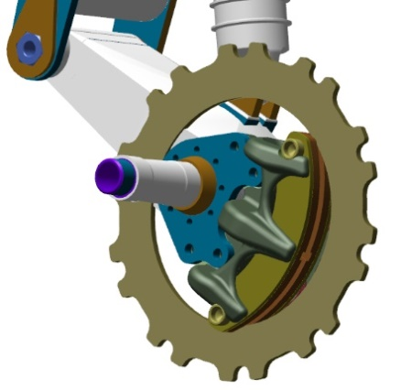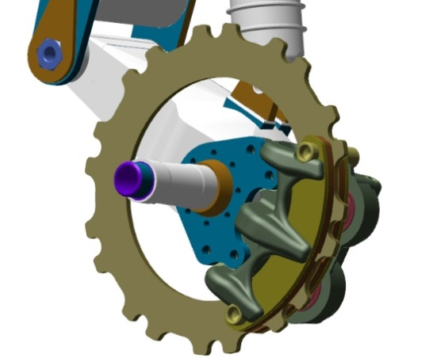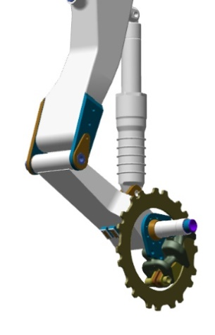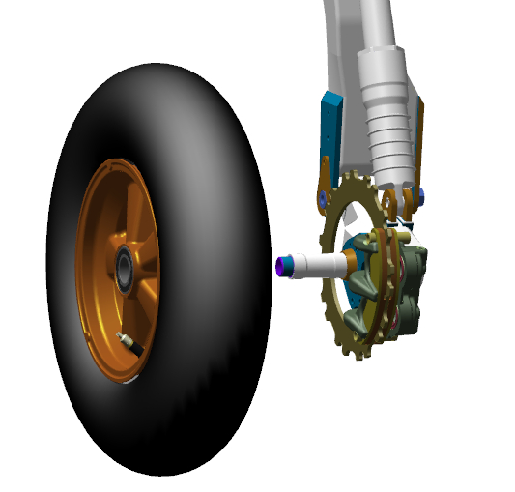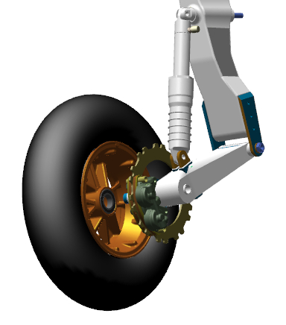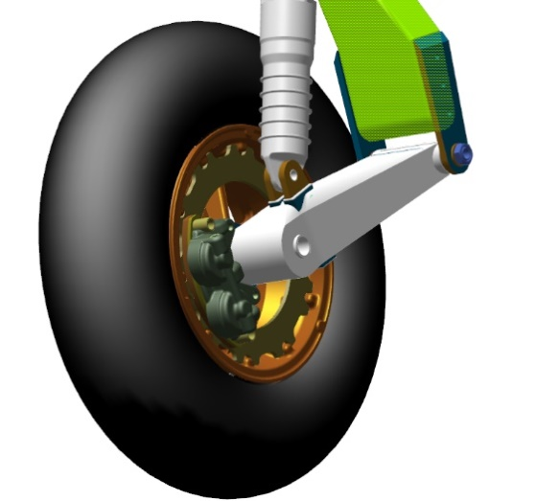

  - Assemble nose landing gear leg
To carry out this task you will need:
Movable table;
8 mm combination wrench 2 pieces;
Combination wrench 10 mm;
14 mm combination wrench;
LOCTITE 648 retaining compound;
Methyl acetate solvent 100 grams;
Clean rag 100x100 mm 2 pieces;
Latex gloves 1 pair;
Unpack and place on the table:
Bellcrank marked ANG-3200-00034203-00;
Nose landing gear truss marked ANG-3220-00030227-00;
Universal link marked ANG-3200-00032916-004;
Landing gear assembly marked ANG-3200-00032916-001;
Polyamide bush marked ANG-3200-00032916-002;
Bolt marked ANG-0000-00052729-001;
Tubeless wheel ANG-3200-00031005-00;
Fork (yoke) marked ANG-3200-00030880-01;
Wheel axle marked ANG-3200-00030880-006;
Spacer bush marked ANG-3200-00030880-005;
Spacer bush marked ANG-3200-00030880-007;
Nut marked ANG-3200-00030880-010;
Washer marked ANG-3200-00032905-001;
2 bushes marked ANG-3200-00032905-002;
Upper bellcrank with marking ANG-3200-00032905-01;
Lower bellcrank with marking ANG-3200-00032905-02;
2 ANG-3200-00034203-001small rod axles;
ANG-3200-00034203-002 small rod axle;
Bolt marked ANG-0000-00052729-011;
Bolt marked ANG-0000-00052729-021;
Bolt marked ANG-0000-00052729-031.
Count and place on the table:
Six 80025 bearings;
Eight М5 DIN 935 nuts;
Eight 1.0x35 DIN 94 cotter pins;
Ten 5 DIN 127 washers;
Six М6 DIN 985 nuts;
Two М5 DIN 985 nuts;
Six 6 DIN 127 washers;
Four М5х16 DIN 962SK bolts;
Find the ANG-3200-00032905-01 upper bellcrank, the ANG-3200-00032905-02 lower bellcrank, the ANG-3200-00032905-001 washer and two ANG-3200-00032905-002 bushes.
Fit onto the pin (stud) of the ANG-3200-00032905-02 lower bellcrank the ANG-3200-00032905-002 polyamide bushing with the projection facing away from the bellcrank.
Fit the ANG-3200-00032905-01upper rocker onto the pin (stud) with the bush, move it until encountering a hard stop. Fit onto the pin (stud) of the ANG-3200-00032905-02 lower bellcrank, the ANG-3200-00032905-002 polyamide bush with the projection facing towards the bellcrank, and the ANG-3200-00032905-001 washer.
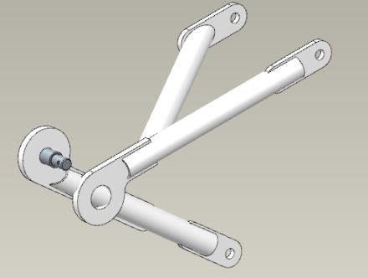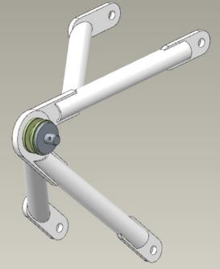
Place the 5 DIN 127 washer, screw the M5 DIN 935 nut on. Using an 8 mm combination wrench, tighten the nut to seat it fully and firmly on the 5 DIN 127 washer. Find a bore in the axle, which is supposed to align with the slot of the DIN 935 M5 nut. If the hole is not visible, tighten the nut to align the hole with the slot.
IMPORTANT! Do not loosen the nut to align the bore with the slot. This will result in a quick failure of the assembly and play (backlash).
Check the bellcranks for freedom of movement. The bellcranks should rotate easily around the axle, without jerks or binding.
Fit the 1,0х35 DIN 94 cotter pin into the slot of the M5 DIN 935 nut aligning with the bore in the axle. Cotter the connection by bending the cotter pin ends with a slotted screwdriver №1. Set the bellcranks aside on the table for later use.
Find the ANG-3200-00032916-001 landing gear assembly and the ANG-3200-00032916-002 polyamide bush.
Moisten the cloth with solvent. Degrease the following items:
Outer surface of the ANG-3200-00032916-002 bush;
Inner bush seat in the ANG-3200-00032916-001 assembly.
IMPORTANT! Take care not apply any retaining compound to the degreased surface immediately. The retaining compound can be applied 5-10 minutes after degreasing. Do not allow the ingress of any retaining compound into inner cavities of the bushes. In case of ingress of the retaining compound, immediately wipe it clean with a rag wetted with solvent.
Apply an even thin layer of LOCTITE 648 retaining compound to the degreased surface ANG-3200-00032916-002 bush.
Fit the bush into the bore of the assembly and seat it home, slightly tapping on it with a hammer, with use of a mandrel. The bush should be seated so that its shoulder rests on the plane of the assembly. Wipe away the squeeze-out with a rag. Set the assembly aside on the table for later use.
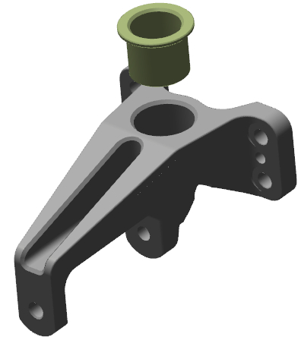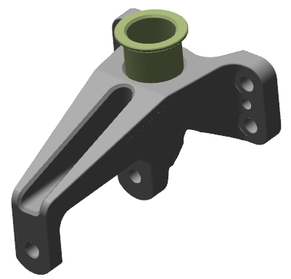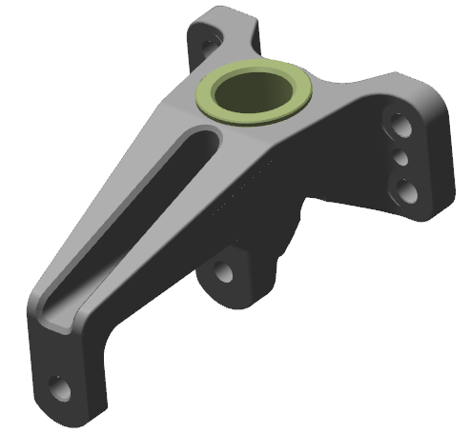
Find the ANG-3200-00032916-004 universal link and four 80025 bearings.
Moisten a rag with solvent. Degrease the following items:
Outer surfaces of the four bearings 80025;
Inner bearing seats in the ANG-3200-00032916-004 universal link.
IMPORTANT! Take care not to apply any retaining compound to a degreased surface immediately. The retaining compound can be applied 5-10 minutes after degreasing. Do not allow the ingress of any retaining compound into the bearing. This will render the bearing unserviceable.
Apply an even thin layer of LOCTITE 648 retaining compound to the degreased surface of the bearing.
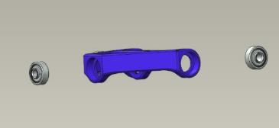
Position the bearing into the bore and seat it home tapping on it with a hammer with use of a mandrel (pad). The bearing should sit flush with the bush. Wipe away any excess and squeeze-out of the retaining compound with a rag.
IMPORTANT! Do not tap on any part of the bearing other than the outer ring (race).
Repeat the process above for remaining bearings.
Find the ANG-3200-00032916-001 gear assembly and the ANG-0000-00052729-001 bolt. Fit the ANG-3200-00032916-004 universal link (with bearings) in the opening with the lugs facing towards the bores of the assembly.
Align the bores of the bearings with those of the ANG-3200-00032916-001 gear assembly. Fit the assembly bolt ANG-0000-00052729-001 into the aligning bores, with its head on the side of the universal joint lugs. Push the bolt through the bores until the threads show up, place on it the 5 DIN 127 washer, screw the M5 DIN 935 nut on. Using two 8mm combination keys, tighten the nut to seat it fully and firmly on the 5 DIN 127 washer. Find a bore in the ANG-0000-00052729-001 assembly bolt, which should align with the slot of the M5 DIN 935 nut. If the hole is not visible, tighten the nut until the bore aligns with the slot.
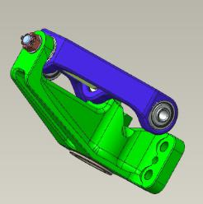
IMPORTANT! Do not loosen the nut to align the hole with the slot. This will result in a quick failure of the assembly and play (backlash).
Find the truss of the ANG-3220-00030227-00 nose gear, the nose shock absorber, the ANG-3200-00032916-001 gear assembly.
With the bushes facing upwards and the lugs outwards, fit the truss of the ANG-3220-00030227-00 ANG-3220-00030227-00 nose gear into the lower bush of the nose gear shock absorber. Check for freedom of movement of the truss in the bush. The rotation should be smooth, without jerks or binding. Place the ANG-3200-00032916-001 gear assembly on the truss pin (stud), align the bores and push it towards the shock absorber.
Check for freedom of movement of the truss in the bushes. The rotation should be smooth, without jerks or binding. Position into place four М5х16 DIN 962SK bolts, tighten them with an 8 mm wrench. Check for the freedom of movement of the truss in the bushes. The rotation should be smooth, without jerks or bindings.
Unscrew the M5x16 DIN 962SK bolts from their bores. Moisten a rag with solvent. Degrease the threaded portion of the bolts. Apply an even thin layer of LOCTITE 648 retaining compound to the degreased surface of the M5x16 DIN 962SK bolt. Fit the bolt into one of the bores.
Tighten it with an 8 mm wrench. Repeat the process above for remaining bolts. Attach an 8mm socket to the torque wrench. Set the torque wrench to 5 Nm. Tighten the assembly mounting bolts with a wrench up to 5Nm. Check for freedom of movent of the truss in the bushes. The rotation should be smooth, without jerks or binding.
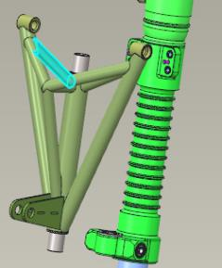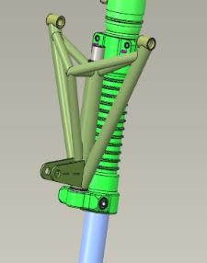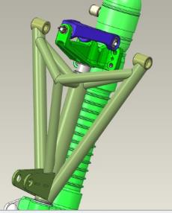

Feed an 0.8mm safety wire into the bore in the bolt head on the left side of the landing gear leg. Pull the wire strongly at both ends through the bore to align it. Make 8-10 twists, feed one of the ends into the bore in the head of the adjacent bolt, run it through the bore. Pull the wire strongly at both ends through the bore to align it. Make 4-6 twists near the bolt head, sever remaining parts of the wire, bend the twist towards the gear assembly. Repeat the process above to secure the remaining bolts.
Find the ANG-3200-00030880-01 fork (yoke). Screw the ANG-3200-00030880-01 fork (yoke) onto the landing gear rod. The fork (yoke) must screw through the thread length. Unscrew the fork (yoke).
Moisten a rag with solvent. Degrease the following items:
Threaded rod surface;
Female thread of the ANG-3200-00030880-01 fork (yoke).
Take care not to apply any retaining compound to the degreased surface immediately. The retaining compound can be applied 5-10 minutes after degreasing.
Apply to the degreased surfaces an even, thin layer of LOCTITE 648 retaining compound.
Screw the ANG-3200-00030880-01 fork (yoke) back onto the landing gear rod. The fork must screw through the thread length.
Find the torque link (assembled earlier). Aproach the torque link to the landing gear leg. Position the torque link with the nut at the joint of the bellcranks facing to the right and the lugs over the landing gear leg and the assembly with the fork (yoke). Place the the lower part of the torque link over the torque link assembly with the fork (yoke), align the lug and bearing bores. Insert into aligning bores the ANG-0000-00052729-011 bolt. Place the 5 DIN 127 washer, screw the M5 DIN 935 nut on, use the 8 mm wrench to screw the M5 DIN 935 nut on until aligning the bolt bore with the nut slot.
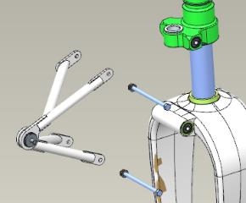
Fit the 1.0x35 DIN 94 cotter pin into the slot of the M5 DIN 935 nut aligning with the ANG-0000-00052729-011bolt bores. Cotter the connection by bending aside the cotter pin ends with a slotted (flat-tip) screwdriver No. 1.
Check for freedom of movement of the torque link in the assembly by tilting it upwards and downwards. The movement should be smooth, without jerks or binding.
IMPORTANT! Do not loosen the nut to align the bore with the slot. This will result in a quick failure of the assembly and backlash.
Align the torque link bellcrank lugs with the bearings on the landing gear leg housing, rotating it by fork (yoke) around the rod axis, position the ANG-3220-00030227-00 nose truss onto the torque link.
Position the upper part of the torque link over the bearings on the landing gear leg (“embracing” them), align the lug and bearing bores. Fit into aligning bores the ANG-0000-00052729-021 stud. Place onto it the 5 DIN 127 washer, screw the M5 DIN 935 nut on, keep screwing it with the 8 mm wrench until aligning the bore of the stud with the slot of the nut. Fit the 1.0x35 DIN 94 cotter pin into the slot of the M5 DIN 935 nut aligning with the bore of the ANG-0000-00052729-021 stud.
Cotter the connection by bending aside the cotter pin ends with a slotted (flat-tip) screwdriver No. 1.
IMPORTANT! Do not loosen the nut to align the hole with the slot. This will result in a quick failure of the assembly and its play (backlash).
Find the ANG-3200-00031005-00 tubeless wheel, the ANG-3200-00030880-005 and ANG-3200-00030880-007 spacer bushs, the ANG-3200-00030880-006 wheel axle, the ANG-3200-00030880-010 nut.
Position landing gear leg with the ANG-3220-00030227-00 truss facing towards you, place it on the left side. Place the ANG-3200-00031005-00 tubeless wheel on the table with the charging nipple facing upward from the table. Fit into the bore the ANG-3200-00030880-005 bush from above, with the its shoulder facing away from the wheel. Align the bores and push firmly on the bush.
Fit from above the ANG-3200-00030880-007 bush into the bore with a collar, with its shoulder facing away from the wheel. Align the bores and push firmly on the bush. Invert the wheel so that the charging nipple faces upwards relative to the table.
Roll the wheel into the fork (yoke) opening, align the fork (yoke) and bush bores. Fit the ANG-3200-00030880-006 wheel axle into the bores, push all the way over the full length of the axle until encountering a hard stop. Mount the leg to the wheel on the table. Drive the axle into the bore, tapping it slightly with a hammer until the thread can be seen on the opposite side.
Place the ANG-3200-00030880-010 nut on the thread of the ANG-3200-00030880-006 axle, hand-tighten the nut.
Remove the leg from the table and place it with its wheel on the floor, rest it against your knees. Using a 24 mm combination wrench, tighten the nut to take out the gaps and align the wheel axle bore with the nut slot.
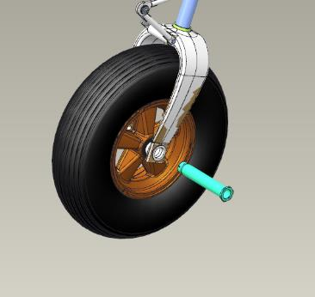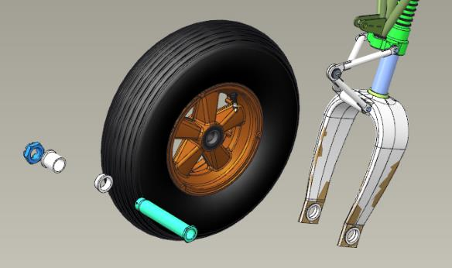
Fit the 2х60 DIN 94 cotter pin into the nut slot aligning with the wheel axle bores. Cotter the connection by bending aside the cotter pin ends with a slotted (flat-tip) screwdriver No. 1.
Find the ANG-3200-00034203-00 bellcrank, 2 ANG-3200-00034203-001 small rod axles, one ANG-3200-00034203-002 axle.
Moisten a rag with solvent. Degrease the following items:
The male thread of the small rod axles;
The female thread of the ANG-3200-00034203-00 bellcrank.
IMPORTANT! Take care not apply any retaining compound to the degreased surface immediately. The retaining compound can be applied 5-10 minutes after degreasing.
Apply to the degreased surfaces an even, thin layer of LOCTITE 648 retaining compound.
Screw the rods successively into the bellcrank threads. Tighten the ANG-3200-00034203-001 axles with a 10 mm wrench, and the ANG-3200-00034203-002 axle with a 14 mm wrench to take out the clearance between the axle shoulders and the bellcrank plane.
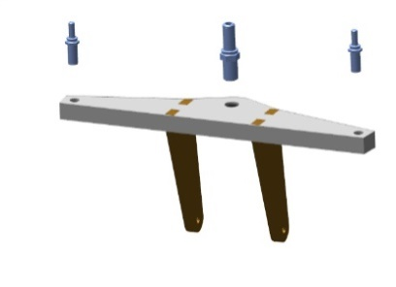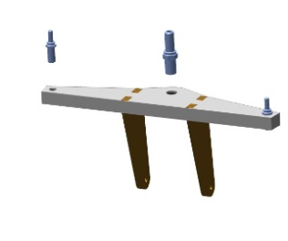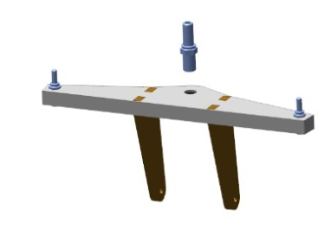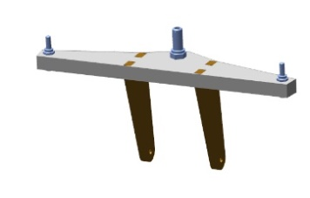
Position the bellcrank attachment lugs over the universal link fitted to the landing gear leg. Align the attachment lug bores with those of the universal link. Fit into aligning bores the ANG-0000-00052729-031 bolt. Place onto it the 5 DIN 127 washer, screw on the M5 DIN 935 nut with an 8 mm wrench, keept screwing the M5 DIN 935 nut to align the stud bore with the nut slot.
Fit the 1.0x35 DIN 94 cotter pin into the slot of the M5 DIN 935 nut aligning with the bore of the ANG-0000-00052729-031 stud. Cotter the connection by bending aside the cotter pin ends with a slotted (flat-tip) screwdriver No. 1.
Checkup operations:
Check the bellcrank for freedom of movement on the universal link by tilting it back and forth. The movement should be smooth, without jerks or binding.
Check the ease of rotation of the wheel. The rotation should be easy without jerks or binding.
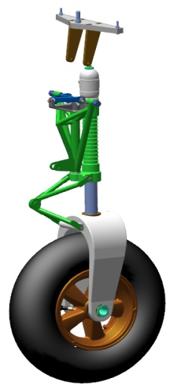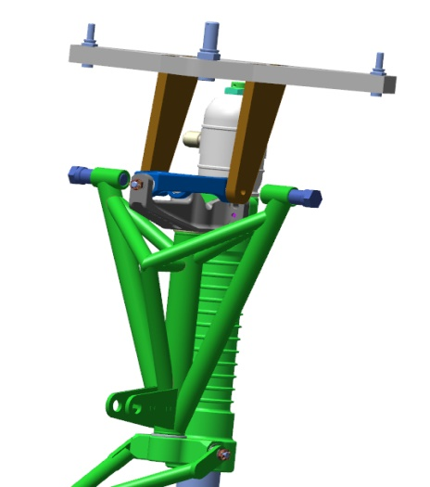
IMPORTANT! Do not loosen the nut to align the bore with the slot. This will result in a quick failure of the assembly and its play.

4.7 Assemble the landing gear retract cylinders
To carry out this task you will need:
Wrench for theTE lower cover;
Wrench for the TE upper cover;
Wrench for the TE liner (sleeve);
Spacer for the TE cover sensors;
2 mm hex key (Allen wrench);
LOCTITE 648 retaining compound;
Solvent methyl acetate 100 grams;
Clean rag 100x100 mm 6 pieces;
Latex gloves 1 pair;
30-100Nm torque wrench;
14 mm socket head;
Slotted (flat-tip) screwdriver No. 1;
Slotted (flat-tip) screwdriver No. 2;
14 mm combination wrench;
16 mm combination wrench;
IMPORTANT! Before starting the work with parts of the aircraft hydraulic system, clean your workplace of small objects and dust. Make sure to keep it clean and free of any foreign objects and fluids.
Unpack and place on the table:
2 ANG-3200-00033966-001cylinder liners;
1 ANG-3200-00032740-001cylinder liner;
3 ANG-3200-00032740-002 hydraulic cylinder upper covers;
3 ANG-3200-00032740-005 bronze bushes;
3 ANG-3200-00032757-002 nuts;
3 washers ANG-3200-00032757-003;
3 ANG-3200-00032757-004 washers;
3 ANG-3200-00032757-005 rods;
3 ANG-3200-00032757-006 pistons;
3 ANG-3200-00032757-008 nuts;
3 ANG- 3200-00032757-011 lock rings;
6 ANG-3200-00032757-010 circlips (split rings);
3 ANG- 3200-00032757-009 guides;
3 ANG-3200-00032740-004 locknuts;
2 ANG-3200-00033966-002 hydraulic cylinder rods;
1 ANG-3200-00032757-001 hydraulic cylinder rod;
3 ANG-3200-00032740-003 lower hydraulic cylinder covers;
12 ANG- 3200-00032777-001 bushes;
Count and place on the table:
6 fittings marked prch-00032785;
3 collars marked prch-00032803;
6 collars marked prch-00032800;
3 wipers marked prch-00032798;
Three 20-23-19 rings;
Three 1.0х65 DIN 94 cotter pins;
Six 34-37-19 rings;
3 rod ends marked prch-00032781;
12 prch-00032794 spring clips;
3 prch-00032779 bearings.
Find four prch-00032794 spring clips. Fit the screws with a 2 mm hex key (Allen wrench) into the bores of the ANG-3200-00032777-001 bush until 1-2 threads protrude behind the bushing. The screws must drive in without cross-threading or binding.
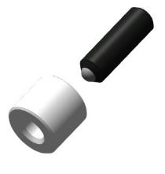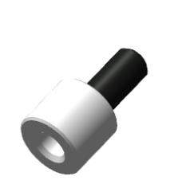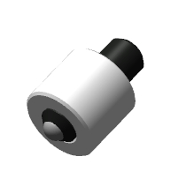
Remove the screws from the bores with the 2 mm hex key (Allen wrench). Set the vernier caliper to 1.8 mm.
Put on latex gloves and a respirator. Moisten a rag with solvent. Degrease the following items:
Female thread of the four ANG- 3200-00032777-001 bushes;
Outer surface of the four prch-00032794 spring clips (retainers).

IMPORTANT! Take care not to apply any retaining compound to the degreased surface immediately. The retaining compound can be applied 5-10 minutes after degreasing.
Apply an even thin layer of LOCTITE 648 retaining compound to the degreased inner surface of the ANG-3200-00032777-001 bush. Set the bush aside on the table for later use. Place the prch-00032794 spring clip on the 2 mm hex key (Allen wrench). Apply an even thin layer of LOCTITE 648 retaining compound to the outer degreased surface of the screw. Fit the prch-00032794 spring clip into the bore on the surface of the ANG-3200-00032777-001 bush, tighten the screw until the spherical part is seen on the other side of the bush. Check the projection of the screw with a vernier caliper. Tighten the screw to get a reading of 1.8mm set on the vernier caliper.
Clean up any excess or squeeze-out of retaining compound with a rag, thorougly wipe the retaining compound away from the threaded and spherical portion of the screw.
IMPORTANT! Do not allow the retaining compound to spread onto projection of threaded and spherical parts of the screw. Use a rag to immediately clean off the retaining compound. It is allowed to fit the bushes with screws only in 1-2 hours after applying the retaining compound
Repeat the process above for the remaining prch-00032794 spring clips and ANG-3200-00032777-001 bushes.
Find the ANG-3200-00032740-003 lower hydraulic cylinder cover, the ANG-3200-00032740-005 bronze bush, the prch-00032803 collar and the prch-00032798 wiper.
Put on latex gloves and respirator. Moisten a rag with solvent. Degrease the following items:
The inner cavity of the ANG-3200-00032740-003 lower hydraulic cylinder cover;
The outer surface of the ANG-3200-00032740-005 bronze bush.
Fit into the ANG-3200-00032740-003 lower hydraulic cylinder cover the prch-00032803 collar with the groove facing towards the thread. Slide the collar inside the cover until encountering a hard stop.
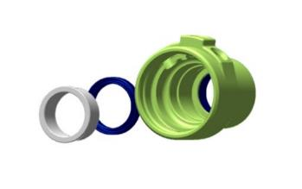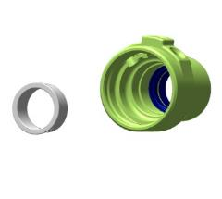
Apply an even thin layer of LOCTITE 648 retaining compound to the degreased surface of the ANG-3200-00032740-005 bronze bush.
IMPORTANT! Take care not to allow the ingress of the retaining compound into the bush. This will render the bush unserviceable.
Place the ANG-3200-00032740-005 bronze bush into the bore and tap on it gently with a hammer using a mandrel to drive it fully home.
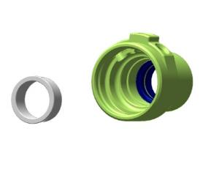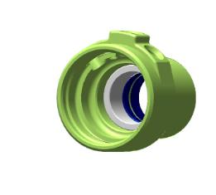

Clean up any excess or squeez-out of retaining compound with a rag.
Fit the prch-00032798 wiper into the upper groove outside the ANG-3200-00032740-003 cover, with bevel (oblique portion) facing outwards the cover. Spread the prch-00032798 wiper in the groove with your fingers.
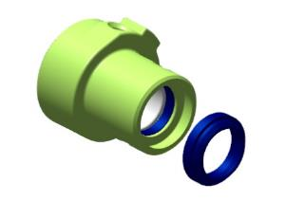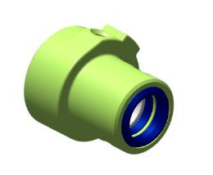
Position into place and hand-tighten the spacer for cover sensors.
Screw the ANG- 3200-00032777-001 bush into one of the bores until encountering a hard stop. The bush must screw in without binding or cross-threading. Screw the second bush in. Unscrew the bushes from their bores.
Put on latex gloves and respirator. Moisten a rag with solvent. Degrease the following items:
Female thread of the ANG-3200-00032740-003 lower hydraulic cylinder cover;
Male thread of the ANG- 3200-00032777-001 bushes.
The male thread of the 2010 1/8 fitting.
Apply an even thin layer of LOCTITE 648 retaining compound to the degreased threaded surfaces of the ANG-3200-00032740-003 lower cylinder cover. Set the cover aside on the table fro later use.
Apply an even thin layer of LOCTITE 648 retaining compound to the degreased surface of the 2010 1/8 fitting. Screw the 2010 1/8 fitting in, tighten it with the 9 mm combination wrench. The vacant threaded portion of the 2010 1/8 fitting must face away from the smaller diameter of the cover and be parallel to the cover axis.
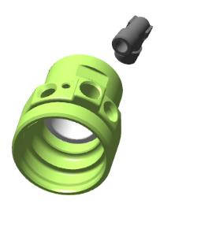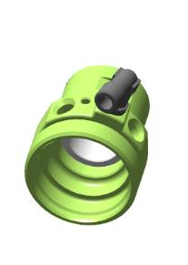
Apply an even thin layer of LOCTITE 648 retaining compound to the degreased outer surface of the ANG-3200-00032777-001 bush. Screw the ANG-3200-00032777-001 bush into the bore of the ANG-3200-00032740-003 lower hydraulic cylinder cover with a 2 mm hex (Allen) wrench, tighten it until encountering a hard stop. Repeat the process for the second ANG- 3200-00032777-001 bush.
Remove the cover sensor spacer from the ANG-3200-00032740-003. lower cylinder cover Clean up any excess or squeeze-out of retaining compound with a rag, thoroughly wipe off the retaining compound from the threaded and spherical portion of the screw.
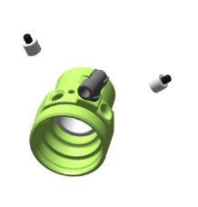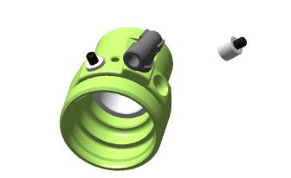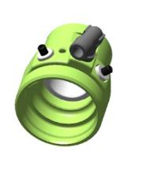
IMPORTANT! Take care not to allow the retaining compound to spread onto the threaded and spherical portions of the screw. Use a rag to immediately wipe off the retaining compound. Do not allow the ingress of the retaining compound into the inner cavity. This will render the hydraulic cylinder unserviceable.
Find the ANG-3200-00032740-002 upper cylinder cover. Fit to it and hand-tighten the cover sensor spacer. Repeat the process described above for fitting the ANG-3200-00032777-001 bushes into the ANG-3200-00032740-002 upper hydraulic cylinder cover.

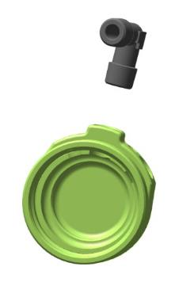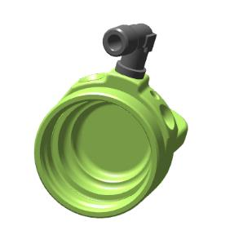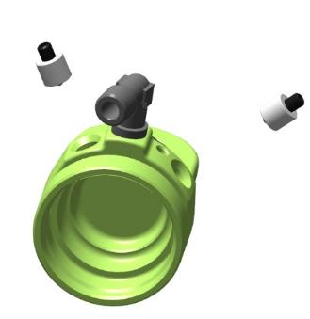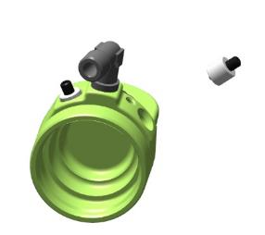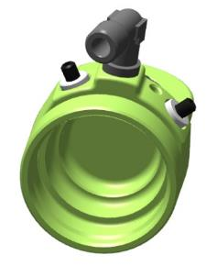
Find the ANG-3200-00032757-005 and ANG-3200-00033966-002 rods, the ANG-3200-00032757-011 locking ring.
Hand-screw from the side without flats the ANG-3200-00032757-005 rod with it long threaded part into the ANG-3200-00033966-002 rod until encountering a hard stop. A clearance of 3 mm should be provided between the two edges of the rods.
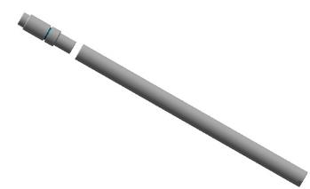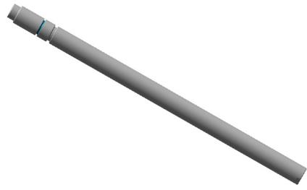
Place the ANG-3200-00032757-011 locking ring on the ANG-3200-00032757-005 rod, slide it along the rod until seating into the rod groove.
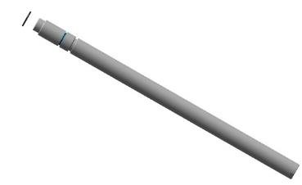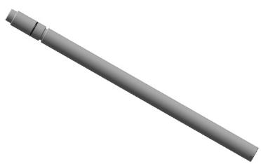
Detach the rods from each other. Place the ANG-3200-00032757-003 washer on the ANG-3200-00033966-002 rod, with a recess facing the rod. Hand-screw until encountering a hard stop the ANG-3200-00032757-005 rod with its long threaded part into the ANG-3200-00033966-002 rod from the side without flats. Check the ANG-3200-00032757-003 washer between the two rods for the absence of any play and likely spinning. Disassemble the parts, place them on the table.
Put on latex gloves and a respirator. Moisten a rag with solvent. Degrease the following items:
Female thread of the ANG-3200-00033966-002 rod;
Male thread of the ANG-3200-00032757-005 rod.
Apply an even thin layer of LOCTITE 648 retaining compound to the degreased female threads of the ANG-3200-00033966-002 rod.
Set the rod aside on the table for later use. Apply an even thin layer of LOCTITE 648 retaining compound to the degreased male threads of the ANG-3200-00032757-005 rod.
Place the ANG-3200-00032757-003 washer on the ANG-3200-00033966-002 rod with a recess facing the rod. Hand-screw until encountering a hard stop the ANG-3200-00032757-005 rod with its long threaded part into the ANG-3200-00033966-002 rod from the side without flats.
Check the ANG-3200-00032757-003 washer between the two rods for the absence of any play and likely spinning. Clean up any excess or squeeze-out of the retaining compound with a rag, thoroughly wipe off the retaining compound from the threaded and spherical portion of the screw.

IMPORTANT! Take care not to allow the retaining compound to spread onto the projecting threaded and smooth parts of the rods. Use a cloth to immediately wipe off the retainer.
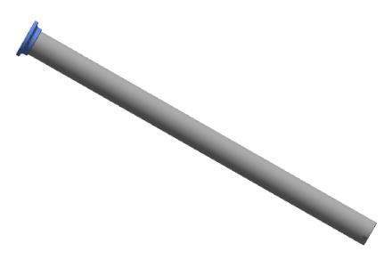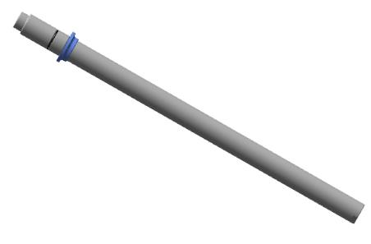

Find and place on the table the ANG-3200-00032757-006 piston, 2 prch-00032800 collars, the 20-23-19 ring, the ANG-3200-00032757-009 guide. Fit into the grooves on both sides of the ANG-3200-00032757-006 piston the prch-00032800 collars with cannelures facing outwards.
Place the ANG-3200-00032757-009 guide between the collars, in the middle groove of the piston. Position and fit the 20-23-19 ring into the groove of the ANG-3200-00032757-006 piston inner cavity. The ring should sit snugly in the groove.
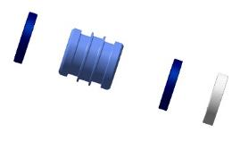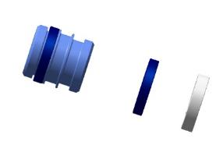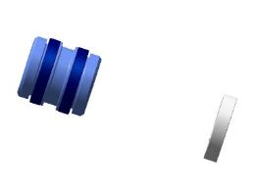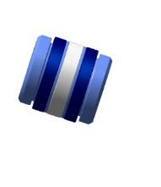

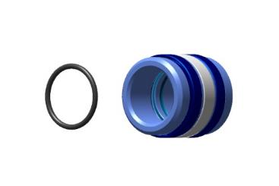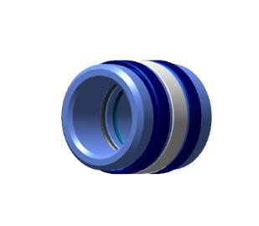
Find 2 ANG-3200-00032757-010 split rings, the ANG-3200-00032757-004 washer, the ANG-3200-00032757-008 nut.
Fit the ANG-3200-00032757-010 ring on the rod on the male thread side with its bevel (oblique portion) facing towards the male thread of the rod.
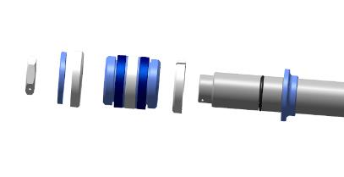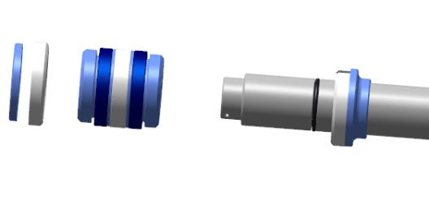
Find a vacant groove in the inner cavity of the piston (assembled by you earlier). Fit the piston with collars onto the rod, slide it along the rod until encountering a hard stop. Fit the ANG-3200-00032757-010 ring onto the rod on the male thread side, with its bevel (oblique portion) facing away from the rod male thread.
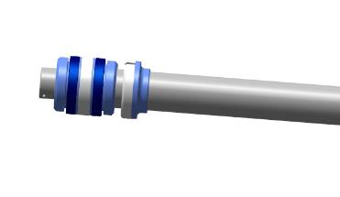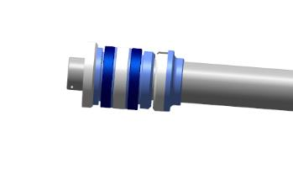
Place the ANG-3200-00032757-004 washer on the ring, screw the ANG-3200-00032757-008 nut on. Clamp the bottom portion of the rod with flats in a vice. Clamp only the portion with flats. Tighten the ANG-3200-00032757-008 nut with a 19 mm combination wrench. To avoid cross-threading and to facilitate tightening the nut, hold the item by the rod.
Unclamp the item from the vise.
Find the bottom cover with the fitted sensors. Apply a smear of machine oil to the inner surface of the bush. Fit the cover with threaded portion facing towards the piston, place the bush on the rod, slide it along the rod to the piston. The cover should travel along the rod without binding, but with some effort applied.
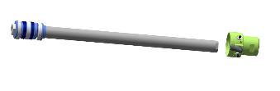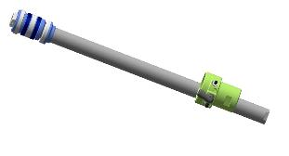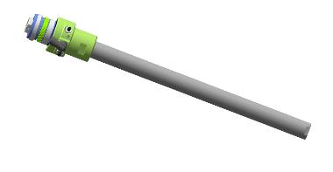

Find the ANG-3200-00032757-002 nut. Hand-screw the ANG-3200-00032757-002 nut into the rear portion of the rod with flats, until encountering a hard stop. The nut should screw in easily. Unscrew the nut from the rod.
Put on latex gloves and a respirator. Moisten a rag with solvent. Degrease the following items:
female thread of the ANG-3200-00033966-002 rod;
male thread of the ANG-3200-00032757-002 nut.
IMPORTANT! Take care not to apply any retaining compound to the degreased surface immediately. The retaining compound can be applied 5-10 minutes after degreasing.
Apply an even thin layer of LOCTITE 648 retaining compound to the female thread of the ANG-3200-00033966-002 rod. Set the rod aside on the table for later use. Apply an even thin layer of LOCTITE 648 retaining compound to the male thread of the ANG-3200-00032757-002 nut.
Hand-screw the ANG-3200-00032757-002 nut into the rear portion of the rod with flats, until encountering a hard stop. Holding it in place with a 17mm combination wrench, tighten the ANG-3200-00032757-002 nut with another 17mm combination wrench to take out the clearance between the rod and nut edges. Clean up with a rag any excess or squeeze-out.
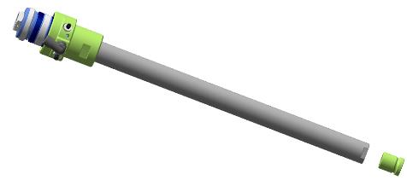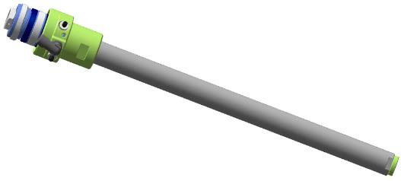

Find the hydraulic cylinder liner and the ANG-3200-00032740-004 locknut. Hand-screw the ANG-3200-00032740-004 locknut on the liner on the longer thread side.
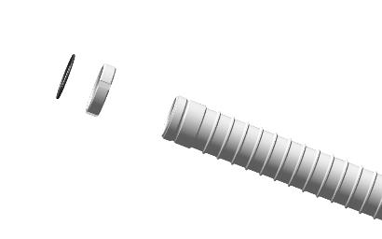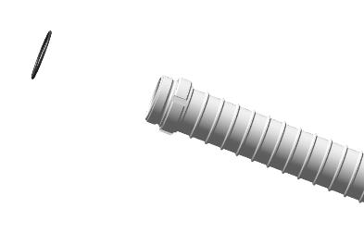
Find two 34-37-17 rings. Place the ring on the outer threaded portion of the ANG-3200-00033966-001 the hydraulic cylinder liner on any of its sides. Slide the ring carefully through the threads, seat it in place and align it in the groove of the liner.
Repeat the process above to fit the second 34-37-17 ring onto the ANG-3200-00033966-001 hydraulic cylinder liner.
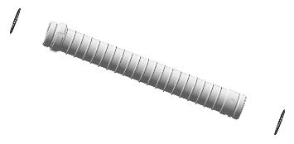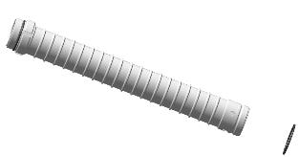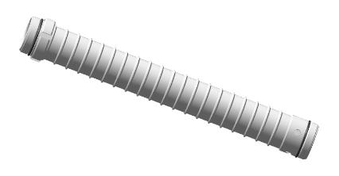
Find the ANG-3200-00032740-002 upper hydraulic cylinder cover. Hand-screw the ANG-3200-00032740-002 hydraulic cylinder cover onto the thread of the ANG-3200-00033966-001 liner until encountering a hard stop. The cover should screw on easily, without cross-threading or binding.
IMPORTANT! When screwing on the cover, avoid misalignment of the ring fitted onto the liner. If a misalignment occurs, unscrew the cover to align the ring in the groove and start over. Misalignment of the seal will result in a fluid leak.
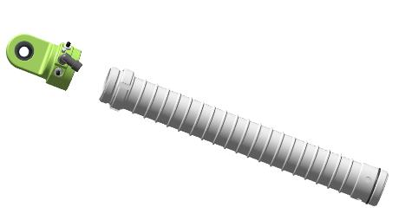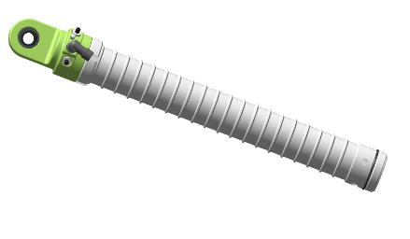
Place the liner with its cover on the table. Apply the TE liner wrench to the reinforced portion of the item. Tighten the parts with the TE top cover wrench for about 1/10 turn, until the sensation of some effort.
Dip your finger in oil several times, smear slightly the inner cavity of the liner, turning it in your hand. There should remain a shiny greasy trace. Smear slightly the prch-00032800 collars, dipping your finger in oil. There should remain a shiny greasy trace.
Check the position of the prch-00032794 spring clips (retainers) on the ANG-3200-00032740-003 and ANG-3200-00032740-002 hydraulic cylinder covers. Turn the ANG-3200-00032757-010 rings in such a manner that their split portions are positioned opposite to the prch-00032794 spring clips (retainers). Mark the position of the ANG-3200-00032757-010 ring slits with a marker on the edges of the rod bushings.
Fit to the piston portion the assembly semi-rings and tighten them with a clamp. Fit onto the assembly semi-rings the ANG-3200-00033966-001 liner, place the piston into the liner with a with the mark facing away from the prch-00032794 spring clips (retainers). Seat the liner onto the rod, tapping gently with a hammer on the ANG-3200-00032740-002 upper cover. After the assembly semi-rings slide onto the rod, take them off by removing the clamp. Slide the ANG-3200-00032740-003 lower cylinder cover along the rod down to the liner thread. Hand-screw the cover untill encountering a hard stop. The cover should screw on easily, without cross-threading or binding.
IMPORTANT! When screwing on the cover, avoid misaligning the ring, fitted on the liner. If a misalignment occurs, unscrew the cover to align the ring in the groove and start over. A misaligned seal will result in fluid leak.
Apply the TE liner wrench to the reinforced portion of the item. Tighten the parts with the TE bottom cover wrench for about 1/10 turn until the sensation of some effort. Check the position of the covers relative to each other - the threaded bore of the ANG-3200-00032740-003 lower hydraulic cylinder cover should be positioned in the middle, between the threaded bores of the ANG-3200-00032740-002 upper cover. If there is no such arrangement, tighten the covers one by one with wrenches.
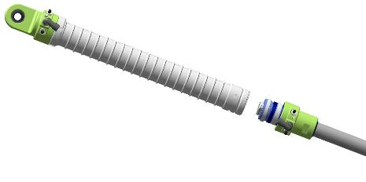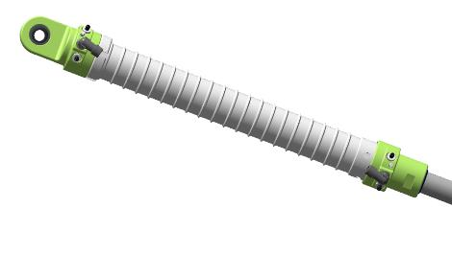
Make sure the gas cylinder is closed and the needles on both gauges point to "0". Set the nitrogen regulator to "0", make sure that the valves of the charging device are closed.
IMPORTANT! Do not leave the cylinder valve open for a long time and the hose under pressure.

Attach the test device coupling to the 2010 1/8 fitting on the ANG-3200-00032740-003 lower cylinder cover through the full thread length.
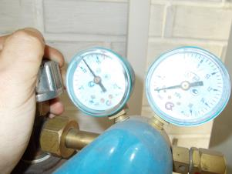
IMPORTANT! It is impermissible to use oxygen instead of compressed air!!! It will result in an explosion!!! The use of compressed air pressure exceeding 35 atmospheres (3.5 MPa) is impermissible.
Open the valve on the cylinder, set the pressure on the second pressure gauge to 10 atm (1 MPa). Open the gas valve on the charging device. The hydraulic cylinder rod must retract.
Checkup operations:
Set your multimeter to continuity test (or minimum resistance). Check for the appropriate adjustment, by touching the test probes together. A sound should be heard (or the needle should point to "0"). Place the test probes on the prch-00032794 spring clips of the ANG-3200-00032740-002 upper cover. A sound should be heard (or the needle should point to ""0"). Touch with a multimeter probe the 2010 1/8 fitting and touch with the second probe one of the prch-00032794 spring clips. A sound should be heard (or the needle should point to ""0"). Touch with a multimeter probe the second prch-00032794 spring clip . A sound should be heard (or the needle should point to ""0").
Repeat the process above to check the prch-00032794 spring clips of the ANG-3200-00032740-003 lower cover. A sound should not be heard (or the needle should point to any values).
Open the gas valve on the charging device. Check each 2010 1/8 fitting for air leak, touching it with your finger. There should be no air leak.
IMPORTANT! If the air is escaping from the 2010 1/8 fitting, this is the evidence of improper installation or damage to the collars.
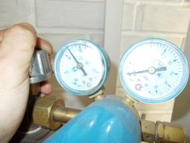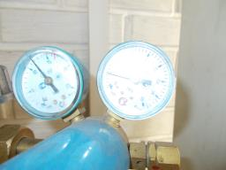
Note. If the rod does not travel, gradually increase the pressure, not exceeding 15 atmospheres (1.5 MPa).
Uncrew the test device coupling from the lower cover, and attach it to any of the 2010 1/8 fittings.
Uncrew the test device coupling from the lower cover, and attach it to the unmarked 2010 1/8 fitting. Place your finger on the marked 2010 1/8 fitting of the ANG-3200-00032740-002 upper cover.
Open the gas valve of the charging device. The rod of the hydraulic cylinder should come out, a click can be heard in the cover while the ANG01-0-3233-5001-00 piston is travelling from its end position. Make sure that the air does not leak from the marked 2010 1/8 fitting of the ANG-3200-00032740-002 top cover.
Repeat the process described above 10-15 times for checking the operation of the hydraulic cylinder with air and checking the contacts.
Find the prch-00032781 rod end and the std-00029674 nut. Hand-screw the nut onto the threaded portion of the prch-00032781 rod end until encountering a hard stop. Hand-screw the rod end with the nut into the threaded portion of the rod edge until encountering a hard stop. Set the hydraulic cylinder aside on the table for later use.
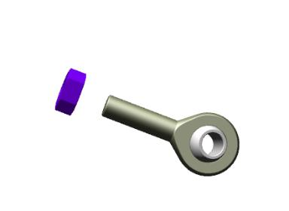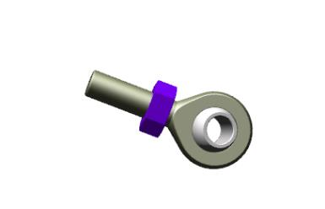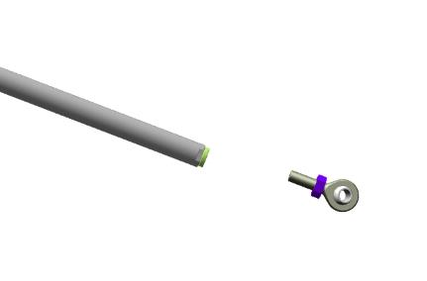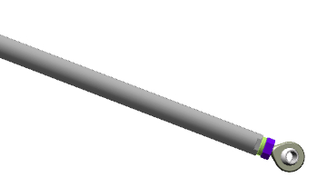

Repeat the whole process described above in the same sequence for the two remaining hydraulic cylinders.

4.8 Fit the nose landing gear
To carry out this task you will need:
Movable table;
Slotted (flat-tip) screwdriver №2;
LOCTITE 648 retaining compound;
Two 17 mm combination keys;
Unpack and place on the table:
Nose landing gear leg (assembled as per 4.6);
Landing gear retract hydraulic cylinder (assembled as per 4.7);
Two ANG-5330-00029526-002 bolts;
One 10x65 DIN 912 bolt;
One М10 DIN 935 nut;
Two 10 DIN 127 washers;
One 2x60 DIN 94 cotter pin.
IMPORTANT! Before performing any kind of work, make sure that the part of the aircraft to be worked under is properly secured and stable. Inadequately secured parts can be damaged or cause an injury when falling.
Approach the nose landing gear leg with the torque link to the fuselage. Raise the landing gear leg up to match the middle stud with the bearing bore. Insert the stud into the bearing. Place the DIN 127 washer 10 on the protruding threaded portion, screw the nut M10 DIN 935 on.
Align the bush of the nose landing gear truss with the bearing bore of the fuselage.
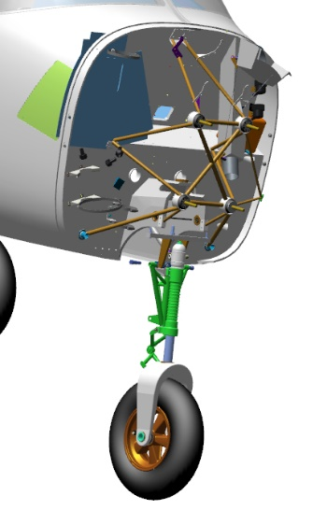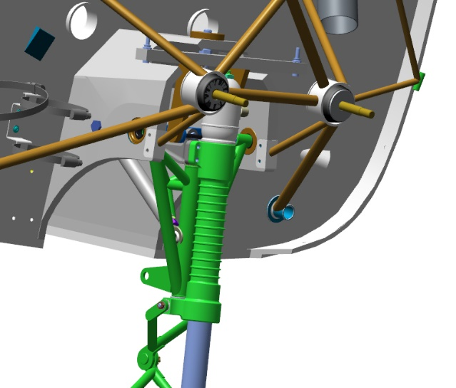
Feed the ANG-5330-00029526-002 bolt into the aligning bore of the fuselage, screw the bolt into the thread of the nose landing gear truss bush.
Repeat the process for the second ANG-5330-00029526-002 bolt. Tighten the two bolts with a 17 mm combination wrench until encountering a hard stop against the 10 DIN 127 washer.
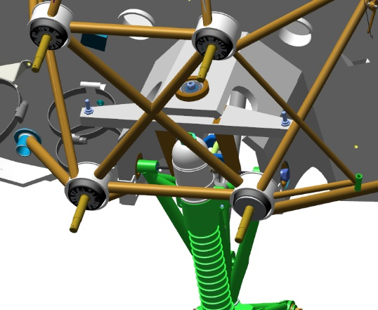
Get under the fuselage besides the nose landing gear leg.
Fold the nose landing gear leg by hand into the bay (well), simulating the landing gear retraction. Check the retracted landing gear leg for abutting against other structural elements of the aircraft, and for difference in clearance. Clearance should be uniform and approximately equal on both sides of the landing gear leg. There should be no abutting against the elements of the fuselage structure. Repeat the movement and checking for 2-3 times.
Get to your feet. Unscrew one ANG-5330-00029526-002 bolt with a 17 mm combination wrench.
Moisten a rag with solvent, degrease the threaded portion of the ANG-5330-00029526-002 bolt, the threaded portion of the nose landing gear truss bush.
IMPORTANT! Take care not to apply any retaining compound to the degreased surface immediately. The retaining compound can be applied 5-10 minutes after degreasing.
Apply a thin even layer of the LOCTITE 648 retaining compound to the degreased surface of the ANG-5330-00029526-002 bolt. Fit the bolt into the threaded hole of the nose landing gear truss. Tighten it with a 17mm combination wrench.
Repeat the process above for the second bolt on the opposite side of the fuselage.
Clean your workplace and tools as per the standard operation 7.
Tighten the nut on the center bearing at the top of the landing gear leg with a 17 mm combination wrench, to fully and tightly seat it on the 10 DIN 127 washer. Find a hole in the landing gear stud, which should align with the slot of the M10 DIN 935 nut. If the hole is not visible, tighten the nut until aligning the bore with the slot.
IMPORTANT! Do not loosen the nut to align the hole with the slot. This will result in a quick failure of the assembly and play in the control system.
Place the 2x60 DIN 94 cotter pin into slot of the M10 DIN 935 nut aligning with the bores of the stud. Cotter the connection by bending aside the cotter pin ends with a slotted (flat-tip) screwdriver No. 2.
Find the hydraulic cylinder (assembled as per 4.7), the 10x65 DIN 912 bolt, the 10 DIN 127 washer. Find a hole in the landing gear bay (well). Insert the 10x65 DIN 912 bolt into the hole. The bolt should fit in easily. Remove the bolt from the hole.
Align the holes of the cylinder bearing inside the gear bay (well). Once the hole are aligned, fit into them the bolt. Tighten the bolt with a wrench.
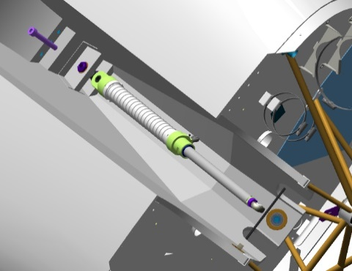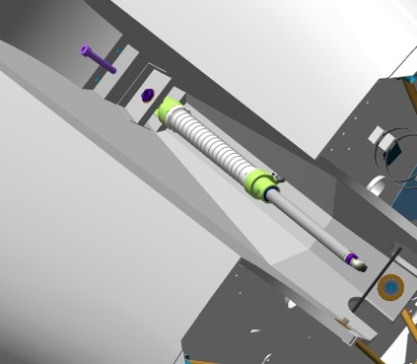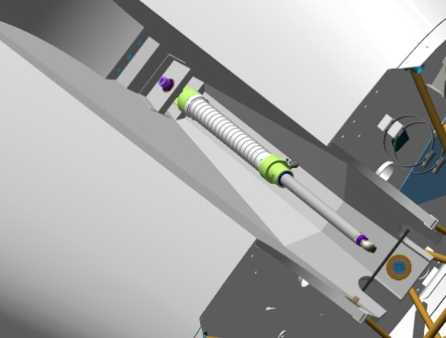
Find two lugs on the nose landing gear truss, on the landing gear bay (well) side. Position between the lugs the rod end of the hydraulic cylinder, align the holes.
Fit into the aligning bores the hydraulic cylinder attachment bolt, put in place the 10 DIN 127 washer and the M10 DIN 935 nut, tighten the nut to seat it fully on the 10 DIN 127 washer.
Find a bore in the bolt that should align with the slot of the M10 DIN 935 nut. If the hole is not visible, tighten the nut slightly to align the bore with the slot.
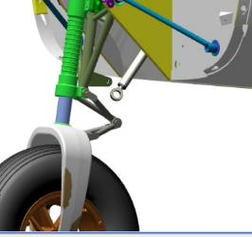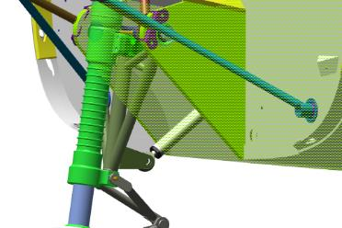
IMPORTANT! Do not loosen the nut to align the hole with the slot. This will result in a quick failure of the assembly and its backlash.

Place a cotter pin into the slot of the M10 DIN 935 nut aligning with the bores of the hydraulic cylinder attachment bolt. Bend one end cotter pin end aside but do not cotter it.
Checkup operations:
Check for freedom of rotation of the wheel. The rotation should be easy without jerks or binding.
To be added: clearances between the landing gear leg and the casing in retracted position, cottering, backlash
Нужно добавить контрольные операции: зазоры между опорой и коробом в убранном положении, контровка, люфты

4.9 Fit the main landing gear legs
Note. The operations described below pertain to the left main landing gear. Mounting of the right landing gear is performed in the same sequence.
To carry ot this task you will need:
Movable table;
Slotted (flat-tip) screwdriver № 2;
LOCTITE 648 retaining compound;
Two 17 mm combination keys;
19 mm socket head;
Socket head handle:
Unpack and place on the table:
Left landing gear leg (assembled by you earlier);
Right landing gear leg (assembled by you earlier);
2 landing gear retract cylinders (assembled by you earlier);
4 ANG-5313-00029347-002 bearing block bolts;
4 М10 DIN 935 nuts;
Two10 DIN 127 washers;
Two 2x60 DIN 94 cotter pins
Two М10х65 DIN 912 bolts
IMPORTANT! Before performing any kind of work, make sure that the part of the aircraft to be worked under is properly secured and stable. Inadequately secured parts can be damaged or cause an injury when falling.
Check the M16 threaded bores in the main landing gear leg as per the standard operation 6.
Fing two bores with bearings at the top of the main landing gear bay (well). Make sure that are free of any foreign objects. Find the ANG-5313-00029347-002 bearing block bolt, check the ease of fitting the bolt into the bearing. The bolt should fit in each bore easily, without any play and jerks.
You will need a helper to carry on with this task.
Approach and roughly align the bores of the main landing gear with those of the landing gear bay (well). Insert the bolt from behind having placed it into a19mm socket with a tommy bar. Turning the socket clockwise, advance the fixture towards the landing gear leg until you feel the engagement of the threaded portions. If it does not engage, adjust the landing gear leg. Tighten the bolt until until it feels snug.
IMPORTANT! If the threaded parts engage, but rotation requires force, remove the bolt and start over.
Feel for the bore to fit second bolt of the ANG-5313-00029347-002 bearing block.
Repeat the process described above to fit the second bolt.
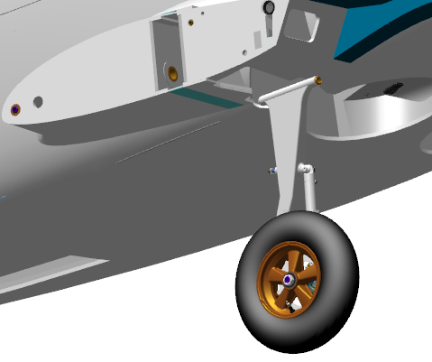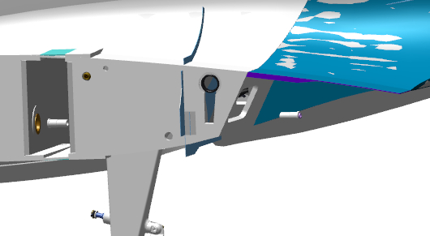
Get under the fuselage besides the main landing gear.
Checkup operations:
Fold the landing gear by hand into the bay (well), simulating a landing gear retraction. Check the retracted landing gear leg for abutting against other structural elements of the aircraft, and for differences in clearance. Clearance should be uniform and approximately equal to the outline of the landing gear wheel. There should be no abutting against the elements of the fuselage structure.
Repeat the movement and checking for 2-3 times. Move the landing gear leg out of the landing gear bay (well).
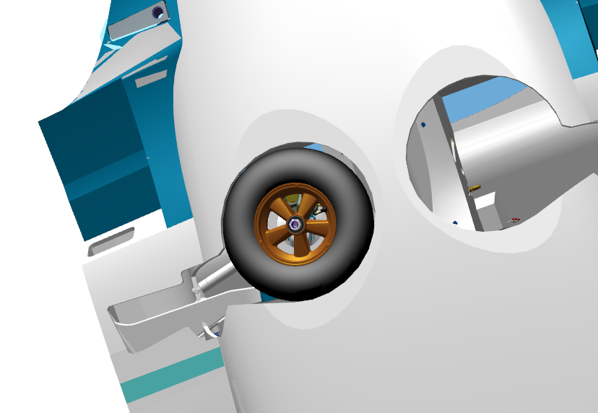
Unscrew one ANG-5313-00029347-002 bolt with a 19mm socket, equipped with a tommy bar. Moisten a cloth with solvent, degrease the threaded portion of the ANG-5313-00029347-002 bolt.
IMPORTANT! Take care not to apply any retaining compound to the degreased surface immediately. The retaining compound can be applied 5-10 minutes after degreasing.
Apply an even thin layer of LOCTITE 648 retaining compound to the degreased surface of the ANG-5313-00029347-002 bolt.
Insert the bolt into the threaded bore of the landing gear truss. Tighten the ANG-5313-00029347-002 bolt with the 19 mm socket equipped with a tommy bar until it feels snug.
Repeat the process above to fit the second bolt to the inner side of the fuselage.
Clean your workplace and tools as per the typical operation 7.
Find the hydraulic cylinder (assembled by you earlier), the M10x65 DIN 912 bolt, the M10 DIN 935 nut, the 10 DIN 127 washer, the 2x60 DIN 94 cotter pin. You will need a helper to carry on with this task.
Place all the parts under the fuselage in the area of ​​the main landing gear bay (well), except for the M10x65 DIN 912 bolt. Find a hole in the back sofa. Fit into the hole the hydraulic cylinder mounting bolt. The bolt should fit in easily.
Find a stud (pin) on the bay side of the main landing gear casing. Fit the rod end of the hydraulic cylinder to the stud, place on the stud the 10 DIN 127 washer and the M10 DIN 935 nut, tighten the nut a 17 mm combination wrench to seat it fully and firmly onto the 10 DIN 127 washer. Find in the stud a bore, which should align with the slot of the M10 DIN 935 nut. If the bore is not visible, tighten the nut to align the bore with the slot.
IMPORTANT! Do not loosen the nut to align the hole with the slot. This will result in a quick failure of the assembly and its play.
Feed a cotter pin into the slot of the M10 DIN 935 nut aligning with the holes in the hydraulic cylinder attachment bolt. Bend one end cotter pin end aside but do not cotter it.
Get under the fuselage. Find a bore in the bay (well). Align the bearing bore in the cover with that of the rear sofa inside the bay. Once the bores are aligned, ask your helper to insert the bolt. Make sure that the bolt is inserted through the bearing.
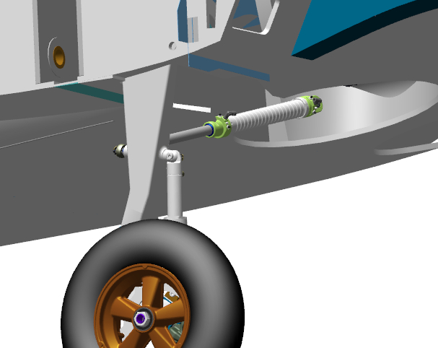
Once the work with the left main landing gear leg is completed, repeat the process for the other side.
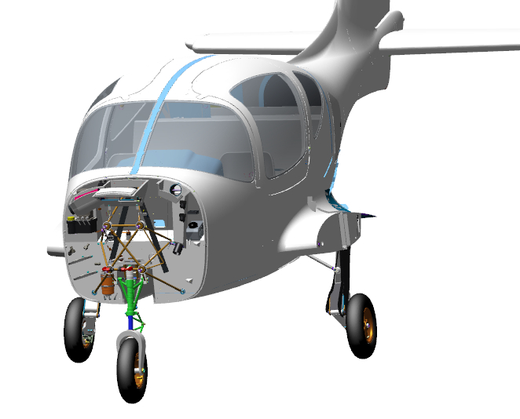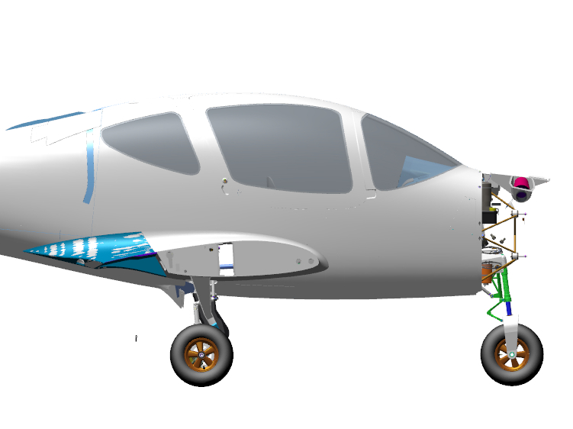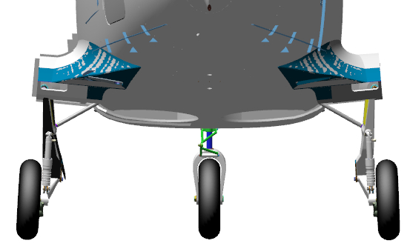

4.9.1 Fit the footrests
Олегу написать раздел

PART 5 ASSEMBLE THE CONTROL SYSTEM

5.1 Assemble the rudder pushrod
The objective of this task is to assemble the rudder pushrod in the tail area.
To carry ot this task you will need:
Movable table;
8 mm combination wrench;
Latex gloves 1 pair;
Solvent methyl acetate 100 grams;
100x100 mm clean rag 1 piece;
Respirator;
Vernier caliper 300 mm;
LOCTITE 648 retaining compound.
Unpack and place on the table the tube marked ANG-2700-00055170-001.
Count and place on the table:
2 М5 DIN 934 nuts;
2 spherical rod ends marked std00028321.
Take 2 std 00028321 rod ends, screw one M5 nut onto the threaded portion of each rod end until encountering a hard stop.
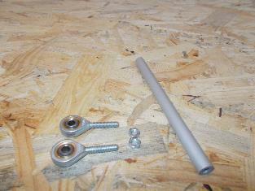 | 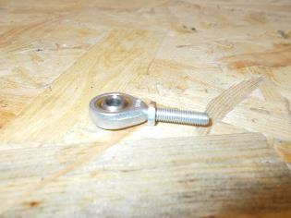
Set the vernier caliper to 145mm and secure the value.
Screw the rod ends one by one into the ANG-2700-00055170-001 tube up to approximately mid-length. Check, using the vernier caliper that the length is 145 mm. Screw one rod end in for 1-2 turns. Recheck the length with the vernier caliper.
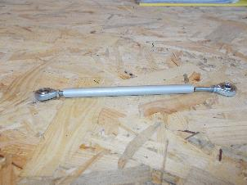 | 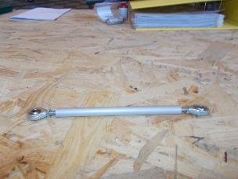 | 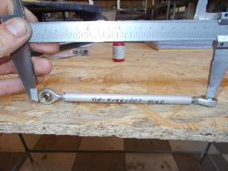
Once the desired value is obtained, tighten one M5 nut so that it rests against the ANG-2700-00055170-001 tube. Carefully, without letting the M5 nut turn, detach the std00028321 rod end from the ANG-2700-00055170-001 tube.
Put on latex gloves and a respirator. Moisten a rag with solvent. Degrease the threaded portion of the std0002832 rod end that is to be screwed into the tube.
IMPORTANT! Take care not apply any retaining compound to the degreased surface immediately. The retaining compound can be applied 5-10 minutes after degreasing.
Apply an even thin layer of LOCTITE 648 retaining compound to the degreased surface of the rod end.
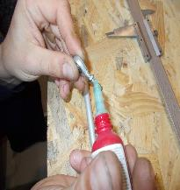
Screw the end rods successively into the ANG-2700-00055170-001 tube, approximately to the mid-length thereof. Check, using the vernier caliper that the length is 145 mm. Once the desired value is obtained, tighten the M5 nut with the 8mm wrench so that it rests against the ANG-2700-00055170-001 tube.

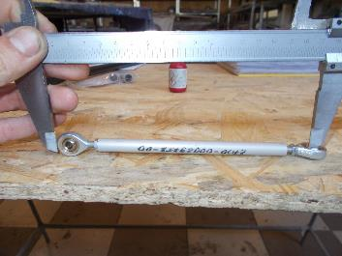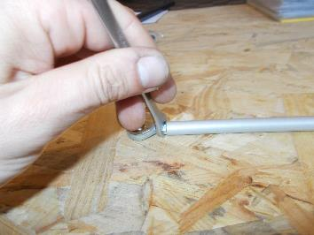

Tighten the second M5 nut with the 8mm wrench so that it rests against the ANG-2700-00029758-001 tube.
IMPORTANT! Do not fit the second std00028321 end rod at this stage of the task, applying LOCTITE 648 retaining compound. The end rod will be needed for the adjustment of the control system in the course of further assembly of the aircraft, and will be permanently secured after adjustments.

Clean work area and tools as per the typical operation 7.
Checkup operations:
Контрольные операции:
Нужно добавить контрольные операции: длины, подшипники, люфты

P 26-52
Find the ANG-3220-028485-002 bush and the 010_014_25 ring. Fit the 010_014_25 ring into the groove of the ANG-3220-028485-002 bush on the side opposite to the thread. Fit the ANG-3220-028484-005 damper and the ANG-3220-028484-004 thrust bush onto the ANG-3220-028485-001 tube-rod. Screw the ANG-3220-028485-002 bush into the thread of the rod-tube ANG-3220-028485-001. The bush should easily screw in through the thread length until encountering a hard stop.
Unscrew the bush from the rod-tube and place the parts on the table. Put on latex gloves and a respirator. Moisten a rag with solvent. Degrease the following items:
Male thread of the ANG-3220-028485-002;
Female thread of the ANG-3220-028485-001tube-rod;
IMPORTANT! Take care not apply any retaining compound to the degreased surface immediately. The retaining compound can be applied 5-10 minutes after degreasing.
Apply an even thin layer of LOCTITE 648 retaining compound to the degreased threaded surface of the ANG-3220-028485-001rod-tube. Set the tube-rod aside on the table for later use. Apply an even thin layer of LOCTITE 648 retaining compound to the degreased threaded surface of the ANG-3220-028485-002 bush. Screw the bush into the rod tube to take out the clearance between the edges of the parts.
Clean your workplace and tools as per the typical operation 7.
Feed a 0.8 mm, 200 mm long safety wire through a locking hole in the ANG-3220-028485-002 bush. Make 3-4 twists in safety wire.
Find the ANG-3220-028484-001 rod and the ANG-3220-028483-001 landing gear shock absorber housing. Verify the shock absorber housing for the absence of foreign objects in its inner cavities. There should be no foreign objects.
Fit the the holed part of ANG-3220-028484-001 rod into the wiper on the ANG-3220-028483-001 landing gear shock absorber housing. Avoiding misalignment, carefully slide the rod into the housing for its full travel. Clamp it in a vice, using aluminum pads, the bearing portion of the shock absorber housing, with its rod facing downwards.
Fit the rod-tube with its parts into the rod. Fit the ANG-3220-028484-005 damper into the groove of the ANG-3220-028484-001 rod on the female thread side. Spread it out in the groove. Screw the ANG-3220-028484-004 thrust bush into the female thread of the ANG-3220-028484-001 rod. The bush should screw easily into the rod.
 | 
Clean your workplace and tools as per typical operation 7.
Find the ANG-3220-028483-002 upper turret and the ANG-3220-028485-006 nut. Approach the threaded part of the ANG-3220-028483-002 upper turret to the landing gear leg. Feed the wire on the ANG-3220-028485-002 bush through the upper hole of the turret. Screw the turret into the shock absorber housing for several turns.
Pull the ANG-3220-028485-002 bush through the turret hole with the wire until the thread projects over the turret. Place the ANG-3220-028485-006 nut on the wire, and hand-screw it on the ANG-3220-028485-002 bush until encountering a hard stop. Remove the wire.
IMPORTANT! When screwing on the cover, take care not to deform the ring fitted onto the sleeve. If deforming occurs, unscrew the cap until the ring aligns in the groove and start over. Misalignment of seal will result in fluid leak.
Tighten the ANG-3220-028483-002 upper turret with a strap wrench into the shock absorber housing until the edges of the turret encounter a hard stop against the housing and the clearance between them is closed. Tighten the ANG-3220-028485-006 nut with a 19 mm combination wrench until the protrusion of one thread, securing the connection from turning with a flat bit screwdriver No. 3 behind the ANG-3220-028485-002 bush.
Check the shock absorber travel by pressing the top of the landing gear leg then extend it. The shock absorber stroke should be smooth, with an average effort (5-10 kg).
Feed 0.8mm safety wire into the hole in the ANG-3220-028485-002 bush. Pull the wire through, bend and route it into the ANG-3220-028485-006 nut bore. Pull firmly at both ends of the wire to align it. Make a 6-8 twists near the nut, sever the remaining parts of the wire, bend the twist towards the ANG-3220-028485-002 bush.
Find the prch-00027867 charging valve. Hand-screw the valve into the side orifice in the ANG-3220-028483-002 upper turret. The valve should easily screw into the orifice. Unscrew the valve, moisten a rag with solvent. Degrease the following items:
Male thread of the prch-00027867charging valve;
Female thread of the ANG-3220-028483-002 upper turret.
IMPORTANT! Take care not to apply any retaining compound to a degreased surface immediately. The retaining compound can be applied 5-10 minutes after degreasing.
Apply a level thin layer of LOCTITE 648 retaining compound to the degreased threaded surface of the ANG-3220-028483-002 upper turret. Apply a level thin layer of LOCTITE 648 retaining compound to the degreased threaded surface of the prch-00027867 charging valve. Screw the valve into the upper turret, tighten it with a 11 mm combination wrench to seat it fully home.
 | 
Clean your workplace and tools as per typical operation 7.
IMPORTANT! It is forbidden to fill in the fluids and to charge the units with gas earlier than 2 hours after applying retaining compound.
4.4.2 Charging the shock absorber with working fluid and gas
To carry out this task you will need:
Movable table;
Nose landing gear shock absorber (assembled earlier);
PMS-20 silicone oil 100 ml;
Plastic cup 200 ml 3 pieces;
Disposable medical syringe with a 60 ml needle 1 piece;
Valve core installer wrench;
Bench vice 100 mm;
Aluminum vice pads 2 pieces;
Industrial nitrogen in a cylinder (pressure bottle);
Shock absorber charging device;
Liquid soap;
Latex gloves 1 pair;
Clean rags 100x100 mm 2 pieces;
Compress the shock absorber until encountering a hard stop. Clamp it in the vice in a tilted position, using the aluminum pads (jaw lining), with its coupling facing upwards. Unscrew the cap from the charging valve and put it in a cup. Detach the core from the coupling with a valve core wrench, put it in a cup.

IMPORTANT! Do not put any small-sized aircraft parts on the table. They can be lost. Use a container. Fill the syringe with the needle removed. This will allow you to draw in the fluid without cavitation effects.
Put on latex gloves. Draw 60 ml of PMS-20 silicone oil into the syringe. Attach the needle to the syringe, insert the syringe needle into the orifice of the charging valve, until the needle encounters a hard stop against the wall. Push the syringe plunger smoothly and slowly to inject silicone oil. Extract the needle smoothly out of the charging valve.
IMPORTANT! The needle of the syringe, due to its small diameter, allows to escape the air which is displaced out of the inner cavities of the shock absorber when filled with liquid. Do not apply any undue force to the syringe plunger. This will dislodge the needle from the syringe and result in spilling the fluid.
Screw the cap onto the charging valve. Extend the shock absorber for its full stroke. Push gently on the top of the shock absorber, compress the shock absorber for about its half stroke. Unscrew slowly and remove the charging valve cap. The air must bleed out. Extend the shock absorber for its full stroke.
Unscrew and slowly remove the cap from the charging valve. The air must bleed out. Extend the shock absorber for its full stroke. Draw 40 ml of PMS-20 Silicone oil into the syringe. Attach the needle to the syringe, insert the needle syringe into the orifice of the charging valve, until the needle encounters a hard stop against the wall.
Push the syringe plunger gently and slowly to inject silicone oil. Extract smoothly the needle out of the charging valve. PMS-20 Silicone oil may spill. Screw the cap onto the charging valve.
Push gently on the top of the shock absorber, compress the shock absorber until encountering a hard stop. The shock absorber rod may recoil from the bottom point after removing the hand. Extend the shock absorber for its full stroke. Unscrew slowly and remove the charging valve cap. The air must bleed out. PMS-20 Silicone oil may spill. Use the wrench to screw the core into the charging valve.
Turn the rod to align shock absorber lugs and to position the charging valve either on the right or on the left side. Unclamp the shock absorber from the vice. Wipe off with a dry, clean rag any excess silicone oil, spilt during the recharging process.
Make sure that the bottle is closed and the arrows on both gauges read "0". Set the nitrogen pressure regulator to position "0", make sure that the valves of the charging device are closed.

IMPORTANT! Do not leave the cylinder valve open for a long time and the hose under pressure.
Screw the charging device coupling to the shock absorber charging valve through the full thread length. Open the cylinder valve, set the pressure on the second pressure gauge to 10 atm (1 MPa). Open (screw in) the core valve. Open the gas feed valve on the charging device. Close (unscrew) the core valve, close the gas feed valve on the charging device.
Open (screw in) the core valve. Open the gas feed valve on the charging device. Close (unscrew) the core valve, close the gas feed valve on the charging device. Detach the charging device coupling from the charging valve. Replace the cap on the charging valve.


Checkup operations:
Verify the shock absorber for likely silicone oil leak. There should be no oil leak. Set the shock absorber vertically on the floor, with its turret down, and push hard on its the top. There should be no shock absorber stroke.
Take the shock absorber in your hand. Apply a continuous thin layer of liquid soap around the charging valve. In case of leak, there will appear the bubbles. There should be no bubbles.
Apply a continuous, thin layer of soap to the rod near the wiper, along the line of contact between the turret and the housing. The bubbles should be absent. Remove liquid soap from the test areas with a dry, clean cloth.

4.5 Assemble the main landing gear legs
Note.The operations described below pertain to the left main landing gear leg. The assembly of the right landing gear is to be performed in the same sequence.

To carry out this task you will need:
Movable table;
13 mm combination wrench 2 pieces;
10 mm combination wrench 2 pieces;
Slotted screwdriver №1;
600 gram bench hammer;
Litol-24 lubricant 10 grams;
Latex gloves 1 pair;
Methyl acetate solvent 100 grams;
Clean rag 100x100 mm 2 pieces;
Adjustable wrench from 10 to 32 mm;
Combination wrench 17 mm;
LOCTITE 648 retaining compound.
Unpack and place on the table:
Upper leg marked ANG-3200-00030921-00;
Upper leg marked ANG-3200-00030921-00Z;
Lower arm marked ANG-3200-00030922-00;
Lower arm marked ANG-3200-00030922-00Z;
2 tubeless wheels ANG-3200-00031005-00;
2 bolts marked ANG-3200-00030920-009;
2 nuts marked ANG-3200-00030920-008;
4 bolts marked ANG-3200-00052570-021;
8 bolts marked ANG-3200-00052570-011;
2 shock absorbers (assembled earlier);
2 wheel nuts marked ANG-3200-00034065-004;
2 brake discs marked ANG-3200-00031000-011;
Left brake caliper (assembled earlier);
Right brake caliper (assembled earlier);
2 movable pads marked ANG-3200-00031000-01;
2 fixed pads marked ANG-3200-00031000-02;
Count and place on the table:
8 М6 DIN 985 nuts;
eight 6 DIN 127 washers;
eight 6 DIN 125 washers;
4 М8 DIN 935 nuts;
four 8 DIN 127washers;
four 1,6x30 DIN 94 cotter pins;
IMPORTANT! Take care to avoid prolonged exposure of shock absorbers to direct sunlight. The shock absorbers are charged with high pressure nitrogen.
Find the ANG-3200-00030922-00 lower arm, the ANG-3200-00030921-00 upper leg, the ANG-3200-00030920-009 bolt, the ANG-3200-00030920-008 nut. Place the upper part of the arm into the gear fork (yoke), align the bores. Fit into the aligning bores the ANG-3200-00030920-009 bolt, with its head on the side of the hexagonal recess on the arm fork (yoke). Push the bolt through until it shows completely out and its head is aligned in the recess. Place the ANG-3200-00030920-008 nut on, tighten it with a 17mm wrench.
Move the arm several times relative to the leg. It should move smoothly, without any bonding and play (backlash).
IMPORTANT! A play will result in rapid wearing of the bushes and collapse of the assembly.
 |  | 


Find the shock absorber. Turn the shock absorber so that the charging nipple faces towards the wheel axle, place the lower part of the shock absorber into the lugs of the ANG-3200-00030922-00 lower arm, align the bores. Insert into the bores the ANG-3200-00052570-021 bolt with the head on the wheel axle side. Place the 8 DIN 127 washer onto the bolt, screw the M8 DIN 935 nut on, tighten the nut to seat it fully and firmly onto the 8 DIN 127 washer. Find a bore in the bolt, which is supposed to align with the slot of the M8 DIN 935 nut. If the hole is not visible, tighten slightly the nut to align the bore with the slot.
IMPORTANT! Do not loosen the nut to align the bore with the slot. This will result in quick failure of the assembly and its play.
Fit the cotter pin 1.6x30 DIN 94 into the slot of the M8 DIN 935 nut aligning with the bores in the bolt. Secure the connection by bending the cotterpin ends with a slotted (flat-tip) screwdriver №1.
Fit the upper part of the shock absorber into the shock absorber lugs on the ANG-3200-00030921-00 leg, to align the holes by sliding the strut onto the shock absorber.
Insert the bolt into the bores, with its head on the wheel axle side. Place the 8 DIN 127 washer onto the bolt, screw the M8 DIN 935 nut on. Tighten the nut to seat it fully and firmly onto the 8 DIN 127 washer. Find a bore in the bolt, which is supposed to align with the slot of the M8 DIN 935 nut. If the hole is not visible, tighten slightly the nut to align the bore with the slot.
IMPORTANT! Do not loosen the nut to align the bore with the slot. This will result in quick failure of the assembly and its play.
Fit the 1.6x30 DIN 94 cotter pin into the slot of the M8 DIN 935 nut aligning with the bores in the bolt. Secure the connection by bending the cotter pin ends with a slotted (flat-tip) screwdriver №1.

Find the ANG-3200-00030922-00 lower arm, the brake caliper, 4 ANG-3200-00052570-011 bolts, 6 DIN 127 and 6 DIN 125 washers, 4 pieces each, 4 M6 DIN 985 nuts. Fit the brake caliper to bracket on the right of the wheel axle. Align the bracket and caliper bores. Fit into aligning bores 4 ANG-3200-00052570-011 bolts, with their heads on the wheel axle side.
Place the 6 DIN 125 and 6 DIN 127 washers and the M6 DIN 985 nuts onto the bolts, tighten them with a wrench.


Find the ANG-3200-00031000-01 moveable brake pad and the ANG-3200-00031000-02 fixed brake pad. Fit the ANG-3200-00031000-01 movable brake pad into the grooves of the brake caliper. ANG-3200-00031000-01, with its lining facing towards the wheel axle. Slide the pad until encountering a hard stop. Fit the ANG-3200-00031000-02 fixed brake pad into the grooves of the brake caliper, with lining facing away from the wheel axle. Slide the pad on until encountering a hard stop.
Find the ANG-3200-00031000-011 brake disc.

Place the disc through the axle, fit it between the pads in the caliper. Place the landing gear leg on the table with the wheel axle up. Fit a tubeless wheel to the ANG-3200-00031005-00 axle, with the charging valve facing away from the landing gear.
Slide the ANG-3200-00031005-00 tubeless wheel along the axis, to align its protrusion level with the wheel. Guide the ANG-3200-00031000-011brake disc grooves to the ridges (bosses) on the ANG-3200-00031005-00 wheel hub.
Push the wheel all the way down till encountering a hard stop. Stand the landing gear leg on the wheel, check if the brake disc ANG-3200-00031000-011 is properly fitted into the grooves of the ANG-3200-00031005-00 tubeless wheel hub. Place the landing gear leg on the table with the wheel facing up. Check the wheel for freedom of movement. It should rotate smoothly without jerks or binding.
IMPORTANT! Undue over-tightening of wheel nuts can damage the bearings.
Find the ANG-3200-00034065-004 wheel nut. Place on the wheel axle the ANG-3200-00034065-004 landing gear wheel nut, hand-tighten it until encountring a hard stop.
Set the adjustable wrench to 32 mm. Tighten the ANG-3200-00034065-004 landing gear wheel nut with the adjustable wrench until its hexagonal portion encounters a hard stop against the wheel collar.
Checkup operations:
Check the wheel for freedom of movement. It should rotate smoothly without jerks or binding.
Нужно добавить контрольные операции: зазоры между колесом и амортизатором, между диском и суппортом, контровка, люфты

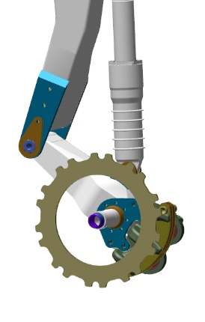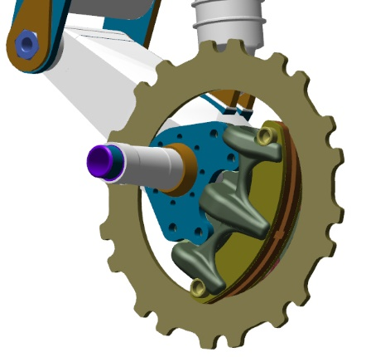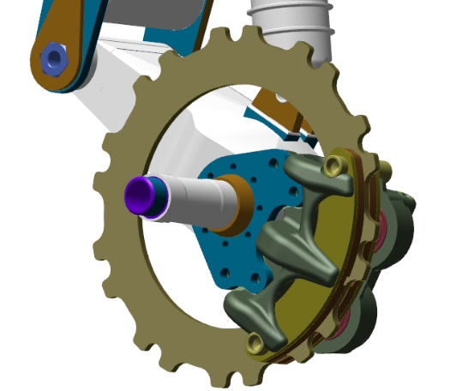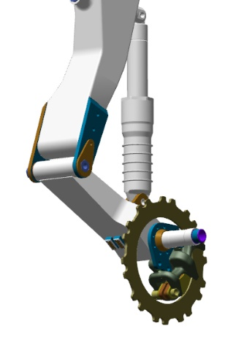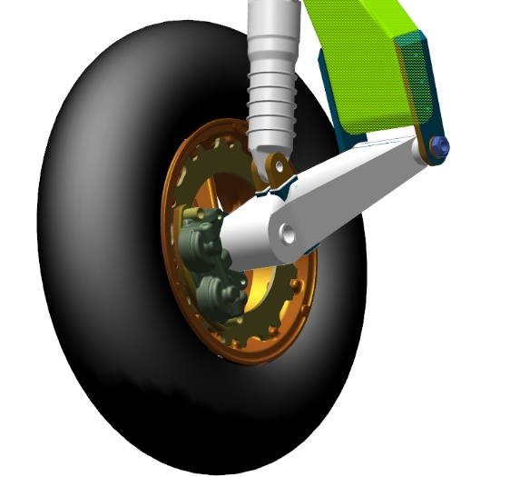

  - Assemble nose landing gear leg
To carry out this task you will need:
Movable table;
8 mm combination wrench 2 pieces;
Combination wrench 10 mm;
14 mm combination wrench;
LOCTITE 648 retaining compound;
Methyl acetate solvent 100 grams;
Clean rag 100x100 mm 2 pieces;
Latex gloves 1 pair;
Unpack and place on the table:
Bellcrank marked ANG-3200-00034203-00;
Nose landing gear truss marked ANG-3220-00030227-00;
Universal link marked ANG-3200-00032916-004;
Landing gear assembly marked ANG-3200-00032916-001;
Polyamide bush marked ANG-3200-00032916-002;
Bolt marked ANG-0000-00052729-001;
Tubeless wheel ANG-3200-00031005-00;
Fork (yoke) marked ANG-3200-00030880-01;
Wheel axle marked ANG-3200-00030880-006;
Spacer bush marked ANG-3200-00030880-005;
Spacer bush marked ANG-3200-00030880-007;
Nut marked ANG-3200-00030880-010;
Washer marked ANG-3200-00032905-001;
2 bushes marked ANG-3200-00032905-002;
Upper bellcrank with marking ANG-3200-00032905-01;
Lower bellcrank with marking ANG-3200-00032905-02;
2 ANG-3200-00034203-001small rod axles;
ANG-3200-00034203-002 small rod axle;
Bolt marked ANG-0000-00052729-011;
Bolt marked ANG-0000-00052729-021;
Bolt marked ANG-0000-00052729-031.
Count and place on the table:
Six 80025 bearings;
Eight М5 DIN 935 nuts;
Eight 1.0x35 DIN 94 cotter pins;
Ten 5 DIN 127 washers;
Six М6 DIN 985 nuts;
Two М5 DIN 985 nuts;
Six 6 DIN 127 washers;
Four М5х16 DIN 962SK bolts;
Find the ANG-3200-00032905-01 upper bellcrank, the ANG-3200-00032905-02 lower bellcrank, the ANG-3200-00032905-001 washer and two ANG-3200-00032905-002 bushes.
Fit onto the pin (stud) of the ANG-3200-00032905-02 lower bellcrank the ANG-3200-00032905-002 polyamide bushing with the projection facing away from the bellcrank.
Fit the ANG-3200-00032905-01upper rocker onto the pin (stud) with the bush, move it until encountering a hard stop. Fit onto the pin (stud) of the ANG-3200-00032905-02 lower bellcrank, the ANG-3200-00032905-002 polyamide bush with the projection facing towards the bellcrank, and the ANG-3200-00032905-001 washer.

Place the 5 DIN 127 washer, screw the M5 DIN 935 nut on. Using an 8 mm combination wrench, tighten the nut to seat it fully and firmly on the 5 DIN 127 washer. Find a bore in the axle, which is supposed to align with the slot of the DIN 935 M5 nut. If the bore is not visible, tighten the nut to align the bore with the slot.
IMPORTANT! Do not loosen the nut to align the bore with the slot. This will result in a quick failure of the assembly and play (backlash).
Check the bellcranks for freedom of movement. The bellcranks should rotate easily around the axle, without jerks or binding.
Fit the 1,0х35 DIN 94 cotter pin into the slot of the M5 DIN 935 nut aligning with the bore in the axle. Cotter the connection by bending the cotter pin ends with a slotted screwdriver №1. Set the bellcranks aside on the table for later use.
Find the ANG-3200-00032916-001 landing gear assembly and the ANG-3200-00032916-002 polyamide bush.
Moisten the cloth with solvent. Degrease the following items:
Outer surface of the ANG-3200-00032916-002 bush;
Inner bush seat in the ANG-3200-00032916-001 assembly.
IMPORTANT! Take care not apply any retaining compound to the degreased surface immediately. The retaining compound can be applied 5-10 minutes after degreasing. Do not allow the ingress of any retaining compound into inner cavities of the bushes. In case of ingress of the retaining compound, immediately wipe it clean with a rag wetted with solvent.
Apply an even thin layer of LOCTITE 648 retaining compound to the degreased surface ANG-3200-00032916-002 bush.
Fit the bush into the bore of the assembly and seat it home, slightly tapping on it with a hammer, with use of a mandrel. The bush should be seated so that its shoulder rests on the plane of the assembly. Wipe away the squeeze-out with a rag. Set the assembly aside on the table for later use.

Find the ANG-3200-00032916-004 universal link and four 80025 bearings.
Moisten a rag with solvent. Degrease the following items:
Outer surfaces of the four bearings 80025;
Inner bearing seats in the ANG-3200-00032916-004 universal link.
IMPORTANT! Take care not to apply any retaining compound to a degreased surface immediately. The retaining compound can be applied 5-10 minutes after degreasing. Do not allow the ingress of any retaining compound into the bearing. This will render the bearing inserviceable.
Apply an even thin layer of LOCTITE 648 retaining compound to the degreased surface of the bearing.

Position the bearing into the bore and seat it home tapping on it with a hammer with use of a mandrel (pad). The bearing should sit flush with the bush. Wipe away the excess and squeeze-out of the retaining compound with a cloth.
IMPORTANT! Do not tap on any part of the bearing other than the outer ring (race).
Repeat the process above for remaining bearings.
Find the ANG-3200-00032916-001 gear assembly and the ANG-0000-00052729-001 bolt. Fit the ANG-3200-00032916-004 universal link (with bearings) in the opening with the lugs facing towards the bores of the assembly.
Align the bores of the bearings with those of the ANG-3200-00032916-001 gear assembly. Fit the assembly bolt ANG-0000-00052729-001 into the aligning bores, with its head on the side of the universal joint lugs. Push the bolt through the bores until the threads show up, place on it the 5 DIN 127 washer, screw the M5 DIN 935 nut on. Using two 8mm combination keys, tighten the nut to seat it fully and firmly on the 5 DIN 127 washer. Find a bore in the ANG-0000-00052729-001 assembly bolt, which should align with the slot of the M5 DIN 935 nut. If the hole is not visible, tighten the nut until the bore aligns with the slot.

IMPORTANT! Do not loosen the nut to align the bore with the slot. This will result in a quick failure of the assembly and play (backlash).
Find the truss of the ANG-3220-00030227-00 nose gear, the nose shock absorber, the ANG-3200-00032916-001 gear assembly.
With the bushes facing upwards and the lugs outwards, fit the truss of the ANG-3220-00030227-00 ANG-3220-00030227-00 nose gear into the lower bush of the nose gear shock absorber. Check for the freedom of movement of the truss in the bush. The rotation should be smooth, without jerks or binding. Place the ANG-3200-00032916-001 gear assembly on the truss pin (stud), align the bores and push it towards the shock absorber.
Check for the freedom of movement of the truss in the bushes. The rotation should be smooth, without jerks or binding. Position into place four М5х16 DIN 962SK bolts, tighten them with an 8 mm wrench. Check for the freedom of movement of the truss in the bushes. The rotation should be smooth, without jerks or bindings.
Unscrew the M5x16 DIN 962SK bolts from their bores. Moisten a rag with solvent. Degrease the threaded portion of the bolts. Apply an even thin layer of LOCTITE 648 retaining compound to the degreased surface of the M5x16 DIN 962SK bolt. Fit the bolt into one of the bores.
Tighten it with an 8 mm wrench. Repeat the process above for remaining bolts. Attach an 8mm socket to the torque wrench. Set the torque wrench to 5 Nm. Tighten the assembly mounting bolts with a wrench up to 5Nm. Check for freedom of movent of the truss in the bushes. The rotation should be smooth, without jerks or binding.


Feed an 0.8mm safety wire into the bore in the bolt head on the left side of the landing gear leg. Pull the wire strongly at both ends through the bore to align it. Make 8-10 twists, feed one of the ends into the bore in the head of the adjacent bolt, run it through the bore. Pull the wire strongly at both ends through the bore to align it. Make 4-6 twists near the bolt head, sever remaining parts of the wire, bend the twist towards the gear assembly. Repeat the process above to secure the remaining bolts.
Find the ANG-3200-00030880-01 fork (yoke). Screw the ANG-3200-00030880-01 fork (yoke) onto the landing gear rod. The fork (yoke) must screw through the thread length. Unscrew the fork (yoke).
Moisten a rag with solvent. Degrease the following items:
Threaded rod surface;
Female thread of the ANG-3200-00030880-01 fork (yoke).
Take care not to apply any retaining compound to the degreased surface immediately. The retaining compound can be applied 5-10 minutes after degreasing.
Apply to the degreased surfaces an even, thin layer of LOCTITE 648 retaining compound.
Screw the ANG-3200-00030880-01 fork (yoke) back onto the landing gear rod. The fork must screw through the thread length.
Find the torque link (assembled earlier). Aproach the torque link to the landing gear leg. Position the torque link with the nut at the joint of the bellcranks facing to the right and the lugs over the landing gear leg and the assembly with the fork (yoke). Place the the lower part of the torque link over the torque link assembly with the fork (yoke), align the lug and bearing bores. Insert into aligning bores the ANG-0000-00052729-011 bolt. Place the 5 DIN 127 washer, screw the M5 DIN 935 nut on, use the 8 mm wrench to screw the M5 DIN 935 nut on until aligning the bolt bore with the nut slot.

Fit the 1.0x35 DIN 94 cotter pin into the slot of the M5 DIN 935 nut aligning with the ANG-0000-00052729-011bolt bores. Cotter the connection by bending aside the cotter pin ends with a slotted (flat-tip) screwdriver No. 1.
Check for freedom of movement of the torque link in the assembly by tilting it upwards and downwards. The movement should be smooth, without jerks or binding.
IMPORTANT! Do not loosen the nut to align the bore with the slot. This will result in a quick failure of the assembly and backlash.
Align the torque link bellcrank lugs with the bearings on the landing gear leg housing, rotating it by fork (yoke) around the rod axis, position the ANG-3220-00030227-00 nose truss onto the torque link.
Position the upper part of the torque link over the bearings on the landing gear leg (“embracing” them), align the lug and bearing bores. Fit into aligning bores the ANG-0000-00052729-021 stud. Place onto it the 5 DIN 127 washer, screw the M5 DIN 935 nut on, keep screwing it with the 8 mm wrench until aligning the bore of the stud with the slot of the nut. Fit the 1.0x35 DIN 94 cotter pin into the slot of the M5 DIN 935 nut a ligning with the bore of the ANG-0000-00052729-021 stud.
Cotter the connection by bending aside the cotter pin ends with a slotted (flat-tip) screwdriver No. 1.
IMPORTANT! Do not loosen the nut to align the hole with the slot. This will result in a quick failure of the assembly and its play (backlash).
Find the ANG-3200-00031005-00 tubeless wheel, the ANG-3200-00030880-005 and ANG-3200-00030880-007 spacer bushings, the ANG-3200-00030880-006 wheel axle, the ANG-3200-00030880-010 nut.
Position landing gear leg with the ANG-3220-00030227-00 truss facing towards you, place it on the left side. Place the ANG-3200-00031005-00 tubeless wheel on the table with the charging nipple facing upward from the table. Fit into the bore the ANG-3200-00030880-005 bush from above, with the its shoulder facing away from the wheel. Align the bores and push firmly on the bush.
Fit from above the ANG-3200-00030880-007 bush into the bore with a collar, with its shoulder facing away from the wheel. Align the bores and push firmly on the bush. Invert the wheel so that the charging nipple faces upwards relative to the table.
Roll the wheel into the fork (yoke) opening, align the fork (yoke) and bush bores. Fit the ANG-3200-00030880-006 wheel axle into the bores, push all the way over the full length of the axle until encountering a hard stop. Mount the leg to the wheel on the table. Drive the axle into the bore, tapping on it slightly with a hammer until the thread can be seen on the opposite side.
Place the ANG-3200-00030880-010 nut on the thread of the ANG-3200-00030880-006 axle, hand-tighten the nut.
Remove the leg from the table and place it with its wheel on the floor, rest the it against your knees. Using a 24 mm combination wrench, tighten the nut to take out the clearance and align the wheel axle bore with the nut slot.

Fit the 2х60 DIN 94 cotter pin into the nut slot aligning with the wheel axle bores. Cotter the connection by bending aside the cotter pin ends with a slotted (flat-tip) screwdriver No. 1.
Find the ANG-3200-00034203-00 bellcrank, 2 ANG-3200-00034203-001 small rod axles, one ANG-3200-00034203-002 axle.
Moisten a rag with solvent. Degrease the following items:
The male thread of the small rod axles;
The female thread of the ANG-3200-00034203-00 bellcrank.
IMPORTANT! Take care not apply any retaining compound to the degreased surface immediately. The retaining compound can be applied 5-10 minutes after degreasing.
Apply to the degreased surfaces an even, thin layer of LOCTITE 648 retaining compound.
Screw the rods successively into the bellcrank threads. Tighten the ANG-3200-00034203-001 axles with a 10 mm wrench, and the ANG-3200-00034203-002 axle with a 14 mm wrench to take out the clearance between the axle shoulders and the bellcrank plane.
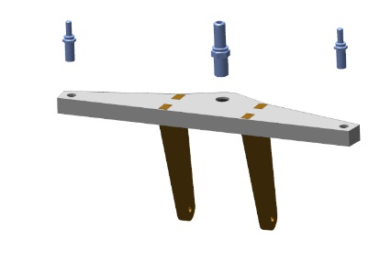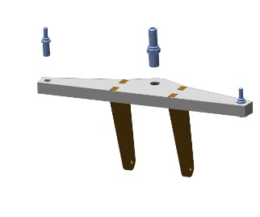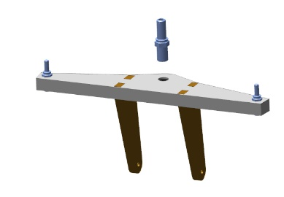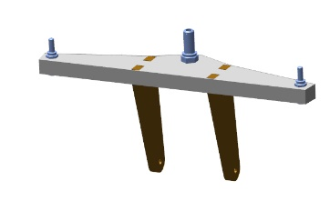
Position the bellcrank attachment lugs over the universal link fitted to the landing gear leg. Align the attachment lug bores with those of the universal link. Fit into aligning bores the ANG-0000-00052729-031 bolt. Place onto it the 5 DIN 127 washer, screw on the M5 DIN 935 nut with an 8 mm wrench, keept screwing the M5 DIN 935 nut to align the stud bore with the nut slot.
Fit the 1.0x35 DIN 94 cotter pin into the slot of the M5 DIN 935 nut aligning with the bore of the ANG-0000-00052729-031 stud. Cotter the connection by bending aside the cotter pin ends with a slotted (flat-tip) screwdriver No. 1.
Checkup operations:
Check the bellcrank for freedom of movement on the universal link by tilting it back and forth. The movement should be smooth, without jerks or binding.
Check the ease of rotation of the wheel. The rotation should be easy without jerks or binding.
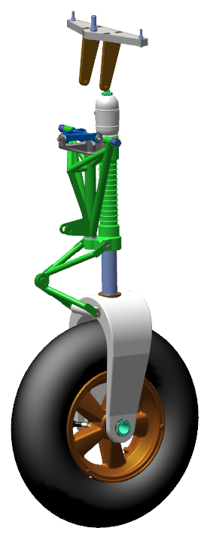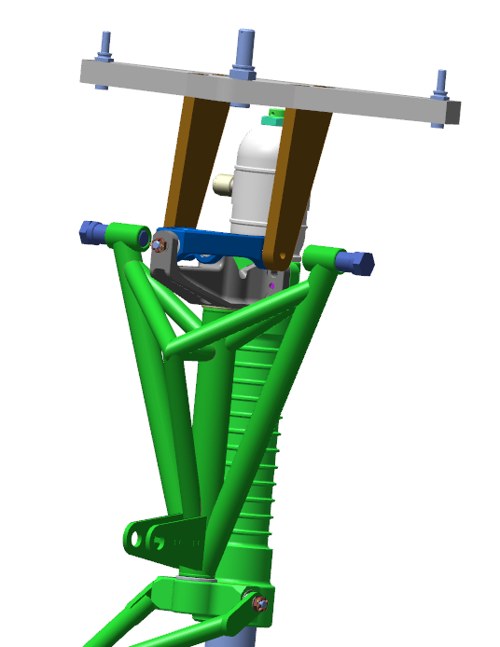
IMPORTANT! Do not loosen the nut to align the bore with the slot. This will result in a quick failure of the assembly and its play.

4.7 Assemble the landing gear retract cylinders
To carry out this task you will need:
Wrench for theTE lower cover;
Wrench for the TE upper cover;
Wrench for the TE liner (sleeve);
Spacer for the TE cover sensors;
2 mm hex key (Allen wrench);
LOCTITE 648 retaining compound;
Solvent methyl acetate 100 grams;
Clean rag 100x100 mm 6 pieces;
Latex gloves 1 pair;
30-100Nm torque wrench;
14 mm socket head;
Slotted (flat-tip) screwdriver No. 1;
Slotted (flat-tip) screwdriver No. 2;
14 mm combination wrench;
16 mm combination wrench;
IMPORTANT! Before starting the work with parts of the aircraft hydraulic system, clean your workplace of small objects and dust. Make sure to keep it clean and free of any foreign objects and fluids.
Unpack and place on the table:
2 ANG-3200-00033966-001cylinder liners;
1 ANG-3200-00032740-001cylinder liner;
3 ANG-3200-00032740-002 hydraulic cylinder upper covers;
3 ANG-3200-00032740-005 bronze bushes;
3 ANG-3200-00032757-002 nuts;
3 washers ANG-3200-00032757-003;
3 ANG-3200-00032757-004 washers;
3 ANG-3200-00032757-005 rods;
3 ANG-3200-00032757-006 pistons;
3 ANG-3200-00032757-008 nuts;
3 ANG- 3200-00032757-011 lock rings;
6 ANG-3200-00032757-010 circlips (split rings);
3 ANG- 3200-00032757-009 guides;
3 ANG-3200-00032740-004 locknuts;
2 ANG-3200-00033966-002 hydraulic cylinder rods;
1 ANG-3200-00032757-001 hydraulic cylinder rod;
3 ANG-3200-00032740-003 lower hydraulic cylinder covers;
12 ANG- 3200-00032777-001 bushes;
Count and place on the table:
6 fittings marked prch-00032785;
3 collars marked prch-00032803;
6 collars marked prch-00032800;
3 wipers marked prch-00032798;
Three 20-23-19 rings;
Three 1.0х65 DIN 94 cotter pins;
Six 34-37-19 rings;
3 rod ends marked prch-00032781;
12 prch-00032794 spring clips;
3 prch-00032779 bearings.
Find four prch-00032794 spring clips. Fit the screws with a 2 mm hex key (Allen wrench) into the bores of the ANG-3200-00032777-001 bush until 1-2 threads protrude behind the bushing. The screws must drive in without cross-threading or binding.

Remove the screws from the bores with the 2 mm hex key (Allen wrench). Set the vernier caliper to 1.8 mm.
Put on latex gloves and a respirator. Moisten a rag with solvent. Degrease the following items:
Female thread of the four ANG- 3200-00032777-001 bushes;
Outer surface of the four prch-00032794 spring clips (retainers).

IMPORTANT! Take care not to apply any retaining compound to the degreased surface immediately. The retaining compound can be applied 5-10 minutes after degreasing.
Apply an even thin layer of LOCTITE 648 retaining compound to the degreased inner surface of the ANG-3200-00032777-001 bush. Set the bush aside on the table for later use. Place the prch-00032794 spring clip on the 2 mm hex key (Allen wrench). Apply an even thin layer of LOCTITE 648 retaining compound to the outer degreased surface of the screw. Fit the prch-00032794 spring clip into the bore on the surface of the ANG-3200-00032777-001 bush, tighten the screw until the spherical part is seen on the other side of the bush. Check the projection of the screw with a vernier caliper. Tighten the screw to get a reading of 1.8mm set on the vernier caliper.
Clean up any excess or squeeze-out of retaining compound with a rag, thorougly wipe the retaining compound away from the threaded and spherical portion of the screw.
IMPORTANT! Do not allow the retaining compound to spread onto projection of threaded and spherical parts of the screw. Use a rag to immediately clean off the retaining compound. It is allowed to fit the bushes with screws only in 1-2 hours after applying the retaining compound
Repeat the process above for the remaining prch-00032794 spring clips and ANG-3200-00032777-001 bushes.
Find the ANG-3200-00032740-003 lower hydraulic cylinder cover, the ANG-3200-00032740-005 bronze bush, the prch-00032803 collar and the prch-00032798 wiper.
Put on latex gloves and respirator. Moisten a rag with solvent. Degrease the following items:
The inner cavity of the ANG-3200-00032740-003 lower hydraulic cylinder cover;
The outer surface of the ANG-3200-00032740-005 bronze bush.
Fit into the ANG-3200-00032740-003 lower hydraulic cylinder cover the prch-00032803 collar with the groove facing towards the thread. Slide the collar inside the cover until encountering a hard stop.

Apply an even thin layer of LOCTITE 648 retaining compound to the degreased surface of the ANG-3200-00032740-005 bronze bush.
IMPORTANT! Take care not to allow the ingress of the retaining compound into the bush. This will render the bush unserviceable.
Place the ANG-3200-00032740-005 bronze bush into the bore and tap on it gently with a hammer using a mandrel to drive it fully home.


Clean up any excess or squeez-out of retaining compound with a rag.
Fit the prch-00032798 wiper into the upper groove outside the ANG-3200-00032740-003 cover, with bevel (oblique portion) facing outwards the cover. Spread the prch-00032798 wiper in the groove with your fingers.

Position into place and hand-tighten the spacer for cover sensors.
Screw the ANG- 3200-00032777-001 bush into one of the bores until encountering a hard stop. The bush must screw in without binding or cross-threading. Screw the second bush in. Unscrew the bushes from their bores.
Put on latex gloves and respirator. Moisten a rag with solvent. Degrease the following items:
Female thread of the ANG-3200-00032740-003 lower hydraulic cylinder cover;
Male thread of the ANG- 3200-00032777-001 bushes.
The male thread of the 2010 1/8 fitting.
Apply an even thin layer of LOCTITE 648 retaining compound to the degreased threaded surfaces of the ANG-3200-00032740-003 lower cylinder cover. Set the cover aside on the table fro later use.
Apply an even thin layer of LOCTITE 648 retaining compound to the degreased surface of the 2010 1/8 fitting. Screw the 2010 1/8 fitting in, tighten it with the 9 mm combination wrench. The vacant threaded portion of the 2010 1/8 fitting must face away from the smaller diameter of the cover and be parallel to the cover axis.

Apply an even thin layer of LOCTITE 648 retaining compound to the degreased outer surface of the ANG-3200-00032777-001 bush. Screw the ANG-3200-00032777-001 bush into the bore of the ANG-3200-00032740-003 lower hydraulic cylinder cover with a 2 mm hex (Allen) wrench, tighten it until encountering a hard stop. Repeat the process for the second ANG- 3200-00032777-001 bush.
Remove the cover sensor spacer from the ANG-3200-00032740-003. lower cylinder cover Clean up any excess or squeeze-out of retaining compound with a rag, thoroughly wipe off the retaining compound from the threaded and spherical portion of the screw.

IMPORTANT! Take care not to allow the retaining compound to spread onto the threaded and spherical portions of the screw. Use a rag to immediately wipe off the retainer. Do not allow the ingress of the retaining compound into the inner cavity. This will render the hydraulic cylinder unserviceable.
Find the ANG-3200-00032740-002 upper cylinder cover. Fit to it and hand-tighten the cover sensor spacer. Repeat the process described above for fitting the ANG-3200-00032777-001 bushes into the ANG-3200-00032740-002 upper hydraulic cylinder cover.


Find the ANG-3200-00032757-005 and ANG-3200-00033966-002 rods, the ANG-3200-00032757-011 locking ring.
Hand-screw from the side without flats the ANG-3200-00032757-005 rod with it long threaded part into the ANG-3200-00033966-002 rod until encountering a hard stop. A clearance of 3 mm should be provided between the two edges of the rods.

Place the ANG-3200-00032757-011 locking ring on the ANG-3200-00032757-005 rod, slide it along the rod until seating into the rod groove.

Detach the rods from each other. Place the ANG-3200-00032757-003 washer on the ANG-3200-00033966-002 rod, with a recess facing the rod. Hand-screw until encountering a hard stop the ANG-3200-00032757-005 rod with its long threaded part into the ANG-3200-00033966-002 rod from the side without flats. Check the ANG-3200-00032757-003 washer between the two rods for the absence of any play and likely spinning. Disassemble the parts, place them on the table.
Put on latex gloves and a respirator. Moisten a rag with solvent. Degrease the following items:
Female thread of the ANG-3200-00033966-002 rod;
Male thread of the ANG-3200-00032757-005 rod.
Apply an even thin layer of LOCTITE 648 retaining compound to the degreased female threads of the ANG-3200-00033966-002 rod.
Set the rod aside on the table for later use. Apply an even thin layer of LOCTITE 648 retaining compound to the degreased male threads of the ANG-3200-00032757-005 rod.
Place the ANG-3200-00032757-003 washer on the ANG-3200-00033966-002 rod with a recess facing the rod. Hand-screw until encountering a hard stop the ANG-3200-00032757-005 rod, with its long threaded part into the ANG-3200-00033966-002 rod from the side without flats.
Check the ANG-3200-00032757-003 washer between the two rods for the absence of any play and likely spinning. Clean up any excess or squeez-out of the retaining compound with a cloth, thoroughly wipe off the retaining compound from the threaded and spherical portion of the screw.

IMPORTANT! Take care not to allow the retaining compound to spread onto the projecting threaded and smooth parts of the rods. Use a cloth to immediately wipe off the retainer.


Find and place on the table the ANG-3200-00032757-006 piston, 2 prch-00032800 collars, the 20-23-19 ring, the ANG-3200-00032757-009 guide. Fit into the grooves on both sides of the ANG-3200-00032757-006 piston the prch-00032800 collars with cannelures facing outwards.
Place the guide ANG-3200-00032757-009 between the collars, in the middle groove of the piston. Position and fit the 20-23-19 ring into the groove of the ANG-3200-00032757-006 piston inner cavity. The ring should sit snugly in the groove.



Find 2 ANG-3200-00032757-010 split rings, the ANG-3200-00032757-004 washer, the ANG-3200-00032757-008 nut.
Fit the ANG-3200-00032757-010 ring on the rod on the male thread side with its bevel (oblique portion) facing towards the male thread of the rod.

Find a vacant groove in the inner cavity of the piston (assembled by you earlier). Fit the piston with collars onto the rod, slide it along the rod until encountering a hard stop. Fit the ANG-3200-00032757-010 ring onto the rod on the male thread side, with its bevel (oblique portion) facing away from the rod male thread.

Place the ANG-3200-00032757-004 washer on the ring, screw the ANG-3200-00032757-008 nut on. Clamp the bottom portion of the rod with flats in a vice. Clamp only the portion with flats. Tighten the ANG-3200-00032757-008 nut with a 19 mm combination wrench. To avoid cross-threading and to facilitate tightening the nut, hold the item by the rod.
Unclamp the item from the vise.
Find the bottom cover with the fitted sensors. Apply a smear of machine oil to the inner surface of the bush. Fit the cover with threaded portion facing towards the piston, place the bush on the rod, slide it along the rod to the piston. The cover should travel along the rod without binding, but with some effort applied.


Find the ANG-3200-00032757-002 nut. Hand-screw the ANG-3200-00032757-002 nut into the rear portion of the rod with flats, until encountering a hard stop. The nut should screw in easily. Unscrew the nut from the rod.
Put on latex gloves and a respirator. Moisten a rag with solvent. Degrease the following items:
female thread of the ANG-3200-00033966-002 rod;
male thread of the ANG-3200-00032757-002 nut.
IMPORTANT! Take care not to apply any retaining compound to the degreased surface immediately. The retaining compound can be applied 5-10 minutes after degreasing.
Apply an even thin layer of LOCTITE 648 retaining compound to the female thread of the ANG-3200-00033966-002 rod. Set the rod aside on the table for later use. Apply an even thin layer of LOCTITE 648 retaining compound to the male thread of the ANG-3200-00032757-002 nut.
Hand-screw the ANG-3200-00032757-002 nut into the rear portion of the rod with flats, until encountering a hard stop. Holding it in place with a 17mm combination wrench, tighten the ANG-3200-00032757-002 nut with another 17mm combination wrench to take out the clearance between the rod and nut edges. Clean up with a rag any excess or squeeze-out.


Find the hydraulic cylinder liner and the ANG-3200-00032740-004 locknut. Hand-screw the ANG-3200-00032740-004 locknut on the liner on the longer thread side.

Find two 34-37-17 rings. Place the ring on the outer threaded portion of the ANG-3200-00033966-001 the hydraulic cylinder liner on any of its sides. Slide the ring carefully through the threads, seat it in place and align it in the groove of the liner.
Repeat the process above to fit the second 34-37-17 ring onto the ANG-3200-00033966-001 hydraulic cylinder liner.

Find the ANG-3200-00032740-002 upper hydraulic cylinder cover. Hand-screw the ANG-3200-00032740-002 hydraulic cylinder cover onto the thread of the ANG-3200-00033966-001 liner until encountering a hard stop. The cover should screw on easily, without cross-threading or binding.
IMPORTANT! When screwing on the cover, avoid misalignment of the ring fitted onto the liner. If a misalignment occurs, unscrew the cover to align the ring in the groove and start over. Misalignment of the seal will result in a fluid leak.

P 26-52

Place the liner with its cover on the table. Apply the TE liner wrench to the reinforced portion of the item. Tighten the parts with the TE top cover wrench for about 1/10 turn, until the sensation of some effort.
Dip your finger in oil several times, smear slightly the inner cavity of the liner, turning it in your hand. There should remain a shiny greasy trace. Smear slightly the prch-00032800 collars, dipping your finger in oil. There should remain a shiny greasy trace.
Check the position of the prch-00032794 spring clips (retainers) on the ANG-3200-00032740-003 and ANG-3200-00032740-002 hydraulic cylinder covers. Turn the ANG-3200-00032757-010 rings in such a manner that their split portions are positioned opposite to the prch-00032794 spring clips (retainers). Mark the position of the ANG-3200-00032757-010 ring slits with a marker on the edges of the rod bushings.
Fit to the piston portion the assembly semi-rings and tighten them with a clamp. Fit onto the assembly semi-rings the ANG-3200-00033966-001 liner, place the piston into the liner with a with the mark facing away from the prch-00032794 spring clips (retainers). Seat the liner onto the rod, tapping gently with a hammer on the ANG-3200-00032740-002 upper cover. After the assembly semi-rings slide onto the rod, take them off by removing the clamp. Slide the ANG-3200-00032740-003 lower cylinder cover along the rod down to the liner thread. Hand-screw the cover untill encountering a hard stop. The cover should screw on easily, without cross-threading or binding.
IMPORTANT! When screwing on the cover, avoid misaligning the ring, fitted on the liner. If a misalignment occurs, unscrew the cover to align the ring in the groove and start over. A misaligned seal will result in fluid leak.
Apply the TE liner wrench to the reinforced portion of the item. Tighten the parts with the TE bottom cover wrench for about 1/10 turn until the sensation of some effort. Check the position of the covers relative to each other - the threaded bore of the ANG-3200-00032740-003 lower hydraulic cylinder cover should be positioned in the middle, between the threaded bores of the ANG-3200-00032740-002 upper cover. If there is no such arrangement, tighten the covers one by one with wrenches.

Make sure the gas cylinder is closed and the needles on both gauges point to "0". Set the nitrogen regulator to "0", make sure that the valves of the charging device are closed.
IMPORTANT! Do not leave the cylinder valve open for a long time and the hose under pressure.

Attach the test device coupling to the 2010 1/8 fitting on the ANG-3200-00032740-003 lower cylinder cover through the full thread length.

IMPORTANT! It is impermissible to use oxygen instead of compressed air!!! It will result in an explosion!!! The use of compressed air pressure exceeding 35 atmospheres (3.5 MPa) is impermissible.
Open the valve on the cylinder, set the pressure on the second pressure gauge to 10 atm (1 MPa). Open the gas valve on the charging device. The hydraulic cylinder rod must retract.
Checkup operations:
Set your multimeter to continuity test (or minimum resistance). Check for the appropriate adjustment, by touching the test probes together. A sound should be heard (or the needle should point to "0"). Place the test probes on the prch-00032794 spring clips of the ANG-3200-00032740-002 upper cover. A sound should be heard (or the needle should point to ""0"). Touch with a multimeter probe the 2010 1/8 fitting and touch with the second probe one of the prch-00032794 spring clips. A sound should be heard (or the needle should point to ""0"). Touch with a multimeter probe the second prch-00032794 spring clip . A sound should be heard (or the needle should point to ""0").
Repeat the process above to check the prch-00032794 spring clips of the ANG-3200-00032740-003 lower cover. A sound should not be heard (or the needle should point to any values).
Open the gas valve on the charging device. Check each 2010 1/8 fitting for air leak, touching it with your finger. There should be no air leak.
IMPORTANT! If the air is escaping from the 2010 1/8 fitting, this is the evidence of improper installation or damage to the collars.

Note. If the rod does not travel, gradually increase the pressure, not exceeding 15 atmospheres (1.5 MPa).
Uncrew the test device coupling from the lower cover, and attach it to any of the 2010 1/8 fittings.
Uncrew the test device coupling from the lower cover, and attach it to the unmarked 2010 1/8 fitting. Place your finger on the marked 2010 1/8 fitting of the ANG-3200-00032740-002 upper cover.
Open the gas valve of the charging device. The rod of the hydraulic cylinder should come out, a click can be heard in the cover while the ANG01-0-3233-5001-00 piston is travelling from its end position. Make sure that the air does not leak from the marked 2010 1/8 fitting of the ANG-3200-00032740-002 top cover.
Repeat the process described above 10-15 times for checking the operation of the hydraulic cylinder with air and checking the contacts.
Find the prch-00032781 rod end and the std-00029674 nut. Hand-screw the nut onto the threaded portion of the prch-00032781 rod end until encountering a hard stop. Hand-screw the rod end with the nut into the threaded portion of the rod edge until encountering a hard stop. Set the hydraulic cylinder on the table for later use.


Repeat the whole process described above in the same sequence for the two remaining hydraulic cylinders.

4.8 Fit the nose landing gear
To carry out this task you will need:
Movable table;
Slotted (flat-tip) screwdriver №2;
LOCTITE 648 retaining compound;
Two 17 mm combination keys;
Unpack and place on the table:
Nose landing gear leg (assembled as per 4.6);
Landing gear retract hydraulic cylinder (assembled as per 4.7);
Two ANG-5330-00029526-002 bolts;
One 10x65 DIN 912 bolt;
One М10 DIN 935 nut;
Two 10 DIN 127 washers;
One 2x60 DIN 94 cotter pin.
IMPORTANT! Before performing any kind of work, make sure that the part of the aircraft to be worked under is properly secured and stable. Inadequately secured parts can be damaged or cause an injury when falling.
Approach the nose landing gear leg with the torque link to the fuselage. Raise the landing gear leg up to match the middle stud with the bearing bore. Insert the stud into the bearing. Place the DIN 127 washer 10 on the protruding threaded portion, screw the nut M10 DIN 935 on.
Align the bush of the nose landing gear truss with the bearing bore of the fuselage.

Feed the ANG-5330-00029526-002 bolt into the aligning bore of the fuselage, screw the bolt into the thread of the nose landing gear truss bush.
Repeat the process for the second ANG-5330-00029526-002 bolt. Tighten the two bolts with a 17 mm combination wrench until encountering a hard stop against the 10 DIN 127 washer.

Get under the fuselage besides the nose landing gear leg.
Fold the nose landing gear leg by hand into the bay (well), simulating the landing gear retraction. Check the retracted landing gear leg for abutting against other structural elements of the aircraft, and for difference in clearance. Clearance should be uniform and approximately equal on both sides of the landing gear leg. There should be no abutting against the elements of the fuselage structure. Repeat the movement and checking for 2-3 times.
Get to your feet. Unscrew one ANG-5330-00029526-002 bolt with a 17 mm combination wrench.
Moisten a rag with solvent, degrease the threaded portion of the ANG-5330-00029526-002 bolt, the threaded portion of the nose landing gear truss bush.
IMPORTANT! Take care not to apply any retaining compound to the degreased surface immediately. The retaining compound can be applied 5-10 minutes after degreasing.
Apply a thin layer of LOCTITE 648 retaining compound to the degreased surface of the ANG-5330-00029526-002 bolt. Fit the bolt into the threaded bore of the nose landing gear truss. Tighten it with a 17mm combination wrench.
Repeat the process above for the second bolt on the opposite side of the fuselage.
Clean your workplace and tools as per the typical action 7.
Tighten the nut on the center bearing at the top of the landing gear leg with a 17 mm combination wrench, to fully and tightly seat it on the 10 DIN 127 washer. Find a bore in the landing gear stud, which should align with the slot of the M10 DIN 935 nut. If the bore is not visible, tighten the nut until aligning the bore with the slot.
IMPORTANT! Do not loosen the nut to align the bore with the slot. This will result in a quick failure of the assembly and play in the control system.
Place the 2x60 DIN 94 cotter pin into slot of the M10 DIN 935 nut aligning with the bores of the stud. Cotter the connection by bending aside the cotter pin ends with a slotted (flat-tip) screwdriver No. 2.
Find the hydraulic cylinder (assembled as per 4.7), the 10x65 DIN 912 bolt, the 10 DIN 127 washer. Find a bore in the landing gear bay (well). Insert the 10x65 DIN 912 bolt into the bore. The bolt should fit in easily. Remove the bolt from the bore.
Align the bores of the cylinder bearing inside the gear bay (well). Once the bores are aligned, fit into them the bolt. Tighten the bolt with a wrench.
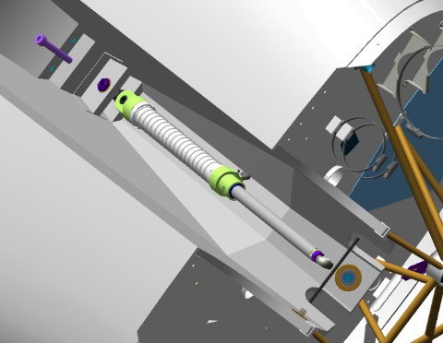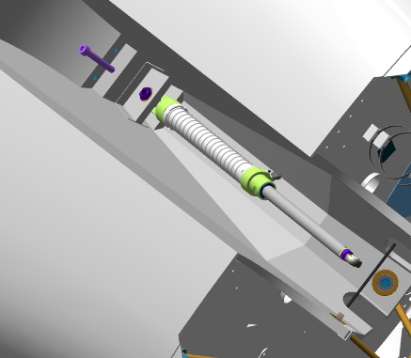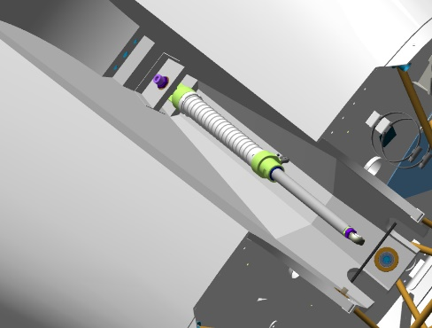
Find two lugs on the nose landing gear truss, on the landing gear bay (well) side. Position between the lugs the rod end of the hydraulic cylinder, align the bores.
Fit into the aligning bores the hydraulic cylinder attachment bolt, put in place the 10 DIN 127 washer and the M10 DIN 935 nut, tighten the nut to seat it fully on the 10 DIN 127 washer.
Find a bore in the bolt that should align with the slot of the M10 DIN 935 nut. If the hole is not visible, tighten the nut slightly to align the bore with the slot.

IMPORTANT! Do not loosen the nut to match the bore with the slot. This will result in a quick failure of the assembly and its backlash.

Place a cotter pin into the slot of the M10 DIN 935 nut aligning with the bores of the hydraulic cylinder attachment bolt. Bend one end cotter pin end aside but do not cotter it.
Checkup operations:
Check for freedom of rotation of the wheel. The rotation should be easy without jerks or binding.
To be added: clearances between the landing gear leg and the casing in retracted position, cottering, backlash
Нужно добавить контрольные операции: зазоры между опорой и коробом в убранном положении, контровка, люфты

4.9 Fit the main landing gear legs
Note. The operations described below pertain to the left main landing gear. Mounting of the right landing gear is performed in the same sequence.
To carry ot this task you will need:
Movable table;
Slotted (flat-tip) screwdriver № 2;
LOCTITE 648 retaining compound;
Two 17 mm combination keys;
19 mm socket head;
Socket head handle:
Unpack and place on the table:
Left landing gear leg (assembled by you earlier);
Right landing gear leg (assembled by you earlier);
2 landing gear retract cylinders (assembled by you earlier);
4 ANG-5313-00029347-002 bearing block bolts;
4 М10 DIN 935 nuts;
Two10 DIN 127 washers;
Two 2x60 DIN 94 cotter pins
Two М10х65 DIN 912 bolts
IMPORTANT! Before performing any kind of work, make sure that the part of the aircraft to be worked under is properly secured and stable. Inadequately secured parts can be damaged or cause an injury when falling.
Check the M16 threaded bores in the main landing gear leg as per the standard operation 6.
Fing two bores with bearings at the top of the main landing gear bay (well). Make sure that are free of any foreign objects. Find the ANG-5313-00029347-002 bearing block bolt, check the ease of fitting the bolt into the bearing. The bolt should fit in each bore easily, without any play and jerks.
You will need a helper to carry on with this task.
Approach and roughly align the bores of the main landing gear with those of the landing gear bay (well). Insert the bolt from behind having placed it into a19mm socket with a tommy bar. Turning the socket clockwise, advance the fixture towards the landing gear leg until you feel the engagement of the threaded portions. If it does not engage, adjust the landing gear leg. Tighten the bolt until you can feel some tension on the wrench handle.
IMPORTANT! If the threaded parts engage, but rotation requires force, remove the bolt and start over.
Feel for the bore to fit second bolt of the ANG-5313-00029347-002 bearing block.
Repeat the process described above to fit the second bolt.

Get under the fuselage besides the main landing gear.
Checkup operations:
Fold the landing gear by hand into the bay (well), simulating a landing gear retraction. Check the retracted landing gear leg for abutting against other structural elements of the aircraft, and for differences in clearance. Clearance should be uniform and approximately equal to the outline of the landing gear wheel. There should be no abutting against the elements of the fuselage structure.
Repeat the movement and checking for 2-3 times. Move the landing gear leg out of the landing gear bay (well).

Unscrew one ANG-5313-00029347-002 bolt with a 19mm socket, equipped with a tommy bar. Moisten a cloth with solvent, degrease the threaded portion of the ANG-5313-00029347-002 bolt.
IMPORTANT! Take care not to apply any retaining compound to the degreased surface immediately. The retaining compound can be applied 5-10 minutes after degreasing.
Apply an even thin layer of LOCTITE 648 retaining compound to the degreased surface of the ANG-5313-00029347-002 bolt.
Insert the bolt into the threaded bore of the landing gear truss. Tighten the ANG-5313-00029347-002 bolt with the 19 mm socket equipped with a tommy bar until the sensation of a significant effort to the handle.
Repeat the process above to fit the second bolt to the inner side of the fuselage.
Clean your workplace and tools as per the typical operation 7.
Find the hydraulic cylinder (assembled by you earlier), the M10x65 DIN 912 bolt, the M10 DIN 935 nut, the 10 DIN 127 washer, the 2x60 DIN 94 cotter pin. You will need a helper to carry on with this task.
Place all the parts under the fuselage in the area of ​​the main landing gear bay (well), except for the M10x65 DIN 912 bolt. Find a hole in the back sofa. Fit into the hole the hydraulic cylinder mounting bolt. The bolt should fit in easily.
Find a stud (pin) on the bay side of the main landing gear casing. Fit the rod end of the hydraulic cylinder to the stud, place on the stud the 10 DIN 127 washer and the M10 DIN 935 nut, tighten the nut a 17 mm combination wrench to seat it fully and firmly onto the 10 DIN 127 washer. Find in the stud a bore, which should align with the slot of the M10 DIN 935 nut. If the bore is not visible, tighten the nut to align the bore with the slot.
IMPORTANT! Do not loosen the nut to align the bore with the slot. This will result in a quick failure of the assembly and its play.
Feed a cotter pin into the slot of the M10 DIN 935 nut aligning with the bores in the hydraulic cylinder attachment bolt. Bend one end cotter pin end aside but do not cotter it.
Get under the fuselage. Find a bore in the bay (well). Align the bearing bore in the cover with that of the rear sofa inside the bay. Once the bores are aligned, ask your helper to insert the bolt. Make sure that the bolt is inserted through the bearing.

Once the work with the left main landing gear leg is completed, repeat the process for the other side.

4.9.1 Fit the footrests
Олегу написать раздел

PART 5 ASSEMBLE THE CONTROL SYSTEM

5.1 Assemble the rudder pushrod
The objective of this task is to assemble the rudder pushrod in the tail area.
To carry ot this task you will need:
Movable table;
8 mm combination wrench;
Latex gloves 1 pair;
Solvent methyl acetate 100 grams;
100x100 mm clean rag 1 piece;
Respirator;
Vernier caliper 300 mm;
LOCTITE 648 retaining compound.
Unpack and place on the table the tube marked ANG-2700-00055170-001.
Count and place on the table:
2 М5 DIN 934 nuts;
2 spherical rod ends marked std00028321.
Take 2 std 00028321 rod ends, screw one M5 nut onto the threaded portion of each rod end until encountering a hard stop.
 | 
Set the vernier caliper to 145mm and secure the value.
Screw the rod ends one by one into the ANG-2700-00055170-001 tube up to approximately mid-length. Check, using the vernier caliper that the length is 145 mm. Screw one rod end in for 1-2 turns. Recheck the length with the vernier caliper.
 |  | 
Once the desired value is obtained, tighten one M5 nut so that it rests against the ANG-2700-00055170-001 tube. Carefully, without letting the M5 nut turn, detach the std00028321 rod end from the ANG-2700-00055170-001 tube.
Put on latex gloves and a respirator. Moisten a rag with solvent. Degrease the threaded portion of the std0002832 rod end that is to be screwed into the tube.
IMPORTANT! Take care not apply any retaining compound to the degreased surface immediately. The retaining compound can be applied 5-10 minutes after degreasing.
Apply an even thin layer of LOCTITE 648 retaining compound to the degreased surface of the rod end.

Screw the end rods successively into the ANG-2700-00055170-001 tube, approximately to the mid-length thereof. Check, using the vernier caliper that the length is 145 mm. Once the desired value is obtained, tighten the M5 nut with the 8mm wrench so that it rests against the ANG-2700-00055170-001 tube.



Tighten the second M5 nut with the 8mm wrench so that it rests against the ANG-2700-00029758-001 tube.
IMPORTANT! Do not fit the second std00028321 lend rod at this stage of the task, applying LOCTITE 648 retaining compound. The end rod will be needed for the adjustment of the control system in the course of further assembly of the aircraft, and will be permanently secured after adjustments.
Clean work area and tools as per the typical operation 7.
Checkup operations:
Контрольные операции:

Нужно добавить контрольные операции: длины, подшипники, люфты

5.2 Assemble composite pushrods
The objective of this task is to assemble a control pushrod made of composite materials.
Note... The operations described below pertain to one of the pushrods. The rest of the pushrods differ from that described in diameter and length of the pipe.
To carry out this task you will need:
Movable table;
Combination wrench 8 mm;
Digital kitchen scales;
Latex gloves - 1 pair;
Larit L285 epoxy resin - 15 grams;
H287 hardener - 6 grams;
100 ml paper cup;
Aerosil thickener 3 grams;
P1000 grit sandpaper one 200x300 mm sheet;
Methyl acetate solvent 30 grams;
100x100 mm clean rags - 2 pieces;
P240 grit sandpaper one 200x300 mm sheet;
Respirator;
Metal spatula (putty knife) 30 mm;
М16 DIN 934 nut.
Mandrel for the D14 bearings;
Hammer weighing 400 grams.
Unpack and place on the table:
Tube marked ANG-2700-00029716-001;
Rod end marked ANG-2700-00029716-002;
Rod end marked ANG-2700-00029716-003;
Count and place on the table:
1 bearing marked std00028269;
1 М5 DIN 439nut;
1 std00028321 spherical rod end.
Find ANG-2700-00029716-003 rod end.
Put on latex gloves and a respirator. Slightly moisten a rag with solvent. Degrease the following items:
The outer surface of the std00028269 bearing;
The bearing seat in the ANG-2700-00029716-003 rod end.
IMPORTANT! Take care not apply the retaining compound to the degreased surface immediately. The retaining compound may be applied 5-10 minutes after degreasing.
Apply an even thin layer of LOCTITE 648 retaining compound to the degreased bearing surface.
IMPORTANT! Do not allow the ingress of the retaining compound inside the bearing. This will render the bearing unserviceable.
Place an M16 DIN 934 nut on a hard surface of the table, place the rod end above. Place the bearing into the hole and drive the bearing fully home slightly tapping on, interposing the mandrel. The bearing should sit 0.5mm deeper relative to the rod end level. Clean up with a rag any excess or squeeze-out of the retaining compound.
IMPORTANT! Do not tap on any part of the bearing other than the outer ring (race).
Place the ANG-2700-00029716-001 tube on the edge of the table in such a manner that one end of the pipe should hang from the table. Sand (roughen) the two spots as per the typical operation 3, turning over the tube, fitting ANG-2700-00029716-002 and ANG-2700-00029716-003 end rods into the ANG-2700-00029716-001 tube.
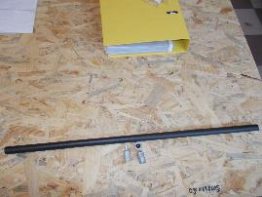 | 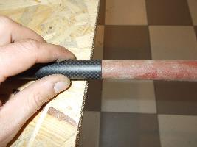
Important! Take care not to damage the composite parts of the portions to be sanded. Do not rub it in one spot for too long time, even if the area to be sanded does not turn dull (matte).
Sand as per the standard operation 4 the outer portions of the ANG-2700-00029716-002 and ANG-2700-00029716-003 end rods areas mating the ANG-2700-00029716-001 tube.
Fit the ANG-2700-00029716-002 and ANG-2700-00029716-003 rod ends into the ANG-2700-00029716-001 tube. The rod ends should fit snugly, but without undue force applied. Remove the ANG-2700-00029716-002 and ANG-2700-00029716-003 rod ends from the ANG-2700-00029716-001 tube and set them aside on the table for later use.
Upon sanding of all portions, put on latex gloves and a respirator. Moisten a rag with solvent. Degrease the following items:
The mating portions of the rod ends inside the ANG-2700-00029716-001 tube.
The areas of the ANG-2700-00029716-002 and ANG-2700-00029716-003 end rods mating the tube.
Prepare the epoxy glue from Larit L285 resin and H287 hardener in a ratio of 15: 6 as per the typical operation 1.
IMPORTANT! The epoxy glue is to be used within 60 minutes following its preparation.
Apply the glue to the degreased surfaces of the ANG-2700-00029716-002 and ANG-2700-00029716-003 rod ends and the degreased areas inside the tube as per the standard operation 5.1.
Move the soft covering of the table aside to provide a surface of about 1 m2. Place on the vacant surface a 0.5x0.5m plastic film, secure its edges with small pieces of masking tape (also known as painter's tape). Take a piece of 50g/m2 density fiberglass, measure and mark the dimension of 60x140 mm, cut it to the size with scissors. Mark two equal 70mm portions on the 140mm long side of the fabric. Apply a thin layer of glue onto the marked fabric. Take care not to apply excessive glue.
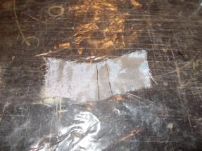 | 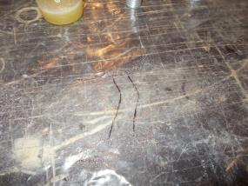
IMPORTANT! The fabric to be impregnated with glue should become transparent when glue is applied to it, and should not have any white or silverfish portions. The presence of such portions results in appearance of “starved spots” and impairs the strength of the structure.
Use scissors to cut the impregnated fiberglass fabric as marked.
Measure, mark with a marker, cut off with scissors 2 pieces of ERS240T-132BS fiber-glass roving, 100mm each. Place the cut glass roving on the film on the table. Roll by turns a thin layer of glue onto the fiber fiberglass roving, holding one of the edges with your hand.
Prepare some adhesive from the remaining glue as per the standard operation 2.
Place the impregnated fiberglass on the surface of the ANG-2700-00029716-002 rod end with glue previously applied to it. The edges of the impregnated fiberglass should protrude beyond the cylindrical part at least 10 mm each way. Spread the fiberglass on the rod end with your fingers. Place the impregnated fiber-glass roving in the first groove on the far side of the end rod shoulder (collar) and tie a overhand knot twice. Tighten it strongly. Place the impregnated fiber-glass roving in the first groove on the near side of the rod end shoulder (collar) and tie an overhand knot twice. Tighten it strongly.
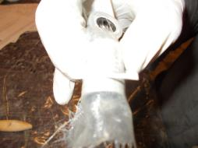 | 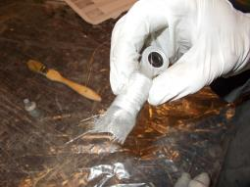
Apply the adhesive to the ANG-2700-00029716-002 rod end surface as per the standard operation 5.2. Fit the ANG-2700-00029716-002 rod end into the ANG-2700-00029716-001 tube as deep as possible.
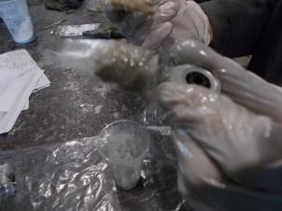 | 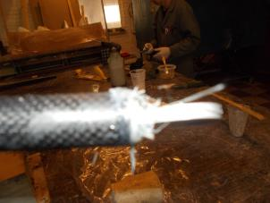
Drive the ANG-2700-00029716-002 rod end fully home into the tube tapping it slightly with hammer to make it slip along the tube until the end rod shoulder (collar) encounters a hard stop against the tube edge.
IMPORTANT! The fiberglass fabric on the rod end should protrude beyond the tube.
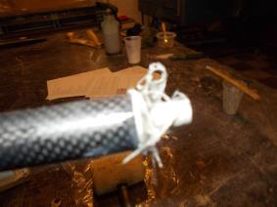 | 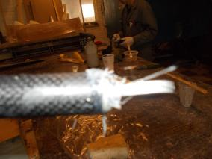
Repeat the process above to fit the ANG-2700-00029716-003 rod end.
IMPORTANT! Take care to prevent the ingress of any adhesive into the inner portion of the bearing and the rod end thread. This will render the bearing and end rod unusable.
Use scissors to trim any excess fabric protruding from the tube.
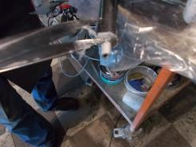 | 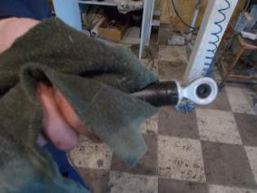
Take the std00028321 rod end (lug), screw the M5 DIN 439 nut onto the thread until encountering a hard stop.
Screw the std00028321 rod end (lug) into the ANG-2700-00029716-003 rod end for about half length. Check with a measuring-tape for the size of 808 mm between the two edges of the rod ends. Screw the rod end in for 1-2 turns. Check again with the measuring-tape. When the desired value is obtained, tighten the M5 DIN 439 nut with an 8mm combination wrench until encountering a hard stop against the ANG-2700-00029716-003 rod end.
IMPORTANT! Do not permanently fit the std00028321 rod end (lug) using the LOCTITE 648 retaining compound at this step. The rod end will be needed for adjustments of the control system in the course of further assembly of the aircraft, and will be finally fitted after adjustment operations.
Checkup operations:
It is required to add the checkup operations: lengths, bearings, backlash, pins, bonding
Нужно добавить контрольные операции: длины, подшипники, люфты, штифты, проклейка
To assemble the remaining pushrods unpack and lay on the table one by one:
4 ANG-2700-00029408-001 tubes;
8 ANG-2700-00029408-002 rod ends;
8 bearings std00028269;
2 ANG-2700-00029706-001 tubes;
4 ANG-2700-00029706-002 rod ends;
4 std00028269 bearings;
2 ANG-2700-00029710-001 tubes;
4 ANG-2700-00029710-002 rod ends;
4 std00028269 bearings;
1 ANG-2700-00029711-001 tube;
2 ANG-2700-00029711-002 rod ends;
2 std00028269 bearings;
1 ANG-2700-00029714-001 tube;
2 ANG-2700-00029714-002 rod ends;
2 std00028269 bearings;
1 ANG-2700-00029716-001 tube;
2 ANG-2700-00029716-002 rod ends;
2 std00028269 bearings;
2 ANG-2700-00030488-001 tubes;
4 ANG-2700-00030488-002 rod ends;
4 prch-00031941 bearings;
1 ANG-2700-00030802-001 tube;
2 ANG-2700-00030802-002 rod ends;
2 std00028269 bearings;
1 ANG-2700-00030869-001 tube;
2 ANG-2700-00030869-002 rod ends;
2 std00028269 bearings.

5.3 Assemble aileron control system
Note.The operations described below pertain to the left wing panel. The wing panel should be placed on the trestle-mounted cradle, with the upper covering facing the floor.
To carry out this task you will need:
Movable table;
8 mm combination wrench;
10 mm combination wrench;
12 mm combination wrench;
Tweezers;
Combination pliers;
Slotted (flat-tip) screwdriver No. 1;
Left aileron (assembled earlier);
Right aileron (assembled earlier);
2 control system bellcranks marked ANG-2700-00033355-00;
2 control system bellcranks marked ANG-2700-00034561-00;
8 screws marked ANG-0002-00037651-002;
8 bushes marked ANG-2700-00033355-002;
8 bushes marked ANG-2700-00033355-010;
8 bushes marked ANG-2700-00033355-012;
2 pushrods marked ANG-2700-00030802-00;
2 pushrods marked ANG-2700-00038057-00;
2 pushrods marked ANG-2700-00034989-00.
Unpack and place on the table:
Eight М6 DIN 935 nuts;
Eight 6 DIN 6798J washers;
Six М5 DIN 935 nuts;
Six 5 DIN 6798J washers;
Fourteen 1x20 DIN 94 cotterpins;
8 bearings marked prch-00034668;
8 bearings prch-00034559;
8 A27 DIN 472 rings.
Find the ANG-2700-00033355-00 bellcrank and 2 ANG-0002-00037651-002 screws. Moisten a rag with solvent. Degrease the following items:
Female threads of the ANG-2700-00033355-00 bellcrank;
Male threads (short part) of the ANG-0002-00037651-002 screws.
IMPORTANT! Take care not to apply any retaining compound to the degreased surface immediately. The retaining compound can be applied 5-10 minutes after degreasing.
Apply an even thin layer of LOCTITE 648 retaining compound to the degreased surfaces.
Apply an even thin layer of LOCTITE 648 retaining compound to the outer degreased surface of the two bearings.
Screw one by one the screws into the holes in the bellcrank. Tighten them with a 12 mm wrench to take put the gap between the screw and the bellcrank.
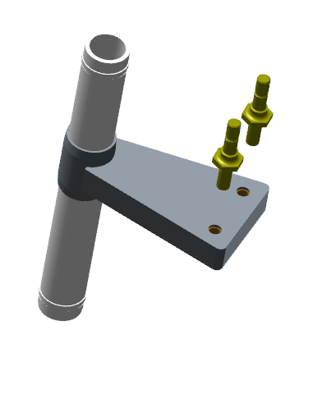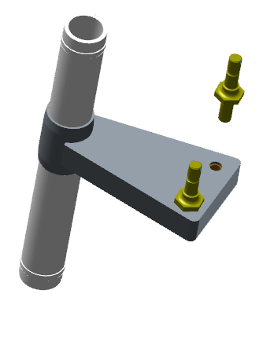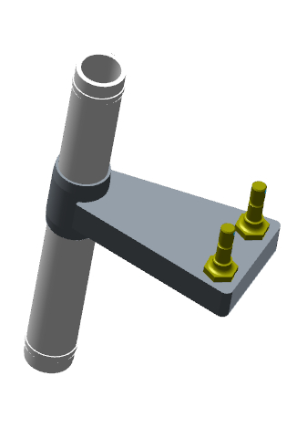
Repeat the procedure above to fit the ANG-0002-00037651-002 screws to the ANG-2700-00034561-00 bellcrank.
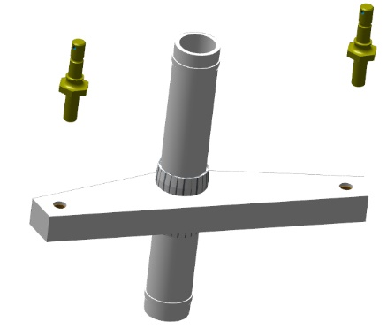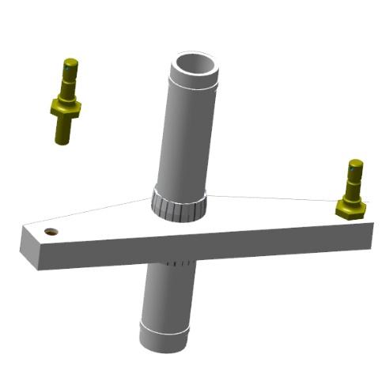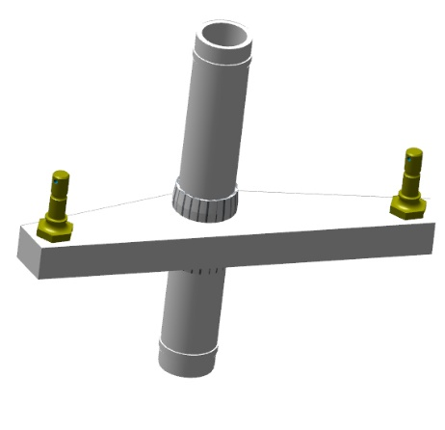
Place the ANG-2700-00034561-00 bellcrank into the wing panel through the access hole in the bottom covering. Pass the bellcrank rotation axle through the upper bush in the covering (skin).
Pre-fit the prch-00034559 bearings to the bellcrank above and below, fit them into the bushes in the wing covering (skin). Lock the bearings in each hole with the A27 DIN 472 circlips (retaining rings).
Check the bellcrank for freedom of rotation, make sure that the ring is correctly fitted.
IMPORTANT! After fitting the circlips (retaining rings), make sure that they are well positioned in the groove and cannot dislodge. If the circlip (retaining ring) dislodges in flight, this will result in the loss of control and an inevitable accident!
Repeat the procedure above to fit the ANG-2700-00033355-00 belcrank
The description of the installation of lock washers….
?? Где описание установки стопорных шайб
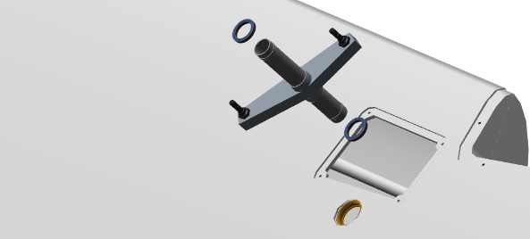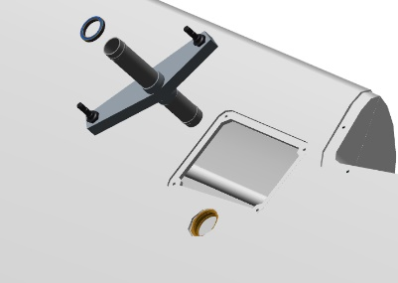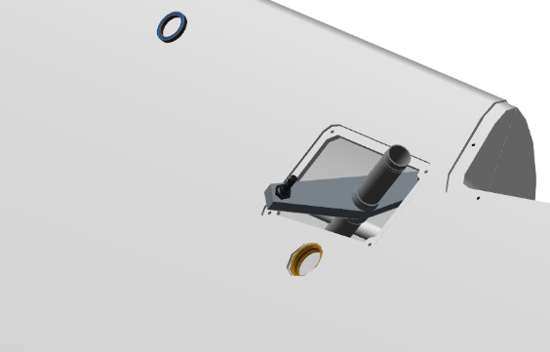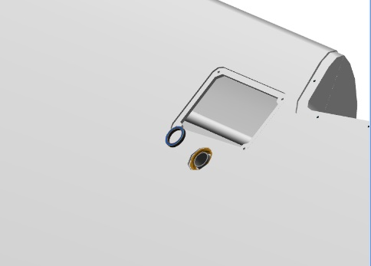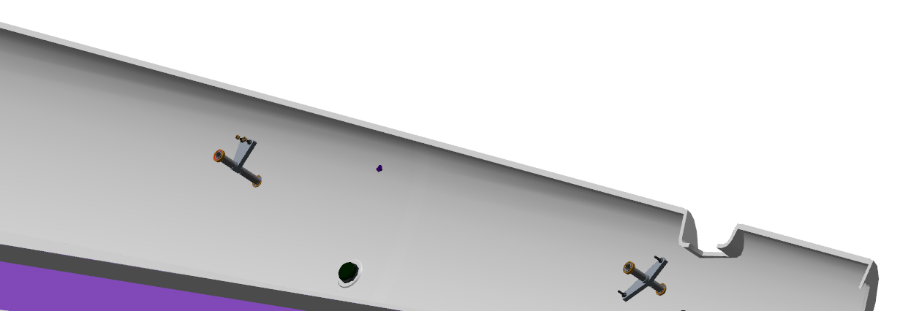
Place the ANG-2700-00034989-00 pushrod through the opening in the aileron area, with the adjustable rod end facing outwards. Fit the pushrod to the ANG-2700-00034561-00 bellcrank and secure it. Tighten the M6 ​​nut DIN 935 and lock it with the 1x20 DIN 94 cotter pin.
Place the ANG-2700-00038057-00 pushrod through the hole in the front part of the root rib, slide it up to the ANG-2700-00034561-00 bellcrank, feeding it through the access holes in the bottom wing covering. Fit the pushrod to the ANG-2700-00034561-00 and ANG-2700-00033355-00 bellcranks successively, secure it with M6 DIN 935 nuts and 1x20 DIN 94 cotter pins.
Place the ANG-2700-00030802-00 pushrod through the opening in the front portion of the root rib; slide it to the ANG-2700-00033355-00 belcrank, moving it through feeding it through the access holes in the bottom wing covering. Fit the pushrod to the ANG-2700-00033355-00 bellcrank, secure the connection with an M6 DIN 935 nut and 1x20 DIN 94 cotter pin.
Checkup operations:
Check the mechanism for proper operation by moving the ANG-2700-00030802-00 pushrod to and fro. It should move without any undue effort and jerks.
Verify the aileron mounting assemblies for the absence of any foreign objects.
Verify the aileron axles for nicks (dents), squeeze-out of adhesive. There should be no foreign objects, dents, or squeeze-out of adhesive.
Find 4 prch-00034668 bearings. Find on the wing panel the aileron hinge assemblies.
Moisten a rag with solvent. Degrease the following items:
Innner surfaces of the holes of the aileron hinge assembly holes;
Outer surfaces of the prch-00034668 bearings.
IMPORTANT! Take care not to apply any retaining compound to the degreased surface immediately. The retaining compound can be applied 5-10 minutes after degreasing.
Apply an even thin layer of LOCTITE 648 retaining compound to the degreased inner surfaces of the hinge assemblies on the wing panel.
Apply an even thin layer of LOCTITE 648 retaining compound to the degreased outer surface of the two bearings.
Pre-fit one bearing into the hole of the hinge assembly, with its flange facing outwards, farther from the wing panel tip. Press-fit the bearing with a clamp until the bearing flange abuts against the plane of the hinge assembly.
Press-fit up the second bearing using a wood (non-metallic) pad.
IMPORTANT! Do not use an impact method for fitting bearings. Also, do not rest (lean) against the entire assembly while fitting the bearings. This may result in damaging the assembly. Do not allow the ingress of any retaining compound inside the bearing. This will result in loss of the bearing serviceability.
Wipe away with a rag any excess or squeeze-out of the retaining compound.
Repeat the process above to fit the bearings to the second assembly.

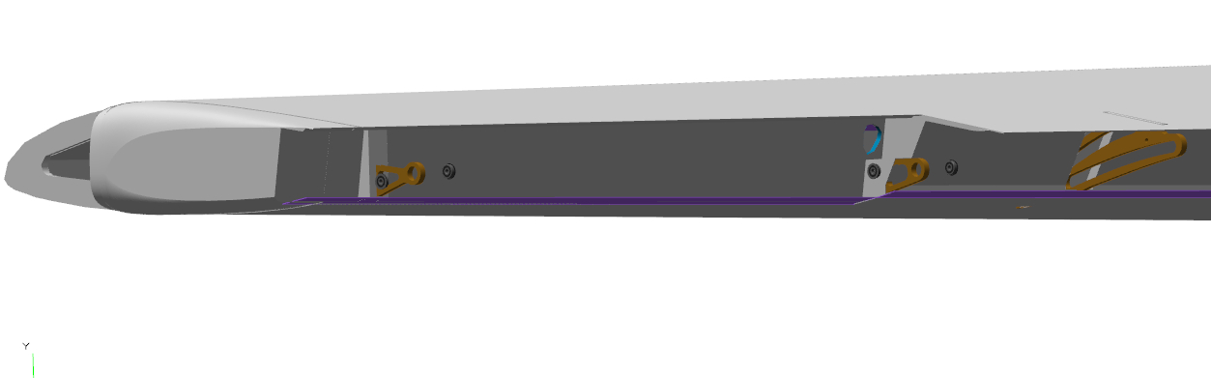
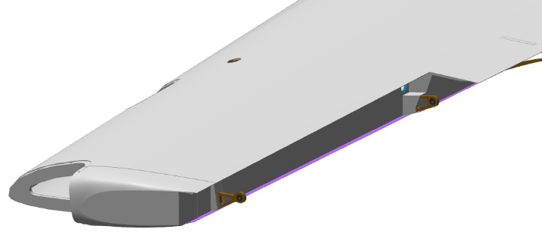
5. 4 Assemble and fit the foot control unit
5.1.1 Assemble the foot control unit
To carry out this task you will need:
Movable table;
Slotted (flat-tip) screwdriver No. 2;
Bench hammer weighing 400 grams;
1mm, 100 mm safety (locking) wire - 6 pieces;
М5х46 DIN 933 bolts - 2 pieces;
М5 DIN 934 nuts - 2 pieces;
5 DIN 125 washers - 4 pieces;
Litol-24 grease 10 grams;
100x100 mm clean rags - 2 pieces;
Pliers;
8 mm combination wrench 2 pieces.
Unpack and place on the table:
Left pedal marked ANG-2700-00030413-00;
Right pedal marked ANG-2700-00030414-00;
2 left brake pedals marked ANG-2700-00030419-00;
2 right brake pedals marked ANG-2700-00030419-00Z;
10 supports (feet) marked ANG-2700-00030418-001;
4 ANG-2700-00031980-00 brake master cylinders (assembled as per 4.1);
Count and place on the table:
4 М5х35 axles;
8 М5х40 axles;
Twelve 5 DIN 125 washers;
Find the ANG-2700-00030413-00 left pedal, if necessary, place it with the brake system attachment points facing upwards,and with the pedals on the table. Find the ANG-2700-00031980-00 brake master cylinder with the S6520-6 1/8 top fitting.
Feed the bottom part of the ANG-2700-00031980-00 master cylinder into the bottom lugs on the right side (viewed from you) of the ANG-2700-00030413-00 left pedal, positioning upwards the fittings relative to the left pedal master cylinder.
Align the holes of the master cylinder with those of the left pedal.
Fit into the aligning holes the M5x35 axle, with its the head on the pedal side.
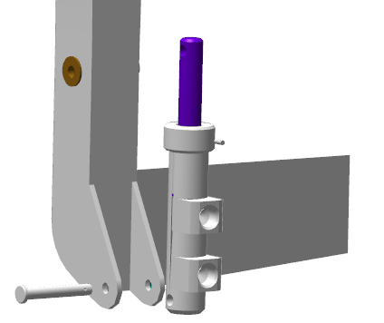 | 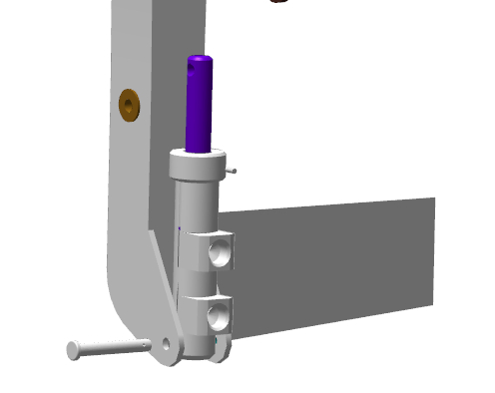
Press-fit the axle into the holes tapping slightly on it with a hammer. Check for freedom of movement of the master cylinder on the axle. The movement should be easy, without jerks or binding. Fit onto the protruding part of the axle the 5 DIN 125 thrust washer, cotter the axle, bend aside one cotter pin end.
Find the left ANG-2700-00030419-00 brake pedal. Place the lugs of the left ANG-2700-00030419-00 brake pedal onto the ANG-2700-00030413-00 left pedal. The tube of the left brake pedal should be located on the pedal side. Align the pedal holes.
Fit the M5x40 axle into the aligning holes, with its head on the pedal side. Press-fit the axle into the holes by tapping on it slightly with a hammer. Fit the 5 DIN 125 thrust washer onto the protruding part of the axle, fit the cotter pin into the axle hole, bend aside one cotter pin end. Check for freedom of movement of the brake pedal around the axle. The movement should be easy, without jerking or binding.
Place the lugs of the ANG-2700-00030419-00 left brake pedal onto the rod of the ANG-2700-00031980-00 master cylinder. Align the holes of the pedal with those of the rod. Fit the M5x40 axle into the aligning holes, with its the head on the pedal side. Press-fit the axle into the holes by tapping on it slightly with a hammer.
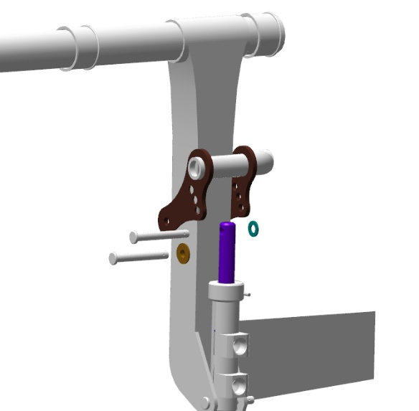 | 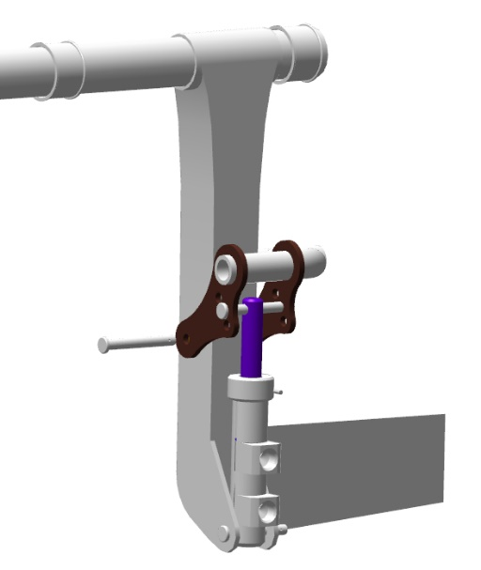
Fit onto the protruding part of the axle the 5 DIN 125 thrust washer, insert the cotter pin into the axle hole, bend one cotter pin end aside.
Checkup operations:
Check for freedom of movement of the master cylinder on the axle. The movement should be easy, without jerks or binding.
Check for freedom of movement of the of the brake pedal with cylinder. The movement should be easy, without any jerks or binding.
Repeat the process above to assemble the other part of the ANG-2700-00030413-00 left pedal with the ANG-2700-00031980-00 brake master cylinder, whose both fittings are S6520-4 1/8.
After having assembled the left pedal, repeat the same process to assemble the ANG-2700-00030414-00 right pedal:
The ANG-2700-00031980-00 brake master cylinder with the S6520-6 1/8 fitting should be located on your right;
The ANG-2700-00031980-00 Brake master cylinder with the S6520-4 1/8 fittings should be located on your left.
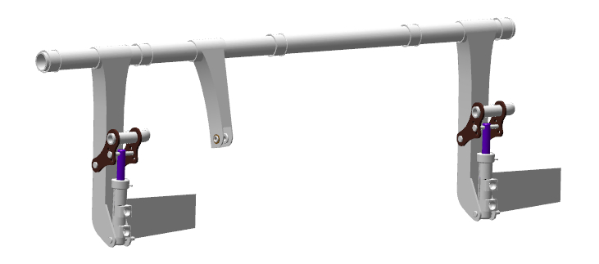
After having assembled the right and left pedals, find 6 ANG-2700-00030418-001 supports (feet) and place them next to the pedals.
- Place on the table the left ANG-2700-00030413-00 pedal onto the right pedal ANG-2700-00030414-00 having shifted the left pedal to the right.
- Align the bushes on the pedal shafts opposite each other. Fit one ANG-2700-00030418-001support (foot) below on the left side.
IMPORTANT! Do not apply any lubricant to the supports (feet). The material of the supports (feet) absorbs them and swells, resulting in the failure of the unit.
Align the ends of the bushes on the pedal shafts and fit the ANG-2700-00030418-001 support (foot) onto them. Fit onto the opposite side the ANG-2700-00030418-001second support.
Align the mounting holes of the supports, fit into the mounting holes two M5x46 DIN 933 bolts with 5 DIN 125 washers placed under their heads. Place onto the opposite side two 5 DIN 125 washers, hand-screw one M5 DIN 934 nut on each bolt. Tighten the M5 DIN 934 nuts with 8 mm combination wrenches.
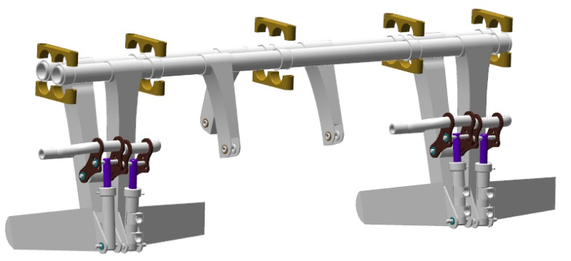
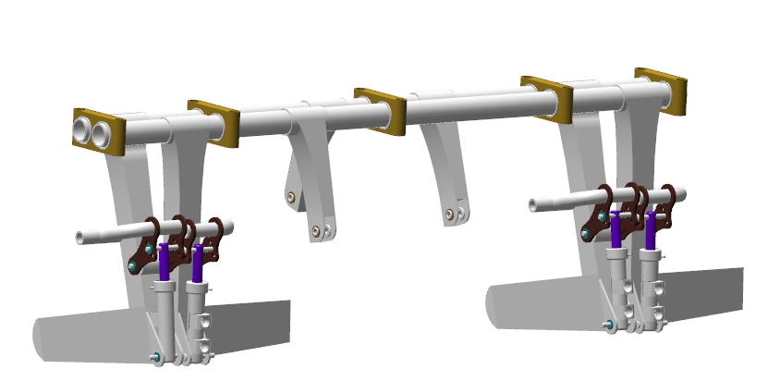
Pull safety wire through the side hole of the ANG-2700-00030418-001 support (foot) for about half of its length. While holding the wire with one hand, feed it with the other hand through the side hole of the second ANG-2700-00030418-001 support (foot). Twist the wire by hand, tighten it with pliers.
Repeat the wire locking process for the side holes of the ANG-2700-00030418-001 supports (feet) on the opposite side.
Unscrew the M5 DIN 934 nuts with 8 mm combination wrenches. Remove 5 DIN 125 washers, take both M5x46 DIN 933 bolts out of the support (foot) holes.
Repeat the wire locking process above for the rest of the ANG-2700-00030418-001 supports (feet) on the pedal shafts.
5. 4. 2 Fit the foot control unit
To carry out this task you will need:
Movable table;
foot control unit (assembled earlier);
8 mm combination wrench;
Digital kitchen scales;
Latex gloves - 1 pair;
Larit LR285 epoxy resin - 30 grams;
H287 hardener - 12 grams;
100 ml paper cup;
Aerosil thickener - 3 grams;
P1000 grit sandpaper one 200x300 mm sheet;
Methyl acetate solvent - 100 grams;
100x100 mm clean rags - 2 pieces;
P240 grit sandpaper one 200x300 mm sheet;
Respirator;
50 mm metal spatula (putty knife);
LOCTITE 648 retaining compound.
Pliers;
1-25Nm torque wrench;
2.5 mm hexagonal socket;
2.5 mm hex (Allan) key.
Count and place on the table 10 screws М5х46 DIN912.
Check as per standard operation 6 the M5 threaded holes and attachment points of the foot control unit on the frame.
Take with you the bolts and the 2.5mm Allen key. Bring the foot control unit to the door opening on the port (left) side of the fuselage. Direct the right side into the door opening, slip the foot control unit inside the fuselage, turn the right side of the unit towards the forward part of the fuselage, lower it below the control panel line, move it forwards and place on the floor.

Get inside the fuselage. Lift the right part of the foot control unit up until encountering a hard stop against the control panel, and lower the other part down until it stops against the floor. Move the lifted part along the frame to the right, slide it all the way until encountering a hard stop against the fuselage covering on the right. Turn the foot control unit so that the pedals face downwards, raising the entire unit upwards, parallel to the frame web.
Assume supine position on the floor with your head facing upward. Lift the unit up towards the frame cap and align the holes of the ANG-2700-00030418-001 support with those of the frame. Pre-fit into the holes of the support two M5x46 ISO 7380-2 screws, hand-screw them into the threaded holes of the frame.
Fit the same way the next ANG-2700-00030418-001 support. Assume the same position on the right side of the fuselage, fit the third ANG-2700-00030418-001 support. Tighten all the retaining bolts of the ANG-2700-00030418-001 support with an 8mm combination wrench.
Checkup operations:
Check for freedom of movement the foot control unit in the supports. The movement should be smooth, without any jerks and binding, without applying undue force. Circle the position of the supports on the frame with a marker.
Unscrew the M5x46 DIN912 screws with a 2.5 mm hexagon wrench (Allen key), one by one, shift the foot control unit down. Place the bolts on the floor of the fuselage. Exit from the fuselage.
Put on a respirator and safety glasses. Take with you P240 grit and P1000 grit sandpaper inside the fuselage. Get inside the fuselage.
IMPORTANT! It is necessary to sand the areas for applying adhesives 10-15 mm wider than the actual outline of the part to be fitted. Do not take with you into enclosed spaces any open solvent or rags moistened with it.

Sand the contact area of the ANG-2700-00030418-001 supports of the foot control unit on the fuselage frame as per typical action 3.
IMPORTANT! Take care not damage the composite parts in the areas to be sanded. Do not sand the same spot for a long time, even if the sanded area does not turn matt.
Sand as per the standard operation 3 the 4 areas of contact of the supports ANG-2700-00030418-001 with the frame.
Exit from the fuselage.
Upon sanding all the spots, put on latex gloves. Moisten a cloth with solvent. Get into the fuselage and degrease the following items:
The attachment surfaces of the ANG-2700-00030418-001 supports on the fuselage frame;
Contact surfaces of the ANG-2700-00030418-001 supports with the frame.
Exit from the fuselage.
Make a batch of the epoxy glue mixing the Larit L285 resin and H287 hardener in a ratio of 30:12 as per the standard operation1.
IMPORTANT! The epoxy glue is to be used within 60 minutes following its preparation.
Get inside the fuselage and apply the glue as per the standard operation 5.1 to the degreased surfaces of the ANG-2700-00030418-001 foot control unit supports, the degreased areas for mounting the ANG-2700-00030418-001 supports to the frame. Exit from the fuselage.
Make an adhesive from the remaining glue according to the standard operation 2.
Take with you a 50 mm spatula (putty knife), adhesive, 2.5 mm Allen key. Get into the fuselage.
Apply the adhesive compound as per the the standard operation 5.2 to the surfaces of the ANG-2700-00030418-001 supports.
Lift the unit up to the frame cap and align the holes of the ANG-2700-00030418-001 support with those of the frame. Apply an even, thin layer of LOCTITE 648 retaining compound to the degreased surface of the bolts. Place two M5x46 DIN912 screws into the holes of the support, hand-screw them into the threaded holes of the frame.
Attach the next support ANG-2700-00030418-001 the same way. Assume the same position on the right side of the fuselage, fit the third ANG-2700-00030418-001 support. Tighten all ANG-2700-00030418-001 support bolts with a 2.5mm hex wrench (Allen key) until encountering a hard stop with your hand.
Attach the 2.5 mm hex bit, adjust the torque wrench to 5 Nm. Get into the fuselage with the tool. Tighten the bolts of the ANG-2700-00030418-001 supports with a wrench to 5Nm.
Checkup operations:
Check for freedom of movement of the foot control unit in the supports. The movement should be smooth, without any jerks and binding, without applying any undue effort. Remove the wire connecting the ANG-2700-00030418-001 supports.
Exit from the fuselage.
Clean your workplace and tools as per the standard operation 7.
You can proceed to the next task while the adhesive is curing.

5.4.2 Assemble and fit the manual control unit

To carry out this task you will need:
- Movable table;
- Two 8 mm combination keys;
- Tweezers;
- Combination pliers;
- Slotted (flat tip) screwdriver No. 1;
- 5mm hex key (Allan wrench);
- 3mm hex key (Allan wrench);
- LOCTITE 648 retaining compound;
- Methyl acetate solvent 100 grams;
- 100x100 mm clean rags - 2 pieces;
- 1-25Nm torque wrench;
- 3 mm hexagon socket;

Unpack and place on the table:
- ANG-2700-00030462-00 control stick (left);
ANG-2700-00030462-02 control stick (right);
6 ANG-2700-00030464-001 supports (feet);
ANG-2700-00030461-00 lever (arm);
ANG-2700-00030485-00 pushrod (assembled earlier);
ANG-2700-00031282-00 pushrod (assembled earlier);
ANG-2700-00031282-00Z pushrod (assembled earlier);
6 std-00032283 bolts;
6 М5 DIN 935 nuts;
Six 1.0x35 DIN 94 cotter pins;
Six 5 DIN 127 washers;
2 АNG-2700-00030488-004 bolts;
2 АNG-2700-00030488-005 bolts;
2 АNG-2700-00030488-007 bolts;
Find the ANG-2700-00030461-00 lever (arm), 6 ANG-2700-00030464-001 supports, 6 std-00032283 bolts.
Fit two ANG-2700-00030464-001 supports onto the ANG-2700-00030461-00 lever (arm) bearing and bring them close together.
Check the junction of the supports for clearance. There should be no clearance.
Fit through the holes of the supports two std-00032283 bolts, compress the supports again.
Make several circular motions with the compressed supports with bolts. The movement should be smooth, light, without any jerks or binding.
Repeat the process above to check the rest of the supports.
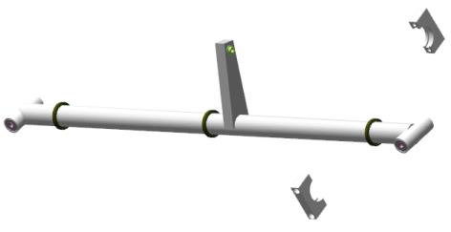 | 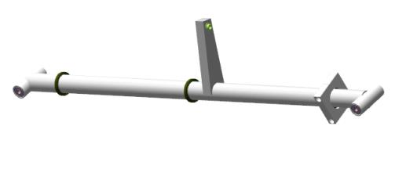
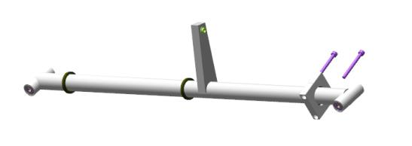 | 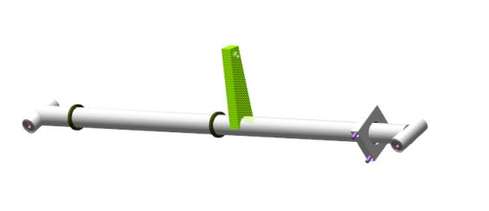
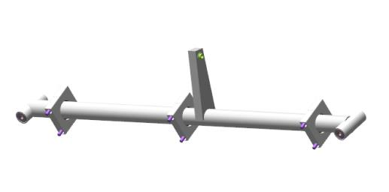 | 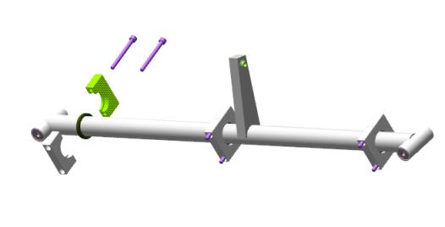
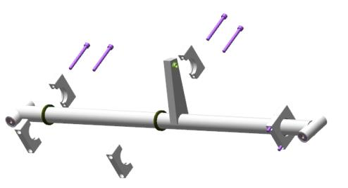
Remove the supports and bolts from the lever (arm). Get inside the fuselage cockpit together with the parts. Push the lever (arm) through the opening of the left handle of the pilot beam all the way down by tilting one bearing support upward. Feed the lever (arm) under the pilot beam, by tilting the top of the lever to the left, place it on the floor moving to the right.

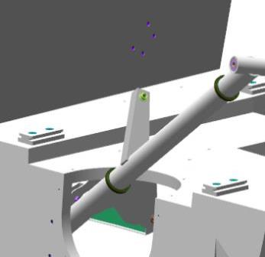 | 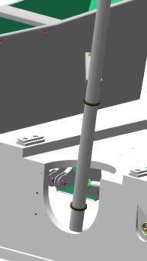
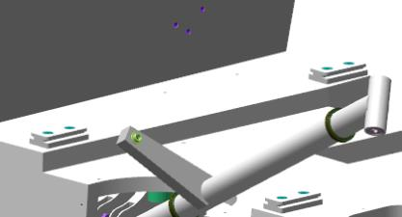 | 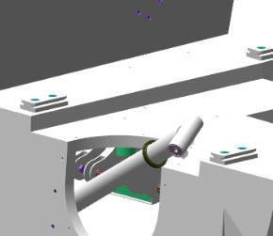
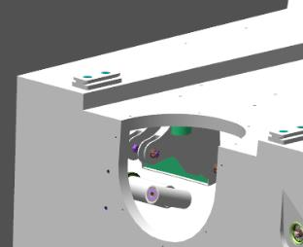
Place two std-00032283 bolts through the holes in the ANG-2700-00030464-001 support. Move the shaft away from the front web of the pilot beam. Bring the supports together on the shaft in the area of the fitted bearing. Move the shaft with the supports to the left and then to the right and repeat the process above to fit the supports on the left and right sides. Approach the shaft to the front web, align the holes of the web with those of the middle support. Hand-screw the std-00032283 bolts for 2-3 turns into the threaded holes in the front web of the pilot beam. Repeat the process above to fit the supports on the left and right sides. If the holes do not align, slide the shaft end up and down smoothly to align the holes.
Important! When working, take care not to drop the screws into the fuselage cavity. Use magnetized tools.
Tighten the six std-00032283 retaining bolts of the ANG-2700-00030464-001 support using a 3mm hex key (Allen wrench). Move the ANG-2700-00030461-00 lever (arm) forward turning it by the bearing assembly. The movement should be smooth, easy, without jerks or binding. Move the lever (arm) back. The movement should be smooth, easy, without jerks or binding. Make 5-6 rotational movements. The movement should be smooth, easy, without any jerks or binding.
- Remove one std-00032283 bolt from the supports. Put on the latex gloves and respirator. Moisten a rag with solvent. Degrease the threaded portion of the bolt.
IMPORTANT! Take care not to apply any retaining compound to a degreased surface immediately. The retaining compound can be applied 5-10 minutes after degreasing.
Apply an even thin layer of LOCTITE 648 retaining compound to the degreased surface of the std-00032283 bolt.
Thread the bolt into the hole in the supports, tighten it with the 3mm Allen wrench, until it feels snug.
Remove the second bolt and repeat the pocess above.
Attach the 3 mm hex socket, set the torque wrench to 6 Nm. Tighten the retaining bolts of the supports with a wrench to 6Nm.
Repeat the process above to fit the bolts to the two remaining supports.
Make 5-6 rotational movements. The movement should be smooth, light, without any jerks or binding.
Clean your workplace and tools as per the standard operation 7.
Exit the cockpit, approach the table. Find the ANG-2700-00030485-00, ANG-2700-00031282-00Z, ANG-2700-00031282-00 pushrods and ANG-2700-00030462-02, ANG-2700-00030462-00 handles. Find the remaining fasteners.
Move the parts into the fuselage cockpit. Place the handles and fasteners onto the rear sofa.
Place the ANG-2700-00030485-00 pushrod through the same way like the ANG-2700-00030461-00 lever (arm), put it under the pilot beam.
Feed the ANG-2700-00031282-00 pushrod through the aperture of the left control handle, place it under the pilot beam.
Feed the ANG-2700-00031282-00Z pushrod through the aperture of the right control handle.
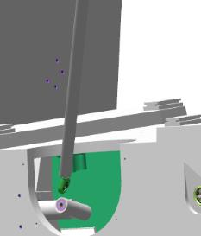 | 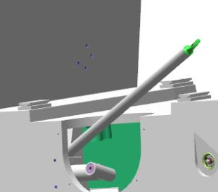
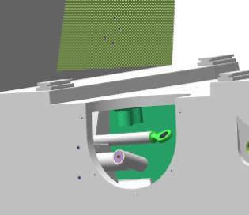

Find the ANG-2700-00030462-00 handle. Place the handle into the apertureon the left, align the holes of the handle plates with the bearing assembly of the lever.
Fit the АNG-2700-00030488-005 bolt into the aligning holes, push it through its entire length until its head encounters a hard stop against the handle.
Checkup operations:
Make several movements leftward and rightward. The movements should be smooth, easy, without any jerks or binding.

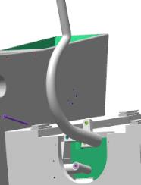 | 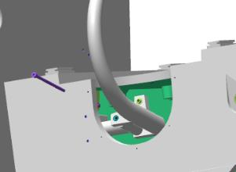
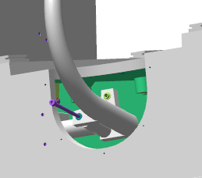 | 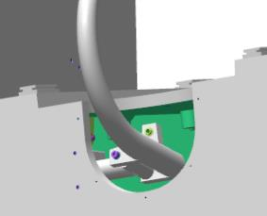
Place the 5 DIN 127 washer onto the АNG-2700-00030488-005 bolt, screw the M5 DIN 935 nut on. Hold the bolt with a 5 mm hex key (Allan wrench) and tighten the nut with an 8 mm combination wrench to seat the nut completely and tightly onto the 5 DIN 127 washer. Find in the bolt the hole that is supposed to align with the slot of the M5 DIN 935 nut.
IMPORTANT! Do not loosen the nut to align the hole with the slot. This will result in a quick failure of the assembly and its play.
Feed the 1.0x35 DIN 94 cotter pin into the aligning slot of the M5 DIN 935 nut and the hole of the АNG-2700-00030488-005 bolt. Secure the connection by bending the cotterpin ends aside with a slotted (flat-tip) screwdriver №1;
Repeat the process above to fit the right ANG-2700-00030462-02 handle.
Approach the ANG-2700-00031282-00 rod end from outside to the hole in the protrusion of the ANG-2700-00030462-00 handle, align the holes. Fit the bolt АNG-2700-00030488-004 into the aligning holes, push it through until encountering a hard stop.
Approach the ANG-2700-00030485-00 pushrod from behind the handle, fit onto the protruding part of the bolt, holding the bolt with your finger. Place the 5 DIN 127 washer on the bolt, screw the M5 DIN 935 nut on.
While holding the bolt with a 5 mm hex key (Allen wrench), tighten the nut with an 8 mm combination wrench to to seat the nut completely and tightly on the 5 DIN 127 washer. Find in the bolt the hole that is supposed to align with the slot of the M5 DIN 935 nut.

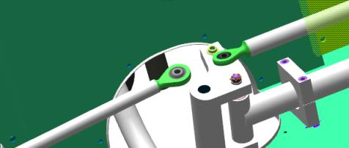 | 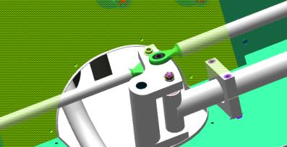
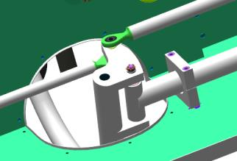 | 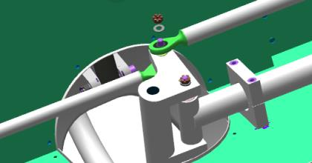
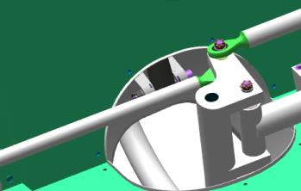
IMPORTANT! Do not loosen the nut to align the hole with the slot. This will result in quick failure of the assembly and its play.
Feed the 1.0x35 DIN 94 cotter pin into the aligning slot of the M5 DIN 935 nut and the hole of the АNG-2700-00030488-004 bolt.
Secure the connection by bending the cotterpin ends aside with a slotted (flat-tip) screwdriver №1;
Repeat the above process to fit the right ANG-2700-00030462-02 handle.
86 107
Checkup operations:
Tilt any handle gently to the left. The movement should be smooth and easy, without any jerks or binding, the opposite handle should completely follow the movement. A sound caused by the movement of the ANG-2700-00031282-00 and ANG-2700-00031282-00Z pushrods can be heard from the bottom area of the fuselage.
Tilt any handle gently to the right. The movement should be smooth and easy, without any jerks or jamming, the opposite handle should completely repeat the movement.
Check the handle for the back and forth movement. The movement should be smooth and easy, without any jerks or binding, the opposite handle should completely follow the movement.
Set the handle approximately in the middle. The second handle should assume the same position.
Move any of the handles to the left. Find the rod end ANG-2700-00031282-00 in the opening on the left.
Approach the rod end to the ANG-2700-00031210-00 aileron bellcrank arm in front, align the holes.
Fit the АNG-2700-00030488-007 bolt into the aligning holes, push it through all the way until its head encounters a hard stop. Make several movements left and right. The movement should be smooth and easy, without any jerks or binding.
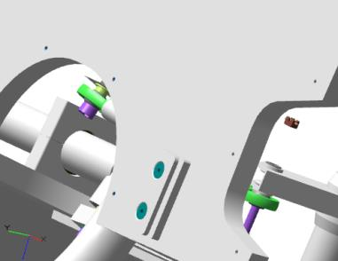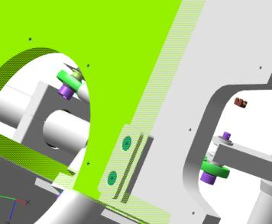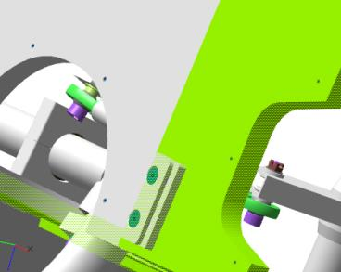
Place a 5 DIN 127 washer onto the АNG-2700-00030488-005 bolt, thread the M5 DIN 935 nut on it. Holding the bolt with a 5 mm hex key (Allen wrench), tighten the nut with an 8 mm combination wrench to seat it on the 5 DIN 127 washer is completely and tightly. Find in the bolt the hole that should align with the slot of the M5 DIN 935 nut.
IMPORTANT! Do not loosen the nut to align the hole with the slot. This will result in a quick failure of the assembly and its play (backlash).
Fit the 1.0x35 DIN 94 cotter pin into the slot of the M5 DIN 935 nut aligning with the holes of the bolt АNG-2700-00030488-005. Secure the connection by bending the cotter pin ends aside with a with a slotted (flat-tip) screwdriver №1.
Repeat the process above to fit the pushrod ANG-2700-00031282-00Z.
Checkup operations:
Tilt any handle gently to the right. The movement should be smooth and easy, without any jerks or binding, the opposite handle should completely follow the movement.
Check the back and forth movement of the handle. The movement should be smooth, light, without any jerks or binding, the opposite handle should completely follow the movement.

5.6 Assemble the elevator and rudder controls
Note: the elevator and rudder have been already fitted (as per 6.2, 6.3).
To carry out this task you will need:
Movable table;
Two 8 mm combination keys;
Tweezers;
Combination pliers;
Slotted (flat-tip) screwdriver №1;
Unpack and place on the table:
17 М5 DIN 935 nuts;
17 5 DIN 127 washers;
Fifteen 1x20 DIN 94 cotterpins;
14 std000 bolts;
3 ANG-5300-00030450-015 bolts;
4 ANG-2700-00030331-00 bellcranks;
RN ANG-2700-00034456-00 bellcrank;
ANG-2700-00029397-00 bellcrank;
ANG-2700-00055198-00 bellcrank;
ANG-2700-00037821-00 pushrod;
ANG-2700-00037822-00 pushrod;
ANG-2700-00029714-00 pushrod;
6 ANG-2700-00029408-00 pushrods;
2 ANG-2700-00029710-00 pushrods;
ANG-2700-00029711-00 pushrod;
ANG-2700-00029716-00 pushrod;
ANG-2700-00055169-00 pushrod;
ANG-2700-00055170-00 pushrod
Find four ANG-2700-00030331-00 bellcranks, two ANG-5300-00030450-015 bolts, two М5 DIN 935 nuts, two 5 DIN 127 washers, two 1х20 DIN 94 cotter pins. Access the fuselage compartment, behind the luggage compartment, having taken with you the parts.
IMPORTANT! Place the small items to be used in a bag before taking them into the aircraft compartment. Leaving any foreign objects in the aircraft compartment is not acceptable.
Find three bracket lugs on the bottom of the fuselage, closer to the aft.
Place a 5 DIN 125 washer onto the inner lug, feed the ANG-5300-00030450-015 bolt into the bracket hole, so that the axle is level with the washer.
Fit the ANG-2700-00030331-00 bellcrank onto the bracket, aligning roughly the holes of the bearings and lugs.
Place the ANG-5300-00030450-015 bolt through the bellcrank so that the axle is level with the bearing.
Place a 5 DIN 125 washer between the bearing and the bracket lug, feed the axle through until it protrudes slightly on the other side of the bracket lug.
Place a 5 DIN 125 washer onto the inner lug, feed the ANG-5300-00030450-015 bolt into the bracket hole, so that the axle is level with the washer. Position the second ANG-2700-00030331-00 bellcrank onto the lugs, aligning roughly the holes of the bearings and the bracket.
Place the ANG-5300-00030450-015 bolt through the bellcrank so that the axle is level with the bearing.
Slip a 5 DIN 125 washer between the bearing and the bracket lug, feed the axle through until its head encounters a hard stop against the bracket lug.
Check for freedom of movement of the bellcranks on the bracket. The bellcranks should rotate around the axle easily, without any jerks or binding.
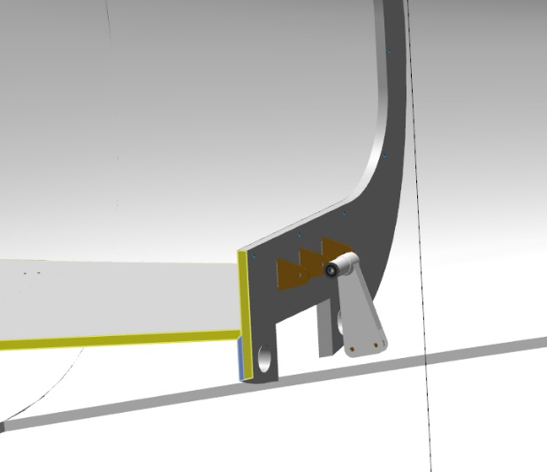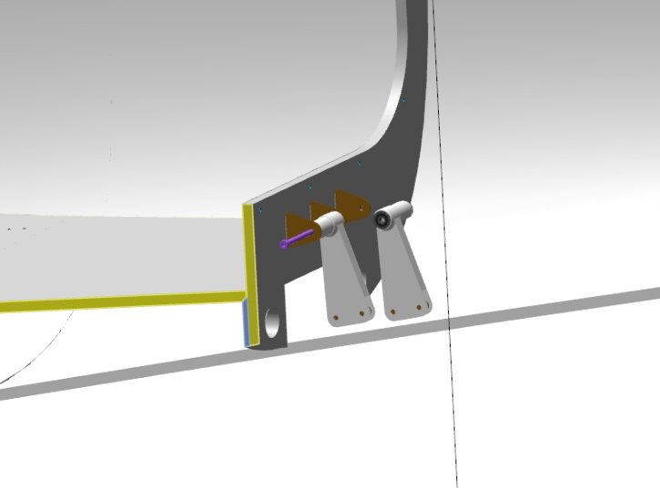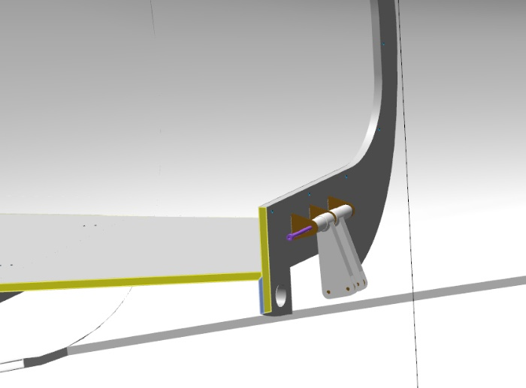
Place the 5 DIN 127 washer onto the ANG-5300-00030450-015 bolt, screw the M5 DIN 935 nut on. Tighten the nut with the 8 mm wrench to seat it on the 5 DIN 127 washer fully and tightly. Find in the ANG-270029291-00 axle the hole, which is supposed to align with the slot on the M5 DIN 935 nut. If the hole cannot be seen, tighten the nut slightly to get the correct alignment of the hole with the slot. Insert the 1x20 DIN 94 cotter pin into the aligning slot of the M5 DIN 935 nut and the holes in the bolt. Secure the connection by bending the cotter pin ends aside with a with a slotted (flat-tip) screwdriver №1.
Repeat the process above to fit the two bellcranks inside the fuselage through the accees hole in the luggage compartment floor.
Get inside the aircraft cabin, position yourself on the left side of the rear sofa. Repeat the process to fit the bellcranks through the access hole in the sofa. Move towards the tail section of the aircraft. Feed through the rear window the ANG-2700-00055170-00 pushrod, with the adjustable end facing outward the aircraft, put it down.
You will need a helper to do the next step. Move to the access holes in the aft portion on the right side. Feed the ANG-2700-00029758-00 pushrod through the access hole.
Fit the pushrod as per the standard operation 9.
Important! When working, take care not to drop the fasteners into the fuselage cavity. Use magnetized tools.
Repeat the process above to connect the ANG-2700-00029758-00 pushrod with the rudder, do not fit the cotter pin in this step.
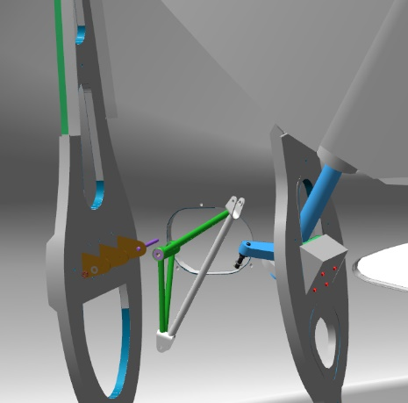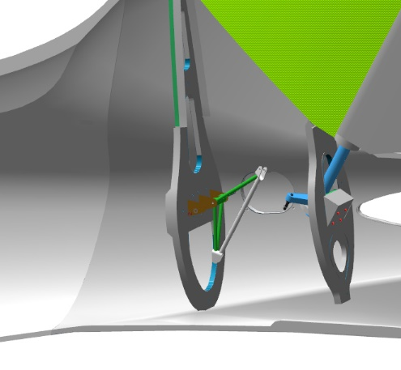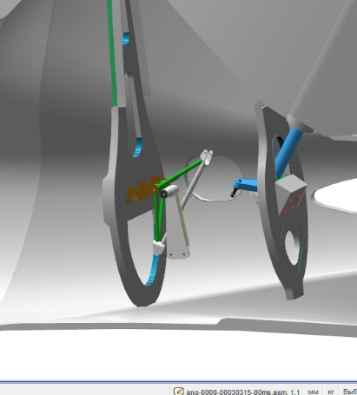
Repeat the process above to connect the pushrod ANG-2700-00029716-00 with the ANG-2700-00030331-00 bellcrank.
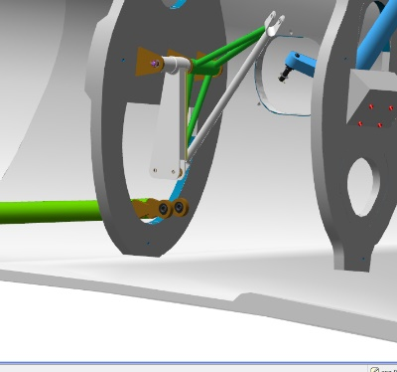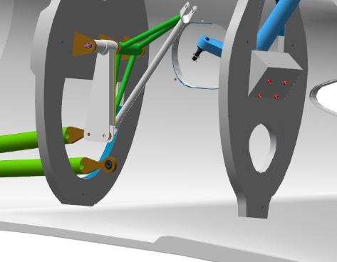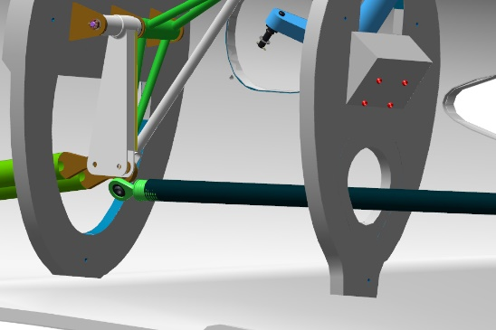
Find the 4 ANG-2700-00029408-00 pushrods (assembled earlier). Access the fuselage compartment, behind the luggage compartment, carrying with you the parts.
Repeat the steps for installing the pushrods in the compartment, following the procedure of fitting the ANG-2700-00029758-00 pushrod to the bellcrank.
Find the 2 ANG-2700-00029408-00 pushrods ( assembled earlier). Slide the pushrods into the fuselage behind the luggage compartment. Place the pushrods under the luggage compartment floor, and connect them to the fitted bellcranks, as described above.
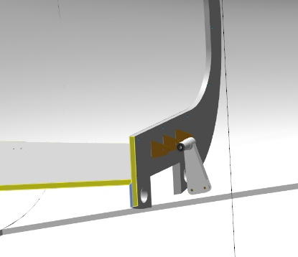 | 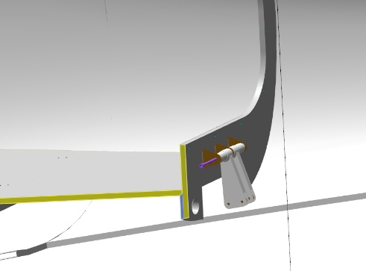
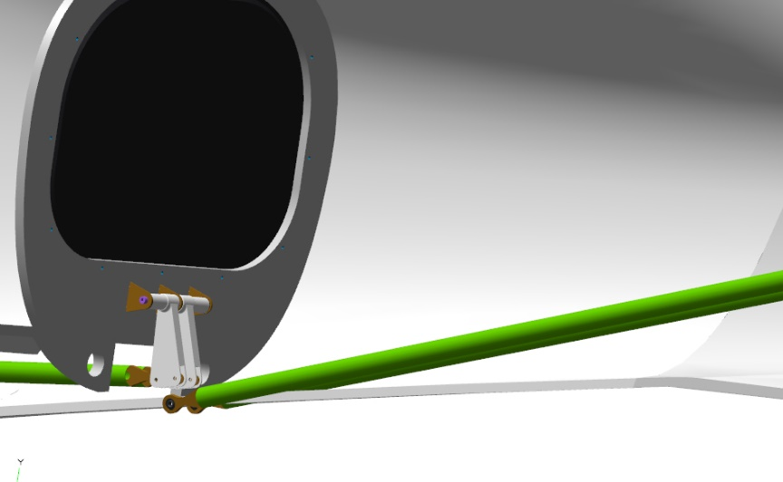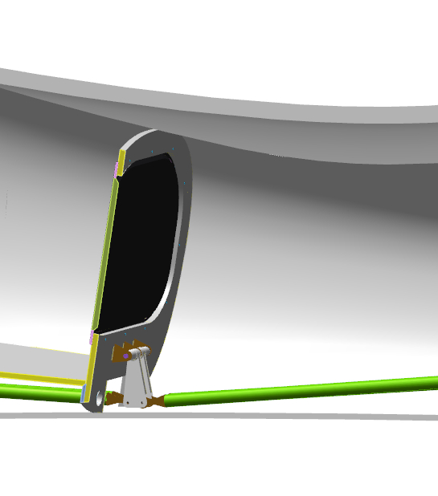
Find the ANG-2700-00029716-00 and ANG-2700-00029711-00 pushrods (assembled earlier). Access the aircraft cabin, carrying with you the pushrods.
Fit the ANG-2700-00029711-00 pushrod as per the standard operation 9 to the right side of the ANG-2700-00031287-00 bellcrank inside the armrest.
Slide the ANG-2700-00029716-00 pushrod with its end facing down pushrod through the opening in the armrest of the pilots' beam
Feed the second rod end inside the armrest towards the ANG-2700-00031287-00 bellcrank. Fit the ANG-2700-00029716-00 pushrod as per the standard operation 9 to the ANG-2700-00031280-00 bellcrank under the pilots' beam.
Fit the ANG-2700-00029716-00 pushrod as per the standard operation 9 to the left side of the ANG-2700-00031287-00 bellcrank inside the armrest.
Fit the ANG-2700-00029711-00 as per the standard operation 9 to the middle bellcrank of the foot control unit (assembled and installed earlier).
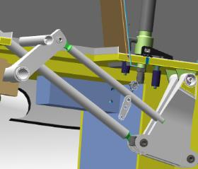 | 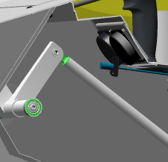
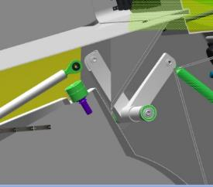 | 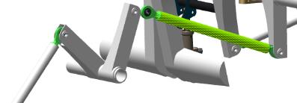
Note. The travel of the pedals of the foot control unit is not synchronized unless landing gear the nose gear steering control pushrods are fitted. Solely the pair of pedals acted upon will move.
.
Checkup operations:
With the pushrods connected to the rudder and foot control unit, depress gently the right pedal fully with your foot. The rudder should deflect to the right. The travel should be smooth, without any jerks or binding, not requiring any undue force.
Pull the right pedal fully towards you by hand. The rudder should deflect to the right. The travel should be smooth, without jerks or binding, not requiring any undue force.
Move the right pedal of the foot control unit 5-6 times, deflecting the rudder to the right and left. The travel should be smooth, without any jerks or binding, not requiring any undue force.
Exit the cockpit, find the ANG-2700-00030868-00 and ANG-2700-00030869-00 pushrods (assembled earlier), and get back into the cockpit.
Place the ANG-2700-00030868-00 pushrod through the hole in the frame on the left. Fit the ANG-2700-00030868-00 pushrod to the right belcrank of the foot control unit as per the standard operation 9.
Place the ANG-2700-00030869-00 pushrod through the hole in the frame on the right. Fit the ANG-2700-00030868-00 pushrod to the left belcrank of the foot control unit as per the standard operation 9.
Move to the nose landing gear leg (fitted earlier), fit the rod ends onto the nose landing gear leg pins (studs). Place one 5 DIN 127 washer on each pin (stud), thread the M5 DIN 935 nuts.
Tighten the nuts alternately with an 8 mm combination wrench to seat them fully and tightly on the 5 DIN 127 washers. Find in the pins (studs) the holes that are supposed to align with the slot of the M5 DIN 935 nut. If the hole cannot be seen, tighten slightly the nut to align the hole with the slot. Fit the 1x20 DIN 94 cotter pin into the aligning slot of the M5 DIN 935 nut and the holes in the pin (stud). Secure the connection by bending the cotter pin ends aside with a slotted (flat-tip) screwdriver №1.
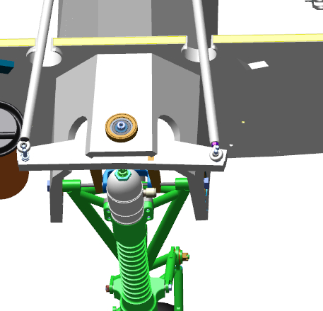
Note. After connecting the nose landing gear control pushrods, the pedals of the foot control unit will travel synchronously - the pedal, which is not acted upon, will move away from the frame.
Checkup operations:
Access the fuselage cockpit. Gently depress the right pedal fully with your foot. The rudder and nose wheel should deflect to the right, and the left pedal should travel upward from the frame. The travel should be smooth, without any jerks or binding and not requiring any undue force. Any creaking, crackling and scratchy sounds should be absent.
Gently depress the left pedal fully with your foot. The rudder and nose wheel should deflect to the left, and the right pedal should travel upward from the frame. The travel should be smooth, without jerks or binding and not requiring any undue force. Any creaking, crackling and scratchy sounds should be absent.

Move the the foot control unit pedals 5 or 6 times, deflecting the rudder to the right and left. The travel should be smooth, without ane jerks or binding and not not requiring any undue force. Any creaking, crackling and scratchy sounds should be absent.
Set the right and left pedals approximately at the same level, as accurately as possible. Move from the cockpit to the rudder. Check the position of the rudder. The rudder should be at zero position approximately. Proceed to the nose wheel. The wheel must be in a position corresponding to a straight-line path (to be positioned straightly).
Note. In case when you set the foot control unit pedals to the same level and the rudder deflects from zero position, it is required to adjust the ANG-2700-00029758-00 pushrod.
To adjust the length thereof you will need to:
Loosen the nut on the rod end near the rudder by 1 turn;
Detach the fasteners fixing the pushrod to the rudder;
Disengage the rod end from the rudder fork;
Unscrew the rod end from the pushrod by 1 turn;
Fit and secure the pushrod in reverse order;
Check the position of the foot control unit pedals and the position of the rudder.
If the rudder position changes in the correct sense, it is necessary to repeat steps 1-6 until the required value is obtained. If the position of the rudder changes in the wrong sense, it is necessary to screw the rod end in the step 4 above into the pushrod.
Upon completion of the adjustments, screw the nut on the rod end using the retaining compound until encountering a hard stop.
Once the adjustment is completed and the rudder is set correctly, secure the connection of the rudder and the pushrod with a 1x20 DIN 94 cotter pin.
Upon completion of fitting the rudder and nose steering control, proceed with fitting of the elevator control.
Find the ANG-2700-00029714-00 pushrod (assembled earlier). Access the cockpit carrying with you the pushrod. Place the ANG-2700-00029714-00 pushrod with its rod end facing down through the opening in the armrest of the pilots' beam. Slide the second rod end inside the armrest toward the bellcrank of the hand control unit.
Fit the ANG-2700-00029714-00 pushrod as per the standard operation 9 onto the ANG-2700-00031280-00 bellcrank under the pilots' beam. Fit the ANG-2700-00029714-00 pushrod to the manual control shaft bellcrank under the pilots' beam as per the standard operation 9.
Proceed from the fuselage to the elevators in the tail section. Position the ANG-2700-00029716-00 rod end between the elevator bellcranks. Align the hole of one of the bellcranks with that of the pushrod. Place the std000 bolt into the aligning holes flush with the rod end. Align the hole of the second bellcrank with that of the pushrod, fit the bolt through until encountering a hard stop.
Place a 5 DIN 127 washer on the bolt, thread on it the M5 DIN 935 nut. Tighten the 5 DIN 127 nut with two 8 mm combination wrenches, to seat it fully and tightly on the washer. Find in the axle a hole, which is supposed to align with the slot of the M5 DIN 935 nut.
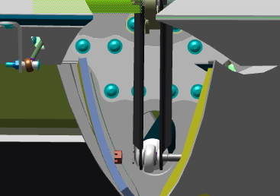 | 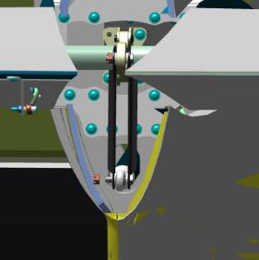
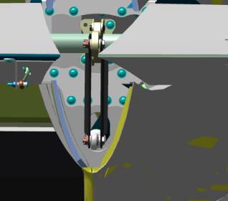
Checkup operations:
Approach the cockpit from the right or from the left, pull the control stick toward you. The elevators should deflect upwards. The travel should be smooth, without any jerks or binding and not requiring any undue force. Any creaking, crackling and scratchy sounds should be absent.

Push the control stick away from you. The elevators should deflect downwards. The travel should be smooth, without any jerks or binding, and not requiring any undue force. Any creaking, crackling and scratchy sounds should be absent.

Set the control stick approximately in the middle of its travel. Proceed to the tail section, approach the elevators. While your helper is holding the stick in the middle position, check the position of the elevators. They must be in zero position.
Note. If, when setting the control stick in the middle position, the elevators deflect from zero position, it is necessary to adjust the ANG-2700-00029716-00 pushrod.
To adjust the length thereof you will need to:
Loosen the nut on the rod end near the elevators by 1 turn;
Detach the fasteners fixing the pushrod to the elevators;
Disengage the rod end from the elevator bellcranks;
Unscrew the rod end from the pushrod by 1 turn;
Fit and secure the pushrod in reverse order;
Check the position of the control stick and that of the elevators.
If the position of the elevators changes in the correct sense, then it is necessary to repeat the steps 1-6 until the required value is obtained. If the position of the rudder changes in the wrong sense, it is necessary to screw the rod end in the step 4 above into the pushrod.
After making adjustments, tighten the nut on the rod until it encounering a hard stop, using the retaining compound.
Once the adjustment is completed and the elevators are set correctly, secure the connection of the elevators and pushrod with a 1x20 DIN 94 cotter pin.

5.7 Assemble and fit the throttle control lever (often referred to as a thrust lever or power lever)
To carry out this task, you will need:
Movable table;
10 mm combination wrench;
4 mm hex key (Allen wrenh);
2.5 mm hex key (Allen wrenh);
slotted (flat-tip) screwdriver №2;
Unpack and place on the table:
Plate marked ANG-3100-00031148-001;
2 shims (pads) marked ANG-3100-00031148-002;
Throttle cable bracket marked ANG-3100-00031148-003;
M4 pin (stud) marked ANG-3100-00031148-004;
Bush marked ANG-3100-00031148-005;
Spring marked ANG-3100-00031148-006;
Bush marked ANG-3100-00031148-007;
Stopper marked ANG-3100-00032309-00;
Count and place on the table:
М6х25 one-piece handle with prch-00031149 marking;
М6 DIN 125 washer;
М6 DIN 985 nut;
М6х55 DIN 912 bolt;
2 М4х8 ISO 7380-2screws;
std-00032822 screw marked.
Find the ANG-3100-00031148-001 plate and the ANG-3100-00031148-005 bush. Push the bush through the hole of the plate until the edge of the bush protrudes 3 mm above the plate.
Fit the std-00032822 screw thrugh the ANG-3100-00031148-007 bush. Fit the bush with the screw into the middle hole of the ANG-3100-00031148-001 plate. Place the M6 ​​DIN 125 washer and the M6 ​​DIN 985 nut onto the threaded portion of the screw. Hand-tighten the connection.
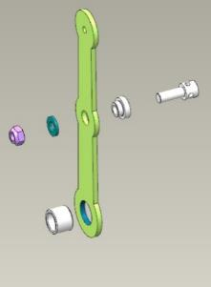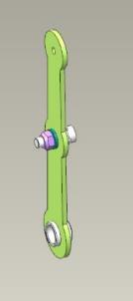
Fit two shims ANG-3100-00031148-00 to the ANG-3100-00031148-005 bush on its both sides. Turn the shims on the plate so that the cutouts face away from the top of the plate.
Place the ANG-3100-00032309-00 stopper on the shim with pins on the the screw head side in the middle hole, aligning the pins with the slotsof the shims. Fit the M6x55 DIN 912 bolt into the holes of the stopper and the bush in the plate.
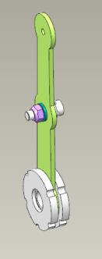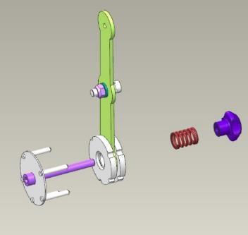
Get inside the aircraft. Fit the partially assembled unit with the protruding portion of the bolt into the bush of the armrest. Align the holes of the armrest with the stopper pins. Slide the unit toward the armrest to feed the pins into the holes.
IMPORTANT! If the stopper pins do not fit into the holes in the armrest, do not apply any undue force or use tools. This will inevitably result in damaging the armrest and impossibility of its further use.
Place the ANG-3100-00031148-006 spring from the outside of the armrest onto the protruding threaded portion of the bolt,. Screw the prch-00031149 one-piece handle onto the thread. Hold the head of the bolt with a 4mm hex key (Allan wrench) and screw the knob by 2-2.5 turns.
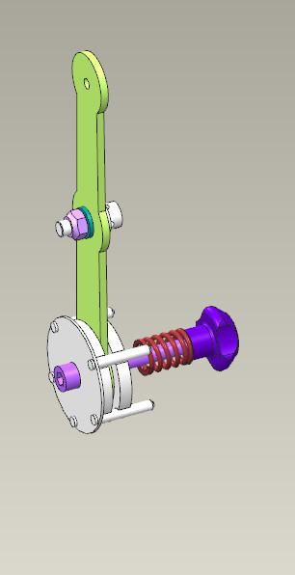
IMPORTANT! The handle should be completely tightened following the fitting of the throttle control cable.
Checkup operations:
Check the throttle control lever travel by moving the ANG-3100-00032309-00 plate forward and backward (from stop to stop). The travel should not require undue force, be smooth and without binding. The plate must remain in whatever position it was moved to.
Find the ANG-3100-00031148-003 throttle cable bracket. Feed the throttle cable through the hole in the bracket, with the two holes of the bracket lug facing toward the cable sleeving.
Feed the throttle cable bracket ANG-3100-00031148-003 into the inner cavity of the armrest, align with the two holes on the partition inside the armrest. Fix the bracket with the cable to the armrest with two M4x8 ISO 7380-2 screws. Tighten the screws with the 2.5 mm hex key (Allen wrench).
IMPORTANT! When working, take care not to drop the screws into the fuselage cavity. Use a magnetized tool.
Move the ANG-3100-00031148-001 plate to the 100% (maximum) position.
Feed the throttle cable into the hole of the std-00032822 screw. Hold the screw with slotted (flat-tip) screwdriver №2 and tighten the M6 ​​DIN 985 nut with a 10 mm combination wrench until encountering a hard stop. Check the throttle control lever travel by moving the ANG-3100-00032309-00 plate forward and backward (from stop to stop). The travel should not require any undue force, be smooth and without any binding. The plate must remain in whatever position it was moved to.
Using a 2.5mm hex key (Allen wrench), detach one M4x8 ISO 7380-2 screw, which holds the ANG-3100-00031148-003 throttle cable bracket. Moisten a rag with solvent, degrease the threaded portion of the screw.
IMPORTANT! Take care not to apply any retaining compound to the degreased surface immediately. The retaining compound can be applied 5-10 minutes after degreasing.
Apply an even thin layer of the LOCTITE 648 retaining compound to the degreased surface of the screw. Fit the screw into the hole, tighten it with a 2.5mm hex key (Allen wrench) until it feels snug.
Repeat the process to fit the second screw that secures the throttle cable bracket. Clean up with a rag any excess or squeeze-out of the retaining compound.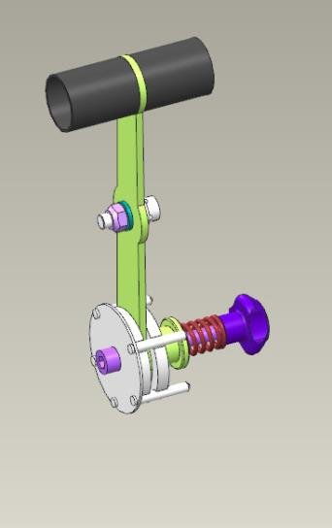

SECTION 6 ASSEMBLE THE AIRFRAME

6.1 Fit the stabilizer
The objective of this task is to fit the stabilizer to the fuselage.
To carry out this task you will need:
Movable table;
2.5 mm hex key (Allen wrench);
Digital kitchen scales.
Latex gloves 1 pair.
Larit L285 epoxy resin - 30 grams.
H287 hardener - 12 grams.
100 ml paper cup.
Aerosil thickener 3 grams.
P1000 grit sandpaper 1 sheet 200x300 mm.
Methyl acetate solvent 100 grams.
100x100 mm clean rags 5 pieces.
P240grit sandpaper 1 sheet, 200x300 mm.
White marker.
Respirator.
50 mm metal spatula (putty knife).
1-25Nm torque wrench.
2.5mm hexagonal socket.
10 meter measuring tape
Unpack and place on the table:
ANG-5500-00039326-00 stabilizer;
ANG-5500-00039325-002 plate;
ANG-5500-00039325-003 plate.
Count 12 M4x10 ISO 7380-2 screws and place them on the table.
Check the M4 threaded holes in the stabilizer and fuselage as per the standard operation 6.
Find the 2 threaded holes on the stabilizer spar, they are located in the middle of the stabilizer on the spar side. This mark points to the lower covering of the stabilizer.
Place the stabilizer through from the left or from the right side into the fuselage opening approximately to the middle. Fit the ANG-5500-00039325-002 and ANG-5500-00039325-003 plates to the frame, align the holes of the plate and of the frame.
Attach the edge holes to the frame with M4x10 ISO 7380-2 screws.
IMPORTANT! Take care not to tighten the screws firmly unless the screws are fitted in all holes. When working, take care not drop the screws into the fuselage cavity. Use a magnetized tool.
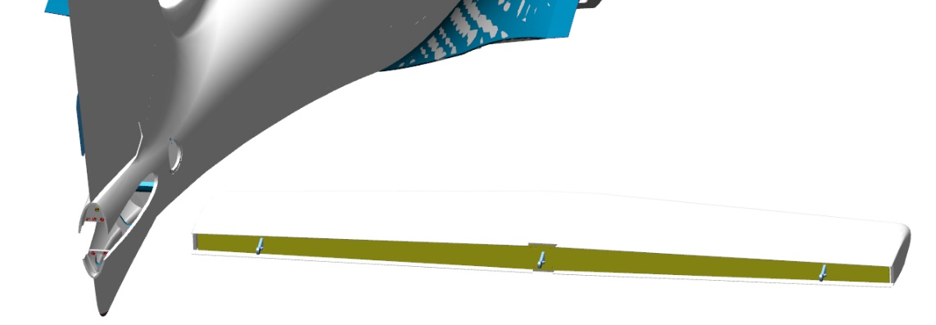
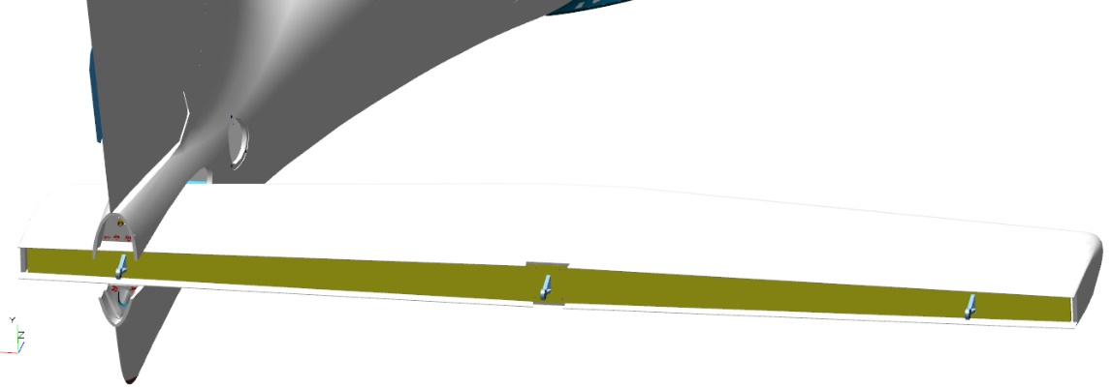
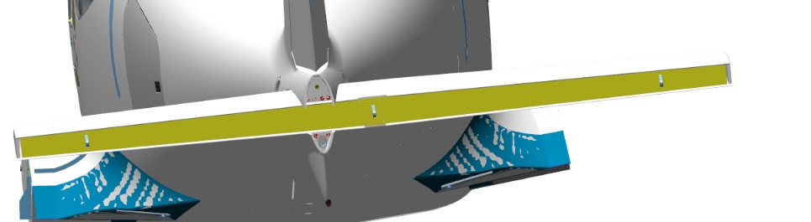
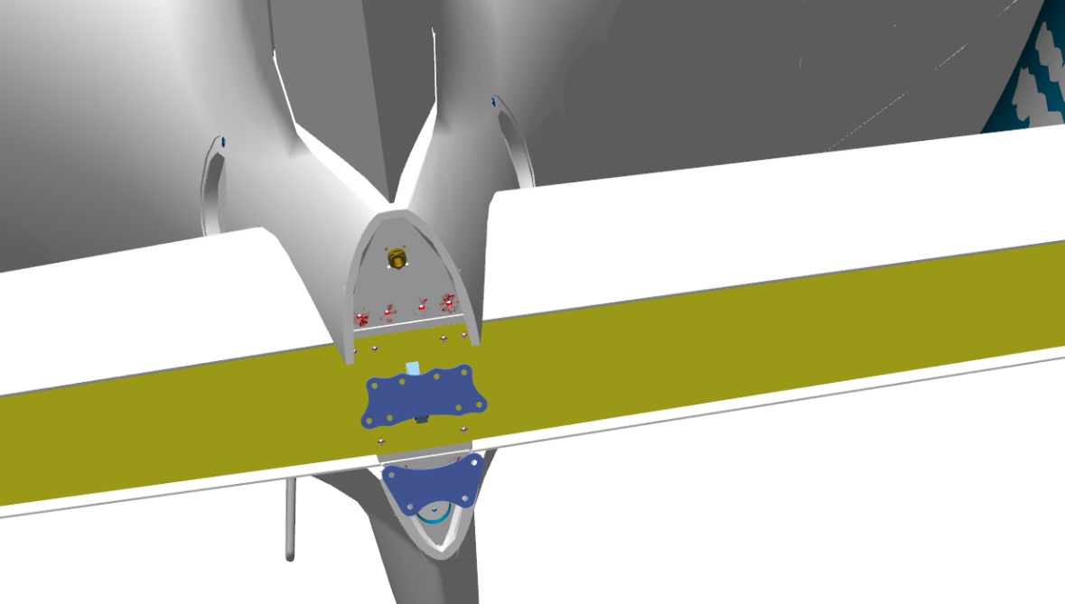
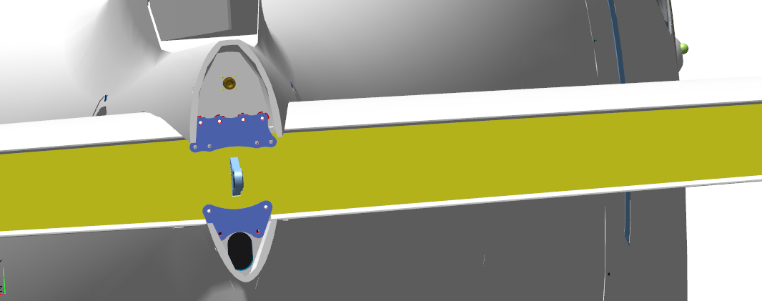
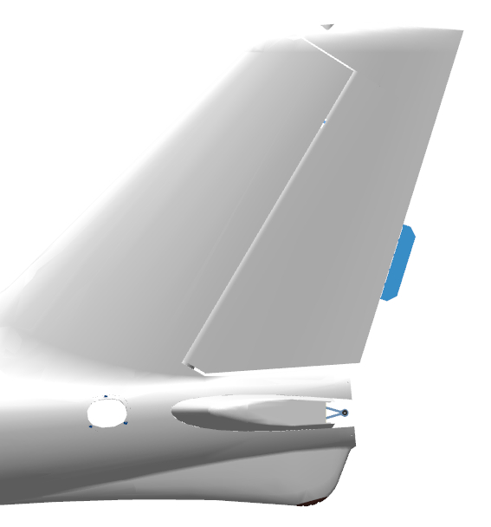 | 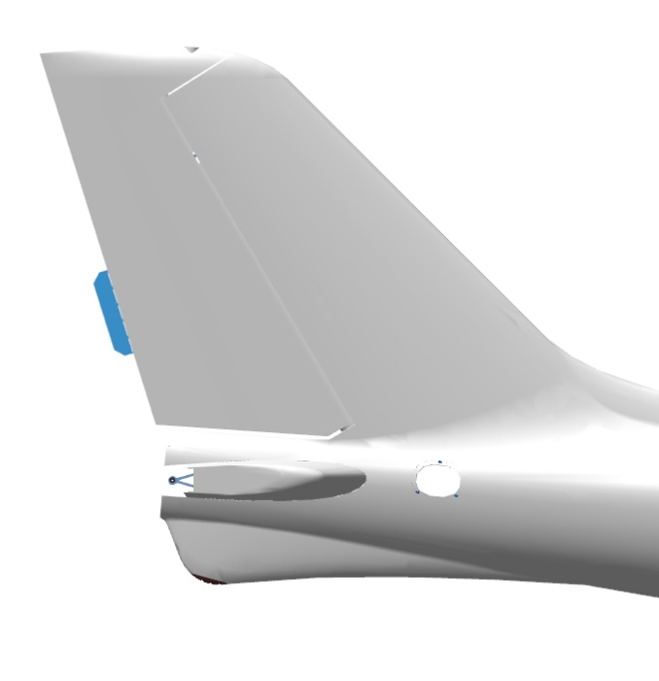
Checkup operations:
Check the gaps on the outline of the stabilizer mating with the fuselage. The gaps should be uniform, ranging from 0.5mm to 1mm.
Measure the distance between the axis of the right hinge assembly hole on the stabilizer and that of of the hinge assembly hole on the fin. Use for checking a measuring tape.
Measure the distance between the axis of the left hinge assembly hole on the stabilizer and that of of the hinge assembly hole on the fin. Use for checking a measuring tape. The difference should not exceed 5 mm.
Check the gaps under the stabilizer mounting plates. They may range from 0 to 0.5 mm.
If all the checked areas are appropriate, trace with a marker the outline of the fuselage above and below, the outlines of the plates on the frame and the stabilizer spar.
Detach the stabilizer in the reverse order.
IMPORTANT! The areas where the adhesives are to be applied should always be sanded (roughened) 10-15 mm more than the actual outline of the part to be fitted.
Sand (roughen) as per the standard operation 3:
The mating face of the stabilizer inside the fuselage aperture.
The mating faces of the stabilizer aperture, above and below the mating face of the fuselage.
The mating faces of the plates and those of the frame and spar.
Important! Take care not to damage the composite portions of the areas to be sanded. The thickness of some areas of covering is 0.08 mm only. Do not rub them in one spot for too long time, even if the area to be sanded does not turn dull (matte).
Sand (roughen) as per the standard operation 4 the mating faces of the plates with the frame and the stabilizer spar.
Upon sanding all the areas, put on latex gloves and a respirator. Moisten a rag with solvent. Degrease the following items:
The sanded area of the stabilizer aperture in the fuselage;
The sanded areas of the stabilizer covering;
The sanded areas of the fuselage frame;
The sanded areas of the stabilizer spar;
The sanded areas of the plates.
Place the stabilizer into the aperture, position it approximately in the middle.
Make a batch of the epoxy glue as per the standard operation 1, mixing the Larit L285 resin and H287 hardener in a ratio of 30:12.
IMPORTANT! The epoxy glue is to be used within 60 minutes following its preparation.
Apply the glue as per the standard operation 5.1 to the degreased surfaces of the plates, the mating faces of the plates and the frame and the stabilizer spar, the aperture and the stabilizer. It is allowed to slightly bend the fuselage covering (skin) aside to increase the apeture in the stabilizer area.
Prepare from the remaining glue some adhesive compound as per the standard operation 2.
Apply the compound as per the standard operation 5.2 to the surfaces of the plates, to the fuselage aperture with the stabilizer. Fit the plates to the frame, align the holes of the plates with those of the frame. Fix the edge holes to the frame of each plate with two M4x10 ISO 7380-2 screws.
It is not needed to tighten the screws strongly in this step. Align the screw holes of the stabilizer with those of the plates. Fit the plate to the stabilizer with four M4x10 ISO 7380-2 screws. It is not needed to tighten the screws strongly in this step.
Fit the ANG-5500-00039325-002 plate to the stabilizer with four M4x10 ISO 7380-2 screws. It is not needed to tighten the screws strongly in this step. Fit the ANG-5500-00039325-003 plate to the frame with two M4x10 ISO 7380-2 screws. It is not needed to tighten the screws strongly in this step.
Clean your workplace and tools as per the standard operation 7.
Checkup operations:
Check the fitted stabilizer according to the measurements procedure used when fitting the stabilizer initially.

6.2 Fit the elevator and trim tab
6.2.1 Fit the elevator hinge assemblies
To carry out this task you will need:
Movable table;
2.5 mm hex key (Allan wrench);
Digital kitchen scales.
Latex gloves - 1 pair.
Larit L285 epoxy resin - 30 grams.
H287 hardener - 12 grams.
100 ml paper cup.
Aerosil thickener - 3 grams.
P1000 grit sandpaper 1 sheet, 200x300 mm.
Methyl acetate solvent 100 grams.
Clean rags 100x100 mm, 3 pieces.
P240 grit sandpaper 1 sheet 200x300 mm.
White marker.
Respirator.
Metal spatula (putty knife) 50 mm.
1-25Nm torque wrench.
2.5mm hex socket.
10 meter measuring tape.
2 mm hex key (Allan wrench);
2mm hexagonal socket.
5.5 mm combination wrench.
8 mm combination wrench.
100 mm tweezers.
Unpack and place on the table:
ANG-5500-00054627-01elevator;
ANG-5500-00054627-01Z elevator;
2 ANG-5500-00054627-001 plates;
ANG-5500-00054546-00Z trim tab;
2 ANG-0002-00037651-002 axles;
ANG-5200-00054568-001trim tab axle;
2 ANG-0002-00054576-01 bearings;
ANG-5300-00039512-00 tail cone.
Unpack and place on the table:
T2-10A trim tab drive;
Five 3 DIN 125 washers;
8 M4X12 DIN7991 screws;
4 M3X12 ISO7380-2 screws;
3 M3X20 ISO7380-2 screws;
4 M4X20 ISO7380-2 screws;
2 М3 DIN 934 nuts;
4 М5 DIN 935 nuts;
2 М3 DIN 985 nuts;
2 F693 2RS bearings;
М3х12 DIN 427 screw.
Find the ANG-0002-00037651-002 axle. Moisten a rag with solvent. Degrease the following:
Short threaded portion of the axle;
Female thread of the elevator “pocket” (recess).
Apply to the degreased surfaces an even thin layer of LOCTITE 648 retaining compound.
Fit the axle into the “pocket” (recess), tighten it with a 10 mm wrench to take out the gap under the axle shoulder and elevator.
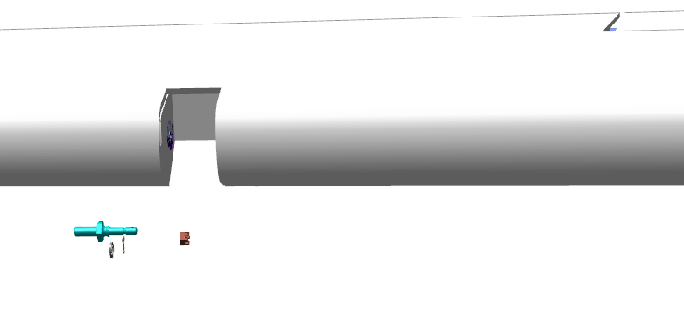 | 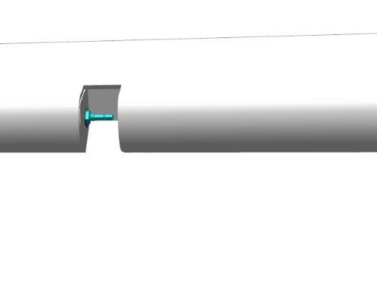
Find the M3x12 DIN 427 screw. Fit the screw through the entire thread length into the hole of the elevator, using LOCTITE 648 retaining compound. Place onto the screw three 3 DIN 125 washers.
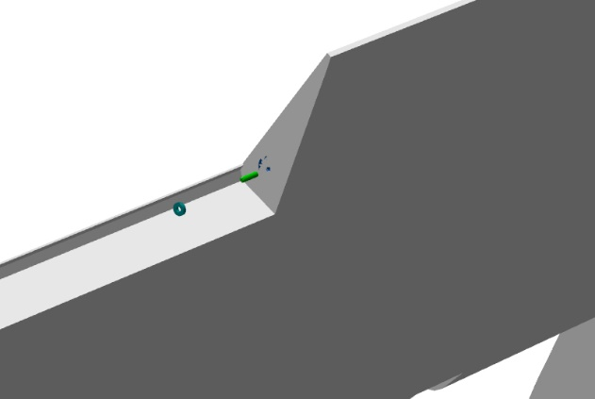 | 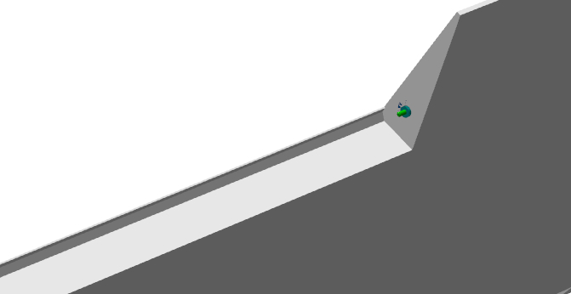
Find two F693 2RS bearings. Fit the bearings one by one to the elevator bracket, using LOCTITE 648 retaining compound, with their shoulders facing outward the bracket.
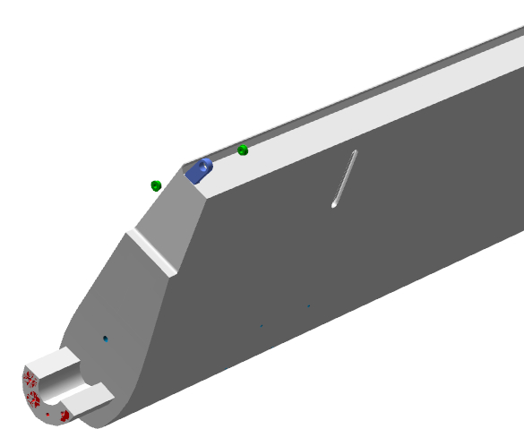 | 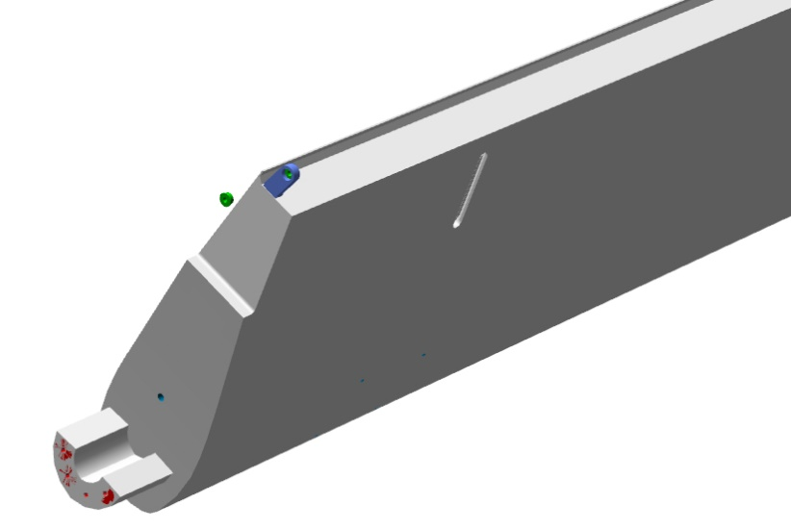
Find the ANG-5500-00054627-001 plate and four M4x12 DIN7991 screws. Fit the plate to the edge of the elevator. Fix it with screws. Make sure there are no gaps under it.
Permanently fit the four M4x12 DIN7991 screws, applying the LOCTITE 648 retaining compound.
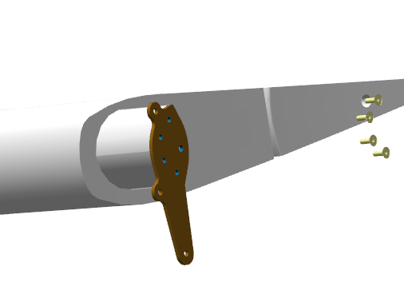 | 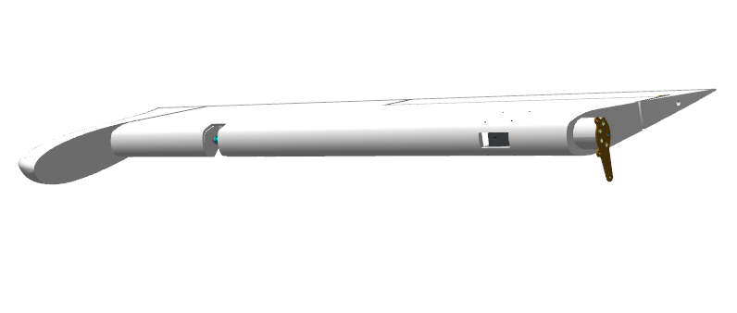
Repeat the process for fitting the ANG-0002-00037651-002 axle, ANG-5500-00054627-001 plate to the ANG-5500-00054627-01 elevator.

6.2.2 Fit the elevator trim tab
Find the ANG-5200-00054568-001trim tab axle, two ANG-0002-00054576-01 bearings, two M3 nuts DIN 934. Screw the two M3 nuts onto the axle.
Screw the two bearings onto the axle through the entire thread length.
Adjust the caliper to the size 186.
Unscrewing alternately by the same number of turns, set the size186 between the axes of the ANG-0002-00054576-01bearing bores.
Lock the bearings by tightening the nuts with a 5.5 mm wrench.
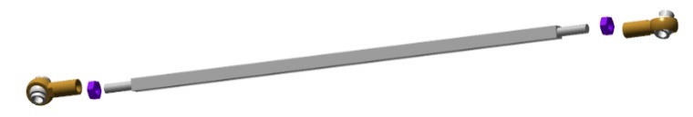 | 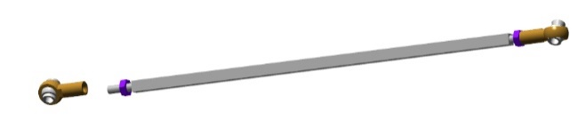
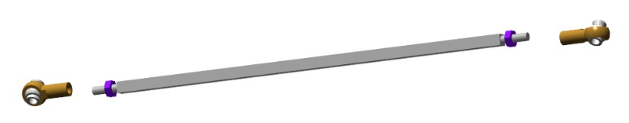 | 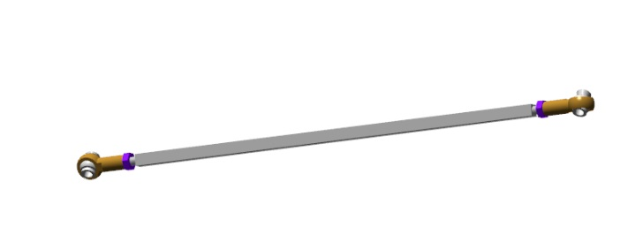
Find the T2-10A trim tab drive, 3 DIN 125 washer, M3X20 ISO7380-2 screw, M3 DIN 985 nut. Fit the pushrod with bearings to the drive lug.
Secure it with M3X20 ISO7380-2 screw, 3 DIN 125 washer and M3 DIN 985 nut.
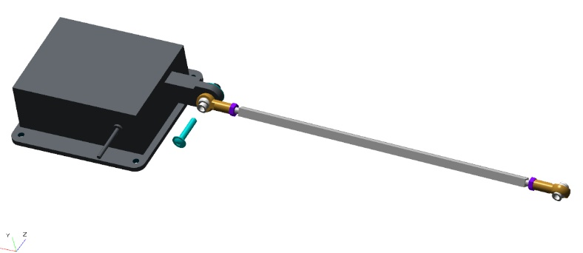 | 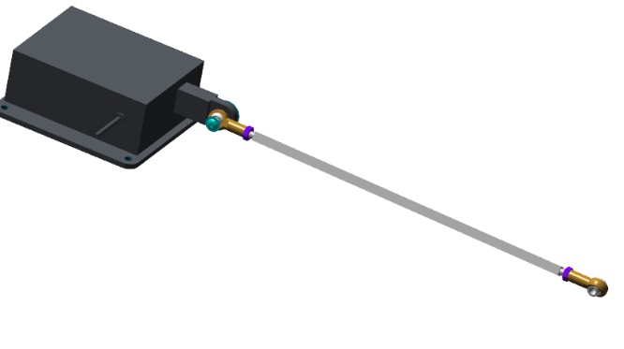
Find the ANG-5500-00054546-00Z trim tab, M3x20 ISO7380-2 screw. Approach the trim tab to the elevator aperture.
Position the trim tab onto the M3x12 DIN 427 screw, align the other side with the elevator eye.
Secure the trimmer through the aperture with the M3x20 ISO7380-2 screw.
Checkup operations:
Make several upward and downward deflections. The trim tab should deflect easily without any binding or chafing.
Permanently fit the M3x20 ISO7380-2 screw, using the LOCTITE 648 retaining compound.

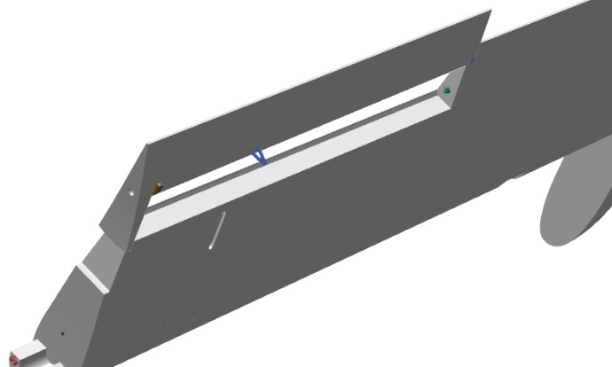 | 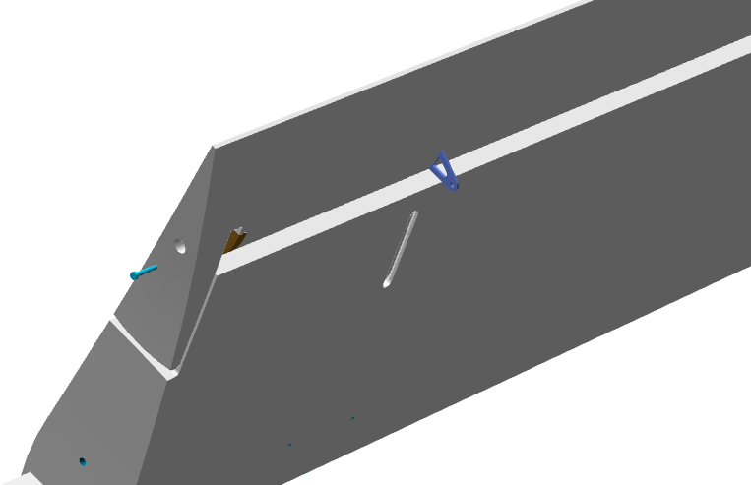
Put the ANG-5500-00054627-01Z elevator down with the pushrod slot in the covering facing upward.
Feed the trim tab drive with the axle attached to it through the elevator side aperture and pull the axle through the slot in the covering. Place the drive on the mounting surface, secure it with 4 M3X12 ISO7380-2 screws.
Fix the axle bearing to the trim tab eye with the M3x20 ISO7380-2 screw, 3 DIN 125 washer and M3 DIN 985 nut.
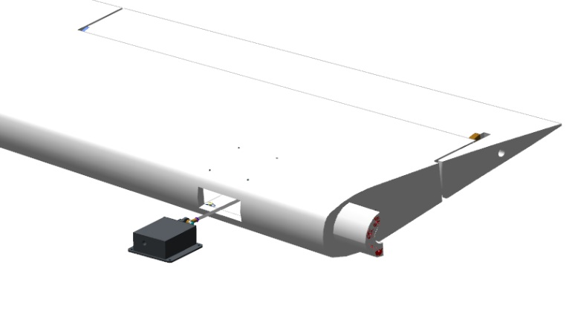
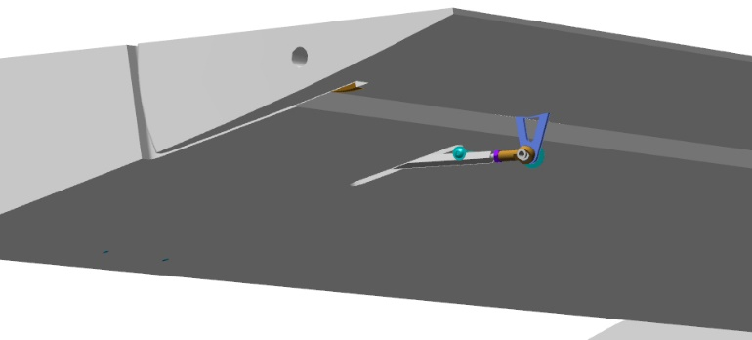
Bring the elevator behind the stabilizer on the starboard (right) side of the aircraft. The elevator should be faced with its plate toward the middle hinge assembly. Approach the elevator to the spar, place the axle through the bearing hole. Inch the elevator closer, aligning the hole of the elevator plate with that of the middle hinge assembly bearing.
Place a bolt through the aligning holes. The bolt should easily fit through all the holes.
Find the ANG-5500-00054627-01 left elevator.
Bring the elevator behind the stabilizer on the port (left) side of the aircraft. The elevator should be faced with its plate towards the middle hinge assembly. Approach the elevator to the spar, place the axle through the bearing hole. Inch the elevator closer, aligning the hole in the plate with the bolt fitted in the middle hinge assembly.
Thread an M5 DIN 935 nut on the bolt. Tighten the nut with an 8 mm wrench, apllying a slight hand force, just to close the gaps between the plates and the bearing of the middle assembly. Find the second bolt. Place the bolt through the bottom holes of the plates. Screw the nut onto the bolt until encountering a hard stop, tighten it with an 8 mm wrench.
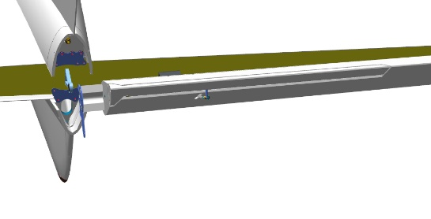
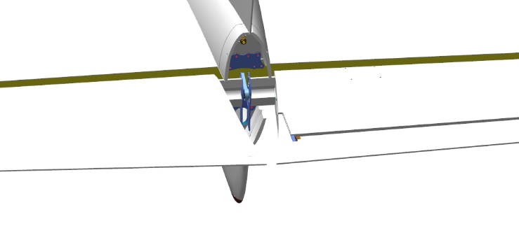
Checkup operations:
Check that the elevators can swing freely with no binding in the hinge, by deflecting them upwards by hand all the way, then do the same downwards. The elevators should swing freely both ways, without any jerks or binding. The elevator edges should not touch the fuselage. Repeat the upward and downward movement of the elevators three or four times.
Approach the left elevator from behind, deflect it upwards. Thread the M5 DIN 935 nut onto the axle, tighten it with an 8mm wrench. Repeat the process for the right elevator. Check the fitted elevators by deflecting them by hand all the way upwards, then do the same downwards. The elevators should swing freely, without any jerks or binding. The elevator edges should not touch the fuselage.
Find the ANG-5300-00039512-00 tail cone and four M4x20 ISO 7380-2 screws. Fit the tail cone between the elevators. Align the holes of the tail cone and those of the fuselage. Fix the tail cone in place with the four M4x20 ISO 7380-2 screws. Tighten the bracket mounting screws with a wrench in any sequence.
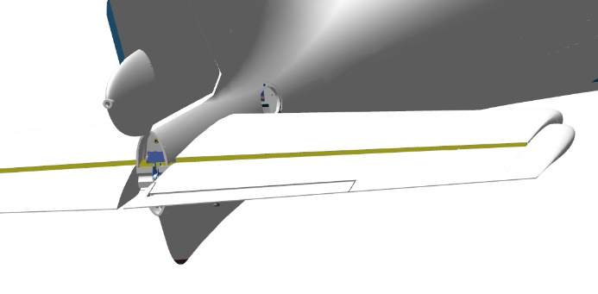
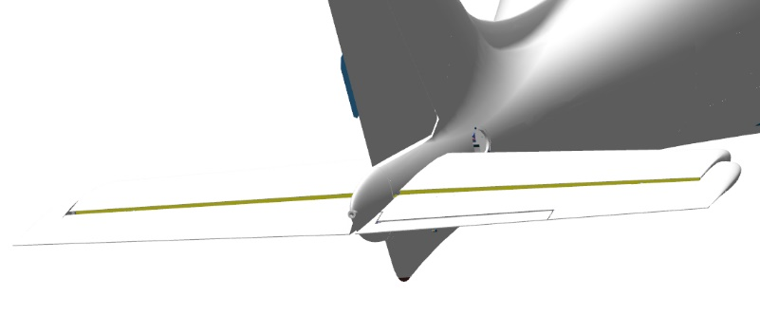
Checkup operations:
Check the fitted tail cone by deflecting the elevators by hand upward and downward until encountering a hard stop. The elevators should swing freely, without any jerks or binding. The edges of the rudders should not touch the fuselage and tail cone.

6.3 Fit the rudder
Objectives of this task: to assemble and fit the rudder
To carry out this task you will need:
Movable table;
10 mm combination wrench;
8 mm combination wrench;
Unpack and place on the table:
Rudder marked ANG-5500-00039332-00;
Two axles marked ANG-0002-00037651-002;
Count and place on the table:
Two 1.0x35 DIN 94 cotter pins;
Two М5 DIN 934 nuts;
Two F625ZZ bearings.
Find the ANG 5500-00039332-00 rudder and two ANG-0002-00037651-002 axles.
Moisten a rag with solvent. Degrease the following:
Male m6 threaded portions of the axles;
Threaded hole in the rudder “pocket” (recess).
Threaded hole in the rudder bellcrank .
Apply an even thin layer of LOCTITE 648 retaining compound to the degreased surface of axle.
Fit the ANG-0002-00037651-002 axle into the rudder “pocket” (recess), tighten it with a 10 mm wrench until closing the gap between the axle shoulder (collar) and rudder.
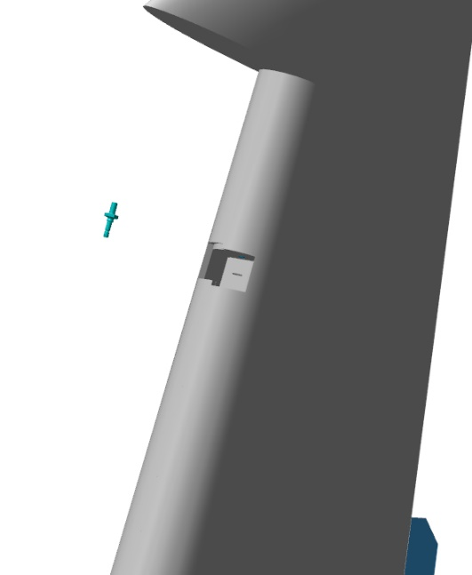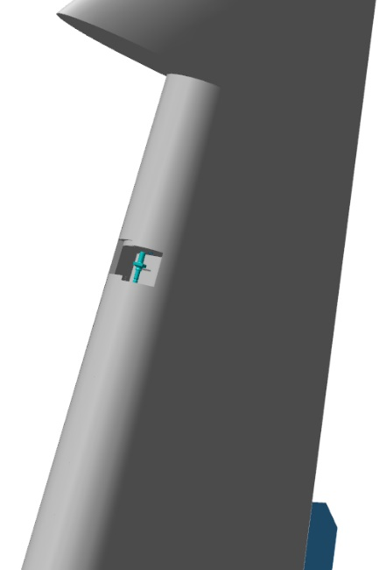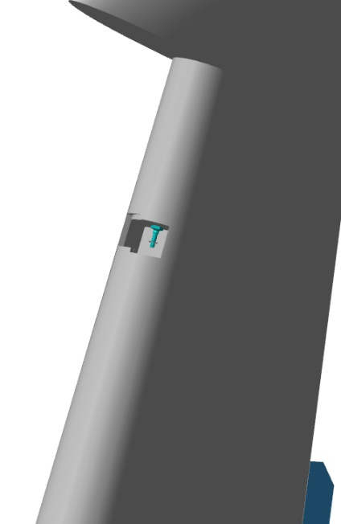

Fit the ANG-0002-00037651-002 axle to the bellcrank from below, tighten it with a 10 mm wrench to close the gap between the axle shoulder (collar) and the rudder bellcrank.
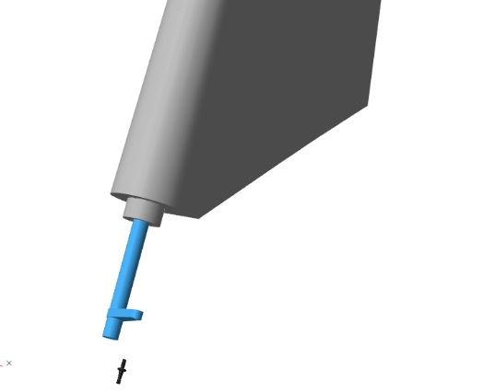 | 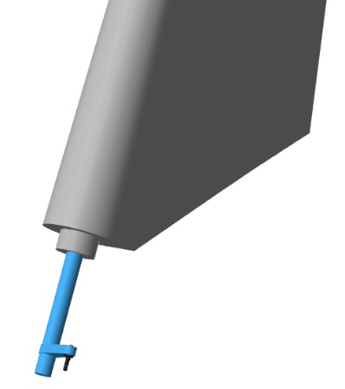
Find the two F625ZZ bearings. Moisten a rag with solvent. Degrease the following items:
Outer portions of the bearings;
The inner surface of the fuselage hinge assembly.
Apply an even thin layer of LOCTITE 648 retaining compound to the degreased surfaces of the bearings and the surface of the bracket.
Fit the bearings into the assembly one by one with their shoulders facing outward the bracket.
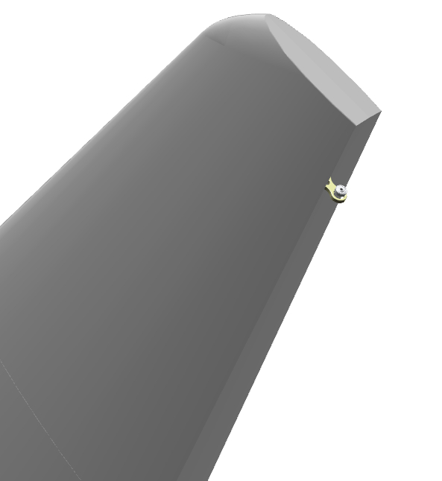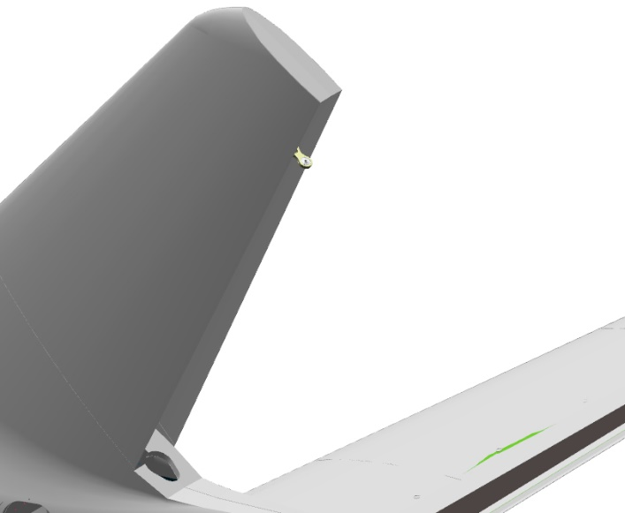
IMPORTANT! Take care not to allow the ingress of the retaining compound inside the bearing. This will render the bearing unserviceable.

Approach the rudder to the vertical stabilizer.
Tilt the top of the rudder away from the stabilizer, slide the bellcrank into the aperture (opening) and push it down.
Approach the rudder to the frame, place the pin of the upper assembly into the bearing, the lower tube of the bellcrank into the frame bearing.
Lower the rudder down.
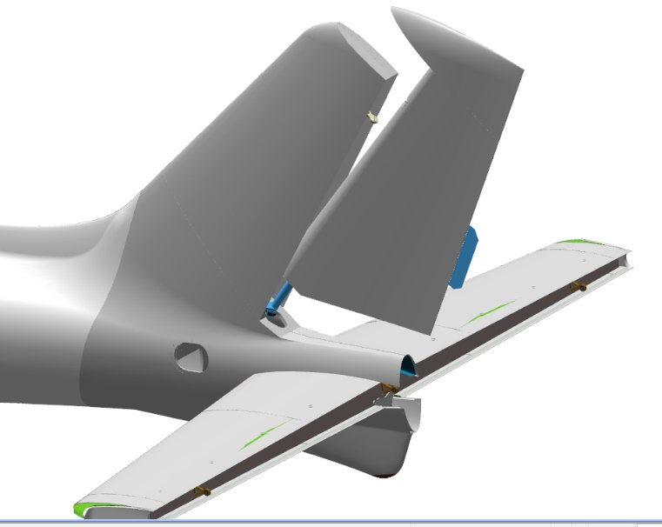 | 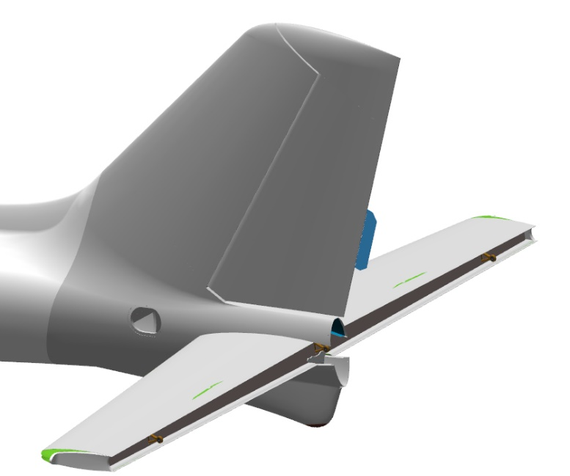
Deflect the rudder to the left or right. Thread the M5 DIN 934 nut onto the axle of the upper assembly. Tighten the nut with the 8 mm combination wrench.
Checkup operations:
Check that the rudder can swing freely in the hinges by deflecting it with your hand to the left and then to the right as far as it will go. The rudder travel should be smooth, without any jerks or binding and any abnormal sounds. The edges of the rudder should not touch the fuselage. Repeat the movement three or four times.
Find in the “pocket” the hole of the axle, which should align the slot of the M5 nut DIN 935. If the hole cannot be seen, tighten slightly the nut to align the hole with the slot.
IMPORTANT! Do not loosen the nut to align the hole with the slot. This will result in a quick failure of the assembly and its play.

6.4 Fit the ailerons
6.4.1 Assemble the ailerons
To carry out this task you will need:
Movable table;
Grit P600 sandpaper, one 200x300 mm sheet;
Methyl acetate solvent 100 grams;
Clean rags, two 100x100 mm pieces;
Latex gloves - 1 pair;
Unpack and place on the table:
ANG-5700-00033266-01 left aileron;
ANG-5700-00033266-01Z right aileron;
Six m5x10 ANG-0002-00037651-002 axles;
Find the ANG-5700-00033266-01 left aileron and 3 ANG-0002-00037651-002 axles. Find two holes on the edge of the aileron and one hole in the “pocket” (recess) closer to the aileron tip.
Check the M6 threaded holes of the aileron as per the standard operation 6.
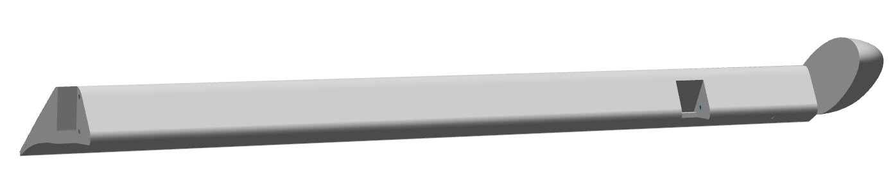
Put on latex gloves and respirator. Moisten a rag with solvent. Degrease the following items:
Female threads of the ANG-5700-00033266-01 aileron
Male threads M6 of the m5x10 ANG-0002-00037651-002 axles.
IMPORTANT! Take care not to apply any retaining compound to the degreased surface immediately. The retaining compound can be applied 5-10 minutes after degreasing.
Apply an even thin layer of the LOCTITE 648 retaining compound to the degreased inner threaded portions of the ANG-5700-00033266-01 aileron.
Set the aileron aside on the table for later use.

Apply an even thin layer of the LOCTITE 648 retaining compound to the degreased outer threaded (M6) surface of one of the м5х10 ANG-0002-00037651-002 axles.
Hand-screw until encounering a hard stop the m5x10 ANG-0002-00037651-002 axle into the hole in the “pocket” (recess) closer to the tip of the aileron. Using a 12 mm combination wrench, tighten the m5x10 axle ANG-0002-00037651-002 to close the gap between the axle edge and the aileron plane (flat surface).
Clean up any excess or squeeze-out of the retaining compound with a rag.
Repeat the process to fit the two remaining axles.
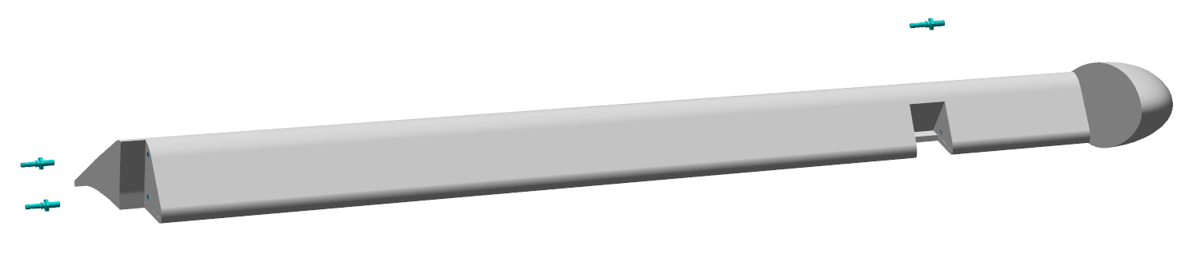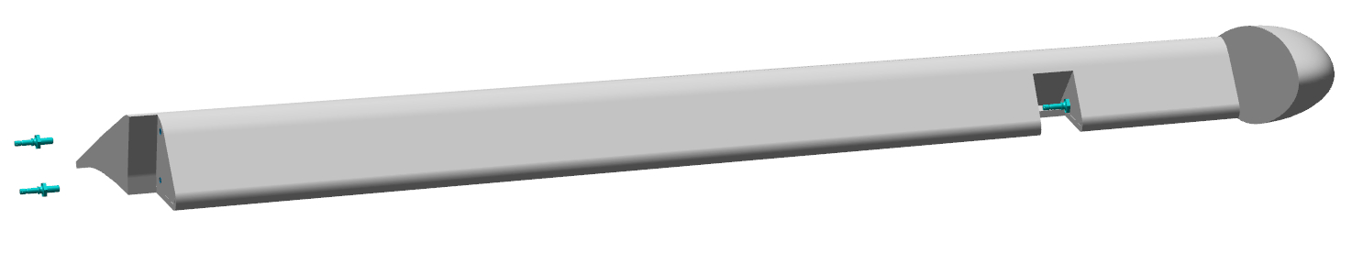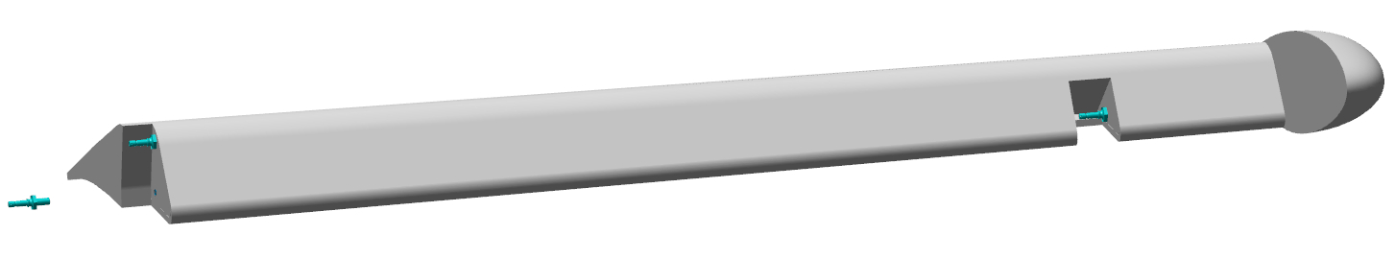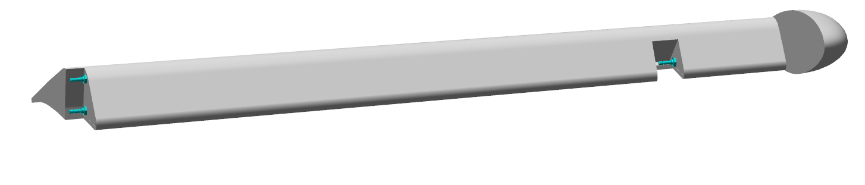Upon completion of the left aileron assembly task, repeat the process above for the right aileron.
6.4.2 Fit the ailerons
Approach the aileron to the wing panel from below close to the covering (skin) so that the the aileron axles are aligned on the side with the bearing holes in the hinge assemblies.
Slip the aileron along the wing panel, approaching the aileron and wing panel tips and aligning the aileron axles with the bearing holes. Insert the axles into the bearings and move along until the axle grooves encounter a hard stop against the bearing.
Fit the control pushrod end to the bottom axle.
Checkup operations:
Check the aileron for the freedom of movement both ways. The aileron must move without any jerks, binding and not requiring any significant force.
The mounted aileron, when deflected to the positions of approximately 30° -35°, should not touch in any position any other parts of the wing panel. The clearance between the plane (flat surface) of the aileron tip and the adjacent plane of the wing should be from 3 mm to 4 mm.
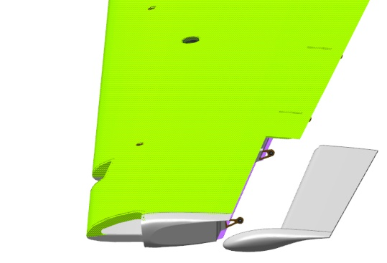 | 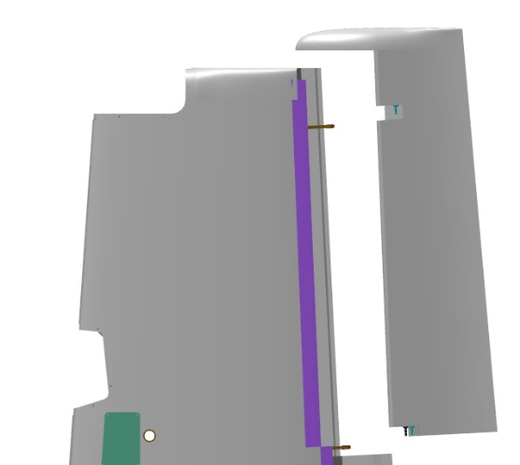
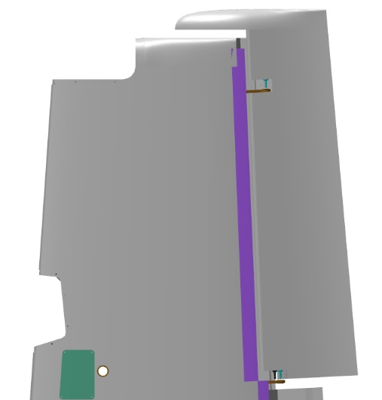 | 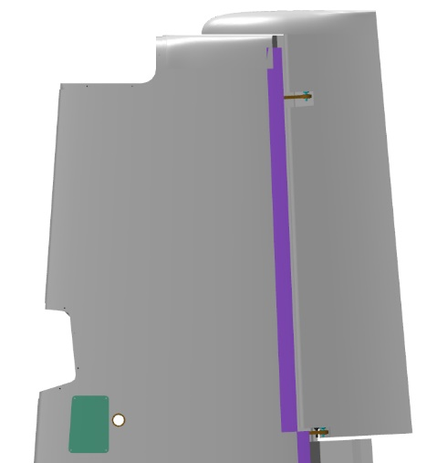
Find three М5 DIN 935 nuts, three 5 DIN 6798J washers, three 1x20 DIN 94 cotter pins.
Place the washer onto the axle located closer to the tip, hand-screw on it the nut. Tighten the nut with an 8 mm combination wrench to seat it fully and firmly onto the washer. Find a hole in the aileron axle, which should align with the slot of the DIN 935 M5 nut. If the hole cannot be seen, tighten the nut to align the hole with the slot.
IMPORTANT! Do not loosen the nut to align the hole with the slot. This will result in a quick failure of the assembly and play in the control system.
Repeat the process to fit the washers and nuts to the remaining two axles.
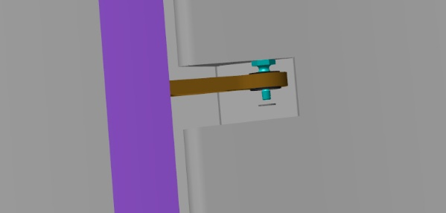 | 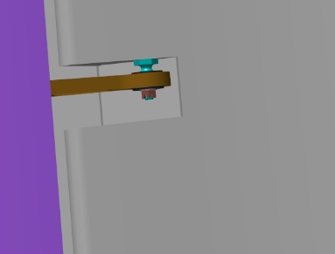
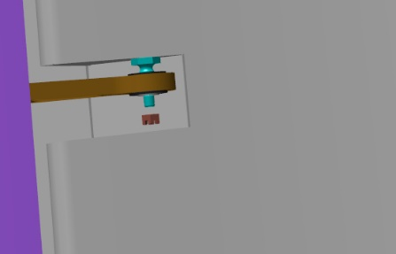 | 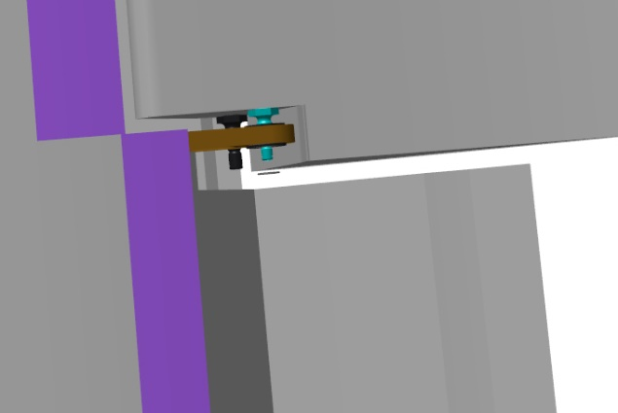
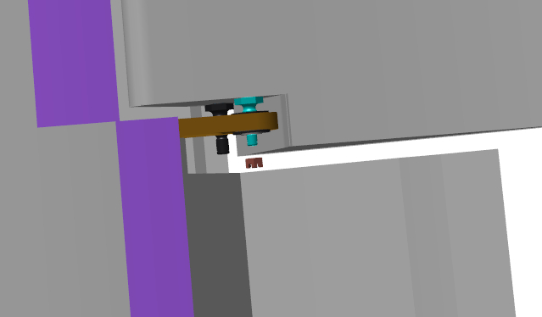 | 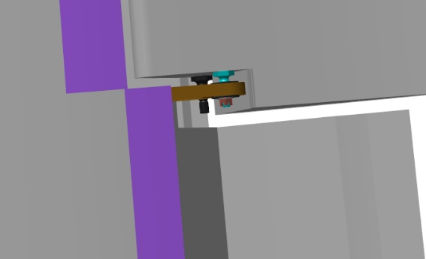
Fit the 1x20 DIN 94 cotter pins through the aligning slots of the M5 DIN 935 nuts and the holes in the axles. Use a screwdriver to bend aside only one of the cotter-pin ends so that the cotter pin does not fall out, and if need be, it could be easily removed. The connections must be permanently secured with cotter pins upon completion of all adjustments of the assembled aircraft.
Repeat all the process above to carry out the tasks for the right wing panel.

6.5 Fit the flaps
Note. The operations described below pertain to the left wing panel. The wing panel should be placed on the trestle-mounted cradle, with the lower covering (skin) facing away from the floor. You will need a helper to carry out this task.
To carry out this task you will need:
- Movable table;
- Two 8 mm combination keys;
- Tweezers;
- Combination pliers;
- Pliers for inner circlips (retaining rings);
- Slotted (flat-tip) screwdriver No. 1;
Unpack and place on the table:
- Two ANG-5700-00033263-41 flap shafts;
- Six ANG-0002-00037651-002 screws;
- Two ANG-2700-00033263-423 bushes;
- Twelve ANG-0002-00034534-08 bolts;
- Four ANG-0002-00037651-003 axles;
- ANG-5700-00033263-01 left flap;
- ANG-5700-00033263-01Z right flap;
- Two ANG-2700-00034989-00 pushrods;
- Two ANG-2700-00037865-00 pushrods;
- Two ANG-2700-00037866-00 pushrods;
Count and place on the table:
- Thirty two F605-2RS bearings;
- Eight 687 618 bearings;
- Four S61704-2RSR bearings;
- Six М6 DIN 935 nuts;
- Six 6 DIN 6798J washers;
- Six 6 DIN 125 washers;
- Twenty М5 DIN 935 nuts;
- Twenty 5 DIN 6798J washers;
- Twenty 5 DIN 125 washers;
- Twenty eight 1x20 DIN 94 cotter pins;
- Two А32 DIN 472 rings.
Find the ANG-5700-00033263-41 flap shaft, three ANG-0002-00037651-002 screws. Tap the M6 thread through the three holes of the shaft bellcranks.
Moisten a rag with solvent. Degrease the following items:
Short threaded portions of the screws;
Inner threaded portions of the shaft.
Apply an even thin layer of the LOCTITE 648 retaining compound to the degreased axle surface.
Fit to the bellcrank with one hole the ANG-0002-00037651-002 screw with its long threaded portion to the short portion of the tube, tighten it with a 12 mm wrench until closing the gap between the bellcrank plane (flat surface) and the axle plane.
Fit the axles to the second belcrank, applying the LOCTITE 648 retaining compound. The axle to be fitted into the hole, should be positioned closer to the shaft tube should be pointed with its long threaded portion onto the short portion of the tube.
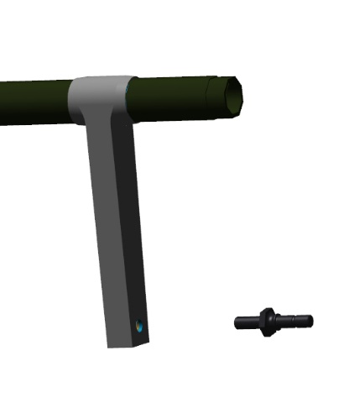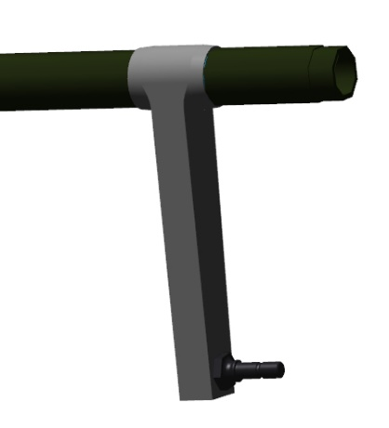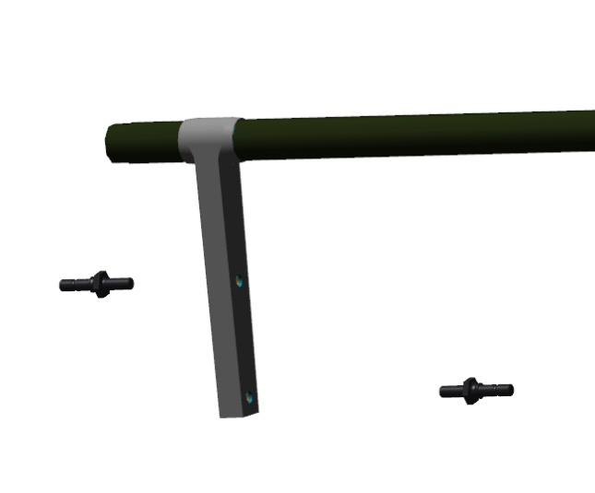
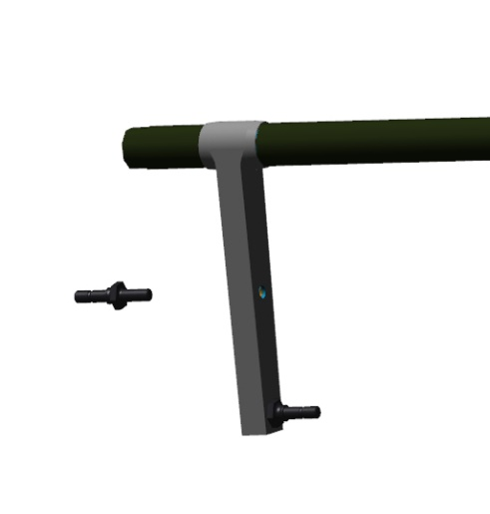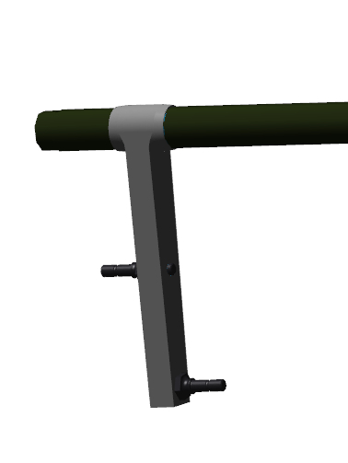
Find two S61704-2RSR bearings. Moisten a rag with solvent. Degrease the following items:
Outer edges of the shaft;
Inner portions of the bearings.
Apply an even thin layer of the LOCTITE 648 retaining compound to the the degreased shaft and bearing surfaces.
Fit the bearings to the edges of the shaft until encountering a hard stop. Wipe away any excess of the retaining compound with a rag.
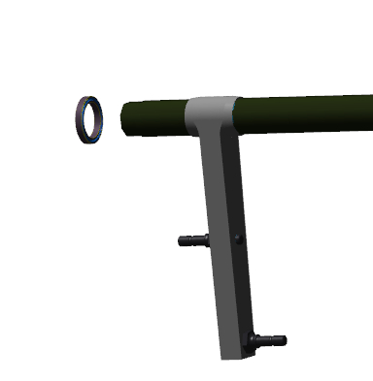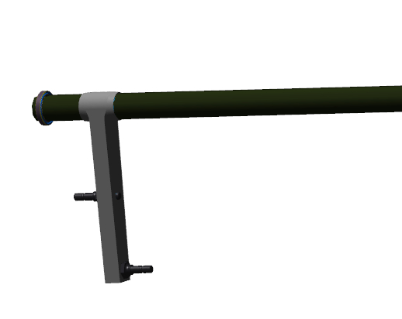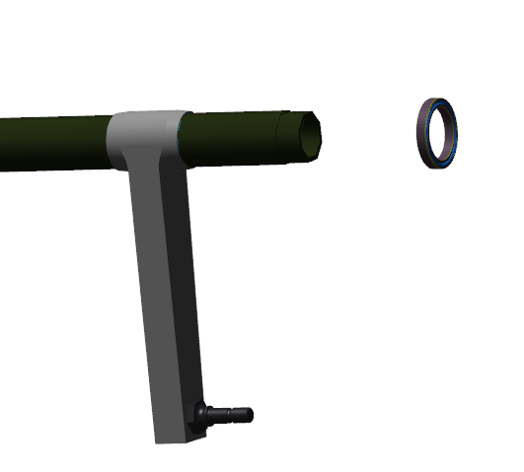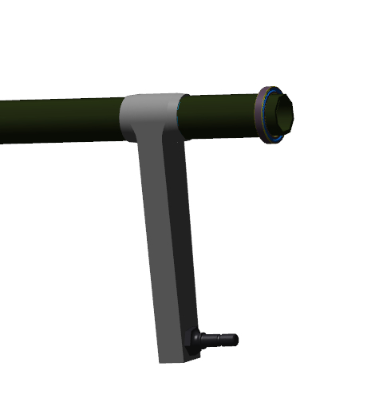

Find the ANG-2700-00034989-00, ANG-2700-00037865-00, ANG-2700-00037866-00 pushrods, three М6 DIN 935 nuts, the 6 DIN 6798J and 6 DIN 125 washers 3 pieces each, three 1x20 DIN 94 cotter pins.
Fit the ANG-2700-00034989-00 pushrod to the bellcrank with one axle. Place the 6 DIN 125 and 6 DIN 6798J washers, thread the M6 DIN 935 nut.
Using a 10 mm wrench, tighten the nut to fully and firmly seat it on the 6 DIN 6798J washer. Find in the axle a hole, which is supposed to align with the slot of the M6 ​​DIN 935 nut.
If the hole cannot be seen, tighten the nut to align the hole with the slot.
IMPORTANT! Do not loosen the nut to align the hole with the slot. This will result in a quick failure of the assembly and its play.
Checkup operations:
Check for freedom of movement of the pushrod. The pushrod should easily move around the axle, without any jerks or binding, and be able to deflect from the axis of rotation.
Fit the 1x20 DIN 94 cotter pin into the aligning slot of the nut M6 DIN 935 and the hole in the axle. Secure the connection by bending aside with a screwdriver the ends of the cotter pin.
Repeat the process to fit the remaining pushrods.
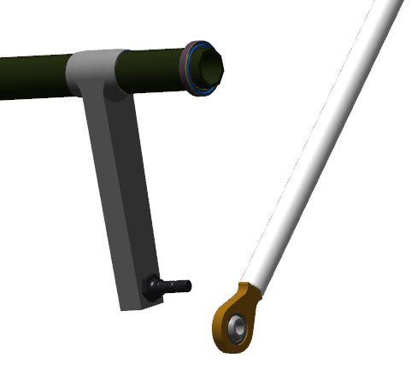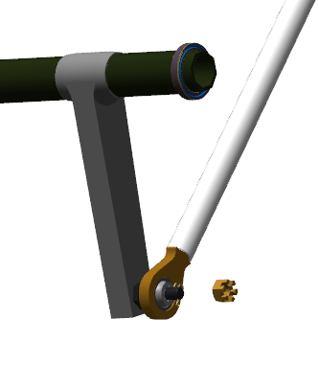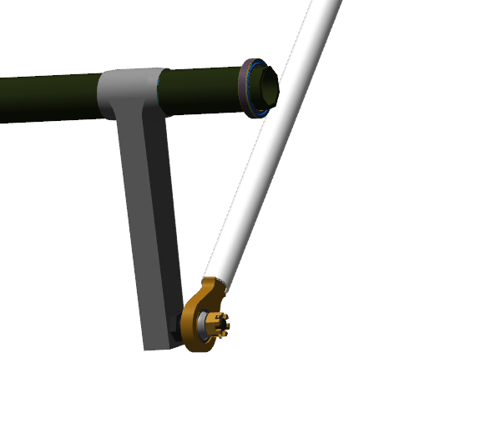
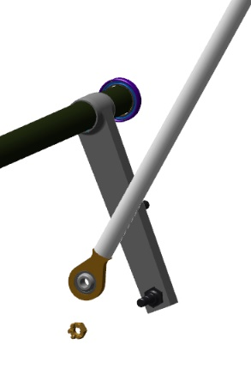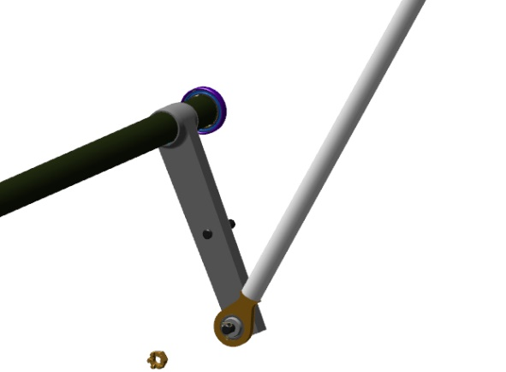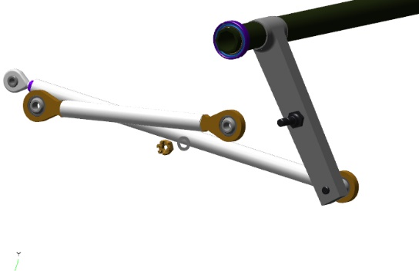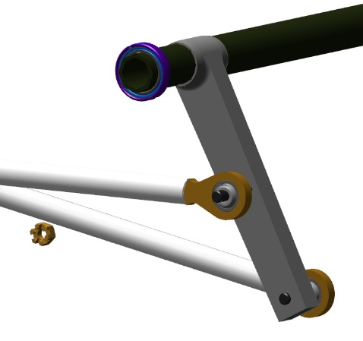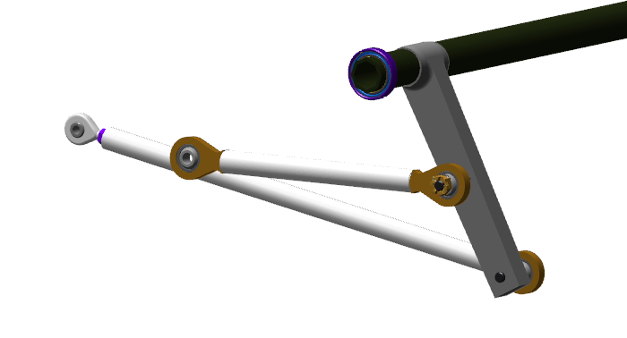
Feed into the wing panel the assembled flap shaft with pushrods through the aperture in the rear portion of the root rib.
Fit the shaft to the far support, push it in until encountering a hard stop. Direct the front of the shaft into the slot in the rib, push it towards you. Turn the shaft around the axis, place the rods outwards.
Place the ANG-2700-00033263-423 bush on the bearing, slide it into the rib until encountering a hard stop. Secure the bearing with a A32 DIN 472 circlip (retaining ring).
IMPORTANT! After fitting the circlips, check that they are well positioned in the groove and cannot fall out. If the ring falls out in flight, this will result in loss of control and inevitable accident.
Checkup operations:
Check for freedom of rotation of the shaft in the bearings. The shaft should rotate easily.
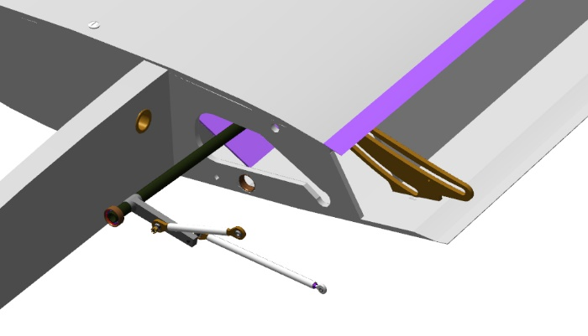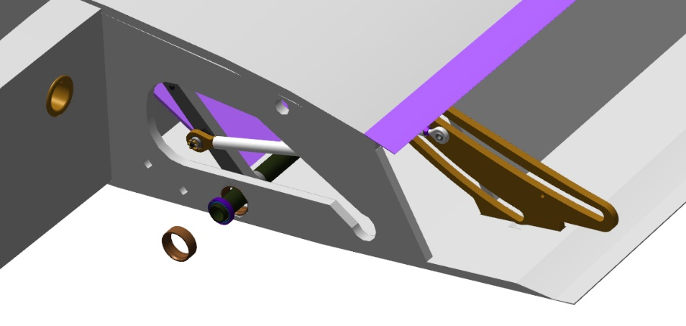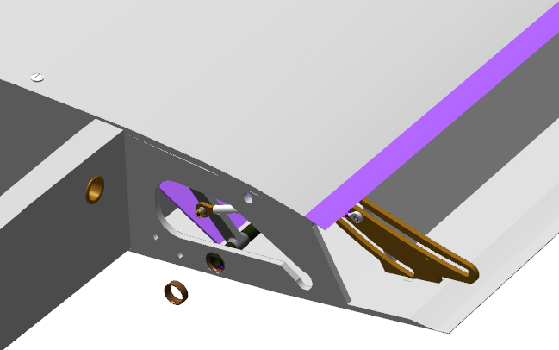
Place the flap on the table with its convex surface facing down, check the flap plates to rule out the presence of any foreign objects.
Approach the flap to the wing panel, place it the way that the flap plates are positioned around the rails. Slide the flap along the rails until it encounters a hard stop against the wing panel. The flap will not necessarily move smoothly and its movement may be slightly jammed.
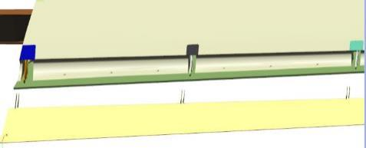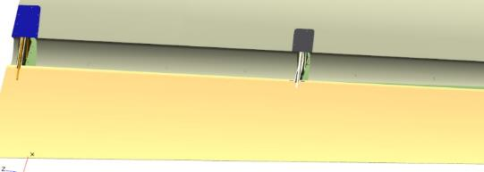
Extend the flap along the rails approximately to the middle length of the first rail. Fit one F605-2RS bearing into the lower track of the rail. Using the slotted (flat-tip) screwdriver No. 1, slide the bearing along the track to the hole located closer to the flap covering (skin) in the flap plate.
Move the bearing and the flap to align the holes. Place through the aligning holes the ANG-0002-00037651-003 axle so that it passes one plate only and is positioned flush with the bearing. Fit the 687 618 bearing into the lower track of the rail.
Slide the bearing along the track with a screwdriver until fitting the bearing and aligning the holes with the plate. Fit the second F605-2RS bearing into the lower track of the rail. Slide the axle through the bearing and the second hole in the flap plate.
Place the 5 DIN 6798J washer onto the axle, screw on the M5 DIN 935 nut.
Repeat the process above to fit the bearings to the rails. Fit the ANG-0002-00034534-08 bolts to the second and fourth rails instead of the axle.
Once the fitting of the bearings to the lower tracks of the rails is completed, repeat successively the same steps to fit the bearings into the upper tracks, ffittng as well the ANG-0002-00034534-08 bolts.
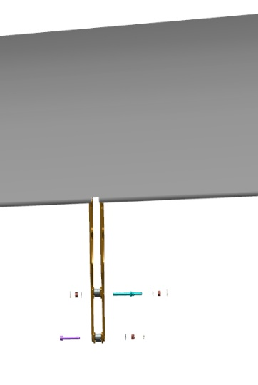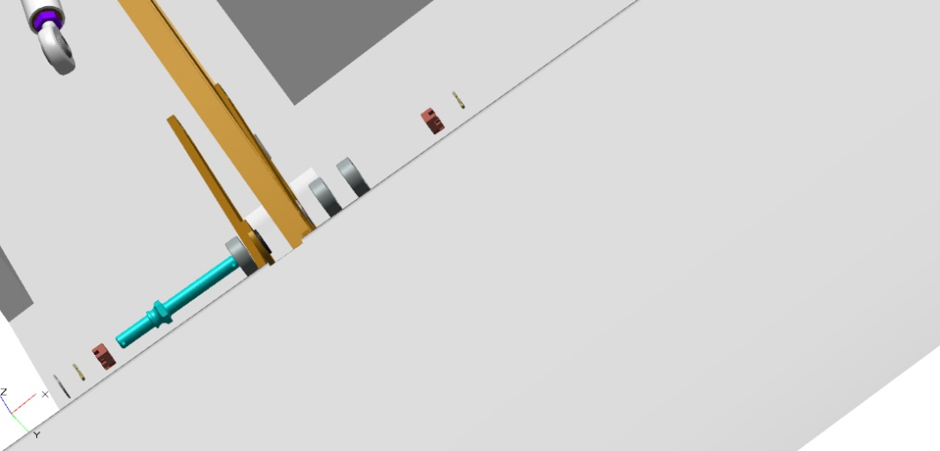
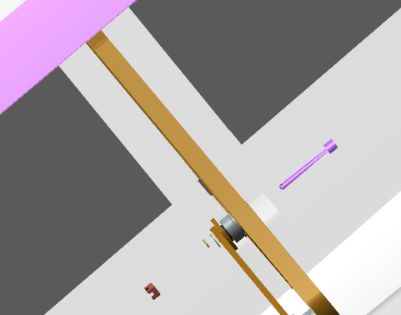
Place successively a 5 DIN 6798J washer on each ANG-0002-00034534-08 bolt, screw on the М5 DIN 935 nut.
Checkup operations:
Retract the flap by hand until encountering a hard stop. The movement may not be smooth, but it will not require any undue force. Extend the flap fully until it encountering a hard stop.
Repeat the flap movement 3 or 4 times, and leave it in the extended position.
Fit the rod end to the axle on the outer side of the first rail, place the 5 DIN 125 and 5 DIN 6798J washers, screw on the М5 DIN 935 nut.
Repeat the process above to fit the pushrod to the farther positioned rail.
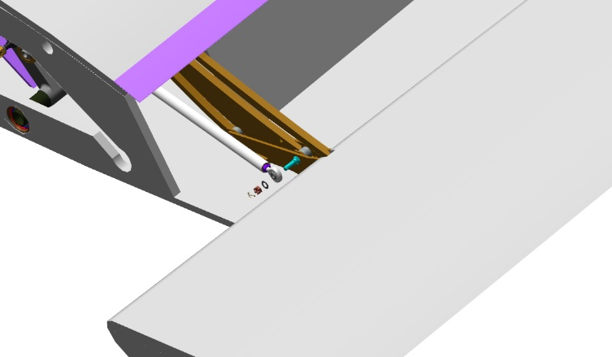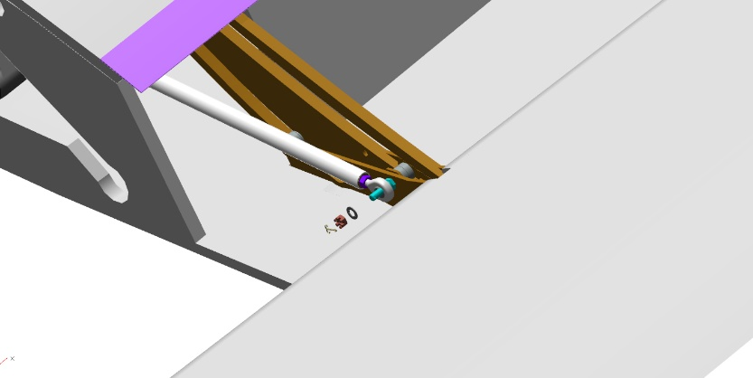
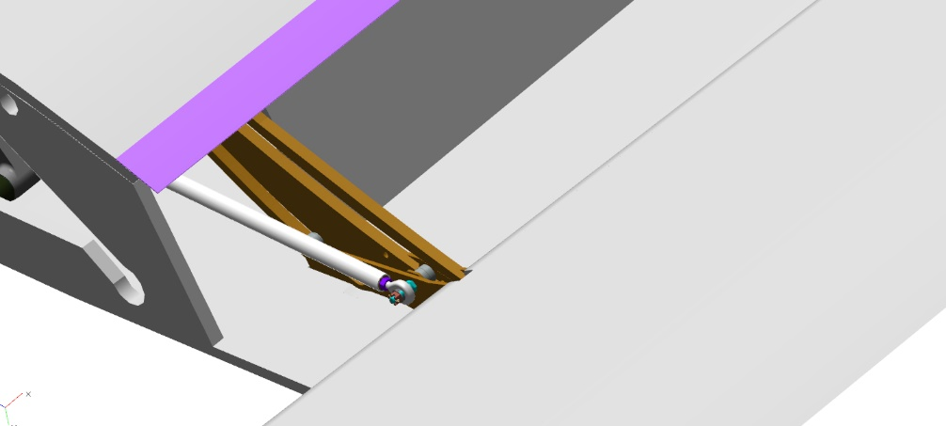
Checkup operations:
Retract the flap by hand until encountering a hard stop.The movement should be smooth, without any jerks or binding and not requiring any undue force.
Check for clearance between the flap and the wing panel. The clearance should be within 2 to 3 mm; protrusions should not exceed 2 mm. Set the aileron to zero position by aligning the edges of the aileron and the wingtips. Check the gaps between the flap and aileron edges. The gaps should be within 3 - 5 mm.
Note. If the gaps are below specified values, you need to slightly sand the wing panel covering (skin).
Extend the flap until the full flap position is reached. Tighten the M5 DIN 935 nuts one by one on each axle and bolt until it feels snug. Apply a thin coat of the Lithol-24 grease to the planes (flat surfaces) of all tracks. Move the flap 3-4 times, and leave it in the extended position. Check the areas where the grease has been applied. Apply a thin coat of the Lithol-24 of grease to the planes (flat surfaces) of all tracks once again. Move the flap 3-4 times and leave it in the extended position. The movement should be smooth, without any jerks or binding. The force required for movement should be less than before having applied the lubricant.
Checkup operations:
Proceed to the root rib on the flap side. Retract the flap fully by hand.
Check the rail tracks. There should not be any gaps between the bearings and rail tracks.
Extend the flap and recheck each rail.
Note. If when checking you find some noticeable gaps, and the flap can no longer be moved, this means that it is necessary to adjust the length of the pushrod whose thread has been undercut.
To adjust the length you need to:
Loosen the nut of the rod end by 1 turn;
Unscrew the nut from the axle, strip the washers and the rod end;
Unscrew the rod end from the pushrod by 1 turn;
Fit and secure the pushrod in reverse order;
Check for proper flap movement and gaps.
If the gaps are decreasing, repeat the steps 1-5 until closing the gaps.
In the case the gaps are not closing, screw the rod end into the pushrod in the step 3.
After performing the adjustments, screw the nut onto the rod end until encountering a hard stop, applying the retaining compound.
Once all the checks are completed and you are satisfied that the flap is fitted correctly, secure all the nuts with the 1x20 DIN 94 cotter pins.
IMPORTANT! Do not loosen the nut to align the hole with the slot. This will result in a quick failure of the assembly and its play.
Upon completing the operations with the left flap, carry out the operations for fitting and adjusting the flap on the right wing panel, as per the procedure described above.

6.6 Fit the glazing
To carry out this task you will need:
- Movable table;
- Masking tape also (known as painter's tape), 48-50 mm, 1 roll;
- P600 grit sandpaper, 200x300 mm, 1 sheet;
- Methyl acetate solvent 100 grams;
- Clean rags, 100x100 mm, 4 pieces;
- Latex gloves 1 pair;
- Metal spatula (putty knife) 30 mm;
- Utility knife;
- 3M ™ P590 primer;
- 3M 503 OEM adhesive sealant;
Unpack and place on the table:
- ANG-5211-00028520-00 left cabin door;
- ANG-5211-00028520-002 door glazing;
IMPORTANT! Before test fitting the glazing and bonding it, make sure that there are no foreign objects on the glazing opening joggle and on the glazing itself. The protective plastic sheet can be removed from the glazing only after bonding and curing of the glue.
Lay the ANG-5211-00028520-00 left cabin door with the convex part facing away from the table surface. Place the ANG-5211-00028520-002 door glazing onto the opening of the cabin door.
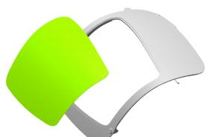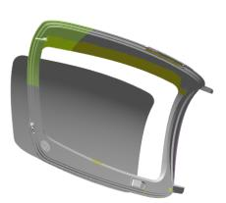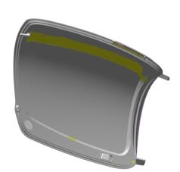
Checkup operations:
Check for proper alignment of the opening with the glazing. The glazing should not protrude above the door covering (skin). The gaps must be even.
Note...The gaps along the perimeter of the glazing and door covering (skin) may be absent in two areas, while in the areas where the gaps do exist, their size will increase.
Stick the masking tape in 5-6 spots in such a manner that a part of it is positioned on the glazing, and the other part is on the door covering (skin).
Place the door face down on the table. Mark with a white marker thelocation of the glazing on the inner outline of the door.
Revert the door to its previous position.
Using a utility knife, carefully cut the masking tape on the gap between the glazing and the door joggle.
Remove the glazing and place it on the table, with the marks facing upwards.
Tape the outer outline of the door covering (skin) around the glazing edge.
IMPORTANT! Do not tape the glazing seat. This can render impossible bonding of the glazing to this area. Remove any masking tape getting into that area.
Turn the door over on the table. Tape the inner outline of the door around the glass opening.
Tape the outline along the marks on the glazing, so that the marked line is slightly visible, and the gluing outline is formed on the rest of the glazing. Detach the protective plastic sheet with a utility knife, carefully unfold it and lay it over the attached masking tape. Secure the sheet with the masking tape.
Clean the glazing mating door joggle as per the standard operation 4.
IMPORTANT! Take care not to damage the composite portions of the areas to be sanded. Do not rub the same spot for too long time, even if the area to be sanded does not turn dull (matte).
Moisten a rag with solvent. Degrease the sanded area of ​​the door joggle which is supposed to mate the glazing.
IMPORTANT! Degrease until the rags moistened with solvent remains clean. Change soiled rags immediately. If the surface has pores, cavities and other small irregularities, clean the area with compressed air, and degrease it afterwards.
Moisten a rag with some isopropyl alcohol. Degrease the bonding outline of the glass (the area, which is not covered with the protective sheet).
Put on latex gloves and a respirator. Apply a thin, continuous coat of 3M ™ P590 Primer with an applicator to the whole surface of the door joggle. Repeat the step on the prepared glazing surface with primer. Allow the primer to dry for 10-15 minutes.
IMPORTANT! Do not let the primer dry for more than 60 minutes!
Apply to the glazing door joggle the 3M 503 OEM adhesive sealant in a 5-7 mm high triangle shape, positioning it approximately in the middle of the joggle cap.
IMPORTANT! Make sure that the time between applying the adhesive sealant and fitting into place the glazing and securing it does not take more than 12 minutes.
Fit the glazing to the joggle with the prepared strip facing the adhesive sealant. Gently press the glazing into position along the perimeter of the glazing joggle. Keep pressing until the glazing surface is in line with the door covering (skin) surface without any protrusions.
IMPORTANT! Do not immediately press random areas of the glazing against the joggle. Do it step by step.
Attach the glazing to the door covering (skin) with masking tape in 8-10 locations.
Remove with a putty knife any squeezed-out adhesive sealant from the gaps between the door joggle and the glazing, without making thereby any grooves.
Smooth out any unevenness of the adhesive sealant with a putty knife. The curing time of the adhesive sealant is at least 8 hours.
IMPORTANT! Do not turn over or place the door with its glazing faced toward the table unless the adhesive has cured. This can result in disbonding of the glazing from the door joggle, formation of protrusions between the covering (skin) and the glazing and the loss of the door finish.
Clean your workplace and tools as per the standard operation 7.
Repeat the process described above to bond the glazing to the right door and fuselage.
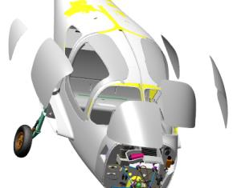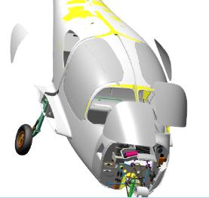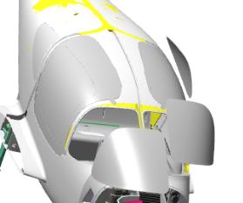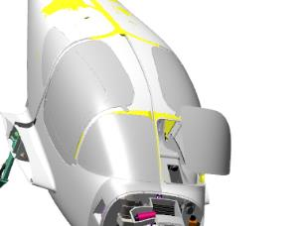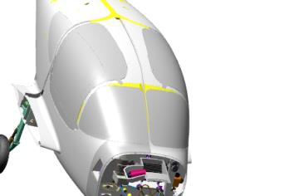
Note. Bonding the glazing to the fuselage will be a bit more complicated as it will not be possible to move the fuselage.

6.7 Fit the doors
Note.The door fitting process is described for the left door. Fitting of the right door is to be carried out in the same manner.
To carry out this task you will need:
- Movable table;
- 400 gram rubber hammer;
- Slotted (flat-tip) screwdriver No. 2;
- Combination pliers;
- 13 mm combination wrench;
- P600 grit sandpaper, 200x300 mm, 1 sheet;
- Methyl acetate solvent 100 grams;
- Clean rags, 100x100 mm, 2 pieces;
- Latex gloves 1 pair;
- Larit L285 epoxy resin 10 grams;
- H287 hardener 4 grams;
- Paper cup 100 ml;
- Aerosil thickener 3 grams;
Unpack and place on the table:
- Four ANG-5330-00028553-00 lower brackets;
- Four ANG-5330-00028552-006 washers;
- ANG-5211-00028520-00 left cabin door (assembled by you earlier);
- ANG-5211-00028520-00Z right cabin door (assembled by you earlier);
- Two ANG-5211-00028544-00 ball brackets;
- Four 2E DIN 11024 cotter pins;
- Four M8 prch-0000007685 ball bolts;
- Two 5079DX prch-00028214 air springs;
- Two prch-0000009289 rubber seals;
Find two ANG-5330-00028553-00 lower brackets, two ANG-5330-00028552-006 washers, two 2E DIN 11024 cotter pins. Come up to the door opening on the left side of the fuselage.
Get inside the fuselage. Place an ANG-5330-00028552-006 washer onto the ANG-5330-00028553-00 lower bracket until encountering a hard stop against the ring.
Fit the bracket with a washer into the hole below, on the fuselage edging, aligning the vacant hole of the bracket pin with that of the fuselage bush hole. The pin should easily fit through the fuselage bush hole.
Fit into the aligning holes the 2E DIN 11024 cotter pin. If the holes are not properly aligned, adjust them with slight twists of the bracket pin.
Repeat the process above to fit the second bracket into the fuselage bush hole. Proceed from the fuselage to the table.
Find a threaded hole on the top inner side of the door. Check the M8 threaded holes as per the standard operation 6. Repeat the process for the hole on the upper part of the fuselage door opening.
Put on the latex gloves. Moisten a rag with solvent. Degrease the threaded portions of the two M8 prch-0000007685 ball bolts.
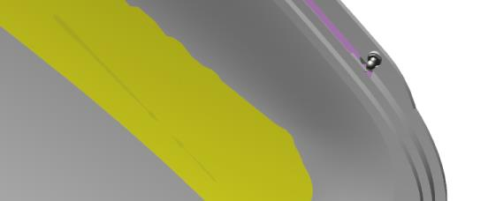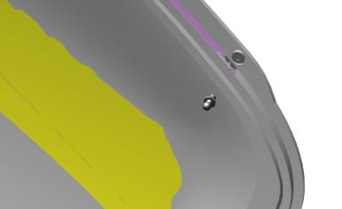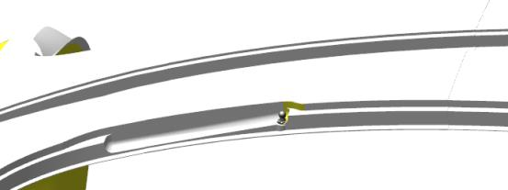
IMPORTANT! Take care not to apply any retaining compound to the degreased surface immediately. The retaining compound can be applied 5-10 minutes after degreasing.
Apply an even thin layer of the LOCTITE 648 retaining compound to the degreased surface of the M8 prch-0000007685 ball bolt. Permanently fit the bolt into the threaded hole of the door. Tighten it with a 13 mm combination wrench until closing the gap between the hexagonal portion of the bolt and the mating surface. Repeat the process above to fit the bolt to the fuselage.
Clean your workplace and tools as per the standard operation 7.
You will need a helper to carry out further work.
Get inside the fuselage. Detach the 2E DIN 11024 cotter pins from the holes, detach the ANG-5330-00028553-00 brackets from the fuselage bushes.
Approach the door to the fuselage opening, in a position that simulates a slightly open door, insert the door lugs into the fuselage opening (have your helper carry out this operation).
Insert the ANG-5330-00028553-00 bracket pin into one of the fuselage bushes (upper or lower one). If the pin does not fit into the bush before aligning the holes for the cotter pin, smoothly move the door to simulate opening or closing. Fit into the aligning hole the 2E DIN 11024 cotter pin.
IMPORTANT! Do not release or slant the door unless the second bracket is fitted. Doing so may result in breaking the door lug.
Fit the second ANG-5330-00028553-00 bracket and a cotter pin into the remaining fuselage bush.
Checkup operations:
Open and close the door several times for its full travel. The travel should be smooth and light, not requiring any undue force.
Exit from the fuselage.
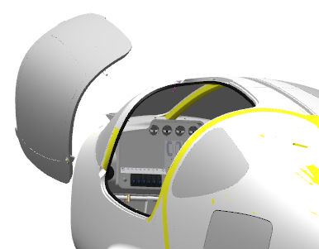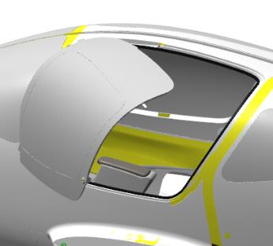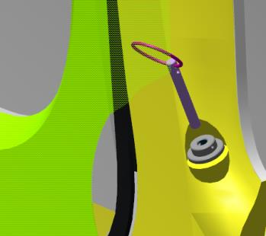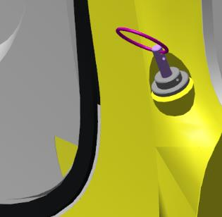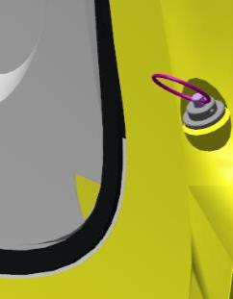
Checkup operations:
Close the door, press it firmly in the lock area. Check the door outline (edge) for the protrusions along the fuselage outline. There should not be any protrusions of the door above the fuselage surface. A slight sinking of the door into the fuselage opening is allowed.
Find the prch-00028214 air spring. Using a slotted (flat-tip) screwdriver No. 1, move the retaining plates of the pneumatic spring ends beyond the grooves. Come up to the fitted door, open it.
Place the air spring end with its stem side onto the M8 prch-0000007685 ball bolt. Using a slotted (flat-tip) screwdriver No. 1, seat the retaining plate into the groove of the tip. Fit the second air spring end in the same way.
Checkup operations:
Check the door for ease of opening and closing. The movement should be smooth, not requiring any undue force.
IMPORTANT! Don't release the door when moving it. This can result in damaging the parts of the aircraft.
Find the ANG-5211-00028544-00 ball bracket. Come up to the door, partially open it. Find the lock slot, and fit the ball bracket ANG-5211-00028544-00 slightly pushing on it by hand. The bracket must fit into the lock seat without falling out. Press on the spheric portion of the lock outside the door, the bracket should disengage and fall out. Repeat this step several times.
Checkup operations:
Close the door with the bracket fitted into the lock slot, press it against the fuselage.
Check the area for irregularities between the door and the fuselage. The door must not protrude above the fuselage. The door is allowed to sink in relation to the fuselage by up to 1 mm.
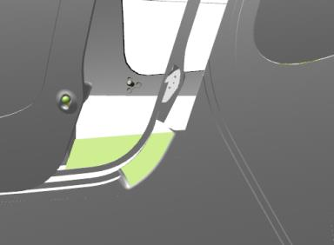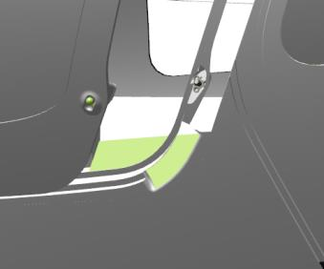
Open the door, disengage the ball bracket from the lock. Apply a slight coat of grease to the seat of the lock, around its perimeter. This will allow you to easily remove accidentally trapped particles of the adhesive, and will keep the lock serviceable.
Sand the bonding location of the ball bracket ANG-5211-00028544-00 on the fuselage as per the standard operation 3.
IMPORTANT! Take care not damage the composite parts of the areas to be sanded . Do not rub the same spot for a long time, even if the area to be sanded does not turn dull (matte).
Sand the surfaces of the ANG-5211-00028544-00 ball bracket to be bonded to the fuselage as per the standard operation 4.
Once all surfaces are sanded, put on latex gloves. Moisten a rag with solvent, degrease the following:
The surface of the ANG-5211-00028544-00 ball bracket to be bonded to the fuselage;
The bonding surface of the fuselage;
Mix as per the standard operation 1 a batch of epoxy glue from Larit L285 resin and H287 hardener in a ratio of 10:4.
IMPORTANT! The epoxy glue is to be used within 60 minutes following its preparation.
Apply a coat of glue as per the standard operation 5.1 to the degreased surfaces to be bonded: that of the ball bracket ANG-5211-00028544-00 and that of the fuselage.
Make from the remaining glue some adhesive compound as per the standard operation 2.
Insert the ANG-5211-00028544-00 ball bracket into the lock slot, push it in until encountering a hard stop. Apply a coat of adhesive as per the standard operation 5.2 to the surface of the ball bracket ANG-5211-00028544-00.

Checkup operations:
Close the door gently. Check for the irregularities between the door and fuselage covering (skin) in the area of the lock.
If the door protrudes above the fuselage, press it down lightly.
If the door sinks, open the door and apply a thicker coat of adhesive to the surface of the ball bracket ANG-5211-00028544-00 one more time as per the standard operation 5.2.
Open the door by means of the lock at least after 3 hours (180 minutes).
IMPORTANT! In this case the adhesive serves as a self-leveling seal and a temporary bonding agent, but not as a permanent means of attachment.
Smooth away any excess adhesive around of the bracket with a needle file. Find three holes on the bracket plane. Drill three ø2.5 mm holes. Clean away the resin from the countersunk slots on the top of the three holes with a 6 mm drill.
Fit the 3x12 prch-000 self-tapping screws into the three holes using a Phillips screwdriver with a PH1-tip. The screw heads should sit flush with the slots.
Checkup operations:
Close the door gently, press it with your hand in the lock area. The door must lock. Try to open the door easily, without pressing the lock spheric portion from outside. The door must remain closed.
Increase the force and try to open the door again. The door must remain closed.
Press on the lock spheric portion from outside. The door must open.
Retest opening and closing the door. The lock should operate each time.
Find the prch-0000009289 rubber door seal. Find the “inflated” (tube) portion and the mounting (flat) portion of the seal.
Open the mounted door. Find a ledge on the fuselage opening. Fit the seal to the ledge on the fuselage opening with the “inflated” (tube) portion of the seal away from the fuselage, to the ledge in the opening.
The fitting should be performed in a step-by-step manner, pressing on the seal with your hand from above. Once the seal is positioned in place, seat it home by slightly tapping on it with a hammer.
Checkup operations:
Open and and close the door fully several times. The door should move smoothly and easily, and full closing without any protrusions on the fuselage is possible only after slightly pushing the door by hand.
Note.The new rubber seal will complicate complete easy closing of the door unless the door breaks in (beds in). Close the door after finishing work or not working in the fuselage. This will speed up the breaking-in (bedding-in) process of the rubber seal.
While the left door seal is getting a needed shape, mount the right door repeating the process described above.

6.8 Fit the hatches
To carry out this task you will need:
- Movable table;
- 400 gram rubber hammer;
- Slotted (flat-tip) screwdriver No. 2;
- Phillips screwdriver with a PH2 tip;
Unpack and place on the table:
- ANG-5211-00028914-00 luggage compartment hatch door;
- prch-0000009289-01 rubber seal;
- prch-00028214 air spring;
- 2 self-tapping screws (provided together with the spring).
Fit the air spring support to the back of the sofa, with the shoulder (collar) of the bush facing down. Fix the support to the back shelf of the sofa with 2 self-tapping screws. Slide the door hinge into luggage compartment, align the holes of the hinge with the lugs on the fuselage. While holding the luggage compartment hatch with your hand, fit one by one the fastening screws.
- Swing open and close the hatch door several times. The movement should be smooth and easy, not requiring any significant force.
- Close the door, press it firmly in the lock area.
- Check the door outline (edge) for protrusions in respect to the fuselage outline (edge). There should be no protrusions of the door above the plane (surface) of the fuselage. Some sinking of the door into the fuselage opening is allowed.
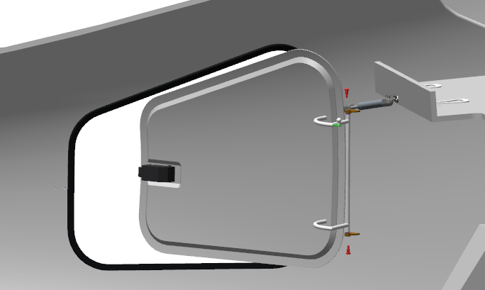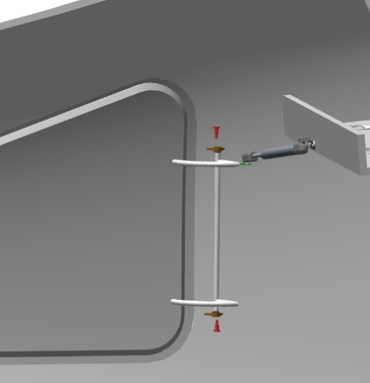
Note... The air spring set includes a spherical bracket.
Fit the spherical air spring bracket to the the rear sofa web with 2 self-tapping screws.
Using a slotted (flat-tip) screwdriver No. 1, move the retaining plates of the tips of the airspring beyond the grooves. Come up to the installed door, open it.
Place the air spring end with its stem side onto the spheric portion of the hatch hinge. Insert the retainer into the groove of the spring end, using a screwdriver with a straight slot No. 1.
Fit in the same manner the second air spring end to the bracket on the rear sofa web.

Checkup operations:
- Check the opening and closing of the door. The movement should be smooth, not requiring any undue force. Gently close the door, press it slightly with your hand in the lock area. The door must be locked. Easily try to open the door, without moving the lock handle from the outside. The door must remain closed.
- Increase the force and try to open the door again. The door must remain closed. Slightly turn the lock handle from the outside pull at it. The door should open. Repeat the door opening and closing steps. The lock should operate each time.

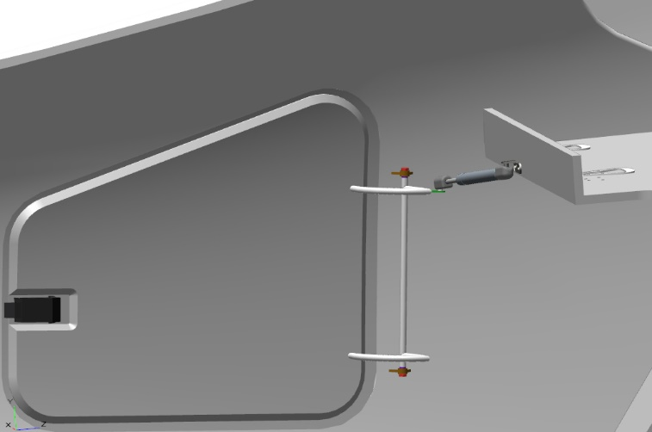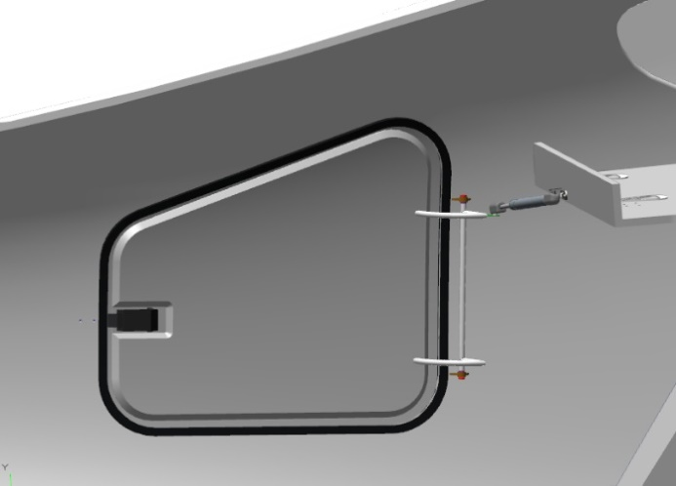
Find the prch-0000009289-01 rubber seal. Find the “inflated” (tube) portion and the mounting (flat) portion of the seal. Open the installed door.
Find the ledge on the fuselage opening. Fit the seal to the ledge in the opening with its “inflated” (tube) portion away from the fuselage, The fitting should be performed in a step-by-step manner, pressing on the seal with your hand from above.
Once the seal is positioned in place, seat it home by gently tapping on it with a hammer.
Check operations:
Swing open and close the door several times. The door should move smoothly and easily, and full closing without any protrusions on the fuselage should be possible only with slightly pushing the door by hand.

Note. The new rubber seal will complicate complete easy closing of the door until the door breaks in (beds in). Close the door after finishing work or not working in the fuselage. This will speed up the breaking-in (bedding-in) process of the rubber seal.

6.9 Fit the engine mount
To carry out this task you will need:
- Movable table;
- Digital kitchen scales;
- Latex gloves 1 pair;
- Larit L285 epoxy resin 30 grams;
- H287 hardener 12 grams;
- Paper cup 100 ml;
- Aerosil thickener 3 grams;
- Grit P1000 sandpaper, 1 sheet, 200x300 mm;
- Solvent methyl acetate 100 grams;
- Clean rags, 100x100 mm, 2 pieces;
- P600 grit sandpaper, 200x300 mm, 1 sheet;
- Respirator;
- Metal spatula (putty knife) 50 mm;
- Torque wrench 1-25Nm;
- 3 mm hex socket;
- 4 mm hex socket;
- 4 mm hex key (Allen wrench);
- 3 mm hex key (Allen wrench);
- 10 mm drive socket;
- Socket head Tommy bar (handle);
- 750 Watt electric drill;
- 6.0 mm diameter drill bit for metal.
Unpack and place on the table the engine mount marked ANG-7100-00029076-00.
Count and place on the table:
- Twenty М5х16 ISO 7380-2 screws;
- Two М6х20 ISO 7380-2 screws;
- Two М6 DIN 985 nuts;
- Two М6 DIN 934 nuts.
You will need a helper to carry out further work.
Take the ANG-7100-00029076-00 engine mount, approach it to the first frame in front. Point the engine mount with the brackets toward frame, having directed downward the two brackets of the nose landing gear. Test fit ANG-7100-00029076-00 engine mount to the frame, align approximately the holes. The nose landing gear brackets should fit to the edges of the nose landing gear recess. Mark all the mating locations of the engine mount on the frame.
IMPORTANT! The frame has a very large number of other mounting holes. Take care not to mistake them.
Remove the ANG-7100-00029076-00 engine mount from the frame and place it on the table. Check as per the standard operation 6 the M5 threaded holes in the marked locations.
Note. You can at the same time check all other threaded holes located on the frame.
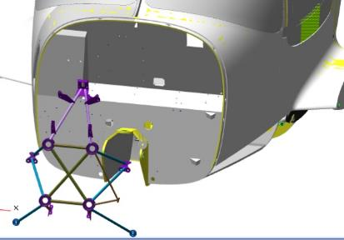 | 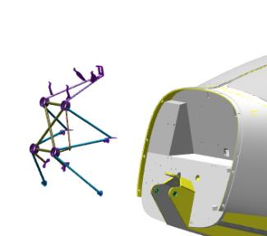
Test fit the engine mount to the frame as you did earlier. Align the holes. Fit to the bracket two M5x16 ISO 7380-2 screws on the left side at the bend of the frame, tighten them slightly with a 3mm hex key (Allen wrench).
Fit and tighten two M5x16 ISO 7380-2 screws in the similar location on the right side. Fit four M5x16 ISO 7380-2 screws to the left nose landing gear arm.
Tighten the screws slightly with a 3mm hex key (Allen wrench). Fit and tighten four M5x16 ISO 7380-2 screws to the similar location on the right side. Fit four M5x16 ISO 7380-2 screws to the top bracket of the engine mount.
Tighten the screws lightly with a 3mm hex key (Allen wrench).
Drill with a 6.0 mm diameter drill-bit on the in the frame left side a throughout hole, with a recess.
Fit from the inside of the fuselage a M6x20 ISO 7380-2 screw, place onto it from the outside a M5 DIN 934 nut. Tighten the screw slightly with a 4mm Allen key. Repeat the process in the similar location on the right side. Tighten all fitted screws until it feels snug.

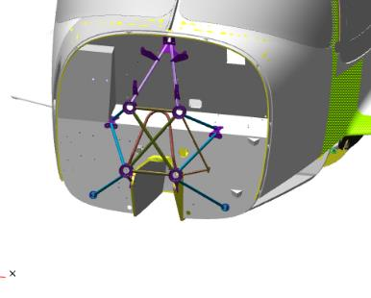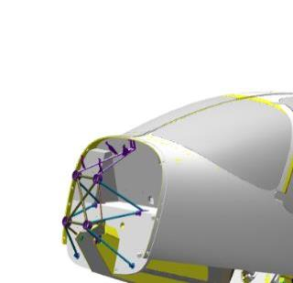
Checkup operations:
- Check the installed engine mount for the gaps between the brackets and the plane of the frame. The gaps should range from 0 to 1 mm.
If you are satisfied with everything, mark a line around the engine mount brackets on the fuselage frame. Detach the engine mount loosing all the screws with 3 and 4 mm hex keys (Allen wrenches) and set it aside on the table for later use.
IMPORTANT! The areas where the adhesives are to be applied should always be sanded 10-15 mm wider than the actual outline of the part to be fitted. Take care not to damage the composite parts of the areas to be sanded. The thickness of the covering (skin) in some areas is only 0.08 mm. Do not sand the same area for a long time, even if the area to be sanded does not turn matte.
Sand as per the standard operation 3 seven bonding surfaces of the fuselage frame.
Sand as per the standard operation 4 seven bonding surfaces of the ANG-7100-00029076-00 mating with the fuselage frame.
Once all the surfaces are sanded, put on latex gloves and a respirator. Moisten a rag with solvent. Degrease the bonding surfaces of ANG-7100-00029076-00 engine mount and the fuselage frame.
Mix a batch of epoxy glue from Larit L285 resin and H287 hardener in a ratio of 20:8 as per the standard operation 1.
IMPORTANT! The epoxy glue is to be used within 60 minutes following its preparation.
Apply the glue as per the standard operation 5.1 to the degreased surfaces of the ANG-7100-00029076-00 engine mount brackets, degreased mating surfaces of the fuselage frame where the ANG-7100-00029076-00 engine mount is to be bonded.
Prepare the adhesive compound from the remaining glue as the standard operation 2.
Apply the adhesive compound to the surfaces of the ANG-7100-00029076-00 engine mount brackets as per the typical operation 5.2. Install the ANG-7100-00029076-00 engine on the fuselage frame.
Align the holes. Fit two M5x16 ISO 7380-2 screws to the left side of the bracket at the bend of the frame, tighten them slightly with a 3mm Allen wrench. Fit two M5x16 ISO 7380-2 screws to the similar location on the right side and tighten them.
Fit five M5x16 ISO 7380-2 screws to nose landing gear arm on the left side. Slightly tighten the screws with a 3mm hex key (Allen wrench). Fit and tighten five screws M5x16 ISO 7380-2, in the similar location on the right side. Fit four M5x16 ISO 7380-2 screws to the top bracket of the engine mount. Slightly tighten the screws with a 3mm Allen wrench.
Fit the M6x20 ISO 7380-2 screw into the 6 mm diameter hole from the inside of the fuselage on the left side fit the M6 ​​ DIN 985 nut in the well from the outside. Tighten the screw slightly with a 4mm Allen wrench, hold the nut with a 10mm drive socket. Fit and tighten the M6x20 ISO 7380-2 screw in the similar area on the right side. Tighten all the screws firmly. Attach the 3 mm hex socket, set the torque wrench to 5 Nm. Tighten one by one with the wrench twenty M5x16 ISO 7380-2 screws securing the brackets of the engine mount ANG-7100-00029076-00 with the 5Nm force.
Change the hex socket to 4mm. Readjust the wrench to 8 Nm. Tighten with the wrench the two M6x20 ISO 7380-2 screws securing the engine mount brackets ANG-7100-00029076-00 with a force of 8Nm.

6.10 Assemble and fit the cowlings
Note. The work is to be carried out with the installed engine and its systems.
To carry out this task you will need:
- Movable table;
- 2.5 mm drill bit;
- 4 mm drill bit;
- 6mm drill bit;
- 6.5 mm drill bit;
- 8 mm drill bit;
- 12 mm drill bit;
- 400 gram bench hammer;
- Phillips screwdriver with PH2 bit;
- 500 watt electric drill;
- Hand riveter;
- G 25 mm clamps 4 pcs;
- Mandrel for fitting the lock washers;
- Ten М6х12 DIN 933 bolts;
- P600 grit sandpaper, 200x300 mm, 1 sheet
Unpack and place on the table:
- ANG-7100-00029056-01bottom cowling;
- ANG-7110-00029057-01 top cowling;
- Twelve ANG-7100-00029057-016 axles;
- Six quick access fastener (DZUS or Skybolt Aerospace Fasteners) prch-0000009462-01 ANG screw;
- Six quick access fastener (DZUS or Skybolt Aerospace Fasteners) prch-0000009462-02 ANG nut;
- Twelve std 000 rivets
Screw through the thread length 8 axles ANG-7100-00029057- 016 into the fuselage in the location where the cowlings are to be fitted.
You will need a helper to carry out further work.
Find the ANG-7110-00029056-01 bottom cowling, revert it with its concave side upwards. Bring the cowling to the fuselage with its ring-like cut towards the propeller installation flange, from below in the area of ​​the nose landing gear leg.
Lift the cowling and align it with the attachment projection (bonding surface) on the fuselage, align the holes in the cowling with the fitted axles and press it down with your hand.
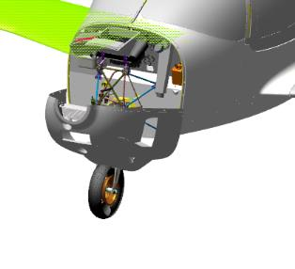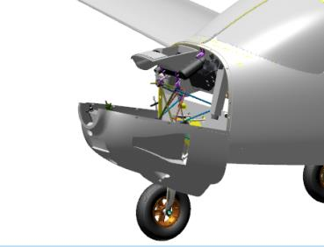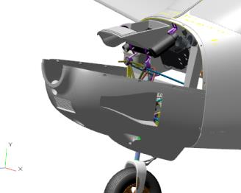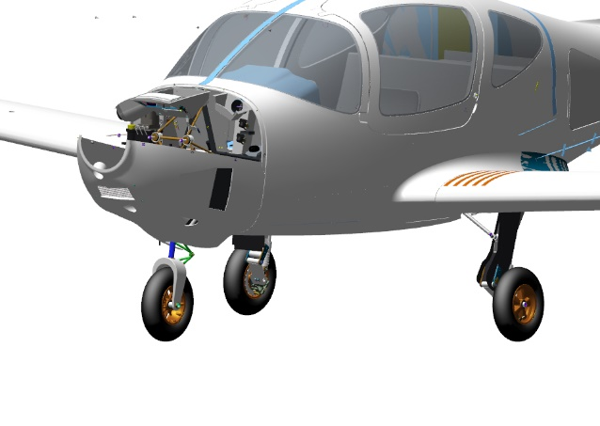
IMPORTANT! When fitting the cowling, make respective turns to clear the engine systems fitted in place. Otherwise you can damage the cowling or the engine systems.
Move the cowling towards the fuselage so that the edge of the cowling skin fits to the attachment projection (bonding surface) until it encountering a hard stop. Secure the cowling in this position with two clamps in its top part.
IMPORTANT! Do not compress the mating parts too hard. This will inevitably damage them. If it is necessary to compress these parts strongly, use pads made of soft rubber materials.
Checkup operations:
- Check the the fitted cowling along the edge of its mating surface for gaps and protrusions and snug fitting to the fuselage. The protrusions at the junction with the fuselage should be within 0.5 mm, the gaps in the area of junction with the fuselage should be from 1 to 2 mm. There should be no gaps in the area of contact of the cowling skin with the attachment protrusion (bonding surface) on the fuselage.
Note. Refit the cowling if the gaps at the join of the skin edge exceed the specified values or are uneven . If you have found an area without any gap, and it affects the size and uniformity of the gaps in other areas, mark this area and trim it off. If the systems of the installed engine do not allow to obtain the required gaps, trim the cowling in the abutment area.
Once all the areas have been checked and you are satisfied that the values are within the acceptable range, fix the cowling with two clamps from below. Check once again the attached cowling again along its join. Gaps and protrusions must not change their values.
Find three small dot-like notches on the right and left in the area where the cowling is mated with the fuselage. Drill at the mentioned notches the pilote holes with a 2.5 mm pilot drill bit. Drill the holes with a 4 mm pilot drill bit and then with a 6.5 mm drill.
IMPORTANT! Take care to avoid any displacement of the cowling when drilling. If there are any elements of engine systems near the points to be drilled, they must be protected to avoid any damaging with a drill bit.
Remove the clamps one by one, remove the cowling and place it on the table. Remove any chips from the cowling after drilling the holes. Sand away the burrs in the location of ​​the holes with the grit P 600 sandpaper.
Come up to the fuselage with the tools. Drill 6 holes for the locks with an 8 mm drill bit, then with a 12 mm bit. Sand away the burrs in the location of ​​the holes with with the grit P 600 sandpaper. Find six quick access fastener (DZUS or Skybolt Aerospace Fasteners) prch-0000009462-02 ANG nuts.
IMPORTANT! Do not remove the locking pin from the side of the nut body unless the fitting and adjustment of the locks is completed.
Fit a quick access fastener (DZUS or Skybolt Aerospace Fasteners) nut into each drilled hole. Check the fitted nuts for gaps in the areas where they mate the fuselage. There should be no gaps in the contact areas, and if there are any minor gaps, they should be eliminated after pressing by hand.
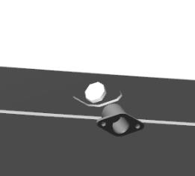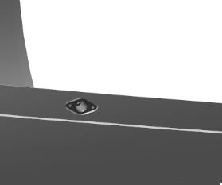
Align the nut in the recess, drill with a 2.5 mm drill bit a hole in the fuselage through the hole in the nut.
Place into the hole a std 000 rivet but do not clinch it. Press the nut and the std 000 rivet firmly with your fingers,drill a second hole through the nut. Remove the rivet, remove the nut, clean up the chips from the drilling area; sand the burrs with the P 600 grit sandpaper.
Place the nut on the fuselage, align it with the drilled holes, prefit two std 000 rivets. Press the nut and one of the rivets with your fingers, clinch the second rivet with a hand riveter.
Check the fitted nut for skewing and riveting quality. There should be no skewing or displacement, the spherical portion of the rivet should not sink into plastic. The remainders of the rivet stem should not protrude beyond the plane of the nut.
IMPORTANT! Do not drop the spent rivet stem in any cavity and on aircraft components. To discard the spent rivet stem, move the riveter away from the work area.
Repeat the steps above to fit the remaining quick access fastener (DZUS or Skybolt Aerospace Fasteners) ANG nuts to the aircraft fuselage.
Come up to the cowling on the table. Find the six quick access fastener (DZUS or Skybolt Aerospace Fasteners) ANG prch-0000009462-01 screws (the set should include the retaining washers).
Prefit the quick access fastener (DZUS or Skybolt Aerospace Fasteners) ANG into the hole on the cowling with its screw driver portion facing outsides. To place the screw stem through the hole, slightly incline it, align it after placing it through and press it with your finger against the covering (skin).
Revert the cowling on the table so that fitted screw faces the plane of the table. Press the cowling at the screw area against the table. Have your helper hold the cowling in this position, drive in place the retaining washer on the screw tapping on it slightly with hammer, using a mandrel. The washer should be seated snug on the inner covering (skin) without any gaps.

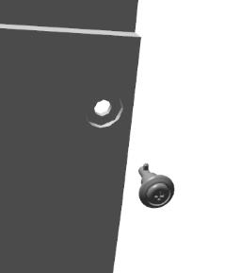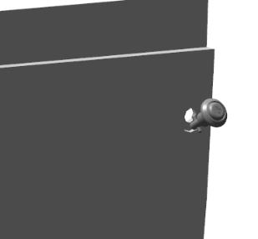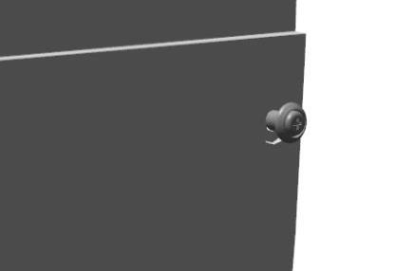
Note.If the washer cannot be seated without gaps in respect with the covering (skin), check the position of the cowling on the table. The screw must be placed so that its axis of rotation is perpendicular to the table.
Revert the cowling, press on the screw a few times. The screw should move easily, without any jerks or binding. The quick access fastener (DZUS or Skybolt Aerospace Fasteners) should not detach from the cowling covering (skin) after several pressings, and gaps should not appear under the washer.
Repeat the steps above to fit to the cowling the remaining quick access fasteners (DZUS or Skybolt Aerospace Fasteners) ANG screws.
Approach the cowling to the fuselage from below in the area of ​​the nose landing gear leg with its ring-like cut to the propeller installation flange. Lift the cowling up and align the pins of the screws of the cowling with the nuts of the fuselage.
IMPORTANT! When fitting the cowling, take care to make the movements to clear the installed engine systems, otherwise you can damage the cowling or installed systems.
Slide one by one the cowling screws into the seats of the nuts on the fuselage. While holding the cowling with your hand, press the Phillips head of the screw with a PH2 screwdriver, rotate the screw clockwise by 0.5-1 turn, release the screwdriver. The lock should close, and the portion of the screw pressed by the screwdriver should slightly protrude. Press with the PH2 screwdriver on the the Phillips head of the screw, rotate it clockwise until it feels snug, release the screwdriver. The lock must remain closed, and the portion of the screw pressed down by the screwdriver must not protrude.
Repeat the steps above to close and adjust the remaining locks.
Note. If the lock does not close, the screw does not engage with the nut, strip the cowling, loosen the inner part of the lock nut by 2-3 turns with slotted (flat-tip) screwdriver No. 2 and start over the fitting and closing.
Check the mating surfaces of the mounted cowling and fuselage for the gaps and protrusions along the outline of their join. The protrusions along the join with the fuselage should be within 0.5 mm, the gaps between the edge of the cowling skin and the fuselage should be from 1 to 2 mm. The gap between mating surfaces of the cowling skin and the attachment projection (bonding surface) on the fuselage should not exceed 0.5 mm.
Position yourself under the aircraft. Turn gently by hand the nose wheel to the left, then to the right, then return the nose gear to its initial position. When moving the landing gear leg, be sure to carefully check for the gaps between the landing gear leg parts and the adjacent cowling skin parts. The gaps should be less then 10mm, in any position of the landing gear leg.
Once you are satisfied that the measured values ​​ are within the required range, find the ANG-7110-00029057-01 top cowling.
Place the top cowling on the bottom cowling mounted on the fuselage. Align the top cowling with the attachment projection (bonding surface) of the fuselage and the attachment projection (bonding surface) of the bottom cowling, press it with your hand.
Checkup operations:
- Check the mounted cowling for gaps and protrusions. The protrusions at the join with the fuselage and the bottom cowling should be within 0.5 mm, the gaps between the cowling skin edge and the fuselage joint should be in the range from 1 to 2 mm, the gaps at the join of the the two cowlings should be from 0 to 1 mm. There should be no gaps between the mating surfaces of the cowling skin and the attachment projections (bonding surfaces) of the fuselage and the bottom cowling.
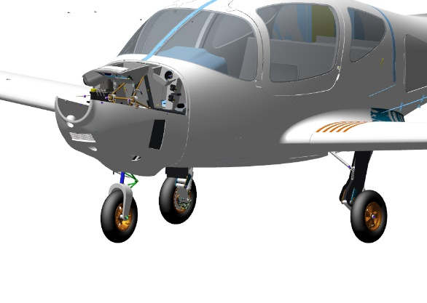
Note. If the gaps at the joins are beyond the specified values or are irregular, in this case refit the cowling. If you find an area where the gap is missing, and it affects the size and regularity of the gaps in other areas, mark this area and trim it off. If the systems of the installed engine do not allow obtaining the required gaps trim the cowling in the abutment area.
You will need a helper for further work.
Hold the cowling with your hands (together with the helper) until all holes are drilled. Find three small dot-like notches on the right and left in the area where the cowling adjoins fuselage.
Drill one by one at each dot-like notchwith a pilot hole a 4 mm drill bit. After this continue drilling the holes with a 6 mm drill bit. Fit bolt into the hole the M6x12 DIN 933 bolt.
IMPORTANT! Take care to avoid any displacement of the cowling when drilling. If there are any elements of the engine systems positioned near the drilling area, take care to protect them from damaging with a drill bit.
Repeat the process above to drill the holes and fitting the bolts into the remaining locations. When the side holes are open, the bolts are installed in the holes, without releasing the cowling, find five small dot-like notches at the join of the top cowling with the fuselage.
Remove the M6x12 bolts installed in the holes, remove the top cowling and place it on the table. Drill the pilot holes with a 6 mm bit, drill them subsequently with a 6.5 mm drill bit for fitting the lock screws. Repeat the whole process described above for screws and nuts to fit them to the bottom cowling and fuselage.
Insert one by one, the screws of the cowling into the seats of the nuts on the fuselage and bottom cowling.
While holding the cowling with your hand, press the Phillips portion of the screw with a PH2 screwdriver, turn it clockwise by 0.5-1 turn, release the screwdriver. The lock should close, and the portion of the screw pressed by the screwdriver should protrude slightly.
Press the Phillips portion of the screw with a PH2 screwdriver, turn it clockwise until it feels snug,, release the screwdriver. The lock must remain closed, and the portion of the screw pressed down by the screwdriver must not protrude.
Repeat the process above to close and adjust the remaining locks.
Note. If the lock does not close, the screw does not engage with the nut, in this case strip the cowling, loosen the inner part of the lock nut by 2-3 turns with a slotted screwdriver № 2, and start over the fitting and closing.
Checkup operations:
- Check the mounted cowling for gaps and protrusions. The protrusions at the join of the fuselage and the bottom cowling should be within 0.5 mm, the gaps at the join between the edge of the cowling covering and fuselage should be from 1 to 2 mm, the gaps at the join of the two cowlings should be from 0 to 1 mm. The gaps at the areas where the cowling skin mates with the attachment projection (bonding surface) of the fuselage and the bottom cowling should not exceed 0.5 mm.
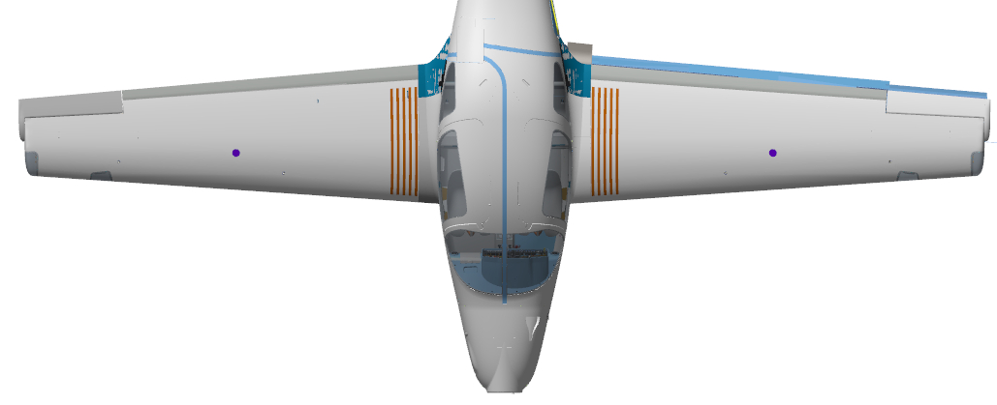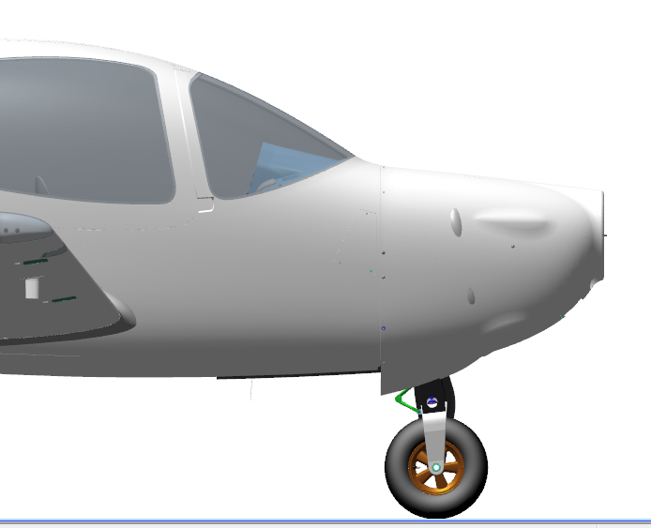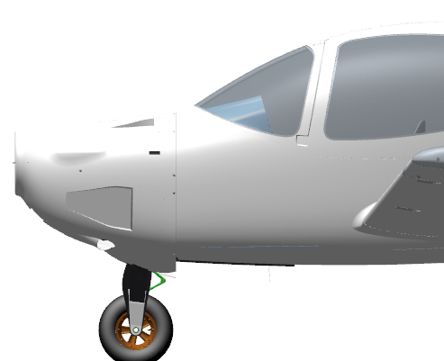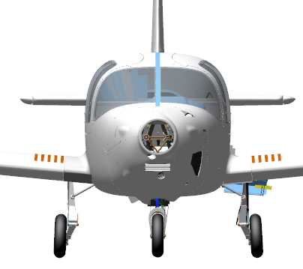
Once all the areas checked, and your are satisfied with the values ​​of the gaps and protrusions, remove the top cowling.
Remove the securing pins from the nuts of the bottom and top cowling locks. Refit the top cowling. The locks should close and hold in place after removing the screwdriver from the screw.

6.11 Fit the wing panels
You will need two helpers to perform this task. The wing panels should be placed with their bottom covering (skin) facing the floor.
To carry out this task you will need:
- Movable table;
- 2 mm hex key (Allen wrench);
- 19 mm mm hex key (Allen wrench);
- Socket head 17 mm;
- Two 8 mm combination keys;
- Tweezers;
- Combination pliers;
- Slotted (flat-tip) screwdriver № 1;
- Methyl acetate solvent 100 grams;
- Clean rags, 100x100 mm, 2 pieces;
- LOCTITE 648 retaining compound;
- 4 stands with cradles for upholding the wing panel.
Unpack and place on the table:
- Two ANG-5700-00030810-14 bolts;
- Left wing panel with flap and aileron (assembled earlier);
- Right wing panel with flap and aileron (assembled earlier);
- Eight М3х8 ISO 7380-2 screws;
- Two std000 bolts ;
- Two М5 DIN 935 nuts;
- Two М12 DIN 935 nuts;
- Two 5 DIN 127 washers;
- Two 1x20 DIN 94 cotter pins;
Prior to commencing the work, make sure that the fuselage is securely mounted on the landing gear legs, there is more than 7 meters of free space from the sides of the fuselage on the right and left.
Check the fuselage casing for foreign objects. There should be no foreign objects.
Find two ANG-5700-00030810-14 bolts, access the fuselage and position yourself on the back sofa. Find feeling with your hands through the access hole in the opening along the port (left) side the location for fitting the ANG-5700-00030810-14 bolt.
Fit the bolt into the hole, screw it in until encountering a hard stop. The bolt should fit into the hole easily and without any binding. Remove the bolt from the hole, place it on the sofa. Repeat the steps above for the second ANG-5700-00030810-14 bolt. Exit from the fuselage.
Slide the spar of the right wing panel into the fuselage casing, place the spar into the recess, closer to the rear web of the casing, slide the aileron pushrod into the fuselage fillet hole.
Push the wing panel forward until the wing covering (skins) encounter a hard stop against the fuselage fillet. Hold the wing panel in this position and place the cradle on the stand at a position suitable for its height.
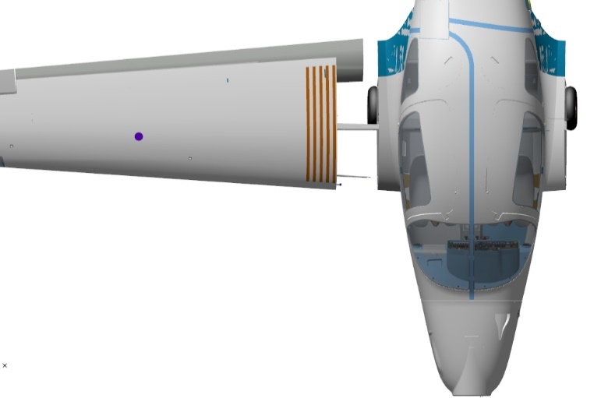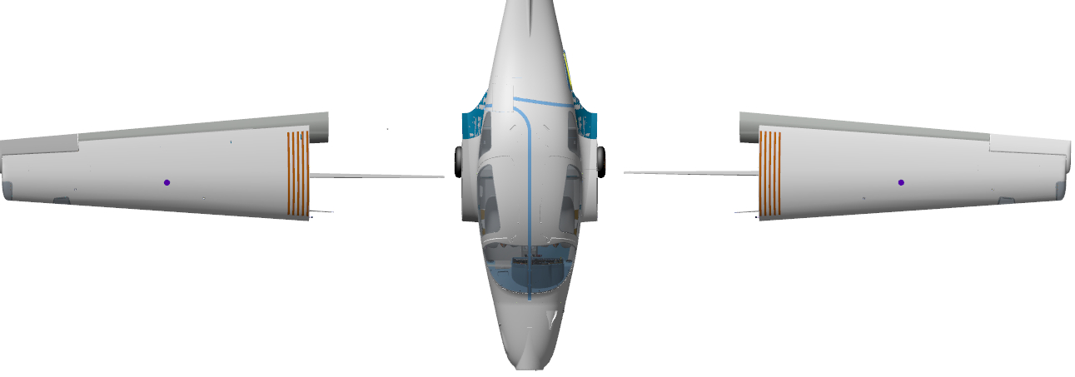

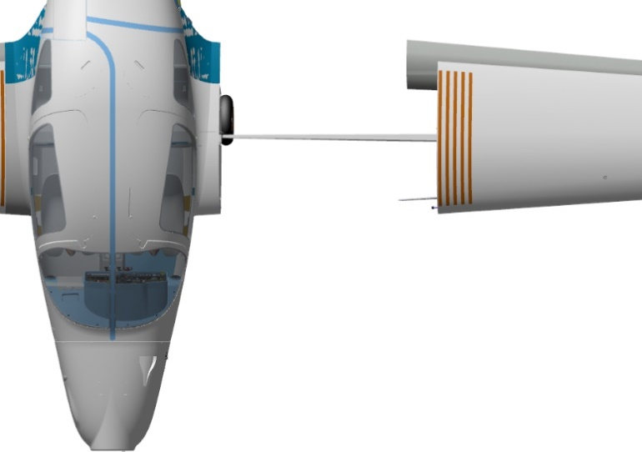
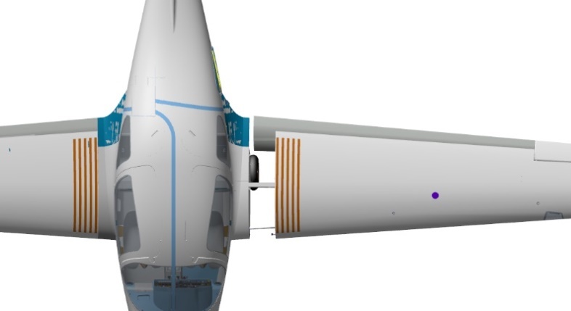
Acccess the fuselage, position yourself on the back sofa. Place the bolt through the hole until encountering a hard stop. If the bolt does not fit in, it is necessary to move the left wing panel up and down by the wing tip for a very small angle, pushing simultaneously the bolt into the hole.
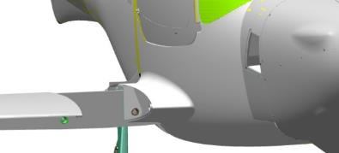
IMPORTANT! Do not move the wing panels by the tip sharply or for a long distance. This may result in damaging the fuselage.
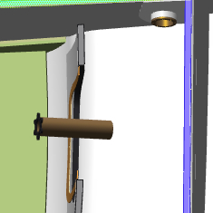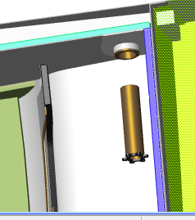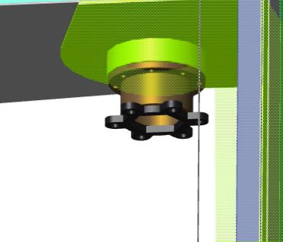
Tighten one by one the bolts with a special wrench.
Checkup operations:
If tightening a bolt requires applying any significant force, you may easily move the wing panel up and down by the wingtips. The bolts must be tightened until the gap between the bolt surface and the bush is closed.
Proceed from the fuselage to the left wing panel.
Checkup operations:
Check from above and below the gaps at the join of the wing panel with the fuselage. The gaps should be from 3 to 6 mm. Proceed to the right wing panel. Check from above and below the gaps at the join of the wing panel with the fuselage. The gaps should be from 3 to 6 mm.
Once the gaps are checked and are within the required values, access the fuselage from the left, position yourself on the rear sofa. Fit as per the standard operation 9 the ANG-2700-00030802-00 pushrod to the ANG-2700-00028580-00 bellcrank through the opening under the pilots' beam.
Position yourself of the right side of the rear sofa. Repeat the process above to fit the second pushrod.

Checkup operations:
- Move the control stick to the right - the right aileron should move up, the left aileron should move down. The travel should be smooth, without any jerks or binding, and not requiring any undue force. Any creaking, crackling and scratchy sounds should be absent.
- Move the control stick to the left - the right aileron should move down, the left aileron should move up. The travel should be smooth, without any jerks or binding, and not requiring any undue force. Any creaking, crackling and scratchy sounds should be absent.
- Position the control stick approximately in the middle. Proceed from the fuselage to the right aileron. Check the position of the aileron - it should be in zero position (the aileron covering (skin) should be level with that of the wing tip wthout any irregularities). Proceed to the left aileron and repeat the checking, it should also be in zero position.
Note. If the ailerons are deflected from the zero position when setting the control stick is to the middle position, it is necessary to adjust the pushrod in the area of ​​the aileron control unit.
To adjust the length you need to do the following:
- If it concerns the position of the aileron, loosen by 1 turn the nut on the rod end of the aileron control unit;
- Detach the fasteners attaching the pushrod to the aileron assembly;
- Deflect the aileron upwards;
- Unscrew the rod end from the pushrod by 1 turn;
- Refit and secure the pushrod in the reverse order;
- Check the position of the control stick and that of aileron.
If the position of the rudder changes in the direction opposite the required one, in this case it is necessary in step 4 to screw the rod end into the pushrod. Once the adjustments are completed, tighten the nut on the rod end until encountering a hard stop, applying the retaing compound.
Once the adjustment is completed and the ailerons are set correctly, cotter the connection of the aileron and the push rod with a 1x20 DIN 94 cotter pin,provided that the installation and adjustment operations are completed, and there is no need to transport the aircraft.
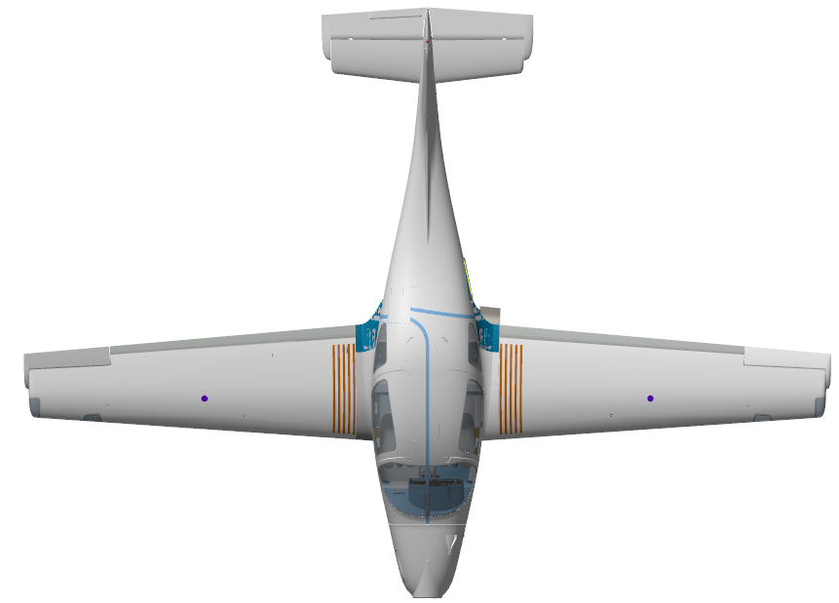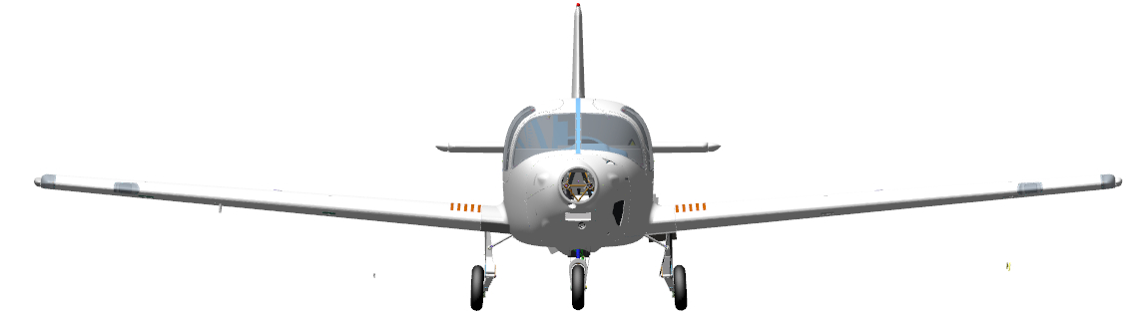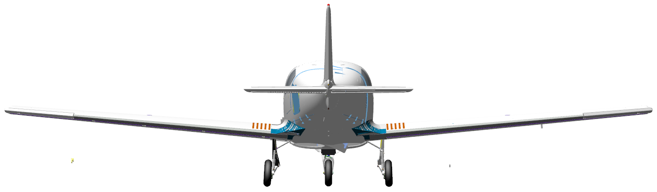

SECTION.7 FIT ACCESSORIES TO THE ENGINE COMPARTMENT
To carry out this task you will need:
- Movable table;
- 2.5mm hex wrench;
- Phillips screwdriver with a PH2 tip;
- Ten М6х12 DIN 933 bolts;
- Grit P600 sandpaper, 1 sheet, 200x300 mm;
- Methyl Acetate solvent 100 grams;
- Clean rags,100x100 mm, 2 pieces;
- Latex gloves 1 pair;
- Larit L285 epoxy resin 10 grams;
- H287 hardener 4 grams;
- Paper cup 100 ml;
- Aerosil thickener 3 grams;
Unpack and place on the table:
- Hydraulic unit (pump motor),
- ANG-5300-00029095-001 upper baffle;
- ANG-5300-00029097-001 lower baffle;
- ANG-5300-00029084-001bracket;
- ANG-5300-00032428-001 needle;
- Two ANG-7100-00030327-002 oil tank brackets;
- ANG-7100-00031946-002 bracket;
- ANG-2400-00032760-01 jumper;
- Two ANG-5300-00032403-001 brackets;
- Three 35103481400_70 collars (clamps);
- Twelve М4х12 ISO 7380-2 screws;
- Two М5х10 ISO 7380-2 screws;
- Four М3х8 ISO 7380-2 screws;
- Two М10х20 DIN 912 screws;
- Two PRCH-0000007682 tanks (reservoirs);
- ANG-7100-00030813-00 expansion tank;
- 2 PRCH-00030874 relays;
- 70-111226-5 master relay;
- Starter relay;
- Two12V70A relays;
- AF-454 fuel filter.
Find on the frame the location for fitting the fine filter. Find the ANG-7100-00031946-002 bracket and two M4x12 ISO 7380-2 screws. Fit the bracket to the frame, secure it with screws.
Fit above and below two 35103481400_70 collars (clamps). Slide the filter into the collars (clamps), direct the side arrowed “inlet” to the fuel line, tighten the collars (clamps).
Check if the filter is properly secured by moving its body in different directions. It should be impossible to move it relative to the collars (clamps).
IMPORTANT! Do not remove the filter plugs before connecting the hoses. The ingress of dirt into the filter will inevitably result in engine failure.
Connect the fuel line hose to the filter inlet, fit the collar (clamp).
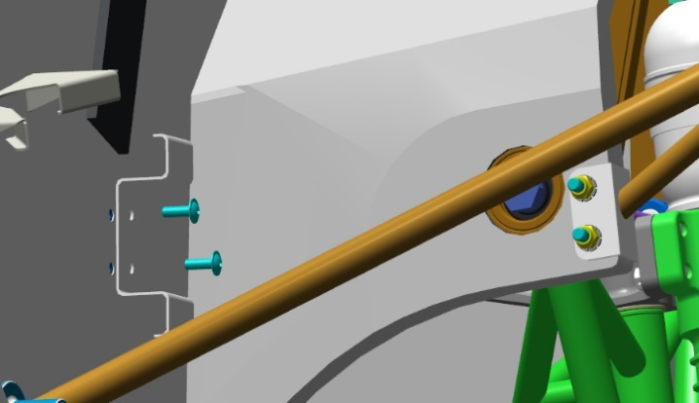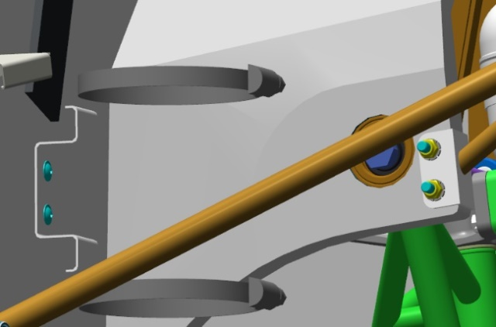
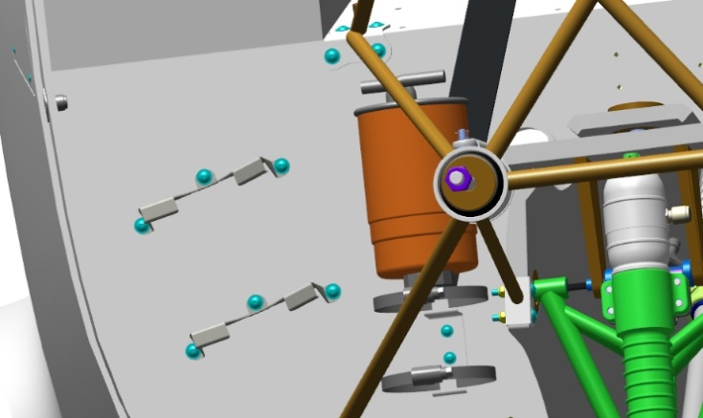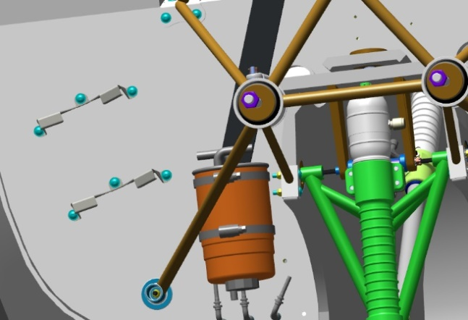
Find on the frame the location for fitting the oil tank brackets. Find the ANG-7100-00030327-002 brackets and six M4x12 ISO 7380-2 screws. Fit the brackets to the frame, secure them with the screws.
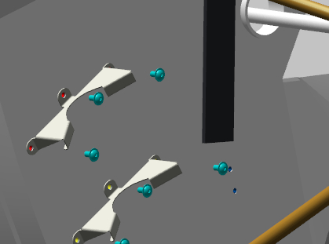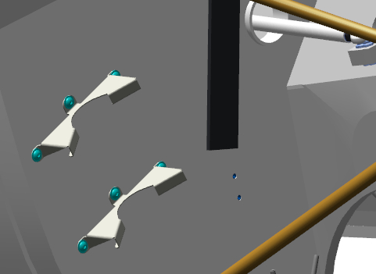
Find two M5x10 ISO 7380-2 screws and the ANG-5300-00029084-001 bracket. Fit the ANG-5300-00029084-001 bracket to the top of the storage battery compartment, secure it with 2 screws.
Find two M10x20 DIN 912 screws and the hydraulic unit (pump motor).
Place the hydraulic unit (pump motor), onto the battery compartment casing, secure it with 2 screws.
Fit the collar (clamp) into the bracket catch, place it from above on the hydraulic unit (pump motor), tighten it firmly till complete gripping of the hydraulic unit top.
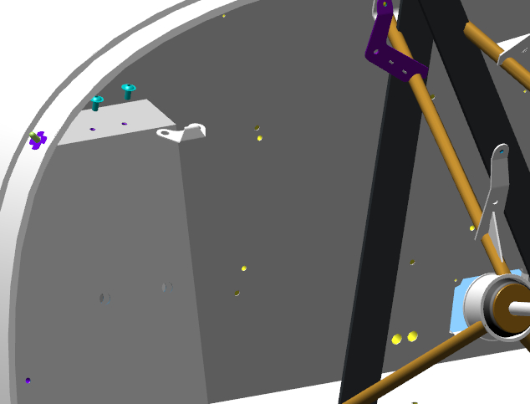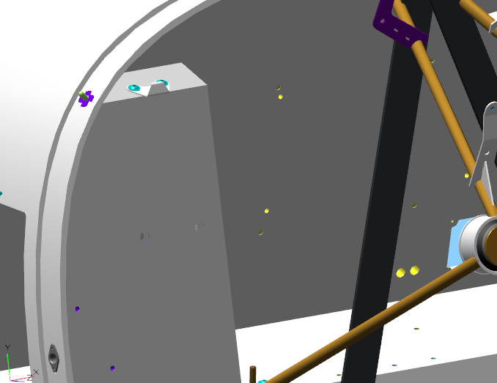
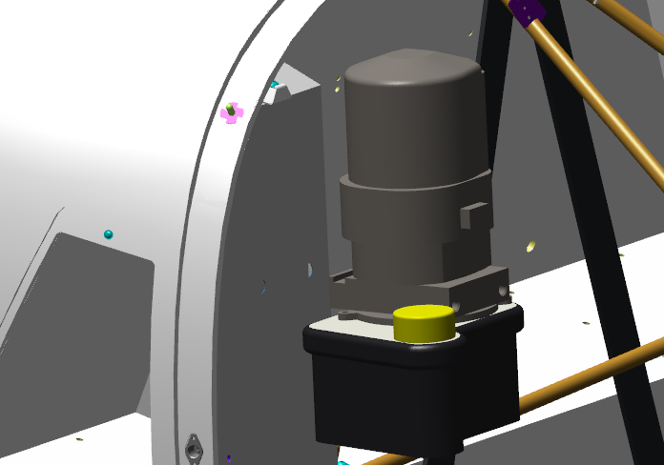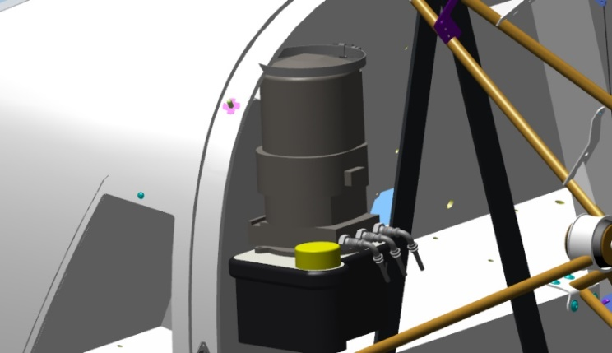
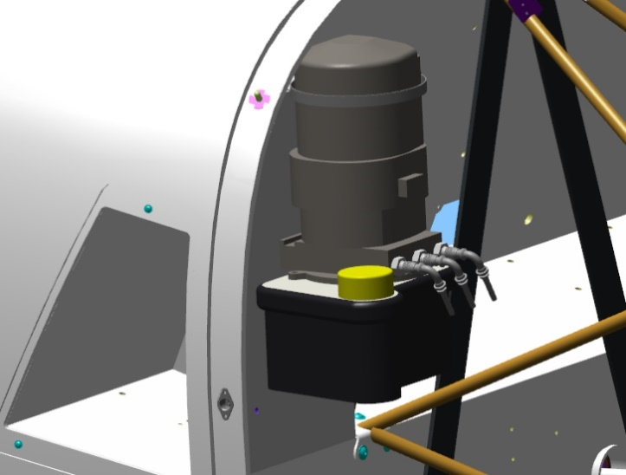
Find the location for fitting two 12V70A relays at the top area of the frame near the battery compartment. Attach the relay to the frame with two M4x12 ISO 7380-2 screws.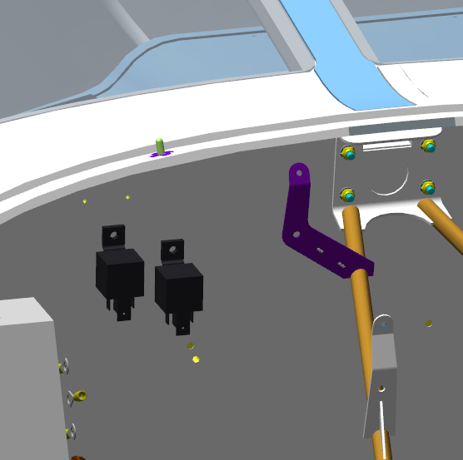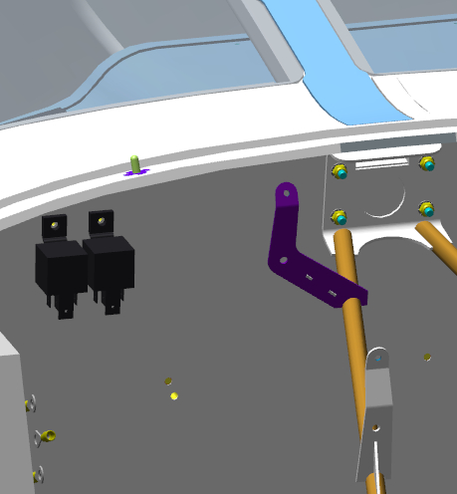
Find on the frame the location for fitting the master relay and starter relay. Fit the starter relay, secure with 2 screws. Fit the master relay, connect the jumper to the starter relay, secure it to the frame with 2 screws.
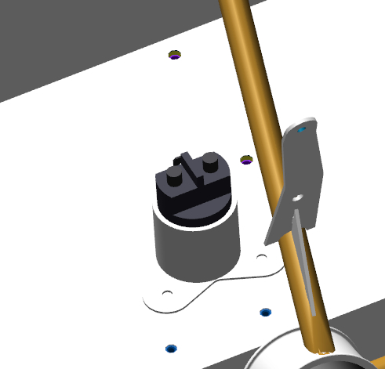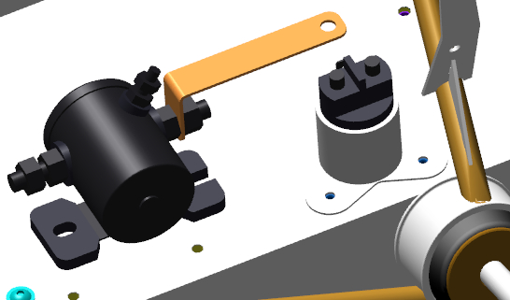
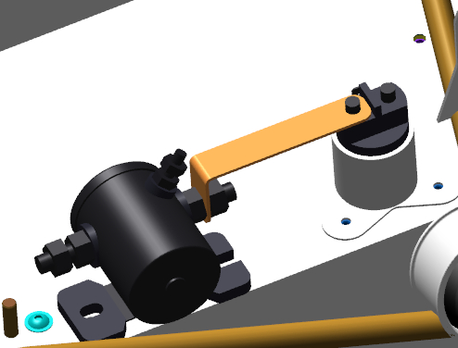
Find the ANG-5300-00029095-001 upper baffle and the ANG-5300-00029097-001 lower baffle. Fit the lower baffle into the hole at the bottom of the casing on the frame, fit the upper one at the top. Fit the ANG-5300-00032428-001 needle to the baffle bellcranks.
Checkup operations:
- Check the movement of the baffles and their correct operation. When the upper baffle is open, the lower baffle is closed, and vice versa. Their movement should be easy.
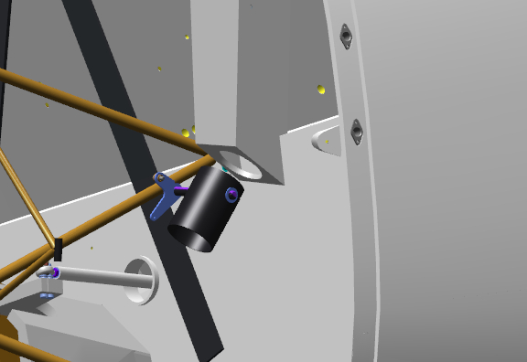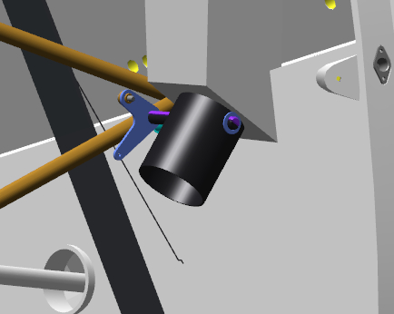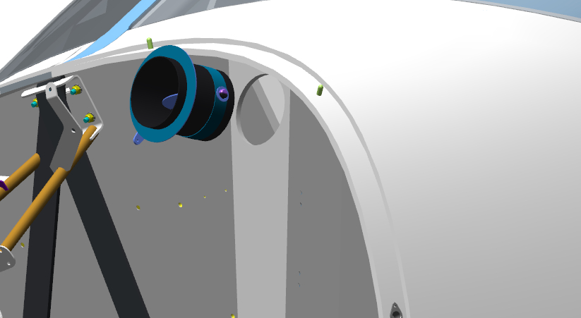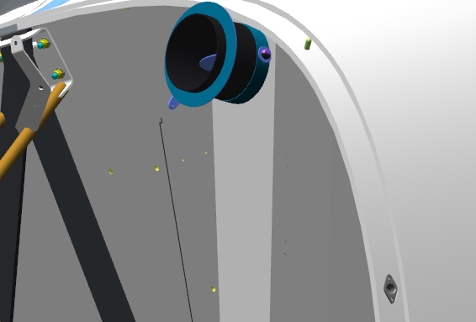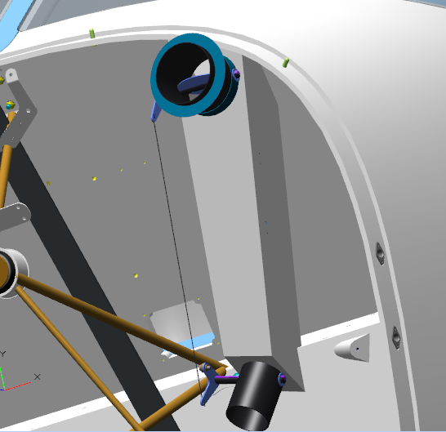
If everything is OK, detach the needle and baffles in the reverse order.
Sand the baffle installation locations as per the standard operation 4.
Once the sanding is completed put on latex gloves. Moisten a rag with solvent, degrease the following:
- Locations of dampers in the casing;
- Bonding surfaces of the baffles;
Mix a batch of glue as per the standard operation 1, using Larit L285 resin and H287 hardener in a ratio of 10:4.
IMPORTANT! The epoxy glue is to be used within 60 minutes following its preparation.
Apply glue as per the standard operation 5.1 to the degreased surfaces of the baffles and their positions in the casing.
Prepare from the remaining glue an adhesive as per the standard operation 2.
Apply the adhesive to the surfaces of the bafflers as per the standard operation 5.2. Fit the lower baffle into the hole at the bottom of the casing on the frame, fit the upper one at the top. Fit the ANG-5300-00032428-001 needle to the baffle bellcranks. Check for freedom of movement of the baffles and their correct operation. When the top baffle is open, the bottom baffle should be closed, and vice versa. The movement should be easy.
IMPORTANT! Do not allow adhesives to come into contact with the moving parts of the baffles. This will result in loss of their serviceability. Any smears of adhesives must be immediately wiped off with a solvent.
Find two ANG-5300-00032403-001 brackets and four M3x8 ISO 7380-2 screws. Fit the brackets to the casing, secure with screws.
Fit the brake reservoirs to the brackets, secure them with a screw and nut.
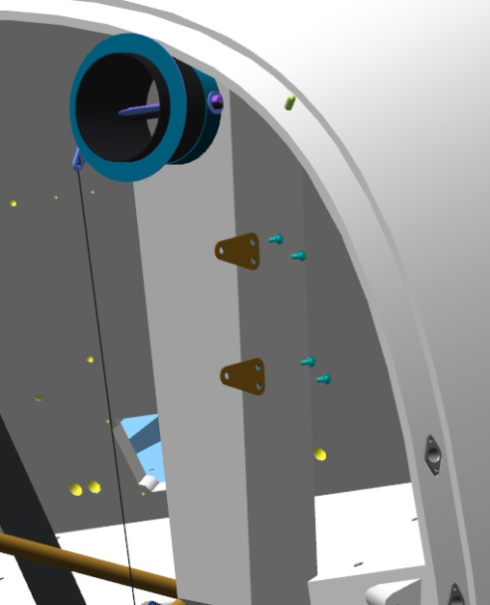 | 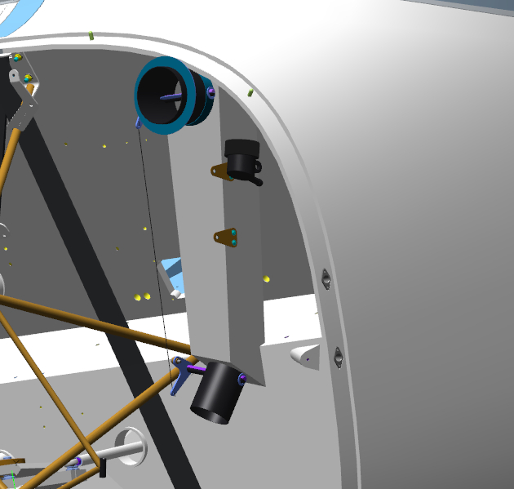 | 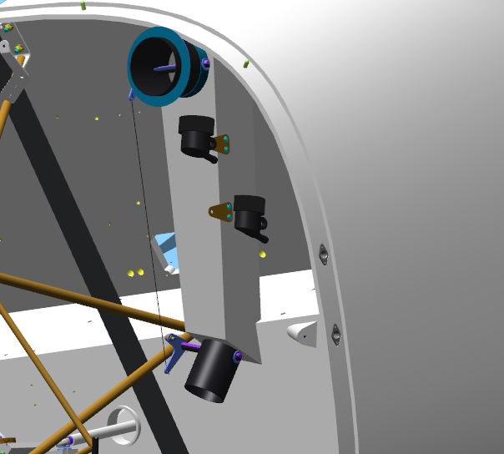

General view of all installed accessories:
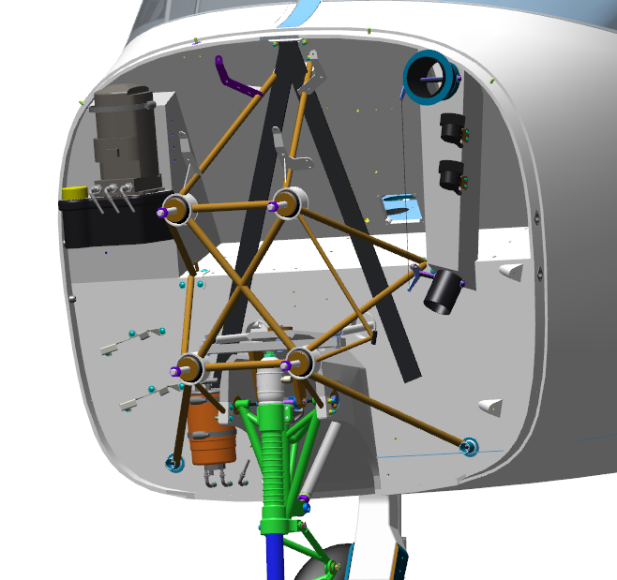
Oleg should supplement the installation of hydraulic pipelines and a landing gear emergency extension valve

SECTION 8 ASSEMBLE POWER PLANT

8.1 Assemble and fit the engine accessories
8.1.1 Assemble the oil cooler
To carry out this task, you will need:
- Movable table;
- 2 mm hex key (Allen wrench);
- М6х12 DIN 933 bolts;
- Methyl acetate solvent 100 grams;
Unpack and place on the table:
- ANG-7100-00031945-001 housing (body);
- ANG-7100-00031945-002 nut;
- ANG-7100-00031945-003 stop;
- ANG-7100-00031945-004 spring;
- ANG-7100-00031945-005 wire;
- Three ANG-7100-00031945-007 couplings (unions);
- Two ANG-7100-00030325-004 brackets;
- Two ANG-7100-00030325-005 brackets;
- PRCH-00030324 oil radiator;
- 0773-4-A-007 thermostat;
- AN10 fitting;
- Twelve М4х10 ISO 7380-2 screws;
- Twelve DIN 934 nuts М4;
- AN10 hose;
- AN8 hose;
Find the ANG-7100-00031945-001 housing (body) and the three ANG-7100-00031945-007 couplings.
Moisten a rag with solvent. Degrease the following:
- Male threads of the couplings (unions);
- Female threads of the housing (body).
Apply to the degreased surfaces an even thin layer of the LOCTITE 648 retaining compound. Screw the couplings into the holes, tighten each coupling with a 17 mm wrench till closing the gap between the housing and skirt surfaces.
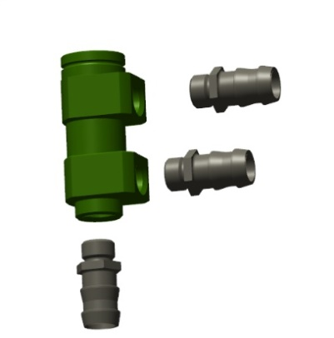 | 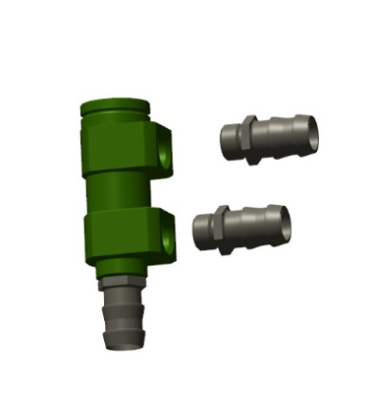 | 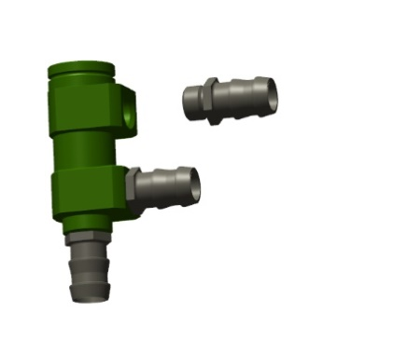 | 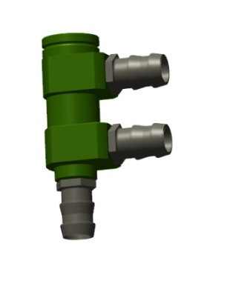
Find the spring, thermostat, wire, stop and nut. Fit the spring and thermostat into the housing (body).
Place the stop on the thermostat needle, press it with your finger. The spring should compress. Place the nut, feed the wire into the side hole, turning the nut, gradually pull the wire insides.
Checkup operations:
- Check that the nut is securely seated. The nut should not be able to come off, but it should rotate around its axis.
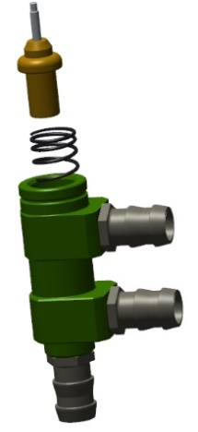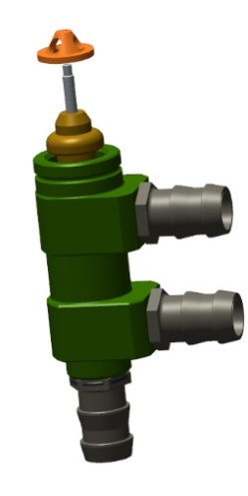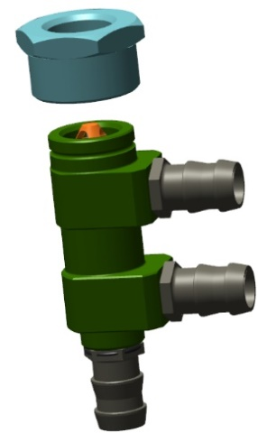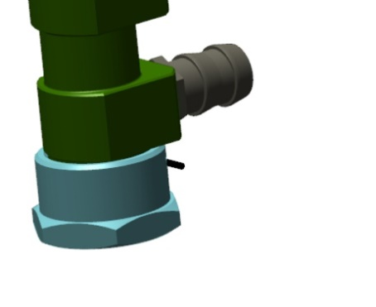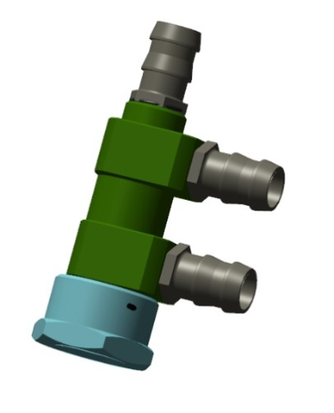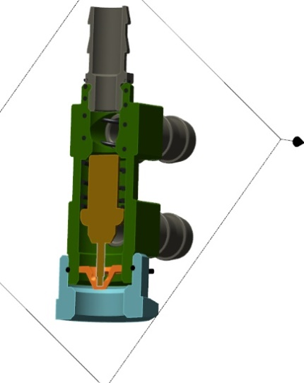
Find the oil radiator, the ANG-7100-00030325-004 and ANG-7100-00030325-005 brackets, eight M4x10 ISO 7380-2 screws and eight M4 DIN 934 nuts.
Fit the brackets to the radiator, secure with screws and nuts.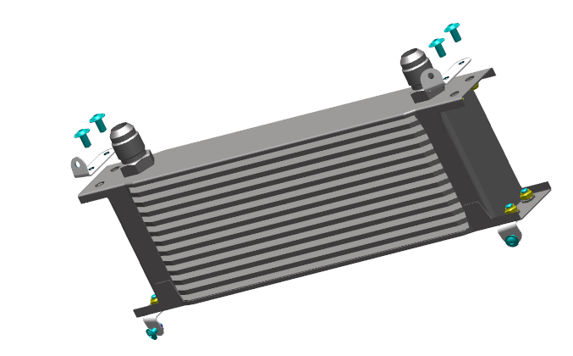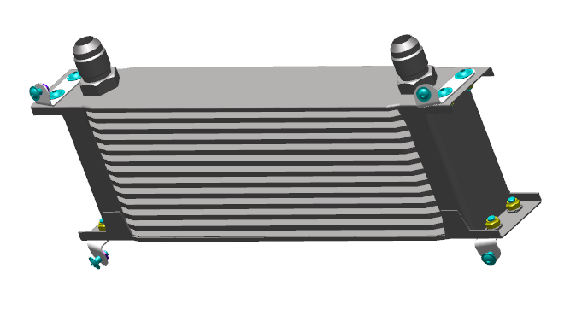
Screw the fitting onto the left radiator till encountering a hard stop , the AN10 fitting to the right thermostat.
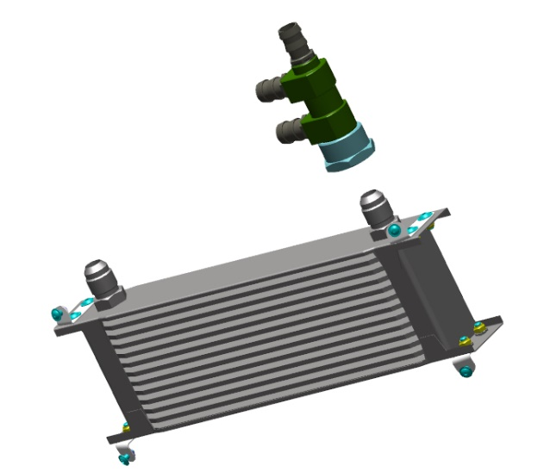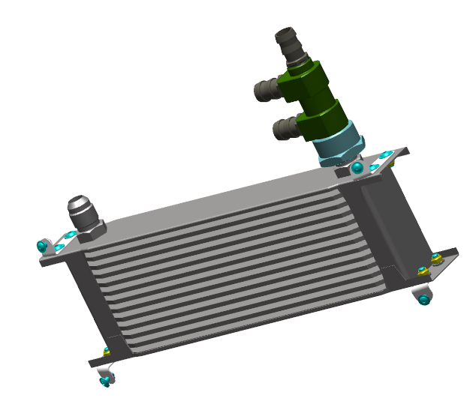
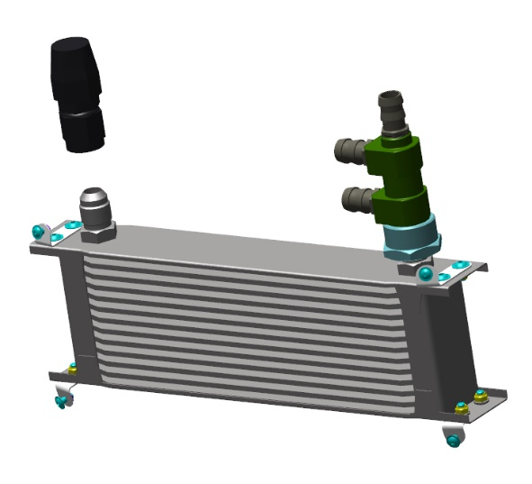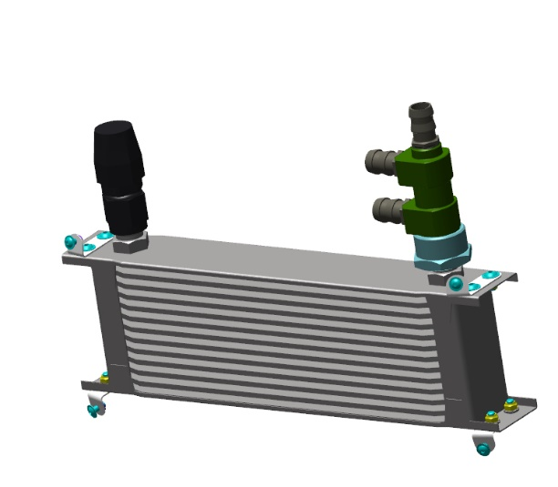
Measure and cut the hose from the coil to following lengths:
- AN8 hose 260 mm;
- AN10 hose 370 mm;
- AN10 hose 1350 mm.
Fit the 260 mm hose to the lowest thermostat coupling, secure with a collar. Fit to the coupling and secure the 370 mm hose, and fit the second part to the middle thermostat coupling, secure it with a clip. Fit to the upper fitting the 1350 mm hose, secure it with a clip.

8.1.2 Assemble the water radiator
To carry out this task, you will need:
- Movable table;
- 2 mm hex key (Allen wrench);
- 17 mm combination wrench;
- Hydraulic hoist;
- Rigging device for the engine;
- 2.5 mm hex key (Allen wrench);
Unpack and place on the table:
- Detachable engine parts;
- Two ANG-7100-00053168-00 fittings;
- Eight ANG-7100-00053120-001washers;
- Four ANG-7100-00053120-002 bushes;
- ANG-0000-00053169-00 fitting;
- Two ANG-0000-00053169-10 fittings;
- ANG-7100-00030329-00 cabin heater;
- Two ANG-7100-00053168-00 fittings;
- ANG-7100-00030318-00 air filter casing;
- ANG-7100-00030319-00 casing cover;
- ANG-7100-00032395-00 cover mechanism;
- Four ANG-7100-00029213-001 tubes;
- 4 ANG-7100-00053116-011 washers;
- ANG-7100-00029213-001 piping;
- ANG-7100-00029213-002 piping;
- ANG-7100-00029213-003 piping;
- ANG-7100-00029213-005 piping;
- ANG-7100-00029213-006 piping;
- Eight PRCH-00053119 pads;
- Four STD-00053110 bolts;
- Four STD-00029674 nuts;
- PRCH-00032377 thermostat;
- PRCH-00032379 cooling radiator;
- Four М5х25 ISO 7380-2 screws;
- Four М6х12 ISO 7380-2 screws;
Find the cooling radiator, piping and thermostat. Fit one by one the ANG-7100-00029213-006, ANG-7100-00029213-005, ANG-7100-00029213-003 pipings to the thermostat. Tighten each connection with a collar.
Fit the piping sub-assembly to the cooling radiator. Tighten each connection with a hose collar.
IMPORTANT! Inadequately tightened collars will result in fluid leakage.
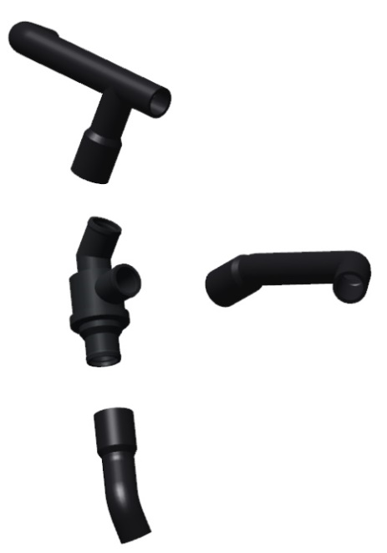 | 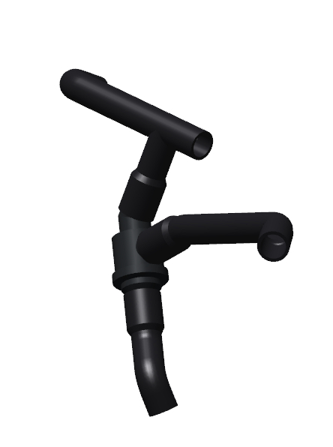 | 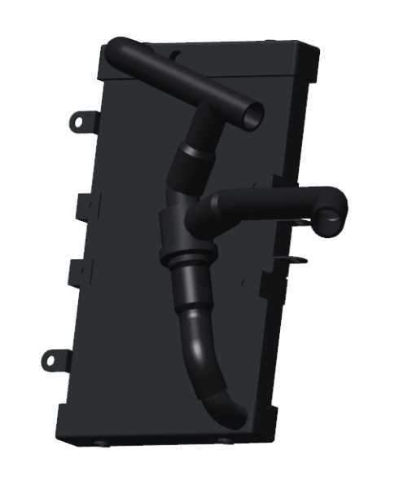
8.1.3 Fit the intercooler casing
Equipment, materials and tools – as per p. 8.2.2
Find the ANG-7100-00030318-00 casing, ANG-7100-00030319-00 cover, ANG-7100-00032395-00 mechanism. Fit the hinge to the casing, secure it with screws.
Fit the mechanism to the casing, secure it with screws. Fit the bracket to the cover, secure it with screws.
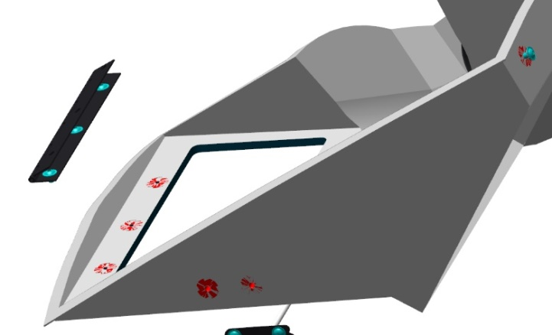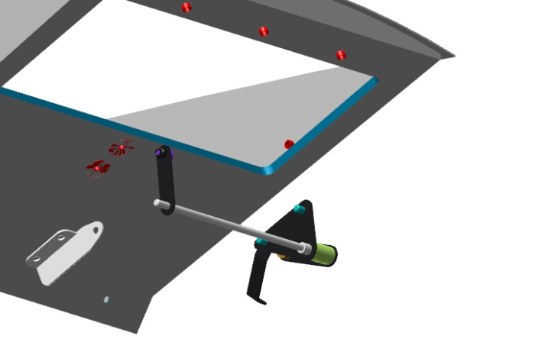
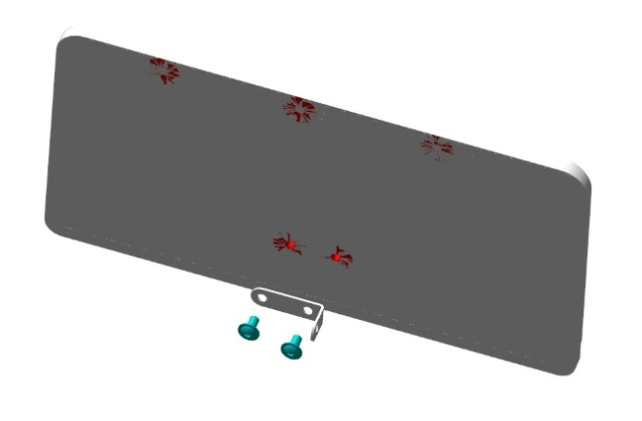
Place into the casing the cover hinge, attach to the hinge it with screws. Connect it to the cover bracket by means the mechanism.
Move the cover several times to and fro, by slightly turning the mechanism. The mechanism should move the cover up and down.
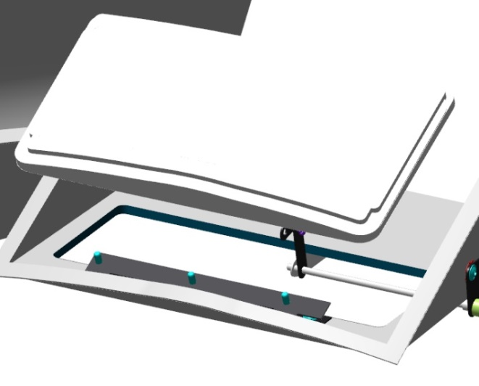 | 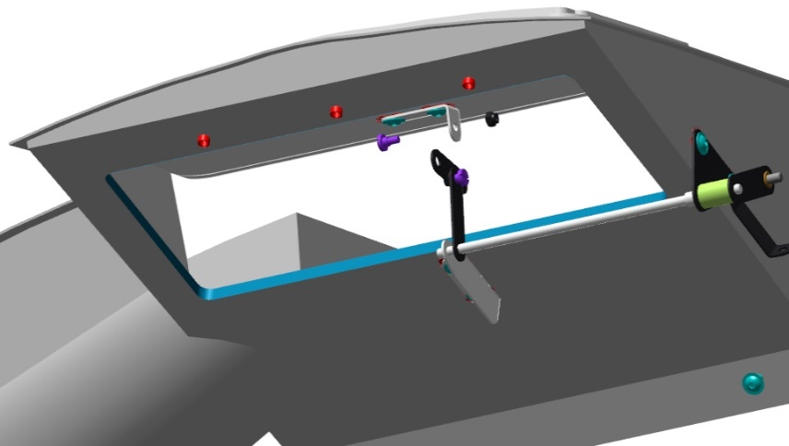

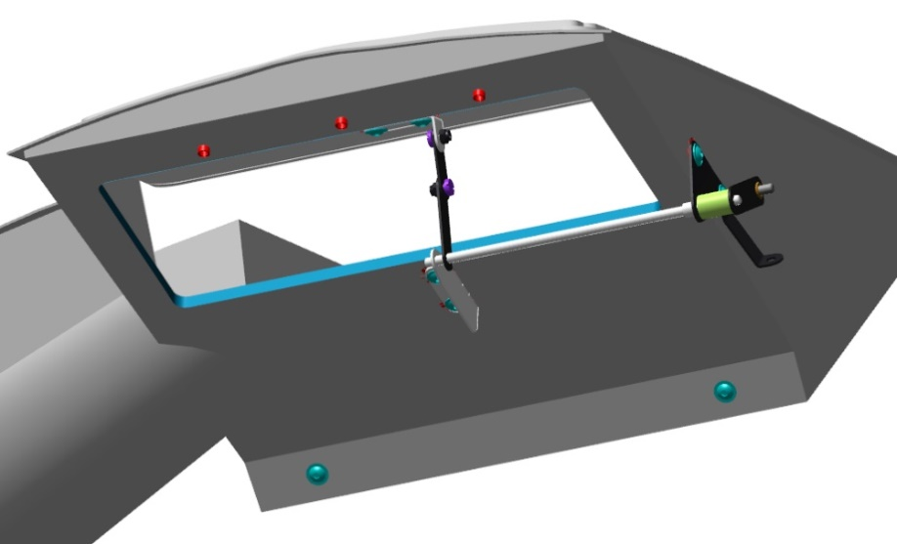
8.1.4 Mount the engine
Unpack the engine parts, prepare the engine for mounting to the aircraft. Extract the engine from the container using a hoist. Check for the placing of the STD-00053110 bolt through the holes in the engine frame. The bolt should fit in snugly, but without applying undue force. If the bolt does not pass through, or requires undue force, re-drill the holes to a diameter of 11.0-11.05, and make sure the bolt passes through the holes.
Fit the engine fuse box to the frame web (wall), secure it with bolts.
Fit the pads with pipes inside and outside, to the engine seats on the engine mount.
Approach the hoist with the engine to the engine mount, align the holes of the engine mount with the engine pads.
Place one by one a bolt with a washer through each hole, places washers between the engine mounts. When attaching the engine, as you approach the engine mount, feed the engine wires through the opening in the frame.
Moisten a rag with solvent. Degrease the following:
Male threads of the bolts;
Female threads of the nuts.
Apply to the degreased surfaces an even thin layer of the LOCTITE 648 retaining compound. Screw on the nuts, using a 17 mm wrench, until closing the gap between the surfaces.
Detach the hoist from the engine. Check the installed engine for the absence of any damage and proper tightening of the motor fasteners.
8.1.5 Fit other engine accessories
Fit the bottom cowling, secure it with locks. Make sure there is no abutment of the engine components against the cowling.
IMPORTANT! The exhaust system is a specific place where the clearances should not be less than 20 mm.
Fit the top cowling, also make sure there are sufficient clearances and no abutments. Remove the cowlings.
Fit the cooling radiator with pipes and thermostat to the frame and engine mount and secure it.
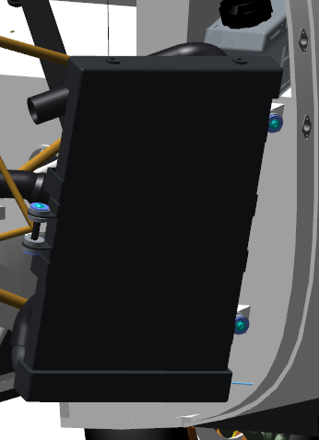
Connect the piping to the engine, secure it with collars.
IMPORTANT! Inadequate tightening of the collars will result in fluid leakage.
Fit the intercooler to the lower holes to of the engine mount lugs. Fasten it with bolts, but do not tighten them completely.
Fit onto the intercooler the assembled ANG-7100-00030318-00 casing, align the holes with the engine mount lugs, fasten with screws, but do not tighten them completely. Connect the throttle control cable. Move the cable several times to and fro. The cover should move and return to the same position.
Fit the tubes of the turbine, throttle, intercooler, secure them with clips.Fit the sensors into the branches of the tubes.
Fit the lbottom cowling, secure it with locks. Check for likely abutments. There should be no abutments. Set the casing cover in the open position by means of the cable.
Checkup operations:
- Fit the top cowling, check for likely abutments.
- Set the cover into closed position by means of the cable. The cover should be flush with the cutout in the cowling. Open and close the cover several times, the cover should take the same position.
- Remove the top cowling, tighten the intercooler and casing fasteners. Fit the cowling and re-check the position of the cover. The cover should sit flush with the cowling surface.
Note. If the cover does not sit flush, remove the top cowling and proceed as follows:
- If the cover sinks, loosen the fasteners, displace the casing upwards, tighten the fasteners.
- If the cover abuts and it is impossible to close it completely, displace the casing downwards, tighten the fasteners.
Remove the cowlings from the aircraft.
Detach the the engine plug on the side opposite to the oil radiator. Place into the hole the AN10-90 fitting, tighten it with a 24mm wrench. Find two plugs on the bottom part of the engine, on the right and left protrusions. Remove the plugs. Place the AN8-90 fittings into holes instead of plugs — one on the left, one on the right. Tighten fittings with a wrench.
Find the plug underneath the oil pump and detach it. Screw the 1020 6-1/8 fitting into the hole, tighten it with a wrench, directing the outlet to the frame.
Measure and cut from the coil the following lengths:
- AN8 hose - 800 mm;
- AN8 hose - 850 mm;
- Copper pipe 6x1 600 mm;
- Copper pipe 6x1 110 mm;
...
Find two branches on the ANG-7100-00029213-003 piping, place on them the collars. Fit into the branches the engine sensors, tighten the collars.
Fit a hose to the expansion tank coupling, tighten it with a collar. Fit the second part of the hose to the coupling of the tank, tighten with a collar.
Connect the electrical part of the engine. Find the oil radiator that you have assembled earlier. Attach a short hose from the lower thermostat fitting to the fitting in front of the engine, secure the hose to the fitting.
Attach the AN8 800mm hose to the fitting in the middle part of the engine, secure it to the fitting, and feed it under the engine to the area of ​​the oil tank. Attach the AN8 850mm hose to the fitting in the middle part of the engine, secure it to the fitting, feed it under the engine to the area of ​​the oil tank.
Place the long hose from the thermostat to the oil tank area.
Connect two 6x1 pipes with a hose, tighten them with collars at the ends. Pull the pipe from the front towards the oil tank, with the short pipe towards the oil tank. Secure the pipe to the fitting under the motor.
Find the oil tank (included with the engine) and two collars. Place the oil tank on the brackets fitted to the frame, fasten it with collars, but do not fully tighten to allow the tank to move. Attach two AN10 hoses to the oil tank, tighten the couplings. Connect the 6x1 pipe to the oil tank, tighten the coupling.
IMPORTANT! Iproperly tightened connections may result in oil leakage and likely engine damage.
Fit the air filter to the branch pipe in the ANG-7100-00030318-00 casing, secure it with a collar. Find the ANG-7100-00029213-003 piping, place on it two collars.
Fit the piping to the pipe of the filter casing, fit its second part to the engine turbine; fix both parts with collars. Find the ANG-7100-00029213-002 pipeline, place onto it two collars.
Feed the piping over the engine mount, fit it to the intercooler outlet on the frame side; secure it with a collar.
Connect the second part of the piping to the throttle assembly of the engine. Find the ANG-7100-00029213-001 piping, place onto it two collars.
Fit the piping to the turbine outlet; secure it with a collar in accordance with the respective section of the engine installation instructions.
Fit the bottom cowling, secure it with locks. Check the areas of likely abutments. There should be no abutments. Place the casing cover in open position using the cable rope. Fit the top cowling, check the areas of likely abutments.
Move the cover to the closed position using a cable. The cover should be flush with the cutout in the cowling. Carry ou several openings and closings, the cover should take up in the same position.
Note. If the cover does not sit flush, or if it rests against the casing, in this case it is necessary to remove the top cowling and proceed as follows:
1.If the cover sinks, loosen the fasteners, shift the casing upwards, tighten the fasteners.
2. If the cover abuts and it is impossible to close it completely, shift the bcasing downwards, tighten the fasteners.
Remove the cowlings from the aircraft.
IMPORTANT! Follow the engine installation instructions carefully. Do not start the engine without the propeller installed.

8.2 Fit the propeller
Oleg write a section

8/.3 Assemble and fit feed tanks
Oleg write a section, incl. installation of drainage and pumps

SECTION 9 ASSEMBLY THE ELECTRICAL SYSTEM

9.1 Route the harnesses
Oleg write the section

9.2 Fit the lighting equipment
Oleg write a section (aircraft navigation lights , strobe lights + control board)

9.3 Fit the annunciator panel (also referred to as Caution Advisory Panel (CAP)
To carry out this task, you will need:
- Movable table;
- Craft knife;
- Ø4.2 mm drill bit;
- Ø 5mm drill bit;
- Ø 7 mm drill bit;
- Ø9 mm drill bit;
- Ø10 mm drill bit;
- Hex key 2.5 mm hex key (Allen wrench);.
Unpack and place on the table:
- ANG-2400-00076008-00 instrument panel;
- Three М4х10 ISO 7380-2 screws;
- AP105 ANG-3100-00033134-00 display panel;
Cut from the inside with a knife (you can use a power tool) the openings for the parts of the control that you intend to fit.
Clean up the burrs from the openings.
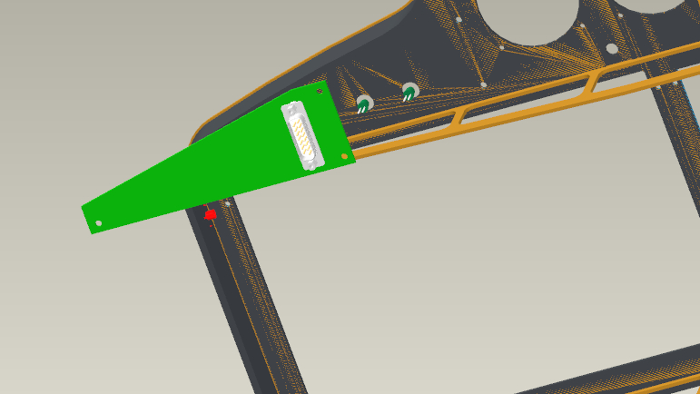
Find the AP105 display panel.
Fit the panel to the upper right corner, aligning the LED holes with the mounting holes.
Fix the panel with three M4x10 ISO 7380-2 screws.
Checkup operations:
- Make sure the panel is not touching the instrument panel

9.4 Fit toggle switches and circuit breakers
To carry out this task, you will need:
- Movable table;
- Craft knife;
- Ø4.2 mm drill bit;
- Ø5mm drill bit;
- Ø7 mm drill bit;
- Ø9 mm drill bit;
- Ø10 mm drill bit;
- Ø11 mm drill bit;
- Ø12 mm drill bit;
- Ø12.6 mm drill bit;
- Electric drill.
Unpack and place on the table:
- ANG-2400-00076008-00 instrument panel;
- ANG-2400-00032732-004 bus;
- Six VME-01 toggle switch frames;
- Five VMM-01 toggle switch frames;
- VMS toggle switch frame;
- Twelve KR313AXEXA switches;
- AES1118SP011cigar lighter;
- S6F toggle switch;
- SAC-01cover;
- PBS-28B button;
- W58XC4C12A-1automatic circuit breaker;
- Two W58XC4C12A-3 automatic circuit breakers;
- Four W58XC4C12A-5 automatic circuit breakers;
- W58XC4C12A-10 automatic circuit breaker;
- Two W23X1A1G-50 automatic circuit breakers;
Cut from the inside with a knife (you can use a power tool) the openings for the parts of the panel that you intend to fit. Clean up the burrs from the openings.
Drill holes with a diameter of 4.2 mm, which are visible from the inside. Drill one by one 9 holes with a diameter of 12.6 mm for automatic circuit breakers. Find automatic circuit breakers, unscrew the nuts from them. Test fit any of them into the holes in the lower right side of the instrument panel. The threaded part should pass through easily.
Place each automatic circuit breaker in the lower right part of the panel and fix it with a nut, start from the right and proceed to the center: 5; 5; 1; 5; 3; 3; 5; 10; 50.
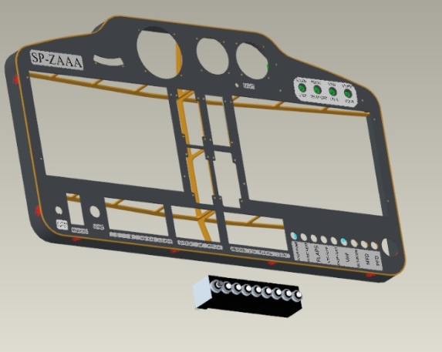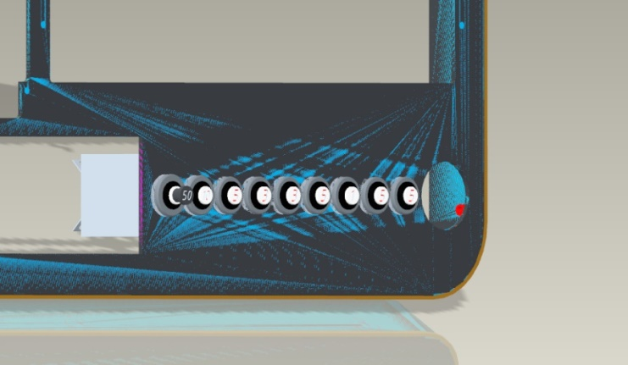
Checkup operations:
- After tightening the nuts, revert the panel, check the fitted automatic circuit breakers - the contacts should not touch each other.
- Find the frames for the VME and VMM toggle switches. Connect the frames with the grooves in the following sequence:
- 2 sets of 1VME + 2VMM + 1VME;
- 1 set of 1VME + 1VMM + 1VME.
Find the S6F toggle switch, SAC-01 cover, PBS-28B button. Identify, using a multimeter the "OFF" position of the toggle switch with.
Fit to the lower right corner of the panel the toggle switch (with its position "OFF" downwards) and cover; secure the toggle switch with its nut. Install the button in the next hole, tighten with a nut from the inside of the panel.
Fit the VMS frame between the toggle switch and the button, seat it in place until encountering a hard stop
Check that the frame latches sit snugly in the panel. Fit into the opening below the panels, the frames that have been connected in advance, in combination 4-3-4. Check that the frame latches sit snugly in the panel.
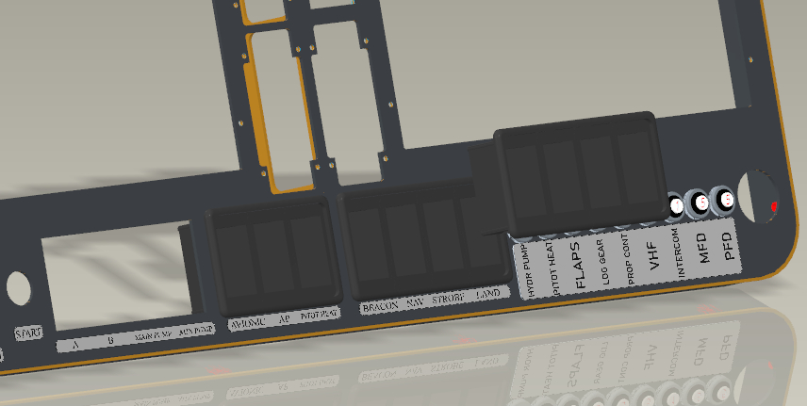
Find the KR313AXEXA switches. Identify the OFF position of all switches, using a multimeter.
Fit one by one all switches to the frames of toggle switches. Check that the frame latches sit snugly in the panel.
Checkup operations:
Check each switch by turning them ON and OFF. There should be no binding abutting or other obstacles when moving the switches to any position.
The adjacent switches should come into action.

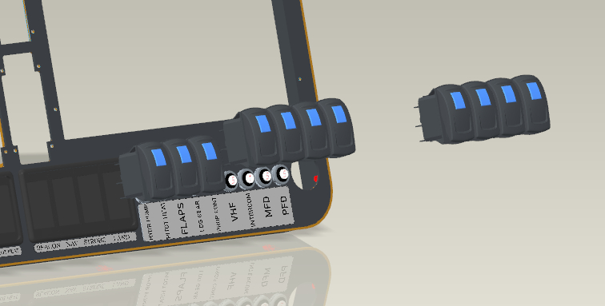
Find a cigar lighter, unscrew the nut from it. Fit the cigar lighter to the lower right side of the panel, tighten the nut.
Make sure that is the cigar lighter does not turn around its axis.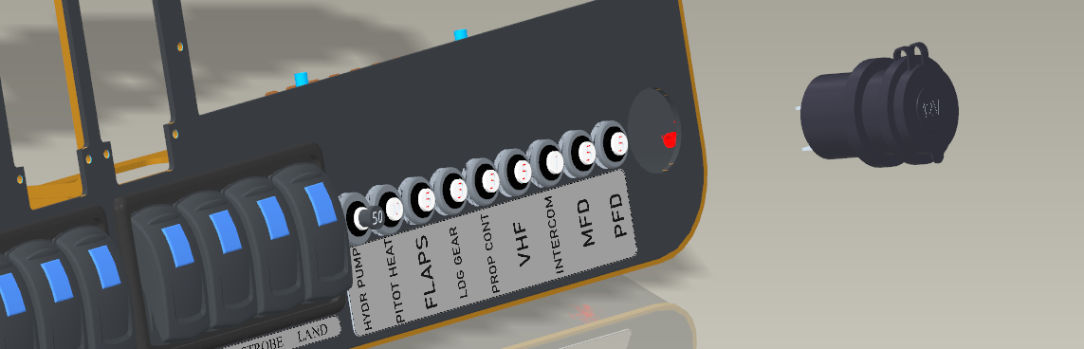
9.5 Fit the seat adjustment system
Oleg write a section (actuators, buttons)

SECTION 10 FIT THE INSTRUMENTATION

10.1 Route pneumatic lines
Oleg write a section

10.2 Fit the Pitot probe
Oleg write a section (with a heating controller)

10.3 Fit the Dynon SW 1100 system
10.3.1 Fit the ADAHRS Modules
Oleg write a section (+ electrical, pneumatic connection)
10.3.2 Fit the SNS module
Oleg write a section (+ connection)
10.3.3 Fit the EMS module
Oleg write a section (+ connection)
10.3.4 Fit the temperature sensors
Oleg write a section (+ connection)
10.3.5 Fit the autopilot
Oleg write a section (+ connection + servos + remote control)
10.3.6 Fit the radio set
Oleg write a section (+ connection + antenna + remote control)
10.3.7 Fit the transponder
Oleg write a section (+ connection)
10.3.8 Installing displays
Oleg write a section (+ connection + battery)

10.4 Fit the redundant flight instruments
To carry out this task, you will need:
- Movable table;
- Craft knife;
- Ø4.2 mm drill bit;
- Electric drill.
- Unpack and place on the table:
- Instrument panel ANG-2400-00076008-00;
- BC-6A vertical speed indicator;
- BG-3 altimeter;
- 3-1/8 speed ​​indicator;
- Attitude indicator;
Cut from the inside using a knife (you can use a power tool) the openings for the parts of the panel that you intend to fit. Clean up the burrs from the openings. Drill holes with a diameter of 4.2 mm, visible from the inside.
Find the attitide indicator, check for its integrity, unpack the fasteners. Place the indicator in the upper left corner of the panel, sliding from the back. Check from the rear side if sits snug in the panel.
Note.If the indicator does not pass through the opening or the passage is difficult, slightly sand the opening. If the holes of the panel and the indicator do not match, drill holes in the panel with a diameter of 0.5 mm larger than the size of the fastener.
Secure the attitiude indicator with the supplied fixings.
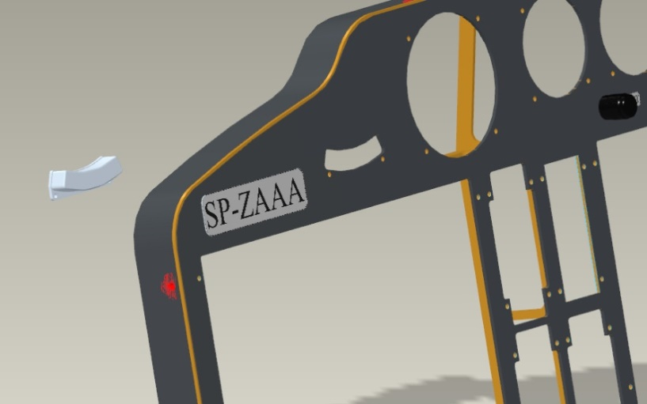
Fit the instruments to the panel one by one in the following sequence:
- Fit the vertical speed indicator to the upper right corner of the panel, sliding it from the rear side. Check from the rear side if sits snug in the panel;
- Fit the altimeter into the central hole, in the upper part of the panel sliding it from the rear side. Check from the rear side if sits snug in the panel;

Fit the speed indicator to the upper left corner of the panel, sliding it from the rear side.
Check from the rear side if sits snug in the panel
Secure each instrument in the sequence of fitting with the supplied fixings.
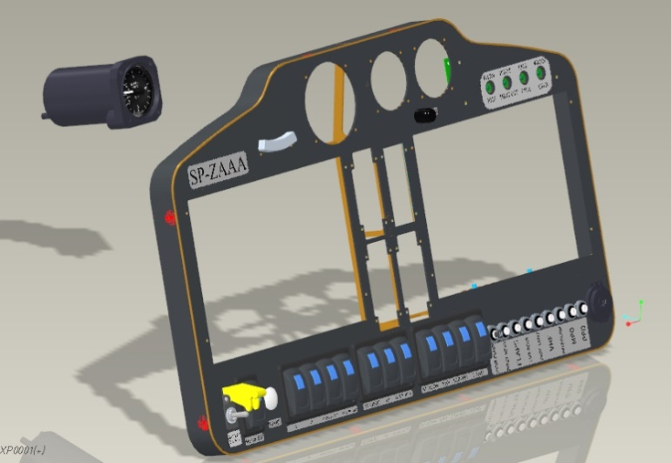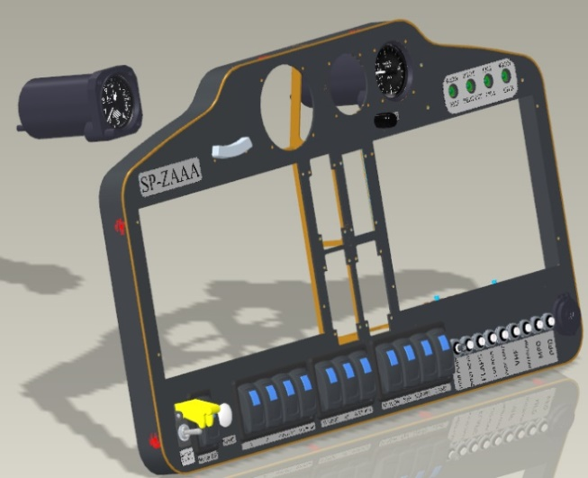
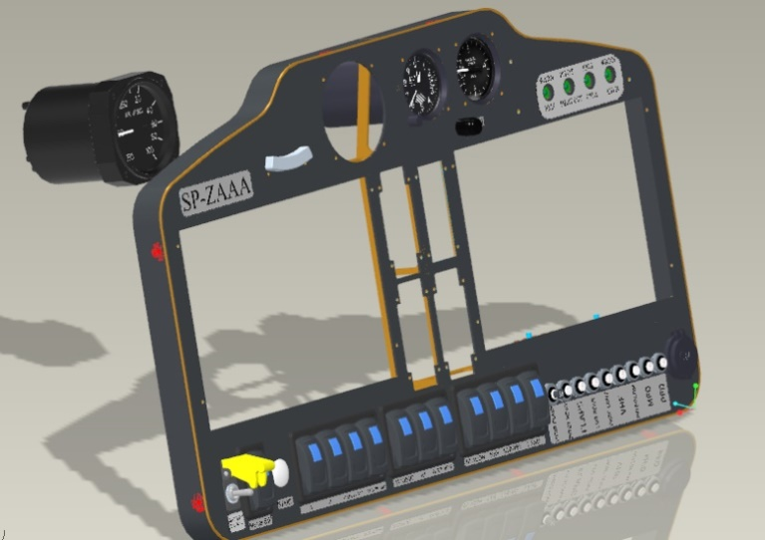
Check the fitted instruments from their rear side. There must be a clearance between the instruments, and they must sit snugly in the instrument panel openings.
10.5 Fit the landing gear control system and footrest
Oleg write a section (landing gear board)

10.6 Fit the intercom system
Oleg write a section (communication board)

SECTION 11 FIT THE PARACHUTE RESCUE SYSTEM
Check up the parachute system compartment. The wall should have 6 through holes with a diameter of 6 mm for attaching the rucksack. There should be no foreign objects inside the compartment.
IMPORTANT! Before any handling the rescue system, properly read the instructions for its unpacking, assembly and installation. Start working only after fully understanding the operations described in the mentioned instructions.
Fit the system into the compartment with the rucksack guides towards the perforated wall. You should not necessarily place through the cable, you may leave it beyond the compartment. Check the fitted rucksack for:
the alignment of the holes in the beams and the casing web;
protrusion beyond the dimensions of the fuselage. There should be no protrusions, the hatch should cover the opening without resting on the system.
Take the rucksack from the compartment, put it aside on the fuselage. Feed the cable through the hole in compartment the floor, pull it under the luggage compartment floor to its full length. Remove the safety screw.
Place the rucksack into the compartment, pull the cable up. Keep carrying out this action until the rucksack is completely introduced into the compartment, pulling the cable to the instrument panel.
After complete introduction, fix the handle under the instrument panel with 4 M4x10 screws. Fit the handle and the cable pin (assemble in reverse order according to the rescue system manual).
Attach the rucksack to the web of the aircraft casing with 6 M6x20 screws.
Test fit on the opening hatch. The hatch should not abut against the parts of the system. Attach the aircraft belts to the carabiner on the rucksack.
Remove the top pin from the rescue system launcher, secure the hatch according to one of the options recommended by the manufacturer.

SECTION 12 INTERIOR FURNISHINGS

12 .1 Cabine upholstery
Oleg write a section

12 .2 Luggage compartment upholstery
Oleg write a section

12.3 Seats and fittings (fixtures)
Oleg write a section

SECTION 13 PAINTING THE AIRCRAFT

13 . 1 Painting external surfaces
Oleg write a section + putty

13 . 2 Painting of interior elements
Oleg write a section

13.3 Apply the placards
Oleg write a section

13.4 Fit the plates
Oleg write a section

SECTION 14 COMMISSIONING ACTIVITIES

14.1 General Provisions
Testing and adjustment activities represent a final stage of the assembly of a particular ANG-01 aircraft kit and are designed to assess the functioning of its units, the compliance of its weight, size and geometrical dimensions with those specified in the ANG.01.MM.01 Maintenace Manual.
Each subsequent check as per the Commissioning Activities Checklist is to be performed after the successful completion of the previous check.
If any faults are identified, the process is to be suspended until their rectification.
The completion of this Checklist confirms the readiness of a particular ANG-01 kit-built aircraft to carry out test flights (0).

14.2 Safety measures
Their observance is essential for protecting those involved in the commissioning process from electric shock, inadvertent engine starting, or landing gear retraction.
All participants in the process should wear overalls, there should be not any items in their pockets that do not pertain to the process (to prevent them from getting into hard-to-reach places of the aircraft). For the same reason the flashlight and camera must be attached to on the examiner's hand.
Ensure that there are no persons on the site who are not involved in the process.
Smoking, making open flames, placing heating devices, flammable substances at a distance closer than 10 m is PROHIBITED.
In case of occurance of a fire due to any reason, it is PROHIBITED to extinguish it with water. First of all, shut down the engine (if running), turn off the power supply (if ON) and immediately use a fire extinguisher.
When starting the engine, it is PROHIBITED that participants of the process stay in the plane of rotation of the propeller at a distance closer than 10 m, and closer than 5 m on all other sides (except for the person sitting in the aircraft cabin). The aircraft is to be chocked and its main landing gear legs secured with belts (from the ground equipment kit) to a reliable fixed structure, the doors are to be unhinged to ensure an emergency escape, the wing panels should not be necessarily attached (but it is necessary to plug the fuel lines to the wing tanks).
It is PROHIBITED to work beyond the aircraft assembly area in case of a thunderstorm, precipitation, wind above 5 m/s, temperatures below +5 ⁰С.

14.3 Commissioning Activities Checklist
Sequence | Purpose | Verification method | Compliance criterion | Tools, appliances., consumables
Location: closed space (hangar)
 | Preparation of the site and aircraft | Clean up from the site and aircraft the production waste, dust, take away equipment, tools and temporary coverings (films, etc.) from the aircraft and site.  Perform the verification of operational documentation | The aircraft and site are prepared  Operational documentation verified with reference copies | vacuum cleaner, detergents, rags, gloves (2 pairs.), table
 | Examine the aircraft | Check the aircraft for the absence of: mechanical or thermal damage, delamination, dents, corrugations on all external and accessible internal surfaces (including glazing).  Check the accessible metal parts for corrosion.  Check for mechanical or thermal damage accessible elements of wiring and connectors.  Estimate the clearances as per 0  Open and close the doors and the luggage compartment hatch (10 times).  Take photos to record the results | Absence of any damage. Clearances should not exceed those indicated in0...  Doors and luggage compartment hatch can be closed and opened without significant physical effort | flashlight, caliper, gloves (1pair) for photo/video cameras.
 | Verify main assembly units | Verify the serial numbers of the main assembly units as per 0 with the data of the KIT Specification. Enter data into the Form.  Take photos to record the results | The compliance of the serial numbers of the KIT- units has been confirmed, the data are entered in the Form | flashlight, screwdrivers, photo/video cameras.
 | Verify  major commercial components | Verify models and modifications, commercial components serial numbers as per 0 with the data of the KIT Specification.  Enter data into the Form.  Take photos to record the results | The compliance of models and modifications, serial numbers of commercial components has been confirmed, the data is entered in the Form | flashlight, screwdrivers, photo/video cameras.
 | Leveling | Carry out leveling as per the Section 4.3 of the MM.  Enter data into the Form.  Take photos to record the results | The estimated geometric data comply with MM .  Results entered in the Form | level, measuring tape, builder’s plumb bob marker,  cord, jack, Ш1 template, photo/video cameras.
 | Determining weight and balance | Carry out weighing as per the technique described in Section 4.4 of the MM.  Enter data into the Form.  Take photos to record the results | The weight and centering of an empty, equipped airplane comply with Section 3.1 of the MM.  Results entered in the Form | floor scales (3 pcs.),  measuring tape, builder’s plumb bob, marker, calculator,  photo/video camera.
 | Reliability of rigidly attached elements | Assess immobility relative to the aircraft (try to shake with hands without applying undue physical force):  - wing panels;  - stabilizer;  - engine frame;  - engine and its accessories;  - engine compartment cowlings;  - seat belts anchorage in the cabine;  - parachute rescue system sling anchorage;  - instrument panel;  - glazing | Elements should not move | -
 | Check moving elements for play (backlash) | Assess the play of moving elements (try to shake the elements loose with your hands without applying undue physical force):  - propeller blades (all);  - propeller hub (longitudinally);  - intercooler baffle;  - aircraft control stick (both), throttle control lever;  - pilot seats;  - flaps;  - ailerons, rudder, elevator, elevator trim tab;  - landing gear legs (all);  - doors, luggage compartment hatch.  Perform video recording of results | Play should not exceed 2mm | vernier caliper, photo / video cameras.
 | Attachment reliability of  equipment (avionics) | Assess immobility relative to the aircraft (try to shake the elements loose with your hands without applying undue physical force):  - board attachments of electrical wiring harness;  - batteries and its terminals;  - Dynon SW1100 displays;  - redundant flight instruments;  - engine monitoring system (EMS);  - Pitot probe;  - Pitot probe heating controller;  - temperature sensors;  - ADАHRS modules;  - SNS module;  - radio set module;  - transponder;  - all automatic circuit breakers, toggle switches and caps;  - accessible electrical connectors;  - commutation block (RK system);  - control boards (radio, intercom, variable pitch propeller, flaps, landing gear, autopilot, transponder).  Perform video recording of results | The elements should not move  The harness should be fastened to the fixed structural elements with a spacing of 40 ... 50 cm, their mechanical contact with the moving elements of the aircraft control system (pushrods, rockers), as well as pilots and passengers in the cabin, and luggage (in the luggage compartment) should be precluded | -
 | Assessment of elements to be locked | Check for the presence and correctness of locking the elements:  - propeller slip ring;  - the engine to the engine mount;  - engine accessories;  - control pushrods;  - collars in the engine compartment;  - fuel system connectors;  - pressure line couplings  Take photos to record the results | Elements are properly locked | flashlight, screwdrivers, photo/video cameras.
 | Assessment of elements to be lubricated | Check for proper lubrication of components:  - control system bellcranks;  - control surface hinge assemblies  - flaps hinge assemblies;  - landing gear extension assembly  - nose landing gear steering assembly.  Perform photo recording of results | Elements are properly lubricated | flashlight, screwdrivers, gloves (1 pair) photo/video cameras.
 | Evaluation of the control system kinematics | Evaluate the smoothness of movement to the extreme positions of the control stick and pedals from the seats of the left and right pilots, as well as the correspondence of the of the elevators movement and the extreme angles of their deflection (external loading of the rudders is not allowed, only by the controls):  - Pull control stick - upward deflection of elevators;  - Push control stick - downward deflection of elevators;  - ;  - Deflect control stick to the left – upward deflection of left aileron, downward deflection of the right one;  - Deflect control stick to the right – downward deflection of left aileron, upward deflection of the right one;  - Depress left pedal - deflection of the rudder to the left;  - Depress right pedal - deflection of the rudder to the right  Perform photo recording of results | The stick and pedals should move smoothly. The control stick and pedals in end positions should not touch the elements of the cabin and interior. The steering wheels should swivel in the right direction.  When the controls are in neutral position, all elevators and rudder should be flush with the surface. In end positions, the deflection of the elevators and rudder should comply with the section 3.2 of the MM | goniometer photo/video camera
 | Assess the elevator trim tab kinematics | Check from the seats of the left and right pilots for the smoothness of travel to the end positions, the annunciators and warning lights in the cabin, as well as the compliance of therudder trim tab movement (external loading is not allowed, only using the controls):  - Set toggle-switch to “Dive”: - upward movement of the trim tab;  - Set toggle-switch to “Nose-up”: - downward movement of the trim tab;  - .  Move the trim tab to the end positions 10 times.  Perform photo and video recording of results | The trim tab should smoothly move to the end positions within time and angles specified in the section 3.2 of the MM. Indication in the cabin should comply with the actual position | Protractor, stopwatch,  photo/video cameras.
 | Assess the flap control and kinematics | Check for the smoothness, correctness of movement to all fixed positions ("0", "1" "2" "3"), synchronization (left / right. sections), indication on the panel and corresponding flap deflection angles.  Check 10 times the deflection of the flaps from position "0" to "3".  Perform photo and video recording of results | The flaps (their left/right. Sections) should move to all fixed positions smoothly and synchronously in accordance with the position of the toggle switch on the control panel.  The angles of deflection in each position should comply with the section 3.2 of the MM.  At the "0" position, the flaps should be flush with the wing surface.  Indication on the control board should correspond to the real position | Protractor, stopwatch,  photo / video cameras.
 | Assess the variable pitch control | When turning all propeller blades (by means of the control board) check them for smooth and synchronous movement, right direction, timing, angles of position:  - When set "To higher pich": the blades are clockwise;  - When set "To lower pitch": blades are counterclockwise  Reverse the blades 20 times.  Perform photo and video recording of results | The blades should move to the end positions smoothly and synchronously, following the inputs of the control board withing the time and angles specified section 3.3.2 of the MM | Protractor, stopwatch,  photo/video cameras.
 | Electrical system check | Switch on one by one all the automatic circuit breakers  Connect the ground battery.  Check the voltage of the aircraft circuit.  Turn on and off (sequentially, one by one) toggle switches (with “MASTER SW” toggle switch being ON) of the following equipent:  - Aircraft navigation/position lights and headlights ("LAND LT");  - Strobe (Flash) Lighting ("STROBE");  - Avionics ("AVIONIC");  - Autopilot ("AP");  - Pitot heating ("PITOT HEAT”) (up to 1 min.);  - Variable pitch propeller control board, flap control board;  - Dynon SW1100 displays;  Adjust the position of the pilots' seats under the pilot's weight to their end positions (separately and two at the same time).  Carry out the power supply continuity test on of the 12 V cabin sockets.  Assess the equipment operability during its operation, as well as the heating mode and the gradient of the temperature rise of the Pitot tube, the onboard circuit voltage slump when the pilot's seats are moved.  Perform photo and video recording of results | Any open fire, sparking, smell of burnt wiring should be absent.  The specified consumers should be operative. the Pitot probe heater maintains the temperature and growth gradient in conformity with Section 2.10 of the MM.  Seats under human weight can smoothly move to the end positions, the on-board voltage slump should not be below 11 V.  12 V sockets in the cabin should be operative | ground battery,  pyrometer,  multimeter, photo / video camera.
 | Equipment check and calibration | Carry out the following operations, using the ground battery power supply (with the "MASTER SW" toggle switch switched on):  - Update the Dynon SW1100 system software version according to the method described in the section 4.12.2 of the MM;  - Determine all associated displays of the Dynon SW1100 system (see section 2.10.1 of the MM) as per section 4.12.3 of the MM;  - Check the pneumatic lines for leak-proofness, calibrate the speed according as per the section 4.12.4 of the MM;  - calibrate gyroscopes and accelerometers of ADАHRS modules as per the section 4.12.5 of the MM;  - Calibrate the autopilot servos as per the procedure described in Section 4.12.8 of the MM;  Perform photo and video recording of results | Software comply with the the current version.  All associated displays should be determined.  The pneumatic lines should be leak-proof.  Instrumental speed correction for the primary and redundant indicators should be determined.  Instrumental and aerodynamic corrections should be entered in the Dynon system and specified on the redundant indicator plate  ADAHRS and autopilot should calibrated | ground battery,  pressure setting device (see section 4.12.4 of the MM)  photo/video camera.
 | Check the landing gear | Check the pressure in the tires.  Apply the marks indicating the movement of the tires.  Check the landing gear legs for oil and nitrogen charging of the shock absorbers.  Check the brakes by pressing the brake pedals of the foot control unit (left and then right) and behind the console trying to push the aircraft backwards, applying a force of 1-2 persons.  With the aircraft raised by a hoist (by the engine output shaft) and jacked up, carry out checking of the main extension/retraction system of the landing gear (2 times) and evaluate thereby:  - timing and synchrony of retraction;  - timing and synchrony of the extension;  - landing gear position indication in the cabin;  - centering of the nose landing gear leg at retraction;  - serviceability of the footrest extension/retraction mechanism;  - operation and power supply of the hydraulic unit (trim pump motor);  , With the aircraft hoisted, check the landing gear emergency extension system (1 time), evaluating thereby:  - timing and synchrony of the extension;  - indication of the landing gear position in the cabin.  With the aircraft hoisted, check the maximum swivel angles of the nose landing gear leg (with a protractor), engaging the pedals of the left and right foot control unit.  Check the shock absorbers, retract/extension cylinders, hydraulic line, hydraulic unit (trim pump motor), cylinder and emergency extension valve  Perform photo and video recording of results | The pressure in the pneumatics should conform with Section 2.8.1 of the MM. Turn marks should applied.  The nose landing gear swivel angles should conform with the Section 2.6 of the MM.  The landing gear brakes should operate efficiently.  The main landing gear retraction/extension system, the emergency landing gear extension system and the hydraulic unit should be serviceable.  The timing and synchrony of the landing gear extension/retraction should be in conformity with Section 2.8 of the MM.  The landing gear position should be displayed correctly, in conformity with 2.8.3 of the MM.  The nose landing gear should be centered during retraction. Hydraulic unit should operation without voltage slump below 11V. Shock absorbers, hydraulic line, hydroelectric unit, the cylinder and emergency extension valve should not have any fluid leak.  Footrests should extend and retract simultaneously with the landing gear | Jack, crane 200 kg,  pressure gauge,  ground battery,  goniometer,  paint (red, for crank marks), stopwatch, 2 spare landing gear cylinders,  fire extinguisher,  photo/video camera.
Location: open area
 | Prepare the area and aircraft | Check the area for the absence of puddles of water, garbage, dust, stones, sand within a range of 10 m around the aircraft, the absence of massive structures made of magnetic metal within the range of 20 m around the aircraft, make sure that a fire extinguisher is available.  Determine the level of the site (should be approximately horizontal).  Chock the aircraft, properly attach the aircraft by the main landing gear legs with mooring belts to a reliable fixed structure according to the procedure described in Section 4.5.2 of the MM | The aircraft and site should be ready for further operations | fire extinguisher, mooring straps and chocks (from standard equipment set)
 | Calibrate magneto meters and SNS | Carry out this operation as per the technique described in the section 4.12.6 and 4.12.7 of the MM.  Perform video recording of results | Calibration of ADAHRS and SNS magnetometers should be completed | photo/video camera.
 | Check  and flush the fuel system | Check the feed supply and all accessible fixings (fuel lines, connectors, drainage) for their integrity.  Flush the fuel system with fuel through the necks of the left and right wing tanks, using a measuring container (20 liters in each).  Check for likely leaks, proper operation of the drainage, fuel odor in the cabine and luggage compartment (doors and hatch being closed).  Carry out a measured fuel drain through the fuel filter in the container, determining the trapped (undrainable) fuel (by the difference in the amount of the drained fuel with filled fuel).  Perform photo and video recording of results | Wing and feed tanks, fuel fixings and drainage should be free of any mechanical, electrical and thermal damage, leakage and corrosion.  The fuel system should be flushed from any likely dirt and dust resulting from the assembly process.  Should the amount of undrainable fuel be assessed | gasoline (40L), measuring container (20L)  respirator (2 pcs.), fire extinguisher
 | Check the radio communication | Check the external and internal radio communication during engine test | Radio communication system should be serviceable, moderate noise is acceptable | Headsets
 | Check the power plant | Fill into the tank up to 40 liters of fuel.  Carry out cold cranking.  Start, warm up and shutdown the engine as per the technique described in the section 4.2 of the MM, assess thereby:  - aircraft vibration;  - the accuracy of maintaining the rotation speed;  - temperature conditions of the engine.  Repeat the test in idle running 3 times, increasing the duration to 30 minutes.  Perform the test up to the maximum condition (5500 rpm), assess thereby:  - aircraft vibration;  - performance of the variable pitch propeller;  - serviceability of the cabin heating;  - the accuracy of maintaining the speed;  - temperature conditions of the engine.  After stopping the engine at each test, check the condition of the cowling, check the engine compartment for leaks of fuel, oil, water, and the condition of the electrical wiring.  Perform photo and video recording of results | the accuracy of maintaining the speed, the engine temperature condition within the testing range, should meet the limitations specified in the Section 3.3 of the MM.  Aircraft vibration is acceptable.  The variable pitch propeller, cabin heating system, fuel system should be serviceable | gasoline (40l), headset,  pyrometer, fire extinguisher,  photo/video camera.
 | Calibration  of the fuel level gauge | Set for the final testing the idle mode with the remaining fuel of 10 liters or less and when the first signs of unstable engine operation (fluctuations in sound, rpm) appear, turn off the engine. Perform a measured fuel drain and enter this value into the Dynon system as "0" as per the procedure described in Section 4.12.9 of the MM | Fuel system should calibrated | measuring container (1L)  respirator (1pc), fire extinguisher
14.3.1 The aircraft inspection points (required inspection items (RII)) for determining clearances
Determining of the clearances (gaps) between the structural elements of the aircraft is essential for assessing the compliance of its flight performance characteristics with those specified in the Airplane Flight Manual, as well as to ensure the normal operation of moving units.
All required inspection points and maximum/minimum clearances are specified in the illustrations below:
Picture 1: propeller spinner and cowling (4 points), propeller spinner and blades (2 points per blade)

Picture 2: fuselage and cowling (3 points), fuselage and windshield (3 points for each glass), fuselage and battery compartment hatch (4 points)

Picture 3: fuselage left view and wing panel (6 points), fuselage and luggage compartment hatch (4 points), fuselage and rear glazing (3 points), fuselage and door (4 points), door and door glass (4 points). The text on the right is the same, except for the luggage compartment hatch (but there is a the rescue system cover)

Picture 4: left wing panel and flush inset aileron (8 points), wing and flush inset flap (8 points), wing panel and control system hatch. Aileron (4 points each), wing panel and headlight (4 points), wing and navigation light fairing (3 points), wing panel and fuel filler neck (2 points), wing panel and 5 templates along the leading edge of the wing (3 points each) ... The text for the right wing panel is the same.

Picture 5: stabilizer on the right and flush inset elevator (6 points), elevator and flush inset trim tab (6 points)

14.3.2 List of the main assembly units of the KIT
P / No. | Assembly unit | Quantity per aircraft | Drawing number
 | Fuselage assembly including:  - the fuselage proper with the fin;  - the cabin and luggage compartment hatches (7 pcs.)  - cabin glazing (4 pcs., without doors);  - foot control unit assembly (see p. 5.4);  - manual control unit assembly (see p. 5.5);  - rudder and elevator control system assembly (see. see p. 5.6);  - engine control system. assembled (see p. 5.7);  - the fuel system pipelines;  - electrical harness;  - the rescue system casing cover (1vpc.);  - footrest assembly (2 pcs.);  - tail fairing with navigation lights (1 pc.);  - cabin heating and ventilation baffle;  - strobe with fairing (1 pc.); | one | p / n
 | Wing panel assembly including:  - spar (1 pc.);  - root rib (1 pc.);  - flap hinge brackets (3 pcs.);  - aileron hinge brackets (2 pcs.);  - access hatches with fasteners (3 pcs.);  - aileron control system assembly;  - wing panel to the fuselage attachment elements;  - headlamp with fairing (1 pc.);  - Navigation lights, strobes with fairing (1 pc.); | 2 | p / n
 | Stabilizer assembly:  - stabilizer proper;  - elevator hinge brackets (2 pcs.);  - plates for attaching to the fuselage (2 pcs.) | 1 | p / n
 | Aileron assembly | 2 | p / n
 | Elevator assembly | 2 sections | p / n
 | Rudder assembly | 1 | p / n
 | Elevator trim tab | 1 | p / n
 | Flap assembly | 2 sections | p / n
 | Fuel feed tanks (without pumps) | 2 | p / n
 | Top engine cowling assy | 1 | p / n
 | Bottom engine cowling assy | 1 | p / n
 | Engine mount | 1 | p / n
 | Propeller slip-ring | 1 | p / n
 | Cabin door assy | 2 | p / n
 | Luggage compartment hatch | 1 | p / n
 | Landing gear and footrests control unit | 1 | p / n
 | Navigation and strobe lights control unit | 1 | p / n
 | Intercom switch-board | 1 | p / n
 | Pilot's seat | 2 | p / n

14.3.3 List of commercial components
P No. | Type | Manufacturer | Model and modification | Quantity per aircraft | Attached doc.
 | Complete engine including:  -reduction gear box (1 pc.);  - injector (1 pc.);  - choke (1 pc.);  - intercooler (1 pc.);  - spark plugs (4 pcs.);  - fuel frame (1 pc.);  - turbine (1 pc.);  - motor frame (1 pc.);  - oil pump (1 pc.);  - coolant pump (1 pc.);  - muffler (1 pc.);  - hose and the cylinder air cooling casing;  - starter (1 pc.);  - generator (2 pcs.);  - starter and generator relay (2 pcs.);  - fuse box (1 pc.);  - ECU engine control unit (1 pc.) | BRP-Rotax GmbH | Rotax 915 iS 3A | 1 | Log-book
 | Propeller set:  - propeller hub (1 pc.);  - blades (3 pcs.);  - Variable pitch propeller blade turning mechanism (1 pc.) | S-PROP | SA-72R | one | Data sheet
 | Tank fuel pump, fuel meter | Magnetti Marelli |  | 2 | Label
 | Hydraulic unit (pump motor) | SAE MARINE | J1171 | 1 | Label
 | Battery | Aliant | YLP14 | 1 | -
 | Parachute rescue system complete set | Galaxy GRS s.r.o | 6/800-990 SDS/FF | 1 | Passport
 | Redundancy speed indicator | FALCON | ASI316KN-3 | 1 | Label
 | Redundancy altitude indicator | FALCON | VSI10MEF-3 | 1 | Label
 | Redundancy rate of climb indicator | FALCON | VSI10MEF-3 | 1 | Label
 | Redundancy sideslip indicator | FALCON | SI-2Q | 1 | Label
 | Pitot probe | Dynon Avіonics | Heated Pitot Probe | 1 | Label
 | Pitot probe heating controller | Dynon Avіonics | Heater Controller | 1 | Label
 | Temperature probe | Dynon Avіonics | SV-OAT-340 | 3 | Label
 | Engine monitoring unit | Dynon Avіonics | SV-EMS-221 | 1 | Label
 | Multifunctional display | Dynon Avіonics | SV-HDX1100 / A | 2 | Label
 | SNS module | Dynon Avіonics | SV-GPS-250 | 1 | Label
 | ADAHRS module (primary) | Dynon Avіonics | SV-ADAHRS-200 | 1 | Label
 | ADAHRS module (secondary) | Dynon Avіonics | SV-ADAHRS-201 | 1 | Label
 | Autopilot servo | Dynon Avіonics | SV-52 | 2 | Label
 | Autopilot module | Dynon Avіonics | SV-AR-PANEL / V | 1 | Label
 | Autopilot console | Dynon Avіonics | SV-KNOB-PANEL / V | 1 | Label
 | Transponder | Dynon Avіonics | SV-XPNDR-261 | 1 | Label
 | PNK accumulator | Dynon Avіonics | SV-BAT-320 | 1 | Label
 | Radio station | Dynon Avіonics | SV-COM-25C | 1 | Label
 | VISH control panel | Microel srl | PR-1 | 1 | Label
 | Flap control panel | Microel srl | EFC67-P | 1 | Label
 | Trimmer servo |  | T2-10A | 1 | -
 | Flap actuator |  |  | 1 | -
 | Pilot seat actuator |  |  | 2 | -
 | Fire extinguisher | - | - | 1 | Data sheet

SECTION 15 FLIGHT TESTING PROGRAM

15. Conditions and procedure for flight testing, safety measures
It is permitted to commence the aircraft flight testing solely upon complete and successful execution of the Commissioning Activities Checklist (section 14.3).
It is authorized to perform the flight testing by two pilots, but the presence on the aircraft of other persons is PROHIBITED.
The pilots assigned to perform flight testing must possess a PPL and be familiar with the design of the ANG-01 aircraft, have fully studied the current version of the ANG.01.FM.01 flight manual, have sufficient skills to act in emergency situations (section 5 of the Flight Manual).
When performing the flight testing of the aircraft, only the technicians who are thoroughly familiar with the design of the ANG-01 aircraft, have fully studied the current version of the ANG.01.MM.01 Maintenance Manual and have an expertise in implementing the aircraft maintenance procedures (Section 4 of the MM) and Service Regulations (Section 5 of the MM) are authorized to carry out the maintenance of the aircraft.
All flight testing is to be performed within the operational limits defined in the section 3 of the Airplane Flight Manual current version.
All actions of a pilot during normal operation of the aircraft systems should be performed in conformity with Section 4 of the Flight Manual.
In case of failure of any functional system, the pilot should make a decision to terminate the flight mission and perform landing in conformity with sections 5 or 6 of the Flight Manual.
Before commencing the flight testing, the concened personnel should be given a thorough briefing on the use of the emergency system and emergency evacuation on the ground (procedures of section 5 of the Airplane Flight Manual).
The flight sheet is the major document authorizing a pilot to carry out a flight task within the flight testing of the aircraft. The flight sheet is drawn up based on the test procedure for a particular flight and approved in accordance with the established procedure by the qualified authority (CAA) of the country of registration of the aircraft.
After assembly, all ANG-01 test flights should be performed according to the program described in the section 15.2, as a result of which, the complete compliance of the assembled aircraft with its operational and flight characteristics, laid down in the MM and FM, is established. It is assumed that the flight program can be drawn up according to the requirements of the CAA of the country of registration, but it should NECESSARILY include the elements of flight tasks set out in the section 15.2 in the same sequence of execution.
Before each flight, carry out the operational inspection in confromity with Section 5.6 of the MM.
Upon completion of all flights under this program, perform the Maintenace-2 Checking in accordance with Section 5.7.2 of the MM.

15.2 EXTENT AND TECHNIQUE OF THE FLIGHT TESTING
The flight testing comprises taxiing, speed ground runs and flights according to the sequence and procedure outlined below.
15.2.1 Taxiing
To be carried out before the flight №1, in actual weather conditions and runway type/condition. The aircraft weight and balance should be the same as for flight No. 1 (see section 15.2.3).
Technique and sequence of execution (in addition to section 4.3 of the Airplane Flight Manual):
Check the possibility of holding the aircraft stationary at engine power setting up to 50%.
Perform S-turns and 180, 360° turns.
Estimate:
- engine power setting, at which it is possible to hold the aircraft stationary with fully compressed brakes (depends on the type and condition of the runway, the flight weight of the aircraft);
- the ability to maintain the rectilinear direction of the aircraft when steering with the nose wheel (depends on the type and condition of the runway, the flight weight of the aircraft, crosswind);
- the stability of the engine operation at the engine power setting requisite for taxiing and idle condition, the temperature conditions of the engine (CHT, oil and coolant temperature);
- Absence of self-excited vibration of the wheels induced by shimmy;
- serviceability and efficiency of the braking system during short-term pedal compression;
- serviceability of the landing gear shock absorption, the level of comfort and vibration;
- serviceability of the Dynon SW1100 system during the movement, correct indication of engine parameters, attitude (heading, roll, pitch), ground speed, redundancy instrument magnetic heading;
- turning radius at 180, 360° (compare with the Airplane Flight Manual).
15.2.2 Speed ground runs
To be carried out before flight №1, in actual weather conditions and runway type/condition. Aircraft weight and balance should be the same as those for flight No. 1 (see section 15.2.3).

Technique and sequence of execution:
- Calculate, using the nomogram of Section 7.2.2 of the Airplane Flight Manual the rejected (aborted) take-off distance as function of the actual flight weight, the type and condition of the runway, and the headwind component of the wind speed.
IMPORTANT! If the calculated requisite runway length exceeds the available (actual) runway, it is PROHIBITED to carry out a speed ground run, this may result in a runway overrun and cause a flight accident with consequences up to catastrophic. It is necessary either to ensure the runway of requisite size and type/condition, or to reduce, as much as possible, the actual mass of the aircraft, or to wait for increase of the headwind.
- Set the flaps to position "1".
- Set the variable pitch propeller speed controller to 5500 rpm.
- Request and obtain clearance to lineup position for performing a run.
- Lineup on the upwind runway.
- Release the brakes and at the same time smoothly push the throttle control lever all the way till encountering a hard stop
- Accelerate to CAS = 70 ... 85 km / h, pressing the nose landing gear down by proportionally pushing the aircraft control stick, immediately after that:
- Pull the throttle control lever till encountering a hard stop simultaneously press on the brakes till encountering a hard stop.
- Counter the lateral drift of the aircraft from the runway axis by controlling the pedals (launch vehicle and nose support), which may occur due to crosswind and/or lapping of the brake pads. Asymmetric braking is allowed. For more effective deceleration on a precipitation affected runway with a paved surface or on an unpaved runway use impulsive deceleration (depressing and releasing the brake pedals with a period of approximately 1 second).
Repeat the speed ground run as described above, but with the flaps in position "3" and with raising and lowering the nose landing gear leg at a speed of CAS = 65 ... 80 km/h up to a pitch of 3 ... 5 ° immediately after pulling to you the throttle control lever until encountering a hard stop (efficiency of the elevator control) for 1 ... 2 seconds and the use of brakes AFTER lowering the nose landing gear leg.
IMPORTANT! If the aircraft has a tendency to take off after raising the nose landing gear leg, IMMEDIATELY press it down by proportionally moving forwards the control stick
Estimate the following:
- the ability to maintain the direction of movement and its correction (if necessary) by steering with the nose landing gear leg and rudder (with the nose landing gear leg lowered), as well as asymmetric braking (on the run);
- the ability to hold the aircraft in pitch with the nose landing gear leg raised, the travel and force on the stick in the longitudinal (pitch) channel, the absence of oscillations of the aircraft with the nose landing gear leg raised;
- the necessity to adjust the angle of installation of rudder and its the trim tab for countering lateral drift;
- the stability of the engine operation at the takeoff engine power setting, idle setting and transition modes, the temperature conditions of the engine (CHT, oil and coolant temperature);
- the absence of self-excited vibration of the wheels induced by shimmy ;
- the serviceability of the landing gear wheel brakes and braking symmetry;
- the serviceability of the landing gear shock absorption, level of comfort and vibration;
- Correctness of the landing gear position indication during the movement (green lights indicating the extended position should be on steadily) and annunciator lights (all should be green);
- The serviceability of the Dynon SW1100 system in movement, correct indication of engine parameters, attitude (heading, roll, pitch), indicated air spedd and ground speed displayed on the primary and redundancy instruments.
After performing a number of speed runs (recommended 2 ... 3 without raisng / lowering nose landing gear leg and 1 ... 2 with raising/lowering of the nose landing gear leg) carry out operational maintenance in accordance with Section 5 of the MM.
Be sure to carefully check the engine compartment for fastening the collars, wiring, engine attachment to the mount, likely leakage of fuel, oil, coolant, the integrity and absence of the propeller blades backlash (play), check as well the landing gear legs and wheels for the integrity of shock absorbers, brakes, discs and tires, alignment of the turning marks.

15.2.3 Flight №1
Flight objectives:
- Assess the general serviceability of systems.
- Assess of take-off and landing distances.
- Assess takeoff and landing controllability.
Takeoff weight. ……………………………………. 500 ... 600 kg
Flight altitude ……. ……………………………… .. 300 ... 400 m
Flight duration ……………………………………….. 10 ... 15 min
No. | Stage, conditions | Techniques | Assessment subject
 | Takeoff and initial climb | Section 4.4 of the Aircraft Flight Manual, do not retract the landing gear | Take-off run, take-off distance (compare with Aircraft Flight Manual).  Stability of the engine and propeller operation at the take-off engine power setting, temperature conditions (CHT, oil and coolant temperature).  Stability and controllability of the aircraft at target speeds V_{R}, V₂ in the longitudinal, lateral and directional channels, force and deflections of the control stick and pedals
 | Level flight (in circle) | Section 4.6 of the Aircraft Flight Manual, CAS = 120 ... 130 km / h, landing gear extended, rolls up to 30 ° | Stability of the engine and propeller operation at the requisite engine power setting, temperature conditions (CHT, oil and coolant temperature).  Stability and controllability of the aircraft when extending and retracting the flaps.  Comfort and vibration level.  General performance in flight of the Dynon SW1100 system, correct displaying of engine parameters, attitude (head, roll, pitch), indicated and ground speed, as well as altitude and vertical speed according on the primary and secondary instruments.  Correct indication of the landing gear position, flaps, proper operation of the warning lights.  Stability of external radio communication.

3) Approach on glide path | Section 4.9 of the Airplane Flight Manual, flat glide path (VY = -2 ... 3 m / s), flaps in position "2" | Stability of the engine and propeller operation at the requisite engine power setting, temperature conditions (CHT, oil and coolant temperature).  Stability and controllability of the aircraft at the target V_{REF} in the longitudinal (pitch), lateral (roll) and directional (yaw) channels, force and deflections of the control stick and pedals
4) Landing | Section 4.9 of the Airplane Flight Manual, hold the aircraft with a pitch of 3 ... 5 ° by deflecting the control stick until the self-lowering of the nose landing gear leg | The length of the roll, the landing distance (refer to the Airplane Flight Manual).  Possibility of holding the aircraft in pitch with raised nose landing gear leg, travel of control stick and force applied to it the longitudinal channel (the efficiency of the elevators taking into account the effect of the ground with the flaps extended into the landing configuration)

15.2.4 Flight №2
Flight objectives:
- Assessment of landing gear retraction/extension.
- Assessment of stall characteristics.
- Assessment of maneuvering and authorized aerobatics.
Takeoff weight. ……………………………………. 500 ... 600 kg
Flight altitude ……. ……………………………… .. 800 ... 1000 m
Flight duration ………………………. 20 ... 30 min
No. | Stage, conditions | Techniques | Assessment subject
 | Takeoff and initial climb | Section 4.4 of the Airplane Manual | Take-off roll length, take-off distance (refer to the Aircraft Flight Manual).  Correct indication of the landing gear position, flaps, proper operation of the warning lights.
 | Reversals, sliding | Reversal from a roll of 30 ° to a roll of 30 ° with a maximum angular velocity, sliding with the rudder pedals:  CAS = 200 km / h (flaps "0");  CAS = 100 km / h (flaps "3"); | Assessment of the travel and force on the control stick in the lateral control channel and pedals, the efficiency of the ailerons when maneuvering in the roll (the time of reversal should not exceed 5 seconds).  Assessment of the travel and force on pedals in the directional control channel, efficiency of the elevator in sliding
 | Maneuvering | Section 4.7 of the Aircraft Flight Manual.  Flaps in position "0", CAS = 140 ... 150 km / h:  - steep turns with a roll of 45°;  - spirals;  - zooms;  - lazy "eights" | Assessment of the travel and force on the control stick and pedals, the efficiency of the ailerons and the rudder.  The stall margin should be sufficient.  Load factors should not exceed operational ones.  Engine, fuel system and propeller are stable
 | Stall in straight flight with a speed loss rate of 1.2 km/h per 1 second | Flaps in position "0":  Speed decr. CAS = 130→ 70 km/h, engine power setting 0%, propeller speed 4000 rpm, trimming at a speed of 120 km/h.  Flaps in position "3":  Speed decr. CAS = 120→ 60 km/h, engine power setting 0%, propeller speed 4000 rpm, trimming at a speed of 100 km/h | Assessment of stall speed, force and travel of the control stick in the longitudinal control channel.  During the stall, the aircraft should not have any tendency towards sharp banking and yawing (unless provoked by the launch pad pedals).  5 ... 10 k/h prior to the stall, there occurs a warning shaking of the structure.  After the stall the aircraft lowers its nose and accelerates, the engine runs steadily.  Recovery from stall in conformity with the section 4.7.3 of the Aircraft Flight Manual
 | Approach along the glide path | Section 4.9 of the Airplane Flight Manual, flat glide path (V_{Y} = -2 ... 3 m / s), flaps in position "3" | Stability and controllability of the aircraft in the longitudinal, lateral and directional channels at a designated V_{REF}, force and deflections of the control stick and pedals
 | Landing | Section 4.9 of the Airplane Flight Manual, hold the aircraft with a pitch of 3 ... 5 ° by deflecting the control stick until the self-lowering of the nose gear leg | The length of the landing roll, the landing distance (refer to the Aircraft Flight Manual).  Possibility of holding the aircraft in pitch with raised nose landing gear leg, travel of the control stick and force applied to it in the longitudinal channel (the efficiency of the elevators taking into account the effect of the ground with the flaps extended into the landing position)

15.2.5 Flight №3
Flight objectives:
- Assessment of stability and controllability when changing speed, RRD.
- Assessment of take-off and landing distances.
- Assessment of the missed approach.
Takeoff weight. ……………………………………. 600 ... 700 kg
Flight altitude ……. ……………………………… .. 800 ... 1000 m
Flight duration ………………………………………. 20 ... 30 min

No. | Stage, conditions | Techniques | Assessment subject
 | Takeoff and initial climb (climb out) | Section 4.4 of the Aircraft Manual | Take-off ground roll, take-off distance (check with Aircraft Flight Manual).  Correct indication of the landing gear position, flaps, proper operation of the warning lights.
 | Acceleration-deceleration | Flaps in position "0":  Accelerate CAS = 120→280 km/h, engine power setting 80%, propeller speed 5400 rpm, Decelerate CAS = 280→120 km/h, engine power setting 0%, propeller speed 4000 rpm. | Assess the travel and force on the control stick in the longitudinal control channel, the efficiency of the elevator trim tab.  With the aircraft trimmed and in level flight at CAS = 120 km/h and CAS = 280 km/h with the requisite engine power setting, the aircraft should not show any tendency to pitching or diving when the control stick is released.
 | Acceleration-Deceleration | Flaps in position "3":  Accelerate CAS = 100→130 km/h, engine power setting 100%, propeller speed 5500 rpm, Decelerate CAS = 130→100 km/h, engine power setting 0%, propeller speed 4000 rpm. | Assess the travel and force on the control stick in the longitudinal control channel, the efficiency of the trimmer RV.  With the aircraft trimmed and descending along the glide path at CAS = 100 km/hand engine power setting to idle, the aircraft should not show any tendency to nose-up pitching or dive when the control stick is released.
 | Go around | Section 4.10 of the Aircraft Flight Manual, steep glide path (V_{Y} = -4 ... 5 m/s), flaps in position "3", decision height = 15 m | Assess the loss of height at the first action when descending to minimum height.  Assess the stability and controllability of the aircraft during acceleration and increase of the engine power setting.  Assess the vertical speed of climb
 | Approach along the glide path | Section 4.9 of the Aircraft Flight Manual, steep glide path (V_{Y} = -4 ... 5 m / s), flaps in position "3" | Assess the stability of the engine and propeller at the requisite engine power setting, temperature conditions (CHT, oil and coolant temperature).  Assess the stability and controllability of the aircraft at the designated V_{REF} in the longitudinal, lateral and directional channels, and deflections of the control stick, pedals and the force applied
 | Landing | Section 4.9 of the Aircraft Flight Manual | Assess the length of the landing roll, landing distance (compare with Aircraft Flight Manual)

15.2.6 Flight №4
Flight purpose:
- Assessment of the climb and descent performance
- Assessment of the fuel consumption in level flight.
- Assessment of the maximum level flight speed.
- Assessment of take-off and landing distances.
Takeoff weight. ……………………………………. 700 ... 800 kg
Flight altitude ……. ……………………………… .. 2000 ... 2500 m
Flight duration ………………………. 30 ... 45 min
No. | Stage, conditions | Techniques | Assessment subject
 | Takeoff and initial climb | Section 4.4 of the Aircraft Flight Manual | Take-off ground roll, take-off distance (compare with airplane flight control).  Correct indication of the landing gear position, flaps, proper operation of the warning lights.
 | Climb | Section 4.5 of the Aircraft Flight Manual | Assess the time, vertical speed and fuel consumption in the climb (compare with the Aircraft Flight Manual).  Assess the stability of the engine and propeller operation, temperature conditions (CHT, oil and coolant temperature, oil and turbine pressure).  Enter data in the Form
 | Level flight | Section 4.6 5 of the Aircraft Flight Manual  - CAS = 230 km/h;  - CAS = 280 km/h;  - CAS = 320 km/h | Assess the fuel consumption (by the Dynon SW1100 readings) at the three speeds in level flight (compare with the Airplane Flight Manual).  Assess the ability of reaching the maximum level flight speed (V_{NO} = 320 km/h)  Enter data in the Form
 | Descent | Section 4.8 of the Aircraft Flight Manual | Assess the time, vertical speed and fuel consumption in the descent (compare with the Airplane Flight Manual).  Assess the stability of the engine and propeller operation, temperature conditions (CHT, oil and coolant temperature)
 | Approach along the glide path | Section 4.9 of the Aircraft Flight Manual, standard glide path (V_{Y} = -3 ... 4 m/s), flaps in position "3" | Assess the stability and controllability of the aircraft at the designated V_{REF} in the longitudinal, transverse and track channels, efforts and deflections of the RSS, pedals
 | Landing | Section 4.9 of the Airplane Flight Manual | Assess the length of the landing roll, landing distance (compare with Aircraft Flight Manual)

