CONSTRUCTORS MANUAL | Airplane  ANG-01
 | 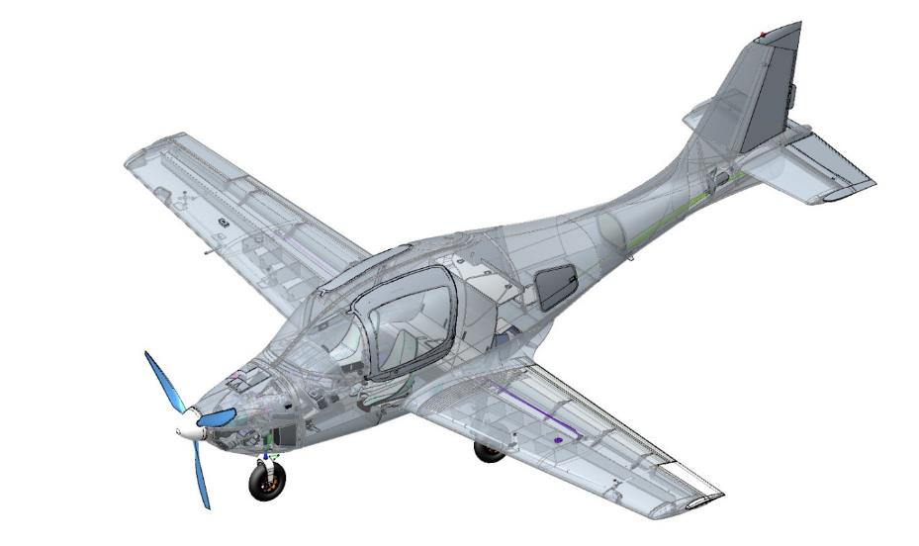
INSTRUCTION
ON ASSEMBLING THE KIT
(Constructors Manual)
ANG.01.CM.01
Revision 1
Exh. #___
(checked against reference ________)
Date

TO STEPPING
This Kit Kit Assembly Manual (hereinafter referred to as CM, Constructors Manual) regulates specific procedures, sequence, equipment, materials and technology of ANG-01 kit assembly.
The manual is available in Russian and English. The assembler can translate the CM into any language at his own responsibility.
The manual is not a substitute for competent theoretical and practical training. Failure to comply with CM provisions, as well as lack of proper training of assemblers may result in damage to the airplane, its units or injury to assemblers.
Builders may only begin assembling an airplane KIT kit after detailed study of these Instructions.
The holder of the IM and the owner of all intellectual property, which is stated in it, is the Developer and Producer of the ANG-01 airplane Kit, JSC "ANG Patriot-Ukraine" (Brovary, Kiev region, Ukraine), which is fully responsible for timely and correct introduction of all changes and additions to the CM.
If you have any questions regarding these Instructions, please contact the Developer's support service at angpatriotua@ukr.net.
All CM changes shall be issued in lieu of or in addition to the material set forth in the Instructions as separate model sheets. These changes are noted in the Change Record Sheet, and on each changed page in the footer the text "Revision ..." (for changes greater than 25% of the material) or "Revision ..." is placed, with the date of the change. (in case of changes exceeding 25% of the material) or "Revision ...", with the date of the change. The previous revision of these pages is removed and destroyed by the user.
All numerical values are presented in the metric system of measurement.
You should regularly (at least once a month) check the Developer's website for CM updates.
The total number of assembly, installation and commissioning operations to be performed according to these Instructions from the ANG-01 kit varies from 65% to 55%. The number of assembly operations may vary depending on the specific order and is determined by the Specification of the specific Kit (e.g., subassembly of individual units).
After completion, the assembler is obliged to fill in the relevant sections of the Log Book ANG.01.LB.01, which is provided as part of the kit's operational documentation.
IMPORTANT: It is forbidden to perform works on assembly of ANG-01 airplane Kit using equipment, materials, tools, technological processes not provided by this Instruction.

Registration sheet changes
Reg.  № | Section number, paragraph a | Page number |  |  | Reason for change | Subscribe | Date
 |  | Modification. | Nov . | Annul ir.
Revision 1  Revision 0 | Editorial | n/a | n/a | n/a | n/a |  | 18/05/2020

Abbreviations
ADAHRS | - | Sensor for speed, altitude, angle of attack and attitude angles;
CAA | - | National Aviation Administration;
CAS | - | Indicator flight speed;
CG | - | The plane's center of gravity;
ECU/EMS | - | Engine control/monitoring units;
STROBA | - | On-board flashing lights;
V_{NO} | - | Unbeatable airspeed;
V_{R}, V₂, V_{REF} | - | Characteristic speeds on takeoff, landing;
V_{Y} | - | Vertical velocity;
GAS STATION | - | Automatic protection of the on-board electrical system;
BANO | - | Airborne Aeronautical Fire;
VISH | - | Variable pitch screw;
WFP | - | Runway;
LCP | - | Paint and varnish coating;
NDP | - | Pre-commissioning;
PO | - | Software;
PSS | - | The plane of symmetry of the airplane;
RLE | - | Flight Operations Manual;
RH, RV, EL | - | Rudder, altitude, aileron;
RRD | - | Engine mode of operation;
RTE | - | Technical Operation Manual;
RUD | - | Engine control lever;
RUS | - | The airplane's control stick;
SAH | - | Average aerodynamic chord of the wing;
SNA | - | Satellite navigation system
TGC | - | Engine cylinder head temperature

CONTENTS.
SECTION 1 INTRODUCTION 2
SECTION 2 GENERAL RECOMMENDATIONS 8
SECTION 3 TYPICAL OPERATIONS 14
SECTION 4 CHASSIS ASSEMBLY 19
4.1 Assembling brake master cylinders 19
4.2 Brake caliper assembly 22
4.3 Assembly of the shock absorbers of the main landing gear supports 25
4.4 Chassis nose strut shock absorber assembly 32
4.5 Assembly of the main chassis struts 39
4.6 Assembly of the nose landing gear strut 49
4.7 Assembly of landing gear retractor cylinders 58
4.8 Installing the nose landing gear support 73
4.9 Installing the main landing gear supports 76
SECTION 5 CONTROL SYSTEM ASSEMBLY 89
5.1 Assembling the rudder linkage 89
5.3 Aileron control assembly 91
5.4 Assembly and installation of the foot control post 96
5.5 Assembly and installation of the manual control post 101
5.6 Assembling the rudder and rudder control assembly 119
5.7 Assembling and installing the PDR 137
SECTION 6 AIRFRAME ASSEMBLY 140
6.1 Stabilizer installation 140
6.2 Installation of the elevator and trimmer 144
6.3 Installing the rudder 154
6.4 Aileron installation 158
6.5 Installing the flaps 162
6.6 Installation of glazing 172
6.7 Door installation 176
6.8 Installation of hatches 181
6.9 Installing the sub-motor frame 185
6.10 Assembly and installation of hoods 189
6.11 Installation of wing consoles 198
SECTION 7 INSTALLATION OF UNITS IN THE ENGINE COMPARTMENT 204
SECTION 8 POWERTRAIN ASSEMBLY 213
8.1 Assembly and installation of engine units 213
8.2 Air propeller installation 233
8.3 Assembly and installation of flow tanks 238
SECTION 9 ELECTRICAL SYSTEM ASSEMBLY 238
9.3 Installation of lighting equipment 247
9.4 Installation of lighting and signaling equipment 247
9.5
9.6 Installation of the seat adjustment system 257
SECTION 10 INSTALLATION OF INSTRUMENTATION 262
10.2 Pitot tube installation 262
10.3 Dynon SW 1100 system installation 262
10.4 Installation of redundant pilot instruments 284
10.6 Installation of intercom system 286
SECTION 11 SPASSYSTEM INSTALLATION 289
SECTION 12. Installation of the INTERIOR 290
12.1 Cab upholstery 290
12.2 Trunk lining 290
SECTION 13 AIRCRAFT PAINTING 293
13.1 Painting of external surfaces 293
13.2
13.3 Stencil application 294
13.4 Installation of signs 294
SECTION 14 COMMISSIONING 297
14.1 General Provisions 297
14.2 Safety measures 297
14.3 Check list of commissioning works 298
SECTION 15 FLIGHT PROGRAM 306
15.1 Conditions and procedures for performing overflights, safety measures 306
15.2 SCOPE AND METHODOLOGY 307

GENERAL GUIDELINES
It is recommended to assemble airplane parts and the airplane as a whole on a platform with dimensions of at least 11 m in length, 14 m in width, with a height from floor to ceiling of at least 3 m. It is recommended that the site be located in a well-ventilated (or climate-controlled) room with a hard floor and good lighting.
The work is recommended to be performed at ambient air temperatures from 16°C to 30°C, and relative humidity not exceeding 75%.
For work on the assembly of aircraft parts, we recommend placing a mobile table 1.5 meters wide, 3 meters long, and 0.75 to 1 meter high from the floor near the aircraft assembly area. Provide a removable soft cover on the working surface of the table to avoid accidental damage and scratches to the airplane parts placed on the table.
Do not damage or touch the pipelines during stripping, sanding or trimming work. On hoses, this can lead to fluid leakage and subsequently hose rupture. On metal piping, this will inevitably lead to rapid corrosion and destruction of the piping. Pipelines are coated with colorless anodizing and it is impossible to visually identify the damaged area. Use temporary protection against accidental damage at such locations-plywood, board or thin metal.
All uncoated metal parts of the airplane can be protected after all work is completed with paints and varnishes or by contacting an appropriate specialist.
The rudders, ailerons and flaps, and the skin ends in the unit area may be curved and not straight along the trailing edge along the entire span. The permissible curvature deviation does not exceed 3 mm per one meter of length at any measured point. The permissible deviation in trailing edge straightness does not exceed 3 mm per one meter of length at any measured point.
It is permissible to have bare areas of the sandwich structure filler in non-force areas. Such areas may be glued during assembly, painted or left as is. Such locations include:
- Rear parts of the horizontal stabilizer ribs in the spar area;
- Front ends of the wing spars;
- Fuselage ends in the cowl attachment area, provided they are treated with three coats of fire retardant;
- Aileron linkage holes in wing consoles and fuselage bays;
- Openings for piping and electrical harnesses in wing consoles and fuselage bays;
- Contour of the recesses of the main chassis struts;
- End portions of the spar box that are in the plane of the fuselage skid;
- Rear parts of the vertical stabilizer nervures in the area of spar 3;
- Inside the windows and lightening of the spandrels and nervures;
IMPORTANT: Do not expose unpainted (unprotected) composite aircraft parts to direct sunlight for extended periods of time. Ultraviolet radiation from sunlight will degrade the epoxy resin and in some cases render the aircraft parts unusable. Please cover aircraft parts with opaque fabric materials in such cases.
It is recommended to store the finished airplane inside the hangar, without access to direct sunlight
When storing the airplane in an open area, all parts of the airplane must be covered with white-colored covers.
It is unacceptable to store the airplane and its parts at surface temperatures above 60°C.
We recommend using tools to assemble the airplane:
- Hexagon set 1.5-10 mm - 1 set;
- Set of combination wrenches from 5 to 19 mm - 1 set;
- Set of socket heads from 5 to 19 mm - 1 set;
- Set of screwdrivers with Phillips blade PH1 and PH2 - 1 set;
- Straight blade screwdriver set - 2 tools;
- Pliers, long-nose pliers, side cutters - 1 set;
- Open-ended wrench from 10 to 32 mm - 1 tool;
- Locksmith hammer 600 g 1 tool;
- Set of clamps from 50 to 100 mm - 1 set;
- Metal drill bits from 1 to 10 mm-1 set;
- Electric drill 750Watt- 1 tool;
- Caliper with depth gauge 150 mm-1 tool;
- Hand-held non-ferrous metal pipe cutter from 4 to 12 mm - 1 tool;
- Locking ring pliers - 1 set;
- Ruler 500 mm - 1 tool;
- 10 meter tape measure - 1 tool;
- Tool for laying electrical wires - 1 tool;
- Crimper for crimping terminals - 1 tool;
- 40 Watt electric soldering iron - 1 tool;
- Forceps 100 mm- 1 instrument;
- Digital kitchen scales up to 5 kg in 2 gram increments - 1 instrument.
- Torque wrench 1-25Nm- 1 tool.
- Set of hexagonal socket bits 1.5-10mm - 1 set.
IMPORTANT: Always use personal protective equipment. Always use safety glasses with transparent glasses, respirator, cloth gloves, latex gloves.
Before you start assembling the airplane, you need to unpack its parts.You will need 3 helpers for this job. Remove the packing materials.
Disconnect the upper spar and remove from the console. Hold the front of the spar by hand and remove the pin. Raise the console and move it back along the fuselage. Take it outside the airplane and place it on a table or stands.
Unlock the second spar, remove it from the console. Hold the front of the spar by hand and remove the pin. Raise the console and move it back along the fuselage. Take it outside the airplane and place it on a table or stands.
Remove rudders, trimmer, pilot seats from the cabin. Place on table or stands. Remove the ailerons, aileron and component containers from the luggage compartment. Place on a table. Remove the control system parts from the fuselage.
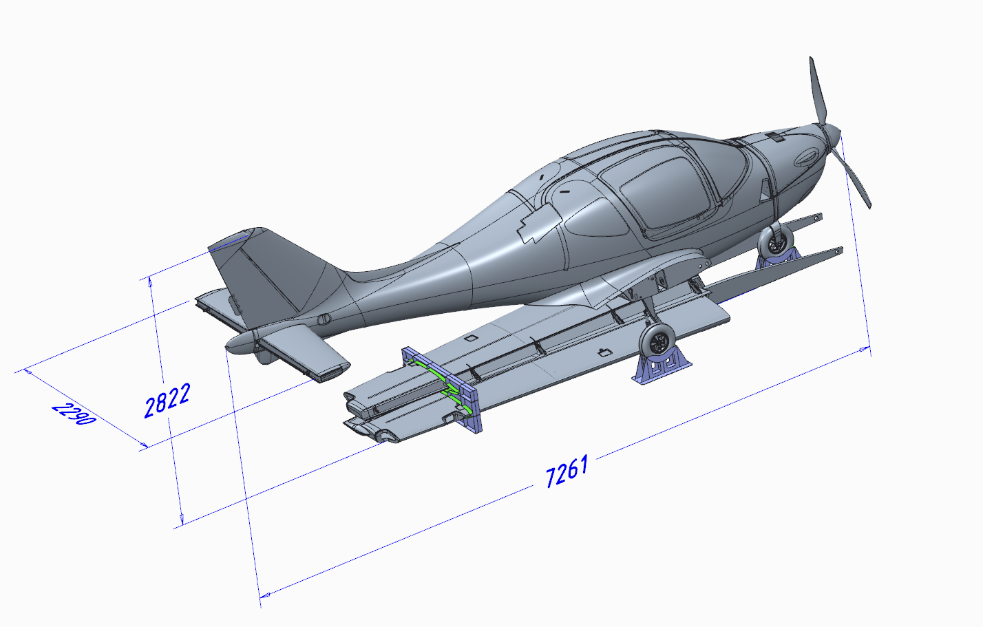
Unlock the fuselage stands.Remove the fuselage from the transportation stands.
It is recommended to remove the fuselage from the stands after all work in it, before installing the engine. Take the fuselage by the lower part of the fuselage in the stabilizer mounting area, on the right and left side of the spar opening and the caulk. Lift and carry it to the platform.
Insert the fingers of the stands forward into the fuselage skin at the location shown in the diagram.
Note.If the stand pin does not fit into the hole, the hole must be reamed to a diameter of 9.0 mm.
Gently lower the fuselage while holding the stand until the stand touches the floor. Install the second stand in the same way.
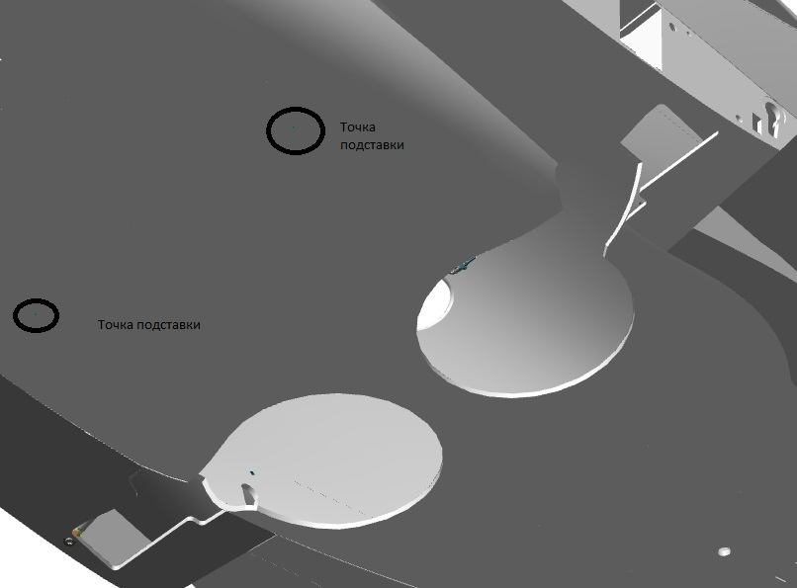
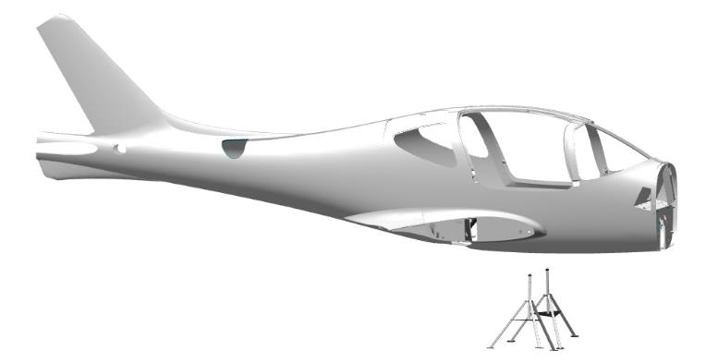

Locate the rear stand behind the main landing gear recesses according to the diagram.Put your finger in the hole, gently lower the fuselage, holding the stand until the stand touches the floor.

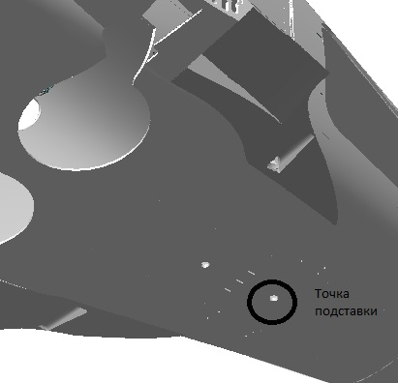

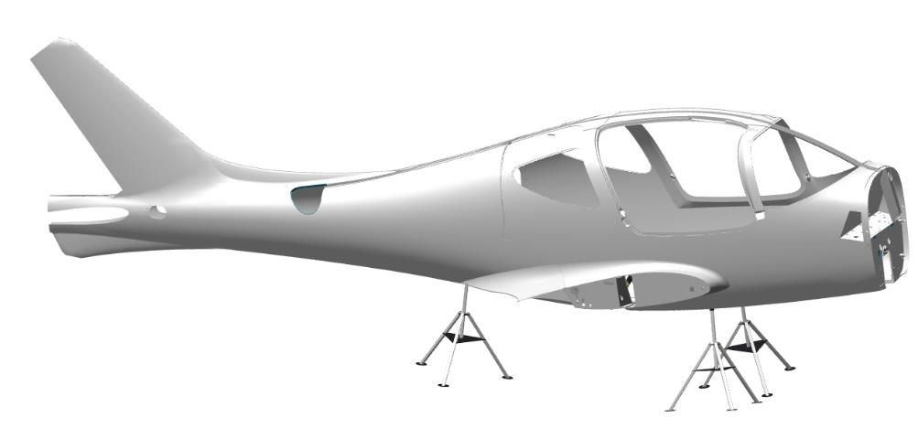

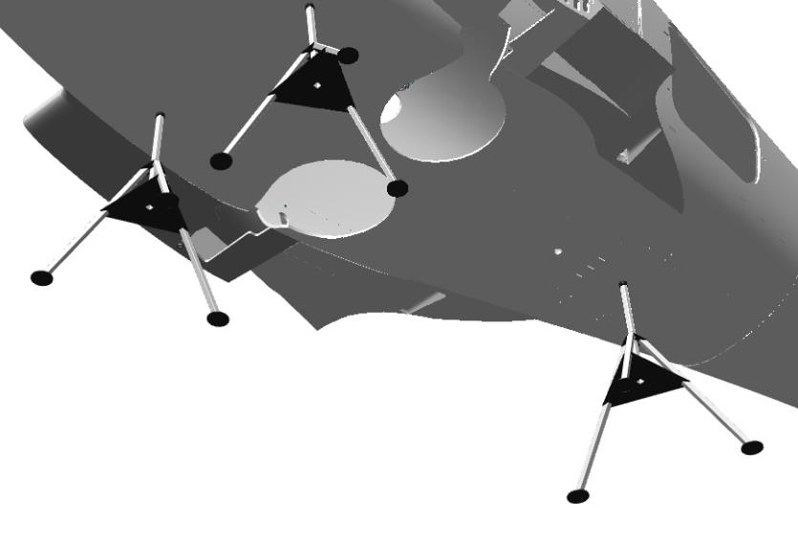

To carry out the work and to avoid tipping the fuselage, place weights of 25 kg each on the right and left side of the pilots' floors. The load can be a sandbag.
Note.The weight is required to balance the fuselage without the engine.
Check that each pad is fully touching the floor.All pads should be touching the floor.Check for secure installation by slightly loosening the fuselage.The fuselage should be stable.
Note.After removal from the stands, the holes may not be plugged, they will be additional drainage.

STANDARD OPERATIONS
Type Action 1.
Preparation of epoxy adhesive from Larit L285 resin and H287 hardener.
Precautions and safety precautions for carrying out the work.
- The place of work must be well ventilated.
- Smoking is prohibited in the place of work.
- Wear latex gloves before carrying out work.
- Closed toed shoes and safety glasses are recommended.
- In case of contact with eyes, rinse with water for 10 minutes and seek medical attention immediately.
- Fire extinguishing means - carbon dioxide and powder fire extinguishers, water, inert gas, asbestos cloth, sand.
The proportion for mixing is 100:40 in weight parts.
Prepare epoxy adhesive from Larit L285 resin and hardener H287. To do this, proceed as follows:
1.Turn on the scale;
2.Place a paper cup on the scale and zero the scale by pressing the button ,,0, or ,,TARE,;
3.Pour Larit L285 resin into the beaker on the scale, in the amount complete for the job;
4.Zero the scale by pressing the button ,,0,,, or ,,TARE,,;
5.Pour the amount of hardener H287 in the resin beaker with the resin in the amount required for the work;
6.Remove the beaker from the scale and mix the composition thoroughly. Stirring time is about 2 - 3 minutes. Pay special attention to the walls and bottom of the container.
Model Action 2.
Preparation of adhesive composition with aerosil from Larit L285 epoxy resin adhesive and H287 hardener.
Precautions and safety precautions for carrying out the work.
- The place of work must be well ventilated.
- Smoking is prohibited in the place of work.
- Wear latex gloves before carrying out work.
- Closed toed shoes and safety glasses are recommended.
- In case of contact with eyes, rinse with water for 10 minutes and seek medical attention immediately.
- Fire extinguishing means - carbon dioxide and powder fire extinguishers, water, inert gas, asbestos cloth, sand.
The proportion for mixing is determined during the preparation process, while stirring.
1.Add Aerosil to the adhesive approximately equal to the volume of the adhesive.
2.Mix thoroughly. There should be no dry parts, no lumps.
3.Check the consistency of the compound. It should resemble thick putty.
If the composition is not thick enough, repeat steps 1,2,3 in a proportion of aerosil ¼ of the available volume, until the desired consistency is obtained.
Model Action 3.
Cleaning of the parts adhesion areas before gluing on composite parts.
Precautions and safety precautions for carrying out the work.
- The place of work must be well ventilated.
- Smoking is prohibited in the place of work.
- Closed toed shoes and safety glasses are recommended.
- Do not blow off the dust generated during stripping with compressed air.
- In case of dust contact with eyes, rinse with water for 10 min and seek medical attention immediately.
- Fire extinguishing means - carbon dioxide and powder fire extinguishers, water, inert gas, asbestos cloth, sand.
Scrubbing should be carried out with sandpaper with grit not less than P400.
- Mark the stripping area with a marker, 10-15 mm larger in each direction.
- Rub the marked area with sandpaper until a matte surface appears.
- Wipe the scraping area with a clean rag.
Model Action 4.
Scraping of the adhesion points of the parts before gluing on metal parts.
Precautions and safety precautions for carrying out the work.
- The place of work must be well ventilated.
- Smoking is prohibited in the place of work.
- Closed toed shoes and safety glasses are recommended.
- Do not blow off the dust generated during stripping with compressed air.
- In case of dust contact with eyes, rinse with water for 10 min and seek medical attention immediately.
- Fire extinguishing means - carbon dioxide and powder fire extinguishers, water, inert gas, asbestos cloth, sand.
Scrubbing should be carried out with sandpaper with grit not less than P240.
- Mark the stripping area with a marker
- Rub with sandpaper on the adjoining area until light surface ridges appear.
Wipe the scraping area with a clean rag.

Model Action 5.
Application of aerosil adhesive prior to installing parts.
Precautions and safety precautions for carrying out the work.
- The place of work must be well ventilated.
- Smoking is prohibited in the place of work.
- Wear latex gloves before carrying out work.
- Closed toed shoes and safety glasses are recommended.
- In case of contact with eyes, rinse with water for 10 minutes and seek medical attention immediately.
- Fire extinguishing means - carbon dioxide and powder fire extinguishers, water, inert gas, asbestos cloth, sand.
Model Action 5.1.
Apply the adhesive to a degreased surface.
- Brush a thin layer of adhesive onto the degreased surface of the part to be installed.
- Place the piece on the table with the glue surface facing up or to the side.
- Brush a thin layer of adhesive onto the degreased surface of the part to be installed.
Model Action 5.2.
Application of adhesive composition with Aerosil on the prepared surface.
- Apply a layer of adhesive to the surface with the adhesive applied, about 1.5-2 mm.
- Spread the compound evenly over the surface with a trowel.
- Remove any excess compound that protrudes beyond the contour of the part when smoothing over the surface.
Model Action 6.
Checking threaded holes in parts.
Precautions and safety precautions for carrying out the work.
- The place of work must be well ventilated and lighted.
- Smoking is prohibited in the place of work.
- It is recommended to use a magnetized tool.
- Fire extinguishing means - carbon dioxide and powder fire extinguishers, water, inert gas, asbestos cloth, sand.
Checking should be carried out with hardware of the same size as the hole (M3, M4, M5, M6).
- Determine the size of the threaded hole to be checked (M3,M4,M5,M6).
- Select the appropriate size (M3,M4,M5,M6).
- Use a tool (wrench or screwdriver) to screw the fastener into the hole; the fastener should screw into the hole easily without sticking.
- Use a tool (wrench or screwdriver) to unscrew the hardware from the hole; the hardware should unscrew from the hole easily without sticking.
Model Action 7.
Removal of excess materials after installation.
Precautions and safety precautions for carrying out the work.
- The place of work must be well ventilated.
- Smoking is prohibited in the place of work.
- Wear latex gloves before carrying out work.
- Closed toed shoes and safety glasses are recommended.
- In case of contact with eyes, rinse with water for 10 minutes and seek medical attention immediately.
- Fire extinguishing means - carbon dioxide and powder fire extinguishers, water, inert gas, asbestos cloth, sand.

Do not dip rags in solvent!!!! Pour the solvent on the rags!!!!
- Wear latex gloves.
- Moisten the rag with solvent.
- Use a rag to remove any excess material that has been squeezed out in the process.
- Moisten the rag with solvent.
- Clean the tools used in the work (trowel, keys, screwdrivers).
Model Action 8.
Installing the bearing on the shaft sleeve retainer in the bore .
Precautions and safety precautions for carrying out the work.
- The place of work must be well ventilated and lighted.
- Smoking is prohibited in the place of work.
- Wear latex gloves before carrying out work.
- Closed toed shoes and safety glasses are recommended.
- In case of contact with eyes, rinse with water for 10 minutes and seek medical attention immediately.
- Fire extinguishing means - carbon dioxide and powder fire extinguishers, water, inert gas, asbestos cloth, sand.
The bearing designation is indicated in the job description.
Do not apply shaft and bushing retainer to a surface that has been degreased immediately. The fixative can be applied 5-10 minutes after degreasing.
Do not allow the retainer to get into the inside of the bearing. This will render the bearing unusable.
Do not strike any part of the bearing other than the outer ring (cage).
- Wear latex gloves.
- Moisten the rag with solvent.
- Degrease the outer surface of the bearing.
- Degrease the inner bearing seat in the part.
- Apply an even, thin layer of shaft bushing retainer to the degreased bearing surface.
- Place the bearing in the bore and install with light hammer blows through the mandrel. The bearing must be level with the bushing (for control rods to a depth of 0.5 mm from the plane).
- Use a rag to remove any residue of bushing shaft retainer that has been squeezed out.

CHASSIS ASSEMBLY

Assembling brake master cylinders

IMPORTANT: Use only one brand of DOT-4 or DOT-5 brake fluid. Mixing of fluids is strictly prohibited. When working on the brake system, use only the type of fluid used during assembly.
Objectives of this work: to assemble brake master cylinders.
To complete this work you will need:
Mobile desk;
DOT-4 brake fluid 30 grams;
Plastic beaker 100 ml;
Latex gloves 1 pair;
Welding wire 0,8mm 150mm 2 pieces.
Combination wrench 12 mm.
Shift the soft covering on the table about 1 m2. Place 0.5x0.5m polyethylene film on the vacated space, fix the edges of the film with small pieces of painter's tape.

IMPORTANT: Do not allow foreign materials or liquids to get on the rubber and metal parts. Doing so will result in loss of function or inability to reassemble the product.
Unpack it and stack it on the table:
- 4 cases 00145524;
- 4 stems 00145525;
- 4 covers 00145527;
- 4 rings 00136144
Count it out and stack it on the table:
- 4 T1 cuffs;
- 4 T2 cuffs;
- 4 springs prch-00032013;
- 2 S6520-6 1/8 fittings;
- 6 S6520-4 1/8 fittings.
Place the collars T1 and T2 in the beaker. Pour 30 grams of brake fluid into the beaker. Leave the cuffs in the beaker with brake fluid for 30 minutes.
IMPORTANT: Do not confuse the location and placement of the collars. This will cause the system to become inoperable. Do not allow sharp parts and collars to touch.
Thread the wire through the hole in the collar T1.Take the stem 00145525 put the collar T1 on, pressing the wire against the stem, from the thin end, pull it into the far groove. Pull out the wires one by one. Straighten collar T1 in the groove. Put on collar T2, pull it into the near groove. Spread collar T2 in the groove.
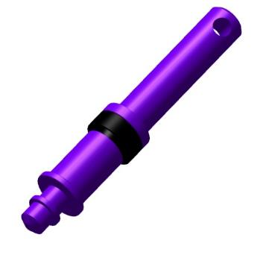 | 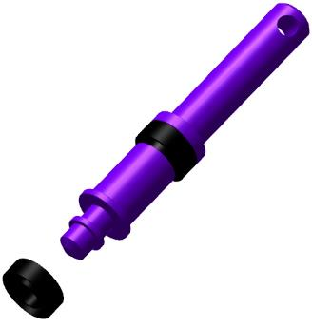 | 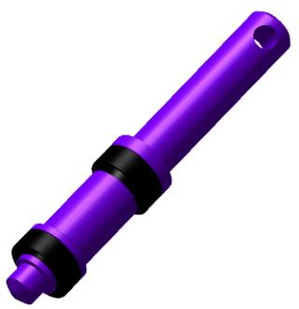
IMPORTANT: Do not allow foreign objects or liquids to enter the internal cavity. This will result in loss of function or inability to reassemble the product.
Slide the spring from the thin end of the stem 00145525 with the smaller diameter onto the stem Insert the assembled stem into the body 00145524 until the T2 collar stops.
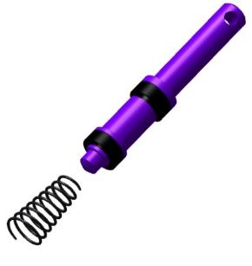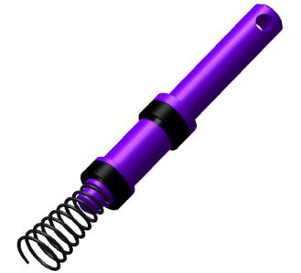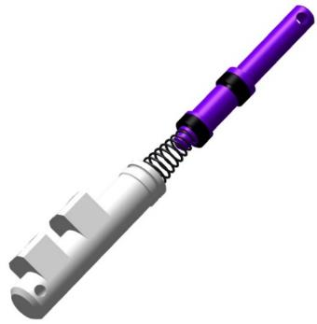
Slightly push the stem 00145525 into the housing 00145524 by tilting the stem to the left and right by a small angle. As soon as the collar T1 enters the housing, push the stem to the stop. Place the cover 00145527 on the stem, bring it to the stop. Press the cover against the housing and press the stem to the stop a few times. The stem should move easily without sticking and return easily.
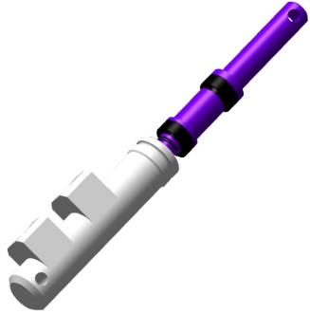 | 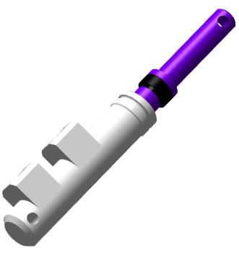 | 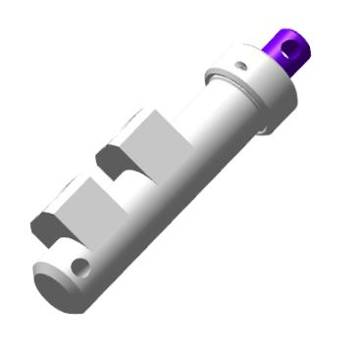
Locate the 00136144 ring and install it in the hole of the cover 00145527 pressed against the housing. Push the rod in a few times until it stops. The rod should move easily without sticking and return easily.
Locate the S6520-6 1/8 fitting. Screw by hand into the hole closest to the rod in the housing 00145524. Locate fitting S6520-4 1/8. Hand screw into the hole farthest from the stem in the 00145524 housing. Tighten the fittings with a 12mm wrench until the fitting skirt stops against the housing seat Locate fitting S6520-6 1/8. Screw by hand into the hole closest to the stem in the housing.
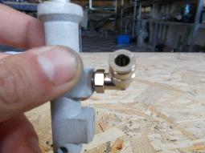 | 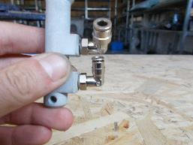 | 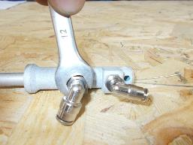
Repeat the steps above to reassemble the remaining brake master cylinders.
Note. Two master cylinders install S6520-4 1/8 fittings in all threaded holes.

Brake caliper assembly

IMPORTANT: Use only one brand of DOT-4 or DOT-5 brake fluid. Mixing of fluids is strictly prohibited. When working on the brake system, use only the type of fluid used during assembly.
To complete this work you will need:
- Mobile desk;
- DOT-4 brake fluid 30 grams;
- Plastic glass 100 ml;
- Locksmith hammer weighing 600 grams;
- LOCTITE 648 bushing shaft retainer;
- Solvent methyl acetate 50 grams;
- Clean rags 100x100 mm 1 piece;
- Combination wrench 12 mm;
- Combination wrench 10 mm;
- Combination wrench 8 mm;
- Latex gloves 1 pair;
Unpack it and stack it on the table:
- 2 brake calipers 00133914;
- 4 heat insulating bushings 00133917;
- 4 pistons 00133916;
- 4 piston seals 00087913;
- 2 pumping connections 00087916;
- 2 fittings 6522 4-M5;
Place the piston seals in the beaker 00087913. Pour 30 grams of brake fluid into the cup. Leave the collars in the beaker with brake fluid for 30 minutes.
Locate the brake caliper 00133914. Lubricate the inside of the caliper with brake fluid.
Insert the 00133914 part of the piston seal 00087913 into the inner groove of the brake caliper and spread it in the groove.
Sequentially spread the remaining part of the piston seal 00087913 in the brake caliper groove 00133914. Repeat the above steps to install the second piston seal 00087913 into the brake caliper groove 00133914.
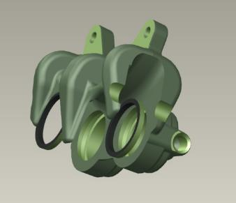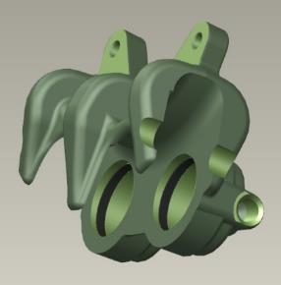
Locate the piston 00133916. Lubricate the outside of the piston with DOT-4 brake fluid. Install the 00133916 piston, guiding the hollow part from the caliper, into the bore.
Move the piston 00133916 all the way down. The force may be great. Repeat the steps above to install the second piston in the brake caliper 00133914.
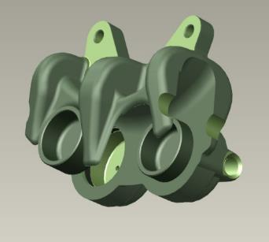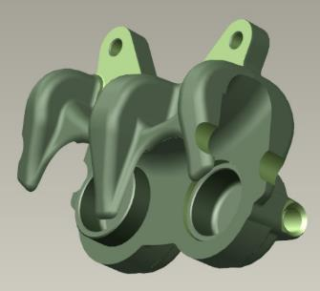
Locate the heat insulating bushing 00133917. Place the heat seal bushing 00133917 on the piston with the recess facing outward from the caliper and press down by hand. Hammer the bushing into the piston using a mandrel.
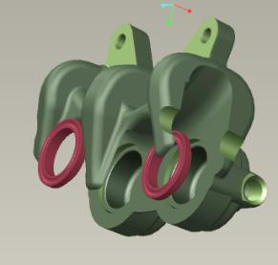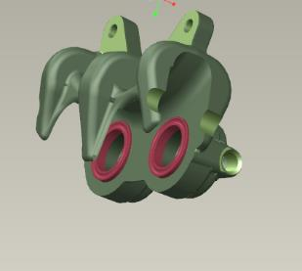
Repeat the steps above to install the second bushing of the heat insulating 00133917. Set the assembled caliper aside and reassemble the second caliper by repeating the steps above.
Lay the calipers on the table with the pistons facing each other, equal parts down. Locate 2 6522 4-M5 fittings. Install the 6522 4-M5 fittings into the two holes next to each other, screw in hand tight. Tighten, on each caliper, using a 12mm combination wrench until the fitting skirt stops in the caliper seat.
Install 2 pumping fittings in the remaining holes, tighten with an 8 mm wrench.
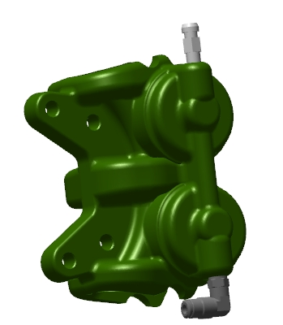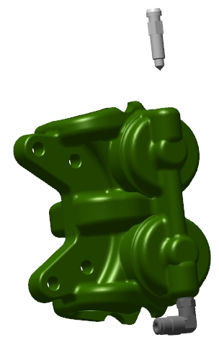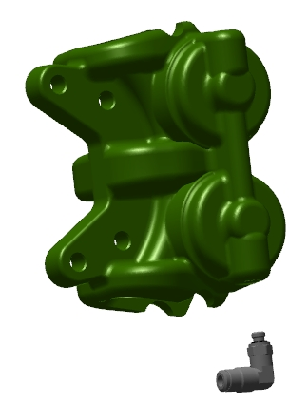

Assembly of the shock absorbers of the main landing gear supports
    - Shock absorber assembly
Note. The work described below is for one of the shock absorbers.
To complete this work you will need:
- Mobile desk;
- Angled pliers for removing circlips;
- Combination wrench 11 mm;
- LOCTITE 648 bushing shaft retainer;
- Solvent methyl acetate 100 grams;
- Clean rags 100x100 mm 2 pieces;
- Assembly tongs size S;
- Latex gloves 1 pair;
- Locksmith hammer 400 grams;
- Vise locksmith 100 mm;
- Aluminum vise pads 2 pieces;
- Plastic cup 50 ml;
- Wrench for the TE shock absorber;
Unpack it and stack it on the table:
- 2 cylinders of the main chassis shock absorber 00109658;
- 2 main chassis shock absorber cylinder covers 00109656;
- 2 bushings guide 00109652;
- 2 stems 00109675;
- 2 main landing gear shock absorber valve housings 00109677;
- 2 main chassis shock absorber valves 00109678;
- 2 shock absorber tubes of the main chassis strut 00109676;
Count it out and stack it on the table:
- 2 charging valves 00027867;
- 2 mudguards 30x38x4/7 K05 PU;
- 2 cuffs 30x40x7 K33 PU;
- 2 rings 038_042_30;
- 2 locking rings A14 DIN 471;
- 2 rings 26.58X3.53 XR.
Slide the soft cover on the table about 1 m².
Locate the cover 00109656. Degrease all internal cavities of the cover 00109656. Insert the 30x40x7 K33 PU collar 30x40x7 into the wide groove inside the 00109656 cover with the assembly pliers, with the recess from the hexagonal part of the cover. Spread the collar in the groove. Insert a 30x38x4/7 K05 PU wiper into the upper groove inside the cover 00109656, with the bevel outside the cover. Spread the wiper in the groove. Screw in the guide bushing 00109652 with the smallest possible diameter and secure the position. Insert the compressed bushing as far as possible from the threaded side into the cover 00109656. Spread the bushing in the groove of the cover. Place ring 038_042_30 on the outside of the cover 00109656 on the thread side, slide the ring over the thread and place it in the groove. Set the cover 00109656 aside on the table, in a free space.
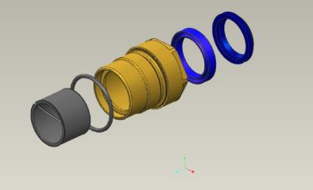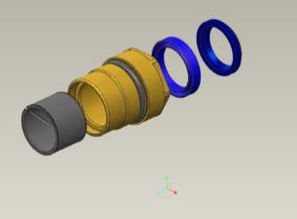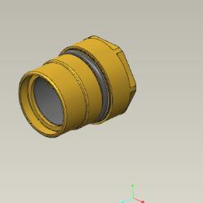
Locate valve body 00109677 and valve 00109678. Install the 00109678 valve into the opening of the 00109677 housing, recessed side. Push it all the way in. Check if the valve 00109678 moves easily in the housing 00109677 in the axis of rotation. It should move easily, without jerking or sticking. Remove the valve 00109677 from the housing 00109678 and place it on a table. Locate the 26.58X3.53 XR ring. Place the ring on the housing 00109677, thread side.
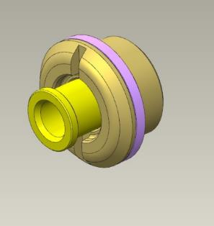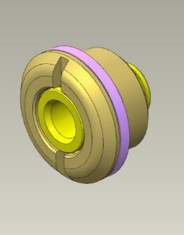
Locate the pipe 00109676. Hand screw the 00109677 body into the pipe, on either side, until the 26.58X3.53 XR ring stops in the pipe face.
Locate rod 00109675 and tube 00109676. Screw the 00109676 tube onto the 00109675 stem until there is no gap between the ends of the parts. The stem should easily screw into the pipe until it stops, with no gaps between the ends. Unscrew the rod from the pipe and place the parts on the table.
Degrease:
- Outer threaded part of the stem 00109675;
- The internal threaded part of the pipe 00109676, without a hole.
IMPORTANT: Do not apply shaft and bushing retainer to an immediately degreased surface. The fixative can be applied 5-10 minutes after degreasing.
Apply an even, thin coat of LOCTITE 648 Shaft-Hub Fixative to the degreased threaded surface of the pipe 00109676. Set the pipe aside on a table.
Apply an even, thin coat of LOCTITE 648 bushing shaft locker to the degreased threaded surface of the stem 00109675. Screw the stem into the pipe until there are no gaps between the end faces.
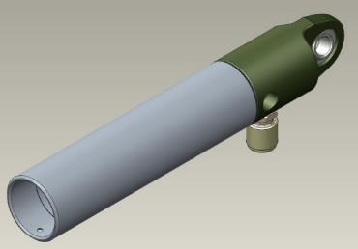
Clean the workplace and tools according to standard procedure 7.
Locate the charging valve . Screw the valve by hand into the hole on the side of the stem 00109675. The valve should screw into the hole easily. Degrease:
- Outer threaded part of the charging valve prch-00027867;
- Internal threaded part on the stem 00109675.
IMPORTANT: Do not apply shaft and bushing retainer to an immediately degreased surface. The fixative can be applied 5-10 minutes after degreasing.
Apply a thin, even coat of LOCTITE 648 Shaft-Hub Locker to the degreased threaded surface of stem 00109675. Set the pipe aside on a table. Apply a thin, even coat of LOCTITE 648 Shaft-Hub Locker to the degreased threaded surface of the charging valve. Screw the valve into the stem, tighten with an 11 mm wrench until the threads are fully threaded into the stem.
Clean the workplace and tools according to standard procedure 7.
Set the parts aside on the table. Locate valve body 00109677 and valve 00109678.
Insert the valve 00109678 into the opening of the housing 00109677, on the recessed side. Push it all the way in. Check that the 00109678 valve in the 00109677 housing moves easily along the axis of rotation. It should move easily, without jerking or sticking. Slide the valve as far as it will go into the housing seat. Insert the circlip into the groove of the valve 00109678 using angle pliers to remove the circlips.
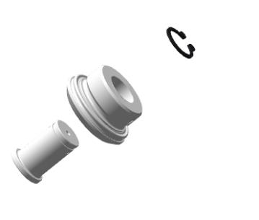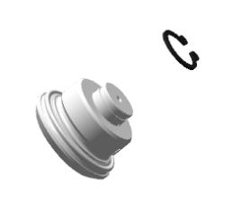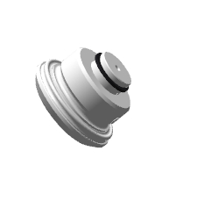
Locate cover 00109656 (with seals installed) and stem 00109675 (with parts installed). Inspect the cover for foreign objects in the interior of the cover. There should be no foreign objects.
Install the pipe with the bore part 00109676 of the dirt collector on the cover 00109656. Without any misalignment, slide the cover 00109656 over the pipe 00109676, approximately to the middle of its length.
Screw the housing 00109677 into the pipe until the 26.58X3.53 XR ring stops at the pipe end.
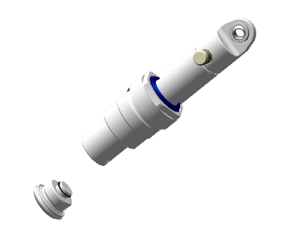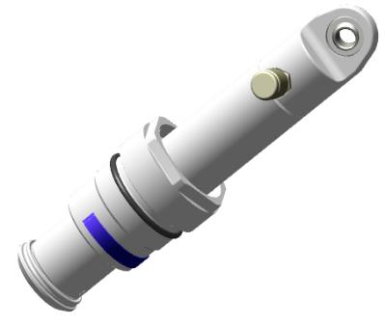
Unscrew the parts, degrease:
- The outer threaded part of the housing 00109677;
- Internal threaded part of the stem 00109675.
IMPORTANT: Do not apply shaft and bushing retainer to an immediately degreased surface. The fixative can be applied 5-10 minutes after degreasing.
Apply LOCTITE 648 shaft bushing retainer to the degreased threaded surface of the stem 00109675 in an even, thin layer of LOCTITE 648 shaft bushing retainer. Set the pipe aside on a table. Apply an even, thin coat of LOCTITE 648 shaft-to-bushing retainer to the degreased threaded surface of the 00109677 housing. Screw the housing into the stem, tighten until the threads are fully threaded into the stem.
Clean the workplace and tools according to standard procedure 7.
Locate the shock absorber cylinder 00109658. Inspect the cup for foreign objects in its internal cavities. There should be no foreign objects. Secure the cup in a vise, using aluminum pads. Install the pipe with the parts installed in the cup. Screw by hand the cover 00109656 into the shock absorber cylinder 00109658.
IMPORTANT: While screwing the cap on, do not allow the ring on the nut to buckle. If buckling begins to occur, unscrew the cap until the ring is aligned in the groove and re-screw. A wrinkled seal will result in fluid leakage.
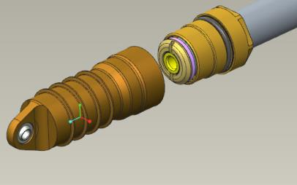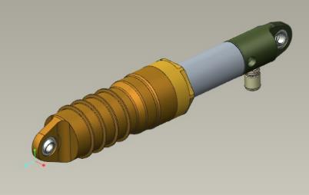
Tighten the cap with the shock absorber wrench until the cap end stops against the cup face. Check the shock absorber stroke by pressing the upper part of the rod, then pull it out. The shock absorber stroke should be smooth, with medium force (5-10 kg). Remove the shock absorber from the vise and place it on the table.
Repeat all steps above to assemble the second shock absorber.
IMPORTANT: No liquids or gases may be added to the product earlier than 2 hours after application of the bushing shaft retainer.
    - Charging shock absorbers with working fluid and gas
Note. The work described below is for one of the shock absorbers.
To complete this work you will need:
- Mobile desk;
- Chassis strut shock absorbers (previously assembled) 2 pieces;
- Silicone oil PMS-20 150 ml;
- Plastic glass 250 ml 3 pieces;
- Disposable medical syringe with needle 60 ml 1 piece;
- Key for the spools;
- Vise locksmith 100 mm;
- Aluminum vise pads 2 pieces;
- Technical nitrogen in a cylinder;
- Fixture for refilling shock absorbers;
- Liquid soap;
- Latex gloves 1 pair;
- Clean rags 100x100 mm 2 pieces;
Unfold the top of the shock absorber with the position of the charging valve perpendicular to the eyelet on the cup. Fold the shock absorber as far as it will go. Secure in a vise, through the aluminum pads, in a tilted position with the connection facing upwards. Unscrew the cap from the charging valve, put it aside in the cup. Unscrew the spool from the connection with a wrench, put it in the cup.
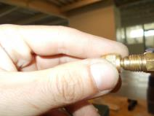
IMPORTANT: Do not place small parts of the airplane on the table. They may get lost. Use a container. Fill the syringe with the needle removed. This will allow the liquid to be drawn in without cavitation phenomena.
Fill a syringe with 60 ml of PMS-20 silicone oil. Put the needle on the syringe, place the syringe with the needle in the opening of the charging valve until the needle stops against the wall. Smoothly, at low speed, push the syringe piston and inject the silicone oil. Smoothly withdraw the needle from the charging valve.
Screw the cap onto the charging valve. Stretch the shock absorber to full stroke. Gently push down on the top of the shock absorber, squeeze the shock absorber to half stroke. Slowly unscrew and remove the cap from the charging valve. This should bleed air. Stretch the shock absorber to full stroke. Repeat filling with the syringe
Screw the cap onto the charging valve. Gently push down on the top of the shock absorber, squeeze the shock absorber as far as it will go. The shock absorber stem should not reach the bottom point, and may push off the bottom point when the hand is removed. Stretch the shock absorber to its full stroke.
Slowly unscrew and remove the cap from the charging valve. This should bleed air. PMS-20 silicone oil may be spilled. Screw the spool into the charging valve with a wrench.
Turn the stem so that the shock absorber lugs are in line and the charging valve is on the right or left. Remove the shock absorber from the vise. Remove any residual silicone oil spilled during the filling process with a clean, dry rag.
Ensure that the tank is closed and that the arrows on both pressure gauges show "0". Set the adjustment on the nitrogen reducer to "0", that the filler valves are closed.
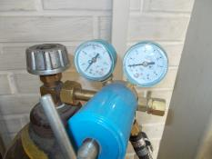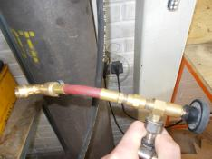
IMPORTANT: Do not leave the cylinder valve open and the hose pressurized for long periods of time.
Screw the filler fitting onto the charging valve of the shock absorber to the full length of the thread.
Open the valve on the cylinder, set the pressure on the second manometer to 25-27 atm (2.5-2.7 MPa). Open (screw in) the spool valve. Open the gas supply valve on the filling device. Close (screw in) the spool valve, close the gas supply valve on the filling device. Unscrew the filler connection from the charging valve. Screw on the cap of the charging valve.
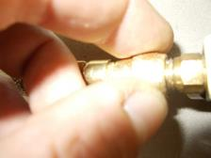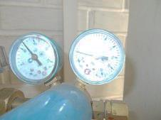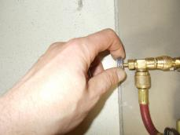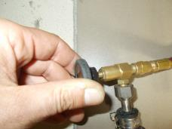
Control Operations:
- Inspect the shock absorber for possible silicone oil leaks. There should be no oil leaks.
- Place the shock absorber vertically on the floor, cup side down, and press down firmly on the top. There should be no gas-filled stroke on the shock absorber.
- Hold the shock absorber in your hand. Apply a thin layer of liquid soap around the charging valve. If there are leaks, bubbles will form. There should be no bubbles.
- Apply a thin, continuous layer of soap to the pipe near the strainer, at the line of contact between the cup and the cap. There should be no bubbles. Remove the liquid soap from the test points with a clean, dry rag.
- Note. It is acceptable to immerse the shock absorber in clean water to check for gas leaks. Air bubbles will be visible at the leakage points. After all checks, wipe the shock absorber with a dry, clean rag.
Repeat all steps above for the second shock absorber.

Chassis nose strut shock absorber assembly
    - Shock absorber assembly
To complete this work you will need:
- Mobile desk;
- Angled pliers for removing circlips;
- Hex key 2 mm;
- Combination wrench 11 mm;
- LOCTITE 648 bushing shaft retainer;
- Solvent methyl acetate 100 grams;
- Clean rags 100x100 mm 2 pieces;
- Assembly tongs size S;
- Latex gloves 1 pair;
- Locksmith hammer 400 grams;
- No. 2 straight blade screwdriver;
- Vise locksmith 100 mm;
- Aluminum vise pads 2 pieces;
- Plastic cup 50 ml;
- Wrench for shock absorber rod TE;
Unpack it and stack it on the table:
- Nose strut shock absorber housing 00109679;
- Glass top 00109680;
- 4 threaded fittings 00109705;
- 2 bushings guide 00109652;
- Stem 00109702;
- Bushing 00109698;
- Thrust bushing 00109688;
- Dampener 00109699;
- Tube - rod 00109686;
- Bushing 00109687;
- Lower bushing 00109689;
- Piston 00109690;
- Nut 00109691;
- Valve 00109692;
- Count it out and stack it on the table:
- Charge Valve KA-3213-00027867;
- Dirt collector 30x38x4/7 K05 PU;
- Cuff 30x40x7 K33 PU;
- Ring 010_014_25;
- Ring 034_037_19;
- Retaining ring A8 DIN 471;
- 2 bearings 625zz;
Slide the soft cover on the table about 1 m². Locate the nose strut shock absorber housing 00109679.
Degrease all internal cavities of the shock absorber housing 00109679. Bend the guide bushing 00109652 with the smallest possible diameter and secure the position. Insert the compressed bushing 00109652 as far as possible from the threaded side of the shock absorber housing 00109679. Spread the bushing 00109652 in the groove of the shock absorber housing.
Repeat the steps above to install the bushing 00109652 in the groove of the shock absorber housing 00109679 on the opposite side.
Using assembly pliers, insert the 30x40x7 K33 PU cuff 30x40x7 into the wide groove inside the shock-absorber body 00109679, with recess inside the body. Spread the collar std-00028224 in the groove. Install in the upper groove, shock absorber body 00109679, dirt separator 30x38x4/7 K05 PU, with bevel outside the cover. Spread the wiper std-00028223 in the groove.
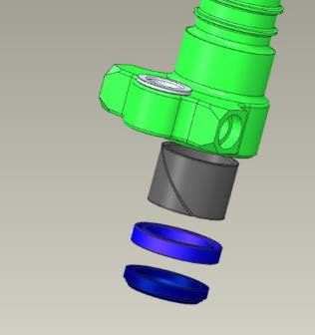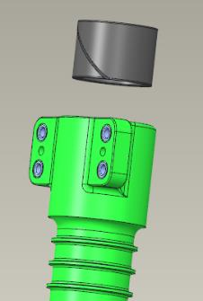
Degrease:
- The outer surfaces of the two 625zz bearings;
- Outer threaded surfaces of 4 threaded futures 00109705;
- Internal bearing seats in the shock absorber housing 00109679.
IMPORTANT: Do not apply shaft and bushing retainer to an immediately degreased surface. Apply the retainer 5-10 minutes after degreasing. Do not allow the retainer to get into the inside of the bearing. This will render the bearing unusable.
Apply an even, thin coat of LOCTITE 648 Shaft-Bushing Fixative to the degreased bearing surface.
Place the bearing in the bore and install with light hammer blows through the mandrel. The bearing must be flush with the housing. Use a rag to remove any residue of the shaft bushing retainer that has been squeezed out.
IMPORTANT: Do not strike any part of the bearing other than the outer ring (cage).
Turn over the shock absorber housings 00109679 with the installed bearing facing downwards. Apply an even, thin layer of LOCTITE 648 shaft and bushing retainer to the degreased bearing surface.
Place the bearing in the bore and install with light hammer blows through the mandrel. The bearing must be flush with the housing. Use a rag to remove any residue of the shaft bushing retainer that has been squeezed out.
Apply an even thin layer of LOCTITE 648 Shaft-Bushing Fixative to the degreased surface of the threaded lug 00109705.
Install in the upper part, slotted from the body, in the M8 hole. Screw in 2-3 turns by hand, tighten with a screwdriver. The fitting must be screwed in until it is level with the housing. Use a rag to remove any residue of the bushing shaft retainer that has been squeezed out.
Repeat the steps above to install the remaining threaded liners 00109705. Set the strut shock absorber housing 00109679 aside on the table.
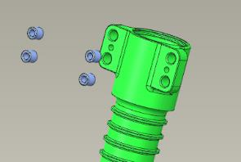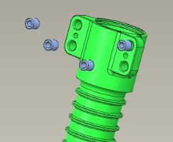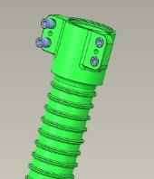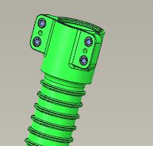
Locate lower bushing 00109689 and valve 00109692. Install the valve 00109692 into the hole in the lower bushing 00109689, recessed side. Push it all the way in.
Check whether the valve 00109692 moves easily in the sleeve of the lower 00109689 vol axis of rotation. The valve should move easily, without jerking or jamming, under its own weight in the sleeve. Insert the circlip into the valve groove 00109692 using angle tongs to remove the axe rings.
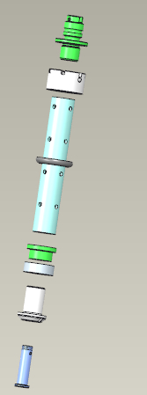
Find tube - rod 00109686, thrust bushing, piston 00109690.
Screw the lower bushing 00109689 into the tube - rod 00109686 from the side with holes located farther away from the end, until the end of the stop bushing stops against the end of the tube - rod 00109686. The bushing should easily screw into the tube-rod up to the stop, without gaps between the ends. Unscrew the bushing from the rod tube and place the parts on the table.
Degrease:
- Outer threaded part of the lower bushing 00109689;
- Internal threaded part of the tube - rod 00109686;
IMPORTANT: Do not apply shaft and bushing retainer to an immediately degreased surface. The fixative can be applied 5-10 minutes after degreasing.
Apply a thin layer of LOCTITE 648 shaft bushing retainer to the degreased threaded surface of the tube-rod 00109686. Set the tube-rod aside on a table. Apply a thin, even coat of LOCTITE 648 to the degreased threaded surface of the lower bushing 00109689. Screw the lower bushing into the tube-rod until there are no gaps between the ends of the parts.
Clean the workplace and tools according to standard procedure 7.
Set the parts aside on the table. Locate the bushing 00109698. Using a stem wrench, screw the bushing 00109698 into the stem 00109702 on the opposite side of the support. The bushing should easily screw inside the rod as far as it will go, 10 turns.
Unscrew the bushing from the stem and lay the parts on the table. Degrease:
- Outer threaded part of the bushing 00109698;
- Internal threaded part of the stem 00109702;
IMPORTANT: Do not apply shaft and bushing retainer to an immediately degreased surface. The fixative can be applied 5-10 minutes after degreasing.
Apply a thin, even coat of LOCTITE 648 shaft-bushing locker to the degreased threaded surface of the bushing 00109698. Using a stem wrench, screw the bushing 00109698 into the stem 00109702 on the opposite side of the support. The bushing should easily screw inside the stem until it stops, 10 turns.
Locate thrust bushing 00109688 and damper 00109699. Insert the damper 00109699 into the groove of the stem 00109702 on the female thread side. Spread it in the groove. Screw the thrust bushing 00109688 into the inner threaded part of the stem 00109702, with the slots facing outwards on the stem, up to the same end level. The bushing should easily screw into the stem until it stops.
Locate bushing 00109687 and ring 010_014_25. Install the ring 010_014_25 in the groove of the bushing 00109687 on the opposite side of the thread. Place the damper 00109699 and the stop bushing 00109688 on the tube - rod 00109686. Screw the bushing 00109687 into the thread of the rod tube 00109686. The bushing should easily screw all the way into the threads.
Unscrew the bushing from the boom tube and lay the parts on the table. Degrease:
- Outer threaded part of the bushing 00109687;
- Internal threaded part of the tube - rod 00109686;
IMPORTANT: Do not apply shaft and bushing retainer to an immediately degreased surface. The fixative can be applied 5-10 minutes after degreasing.
Apply a thin layer of LOCTITE 648 shaft bushing retainer to the degreased threaded surface of the tube-rod 00109686. Set the tube-rod aside on a table. Apply a thin, even coat of LOCTITE 648 shaft-bushing retainer to the degreased threaded surface of the bushing 00109687. Screw the bushing into the tube-rod until there are no gaps between the end faces.
Clean the workplace and tools according to standard procedure 7.
Thread a 200 mm long 0.8 mm balancing wire through the pilot hole in the bushing 00109687. Make a 3-4 turns twist.
Locate stem 00109702 and shock absorber housing 00109679. Inspect the shock absorber body for foreign objects in its internal cavities. There should be no foreign objects.
Insert the bore part of the stem 00109702 into the mudguard on the shock absorber body. Without any misalignment, carefully push the stem into the body to the full stroke. Install and clamp the shock absorber body in the bearing area with the rod downwards in a vise using aluminum pads.
Install the rod tube with the parts installed in the rod. Install the 00109702 damper 00109699 in the groove of the rod on the female thread side. Spread it in the groove. Screw the thrust bushing 00109688 into the inner threaded part of the stem 00109702. The bushing should screw easily into the stem.
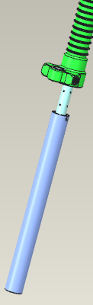 | 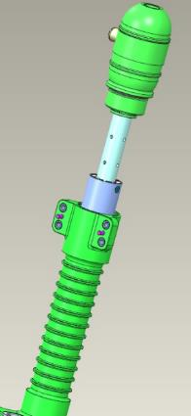
Clean the workplace and tools according to standard procedure 7.
Locate upper cup 00109680 and nut 00109691. Slide the top cup 00109680 threaded end toward the post. Thread the wire, on the bushing 00109687, through the top hole of the cup. Screw the cup into the shock absorber body for a few turns.
Thread the bushing 00109687 through the cup hole until the threads protrude above the cup. Put the nut 00109691 on the wire, and screw it onto the bushing 00109687 by hand until it stops. Remove the wire.
IMPORTANT: When screwing the cap on, do not allow the ring installed on the cap to buckle. If wrinkling begins to occur, unscrew the cap until the ring is aligned in the groove and re-screw. A wrinkled seal will result in fluid leakage.
Use a strap wrench to tighten the upper cup 00109680 into the shock absorber body until the ends of the cup and the body stop and there are no gaps between them. Tighten the 00109691 nut with a 19 mm combination wrench, holding the joint with a #3 straight blade screwdriver by the 00109687 bushing until one thread is protruding.
Check the shock absorber travel by pressing on the top of the strut, then pull it out. The shock absorber travel should be smooth, with medium force (5-10 kg).
Insert the 0.8 mm balancing wire into the hole in the bushing 00109687. Pull the wire through, bend and insert it into the hole in the nut 00109691. Pull both ends of the wire with great force to align it. Make a twist of 6-8 turns near the nut, bite off the remaining parts of the wire, bend the twist towards the bushing 00109687.
Locate the charging valve prch-00027867. Screw the valve by hand into the side hole on the top cup 00109680. The valve should screw into the hole easily. Unscrew the valve, degrease:
- Outer threaded part of the charging valve prch-00027867;
- Internal threads on the cup top 00109680.
IMPORTANT: Do not apply shaft and bushing retainer to an immediately degreased surface. The fixative can be applied 5-10 minutes after degreasing.
Apply an even thin layer of LOCTITE 648 Shaft-Bushing Fixer to the degreased threaded surface of the cup top 00109680. Apply LOCTITE 648 Shaft-Bushing Fixer to the degreased threaded surface of the charging prch-00027867 valve with a uniform thin layer of LOCTITE 648 Shaft-Bushing Fixer. Screw the valve into the cup, tighten with a combination wrench 11 mm until it is completely screwed into the cup.
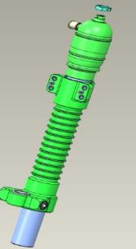 | 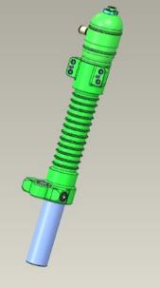
Clean the workplace and tools according to standard procedure 7.
IMPORTANT: No liquids or gases may be added to the product earlier than 2 hours after application of the bushing shaft retainer.

    - Charging the shock absorber with working fluid and gas
To complete this work you will need:
- Mobile desk;
- Nose landing gear shock absorber (assembled earlier);
- Silicone oil PMS-20 100 ml;
- Plastic glass 200 ml 3 pieces;
- Disposable medical syringe with needle 60 ml 1 piece;
- Key for spools;
- Vise locksmith 100 mm;
- Aluminum vise pads 2 pieces;
- Technical nitrogen in a cylinder;
- Fixture for refilling shock absorbers;
- Liquid soap;
- Latex gloves 1 pair;
- Clean rags 100x100 mm 2 pieces;
Fold the shock absorber as far as it will go. Fix in a vise, through the aluminum pads, in a tilted position with the connection upwards. Unscrew the cap from the charging valve, put it aside in the cup. Unscrew the spool from the connection with a wrench, put it in the cup.

IMPORTANT: Do not place small parts of the airplane on the table. They may get lost. Use a container. Fill the syringe with the needle removed. This will allow the liquid to be drawn in without cavitation phenomena.
Fill a syringe with 60 ml of PMS-20 silicone oil. Put the needle on the syringe, place the syringe with the needle in the opening of the charging valve until the needle stops against the wall. Smoothly, at low speed, push the syringe piston and inject the silicone oil. Smoothly withdraw the needle from the charging valve.
Screw the cap onto the charging valve. Stretch the shock absorber to full stroke. Gently press the top of the shock absorber, squeeze the shock absorber to half stroke.
Slowly unscrew and remove the cap from the charging valve. This should bleed air. Stretch the shock absorber to full stroke. Repeat filling with a syringe.
Screw the cap onto the charging valve.
Gently push down on the top of the shock absorber, squeeze the shock absorber until it stops. The shock absorber rod may push away from the lower point when the hand is removed. Stretch the shock absorber to its full stroke. Slowly unscrew and remove the cap from the charging valve. This should bleed air. PMS-20 silicone oil may spill. Screw the spool into the charging valve with a wrench.
Turn the stem so that the shock absorber lugs are in line and the charging valve is on the right or left. Remove the shock absorber from the vise. Remove any residual silicone oil spilled during the filling process with a clean, dry rag.
Ensure that the tank is closed and that the arrows on both pressure gauges show "0". Set the adjustment on the nitrogen reducer to "0", that the filler valves are closed.

IMPORTANT: Do not leave the cylinder valve open and the hose pressurized for long periods of time.
Screw the filler fitting onto the shock absorber charging valve to the full length of the thread. Open the valve on the cylinder, set the pressure on the second pressure gauge to 20atm (2MPa). Open (screw in) the spool valve. Open the gas supply valve on the filling device. Close (unscrew) the spool valve, close the gas supply valve on the filler.
Unscrew the filler connection from the charging valve. Screw on the cap of the charging valve.

Control Operations:
- Inspect the shock absorber for possible silicone oil leaks. There should be no oil leaks. Place the shock absorber vertically on the floor, cup side down, and press down firmly on the top of the shock absorber. The shock absorber should not move.
- Hold the shock absorber in your hand. Apply a thin layer of liquid soap around the charging valve. If there are leaks, bubbles will form. There should be no bubbles.
- Apply a thin, continuous layer of soap to the rod near the wiper, at the line of contact between the cup and the body. There should be no bubbles. Use a clean, dry rag to remove the liquid soap from the test points.

Assembly of the main chassis struts
Note. The work described below is for the left main landing gear strut. The right landing gear strut is assembled in the same sequence.
It is preferable to paint the chassis arms before assembly. The color can be any color.
IMPORTANT: The coating material must be compatible with the materials to be coated and must not cause damage or destruction.
The shock absorber rod must not be painted. The shock absorber stem will inevitably become inoperable if paint materials get on the stem.
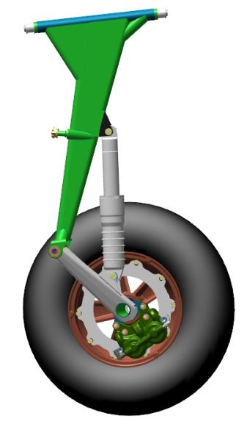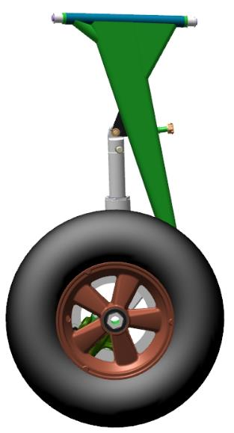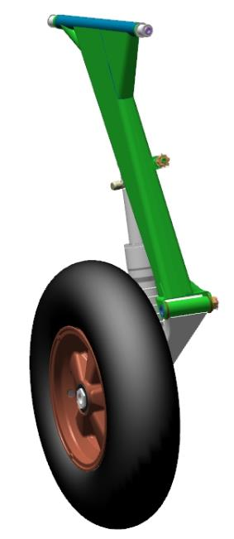
To complete this work you will need:
- Mobile desk;
- Combination wrench 13 mm;
- Combination wrench 10 mm;
- Combination wrench 19 mm;
- Hexagonal wrench 5 mm;
- Screwdriver with straight slot #1;
- Locksmith hammer weighing 600 grams;
- Litol-24 grease 10 grams;
- Latex gloves 1 pair;
- Solvent methyl acetate 100 grams;
- Clean rags 100x100 mm 2 pieces;
- Open-ended wrench from 10 to 32 mm;
- Combination wrench 17 mm;
- LOCTITE 648 bushing shaft retainer.
Unpack it and stack it on the table:
- Upper left lever 00136580;
- Upper right upper arm 00136580-01;
- Lower left lever 00108694;
- Lower right lever 00108694-01;
- 2 wheels 00234511;
- 2 bolts 00121813;
- 4 M8 screws 00236643;
- 4 bronze bushings 00136610;
- 2 shock absorbers (previously assembled);
- 2 wheel bolts 00108690;
- 2 brake disks 00271038;
- Brake mechanism caliper left (assembled by you earlier);
- Brake mechanism caliper right (assembled by you earlier);
- 2 pads movable 00133919;
- 2 pads fixed 00133920;
Count it out and stack it on the table:
- 8 M6 screws 00133915;
- 8 nuts M6 DIN 985;
- 8 washers 6 DIN 6798A;
- 8 washers 6 DIN 125;
- 4 nuts M8 DIN 937;
- 4 washers 8 DIN 6798A;
- 2 nuts M12 DIN 937;
- 6 cotter pins 1,6x30 DIN 94;
IMPORTANT: Do not leave the chassis shock absorbers in direct sunlight for long periods of time. The shock absorbers are filled with nitrogen under high pressure.
Locate lower arm 00108700, 2 bronze bushings 00136610. Degrease:
- The outer surface of the bushings 00136610;
- Internal bushing seating in the lever 00108700.
IMPORTANT: Do not apply bushing shaft retainer to a surface that has been degreased immediately. Apply the fixer after 5-10 minutes after degreasing Do not allow the bushing shaft fixer to get into the internal cavities of the bushings. Remove any bushing shaft locker immediately with a rag soaked in solvent.
Apply LOCTITE 648 Shaft-Hub Fixer to the degreased surface of the bushing 00136610 with an even, thin coat of LOCTITE 648.
Insert the bushing into the bore of the lever tube and install with light hammer blows through the mandrel. The bushing should seat until the bushing shoulder stops against the plane of the assembly. Remove any residue of bushing shaft retainer that has been squeezed out with a rag. Repeat the steps to install the second bushing into the lever tube.
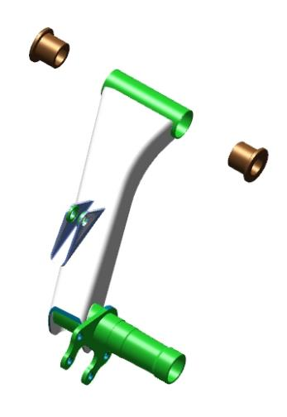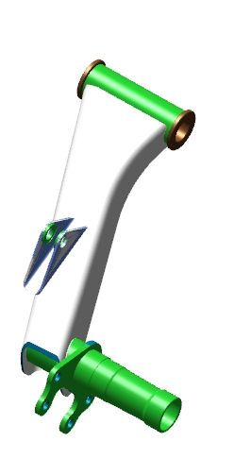
Find the lower lever 00108700, upper strut 00179621, bolt 00121813, nut M12 DIN 937. Insert the upper part of the lever into the fork of the rack, align the holes. Insert the bolt 00121813 into the aligned holes, with the head on the side with the hexagonal recess in the fork of the lever. Thread the bolt through until the head is fully extended and aligned in the depression. Install M12 nut DIN 937, tighten with a 19 mm wrench.
Make several movements with the lever against the rack. The movement should be smooth, without jams or play.
IMPORTANT: play will result in rapid bushing wear and assembly failure.
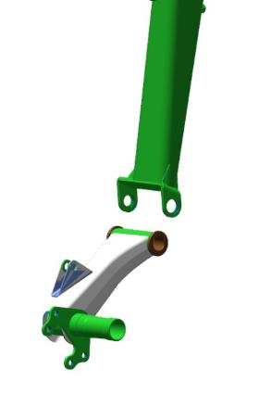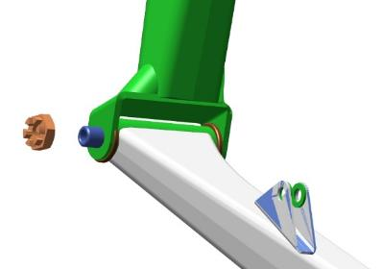 | 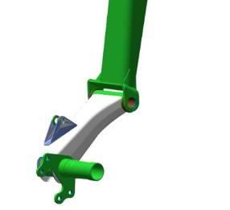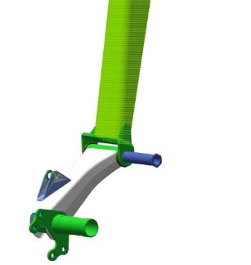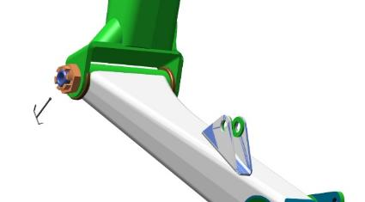

Locate the shock absorber. Turn the shock absorber with the charging connector towards the wheel axle, insert the lower part of the shock absorber into the lugs on the lower arm 00108700, align the holes. Install the bolt 8x28 DIN 6912 in the holes, with the head on the wheel axle side. Place washer 8 DIN 6798A on the bolt, screw on nut M8 DIN 937, tighten the nut until the washer 8 DIN 6798A is fully compressed. Locate the hole in the bolt, which should match the slot in the M8 DIN 937 nut. If the hole is not visible, tighten the nut until the hole matches the slot.
IMPORTANT: Do not twist the nut to match the hole and slot. This will result in rapid assembly failure and backlash.
Place a 1.6x30 DIN 94 cotter pin in the coincident slot of the M8 DIN 937 nut and the hole in the bolt. Tighten the cotter pin by loosening the cotter pin tabs with a #1 slotted screwdriver.
Slide the top of the shock absorber into the shock absorber lugs on the strut 00179621 until the holes match, sliding the strut onto the shock absorber.
Install the bolt in the holes with the head on the wheel axle side. Place washer 8 DIN 6798A on the bolt, screw on nut M8 DIN 937. Tighten the nut until the 8 DIN 6798A washer is fully compressed. Locate the hole in the bolt, which should match the slot in the M8 DIN 937 nut. If the hole is not visible, tighten the nut until the hole matches the slot.
IMPORTANT: Do not twist the nut to match the hole and slot. This will result in rapid assembly failure and backlash.
Place a 1.6x30 DIN 94 cotter pin in the coincident slot of the M8 DIN 937 nut and the hole in the bolt. Tighten the joint by loosening the cotter pin tabs with a #1 slotted screwdriver.
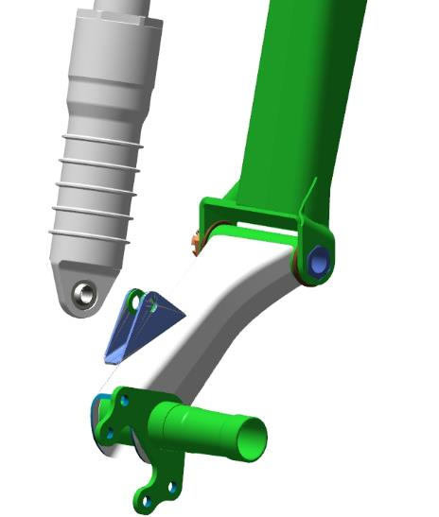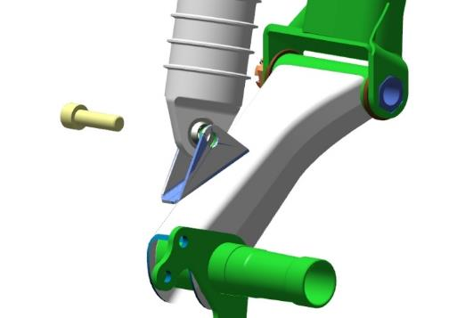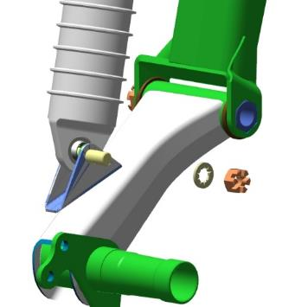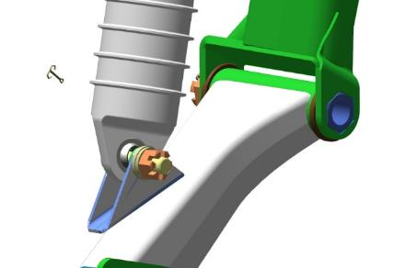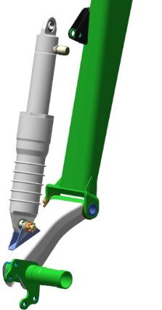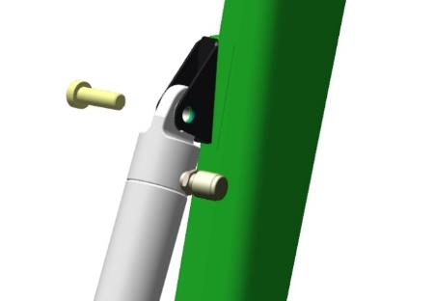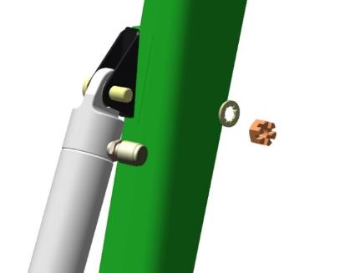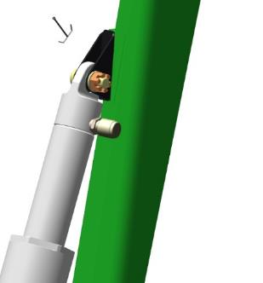
Find the lower lever 00108700, brake caliper, 4 bolts 6x28 DIN 6912, 4 washers each 6 DIN 6798A and 6 DIN 125, 4 nuts M6 DIN 985. Install the brake caliper to the right of the wheel axle on the bracket. Align the holes in the bracket and the caliper. Install 4 bolts 6x28 DIN 6912 in the aligned holes, with the heads on the wheel axle side.
Install 6 DIN 125 washers, 6 DIN 6798A washers, M6 DIN 985 nuts on the bolts, tighten with a wrench.
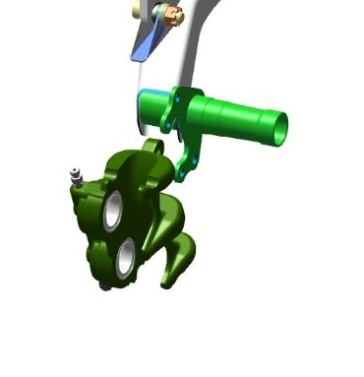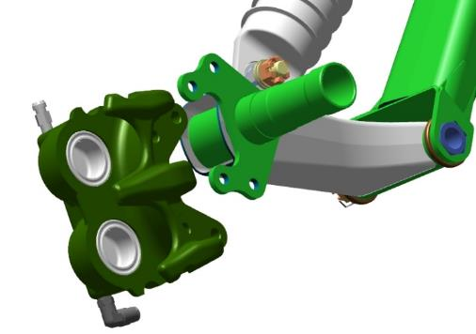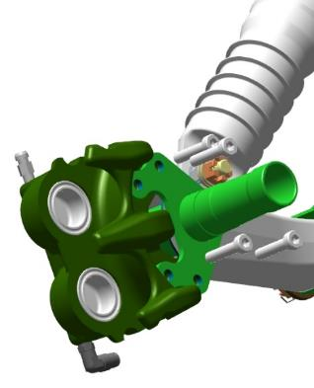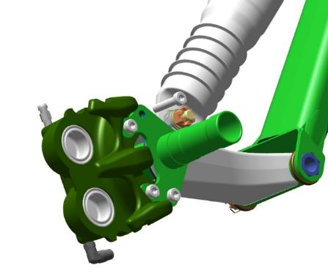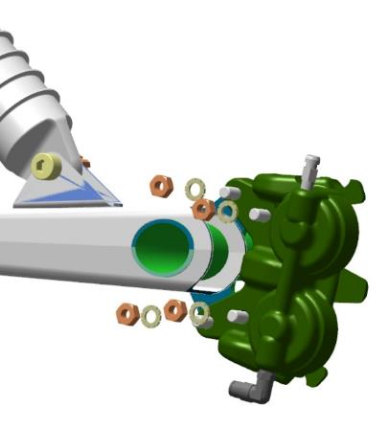

Locate the movable 00133919 and fixed 00133920 brake pads. Insert the sliding brake shoe 00133919 into the grooves of the brake caliper, with the lining towards the wheel axle. Move the shoe as far as it will go. Insert the brake shoe 00133920 into the grooves of the brake caliper with the brake lining facing away from the wheel axle. Move the shoe as far as it will go. 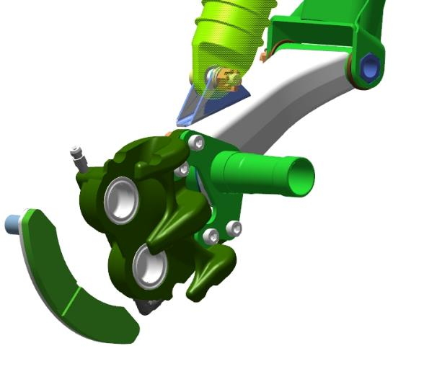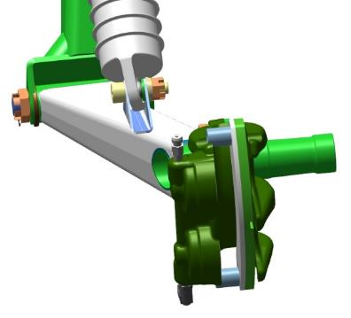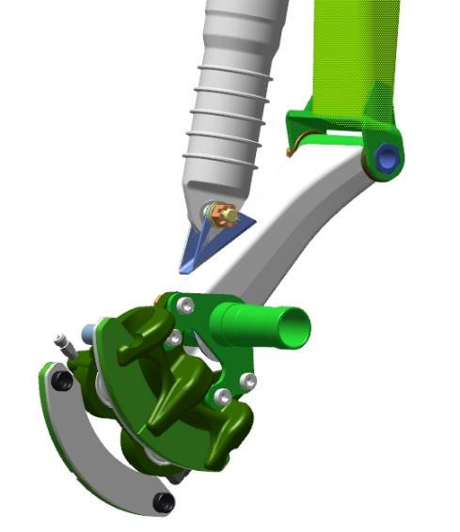
Locate the brake disk 00133918. Slide the disk through the axle, install between the pads in the caliper. Lay the chassis rack on the table with the wheel axle facing up. Install the wheel 00133929 on the axle, charging valve from the chassis rack. 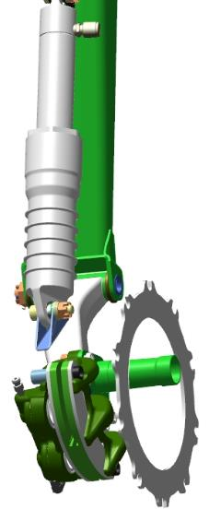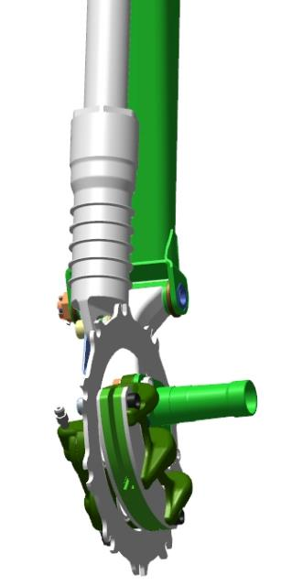
Slide the wheel along the axle until it is level with the wheel. Guide the brake disk 00133918 with the grooves into the projections on the wheel hub 00133929.
Move the wheel all the way down. Place the chassis rack on the wheel, check the position of the brake disk 00133918 in the grooves of the wheel hub 00133929. Place the chassis strut on the table with the wheel up. Check the ease of rotation of the wheel. Rotation should be easy without jerking or sticking. Check the location of the brake disk inside the wheel. The disk should be parallel to the pads, perpendicular to the wheel axis. When turning the wheel, the disk should not change its position in the area without the caliper and pads.
IMPORTANT! If the brake disk is not installed parallel, behind the area of the caliper deviates from the wheel, it will inevitably lead to the destruction of the wheel after a few brakes and uneven wear of the pads. To align the disk it is necessary to put two washers f6 mm thick 0,5 mm under the caliper
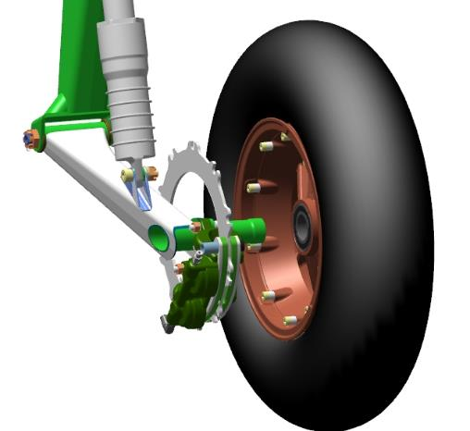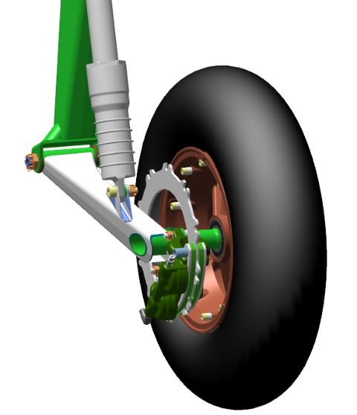
Locate the wheel bolt 00108690. Install the wheel bolt 00108690 on the wheel axle, hand tighten until snug.
Set the adjustable wrench to 27 mm. Tighten the wheel bolt with the adjustable wrench 00108690 until the hexagonal part stops in the wheel bearing.

Assembly of the nose landing gear strut
To complete this work you will need:
- Mobile desk;
- Combination wrench 8 mm 2 pieces;
- Combination wrench 10 mm;
- Combination wrench 14 mm;
- LOCTITE 648 bushing shaft retainer;
- Solvent methyl acetate 100 grams;
- Clean rags 100x100 mm 2 pieces;
- Latex gloves 1 pair;
Unpack it and stack it on the table:
- Rocking 00134425;
- Front strut truss 00108746;
- Cardan 00134991;
- Cardan lower 00134990;
- Bushing 00109684;
- Bolt 00134992;
- Wheel 00133929;
- Fork right 00179962;
- Fork left 00179964;
- 2 wheel axle pins 00136417;
- tube 00136414;
- tube 00136415;
- tube 00136411;
- Puck 00109586;
- 2 bushings 00109584;
- Rocking the top 00109500;
- Rocking the bottom 00109501;
- 2 axle pulls 00134987;
- Tractor axis 00134964;
- 2 truss screws 00109644;
- Bolt 00109585;
- Bolt 00109588;
- Bolt 00134966.
Count it out and stack it on the table:
- 6 bearings 625zz;
- 8 M5 nuts DIN 935;
- 8 cotter pins 1,0x35 DIN 94;
- 10 washers 5 DIN 6798A;
- 10 washers 5 DIN 125;
- 6 nuts M6 DIN 985;
- 2 nuts M5 DIN 985;
- 6 washers 6 DIN 6798A;
- 6x108 DI 912 bolt;
- 4 bolts M5x16 DIN 962SK;
- 4 bolts M6x20 DIN 912.
Find the upper rocker 00109500, lower rocker 00109501, washer 00109586 and 2 bushings 00109584.
Install the polyamide bushing 00109584 onto the rocker pin of the lower rocker 00109501, with the projection away from the rocker.
Install the upper rocker 00109500, on the pin of the bushing, move it to the stop. Install the polyamide bushing 00109584, washer 00109586 on the pin of the lower rocker 00109501, with the projection on the rocker.
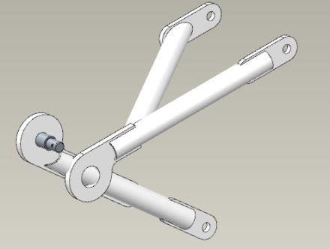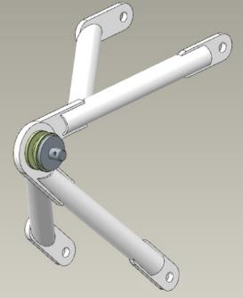
Install washer 5 DIN 6798A, screw on nut M5 DIN 935. Using an 8 mm combination wrench, tighten the nut until the 5 DIN 6798A washer is fully compressed. Locate the hole in the axle, which should line up with the slot in the M5 DIN 935 nut. If the hole is not visible, tighten the nut until the hole matches the slot.
IMPORTANT: Do not twist the nut to match the hole and slot. This will result in rapid assembly failure and backlash.
Check the movement of the rockers. The rockers should rotate easily on the axis, without jerks or jams.
Place a 1.0x35 DIN 94 cotter pin in the coincident slot of the M5 DIN 935 nut and the axle hole. Tighten the joint by loosening the cotter pin tabs with a #1 slotted screwdriver. Set the rockers aside on the table.
Locate the lower gimbal 00134990 and bushing 00109684. Degrease:
- The outer surface of the bushing 00109684;
- Internal bushing seating in the assembly 00134990.
IMPORTANT: Do not apply bushing shaft retainer to a surface that has been degreased immediately. Apply the fixer after 5-10 minutes after degreasing Do not allow the bushing shaft fixer to get into the internal cavities of the bushings. Remove any bushing shaft locker immediately with a rag soaked in solvent.
Apply LOCTITE 648 Shaft-Hub Fixer to the degreased surface of the bushing 00109684 with an even, thin coat of LOCTITE 648 Shaft-Hub Fixer.
Place the bushing in the bore of the assembly and install with light hammer blows through the mandrel. The bushing should seat until the shoulder of the bushing stops against the plane of the assembly. Remove any residue of bushing shaft retainer that has been squeezed out with a rag. Place the assembly on a table.
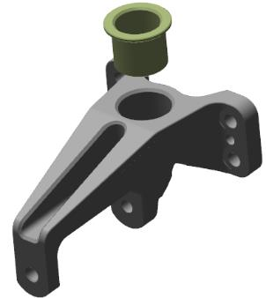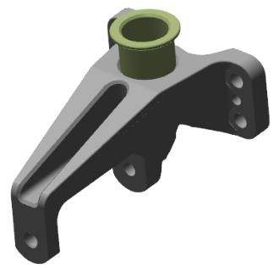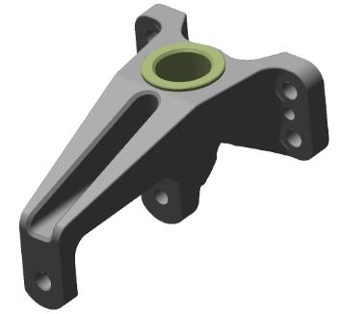
Find the gimbal 00134991 and 4 bearings 625zz.Degrease:
- The outer surfaces of the four 625zz bearings;
- Internal bearing seats in the gimbal 00134991.
IMPORTANT: Do not apply shaft and bushing retainer to an immediately degreased surface. Apply the retainer 5-10 minutes after degreasing. Do not allow the retainer to get into the inside of the bearing. This will render the bearing unusable.
Apply an even, thin coat of LOCTITE 648 Shaft-Bushing Fixative to the degreased bearing surface.
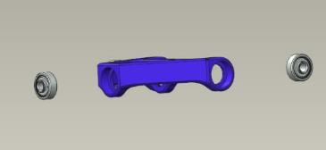
Place the bearing in the bore and install with light hammer blows through the mandrel. The bearing should be flush with the bushing. Remove any residual shaft and bushing retainer that has been squeezed out with a rag.
IMPORTANT: Do not strike any part of the bearing other than the outer ring (cage).
Repeat the steps above to install the remaining bearings.
Locate lower cardan 00134990 and bolt 00134992. Install the cardan 00134991 (with bearings) with the lugs on the holes of the assembly in the opening. Install 2 washers 5 DIN 125 between the bearings on the cardan and the assembly.
Align the holes of the bearings and the strut assembly 00134990. Insert the bolt assembly 00134992 into the aligned holes with the head on the side of the cardan lugs. Slide the bolt through the holes until the threads come out. 5 DIN 6798A washer, screw on the M5 DIN 935 nut. Using two 8 mm combination wrenches, tighten the nut until the 5 DIN 6798A washer is fully compressed. Locate the hole in the bolt assembly 00134992, which should match the slot in the M5 DIN 935 nut. If the hole is not visible, tighten the nut until the hole matches the slot.
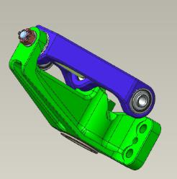
IMPORTANT: Do not screw the nut to match the bore and slot. This will result in rapid unit failure and backlash.Lack of washers between bearing and unit will result in malfunction, jamming and unit failure.
Find the front strut truss 00108746, nose strut shock absorber, lower gimbal 00134990.
Install, with the bushings up and the lugs facing out, the front strut truss 00108746 into the lower bushing on the nose strut shock absorber. Check the rotation of the truss in the bushing. Rotation should be smooth, with no jerks or jams. Place the lower 00134990 gimbal on top of the truss pin, align the holes and press it against the shock absorber.
Check the rotation of the truss in the bushings. The rotation should be smooth, without jerks or jams. Install, tighten with 8 mm wrench, 4 bolts M5x16 DIN 962SK. Check the rotation of the truss in the bushings. The rotation should be smooth, without jerks or jams.
Remove the M5x16 DIN 962SK bolts from the holes. Degrease the threaded parts of the bolts. Apply an even thin layer of LOCTITE 648 shaft and bushing retainer to the degreased surface of the M5x16 DIN 962SK bolt. Install the bolt in one of the holes.
Tighten with an 8 mm wrench. Repeat the above steps for the remaining bolts. Install an 8 mm socket head on the torque wrench. Set the torque wrench to a torque of 5 Nm. Tighten the bolts securing the assembly with the wrench to a torque of 5 Nm. Check the rotation of the truss in the bushings. The rotation should be smooth, without jerks or jams.
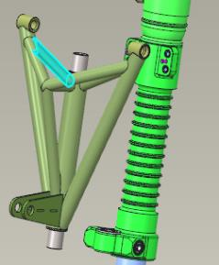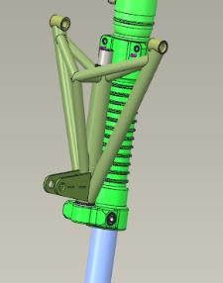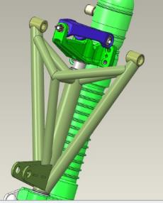
Insert the 0.8 mm balancing wire into the hole in the bolt head on the left side of the post. Pull the wire through the hole, holding both ends of the wire with great force to align it. Make a twist of 8-10 turns, thread one end into the hole in the head of the bolt next to it, thread it through the hole. Pull the wire through the hole, with a lot of force on both ends of the wire to align it. Make a twist of 4-6 turns near the bolt head, bite off the remaining parts of the wire, and bend the twist toward the strut assembly. Repeat the above steps to secure the remaining bolts.
Find right and left fork parts 00179962 and 00179964, 2 625ZZ bearings and 2 F625ZZ bearings, 4 6x20 DIN912 bolts, 4 M6 DIN 985 nuts.Degrease:
- The outer surfaces of the four bearings;
- Internal bearing seats in fork parts.
IMPORTANT: Do not apply shaft and bushing retainer to an immediately degreased surface. Apply the retainer 5-10 minutes after degreasing. Do not allow the retainer to get into the inside of the bearing. This will render the bearing unusable.
Apply an even, thin coat of LOCTITE 648 Shaft-Bushing Fixative to the degreased bearing surface.
Install bearing 625ZZ into the bore on the left side of the fork and install with light hammer blows, through the mandrel. The bearing should fit below the level of the bushing. Use a rag to remove any residual bushing shaft retainer that has been squeezed out. Place bearing F625ZZ into the bore on the left side of the fork and install with light hammer blows through the mandrel. The bearing should be flush with the bushing, with the bearing shoulder against the bushing face. Remove any residue of bushing shaft retainer that has been squeezed out with a rag.
IMPORTANT: Do not strike any part of the bearing other than the outer ring (cage).
Repeat the above steps to install the bearings in the right side of the fork.
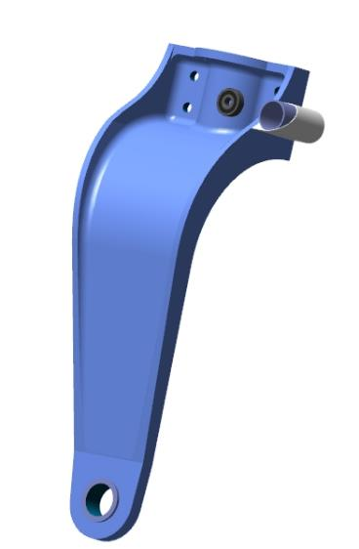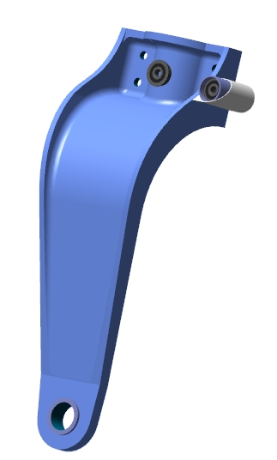
Locate the shock absorber (previously assembled). Try on the fork parts on the stem. Clean the parts of the fork and shock absorber stem to be joined according to steps 3 and 4.
Prepare 50 grams of adhesive according to standard operation 1, apply according to standard operation 5.1. Prepare adhesive according to standard operation 2, apply to both parts of the fork according to standard operation 5.2.
Connect the two parts of the fork on the stem, install the bolts in the holes. Install the nuts, tighten with a 10 mm combination wrench until the two planes are completely aligned, in the area of the stem. Make sure that the adhesive has been squeezed out of all parts. Clean the place of work according to standard procedure 7.
IMPORTANT: Do not allow adhesives to come in contact with the stem. This will inevitably result in loss of performance. If the adhesive gets on the stem, remove it immediately with a rag soaked in solvent.
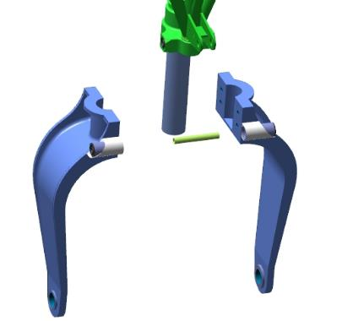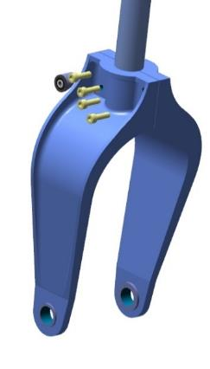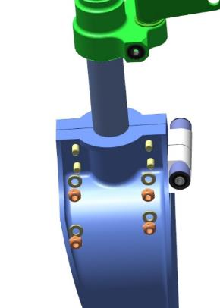
Locate the spline joint (previously assembled). Bring the spline joint to the post. Turn the spline joint nut, on the rocker joint, to the right, with the lugs to the girth of the rack and fork assembly. Place the lower part of the spline joint into the girth of the spline joint assembly on the fork, aligning the holes in the lugs and bearings. Place washers 5 DIN 125 between the rocker arm of the spline joint and the bearing. Install the bolt 00109585 in the aligned holes. Install washer 5 DIN 6798A, screw on nut M5 DIN 935, using an 8 mm wrench, screw on nut M5 DIN 935 until the bolt hole and nut slot match.
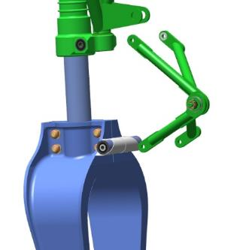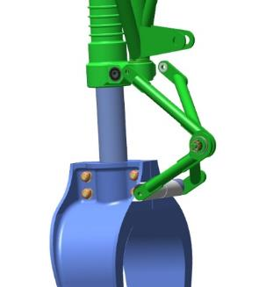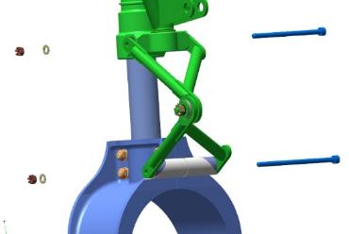
Insert a 1.0x35 DIN 94 cotter pin into the coincident slot of the M5 DIN 935 nut and the bolt hole 00109585. Tighten the connection by loosening the cotter pin tabs with a #1 straight blade screwdriver.
Check the movement of the hinge spline on the assembly by deflecting it up and down. The movement should be smooth, without jerks or jams.
IMPORTANT: Do not twist the nut to match the hole and slot. This will result in rapid assembly failure and backlash.
Rotating the fork around the stem axis, align the spline joint rocker lugs and bearings on the strut body, with the front strut truss 00108746 on the spline joint.
Place the top of the spline joint into the girth of the bearings on the rack, aligning the holes in the eyelets and the bearings. Place washers 5 DIN 125 between the rocker arm of the spline joint and the bearing. Install the stud 00109588 in the aligned holes. Install the washer 5 DIN 6798A, screw on the nut M5 DIN 935 using an 8 mm wrench until the stud hole and the nut slot match. Insert a 1.0x35 DIN 94 cotter pin into the coincident slot of the M5 DIN 935 nut and the stud hole 00109588.
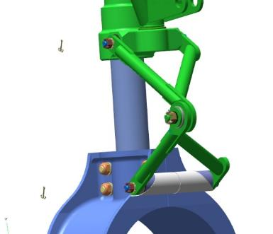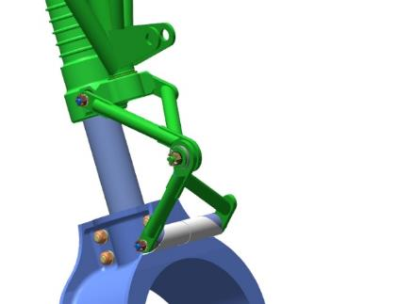
Tighten the joint by loosening the cotter pin tabs with a #1 straight blade screwdriver.
IMPORTANT: Do not twist the nut to match the hole and slot. This will result in rapid assembly failure and backlash.
Find wheel 00133929, wheel axle pins 00136417 and tubes 00136415, 00136414, 00136411, bolt 6x108 DIN 912, nut M6 DIN 985.
Position, toward you, the rack with the front rack truss 00108746; Position the wheel on the table 00133929 with the charging valve up from the table.
Slide the wheel into the fork opening, align the holes in the fork and wheel. Install tube 00136411 in the holes, install tube 00136414 and 00136415 between the fork and wheel. Install bushings 00136417 on the outside of the fork, align with tube 00136411. The bushings should be flanged until they stop against the fork. Install the 6x108 DIN 912 bolt through the bushings, screw on and tighten the M6 DIN 985 nut.
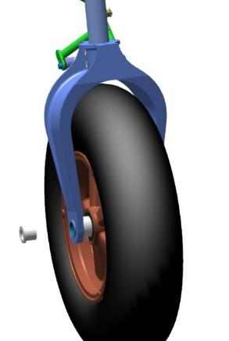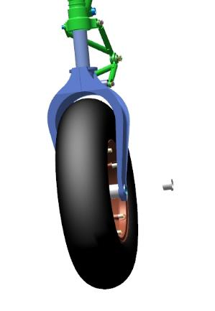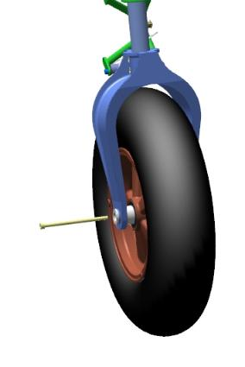
Check the ease of turning the wheel. The wheel should turn easily, the sides of the wheel should not rub against any part of the fork
Find a rocker 00134425, 2 axis weights 00134987, one axis 00134964.
Degrease:
- Outer threaded parts of the tie rod axles;
- Internal threads in the rocker 00134425 .
IMPORTANT: Do not apply shaft and bushing retainer to an immediately degreased surface. The fixative can be applied 5-10 minutes after degreasing.
Apply an even, thin coat of LOCTITE 648 Shaft-Hub Locker to the degreased surfaces.
Alternately screw the axles of the tie rods into the threads of the rocker arm. Tighten the axles 00134987 with a 10 mm wrench, the axle 00134964 with a 14 mm wrench until there are no gaps between the axle flanges and the rocker plane.
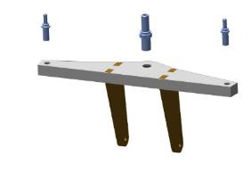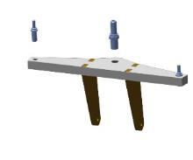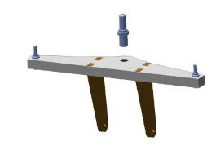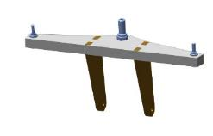
Engage the girth of the rocker arm lugs on the rack-mounted cardan. Place washers 5 DIN 125 between the rocker arm and the bearing. Align the holes of the lugs and the cardan. Install the bolt 00134966 in the aligned holes. Install the washer 5 DIN 6798A, screw on the nut M5 DIN 935, use an 8 mm wrench to screw on the nut M5 DIN 935 until the stud hole and the nut slot match. Insert a 1.0x35 DIN 94 cotter pin into the coinciding slot of the M5 DIN 935 nut and the bolt hole 00134966.
Tighten the joint by loosening the cotter pin tabs with a #1 straight blade screwdriver.
Control Operations:
- Check the movement of the rocker on the gimbal by tilting it back and forth. The movement should be smooth, without jerks or jams.
- Check the ease of rotation of the wheel. Rotation should be easy without jerks or jams.
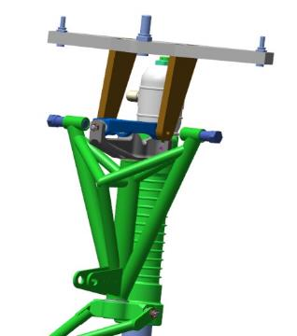
IMPORTANT: Do not twist the nut to match the hole and slot. This will result in rapid assembly failure and backlash.

Assembly of landing gear retractor cylinders
To complete this work you will need:
- Key for the bottom cover of the TE;
- Key for the top cover of the TE;
- Key for hydraulic cylinder housing TE;
- Spacer for TE cover sensors;
- Hex key 2 mm;
- LOCTITE 648 bushing shaft retainer;
- Solvent methyl acetate 100 grams;
- Clean rags 100x100 mm 6 pieces;
- Latex gloves 1 pair;
- Torque wrench 30-100Nm;
- 14 mm socket head;
- Screwdriver with straight slot #1;
- No. 2 straight blade screwdriver;
- Combination wrench 14 mm;
- Combination wrench 16 mm;
IMPORTANT: Before working with parts that are part of the aircraft hydraulic system, keep the workplace free of small objects and dust. Keep clean and free of foreign objects and liquids.
Unpack it and stack it on the table:
- 2 hydraulic cylinder housings 00232984;
- 1 hydraulic cylinder housing 00134400
- 3 hydraulic cylinder covers upper 00134092;
- 3 lowering hydraulic cylinder covers 00134093;
- 3 bronze guide bushings 00134094;
- 3 nuts 00109708;
- 3 pucks 00109709;
- 3 pucks 00109710;
- 3 collar stems 00109711;
- 3 pistons 00109712;
- 3 nuts 00109717;
- 3 retaining rings 00109716;
- 6 split rings 00109715;
- 3 guides 00109713;
- 3 locknuts 00134097;
- 2 hydraulic cylinder rods 00134107;
- 1 hydraulic cylinder rod 00109718;
- 12 bushings 00109648;
Count it out and stack it on the table:
- 6 fittings 2010-1/8;
- 3 cuffs 20x26x5 K33 PU;
- 6 cuffs 24x30x5 K95 NBR;
- 3 dirt wipers 20x28x4/7 K05 PU;
- 3 rings 20-23-19;
- 3 cotter pins 1,0x65 DIN 94;
- 6 rings 34-37-19;
- 3 D10 swivel heads;
- 12 M4x16 spring clips;
- 3 GE 10 E bearings.
Find 4 M4x16 spring clips. Screw the screws, using a 2 mm hex key, into the holes in the bushing 00109648 until 1-2 threads protrude behind the bushing. The screws should be screwed in without misalignment or seizure.
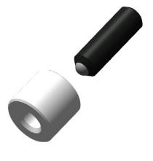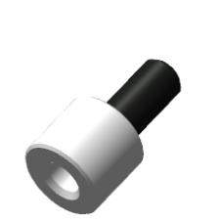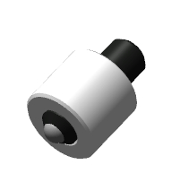
Remove the screws from the holes with a 2 mm hexagon wrench. Adjust the caliper to a value of 1.8 mm.
Degrease:
- Internal threads of 4 bushings 00109648;
- Outer surface of 4 M4x16 spring clips.
IMPORTANT: Do not apply shaft and bushing retainer to an immediately degreased surface. The fixative can be applied 5-10 minutes after degreasing.
Apply LOCTITE 648 Shaft-Bushing Fixative to the degreased inner surface of the bushing 00109648 with an even thin layer of LOCTITE 648 Shaft-Bushing Fixative. Set the bushing aside on a table. Install an M4x16 spring retainer on a 2 mm hex key. Apply an even, thin coat of LOCTITE 648 Shaft-Bushing Retainer to the outer, degreased surface of the screw. Install the M4x16 spring retainer into the bushing hole 00109648, tighten the screw until the spherical part protrudes behind the bushing. Check the protrusion of the screw with a caliper. Tighten the screw to the value of 1.8 mm fixed on the caliper.
Use a rag to remove any residual bushing shaft retainer that has been squeezed out, and carefully remove the bushing shaft retainer from the threaded and spherical part of the screw.
IMPORTANT: Do not allow shaft and bushing retainer to get on the protruding threaded and spherical parts of the screw. Use a rag to remove immediately any spillage of retainer. The bushings may only be installed with the screws after 1-2 hours from the time of application of the bushing shaft locking agent.
Repeat the above steps for the remaining M4x16 spring retainers and bushings 00109648.
Find hydraulic cylinder lower cover 00134093, bronze bushing 00134094, collar prch-00032803 and dirt collector 20x28x4/7 K05 PU. Degrease:
- The inside of the lid 00134093;
- The outer surface of the bushing is bronzed 00134094.
Place the collar prch-00032803 inside the cover of the hydraulic cylinder cover of the lower 00134093, with the slot against the thread. Slide the collar as far as it will go, inside the cover.
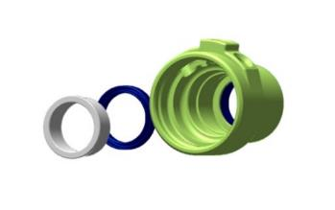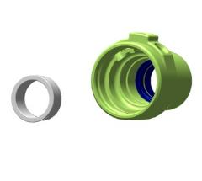
Apply an even, thin coat of LOCTITE 648 Shaft-Bushing Fixative to the degreased surface of the bronze bushing 00134094.
IMPORTANT: Do not allow the retainer to get into the inside of the bushing. This will render the bushing unusable.
Insert the bronze bushing 00134094 into the bore and install with light hammer blows through the mandrel.
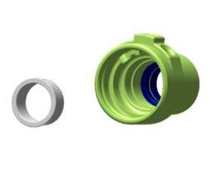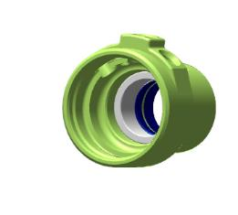
Use a rag to remove any residue of bushing shaft retainer that has been squeezed out.
Place a 20x28x4/7 K05 PU wiper in the upper groove, outside the cover 00134093, with the bevel outside the cover. Spread the wiper prch-00032798 in the groove.
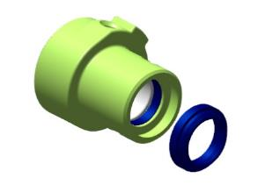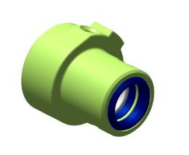
Install, hand tighten the cover sensor spacer.
Screw the bushing 00109648 into one of the holes as far as it will go. The bushing should screw in without seizure or misalignment. Screw in the second bushing. Remove the bushings from the holes. Degrease:
- Internal threaded surfaces of the cover 00134093;
- Outer threaded surface of the bushings 00109648.
- The outside threaded surface of the 2010 1/8 fitting.
Apply an even, thin layer of LOCTITE 648 shaft and bushing retainer to the degreased threaded surfaces of the lower 00134093 hydraulic cylinder cover. Set the cover aside on a table.
Apply a thin, even coat of LOCTITE 648 shaft and sleeve locker to the outer, degreased surface of the 2010 1/8 fitting. Screw in, tighten the 2010 1/8 fitting with a 9 mm combination wrench. The free threaded part of the 2010 1/8 fitting must be turned away from the smaller diameter of the cover and parallel to the axis of the cover.
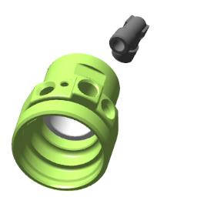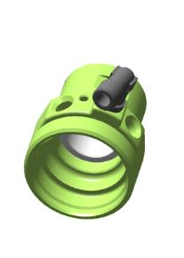
Apply an even, thin coat of LOCTITE 648 shaft-bushing retainer to the outer, degreased surface of the bushing 00109648.
Set the multimeter to dial (or minimum resistance) mode. Touch the multimeter probe to the 2010 1/8 fitting and the other probe to the retainer. Start screwing the bushing 00109648 into the bore of the hydraulic cylinder cover with a 2mm hex wrench when a beep is heard (or "0" is displayed). After the beep, make another ¼ turn.Repeat the above steps to install the second bushing.
IMPORTANT: If the locking mechanism is rotated when installing the bushing, disassemble and reassemble with the bushing. Otherwise there will be oil leaks from this place permanently. After a certain period of operation the hydraulic cylinder and the entire hydraulic system will fail.
Remove the cover sensor spacer from the cover of the lower hydraulic cylinder 00134093. Use a rag to remove any residual shaft and bushing retainer that has been squeezed out, carefully remove the shaft and bushing retainer from the threaded and spherical part of the screw.
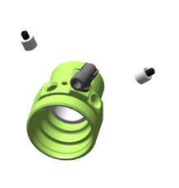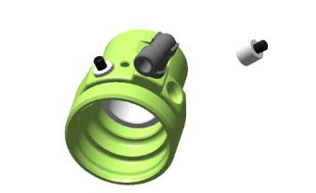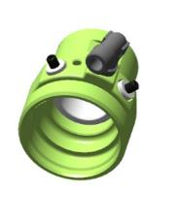
IMPORTANT: Do not allow shaft and bushing retainer to come into contact with the threaded and spherical parts of the screw. Use a rag to remove any immediately spilled retainer. Do not allow the shaft sleeve retainer to get into the internal cavity. This will render the hydraulic cylinder inoperable.
Locate the hydraulic cylinder cover 00134092. Install the cover gauge spacer. Repeat all steps above to install the bushings 00109648 into the top cover 00134092.
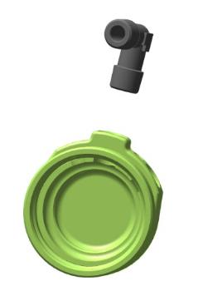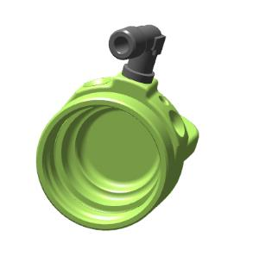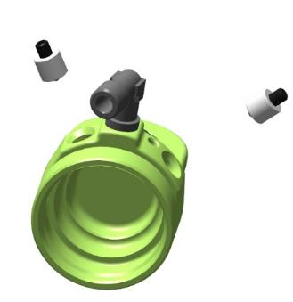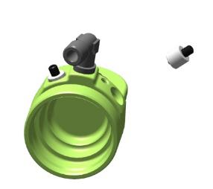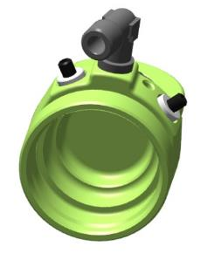
Find rods 00109711 and 00134107, retaining ring 00109716.
Screw the stem 00109711, with the long threaded part, into the stem 00134107 on the non-fluted side by hand until it stops. There should be a gap of 3 mm between the two rod ends.
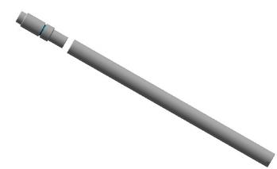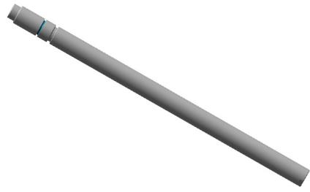
Install the retaining ring 00109716 on the stem 00109711, slide it along the stem until it fits into the groove on the stem.
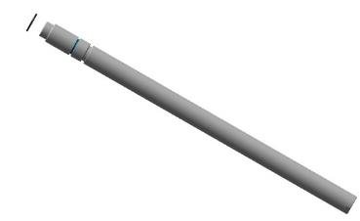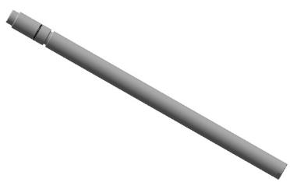
Screw the rods together. Place the washer 00109709 on the stem 00134107, with the recess on the stem. Screw the stem 00109711, with the long threaded part, into the stem 00134107, from the non-fluted side, by hand until it stops. Check the washer 00109709 between the two stems for play and rotation. Disassemble the parts, put them on a table, degrease them:
- Internal threads of the stem 00134107;
- Outer thread of the stem 00109711.
Apply an even, thin coat of LOCTITE 648 shaft bushing retainer to the degreased female threads of the stem 00134107. Set the stem aside on a table. Apply a thin, even coat of LOCTITE 648 Shaft-Bushing Retainer to the male threaded, degreased surface of the stem 00109711.
Place the washer 00109709 on the stem 00134107, with the recess on the stem. Screw the stem 00109711, with the long threaded part, into the stem 00134107, on the non-fluted side, by hand until it stops.
Check the washer 00109709 between the two rods for play and rotation. Remove any residual bushing shaft retainer that has been squeezed out with a rag and carefully remove the bushing shaft retainer from the threaded and spherical part of the screw.
IMPORTANT: Do not allow shaft bushing retainer to get on the protruding threaded and smooth parts of the rods. Use a rag to remove any immediately spilled retainer.
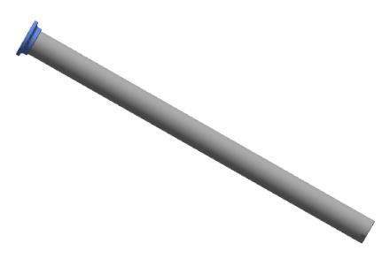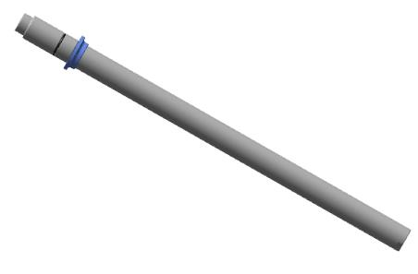

Find and put on the table the piston 00109712, 2 sleeves prch-00032800, ring 20-23-19, guide. Install on the piston 00109712 in the grooves, on both sides of the sleeves prch-00032800 with the grooves facing outwards.
Install the guide ANG-3200-00032757-009 between the collars, in the middle groove on the piston. Start, install in the groove in the inner cavity of the piston cavity 00109712 ring 20-23-19. The ring must lie tightly in the groove.
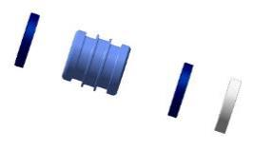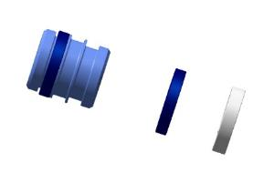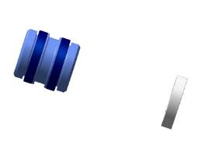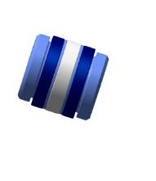

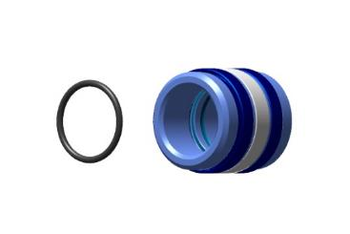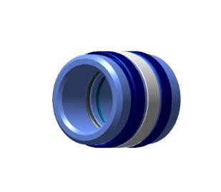
Find 2 split rings 00109715, washer 00109710, nut 00109717.
Install the ring 00109715 on the stem, on the male thread side, with the bevel toward the male thread of the stem.
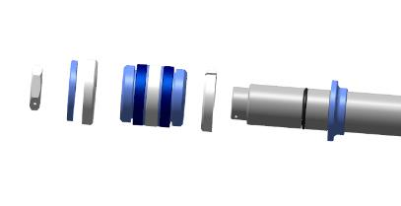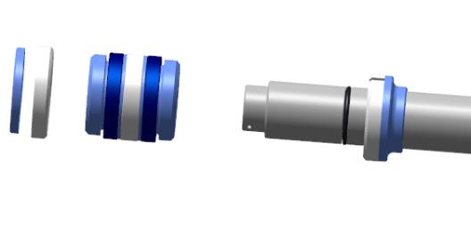
Find a free groove in the inner cavity of the piston (previously assembled). Install the piston with the collars on the rod, push the piston all the way down the rod. Install the ring 00109715 on the rod, on the male thread side, beveled away from the male thread of the rod.
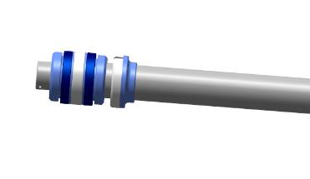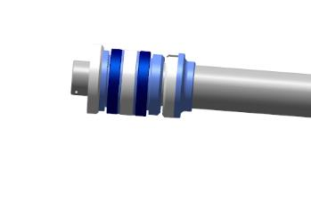
Place the washer 00109710 on the ring, screw on the nut 00109717. Clamp the lower part of the stem with the flats in a vise. Only the part with flats should be clamped. Tighten the nut 00109717 with a 19 mm combination wrench. Hold the assembly by the stem to avoid misalignment and the possibility to tighten the nut.
Remove the assembly from the vise.
Locate the lower cover with the sensors installed. Lubricate the inside surface of the bushing in the cover with machine oil, a thin layer. Install the cover, threaded side toward the piston, thread the bushing through the rod, and slide it along the rod to the piston. The cap should move along the rod without sticking, with some force.
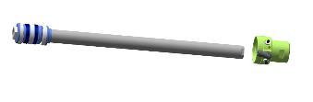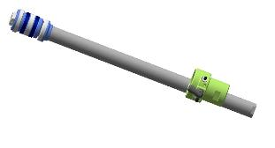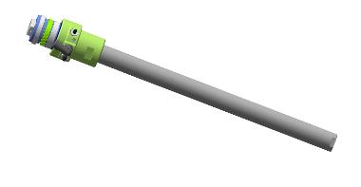

Locate the nut 00109708, screw it by hand into the back of the stem, with the flats, until it stops. The nut should screw in easily. Unscrew the nut from the stem.
Degrease:
- Internal threads of the stem 00134107;
- Outer threads of the nut 00109708.
IMPORTANT: Do not apply shaft and bushing retainer to an immediately degreased surface. The fixative can be applied 5-10 minutes after degreasing.
Apply an even, thin coat of LOCTITE 648 shaft bushing retainer to the degreased female threads of the stem 00134107. Set the stem aside on a table. Apply a thin, even coat of LOCTITE 648 Shaft-Bushing Retainer to the male threaded, degreased surface of the nut 00109708.
Screw the nut 00109708 into the back of the stem with the flats by hand until it stops. Using a 17 mm combination wrench, tighten the nut 00109708 with a second 17 mm combination wrench until there is no more play between the end of the stem and the end of the nut. Remove any residual shaft bushing retainer that has been squeezed out with a rag.
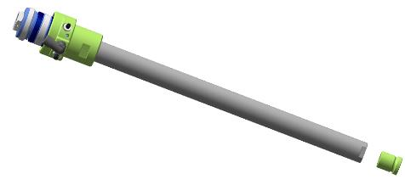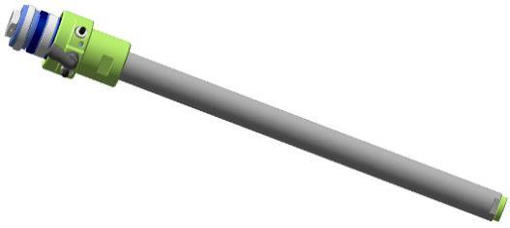

Locate the hydraulic cylinder body 00137948 and the lock nut 00134097. Hand screw the lock nut onto the hydraulic cylinder body on the longer thread side.
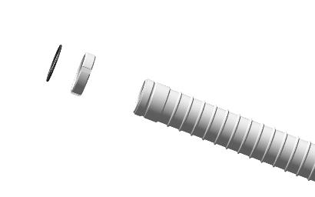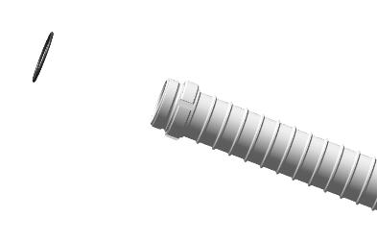
Locate 2 rings 34-37-19. Install the ring on either side of the male threaded part of the hydraulic cylinder body 00137948. Carefully thread the ring through the threads, laying it down and spreading it out in the groove on the hydraulic cylinder body.
Repeat the steps above to install the second ring 34-37-19 on the hydraulic cylinder body 00232984.
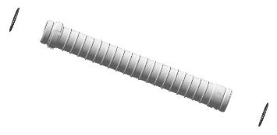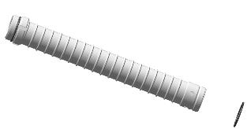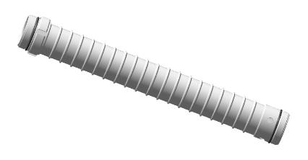
Locate the top hydraulic cylinder cover 00134092. Screw it onto the housing threads by hand until it stops 00232984. The cap should screw on easily, without misalignment or seizure.
IMPORTANT: When screwing on the cap, do not allow the ring on the cylinder body to buckle. If buckling begins to occur, unscrew the cap until the ring is aligned in the groove and re-screw. A wrinkled seal will cause fluid leakage.
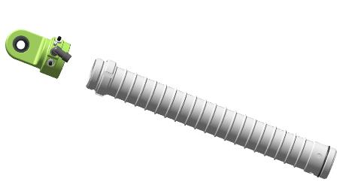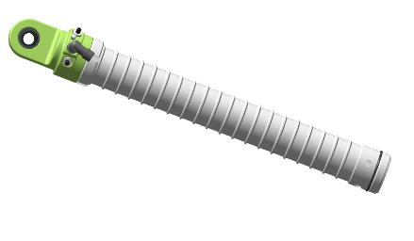
Place the hydraulic cylinder body with cover on the table. Place the TE cylinder body wrench in the reinforcement location. Tighten the parts with the MU top cover wrench to a palpable torque of approximately 1/10 turn.
Wet your finger in the oil several times and wipe the inside of the hydraulic cylinder body by turning it in your hand. A shiny, greasy residue should be left. Wipe, dipping your finger in oil, the cuffs of the prch-00032800 cuffs. A shiny, greasy residue should remain.
Check the location of the prch-00032794 clips on the hydraulic cylinder covers 00134093 and 00134092. Turn the rings 00109715 so that their cuts are on the opposite side of the prch-00032794 retainers. Mark with a marker on the ends of the rod bushings the location of the cuts of the rings 00109715.
Install the mounting half-rings on the piston part, using a clamp. Place the 00137948 housing on top of the mounting half-rings, piston into the housing, marking from the prch-00032794 clips. Slide the hydraulic cylinder body onto the piston rod by lightly striking the top 00134092 cover with a hammer. When the mounting half-rings slide onto the rod, remove them by removing the clamp. Slide the hydraulic cylinder cover lower 00134093 over the rod to the threads on the housing. Screw the cap on by hand until it stops, The cap should screw on easily, without misalignment or seizure.
IMPORTANT: When screwing on the cap, do not allow the ring on the cylinder body to buckle. If buckling begins to occur, unscrew the cap until the ring is aligned in the groove and re-screw. A wrinkled seal will cause fluid leakage.
Install the MU body wrench in the reinforcement location. Tighten the parts with the MU lower cover wrench to a noticeable torque, approximately 1/10 of a turn. Look at the position of the covers in relation to each other - the threaded hole of the hydraulic cylinder cover of the lower 00134093 should be located in the middle, between the threaded holes of the cover of the upper 00134092. If this is not the case, tighten the covers one by one with a wrench.
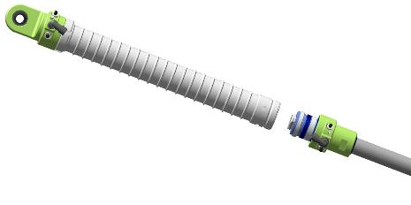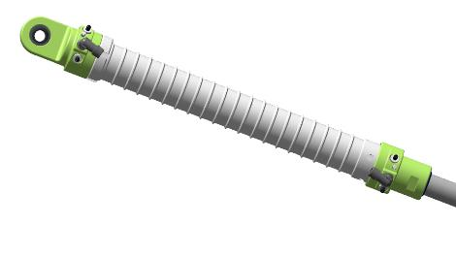
Ensure that the tank is closed and that the arrows on both pressure gauges show "0". Set the adjustment on the nitrogen reducer to "0", that the filler valves are closed.
IMPORTANT: Do not leave the cylinder valve open and the hose pressurized for long periods of time.
Screw the test fixture fitting onto the 2010 1/8 fitting on the hydraulic cylinder cover of the lower 00134093 to the full length of the thread.
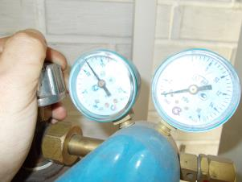
IMPORTANT: Do not use oxygen instead of compressed air!!! This will cause an explosion!!! Do not use compressed air with a pressure of more than 35 atmospheres (3.5 MPa).
Open the valve on the cylinder, set the pressure on the second manometer to 10atm (1MPa). Open the gas supply valve on the filling device. The hydraulic cylinder rod should retract inward.
Control Operations:
- Set the multimeter to the dial (or minimum resistance) mode. Place the feeler gauges on the prch-00032794 clips of the top cover 00134092. A sound should be heard( or show a value of "0"). Touch the multimeter probe to the 2010 1/8 fitting and the second probe to one of the prch-00032794 retainers. A sound should be heard ( or the value "0" should be displayed). Touch the multimeter probe to the second prch-00032794 detector. A sound should be heard ( or value "0" should be displayed).
- Repeat the steps above to check the prch-00032794 latches in the bottom cover 00134093. No sound should be heard (or any values displayed).
- Open the gas supply valve on the dispenser. Use your finger to check each 2010 1/8 fitting for air escape. No air should be coming out.
IMPORTANT: If air is coming out of the 2010 1/8 fitting, this indicates improper installation or damaged collars.
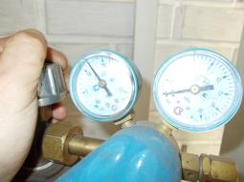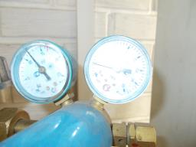
Note. If the stem has not moved, gently increase the pressure to no more than 15 atmospheres (1.5MPa).
Unscrew the test fixture fitting from the bottom cover, and screw on any of the 2010 1/8 fittings.
Unscrew the test fixture fitting from the bottom cover, and screw it onto the unmarked 2010 1/8 fitting. Put your finger on the labeled fitting 2010 1/8 of the top cover 00134092.
Open the gas supply valve on the filling device. The hydraulic cylinder rod should come out and a click may be heard in the cover from the piston moving out of the end position. There should be no air leaks from the marked fitting on the 2010 1/8 top cover 00134092.
Repeat the actions described above for checking the operation of the hydraulic cylinder with air and checking the contacts, 10-15 times.
Locate the M10 DIN 555 nut. Screw the nut by hand onto the threaded part of the D10 head as far as it will go. Screw the tip with the nut into the threaded part of the rod end until it stops by hand. Set the hydraulic cylinder aside on the table.
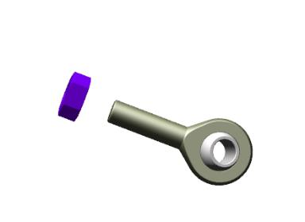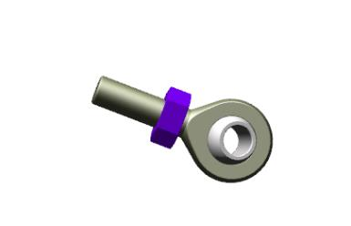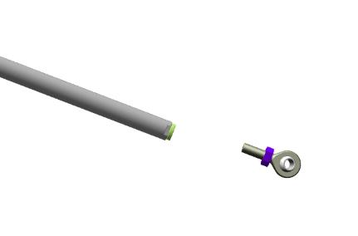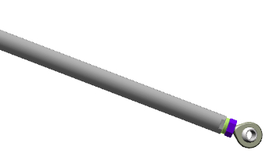

Make harnesses according to the diagram and attach to each hydraulic cylinder.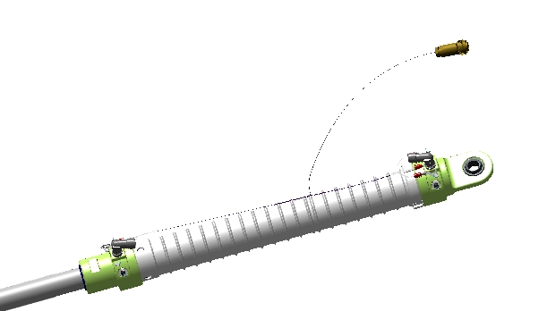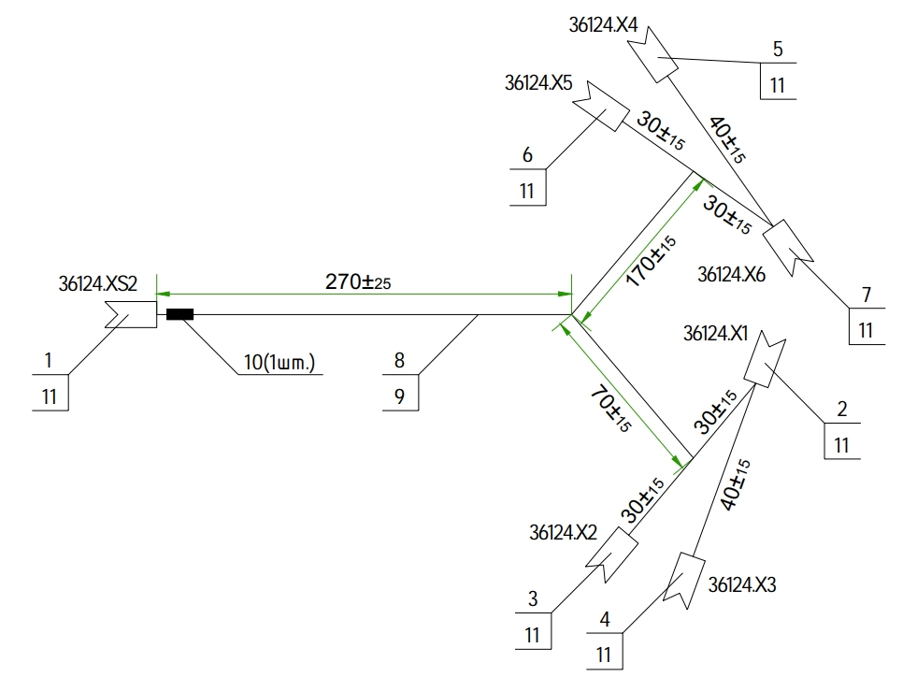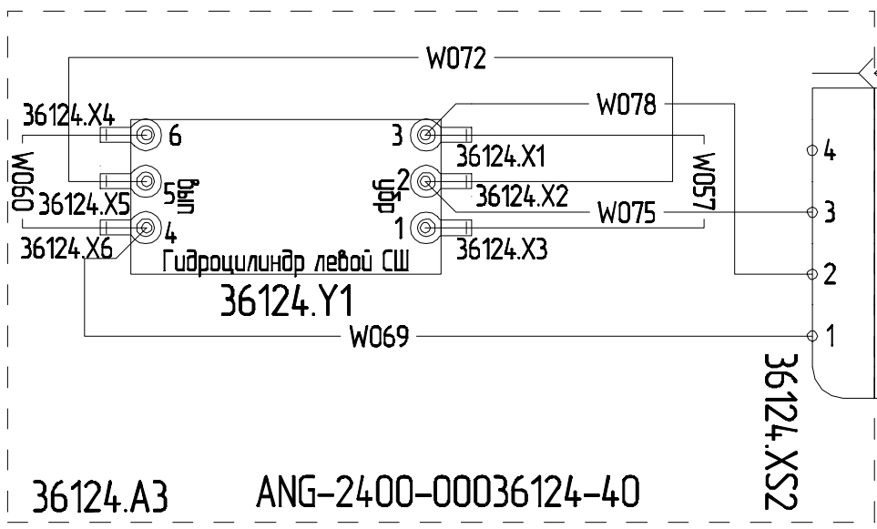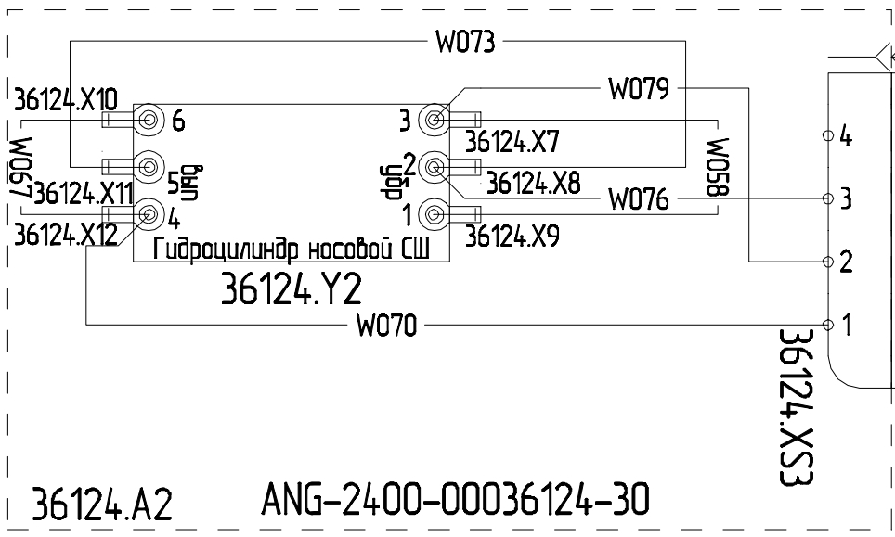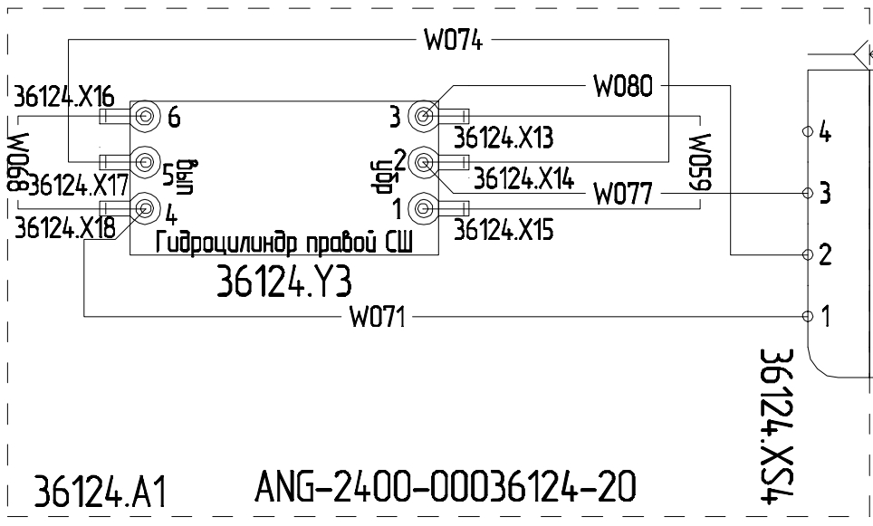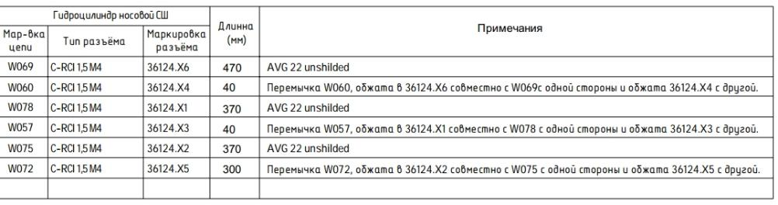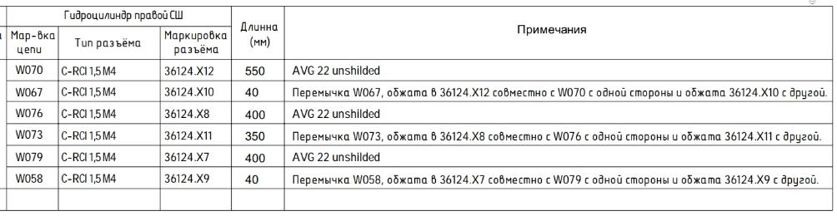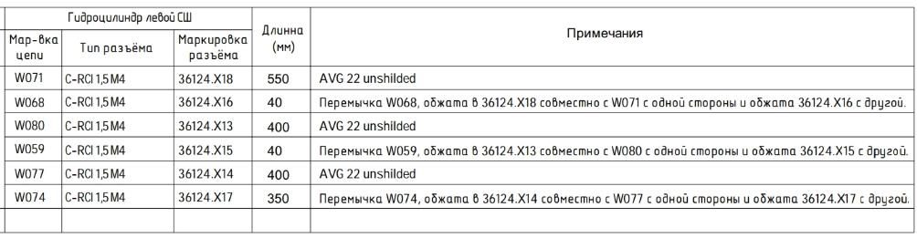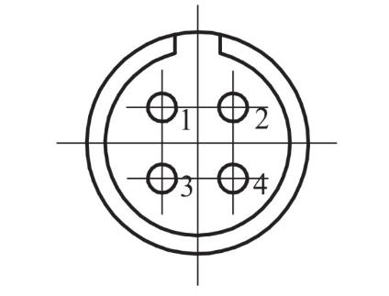
Repeat the above steps in the same order for the remaining two hydraulic cylinders.

Installing the nose landing gear support
To complete this work you will need:
- Mobile desk;
- No. 2 straight blade screwdriver;
- LOCTITE 648 bushing shaft retainer;
- 2 combination wrenches 17 mm;
Unpack it and stack it on the table:
- Landing gear nose strut (assembled from4.6 );
- Chassis retraction hydraulic cylinder (assembled at4.7 );
- 2 nose strut truss screws 00109644;
- bolt 10x65 DIN 6912;
- nut M10 DIN 935;
- washer 10 DIN 6798A;
- 2x60 DIN 94 cotter pins.
IMPORTANT: Before performing any type of work, make sure that the part of the airplane to be worked under is securely and stably fastened. Unsecured parts may not only be damaged, but may also cause injury from falling.
Place the nose landing gear strut with the spline joint against the fuselage. Lift the strut up, aligning the middle pin with the bearing bore. Slide the pin into the bearing. Place washer 10 DIN 6798A on the protruding threaded part and screw on nut M10 DIN 935.
Align the bushing on the nose strut truss with the bearing hole on the fuselage.
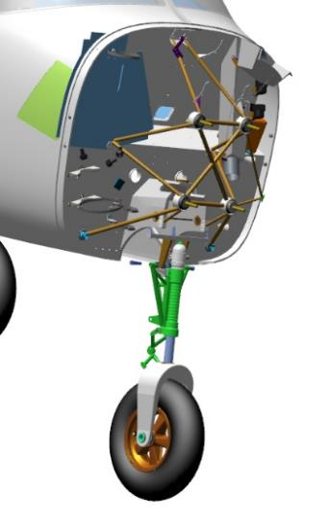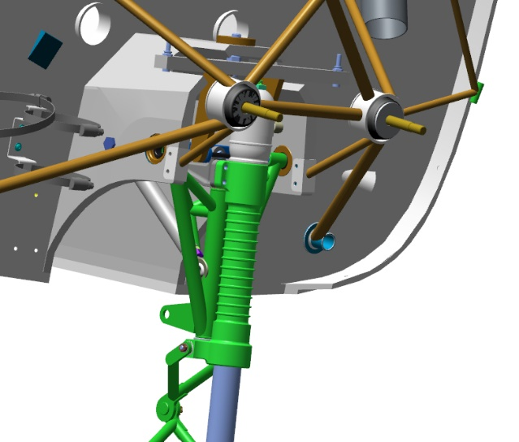
Insert the screw 00109644 into the matching hole on the fuselage, thread the bolt into the threads of the nose strut truss bushing.
Repeat for the second screw 00109644. Tighten the two screws with a 17 mm combination wrench until they stop against the washer 10 DIN 6798A.
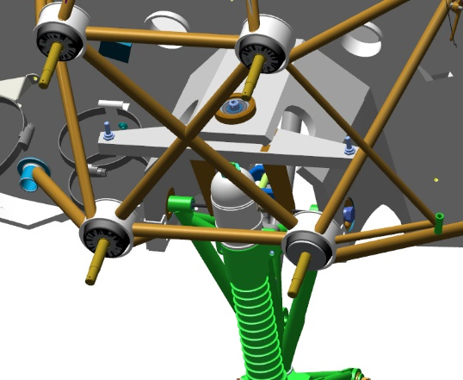
Move under the fuselage, to the side of the nose strut.
Move the nose strut by hand into the recess to simulate landing gear retraction. Inspect the retracted strut for resting against other airplane components and for clearance differences. The clearances should be even and approximately equal on both sides of the landing gear strut. There should be no bumps in the fuselage structural members. Repeat the movement and inspection 2-3 times.
Move from under the fuselage. Use a 17 mm combination wrench to remove one screw 00109644.
Degrease the threaded part of the screw 00109644, threaded part in the nose strut truss bushing.
IMPORTANT: Do not apply shaft and bushing retainer to an immediately degreased surface. The fixative can be applied 5-10 minutes after degreasing.
Apply a thin layer of LOCTITE 648 shaft and bushing retainer to the degreased surface of the screw 00109644. Install the screw into the threaded hole in the nose strut truss. Tighten with a 17 mm combination wrench.
Repeat the above steps to install the second propeller, on the opposite side of the fuselage.
Clean the workplace and tools according to standard action 7.
On the center bearing at the top of the strut, tighten the nut with a 17 mm combination wrench until the washer 10 DIN 6798A is fully compressed. Locate the hole in the strut pin, which should line up with the slot in the M10 DIN 935 nut. If the hole is not visible, tighten the nut until the hole matches the slot.
IMPORTANT: Do not twist the nut to match the hole and slot. This will result in rapid failure of the assembly and backlash in the control system.
Insert a 2x60 DIN 94 cotter pin into the matching slot of the M10 DIN 935 nut and the strut pin hole. Tighten the connection by loosening the cotter pin tabs with a #2 straight blade screwdriver.
Find the hydraulic cylinder (assembled at4.7 ), bolt 10x65 DIN 912, washer 10 DIN 6798A. Locate the hole in the chassis recess. Insert the 10x65 DIN 912 bolt into the hole. The bolt should go in easily. Remove the bolt from the hole.
Align the hydraulic cylinder bearing hole inside the recess. Once the holes are aligned, install the bolt. Tighten the bolt with a wrench.
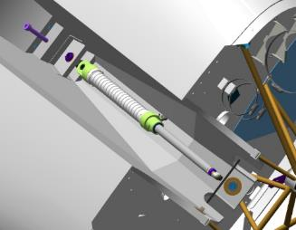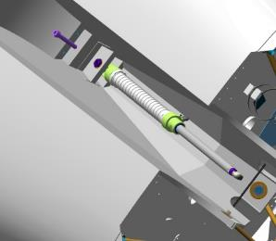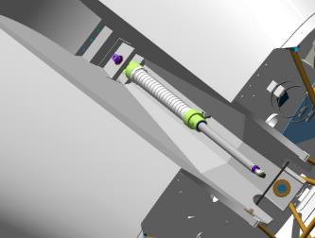
Locate the two lugs on the nose strut truss, on the side of the landing gear recess. Insert the tip of the hydraulic cylinder between the lugs and align the holes.
Insert the bolt for the hz mount into the holes, install the washer 10 DIN 6798A, nut M10 DIN 935. Tighten the nut until the washer 10 DIN 6798A is fully compressed.
Locate the hole in the bolt, which should match the slot in the M10 DIN 935 nut. If the hole is not visible, tighten the nut until the hole matches the slot.
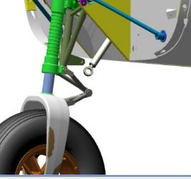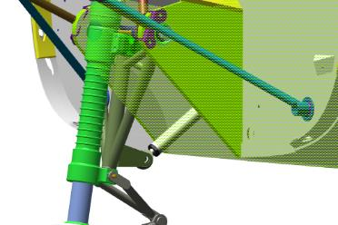
IMPORTANT: Do not twist the nut to match the hole and slot. This will result in rapid failure of the assembly and backlash in the system.
Place a cotter pin in the coincident slot of the M10 DIN 935 nut and the hole in the bolt of the pc bolt. Remove one tab, but do not perform a locking operation.

Installing the main landing gear supports
Note. The work described below is for the left main landing gear strut. Install the right landing gear strut in the same sequence.
To complete this work you will need:
- Mobile desk;
- No. 2 straight blade screwdriver;
- LOCTITE 648 bushing shaft retainer;
- 2 combination wrenches 17 mm;
- Hexagonal wrench 8 mm;
Unpack it and stack it on the table:
- Left landing gear strut (assembled by you earlier);
- Right landing gear strut (assembled by you earlier);
- 2 hydraulic cylinders for chassis retraction (assembled by you earlier);
- 4 bearing seat bolts 00178619;
- 4 nuts M10 DIN 935;
- 2 washers 10 DIN 6798A;
- 2 cotter pins 2x60 DIN 94
- 2 bolts M10x65 DIN 912
IMPORTANT: Before performing any type of work, make sure that the part of the airplane to be worked under is securely and stably fastened. Unsecured parts may not only be damaged, but may also cause injury from falling.
Check the M16X1.5 tapped holes according to standard action 6 in the main landing gear strut.
Locate the two bearing holes at the top of the main rack recess. Make sure there are no foreign objects in the holes. Locate the bearing seat bolt 00178619, check the bolt for ease of insertion into the bearing. The bolt should go into each hole easily, without play or jerk.
A helper will be needed for further work.
Start, roughly align the holes in the main landing gear strut with the holes in the landing gear recess. Insert the bolt from the rear. Turn the head clockwise and feed the fastener toward the strut until you feel the threaded parts engage. If engagement does not occur, adjust the position of the rack. Tighten the bolt until the key feels firmly engaged.
IMPORTANT: If threaded parts engage but rotation requires force, remove the bolt and start over.
Locate the location of the second bearing seat bolt by feel 00178619.
Repeat the steps above to install the second bolt.
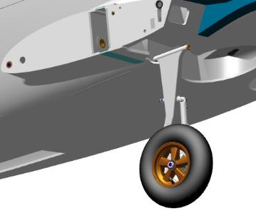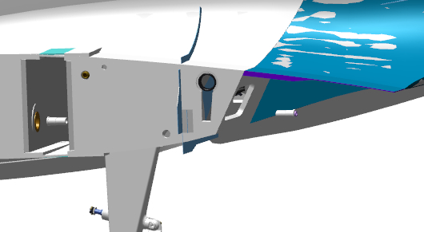
Move under the fuselage, to the side of the main prop.
Control Operations:
- Move the strut by hand into the recess, simulating landing gear retraction. Inspect the retracted strut for resting against other airplane components and for clearance differences. The clearances should be uniform and approximately equal to the contour of the landing gear strut wheel. There should be no bumps in the fuselage structure.
Repeat the movement and inspection 2-3 times. Remove the rack from the chassis recess.
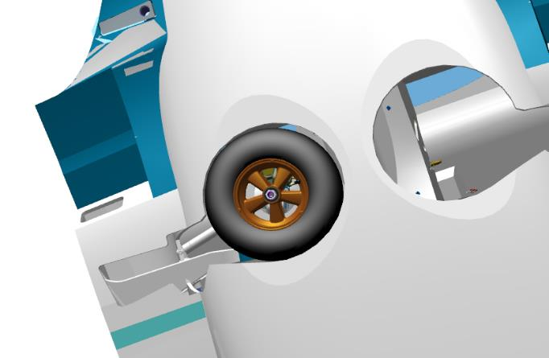
Remove one bolt 00178619. Degrease the threaded part of the bolt
IMPORTANT: Do not apply shaft and bushing retainer to an immediately degreased surface. The fixative can be applied 5-10 minutes after degreasing.
Apply a thin layer of LOCTITE 648 shaft bushing retainer to the degreased surface of the bolt 00178619.
Install the bolt into the threaded hole, tighten with an 8mm hex wrench until there is a significant feel on the key.
Repeat the above steps to install the second bolt, on the inside of the fuselage.
Clean the workplace and tools according to standard procedure 7.
Find the hydraulic cylinder (you have previously assembled), bolt M10x65 DIN 912, nut M10 DIN 935, washer 10 DIN 6798A, cotter pin 2x60 DIN 94. A helper will be needed for further work. Place under the fuselage in the area of the main landing gear strut recess all components except the M10x65 DIN 912 bolt. Locate the hole in the rear couch. Install the rc mounting bolt into the hole. The bolt should go in easily.
Locate the pin on the main strut box, on the side of the chassis recess. Install the hydraulic cylinder lug on the pin, install the 10 DIN 6798A washer on the pin, tighten the M10 DIN 935 nut with a 17 mm combination wrench, tighten the nut until the 10 DIN 6798A washer is fully compressed. Locate the hole in the pin, which should match the slot in the M10 DIN 935 nut. If the hole is not visible, tighten the nut until the hole matches the slot.
IMPORTANT: Do not twist the nut to match the hole and slot. This will result in rapid failure of the assembly and backlash in the system.
Place a cotter pin in the coincident slot of the M10 DIN 935 nut and the hole in the bolt of the pc bolt. Remove one tab, but do not perform a locking operation.
Move under the fuselage. Locate the hole in the recess. Hang, align the bearing hole in the cover and rear couch inside the niche. Once the holes are aligned, command the bolt to be installed. Make sure the bolt goes through the bearing.
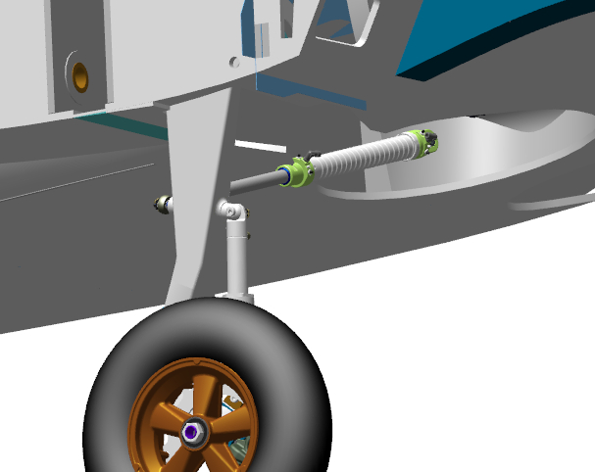
When the left main rack is complete, install the right main rack by following the steps above.
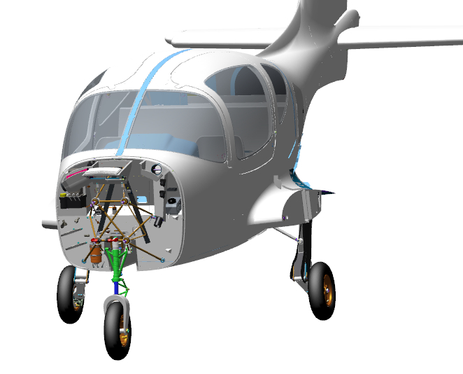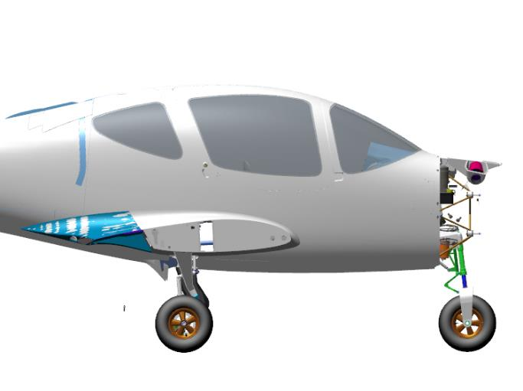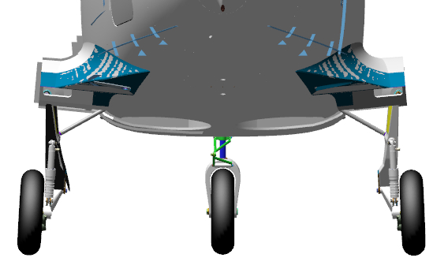
    - Assembly and installation of the footrests
Note. The work described below is for one footrest. The assembly and installation of the second footrest follows the same sequence.
To complete this work you will need:
- Mobile desk;
- Screwdriver with straight slot #1;
- LOCTITE 648 bushing shaft retainer;
- Socket head 10mm with extension;
- Pliers for internal circlips;
- Hex key 2 mm;
Unpack it and stack it on the table:
- Left footrest 00156352;
- Right footrest 00156422;
- 2 plates 00108827;
- 2 bushings 00145316;
- 2 pipes 00145323;
- 2 bushings 00145328;
- 2 engine mounts 00206442;
- 2 engines 00206510;
- 2 keys 00218280;
- Count it out and stack it on the table:
- 2 bearings 628 ZZ;
- 2 washers 7 DIN 6799;
- 2 cotter pins 1,6-16 DIN 94;
- 2 A24 DIN 472 rings;
- 2 nuts M6 DIN 985;
- 4 screws M3x8 DIN 965;
- 2 washers 6 DIN 125;
- 8 with M4x8 screws ISO7380-2
- Find the pipe 00145323 , motor support 00206442, motor 00206510, 2 screws M3x8 DIN 965. Place the motor support on the motor, fasten it with 2 screws.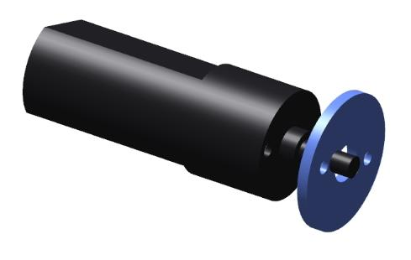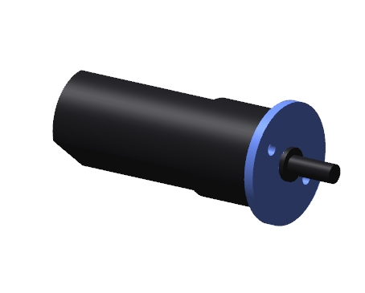
Insert the motor with support into the pipe 00145323 . The motor should enter the pipe fully, flush with or deeper than the end of the pipe. The motor with support should enter with a slight force.
Note. If the motor with the support does not enter the pipe deep enough, turn the pipe around and try again. If more force is required to move the motor, sand the end of the support that contacts the pipe with P320-400 sandpaper.
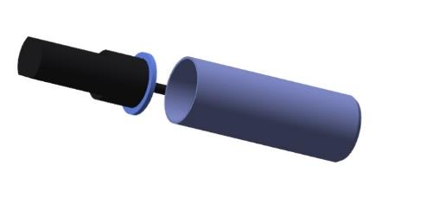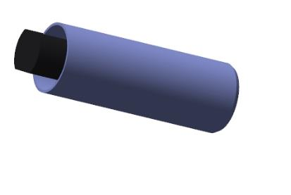
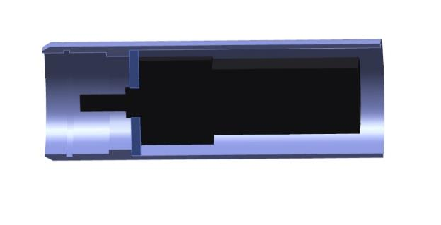
Dismantle the motor, remove the oprah, degrease the threaded parts of the M3x8 DIN 965 screws.
IMPORTANT: Do not apply shaft and bushing retainer to an immediately degreased surface. The fixative can be applied 5-10 minutes after degreasing.
Apply a thin layer of LOCTITE 648 shaft and bushing retainer evenly to the degreased M3x8 DIN 965 screws. Fasten the support to the motor with screws.
IMPORTANT: Do not apply shaft bushing retainer to the motor holes themselves. If the retainer gets inside the motor, it can cause breakage and jamming.
Prepare 10-15 grams of adhesive according to standard procedure 1. Degrease the inside of the tube, the support end and the outside of the plate. Apply the adhesive according to standard procedure 5.1 inside the tube in the support area, on the support end, inside the plate and on the tube Place the motor with support in the tube. Place the plate on the tube as far as it will go. Remove any adhesive behind the motor carefully with a rag. Remove the motor after the adhesive has cured.
IMPORTANT: Do not allow the glue in the tube to get past the motor area.Cured glue will cause difficulty in reassembly.
Clean the workplace and tools according to standard procedure 7.
Find bushings 00145316 and 00145328, key 00218280, bearing 628 ZZ, washer 7 DIN 6799, ring A24 DIN 472 and cotter pin 1,6-16 DIN 94. Mount the bearing on the bushing 00145328. It is permissible to install the bearing with light hammer blows. Insert the key 00218280 into the slot in the bushing and try on the motor. The motor should fit easily, to the full depth of the flat part of the shaft. An axial play of max. 0.5 mm is permissible.
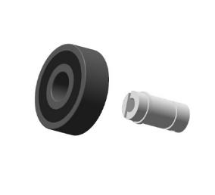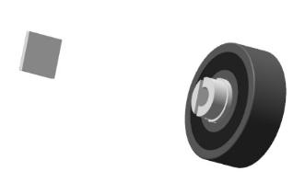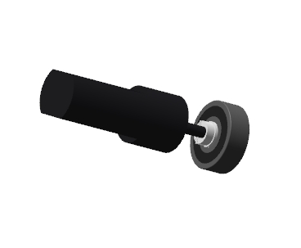
Note. If the motor does not fit into the keyed bushing, burrs may have formed. Remove the burrs with a nat file. It is permissible to trim the flat part on the motor shaft to allow the motor to fit.
Insert the bushing 00145316 into the bushing with the pin and bearing, align the holes, secure with a cotter pin. Check for play - there must be play. Secure the bearing with washer 7 DIN 6799.

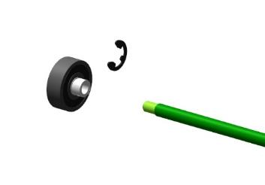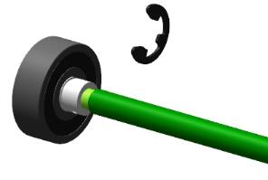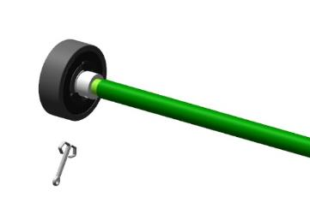
Install the assembled mechanism in the tube, aligning the hole in the bushing with the motor shaft. Check the correct fit by seeing the place for the retaining ring. Secure the mechanism with retaining ring A24 DIN 472.
IMPORTANT: After installing the retaining rings, make sure that they are positioned clearly in the groove and cannot fall out. If rings fall out in flight, this will result in loss of control and an unavoidable crash!

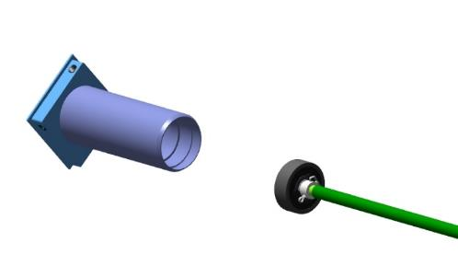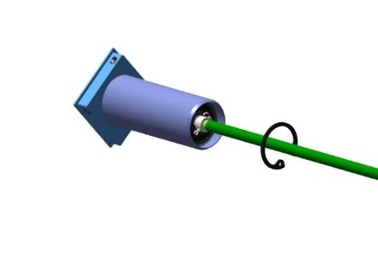

Try on the assembled mechanism in the footrest guide in the fuselage. It should be easy to fit, and it should fit all the way into the fuselage. Check the alignment of the holes in the mechanism and the guide.
Note.If the mechanism does not go in, does not fit all the way in, it is necessary:
1.Turn the mechanism 90° and try to install again.
2.Check that there are no burrs, scuffs, glue drips on the parts. There should not be any. If there are any, remove them with sandpaper.
3.Check the presence of chamfers at the corners of the plate 00108827. If there are no chamfers or if larger chamfers are required, file them with a nat file.
4.If none of the checks successful, then grind off the 4 planes on the plate with a natfile 00108827 until a fit is obtained.
Try on the footrest 00156352 in the fuselage guide.The footrest should move smoothly without jerks and seizures to full travel.
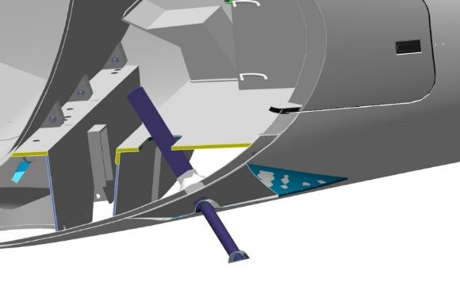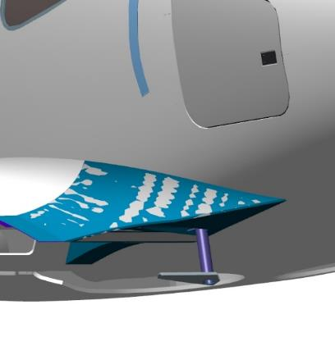
Note.If the footrest does not move smoothly to full travel, then:
1.Make sure the footrest is on the correct side.Right right, left left.
2.Make sure there are no foreign objects or debris in the guide rail or on the footrest itself.
3.If nothing is found, grind the guide planes with a nat file.
Insert the footrest approximately to the middle of its length. Insert the mechanism into the guide, screw the mechanism screw into the nut in the footrest. When the mechanism can no longer be screwed in, push it down as far as it will go (as you did during fitting). Secure the mechanism in the guide with 4 screws. Apply 12 V power to the footrest motor to retract the footrest. Secure the footrest with the M6 nut, tighten with a socket wrench. Make several cleaning runs from the 12V power supply.

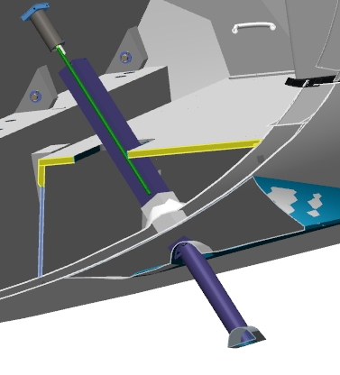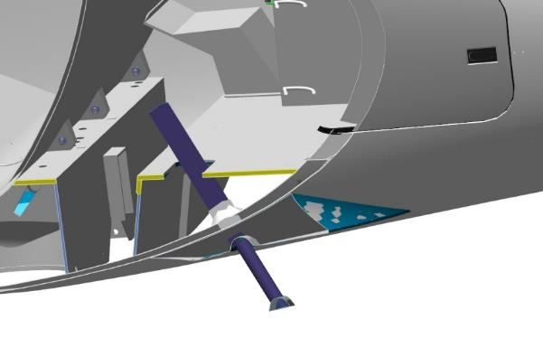

Fabricate, route, and connect harnesses for chassis and footboard controls.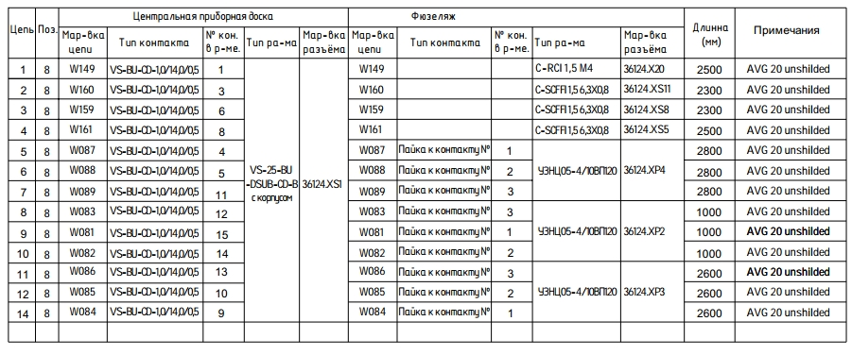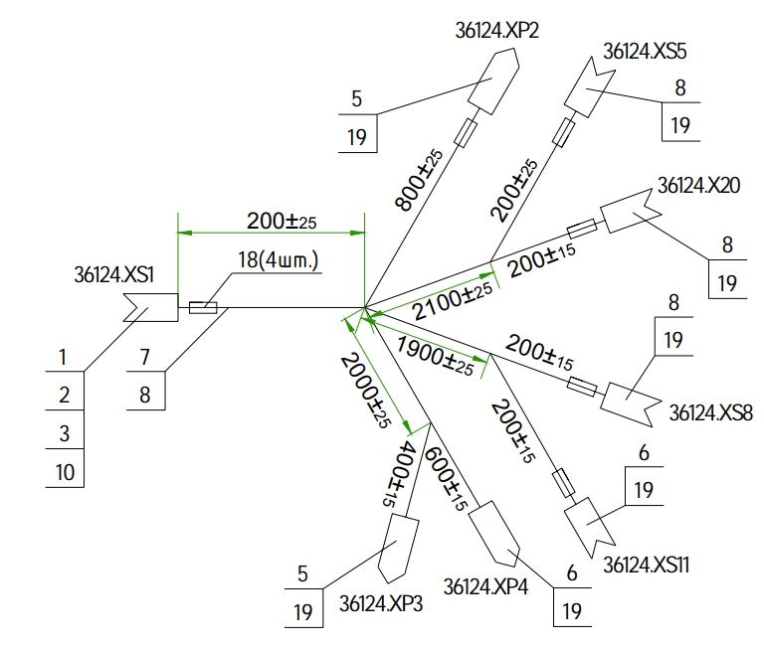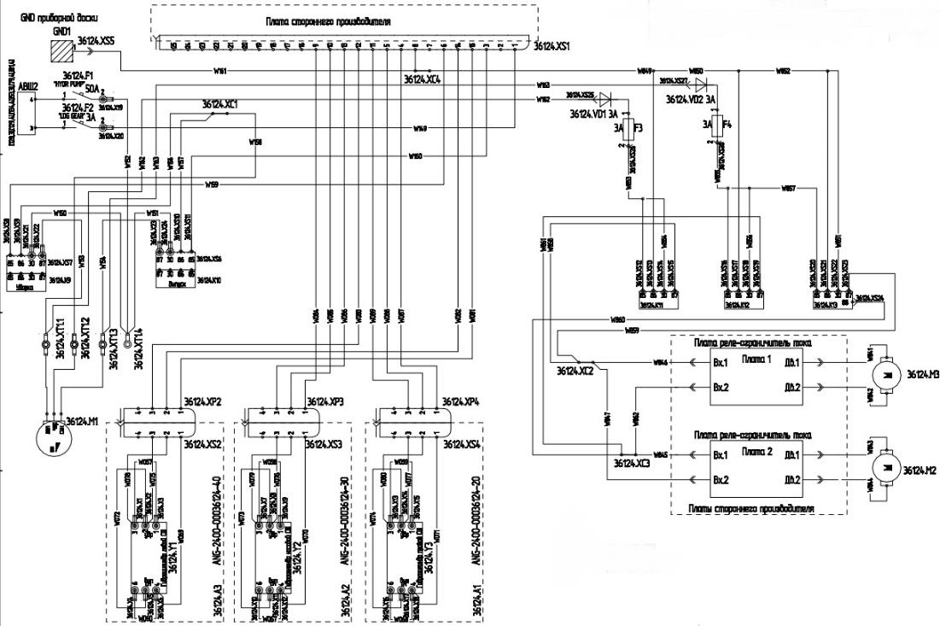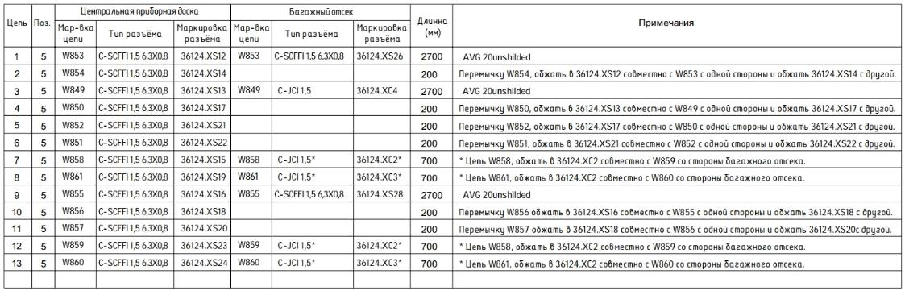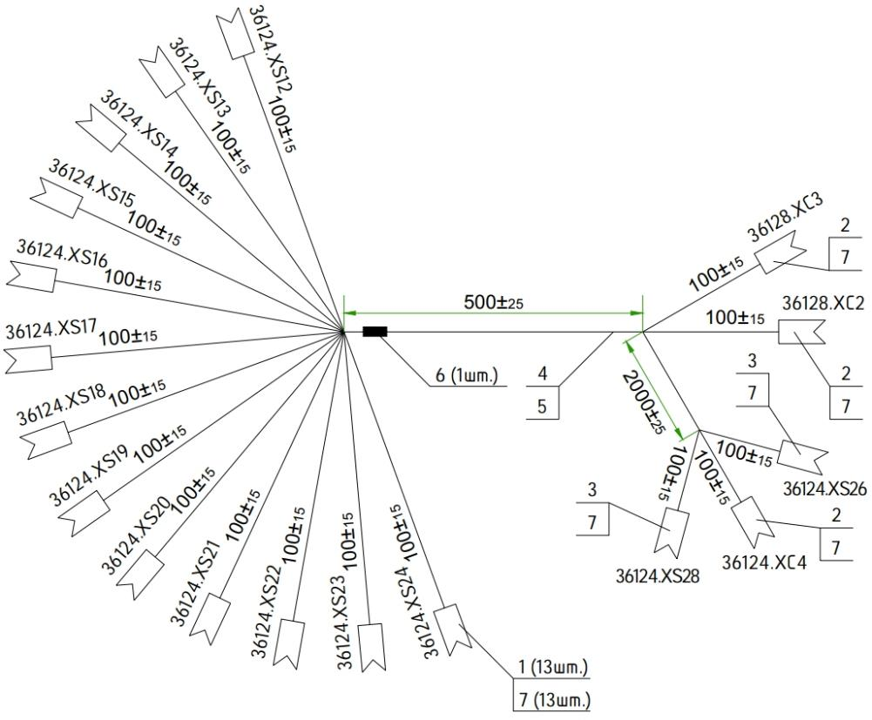

CONTROL SYSTEM ASSEMBLY

Assembling the rudder linkage
The objectives of this job are to assemble the tail end rudder control linkage.
To complete this work you will need:
- Mobile desk;
- 8 mm combination wrench;
- Latex gloves 1 pair;
- Solvent methyl acetate 100 grams;
- Clean rags 100x100 mm 1 piece;
- Respirator;
- Caliper 300 mm;
- LOCTITE 648 bushing shaft retainer.
Unpack and lay the tube on the table 00262433.
Count it out and stack it on the table:
- 2 nuts M5 DIN 934;
- 2 spherical lugs D5xM5.
Take 2 D5xM5 lugs, screw one M5 nut onto the threaded parts until the stop, on each lug.
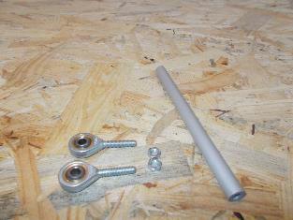 | 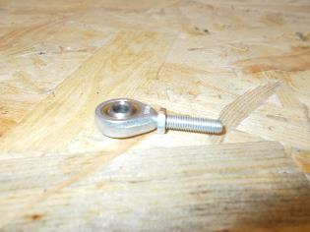
Adjust the caliper to a value of 145mm and lock.
Screw the tips alternately into the tube 00262433, approximately to the middle of the length. Check the value of 145 mm with a caliper. Screw in one tip 1-2 turns. Repeat the caliper check.
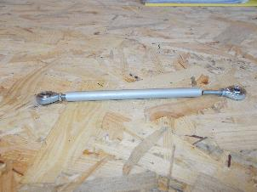 | 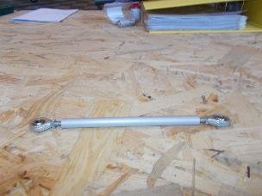 | 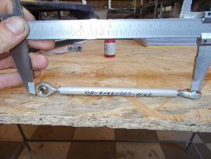
When the desired value has been reached, screw one M5 nut into the stop on the 00206919 tube. Carefully, without allowing the M5 nut to turn, remove the D5xM5 tip from the 00262433 tube.
Degrease the threaded part of the D5xM5 tip that will be screwed into the tube.
IMPORTANT: Do not apply the fixer on a surface that has been degreased immediately. The fixer can be applied 5-10 minutes after degreasing.
Apply an even, thin coat of LOCTITE 648 Shaft-Bushing Retainer to the degreased surface of the tip.
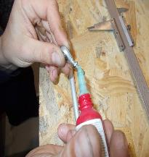
Screw the tips alternately into the tube 00262433, approximately to the middle of the length. Check the value of 144 mm with a caliper. When the desired value is reached, tighten the M5 nut with an 8 mm wrench against the 00262433 tube.
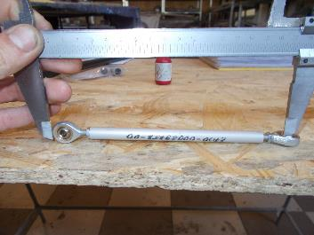 | 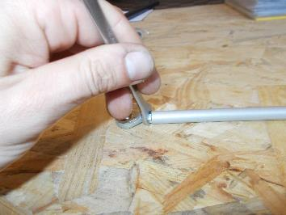
Tighten the second M5 nut with an 8mm wrench against the tube 00262433.
IMPORTANT: Do not install the second tip std00028321 at this stage of work with the LOCTITE 648 shaft bushing retainer. The tip is required for control system adjustments during further assembly of the airplane, and will be finally fixed after the adjustment work.
Clean the workplace and tools according to standard procedure 7.

Aileron control assembly
Note. The work described below is for the left-hand console. The wing console must be placed on the brackets on the gantry, with the upper skin against the floor.
To complete this work you will need:
- Mobile desk;
- Combination wrench 8 mm;
- Combination wrench 10 mm;
- Tweezers;
- Pliers;
- Screwdriver with straight slot #1;
- Aileron left (previously assembled);
- Aileron right (previously assembled);
- 2 rocking SU 00138507;
- 2 rocking SU 00138510;
- 8 axles 00100561;
- 2 pulls 00138493;
- 2 pulls 00138490;
- 2 pulls 00138492.
Unpack it and stack it on the table:
- 8 nuts M6 DIN 935;
- 8 washers 6 DIN 6798A;
- 6 nuts M5 DIN 935;
- 6 washers 5 DIN 6798A;
- 14 1x20 DIN 94 cotter pins;
- 8 bearings S61704-2RSR;
- 4 rings 28 DIN 7993B;
- 4 rings 20 DIN 7993A;
Find a rocker 00138507 and 2 axles 00100561. Degrease:
- Internal threads on the rocker 00138507;
- Outer threads (short part) of the axes 00100561.
IMPORTANT: Do not apply shaft and bushing retainer to an immediately degreased surface. The fixative can be applied 5-10 minutes after degreasing.
Apply an even thin coat of LOCTITE 648 Shaft-Bushing Retainer to the outer degreased surface of the two bearings.
Screw the screws alternately into the holes in the rocker arm. Tighten with a 10 mm wrench until there is no play between the screw and the rocker arm.
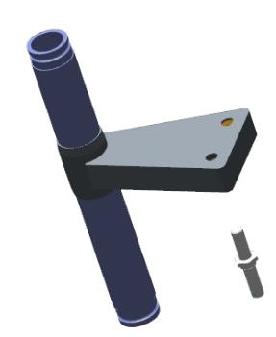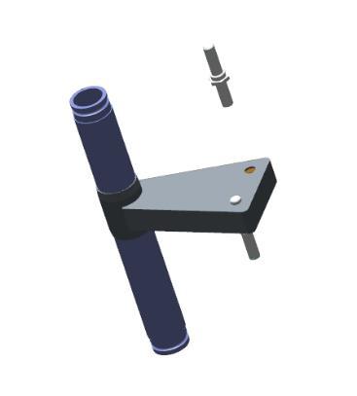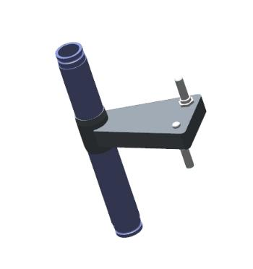
Repeat the steps above to install the 00100561 axes on the 00138510 rocker.
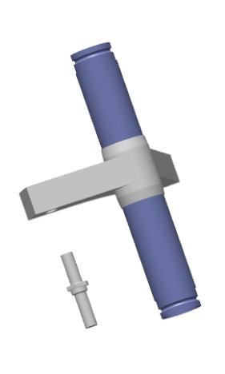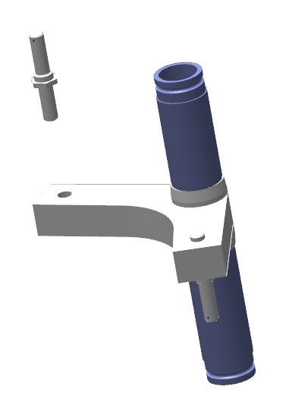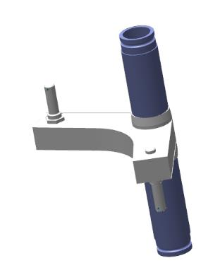
Insert the rocker arm through the lower trim hatch 00138510, inside the wing console. Insert the pivoting axis of the rocker arm through the upper bushing in the trim.
Mount the bearings S61704-2RSR on the rocker arm at the top and bottom and install them in the bushings in the trim. Secure the bearings with circlips 28 DIN 7793B for the bearings in the sockets, circlips 20 DIN 7793A for the bearings on the rocker shaft.
Check the ease of rotation of the rocker, make sure the ring is properly installed.
IMPORTANT: After installing the retaining rings, make sure that they are positioned clearly in the groove and cannot fall out. If a ring falls out in flight, it will result in loss of control and an unavoidable crash!
Repeat the steps above to install the rocker 00138507.
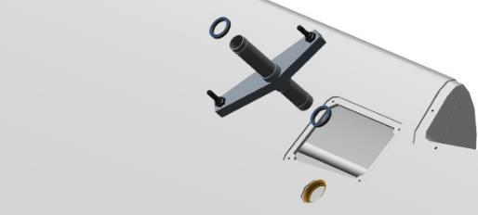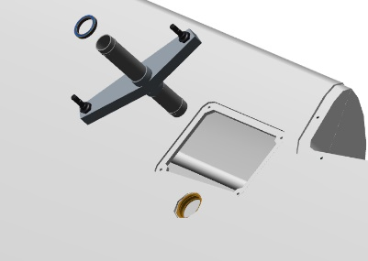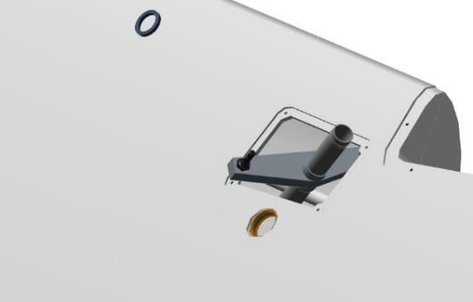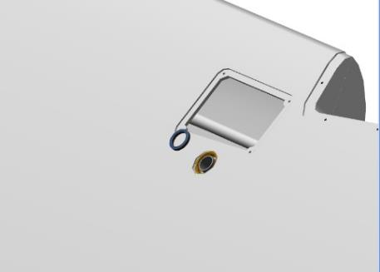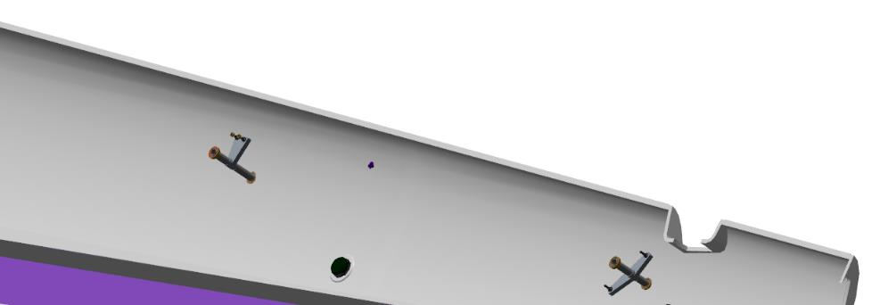
Insert the link 00138492 through the opening in the aileron area with the adjustable tip facing outwards. Place the link on the 00138510 rocker arm, secure the connection with M6 DIN 935 nut and 1x20 DIN 94 cotter pin.
Insert the link 00138490 through the hole in the front part of the root sail to the rocker 00138510, moving it through the hatches in the lower skin. Install the link alternately on the rocker arms 00138510 and 00138507, secure with M6 nuts DIN 935 and cotter pins 1x20 DIN 94.
Insert the link 00138493 through the window at the front of the root sail; guide it up to the rocker 00138507 by sliding it through the hatches in the lower skin. Place the link on the rocker 00138507, secure the connection with M6 DIN 935 nut and 1x20 DIN 94 cotter pin.
Control Operations:
- Check the mechanism in operation by moving the pull rod 00138493 lengthwise away from yourself and towards yourself. There should be no excessive force or jerk.
- Inspect the aileron mounting assemblies for foreign objects.
- Inspect the axles on the aileron for nicks or adhesive residue. There should be no foreign objects, nicks or adhesive residue.
Locate the 4 prch-00034668 bearings. Locate the aileron linkage assemblies on the console.
Degrease:
- Inner surfaces of the holes on the cantilever assemblies;
- Outer bearing surfaces prch-00034668.
IMPORTANT: Do not apply shaft and bushing retainer to an immediately degreased surface. The fixative can be applied 5-10 minutes after degreasing.
Apply an even, thin coat of LOCTITE 648 Shaft-Bushing Retainer to the degreased interior surfaces of the console linkage assemblies.
Apply an even thin coat of LOCTITE 648 Shaft-Bushing Retainer to the outer degreased surface of the two bearings.
Install one bearing in the hole in the linkage assembly, farthest from the end of the console, with the flange facing outward. Use a clamp to clamp the bearing until the bearing flange rests against the plane of the linkage assembly.
Using a wooden (non-metallic) pad, shim the second bearing.
IMPORTANT: Do not use the impact method to install the bearings. Also, do not push the entire assembly while installing the bearings. This will destroy the assembly.Do not allow the shaft bushing retainer to get inside the bearing.This will result in loss of bearing performance.
Use a rag to remove any residue of bushing shaft retainer that has been squeezed out.
Repeat the above steps to install the bearings on the second assembly.
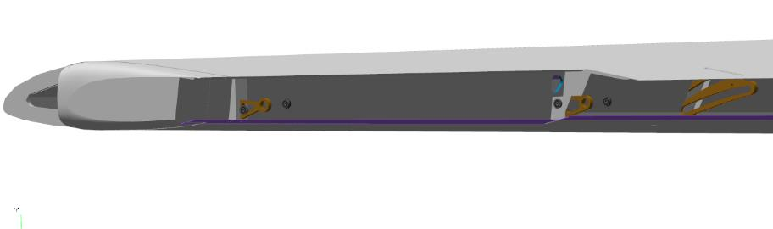
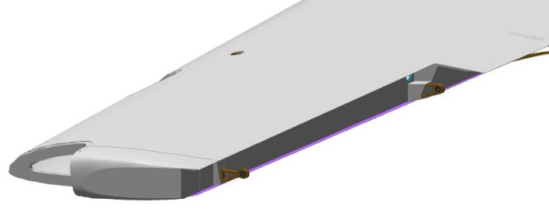

Assembly and installation of the foot control post
    - Assembling the foot control post
To complete this work you will need:
- Mobile desk;
- No. 2 straight blade screwdriver;
- Locksmith hammer weighing 400 grams;
- 1mm 100mm 6 pieces of wire;
- Bolts M5x46 DIN 933 2 pieces;
- Nuts M5 DIN 934 2 pieces;
- Washers 5 DIN 125 4 pieces;
- Litol-24 grease 10 grams;
- Clean rags 100x100 mm 2 pieces;
- Pliers;
- Combination wrench 10 mm.
Unpack it and stack it on the table:
- Pedal Left 00145865;
- Pedal Right 00137502;
- 2 brake pedals left 00108642;
- 2 brake pedals right 00108672;
- 10 supports 00145598;
- 4 brake master cylinders (previously assembled);
- 4 axles 00137700;
- 3 axles 00100561;
- 8 axles 00178378 ;
- 12 washers 4 DIN 6799;
Locate the pedal left 00145865 and if necessary, move it with the brake system mounting points facing up and the pedals on the table. Locate the brake master cylinder with top fitting S6520-6 1/8.
Slide the bottom of the master cylinder into the lower lugs of the left pedal 00145865, positioning the master cylinder fittings from the left pedal upward.
Align the holes in the master cylinder and pedal left.
Insert the axle 00137700 into the matching holes, with the head on the pedal side.
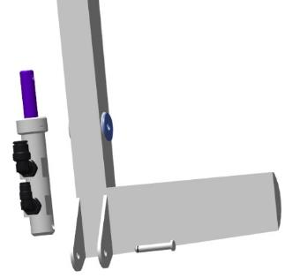 | 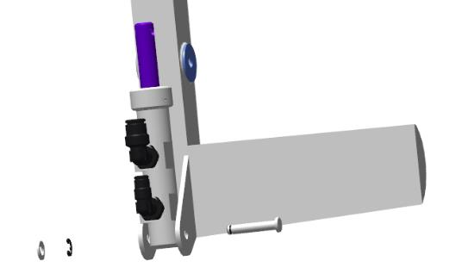
Check the ease of movement of the master cylinder on the axle. It should move easily, without jerking or jamming, and the housing should not rest anywhere. Install thrust washer 4 DIN 6799 on the protruding part of the axle.
Locate the left brake pedal 00108642. Insert the lugs of the brake pedal left 00108642 onto the brake pedal left 00145865. The left brake pedal tube must be located on the pedal side. Align the holes in the pedals.
Insert the axle 00178378 into the holes with the head on the pedal side. Press the axle into the holes with light hammer blows. Place the thrust washer 4 DIN 6799 on the protruding part of the axle. Check whether the brake pedal moves easily on the axle. It should move easily, without jerking or sticking.
Insert the lugs of the left brake pedal 00108642 onto the master cylinder rod. Align the holes in the pedal and rod. Insert the axle 00178378 into the aligned holes, with the head on the pedal side.
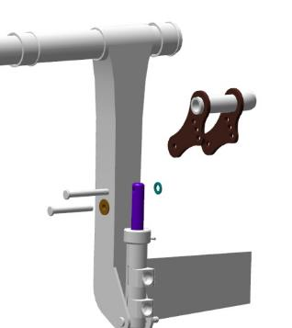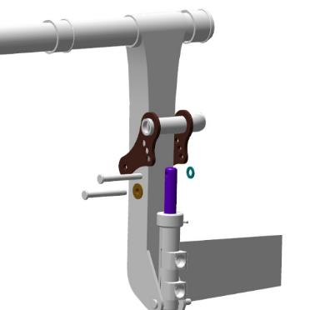 | 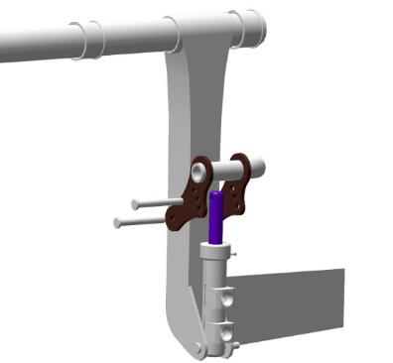
Place thrust washer 4 DIN 6799 on the protruding part of the axle. Check whether the brake pedal moves easily and whether the piston rod is fully depressed. The brake pedal should move easily, without jerking or jamming, and the rod should be deeply embedded in the housing.
IMPORTANT! There must be no movement of the brake pedal and rod when the brake pedal and rod are connected. If this happens, the cylinder will be permanently depressed. To eliminate this phenomenon, select a different hole on the brake pedal.
Note. If after installing the washers 4 DIN 6799 there is a possible play along the axis and there is a gap under the washer, remove the washer, put a washer 4 DIN 125 (or several) under it and fix the connection again.
Repeat the steps above to assemble the other part of the left pedal 00145865 with a brake master cylinder that has both S6520-4 1/8 fittings.
When the left pedal is assembled, follow the same steps to assemble the right pedal 00137502:
- The brake master cylinder with S6520-6 1/8 fitting is located to your right;
- The brake master cylinder with S6520-4 1/8 fittings is located on your left.
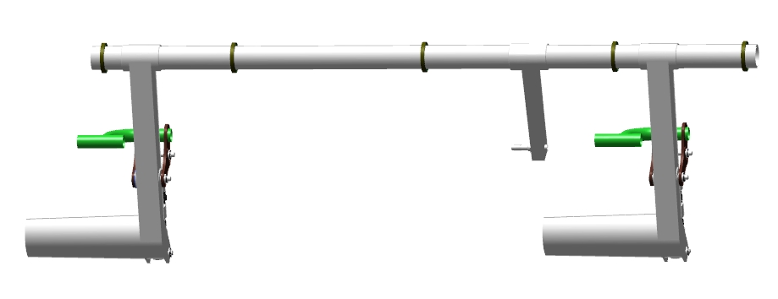
When the pedals right and left are assembled, find the 10 supports 00145598 and stack them next to the pedals.
Lay, on the table, pedal left 00145865 on top of pedal right 00137502, shifting the left pedal to the right.
Align the bushings on the pedal shafts opposite each other. Install one support 00145598, bottom left.
IMPORTANT: Do not lubricate the supports with any lubricants. The support material will absorb them and increase in size, resulting in failure of the assembly.
Align the bearings on the pedal shafts and install the support 00145598 on them, inserting the bearings into the grooves of the support. Install the second support 00145598 on the opposite side.
Align the fixing holes on the supports, install two M5x46 DIN 933 bolts with 5 DIN 125 washers under the head into the fixing holes. Install two 5 DIN 125 washers on the opposite side, screw one M5 DIN 934 nut by hand onto each bolt. Tighten the M5 DIN 934 nuts with 8 mm combination wrenches.

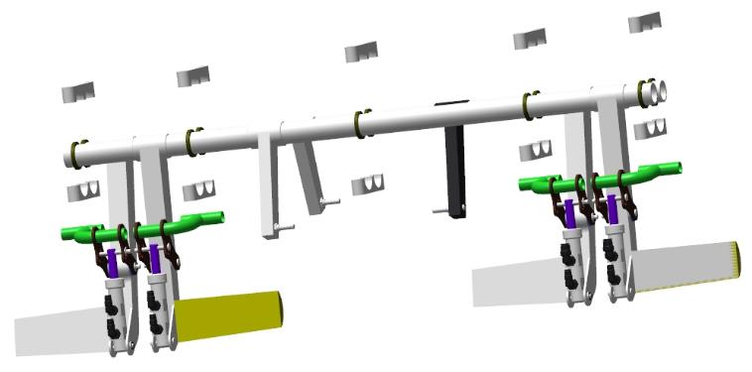
Insert the balancing wire into the side hole of the support 00145598 and pull it out to approximately the middle of its length. Holding the wire with one hand, insert it into the side opening of the second support 00145598 with the other hand. Tighten the wire by hand and tighten with pliers.
Repeat the steps with the wire for the side holes of the supports 00145598, on the opposite side.
Unscrew the M5 DIN 934 nuts with 8 mm combination wrenches. Remove the 5 DIN 125 washers, remove the two M5x46 DIN 933 bolts from the holes in the supports.
Repeat the wire fixing steps above for the remaining 00145598 supports on the pedal shafts.
    - Installing the foot control post
To complete this work you will need:
- Mobile desk;
- The foot control post assembled earlier;
- Clean rags 100x100 mm 2 pieces;
- Respirator;
- LOCTITE 648 bushing shaft retainer.
- Pliers;
- Torque wrench 1-25Nm;
- Hexagonal nozzle 3 mm;
- 3 mm hex key.
Count out and stack 10 M5x46 DIN912 screws on the table.
Check the M5 tapped holes in accordance with standard action 6 of the foot control post attachment point on the spar.
Bring the foot control on the left side of the fuselage to the door opening. Bring the foot control into the fuselage and place it on the floor.
Move inside the fuselage. Raise the right side of the foot control up until it rests on the instrument panel and lower the other side down until it rests on the floor. Move the raised part to the right along the right side of the spar to the right, move it until it rests against the fuselage skin on the right side of the fuselage. Rotate the foot control pedal post downward, raising the entire post upward, parallel to the spar wall. Raise the post up to the spar shelf and align the support holes 00145598 and the spar. Install two M5x46 DIN912 screws in the holes of the support, screw by hand into the threaded holes of the spar.
Attach the next support 00145598 in the same way. Move to the same position on the right side of the fuselage and attach the third support 00145598. Tighten all the bolts securing the supports 00145598 with a 3 mm hexagon wrench until hand tight. 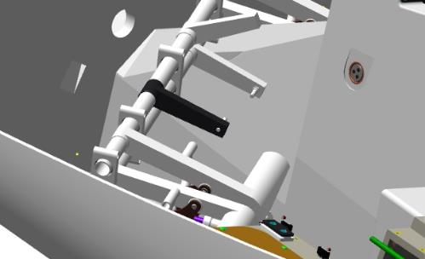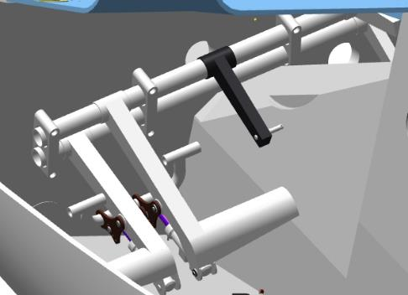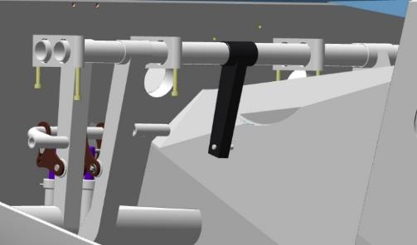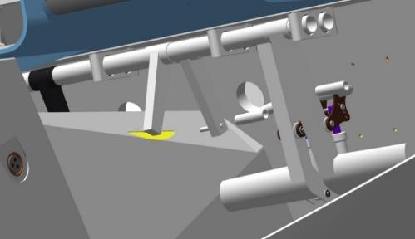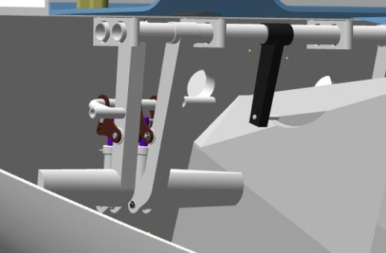
Control Operations:
- Check the movement of the foot control unit in the supports. The movement should be smooth without jerks and jams, without applying great effort.
Apply an even thin layer of LOCTITE 648 shaft bushing fixer to the degreased surface of the bolts. Install two M5x46 DIN912 screws in the holes of the support, screw by hand into the threaded holes of the spar.
Attach the next support 00145598 in the same way. Move to the same position on the right side of the fuselage and attach the third support 00145598. Tighten all the bolts securing the supports 00145598 with a 3 mm hexagon wrench until hand tight.
Install the 3 mm hexagonal nozzle, set the torque wrench to a force of 5 Nm. Move to the fuselage with the tool. Tighten the bolts securing the supports 00145598 with a wrench to a torque of 5Nm.
Control Operations:
- Check the movement of the foot control unit in the supports. The movement should be smooth without jerks and jams, without applying great force. Remove the wire connecting the supports 00145598.
Clean the workplace and tools according to standard procedure 7.

Assembly and installation of the manual control post
To complete this work you will need:
- Mobile desk;
- 2 combination wrenches 8 mm;
- Tweezers;
- Pliers;
- Screwdriver with straight slot #1;
- Hexagonal wrench 5 mm;
- Hexagonal wrench 3 mm;
- LOCTITE 648 bushing shaft retainer.
- Solvent methyl acetate 100 grams;
- Clean rags 100x100 mm 2 pieces;
- Torque wrench 1-25Nm;
- Hexagonal end cap 3 mm;
Unpack it and stack it on the table:
- Pilot handle (left) 00100551;
- Pilot handle (right) 00106751;
- 6 supports 00106703;
- Transverse Shaft 00101638;
- Pull 00100510;
- Pull 00100511;
- Pull 00100513;
- Longitudinal shaft(left) 00100549;
- Longitudinal shaft (right) 00100740;
- 7 axes 00100561;
- 2 tubes 00100864;
- 4 washers 00100657;
- 4 sub-bearing 606 2RS;
- 4 bearings S61705-2RS;
- 4 rings 26 DIN 472;
- 12 screws M3x15 DIN7991;
- 6 bolts M5x60 DIN912;
- 4 bolts M6x30 DIN912;
- 2 bolts M6x60 DIN912;
- 13 nuts M6 DIN 935;
- 13 cotter pins 1,6x35 DIN 94;
- 13 washers 6 DIN 6798A;
Find the longitudinal shafts 00100549 and 00100740, 3 axes 00100561, bearing S61705-2RS. Check the M6 threaded holes on the shafts according to standard action 6.
Degrease:
- External threaded parts of the axles;
- Internal threads in longitudinal shafts .
IMPORTANT: Do not apply shaft and bushing retainer to an immediately degreased surface. The fixative can be applied 5-10 minutes after degreasing.
Apply an even, thin coat of LOCTITE 648 bushing shaft retainer to the degreased surfaces of the axles 00100651.
Screw the axles one by one into the shaft threads. Tighten the axles 00100651 with a 10 mm wrench until there is no clearance between the axle flanges and the plane of the shaft rocker.
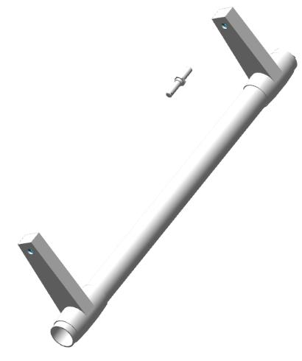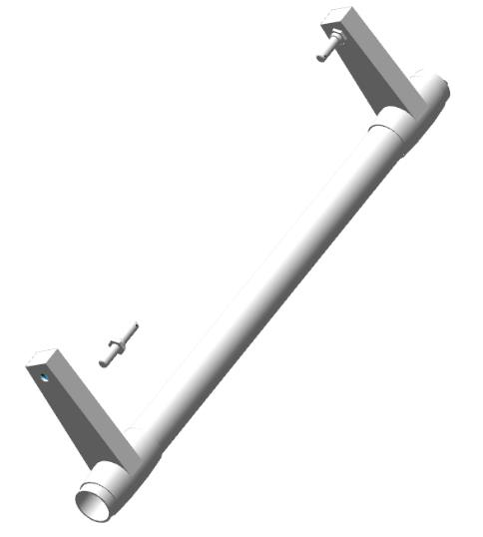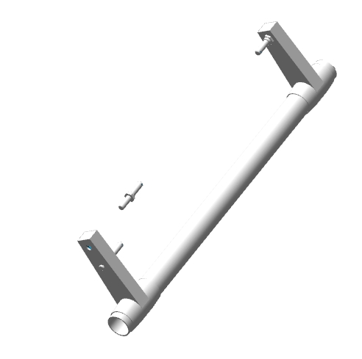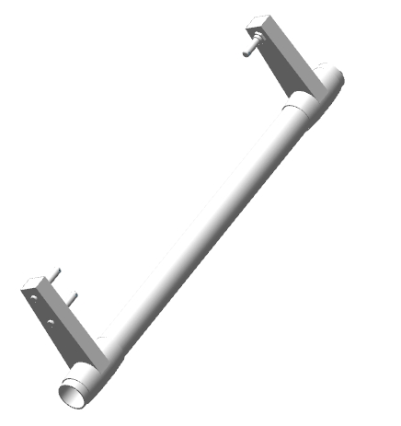
Measure bearing S61705-2RS onto each shaft end. The bearing must be inserted all the way in with force, and removed in the same way.
Note.If the bearing does not reach or requires a very large amount of force, it is necessary to grind the seating area with a natfile.
Insert the longitudinal shaft 00100549 under the pilot beam, through the opening on the left, with the two axes pointing closer to the nose of the airplane. Insert the shaft into the holes at the front and rear of the pilot beam, with the axles pointing downward or sideways away from the fuselage skin. Slide the S61705-2RS bearing into the front gesdo, aligning it with the shaft protrusion at the same time. Insert the bearing into the seat until it stops and secure with the circlip.
Repeat the steps above to install the second longitudinal shaft bearing in the rear of the beam.
IMPORTANT: After installing the retaining rings, make sure that they are positioned clearly in the groove and cannot fall out. If rings fall out in flight, this will result in loss of control and an unavoidable crash!
Check the ease of rotation of the shaft. The shaft should rotate easily without jerking or sticking.
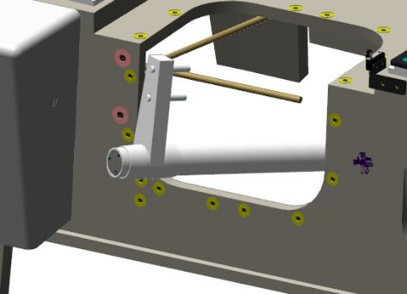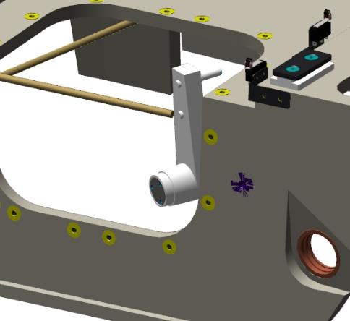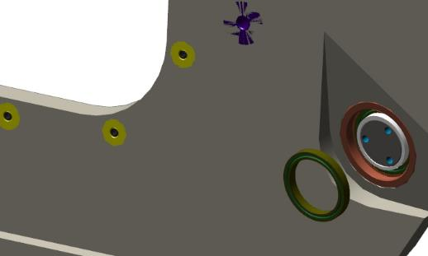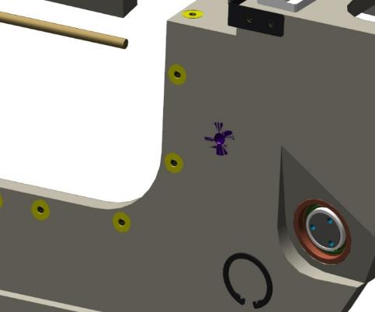

Repeat the steps above to install the shaft 00100740.
Find pilot handles 00100551 and 00106551, 4 bearings 606 2RS, 2 tubes 00100864.
Degrease:
- The outer inner tubular parts of the handles;
- Outer bearing surfaces 606 2RS.
IMPORTANT: Do not apply shaft and bushing retainer to an immediately degreased surface. The fixative can be applied 5-10 minutes after degreasing.
Apply an even thin layer of LOCTITE 648 shaft and bushing retainer to the degreased surfaces of the 2 bearings 606 2RS. Alternately, press the 2 bearings into the handle tube with a spacer. The first bearing should go deep into the tube, the second bearing should be flush with the handle tube.
Repeat degreasing and applying shaft bushing retainer to the 2 bearings. Install the tube 00100864 inside the handle, press in the bearings one by one.
Note. To prevent the tube 00100864 from moving off the axle when pressing the bearings in, install a bolt in the hole with the head on the side of the already installed bearings.
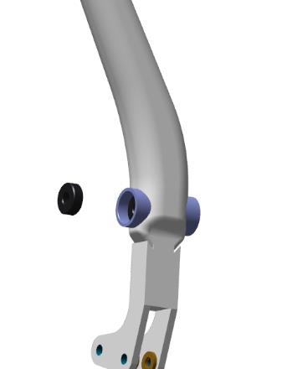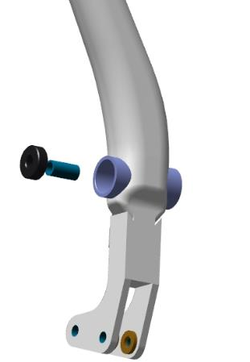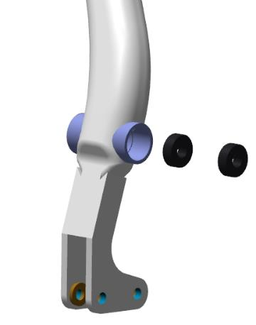
Clean the workplace according to standard procedure 7.Solder the handle wires to the connector according to the attached diagram.

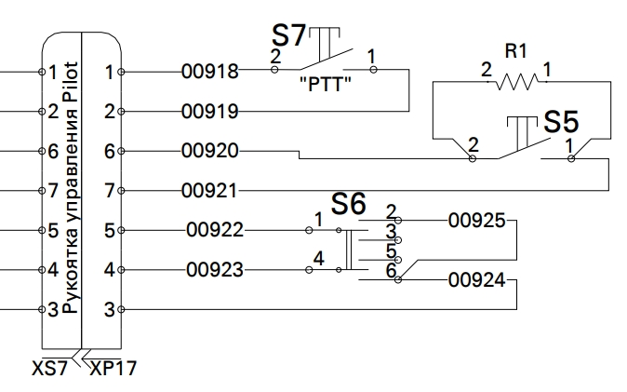

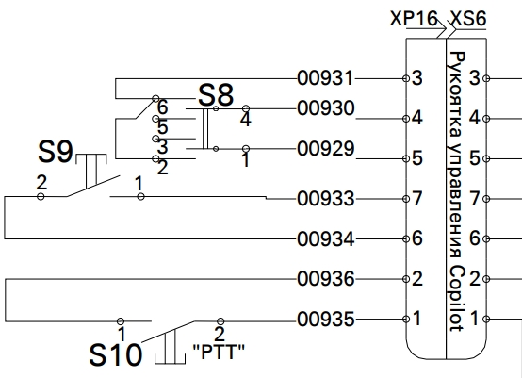
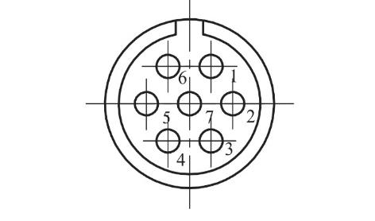
Locate the cross shaft 00101638, 2 axes 00100651. Check the M6 tapped holes according to standard action 6.
Degrease:
- External threaded parts of the axles;
- Internal threads in longitudinal shafts .
IMPORTANT: Do not apply shaft and bushing retainer to an immediately degreased surface. The fixative can be applied 5-10 minutes after degreasing.
Apply an even, thin coat of LOCTITE 648 bushing shaft retainer to the degreased surfaces of the axles 00100651.
Screw the axles one by one into the shaft threads. Tighten the axles 00100651 with a 10 mm wrench until there is no clearance between the axle flanges and the plane of the shaft rocker.
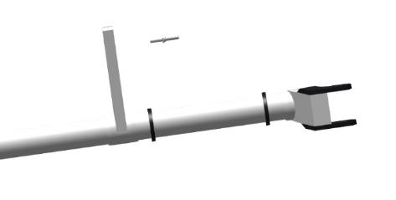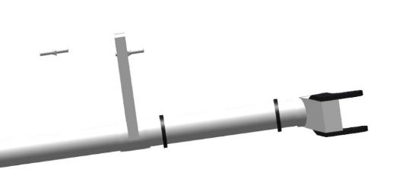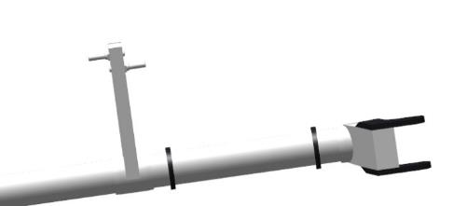
Clean the workplace according to standard action 7.
Find two supports 00106703, place them on the cross shaft and squeeze them firmly with your hands.Inspect the joint of the supports for gaps. There should be no gaps.Install two M5x60 DIN912 bolts in the holes of the supports, squeeze the supports again.Make several circular movements of the compressed supports with bolts. The movement should be smooth, light, without jerks or jams.Repeat the above steps to check the remaining supports.
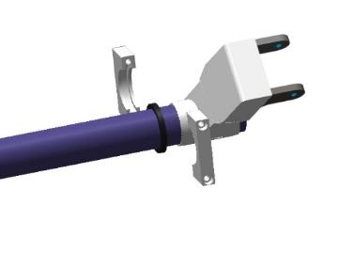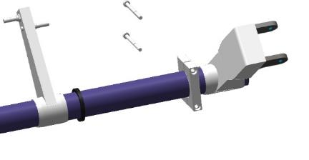
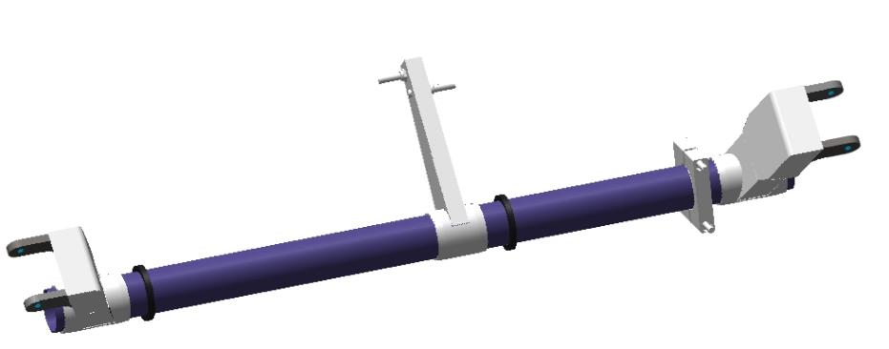
Remove the supports and bolts from the shaft. Install the link inside the shaft 00100510.
Note. The link must be installed inside the shaft before installing it in the airplane. The link cannot be installed in the installed shaft.
Move into the fuselage cockpit with the parts. Start, tilting one bearing up, through the opening of the left handle of the pilots' beam, the lever all the way down. Tilting the top of the lever to the left, bring it under the pilot beam, moving it to the right, lay it on the floor.
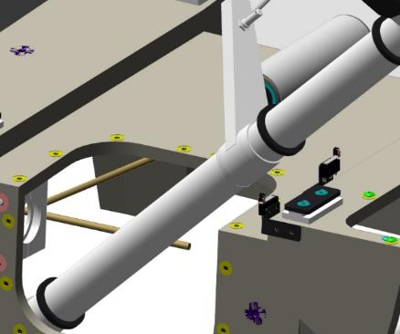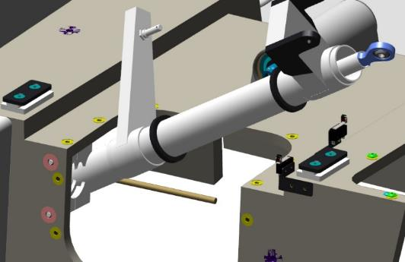
Insert two M5x60 DIN912 bolts through the holes in the support 00106703. Move the shaft away from the front wall of the pilot beam. Interlock the supports on the shaft at the position of the installed bearing. Move the shaft with the supports to the left and then to the right and repeat the steps above to install the supports on the left and right. Bring the shaft to the front wall, aligning the holes in the wall and the center support. Hand screw the M5x60 DIN912 bolts 2-3 turns into the threaded holes in the front wall of the pilot beam. Repeat the steps to attach the supports on the left and right. If the holes do not match, gently move the shaft end up and down until the holes match.
Important: Do not drop the screws into the fuselage cavity when working. Use a magnetized tool.
Tighten the six M5x60 DIN912 bolts of the supports with a 3 mm hexagon wrench 00106703. Make 5-6 rotational movements of the shaft in the supports. The movement should be smooth, easy, without jerks or jams.
Remove one M5x60 DIN912 bolt from the supports. Degrease the threaded part of the bolt.
IMPORTANT: Do not apply shaft and bushing retainer to an immediately degreased surface. The fixative can be applied 5-10 minutes after degreasing.
Apply an even thin coat of LOCTITE 648 shaft bushing retainer to the degreased surface of the bolt.
Install the bolt in the hole of the supports, tighten with a 3 mm hex wrench until a slight force is felt on the key.
Remove the second bolt, and repeat the steps above.
Install a 3 mm hexagonal bit, set the torque wrench to a torque of 6 Nm. Tighten the support bolts with a torque wrench to a torque of 6 Nm.
Repeat the steps above to install the bolts on the remaining two supports.
Make 5-6 rotational movements. The movement should be smooth, light, without jerks or jams.
Clean the workplace and tools according to standard procedure 7.
IMPORTANT! Installation of the pilot handles should be carried out after completing all mounting work under the pilot beam. The handles should also be installed after the compartment under the beam has been thoroughly cleaned of foreign objects.
Find handle 00100551, rod 00100511. Insert the link 00100511 into the beam opening on the left, guide it to the longitudinal shaft, place it on the axle. Place the washer 6 DIN 6798A on the axle, screw on the nut M6 DIN 935. Hold the longitudinal shaft by hand and tighten the nut with a 10 mm combination wrench until the washer 6 DIN 6798A is fully compressed. Locate the hole in the bolt, which should coincide with the slot in the M6 DIN 935 nut.Check the movement of the link on the axle - the link must have a travel relative to the longitudinal axis.
IMPORTANT: Do not twist the nut to match the hole and slot. This will result in rapid assembly failure and backlash.
Place a 1.6x35 DIN 94 cotter pin in the coincident slot of the M6 DIN 935 nut and the axle hole. Tighten the joint by loosening the cotter pin tabs with a #1 straight blade screwdriver.
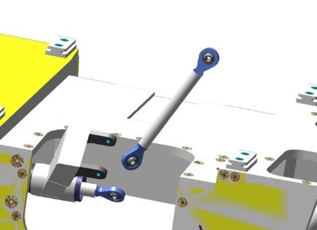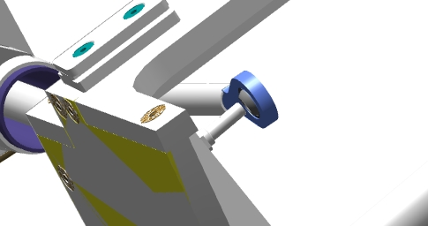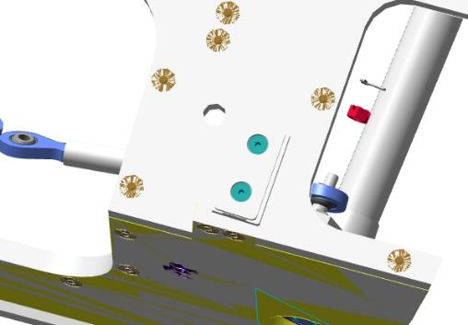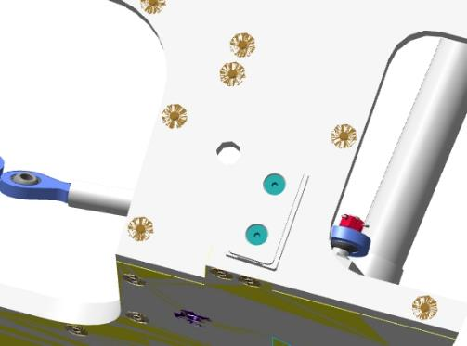
Insert the handle into the opening on the left, align the holes of the handle plates with the bearing assembly on the handle. Insert the M6x60 DIN912 bolt into the aligned holes, drive it all the way in until the head stops in the handle.
- Make several movements to the left and right. The movement should be smooth, light, without jerks or jams.
Place a 6 DIN 6798A washer on the M6x60 DIN912 bolt and screw on the M6 DIN 935 nut. Hold the bolt with a 5 mm hex wrench and tighten the nut with a 10 mm combination wrench until the 6 DIN 6798A washer is fully compressed. Locate the hole in the bolt, which should coincide with the slot of the M6 DIN 935 nut.
IMPORTANT: Do not twist the nut to match the hole and slot. This will result in rapid assembly failure and backlash.
Install a 1.6x35 DIN 94 cotter pin in the coincident slot of the M6 DIN 935 nut and the holes of the M6x60 DIN912 bolt. Tighten the joint by loosening the cotter pin tabs with a #1 straight blade screwdriver.
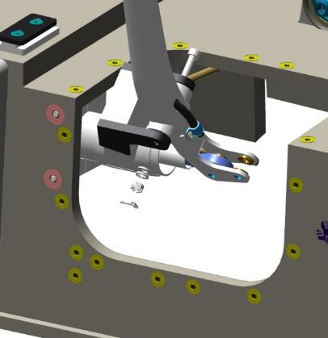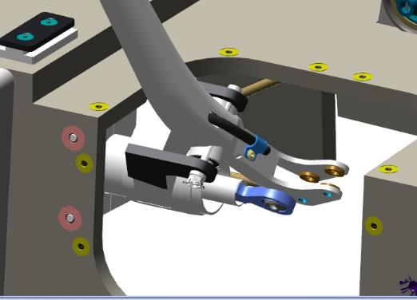
Insert the link 00100510 (installed in the cross-shaft) into the handle. Insert the M6x30 DIN912 bolt into the holes in the handle, screw it in all the way until the head stops in the handle. Place a 6 DIN 6798A washer on the M6x30 DIN912 bolt and screw on the M6 DIN 935 nut. Hold the bolt with a 5 mm hex wrench and tighten the nut with a 10 mm combination wrench until the 6 DIN 6798A washer is fully compressed. Locate the hole in the bolt, which should coincide with the slot of the M6 DIN 935 nut.
IMPORTANT: Do not twist the nut to match the hole and slot. This will result in rapid assembly failure and backlash.
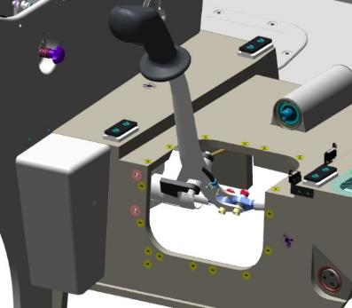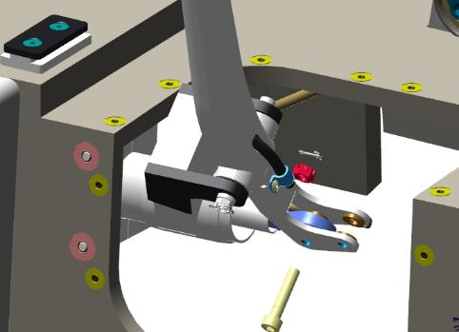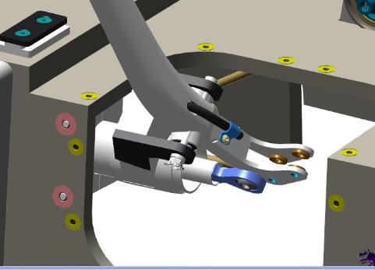
Insert the link 00100511 (installed longitudinal shaft) into the handle. Insert the M6x30 DIN912 bolt into the holes in the handle, screw it in all the way until the head stops in the handle. Place a 6 DIN 6798A washer on the M6x30 DIN912 bolt and screw on the M6 DIN 935 nut. Hold the bolt with a 5 mm hex wrench and tighten the nut with a 10 mm combination wrench until the 6 DIN 6798A washer is fully compressed. Locate the hole in the bolt, which should coincide with the slot of the M6 DIN 935 nut.
IMPORTANT: Do not twist the nut to match the hole and slot. This will result in rapid assembly failure and backlash.
Install 1.6x35 DIN 94 cotter pins into the matching slots of the M6 DIN 935 nuts and the holes of the M6x30 DIN912 bolts. Tighten the joint by loosening the cotter pin tabs with a #1 slotted screwdriver.
Repeat the steps above to install the link 00100513 and the right handle.
Control Operations:
- Smoothly deflect either knob to the left. The movement should be smooth, easy, without jerks or jams, the opposite knob should repeat the movement completely.Smoothly deflect any knob to the right. The movement should be smooth, easy, without jerking or jamming, the opposite knob should repeat the movement completely.
- Check the back and forth movement of the handle. The movement should be smooth, easy, without jerks or jams, the opposite handle should repeat the movement completely.
- Visually position the handle in the middle. The second handle should be in the same position.
    - Installing autopilot actuators.

Note: This point is for vehicles equipped with autopilot. The work should be carried out before point 5.4.
To complete this work you will need:
- Mobile desk;
- 10 mm combination wrench;
- Allen key 3 mm;
- hexagonal wrench 5 mm;
- Tweezers;
- Pliers;
- Screwdriver with straight slot #1;
Unpack it and stack it on the table:
- 2 plates 00178678;
- Pull 00100535;
- Pull 00178677;
- 2 SV-32 servo drives;
- 8 bolts M4x30 DIN6912;
- 2 bolts M6x20 DIN6912;
- 8 washers 4 DIN 6798A;
- 4 washers 6 DIN 6798A;
- 4 nuts M6 DIN 935;
- 8 washers 4 DIN 125;
- 4 washers 6 DIN 125;
- 4 cotter pins 1.6x20 DIN 94;
- 2 plugs PC7TV;
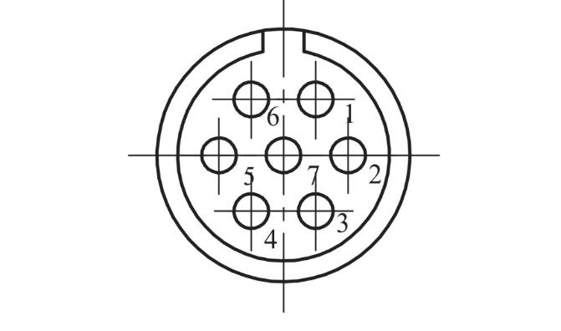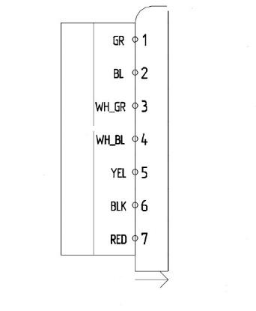
Locate the SV-32 servo drive, linkage 00178677, and PC7TV plug. Attach the plug to the servo drive wires. Install the bolt M6x20 DIN6912 in the hole of the servo drive plate, install the rod 00178677 on the bolt. Secure the rod with a 6 DIN 125 washer, a 6 6798A washer, and tighten the M6 DIN 935 nut. Check the deflection of the rod along and across its longitudinal axis. The link must deflect by an angle of at least 15°.
Note. If the tyana does not have the ability to deflect, then:
- Unscrew the nut, remove the tie rod;
- Place a 6 DIN 125 washer on the M6x20 DIN6912 bolt, between the bearing and the plate;
- Put the connection back together, check the deflection.
- The number of washers between the plate and the bearing should not exceed 2 pieces.
Screw on the nut M6 DIN 935, using a 10 mm wrench, until the bolt hole and the nut slot match. Place a 1.6x20 DIN 94 cotter pin in the coincident slot of the nut and bolt. Tighten the connection by spreading the cotter pin tabs with a #1 straight blade screwdriver.
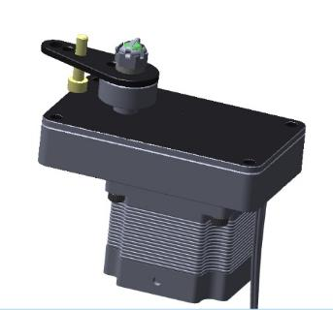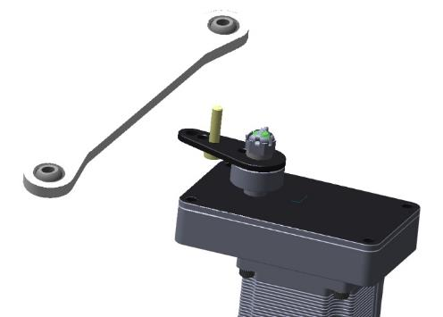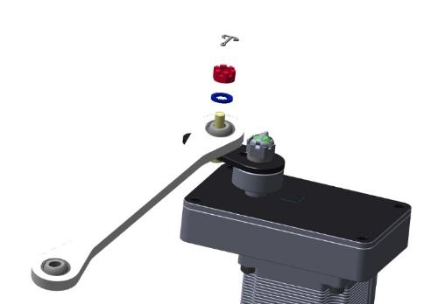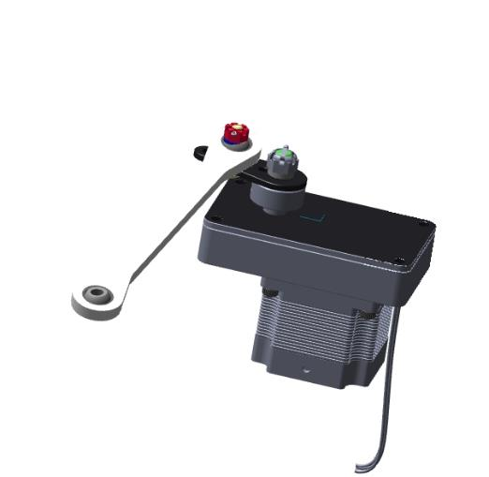
Repeat the above steps for the actuator with the linkage 00100535.
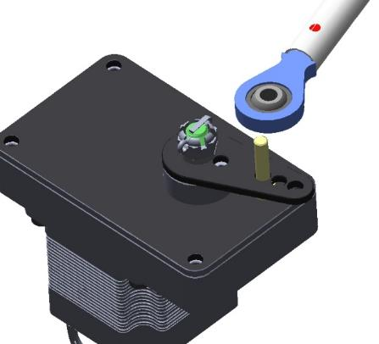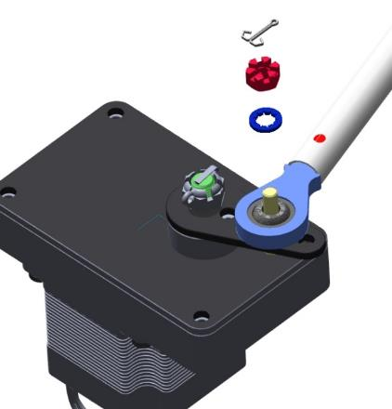
Find the plate 00178678, 4 M4x30 bolts DIN6912, 4 washers 4 DIN 125, 4 washers 4 DIN 6798A, servo with pull rod 00178677.
Insert the servo drive through the opening in the center armrest, into the recess on the left side. Screw the bolts and washers into the 2 upper holes by hand. Place the plate 00178678 on the 2 lower holes, align the holes, screw in the 2 bolts. Tighten the bolts with a 3 mm hexagon wrench until the DIN 6798A washers are fully compressed.
Place the link on the axle of the cross-shaft. Screw on the M6 nut DIN 935, using a 10 mm wrench, until the axle hole and the nut slot match. Insert a 1.6x20 DIN 94 cotter pin into the coinciding nut and axle slot.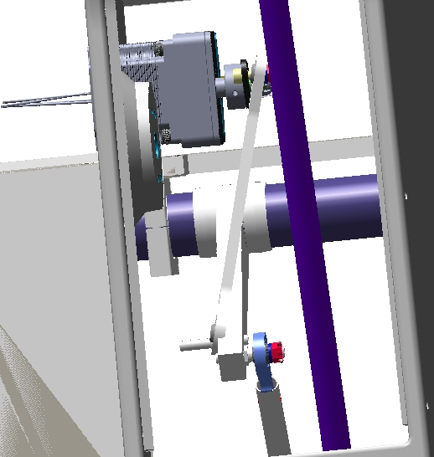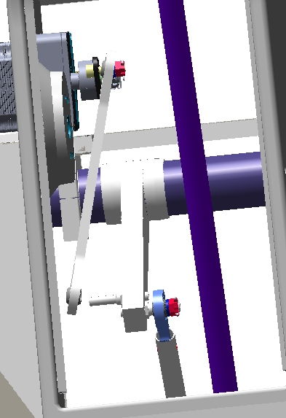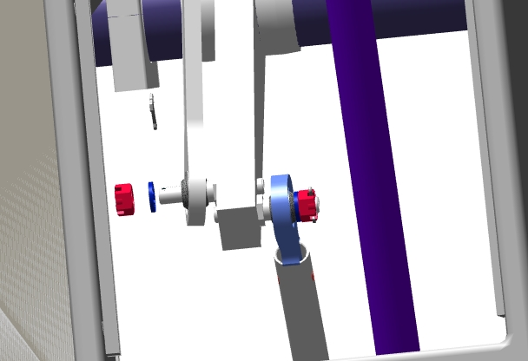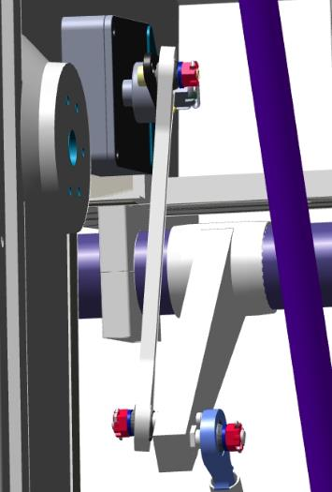
Repeat the steps above to install the servo with the linkage 00100535 under the pilot beam and connecting to the right longitudinal shaft.
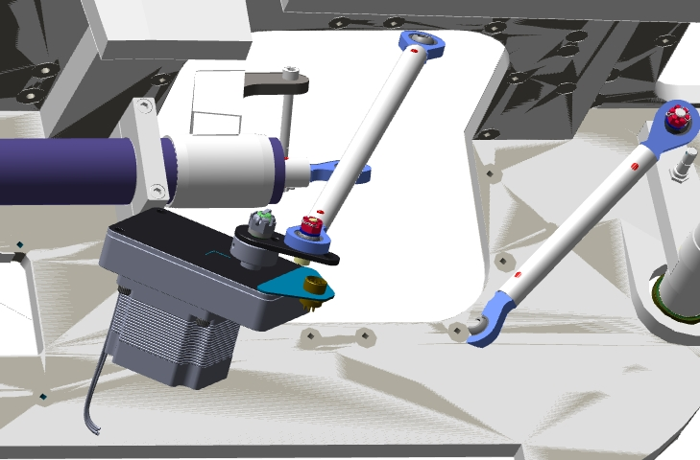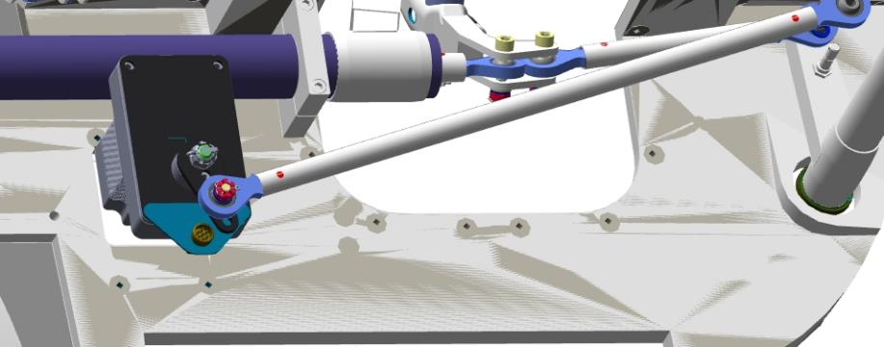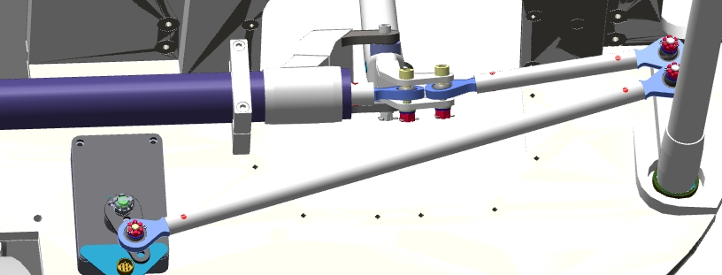
Control Operations:
- Smoothly deflect either knob to the left. The movement should be smooth, easy, without jerks or jams, the opposite knob should repeat the movement completely.Smoothly deflect any knob to the right. The movement should be smooth, easy, without jerking or jamming, the opposite knob should repeat the movement completely.
- Check the back and forth movement of the handle. The movement should be smooth, easy, without jerks or jams, the opposite handle should fully repeat the movement.
Fabricate, route and connect harnesses for autopilot control.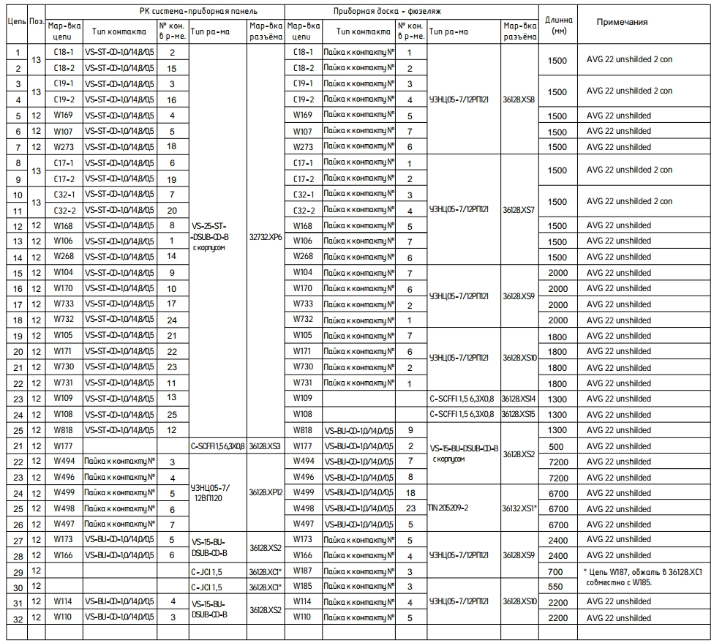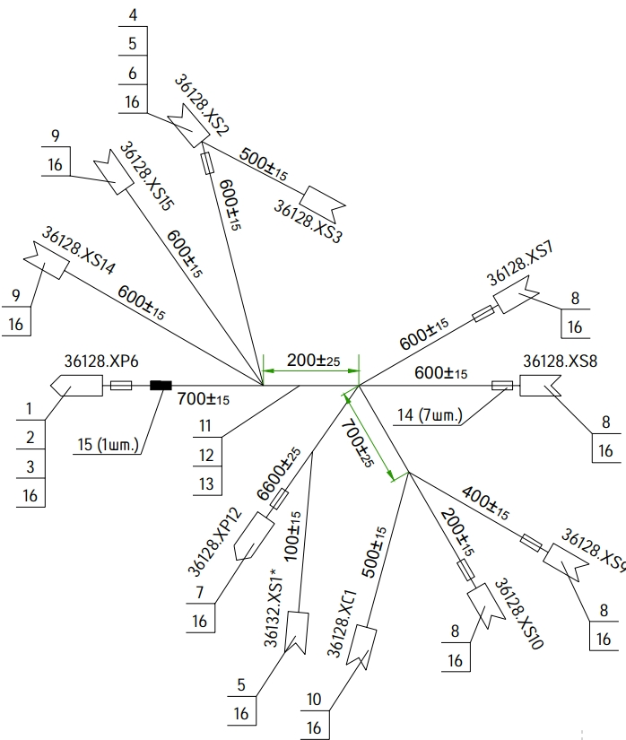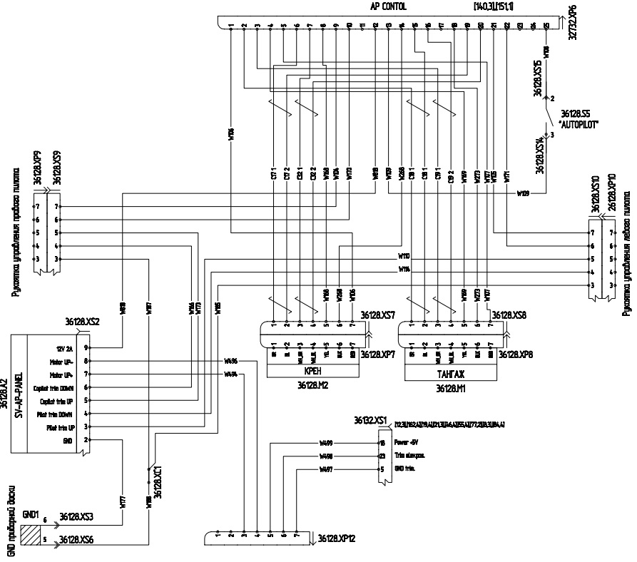

Assembling the rudder control, rudder direction , flaps
Note: altitude rudder and directional rudder are installed (from , ).6.26.3
To complete this work you will need:
- Mobile desk;
- combination wrench 8 mm;
- combination wrench 10 mm;
- hex key 4 mm;
- Tweezers;
- Pliers;
- Screwdriver with straight slot #1;
Unpack it and stack it on the table:
- 9 nuts M5 DIN 935;
- 24 M6 nuts DIN 935;
- 9 washers 5 DIN 6798A;
- 24 washers 6 DIN 6798A;
- 49 washers 5 DIN 125;
- 24 washers 6 DIN 125;
- 33 cotter pins 1,6x20 DIN 94;
- 19 bolts 00206920;
- 5 bolts 00167122;
- 4 rocking 00138831;
- RH rocking 00108701;
- RW rocking 00156274;
- rocker left 00138942;
- rocker right 00138934;
- rocking 00101026;
- rocking 00101387;
- rocking 00167156;
- 6 pulls 00109760;
- 2 pulls 00109762;
- Pull 00109783;
- Pull 00109771;
- Pull 00109781;
- Pull 00109774;
- traction 00100536;
- traction 00194625;
- 10 tubes 00101381;
- 20 F625ZZ bearings;
- 22LVS actuator
Locate 4 rockers 00138831,4 tubes 00101381, 8 F625ZZ bearings. Degrease:
- The outer inner tubular parts of the rocker;
- F625ZZ bearing outer surfaces.
IMPORTANT: Do not apply shaft and bushing retainer to an immediately degreased surface. The fixative can be applied 5-10 minutes after degreasing.
Apply an even thin layer of LOCTITE 648 Bushing Shaft Locker to the degreased surfaces of the F625ZZ bearing. Press the bearing into the rocker tube. The bearing should be clear of the rocker tube.
Install the tube 00101381 inside the rocker, press in the second bearing.
Note. To prevent the tube from coming off the axle when pressing the bearings in, install a bolt in the hole with the head on the side of the already installed bearing.
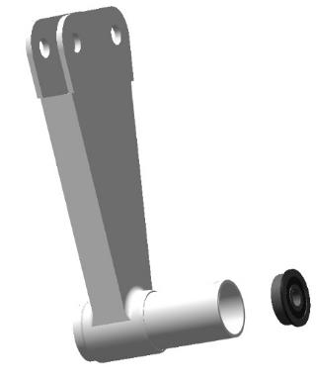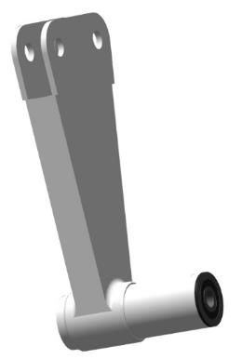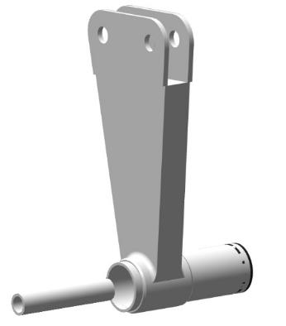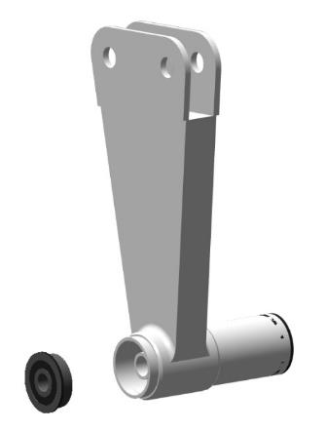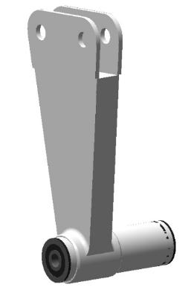
Repeat the steps above for the remaining rockers.
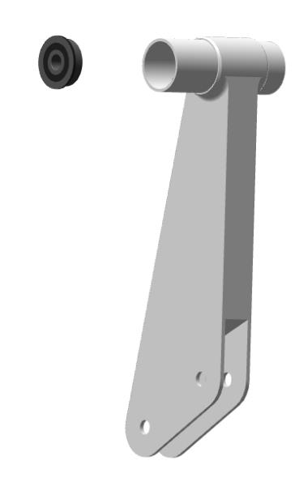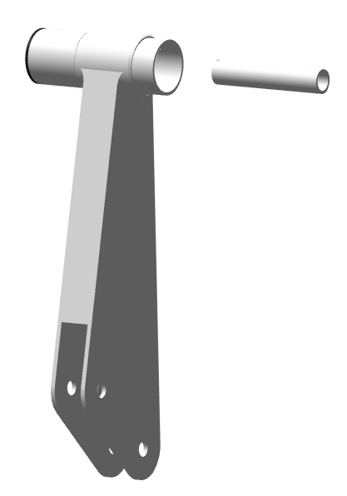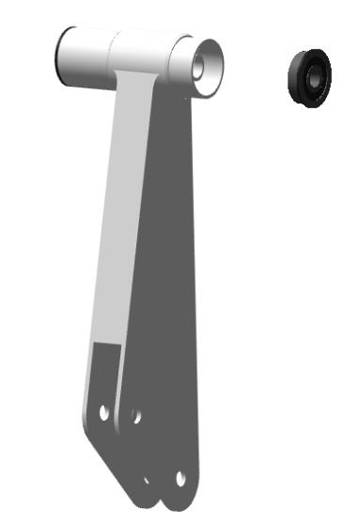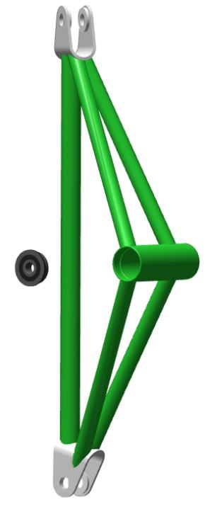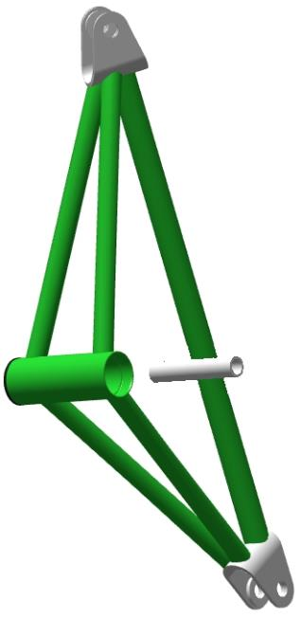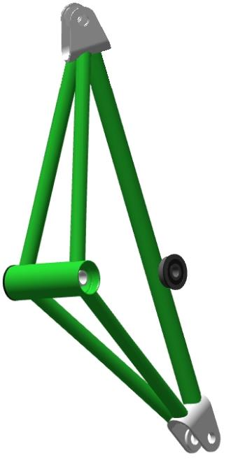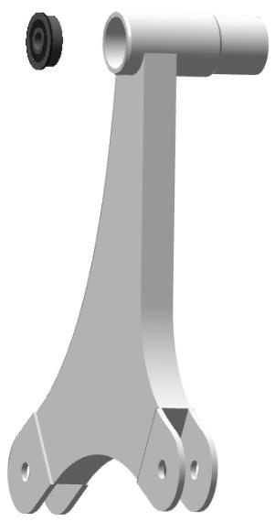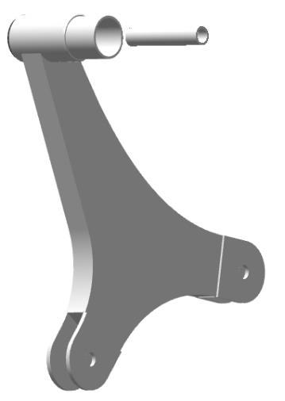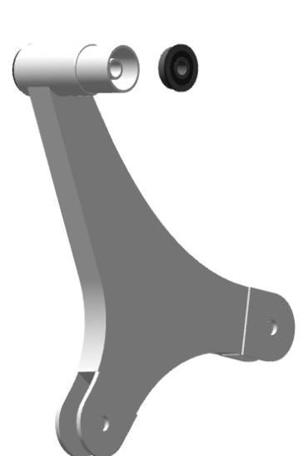

Locate the three lugs on the spar behind the trunk, at the bottom of the spar.
Insert the bolt 00167122 into the hole in the bracket level with the washer.Install the rocker arms 00138831 on the brackets.Push the axle until the head stops in the eye of the bracket.Place M5 DIN 125 washers between the eye and the bearings
Check the movement of the rockers on the bracket. The rockers should rotate easily on the axis, without jerks or jams.
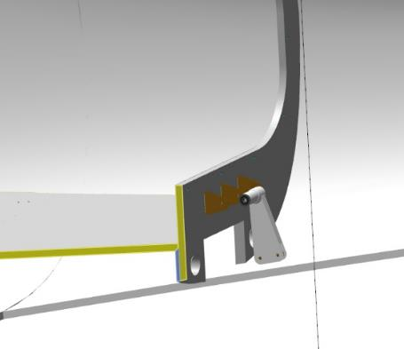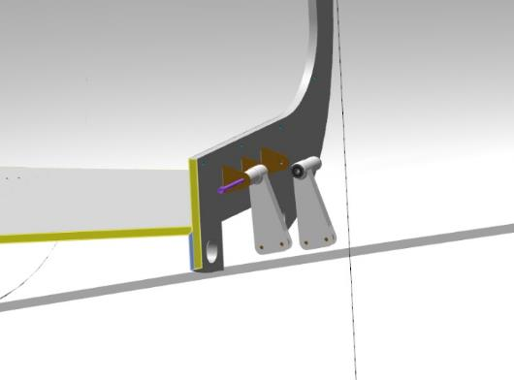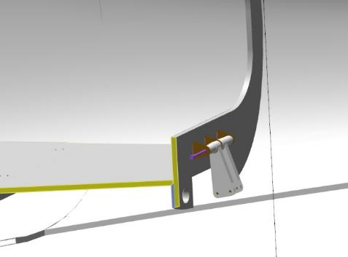
Place the washer 5 DIN 6798A on the bolt, screw on the nut M5 DIN 935. Tighten the nut with an 8 mm wrench until the 5 DIN 6798A washer is fully compressed. Locate the hole in the bolt, which should match the slot in the M5 DIN 935 nut. If the hole is not visible, tighten the nut until the hole matches the slot. Insert a 1x20 DIN 94 cotter pin into the slit of the M5 DIN 935 nut and the hole in the bolt. Tighten the cotter pin by loosening the cotter pin tabs with a #1 slotted screwdriver. Repeat the above steps to install the two rockers inside the fuselage, through the hatch in the trunk floor.
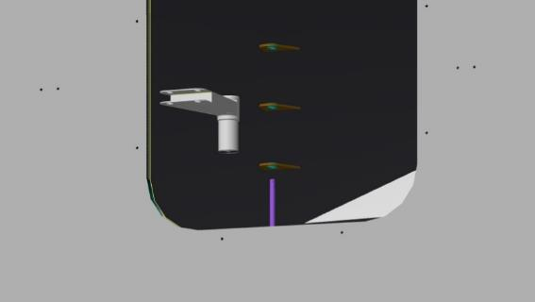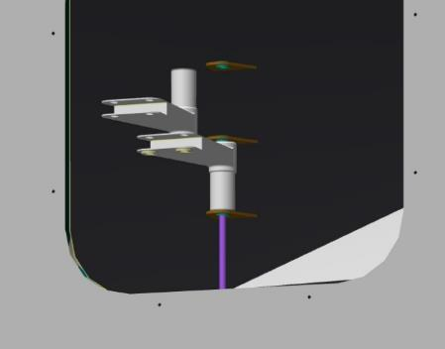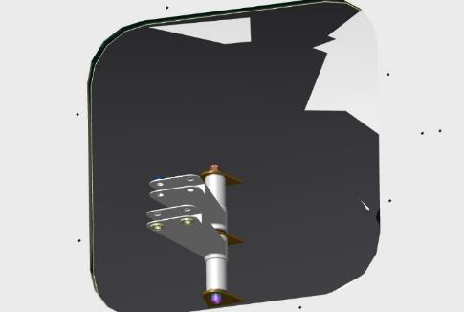
Repeat the steps to install the rockers through the hatch in the couch, near the keel, under the pilot beam.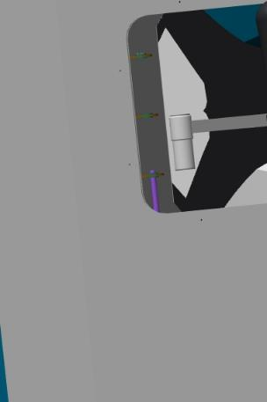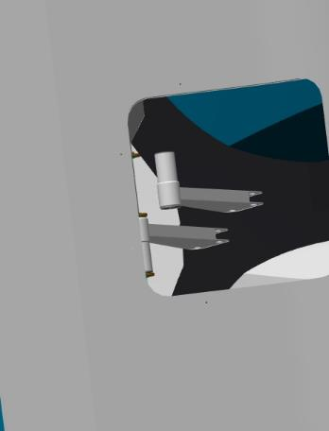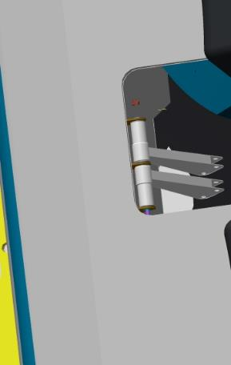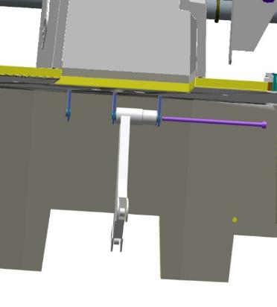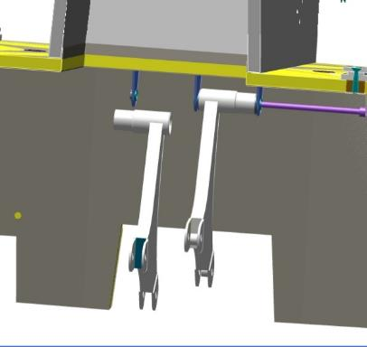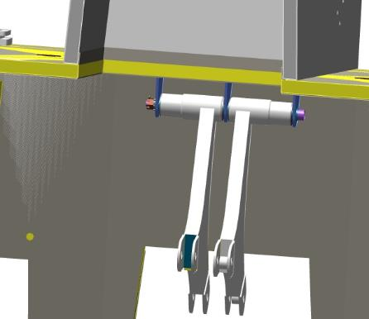
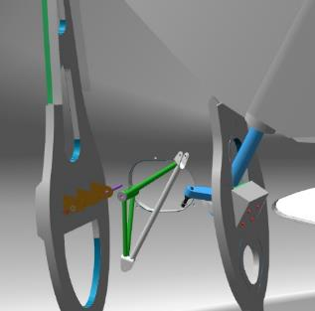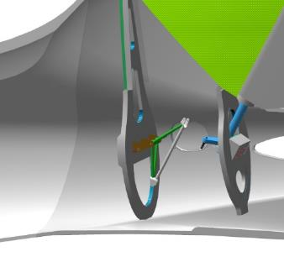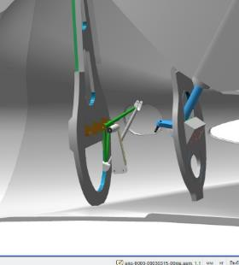

Insert the link 00194625 into the fuselage through the opening at the rear. Insert the link into the rocker eye 00156274, align the positions and install the bolt 00206920. Place washer 6 DIN 6798A on the bolt, screw on nut M6 DIN 935. Tighten the nut with a 10 mm wrench until the washer 6 DIN 6798A is fully compressed. Locate the hole in the bolt, which should match the slot in the M6 DIN 935 nut. If the hole is not visible, tighten the nut until the hole matches the slot. Insert a 1.6x20 DIN 94 cotter pin into the slit in the nut and the hole in the bolt. Tighten the cotter pin by loosening the cotter pin tabs with a #1 straight blade screwdriver.
Important: Do not drop the fastener into the fuselage cavity when working. Use a magnetized tool.
Repeat the steps above to install the pull rods 00109760, 00109762 on the rockers.
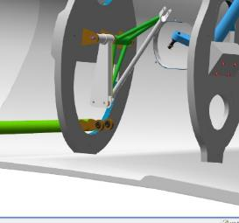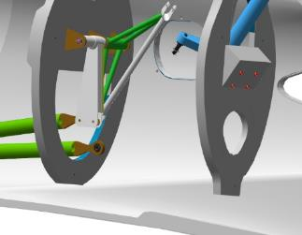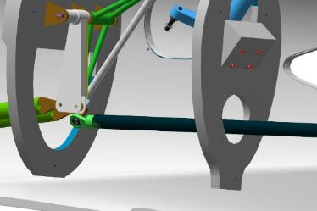

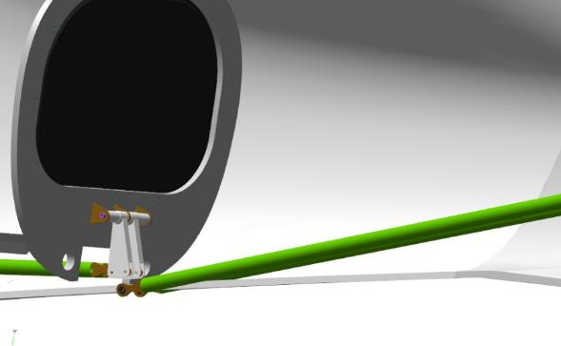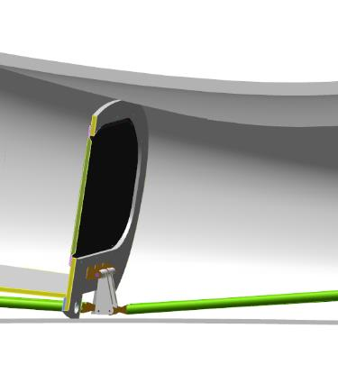
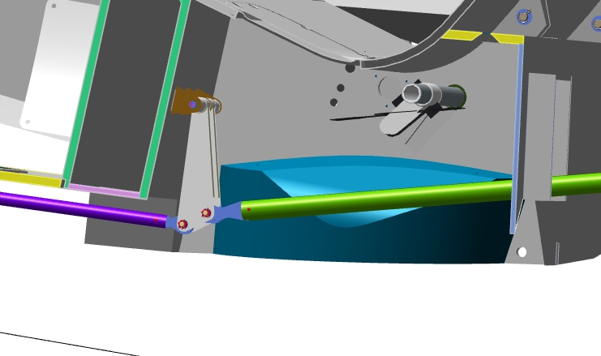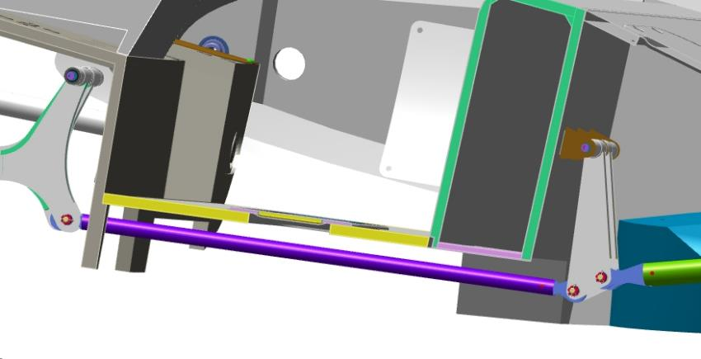

Note. As long as the nose landing gear pivot control rods are not installed, the foot control pedals are not synchronized. Only the pair of pedals that are actuated will move.
Control Operations:
- With the linkages connected to the rudder and foot control post, gently depress the right pedal full foot travel. The rudder should deflect to the right. The stroke should be smooth, without jerks or jams, and should not require much effort.
- Pull the right pedal all the way out by hand. The steering wheel should deflect to the right. The stroke should be smooth, without jerks or jams, and should not require much effort.
- Make 5-6 movements with the right foot control pedal, tilting the rudder to the left and right. The stroke should be smooth, without jerks or jams, and should not require much effort.
Locate the tie rods 00109774 and 00109781 (assembled earlier), and move to the cockpit.
Install the linkage 00109774 on the left side through the hole in the spar. Install the ANG-00109774 link on the right foot control rocker.
Install the tie rod 00109781 on the right side through the hole in the spar. Install the link 00109781.
Move to the nose strut (installed earlier), install the tie rod lugs on the nose strut pins. Place one 5 DIN 6798A washer each on the pins, screw on the M5 DIN 935 nuts.
Tighten the nuts alternately with an 8 mm combination wrench until the 5 DIN 6798A washers are fully compressed. Locate the holes in the fingers, which should line up with the slot in the M5 DIN 935 nut. If the hole is not visible, tighten the nut until the hole matches the slot. Insert a 1x20 DIN 94 cotter pin into the slit of the M5 DIN 935 nut and the hole in the pin. Tighten the cotter pin by loosening the cotter pin tabs with a #1 slotted screwdriver.
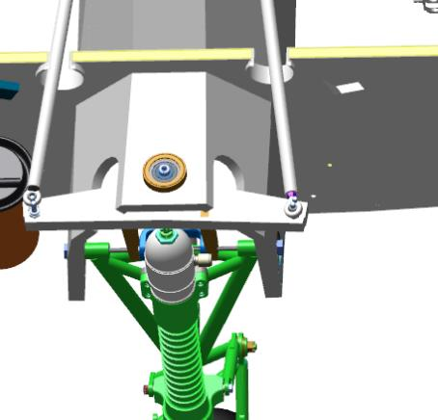
Note. After attaching the nose stand pivot control rods, the foot control pedals will move synchronously-the pedal that is not acted upon will move from the spar.
Control Operations:
- Move into the cockpit of the fuselage. Smoothly depress the right pedal to full foot travel. The rudder and nose strut wheel should deflect to the right, and the left pedal should move up from the spar. The stroke should be smooth, without jerks or jams, and should not require much effort. There should be no squeaking, cracking or grinding sounds.
- Press the left pedal smoothly to full foot travel. The rudder and nose stand wheel should deflect to the left, and the right pedal should move up from the spar. The stroke should be smooth, without jerks or jams, and should not require much effort. There should be no squeaking, cracking or grinding sounds.
- Make 5-6 movements with the foot control pedals, tilting the steering wheel to the left and right. The movement should be smooth, without jerks or jams, and should not require much effort. There should be no sounds of squeaks, cracks or rubbing.
- Set the right and left pedal approximately level, as accurately as possible. Move from the cockpit to the directional rudder. Inspect the rudder to ensure that it is set in position. The rudder should be approximately in the zero position. Move to the nose strut wheel. The wheel should be in the straight ahead position (standing straight).
Note. If the direction rudder is deviated from the zero position when the foot control pedals are set to the same level, the ANG-2700-00029758-00 linkage must be adjusted.
Length adjustment requires:
- Unscrew the nut on the tie rod lug near the steering wheel by 1 turn;
- Remove the fasteners securing the tie rod to the rudder;
- Pull the tip out of the rudder fork;
- Unscrew the lug from the rod by 1 turn;
- Install and fasten the tie rod in reverse order;
- Check the position of the foot control pedals and the position of the rudder.
If the rudder position changes in the required direction, repeat steps 1-6 until the required value is obtained. If the rudder position changes in the direction away from the required direction, screw the tip into the rod in point 4.
After adjustments have been made, screw the nut on the tip all the way in, using a shaft sleeve retainer.
When the adjustment is completed and the rudder is correctly positioned, cotter the rudder and linkage connection with a 1x20 DIN 94 cotter pin.
When the installation work for the rudder control and nose stand rotation is completed, continue with the installation work for the elevation rudder control.
Locate the pull rod 00100536 (previously assembled). Move into the cockpit with the rod. Insert the 00100536 link with the tip down through the pilot beam armrest opening. Guide the other end of the link, inside the armrest, to the rocker arm of the manual control station.
Install the link 00100536 on the 00138942 rocker arm under the pilot beam. Install the link 00100536 to the hand control shaft rocker under the pilot beam.
Move from the fuselage to the elevators in the tail section. Install the tie rod lug 00194625 between the elevator rocker arms. Align the holes in one of the rocker arms and the tie rod. Install the bolt 00206920 , flush with the tie rod lug, into the aligned holes. Align the hole in the second rocker and the tie rod and install the bolt until it stops.
Place the washer 5 DIN 6798A on the bolt, screw on the nut M5 DIN 935. Using two 8 mm combination wrenches, tighten the nut until the 5 DIN 6798A washer is fully compressed. Locate the hole in the axle, which should coincide with the slot of the M5 DIN 935 nut.
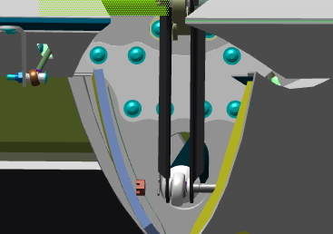 | 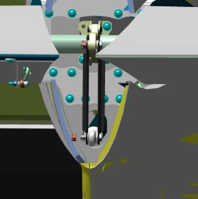
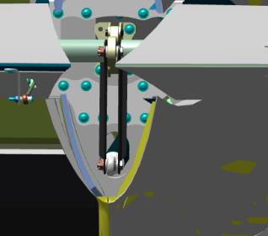
Control Operations:
- To the right or left, pull the control handle toward you. The elevator rudders should deflect upwards. Stroke should be smooth, without jerks or jams, and should not require much effort. There should be no squeaking, cracking or grinding sounds.
- Pull the control handle away from you. The elevator rudders should deflect downwards. Stroke should be smooth, without jerks or jams, and should not require much effort. There should be no creaking, cracking or grinding sounds.
- Set the control knob approximately mid-stroke. Move to the elevation rudders at the tail section. While the helper holds the control stick in the center position, inspect the position of the rudders. The rudders should be in the zero position.
Note. If the elevation rudders are deflected from the zero position when the control knob is set to the center position, the ANG-2700-00029716-00 linkage must be adjusted.
Length adjustment requires:
- Unscrew the nut on the tie rod lug near the elevation rudders by 1 turn;
- Dismantle the tie rod mounting fasteners to the elevator rudders;
- Remove the tip from the rudder rockers;
- Unscrew the lug from the rod by 1 turn;
- Install and fasten the tie rod in reverse order;
- Check the position of the control knob and the position of the rudders.
If the position of the rudders changes in the required direction, repeat points 1-6 until the required value is obtained. If the rudder position changes in the direction away from the required direction, the tip must be screwed into the rod in point 4. After adjustments have been made, screw the nut on the lug to the stop, using the shaft bushing retainer.
When the adjustment is complete and the rudders are correctly positioned, cotter the rudder and linkage connection with a 1x20 DIN 94 cotter pin.
Locate the 22LBS actuator. Locate the black and red wires. Remove the insulation from the wires to a length of approximately 5 mm. Connect the red wire to a 12 volt power source, the red wire to "+" and the black wire to "-". The actuator should retract and release when the poles are changed.
IMPORTANT: Do not use a power supply with a voltage of more than 14 volts. Do not connect wires other than the red and black wires to the power supply. Doing so will cause the actuator to malfunction.
Release the actuator at full stroke until it comes to a complete stop.
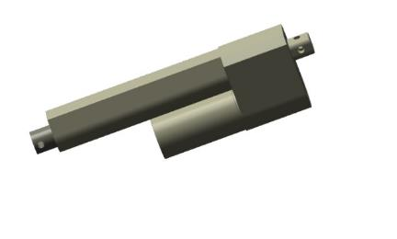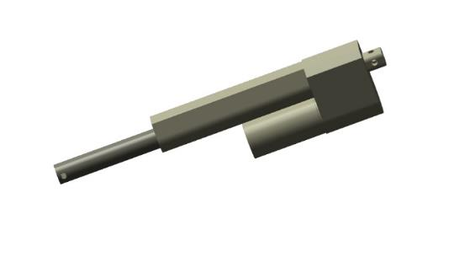
Note. The actuator has built-in end position sensors that are activated at the end positions of retracted or released.
Crimp the connector to the actuator according to the diagram.
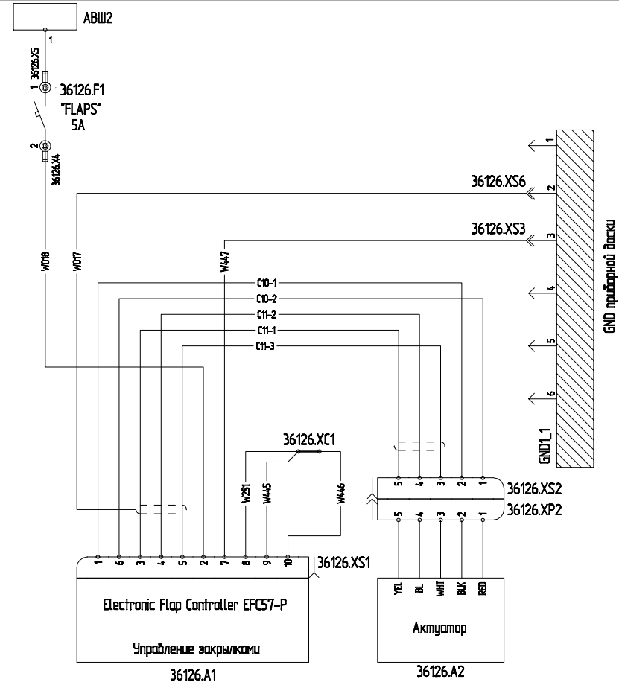
Install the actuator, in released position, on the flap shaft. Secure it to the shaft with a bolt. Check the ease of movement of the actuator on the shaft - up and down, left and right, circumferential movement. The actuator should move easily in all these directions and should not rest on the shaft fork. The circumference and other movements must be at least 10 mm.
Make a harness, connect it to the device and actuator according to the diagram.
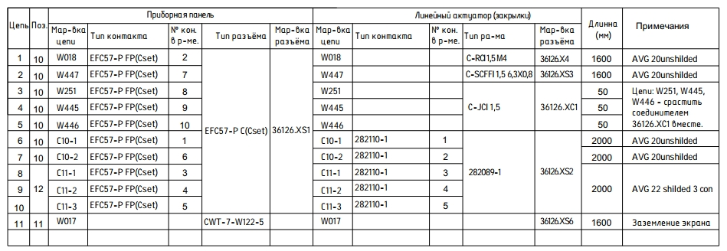
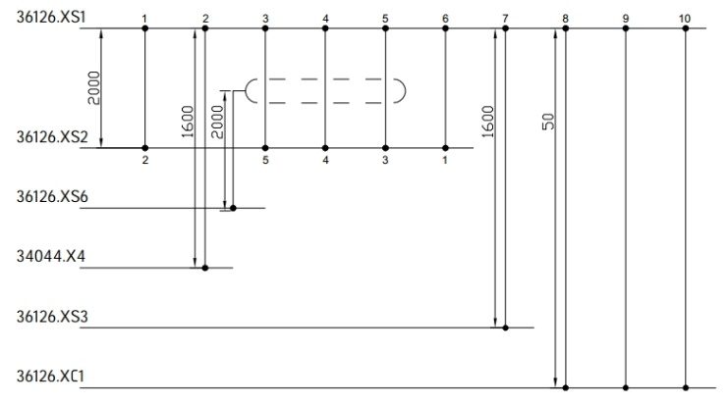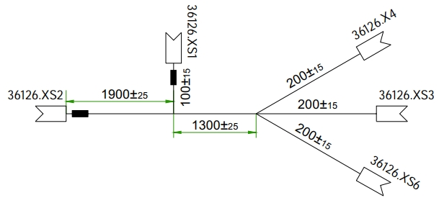

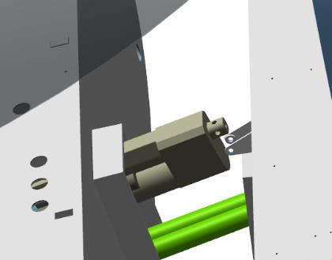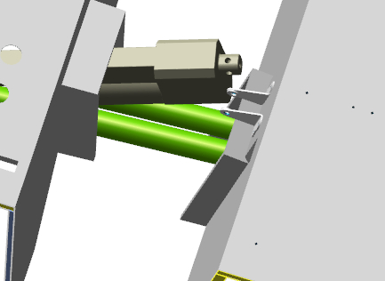
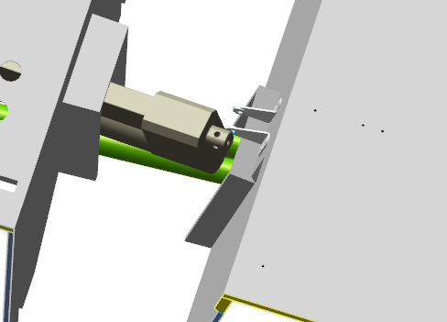
IMPORTANT: If the actuator on the shaft cannot be moved to the above dimension, this will result in shaft failure and possible disaster. If the shaft fails, it can only be repaired in the factory or by replacing the shaft completely.
Note. To allow the actuator to move 10 mm or more on the shaft, follow the steps below:
- Remove the actuator from the shaft;
- File the flap shaft fork between the lugs with a round (semicircular) file;
- Try on the actuator;
- Repeat these steps until a stroke of 10 mm is obtained in all directions.
When the 10 mm dimension is secured, attach the actuator finally to the flap shaft and to the trunk floor brackets. Check the operation of the attached actuator from the power supply. The movement should be smooth, without jerks and no audible sounds. The actuator should stop by itself in the end positions - retracted and released.
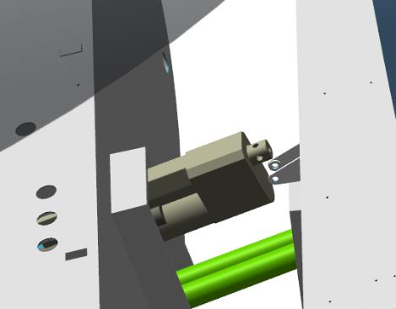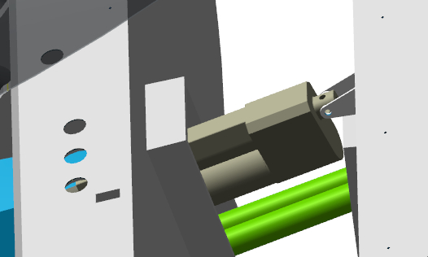

Assembling and installing the PDR
To complete this work you will need:
- Mobile desk;
- Combination wrench 10 mm;
- Hexagonal wrench 4 mm;
- Hexagonal wrench 2.5 mm;
- No. 2 straight blade screwdriver;
Unpack it and stack it on the table:
- Plate 00120769;
- 2 pads 00120748;
- M4 stud 00120759;
- Bushing 00120756;
- Bushing 00120750;
- Restrictor 00120796;
- One-piece handle 00120753;
- 2 handles 00120762;
- Washer M6 DIN 125;
- Nut M6 DIN 985;
- Screw 6x16 DIN 404;
- 2 M4x8 screws ISO 7380-2;
- 5 screws M4x27 DIN 551;
- 8 washers 6 DIN6796
Note. Perform final painting and other coatings after adjustments have been made. The coating material must be compatible with the materials to be coated and must not harm or destroy them.
Find the plate 00120769 and the bushing 00120750. Insert the bushing into the plate hole and a 6x16 DIN 404 screw into the bushing. Place a washer M6 DIN 125 and a nut M6 DIN 985 on the threaded part of the screw. Tighten the connection by hand.
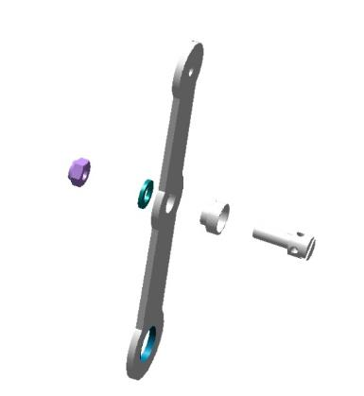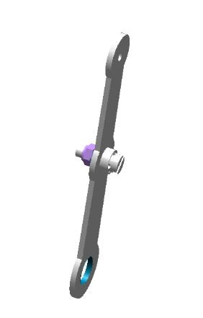
Check the 5 M4 holes in the armrest according to standard procedure 6 5. Degrease the M4x27 DIN 551 screws
IMPORTANT: Do not apply shaft and bushing retainer to an immediately degreased surface. The fixative can be applied 5-10 minutes after degreasing.
Apply an even, thin coat of LOCTITE 648 shaft and bushing retainer to the degreased surfaces of the screws. Install the screws into the armrest holes, tighten until flush with the opposite side of the armrest.
IMPORTANT: When working, do not drop the screws into the fuselage cavity. Use a magnetized tool.
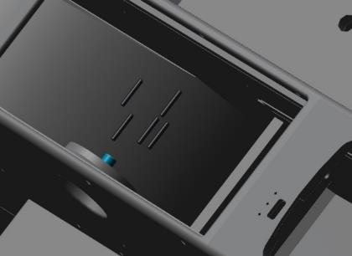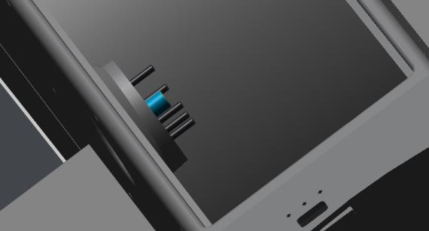
Install in turn: pad 00120748, bushing 00120756, plate 00120769, pad 00120748, organizer
Note.If the pads or stopper cannot be installed:
- Inspect for alignment of slots or holes with screws.Turn until aligned.
- If the pads cannot be rotated or turned, grind the grooves with a nat file.
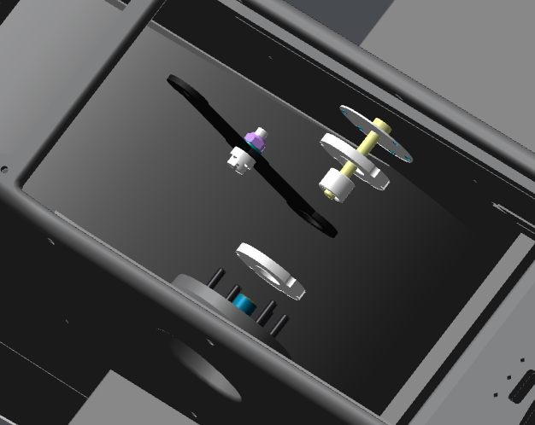
Place 8 washers 6 DIN6796 on the outside of the armrest, on the protruding threads of the limiter, screw on the handle 00120753. Check the ease of movement of the 00120769 plate by moving it back and forth. The movement should be smooth, without jerks and jams, with a slight force. If the force is slight, tighten the knob 00120753 one turn and try again.
Note: If the force is not adjustable, unscrew the handle 00120753, place one washer 6 DIN125 between two washers 6 DIN6796. Reassemble and adjust again. It is allowed to install 4 washers between each pair of 6 DIN6796 washers.
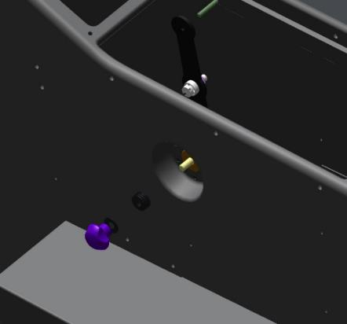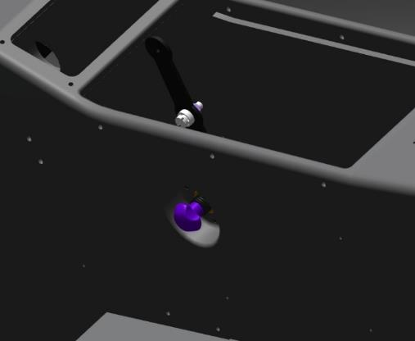

IMPORTANT: The final tightening of the knob will be done after attaching the throttle control cable.
Install the throttle plate in the armrest. Recheck the forward and backward movement of the plate.The travel, smoothness and force should remain the same as without the panel.
Note: If the travel or force changes after installing the panel, locate where the plate rests in the panel. Grind this location with a flat file and check the movement again.

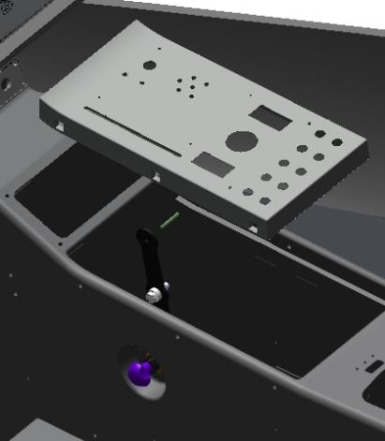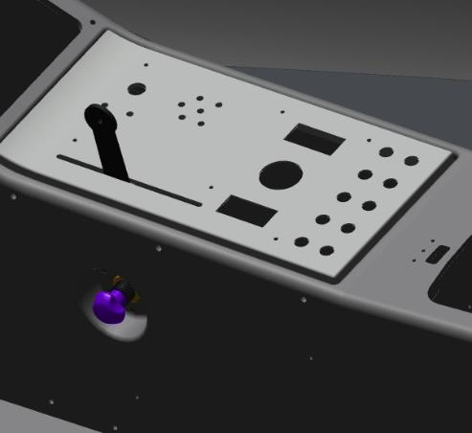

AIRFRAME ASSEMBLY

Stabilizer installation
Objectives of this work: to install the stabilizer on the fuselage.
To complete this work you will need:
- Mobile desk;
- Hexagonal wrench 2.5 mm;
- Digital Kitchen Scale.
- Latex gloves 1 pair.
- Larit L285 epoxy resin 30 grams.
- H287 hardener 12 grams.
- Paper cup 100 ml.
- Aerosil thickener 3 grams.
- Sandpaper grit P1000 1 sheet 200x300 mm.
- Solvent methyl acetate 100 grams.
- Clean rags 100x100 mm 5 pieces.
- Sandpaper grit P240 1 sheet 200x300 mm.
- The marker is white in color.
- Respirator.
- Metal trowel 50 mm.
- Torque wrench 1-25Nm.
- 2.5 mm hexagonal end cap.
- 10-meter tape measure.
Unpack it and stack it on the table:
- Stabilizer 00120238;
- Plate 00120236;
- Plate 00120237.
- 12 M4x10 screws ISO 7380-2.
Check the M4 tapped holes according to standard action 6 on the stabilizer and fuselage.
Locate the 2 threaded holes on the stabilizer member, they are located in the middle of the stabilizer on the spar side. This mark points to the lower stabilizer trim.
Insert the stabilizer from the left or right into the fuselage opening until approximately midway. Install the plates 00120236 and 00120237 on the spar, aligning the holes in the plate and the spar.
Fasten the outermost holes to the spandrel with M4x10 ISO 7380-2 screws.
IMPORTANT: Do not tighten the screws too much until the screws are installed in all holes. Do not drop the screws into the fuselage cavity when working. Use a magnetized tool.
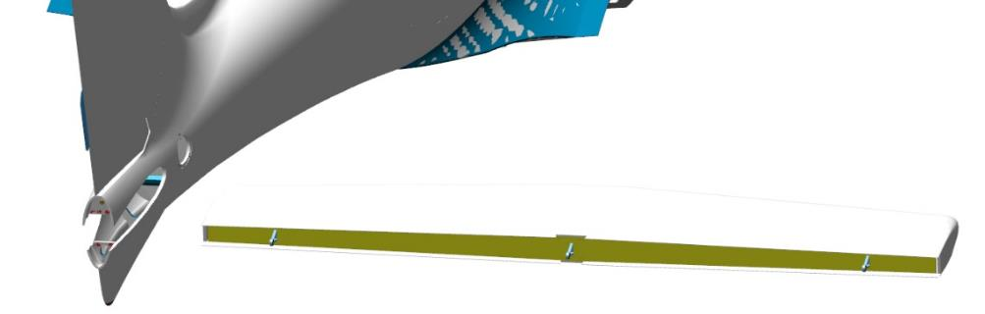
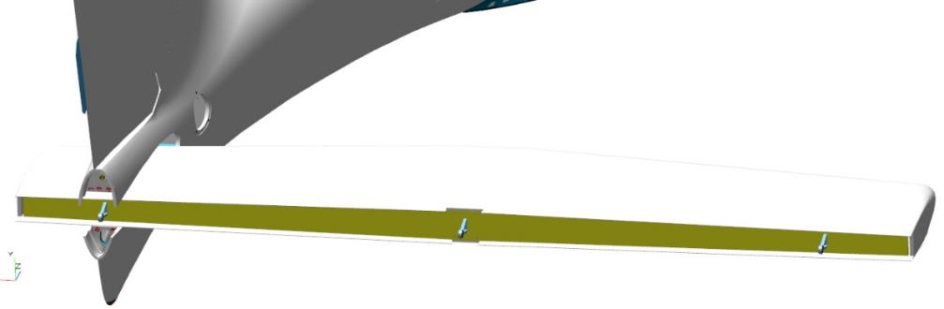
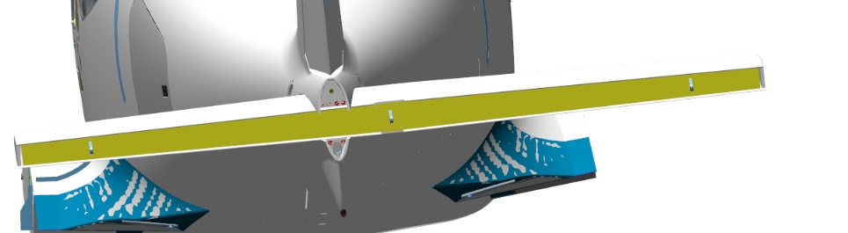
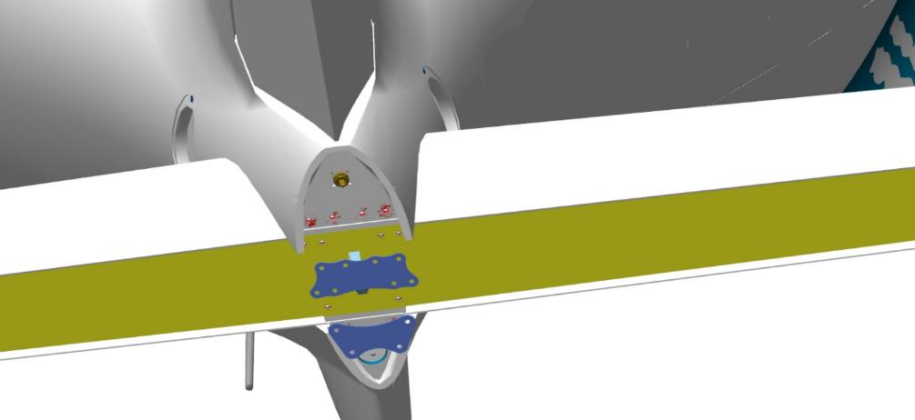
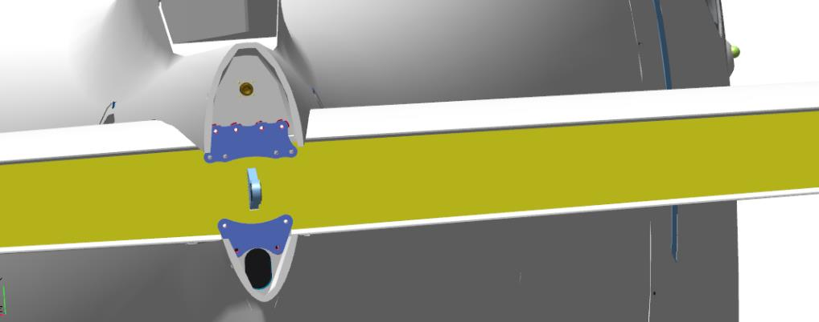
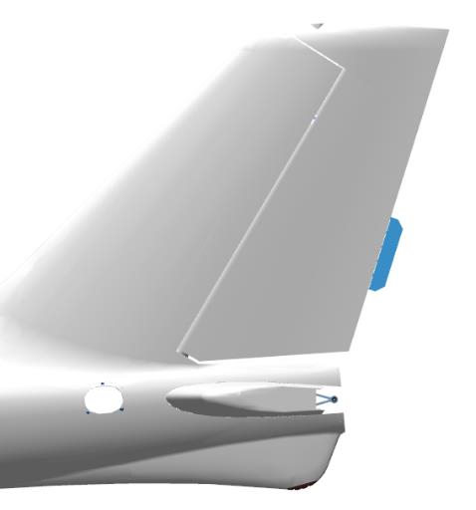 | 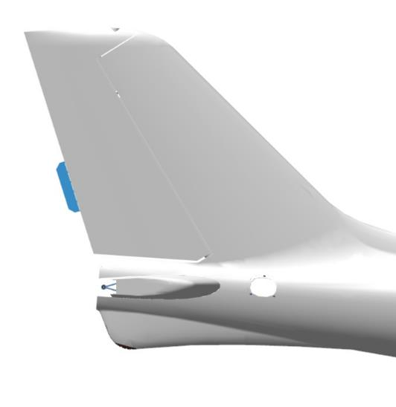
Control Operations:
- Gaps along the stabilizer insertion contour into the fuselage. The gaps should be uniform from 0.5 mm to 1 mm.
- Distance from the axis of the right node hole on the stabilizer to the axis of the node hole on the keel. Use a tape measure for measurements.
- Distance from the axis of the left node hole on the stabilizer to the axis of the node hole on the keel. Use a tape measure for measurements. The difference in dimensions must not exceed 5 mm.
- The clearances under the stabilizer mounting plates can be from 0 to 0.5 mm.
If all checked locations are OK, trace with a marker the fuselage contour at the top and bottom, the contours of the plates on the spar and stabilizer spar.
Remove the stabilizer in reverse order.
IMPORTANT: Always deburr the adhesive areas 10-15 mm larger than the actual contour of the part to be installed.
Brush up on type action 3:
- Stabilizer fit location inside the fuselage opening.
- Places on the stabilizer trim, top and bottom of the touchdown points with the fuselage.
- The places where the plates fit on the spar and spar.
IMPORTANT: Do not damage the composite parts of the stripping points. The thickness of the linings in some places is only 0.08 mm. Do not rub for a long time in one place, even if the area to be stripped does not become matt.
Scrape the places where the plates meet the stabilizer spar and the stabilizer spar in accordance with standard procedure 4.
Degrease:
- Cleaned up area of stabilizer opening on the fuselage;
- Scraped areas of stabilizer trim;
- Cleaned up areas on the fuselage spar;
- Scraped areas on the stabilizer spar;
- Scraped areas on the plates.
Place the stabilizer in the opening, aligning it approximately in the middle.
Prepare an epoxy adhesive from Larit L285 resin and H287 hardener in the proportion of 30:12 according to standard operation 1.
IMPORTANT: Epoxy adhesive has a 60 minute use time from the time of preparation.
Apply the adhesive according to standard procedure 5.1 to the degreased surfaces of the plates, the plate mounting points on the stabilizer spar and the stabilizer spar, the aperture and the stabilizer in the areas where they touch. It is allowed to slightly bend the fuselage skin to increase the aperture in the stabilizer area.
Use the remaining adhesive to prepare the adhesive according to standard procedure 2.
Apply the compound according to standard procedure 5.2 on the surfaces of the plates, in the fuselage opening with stabilizer. Place the plates on the spar, align the holes in the plates and the spar. Fasten with two M4x10 ISO 7380-2 screws the outermost holes to the spar of each plate.
The screws do not need to be tightened too much at this stage of work. Align the screw holes of the stabilizer and the plates. Attach the plate to the stabilizer with four M4x10 ISO 7380-2 screws. The screws do not need to be tightened too much at this stage.
Attach the plate 00120236 to the stabilizer using four M4x10 ISO 7380-2 screws. Do not tighten the screws too much at this stage. Attach the 00120237 plate to the spar using two M4x10 ISO 7380-2 screws. Do not tighten the screws too much at this stage of the work.
Clean the workplace and tools according to standard procedure 7.
Check the installed stabilizer according to the diagram that was used to measure when the stabilizer was first installed.

Installation of the elevator and trimmer
    - Installation of rudder linkage assemblies
To complete this work you will need:
- Mobile desk;
- Hexagonal wrench 2.5 mm;
- Digital Kitchen Scale.
- Latex gloves 1 pair.
- Larit L285 epoxy resin 30 grams.
- H287 hardener 12 grams.
- Paper cup 100 ml.
- Aerosil thickener 3 grams.
- Sandpaper grit P1000 1 sheet 200x300 mm.
- Solvent methyl acetate 100 grams.
- Clean rags 100x100 mm 3 pieces.
- Sandpaper grit P240 1 sheet 200x300 mm.
- The marker is white in color.
- Respirator.
- Metal trowel 50 mm.
- Torque wrench 1-25Nm.
- 2.5 mm hexagonal end cap.
- 10-meter tape measure.
- Hex key 2 mm;
- Hexagonal end cap 2mm.
- Combination wrench 5.5 mm.
- 8 mm combination wrench.
- Tweezers 100 mm.
Unpack it and stack it on the table:
- Left elevation rudder 00105037;
- Right elevation rudder 00105943 ;
- 2 plates 00108623;
- Trimmer 00120481;
- 2 axles 00120291;
- Trimmer axle 00120499;
- 2 bearings 00120500;
- Tail fairing 00182165
- Trimmer drive T2-10A;
- AWG 22 wire 2750 mm;
- 5 connectors C-JCI 1.5 3240061;
- PC7TV outlet;
- 5 washers 3 DIN 125;
- 8 screws M4X12 DIN7991;
- 4 screws M3X12 ISO7380-2;
- 3 screws M3X20 ISO7380-2;
- 4 screws M4X12 ISO7380-2;
- 2 nuts M3 DIN 934;
- 4 nuts M5 DIN 935;
- 2 nuts M3 DIN 985;
- 2 bearings F693 2RS;
- Screw M3x12 DIN 427.
Locate the axle 00120291. Degrease:
- The short threaded part of the axle;
- The internal threaded part in the handlebar pocket.
Apply an even, thin coat of LOCTITE 648 Shaft-Hub Locker to the degreased surfaces.
Install the axle in the pocket, tighten with a 10 mm wrench until there is no play under the axle shoulder and the elevation rudder
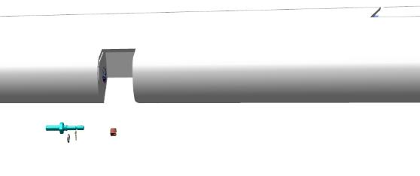 | 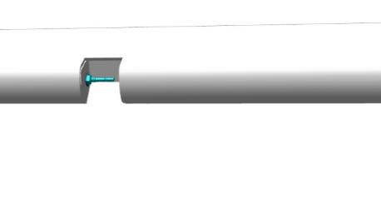
Locate the M3x12 DIN 427 screw. Install the screw to the full depth of thread on the height rudder with LOCTITE 648 shaft retainer. Place 3 washers 3 DIN 125 on the screw.
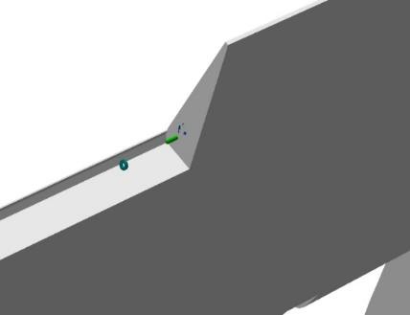 | 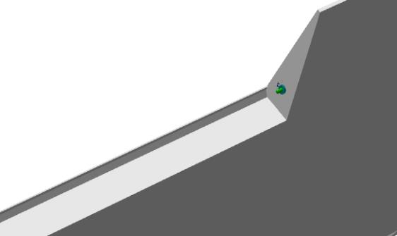
Locate 2 bearings F693 2RS. Install the bearings on the LOCTITE 648 shaft sleeve retainer, one at a time, on the rudder bracket with the tabs facing outward on the bracket.
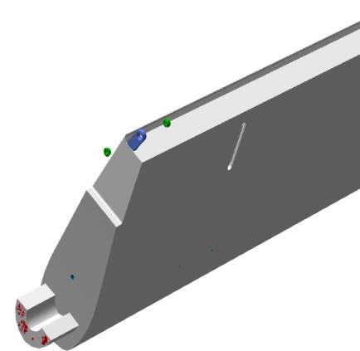 | 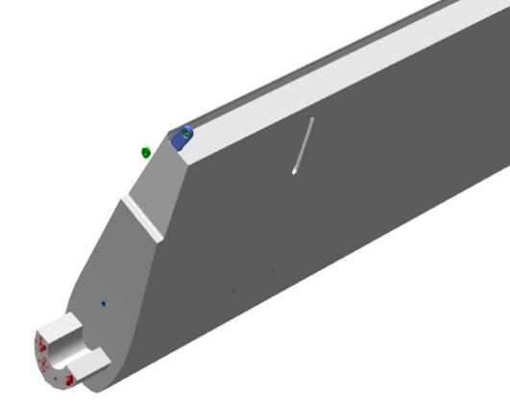
Find the plate 000108623 and 4 M4x12 DIN7991 screws. Place the plate on the rudder end. Secure with the screws. Check the place where the plate is installed for gaps, there should be no gaps.
Re-install the 4 M4x12 DIN7991 screws on the LOCTITE 648 shaft sleeve retainer.
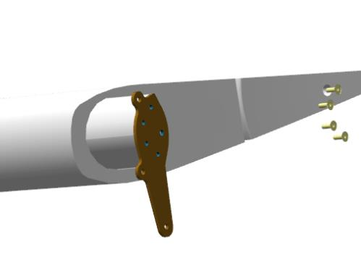 | 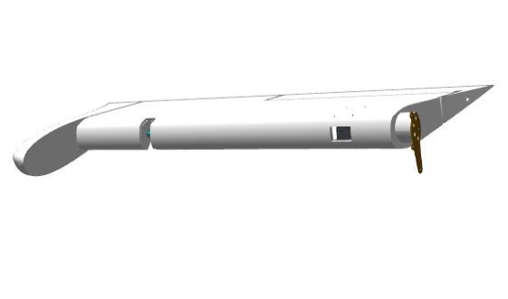
Repeat the work to install the axle 00120291, plate 000108623 on the elevation rudder 000105943.

    - Installing the elevator trimmer
Find the trimmer axle 00120499, 2 bearings 00120500, 2 M3 nuts DIN 934. Screw the two M3 nuts onto the axle. Screw the two bearings onto the axle to full thread travel. Adjust the caliper to size 186. Alternately, unscrew by the same number of turns and align dimension 186 between the bearing bore axes 000120500. Lock the bearings by tightening the nuts with a 5.5 mm wrench.
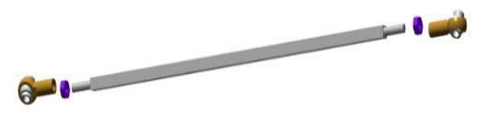 | 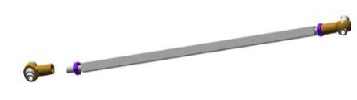
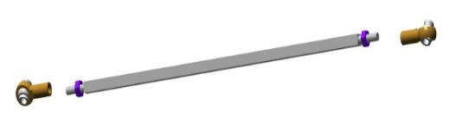 | 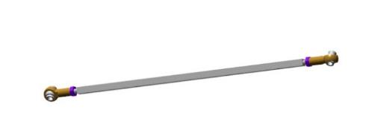
Locate the T2-10A trimmer actuator, 3 DIN 125 washer, M3X20 ISO7380-2 screw, M3 DIN 985 nut. Place the rod with bearings on the actuator eyelet. Secure with screw M3X20 ISO7380-2, washer 3 DIN 125, nut M3 DIN 985.
Connect the trimmer drive wires as shown in the diagram.Each AWG22 wire should be 550+ 25 mm long, and labeled with its number.
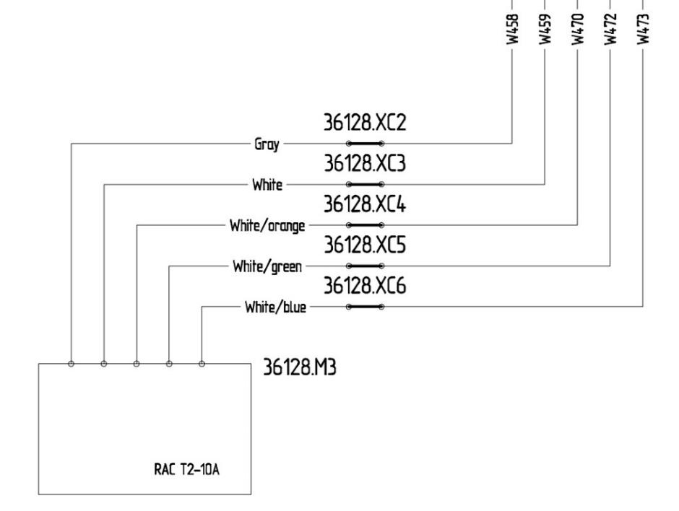

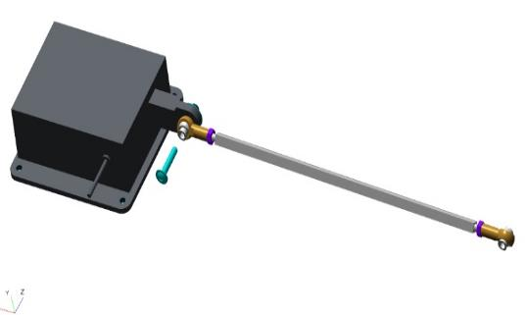 | 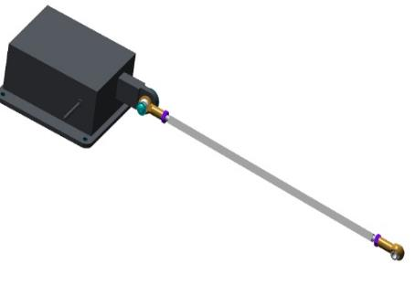
Locate the trimmer 00120481, screw M3x20 ISO7380-2. Fit the trimmer to the opening on the handlebar.Fit the trimmer to the M3x12 DIN 427 screw, align the other side with the eyelet on the handlebar.Secure the trimmer through the opening with the M3x20 ISO7380-2 screw.
Control Operations:
- Make a few tilts up and down. The trimmer should deflect easily without jamming or rubbing.
Re-install the M3x20 ISO7380-2 screw on the LOCTITE 648 shaft sleeve retainer.
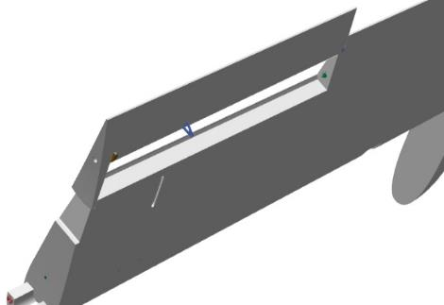 | 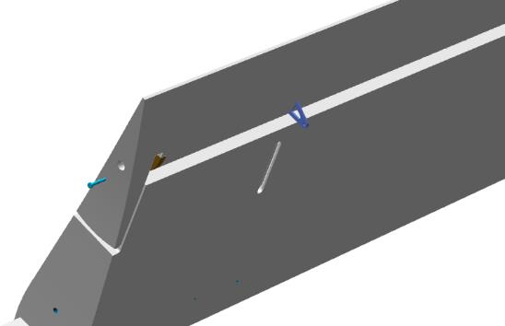
Place the elevator rudder 000105943 with the link slit on the trim facing up.
Drive the trimmer actuator with attached axle through the side opening in the handlebar, pull the axle through the slit in the skin. Place the actuator on the seating area, secure with 4 M3X12 ISO7380-2 screws
Fasten the axle bearing to the trimmer eye with M3x20 ISO7380-2 screw, 3 DIN 125 washer, M3 DIN 985 nut.
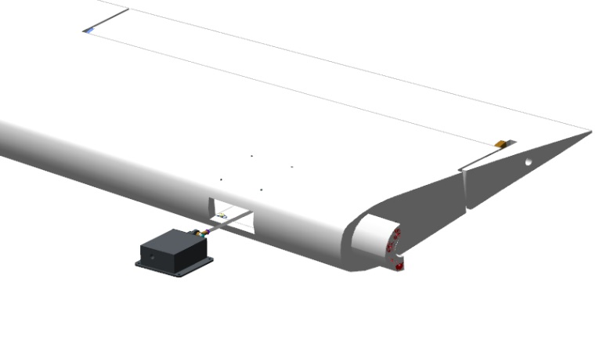
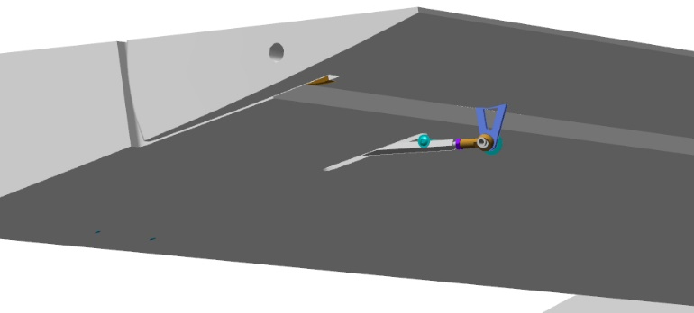

    - When the trimmer actuator is installed in the handlebar, lead the wires outside and connect to the PC7TV socket as per the diagram.

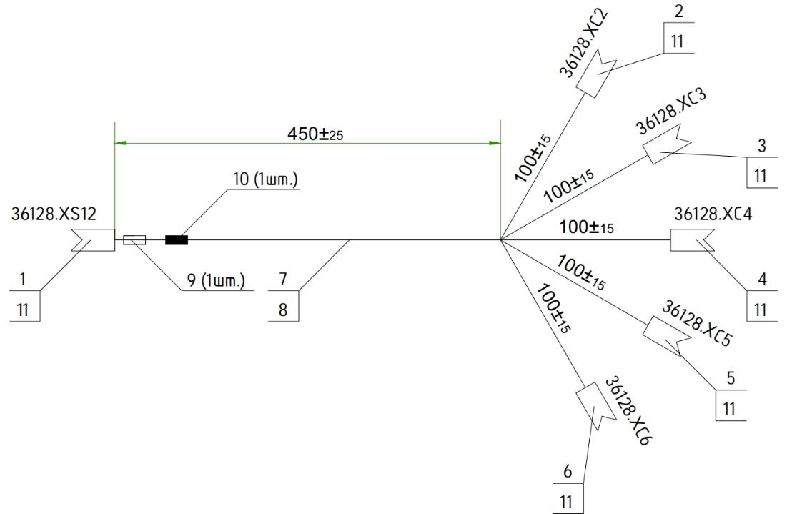

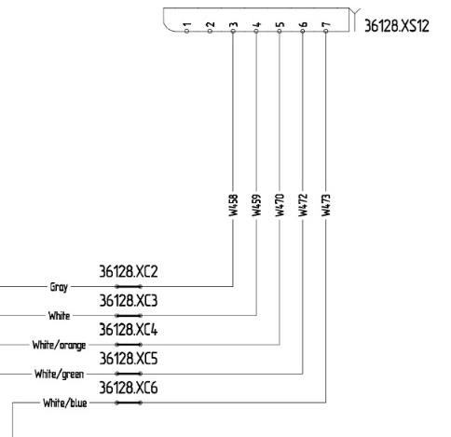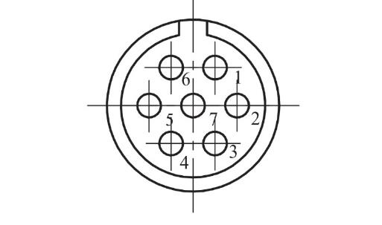
    - Setting the elevator rudder
Locate the elevation rudder right 000105943.
Bring the elevator rudder up behind the stabilizer, on the starboard side of the aircraft. The rudder should point with the plate toward the center linkage assembly. Bring the rudder up against the spar, insert the axle into the bearing hole. Slide the rudder by aligning the holes in the rudder plate and the bearing of the center linkage assembly
Insert the bolt into the aligned holes. The bolt should pass through all holes easily.
Locate elevation rudder left 000105037.
Bring the elevator rudder to the rear of the stabilizer on the port side of the aircraft. The rudder should point with the plate toward the center linkage assembly. Bring the rudder up against the spar, insert the axle into the bearing hole. Slide the rudder by aligning the holes in the plate with the installed bolt in the center linkage assembly.
Screw the M5 DIN 935 nut onto the bolt. Tighten the nut with an 8 mm wrench, with a little hand force, but until the clearance between the plates and the bearing of the middle unit is eliminated. Locate the second bolt . Insert the bolt into the lower holes of the plates. Screw the nut onto the bolt as far as it will go, tighten with an 8 mm wrench.
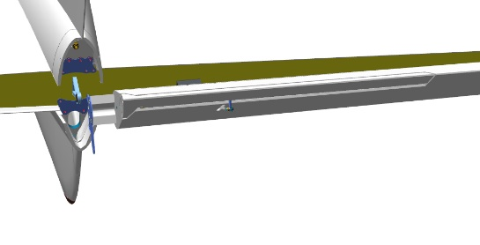
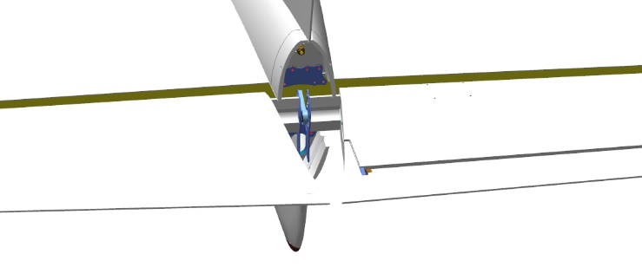
Control Operations:
- Check the axles on the outermost handlebar linkage assemblies - the axles must reach the bearing stops. If this is not the case, but the plates have come to a stop on the middle unit, it is necessary to dismantle the handlebars, put M5 washers and put everything back together.
- Check the installed rudders by deflecting them up and then down by hand until they stop. The rudders should move smoothly, without jerks or jams. The rudder ends should not touch the fuselage. Repeat the rudders up and down movement three or four times.
- Approach the left elevation rudder from behind, tilt it upwards. Screw the M5 DIN 935 nut onto the axle, tighten with an 8mm wrench. Repeat this action for the right rudder. Check the installed rudders by tilting them up and then down by hand until they stop. The rudders should move smoothly, without jerks or jams. The rudder ends should not touch the fuselage.
Locate the tail fairing 00182165 and 4 M4x12 ISO 7380-2 screws. Install the fairing between the rudders. Align the holes of the tail fairing and the fuselage. Attach the fairing with 4 M4x12 ISO 7380-2 screws. Tighten the bracket mounting screws with a wrench in any sequence.
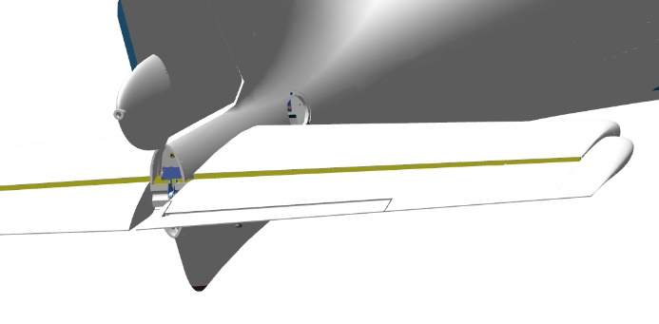
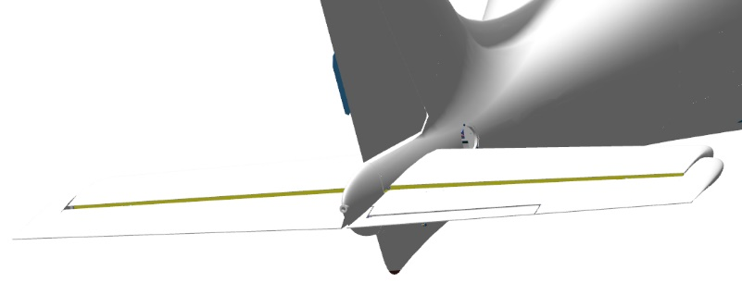
Control Operations:
- Check the installed tail cowling by deflecting the rudders up and then down by hand until they stop. The rudders should move smoothly, without jerks or jams. The stroke of the rudders should be the same as without fairing. The rudder ends must not touch the fuselage and tail cowling in any position.

Installing the rudder
The objectives of this work are: to assemble and install the rudder of direction.
To complete this work you will need:
- Mobile desk;
- Combination wrench 10 mm;
- 8 mm combination wrench;
- Unpack it and stack it on the table:
- Helm of Direction 00120593;
- 2 axles 00120291;
Count it out and stack it on the table:
- 2 cotter pins 1,0x35 DIN 94;
- 2 nuts M5 DIN 934;
- 2 F625ZZ bearings.
Locate directional rudder 00120593 and the 2 axes 00120291.
Degrease:
- Outer threaded parts of axles with m6 threads;
- Threaded hole in the PH pocket.
- Threaded hole on the PH rocker.
Apply an even, thin coat of LOCTITE 648 shaft-bushing retainer to the degreased surface of the axle.
Install the axle 00120291 in the rudder pocket, tighten with a 10 mm wrench until there is no play between the axle shoulder and the rudder.
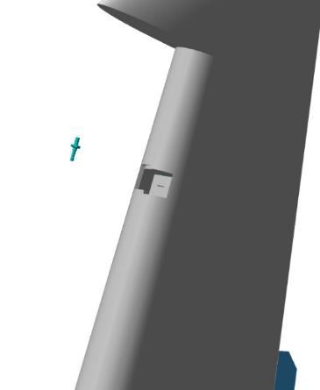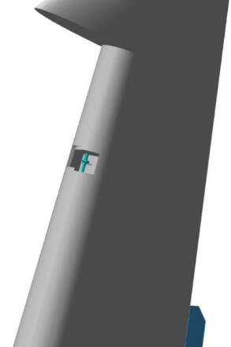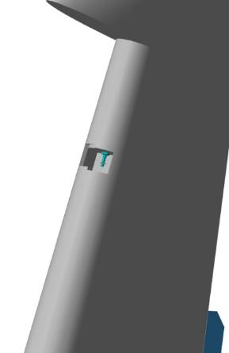

Install the axle 00120291 from below on the handlebar rocker, tighten with a 10 mm wrench until there is no play under the shoulder of the axle and the handlebar rocker.
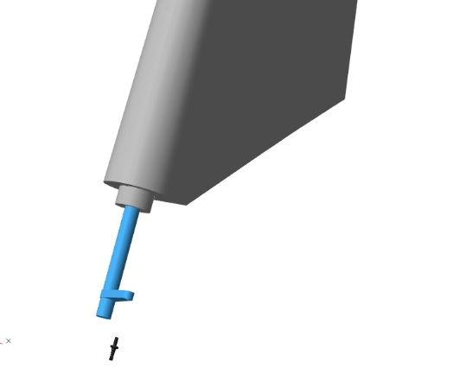 | 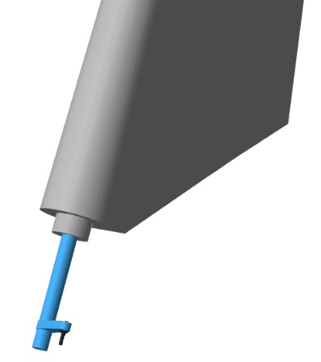
Locate the two F625ZZ bearings. Degrease:
- Outer parts of bearings;
- The inside surface of the linkage assembly on the fuselage.
Apply an even, thin coat of LOCTITE 648 Shaft-Bushing Retainer to the degreased bearing surfaces and bracket surface.
Install the bearings in the assembly one by one with the shoulder facing outward on the bracket.
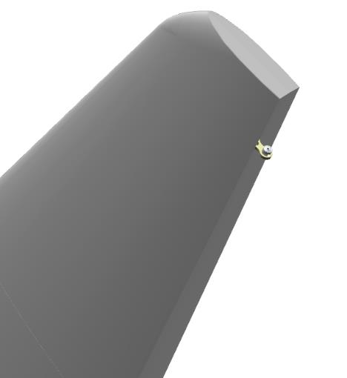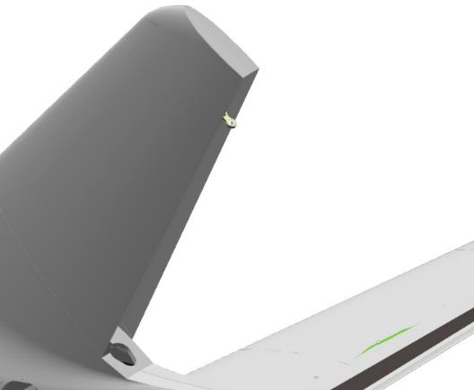
IMPORTANT: Do not allow the retainer to get into the inside of the bearing. This will render the bearing unusable.
Bring the rudder to the vertical stabilizer.
Tilt the top of the rudder away from the stabilizer, drive the rocker into the opening and feed down.
Bring the rudder to the spar, guide the pin of the upper assembly into the bearing, the lower rocker tube into the bearing on the spar.
Put the steering wheel down.
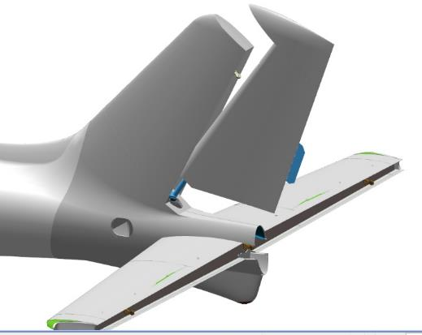 | 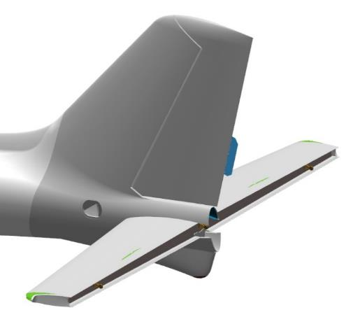
Tilt the rudder to the left or right. Screw the M5 nut DIN 934 onto the axle of the upper unit. Tighten the nut with an 8 mm combination wrench.
Control Operations:
- Check the installed steering wheel by tilting it to the left and then to the right as far as it will go. The rudder stroke should be smooth, without jerks, jams or foreign sounds. The rudder ends should not touch the fuselage. Repeat the left-right rudder movement three or four times.
Locate the hole in the axle in the handlebar pocket, which should match the slot in the M5 DIN 935 nut. If the hole is not visible, tighten the nut until the hole matches the slot.
IMPORTANT: Do not twist the nut to match the hole and slot. This will result in rapid assembly failure and backlash. Failure to install the nylock in this location could result in a catastrophic failure or accident.

Aileron installation
    - Aileron assembly
To complete this work you will need:
- Mobile desk;
- Sandpaper grit P600 1 sheet 200x300 mm;
- Solvent methyl acetate 100 grams;
- Clean rags 100x100 mm 2 pieces;
- Latex gloves 1 pair;
Unpack it and stack it on the table:
- Aileron left 00140785;
- Aileron right 00140786;
- 6 axles 00120291;
Locate the left aileron 00140785 and 3 axles 00120291. Locate two holes on the aileron end and one hole in the pocket closer to the aileron end.
Check the M6 tapped holes for type action 6 on the aileron.
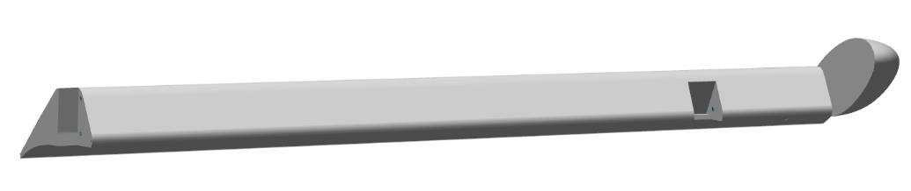
Degrease:
- Internal threads on the aileron
- M6 axis male threads 00120291.
IMPORTANT: Do not apply shaft and bushing retainer to an immediately degreased surface. The fixative can be applied 5-10 minutes after degreasing.
Apply LOCTITE 648 Shaft-Bushing Fixer to the degreased internal threads of the aileron 00140785 in a thin, even coat of LOCTITE 648 Shaft-Bushing Fixer. Set the aileron aside on the table.
Apply LOCTITE 648 shaft bushing retainer to the male threaded (M6) degreased surface of one of the axles 00120291 in an even thin layer.
Screw the 00120291 axle by hand into the hole in the pocket, closer to the aileron end, until it stops. Using a 12 mm combination wrench, tighten the axle until the gap between the end of the axle and the plane in the aileron is eliminated.
Use a rag to remove any residue of bushing shaft retainer that has been squeezed out.
Repeat the steps to install the remaining two axes.
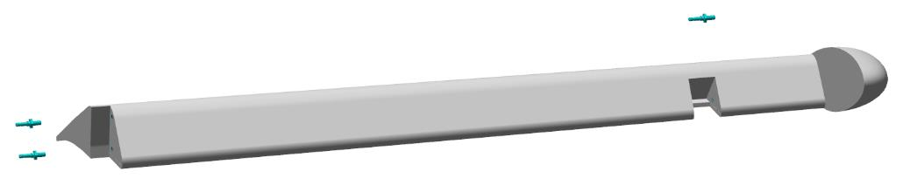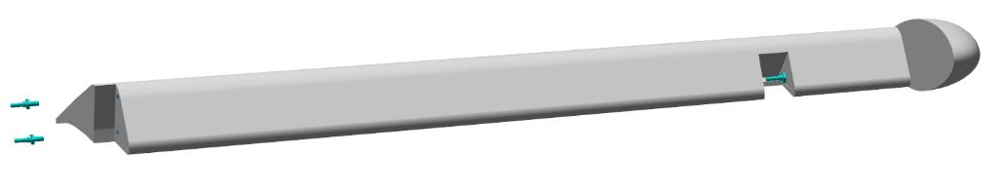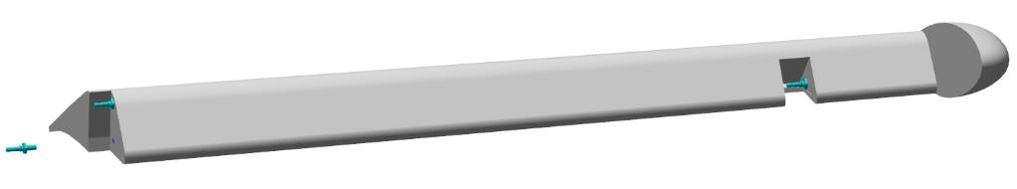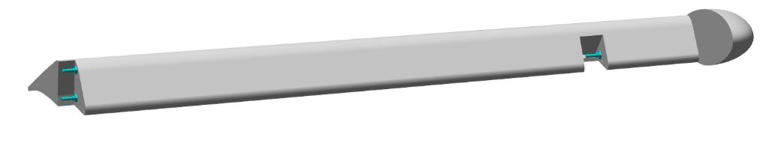When work on the left aileron is complete, perform work on the right aileron 00140786 following the steps above.
    - Aileron installation
Bring the aileron to the wing console from below, close to the skin, so that the axles on the aileron align laterally with the holes in the bearings on the assemblies.
Move the aileron along the console, bringing the aileron and console ends closer together and aligning the aileron axles with the bearing bores. Engage the axles in the bearings and move along until the axle grooves stop in the bearing.
Install the control rod lug to the axle at the bottom.
Control Operations:
- Check that the aileron moves up and down easily. The aileron should move without jerking, jamming or significant force.
The installed aileron, at deflected positions of approximately 30°-35°, must not touch other parts of the wing console in any position. The clearance between the aileron end plane and the adjacent wing plane must be between 3 mm and 4 mm.
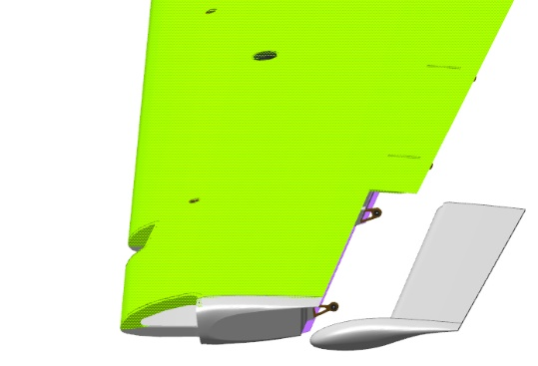 | 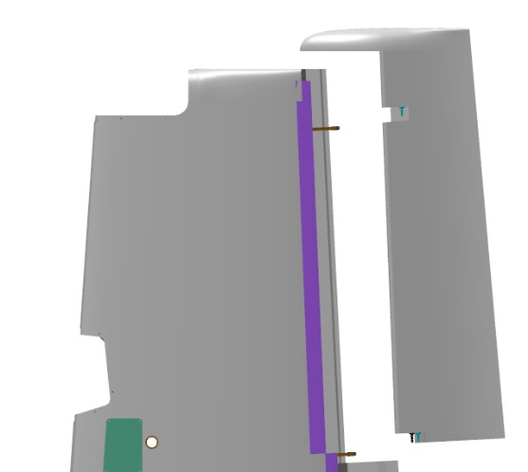
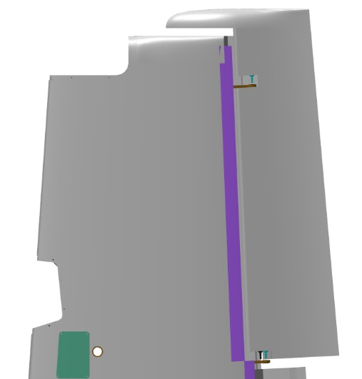 | 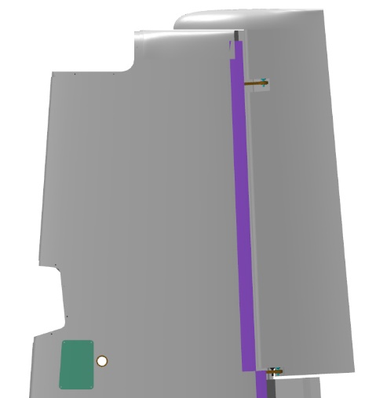
Find 3 M5 DIN 935 nuts, 3 5 DIN 6798A washers, 3 1x20 DIN 94 cotter pins.
Install the washer, hand screw the nut onto the axle closest to the end cap. Using an 8 mm combination wrench, tighten the nut until the washer is fully compressed. Locate the hole in the axle on the aileron, which should match the slot in the M5 DIN 935 nut. If the hole is not visible, tighten the nut until the hole matches the slot.
IMPORTANT: Do not twist the nut to match the hole and slot. This will result in rapid assembly failure and backlash.
Repeat these steps to install washers and nuts on the remaining two axles.
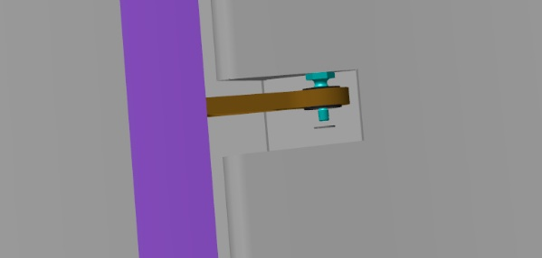 | 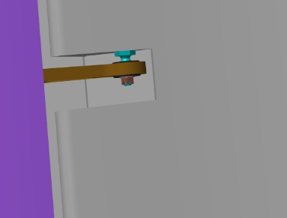
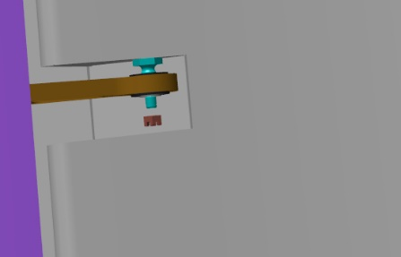 | 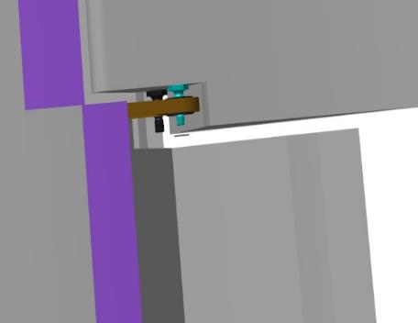
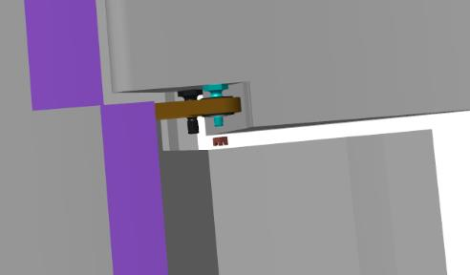 | 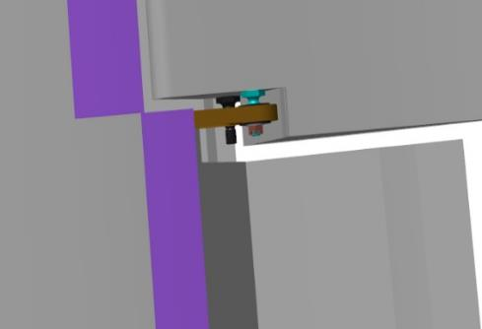
Insert 1x20 DIN 94 cotter pins into the matching slots of the M5 DIN 935 nuts and the holes in the axles. Remove only one of the ears with a screwdriver so that the cotter pin does not fall out and can be easily removed if necessary. Cotter pins should be tightened after all adjustments have been completed on the assembled airplane.
Repeat the above steps to perform the work on the right wing console.

Installing the flaps
Note. The work described below is for the left-hand console. The wing console must be placed on the brackets on the gantry, with the lower skin from the floor. All work must be carried out with a helper.
To complete this work you will need:
- Mobile desk;
- combination wrench 8 mm;
- combination wrench 10 mm;
- Tweezers;
- Pliers;
- Pliers for internal circlips;
- Screwdriver with straight slot #1;
Unpack it and stack it on the table:
- 2 flap shafts 00137424;
- 6 axles 00100561;
- 2 cases 00137430;
- 12 bolts ANG-0002-00034534-08;
- 4 axles 00182276;
- Flap left 00136533;
- Flap right 00136535;
- 2 pulls 00138512;
- 2 pulls 00138516;
- 2 pulls 00138514;
Count it out and stack it on the table:
- 32 bearings F605-2RS;
- 8 bearings 687,618;
- 4 bearings S61704-2RSR;
- 6 nuts M6 DIN 935;
- 6 washers 6 DIN 6798A;
- 6 washers 6 DIN 125;
- 20 M5 nuts DIN 935;
- 20 washers 5 DIN 6798A;
- 20 washers 5 DIN 125;
- 28 cotter pins 1,6x20 DIN 94;
- 2 rings A32 DIN 472.
Locate the flap shaft 00137424, 3 screws 00100561. Cut M6 threads in the three holes of the shaft rockers with a tap through.
Degrease:
- The short threaded portion of the screws;
- Internal threaded parts on the shaft.
Apply an even, thin coat of LOCTITE 648 shaft bushing retainer to the degreased surface of the axle.
Install the axle 00100561 on the rocker, with one hole, with the long threaded part on the short part of the pipe, tighten with a 10 mm wrench until the gap between the plane of the rocker and the plane of the axle is eliminated.
Install the axles on the second rocker, using LOCTITE 648 shaft bushing retainer. The axle to be installed in the hole closer to the shaft tube, with the long threaded part facing the short part of the tube.
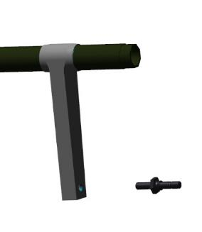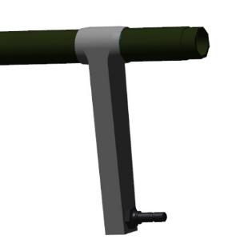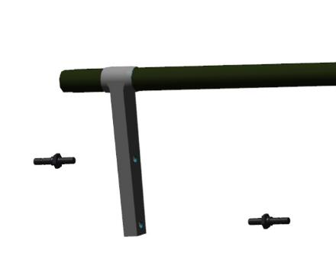
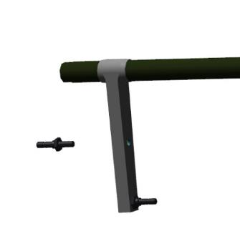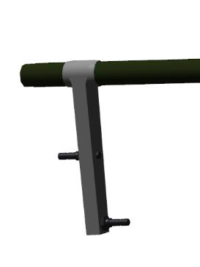
Locate the 2 bearings S61704-2RSR. Degrease:
- Outer ends of the shaft;
- Bearing internals.
Apply LOCTITE 648 Shaft-Bushing Fixative to the degreased shaft and bearing surfaces with an even, thin coat of LOCTITE 648 Shaft-Bushing Fixative.
Place the bearings on the shaft ends until they stop. Remove any residual retainer with a rag.
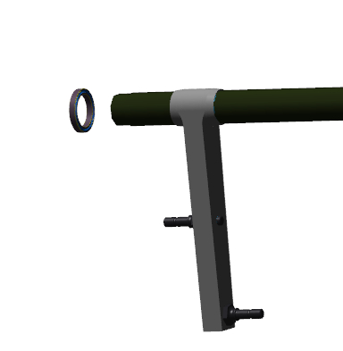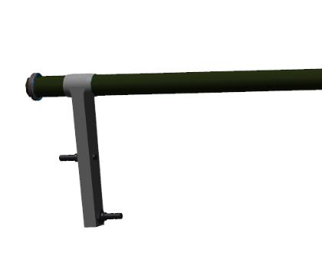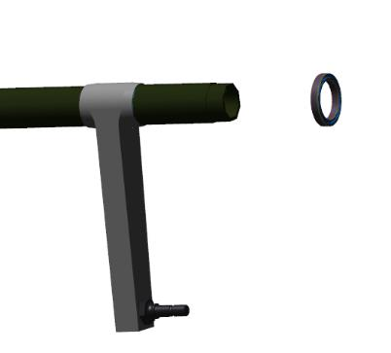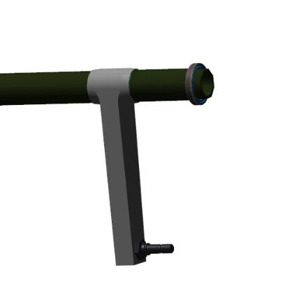

Find pulls 00138512, 00138516, 00138514, 3 nuts M6 DIN 935, 3 washers each 6 DIN 6798A and 6 DIN 125, 3 cotter pins 1,6x20 DIN 94.
Install the pull rod 00138512 on the rocker, with one axle. Install washers 6 DIN 125 and 6 DIN 6798A, nut M6 DIN 935.
Using a 10 mm wrench, tighten the nut until the washer 6 DIN DIN 6798A is fully compressed. Locate the hole in the axle, which must coincide with the slot in the M6 DIN 935 nut.
If the hole is not visible, tighten the nut until the hole lines up with the slot.
IMPORTANT: Do not twist the nut to match the hole and slot. This will result in rapid assembly failure and backlash.
Control Operations:
- Check the movement of the pull rod. The rod should rotate easily on the axis, without jerks or jams, and should be able to deflect from the axis of rotation
Insert a 1.6x20 DIN 94 cotter pin into the matching slot of the M6 DIN 935 nut and the axle hole. Tighten the connection by prying the cotter pin tabs apart with a screwdriver.
Repeat the steps above to install the remaining tie rods.
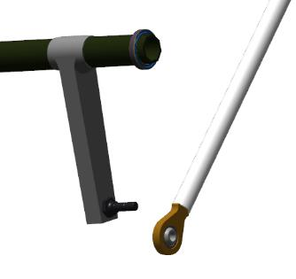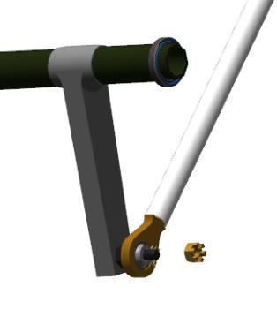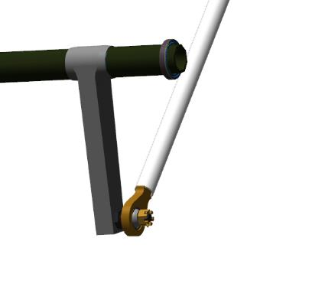
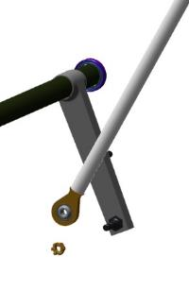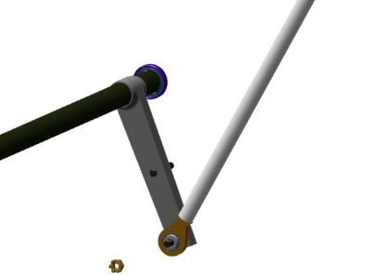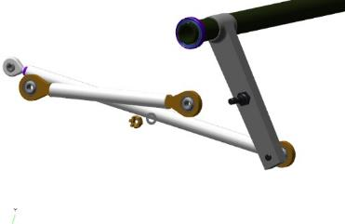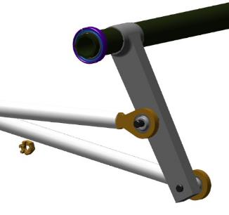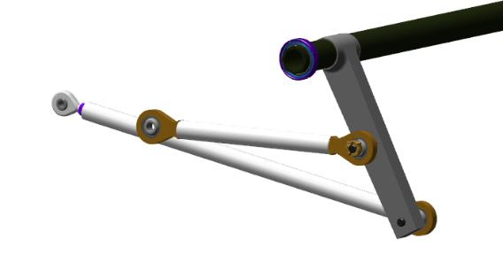
Insert the assembled flap shaft, with linkages, through the opening in the rear of the root sail, inside the console.
Place the shaft in the far support, push it in as far as it will go. Guide the front of the shaft into the socket in the sail, push it towards you. Rotate the shaft along the axis, pull the rods outwards. Place bushing 0013430 on the bearing, push it all the way into the bushing. Secure the bearing with circlip A32 DIN 472.
IMPORTANT: After installing the retaining rings, make sure that they are clearly positioned in the groove and cannot fall out. If a ring falls out in flight, it will result in loss of control and an unavoidable crash.
Control Operations:
- Check the rotation of the shaft in the bearings. The shaft should turn easily.
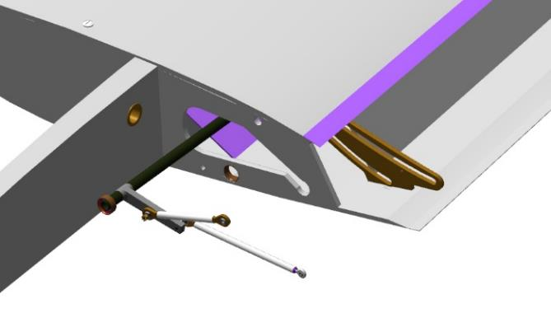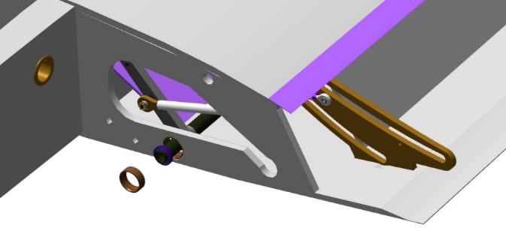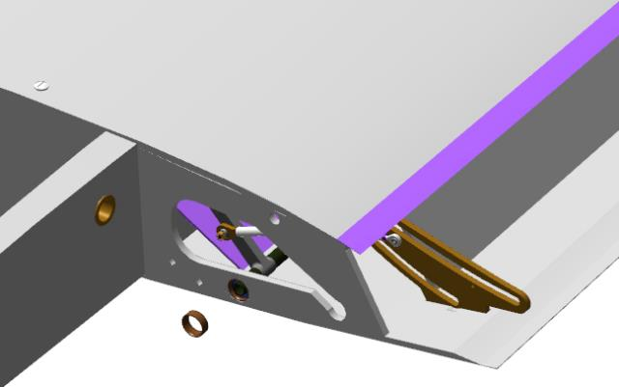
Place the flap with the convex part down on the table and inspect the flap plates for foreign objects. There should be no foreign objects.
Bring the flap up to the wing console, place the flap plates against the rails. Slide the flap along the rails until it stops in the console. The flap may not move smoothly and may stick slightly when moving.
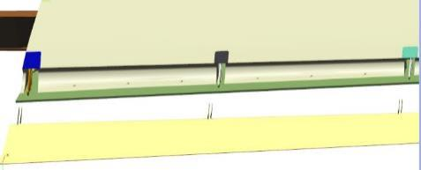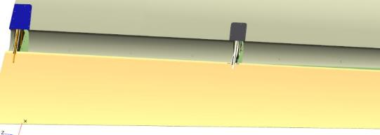
Extend the flap along the rails to approximately midway along the length of the first rail. Install one F605-2RS bearing in the bottom race of the rail. Slide the bearing along the race with a #1 slotted screwdriver to the hole closest to the flap trim in the flap plate.
By moving the bearing and the flap, align the holes. Install the 00182276 axle in the aligned holes so that it passes only one plate and is flush with the bearing. Install bearing 687 618 in the lower rail race.
Move the bearing along the raceway with a screwdriver until the bearing is installed and the holes are aligned with the plate. Install the second F605-2RS bearing in the lower rail race. Drive the axle through the bearing and the second hole in the flap plate.
Place washer 5 DIN 6798A on the axle, screw on nut M5 DIN 935.
Repeat the above steps to install the bearings on the rails. On the second and fourth rails, install bolts instead of the axle.
When the bearings in the lower rail races are installed, repeat the same steps to install the bearings in the upper races alternately, installing the bolts.
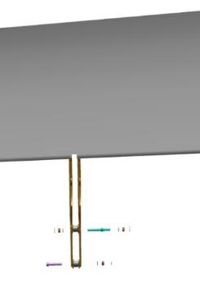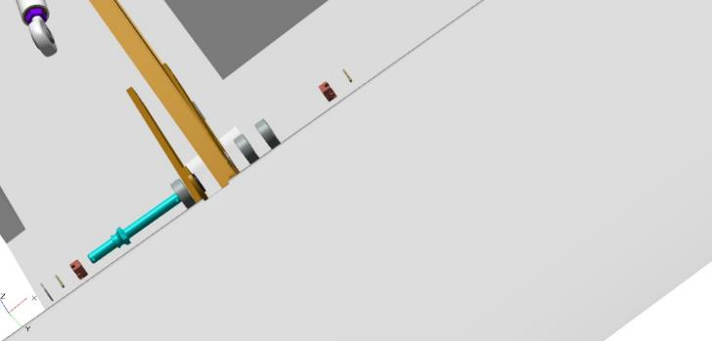
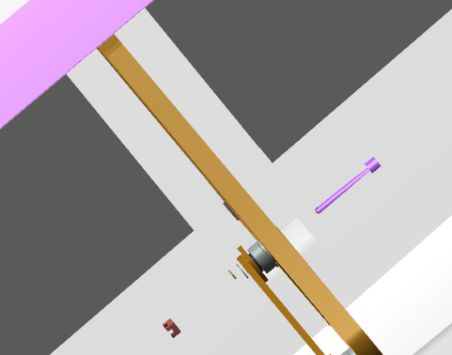
Install alternately, on each bolt ANG-0002-00034534-08 washer 5 DIN 6798A, screw the nut M5 DIN 935.
Control Operations:
- Push the flap all the way in. The movement may not be smooth, but should not require much effort. Extend the flap fully to the stop.
- Repeat the flap movement 3-4 times and leave in the extended position.
Install on the outer side of the first rail, on the axle of the rod end, washers 5 DIN 125 and 5 DIN 6798A, screw on the nut M5 DIN 935.
Repeat the steps above to install the pull rod on the far rail.
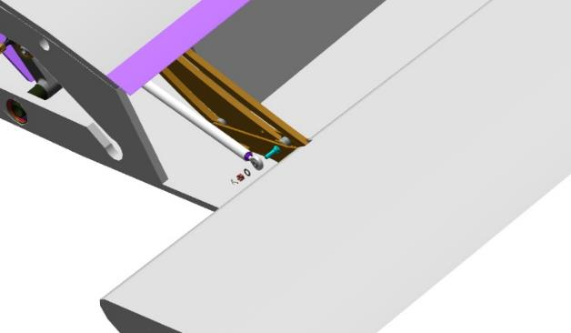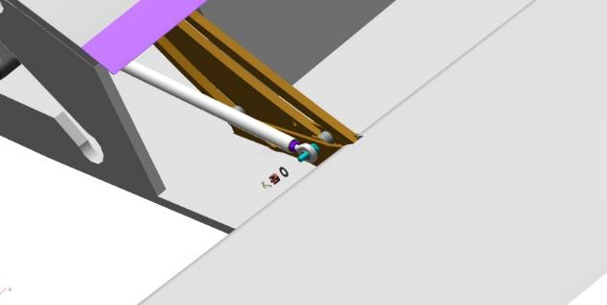
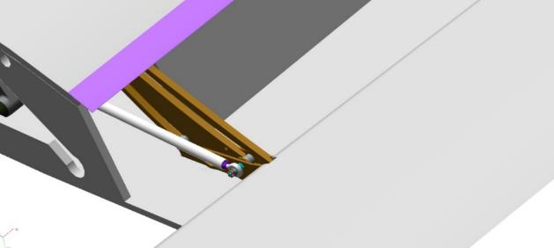
Control Operations:
- Push the flap all the way in. The movement should be smooth, without jerks or jams and without significant effort.
- Inspect the gaps between the flap and the console trim. Gaps should be 2-3 mm; steps should not exceed 2 mm. Set the aileron to the zero position by aligning the aileron ends and the wing tip. Check the clearance between the flap and aileron ends. The clearance should be between 3 and 5 mm.
Note. If the clearances are less than specified, the wing console trim must be sanded.
Extend the flap fully as far as it will go. Tighten the M5 DIN 935 nuts on each axle and bolt in turn until you feel a noticeable force on the key.
Apply a thin layer of lithol-24 grease to all tracks. Move the flap 3-4 times and leave it in the extended position. Inspect the places where the grease was applied. Once again apply a thin layer of lithol-24 grease to the surfaces of all tracks. Move the flap 3-4 times and leave it in the extended position. . The movement should be smooth, without jerks or jams. The force for movement should become less than it was before applying the grease.
Control Operations:
- Move to the root sail, flap side. Push the flap all the way in.
- Look at the rail races. There should be no clearance between the bearings and the rail races.
- Extend the flap and repeat the inspection on each rail.
Note. If visually visible gaps are detected during inspection and the flap cannot be moved any further, it means that the length of the linkage that is under-adjusted must be adjusted.
Length adjustment requires:
- Unscrew the nut on the tie rod lug by 1 turn;
- Unscrew the nut from the axle, remove the washers and the tie rod lug;
- Unscrew the lug from the rod by 1 turn;
- Install and fasten the tie rod in reverse order;
- Check flap movement and clearances.
If the gap decreases, repeat steps 1-5 until the gap is eliminated.
If the gaps are not eliminated, screw the lug into the tie rod in step 3.
After adjustments have been made, screw the nut on the tip all the way in, using a shaft sleeve retainer.
When all checks have been made and the flap is correctly installed, cotter all nuts with 1x20 DIN 94 cotter pins.
IMPORTANT: Do not twist the nut to match the hole and slot. This will result in rapid assembly failure and backlash.
When the left flap work has been completed, perform the flap installation and adjustment work on the right console following the steps above.
Note. If the airplane is stored in an open area, it is necessary to install parking pivot points in the consoles. The work is described on the example of the left console using nuts according to DIN 1624
Mark the location of the king pin nut on the lower console trim. Marking and mounting accuracy+ 5 mm. Drill a hole through the markings:
- 6 mm diameter when using M5 fasteners;
- 7 mm diameter when using M6 fasteners.
Remove the top layer with a knife in the drilling area with a diameter of approximately 25-30 mm.
Seal, with P240 sandpaper, the lining around the removed area by approx. 50-100 mm. Cut 5 square or round pieces of 200 g/m²carbon fiber.
Degrease the cleaned area.
Prepare epoxy adhesive from Larit L285 resin and H287 hardener in the proportion of 20:8 according to type action 1.
IMPORTANT: The epoxy adhesive has a 60 minute use time from the time of preparation.
Apply the adhesive according to standard procedure 5.1 to the degreased area. Place one layer of carbon cloth on the impregnated area, impregnate it and spread it out. Place a nut in the drilled hole, press it in by hand until it stops. If the nut is not flush with the trim, seat it with light blows of a hammer (weighing no more than 200 grams) through a flat wooden spacer.
IMPORTANT: Use a spacer when doing this work. If the nut is shrunk without the spacer and accidentally misses the nut, the wing skin will be severely damaged.
Lay alternately the remaining layers, soaking each one in resin, avoiding wrinkles and creases. Thread a small hole in the fabric layers at the approximate threaded location. After laying out the layers, put a polyethylene film on top, put a flat weight of 2- 3 kg on top (a small bag of sand is possible). After polymerization of the glue, remove the weight, remove the film. Drill the hole, calibrate the thread. Grind the finalized place with sandpaper until smooth transitions are obtained. The holes may not be plugged during operation, as they will be additional ventilation holes inside the wing console.

Installation of glazing

IMPORTANT: It is recommended to consult a specialist for glazing. Materials for glazing glazing are listed as recommended but not obligatory. In case of self-selection of materials, it is necessary to choose materials compatible with carbon fiber and monolithic polycarbonate.
To complete this work you will need:
- Mobile desk;
- Painting tape 48-50 mm 1 roll;
- Sandpaper grit P600 1 sheet 200x300 mm;
- Solvent methyl acetate 100 grams;
- Clean rags 100x100 mm 4 pieces;
- Latex gloves 1 pair;
- Metal trowel 30 mm;
- Office knife;
- 3M™ P590 Primer;
- 3M 503 OEM Adhesive Sealant;
Unpack it and stack it on the table:
- Cab door left 00136886;
- Left door glass 00136198;
- Right door glass 00136203;
- Cab door right 00137297;
- Front left window 00133889;
- Front right window 00133892;
- Left side window 00133897;
- Right side window 00133899;
IMPORTANT: Before fitting the glass and during gluing work, make sure that there are no foreign objects on the flange of the glass opening and on the glass itself. Protective films can be removed from the glass only after gluing and polymerization of the adhesive.
Lay the cab door left 00136886 with the convex part away from the table surface. Insert the door glass 00136198 into the opening on the cab door.
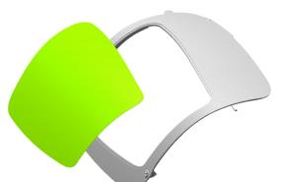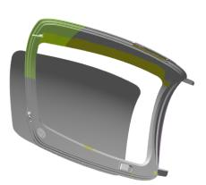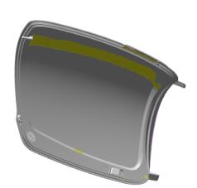
Control Operations:
- Look at the contours of the opening and if there are any steps between the glass and the door surface. There should be no steps when the glass is above the trim. The gaps should be even.
Note. Gaps around the perimeter of the glass and trim may be missing in two locations and will be enlarged where gaps are present.
Apply painter's tape in 5-6 places so that part of it is on the glass and the other part is on the door trim.
Turn the door over with the glass on the table. Mark the outline of the glass on the inside of the door with a white marker.
Flip the door to the previous position.
Using a stationery knife, carefully cut the painter's tape at the gap between the glass and the door flange.
Remove the glass and lay it on the table with the markings facing up.
Glue the outer contour of the door trim around the glass flange.
IMPORTANT: Do not seal the glass seating area. This may make it impossible to glue the glass in this area. Remove any painter's tape that may have fallen off.
Turn the door over on the table. Tape the inside of the door around the glass opening with painter's tape.
Tape an outline on the glass according to the markings, so that the marked line is slightly visible and the remaining part of the glass has an adhesive outline. Undermine the protective film with a stationery knife, carefully unscrew it and place it on the pasted painter's tape. Secure the film with painter's tape.
Clean the flange of the glass flange on the door according to standard action 4.
IMPORTANT: Do not damage the composite parts of the brushing areas. Do not rub for a long time in one place, even if the area to be brushed does not become matte.
Degrease the stripped area of the glass flange on the door trim.
IMPORTANT: Degrease until the solvent rags are clean. Contaminated rags should be replaced immediately. If the surface has pores, sinks and other small irregularities, blow the area with compressed air and then degrease.
Lightly dampen a rag with isopropyl alcohol. Degrease the adhesive outline on the glass (area without film).
Apply a thin, full-width, continuous layer of 3M™ P590 primer with the applicator to the flange of the glass on the door. Repeat this action with the primer on the prepared glass surface. Allow the primer to dry for 10-15 minutes.
IMPORTANT: Do not dry the primer for more than 60 minutes!
Apply 3M 503 OEM adhesive sealant to the glass flange on the door in a triangle shape 5-7 mm high, placing it approximately in the middle of the flange shelf.
IMPORTANT: No more than 12 minutes should elapse between the start of the application of the adhesive sealant and the installation and fixation of the glass.
Install the glass into the flange with the prepared strip of adhesive sealant. Carefully press the glass around the perimeter of the glass flange with little effort. Press until the surface of the glass is aligned with the surface of the door trim without steps.
IMPORTANT: Do not press the individual glass areas onto the flange at once. Do this in stages.
Secure the glass to the door trim in 8-10 places with painter's tape.
Use a trowel to remove the adhesive sealant from the gaps between the door flange and the glass without making any indentations.
Smooth out any unevenness of the adhesive sealant with a trowel. Minimum curing time of the adhesive sealant is at least 8 hours.
IMPORTANT: Do not turn or place the door glass on the table until the adhesive sealant has cured. Doing so may cause the glass to peel off the door flange, create steps between the trim and the glass, and lose the decorative appearance of the door.
Clean the workplace and tools according to standard procedure 7.
Repeat the steps above for gluing the glass on the right door and on the fuselage.
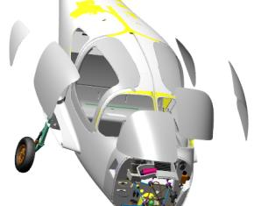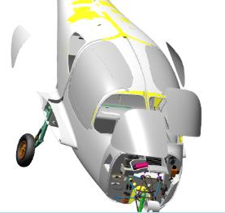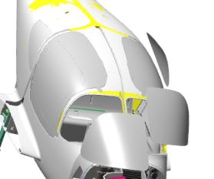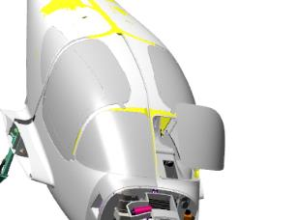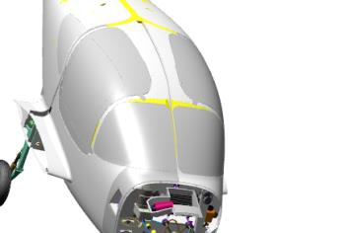
Note. Gluing the panes into the fuselage will be a little more difficult as the fuselage will not be able to be moved.

Door installation
Note. The door installation work is described for the left door. Installation of the right door is performed in the same sequence.
To complete this work you will need:
- Mobile desk;
- Rubber mallet weighing 400 grams;
- No. 2 straight blade screwdriver;
- Pliers;
- 7 mm combination wrench;
- Sandpaper grit P600 1 sheet 200x300 mm;
- Solvent methyl acetate 100 grams;
- Clean rags 100x100 mm 2 pieces;
- Latex gloves 1 pair;
- Larit L285 10 gram epoxy resin;
- H287 hardener 4 grams;
- Paper cup 100 ml;
- Aerosil thickener 3 grams;
Unpack it and stack it on the table:
- 4 axles 00121659;
- 4 sticks 00121660;
- Cab door left 00136886 (assembled by you earlier);
- Cab door right 00137297(assembled by you earlier);
- 2 ball pins 00121657;
- 4 cotter pins 2E DIN 11024;
- 4 M4 ball bolts prch-0000007685;
- 2 air springs 5079DX prch-00028214;
- 2 rubber gaskets prch-0000009289;
Find 2 axles 00121659, 2 sticks 00121660, 2 cotter pins 2E DIN 11024. Screw the axle 00121659 into the hole at the bottom of the fuselage trim. Insert the pin 00121660 into the axle. The pin must fit easily into the hole in the fuselage axle.
Install the cotter pin 2E DIN 11024 in the holes that match. If the holes do not match, align them by lightly turning the pin 00121660.
Repeat the steps above to install the second axle into the fuselage bushing hole.
Locate the threaded hole on the upper inner part of the door 00136886. Check the M4 threaded holes according to standard action 6 . Repeat the steps for the hole on the upper part of the fuselage door opening.
Degrease the threaded parts of the 2 M4 ball screws prch-0000007685.
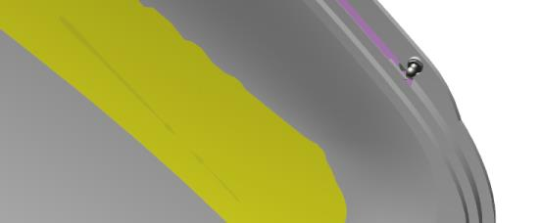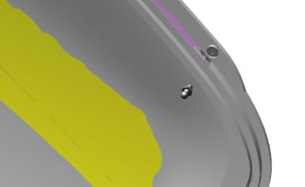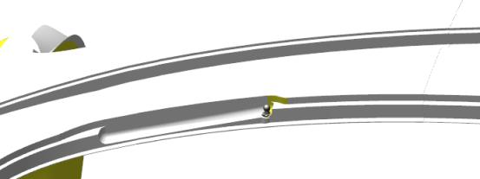
IMPORTANT: Do not apply shaft and bushing retainer to an immediately degreased surface. The fixative can be applied 5-10 minutes after degreasing.
Apply a thin layer of LOCTITE 648 shaft and bushing retainer to the degreased surface of the M4 ball bolt prch-0000007685. Install the bolt into the threaded hole on the door. Tighten with a 7 mm combination wrench until there is no play between the hexagonal part of the bolt and the fitting plane. Repeat the above steps to install the bolt on the fuselage.
Clean the workplace and tools according to standard procedure 7.
Remove cotter pins 2E DIN 11024 from the holes, remove the axles 00121659 from the fuselage bushings.
Bring the door to the fuselage opening, in a position simulating an ajar door, drive the door lugs into the fuselage opening (this work is performed by an assistant).
Insert the pin of the 00121659 axle into one of the bushings (upper or lower) of the fuselage. If the pin does not enter the bushing before the cotter pin holes are aligned, gently move the door to simulate opening or closing. Install a 2E DIN 11024 cotter pin in the aligned hole.
IMPORTANT: Do not release or tilt the door until the second bracket is installed. Doing so may cause the door lug to break.
Install the second axle 00121659 and cotter pin into the remaining fuselage bushing.
Control Operations:
- Open and close the door several times at full stroke. The movement should be smooth and easy, without significant effort.
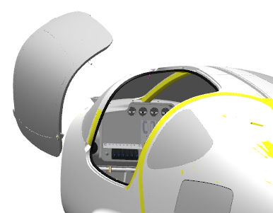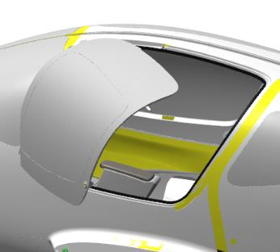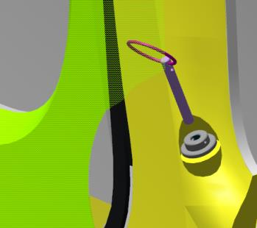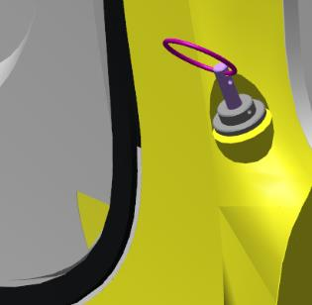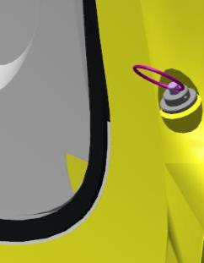
Control Operations:
- Close the door, pressing down firmly in the lock area. Inspect the door contour for steps along the fuselage contour. There should be no protrusion of the door above the plane of the fuselage . It is possible for the door to fall into the fuselage opening.
Locate air spring prch-00028214. Install the air spring tip on the M4 ball bolt prch-0000007685, air spring tip, stem side. Install the second air spring tip in the same way.
Control Operations:
- Check the opening and closing of the door. The movement should be smooth, with little force.
IMPORTANT: Do not release the door while in motion. This may cause damage to parts of the airplane.
Locate the ball bracket 00121657. Approach the door, open it ajar, and install the ball bracket 00121657 by pushing it up with your hand. The bracket must fit into the lock socket and not fall out. Press the lock sphere, on the outside of the door, the bracket should release and fall out. Repeat this action several times.
Note. If the door does not lock, the lock opens with great force, it is necessary to put a washer 6 DIN 125 under the bracket on the fuselage. Check the operation of the lock. It is permissible to install washers to a thickness of no more than 3 mm.
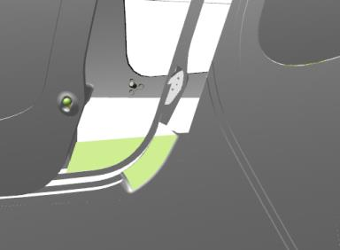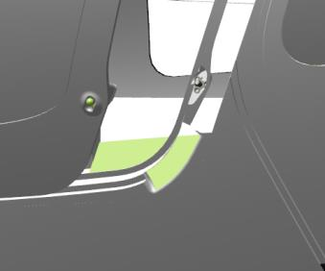
Locate the rubber seal prch-0000009289. Locate the chamber part and the mounting part on the seal.
Open the installed door. Install the seal, with the fuselage chamber facing away from the fuselage, on the tab in the opening.
Install in stages by pressing the seal by hand from above. When the seal is in place, lightly tap the seal from above with a hammer.
Control Operations:
- Make several complete openings and closings of the door. The door should move smoothly and easily, and full closing without stepping against the fuselage is only possible with a slight hand pressure.
Note. The new seal will prevent the door from easily closing fully until the door is worked on. Close the door after completing the work or not working on the fuselage. This will speed up the process of running the gasket over the contour.
While the left door seal is taking shape, install the right door following the steps above.

Installing the sunroof a trunk
To complete this work you will need:
- Mobile desk;
- Rubber mallet weighing 400 grams;
- No. 2 straight blade screwdriver;
- Phillips head screwdriver PH2;
Unpack it and stack it on the table:
- Trunk door 00107478;
- Rubber gasket 0000009289-01;
- 80N air spring (LinkenSystem);
- Door Lock 00036113;
- 2 4x8 screws DIN923
- 2 self-tapping screws (comes with spring).
Install the lock into the opening on the trunk door. Make sure that the lock retaining tabs engage at the installation point and that it is not possible to remove the lock casing back.
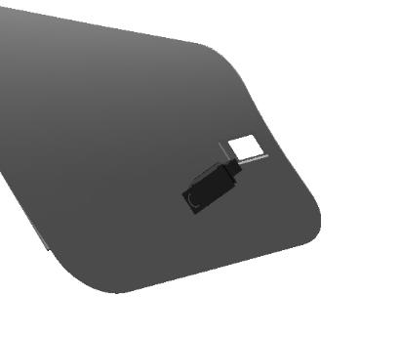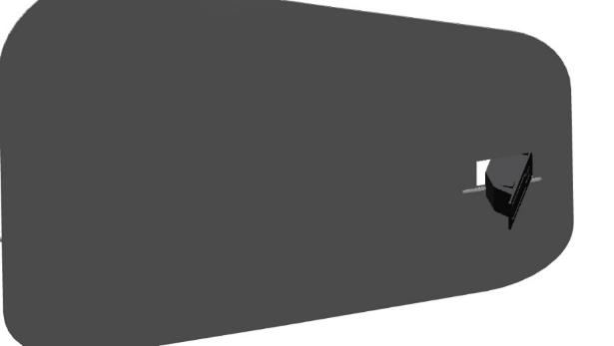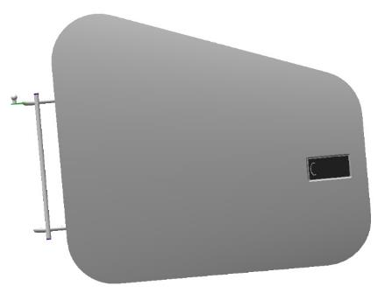
Note: If you cannot get the lock into the opening, grind the contour of the opening with a natfile.
Place the air spring support, with the shoulder of the bushing facing down, on the rear wall of the sofa. Fasten the support with 2 self-tapping screws to the rear shelf of the sofa. Insert the door hinge into the luggage compartment, aligning the hinge holes with the lugs on the fuselage. Hold the luggage compartment hatch by hand and install the mounting screws one by one.
Control Operations:
- Open and close the hatch door several times at full travel. The movement should be smooth and easy, without significant effort.
- Close the door, pressing down firmly in the lock area.
- Inspect the door contour for steps along the fuselage contour. The door should not protrude above the fuselage plane. The door may not protrude into the fuselage opening.
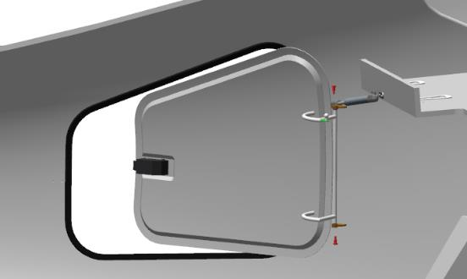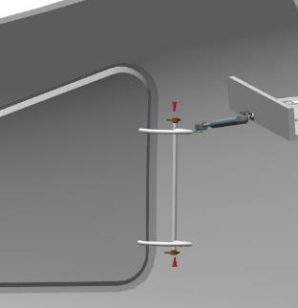
Note. The air spring kit includes one spherical bracket.
Install the spherical air spring bracket to the rear sofa wall with 2 self-tapping screws.
Slide the locking plates in the air spring lugs out of the slots with a #1 straight blade screwdriver. Approach the installed door and open it.
Install the air spring lug onto the trunk hinge sphere, air spring lug, stem side up. Insert the retainer into the groove of the tip with a #1 straight blade screwdriver.
Install the second tip, on the bracket on the rear sofa wall, of the air spring in the same manner.
- Check the opening and closing of the door. The movement should be smooth, with little force.
- Close the door smoothly by pressing with your hand in the lock area. The door should lock into place. Open the door easily, without moving the lock handle from the outside. The door should remain closed.
- Increase the force and try opening the door again. The door must remain closed. Turn, pull the lock handle from the outside. The door should open. Repeat the opening-closing action. The lock should engage each time.
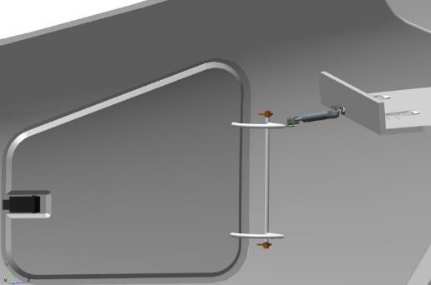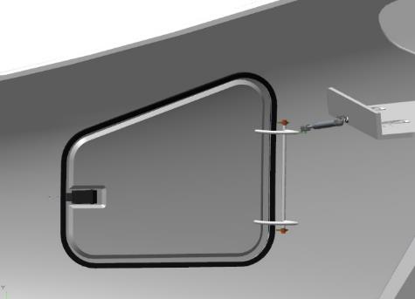
Locate the rubber seal 0000009289-01. Locate the chamber part and the installation part on the seal. Open the installed door.
Locate the tab on the fuselage opening. Install the gasket, with the camera away from the fuselage, onto the tab in the opening. Install in stages by pressing the gasket with your hand on top of the gasket.
When the seal is in place, settle it on top with light hammer blows.
Control Operations:
- Make several complete openings and closings of the door. The door should move smoothly and easily, and full closing without stepping against the fuselage is only possible with a slight hand pressure.
Note. The new seal will prevent the door from easily closing fully until the door is worked on. Close the door after completing the work or not working on the fuselage. This will speed up the process of running the gasket over the contour.

Installing the sub-motor frame
Note. After installation and polymerization of the adhesive, the undermotor frame should be coated with paint to protect against corrosion. It is preferable to paint with light white color.
To complete this work you will need:
- Mobile desk;
- Digital Kitchen Scale;
- Latex gloves 1 pair;
- Larit L285 epoxy resin 30 grams;
- H287 hardener 12 grams;
- Paper cup 100 ml;
- Aerosil thickener 3 grams;
- Sandpaper grit P1000 1 sheet 200x300 mm;
- Solvent methyl acetate 100 grams;
- Clean rags 100x100 mm 2 pieces;
- Sandpaper grit P240 1 sheet 200x300 mm;
- Respirator;
- Metal trowel 50 mm;
- Torque wrench 1-25Nm;
- Hexagonal nozzle 3 mm;
- Hexagonal nozzle 4 mm;
- Hexagonal wrench 4 mm;
- 3 mm hex key;
- 10 mm socket head;
- Torque driver for the socket head;
- 750 watt electric drill;
- Metal drill bit with a diameter of 6.0 mm.
Unpack and lay the sub-motor frame 00135261 on the table.
Count it out and stack it on the table:
- 20 M5x16 screws ISO 7380-2;
- 2 screws M6x20 ISO 7380-2;
- 2 nuts M6 DIN 985;
- 2 nuts M6 DIN 934.
A helper will be required for further work.
Take the undermotor frame 00135261, bring it to the first spar from the front. Place the frame brackets on the spar with the two nose strut brackets pointing downward. Place the frame sub-motor 00135261 on the spar, roughly aligning the holes. The nose strut brackets should hit the edges of the nose strut landing gear recess opening. Trace all the places where the underframe fits on the spar with a marker.
IMPORTANT: There are a very large number of other mounting holes on the spar. Do not mix them up.
Remove the sub-motor frame 00135261 from the spar and lay it on the table. Check the M5 threaded holes according to standard action 6 places in the circled marker.
Note. You can check all other tapped holes located on the spar at the same time.
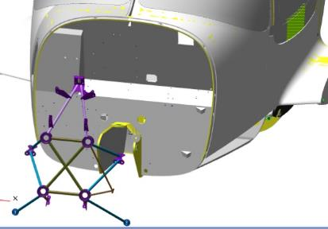 | 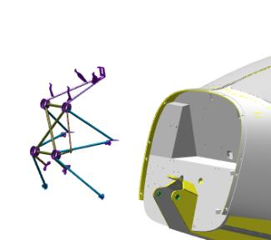
Place the sub-motor frame on the spar as you did before. Align the holes. Install 2 M5x16 ISO 7380-2 screws on the bracket on the left side, at the bend of the spar, tighten lightly with a 3mm hex key.
Install, tighten 2 M5x16 ISO 7380-2 screws, in the same location on the right side. Install 4 M5x16 ISO 7380-2 screws on the nose strut bracket on the left side.
Tighten the screws with a small amount of force using a 3 mm hexagon wrench. Install, tighten the 4 M5x16 ISO 7380-2 screws, in the same location on the right side. Install the 4 M5x16 ISO 7380-2 screws at the top on the upper bracket of the subframe.
Tighten the screws lightly with a 3 mm hexagon wrench.
Drill a 6.0mm diameter drill bit through, from the left, into the recessed hole in the spar.
Install the M6x20 ISO 7380-2 screw from the inside of the fuselage, from the outside install the M6 DIN 934 nut. Tighten the screw with a 4 mm hexagon wrench to a slight torque. Repeat the action at the same location on the right side. Tighten all installed screws with a firm feel.
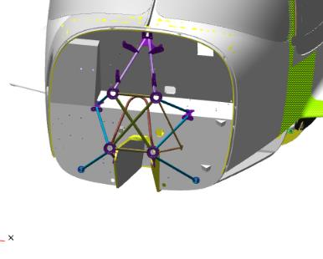 | 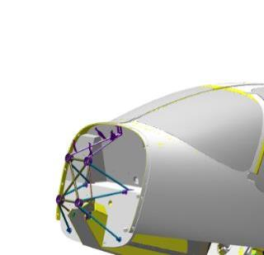
Control Operations:
- Check the installed undermotor frame 00135261 for gaps between the brackets and the plane of the spar. The gaps should be between 0 and 1 mm.
If all locations checked are OK, trace the outline of the underframe brackets on the fuselage spar with a marker. Dismantle the frame by removing all screws with 3 and 4 mm hex keys and place on a table.
IMPORTANT: Always deburr the adhesive areas 10-15 mm larger than the actual contour of the part to be installed. Do not damage the composite parts of the stripping points. The thickness of the cladding in some places is only 0.08mm. Do not rub for a long time in one place, even if the area to be stripped does not become matte
Scratch the mounting points of the underframe brackets on the fuselage spar according to standard action 3 7.
Clean the seven places on the 00135261 under-engine frame brackets adjacent to the fuselage spar according to standard operation 4.
Degrease the mounting points of the 00135261 under-engine frame brackets on the fuselage spar and to the fuselage spar.
Prepare epoxy adhesive from Larit L285 resin and H287 hardener in the proportion of 20:8 according to type action 1.
IMPORTANT: The epoxy adhesive has a 60 minute use time from the time of preparation.
Apply adhesive according to standard procedure 5.1 to the degreased surfaces of the underframe brackets 00135261, degreased mounting points of the underframe 00135261 on the fuselage spar.
Use the remaining adhesive to prepare the adhesive according to standard procedure 2.
Apply the compound according to standard procedure 5.2 to the surfaces of the underframe brackets 00135261. Place the 00135261 underframe on the fuselage spar.
Align the holes. Install 2 M5x16 ISO 7380-2 screws on the bracket on the left, at the bend of the spar, tighten lightly with a 3mm hex wrench. Install, tighten 2 screws M5x16 ISO 7380-2, in the same place on the right side.
Install the 5 M5x16 ISO 7380-2 screws on the nose pillar bracket on the left side. Tighten the screws with a small amount of force using a 3 mm hexagon wrench. Install, tighten the 5 M5x16 ISO 7380-2 screws, in a similar location on the right side. Install the 4 M5x16 ISO 7380-2 screws at the top of the top bracket of the sub-motor frame. Tighten the screws lightly with a 3 mm hexagon wrench.
Install, on the left, from inside the fuselage in the 6 mm diameter hole, an M6x20 ISO 7380-2 screw, from the outside in the well, an M6 DIN 985 nut. Tighten the screw with a 4 mm hexagonal wrench to a low torque, hold the nut with a 10 mm socket head. Install, tighten the M6x20 screw ISO 7380-2, in the same place on the right side. Tighten all installed screws to a satisfactory torque. Install the 3mm hex bit, set the torque wrench to a torque of 5Nm. Tighten the 20 M5x16 ISO 7380-2 screws securing the brackets, each individually, of the undercarriage frame 00135261 with a torque wrench to a torque of 5 Nm.
Change the hexagonal bit to 4 mm. Recalibrate the wrench to a torque of 8 Nm. Tighten the 2 M6x20 ISO 7380-2 screws securing the brackets of the undercarriage frame 00135261 with a wrench to a torque of 8 Nm.
When the motorama is fixed and the adhesive is fully cured, sand the spar and all parts installed on it with sandpaper P400-600. Scrubbing should be done until the gloss is removed (matte surface). If areas of less than 1 cm square, the surfaces are not cleaned, leave them in this condition.
Protect all motorama rods further than 70-80 mm from the spar plane painter's tape.
IMPORTANT: Fireproofing mortar can be used from any manufacturer. The material itself must be water-based.
Degrease the spar and the motor arm. Apply two coats, with an intermediate drying time of at least 30 minutes, of flame retardant solution or paint to all spar elements and motorola rods up to the paint strip. After each coat, make sure that there are no gaps and that the base material is completely covered.
Note. You can eliminate uncoated areas after all coats have dried. Three coats should be applied to each such spot.
IMPORTANT: Do not use forced drying with temperatures above 60°C. This may cause a coating reaction or render composite parts unusable.
After the fire retardant has been applied and dried, remove the painter's tape from the motorama rods.
IMPORTANT: The coating should be renewed at least once a calendar year, regardless of its useful life.

Assembly and installation of hoods
Note. Work is performed with the engine and its systems installed.
To give a decorative look to the hood air intakes, it is possible to glue in decorative grilles or grids with large mesh size and small thickness of the base material
To complete this work you will need:
- Mobile desk;
- 2.5 mm drill bit;
- 4 mm drill bit;
- 6mm drill bit;
- Drill bit 6.5 mm;
- 8mm drill bit;
- 12mm drill bit;
- Locksmith hammer weighing 400 grams;
- Phillips head screwdriver PH2;
- 500 watt electric drill;
- Manual rivet gun;
- Stubzins G 25 mm 4 pcs;
- Spacer for installing lock washers;
- 10 bolts M6x12 DIN 933;
- Sandpaper grit P600 1 sheet 200x300 mm;
Unpack it and stack it on the table:
- Hood bottom 00136781;
- Hood top 00136794;
- 12 axes 00121666;
- 2 hood vortex generators upper 00364107;
- Vortex generator 1 cowl lower 00363830;
- Vortex Generator 2 cowl bottom 00363833;
- Vortex Generator 3 cowl lower 00363837;
- App 00136803;
- 2 vortex generators 00140680;
- 6 DZUS ANG Screw prch-0000009462-01 (not included);
- 6 DZUS ANG Nut prch-0000009462-02 (not included);
- 12 rivets std 000
Screw into the fuselage, in the cowl mounting area, 8 axles 00121666, full length threads.You will need a helper for further work.
Locate the lower cowl 00136781, unfold with the cavity facing up. Place the cowl on the fuselage with the annular cutout against the propeller mounting flange, at the bottom of the nose strut area.
Lift the cowl up and align with the attachment on the fuselage, align the holes in the cowl with the installed axles and press down by hand.
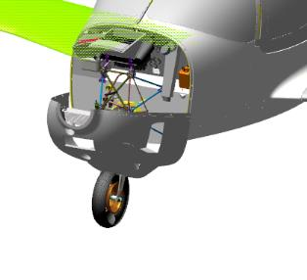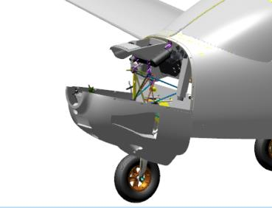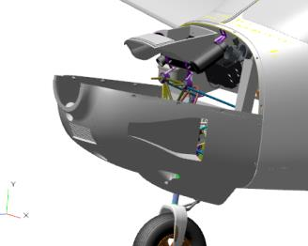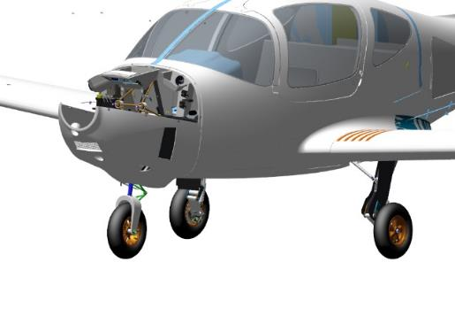
IMPORTANT: When installing the hood, make the necessary turns to bypass the installed engine systems. Installing without doing so may damage the hood or the installed systems.
Move the cowl towards the fuselage so that the cowl trim end of the cowl fits into the attachment as far as it will go. Secure the cowl in this position with two clamps at the top.
IMPORTANT: Do not squeeze the mating parts very hard. This will inevitably damage them. If such parts need to be pressed hard, use pads made of soft rubber materials.
Control Operations:
- Inspect the installed cowl around the fit contour for gaps and steps at the joint and fuselage fit. Steps at the junction with the fuselage should be within 0.5 mm, gaps at the end of the junction between the skin and fuselage should be 1 to 2 mm. There shall be no gaps on the cowl trim to the fuselage attachment.
Note. If the gaps at the trim end joint are outside the specified or non-uniform dimensions, reinstall the cowl. If a location is found where there is no clearance and it affects the size and uniformity of the clearances in other locations, the location should be marked and cut. If the installed engine systems prevent the required clearances from being obtained, cut the cowl in the area where it rests.
When all locations have been inspected and the values of the dimensions to be checked are within the permissible values, secure the hood with two clamps from below. Inspect the installed hood again along the lay-in contour. The gaps and steps must not change their value.
Locate three small pinholes each on the right and left side of the cowl fuselage. Use a 2.5 mm drill bit to drill holes in the locations. Ream the holes with a 4 mm drill bit and then with a 6.5 mm drill bit.
IMPORTANT: The hood must not be moved during drilling and reaming. If there are engine components near the drilling point, protect them from damage caused by the drill.
Alternately remove the clamps, remove and move the hood onto the table. Clean the hood of chips from drilling holes. Deburr the burrs in the hole area with P 320 sandpaper.
Move to the fuselage with the tool. Drill 6 holes for the locks with an 8 mm drill bit, then with a 12 mm drill bit. Deburr the area of the holes with P 600 sandpaper. Locate 6 DZUS ANG Nut prch-0000009462-02.
IMPORTANT: Do not remove the locking tab on the side of the nut housing until lock installation and adjustment is complete.
Install a ROM ANG Nut in each drilled hole. Inspect the installed nuts for clearances where they fit against the fuselage. There should be no gaps in the fit, and if there are minor gaps, they should be eliminated by hand pressure.
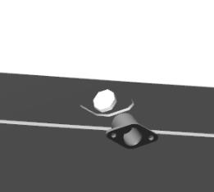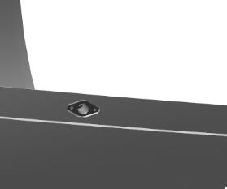
Align the nut in the depression, drill a hole in the fuselage with a 2.5mm drill bit through the hole in the nut.
Install the std 000 rivet in the hole, but do not rivet it. Press the nut and the std rivet firmly together, drill a second hole through the nut. Remove the rivet, remove the nut, clean the drilling area of chips; deburr with P 600 sandpaper.
Place the nut on the fuselage, align with the drilled holes, install two std 000 rivets. Press the nut and one of the rivets, rivet the second rivet with a hand rivet wrench. Rivet the second rivet.
Inspect the installed nut for misalignment and rivet quality. There should be no misalignment or misalignment and the rivet should not be embedded spherically in the plastic. Remnants of the rivet rod must not protrude beyond the nut plane.
IMPORTANT: Do not drop the breakaway portion of the rivet rod in cavities or on aircraft parts. Move the rivet wrench away from the work area to remove the breakaway rod.
Repeat the steps above to install the remaining ROMS ANG nuts on the airplane fuselage.
Move to the hood on the table. Locate 6 DZUS ANG Screw prch-0000009462-01 (lock washers should be included).
Install, with the screwdriver part on the outside of the hood, the ANG screw into the hole in the hood. To pass the screw pin through the hole, skew it, align it after passing and press it against the trim with your finger.
Turn the hood over on the table with the installed screw against the plane of the table. Press the hood against the table at the screw point. While an assistant holds the hood in this position, lightly tap the lock washer on the screw with a hammer through the mandrel. The washer should press against the inner cowl trim without gaps.
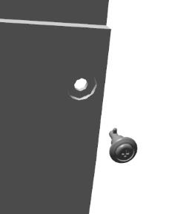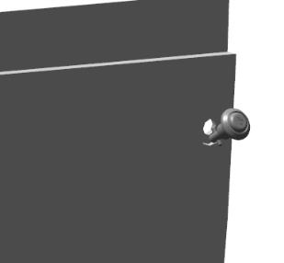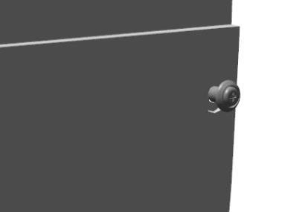
Note. If the washer does not fit snugly against the trim, inspect how the hood is laid on the table. The screw should rest so that its axis of rotation is perpendicular to the table.
Turn the hood upside down, make several presses on the screw. The screw should move easily, without jerking or sticking. After a few presses, the ROM should not move away from the hood trim, and there should be no gaps under the washer.
Repeat the steps above to install the remaining ROMS ANG Screw on the hood.
Place the cowl on the fuselage with the annular cutout against the propeller mounting flange, at the bottom of the nose strut area. Lift the cowl up and align the screw pins on the cowl with the nuts on the fuselage.
IMPORTANT: When installing the hood, make the necessary turns to bypass the installed engine systems. Installing without doing so may damage the hood or the installed systems.
Insert the screws on the cowl into the sockets of the nuts on the fuselage one by one, bending them a little distance. Holding the hood by hand, press the screwdriver PH2 on the cross part of the screw, turn clockwise by 0.5-1 turn, release the screwdriver. The lock should close and the screw part of the screw pressed with the screwdriver should protrude slightly. Press the screwdriver PH2 on the cross part of the screw, turn clockwise to a noticeable force, release the screwdriver. The lock should remain closed and the screw part of the screw pressed with the screwdriver should not protrude.
Repeat the steps above to close and adjust the remaining locks.
Note. If the closing of the lock does not occur, the screw does not engage with the nut, it is necessary to remove the hood, screw the inner part of the lock nut with a screwdriver with a straight slot #2, and repeat the installation and closing again.
Inspect the installed cowl around the fit contour for gaps and steps at the joint and fuselage fit. Steps at the junction with the fuselage should be within 0.5 mm, gaps at the end of the junction between the skin and fuselage should be 1 to 2 mm. Gaps on the cowl trim to the fuselage attachment shall be no more than 0.5 mm.
Move under the airplane. Move the nose strut wheel smoothly by hand to the left, then to the right, then return the strut to its original position. While the strut is moving, look carefully for gaps between parts of the strut and adjacent parts of the cowl trim. The gaps should be at least 10mm in any position of the strut.
When all locations have been inspected and the measured dimension values are within the required range, locate the hood top 00136794.
Place the upper cowl on top of the installed lower cowl on the fuselage. Align the upper cowl with the attachment on the fuselage and the attachment on the lower cowl and press down by hand.
Control Operations:
- Inspect the installed cowl for gaps and steps. Steps at the junction with the fuselage and cowl lower should be within 0.5 mm, gaps at the end of the junction of the trim with the fuselage should be from 1 to 2 mm, at the junction of the two cowls from 0 to 1 mm. There should be no gaps in the fit of the cowl trim to the fuselage and lower cowl.
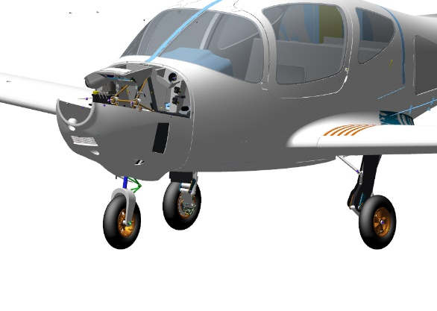
Note. If the joint gaps are outside the specified or non-uniform dimensions, reinstall the hood. If a place is found where there is no clearance and it affects the size and uniformity of the clearances in other places, this place should be marked and cut. If the installed engine systems are preventing the required clearances, cut the hood in the resting area.
A helper will be needed for further work.
Depress the cowl by hand (with an assistant) until all holes have been drilled. Locate three small pinholes on the right and left side of the cowl against the fuselage.
One by one, drill holes with a 4 mm drill bit at each of the points found, according to the points found. Bore out the holes with a 6 mm drill bit. Install the M6x12 DIN 933 bolt in the hole.
IMPORTANT: The hood must not be moved during drilling and reaming. If there are engine components near the drilling point, protect them from damage caused by the drill.
Repeat the steps above to drill holes and install bolts in the remaining locations found. With the side holes drilled and bolts installed in the holes, without letting go of the cowl, find the five small pinholes at the junction of the cowl top with the fuselage.
Remove the M6x12 bolts installed in the holes, remove the upper cowl and lay it on the table. Drill the holes with a 6.5 mm drill bit from a diameter of 6 mm to install the lock screws. Repeat all the steps for the screws and nuts described above for installation on the lower cowl and fuselage.
Insert the screws on the cowl into the sockets of the nuts on the fuselage and lower cowl, one by one, bending them back a little distance.
Hold the hood by hand, press the cross part of the screw with the PH2 screwdriver, turn clockwise by 0.5-1 turn, release the screwdriver. The lock should close and the part of the screw pressed with the screwdriver should protrude slightly.
Press the cross part of the screw with a PH2 screwdriver, turn clockwise until you feel a firm pressure, and release the screwdriver. The lock should remain closed and the screw portion of the screw pressed down with the screwdriver should not protrude.
Repeat the steps above to close and adjust the remaining locks.
Note. If the closing of the lock does not occur, the screw does not engage with the nut, it is necessary to remove the hood, screw the inner part of the lock nut with a screwdriver with a straight slot #2, and repeat the installation and closing again.
Control Operations:
- Inspect the installed cowl for gaps and steps. Steps at the junction with the fuselage and lower cowl should be within 0.5 mm, gaps at the end of the junction of the trim with the fuselage should be from 1 to 2 mm, at the junction of the two cowls from 0 to 1 mm. The gaps on the fit of the cowl trim to the fuselage and cowl lower can be no more than 0.5 mm.
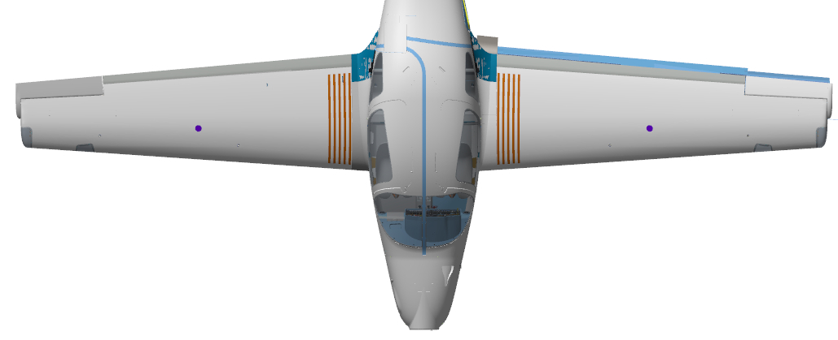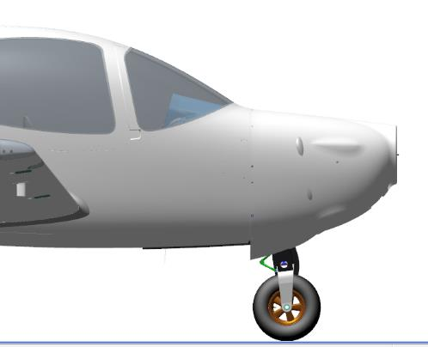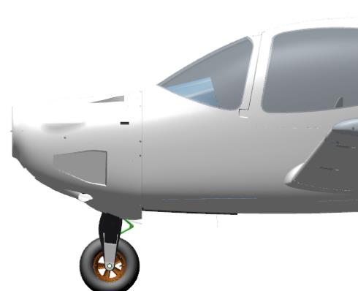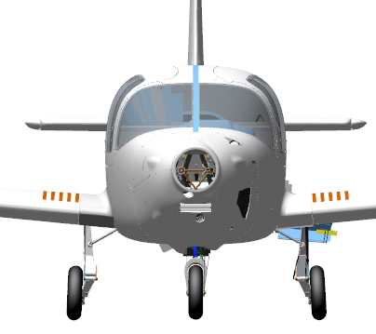
When all locations have been inspected and clearance and step values are within acceptable limits, remove the top cowl.
Remove the protective cotter pins from the lock nuts of the lower hood fasteners, upper hood fasteners, protective cotter pins. Re-install the upper hood. The locks should close and hold in place when the screwdriver is removed from the screw.

When all adjustments are complete, remove the upper cowl and mark the locations of the turbine, exhaust pipe, and heater on the lower cowl with a marker. Remove the lower cowl. Sand all internal surfaces of the hoods with sandpaper P400-600.
Glue 0.1 mm thick aluminum foil to the inner surfaces of the hoods. The adhesive can be epoxy or self-adhesive foil.
Note. To avoid the formation of corrugations, wrinkles and bubbles, the surface should be applied in stages. It is permissible to make cuts when using wide material. It is allowed to use foil strips of convenient width. When using strips or making cuts, the foil should be overlapped by 5-10 mm. It is not permissible to glue foil with gaps.
IMPORTANT: Do not use mechanical means of fixing the thermal insulator. Do not use adhesives that require prolonged heating to temperatures above 80°C.
Find the swirlers, the attachment. Try the attachment on top of the hood, in the cutout area. The attachment must be installed without hinges on the inner surface, relative to the cutout. A gap of no more than 1 mm is allowed. Mark the location of the attachment on the hood.
Prepare the adhesive points on the hoods, vortex generators and air ducts according to standard operation 3. Prepare 50 grams of adhesive according to standard operation 1, and apply it to the parts according to standard operation 5.1. Prepare the adhesive for type action 2, and apply it to the parts for type action 5.2.
Install the duct on the upper cowl, remove excess adhesive, align the lethal to the inner surfaces. Install 2 swirl generators 00364107 in the holes in front of the duct. Remove excess adhesive.
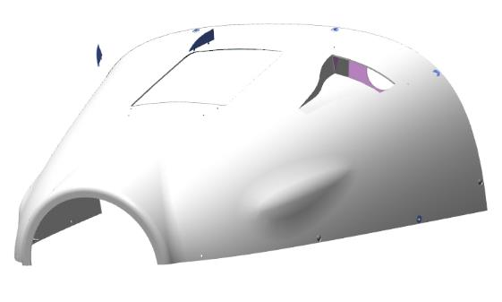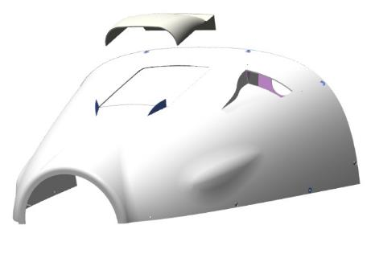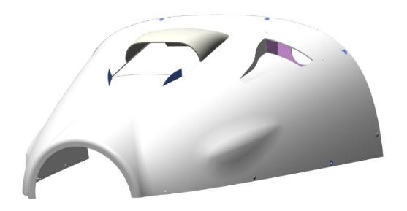

Install the swirl generators on the lower cowl, starting the lines from the joint:00363830 top, 00363833 middle, 00363837 bottom. Remove excess adhesive.
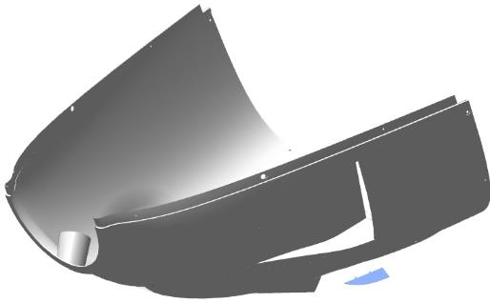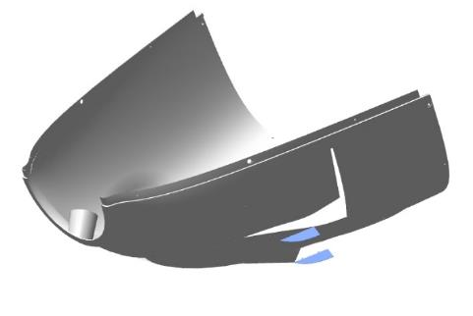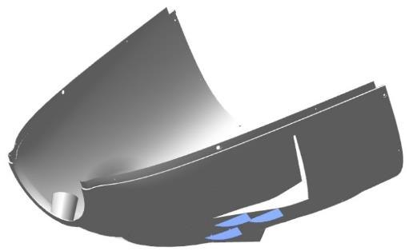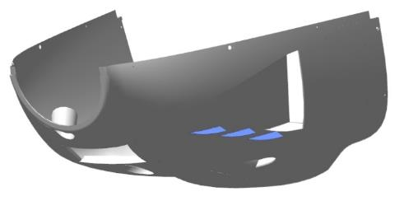

Installation of wing consoles
All installation work must be carried out with two assistants. The wing consoles are laid with the lower skin against the floor.
To complete this work you will need:
- Mobile desk;
- Hex key 2 mm;
- hexagonal wrench 19 mm;
- Socket head 17 mm;
- 2 combination wrenches 8 mm;
- Tweezers;
- Pliers;
- Screwdriver with straight slot #1;
- Solvent methyl acetate 100 grams;
- Clean rags 100x100 mm 2 pieces;
- LOCTITE 648 bushing shaft retainer.
- 4 stands with spoons under the wing consoles.
Unpack it and stack it on the table:
- 2 bolts 00179429;
- Left wing console with flap and aileron (previously assembled);
- Right wing console with flap and aileron (previously assembled);
- 8 M3x8 screws ISO 7380-2;
- 2 nuts M5 DIN 935;
- 2 nuts M12 DIN 935;
- 2 washers 5 DIN 6798A;
- 2 1x20 DIN 94 cotter pins;
Before starting work on the wing consoles, make sure that the fuselage is securely mounted on the landing gear struts and that there is more than 7 meters clearance from the fuselage sides on the right and left sides.
Inspect the box in the fuselage for foreign objects. There should be no foreign objects.
Locate the two bolts 00179429 and move into the fuselage to the rear sofa. In the opening through the hatch along the port side, locate the bolt location by feel.
Place the bolt in the hole, screw it in as far as it will go. The bolt should go into the hole easily, without sticking. Remove the bolt from the hole, lay it on the sofa. Repeat the steps above for the second bolt 00179429. Move out of the fuselage.
Insert the right console spar into the fuselage box, lay the spar in the depression closest to the rear wall of the box, insert the aileron link into the opening of the fuselage casing.
Slide the wing skins into the fuselage casing until they stop. Hold the bracket in this position and place the stand on a suitable height position.
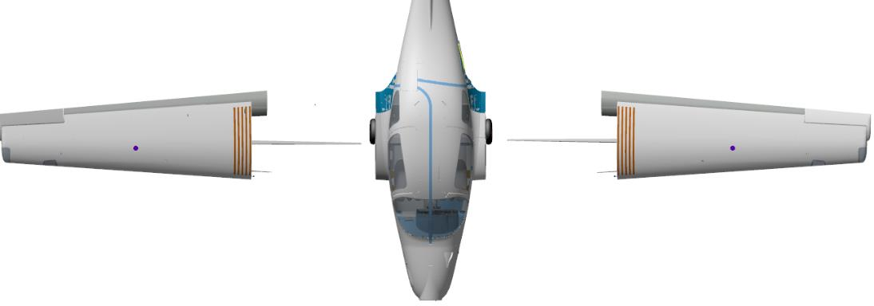
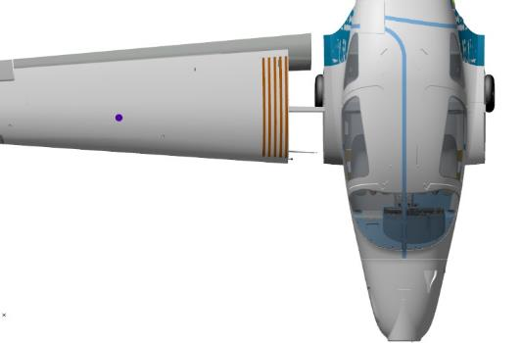
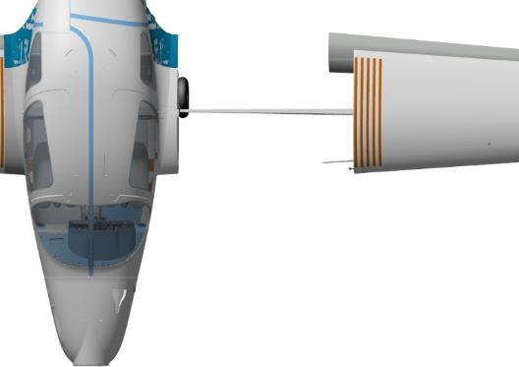
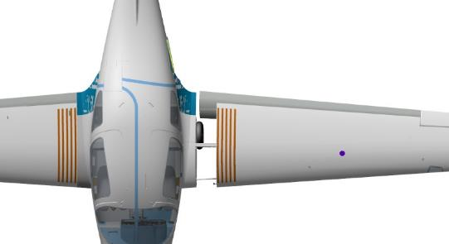
Move to the rear sofa in the fuselage. Slide the bolt into the hole as far as it will go. If the bolt does not go in, move the left console up and down by the wing tip at a very small angle while pushing the bolt into the hole.
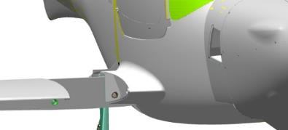
IMPORTANT: Do not move the consoles by the tip sharply or over a long distance. This may cause damage to the fuselage.

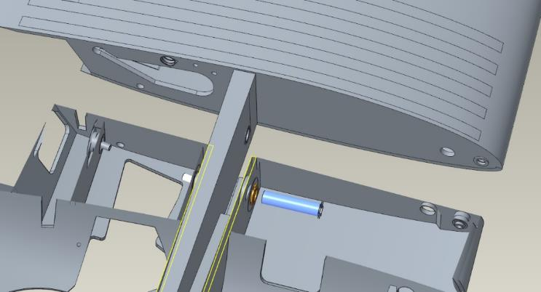
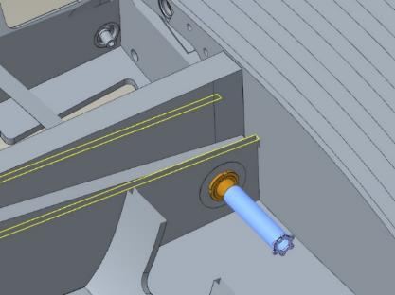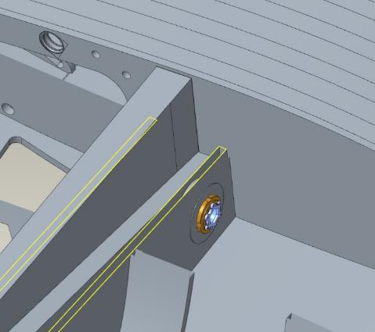

Tighten the bolts one by one with a special wrench
Control Operations:
- If the bolt is tightened to a high torque, it is easy to move the console up and down by the ends. The bolts should be tightened until the gap between the bolt flats and the bushing is eliminated.
Move from the fuselage to the left console.
Control Operations:
- Inspect the gaps at the console/fuselage joint at the top and bottom. The gaps should be between 3 and 6 mm. Move to the right console. Inspect the gaps at the junction between the console and fuselage at the top and bottom. The gaps should be between 3 and 6 mm.
When the clearances are checked and are within the correct values, move into the fuselage on the left side of the rear couch.Install the 00138493 linkage to the rocker arm through the opening under the pilot beam.
Move to the right side. Repeat the steps above to attach the second link.
Control Operations:
- Move the control knob to the right - the right aileron should move up, the left aileron should move down. The stroke should be smooth, without jerks or jams, and should not require much effort. There should be no creaking, cracking or grinding sounds.
- Move the control knob to the left-right aileron should move down, left aileron should move up. The stroke should be smooth, without jerks or jams, and should not require much effort. There should be no creaking, cracking or grinding sounds.
- Position the control stick approximately in the middle. Move from the fuselage to the right aileron. Inspect the position of the aileron-unit should be in the zero position (the aileron trim and wingtip trim should be level with no steps). Move to the left aileron and repeat the inspection, it should also be in position zero.
Note. If the ailerons are deflected from the zero position when the control knob is set to the center position, the thrust in the aileron control assembly area must be adjusted.
Length adjustment requires:
- If aileron position, turn the nut on the aileron link rod end 1 turn;
- Remove the tie rod mounting fasteners from the aileron assembly;
- Tilt the aileron up;
- Unscrew the lug from the rod by 1 turn;
- Install and fasten the tie rod in reverse order;
- Check the position of the control knob and the aileron position.
If the position of the rudder direction changes in the direction from the required one, screw the lug into the rod in point 4. After adjustments have been made, screw the nut on the handpiece as far as it will go, using the shaft sleeve lock.
When the adjustment is complete and the ailerons are set correctly, cotter the aileron and linkage connection with a 1x20 DIN 94 cotter pin.
When installation and adjustment work is complete and there is no need to transport the aircraft.
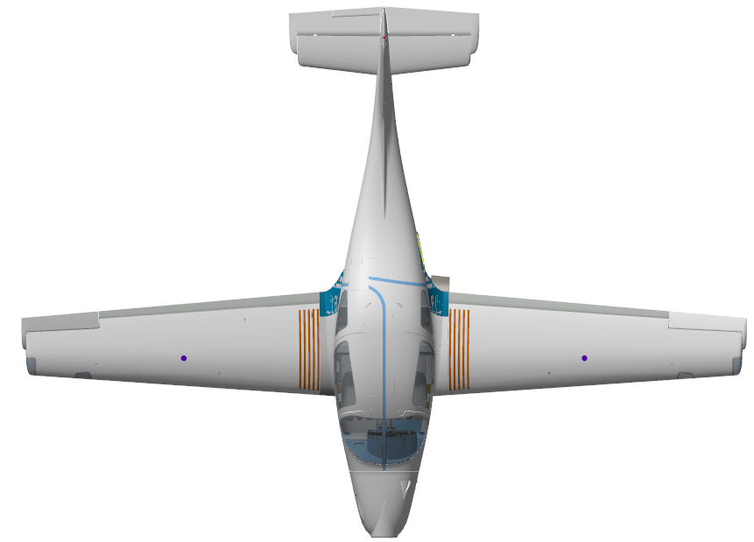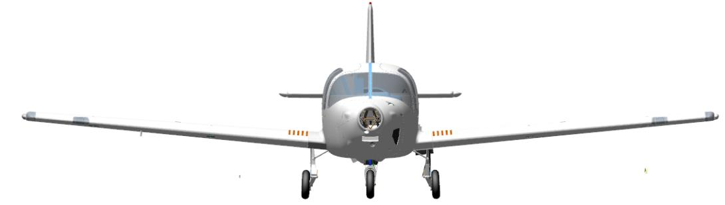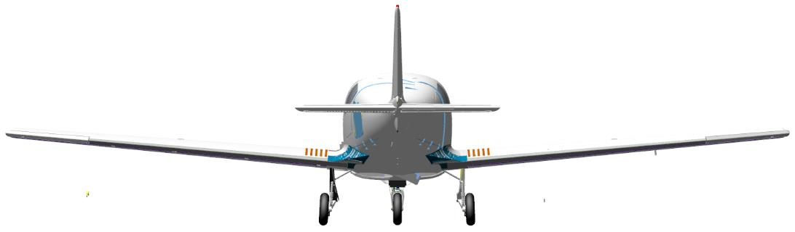

INSTALLATION OF UNITS IN THE ENGINE COMPARTMENT
To complete this work you will need:
- Mobile desk;
- Hexagonal wrench 2.5 mm;
- Phillips head screwdriver PH2;
- 10 bolts M6x12 DIN 933;
- Sandpaper grit P600 1 sheet 200x300 mm;
- Solvent methyl acetate 100 grams;
- Clean rags 100x100 mm 2 pieces;
- Latex gloves 1 pair;
- Larit L285 10 gram epoxy resin;
- H287 hardener 4 grams;
- Paper cup 100 ml;
- Aerosil thickener 3 grams;
Unpack it and stack it on the table:
- Hydraulic Power Station;
- 2 oil tank brackets 00136076;
- Bracket 00136079;
- Jumper 264045;
- Adapter housing 00136330;
- Puncturer 00136331;
- Tube 00136334;
- Plug 00136335;
- 2 springs 00136332;
- 2 valves 00109540;
- Bushing 00136333;
- Spool 00136338;
- 2 corners 00109537;
- Lever 00109538;
- Ball d5;
- 2 rings 003-006-19;
- 2 rings 008-010-14;
- Ring 006-008-14;
- 2 A10 DIN 471 rings;
- 3 clamps 35103481400_70;
- 12 M4x12 screws ISO 7380-2;
- M4x6 screw ISO 7380-2;
- 2 screws M5x10 ISO 7380-2;
- 4 screws M3x8 ISO 7380-2;
- 2 screws M10x20 DIN 912;
- 2 tanks PRCH-0000007682;
- 2 relays PRCH-00030874;
- Master Relay 70-111226-5;
- Starter relay;
- 2 relays 12V70A;
- Fuel Purification Filter AF-454.
Locate the fine filter mounting location on the spar. Locate the bracket 00136079 and two M4x12 ISO 7380-2 screws. Place the bracket on the spar and secure with the screws.
Install 2 clamps 35103481400_70 on top and bottom. Insert the filter into the clamps, point the leads with the arrow "inlet" to the gasoline line, tighten the clamps.
Check that the filter is securely fastened by moving the filter housing in different directions. There must be no possibility of movement relative to the clamps.
IMPORTANT: Do not remove the plugs from the filter before connecting the hoses. Debris entering the filter will inevitably lead to engine failure.
Connect the gasoline line hose to the filter inlet, install the clamp.
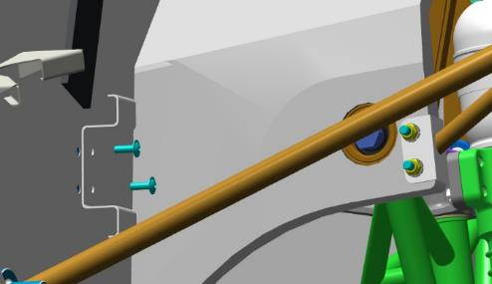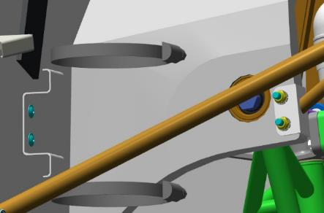
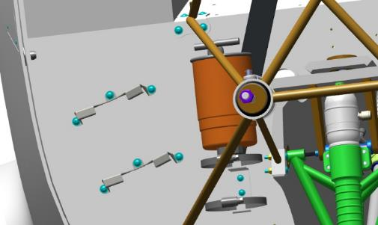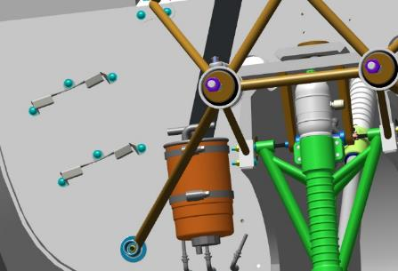
Locate the location of the oil tank brackets on the spar. Locate the brackets 00136076 and 6 M4x12 ISO 7380-2 screws. Install the brackets on the spar and secure with the screws.
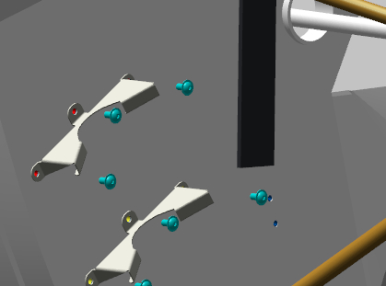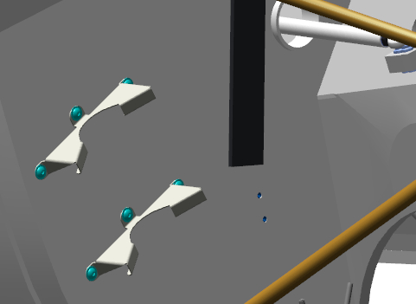
Find 2 M10x20 DIN 912 screws and a hydraulic station.
Place the station on the battery compartment box, secure with 2 screws.
Install the clamp in the bracket hitch, drive it over the top of the hydraulic power pack, tighten until it is completely around the top of the power pack.

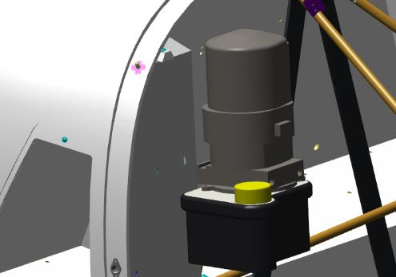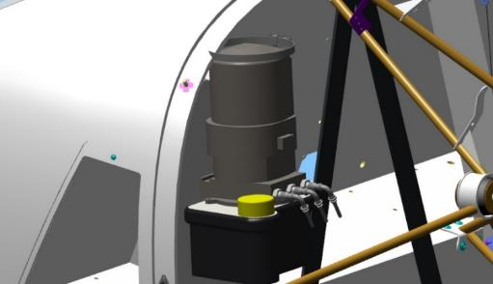
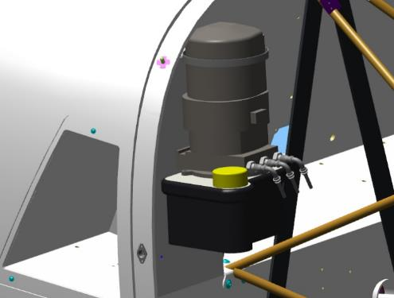
Locate the two 12V70A relays at the top of the spar, near the battery compartment. Fasten the relays to the spar with 2 M4x12 ISO 7380-2 screws.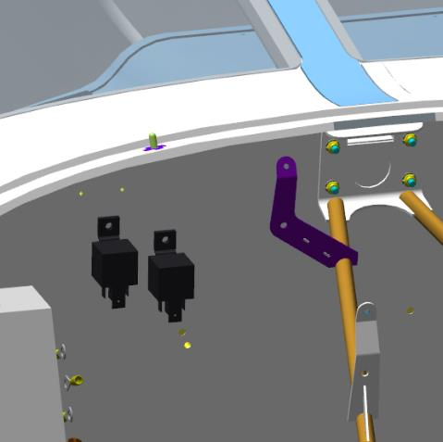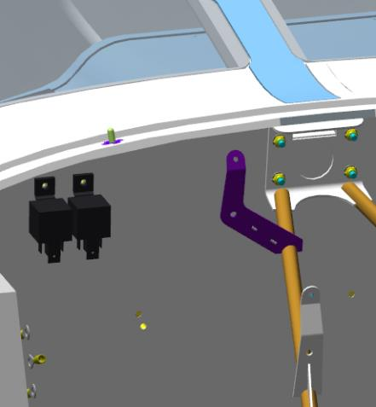
Locate the master relay and starter relay on the spar. Install the starter relay, fasten with 2 screws. Install the master relay, connect the jumper to the starter relay, fasten with 2 screws on the spar.
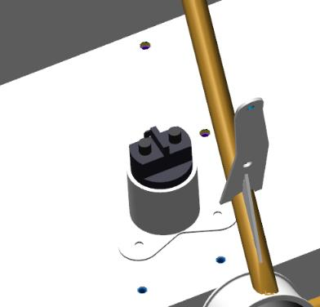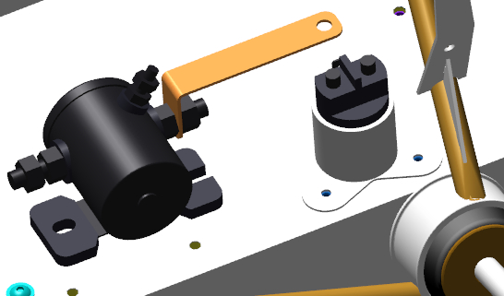
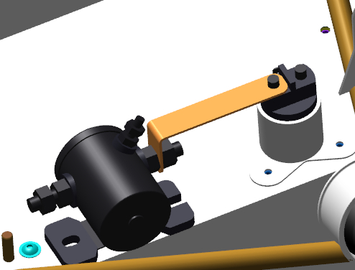

Place the brake reservoirs on the brackets, secure with screw and nut.

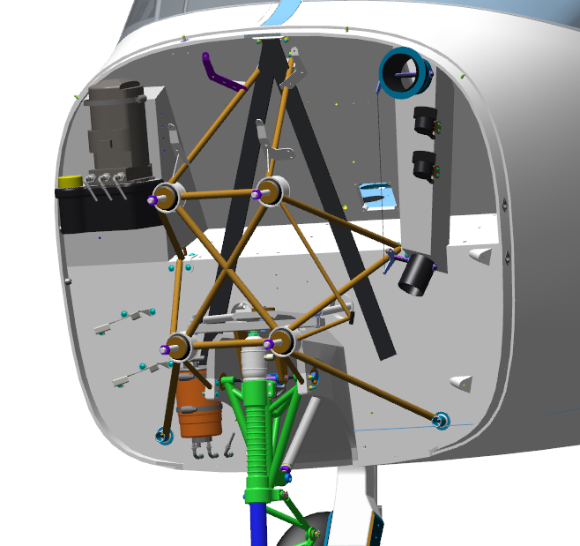
Unpack and stack the parts included in the chassis crane on the table.
IMPORTANT: Keep dust and other small foreign objects away from hydraulic system parts.

Dip the rubber rings, valves, and spool in a container of oil. Install the 008-010-14 rings in the grooves of the spool. Spread the rings in the grooves.
Install ring 003-006-19 in the grooves of each piston. Spread the rings in the grooves.
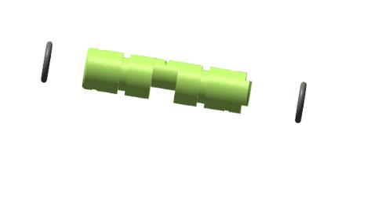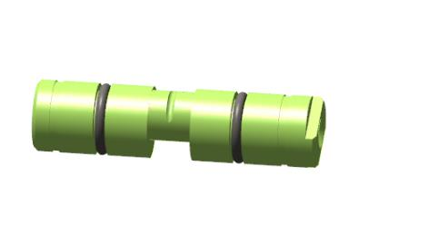
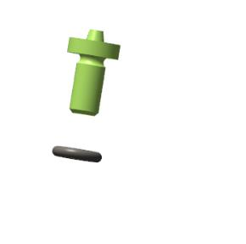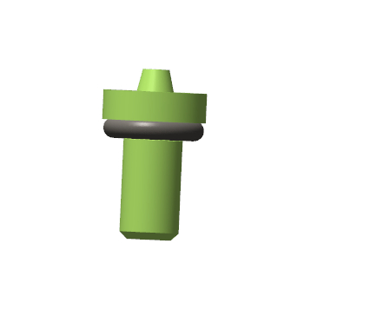

Moisten with oil the inside of the housing, the outside of the spool with the rings installed.
Insert the spool with fitted rings through the smooth (unthreaded) holes in the housing. Seat the spool smoothly in the housing. Check the rotation of the spool in the housing. The rotation should be smooth without jerks, jams, and should be possible to rotate more than a full circle.

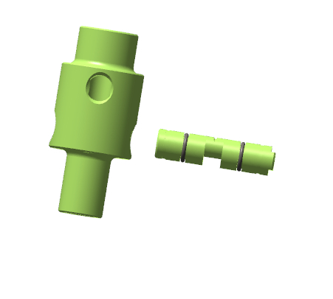

Locate valves with rings installed. Install one valve in the hole at the bottom of the body, the other valve at the top of the body. Install the spring on the valve from the bottom, install the fitting, and tighten with a wrench.
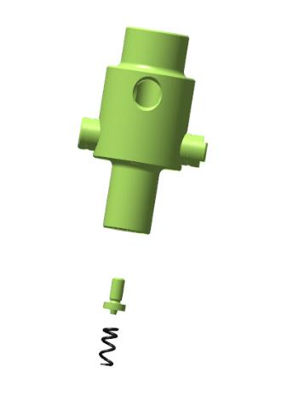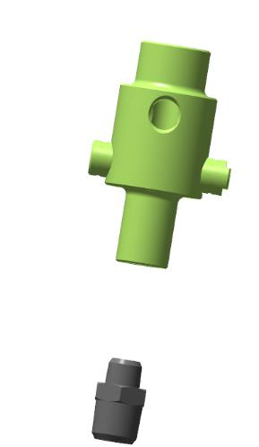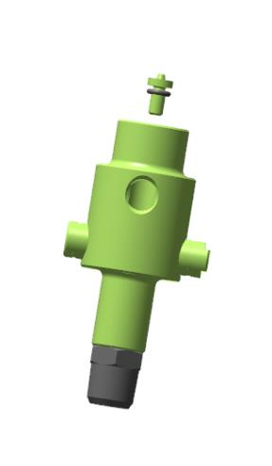

Install the spring and bushing on the second valve. Turn the body on its side, place a d5 ball in the punch, place the punch on the body. Tighten with a wrench.

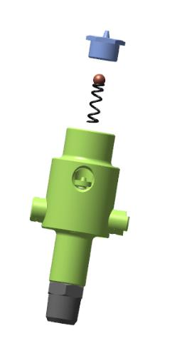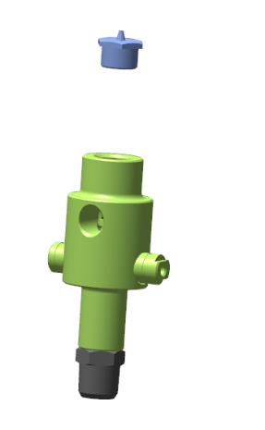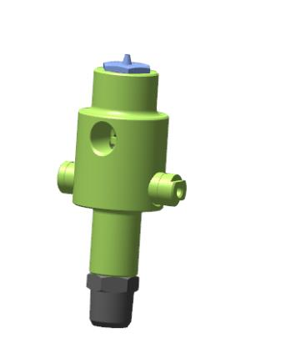

Place the sleeve on the body at the punch side, screw it on until it stops. Install the corners on the spool ends, fix alternately with locking rings. Place the lever on the spool on the cutter side, fix it with the screw. Check the rotation of the spool by making a few full turns by the lever. Rotation should be smooth, without jerks. A slight force is permissible in some places of rotation.

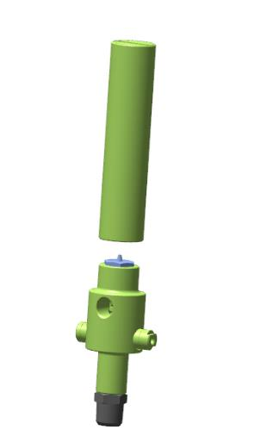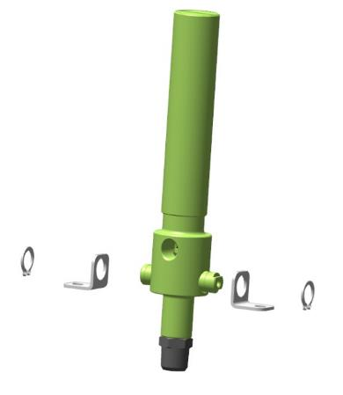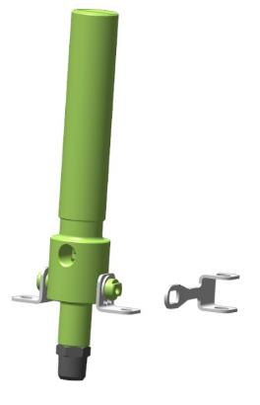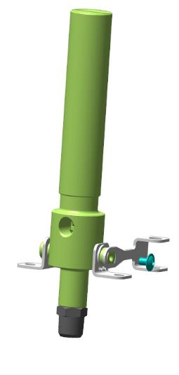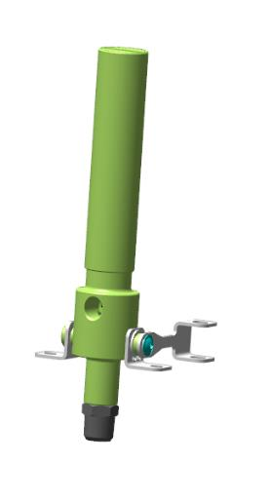

Unscrew the sleeve approximately 4-5 turns. Place a gas cylinder inside the tube.
IMPORTANT! When using the cylinder, be careful as the gas is under very high pressure and puncturing the cylinder will cause a sudden cooling.
Place the plug on top of the sleeve, screw it into the cylinder by hand until it stops. Measure the depth to which the plug is screwed in. Unscrew the plug and place it on the thread locker.

POWERTRAIN ASSEMBLY

Assembly and installation of engine units
    - Oil cooler assembly
To complete this work you will need:
- Mobile desk;
- Hexagonal wrench 2 mm;
- 10 bolts M6x12 DIN 933;
- Solvent methyl acetate 100 grams;
Unpack it and stack it on the table:
- Case 00136137;
- Nut 00136138;
- Emphasis 00136139;
- Spring 00136141;
- Wire 00136144;
- 3 fittings 00134111;
- 5 springs 00206932;
- 2 brackets 00156315;
- 2 brackets 00156316;
- Oil radiator AN10 13 sections;
- Deutz thermostat;
- AN10 fitting;
- 3 rings 11x1,2 DIN3771;
- 12 M4x10 screws ISO 7380-2;
- 12 M4 nuts DIN 934;
- Hose AN10 1950 mm;
- Hose AN 8 1200 mm;
- Gasoline resistant hose 8x13 560 mm;
- Copper tube D56 950 mm;
- Spring clamp 19;
Find housing 00136137, 3 fittings 00134111, 3 rings 11x1,2 DIN3771.
Insert the 11x1.2 DIN3771 ring into the thread groove of the connector.
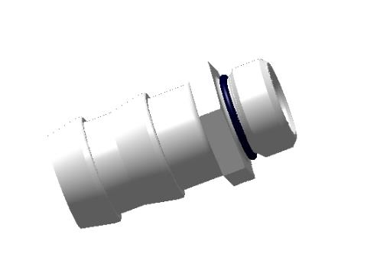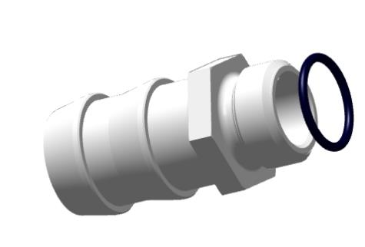
Degrease:
- Outer threaded parts of the fittings;
- Internally threaded parts in the housing.
Apply an even thin coat of LOCTITE 648 shaft and bushing retainer to the degreased surfaces. Screw the fittings into the holes, tighten each fitting with a 17 mm wrench until the gap between the body and skirt flats is eliminated.
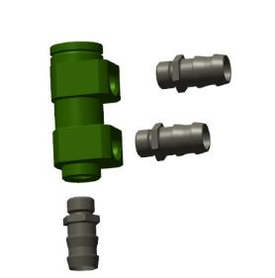 | 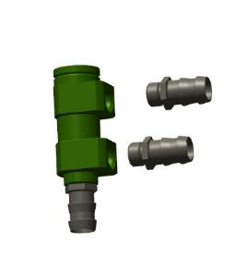 | 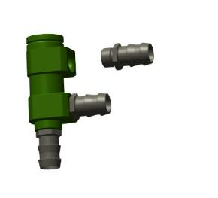 | 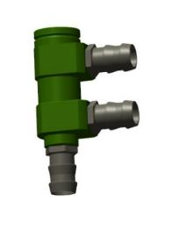
Locate the spring, thermostat, wire, stop and nut. Install spring, thermostat, wire, stop and nut into housing.
Place a stop on the thermostat needle and press down with your finger. The spring should compress. Install the nut, insert the wire into the side hole, turn the nut and pull the wire inwards step by step.
Control Operations:
- Check that the nut is securely fastened. The nut should not be able to be removed, but can be rotated around its axis.
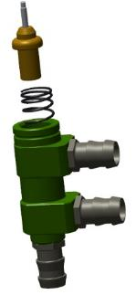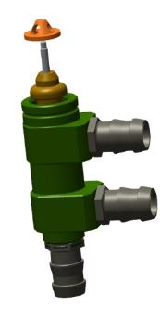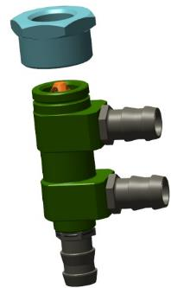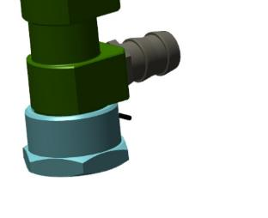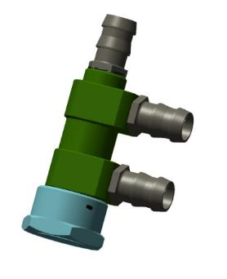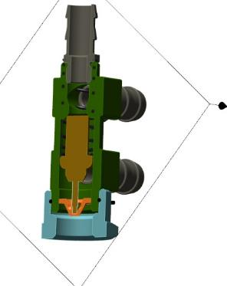
Locate the oil cooler, brackets 00156315 and 00156316, 8 M4x10 ISO 7380-2 screws and 8 M4 DIN 934 nuts.
Install the brackets on the radiator and secure with screws and nuts.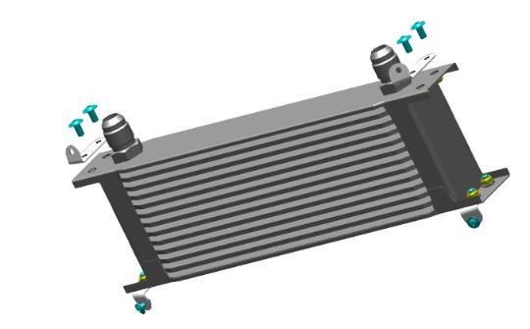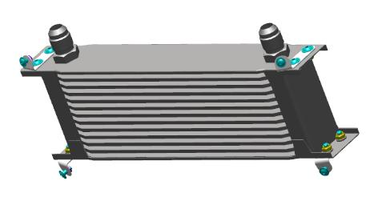
Screw the AN10 fitting onto the left radiator fitting and the thermostat onto the right thermostat until it stops.
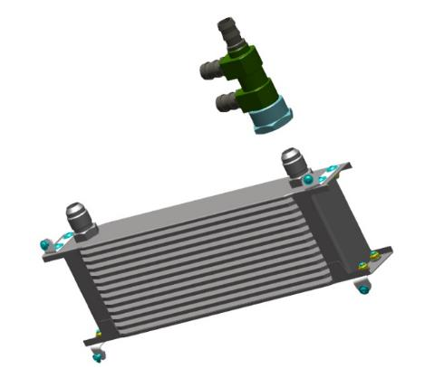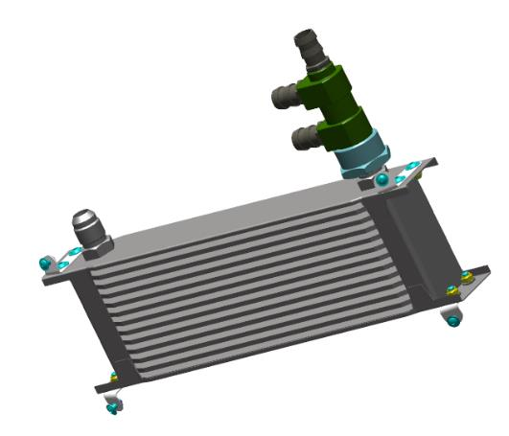
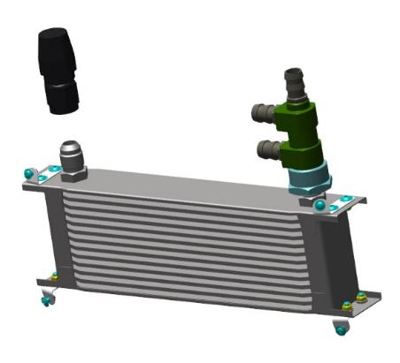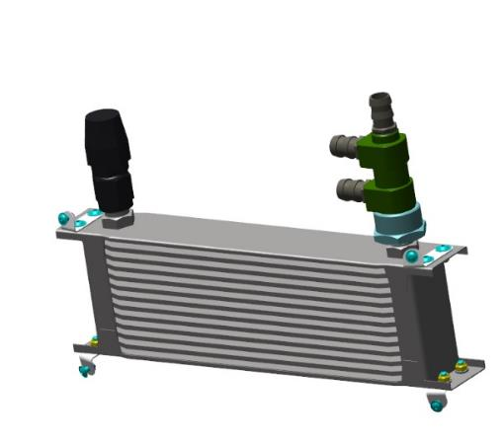
Measure and cut from the coil in lengths:
- Hose AN10 270 mm;
- AN10 350 mm hose;
- Hose AN10 1290 mm;
- AN8 510 mm hose;
- Hose AN8 660 mm;
Install springs in the ends of each hose.
IMPORTANT! If the springs are not installed inside the hoses, they can crumple at the kinks and cut off the oil supply. This will inevitably lead to engine failure and lengthy repairs.
Install a 270 mm hose on the lowest thermostat fitting and secure with a hose clamp. Install and secure the 350 mm hose on the fitting and the other part of the hose on the middle thermostat connection, secure with a clamp. Install a 1290 mm hose on the upper fitting and secure with a hose clamp.

    - Assembling the water radiator
To complete this work you will need:
- Mobile desk;
- combination wrench 8 mm;
- Hexagonal wrench 2.5 mm;
Unpack it and stack it on the table:
- Cabin heating air duct 00133438;
- Pipeline 00144389;
- Pipeline 00144390;
- Pipeline 00144447;
- Pipeline 00144443;
- spring clamp 52;
- screw M 5x16 ISO7380-2;
- Thermostat VERNET TH3310.80;
- Honda CB1000 cooling radiator;
Find the cooling radiator, pipes, ductwork, thermostat.
Install the air duct on the radiator, fasten to the radiator eyelet.
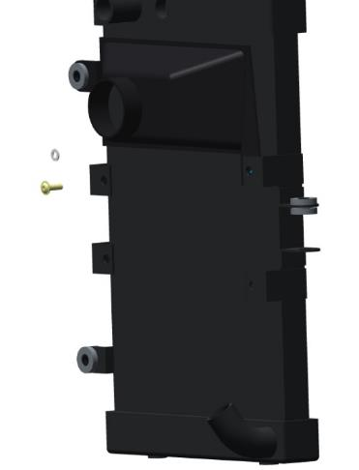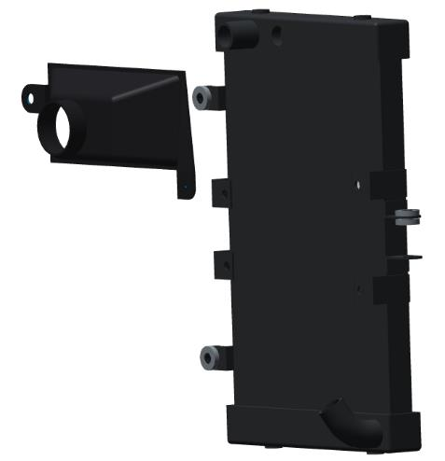
Install the pipe 00144447 on the radiator, near the air duct. Install the thermostat in the pipe, install the pipe 00144390 on the second part of the thermostat, connect it to the lower part of the radiator. Install pipe 00144389 on the thermostat outlet.
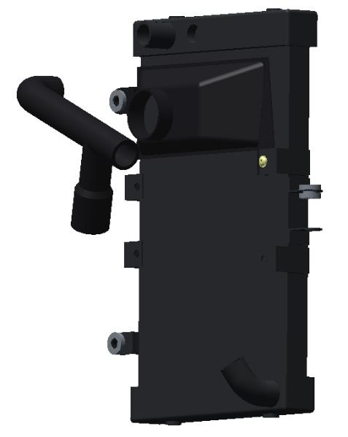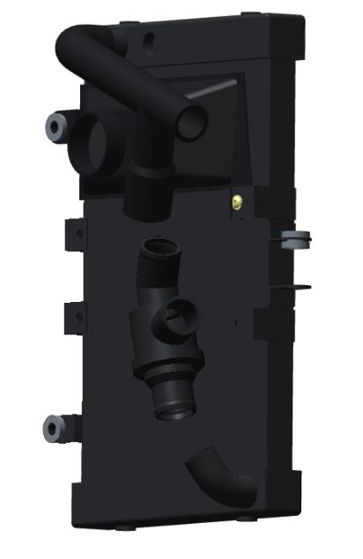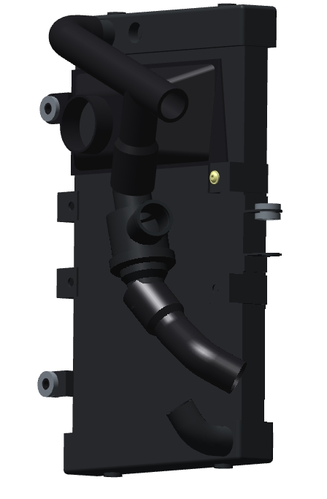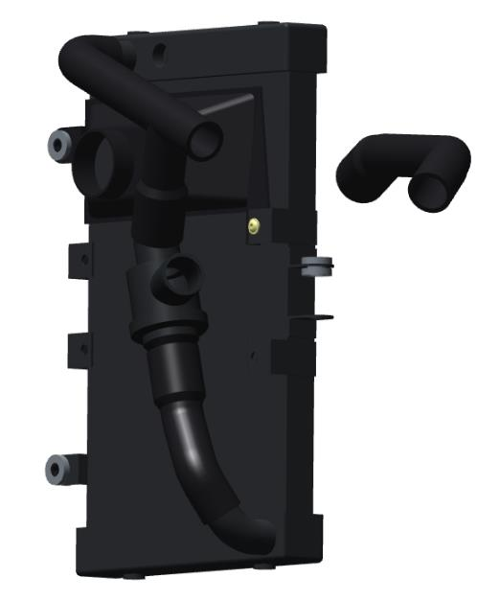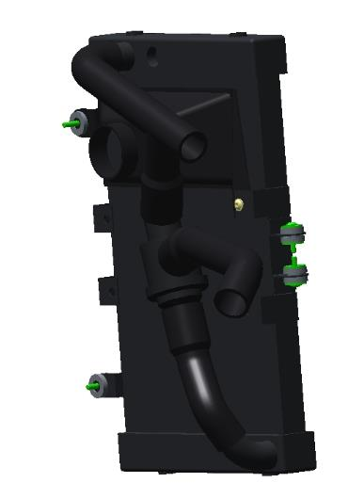
Inspect the piping and thermostat for resting against the radiator. There should be no play and the clearance should be at least 5 mm. Tighten all pipe clamps.
IMPORTANT: Loose clamps will result in fluid leakage.
An incorrectly set thermostat will cause the engine to overheat.
    - Installing the intercooler box
Equipment, materials and tools - by 8.1.2
Find the box 00178639, cover 00178631, mechanism 00144709. Place the hinge on the box and secure with screws.
Place the mechanism on the box, fasten with screws. Place the bracket on the cover, fasten with screws.
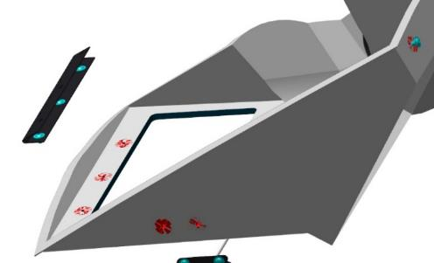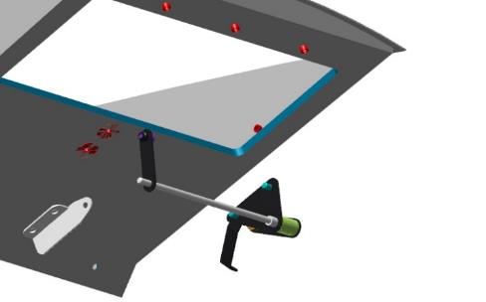
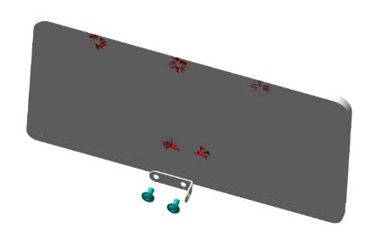
Install the hinge in the box cover, fasten with screws to the hinge. Connect the mechanism to the cover bracket.
Make several movements of the cover by rotating the mechanism. The mechanism should move the cover up and down.
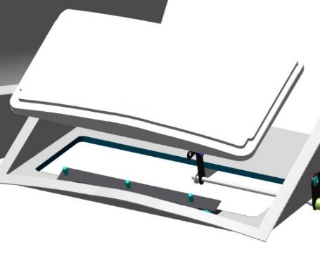 | 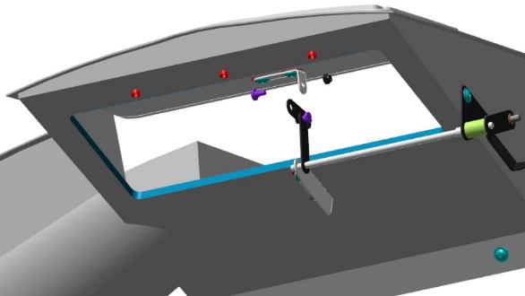

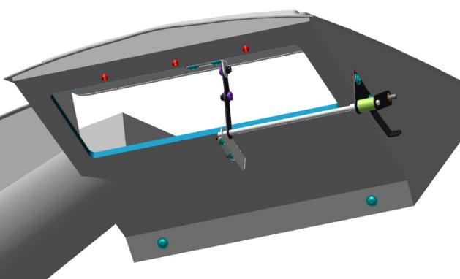
    - Engine installation
Unpack the engine parts, prepare the engine for attachment to the airplane. Remove the engine from the container with a hoist. Check the passage of the STD-00053110 bolt through the holes in the engine frame. The bolt should go through tightly, but without great effort. If the bolt does not go through, or requires a lot of force, then drill the holes to a diameter of 11.0-11.05, and make sure that the bolt goes through the holes.
Install the engine fuse box on the spar wall and bolt it in place.
Install the cushions, with tubes, of the engine, inside and out, into the engine seats on the motorama.
Bring the engine hoist up to the motorama, aligning the motorama holes with the engine pads.
Install a bolt and washer in each hole in turn, with a washer between the motor mounts. When attaching the engine, as you approach the motor mount, pull the engine wires through the window in the spar.
Degrease:
- External threaded parts of the bolts;
- Internal threaded parts of the nuts.
Apply an even, thin coat of LOCTITE 648 shaft bushing retainer to the degreased surfaces. Screw on the nuts, using a 17 mm wrench, until the gap between the planes is eliminated.
Disconnect the hoist from the engine. Inspect the installed engine. Make sure that the engine fasteners are not damaged and are fully tightened.
Fabricate, install and hook up harnesses for engine operation.
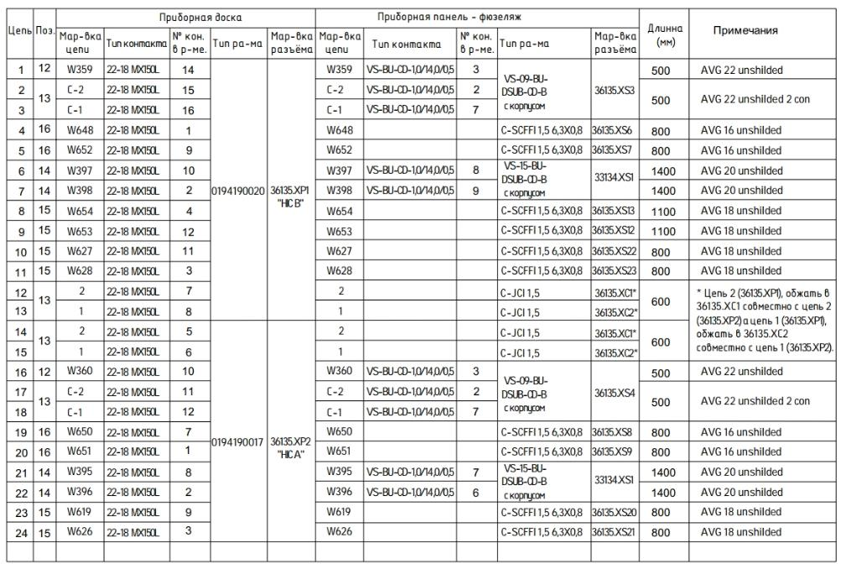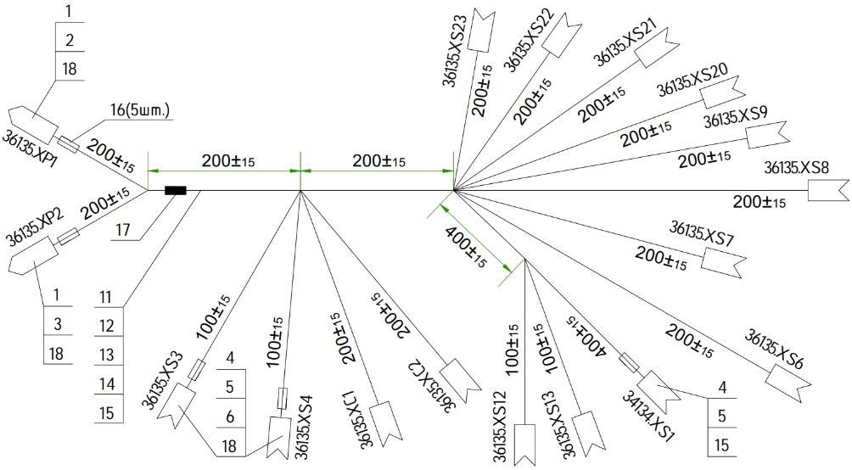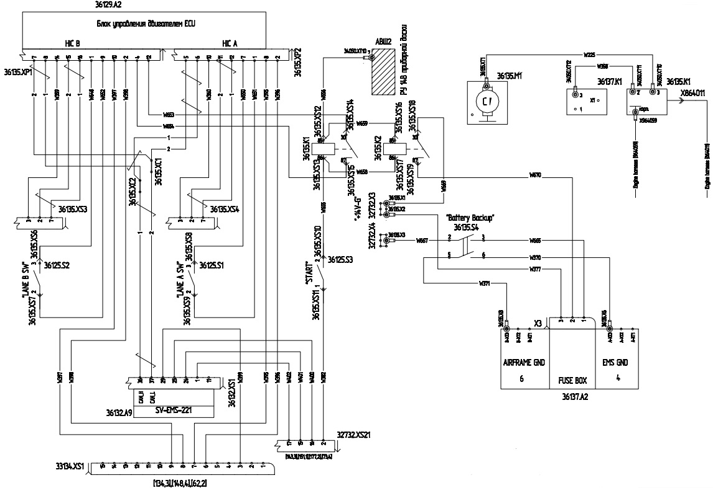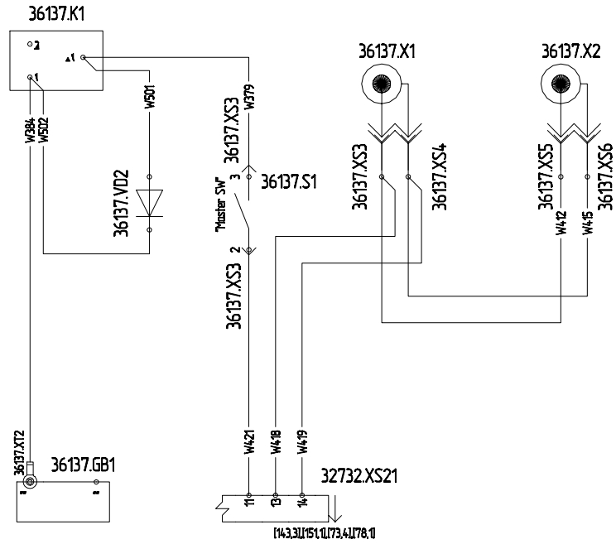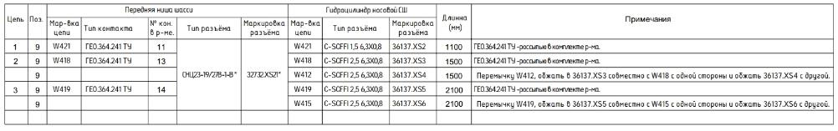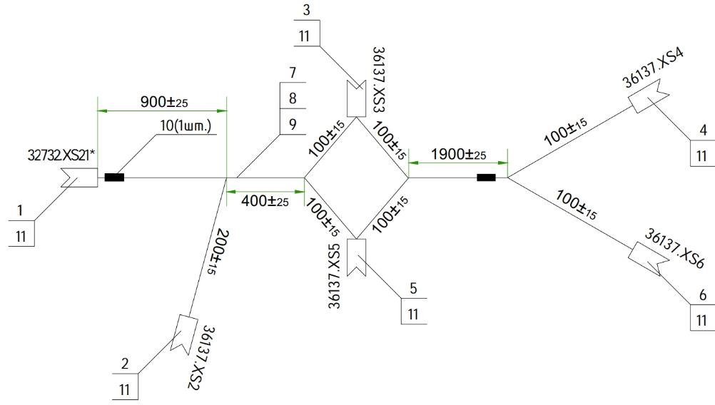
    - Installation of other engine units
Install the lower hood and secure with the locks. Ensure that the engine components are not resting on the hood.
IMPORTANT! A special place where the clearance should be at least 20 mm is the exhaust system.
Install the top cowl, also make sure there are sufficient clearances and no bumping. Remove the hoods.
Install, fasten the cooling radiator with pipes and thermostat on the spar and motorama.
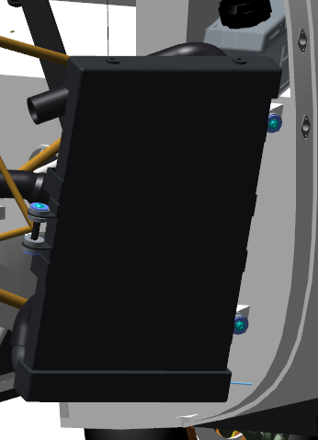
Connect the pipelines to the digester and secure with clamps.
IMPORTANT: Loose clamps will result in fluid leakage.
Install the intercooler on the motor arm lugs, in the lower holes. Secure with bolts, but do not tighten completely.
Place the assembled box 00178639 on the intercooler, align the holes of the motorama lugs, fasten with screws, but do not tighten completely. Attach the damper control cable. Make a few movements with the cable. The cover should retract and return to the same position.
Install turbine, throttle and intercooler connections and secure with clamps. Install the sensors in the branch pipes.
Install lower hood, secure with locks. Check for possible bumps. There must not be any bumps. Use the cable to set the box cover in the open position.
Control Operations:
- Install the top cowl, check for possible pinch points.
- Use the cable to close the cover to the closed position. The cover should be flush with the cutout in the hood. Open and close several times, the cover should be in the same position.
- Remove the top cowl, tighten the intercooler and box fasteners. Reinstall the hood and recheck the position of the cover. The cover must be flush with the surface of the hood.
Note. If the cover is not flush, the top cowl must be removed and the following steps must be followed:
- If the lid is loose, loosen the fasteners, move the box upwards and tighten the fasteners.
- If the lid is pinched and cannot be completely closed, move the box downwards and tighten the fasteners.
Remove the cowls from the airplane.
Assemble the oil system according to the diagram.
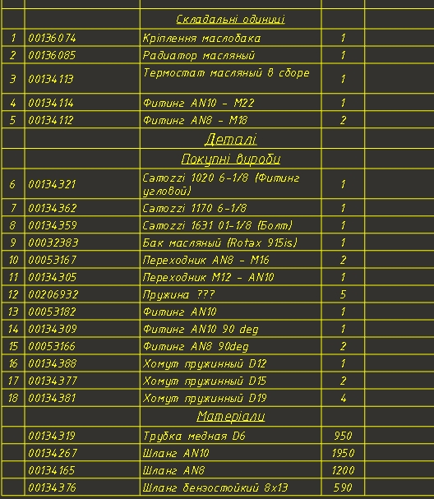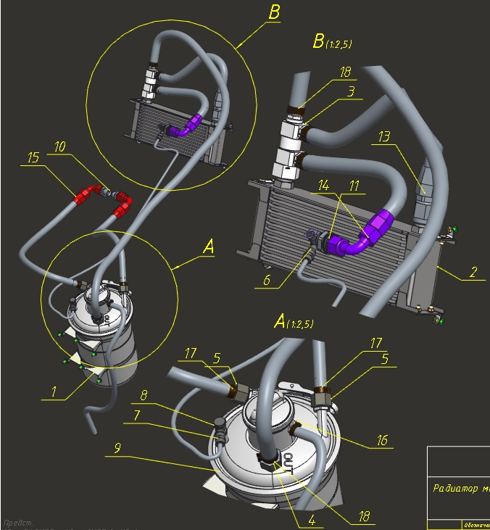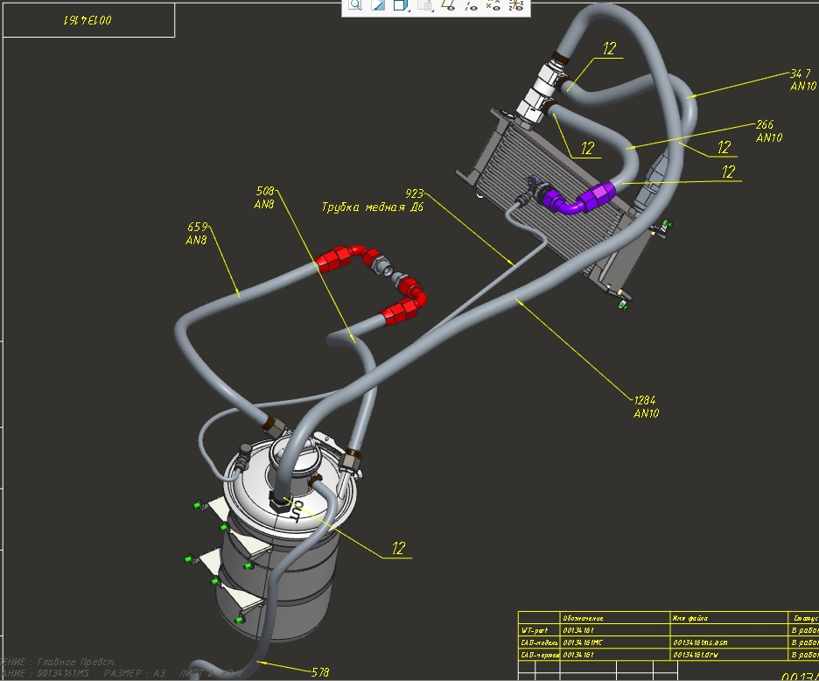
IMPORTANT: Loose connections will result in oil leakage and possible engine damage.
Install the air filter on the pipe in the box 00178639, fasten it with a clamp. Find pipeline ANG-7100-00029213-003, put two clamps on it.
Install the piping on the filter box spigot, install the inner part on the engine turbine; fasten both parts with clamps. 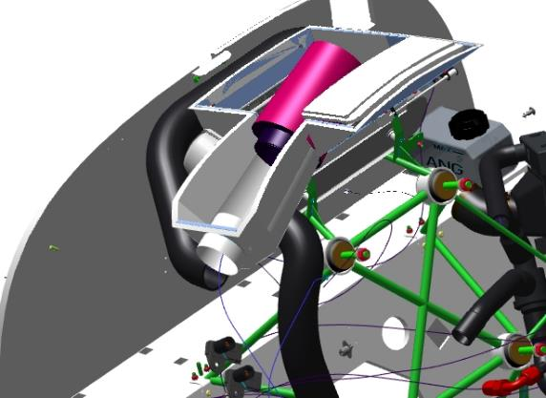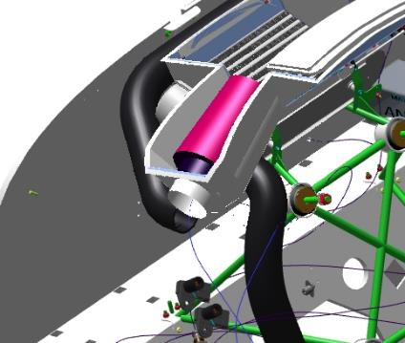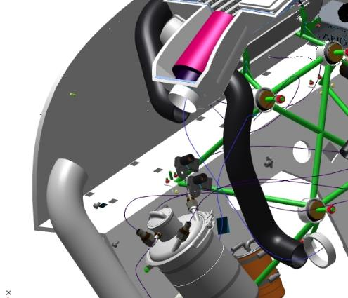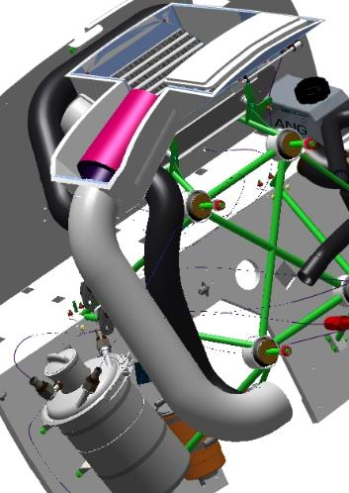
Locate the pipe line 00266977, put two clamps on it.
Pull the piping over the rotorama, install on the intercooler outlet on the spar side; secure with a clamp.
Connect the second part of the pipe to the engine throttle assembly. Locate the pipeline 00266978, put two clamps on it.
Install the piping to the turbine outlet; secure with a clamp.
Locate two branches on the 00266978 pipeline, put clamps on them. Install the motor sensors in the branches and tighten the clamps.
Place a hose on the expansion tank connection, tighten with a hose clamp. Install the other part of the hose to the expansion tank connection and tighten with a clamp.
Connect the electrical part of the motor according to the relevant section of the motor installation instructions.
Install lower hood, secure with locks. Check for possible bumps. There must not be any bumps. Use the cable to set the box cover in the open position. Install the upper hood, check the places where it may be pinched.
Use the cable to close the cover to the closed position. The cover should be flush with the cutout in the hood. Open and close several times, the cover should be in the same position.
Note. If the cover does not fit flush or is resting against the hood, the top cowl must be removed and the following steps must be followed:
1.If the lid is loose, loosen the fasteners, move the box upwards, tighten the fasteners.
2.When the lid is caught and cannot be completely closed, move the box down, tighten the fasteners.
Remove the cowls from the airplane.
IMPORTANT! Follow the manufacturer's instructions for installing the engine exactly. Do not start the engine without the propeller installed.

Air propeller installation

Fabricate, install and connect electrical harnesses to operate and control the variable pitch propeller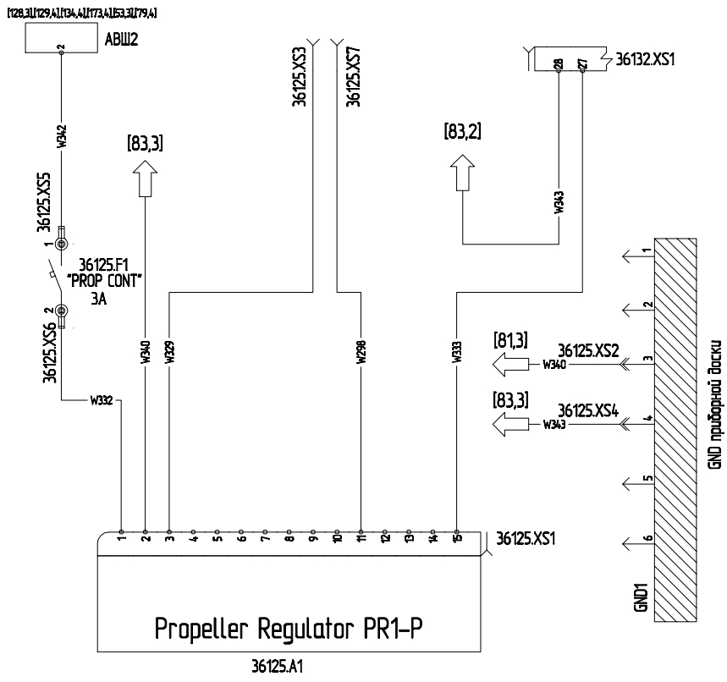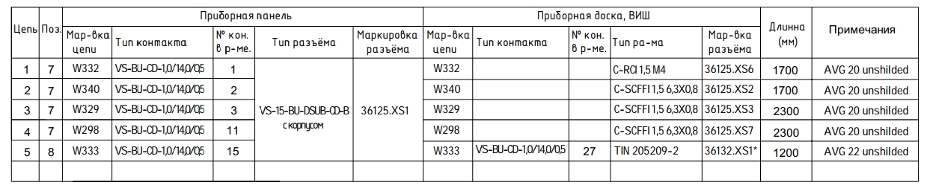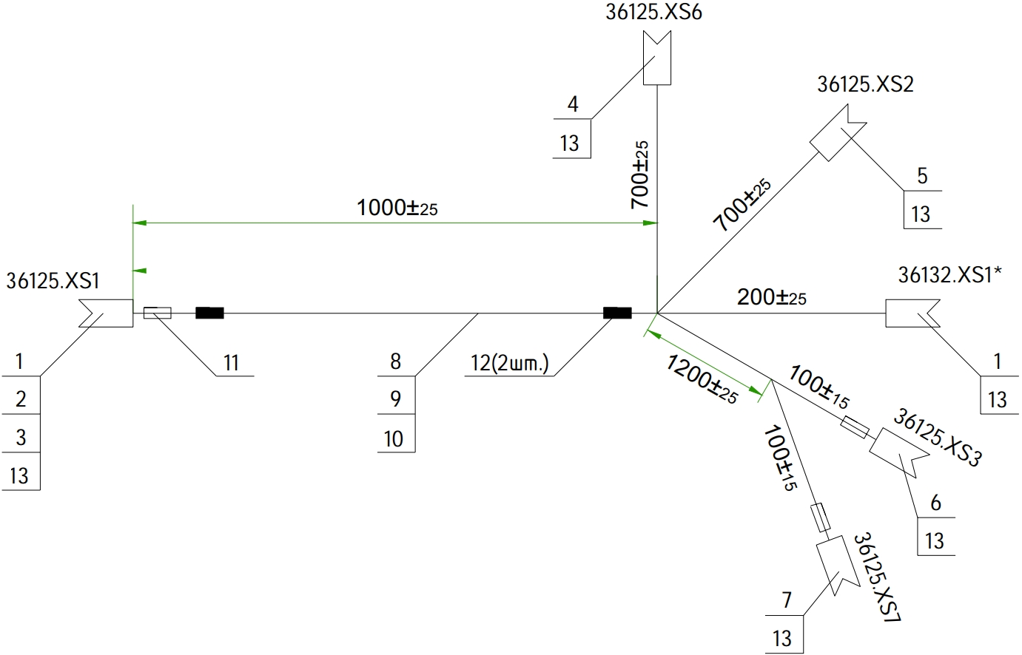
To complete this work you will need:
- Mobile desk;
- Hexagonal wrench 2 mm;
- Combination wrench 13 mm;
Unpack it and stack it on the table:
- Kok 00180868;
- Coke Flange 00180872;
- Screw 00180867;
- 9 M4x10 screws ISO 7380-2;
- 3 screws M3x8 DIN7991;
- 6 nuts M8 DIN 985;
- 6 washers 8 DIN 125;
- 6 washers 8 DIN 6798A;
IMPORTANT! Working with the propeller is very important.
Locate the kok and the kok flange. Check the 7 M4 threaded holes according to standard action 6. Place the kok on the flange, align the holes, fasten with M4x10 screws ISO 7380-2.
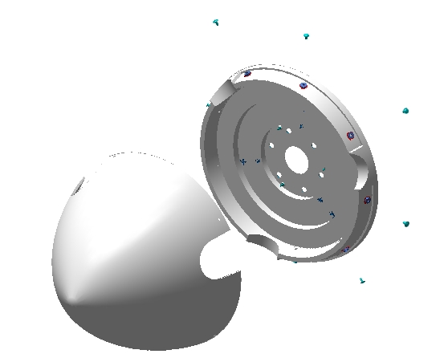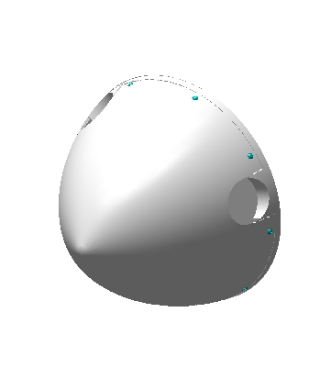
Inspect the contours of the joint between the caulk and the flange for caulk protrusion.
Note: If the holes of the caulk and the flange do not match up to 1 mm, it is acceptable to drill them to 5.0 mm. If the bark rests on the flange and does not allow to install the fastener, it is necessary to grind the perimeter of the bark on a flat plane.
Disassemble the coke and flange in reverse order.Install the flange from behind on the air screw, align the holes, secure with 3 M3x8 DIN7991 screws. Attach the mechanism wires to the flange. Install the cock, fasten the screws and check the clearance between the cock, flange and blades. The clearance should be at least 5 mm.
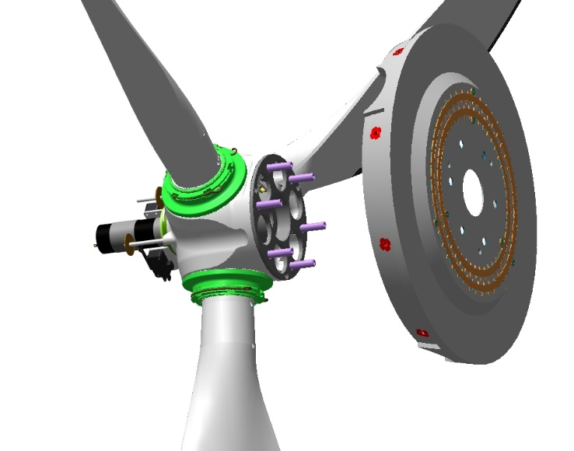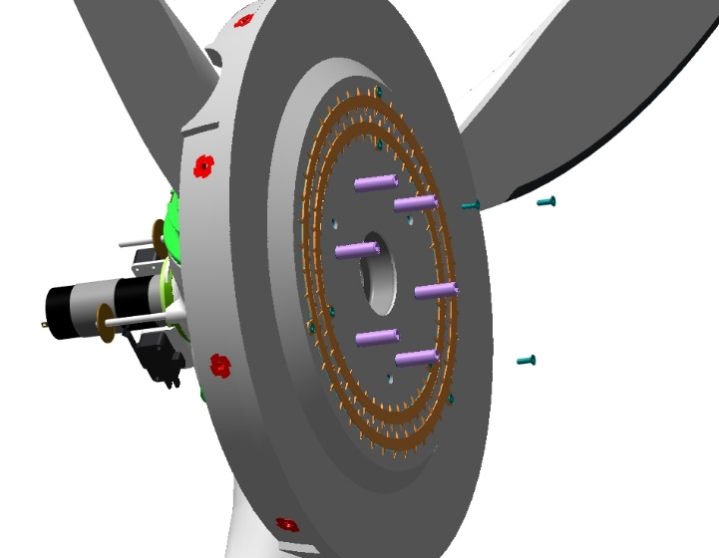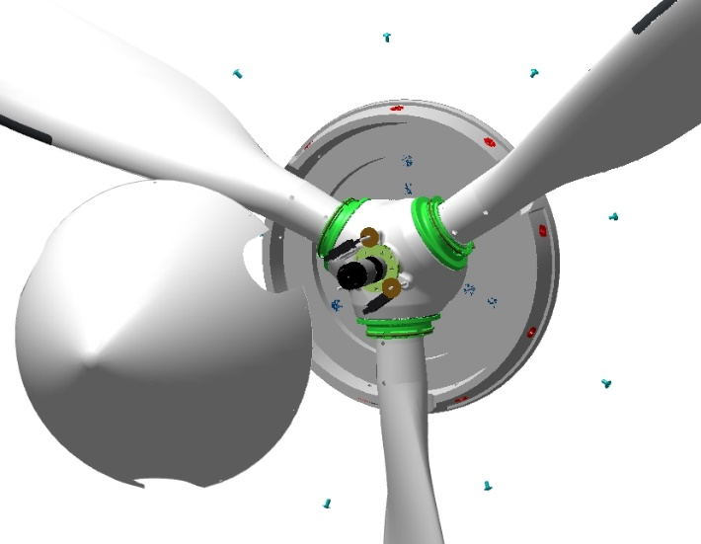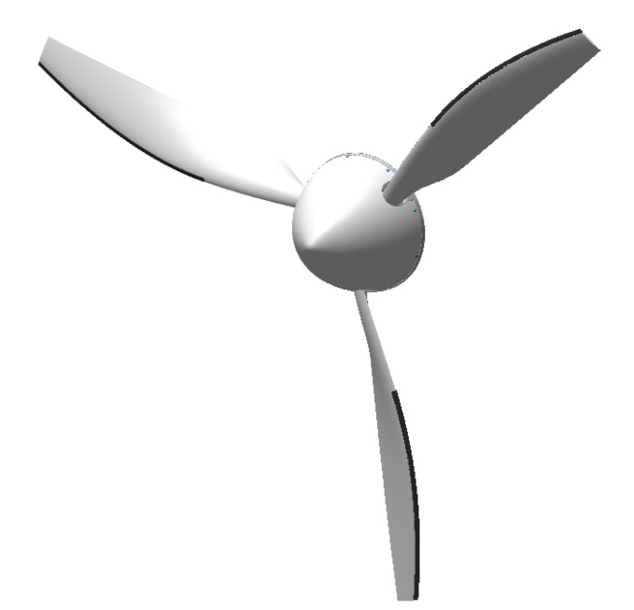
Install 6 bushings in the motor gearbox flange with the shoulder on the inside. Install a screw on the flange in the holes from the bushings. Install a washer 8 DIN 125 and a washer 8 DIN 6798A on each stud, a nut M8 DIN 985. Tighten the nuts alternately according to the tightening scheme until the washers are fully compressed.
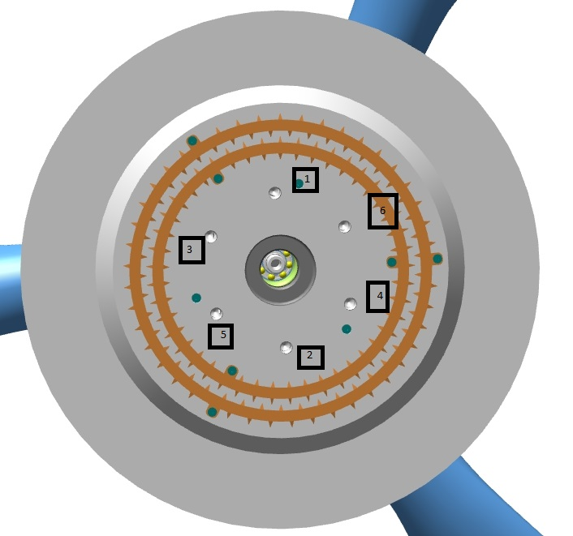
Inspect the installed propeller for clearance between the lower hood and the coke flange all round.The clearance should be at least 5 mm.By turning the propeller by the blade, check the clearance.Check the brushes for contact with the contact plates on the coke flange.There should be good contact in all positions.
IMPORTANT! Before turning the motor shaft, make sure that ignition circuits A and B are switched off and there is no common power supply.
IMPORTANT! Do not turn the motor shaft by the screw in the opposite direction of rotation.
Note: If the brush contact is uneven, it is acceptable to bend the bracket.
Install the top cowl and recheck the clearances between the cowls.The clearances should be at least 5 mm.
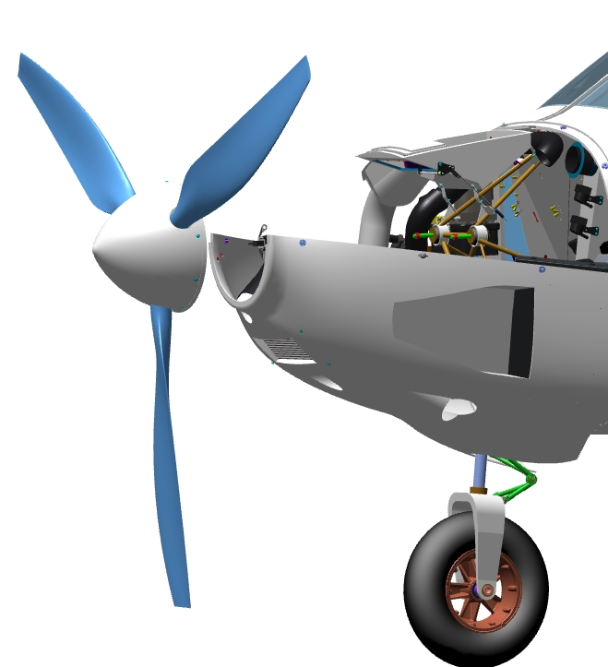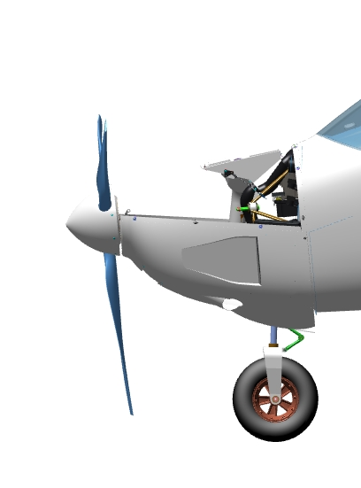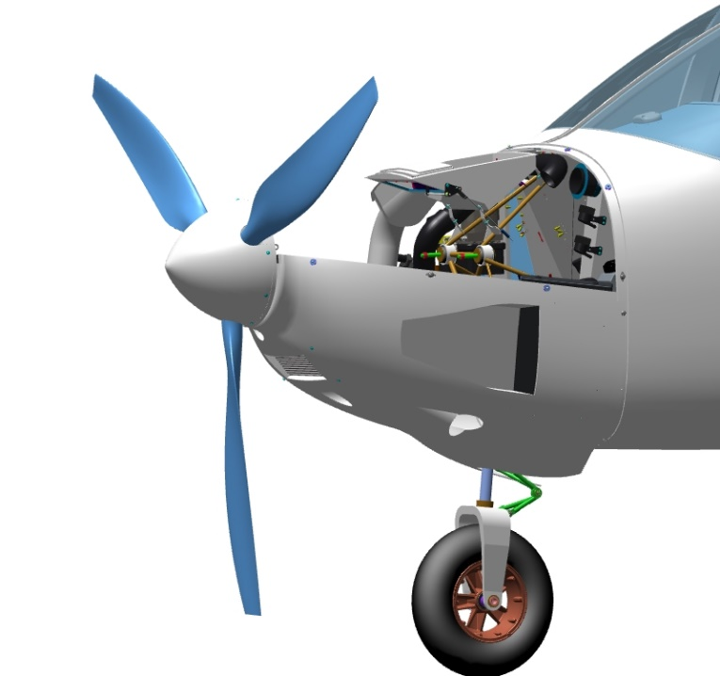
Check the operation of the blade angle change from the instrument in "MANUAL" mode.

Assembly and installation of flow tanks
IMPORTANT: Before working with parts that are part of the aircraft fuel system, keep the workplace and fuselage installation area free of small objects and dust. Keep clean and free of foreign objects and liquids.
Any foreign object can cause the system to malfunction and the airplane to crash. Any leaks in the system will definitely lead to fuel odor in the cabin, fuel leakage and increased fuel consumption.
To complete this work you will need:
- Mobile desk;
- Hexagonal wrench 2 mm;
- Combination wrench 14 mm;
- Electric drill (or screwdriver);
- ST3 Taps;
- Tapping tool;
Unpack it and stack it on the table:
- Consumption tank 00133501;
- Consumption tank 00133502;
- 4 fittings 00133612;
- 2 fittings 00136025;
- 2 washers 00136005;
- 2 pumps 00029783;
- Float 00138060;
- 24 inserts M3x6 DIN 8140;
- 2 quick-release straight connectors;
- Angled quick-release socket;
- Gasoline-resistant hose;
- 2 brass angle fittings;
- Ball Valve 00029522;
- 3 fittings 00029517;
- 24 screws M3x14 ISO7380-2;
- 12 rings 006-008-14;
Find fittings 00133612 and 00136025, rings 006-008-14.Install 2 rings on each fitting on the thread side.
Note: To avoid damaging the ring against the threads, the ring closest to the end should be installed first.
Screw in the bottom of the tank (without pumps) 00133502 2 fittings 00133612. Tighten with a 14 mm combination wrench without much effort until the gap between the fitting and the tank is eliminated. Install the fitting 00136025 on top of the tank in the same way.
Repeat the steps above to install fittings on the second tank 00133501, in exactly the same locations.
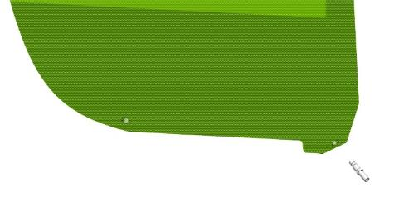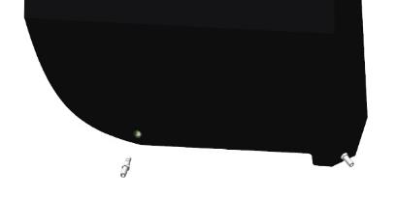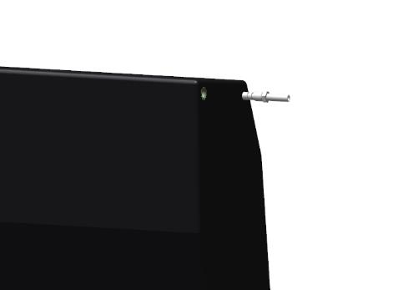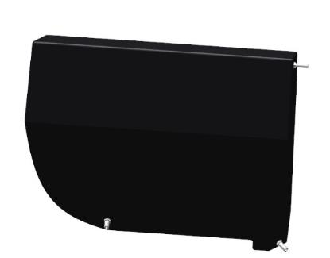

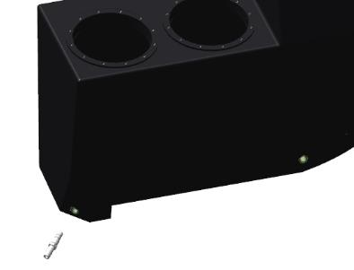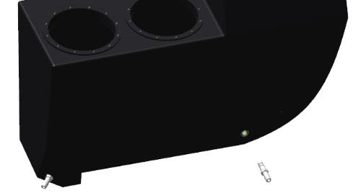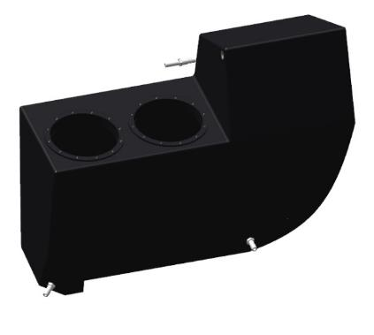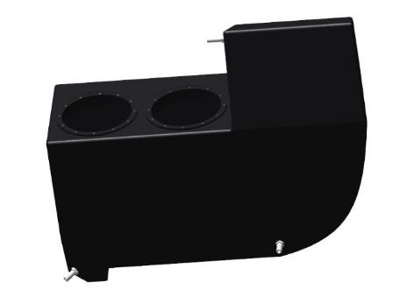

IMPORTANT: Before drilling holes, threading, inserting inserts, place a rag on the bottom of the tank. All waste will fall on the rags during work. When the work is finished, carefully remove the rags. It is a good idea to use a non-woven rag, which will "stick" the waste.
Chips in the fuel system are not permissible!
Drill 24 holes (12 holes for each pump) for the pump mountings according to the template. Thread each hole through with an ST3 tapping tool. Screw 24 M3x6 DIN 8140 inserts into each threaded hole.
Unpack the pumps 00029783, remove the floats from both pumps. On one pump install the float 00138060 to replace the removed float. Check the installed float in motion - it should move by hand, it should also work when the pump is turned over.
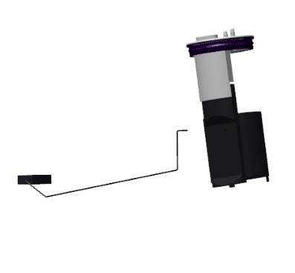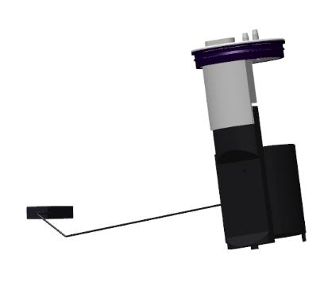
Insert the pump, float forward, into the opening in the tank. Rotate the pump gradually until it is fully seated in the tank, positioning the float as close to the wall as possible.
Note: The o-ring on the pump may prevent the pump from seating. When installing the pump, insert the o-ring into the tank in stages while submerging the pump. Use a non-sharp flat tool to insert the ring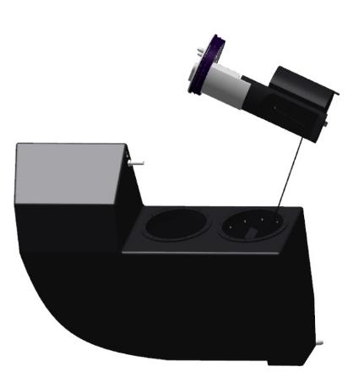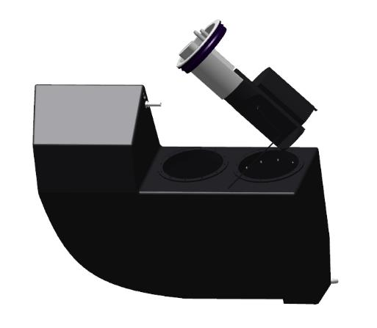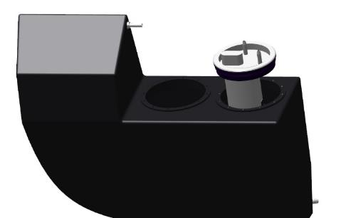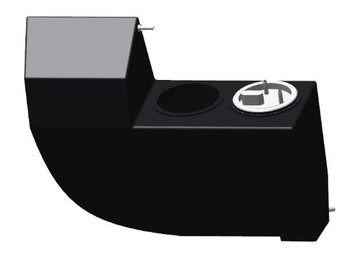

Check the position of the float when the nosepiece is installed in the tank. The spoke should not touch the vertical wall of the tank. If necessary, rotate the pump, to offset the spoke. Check float movement by hand, then turn the tank over. In all cases, the spoke should move.
IMPORTANT! If the spoke does not move, is set far away from the tank wall, rests against the beech wall, the readings will be incorrect.In some cases this will result in a crash or emergency landing in an unprepared area.
Install the washer on the pump 00136005, align the holes of the washer and the tank. Install the washer, fix the screws M3x14 ISO7380-2. Apply a thin layer of gasoline-resistant sealant to the threads of each screw.Do not tighten the screws to the end.
Install the second pump 00029783 into the tank. Install the washer, secure with screws as described above.Check the float movement by turning the tank upside down. A light thumping sound will be heard inside the tank.
Note. If there is no sound or sign of float movement, the second pump may have pinched the float. Remove the second pump and check the installation of the first pump.
Tighten the screws on each pump with a 2 mm wrench, one against the other. Do not twist the washer 00136005. Do not remove any protruding sealant from under the fasteners.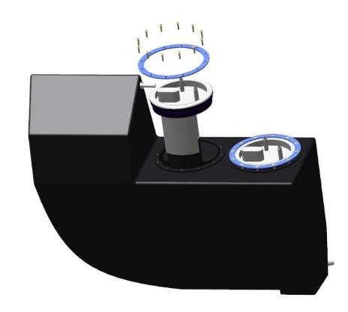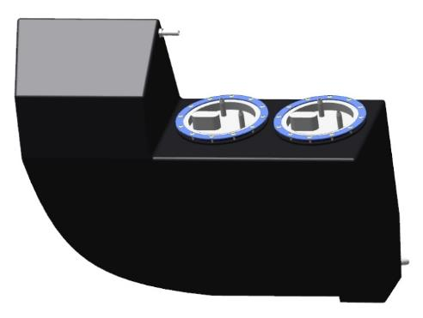

Allow the tank to cure for the sealant to cure. Refer to the sealant instructions for curing time.While the sealant is curing, prepare the tanks for the all-important leak test.
On a tank without pumps. Plug one fitting with a hose, install a pressure gauge on one fitting, and install a hose with a spool or check valve on the remaining fitting.
Note. The pressure gauge must be for pressures up to 200 kPa. If a pressure gauge is not available, a latex glove can serve as an indicator.
IMPORTANT! The tanks must be tested with compressed air. The use of other gases is prohibited.
Pump air into the tank at a pressure of 150-200 kPa and leave it for a few minutes. If the pressure does not decrease, leave the tank for 24 hours, periodically monitoring the pressure. If all is well, the pressure will not decrease. If the pressure drops, find the leaky spot.
Note. If a latex glove is used, the fall will be evident by the reduction in glove size. For ease of observation, you can mark the glove with a marker.
Go to the tank with the pumps. Connect the supply of one pump to the supply of the neighboring pump with a hose. Connect the drain on the pump in the same way. Then make all connections as on the tank without pumps.
Pump air into the tank at a pressure of 150-200 kPa and leave it for a few minutes. If the pressure does not decrease, leave the tank for 24 hours, periodically monitoring the pressure. If all is well, the pressure will not decrease. If the pressure drops, find the leaky spot.
Note. If a latex glove is used, the fall will be evident by the reduction in glove size. For ease of observation, you can mark the glove with a marker.
After 24 hours, verify that the air pressure remains unchanged. Next, disassemble the connections used for testing.
Note.If the tank is not leaking, locate and repair the leak and retest.To locate the leaks, use a liquid soap solution that will bubble at the leak.
For the fuel system operation it is necessary to make, lay and fasten the harness according to the diagrams.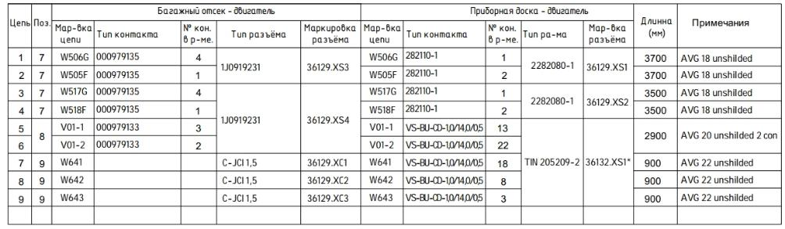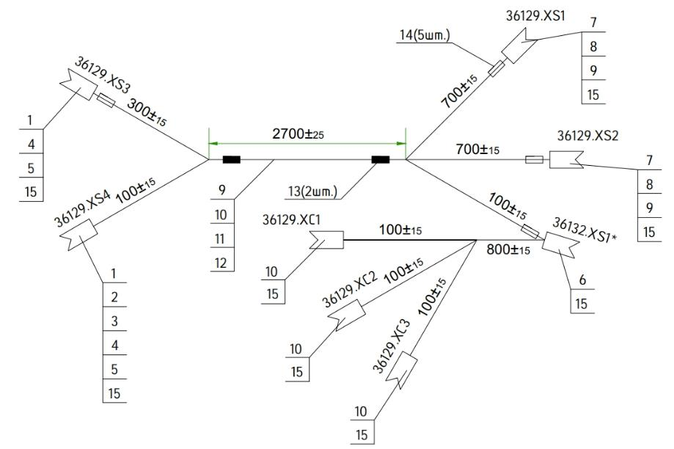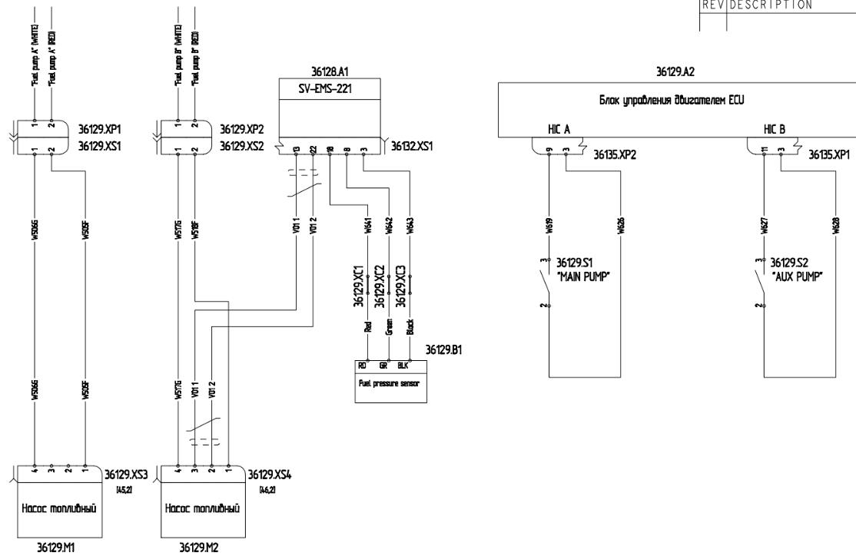

ELECTRICAL SYSTEM ASSEMBLY

Installation of lighting equipment

Make, lay, connect harnesses according to the attached diagrams.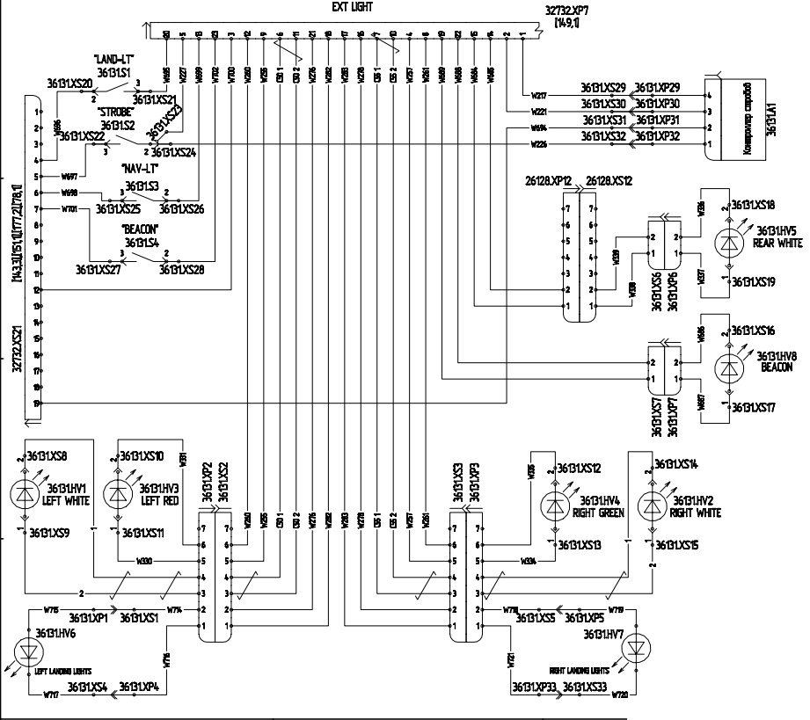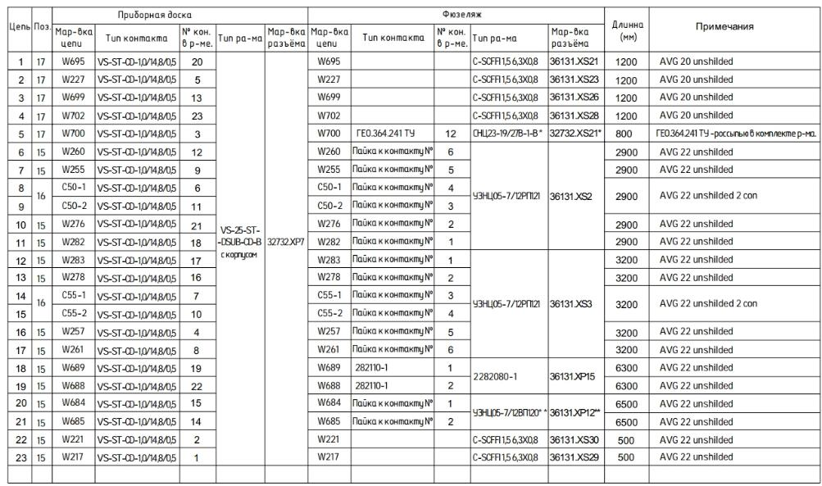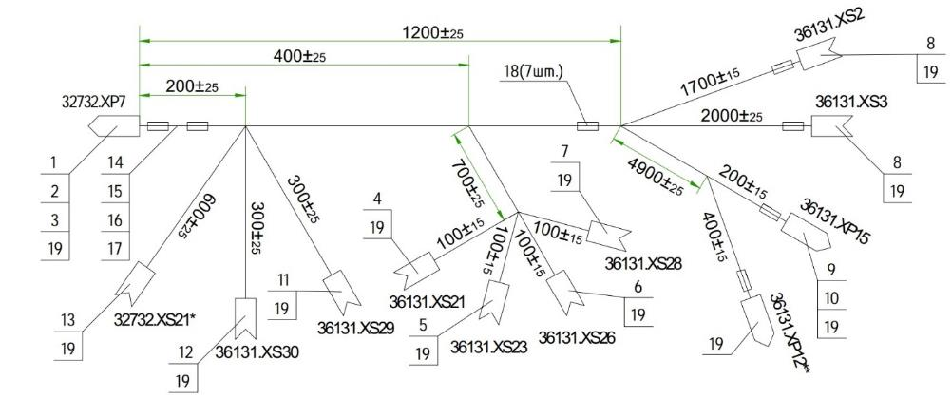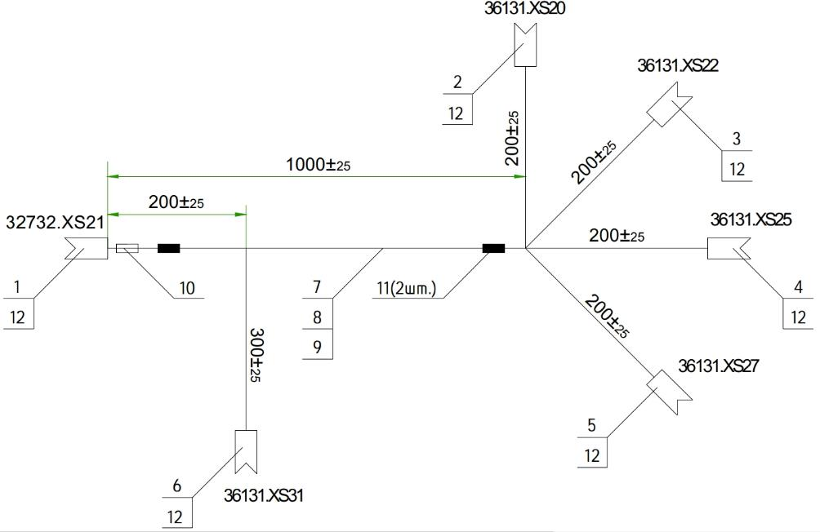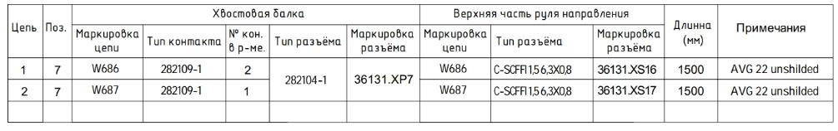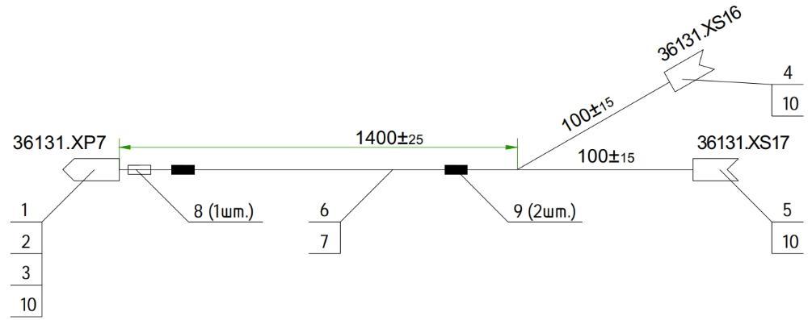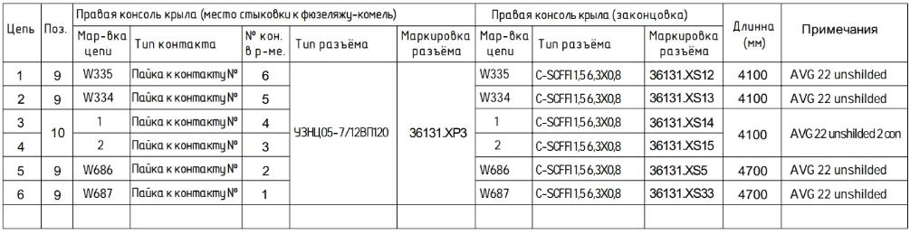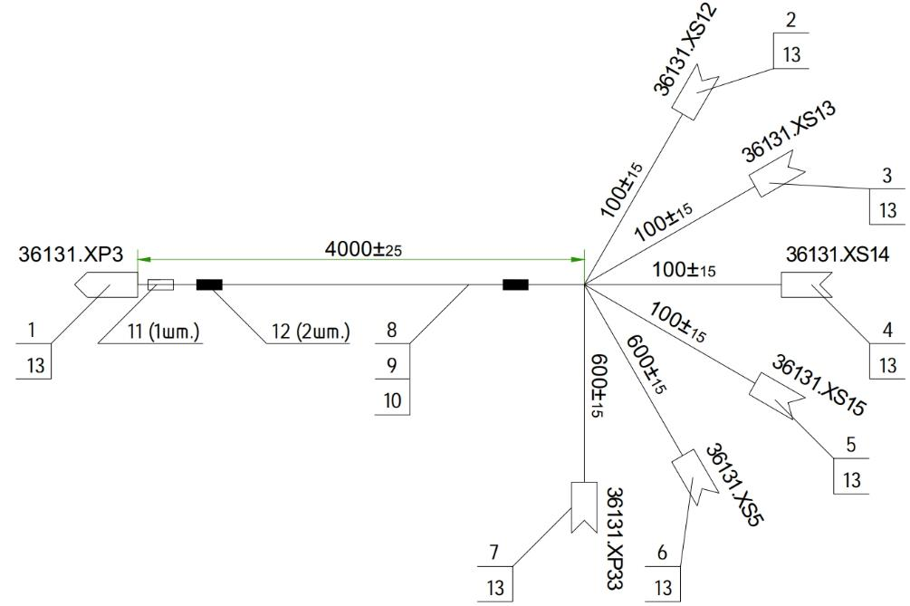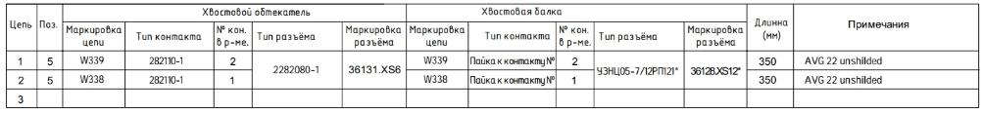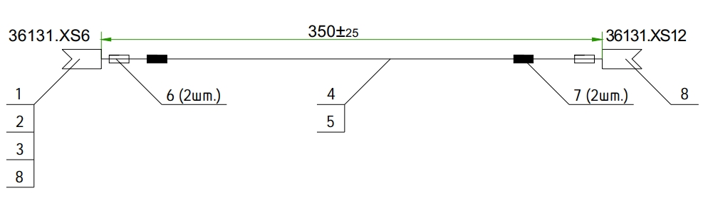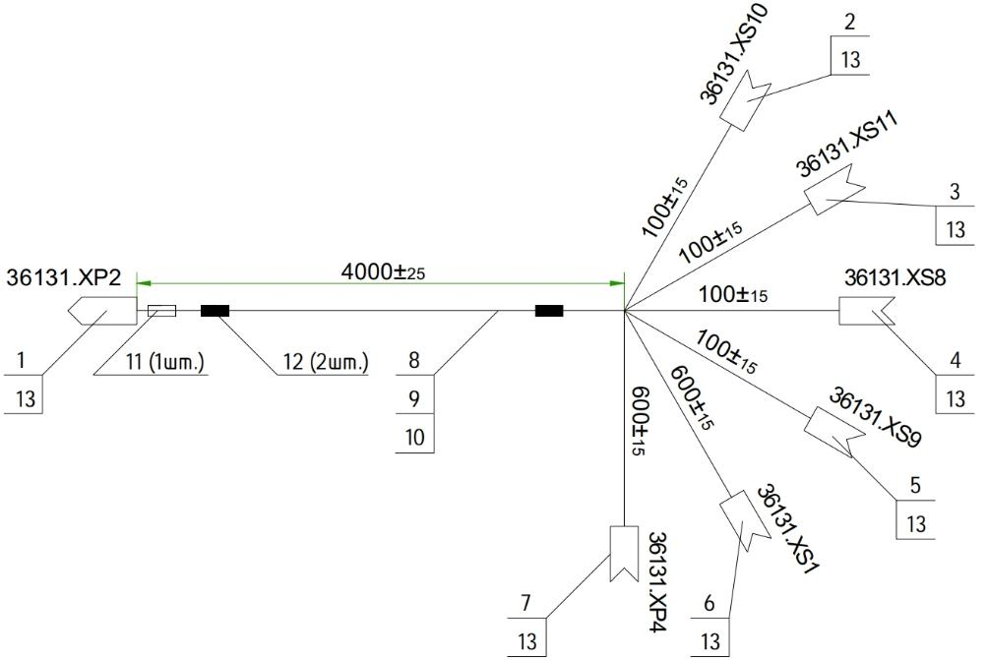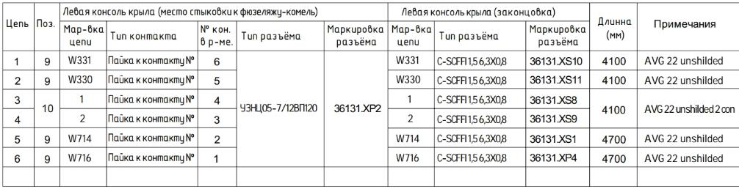

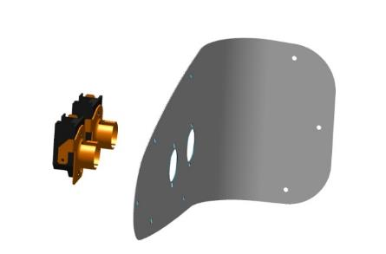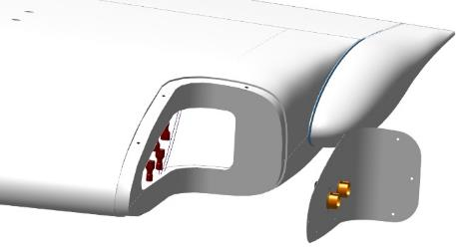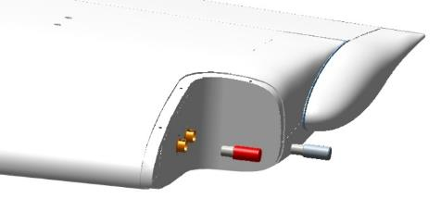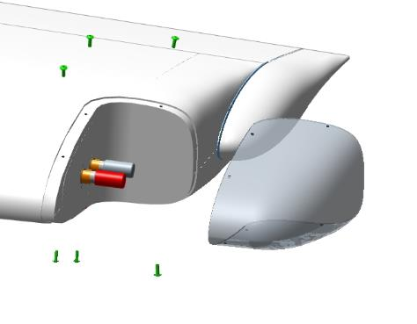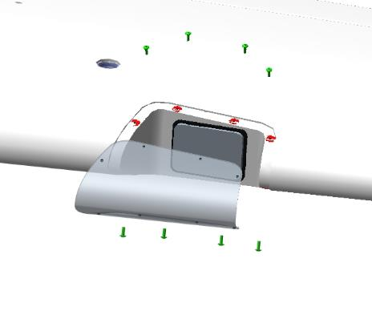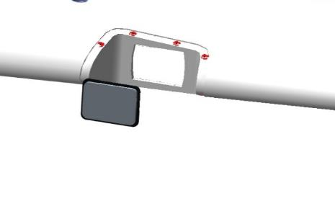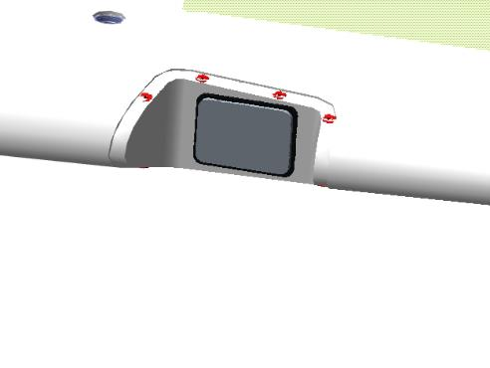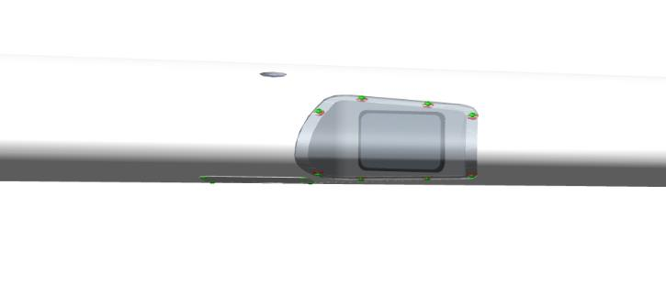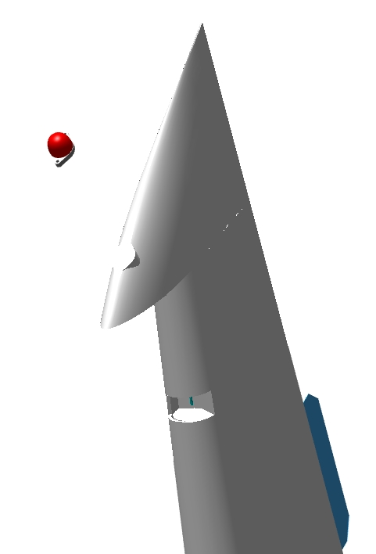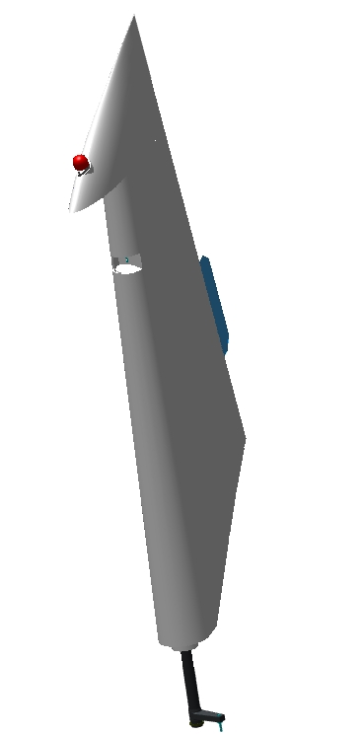

Installation of lighting and signaling equipment
Note. Before working on the instrument panel, you should decide on its decorative appearance. Painting, gluing and other work on the panel should be performed before installing the panel components.
IMPORTANT: Do not use paint materials containing alkalis, acids or hot drying (above 60°C) or other corrosive materials to the epoxy resin. This will cause the panel to deteriorate.
IMPORTANT: When gluing, do not use adhesives that require heating to temperatures above 60°C. This will destroy the panel.
To complete this work you will need:
- Mobile desk;
- Hexagonal wrench 2.5 mm.
Unpack it and stack it on the table:
- Dashboard 00135292;
- 3 screws M4x10 ISO 7380-2;
- Display Panel AP105 ;
- 6 frames of VME-01 toggle switch;
- 5 frames of tumbler VMM-01;
- VMS toggle switch frame;
- 12 switches KR313AXEXA;
- Cigarette Lighter AES1118SP011;
- S6F toggle switch;
- Cover SAC-01;
- PBS-28B button;
- GAS STATION W58XC4C12A-1;
- 2 AZZ W58XC4C12A-3;
- 4 AZZ W58XC4C12A-5;
- GAS STATION W58XC4C12A-10;
- GAS STATION W23X1A1G-50;
Locate the AP105 display panel. Install the panel in the upper right corner, aligning the LED holes and the mounting holes. Secure the panel with 3 M4x10 ISO 7380-2 screws. Make sure that the panel is not touching the dashboard.

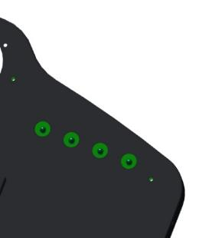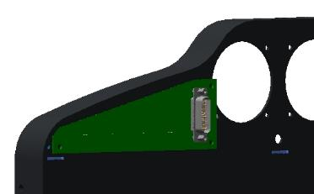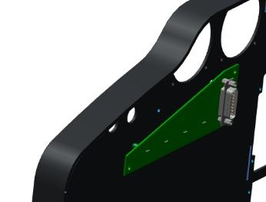
Find the gas stations, unscrew the nuts from them. Try any of them into the holes in the lower right side of the dashboard. The threaded part should go in easily. Install, nut each gas station into the lower right side of the panel, starting from the right, moving to the center:
5;5;1;5;3;3;5;10;50. After tightening the nuts, turn the panel over, inspect the installed filling stations - there should be no contacts touching each other.
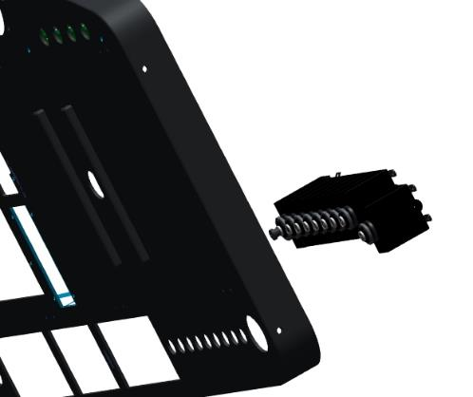
Locate the VME and VMM toggle switch frames. Connect the grooves of the frames in this order:
2 sets of 1VME+2VMM+1VME;
1 set 1VME+1VMM+1VME.
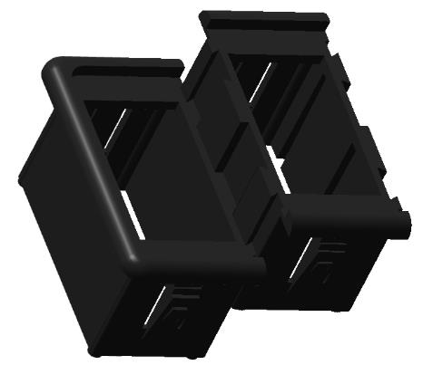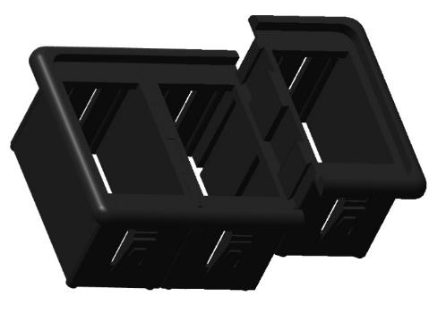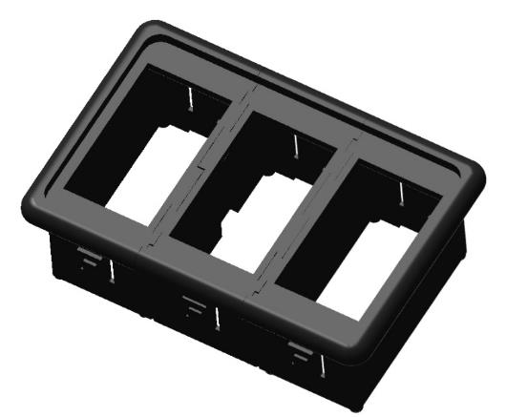
Locate toggle switch S6F, cover SAC-01, button PBS-28B. In the lower right corner of the panel, install the toggle switch, cover; secure with the toggle switch nut. Install the button in the next hole, tighten with the nut from inside the panel.
Place the VMS frame between the toggle switch and the button, push it in as far as it will go. Make sure that the frame latches lock into the panel. Install the frames in combination 4-3-4 in the opening, from the bottom of the panel, connected beforehand. Make sure that the latches of all frames are locked into the panel.

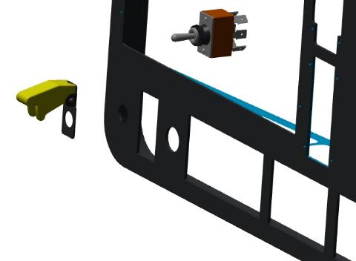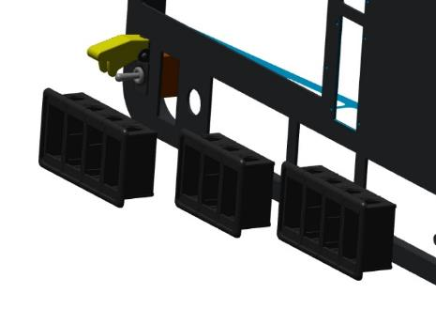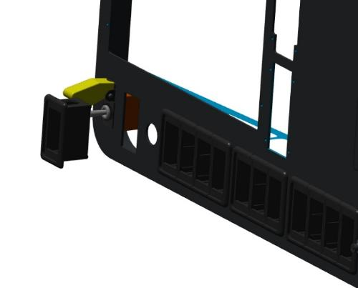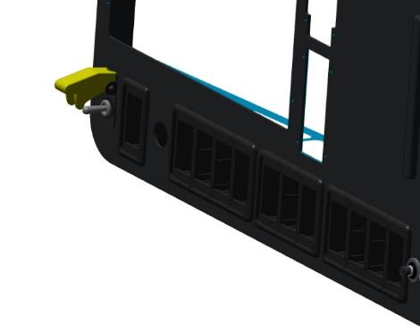
Locate the KR313AXEXA switches. Determine the OFF position of all switches with a multimeter. Install all switches one by one in the toggle switch frames. Make sure that the latches of all switches are locked into the frames. Test each switch by turning them to the "ON" and "OFF" positions. There should be no jams, bumps, or other obstructions to moving the switches to any position. Nearby switches must not operate.
Locate the cigarette lighter, remove the nut from it. Install the cigarette lighter in the lower right side of the panel, tighten the nut. Make sure that the lighter cannot rotate around its axis.
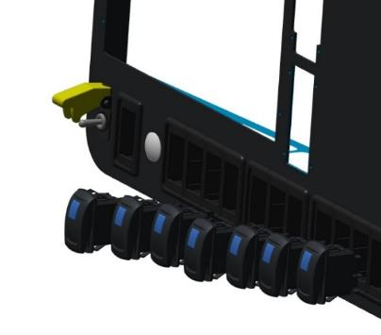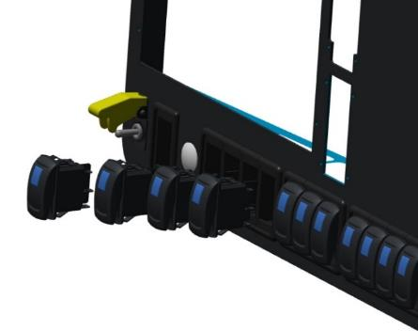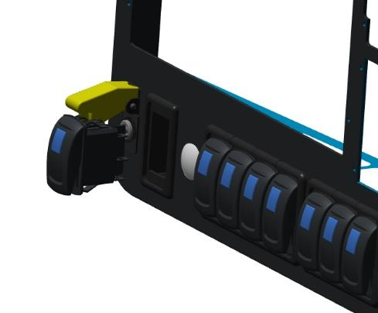
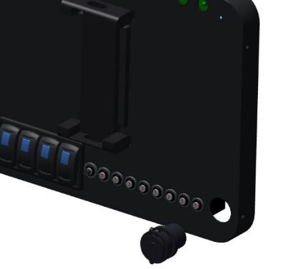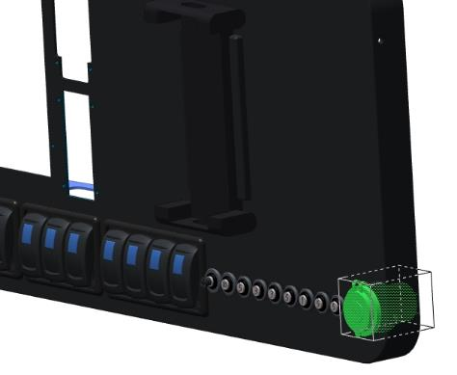

Installation of the seat adjustment system
Note.All work is described for the left side.There are no differences from the right side in the sequence of work.
To complete this work you will need:
- Hex key 2 mm;
- Pliers for internal circlips;
- PH0 screwdriver;
Unpack it and stack it on the table:
- Crocket left 00156355;
- Bracket right 00109492;
- 2 brackets 00156358;
- 2 supports 00109654;
- 2 bushings 00109655;
- 2 axles 00109664;
- 2 shafts 00109663;
- 2 PG36M555 gearmotors;
- 2 washers 12 DIN 6799;
- 2 rings 40 DIN 472;
- 2 bearings 16002 2RS;
- 8 screws M3x10 ISO7380-2;
- 8 screws M3x8 DIN 965;
- 4 limit switches KW104
Fasten the support to the motor with 4 screws. Place bearing 00109664 on the axle, secure with washer 12 DIN 6799. Place the bushing 00109655 on the bearing. Place the shaft 00109663 inside the axle 00109664, secure with a cotter pin.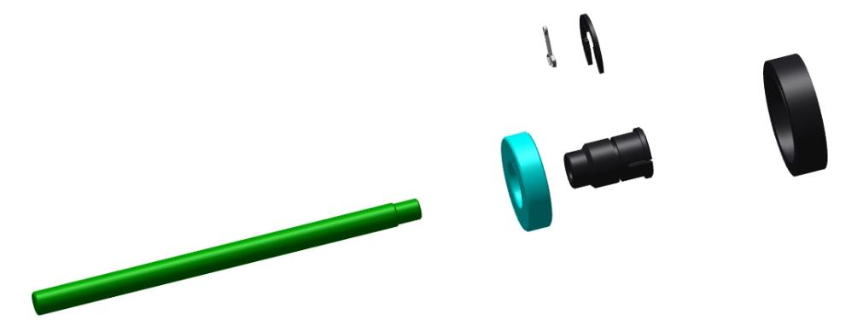
Insert the motor with support into the tube on the pilot beam. The engine should enter the tube fully, flush with or deeper than the end of the tube. The motor with support should enter with a slight force.
Note. If the motor with the support does not enter the pipe deep enough, turn the pipe around and try again. If more force is required to move the motor, sand the end of the support that contacts the pipe with P320-400 sandpaper.
Dismantle the motor, remove the oprah, degrease the threaded parts of the M3x8 DIN 965 screws.
IMPORTANT: Do not apply shaft and bushing retainer to an immediately degreased surface. The fixative can be applied 5-10 minutes after degreasing.
Apply a thin layer of LOCTITE 648 shaft and bushing retainer evenly to the degreased M3x8 DIN 965 screws. Fasten the support to the motor with screws.
IMPORTANT: Do not apply shaft bushing retainer to the motor holes themselves. If the retainer gets inside the motor, it can cause breakage and jamming.
Prepare 10-15 grams of adhesive according to standard procedure 1. Degrease the inner surface of the tube and the outer part of the plate. Apply the adhesive according to standard procedure 5.1 inside the tube in the support area, on the end of the support. Place the motor with the support into the tube. Carefully remove any adhesive behind the motor with a rag.
IMPORTANT: Do not allow the glue in the tube to get behind the motor area.Cured glue will cause difficulty in reassembly.
Clean the workplace and tools according to standard procedure 7.

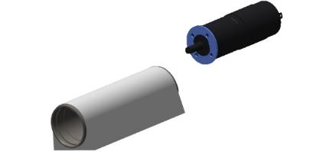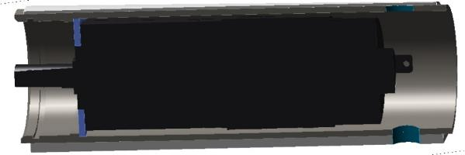

Install the assembled mechanism in the tube, aligning the hole in the axle with the motor shaft. Check the correct fit by seeing the place for the retaining ring. Secure the mechanism with retaining ring A40 DIN 472.
IMPORTANT: After installing the retaining rings, make sure that they are positioned clearly in the groove and cannot fall out. If a ring falls out in flight, it will result in loss of control and an unavoidable crash!

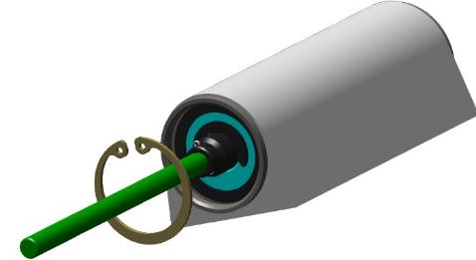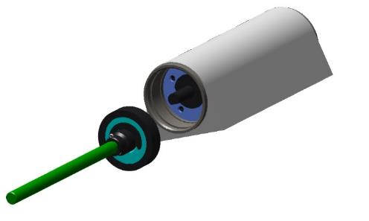
Check the M3 tapped holes for fixing the switch brackets according to standard procedure 6.Install the bracket left 00156355 in front, the bracket 00156358 on the floor plane.Fix each bracket with 2 screws M3x10 ISO7380-2. Install the KW104 switches on the brackets.
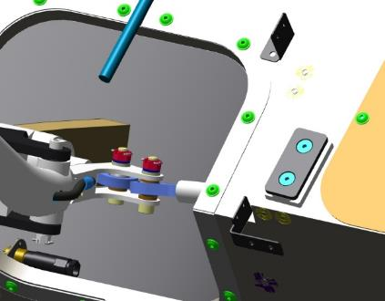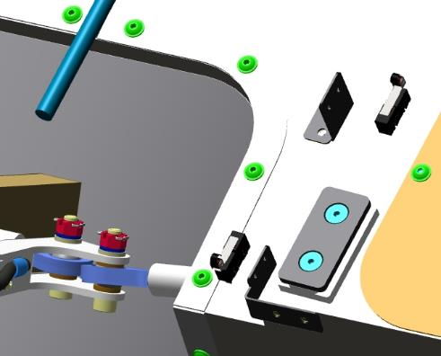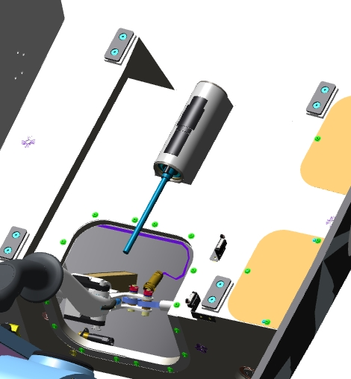

Connect electrical connections to switches, gearmotor, travel button. Check for operation.
Place the pilot's seat from front to back on the guide beams, guiding the mechanism shaft into the seat eye with the nut. Press the button for 1 -2 seconds on the "away" button, moving the chair backwards by hand. After the shaft engages, hold the button until the actuator stops. Press the button on the "forward" movement, the chair should stop in the forward position.
Repeat the steps described above for the right seat.
The electric harness must be constructed, installed and connected for the operation of the electric actuator of the seats.
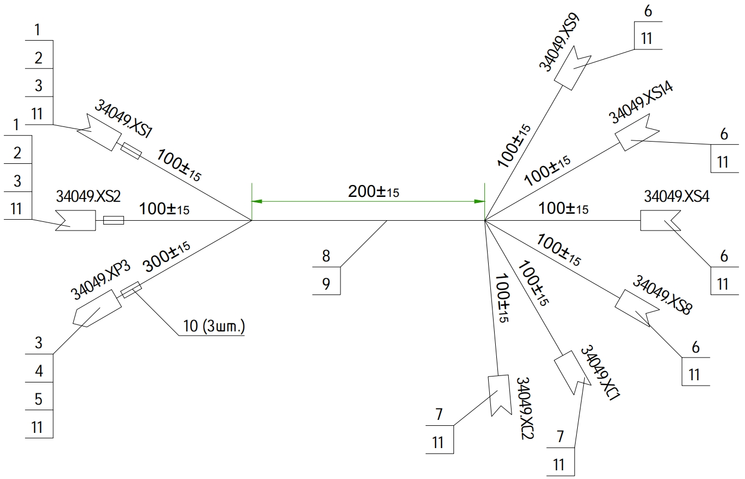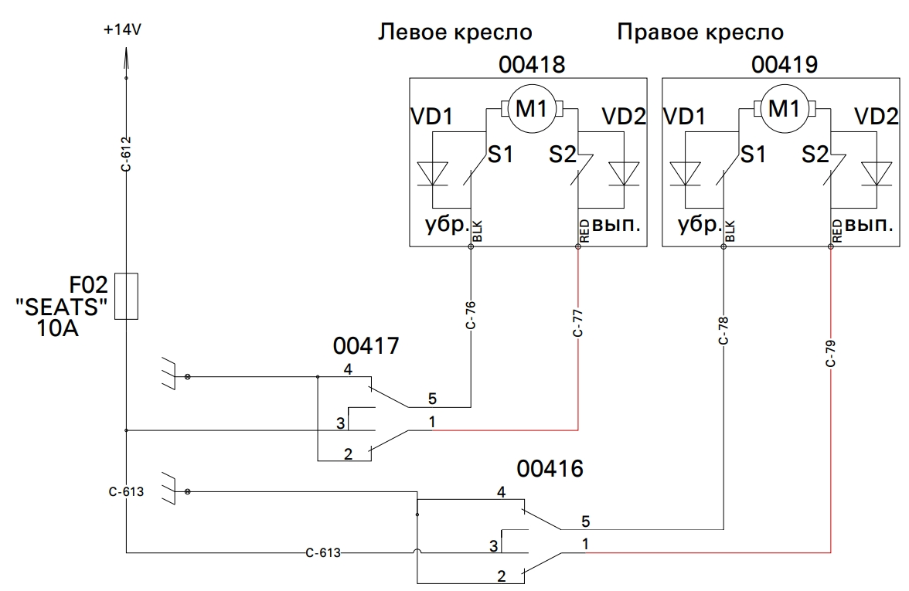

INSTRUMENTATION

Pitot tube installation
To complete this work you will need:
- Hex key 2 mm;
Unpack it and stack it on the table:
- Cover 179477;
- Heater Controller 10-02158;
- PITO sensor with heating 10-02158;
- 8 M4x8 screws ISO 7380-2;
Insert the heating controller through the middle hatch on the right console. Locate the 4 holes, align with the unit, secure with 4 M4x8 ISO 7380-2 screws.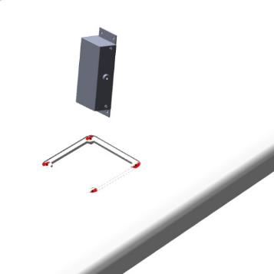
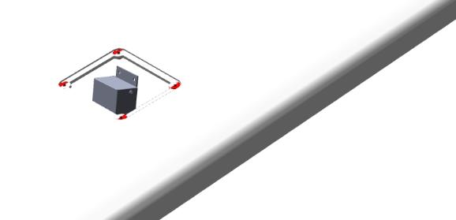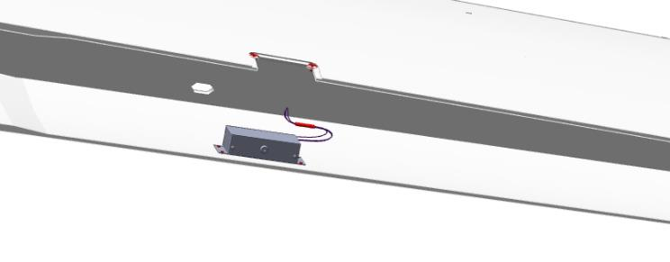
Install the PITO sensor in the housing 179477. The sensor must be fully inserted with a slight force. Glue the sensor into the housing.
Place the sensor housing on the console, connect the tubes and wires. Secure the housing with screws. Check for steps along the contour of the housing. There should be no steps.
IMPORTANT: If the hood with the sensor is installed with steps, this will result in incorrect instrument readings.
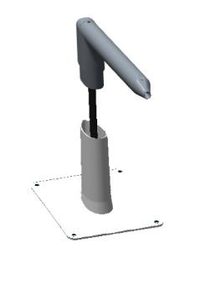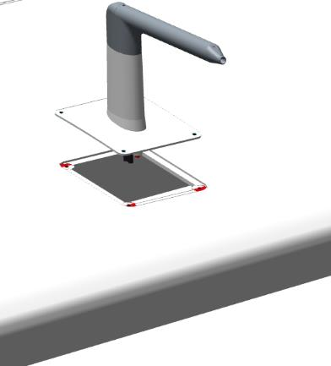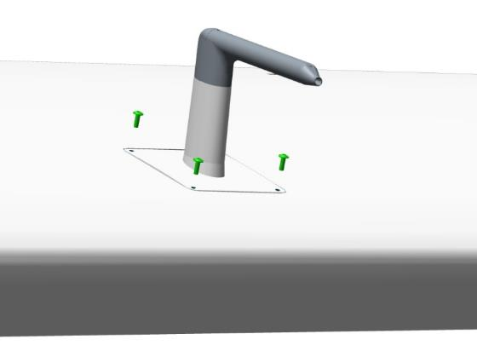
For the heating to work, harnesses must be made and routed and connected to the installed unit.
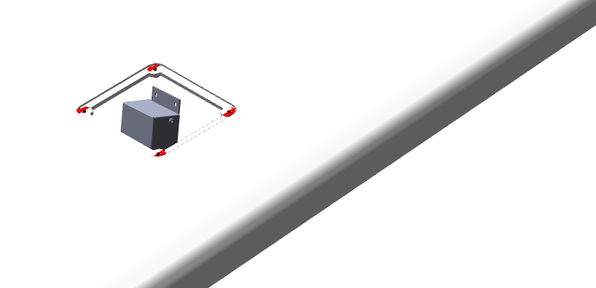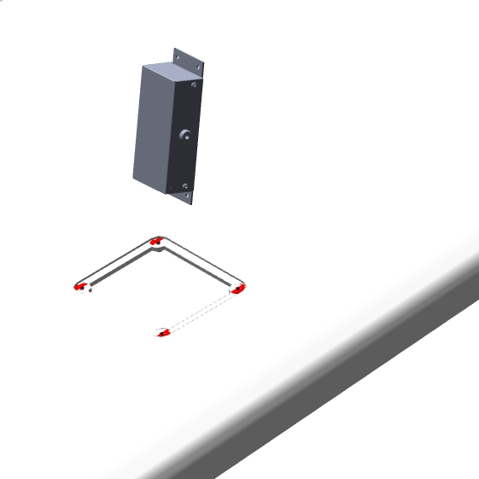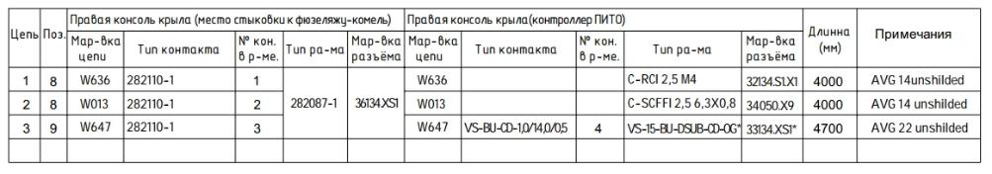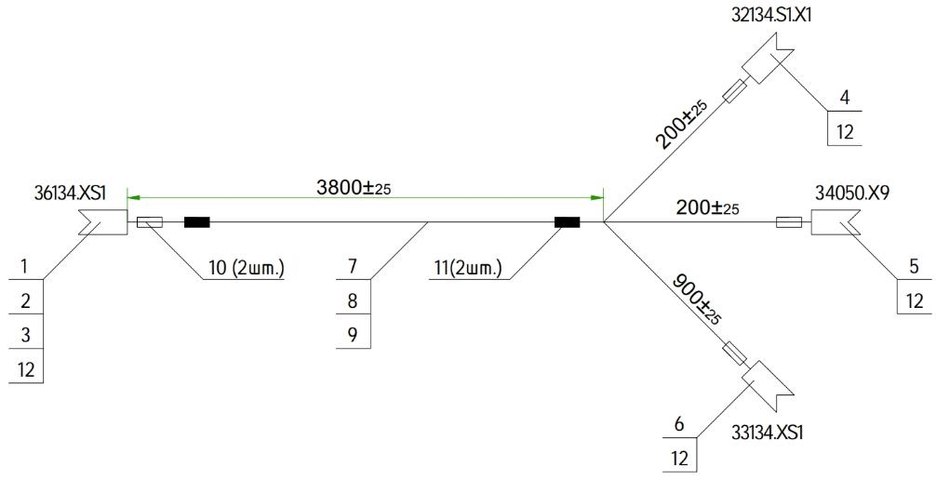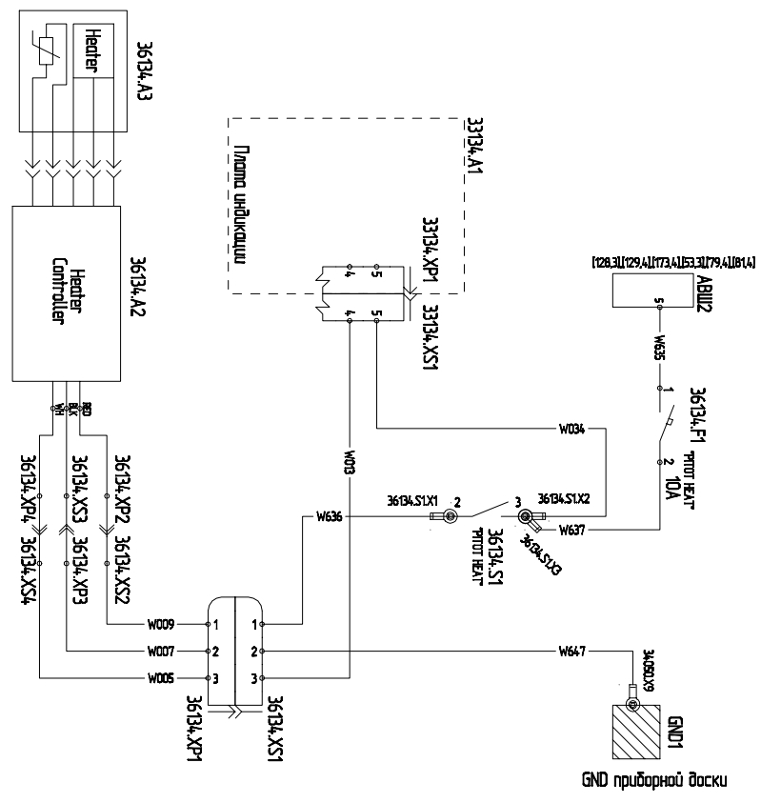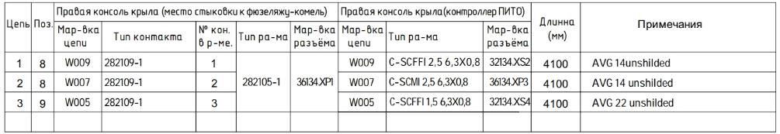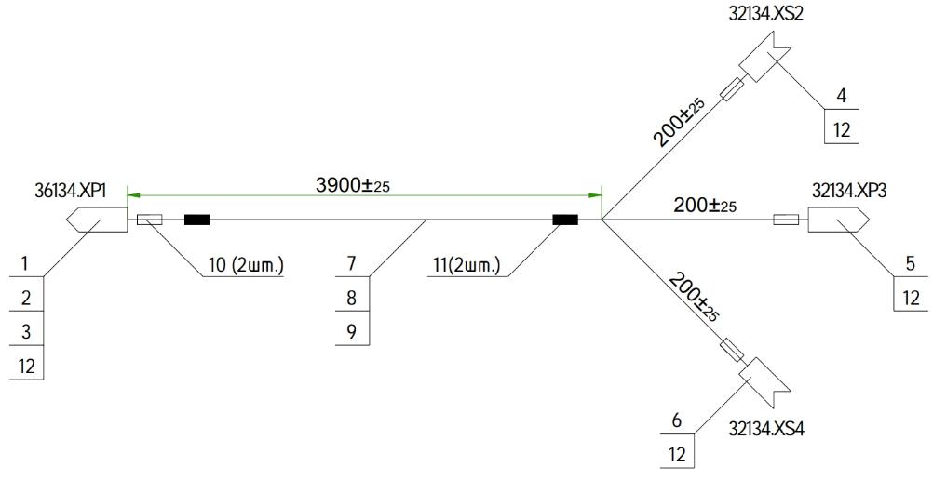

Dynon SW 1100 system installation
    - Installation of ADAHRS modules

Install the blocks on the starboard side of the rear sofa shelf.
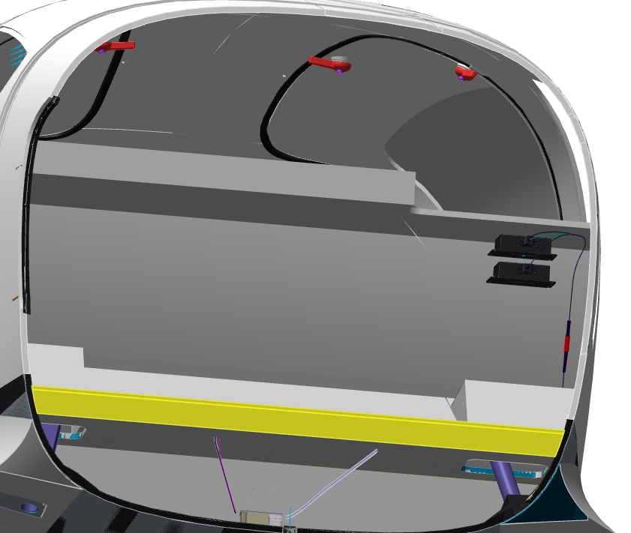
    - Radio installation
The tasks of this job are to install and connect the radio station.
Note. Before using the radio, please read the installation, setup and operation instructions described in the manufacturer's manual.
To complete this work you will need:
- Hex key 2 mm;
- Screwdriver with straight slot #1;
Unpack it and stack it on the table:
- SV-COM-425 transceiver;
- 4 M4x8 screws ISO 7380-2;
Locate the 4 transceiver mounting holes in the fuselage, under the trunk floor.
IMPORTANT! The power supply must be disconnected before starting work. For safety reasons, remove the terminals from the battery, or disconnect the external power supply.
Fasten the transceiver under the luggage compartment floor with 4 M4x8 ISO 7380-2 screws. Connect the connector to the secured unit, tighten the screws with a screwdriver. Connect the antenna to the unit. Make sure that the antenna is securely fastened to the unit.
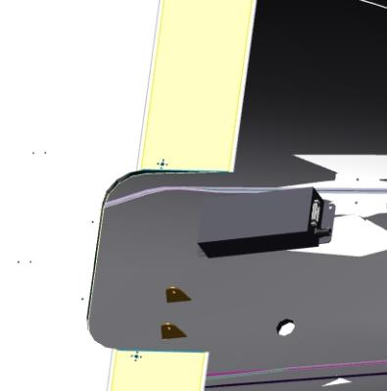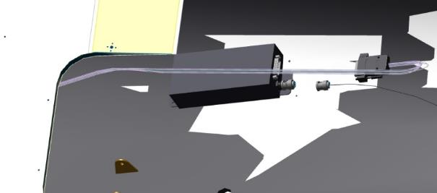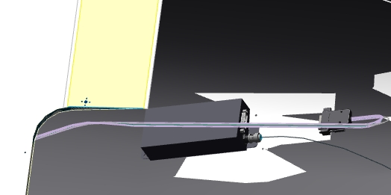
IMPOrTANT! If the antenna is not securely fixed in the unit, or if it is missing, the transceiver may not work properly. Do not power up the transceiver without the antenna
Make and lay the harness according to the diagram.
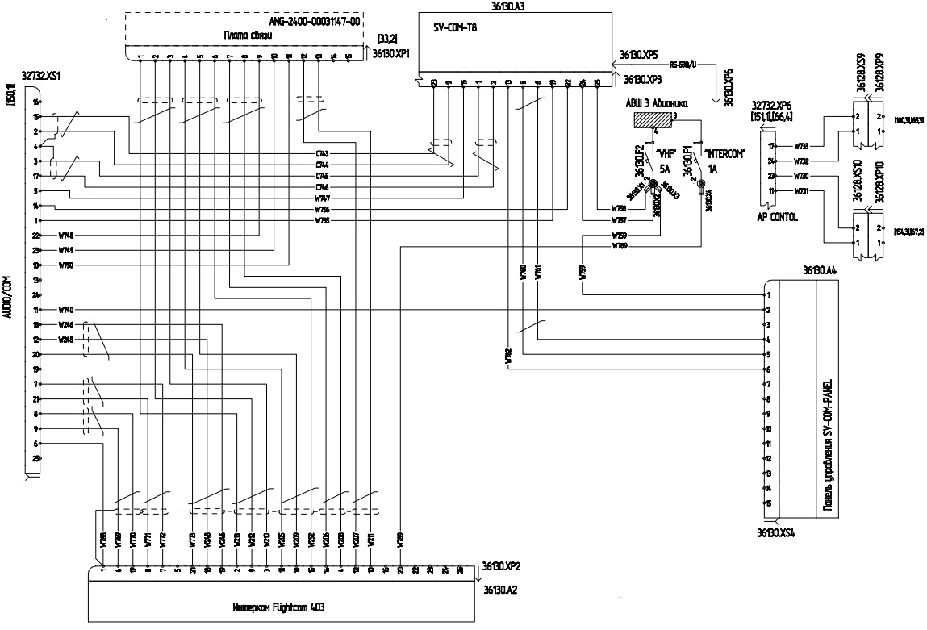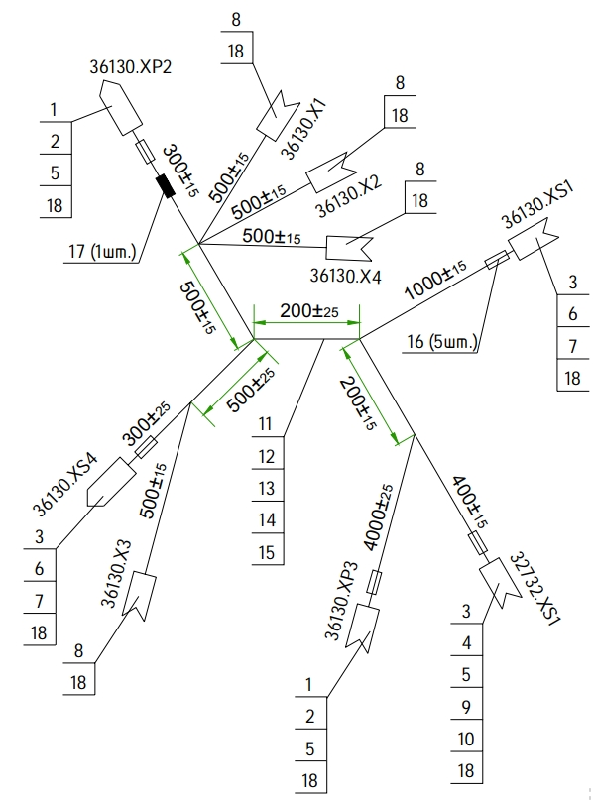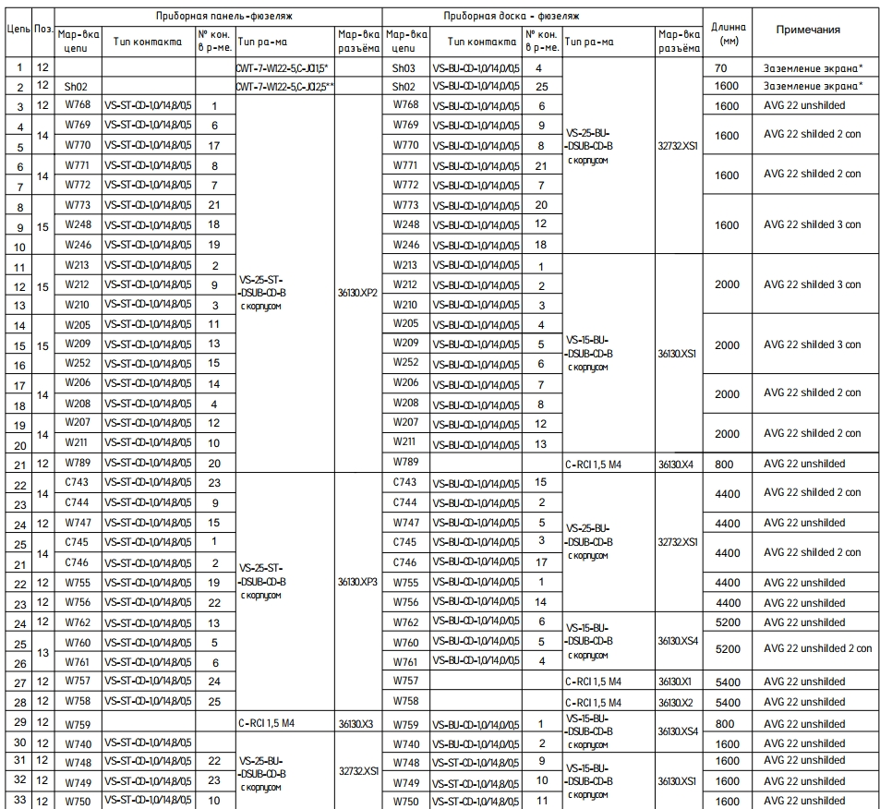

    - Installing the transponder
The tasks of this job are to install and connect the transponder.
Note. Before working with the transponder it is necessary to study the installation, setup and operation instructions described in the equipment manufacturer's manual.
To complete this work you will need:
- Hex key 2 mm;
- Screwdriver with straight slot #1;
Unpack it and stack it on the table:
- Defendant Dynon;
- CI-105 antenna;
- 3 M4x8 screws ISO 7380-2;
Locate the antenna mounting location on the outside of the fuselage. Install the antenna in the opening of the mounting location, secure the antenna with the fasteners from inside the fuselage.
Note. The fastener is included in the antenna kit.
If the antenna is not immersed in the fuselage depression, it is necessary to grind with sandpaper P120-180 the opening for installation.
Connect the cable to the antenna. Make sure the connector is securely attached to the antenna.
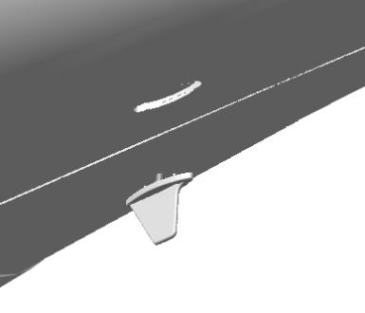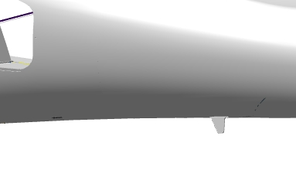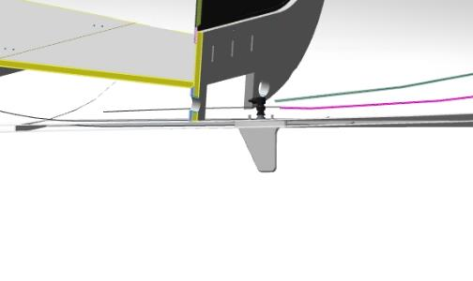
Locate the 3 tap housing mounting holes in the fuselage, under the trunk floor.
IMPORTANT! The power supply must be disconnected before starting work. For safety reasons, remove the terminals from the battery, or disconnect the external power supply.
Fasten the responder mounting plate under the luggage compartment floor with 3 M4x8 ISO 7380-2 screws. Install the tamper unit, fasten the latch to the secured plate, connect the connector, tighten the screws with a screwdriver. Connect the antenna to the unit. Make sure that the antenna connector is securely fastened to the unit.
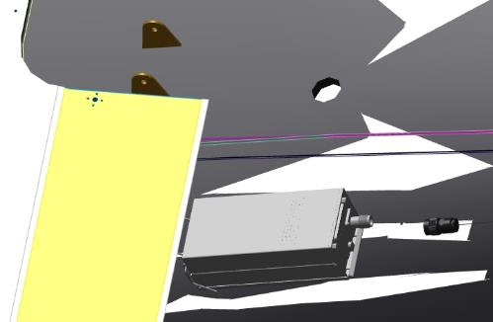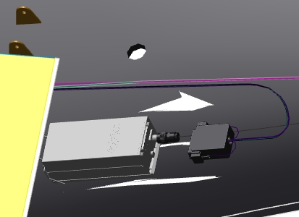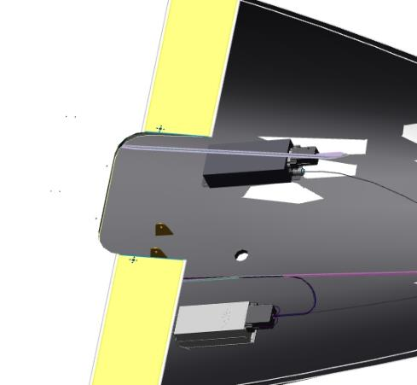
IMPORTANT! An antenna that is not securely fastened in the unit, or the absence of an antenna, may cause the responder to become inoperable. Do not power up the responder without the antenna
Make, route and connect the harness according to the diagram.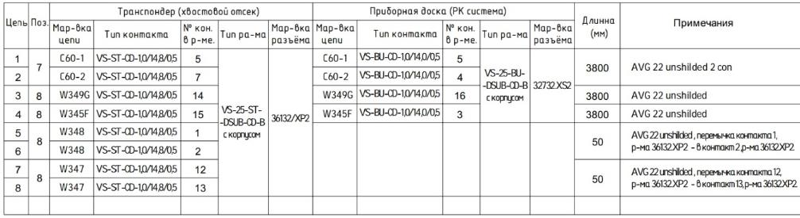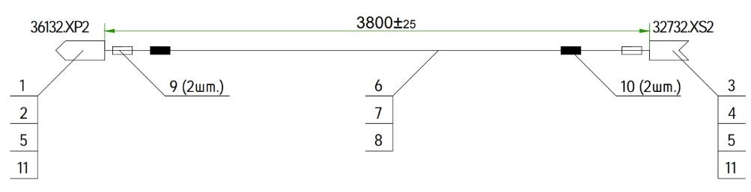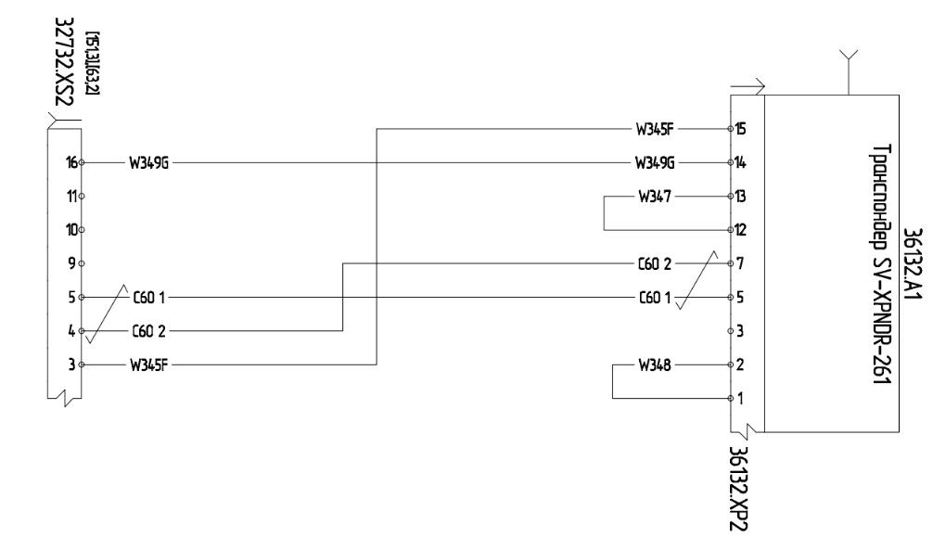
    - Installing displays
Install the display on the dashboard.Secure.
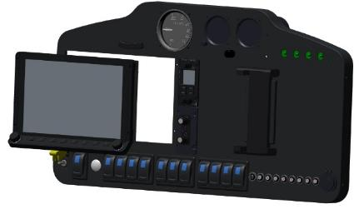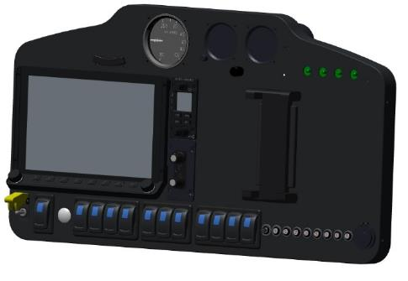
Make harnesses and connect according to the diagram.
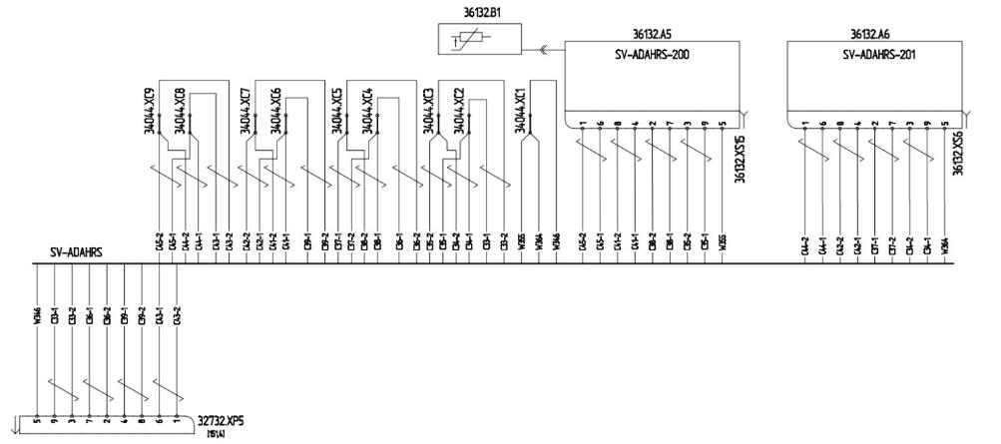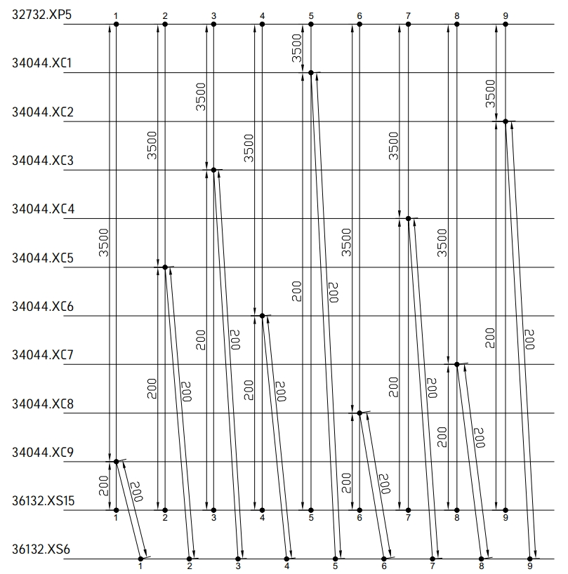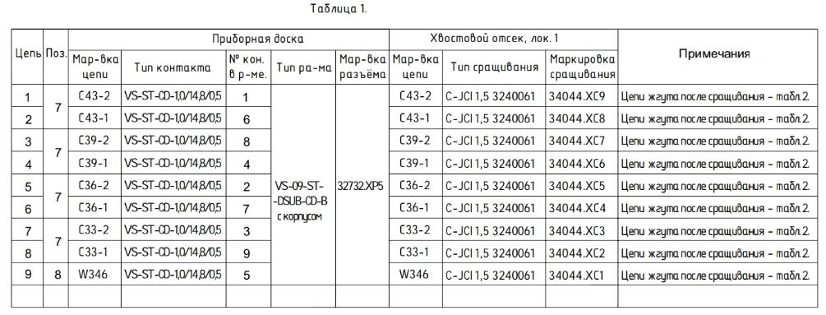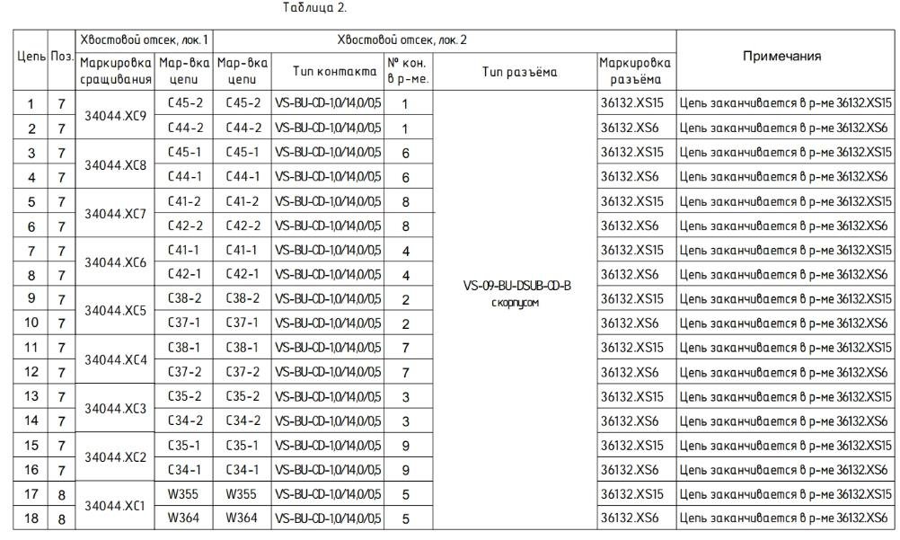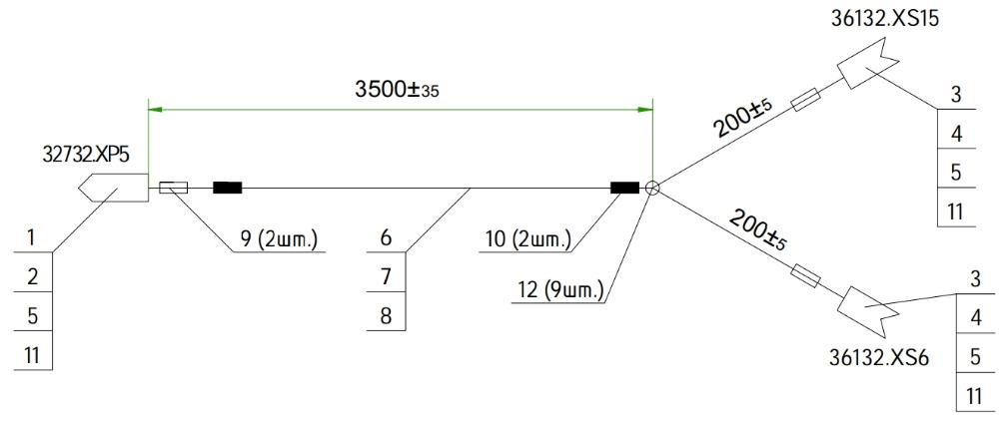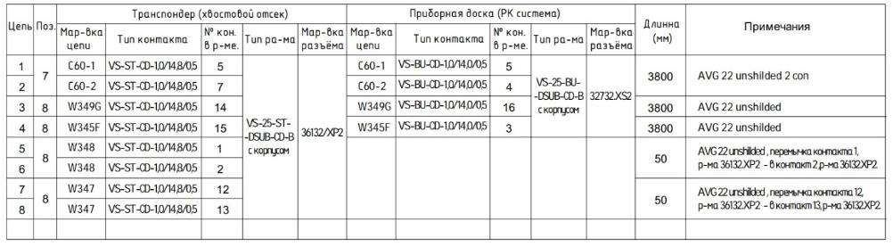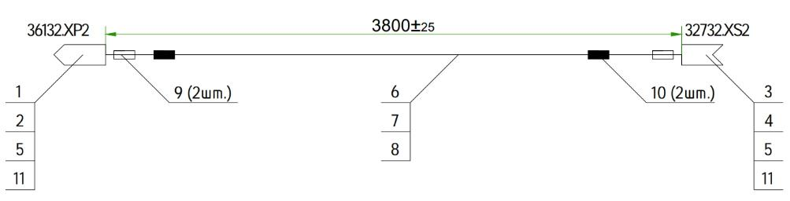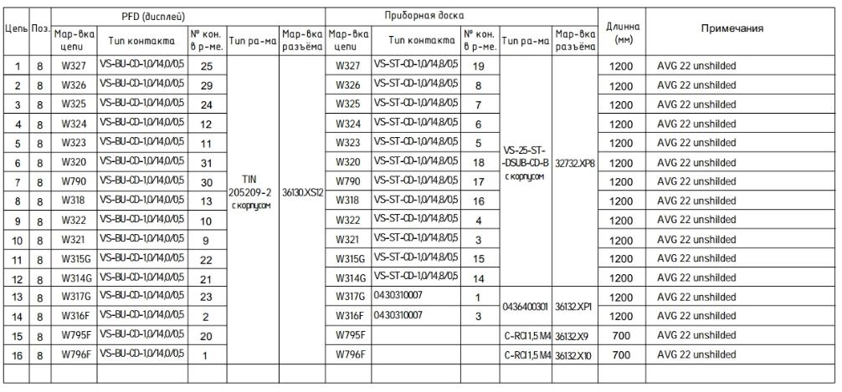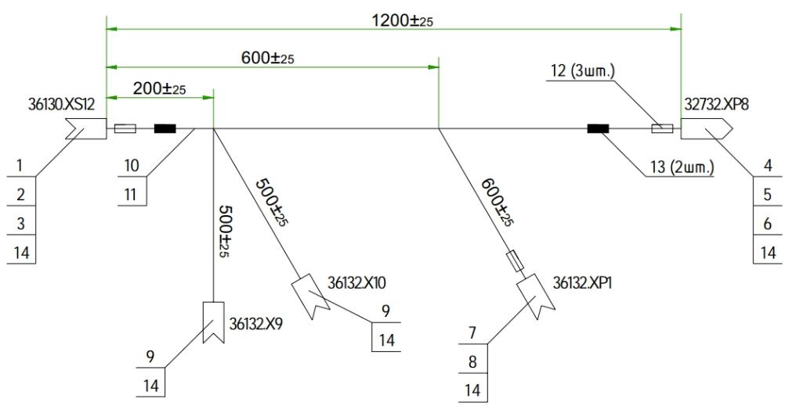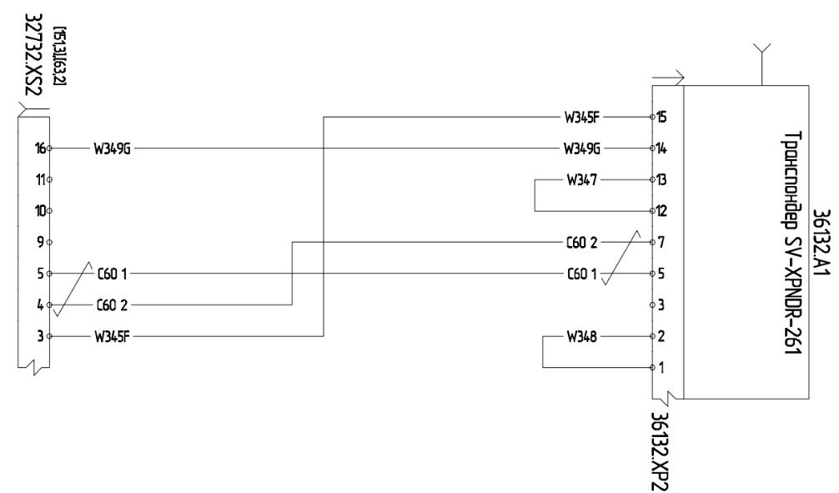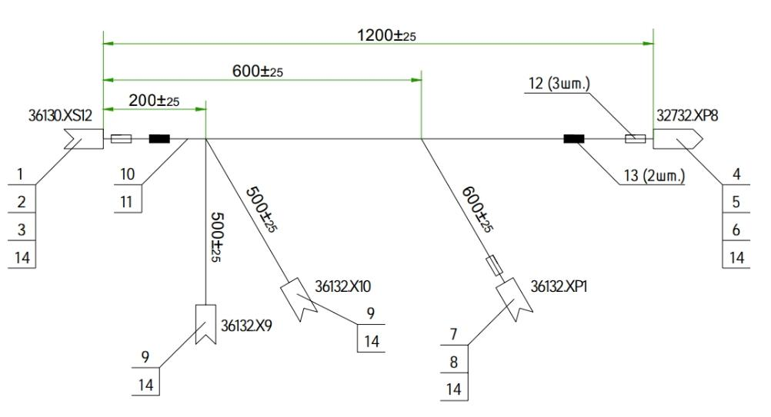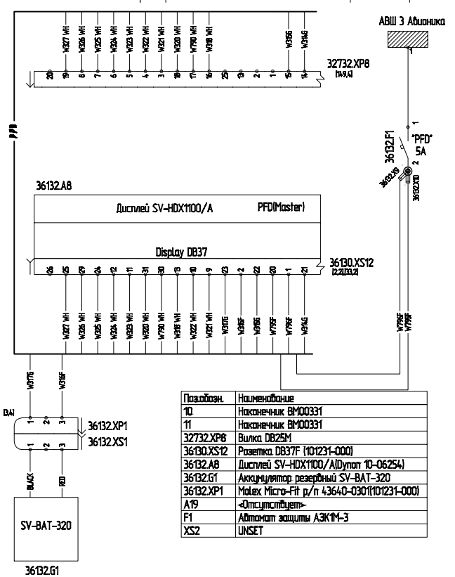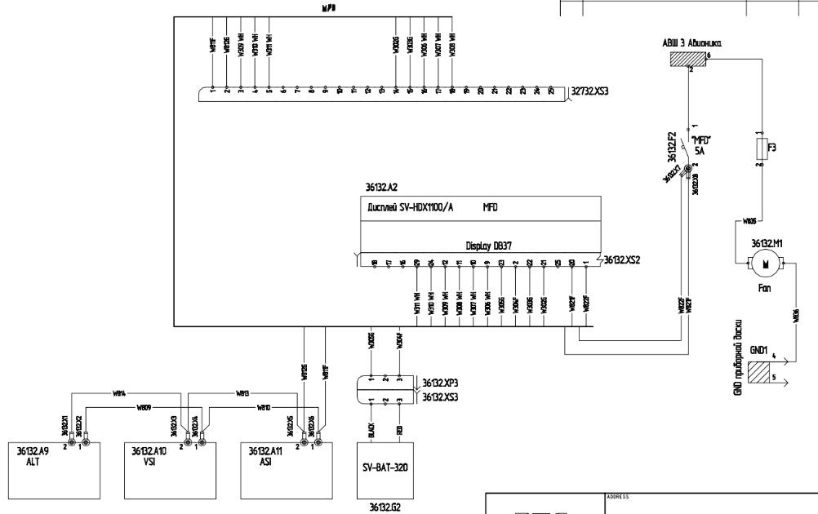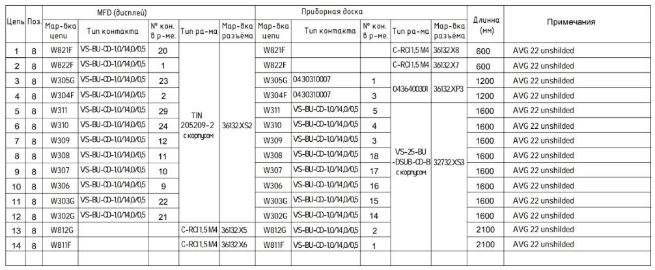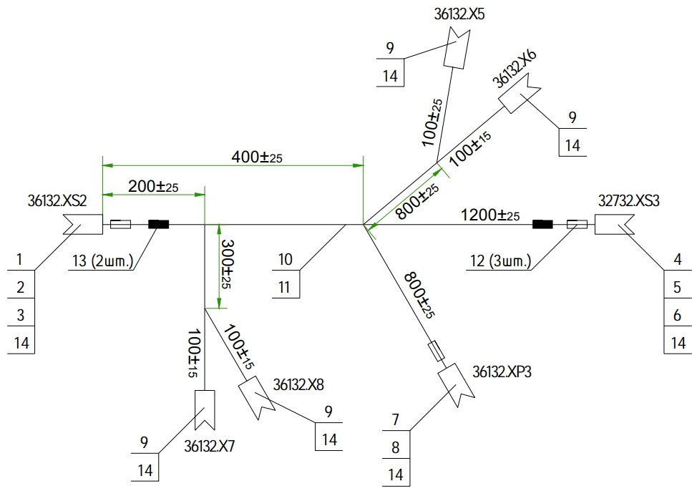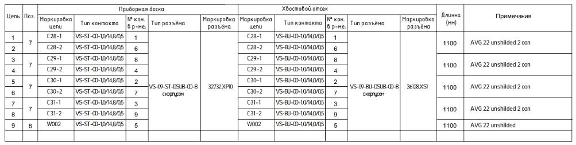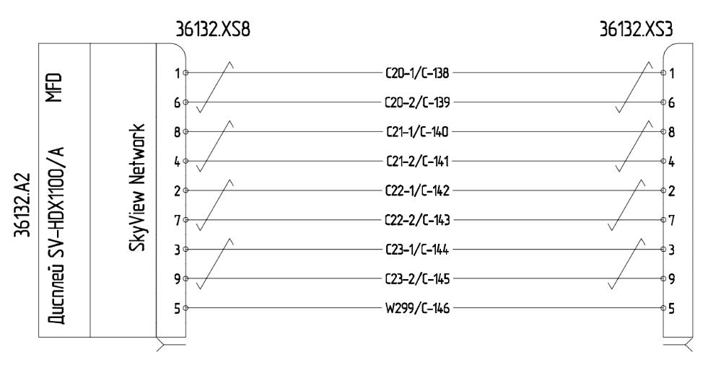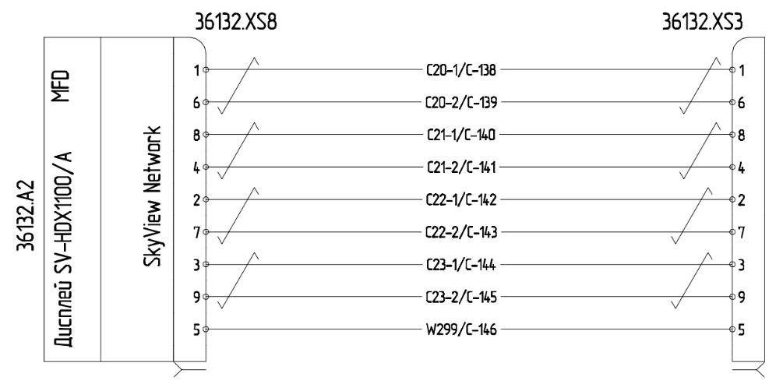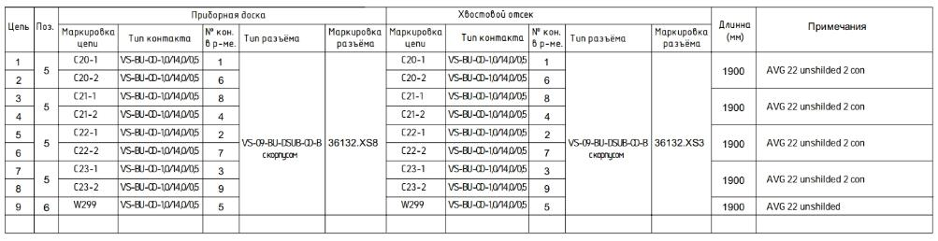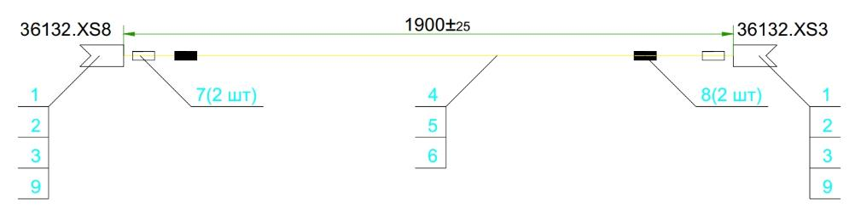

Installation of redundant pilot instruments
The objectives of this work are to install redundant instrumentation on the dashboard.
To complete this work you will need:
- Mobile desk;
Unpack it and stack it on the table:
- Dashboard 00135292;
- Vertical speed indicator;
- Altimeter;
- Speed indicator;
- Horizon pointer;
Locate the horizon indicator, check its integrity, unpack the fasteners. Install the pointer in the upper left corner of the panel, starting from the back side. Check that it fits snugly against the panel from the back side - it should be snug.
Note. If the pointer does not fit into the opening or if it is difficult to fit, the opening should be sanded with sandpaper. If the holes of the panel and the pointer do not match, it is necessary to drill holes in the panel with a diameter 0.5 mm larger than the size of the fastener.
Secure the horizon indicator with the fasteners provided.
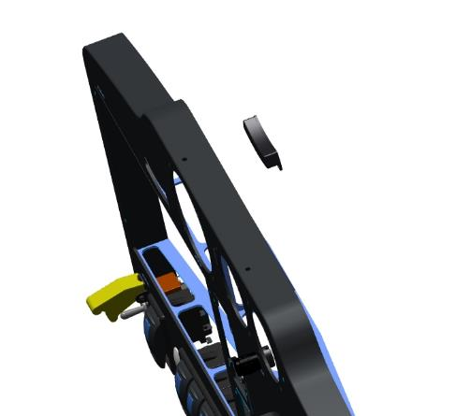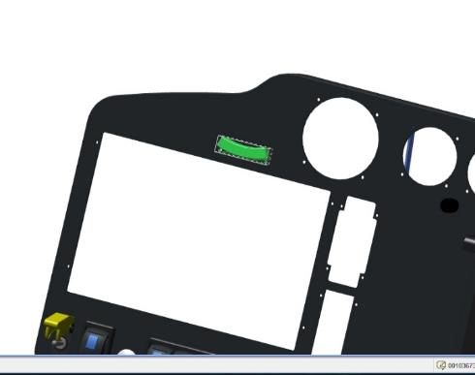
Locate the vertical speed indicator, altimeter, speed indicator, unpack each device in turn, stack on the table.
Install, one by one, each instrument on the panel in this sequence:
- vertical speed indicator in the upper right corner of the panel by winding it from the back side. Check that it fits snugly against the panel on the back side - it should be tight;
- Height gauge in the top of the panel in the center hole, facing the back side of the panel. Check that it fits snugly against the panel on the back side - it should be tight;
- the speed indicator in the upper left corner of the panel by winding it from the back side. Check that it is tight against the panel from the rear side - it should be tight.
Note. If the device does not fit into the opening or if it is difficult to fit, the opening should be sanded with sandpaper. If the holes of the device and the indicator do not match, it is necessary to drill holes in the panel with a diameter 0.5 mm larger than the size of the fastener.
Secure each appliance, in the order of fitting, with the fasteners provided.
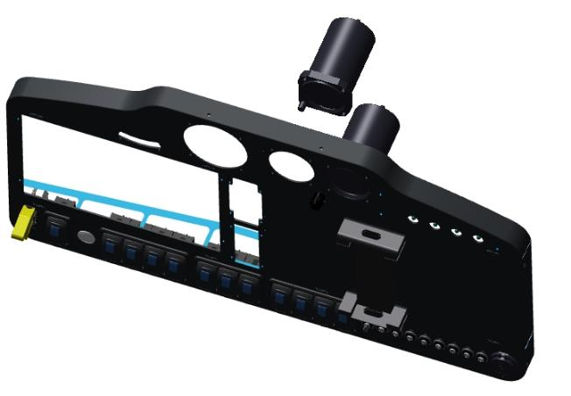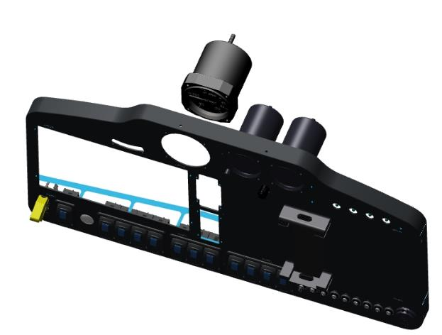

Inspect the rear side of the installed instruments. There must be clearance between the installed instruments and the instruments must be tightly pressed into the instrument panel openings.

Installation of intercom system

Install the units for communication on the dashboard.Secure.Connect according to the diagram.
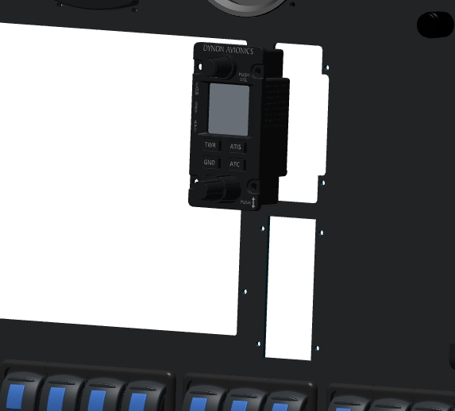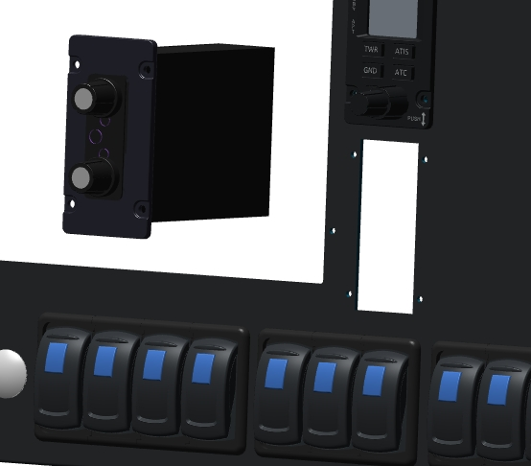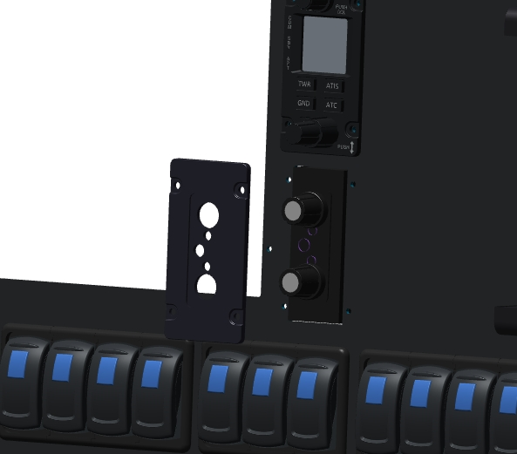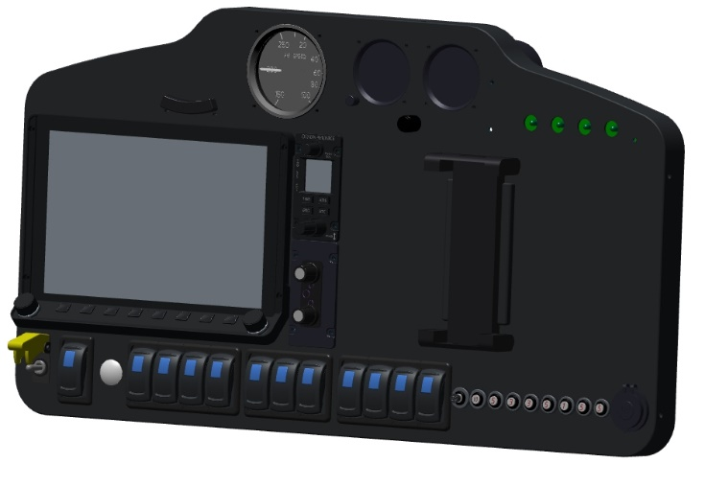



SPASSYSTEM INSTALLATION
IMPORTANT: Read the unpacking, assembly and installation instructions carefully before performing any work on the rescue system. Do not proceed until you have fully understood the work described in these instructions.
Inspect the system mounting compartment. There should be 6 through holes of 6 mm diameter on the wall for attaching the backpack. There should be no foreign objects inside the compartment.
Install the system in the compartment with the backpack guides against the wall with holes. The cable can be left out of the compartment. Inspect the installed backpack:
- Check for alignment between the holes in the strips and the shroud wall;
- protrusion beyond the fuselage dimensions. There should be no protrusions, the hatch should close the opening without bumping into the system.
Remove the satchel from the compartment and place it next to it on the fuselage. Insert the cable into the hole in the compartment floor, pull it under the trunk floor for its entire length. Remove the safety screw. Insert the backpack into the compartment, tighten the cable. Do this until the satchel is completely submerged in the compartment, pulling the cable to the dashboard. After full immersion, fix the handle under the instrument panel with 4 M4x10 screws. Install the handle and cable check (reassemble in reverse order according to the instructions for the rescue system). Fasten the satchel to the airplane cowling wall with 6 M6x20 screws. Try on the hatch covering the opening. The hatch should not rest on any part of the system. Attach the airplane straps to the carabiner on the satchel.
Remove the top check from the rescue system launcher, secure the hatch according to one of the options recommended by the manufacturer.

Installation of INTERIOR

Cab upholstery

The objectives of this job are to upholster or paint the cockpit of an airplane for a final aesthetic appearance.
Note: All parts of the airplane are pre-coated with protective primer and the joints of the parts are puttied. This surface preparation is not a finish or preparatory coating, but serves to protect against ultraviolet radiation from sunlight and weather conditions. The manufacturer's primer may be washed off prior to direct finishing of aircraft parts.
IMPORTANT: the item does not contain a description of specific works, but only recommendations, it is not known what materials and according to what scheme will be used. It is strongly recommended to contact a specialist in interior trim work.
IMPORTANT: Do not use paint materials containing alkalis, acids or hot drying (above 60°C) or other corrosive materials to the epoxy resin. This will cause degradation of the composite parts of the airplane. It is preferable to use self-adhesive based materials.
IMPORTANT: The materials used must not be flammable or emit toxic substances when exposed to heat or flame.
Final cabin finishing should preferably be done after the airplane has been fully assembled and several hours of flight time have been completed.
When painting the cabin, it is recommended that all work is carried out in accordance with point 13.1 below.
If the cabin is finished with leather or leather substitutes, woven materials, vapor-backed or nonvapor-backed, contact a finisher for a recommendation on the quality of surface preparation.
For any type of cabin and cabin trim, these guidelines should be followed:
- The covers between the control knobs and the pilot beam must not restrict the travel of the knobs in all directions. The fasteners of these covers must not protrude more than 10 mm beyond the inside of the beam. Protruding parts of the fasteners shall not be higher than 5 mm and shall not have sharp edges, edges, pins. The fasteners must be detachable.
- The padding on the throttle control and instrument panels must not get into the area of the toggle switches, throttle lever. This may cause the padding to get into the gap between the moving parts and jam them. Also, the upholstery must not reduce the travel of the throttle lever.
- IMPORTANT: If upholstery is used where toggle switches are located, it must not interfere with turning them on and off. Failure to do so may result in a catastrophe
- The upholstery or covering on the instrument panel must not be mirrored, glossy or make it impossible to see quickly and clearly the position of toggle switches, signal lamps, instrument arrows.
- The upholstery or covering on the cab doors must not interfere with their closing and opening and must not affect the operation of the locks.
- The upholstery or covering on cab doors shall not be of the same or similar color to the closing, opening, and locking handles.
- The interior trim and door trim must not obstruct or cover the emergency door release system.
- IMPORTANT: After all finishing and painting work has been completed, check the emergency door opening system. There must be no obstructions to the removal of the pin cotter pins in the door hinge assemblies. The system is reusable.
- The upholstery or covering of the pilot seats and their mounting locations must not obstruct the movement of the seats along the guides.
- The covering on the pilots' floor must not be able to move relative to the floor and must be more than 5 mm high. It is permissible to use textile hook and loop fasteners for fixation. One part must be sewn to the covering, the other part must be glued to the pilots' floor. The clasps must be securely fastened.
- If pockets for small items and cards are installed, they should be placed in areas that do not restrict or obstruct the movement of seats and pilots. The material should be soft and fabric. It is preferable to use textile hook and loop fasteners. Pockets should be placed on the right and left sides of the fuselage. Pockets may be placed on the backs of the pilots' seats.
- The covering or upholstery of the instrument panel torpedo shall not be mirrored.

Trunk lining

The objectives of this job are to upholster or paint the trunk of an airplane for a final aesthetic look.
Note: All parts of the airplane are pre-coated with protective primer and the joints of the parts are puttied. This surface preparation is not a finish or preparatory coating, but serves to protect against ultraviolet radiation from sunlight. The manufacturer's primer may be washed off before directly finishing the aircraft parts.
IMPORTANT: the item does not contain a description of specific works, but only recommendations, it is not known what materials and according to what scheme will be used. It is strongly recommended to contact a specialist in interior trim work.
IMPORTANT: Do not use paint materials containing alkalis, acids or hot drying (above 60°C) or other corrosive materials to the epoxy resin. This will cause degradation of the composite parts of the airplane. It is preferable to use self-adhesive based materials.
IMPORTANT: The materials used must not be flammable or emit toxic substances when exposed to heat or flame.
Final trunk finishing should preferably be done after the airplane has been fully assembled and several hours of flight time have been completed.
In case of painting the trunk, it is recommended to carry out all work in accordance with point 13.1 below.
When trunk trim is performed with or without leather or leather substitutes, woven materials, vapor-backed or not, contact a trim specialist for a recommendation on the quality of surface preparation.
For any type of trunk trim and its hatch, these guidelines should be followed:
- The luggage compartment covering must not be electrically conductive or electrostatic. Do not use materials containing metals.
- The trunk hatch trim must not fall into the locking area. This can lead to it getting caught in the gap between the moving parts and jamming them. Also, the upholstery must not reduce the travel of the sunroof.
- The upholstery or covering on the trunk floor must not be slippery.
- The trunk trim must not change the opening angle of the hatch.
- IMPORTANT: Fuel tanks installed in the luggage compartment must not be covered with any material
- The cover on the load box floor must not be able to move relative to the floor and must be more than 5 mm high. It is permissible to use textile hook-and-loop fasteners for fixing. One part must be sewn to the cover, the other part must be glued to the floor of the luggage compartment. The fasteners must be securely fastened.
- If pockets for small items and cards are installed, they must be placed in areas that do not restrict or obstruct access to the trunk. The material should be soft and fabric. It is preferable to use textile hook and loop fasteners. Pockets should be placed on the right and left sides of the fuselage. It is allowed to place pockets on the trunk hatch, but use them only for things weighing no more than 0.5 kg.
- The covering on the floor of the load box must not obstruct or impair access to the load hinges and securing of the load carried.

AIRPLANE PAINTING

Painting of external surfaces

The objectives of this job are to paint parts of the airplane for a final aesthetic appearance.
Note: All parts of the airplane are pre-coated with protective primer and the joints of the parts are puttied. This surface preparation is not a finish or preparatory coating, but serves to protect against ultraviolet radiation from sunlight. The manufacturer's primer may be washed off before painting the aircraft parts directly.
Final painting should preferably be done after the airplane has been fully assembled and several hours of flight time have been completed.
IMPORTANT: The item does not contain a description of specific works, but only recommendations, it is not known what materials and according to what scheme will be applied. It is strongly recommended to consult a specialist in painting.
IMPORTANT: Do not use paint materials containing alkalis, acids or hot drying (above 60°C) or other corrosive materials to the epoxy resin. This will cause the composite parts of the airplane to deteriorate.
Work on the coating is divided into several stages, which should be followed in the order described below.
Surface preparation stage. At this stage, contaminants from the assembly process are removed. Also here are marked with a pencil or marker places that need to be leveled with putty, sanded, or remove the existing coating.
Inspect carefully, measure and dimension the steps along the contour between:
- wing skins (upper and lower) and BANO glass;
- fender liners (upper and lower) and headlight glass;
- lower wing skin and hatches in the aileron area; for the right console additionally with PITO fairing;
-fuselage cladding and hatches in the keel area;
-fuselage trim and trunk hatch;
- fuselage plating and pilot doors;
- the fuselage skin and the battery compartment hatch.
In all cases, except for the cockpit doors and the luggage compartment hatch, the steps shall not exceed 0.2 mm. Steps across the pilot doors and the luggage compartment hatch in the closed position and pressed down by hand must not exceed 0.5 mm. If the steps are significantly larger than specified, make sure that there are no foreign objects in the places where these elements are installed.
Note: It is recommended to remove the consoles, ailerons, rudders and flaps for ease of operation good inspection.
Stage two. At this stage, preliminary sanding and matting of the places to be leveled with putty is performed. Special attention should be paid to hatches and similar elements. Use abrasive materials and their application methods according to the paint manufacturer's recommendations.
IMPORTANT: Before applying the putty, carefully read the instructions for its use. Pay special attention to the mixing proportions and drying conditions of the applied material.
Before applying putty, be sure to blow the treated areas with compressed air and degrease them.
In marked areas with steps, two puttying options are possible.
Option one. If the element falls (except for the doors and trunk hatch), it is necessary to nashpakleivayut, grind and level these places in the undercut of the installation of the part, to achieve the necessary smooth transition.
Option two. If the element is protruding, the area around it must be puttyed with one edge of the tool on the protruding element and the other edge on the cladding at a length of at least 250 mm. Then this area should be puttyed and leveled, thus ensuring smooth contours.
Note. It is recommended to use a light putty.
Stage three. At this stage the main priming is performed. Before this work, it is necessary to dismantle the glazing of the wing consoles, protect the glazing of the cockpit with paint tape or film, dismantle the cockpit doors and the trunk hatch with their seals, and glue the openings with film. Hatches in the tail section and on the wing consoles, PITO cover should also be dismantled, and their openings glued from the inside with film.
Note. If the engine is already installed on the airplane, it must be thoroughly protected with film, including all its systems (radiators, filters).
Apply and dry the primer according to the paint manufacturer's recommendations.
Stage four. At this stage, the primer is matting, removal of identified irregularities and application of the main paint material.
Note: Preferably, the topmost layer of the finish coat should be a hard varnish. It will need to be polished. The lacquer will ensure better preservation of the main paintwork
Matting of the primer, removal of irregularities should be carried out according to the recommendations of the paint manufacturer.
To obtain uniformity of the base coat, it is allowed to paint the aircraft with cowls, hatches and PITO shroud installed.
Apply the final coating material in accordance with the manufacturer's recommendations.

Stencil application
After completing all work on the assembly and painting of the aircraft, it is necessary to apply stencils with information in certain places.Stencils should be red, or clearly visible against the background of the aircraft (for example, if the aircraft is red, then the stencils are white).
Layout of information outside the airplane
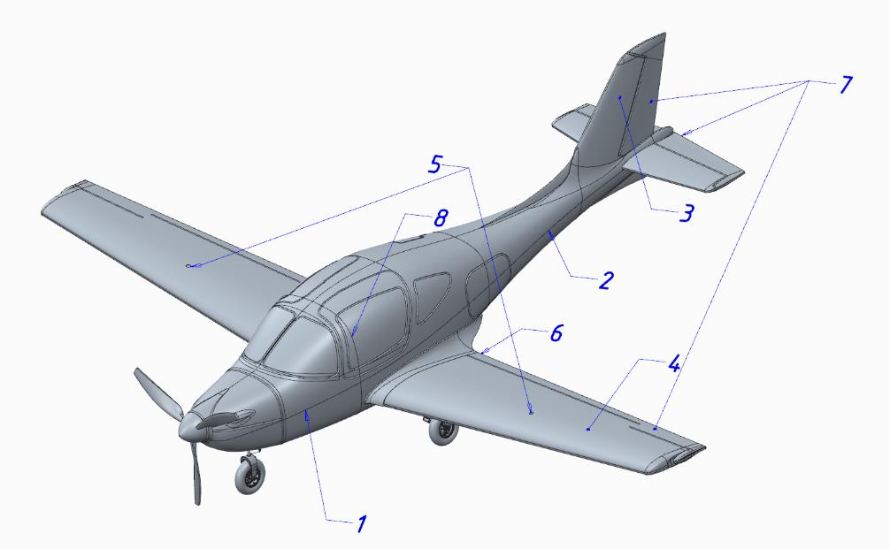
- "ANG-01" (aircraft name in black, Arial 35 font);
- Aircraft registration number (size and inscription according to the laws of the country of registration);
- Flag of the country of registration;
- "NO STEP" (on the flaps);
- "DON'T STEP" (on consoles);
- "92 OCTANE, UNLEADED AUTO GAS, CAPACITY 100 LITRES" (around the filler necks of fuel tanks);
- "NO PUSH" (on PH trimmer, aileron trimmer, aileron trimmer, RV trimmer and RV trimmer);
- "OPEN" and "EMERGENCY EXIT" on the doors;
Stencils should also be placed inside the airplane, in a highly visible location
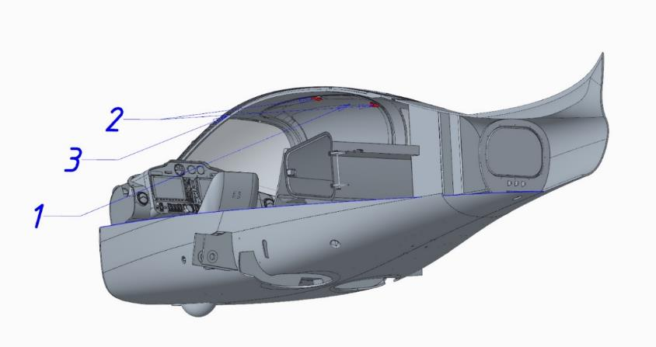
- "CAPACITY 600L, 60 KG, LUGGAGE MOORING IS MANDATORY " (on the inside of the trunk hatch);
- "MTOW 950 KG, VA=200 km/h, VNO=340 km/h, NORMAL-CATEGORY LEVEL 2, LOW SPEED, NO AEROBATICS AEROPLANE" (on the instrument panel);
- "OPEN" (on the doors);
- "NO SMOKING" (top center overhead, just behind the windshield);

Installation of signs
After all the decoration and installation work on the instrument panel is complete, the decals must be installed. These provide information on the function of buttons, toggle switches, fuses, your flight number and flight restrictions. The decals are self-adhesive and only require cleaning of the surface to which they will be affixed.
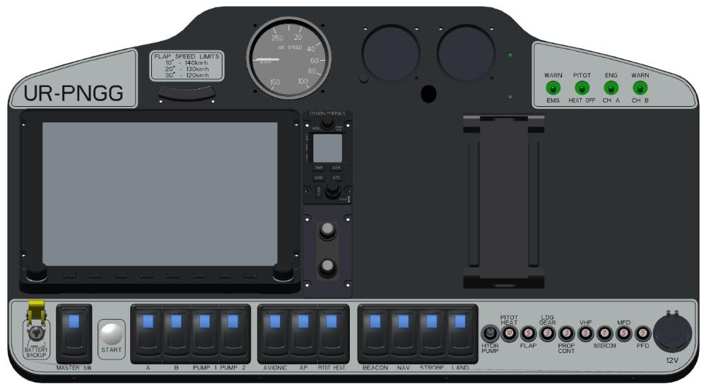

COMMISSIONING

General Provisions
Pre-commissioning works (PCR) is the final stage of assembly of a particular ANG-01 airplane Kit and is intended to assess the functioning of its units, compliance of its mass-dimensional and geometric dimensions with those stated in the ANG.01.MM.01 Technical Operation Manual (TOM).
Each subsequent check of the Commissioning Checklist is performed after the previous check has been successfully completed.
If deficiencies are identified, the process is suspended until they are corrected.
Execution of this Checklist confirms the readiness of a particular instance of the assembled ANG-01 to perform check flights (РАЗДЕЛ 15

Safety measures
Necessary to protect participants in the commissioning process from electric shock, unintentional engine starting or chassis retraction.
All participants of the process are dressed in overalls, pockets are free of items that are not necessary for the process (to prevent them from getting into hard-to-reach places of the airplane). Flashlight and camera are necessarily fixed on the inspector's hand for the same reason.
Ensure that there are no individuals on the site who are not involved in the process.
Smoking, open flames, heating devices, flammable substances at a distance of 10 meters is FORBIDDEN.
In the event of fire for any reason, do NOT perform water extinguishing. The first thing to do is to stop the engine (if running), turn off the power (if on) and use a fire extinguisher immediately.
When starting the engine, it is FORBIDDEN to place the participants of the process at a distance closer than 10 m in the plane of rotation of the propeller, from all other sides - not closer than 5 m (except for the person who is in the cabin of the aircraft). The airplane is mounted on pads and secured with straps (from the ground equipment kit) by the main landing gear supports and to a reliable fixed structure, doors are dismantled to provide emergency egress, wing consoles are not necessary to install (it is necessary to plug the fuel lines to the console tanks).
Work outside the aircraft assembly area in thunderstorm activity, precipitation, winds greater than 5 m/s, temperatures below+ 5 ⁰C, is FORBIDDEN.

Check list of commissioning works
Pos le dov. | Purpose | Methodology  verification | Criterion  compliance | Tools, accessories, expenditure. material.
Site: closed area (hangar)
 | Site and instance (airplanepreparation | Remove production debris, dust, equipment, tools and temporary coverings (films, etc.) from the copy and site.  Reconciliation of operating documentation | The copy and plot have been prepared  Operational documentation checked against control copies | vacuum cleaner, detergents, rags, mittens (2p.), table
 | copy | Inspect the copy for: mechanical or thermal damage, delamination, dents, corrugations, all external and accessible internal surfaces (including glazing).  Inspect accessible metal components for corrosion.  Inspect accessible wiring elements and connectors for mechanical or thermal damage.  Determine clearances according toError! Reference source not found.  Open and close the doors and luggage compartment hatch (10 times).  Perform photo recording of the results | No damage.  Clearances do not exceed those specified inError! Reference source not found.  The doors and luggage compartment hatch close and open without significant physical effort | flashlight, caliper, mittens (1p.) photo/videocam.
 | Reconciliation of major assemblies | Check the serial numbers of the main assembly units according to14.3.1 with the data of the Kit Specification. Enter the data into the Form.  Perform photo recording of the results | The serial numbers of the KIT-set units were matched, and the data were recorded in the Formulary | flashlight, screwdrivers, photo/video camera.
 | major PCI | Check models and modifications, PKI serial numbers according to14.3.2 with the data of the Kit Specification.  Enter the data into the Form.  Perform photo recording of the results | Correspondence of models and modifications, serial numbers of purchased component parts was established, the data was entered into the Formulary | flashlight, screwdrivers, photo/video camera.
 | Leveling | According to the methodology of Section 4.3 of the RTE.  Enter the data into the Form.  Perform photo recording of the results | The evaluated geometric data are in accordance with the RTE.  The results are recorded in the Form | leveler, tape measure,  plummeting,  marker,  cord, jack, Sh1 template, photo/videocam.
 | Determination of mass and alignment | Perform weighing according to the method of section 4.4 of the RTE.  Enter the data into the Form.  Perform photo recording of the results | The weight and alignment of the empty equipped airplane corresponds to section 3.1 of the RTE.  The results are recorded in the Form | floor scales (3 pcs.),  plummeting,  tape measure, marker, calculator,  photo/videocam.
 | Reliability of fixation of fixed elements | Assess immobility relative to the airplane (loosen with hands without applying great physical force):  - wing consoles;  - stabilizer;  - engine frame;  - the engine and its components;  - engine compartment hoods;  - the harness fittings in the cockpit;  - spassistemi sling fittings;  - the dashboard;  - glazing | The elements are stationary | -
 | Backlash assessment  moving parts | Evaluate play (loosen by hand without applying great physical force):  - propeller blades (all of them);  - propeller hub (longitudinally);  - the intercooler flap;  - RUS (both), RUD;  - pilot seats;  - flaps;  - ailerons, RH, RV, RV trimmer;  - landing gear supports (all);  - door, trunk hatch.  Perform video recording of results | The backlash does not exceed 2mm | caliper, photo/video camera.
 | Reliability of fixation  equipment (avionics) | Assess immobility relative to the airplane (loosen with hands without applying great physical force):  - of the wiring harnesses of electrical system  - the battery and its terminals;  - Dynon SW1100 displays;  - of redundant pilot instruments;  - of the engine monitor unit (EMS);  - Pitot tubes;  - of the Pitot tube heating controller;  - temperature sensors;  - of ADAHRS modules;  - of the SNS module;  - of the radio module;  - of the transponder;  - of all gas stations, tumblers and caps;  - of available electrical connectors;  - of the commutation pad (RK system);  - consoles (radio, intercom, VISH, flaps, landing gear, autopilot, transponder).  Perform video recording of results | The elements are stationary.  The harnesses are attached to fixed elements of the structure with a spacing of 40...50 cm, their mechanical contact with moving elements of the aircraft control system (rods, rockers), as well as pilots and passengers in the cockpit, and luggage (in the luggage compartment) is excluded. | -
 | Evaluation of elements to be counter-bolted | Inspect for the presence and correct alignment of the components:  - of the propeller washers;  - of the engine to the sub-engine frame;  - of the engine components;  - of the control rods;  - clamps in the engine compartment;  - fuel system connectors;  - of the aneridic-membrane connections.  Perform photo recording of the results | The elements are finished in the correct way | flashlight, screwdrivers, photo/video camera.
 | Evaluation of elements to be lubricated | Inspect for lubrication of assemblies:  - control system rockers;  - steering surface attachment assemblies;  - of the flap hinge assemblies;  - of the pivoting support units at release;  - of the nose support nodes during taxiing.  Perform photo recording of the results | Elements are properly lubricated | flashlight, screwdrivers, mittens (1p.) photo/videocam.
 | Evaluation of kinematics  control system | Evaluate the smoothness of travel to the extreme positions of the rudder and pedals from the seats of the left and right pilots, as well as the compliance of rudder movement and extreme angles of deflection (no external loading of the rudders, only from the controls):  - RUS "to yourself": RV up;  - RUS "away": RW down;  - RUS left: left. EL up, right down;  - RUS right: left. EL down, right up;  - Pedal left "away": PH to the left;  - Pedal right "away": RH to the right.  Perform photo recording of the results | The handlebars and pedals move smoothly. In extreme positions, the steering wheel and pedals do not touch any elements of the cab or interior. The rudders move in the desired direction.  In the neutral position of the controls, all rudders are inscribed in the surfaces. In extreme positions rudder deflection within the limits of section 3.2 of the RTE | photo/video angle meter.
 | Evaluation of the kinematics  of the RV trimmer | Evaluate the smoothness of travel to the extreme positions from the left and right pilot's seats, cockpit signaling, as well as the compliance of the RV trimmer movement (no external loading is allowed, only from the controls):  - Toggle switch "on pick-up": Trimmer up;  - Toggle switch "on cabr.": trimmer down.  Move the trimmer to the end positions 10 times.  Perform photo and video recording of the results | The trimmer moves smoothly to the end positions in time and at angles within the limits of section 3.2 of the RTE.  The signaling in the cab corresponds to the actual position | angle gauge stopwatch,  photo/videocam.
 | Evaluation of kinematics and  flaps | Evaluate smoothness, conformity of movement to all fixed positions ("0", "1" "2" "3"), synchronization (left/right sections), signaling on the console and flap deflection angles corresponding to the positions.  Perform flap reset from position "0" to "3" 10 times.  Perform photo and video recording of the results | The flaps (left/right sections) move smoothly and synchronously to all fixed positions according to the position of the toggle switch on the remote control.  The deflection angles in each position are in accordance with section 3.2 of the RTE.  In the "0" position, the flaps are in the inboard position in the wing.  The alarm on the remote control corresponds to actual position | angle gauge stopwatch,  photo/videocam.
 | assessment  VISH | Evaluate smoothness, directional compliance, timing, synchronization, angles of position when turning all propeller (from the remote control):  - "to tighten": blades clockwise;  - "to ease": blades counterclockwise  Resurface the blades 20 times.  Perform photo and video recording of the results | The blades move smoothly and synchronously by commands from the console to the end positions in the time and at the angles specified in section 3.3.2 of the RTE | angle gauge stopwatch,  photo/videocam.
 | Checking the electrical system | Turn on all gas stations in sequence.  Connect the ground battery.  Check the on-board voltage.  Turn the toggle switches on and off (one at a time) (with the MASTER SW toggle switch on):  - BANO and LAND LT headlights;  - STROBE flashing lights;  - AVIONIC avionics;  - Autopilot "AP";  - PITOT HIT (up to 1 min.);  - V.I.P. console, flap console;  - Dynon SW1100 displays;  Perform pilot seat position adjustment under the pilot's weight to the extreme positions (separately and simultaneously of the two).  Perform a power supply test of the 12 V sockets in the cabin.  During operation, evaluate equipment operability, thermal regime and temperature growth gradient of the Pitot tube, voltage sag of the flight network when moving the pilots' seats.  Perform photo and video recording of the | No open flames, no sparks, no smell of burning wiring.  The designated consumers are operational. Pitot tube heating provides temperature and growth gradient according to section 2.10 of the RTE.  The seats move smoothly to the end positions under the weight of a person, the on-board voltage sag is not lower than 11 V.  12 V sockets in the cabin are operational | ground battery,  pyrometer,  multimeter, photo/video camera.
 | Checking  и  equipment calibration | Perform with the ground battery power supply switched on (with the "MASTER SW" toggle switch on):  - Dynon SW1100 system software version up-to-date according to the method of section 4.12.2 of the RTE;  - Dynon SW1100 system definition of all associated sensors (see section 2.10.1 of the RTE) according to the methodology of section 4.12.3 of the RTE;  - pneumatic lines tightness check, speed calibration according to the method of section 4.12.4 of RTE;  - calibration of gyroscopes and accelerometers of ADAHRS modules according to the procedure of Section 4.12.5 of the RTE;  - calibration of the autopilot servos according to the procedure of Section 4.12.8 of the RTE;  Perform photo and video recording of the results | The software is up to date.  All associated sensors are identified.  Pneumatic lines are sealed.  The instrumental speed correction for the primary and backup pointers has been determined.  Instrumental and aerodynamic corrections have been made to the Dynon system and to the reserve pointer plate  ADAHRS and the autopilot are calibrated | ground battery,  pressure set point (see section 4.12.4 of this manual)  photo/videocam.
 | Chassis check | Check the pressure in the pneumatics.  Apply the pneumatic rotation marks.  Inspect the chassis supports to ensure that the shock absorbers are charged with oil and nitrogen.  Perform brake check by pressing the brake pedals of the foot post (on the left and then on the right) and using a force of 1-2 ounces applied behind the consoles to try to push the airplane backwards.  With the airplane lifted by crane (by the engine output shaft) and jack, check the main chassis retraction/release system (2 times), evaluate:  - time and synchronization of cleaning;  - the timing and synchronization of the release;  - position signaling in the cockpit;  - centering the bow support during cleaning;  - operability of the footrest release/retraction mechanism;  - the operation and power supply of the hydro plant;  On the lifted airplane, perform check of the backup chassis release system (1 time), evaluate:  - the timing and synchronization of the release;  - position signaling in the cockpit.  On the lifted airplane, check the maximum rotation angles of the nose support (with an angle meter) from the left and right foot pedals.  Inspect shock absorbers, harvesting/release cylinders, hydraulic line, hydraulic power pack, cylinder and backup release valve.  Perform photo and video recording of the results | Pressure in pneumatics complies with section 2.8.1 of the RTE. Rotation marks are applied.  The bow support rotation angles are in accordance with Section 2.6 of the RTE.  The chassis brakes are effective.  The main landing gear retraction and release system, the backup landing gear release system and the hydraulic power plant are operational.  The time and synchronization of landing gear release and retraction according to section 2.8 of the RTE is ensured.  Correct signaling of the chassis position according to 2.8.3 of RTE is provided.  The bow support is centered during cleaning. Hydraulic power plant operation without voltage sag below 11V. Shock absorbers, hydraulic line, hydraulic power unit, cylinder and standby valve are leak free.  Release and retraction of footrests synchronized with the chassis | Jack, crane 200 kg  pressure gauge,  ground battery,  angle gauge,  paint (red, for rotation marks), stopwatch,  2 cans of reserve chassis release,  fire extinguisher,  photo/videocam.
Site: open area
 | Preparation of the site and copy | Inspect the area for puddles of standing water, debris, dust, rocks, sand within 10 meters of the aircraft, no massive magnetic metal structures within 20 meters of the aircraft, and a fire extinguisher.  Determine the level of the site (should be approximately horizontal).  Place the aircraft on the parking pads Secure the aircraft according to the procedure in section 4.5.2 of the Operator's Manual by the main undercarriage supports with mooring straps to a secure fixed structure | The copy and plot have been prepared | fire extinguisher, mooring straps and parking blocks (supplied)
 | Magneto-meters and SNS calibration | Perform according to the methodology of Section 4.12.6 and 4.12.7 of the RTE.  Perform video recording of results | Calibration of ADAHRS and SNA magnetometers was performed | photo/videocam.
 | Checking  and flushing the fuel system | Inspect flow tanks and all accessible fittings (fuel lines, connectors, drains) for integrity.  Flush the fuel system by filling the left and right console tanks with fuel (20 liters each).  Perform inspection for leaks, drainage operation, fuel odor in cab and luggage compartment (doors and hatch closed).  Perform measured fuel drainage through the fuel filter in a container, determining the undrained residue (by the difference between the fuel quantity and the refueled quantity).  Perform photo and video recording of the results | Cantilever and flow tanks, fuel fittings and drains free of mechanical, electrical and thermal damage, leaks and corrosion.  Promite fuel system from possible ingress of debris and dust during assembly.  Non-dischargeable balance determined | gasoline (40 l), measuring container (20 l)  respirator (2 pcs.), fire extinguisher
 | Radio communication check | Check external and internal radio communication during engine test run | Radio communication is operational, interference is acceptable | headset
 | Checking  propulsion system | Fill 40 liters of fuel.  Perform cold cranking.  Perform starting, warming up and shutdown of the engine according to the method of section 4.2 of RLE, evaluate:  - the vibration of the airplane;  - accuracy of speed maintenance;  - engine temperature conditions.  Repeat the low gas test 3 times, increasing the time to 30 minutes.  Run test to maximum mode (5500 rpm), evaluate:  - the vibration of the airplane;  - VISH operability;  - operation of the cabin heater;  - accuracy of speed maintenance;  - engine temperature conditions.  After stopping the engine at each test, inspect the condition of the hoods, inspect the engine compartment for fuel, oil, water leaks, and the condition of the electrical wiring.  Perform photo and video recording of the results | In the tested range, the accuracy of RPM maintenance, engine temperature conditions comply with the limitations of Section 3.3 of the RTE.  Airplane vibration is acceptable.  VISH, cabin heating system, fuel system are operable. | gasoline (40 liters), headset,  pyrometer, fire extinguisher,  photo/videocam.
 | Calibration  tomlivo-measure | If fuel residue is 10 liters or less, during the extreme test set the low throttle mode and turn off the engine at the first signs of unstable engine operation (fluctuations in sound, revolutions). Perform measured fuel drain and enter this value into the Dynon system as "0" according to the method of section 4.12.9 of the RTE. | Fuel system calibrated | measuring container (1 liter)  respirator (1pc), fire extinguisher
    - List of of the main assemblies of the Kit Kit
No. n/a | Assembly  unit | Quantity for ex. | Drawing  number
 | Fuselage assembly including:  - the fuselage itself with the keel;  - cab and trunk hatches (7 pcs.)  - cab glazing (4 pcs., without doors);  - foot control post assembly (see );5.3  - manual control post assembly (see );5.4  - control system of the booster, RV assembly (see );5.5  - engine control system assembly (see );5.6  - fuel system lines;  - electrical harnesses;  - spassistem box cover (1 piece);  - footrest assembly (2 pcs.);  - tail fairing with BANO (1 piece);  - cabin heating and ventilation flaps;  - STROBE with fairing (1 piece); | 1 | p/n
 | Wing console assembly including:  - spar (1 piece);  - root sail (1 piece);  - flap linkage brackets (3 pcs.);  - aileron mounting brackets (2 pcs.);  - inspection hatches with fasteners (3 pcs.);  - aileron control assembly;  - attaching the console to the fuselage;  - headlamp with fairing (1 piece);  - BANO, STROBE with fairing (1 piece); | 2 | p/n
 | Stabilizer assembly:  - stabilizer;  - elevator rudder linkage brackets (2 pcs.);  - fuselage mounting plates (2 pcs.) | 1 | p/n
 | Aileron assembly | 2 | p/n
 | Rudder | 2 sections | p/n
 | Steering wheel assembly | 1 | p/n
 | Altitude rudder trimmer | 1 | p/n
 | Flap assembly | 2 sections | p/n
 | Consumable fuel tanks (without pumps) | 2 | p/n
 | Engine compartment hood upper complete | 1 | p/n
 | Lower engine compartment hood assembly | 1 | p/n
 | Under-engine frame | 1 | p/n
 | Air propeller washer | 1 | p/n
 | Cab door assembly | 2 | p/n
 | Luggage compartment hatch | 1 | p/n
 | Chassis and footrest control unit | 1 | p/n
 | BANO control unit, STROBE | 1 | p/n
 | Intercom switch | 1 | p/n
 | Pilot's chair | 2 | p/n

    - List of purchased components
No. n/a | Type | Manufacturer | Model and modification | Packs  for ex. | Comp. doc.
 | The engine is complete:  -reducer (1 pc.);  - injector (1 piece);  - throttle (1 pc.);  - intercooler (1 piece);  - spark plugs (4 pcs.);  - fuel frame (1 pc.);  - turbine (1 pc.);  - motor frame (1 pc.);  - oil pump (1 piece);  - coolant pump (1 piece);  - muffler (1 piece);  - hose and cylinder head air box;  - starter (1 pc.);  - generator (2 pcs.);  - starter and alternator relays (2 pcs.);  - fuse box (1 pc.);  - ECU control and monitoring unit (1 pc.) | BRP-Rotax GmbH | Rotax 915 iS 3A | 1 | Log Book
 | Air propeller included:  - bushing (1 piece);  - blades (3 pcs.);  - VISH turning mechanism (1 pc.) | S-PROP | SA-72R | 1 | Passport
 | Tank fuel pump, fuel gauge | Magnetti Marelli | ?? | 2 | Label
 | Hydraulic power plant | SAE MARINE | J1171 | 1 | Label
 | Battery | ?? | YLP14 | 1 | -
 | Spassystem complete | Galaxy GRS s.r.o. | 6/800-990 SDS/FF | 1 | Passport
 | Backup speed indicator | FALCON | ASI316KN-3 | 1 | Label
 | Backup altitude indicator | FALCON | VSI10MEF-3 | 1 | Label
 | Redundant lift indicator | FALCON | VSI10MEF-3 | 1 | Label
 | Backup slip indicator | FALCON | SI-2Q | 1 | Label
 | Pitot tube | Dynon Avionics. | Heated Pitot Probe | 1 | Label
 | Pitot tube heating controller | Dynon Avionics. | Heater Controller | 1 | Label
 | Temperature sensor | Dynon Avionics. | SV-OAT-340 | 3 | Label
 | Engine monitoring unit | Dynon Avionics. | SV-EMS-221 | 1 | Label
 | Multifunction display | Dynon Avionics. | SV-HDX1100/A | 2 | Label
 | SNA module | Dynon Avionics. | SV-GPS-250 | 1 | Label
 | ADAHRS module (basic) | Dynon Avionics. | SV-ADAHRS-200 | 1 | Label
 | ADAHRS module (redundant) | Dynon Avionics. | SV-ADAHRS-201 | 1 | Label
 | Autopilot servo | Dynon Avionics. | SV-52 | 2 | Label
 | Autopilot module | Dynon Avionics. | SV-AR-PANEL/V | 1 | Label
 | Autopilot remote control | Dynon Avionics. | SV-KNOB-PANEL/V | 1 | Label
 | Transpoder | Dynon Avionics. | SV-XPNDR-261 | 1 | Label
 | NCP battery | Dynon Avionics. | SV-BAT-320 | 1 | Label
 | Radio station | Dynon Avionics. | SV-COM-25C | 1 | Label
 | VISH control panel | Microel s.r.l. | PR-1 | 1 | Label
 | Flap control panel | Microel s.r.l. | EFC67-P | 1 | Label
 | Trimmer servo drive | ?? | T2-10A | 1 | -
 | Flap actuator | ?? | ?? | 1 | -
 | Pilot seat actuator | ?? | ?? | 2 | -
 | Fire extinguisher | - | - | 1 | Passport

PROGRAM OVERFLIGHT A

Conditions and procedures for performing overflights, safety measures
The airplane should only be allowed to perform a flight after the Checklist for Pre-Commissioning (section14.3 ) has been successfully completed.
Two pilots are allowed to perform the overflight. The presence of other persons in the airplane is FORBIDDEN.
Pilots with a PPL license who are familiar with the ANG-01 aircraft design, have fully studied the current revision of the ANG.01.FM.01 flight manual and know by heart what to do in emergency situations (Section 5 of the flight manual) should be allowed to perform overflight flights.
When performing maintenance of the airplane during overflight flights, allow technicians who are thoroughly familiarized with the ANG-01 airplane design, have fully studied the ANG.01.MM.01 RTE of the current revision and act according to the airplane operation procedures (Section 4 of the RTE) and Maintenance Regulations (Section 5 of the RTE).
All overflight flights are performed within the operational limitations of Section 3 of the current revision's Flight Manual.
All pilot actions during normal operation of the aircraft systems should be performed in accordance with Section 4 of the manual.
In case of failure of any functional system, the pilot decides to terminate the flight task and land in accordance with sections 5 or 6 of the flight manual.
Prior to the commencement of overflight flights, the aircraft is trained in the use of the rescue system and emergency evacuation on the ground (procedures of Section 5 of the flight manual).
For all overflight flights the main document authorizing the pilot to perform the flight task is the flight sheet. The flight sheet is prepared in accordance with the test procedure for a particular flight and approved in accordance with the established procedure by the competent authority (CAA) of the country of registration of the airplane.
After assembly of the ANG-01 airplane, all flight operations should be performed according to the program set forth in section15.2 , which establishes full compliance of the assembled airplane with its performance and flight characteristics as specified in the PTE and FLE. It is allowed that the overflight program may be drawn up according to the requirements of the CAA of the country of registration, but it MUST include the elements of flight tasks set out in section15.2 in the same sequence of execution.
Before each flight perform operational maintenance in accordance with Section 5.6 of the Operational Manual.
After completion of all flights under this program, perform Check FTP-2 according to Section 5.7.2 of the RTE.

SCOPE AND METHODOLOGY
The overflight consists of taxiing, speed runs and flights according to the sequence and methodology outlined below.
    - taxiing
Perform before flight #1, in actual weather conditions and runway type/condition. Aircraft weight and alignment as for flight #1 (see section ).15.2.3
Methodology and sequence of execution (in addition to Section 4.3 of the RLE):
- Verify the ability to hold the airplane on the brakes at RRD up to 50%.
- Perform "snakes" and 180, 360° turns.
Evaluate:
- RRD, at which it is possible to hold the aircraft with fully compressed brakes (depends on the type and condition of the runway, aircraft flight weight);
- the ability to maintain the straight line direction of the airplane when controlling the nose wheel (depends on the type and condition of the runway, the airplane's flight weight, and the side wind);
- stability of engine operation at the required for taxiing RRD and low gas, engine temperature conditions (TTC, oil and coolant temperature);
- no auto oscillation of wheels like″ shimmy ;″
- performance and efficiency of the braking system under short-term pedal compression;
- performance of the chassis shock absorption, comfort and vibration levels;
- Dynon SW1100 system performance in motion, correct indication of engine parameters, spatial position (heading, roll, pitch), ground speed, backup magnetic heading;
- 180°, 360° turning radius (compare with RLE).
    - Speed runs
Perform before flight #1, in actual weather conditions and runway type/condition. Aircraft weight and alignment as for flight #1 (see section ).15.2.3
Methodology and sequence of execution:
- Calculate the distance of aborted takeoff according to the nomogram of Section 7.2.2 of the RLE depending on the actual flight weight, type and condition of the runway, oncoming wind speed component.
IMPORTANT: If the calculated required runway length exceeds the available (actual) runway length, a high-speed run must NOT be performed, as this will result in the airplane rolling off the runway and a precondition for an accident with consequences up to catastrophic. It is necessary either to provide a runway of the required size and type/condition, or to reduce the actual weight of the airplane as much as possible, or to expect a stronger headwind.
- Set the flaps to position "1".
- Set the VISH speed setter to 5500 rpm.
- Request and receive permission to occupy an executive start to perform a jog.
- Take an executive launch with the runway facing downwind.
- Release the brakes and at the same time smoothly set the throttle lever to the "away" stop.
- Accelerate to CAS= 70...85 km/h, pressing the nose landing gear by proportional deviation of the control "away from yourself", immediately after which:
- Set the throttle lever all the way "on" and at the same time apply the brakes all the way to the stop.
- Parry by pedal control (RH and nose support) lateral drifts of the aircraft from the runway axis, which are possible due to side wind and/or brake pad rubbing. Asymmetric braking is allowed. On a precipitation-covered runway with artificial turf or on an unpaved runway, apply impulse braking (pressing and releasing the brake pedals with a period of approximately 1 second) for more effective deceleration.
Repeat the high-speed run according to the above methodology, but with flaps in position "3" and with raising and lowering the nose gear at speed CAS = 65...80 km/h to pitch 3...5° immediately after setting the throttle control to the stop "to yourself" (efficiency of RV control) for 1...2 seconds and applying the brakes AFTER lowering the nose gear.
IMPORTANT: If the airplane tends to take off after the nose gear has been raised, IMMEDIATELY depress the nose gear by a proportional deflection of the throttle "away".
Evaluate:
- the ability to maintain the direction of motion and its correction (if necessary) by controlling the nose support and the booster (with the nose support lowered), as well as by asymmetric braking (on the run);
- ability to hold the airplane in pitch with the nose strut raised, stroke and forces on the control gear in the longitudinal channel, no oscillation of the airplane with the nose strut raised;
- The need to adjust the angle of the boom and boom trimmer plate to compensate for lateral drift;
- stability of engine operation at takeoff RRD, low throttle and transient modes, engine temperature modes (TTC, oil and coolant temperature);
- no auto oscillation of wheels like″ shimmy ;″
- serviceability of chassis wheel brakes and braking symmetry;
- performance of the chassis shock absorption, comfort and vibration levels;
- Correctness in movement of the landing gear signaling (green lamps of the released position must be steadily lit) and indicator lamps (all lights are green);
- performance of the Dynon SW1100 system in motion, correct indication of engine parameters, spatial position (heading, roll, pitch), indicator and track speed by the main and backup instruments.
After a series of high-speed runs (recommended 2...3 without lifting/lowering and 1...2 with lifting/lowering of the nose support) perform operational maintenance according to Section 5 of the RTE.
Pay special attention to the inspection of the engine compartment for fastening clamps, wiring, engine to the sub-motor frame, leaking fuel, oil, coolant, integrity and lack of play of the propeller blades, as well as the chassis supports and pneumatics for the integrity of shock absorbers, brakes, disks and pneumatics wheels, coincidence of rotation marks.

    - Flight No. 1
Purpose of the flight:
- Evaluate the overall performance of the systems.
- Estimating takeoff and landing distances.
- Evaluation of handling characteristics on takeoff and landing.
Takeoff weight. ........................................... 500...600 kg
Flight altitude ............................................. 300...400 м
Flight duration............................ 10...15 min.
No. n/a | Stage, conditions | Methodology | Subject of assessment
 | Takeoff and initial dialing | Section 4.4 of this manual, do not retract the landing gear | Run-up length, take-off distance (compare with RLE).  Stability of engine and propeller operation on takeoff RRD, temperature conditions (TTC, oil and coolant temperature).  Stability and controllability of the airplane at given V_{R}, V₂in longitudinal, transverse and track channels, forces and deviations of the controls and pedals
 | Horizon-tal flight (in a circle) | Section 4.6 RLE, CAS=120...130 km/h, chassis released, roll up to 30° | Stability of engine and propeller operation at the required RRD, temperature conditions (TGC, oil and coolant temperature).  Aircraft stability and controllability during flap release and retraction.  Comfort and vibration levels.  General performance in flight of the Dynon SW1100 system, correct indication of engine parameters, spatial position (heading, roll, pitch), indicator and track speed, as well as altitude and vertical speed on the main and backup instruments.  Correctness of signaling of landing gear position, flaps, signal lamps.  Stability of external radio communications
 | Glide path approach | Section 4.9 RLE, gentle glide path (V_{Y}=-2...3 m/s), flaps in position "2" | Stability of engine and propeller operation at the required RRD, temperature conditions (TTC, oil and coolant temperature).  Aircraft stability and controllability at a given V_{(R) (EF)}in the longitudinal, transverse and track channels, forces and deflections of the controls and pedals
 | Planting | Section 4.9 of this manual, hold the airplane with a pitch of 3...5° by deflecting the throttle control until the nose gear self-deploys. | Length of run, landing distance (compare with RLE).  The ability to hold the aircraft in pitch with the nose strut raised, the stroke and forces on the control stick in the longitudinal channel (RV efficiency taking into account the influence of the ground with flaps released in the landing position).

    - Flight
Purpose of the flight:
- Evaluation of chassis retraction/release.
- Evaluation of stall characteristics.
- Evaluation of maneuvering and permitted aerobatics.
Takeoff weight. ........................................... 500...600 kg
Flight altitude ............................................. 800...1000 м
Flight duration............................ 20...30 min.
No. n/a | Stage, conditions | Methodology | Subject of assessment
 | Takeoff and initial dialing | Section 4.4 of this manual | Run-up length, take-off distance (compare with RLE).  Correctness of signaling of landing gear position, flaps, signal lamps.
 | Shifts, slips | Rolls from roll 30° to roll 30° with maximum angular velocity, glides with PH pedals:  CAS=200 km/h (closed "0");  CAS= 100 km/h (close "3"); | Evaluate the stroke, forces on the cross-channel control and pedals, aileron efficiency during roll maneuvering (the time of shifting should not exceed 5 seconds).  Estimation of stroke, pedal forces in the track control channel, RV efficiency in glides
 | Maneuvering | Section 4.7 of the RLE.  Flaps in position "0", CAS= 140...150 km/h:  - 45° rolls;  - spirals;  - slides;  - flat eights | Evaluation of stroke, RUS and pedal forces, aileron and RH efficiency.  There's plenty of reserves before we stall.  Overloads do not exceed operational overloads.  The engine, fuel system and air propeller are operating steadily
 | Stall in straight flight with speed loss rate of 1...2 km/h in 1 second | Flaps in the 0 position:  Braking. CAS= 130→ 70 km/h, RRD 0%, VISH 4000 rpm, trimming at 120 km/h.  Flaps in position "3":  Braking. CAS= 120→60 km/h, RRD 0%, VISH 4000 rpm, trimming at 100 km/h | Estimation of stall speed, forces and RUS travel in the longitudinal control channel.  On stall, the airplane does not tend to roll and yaw sharply (unless provoked by the RH pedals).  5...10 km/h before the stall, there is a warning shaking of the structure.  After stalling, the airplane lowers the nose and accelerates, engine running steady  Stall recovery in accordance with Section 4.7.3 of this manual
 | Glide path approach | Section 4.9 RLE, gentle glide path (V_{Y}=-2...3 m/s), flaps in position "3" | Aircraft stability and controllability at a given V_{(R) (EF)}in the longitudinal, transverse and track channels, forces and deflections of the controls and pedals
 | Planting | Section 4.9 of this manual, hold the airplane with a pitch of 3...5° by deflecting the throttle control until the nose gear self-deploys. | Length of run, landing distance (compare with RLE).  The ability to hold the aircraft in pitch with the nose strut raised, the stroke and forces on the control stick in the longitudinal channel (RV efficiency taking into account the influence of the ground with flaps released in the landing position).

    - Flight #3
Purpose of the flight:
- Estimation of stability and controllability under changing speed, RRD.
- Estimating takeoff and landing distances.
- Evaluating second-round care.
Takeoff weight. ........................................... 600...700 kg
Flight altitude ............................................. 800...1000 м
Flight duration............................ 20...30 min.
No. n/a | Stage, conditions | Methodology | Subject of assessment
 | Takeoff and initial dialing | Section 4.4 of this manual | Run-up length, take-off distance (compare with RLE).  Correctness of signaling of landing gear position, flaps, signal lamps.
 | Acceleration-braking | Flaps in the 0 position:  Acceleration CAS=120→ 280 km/h, RRD 80%, VISH 5400 rpm, braking. CAS=280→ 120 km/h, PSD 0%, VISH 4000 rpm. | Estimation of the stroke, forces on RUS in the longitudinal control channel, and efficiency of the RV trimmer.  On a streamlined airplane, in horizontal flight at CAS=120 km/h and CAS=280 km/h required by the RRD, the airplane with released throttle has no tendency to cabrio or dive
 | Acceleration-braking | Flaps in position "3":  Acceleration CAS=100→ 130 km/h, PSD 100%, VISH 5500 rpm, braking. CAS= 130→ 100 km/h, PSD 0%, VISH 4000 rpm. | Estimation of the stroke, forces on RUS in the longitudinal control channel, and efficiency of the RV trimmer.  On a streamlined airplane, in glide path descent at CAS=100 km/h and low throttle RRD, the airplane does not tend to roll or dive when the throttle is released
 | Going for a second lap | Section 4.10 RLE, steep glide path (V_{Y}=-4...5 m/s), flaps in position "3", VPR=15 m | Loss of altitude from the first action of leaving to the minimum altitude.  Aircraft stability and controllability during acceleration and increasing RRD.  Vertical speed in climb
 | Glide path approach | Section 4.9 RLE, steep glide path (V_{Y}=-4...5 m/s), flaps in position "3" | Stability of engine and propeller operation at the required RRD, temperature conditions (TTC, oil and coolant temperature).  Aircraft stability and controllability at a given V_{(R) (EF)}in the longitudinal, transverse and track channels, forces and deflections of the controls and pedals
 | Planting | Section 4.9 of this manual | Length of run, landing distance (compare with RLE)

    - Flight #4
Purpose of the flight:
- Assessing enrollment characteristics, decline.
- Estimation of fuel consumption in horizontal flight.
- Estimation of the maximum speed of horizontal flight.
- Estimating takeoff and landing distances.
Takeoff weight. ........................................... 700...800 kg
Flight altitude ............................................. 2000...2500 м
Flight duration............................ 30...45 min.
No. n/a | Stage, conditions | Methodology | Subject of assessment
 | Takeoff and initial dialing | Section 4.4 of this manual | Run-up length, take-off distance (compare with RLE).  Correctness of signaling of landing gear position, flaps, warning lights
 | Gain in altitude | Section 4.5 of this manual | Estimate time, vertical speed and fuel consumption in the set (compare with RLE).  Stability of engine and propeller operation, temperature conditions (TTC, oil and coolant temperature, oil and turbine pressure).  Enter the data into the Form
 | Horizon-tal flight | Section 4.6 of the RLE:  - CAS= 230 km/h;  - CAS= 280 km/h;  - CAS=320 km/h. | Estimation of fuel consumption (based on Dynon SW1100 readings) at three speeds in horizontal flight (compare with RLE).  Estimation of the possibility to reach the maximum speed of horizontal flight (V_{NO}=320 km/h)/  Enter the data into the Form
 | Decrease | Section 4.8 of this manual | Estimate time, vertical speed and fuel consumption in descent (compare with RLE).  Stability of engine and propeller operation, temperature conditions (TTC, oil and coolant temperature)
 | Glide path approach | Section 4.9 RLE, standard glide path (V_{Y}=-3...4 m/s), flaps in position "3" | Aircraft stability and controllability at a given V_{(R) (EF)}in the longitudinal, transverse and track channels, forces and deflections of the controls and pedals
 | Planting | Section 4.9 of this manual | Length of run, landing distance (compare with RLE)

 |  | AIRPLANE KIT PARTS LIST
No. of items  Item | Naming  Name |  | Poznachennya  Designation | Quantity  Quantity | Note  Note
1 | Case |  | 00145524 | 4
2 | Stem |  | 00145525 | 4
3 | Krishka |  | 00145527 | 4
4 | Cuff T1 |  |  | 4
5 | Cuff T2 |  |  | 4
6 | Spring |  |  | 4
7 | Fitting |  | S6520-6 1/8 | 2
8 | Fitting |  | S6520-4 1/8 | 6
9 | Left caliper |  | KA-3240L-00133914 | 1
10 | Right caliper |  | KA-3240R-00133914 | 1
11 | Kilce |  | 2121-3501051 (72Р) | 4
12 | Heat insulation bushing |  | KA-3240-00133917 | 4
13 | Piston |  | KA-3240-00133916 | 4
14 | Pumping connector M6 |  |  | 2
15 | Fitting |  | 6522 4-M5 | 2
16 | Main chassis shock absorber cylinder |  | KA-3213-00109658 | 2
17 | Shaft shock absorber cylinder casing of the main strut |  | KA-3213-00109656 | 2
18 | Guide bushing |  | KA-3223-00109652 | 4
19 | Shock absorber rod |  | KA-3210-00109651 | 2
20 | Main chassis shock absorber valve body |  | KA-3213-00109677 | 2
21 | Main chassis shock absorber valve |  | KA-3213-00109678 | 2
22 | Shock absorber tube of the main chassis strut |  | KA-3213-00109676 | 2
23 | Charging valve |  | KA-3213-00027867 | 3
24 | Bearing |  | GEG8C | 4
25 | Brudoznimach |  | 30x38x4/7 K05 PU | 3
26 | cuff |  | 30x40x7 K33 PU | 3
27 | Nose strut shock absorber housing |  | KA-3223-00109679 | 1
28 | Glass top |  | KA-3223-00109680 | 1
29 | bushing |  | KA-3223-00109698 | 1
30 | Thrust bushing |  | KA-3223-00109688 | 1
31 | Lower bushing |  | KA-3223-00109689 | 1
32 | piston |  | KA-3223-00109690 | 1
33 | Damper |  | KA-3223-00109699 | 1
34 | Boom tube |  | KA-3223-00109686 | 1
35 | Center bushing |  | KA-3223-00109687 | 1
36 | piston |  | KA-3223-00109690 | 1
37 | Nut |  | KA-3223-00109691 | 1
38 | The pinch ring. |  | 9,5x2,5 (010-014-25) NBR-70 | 1
39 | Kilce |  | A8 DIN 471 | 1
40 | Kilce |  | A14 DIN 471 | 2
41 | Kilce |  | 26.58X3.53 XR | 2
42 | Kilce |  | 038-042-30 GOST 9833-73 | 3
43 | HeliCoil insert |  | M5x10 DIN 8140 | 4
44 | Oil |  | PMS-20 | 500
45 | Upper left-hand lever |  | KA-3211L-00136580 | 1
46 | Upper right hand lever |  | KA-3211R-00136580-01 | 1
47 | Lower left-hand gear |  | KA-3212L-00108694 | 1
48 | Lower right hand side lever |  | KA-3212R-00108694-01 | 1
49 | Bolt Elementary School |  | KA-3210-00121813 | 2
50 | Bronze bushing |  | KA-3210-00136610 | 4
51 | The wheel is 8" |  | KA-3240-00234511 | 3
52 | Galmium disk |  | KA-3240-00271038 | 2
53 | Galmivna ruhoma pad |  | KA-3240-00133919 | 2
54 | Galmivna nerukhoma pod |  | KA-3240-00133920 | 2
55 | Gwint M8 |  | KA-3210-00236643 | 4
56 | Gwint M6 |  | KA-3210-00133915 | 8
57 | Upper nose strut rocker of the chassis |  | KA-2720-00134425 | 1
58 | Front strut truss |  | KA-3221-00108746 | 1
59 | Upper cardan |  | KA-3222-00134991 | 1
60 | Lower cardan |  | KA-3222-00134990 | 1
61 | Bearing |  | 625zz | 10
62 | Top rocker |  | KA-3224-00109500 | 1
63 | Lower rocker |  | KA-3224-00109501 | 1
64 | bushing |  | KA-3224-00109584 | 2
65
66 | All heavy |  | KA-2720-00134964 | 1
67 | M5 tie rod axle |  | KA-2720-00134987 | 2
68 | M5 bolt |  | KA-3220-00134966 | 1
69 | Hydrocylinder housing |  | KA-3230-00134400 | 1
70 | GUS cylinder (main support) |  | KA-3230-00232984 | 2
71 | Hydrocylinder upper crankcase |  | KA-3230-00134092 | 3
72 | Hydrocylinder lower crankcase |  | KA-3230-00134093 | 3
73 | Bronze guide bushing |  | KA-3230-00134094 | 3
74 | Ball link nut |  | KA-3231-00109708 | 3
75 | bushing |  | KA-3231-00109709 | 3
76 | Washer |  | KA-3231-00109710 | 3
77 | Collar stem |  | KA-3231-00109711 | 3
78 | piston |  | KA-3231-00109712 | 3
79 | Nut M16x1 |  | KA-3231-00109717 | 3
80 | Retaining ring |  | KA-3231-00109716 | 3
81 | GUS piston rod ring |  | KA-3231-00109715 | 6
82 | Guide ring |  | KA-3231-00109713 | 3
83 | Lock nut |  | KA-3230-00134097 | 3
84 | Stem |  | KA-3231-00109718 | 1
85 | Dielectric bushing |  | KA-3232-00109648 | 12
86 | Brudoznimach |  | 20x28x4/7 K05 PU | 3
87 | cuff |  | 20x26x5 K33 PU | 3
88 | cuff |  | 24x30x5 K95 NBR | 6
89 | Spring retainer |  | M4x16 | 12
90 | Fitting camozzi |  | 2010-1/8 | 6
91 | Kilce |  | 034-037-19 GOST 9833-73 | 6
92 | Kilce |  | 020-023-19 GOST 9833-73 | 3
93 | Swivel head |  | D10 | 3
94 | Nut |  | M10 DIN 555 | 3
95 | Bearing |  | GE 10 E | 3
96 | Gwynth Farms Nasal Stijke |  | KA-3220-00109644 | 2
97 | Axle bolt |  | KA-3211-00178619 | 4
98 | M5 bolt |  | KA-3222-00134992 | 1
99 | Tube |  | KA-3220-00136411 | 1
100 | Tube |  | KA-3220-00136414 | 1
101 | Tube |  | KA-3220-00136415 | 1
102 | Wheel axle pin |  | KA-3220-00136417 | 2
103 | Pidnichnicka liva |  | KA-5260L-00156352 | 1
104 | Pidney right |  | KA-5260R-00156422 | 1
105 | Plate |  | KA-5620-00108827 | 2
106 | bushing |  | KA-5260-00145316 | 2
107 | Pipe |  | KA-5260-00145323 | 2
108 | bushing |  | KA-5260-00145328 | 2
109 | Engine support of the tailgate |  | KA-5260-00206442 | 2
110 | Key |  | KA-5260-00218280 | 2
111 | Gearmotor |  | PG22M180 | 2
112 | HeliCoil insert |  | M4x8 DIN 8140 | 8
113 | Tube |  | KA-2720-00262433 | 1
114 | Spherical nose piece |  | D5xM5 | 4
115 | Rocking SU |  | KA-2710L-00138507 | 2
116 | Rocking SU |  | KA-2710-00138510 | 2
117 | Pull rod (D24) |  | KA-2710-00138493 | 2
118 | yaga (D24) |  | KA-2710-00138490 | 2
119 | Pull rod (D13 eleroni) |  | KA-2710-00138492 | 2
120 | Axle M6x10 |  | KA-2700-00100561 | 24
121 | Bearing |  | S61704-2RSR | 12
122 | Pedal left |  | KA-2720-00145865 | 1
123 | Right pedal |  | KA-2720-00137502 | 1
124 | Galmivna left pedal |  | KA-3240-00108642 | 2
125 | Foot pedal right |  | KA-3240-00108672 | 2
126 | Support |  | 00145598 | 10
127 | Vys |  | KA-3240-00137700 | 4
128 | Vys |  | KA-3240-00178378 | 8
129 | Left pilot's handle |  | 00100551 | 1
130 | Right pilot's handle |  | 00106751 | 1
131 | Support of the undercarriage shaft (SCR) |  | KA-5310-00106703 | 6
132 | Transverse shaft |  | KA-2700-00101638 | 1
133 | Traction |  | KA-2710-00100510 | 1
134 | Traction |  | KA-2710-00100511 | 1
135 | Traction |  | KA-2710-00100513 | 1
136 | Drive shaft (left side) |  | KA-2710-00100549 | 1
137 | Main shaft (aileron straight) |  | KA-2710-00100740 | 1
138 | Plate |  | KA-7610-00120769 | 1
139 | Obmierzwach |  | KA-7610-00120796 | 1
140 | Friction lining |  | KA-7610-00120748 | 2
141 | bushing |  | KA-7610-00120756 | 1
142 | bushing |  | KA-7610-00120750 | 1
143 | Solid M6x25 handle (167107) |  | 00120753 | 1
144 | Handlebar |  | 00120762 | 2
145 | Stabilizer |  | KA-5510-00120238 | 1
146 | Plate |  | 120236 | 1
147 | Plate |  | 120237 | 1
148 | Height kermo live |  | KA-5520-00105037 | 1
149 | Kermo visoti prave |  | KA-5520R-00105943 | 1
150 | CV trimmer |  | KA-5522-00120481 | 1
151 | Axle M5x10 |  | KA-5750-00120291 | 10
152 | Plate |  | KA-5520-00108623 | 2
153 | Trimmer thrust axis |  | KA-2730-00120499 | 1
154 | Tail casing |  | KA-5350-00182165 | 1
155 | Kermo's on a tightrope |  | KA-5540-00120593 | 1
156 | Eleron left |  | KA-5750L-00140785 | 1
157 | Eleron is correct |  | KA-5750R-00140786 | 1
158 | Shuttershaft (crank) |  | KA-2750-00137424 | 2
159 | Axle M5x8 |  | KA-5700-00182276 | 4
160 | Lock left |  | KA-5750L-00136533 | 1
161 | Zakrilok is correct |  | KA-5750R-00136535 | 1
162 | Pull rod (D13 zakrilok) |  | KA-2750-00138512 | 2
163 | Pull rod (D13 zakrilok) |  | KA-2750-00138516 | 2
164 | Pull (zakrilok) |  | KA-2750-00138514 | 2
165 | Cabin doors to the left |  | KA-5200L-00136886 | 1
166 | Cab doors right |  | 00137297 | 1
167 | Door slope (left) |  | KA-5200L-00136198 | 1
168 | Door slope (right) |  | 0013203 | 1
169 | Front left window |  | 00133889 | 1
170 | Front window |  | 00133892 | 1
171 | Left side window |  | 00133897 | 1
172 | Side window |  | 00133899 | 1
173 | Door axle bushing |  | KA-5310-00121659 | 4
174 | The doors |  | KA-5310-00121660 | 4
175 | Finger culovy |  | KA-5310-00121657 | 2
176 | Luggage compartment hatch |  | KA-5230-00107497 | 1
177 | Gas elevator |  | 80N (LinkenSystem) | 1
178 | Trunk hatch lock |  |  | 1
179 | Welded sub-engine frame (915is) |  | KA-7100-00135261 | 1
180 | Lower hood |  | KA-5330-00136781 | 1
181 | Hood top |  | KA-5330-00136794 | 1
182 | Vichrogenerator 1 of the upper hood |  | KA-5330-00364107 | 2
183 | Vichrogenerator 1 of the lower hood |  | KA-5330-00363830 | 1
184 | Vichrogenerator 2 of the lower hood |  | KA-5330-00363833 | 1
185 | Vichrogenerator 3 of the lower hood |  | KA-5330-00363837 | 1
186 | Application of the povitrovod |  | KA-5330-00136803 | 1
187 | Cantilever locking bolt |  | KA-5340-00179429 | 2
188 | Console left |  | KA-5700L-00181496 | 1
189 | Console of Law |  | KA-5700R-00181754 | 1
190 | Oil tank bracket |  | KA-7910-00136076 | 2
191 | Bracket from the fuel filter |  | 00136079 | 1
192 | Tire |  | 00264045 | 1
193 | Adapter housing |  | 00136330 | 1
194 | punch |  | 00136331 | 1
195 | Tube |  | 00136334 | 1
196 | Plug |  | 00136335 | 1
197 | Spring |  | 00136332 | 2
198 | Valve |  | 00109540 | 2
199 | bushing |  | 00136333 | 1
200 | spool |  | 00136338 | 1
201 | Corner |  | 00109537 | 2
202 | Richag |  | 00109538 | 1
203 | Case |  | 00136137 | 1
204 | Stop |  | 00136139 | 1
205 | Spring |  | 00136411 | 1
206 | Wire |  | 00136144 | 1
207 | socket |  | 00134111 | 3
208 | Spring |  | 00206932 | 5
209 | Bracket |  | 00156315 | 2
210 | Bracket |  | 00156316 | 2
211 | Oil Radiator |  | AN10 13 sections | 1
212 | Hose |  | AN10
213 | Hose |  | AN8
214 | Oil hose |  | 8х13
215 | Nut |  | 00207724 | 1
216 | Fitting |  | 00207725 | 1
217 | Nut |  | 00207728 | 2
218 | Fitting |  | 00207729 | 2
219 | Povitroprovid |  | 00133438 | 1
220 | tr5 silicon tube No. 2 |  | 00144389 | 1
221 | tr5 silicon tube #3 |  | 00144390 | 1
222 | tr5 silicon tube #1 |  | 00144447 | 1
223 | Thermostat |  | VERNET TH3310.80 | 1
224 | Cooling radiator |  | Honda CB1000 (1994-1995) | 1
225 | coupling |  | 00218238 | 1
226 | Air filter box |  | 00178639 | 1
227 | Air filter box crush plate |  | 00178631 | 1
228 | Flap mechanism |  | 00144709 | 1
229 | Engine cushion |  | 00053119 | 8
230 | Washer |  | 00145307 | 8
231 | bushing |  | 00145310 | 4
232 | Pipeline No. 1 |  | 00178639 | 1
233 | Pipeline No. 2 |  | 00266978 | 1
234 | Pipeline No. 3 |  | 00266977 | 1
235 | Left bracket |  | 00156355 | 1
236 | Bracket right |  | 00109492 | 1
237 | Bracket |  | 00156358 | 2
238
239
240
241
242
243
244
245
246
247
248
250

