

Document No. AA-0110-10000101
TECHNICAL DESCRIPTION

ANG-01 light aircraft
 | Name | Signature | Date.
Completed | Anton I. Pitelguzov |  | 16.06.2022
 | Design engineer (DE)
Checked.
 | Head of Airworthiness (HoA)
Approved | Andriy Viktorovych Sinitsa |  | 20.06.2022
 | Head of the development organization (HDO)

LIST OF EDITORS
№ editorial offices | The reason for the publication | Date.
01 | The original version | 25.06.2018
02 | Supplementing the description of the control system, fuel system, propeller and aircraft equipment based on the results of the preliminary review of the document by the State Aviation Service | 27.12.2018
03 | Elimination of comments following a working meeting of representatives of ANG PATRIOT-UKRAINE LLC with members of the State Aviation Administration certification group  of Ukraine and on the basis of the letter No. 12.2/450-19 dated February 06, 2019 | 15.06.2022

Document no. | Audit | Name of the document | Date. | Page
AA-0110-10000101 | 003 | Technical description of the ANG-01 light aircraft | 15.06.22 | 2 / 57

Contents.
LIST OF EDITORS 2
- INTRODUCTION 4
- AIRCRAFT CLASSIFICATION 4
- GENERAL DESCRIPTION OF THE DESIGN 4
  - Main geometric parameters of the aircraft 4
  - Constructional scheme 6
  - Fuselage 6
  - Wing 7
  - Tail plumage 8
  - Chassis 8
  - Power plant 8
  - Lever control system 12
  - Fuel system 16
  - Oil system 20
  - Fire extinguishing agents 21
  - Air screw 21
  - Hydraulic system 22
  - Electrical system 23
  - Instrumentation equipment 25
  - Lighting and signaling equipment 30
  - Rescue system 30
- OPERATIONAL LIMITATIONS 31
  - Expected operating conditions 31
  - Weight and centering limits 31
  - Speed limits 31
  - Overload limitations 31
  - Height restrictions 31
  - Maneuvering restrictions 31
  - Restrictions on weather conditions 31
  - Resources and service life 32
  - Conditions of the base 32
- RESTRICTIONS ON AIRWORTHINESS 33
- USE OF COMPOSITE MATERIALS 33
  - Definition of composite structures and their elements 33
  - Physical and mechanical properties of composite materials 34
- LIST OF APPLICATIONS 41
Document no. | Audit | Name of the document | Date. | Page
AA-0110-10000101 | 003 | Technical description of the ANG-01 light aircraft | 15.06.22 | 3 / 57

- AIRCRAFT CLASSIFICATION
In accordance with CS-23 (Amendment 5), the ANG-01 light aircraft belongs to the normal category, non-acrobatic use, level 2 aircraft certification (with a maximum number of seats from 2 to 6 passengers), low level of flight characteristics (speed V NO or V MO250 knots of calibrated (indicator) airspeed (KCAS).
- GENERAL DESCRIPTION OF THE DESIGN
  - Main geometric parameters of the aircraft
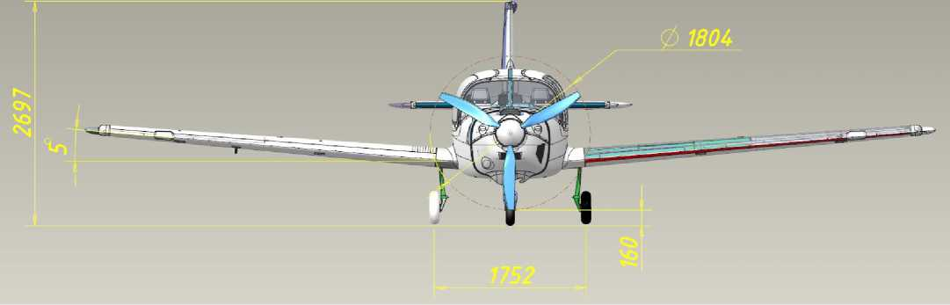

Document no. | Audit | Name of the document | Date. | Page
AA-0110-10000101 | 003 | Technical description of the ANG-01 light aircraft | 15.06.22 | 4 / 57

Document no. | Audit | Name of the document | Date. | Page
AA-0110-10000101 | 003 | Technical description of the ANG-01 light aircraft | 15.06.22 | 5 / 57

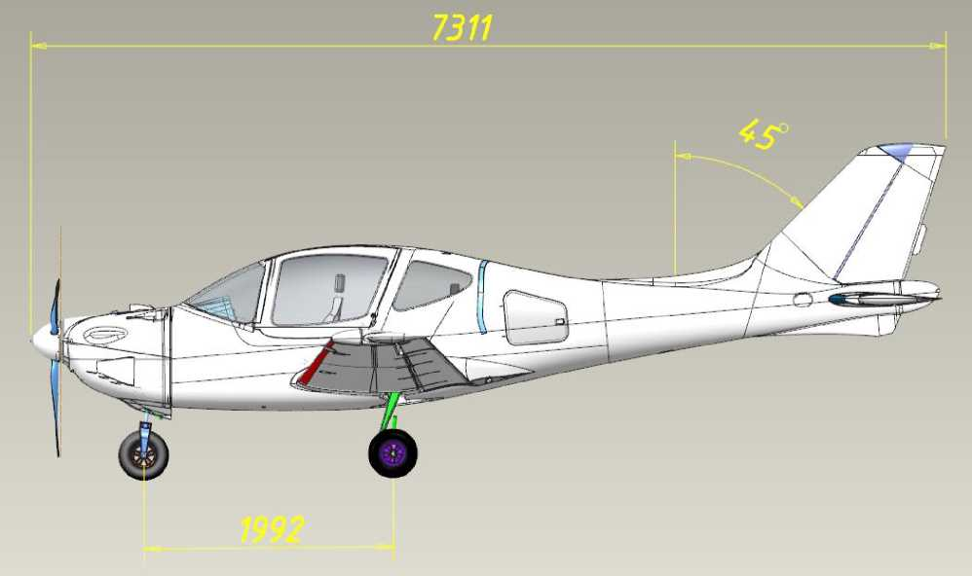
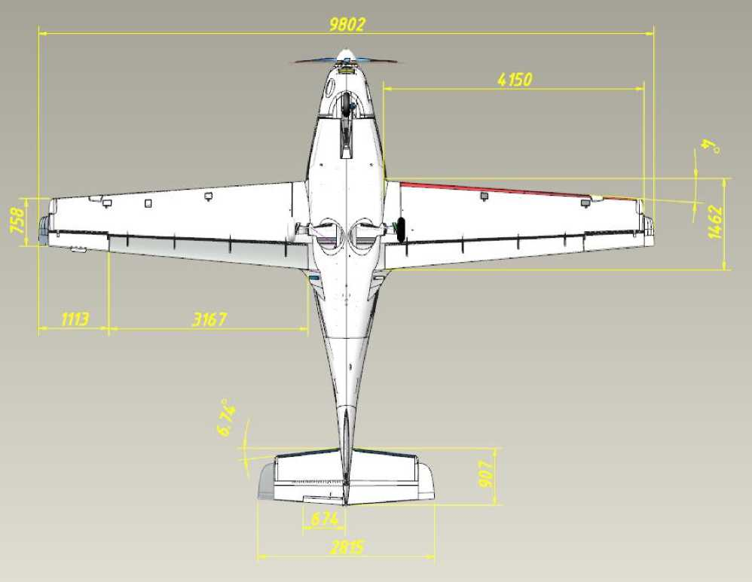

  - Constructional scheme
The ANG-01 aircraft (Annex 1) is a free-wheeling low-wing airplane of normal aerodynamic design, with a three-pillar landing gear, a single piston engine powerplant and a variable pitch propeller.
  - Fuselage
The fuselage (Annex 9) is of variable oval cross-section. The fuselage body is made entirely of composite materials (carbon fiber, fiberglass, foam). The fuselage power scheme includes: right and left upper skins, lower skins, 5 frames, instrument panel, nose strut niche, pilots' floor, pilot seat beam, center armrest, passengers' floor, spars box, main strut niches, and trunk floor.
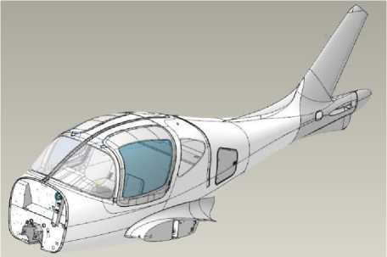
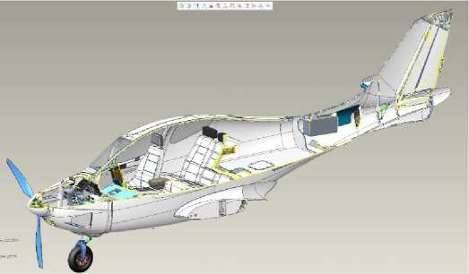
Figure 2 Fuselage. General view (Section)
Figure 1 Fuselage. General view.
In the center part there is a leaky cockpit with a total of 5 seats and a luggage compartment, in the tail part there is a tailplane. Entry and exit to the cabin is through the side doors (made of composite materials) on the left and right sides (they are also emergency exits).
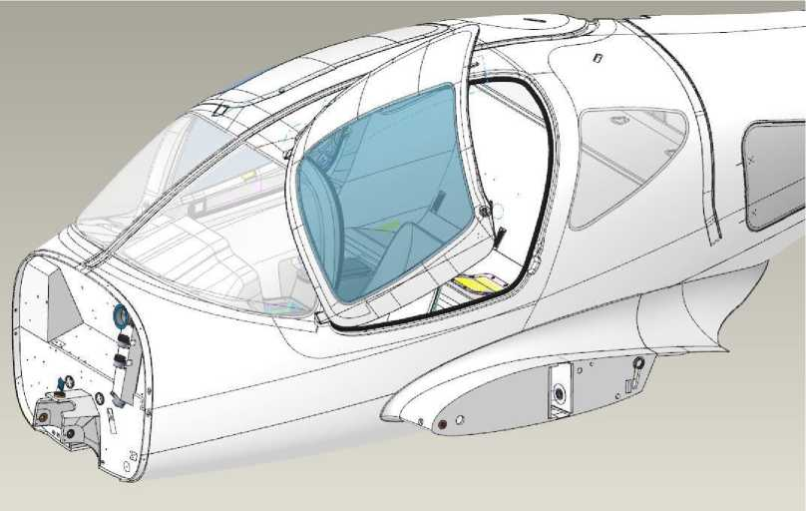
Figure 3 Doors.

Document no. | Audit | Name of the document | Date. | Page
AA-0110-10000101 | 003 | Technical description of the ANG-01 light aircraft | 15.06.22 | 6 / 57

There is a trunk in front of the tail section.
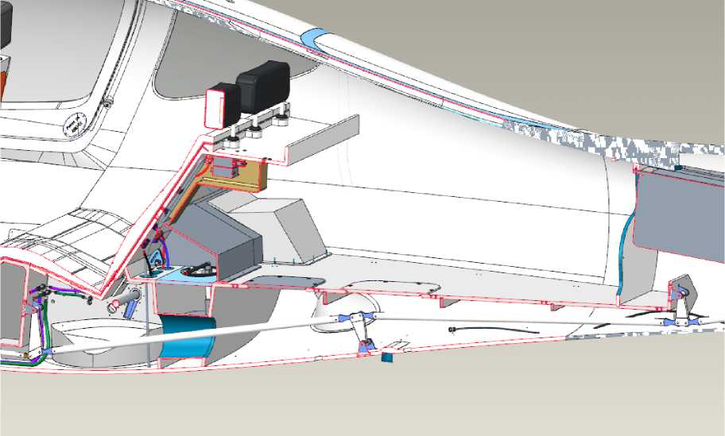
Figure 4 Luggage compartment

  - Wing
The wing (Annex 10) is trapezoidal in plan, with an area of 10.845 m2, with a straight sweep along the line of quarter chords (0.25b) equal to 1.693° and along the leading edge 3.817°. The wing cross-sections have a constant span profile APA-165 (Airfoil Patriot Aircraft 16.5%) with a thickness of 16.5%. The wing chord in the plane of symmetry is 1500 mm, and the end chord is 750 mm.
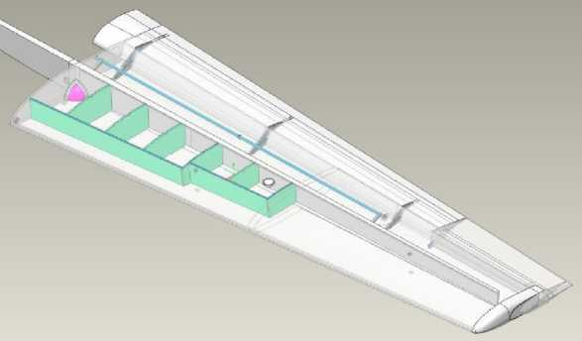
Figure 5 Console on the left. General view.

The wing has no geometric torsion along the span of the cantilevers. The wing cantilever tip is made with horn aileron compensation, which occupies 56% of the final chord. The wing mechanization is a "Fowler flap" with a maximum extension of 16.5%, with a deflection angle of 30°. There are intermediate deflection angles of 10 and 20 degrees.
The wing is made entirely of composite materials. The wing power scheme includes
Document № | Audit | Name of the document | Date. | Page
AA-0110-10000101 | 003 | Technical description of the ANG-01 light aircraft | 15.06.22 | 7 / 57
- upper and lower skin, root nerve, spar.
The spars of the right and left consoles are joined together in the fuselage by two connecting elements.
The upper and lower spar shelves are made of carbon fiber pultruded rods with a square cross section.
The flap drive shaft (made of carbon fiber pipe) of the left and right consoles is located in the fuselage and is driven by an electric drive.
The wing ailerons are controlled by a tie rod system from a manual control station located on the pilot seat beam. All tie rods and rockers of the control system are made of composite materials. The hinge joints of the control system have spherical bearings.
  - Tail plumage
Tail fins of the classic type with one keel. The profile of the horizontal and vertical fins is symmetrical according to NACA 65-1-012. All elements of the tailplane are made of composite materials.
  - Chassis
The chassis (Appendix 9) is three-pillar, retractable and extendable by hydraulic cylinders, with a single nose and two main legs. The main and front chassis legs are equipped with wheels of the same size. The chassis is air-oil damped.
The front chassis support is pedal controlled. The angle of rotation of the rack is ±30º with full pedal deflection. Wheel rims are cast. Mitas 16x4 (4.00-8) 2PR B5 Super pneumatic tires of chamber type. The front rack wheel is not braked. The wheels of the main racks are equipped with hydraulic disc brakes with a movable brake disc and a fixed brake caliper. The brakes are actuated by brake pedals mounted on the directional control pedals. Braking can be performed independently from both the left and right pilot seats, separately for the left and right sides. There are no anti-tip devices.
The nose post (Appendix 7) has a composite fork and upper rocker.
  - Power plant
In the forward part of the fuselage, on the No. 1 spar, there is a welded engine room made of round tubes (AISI 4130 steel), on which the power plant with an engine and a propeller drive is mounted through shock-absorbing cushions.
The Rotax 915 iS3A engine is designed and manufactured by ROTAX (Austria): piston, 4-stroke, 4-cylinder, opposed, combined cooling. The cylinder heads are cooled by liquid, and the cylinders are cooled by air. Propeller drive through a reduction gearbox with a gear ratio of 2.47. The fuel-air mixture system is injected. To increase power, the engine is equipped with a turbocharger and intercooler. The engine control lever controls the power at the output shaft with the help of the injector throttle and is located on the central armrest between the pilot's seats.
Document № | Audit | Name of the document | Date. | Page
AA-0110-10000101 | 003 | Technical description of the ANG-01 light aircraft | 15.06.22 | 8 / 57
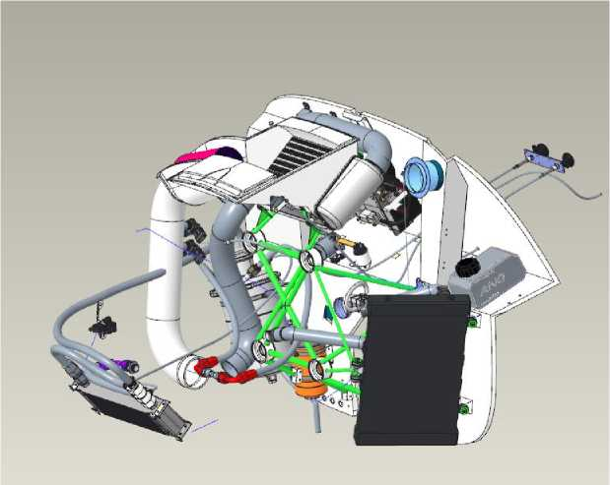

Figure 6 Power plant. General view.
Standard equipment of the electrical system of the Rotax 915 iS5A engine.
- Fully redundant electronic engine management system (EMS), including injection system, ignition system and other kit.
- An electric starter and generator are included.
The electrical and electronic components (including wiring harnesses, ECU, fuse box, PMA, sensors and actuators) of the 915 iS3A engines of all series are part of the equipment and have been tested and qualified. The engine control unit ECU is connected to the on-board display system via a CAN bus. The Rotax 915 iS3A Electronic Control Unit (ECU) receives information about the operating parameters from the sensors installed on the engine by the manufacturer. The Electronic Control Unit (ECU) then transmits the following information about the engine's operating parameters to the Dynon SkyView on-board display system:
- Engine RPM (tachometer)
- Lubricant temperature
- Lubricant pressure
- Coolant temperature
- Lane A Bus voltage
- Lane B Bus voltage
- Exhaust gas temperature of 1-4 cylinders
- Fuel pressure in the fuel
- Instant fuel consumption
- Engine operating time
- Throttle position
- Power supply / operating mode ECO mode
The SV-Dynon SV-HDX1100/A on-board display system indicates alarms of the power plant and generator operation parameters with light and sound signaling to the on-board intercom network. Information on engine emergency parameters is duplicated
Document № | Audit | Name of the document | Date. | Page
AA-0110-10000101 | 003 | Technical description of the ANG-01 light aircraft | 15.06.22 | 9 / 57

an additional indicator (light and signal board) on the dashboard. Information about generator failure is indicated by the light and signal board on the instrument panel.
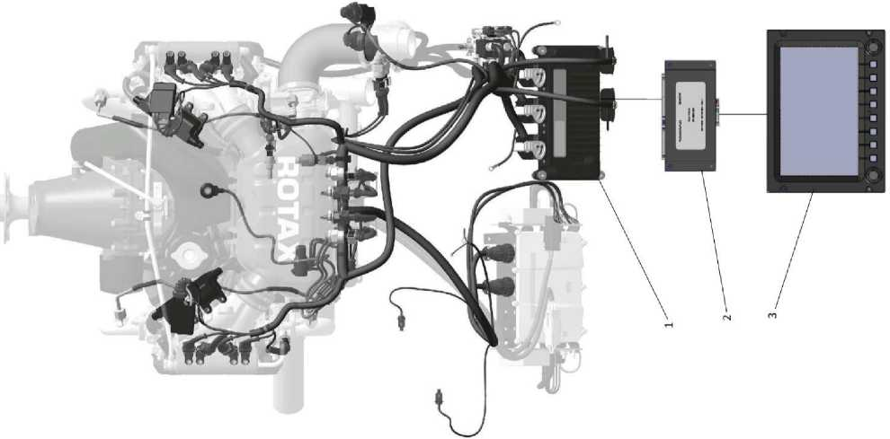

Figure 7 On-board display system
Figure 7 shows: 1 - ECU engine control unit; 2 - SV-EMS-221 engine parameter monitoring unit; 3 - SV-Dynon SV-HDX1100/A on-board display system.
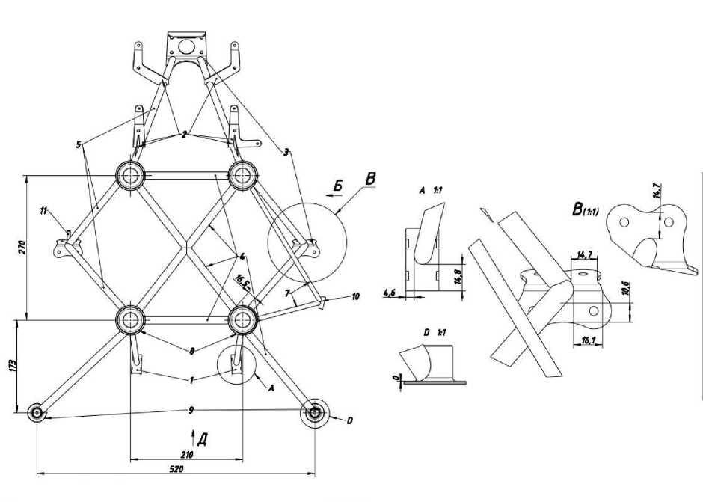
Figure 8 Drawing of motor frame and motor mounting

The display shows alarms of emergency parameters of the power plant, the system
Document № | Audit | Name of the document | Date. | Page
AA-0110-10000101 | 003 | Technical description of the ANG-01 light aircraft | 15.06.22 | 10 / 57
The Dynon SkyView SV1100 generates an appropriate sound alarm and transmits it to the onboard communication system.
Power plant controls in the cab:
- Throttle control knob (ECK);
- The screw pitch control panel.
The ECK is mechanically connected to the throttle. The ECK is mounted on the center armrest between the pilots. The rest of the engine control commands are executed by the ECU. Next to the ECK is a stencil that clearly indicates the purpose of this engine control (TRUST LEVER), the relative scale and the minimum and maximum positions (MIN and MAX).
The propeller pitch control panel designed and manufactured by Microel srl (Italy) operates in manual and automatic mode, switched by a toggle switch on the panel. In manual mode, the pilot sets the required engine speed using a sensor (crematorium), in automatic mode, the speed is set and maintained by the ECU depending on the throttle position. Further, the electrical control signals are transmitted by means of a sliding contact to the electric drive of the propeller pitch change mechanism. The remote control is equipped with a screen that displays the set engine speed.
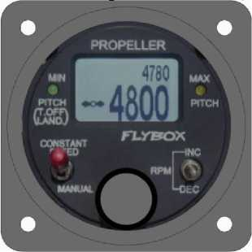
Figure 9 Screw pitch control panel.

The main operational limitations set by BRP-Rotax:
Limitations. | Meaning. | Note
Shaft speeds | 1800 rpm | low gas mode
 | 5500 rpm | nominal mode
 | 5800 rpm | mode max. up to 5 min.
Maximum height | 7000 м | I SA
 | 4570 м | at T h = +50 °C
Medium temperature | -20°C | Minimal
 | 50°С | Maximum
Lubricant consumption. | 0.06 l/h | Maximum
lubrication pressure | 0.8 bar | Minimum, <3500 rpm
 | 2.0 bar | Minimum, <3500 rpm
 | 5.0 bar | Maximum

Document № | Audit | Name of the document |  |  | Date. | Page
AA-0110-10000101 | 003 | Technical description of the ANG-01 light aircraft |  |  | 15.06.22 | 11 / 57
Fuel pressure |  |  | 2.9 bar  3.1 bar | The minimum operating time.  The maximum operating time.
Lubricating oil temperature*. |  |  | -20°С  90°С | Minimal  The maximum operating time.
Coolant temperature* *Coolant temperature |  |  | -20°С  90°С | Minimal  Maximum
Exhaust gas temperature (EGT) |  |  | 200°С  950°С | Minimal  Maximum
* - during ground testing, start-up and warm-up
The operating limits for the use of engine fluids are set forth at by BRP-Rotax (for more information, see Service Manual SI-915 i-001):
Lubricants: according to RON 424 classification.
The coolant recommended is Shell Dex-Cool. Coolant temperature -40°C -+ 120°C, monitored by a temperature sensor .
Fuel: Gasoline A92, 95, AKI 91, MOGAS EN 228 super (plus), AVGAS 100 LL.
  - Lever control system
The control system of the aircraft is traditional, 3-channel: longitudinal channel (elevator), transverse channel (ailerons) and path channel (directional control and nose landing gear).
The control system is mechanical, consisting of controls (control knobs and pedals of the left and right pilots, mechanically connected to each other), mechanical elements (rods and rockers) and steering surfaces.
All rods and rockers of the control system are made of composite materials. There are no cables or spring devices.
All joints of the control system are equipped with spherical bearings.
All control surfaces are slotted, equipped with aerodynamic horn and weight compensation of hinge moments. The elevator is two-section, while the ailerons and rudder are single-section. To increase efficiency, the elevator is equipped with special turbulators.
An electrically conductive trimmer (controlled by a button on the control stick) is installed in the right section of the elevator to reduce the effort of deflecting the pilot's control stick.
A bendable trim plate is mounted on the directional rudder for track balancing during cruise speed flight.
Autopilot servos are installed in the longitudinal and lumbar channels of the control system.
Document № | Audit | Name of the document | Date. | Page
AA-0110-10000101 | 003 | Technical description of the ANG-01 light aircraft | 15.06.22 | 12 / 57

Figure 10 General view of the control system in the longitudinal channel
Figure 11 General view of the control system in the lumbar canal:
Document no. | Audit | Name of the document | Date. | Page
AA-0110-10000101 | 003 | Technical description of the ANG-01 light aircraft | 15.06.22 | 13 / 57

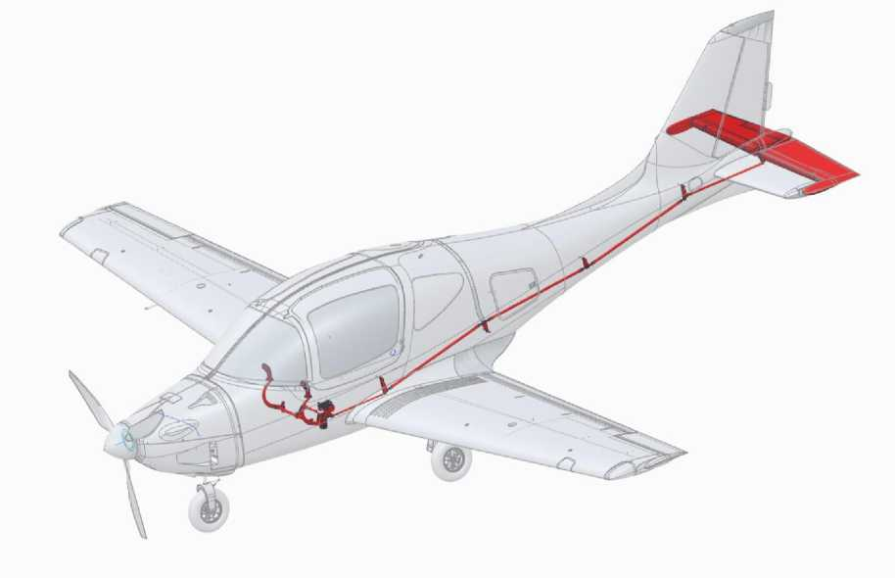
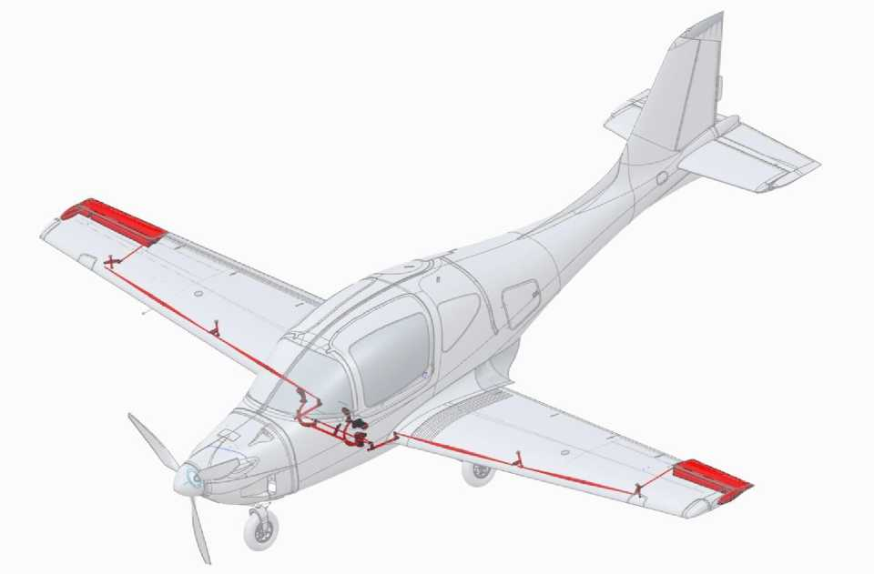

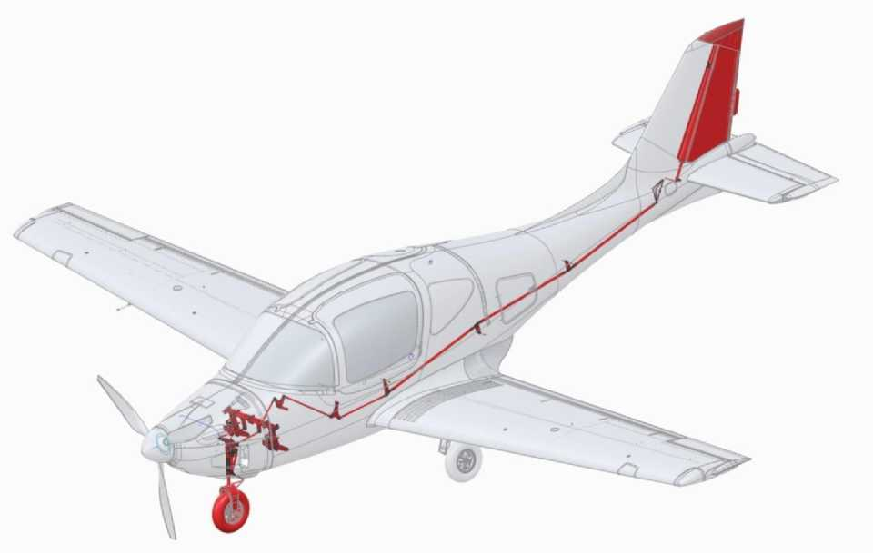

Figure 12 General view of the control system in the track channel:
Mechanization of the trailing edge of the wing: Fowler flap (single-slide, retractable) with a maximum deflection angle of 30°. Intermediate positions are 10 and 20°.
The flap is released and retracted by a servo located in the fuselage using the appropriate part of the shaft (compatible with the consoles when mounted).
Flap release and cleaning system:
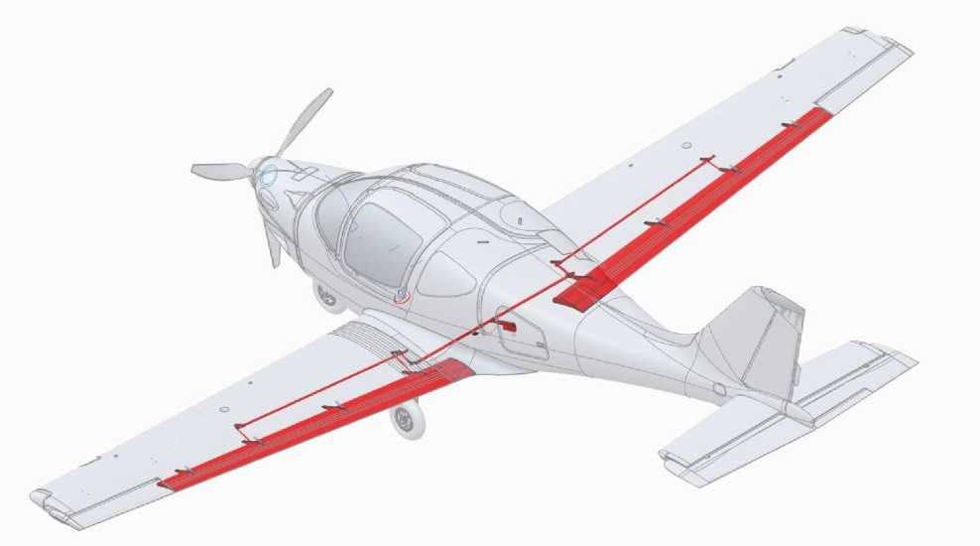
Figure 13 Flap release and cleaning system:

Document no. | Audit | Name of the document | Date. | Page
AA-0110-10000101 | 003 | Technical description of the ANG-01 light aircraft | 15.06.22 | 14 / 57

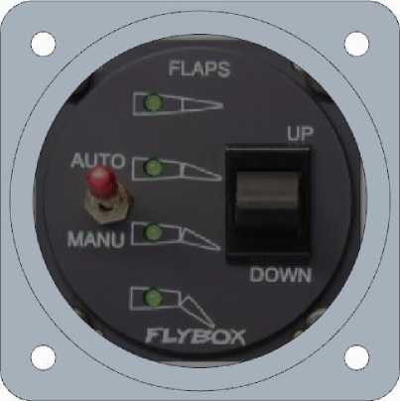
Figure 14 Flap release and retraction control is performed from the EFC67-P remote control designed and manufactured by Microel srl (Italy).
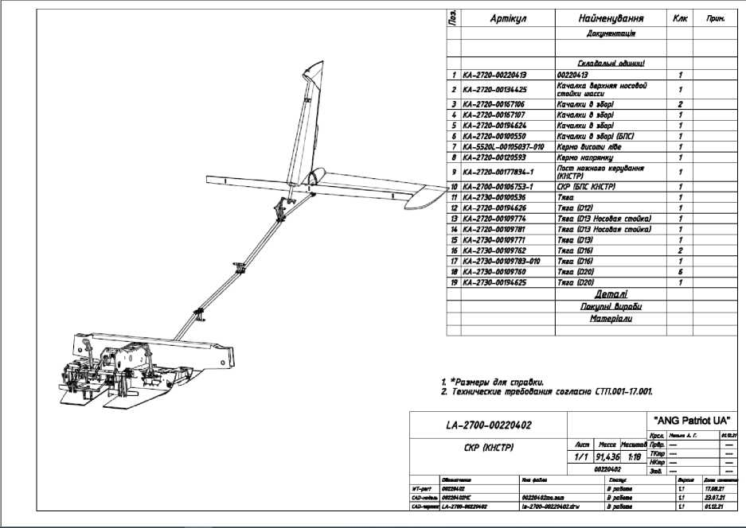
Figure 15 drawing of the control system

Document no. | Audit | Name of the document | Date. | Page
AA-0110-10000101 | 003 | Technical description of the ANG-01 light aircraft | 15.06.22 | 15 / 57

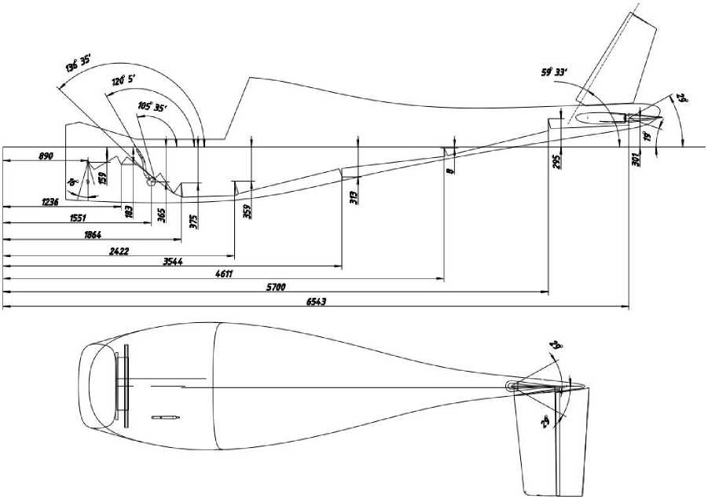
Figure 16: Control system drawing

Maximum deviations of the steering surfaces when deviating from the standard controls (ACK and pedals to the stop):
surface _ _ _ | Direction Angle Tolerance/lift
Height control (left, right section) | Up 29°  ±1°  down 19°
The steering wheel of direction | Left 25° _{±1°}  Right 25°
Aileron (left, right) | Up 14° _{±1°}  down 17°
Height trimmer | Up 15° ±1°  down 15°

Switching speed of the ELV trimmer from one to the other limit position 10 seconds In the neutral position of the control handle and pedals, the steering surfaces must fit into
stabilizer, keel, and wing contours, respectively, the tolerance for all surfaces should not exceed ±1°.
The trimmer plate of the directional rudder can be tilted by an angle of up to ±10° to compensate for gyroscopic torque and oblique airflow from the propeller (see AFM for angle selection).
  - Fuel system
The fuel system (Appendix 5, Appendix 5A) consists of two fuel tanks located in the root
Document № | Audit | Name of the document | Date. | Page
AA-0110-10000101 | 003 | Technical description of the ANG-01 light aircraft | 15.06.22 | 16 / 57
The wing part of the fuel tanks with a capacity of 110 liters each and the fuel tank with a capacity of 70 liters. Thus, the maximum total capacity of the fuel system, excluding the non-draining residue, is 295 liters. The fuel flows into the delivery tank by gravity. There are two fuel booster pumps installed in the fuel tank. The fuel tank drainage system is connected to the atmosphere. In the wing tanks, the drainage pipes are led from the top of the fuel tank to the root neuron and connect to the top of the delivery tank. In the expendable tank, the drainage exits from the top of the tank, passes through the compartment above the fuel tank (behind the passenger compartment), and is discharged at the bottom under the fuselage.
The wing tanks are made of sandwich panel partitions glued into the wing (AEROGLASS fiberglass and Divinycell gasoline-resistant foam). The entire inner surface of the tanks is treated with GASTANK fiberglass fuel tank sealant to seal the fuel tanks.
The fuel tank is located in the fuselage and is made of sandwich panels (carbon fiber and Divinycell gasoline-resistant foam). The inner surface is treated with GASTANK fiberglass fuel tank sealant to seal the fuel tanks
Excess fuel is drained back into the fuel tanks from the engine injector fuel ramp through a drain line, also located between the cockpit floor and the lower fuselage skin to the left of the nose landing gear .
The drainage in the console and flow tanks is centralized,
A U-shaped tube (to prevent fuel from spilling into the center compartment) is led to a fuselage nozzle. Refueling is carried out exclusively through the necks of the console tanks. The fuel system and drainage pipelines are made of aluminum tubes, which are fixed in the aircraft structure. In the engine compartment and at the junction of the consoles, the pipelines are made of gasoline-resistant hoses.
The lids of the cantilever tanks are made of aluminum alloy, equipped with a drainage hole, and can be closed by turning 90° and locking the closed position.
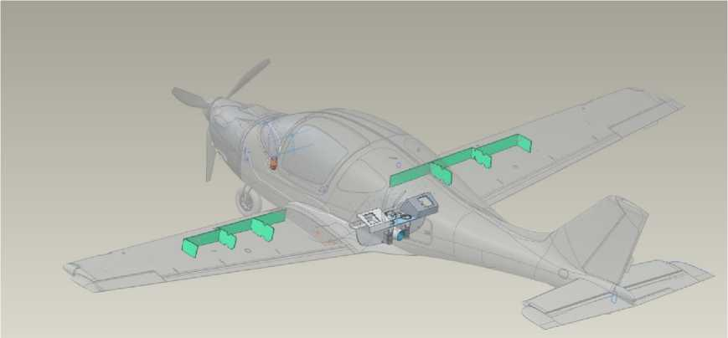
Figure 17 Diagram of fuel tanks

Document № | Audit | Name of the document | Date. | Page
AA-0110-10000101 | 003 | Technical description of the ANG-01 light aircraft | 15.06.22 | 17 / 57

Figure 18 Fuel system
Document no. | Audit | Name of the document | Date. | Page
AA-0110-10000101 | 003 | Technical description of the ANG-01 light aircraft | 15.06.22 | 18 / 57

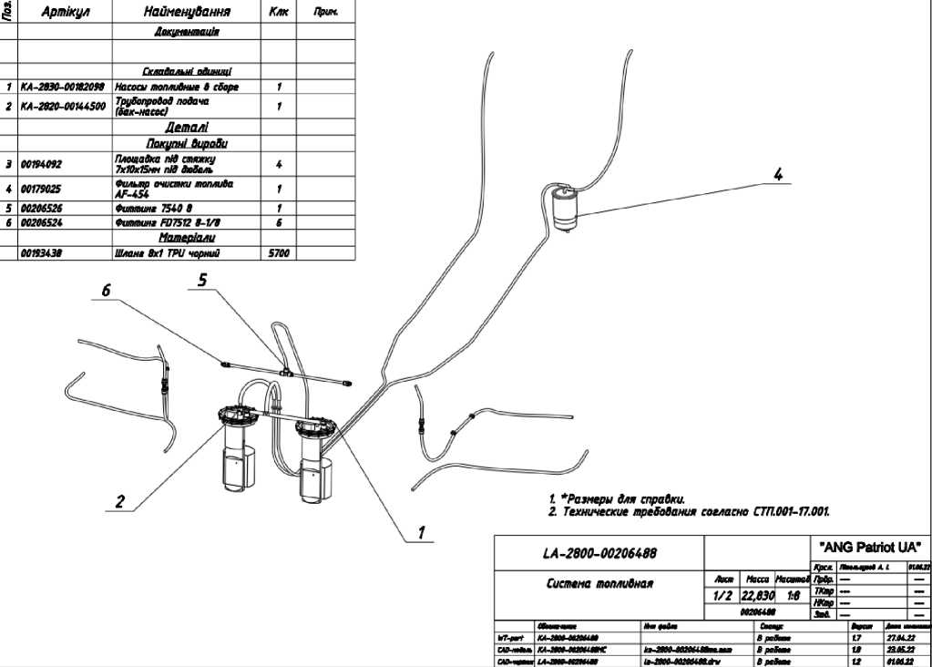

Figure 19 Fuel tank vents and vapor exhaust
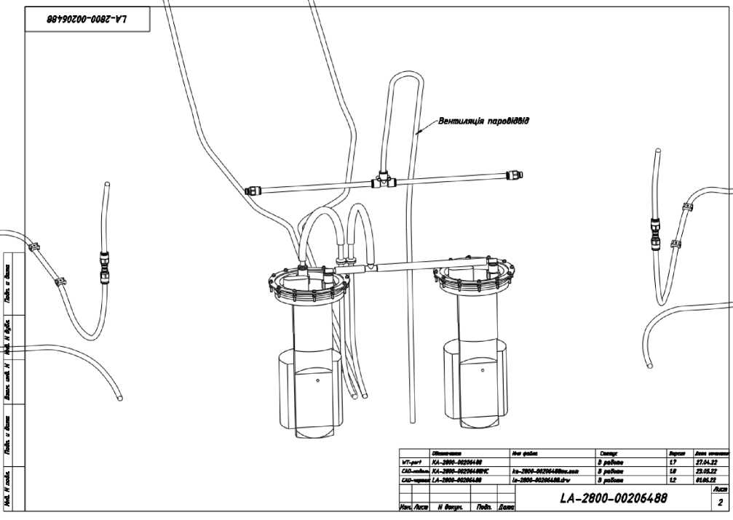

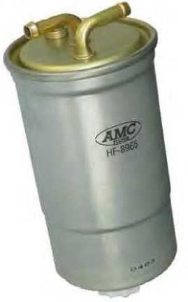
Fueling should be performed manually only through the necks of the console tanks using 10 or 20-liter containers and funnels with a coarse filter (not included in the aircraft ground equipment). It is allowed to refuel with a gun from a vehicle fuel dispenser system.
After refueling, close the fuel tank necks tightly until the red lines on the neck and the console coincide, check the condition of the drainage in the neck (the hole must be clean).
If fuel leaks through the console during refueling, wipe it with a dry cloth.
Fuel quantity control: by the number of tanks and when the appliance is switched on, by the fuel gauge.
The amount of fuel is determined by the pilot based on the route, flight duration, forecasted meteorological conditions, crew composition, and amount of baggage.
Figure 20 Fuel filter
Document no. | Audit | Name of the document | Date. | Page
AA-0110-10000101 | 003 | Technical description of the ANG-01 light aircraft | 15.06.22 | 19 / 57

3.10. Oil system
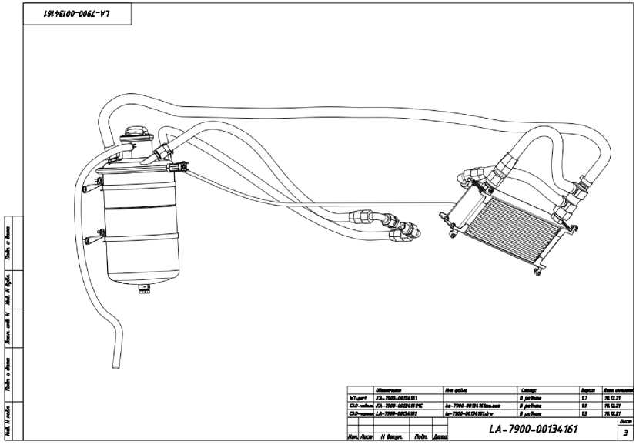

Figure 21 Engine oil system
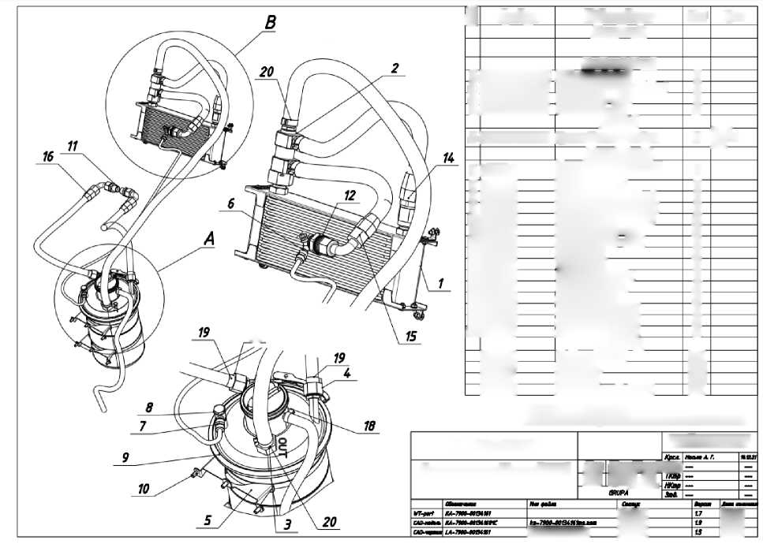
Jatzgiii V rabvya" BpeSt-
Bitzs)
"ANG Patriot UA
LA-7900-00134W
Lk" Mono Maayyuu PrOr.
Mizuna oil system (R915is)
1/3 1,966\J^
(e-tnmoyaiy/
And^ Ramers for the Arabians.
2. Technical traceability according to STP.M1-17.00i
Af 1-2.5)
4
"YL
LIM LIM
1 | Article | Name | How to. | Note.
 |  | Documentation
 |  | Warehouse abundance)
1 | KÀ-792O-00S6085 | Oil radiator | 1
2 | KA-792O-00S41Î3 | Oil thermostat 6 assemblies | 1
3 | KA-7920-OOV4114 | ANYU wick - M22 | 1
4 | KA-792O-001341Î2 | Fitting AN8 - MM | 2
 |  | Details
5 | KA-79W-W136076 | Oil tank bracket | 2 | Lk" 1 ajaiyag Lk"
 |  | Purchased SupoSu
6 | 00134321 | Cemozzi U20 6-1/8 (Fitine veloboy) | 1
7 | 09134382 | CM/ozti 1170 o-va | 1
8 | 00134359 | Cemozzi 1631 01-1/8 (Genesis) | 1
9 | 00032383 | Oil tank (Rolex 3SJt) | 1
№ | 00099964 | Bandage IS07380-2 N5x10-8,8 | в
11 | 0005316 7 | Adapter AN8 - M#. | 2
12 | 00134305 | Adapter N12 - AMO | 1
13 | 00206932 | Spring 777 | 5
14- | 00053182 | AMO fittings | 1
15 | 00134309 | AMO 90 dey fittings | 1
16 | 00053166 | Fitting AN8 90deÿ | 2
17 | 00076206 | Clamp (130-150) | 2
№ | 00134388 | Spring clamp 012 | 1
19 | 00134377 | Spring clamp DS | 2
29 | 00134381 | Spring clamp DS | 4
 |  | Materials.
 | 00134319 | Copper tube D6 | 950
 | 00134267 | AMO slag | 1950
 | 00134165 | Schlenz AM | 1200
 | 00134376 | Schlenk Beckfast 8x13 | 590

Figure 22 Oil system
The oil cooler is indicated by position 1
Document no. | Audit | Name of the document | Date. | Page
AA-0110-10000101 | 003 | Technical description of the ANG-01 light aircraft | 15.06.22 | 20 / 57

  - Fire extinguishing agents
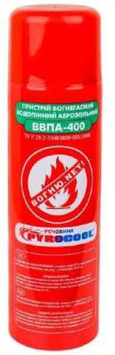
In total, there are 3 containers of aerosol fire extinguishing agent with a total weight of 1.2 kg on board. Containers with extinguishing agents: 2 containers of 0.400 kg are located under the pilots' seat and one container is located on the shelf behind the rear passenger seats.
Figure 23 - PYROCOOL GDP-400 fire extinguisher
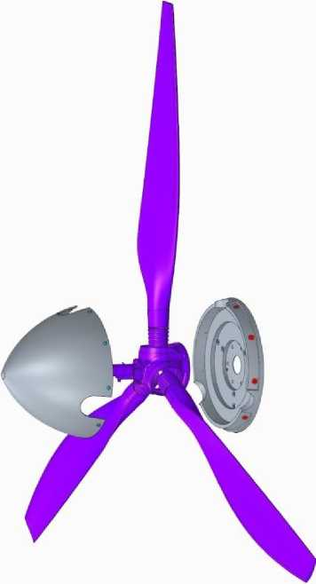
The propeller (Annex 11) was developed and manufactured by Patriot-Ukraine ANG LLC, which does not have a Type Certificate. The propeller is a three-blade propeller with variable pitch in flight. The propeller pitch control actuator is electric, located in the propeller hub and covered by the propeller crown. The pitch control is performed from the cockpit using a device located in the middle of the front faceplate and has two modes (manual and automatic). In manual mode, the pilot directly controls the propeller drive, increasing or decreasing the pitch. In the automatic mode, the engine speed is set and the control unit maintains the set speed, easing or making the propeller heavier or lighter depending on the flight speed and the actual engine crankshaft speed.
3.12. Air screw
Figure 24 air screw
The blades are made of carbon fiber, EPOXY-619 epoxy resin and TELALIT 600 hardener, and the internal cavity is filled with petrol-resistant polyurethane foam. The leading edge of the blade is protected from mechanical damage by a polyurethane lining. The blades are not equipped with heating.
Document № | Audit | Name of the document | Date. | Page
AA-0110-10000101 | 003 | Technical description of the ANG-01 light aircraft | 15.06.22 | 21 / 57

Operational limitations :
Limitations. | Meaning. | Note
Shaft speeds | 2700 rpm | Maximum
Medium temperature | -20°C | Minimal
 | 45°С | Maximum
Blade installation angle | 13° | Minimal
(transfer speed 2 ° / s) | 33° | Maximum
Blade runout | ≤1.5 mm | Radial
 | ≤7.0 mm | Axial

Screw vibration
Blade runout ≤ 1.5 mm Radial; ≤ 7.0 mm Axial.
Restriction of screw speed and pitch
Maximum screw speed 360 km/h; Screw pitch 13º-33º
Installation.
The three blades are mounted in an aluminum hub, which has an electrically driven pitch change mechanism and is closed by a cockle.
  - Hydraulic system
The hydraulic system (Appendix 6, Annex 6A) is designed for releasing and cleaning the chassis. The hydraulic system is assembled from hoses and fittings from HYDROSCAND.
The maximum working pressure of the hoses is 55 MPa.
The pressure source in the hydraulic system is an electrically driven, overheat-protected, reversible gear pump, mounted in a unit with a tank and safety valves. The maximum operating pressure of the hydraulic system is 15 MPa. The capacity of the hydraulic tank is 2.5 liters. The type of hydraulic fluid is ATF DEXTRON 1V lubricant. Control of executive hydraulic cylinders by means of pump reversing. Hydraulic cylinders of chassis cleaning and release have built-in locks in the released and retracted positions. In the released, locked position, the hydraulic cylinder works as a rigid rod, taking the load on the chassis in accordance with the design cases, regardless of the pressure in the hydraulic system. The locks are released by reversing the hydraulic fluid flow. All hydraulic cylinders are equipped with hydraulic cylinder lock position sensors, during operation of which the position of the hydraulic cylinders is indicated (retracted and released position) in the cockpit on the panel on the center armrest.
The emergency landing gear release is provided by a pneumatic system (from CO2 cans). The emergency release system activated by the pilot by "pricking" the cans and turning the tap handle to the emergency release position. With such actions, CO2 is supplied to the hydraulic system hoses under pressure by a valve in the system tee, closing the channels with working oil, and ensuring gas supply. After eliminating the causes of the failure, switching the valve from the emergency release position and supplying lubricant from the main system pump, the valve in the tee returns to its operating position.
Document № | Audit | Name of the document | Date. | Page
AA-0110-10000101 | 003 | Technical description of the ANG-01 light aircraft | 15.06.22 | 22 / 57

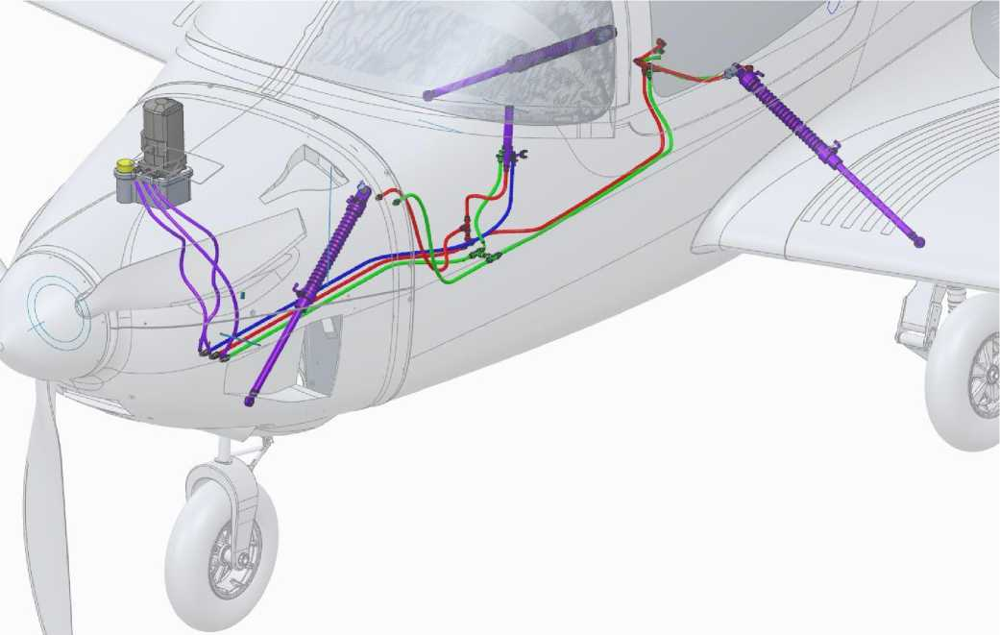
Figure 25 Hydraulic system

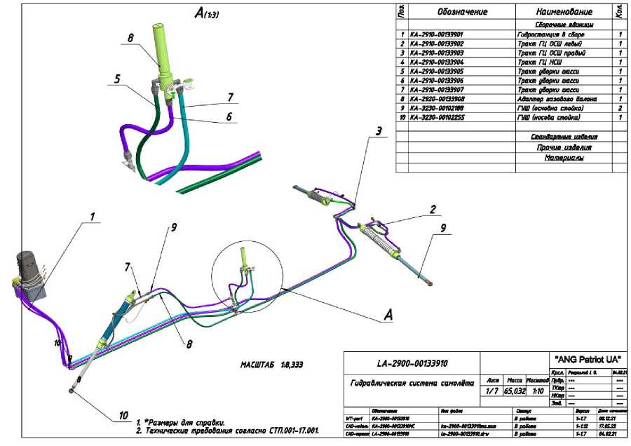
Figure 26 Hydraulic system

  - Electrical system
The current source is a twin generator mounted directly on the engine .
Document no. | Audit | Name of the document | Date. | Page
AA-0110-10000101 | 003 | Technical description of the ANG-01 light aircraft | 15.06.22 | 23 / 57
The main task of the generator is to power the electrical consumers of all aircraft systems. The 12V 24Ah electric battery is located in a separate compartment. The battery compartment is equipped with a temperature sensor, the readings of which are displayed on the Dynon SV-HDX1100/A multifunctional flight information display device. The main task of the battery is to start the engine, power the engine control system during startup, and power the airframe (e.g., equipment) in emergency mode (generator failure). Two generators (generator 1 and generator 2) are electrically isolated and mounted on the same stator. Each generator is connected to a regulator mounted on a box with fuses.
When the engine is started, a battery connection is required to power the engine management system. After the engine has reached a speed sufficient to supply the engine management system from generator 2, the engine is controlled from an external source only in emergency situations. If the set engine speed threshold is reached within a certain time, the engine control system is powered by generator 1. After that, the generator can be used to power the airframe (e.g., equipment). In any operating condition, the generator 1 must not be used to power the airframe.
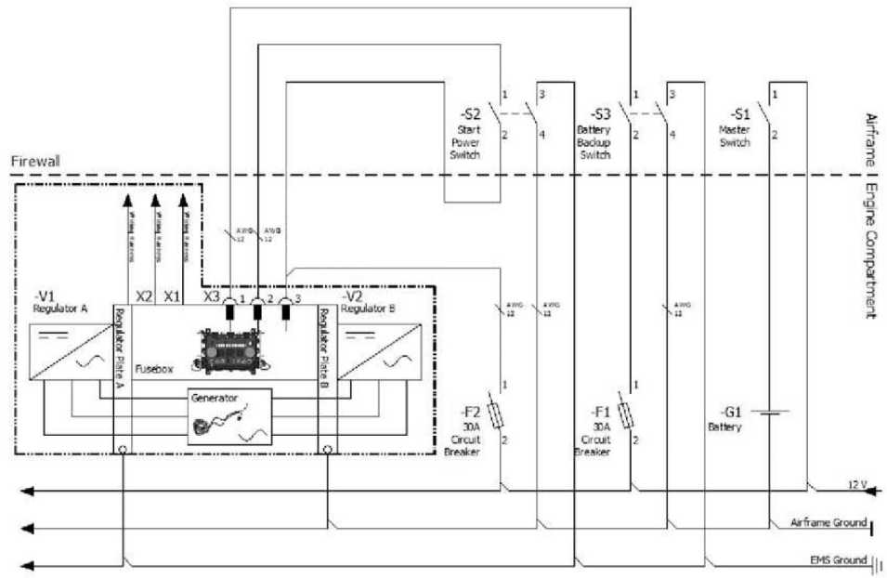
Figure 27: Aircraft power supply scheme.

Document no. | Audit | Name of the document | Date. | Page
AA-0110-10000101 | 003 | Technical description of the ANG-01 light aircraft | 15.06.22 | 24 / 57

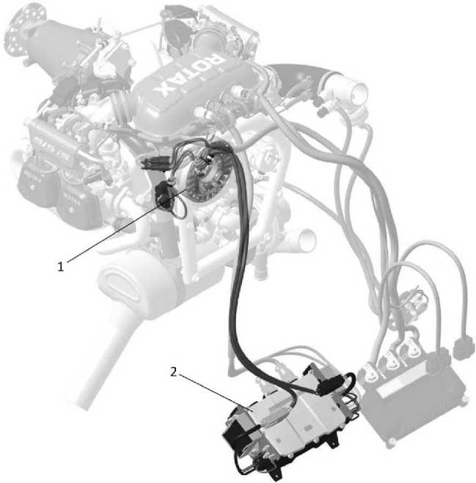

Figure 28 Aircraft power generation and control system.
- Standard integrated generator 1,2; 2) Fuse box with rectifier regulators
1/2.Power supply to the onboard network from generator No. 2 is possible only after the engine speed reaches 1800 rpm and the starter is disconnected.
In case of failure of generator No. 1, the engine power supply is automatically switched to generator No. 2. Thus, it is disconnected from the onboard consumer network, providing power exclusively to the engine. At the same time, the WARN EMS light indicator on the instrument panel turns on.
The battery provides power:
- during maintenance: all consumers (30 minutes, ISA);
- at engine startup: starter and ECU;
- in flight, in case of generator failure: all consumers (15 minutes, in ISA).
The pilot's instrument panel additionally has a light and signal indication:
1) Mnemonic panel of the chassis position (released/retracted),
- Starting up - failure of fuel pumps,
- Generator failure,
- Failure of the HDPE heating controller,
- Starting up - failure of the hydraulic system pump.
  - Instrumentation equipment
Piloting and navigation equipment.
The following instruments of the flight and navigation group are installed on the instrument panel of the aircraft:
Separate devices:
- Speed indicator FALCON 3-1/8 ASI316KN-3 - indicates the speed relative to the air flow, in kilometers per hour. Uses static pressure from the static port and dynamic pressure from the
Document № | Audit | Name of the document | Date. | Page
AA-0110-10000101 | 003 | Technical description of the ANG-01 light aircraft | 15.06.22 | 25 / 57
air pressure transmitter.
- FALCON 3-1/8 VSI10MEF-3 Vertical Velocity Indicator - indicates the rate of ascent/descent in meters per second. Uses static pressure from the static port.
- Altitude indicator FALCON 3-1/8 ALTN10MBF-3 - indicates the barometric altitude in meters. It uses static pressure from the static port.
- The FALCON 2-1/4 SI-2Q sliding indicator shows the amount of sliding. It works autonomously.
- Magnetic heading indicator CM13 - indicates the magnetic heading of the aircraft. It works autonomously.
*Variant instrumentation (feet, metric) by replacing the indicator.
The Dynon SV-HDX1100/A multifunctional flight information display device is indicating:
- Speed relative to airflow, in kilometers per hour,
- Speed relative to the ground, in kilometers per hour (GPS data),
- Rate of ascent/descent, in meters per second,
- The value of the barometric flight altitude, in meters,
- The value of the flight height relative to the ground, in meters (GPS data),
- The spatial arrangement of the airplane,
- The amount of sliding,
- The magnetic course of the aircraft
- Position of the aircraft (GPS data),
- Angle of attack,
- Flight route (GPS data),
- Transponder operation control (used as an interface).
*The Dynon SV-HDX1100/A has a choice of measurement units (feet, metric) in the instrument setup menu.
The Dynon SV-HDX1100/A works in conjunction with the components of the Dynon SkyView system
- Multifunctional flight information display device Dynon SV-HDX1100/A,
- (GPS Antenna/Receiver Module) Dynon SV-GPS-250/A,
- Transponder antenna COMANT CI-105 XPDR ANTENNA,
- Dynon SV-32 autopilot (pitch) servo drive,
- Transponder (Mode-S Class 1 Transponder) SV-XPNDR-261,
- Outdoor temperature sensor Dynon SV-OAT-340,
- Module SV-ADAHRS-200/201,
- Dynon SV-42 autopilot servo (roll),
- Dynon Heater Controller for heating of LDPE
- Airspeed indicator FALCON 3-1/8 ASI316KN-3,
- Barometric altitude indicator FALCON 3-1/8 ALTN10MBF-3,
- Dynon Heated AOA/Pitot Probe,
- Static pressure port,
- vertical speed indicator FALCON 3-1/8 VSI10MEF-3.
Figure 44 shows the connections between the non-autonomous devices of the airplane's flight and navigation complex.
Document № | Audit | Name of the document | Date. | Page
AA-0110-10000101 | 003 | Technical description of the ANG-01 light aircraft | 15.06.22 | 26 / 57

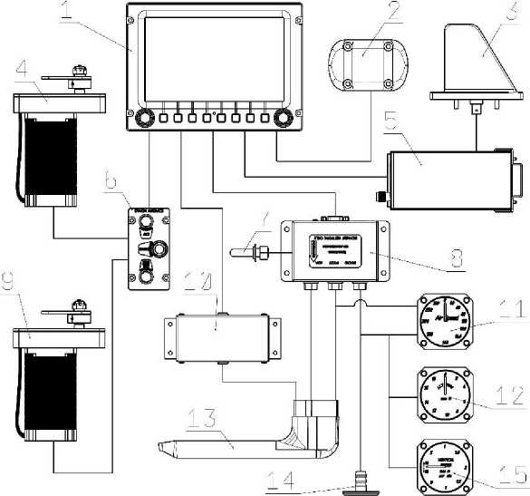
Figure 43
The airplane is equipped with airborne navigation lights (ANL), collision warning flashing lights (strobes) and landing lights. The right wing tip has a combined BANO (aviation green) and a white strobe light. The left wing tip has a combined BANO (aviation red) and a white strobe. Landing lights (1 for each wing console) are located on the leading edges of the wing consoles. At the end of the fuselage in the tail of the aircraft there is a BANO (aviation white). There is a strobe light on the end of the rudder (aviation red). The BANO, strobes and landing lights are switched on from the cockpit using separate switches.
It provides two-way radio communication "Aircraft-to-aircraft" and "Aircraft-to-ground":
- Dynon Skyview Com Radio SV-COM-25C radio station with automatic transmitter.
Negotiations on the internal onboard network are provided:
- a subscriber node with internal radio communication plugs, including the FLIGHTCOM INTERCOM 403MC intercom
Basic flight and navigation equipment
The main flight and navigation equipment is the Dynon SV1100 system developed and manufactured by Dynon Avionics (USA).
The material contained in this AMM is sufficient for the full operation of the Dynon SV1100 system, but a separate manual is available at http://docs.dynonavionics.com (Dynon Avionics does not provide hard copies of the manual).
Elements of the system:
- Heated pitot tube Dynon Heated AOA/Pitot Probe (1 pc);
- Dynon SV-HDX1100 display (1 pc);
- Dynon SV-ADAHRS-200 basic ADAHRS module (1 pc);
- Dynon SV-EMS-221 motor communication module (1 pc);
- Dynon SV-COM-PANEL/V radio remote control (1 pc);
- Radio station Dynon SV-COM-T8 (1 pc);
- Dynon SV-32 autopilot servo drive (1 pc);
- Dynon SV-42 autopilot servo drive (1 pc);
Document no. | Audit | Name of the document | Date. | Page
AA-0110-10000101 | 003 | Technical description of the ANG-01 light aircraft | 15.06.22 | 27 / 57

- SV-XPNDR-261 transponder (1 pc.);
- Backup power supply battery Dynon SV-BAT-320 (1 pc.). Location of system elements on the aircraft:
Figure 44 Instrumentation equipment
Document no. | Audit | Name of the document | Date. | Page
AA-0110-10000101 | 003 | Technical description of the ANG-01 light aircraft | 15.06.22 | 28 / 57

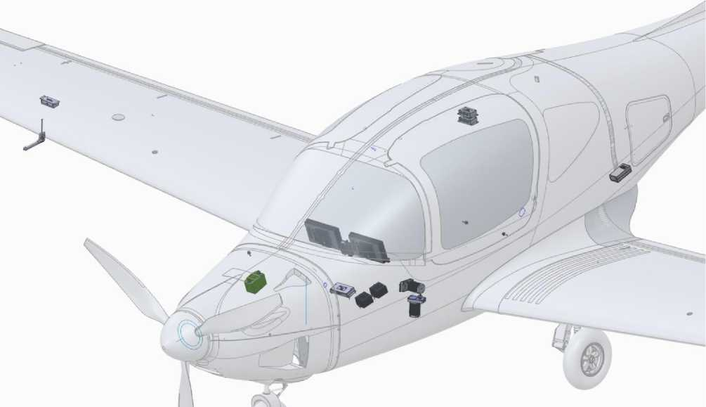

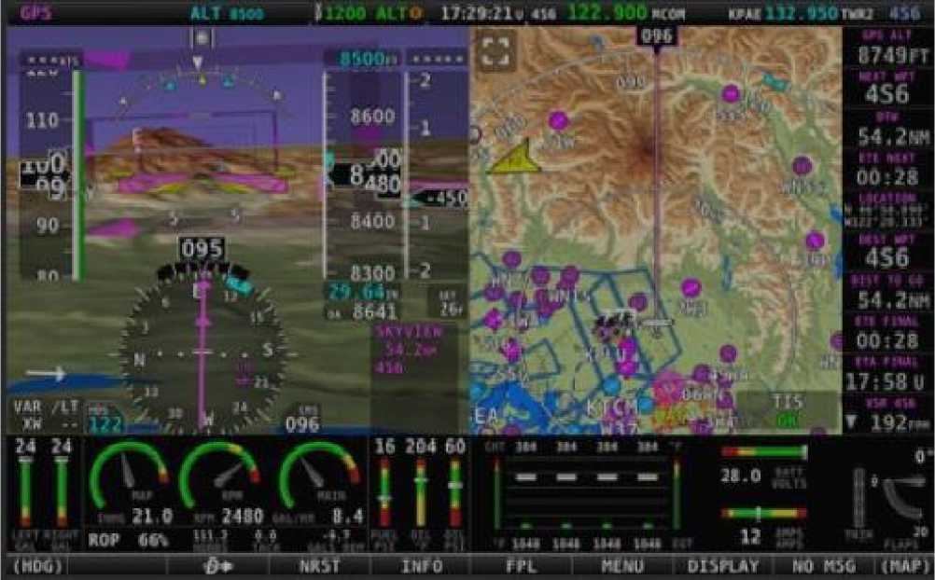

Figure 45 Instrumentation equipment
Backup pilot equipment
In addition to the main Dynon SV1100 system, the aircraft is equipped with the following redundant flight instruments (see section 0 for location):
- Air velocity device ASI3-180
- Barometric altimeter ALT2-3141
- Vertical speed device VSI2-10MS
The devices are connected to the Pitot tube in parallel with the ADAHRS sensors of the main system, the compass and slip indicator operate completely autonomously.
Devices with scales in the metric system. It is possible to place other devices with scales in the imperial system that match the specified dimensions.
The airspeed device is accompanied by an instrument correction chart (located on the cockpit light frame).
The airspeed instrument has sectors of the minimum speed limit (red), maximum operating speed with flaps released (white), and a radial line of the maximum operating speed
General view and location of backup devices:
Document no. | Audit | Name of the document | Date. | Page
AA-0110-10000101 | 003 | Technical description of the ANG-01 light aircraft | 15.06.22 | 29 / 57

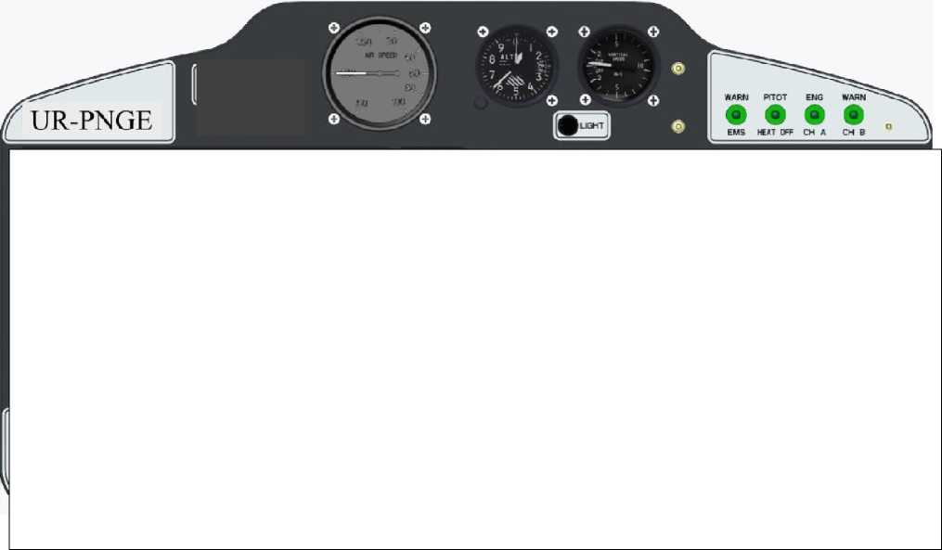
Figure 46 Backup flight equipment

  - Lighting and signaling equipment
There are warning lights on the dashboard
- Circuit A of the ignition system (CI A of the ENG WARN group);
- Circuit B of the ignition system ("B" of the "ENG WARN" group);
- Operation of the engine monitoring system ("WARN EMS");
- Operation of the PITOT HEAT.
All lamps are equipped with stencils with typical abbreviations that unambiguously interpret their functional purpose.
Normal operation of the respective systems is indicated by green lights, and fault conditions are indicated by red lights. The failure state is duplicated by an audio notification to the intercom. Light and sound alarms are generated by the Dynon SkyVieW SV1100 system.
  - Rescue system
The airplane is equipped with a rescue system (Annex 3) consisting of a parachute, cables and a rescue system launch handle. The escape system cables are laid in channels in the upper part of the fuselage and protected by covers. When the handle is pressed, the rocket is launched and the parachute is released by breaking through the cover in the fuselage and opens in the air.
Document № | Audit | Name of the document | Date. | Page
AA-0110-10000101 | 003 | Technical description of the ANG-01 light aircraft | 15.06.22 | 30 / 57
- OPERATIONAL LIMITATIONS
  - Expected operating conditions
- Flight operations in the daytime, according to visual flight rules (VFR).
- Hangar storage is mandatory in places of permanent aircraft deployment.
- In the event of temporary storage of the aircraft outside the permanent deployment sites , the use of covers is mandatory.
In the event of weather conditions with the possibility of icing on parts of the aircraft, it is prohibited to operate the aircraft.
The aircraft takes off and lands with visual guidance from the crew.
  - Weight and centering limits
- Maximum takeoff weight: 950 kg
- Minimum takeoff weight: 450 kg
- Extreme front centering: 15% CAH
- Maximum rear centering: 39.7% SAH
  - Speed limits
- Minimum dumping speed V so : 50 km/h
- Minimum takeoff speed V 2min: 70 km/h
- Minimum landing speed V ref: 75 km/h
- Maximum speed with fully released flaps V fe : 130 km/h
- Maximum speed when retracting and releasing the chassis V le : 150 km/h
- Maximum maneuvering speed V a : 200 km/h
- Maximum speed with flaps retracted V no : 330 km/h
- The non-exceeding speed V ne : 380 km/h
  - Overload limitations
- Vertical load is limited to -2.0...+4.0 for no more than 20 seconds
  - Height restrictions
- Maximum flight altitude: 3000 м.
  - Maneuvering restrictions
- Piloting maneuvers inherent in normal flight, including turns, spirals, rolls, glides, dives, and slides
- Flat eights steep U-turns with a bank angle of no more than 60°,
90° roll is allowed during coordinated turns
- Collapse.
  - Restrictions on weather conditions
- Visibility range: at least 1000 meters.
- Height of the lower edge of the clouds: at least 150 m.
- The temperature of the atmospheric air near the ground is in the range: -18...+35 ° C.
- The height of the airfield above sea level is in the range of 0.3000 m.
Document no. | Audit | Name of the document | Date. | Page
AA-0110-10000101 | 003 | Technical description of the ANG-01 light aircraft | 15.06.22 | 31 / 57

  - Resources and service life
The airframe is authorized for operation according to its technical condition, without limitation of the designated service life and service life, provided that:
- Compliance with the operational procedures defined in the existing AMM;
- Compliance with the regulations for units with a limited service life;
- Correct and timely maintenance of Aircraft and Engine Forms.
List of units with a limited service life:
Unit | Overhaul life | Assigned resource
Engine. | 1200 hours. | 15 years
Air screw | 500 hours. | 1000 hours/6 years
Rescue system | 6 years | 30 years
Engine muffler | - | 5 years
Fuel tank pumps | - | 5 years
Hydroelectric power station | - | 5 years
Fuel hoses | - | 5 years
Lubrication system hoses | - | 5 years
Cooling system hoses | - | 5 years
Chassis brake hoses | - | 5 years
Motor frame shock absorbers | - | 5 years
Battery | - | 2 years
Spark plugs for the engine | - | 100 hours.
Engine oil filter | - | 100 hours.
Engine air filter | - | 100 hours.
Fuel engine filter a | - | 100 hours.

  - Conditions of the base
Hangar storage is required in places of permanent deployment of the aircraft and when performing periodic and special maintenance. The hangar must be equipped with artificial lighting and ventilation. The storage temperature is from -25 to +40⁰С, humidity 35...85%, which is determined by the conditions of long-term storage of the rescue system. At the same time, some work during these types of maintenance lasting up to 2 hours must be carried out outside the hangar (for example, engine testing) or no closer than 50 m from significant metal magnetic structures (for example, compass calibration).
It is possible to store the aircraft outside the hangar in places of temporary deployment for up to 3 days, and during its operational and periodic maintenance. During periodic maintenance, it is mandatory to use all standard covers and plugs, and to prevent the influence of high winds, it is necessary to moor the aircraft. During operational maintenance, it is mandatory to use anti-roll bars and a Pitot tube cover.
Document № | Audit | Name of the document | Date. | Page
AA-0110-10000101 | 003 | Technical description of the ANG-01 light aircraft | 15.06.22 | 32 / 57
- RESTRICTIONS ON AIRWORTHINESS
In order to reduce the cost of operation and restoration of the ANG-01 aircraft, as well as to maximize the use of the serviceability reserves of the aircraft structure and components, it is planned to apply the condition-based maintenance system (CBM) for the airframe, engine and components in accordance with OST 1 02776-2001.
- USE OF COMPOSITE MATERIALS.
  - Products made of composite materials.
The ANG-01 airplane has products made of composite materials.
These products are molded fabric and foam assembly units. The number of fabric layers, type and geometry are determined by the functional characteristics of this element in the aircraft. In most cases, it is a so-called "sandwich" of upper and lower layers of fabric impregnated with a binder and foam between them.
The manufacturing process involves laying out the components in the tooling, vacuuming and heat treatment.
Repeatability of products is ensured by tooling and manufacturing control, which are included in the assembly unit according to the specification of elements and the manufacturing process.
The use of composite materials in the construction of the airframe, wings, and control systems is 85%. Metal butt joints, landing gear struts, and engine mounts account for ≈ 15%. AISI 4130 steel is used in the power structure of the landing gear .
  - Definition of composite structures and their elements .
- the fuselage is completely made of composite materials of the type
"sandwich" (carbon fiber, fiberglass, foam, binder).
- Structural and power scheme: monocoque made entirely of
vertical plumage, the load-bearing skin is supported by a power pack, which is its only integral structure:
- 5 frames;
- wing spar box;
- centerplane iron (at the same time, the niches of the main landing gear supports);
- nose landing gear niche and center box;
- pilots' floor, rear floor and luggage compartment;
- beam of the pilots' seats;
- The wing consoles are made entirely of sandwich composite materials (carbon fiber, fiberglass, foam, and binder). They are made of upper and lower skins supported by a spar, which is their integral structure.
- height and directional rudders are made entirely of sandwich composite materials

Document no. | Audit | Name of the document | Date. | Page
AA-0110-10000101 | 003 | Technical description of the ANG-01 light aircraft | 15.06.22 | 33 / 57

  - Physical and mechanical properties of composite materials
Fiberglass EW60.

SFT INDUSTRIES CO.,LTD
ADD: N".26-12 Donggang 2 Road.Chunjiang Town, Xinbei District
Changhzou 213000, Jiangsu, Chinxi (Chi'OLI, HLA CI. Kinnii)
Email: inf<>(a sftindustries.com

Certificate of quality
Certificate of Quality
Fiberglass EW60
Fiberglass Fabric EW60
The national bathtub  Item | Test result Test Result | Standard Standard
Bara per unit surface area of lshayudemitshgiyal'niya] (g/m ) Area Weight (g/m2) | 48 | 48110
Width (mm)  Width (mm) | 1270 | 12704:10
Weaving weave  Weave | Plain (loincloth) Plain | Plain (linen) Plain
Fiber | Base: lltex  Warp: 11 tex | Base: lltex  Warp: lltex
 | He ran away: 11 texts  Weft: lltex | He ran away: lltex  Weft: lltex
Density (ends/cm)  Density (ends/cm) | The basis: 25  Warp: 25 | Base: 2511  Warp: 2511
 | He escaped: 19  Weft: 19 | He escaped: 19±1  Weft: 1911
Moisture content (%)  Moisture Content (%) | 0.05 | <0.2
Combustible Matter Content (%) | 0.5 | 0.40-0.80

Document № | Audit | Name of the document | Date. | Page
AA-0110-10000101 | 003 | Technical description of the ANG-01 light aircraft | 15.06.22 | 34 / 57
Carbon fiber 3K 200

SFT INDUSTRIES CO.,LTD
ADD: No.26-12 Donggang 2 Road,Chunjiang Town.Xinbci District
Changhzou 213000. Jiangsu.China (i "iii<t">, Uta"". Kunii)
Email: info'# sftindustries.com
Quality certificate
Certificate of Quality
Carbon fiber twill ZK 200 g/m²
Carbon Fabric Twill ZK 200g/nr
Item name | Test result Test Result | Standard Standard
Bai a per unit surface| shimlm ayasanashmg^n№>| (g/m²) Area Weight (g/nr⁾ | 201 | 200±5
Width (mm)  Width (mm) | 1000 | IOOOOO
Thickness (mm)  Thickness (mm) | D.28 | D.28i0.02
Weave weaving Weave | Twill  TwUl | Twill  GMPI
Fiber | The basis: GC  Warp: ZK | The basis: GC  Warp: ZK
 | He ran away: ZK  Weft: ZK | He ran away: ZK  Weft: ZK
Density (ends/100mm) Density (ends/100mm) | The basis: 50  Warp: 50 | Base: 50±2  Warp: 50±2
 | He escaped: 50  Weft: 50 | He's gone: 5О±2  Weft: 50i2
Tensile Breaking Strength (N/25mm) Tensile Breaking Strength (N/25mni) | Base: 1500  Warp: 1500 | Base: >1000  Warp: >1000
 | He escaped: 1576  Weft: 1576 | Escaped: >1000  Weft: >1000

Document № | Audit | Name of the document | Date. | Page
AA-0110-10000101 | 003 | Technical description of the ANG-01 light aircraft | 15.06.22 | 35 / 57

Polyurethane foam

SFT INDUSTRIES CO.,LTD
Add No 26-12 Donggang 2 Road.ChunjiangTown.Xinbei District,
Changhzou 2!3OOO.Jiangsu,China

Arch tn technical data sheet
Technical Data Sheet
I1BX FOAM
PVC FOAM CORF
IyAnMenuNiNG  Item | RI | NY | Р100 | Hi 30 | Р200 | 1'250
Density  (gl?)  IHnMtt ( k m l | 60 | 80 | 100 | 130 | 200 | 250
The strength on  DOIRNK Ipatgm, yar* ^*mmlvmy|  Mino isipiae Strength | 1.8 | 2.5 | 35 | 4.8 | 7.1 | 9Д
Model of elasticity at penny pinching Miu)  I mule Module* Mre) | 75 | ♦5 | 130 | 175 | 250 | 320
Cumpreohe Strength (MPa) Cumpreohe Strength (MPa) | 05 | 1.4 | 2.0 | 3.0 | 4.8 | 6.2
Model of compressive elasticity IMpa) (oMprtttdw ModtdtM(Mpa) | 72 | 90 | 135 | 170 | 240 | EM
The strength at  hpiu| Shear Strength  Dies) | 0.76 | 1.15 | 14 | 2.2 | 3.5 | 45
Heap module (MPa) Shear ModuluMMpa) | 20 | 27 | 35 | 50 | 85 | KM
1 spheres mania kumu (%) Shear Sir pip (%) | 20 | 30 | 40 | 40 | 40 | 40

Document no. | Audit | Name of the document | Date. | Page
AA-0110-10000101 | 003 | Technical description of the ANG-01 light aircraft | 15.06.22 | 36 / 57
Carbon fiber 6K 320

SFT INDUSTRIES CO.,LTD
ADD: 'S0.16-12 Donggang 2 RoadA hunjiang Townjünbei District
( hanghzou JlJtOUiingiu.l him (Chm-mip.Tsmo.Kai^)
Email: info a sftinduitnes.com
( 'er I ifikya I which* t I
Certificate of Quality

By and let cap it nu Twill 6K 320i m2

Carbon Fabric Twill 6K 320 g m2
Item name | Test result lest Result | Standard  Standard
Bat in on "cap turn | yamai>. "gimimim*>aialgti"| (F ^1  Area Weight if nrl | 322 | 320*5
Width (mm) W idth (mm) | 1000 | 1000*10
Thickness (mm)  Thickness (inin) | 0.48 | 0.48x0.02
1 drop weave Weave | Twill You UI | Twill  I will
Fibers" Fiber | Basics: OK  Warp: 6K | The basis: 6k  Warp: OK
 | In the 6 k  Weft: 6K | He escaped: 6K  Weft: 6K
Width (horse. NU mm) Density (cndvlOOmnu | The basis: 40  W arp: 40 | Base: 40±2  Warp: 40i2
 | Into the tide: 40  Weft: 40 | U and ik: 40*2  Weft: 40x2
Dtiip poipaas iru roishmsmssh (W25mm)  Tensile Breaking Strength (N/25mm) | Base: 1390  Warp: 1390 | Base: >1000  Warp: >1000
 | He escaped: 1453  Weft: 1453 | He escaped: "1M0  Weft: >1000

Document № | Audit | Name of the document | Date. | Page
AA-0110-10000101 | 003 | Technical description of the ANG-01 light aircraft | 15.06.22 | 37 / 57

SF1 INDUSTRIES CO..LTD
ADD: >".26-11 Dnaggnag 2 RuadA hunjiaag 1 own.Xinbei District
I hangh/oa IMinShLmprmi. ( hin" (4i-<*n>. Ik MWi. Ka and -ni.
Nimii; infoftafliBdtat gigi uni
( griifiksh QA
( crtilu nii of Quality
< c. pl cumin IAS 300 Fiberglass Fabric 1LM00
INANIENUAMMA  Item | Pi ivibiai tepu  Jeu Wesult | Standard  Slandaid
Kara on a single" surface xwawiw tmashayazhlym I ( 14" ) Area Weight (g m2) | 306 | 300124
Width (mm) W akh (min) | 10M | Y0*±I8
Weaving weaves  W cat c | Simple I 4*1 hymnnw) Plain | Plain |pyaznppe) Plain
B<11<1KM<1  Fiber | Base: 2<#cx  Warp; IDOlei | □sheaf: ÄMHci Warp: 200tiM
 | He ran away: 2*Yest  Weft 200us | Into the tide: 21 llHex Wrft: 'OOirx
Density of liquid)  Density (ends cm) | Base: K Warp: 8 | photo: I±I Waiy KU
 | He escaped: 7  Weft 7 | He ran away: 7*1  Wrfli 7*1
Onir pitrHKi irm potiai ngmni (11 50mm) Tensile Breaking Strength (\75*mm) | The basics of the feedstock  Warp. | i2200 basics  Warp: £280
 | He ran away: 3128  Weft: 3128 | Runaway: >2000  Weft; <2000
MLO1N CONTENT (%)  Moisture Co pi rnl P4) | 0.05
Content and ruminant substance  < ombustible Matter ( ontent (% 1 | 054 | mm.m

Document no. | Audit | Name of the document | Date. | Page
AA-0110-10000101 | 003 | Technical description of the ANG-01 light aircraft | 15.06.22 | 38 / 57

Perforated film

SFT INDUSTRIES CO.,LTD
TECHNICAL DATA SHEET
DRAIN PERFORATED FILM. DRAINAGE PERFORATED
FILM
1 TE M'lIAMEPU V Al 111Y |  | TEST  RESULT  TEST. | STANDARD.'CTAll DART
Material |  | HDPE/Polyethylene  HIGH DENSITY | ---
Soiog/Color |  | Red or Blue | -
Dene Iiul Target |  | 0 93g,\m* (g/cm*) | ---
Tensile  Tensile strength | WaqrOcnoBa | S40MPA | ASTM D 882
 | Weft | a35MRA | ASTMD 882
Tisknen/Toviishna |  | 32±2 cts | -
The highest temperature/Maxc. temperature |  | 120'С | --
Hole pitdl/Kpox perforations |  | 6*6w₁4*8w (±0.5gsh) | ---
Bore diameter |  | 0.384.5 tons | -™
Purpose. Purpose |  | FRP.Fiber-reinforced product



Document № | Audit | Name of the document | Date. | Page
AA-0110-10000101 | 003 | Technical description of the ANG-01 light aircraft | 15.06.22 | 39 / 57

Epoxy resin
№ | Ingredient SFT528 | Molecular formula | CAS No.
1 | Epoxy resin, bisexual phenol A | [CHO]  11 2 3 n | 61788-97-4
2 | Epoxy resin  modified viscosity | - | -
3 | Active thinners for epoxy resin | CHO 12 20 6 | 13236-02-7

№. | Ingredient SFT528A/B | Molecular formula | CAS No.
1 | Hardener made of modified polyester amine | - | -
2 | Lipocyclic hardener | CHN  10 22 2 | 2855-13-2
3 | Lipocyclic hardener | CHN 6 15 3 | 140-31-8

Document no. | Audit | Name of the document | Date. | Page
AA-0110-10000101 | 003 | Technical description of the ANG-01 light aircraft | 15.06.22 | 40 / 57
- LIST OF APPLICATIONS
  - Annex 1. LA-2000-00222532 Aircraft ANG01
  - Annex 2. U0A-2400-00100547 Control system (electronic)
  - Annex 3. LA-2560-00194301Спассистема
  - Appendix 4. LA-2700-00220402 Control system (lever)
  - Appendix 5. LA-2800-00206488 Fuel system
  - Appendix 5A. LA-2800-00029514-00G3 Fuel system (wiring diagram)
  - Appendix 6. LA-2900-00133910 Hydraulic system
  - Appendix 6A. LA-2900-00032574-00G3 Hydraulic System (wiring diagram)
  - Annex 7. LA-3220-00133922 Bow rack
  - Appendix 8. LA-3210-00133924 Main rack
  - Annex 9. LA-5300-00181494 Fuselage
  - Annex 10. LA-5700-00181747 Wing
  - Appendix 11. LA-6100-00268582 Screw
  - Appendix 12. LA-7100-00194206 Power plant
Document no. | Audit | Name of the document | Date. | Page
AA-0110-10000101 | 003 | Technical description of the ANG-01 light aircraft | 15.06.22 | 41 / 57

9802
7308
2697
ATS-cheerleading
kG-^g/ CPR-tEgLU
1 | Article | Name | Kt | By.
 |  | Shkrapsh
 |  | Sshdshy_omsh
1 | KA-5700-Ü018176 7-1.3 | Crete (ANG0I) | I
2 | KA-5300-001814 94-1.5 | Fuselage assembly {А№01| | I
 |  | Dyad!
 |  | Pshushlvyn
 |  | Matches

LA-2000-00222532-1.1 | 0 0.880 |  |  | "ANG Patriot UA"
 |  |  |  | Crea | [Vae&zukO A. i | 02.6&22
Aircraft AN601 | Letter | Mass | Scale | Hpffp. | -
 | 1/1 |  | 1/50 | TKtr | - | -
 |  |  |  | NKtr | - | -
 | 0Ü276B55
 |  |  |  | Zoe. | - | -

Syaaatss
In the works
In the works
In the works
Document no. | Audit | Name of the document | Date. | Page
AA-0110-10000101 | 003 | Technical description of the ANG-01 light aircraft | 15.06.22 | 42 / 57

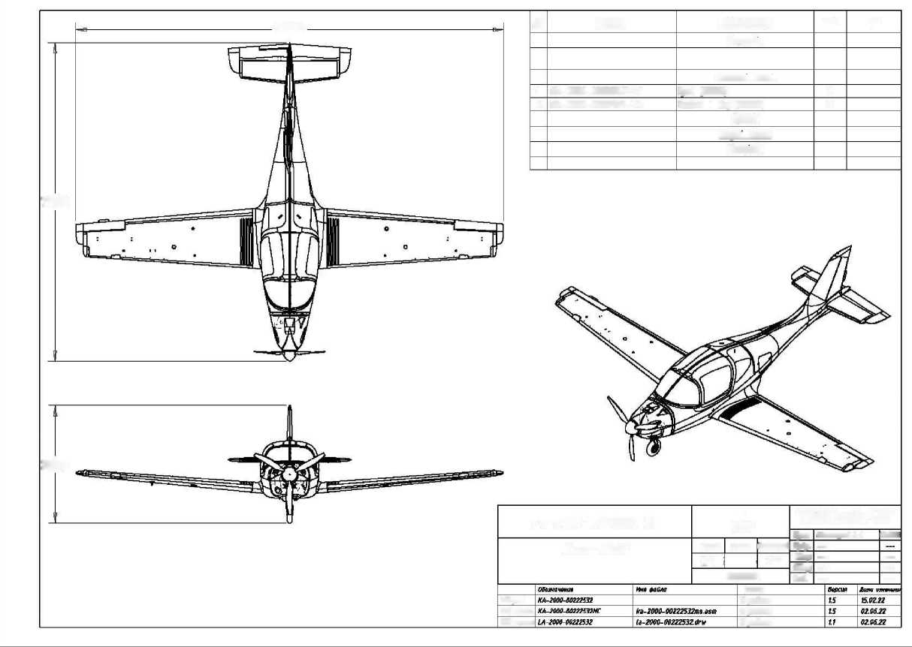

Document no. | Audit | Name of the document | Date. | Page
AA-0110-10000101 | 003 | Technical description of the ANG-01 light aircraft | 15.06.22 | 43 / 57

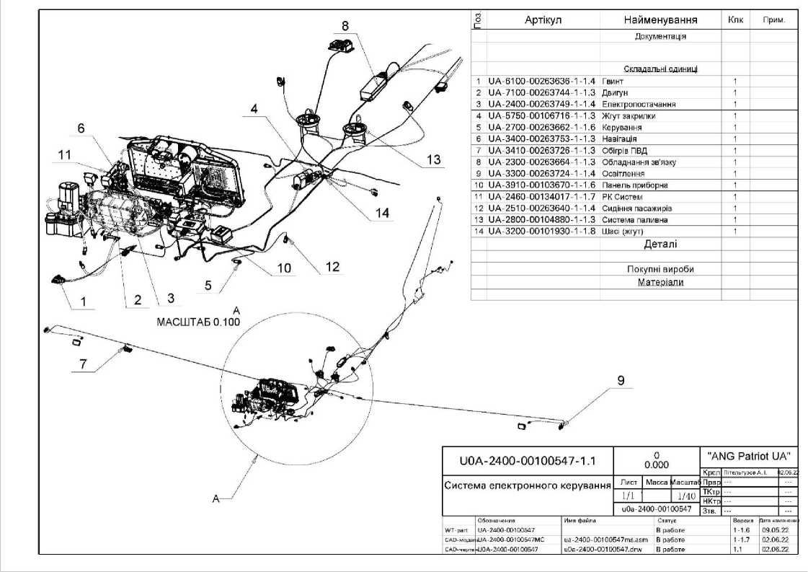

Document no. | Audit | Name of the document | Date. | Page
AA-0110-10000101 | 003 | Technical description of the ANG-01 light aircraft | 15.06.22 | 44 / 57

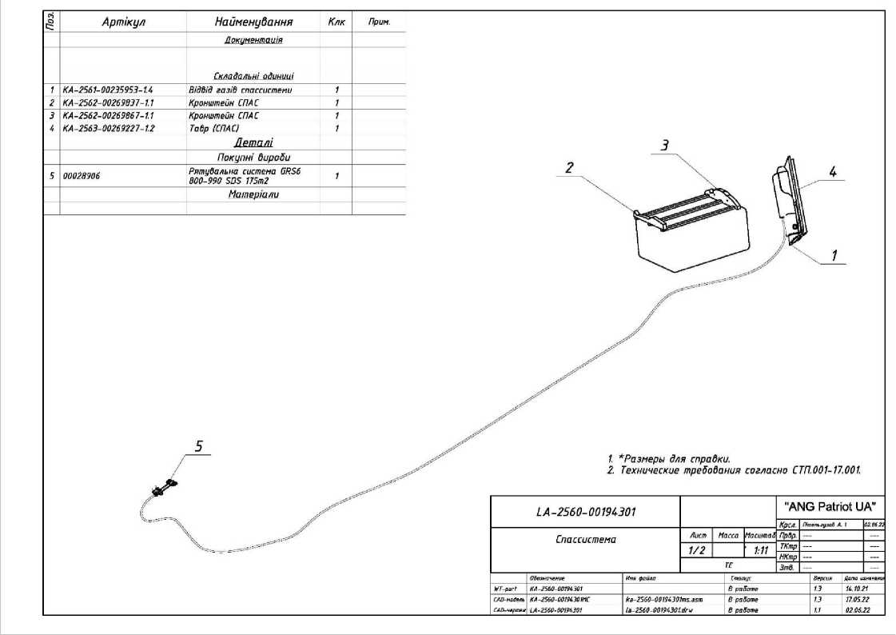

о
1. ★Dimensions for reference.
2. Technical requirements according to STP.001-17.001
'S e | Article. | Name | Clk | Example,
 |  | Documentation
 |  | Assembly units
1 | KA-2720-00220413 | 00220413 | 1
2 | KA-2720-00134425 | Upper nose landing gear rocker | 1
3 | KA-2720-00167106 | Rockers in health | 2
4 | KA-2720-0016 7107 | Rocking chair 8 assembly | 1
5 | KA-2720-00194624 | Rocking chair 8 assembly | 1
6 | KA-2720-00100550 | Rockers 8 assembly (BPSI | 1
7 | KA-55201-001050371 | K^rm of height left | 1
8 | KA-2720-00120593 | The steering wheel of direction | 1
9 | KA-2720-00177834- | .Foot control post (FCP) | 1
10 | KA-2700-00106753- | SCR (BPS CIS) | 1
11 | KA-2730-00100536 | Traction | 1
12 | KA-2720-00194626 | Traction 1012) | 1
13 | KA-2720-00109774 | Tie rod 1013 Nose post) | 1
14 | KA-3000-00270204 | Tie rod 1013 Nose post) | 1
15 | KA-2730-00109771 | Traction 1013) | 1
16 | KA-2730-00109762 | Traction (016) | 2
17 | KA-2730-00109783- | ITilga (016) | 1
18 | KA-2730-00109760 | Traction (020) | 6
19 | KA-2730-00194625 | Traction (020) | 1
 |  | Details
 |  | Purchased products
 |  | Materials.

IA-2700-00220402 |  | "ANG Patriot UA"
 |  | Crepe | Yasskaya A, G. | 01.12.2.
SCR/CNSTR) | Letter from Massa Mosstai | Pr.
 | 1/1 1:18 | TC/pr  NKtr
 | 00220102 | ZTO. | -

S/mypus
In the works
In the works
In the works
Document no. | Audit | Name of the document | Date. | Page
AA-0110-10000101 | 003 | Technical description of the ANG-01 light aircraft | 15.06.22 | 45 / 57

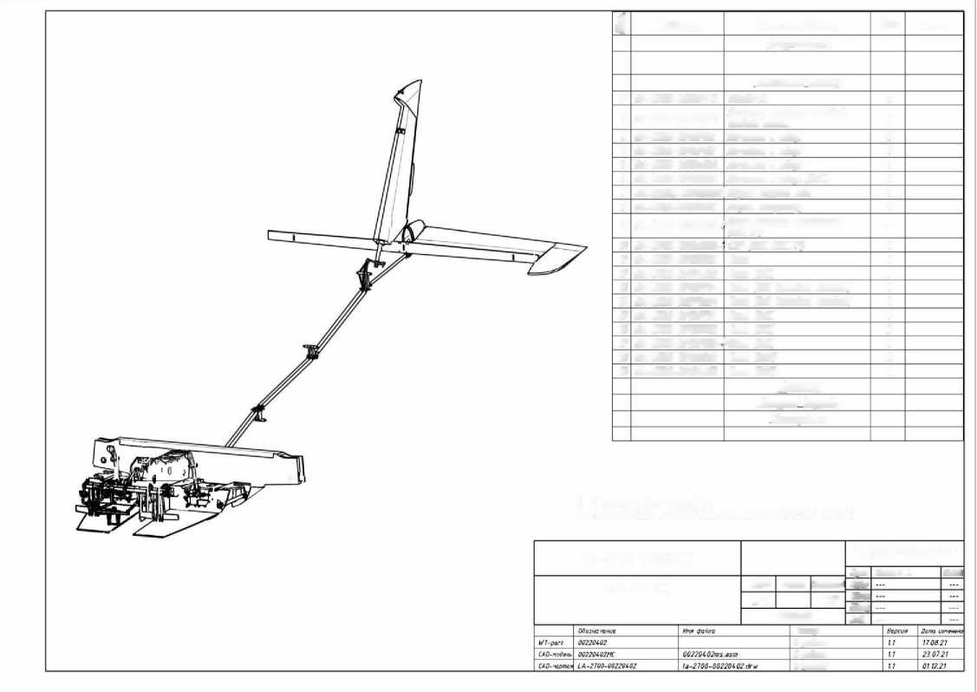

Document no. | Audit | Name of the document | Date. | Page
AA-0110-10000101 | 003 | Technical description of the ANG-01 light aircraft | 15.06.22 | 46 / 57

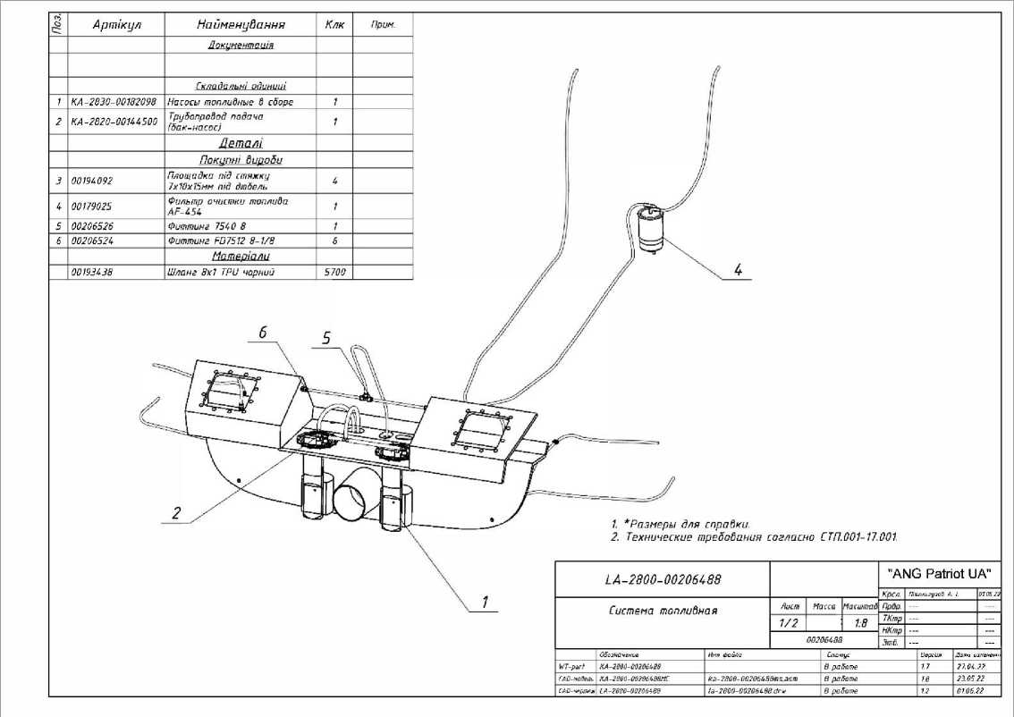

273
274
275
276
29514.Ф1
29514А 1
Fuel supply
KOTAH engine
Fuel return
' 2951415
29514.Н2
29514.Н1
AND= AND ' 2951413
і'' 2951412
and :and 2951414
29514.68
29514.64
29514.61
29514.62
■ 29514.T1 and
29514VN1
Name of the company
29514.H1 Fuel pump Madyaev Magesh U^ B5 1MAN00026M1
29514.H2 Fuel pump Madlen Magesh U^' 851MAM00026M1
29514.T1 Tee Rome
2951412 Tee 6440 6-1/9
29514В Tee 6440 6-1/9
2951414 Tee 6440 6-1/8
2951415 Tee 8mm
29514.Б1 tank
29514.52 Side wing
29514,53 Side wing
29514.54 Side consumable
29514VN1 Ball valve 1/8 1papa-mama1
29514.F1 Fuel purification filter AECH54
RTS  IOKVLSNAKE! AM 03101 | mild
 | ANB-280MSH295I4-00 GZ
amAnchv* olts  (Reaping shea | thick  AYUT | hundred sluggish  Bulk fuel tank
 | AZ 1г | '* Tour 8NEG 6YOUN 6'

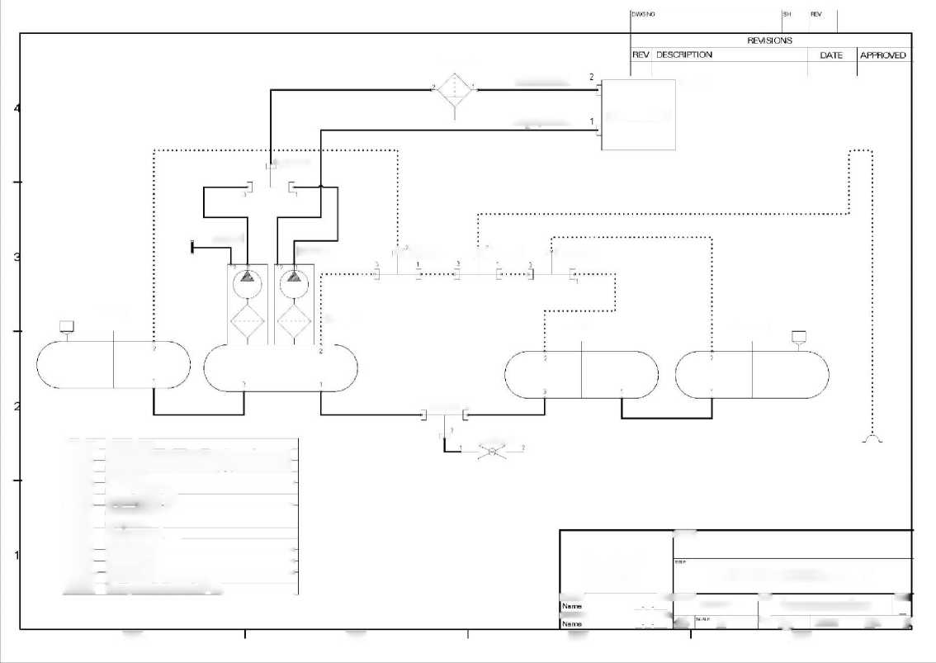

Document no. | Audit | Name of the document | Date. | Page
AA-0110-10000101 | 003 | Technical description of the ANG-01 light aircraft | 15.06.22 | 47 / 57

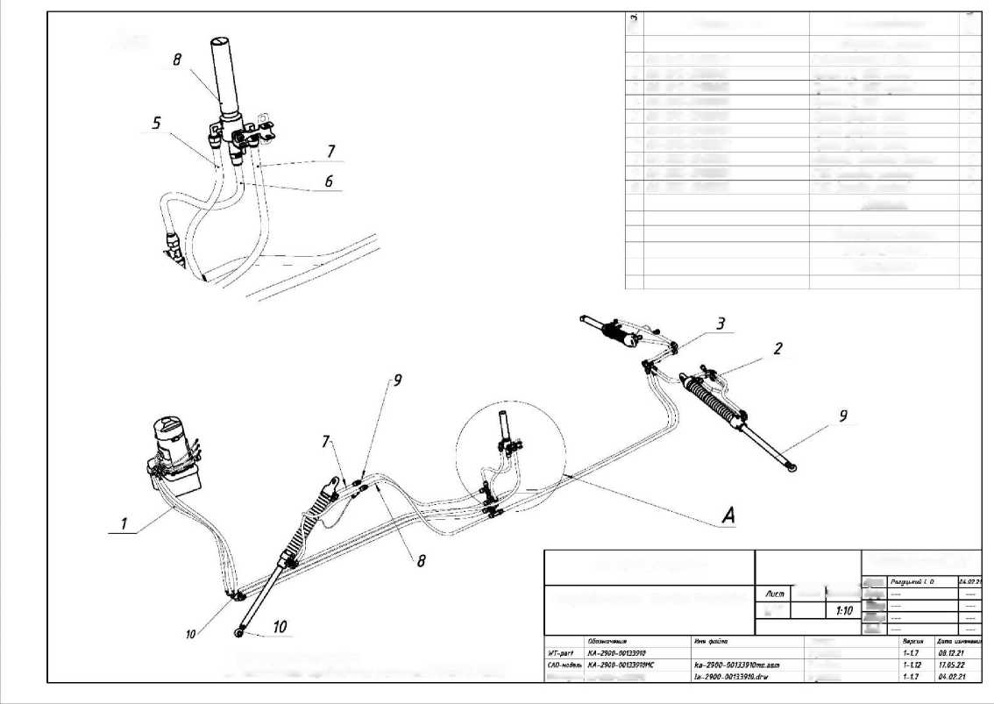
A i id
"ANG Patriot UA"
LA-2900-00133910
Aircraft hydraulic system
1/7
SAO drawing LA-2 900-00133910
1. * Dimensions for reference.
2. Technical requirements according to STP.001-T7.001
I Cree.
Mass Scale Prvr
TKtr NKtr Ztb.
Status.
In the works
In the works In the works
ё | Designation. | Name | J
 |  | Welding units
1 | KA-2910-00133901 | A hydroelectric power plant in the field | 1
2 | KA-2910-00133902 | Tract of the GC OSH left | 1
3 | KA-2910-00133903 | The tract of the GC OSH right | 1
4 | KA-2910-00133904 | Tract of the GC NHS | 1
5 | KA-2910-00133905 | Chassis welding path | 1
6 | KA-2910-00133906 | Chassis welding path | 1
7 | KA-2910-00133907 | Chassis cleaning path | 1
8 | KA-2920-00133908 | Gas cylinder adapter | 1
9 | KA-3230-00102188 | GUSH (main rack} | 2
10 | KA-3230-00102255 | GUSH (bow stanchion} | 1
 |  | Flying
 |  | Standard products
 |  | Other products Materials

Document no. | Audit | Name of the document | Date. | Page
AA-0110-10000101 | 003 | Technical description of the ANG-01 light aircraft | 15.06.22 | 48 / 57

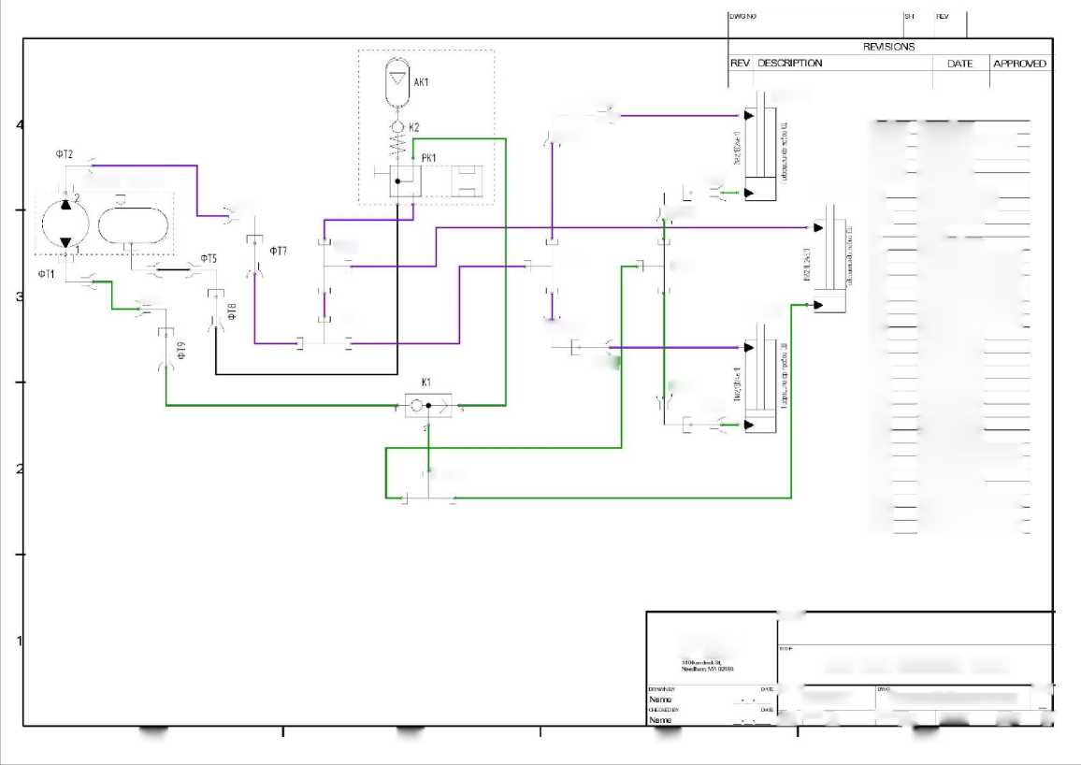
277
278
279
280
36124.Y3
36124M1 1'5'121.124'21
3612471
FT4
AND FT16
FT11
FI4
FT13
FTI
36124 Y2
FT10
1 g FT23
FT20
FT19
and FT12
PTC
FT22
FT15
FT18 - E - - AND FT17
Pos.transportation. | Noipenobation
36124111 | SAE J1171 hybrid power plant
36124.Y1 | GizrocilinOr
36124.Y2 | HyZrocillinZr
36124 Y3 | GizrocilinEr
PK1 | Valve apparatus
AK1 | Gas cylinder 12g
Tank_1 | "No?
K1 | Valve
K2 | "None"; - "None".
FI | 4203-02-03JYDR0SCAND
FT2 | 4203-02-03 HYDROSCAND
FV | 4203-027)3_HYDR0SCAND
FT4 | 4203-02-03 HY0ROSCAND
FV | 4203-02O3JYDR0SCAND
FT6 | 42034I2O3JYDR0SCAND
FT. | -=None='
FTV | "No?
FT9 | "No?
NAME | "No?
FI1 | "No?
FT12 | "No?
FIZ | "No?
FP4 | "No?
FI5 | "No?
FI6 | 4203-02-03 HYDRQSEAND
FI7 | 4203-02-O3_HYDR0SCAND
FP8 | "No?
FP9 | "No?
FT20 | 4203-02-03 .HYDROSC AND
FT22 | "No?
FT23 | 42034J2-03_HYDROSCA.no

imFFSS
ANG-2900-00032574-00 GZ
stumps ter  ANG-CIRCUIT | Hybrid chassis system | ISELC
AZ "* 1 g | ^{IYI}" Tour SHEET 6SDF | 6^{С}

Document no. | Audit | Name of the document | Date. | Page
AA-0110-10000101 | 003 | Technical description of the ANG-01 light aircraft | 15.06.22 | 49 / 57

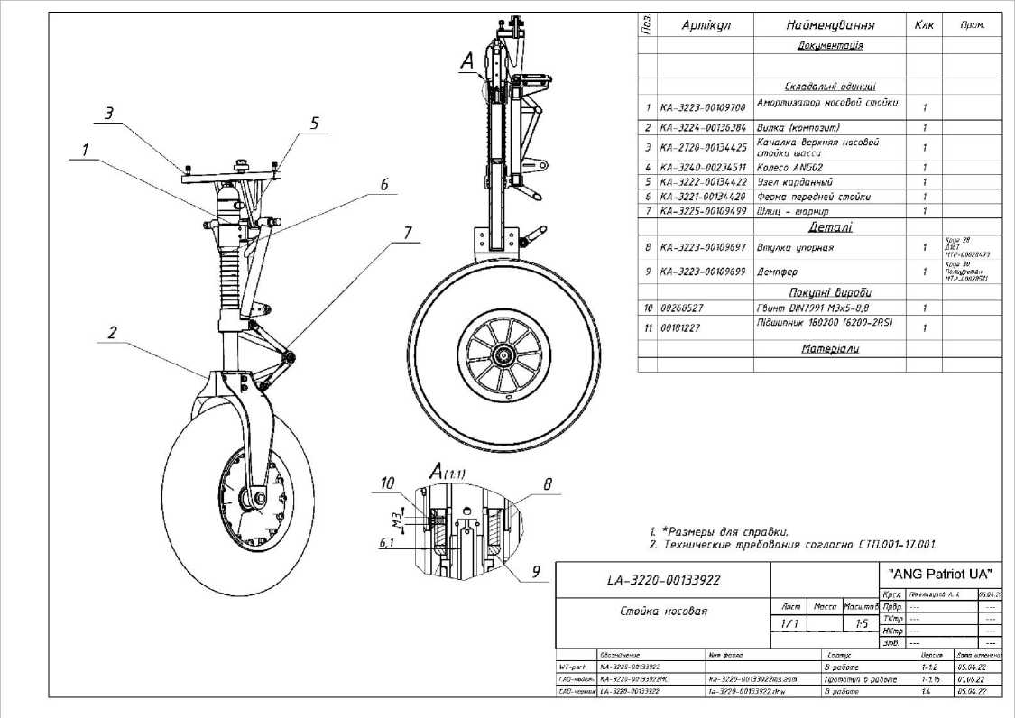
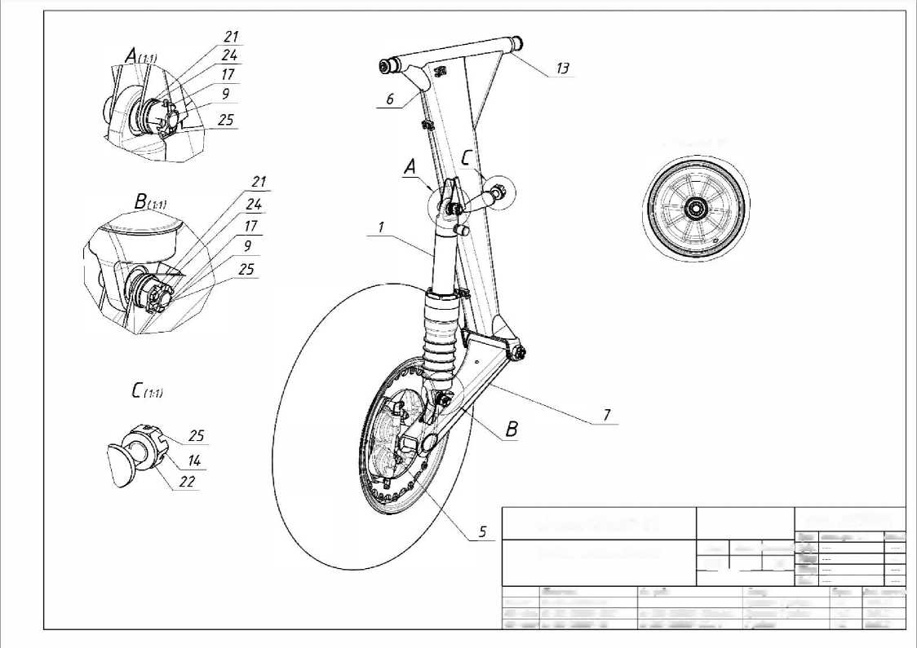
SCALE 1:5
LA-3210-00133924-010 |  |  |  |  |  |  | "ANG Patriot UA"
 |  |  |  |  |  |  | Krol | Gitelguzsgb A. i |  |  | 02.05.21
Main rack (left) |  |  | Letter | Nassau |  | Scale. | prdr.
 |  |  | 7/4 |  |  | 1:3 | TKtr |  |  |  | -
 |  |  |  |  |  |  | NKtr Ztv.
 | Designation. | Meg in the file |  |  | Status. |  |  |  | Version. | Dates vitwt "V'
WT-cart | ka-32yu-ooizz924 |  |  |  | Prototype b robot |  |  |  | 1-18 | 12.05.22
СAD-wde/ie | KA -3210-00 >33324-0 10MS | fa-3210-0 0133970 - 010ms. asm |  |  | Prototype B of the robot |  |  |  | 1-118 | 12.05.22
CAD drawing | LA-3210-00133324-010 | la-3210-00133920-010. dr and |  |  | In the works |  |  |  | 1-18 | 02.06.22

Document № | Audit | Name of the document | Date. | Page
AA-0110-10000101 | 003 | Technical description of the ANG-01 light aircraft | 15.06.22 | 51 / 57

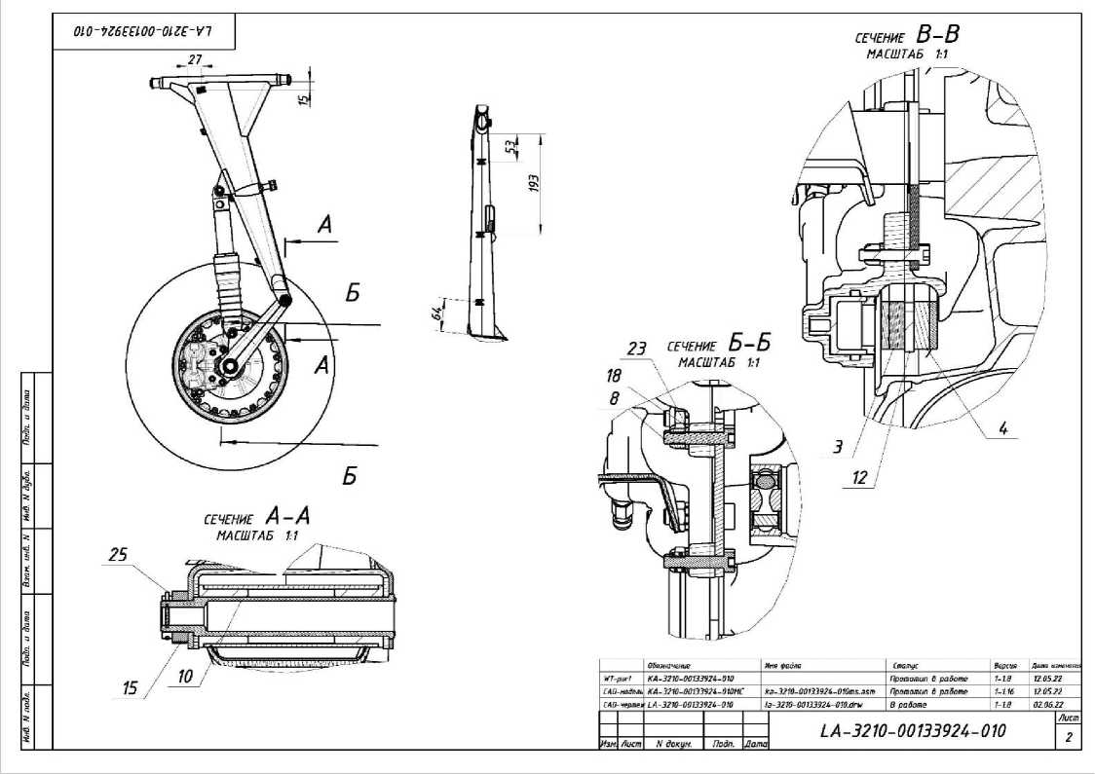
ё | Article |  |  | Name |  |  |  |  | Clk |  | Example.
 |  |  |  | Documentation
 |  |  |  | Rear window glasses
1 | КА-3213-00109649-1-1.6 |  |  | Main chassis shock absorber |  |  |  |  | 1
2 | KA-324 0-00234511-1.4 |  |  | Wheel ANG02 |  |  |  |  | 1
3 | КА-3240-00133920-1-1.5 |  |  | Fixed brake pad |  |  |  |  | 1
4 | КА-3240-00133919-1-1.5 |  |  | Brake pad movable |  |  |  |  | 1
5 | КА-3240-00133912-1-1.15 |  |  | Braking mechanism left |  |  |  |  | 1
6 | KA-3211-00136580-1.9 |  |  | Upper lever (metal) |  |  |  |  | 1
7 | КА-3212-00108694-1-1.16 |  |  | Lower lever |  |  |  |  | 1
 |  |  |  | Details
8 | КА-3210-00133915-1-1.2 |  |  | Bolt M6x23 DIN 6912 (Revision) |  |  |  |  | 4 |  | Bolt DIH 6912  NBHZO - 8.8 00236666
9 | KA-3210-00236643-1.2 |  |  | Bolt M8x30 (Revision) |  |  |  |  | 2 |  | DIN 7984 nail screws  M8x40 - 8.8 00181205
10 | КА-3210-00121813-1-1.6 |  |  | OSS bolt |  |  |  |  | 1 |  | Hexagon 17  Art.  ITR-00013239
11 | KA-3210-00136610-1.2 |  |  | Bronze bushing |  |  |  |  | 2 |  | bushing Branza6a> 15x20x21 00034376
12 | KA-3240-00271038-1.3 |  |  | Brake disc |  |  |  |  | 1 |  | Letter 4  ZOHGSA steel  MTR-00030736
13 | 00133930-1-1.1 |  |  | Washer |  |  |  |  | 1 |  | Letter 1  Art.  MTR-00028283
 |  |  |  | Purchased products
14- | 00134 982 |  |  | Nut DIN 937 M10 |  |  |  |  | 1
15 | 00179565 |  |  | Nut DIN 937 M12 |  |  |  |  | 1
LA-3210-00133924-010 |  |  |  |  |  |  |  |  |  | "ANG Patriot UA"
 |  |  |  |  |  |  |  |  |  | Krsl. | Pitelguzob A. 1. |  |  |  | 02.06.22
Main rack (left) |  |  |  |  | Stork | Mass |  | Scale |  | Pr8r, | - |  |  |  | -
 |  |  |  |  | 3/4 | 11,300 |  | 1:3 |  | TKtr | - |  |  |  | -
 |  |  |  |  |  |  |  |  |  | NKtr | - |  |  |  | -
 |  |  |  |  | ANG
 |  |  |  |  |  |  |  |  |  | Ztb. | - |  |  |  | -
 |  | Designation. | File name |  |  |  | Status. |  |  |  |  | Version. | Date changed
WT-part |  | KA-3210-00133924-010 |  |  |  |  | The prototype is in the works |  |  |  |  | 1-1.8 | 12.05.22
CAO model |  | КА-3210-00133924-010МС | ka-3210-00133924-010ms.asm |  |  |  | Prototype 6 work |  |  |  |  | 1-1.16 | 12.05.22
SAO drawing |  | LA-3210-00133924-010 | la-3210-00133924-010.drw |  |  |  | In the works |  |  |  |  | 1-1.8 | 02.06.22

Document no. | Audit | Name of the document | Date. | Page
AA-0110-10000101 | 003 | Technical description of the ANG-01 light aircraft | 15.06.22 | 53 / 57

16 | 002 71283 | Nut DIN 937 M20 | 1
17 | 00099823 | Nut DIN 937 M8 | 2
18 | 00120 760 | Nut DIN 985 MB | 4
19 | 0 0194 0 92 | Platform for screed 7x10k 15mm for dowel | 4
20 | 00097952 | Fitting Camozzi 6522 4-M5 | 1
21 | 00222848 | Washer DIN 126 8 | 2
22 | 00179570 | Washer DIN 127-A 10 | 1
23 | 00087910 | Washer DiN 6798A 6 | 4
24 | 00099825 | Washer DiN 6798! 8 | 2
25 | 00032895 | Pin 1.6x25 DIN 94 | 4
26 | 00087916 | Pumping connection MB | 1
 |  | Materials.

LA-3210-00133924-010 |  |  |  |  |  |  | "ANG Patriot UA"
 |  |  |  |  |  |  | Krsl. | Pitelguzob A. 1. |  |  | 02.06.22
Main rack (left) |  |  | Letter | Mass |  | Scale | Pr8r, | - |  |  | -
 |  |  | 4/4 | 11,300 |  | 1:3 | TKtr | - |  |  | -
 |  |  |  |  |  |  | NKtr | - |  |  | -
 |  |  | ANG
 |  |  |  |  |  |  | 3mö. | - |  |  | -
 | Designation. | File name |  |  | Status. |  |  |  | Version. | Date changed
WT-part | KA-3210-00133924-010 |  |  |  | Prototype 8 work |  |  |  | 1-1.8 | 12.05.22
CAO model | КА-3210-00133924-010МС | ka-3210-00133924-010ms.asm |  |  | Prototype 6 work |  |  |  | 1-1.16 | 12.05.22
SAO drawing | LA-3210-00133924-010 | la-3210-00133924-010.drv |  |  | In the works |  |  |  | 1-1.8 | 02.06.22

Document no. | Audit | Name of the document | Date. | Page
AA-0110-10000101 | 003 | Technical description of the ANG-01 light aircraft | 15.06.22 | 54 / 57

1. *Dimensions for reference.
2. Technical requirements according to STP.001-17.001.
13
16
7 22 \
І | Article | Name | How to. | Example.
 |  | Documentation
 |  | Assembly units
1 | KA-2 750-00221997 | Actuator 6 assembly | 1
2 | KA-5600-00133888 | Fuselage windows | 1
3  4  5 | KA-6100-00268582  KA-5300-00262S59  KA-2520-00182861 | Airplane propeller  A set of armor tapes  Headrest set | 1  1  1
6  ? | KA-5300-00178952  KA-5310-00194254 | Complete set 3  Spar box (details} | 1  1
в | KA-5330-00122200 | SPAS system covers | 1
9 | KA-5330-00182244 | Fuselage hatches | 1
10 | KA-3910-00166850 | Panel (H&S, lock, composite chassis) | 1
11 | KA-3910-001036 73 | The instrument panel on the | 1
12 | KA-2520-00106891 | Foam rubber (passenger seat} | 1
13 | KA-3420-00221965 | Pneumatics (ADAHRS) | 1
11 | KA-2510-00145838 | Pilots' seats | 1
15  16 | UA-2400-0010054 7  KA-2800-00206488 | Electronic control system  Fuel system | 1  1
17  18  19 | KA-7100-00194206  KA-2 700-00106755  KA-2560-00194301 | SKR engine systems (Fuselage] Spassistem | 1  1  1
20  21 | KA-3220-00133922  KA-3210-00133924-6 | Bow stanchion  Main key (left} | 1  1
22 | KA-3210-00133923-0 | Yutoyka main (right) | 1
Details
Purchased products
23 | KA-1130-00221986 | Stencil set (internal) | 1
24 | KA-1120-00221966 | Stencil set (external) | 1
25 | 0010 7453 | Armrest of Mitsubishi Lancer СХ | 1
 |  | Materials.

LA-5300-0018H9i |  |  |  |  |  |  | "ANG Patriot UA"
 |  |  |  |  |  |  | Krsl. | The number of universities A. 1. |  |  | 03 0Л21
Fuselage assembly (ANG01) |  |  | Letter | Mass |  | Scale | Prbr. | -
 |  |  | 1/1 |  |  | 1/40 | TKtr | -
 |  |  |  |  |  |  | NKtr
 |  |  | ANG
 |  |  |  |  |  |  | Approved by. | -
 | Designation. | The "them" of the file |  |  | Status. |  |  |  | Version. | Wool and / or woolen
HT-ptrt | KA-5300-0E101IM |  |  |  | 8 work |  |  |  | IS | К. 1121
SAO-moyem | KA-5300-0018N9IMS  LA-i3<70-W#MK | ka-5300-00#14 04ms.asm  la-S300-M181494.drw |  |  | In the works  8 work |  |  |  | 1.5  1.2 | 17.05.22  03.08.21

Document no. | Audit | Name of the document | Date. | Page
AA-0110-10000101 | 003 | Technical description of the ANG-01 light aircraft | 15.06.22 | 55 / 57

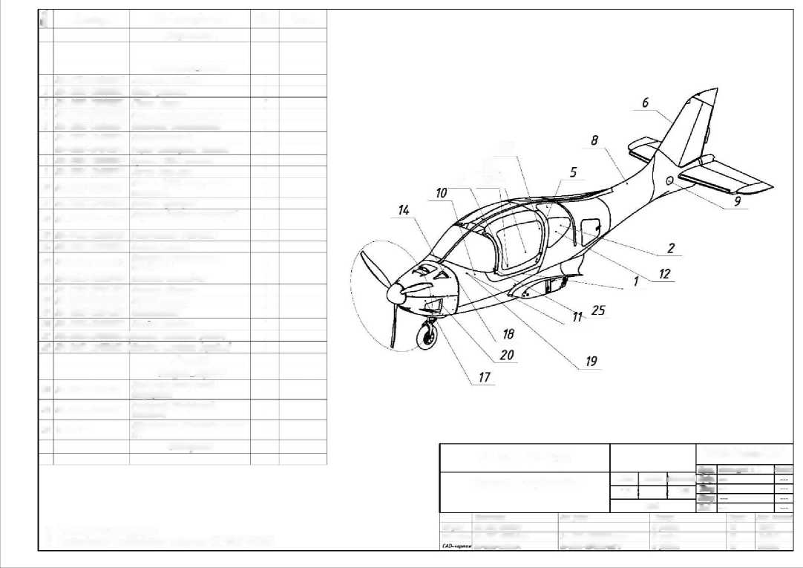

SAO drawing - LA-5700-001Bm7
1. * Dimensions for reference.
2. Technical requirements according to STP.001-17.001.
к | Article | Name | Clk | Example.
 |  | Documentation
 |  | Assembly units
1 | KA-5700L-0018M96 | Console left | 1
2 | KA-5700R-0Ö18175 4- | Console of the right 8 assembly Details | і
 |  | Purchased products
 |  | Materials.

LA-5700-0018174.7 |  |  |  | "ANG Patriot UA"
 |  |  |  | Krsl. | Shtepguzab A. 1. | 04.04.21
Crimea (ANG011 | Letter | Mass | Scale | flpöp. | - | -
 | 1/1 |  | 1:30 | TKtr | - | -
 |  |  |  | NKtr | - | -
 | ANG
 |  |  |  | Ztb. | - | -

Status.
In the works
In riVote
In the works
Document no. | Audit | Name of the document | Date. | Page
AA-0110-10000101 | 003 | Technical description of the ANG-01 light aircraft | 15.06.22 | 56 / 57

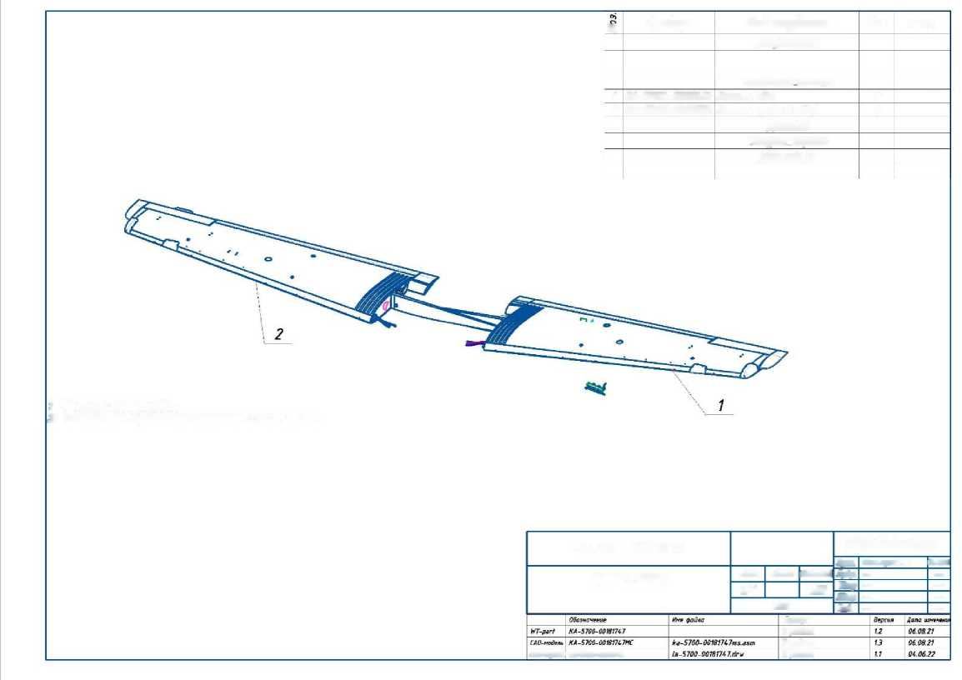

Aci
"1 ё | Article. | Name | Clk | Note.
 |  | Documentation
 |  | Assembly units
1 | KA-6110-00234660-1.3 | Three-lobed bushing for the mining machine (A#02) | 1
2 | KA-6120-002 70868-1.2 | Screw cock | 1
3 | KA-6120-001808 72-1-1.5 | Flange of the coil screw assembly | 1
 |  | Details.
 |  | Purchased freaks
4 | 00136346 | Screw 130 7380-2 M4x10-8.8 | 9
5 | 00270502 | Screw PIN7991 MZx8-8,8 | 3
 |  | Materials.

LA-6100-00268582-1-1.2 |  |  |  | "ANG Patriot UA"
 |  |  |  | KrSA. | Ltelguzov A. i. | 0 and. 06.2 and
Airplane propeller | Letter | Mass | Scale | PrVr.
 | 1/1 |  | 15 | TKtr
 |  |  |  | NKtr |  | -
 | Aircraft propeller
 |  |  |  | Approved by.

In the works
In the works
In the works
1. Dimensions for reference.
2. Technical requirements according to STP.001-17.001
No. | Article. | Name | As the example.
 |  | Documentation
 |  | Assembly. units
1 | KA-7520-00180909 | Expansion tank (I915i8) | 1
2 | KA-7100-00180888 | Engine Roy* 915is | 1
3 | KA- 7910-001360 74 | Mounting the oil tank | 1
4 | KA-7900-00134161 | Engine oil system (P915I57 | 1
5 | KA-7500-0014 4 361 | Water cooling system | 1
5  7 | KA-7500-00180878  KA-2120-00262458 | Air cooling system  SB slide cable | 1  1
8 | KA-2120-00135054 | Installing the air conditioning damper cable | 1
9 | KA-3940-00263971 | Installation.  electrical equipment (Spar No. 17 | 1
10 | KA-2820-00179024 | Fuel filter (I915iz) | 1
11  12 | KA-5310-00133872  KA-6130-00136206 | Frame No. 1 (composite) Brush assembly  Leta Li | 1  1
13 | PRC-0000007723 | Air purification filter | 1
 |  | Materials.

LA-7100-0019L206 |  |  |  | "ANG Patriot UA"
 |  |  |  | Krsl. | TKteliuzaV A. 1 | 06.0621
Engine systems | Letter | Nassi | Scale | Prbr | - | -
 | "1 |  | ' 15 | TKtr | - | -
 |  |  |  | NKtr | - | -
 | ANG
 |  |  |  | Approved by. | - | -

Status.
In the works
In the works
8 work
