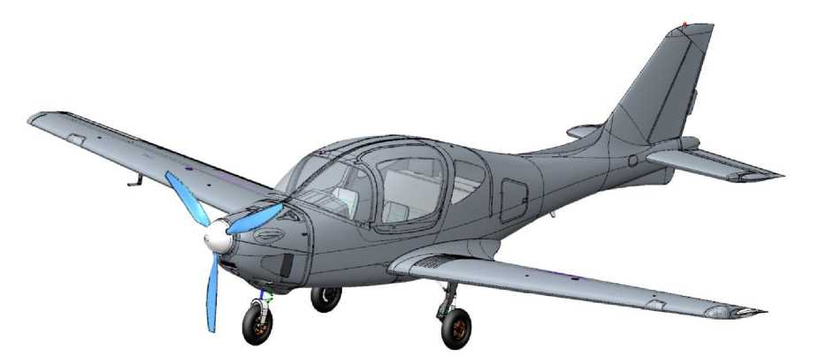
FLIGHT MANUAL
ANG-01
MANAGEMENT
ON THE FLIGHT OPERATION OF THE AIRCRAFT
(Aircraft Flight Manual)
ANG.01.AFM

INFORMATION ABOUT THE DOCUMENT
Title: ANG-01 Aircraft Flight Operations Manual
Designation: ANG.01.AFM (Revision 0)
Developer: Inna Golovach (Brovary, Ukraine)
Purpose: the document regulates the specific rules for the ANG-01 airplane.
Applicability: ANG-01 aircraft
Audit registration sheet
№ Audits | Date of issue/date of approval by SASU | Name of the person who made the changes | Date of amendment / date of approval by SASU | Signature
00 | 24.12.2021/ | Golovach I.I.
INFORMATION ABOUT THE DOCUMENT 2
SECTION1. INTRODUCTION 4
SECTION2. DESIGN DESCRIPTION 7
  - Classification, purpose of the aircraft 8
  - General information 8
  - Main geometric dimensions 10
  - Airframe of an airplane 11
  - Power plant 13
  - Chassis and hydraulic system 15
  - Electrical system 16
  - Instrumentation equipment 17
  - Household and rescue equipment 21
SECTION3. OPERATIONAL RESTRICTIONS 24
  - Weight and 25
  - Crew composition 26
  - Speeds 27
  - Flight height 28
  - Overload 28
  - Maneuvering 28
  - Types of flights 28
  - Meteorological conditions 28
  - Airfields 29
  - Power plant 30
SECTION4. STANDARD PROCEDURES 32
  - Pre-flight inspection 33
  - Starting and shutting down the engine 35
  - Steering 37
  - Takeoff 38
  - Height dial 39
  - Horizontal flight 40
  - Performing a pilotage 41
  - Decrease 42
  - Landing 43
  - Going for a second round 45
  - After the flight 46
SECTION5. ACTIONS IN EMERGENCY SITUATIONS 48
  - Use of the rescue system 49
  - Engine failure on the ground 50
  - Engine failure at low altitude 50
  - Engine failure at high altitude 50
  - Fire in the engine compartment on the ground 51
  - Fire in the engine compartment in flight 51
  - Fire in the cabin 51
  - Unintentional entry into the corkscrew 52
SECTION6. ACTIONS IN DIFFICULT SITUATIONS 54
  - Forced landing 55
  - Getting into a zone of significant turbulence 56
  - Impaired visibility 56
  - Icing 56
  - Malfunction of the pitot tube 57
  - Failure of the main flight and navigation system 57
  - Failure power supply 57
  - Failure trimmer control 57
  - Failure flaps 58
  - Failure chassis 58
SECTION7. FLIGHT CHARACTERISTICS 60
  - Introduction 61
  - Takeoff 62
  - Landing 64
  - Height dial 65
  - Decrease 66
  - Range and flight duration 67
APPENDIX 1 68

SECTION 1. INTRODUCTION
The ANG-01 Aircraft Flight Manual (hereinafter referred to as AFM, Aircraft Flight Manual or Manual) is written in Ukrainian.
The AFM contains the data necessary for the flight operation of the aircraft on its composition and functioning of systems, components, and assemblies.
The AFM lists malfunctions that can cause severe accidents and provides recommendations for mitigating or eliminating them.
The AFM is the only flight document governing the operation of the ANG-01 airplane. Aviation operations not specified in the AFM are PROHIBITED.
The available AFM is not a substitute for competent theoretical and practical training. Failure to comply with the provisions of the AFM may result in the breakdown, loss of the aircraft, or tragic consequences.
The pilot is allowed to operate the ANG-01 aircraft with a PPL or CPL certificate and only after a detailed study of the available AFM.
The developer is not obliged to provide the existing Manual in printed .
Permission to print the Guidelines is granted to third parties. Preferred print format: A5 size.
It is also convenient to have an electronic version of the Guidelines on your tablet or smartphone. The electronic version in PDF format (with a ban on making changes) has a structure of sections, subsections and chapters, as well as working cross-references that make it easier to find the information you need.
Checklists for flights are provided in APPENDIX 1.
The list of equipment with which failures are permitted to operate (MMEL, Master Minimum Equipment List) is provided in ANNEX 3 of the Technical Operation Manual ANG.01.АMM.
Changes and additions to the AFM are issued instead of or in addition to the existing material in the form of separate standard sheets.
These changes or additions are noted in the Change Registration Sheet, indicated by a vertical line in the fields to the right opposite the changed part.
In the lower left part of the modified page, in the line of the Revision number, the text "Change" with the change number is placed. Also, instead of the revision number and the date of the previous revision/change, a new revision/change number with the new date is placed.
In the printed version of the Guidelines, the previous version of the changed page is removed and destroyed.
ATTENTION! ANG-01 airplane flights without AFM are prohibited

Definition of terms
Information that is critical or of particular importance is indicated by CAUTION, WARNING, and NOTE in bold, capitalized type. The importance of the instructions is further emphasized by the color-coding (red, brown, and green, respectively) of the block of text. Each of these terms is defined below.
ATTENTION means that failure to follow the appropriate procedure or conditions may cause an aviation accident with serious consequences.
WARNING means that failure to follow the appropriate procedure or conditions may result in damage to the aircraft or crew.
A NOTE draws attention to special circumstances that need to be emphasized, provides necessary information and explanatory material.
All numerical values are given in the metric system.

Abbreviations
ACK - Aircraft control knob (aitcraft control knob)
ADAHRS - Sensor for speed, altitude, angle of attack and position angles
AFM - Flight operations manual
AMM - Technical operation manual
ANL - Airborne navigation light (airborne nav light)
CB - Circuit breaker for the on-board power system
CG - The center of gravity of an airplane
CS-23 - Airworthiness standards
EASA - European Aerospace Agency
ECK - Engine control knob - Engine control knob
ECU - Engine control unit
EGT - Engine cylinder head temperature
ELA - Light aircraft
ELV - Elevator - Elevator control
EMS - Engine monitoring unit
EOM - Engine operating mode
FC - Fabric cover - Paint and varnish coating
RW STROBE V2,  VY | - Satellite navigation system (global nav satellite syst)  - Runway with unpaved surface  - International standard atmosphere  - Average aerodynamic chord of the wing  - Directional control (rudder)  - The runway  - Onboard flashing fire  - Characteristic takeoff and landing speeds  - Maximum speed  - Maximum speed operational  - Variable pitch propeller  - Dumping speed  - Vertical speed

SECTION 2. DESCRIPTION OF THE DESIGN
DESCRIPTION
CONSTRUCTIONS
TABLE OF CONTENTS
  - Classification, purpose of the aircraft 8
  - General information 8
  - Main geometric dimensions 10
  - Airframe of an airplane 11
  - Power plant 13
  - Chassis and hydraulic system 15
  - Electrical system 16
  - Instrumentation equipment 17
  - Power tools and rescue equipment 21

Introduction
The section defines the classification and purpose of the ANG-01 aircraft, information on its design and functional purpose of its main components.
The text and graphic material presented is sufficient to present the design of the ANG-01 airplane for safe flight operations.
  - Classification, purpose of the aircraft
DESCRIPTION
CONSTRUCTIONS
The ANG-01 belongs to the ELA1 class (with a maximum takeoff weight of up to 1200 kg).
The ANG-01 is a normal category airplane for daytime operations only in simple meteorological conditions without icing, according to the rules of visual flight outside clouds and thunderstorm areas. It is FORBIDDEN to perform aerobatics and aerobatics with the ANG-01.
  - General information
The ANG-01 airplane is a normal aerodynamic design, a strutless low-wing aircraft with a fuselage, deck tailplane, and trapezoidal wing.
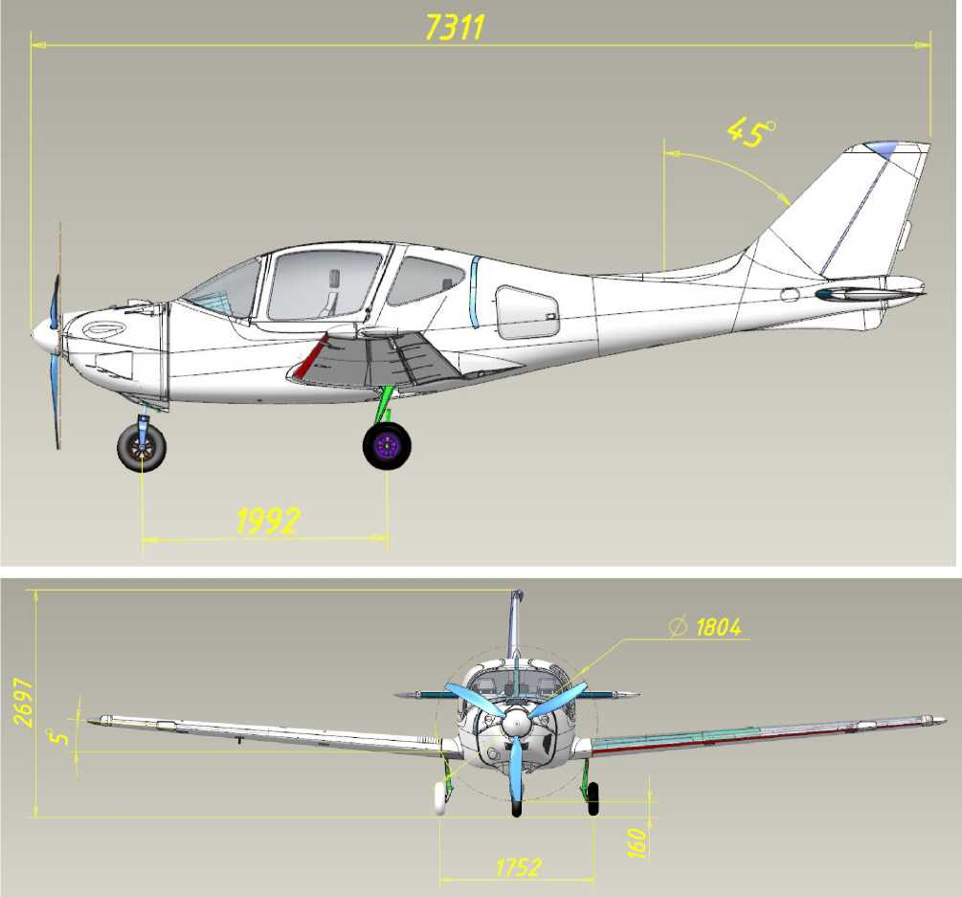
General view and main geometric dimensions of the ANG-01 airplane:
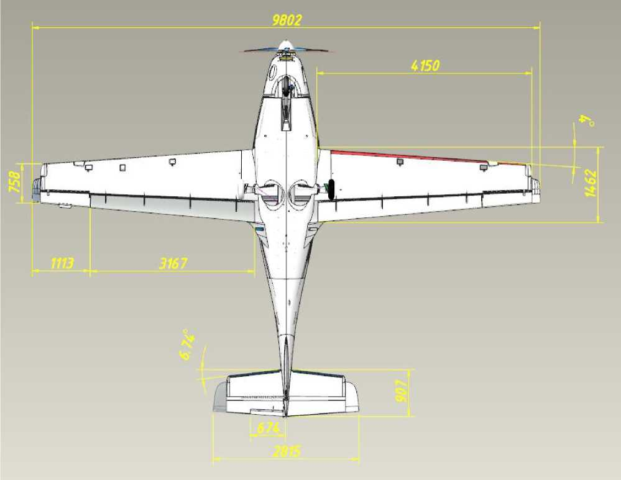
DESCRIPTION
CONSTRUCTIONS
Steering surfaces: two-section elevator (with trimmer on the right section), single-section ailerons, directional rudder (with trimmer plate). All surfaces with aerodynamic horn compensators. The rudder is equipped with turbulizers for greater efficiency.
Wing mechanization: two-section flap.
Landing gear: retractable in flight, three-pillar, with a nose steerable prop.
Power plant: one piston engine.
Propeller: Pulling 3-blade propeller with variable pitch in flight.
2.3 Basic geometric dimensions  Geometric data (in addition to those defined in the figure in Section 2.2): |  |  | zg o >  °£  о
Unit | Data type | Meaning.
Wing | Area. | 11.2 ^{м(2)}
 | Extension | 8.5
 | Narrowing | 2.0
 | Arrowhead on the leading edge | 4.0°
 | Lumbar V console angle | 5.0°
 | Insertion angle along the root nerve | 0.0°
 | Geometric torsion | 0.0°
Plumage | Area. | 1.28 ^{м(2)}
 | Arrowhead on the leading edge | 5.0°
 | Lumbar V angle | 0.0°
 | Setting angle along the root nerve | 5.5°
 | Geometric torsion | 0.0°
Fuselage | Door size*. | 1.1x0.8 m
 | Trunk hatch size* | 0.3x0.2 m
 | Useful trunk volume | 1.00 ^{м(3)}
 | Keel installation angle | 0.0°
 | Propeller clearance***. | 0.20 м
Chassis**. | Track | 1.94 м
 | Base. | 1.98 м

- minimum length and width
- for static compression of shock absorbers with the maximum weight of the aircraft.
  - Airframe of an airplane
DESCRIPTION
CONSTRUCTIONS
The design of the airframe components is described in detail in the AMM, while the AFM provides only some information.
    - Fuselage
The engine compartment is located in the nose, the central part has a leaky cockpit (for pilots and others) and a luggage compartment, and the tail has the fins.
The engine compartment houses the engine with the attachments necessary for its operation, pipelines and air intake to the cab, the cab heating system, the hydraulic power plant, and the chassis brake units. The front chassis support is located in the lower area of the compartment. The battery is located in a separate compartment. The engine is mounted on a steel engine frame through shock absorbers, which is fixed to the power frame No. 1 (with a fireproof coating).
Two doors on the port and starboard sides, which open forward and upward, serve as emergency exits (checks on the door hinges). Access to the luggage compartment is through the hatch behind the cab (on the port side).
The aircraft cabin is five-seat, with 2 pilots on the left or right, and 1 to 3 people on the rear sofa. The cabin is equipped with ventilation and air heating. In the front area of the cabin there is a niche for equipment mounted on the dashboard. There is a small trunk ("glove compartment" for small items and documentation) offset to the right. The pilots' seats are located in the central area of the cockpit. In the middle between the pilot's seats is a central armrest. It contains an intercom, landing gear release/removal panel, a crane and a backup landing gear release cylinder (in the armrest). There is a sofa in the rear area of the cabin, under which the wing spar box passes. Behind the back of the sofa are the sensors of the flight and navigation system and a consumable fuel tank with fittings. The luggage compartment is located in the rear of the central compartment.
In the tail section, there are vertical and horizontal plumage with control surfaces.
Vertical winglets: boom-shaped, symmetrical profile NACA 65-1-012, made in one piece with a fuselage made of fiberglass composite materials (to ensure radio transparency, as it houses the radio communication antenna).
Horizontal winglets: boom-shaped, asymmetrical NACA 6401 profile, one-piece construction, glued into the fuselage, made of carbon fiber and fiberglass composite materials.
    - Wing and mechanization
DESCRIPTION
CONSTRUCTIONS
The wing of the airplane is trapezoidal in plan, without geometric torsion.
Full span wing profile NLF(1)-215F, with a relative thickness of 16.5%, an average aerodynamic chord of 1.2 m (at a distance of 1.2 m from the onboard nerve centerline), and a wing stall angle of 0°.
Structurally, the wing is made of left and right consoles made entirely of carbon fiber composite materials, with the spars integrally integrated into them.
The consoles contain the control system aileron rods and rockers, the mechanization drive shaft, and wiring harnesses. The right console also contains elements of the pitot tube: wiring harnesses (heating controller and pneumatic line).
In the middle part of each console, there is one fuel tank. In the upper part of the consoles is the neck of the corresponding caisson tank.
Mechanization of the trailing edge of the wing: Fowler flap (single-slide, retractable), with a maximum extension of 16.5% and a corresponding deflection angle of 30°. Intermediate positions are 10° and 20°.
The flap is released and retracted by a servo located in the fuselage in the middle of the corresponding part of the shaft; the release and retraction are controlled from a separate panel on the central armrest.
    - Control system
The control system of the aircraft is traditional, 3-channel: longitudinal channel (elevator), transverse channel (ailerons) and path channel (directional control).
The control system is mechanical, consisting of controls (ACK and left and right pilot pedals, which are mechanically interconnected), mechanical elements (rods and rockers) and steering surfaces.
All control surfaces are flat, equipped with aerodynamic horn and weight compensation of hinge moments. The elevator is two-section, the ailerons and rudder are single-section.
An electric trimmer is mounted on the right section of the elevator to reduce the effort required to deflect the ACK (controlled by a button on the ACK).
A trimmer plate is installed on the directional rudder for track balancing during cruise speed flight.
Autopilot servos are installed in the longitudinal and lumbar channels of the control system.
  - Power plant
DESCRIPTION
CONSTRUCTIONS
    - Engine
The Rotax 915 iS 3A engine is designed and manufactured by BRP-Rotax GmbH (Austria): piston, gasoline, 4-stroke, 4-cylinder, with an opposed cylinder arrangement.
Engine power (nameplate, in ISA):
V^{x}Takeoff mode: 104 kW (141 hp) at 5800 rpm;
V Rated mode: 99 kW (135 hp) at 5500 rpm.
The propeller is driven by a reduction gearbox. Formation of the fuel-air mixture: injection. To increase power, the engine is equipped with a turbocharger and intercooler.
The engine cooling system is combined: liquid cooling of the cylinder heads and air cooling of the cylinders. The engine is equipped with a closed-loop lubrication system.
    - Air screw
The propeller is a propeller of our own production with a diameter of 1815 mm. The propeller type is a torsionally stabilized, three-blade, variable-pitch propeller.
The blades are made of composite materials, the leading edge is protected from mechanical damage by a polyurethane cover. The blades are not heated.
The hub is made of aluminum alloy. The pitch control drive is electric, located on the hub (under the wheel). The pitch control signal is transmitted to the actuator from a separate console (in the cab, on the central armrest) via a sliding contact.
    - Management and control bodies
To control the power plant, the crew is provided with current information:
- Engine speed;
- Temperature of the cylinder heads (rear);
- Exhaust gas temperature;
- Coolant temperature;
- Lubricant temperature;
- Lubricant pressure;
- Air pressure in the receiver;
- Instant fuel consumption;
- Fuel pressure in the ramp;
- Fuel remaining in the tanks (total);
- Voltage at the generator terminals (phases A, B);
- Targeting the engine.
To display this information, the ECU receives it from the engine sensors and additional sensors and transmits it via the CAN bus to the EMS unit for display on the Dynon SkyView SV1100 multifunctional display.
DESCRIPTION
CONSTRUCTIONS
The display also displays alarms of emergency parameters of the power plant, the Dynon SkyView SV1100 system generates the appropriate sound alarm and transmits it to the on-board communication system.
Power plant controls in the cockpit:
- Throttle control knob (ECK);
- Control panel for the variable pitch screw.
The 2.8.6 ECK (see section for location) is mechanically connected to the throttle by a cable. The ECK is mounted on the center armrest between the pilots. All other engine control commands are executed by the ECU.
The 2.8.6 propeller control panel (see section for location) operates in manual and automatic modes, switched by the toggle switch on the panel. In the manual mode, the pilot sets the required engine speed with a setpoint (dial), in the automatic mode, the speed is set and maintained by the ECU depending on the throttle position. The remote control is equipped with a screen that displays the set engine speed.
    - Fuel system
The fuel is placed in two cantilevered caisson tanks and a consumable fuselage tank with a maximum total capacity of 260±10 liters.
The fuel tank is located between the rear sofa and the luggage compartment of the central fuselage compartment below, so that fuel from the console tanks flows into it by gravity.
There are 2 constant-flow pumps in the fuel tank, which also have a level sensor (fuel gauge) built in. They pump the fuel to the fuel filter located in the engine compartment and then to the engine injector through the discharge pipeline. Excess fuel is returned to the consumption tank from the injector through the drain line.
The drainage in the console and consumption tanks is centralized, with a U-shaped tube (to prevent fuel from spilling into the center compartment) leading to a spigot under the fuselage. In the cantilever tanks, additional drainage is provided through the filler caps.
  - Chassis and hydraulic system
DESCRIPTION
CONSTRUCTIONS
    - Chassis
The chassis is three-pillar, three-wheeled, with two single-axle main legs and a single-axle nose support.
All props are retractable in flight: the nose props backward along the flow, the main props under the fuselage across the flow (to the plane of symmetry of the aircraft). All props are equipped with gas-lubricated shock absorbers. The nose support is of telescopic type, the main ones are of lever type.
The nose support with a pivot mechanism is kinematically connected to the steering pedals (±30° angle of rotation of the wheel at full pedal travel). The nose support is centered during cleaning thanks to a special universal joint mechanism.
All wheels with cast wheels and chamber pneumatics.
    - Brakes
The main supports are equipped with hydraulically operated disc brakes, no anti-skid automation. Hydraulic brakes are automotive-type: they work without switching on the hydraulic power plant, the tanks are located in the engine compartment.
Braking is performed by pressing the brake pedals located on the control pedals along the course from both the left and right pilot's seats.
    - Controlling the release/retraction of supports
The position of each chassis support is monitored by the corresponding green LEDs (red in intermediate positions) on the chassis remote control located on the central puddle (see section 2.8.6 for location).
The retracted or released position of each support is determined by the lock built into each cylinder.
When the toggle switch on the chassis control panel is turned on for discharge or cleaning, the electric drive hydraulic station is switched on, and the working fluid pressure enters the cylinders on the corresponding side.
In the event of a malfunction of the hydraulic power plant or a power failure, the chassis can only be released from the backup system. To do this, the three-position valve must be set to the release position. This opens the fitting of the carbon dioxide cylinder (in the cylinder above the valve), the pressure of this gas moves the spool, closing the pressure line of the hydraulic power plant and pressurizing the exhaust cavity of each cylinder.
    - Hydraulic system
Pressure source: electrically driven hydraulic station in a single unit with a 2.5-liter tank and safety valves.
  - Electrical system
DESCRIPTION
CONSTRUCTIONS
The power source is the generator No. 2 built into the engine. Generator #1 is the source of power exclusively for the engine (injector, ignition system, ECU, etc.).
The onboard 12 V (24 Ah) lithium-polymer battery is located in a separate compartment in front of the frame No. 1. The compartment contains terminals for connecting the onboard power supply and a temperature sensor.
Power supply to the onboard network from generator No. 2 is possible only after the engine speed reaches 1800 rpm.
In case of failure of generator No. 1, the engine power supply is automatically switched to generator No. 2. In this way, it is disconnected from the onboard consumer network, providing power exclusively to the engine. In this case, the corresponding indicator light on the instrument panel is activated.
The battery provides power in flight:
- at engine startup: starter and ECU;
- in flight, in case of generator failures: all consumers (15 minutes, in ISA).
  - Instrumentation equipment
DESCRIPTION
CONSTRUCTIONS
    - Basic flight and navigation equipment
The main flight and navigation equipment is the Dynon SkyVieW SV1100 system. System elements:
- Multifunctional display (1 pc.);
- Pitot tube with heating controller;
- The ADAHRS module is the main one;
- Temperature sensor (2 pcs.);
- GNSS module;
- Communication module with the EMS engine;
- The remote control of the radio station;
- Autopilot servos (2 pcs.);
- Transponder;
- Power supply battery (1 pc.).
All system elements are powered by 12 V DC from the onboard power supply. In the event of a power outage, the system is equipped with an emergency battery that provides power for 30 minutes (in ISA).
The Pitot tube is connected to the ADAHRS module by pneumatic tubing. The tube is heated in case of icing.
The ADAHRS module is a source of data on instrument and vertical speeds, barometric altitude, angle of attack, attitude angles, overloads, and ambient air temperature.
The magnetometer (compass) is the source of magnetic heading data and is also used by the system to calculate the wear angle.
The GNSS module is the source of data for the airspeed, altitude relative to the earth's surface, and the position of the aircraft on the map (in this version of the GNSS module, only GPS NAVSTAR is used).
The EMS module links the power plant data to the system.
The transponder sends the necessary aircraft identification data (current position, altitude, registration number, etc.).
The multifunctional color display of the tuch-screen type (see Section 2.8.6 for location) is equipped with processors that calculate all current data and generate images of scales and current flight, navigation, engine, autopilot, transponder information, as well as the aircraft position on the map, flight route, and battery temperature.
Indicator speed is corrected by the instrumental correction.
The display is equipped with a brightness adjustment dial and buttons.
All elements of the Dynon SkyView SV1100 system are protected against electromagnetic influences), mechanical loads, vibration, humidity, water, barometric pressure and ambient temperature (exceeding the operational limitations of the aircraft).
DESCRIPTION
CONSTRUCTIONS
    - Backup pilot equipment
DESCRIPTION
CONSTRUCTIONS
In addition to the primary Dynon SkyView SV1100 system, the following backup flight equipment is installed on the aircraft (see Section 2.8.6 for locations):
- Airspeed indicator;
- Vertical speed indicator;
- Barometric altitude indicator;
- Magnetic compass;
- Slip indicator.
The pointers are connected to the Pitot tube in parallel with the ADAHRS sensors of the main system, while the compass and slip indicator operate autonomously.
The airspeed indicator is accompanied by an instrument correction chart (located on the cockpit light frame).
The airspeed indicator shows the sectors of the minimum speed limit (red), the maximum operating speed with flaps released (white), and the maximum operating speed dash
    - Radio communication equipment
External radio communication is provided by the Dynon Skyview Com Radio SV-COM-T8 ultra-shortwave radio station. The antenna feeder of the radio is built into the vertical tailplane (the radio is transparent, made of fiberglass). The radio remote control is located on the instrument panel (see 2.8.6 for location).
Internal radio communication is provided by a 5-person subscriber node with headset plugs, including an intercom (see section 2.8.6 for location).
Headsets with noise reduction are recommended.
    - Lighting equipment
The aircraft is equipped with airborne navigation lights (ANL), flashing lights (STROBE) and headlights.
There is no interior lighting for the cockpit, luggage compartment, or instrumentation (the aircraft is designed for daytime flights).
The right and left wing consoles have green and red ANLs, respectively, and the fuselage has a white ANL on the tip.
STROBE is located on the ends of the right and left wing consoles (in conjunction with ANL), as well as on the top of the directional rudder (separately).
    - Lighting and signaling equipment
DESCRIPTION
CONSTRUCTIONS
There are warning lights on the instrument panel (see section 2.8.6 for location):
- Circuit A of the ignition system ("CH A" of the "ENG WARN" group);
- Circuit B of the ignition system ("CH B" of the "ENG WARN" group);
- Operation of the engine monitoring system ("WARN EMS");
- Operation of the Pitot tube heating ("PITOT HEAT").
All lamps are equipped with stencils with typical abbreviations that unambiguously interpret their functional purpose.
Normal operation of the respective systems is indicated by green lights, and fault conditions are indicated by red lights. Failure status is duplicated by audio notifications to the intercom.
Light and sound alarms are generated in the Dynon SkyVieW SV1100 system.
    - Instrumentation layout
General view of the dashboard and central control panel:
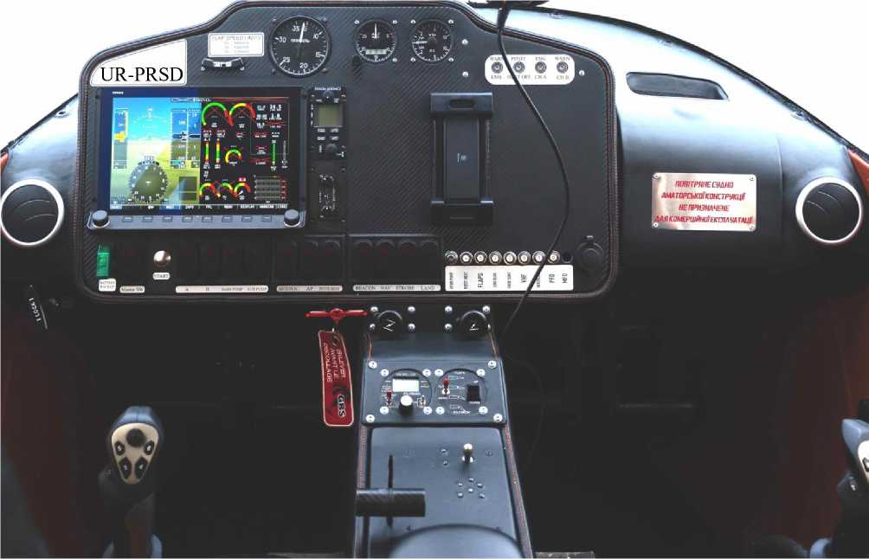
  - Household and rescue equipment
DESCRIPTION
CONSTRUCTIONS
    - Seats and belts, cab interior
Pilots are seated in individual seats that are separately adjustable from the buttons on the central armrest in the longitudinal direction for comfort and reach of the controls (depending on height).
In front of the pilot, within his reach in the tethered position, are the aircraft control system controls (ACK and pedals), the instrument panel with flight and navigation equipment, toggle switches and CB, on the central armrest between them are the controls for the power plant, landing gear and the subscriber internal communication unit.
In addition to the pilot, the aircraft can accommodate up to 4 more people. One person in the front seat and three people on a solid rear three-seater sofa in the rear cabin area, where no separate position adjustment is provided.
The pilot and other occupants are secured in a sitting position by individual 4-point harnesses with individual adjustment. Reliable fastening of the harness fittings to the aircraft structure is ensured in case of loads during an emergency landing.
The cab interior is made of non-combustible and easy-to-clean materials.
    - Ventilation and heating of the cabin
The cab is ventilated with outside air through deflectors located to the left and right of the dashboard.
The crane is controlled by a pull-out handle on the central armrest. Air distribution is controlled by turning the deflectors.
The cab is heated by removing excess heat from the liquid cooling radiator, thanks to a special casing. The casing is connected to the flow control valve by deflectors.
    - Luggage compartments
DESCRIPTION
CONSTRUCTIONS
The aircraft is equipped with a separate luggage compartment, a small luggage compartment on the torpedo, and a compartment in the armrest.
The luggage compartment is designed to accommodate hand luggage such as bags or suitcases of medium size, and other items. The maximum total weight is not more than 60 kg.
For securing luggage, a mooring net is provided, which is fixed to special mooring nodes on the power floor of the compartment.
WARNING Exceeding the maximum baggage weight or not securing the baggage can cause a critical change in centering and, as a result, deterioration of the aircraft's handling.
The small trunk (glove compartment) is designed to accommodate operational documentation: AFM, AMM, Forms and Log Book of the aircraft and engine, as well as small items and documents.
The compartment in the armrest is used to access the landing gear emergency release valve (see section 26.3) .and to place the AFM (must be in the pilot's quick access area).
Access to the luggage compartment is possible only on the ground, from the outside, through a separate hatch on the port side, which is open against the flow to prevent opening in flight.
The luggage compartment and small trunk are lined with fleecy, non-combustible and easy-to-clean materials.
    - Rescue system
DESCRIPTION
CONSTRUCTIONS
The aircraft is equipped with the Galaxy GRS 6/750 SDS Speedy FF Soft B13 rescue system, which provides an emergency parachute landing with a maximum weight, in the speed range of 60...320 km/h (all data are within the operational limits of the ANG-01 aircraft), from a minimum altitude of 80 m.
The system consists of a single container with a packed parachute and a powdered parachute release device. The system is installed on the aircraft on a special box in the rear area of the central fuselage compartment on the right. The compartment is covered with a separate lid.
The halyards of the rescue system are laid in the longitudinal and lumbar troughs in the upper part of the fuselage, under protective covers. The ends of the halyards are securely fastened to the parachute and fuselage power elements.
The rescue system is activated by a handle (with a check), which is mechanically connected to the parachute release device. This activates the powder device to pierce the box lid in the fuselage and open the parachute.

SECTION 3. OPERATIONAL LIMITATIONS
TABLE OF CONTENTS
  - Weight and 25
  - Crew composition 26
EXPL.
LIMITATIONS
  - Speeds 27
  - Flight height 28
  - 28
  - Maneuvering 28
  - Types of flights 28
  - Meteorological conditions 28
  - Airfields 29
  - Power plant 30

Introduction
The section defines all the necessary operational limitations of the ANG-01 aircraft, which guarantee its safe operation.
For an additional list of operational limitations of the aircraft required for its trouble-free operation and maintenance, see the Aircraft Maintenance Manual ANG.01.AMM.
NOTE 1. The pilot must know all these restrictions by heart.
2. Failure to comply with these restrictions may result in damage to the structural elements of the aircraft or create conditions for serious accidents.
  - Mass and center of ization
    - The minimum flight weight of 550 kg is determined by the sum:
- The weight of an empty equipped aircraft is 460 kg (maximum);
- The weight of the 1st pilot is 77 kg (according to CS-23);
EXPL.
LIMITATIONS
- Fuel weight is 13 kg (18.5 liters) for a flight of 30 minutes.
    - The maximum flight weight of the airplane is 950 kg:
- The weight of an empty equipped aircraft is 460 kg (maximum);
- The weight of the 1st pilot is 77 kg (according to CS-23);
- The weight of 4 people is 77 kg (according to CS-23), which is the full crew;
- Fuel weight is 230 kg.
NOTE The weight of an unladen airplane is determined without crew, baggage, fuel (excluding the unladen balance), and ground equipment. The aircraft is filled with hydraulic fluid, lubricating oil, and engine coolant.
WARNING Determining the actual weight and centering in a specific
combinations of the number of persons on board, their baggage and the amount of fuel, in accordance with the methodology set out in the AMM without exceeding the weight limit of 950 kg.
    - Centering range
Mass-centering diagram with the area of restrictions, all possible combinations of the number of pilots, other persons, baggage, and fuel consumption:
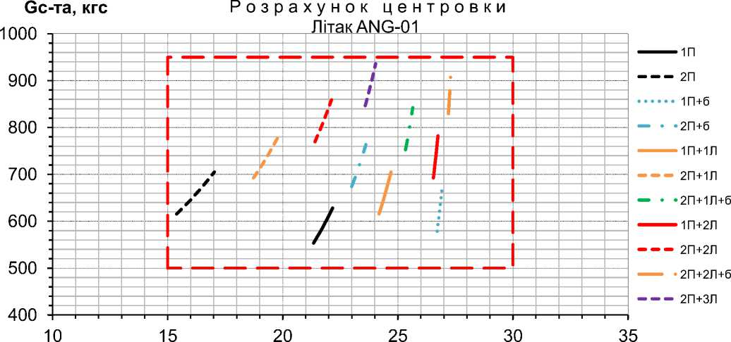
Xt, %SAH
The designation "1P" means an aircraft with one pilot, "2P" - with two
pilots, "1P+B" - with one pilot and 60 kg of luggage in the luggage compartment, "1P+1L" - with one pilot and one person in the back seat, etc.
EXPL.
LIMITATIONS
During fuel production, the centering changes insignificantly, within 3%MAC, this change can be ignored in the calculations (determine the weight and centering by the worst case, i.e., fueling).
Maximum frontal centering of 15.0% MAC is provided with a minimum filling in the "2P" combination, maximum rear centering of 28% MAC in the "2P+2L+b" combination with a filling of 140 liters.
ATTENTION Combinations "1P+3L+b", "2P+3L+b" are NOT allowed because they are outside the operating range.
  - Crew composition
Minimum crew: 1 pilot, maximum 2 pilots.
NOTE 1: Aircraft equipment and characteristics allow for
one pilot can safely, within operational limits, fly the aircraft, monitor the environment outside the cockpit, conduct radio communications and other work operations in accordance with the available AFM.
2. The degree and duration of mental and physical effort expenditure do not lead to extreme fatigue in normal flight and in emergency situations.
The maximum number of people on board is 5, subject to the operating range in terms of weight and centering of the aircraft.
  - Speeds
The speeds are determined in accordance with CS-23 airworthiness standards, with maximum forward centering, without taking into account propeller thrust, and with an instrumental correction (all CAS speeds).
ATTENTION Flying at speeds less than the minimum or greater than the maximum speed is PROHIBITED.
EXPL.
LIMITATIONS
3.3.1 Stall speed (Vs) depending on the weight of the airplane and flaps:
Aircraft weight, kg | 550 | 650 | 750 | 850 | 950
Flaps "0" | 90 | 95 | 100 | 105 | 110
Flaps "1" | 85 | 90 | 95 | 100 | 105
Flaps "2" | 80 | 85 | 90 | 95 | 100
Flaps "3" | 75 | 80 | 85 | 90 | 95

Thus, an increase in flight weight by every 100 kg leads to an increase in dumping speed by 5 km/h.
    - Minimum flight speeds
Determined with normalized reserves to the stall speed and depending on the weight of the aircraft, they are:
- 90...120 km/h on takeoff with flaps "1" (V2);
- 95.125 km/h on landing with flaps "2" or "3" (VREF);
- 110.135 km/h in climb, descent, and horizontal flight.
NOTE: To determine the minimum speeds for a particular aircraft mass, use the nomograms in SECTION 7.
    - Maximum flight speeds
Determined with normalized margins up to the maximum speed depending on the aircraft configuration (flap and landing gear position) are:
Quick. | Meaning. | Configuration | Note
VD | 340 km/h | flaps "0", landing gear removed | ultimate in terms of strength and flute
VNO  VA | 320 km/h  200 km/h |  | not allowed to be exceeded  maneuverable, without limiting overloads
VFE | 130 km/h | flaps "1", "2", "3" | when releasing/removing the flaps*
VLE | 130 km/h | chassis released | when releasing/removing the chassis*.
* - as well as when flying with flaps and landing gear released.

  - Flight height
The maximum flight altitude is 3,500 meters, limited by the lack of oxygen equipment on the aircraft (the cabin is leaky).
  - Overload
EXPL.
LIMITATIONS
Vertical overload is limited to the range of -0.5...3.0 units.g.
  - Maneuvering
    - Pilotage maneuvers are allowed:
- all maneuvers inherent in normal flight, including turns, spirals, rolls, glides, dives, and slides;
- flat figure eights, intensive turns with a bank angle of no more than 60°;
- dumping.
WARNING Piling is permitted for educational purposes only.
    - The maximum tilt angle is 60° to the left and right. During coordinated turns, a roll of up to 90° is allowed.
ATTENTION Difficult, aerobatic and inverted flying is prohibited.
  - Types of flights
Daytime flights are permitted in simple meteorological conditions without icing, according to the rules of visual flights outside clouds and areas of thunderstorm activity.
ATTENTION Flying in conditions of predicted icing, in areas of thunderstorms
activities, near significant cumulus clouds, over water areas at a distance from the coastline exceeding the planning range with a failed engine is prohibited.
  - Meteorological conditions
Visibility range is not less than 1000 meters.
The height of the lower edge of the clouds is at least 150 m.
The air temperature in the ground is in the range of -20...+35°C.
The airfield height above sea level is in the range of 0...500 m. Maximum wind speed at the ground:
- The oncoming component is up to 10 m/s;
- The bypass component is up to 5 m/s;
- Lateral component up to 5 m/s (left, right).
  - Airfields
    - Operation from airfields of classes A, B, C, D, E, F, unclassified and out-of-class airfields, permanent and temporary runways is allowed.
    - Minimum equipment of airfields and sites: communication and visual surveillance equipment, means of determining meteorological information (pressure, temperature, wind direction and speed at the ground).
EXPL.
LIMITATIONS
    - Dimensions RW: 700x10 m in all expected operating conditions.
Dimensions RW dimensions depending on aircraft weight, wind speed and
ambient temperatures are 180...480 m for takeoff, 300...650 m for aborted takeoff, 520...700 m for landing (incline up to 2% to any RW edge).
NOTE: To determine the required RW size for specific actual aircraft weight and environment, use the nomograms SECTION 7.
    - Types and states of RW:
- dry RW (DRY state);
- wet or damp RW (GOOD condition);
- dry soil RW with a strength of at least 8 kgf/cm², with a grass stand of up to 5 cm.
WARNING 1. The ground RW must have a prepared surface without holes and bumps, with unevenness not exceeding 5 cm on a 3 m base.
- Landing on an unprepared site is allowed only in an emergency situation.

3.10 Power plant
The main operational limitations set by BRP-Rotax:
Limitations. | Meaning. | Note
Revolutions on the shaft | 1800 rpm  5500 rpm  5800 rpm | low gas mode nominal mode max. up to 5 min.
Lubricant consumption | 0.06 l/g | maximum
Lubricant pressure | 0.8 bar  2.0 bar  5.0 bar | minimum, <3500 rpm minimum, >3500 rpm maximum
Fuel pressure | 2.9 bar  3.1 bar | minimal exp maximal exp.
Lubricating oil temperature* | 50°С  130°С | minimal  maximum utilization.
Coolant temperature*. | 40°С  120°С | minimal  maximum
Exhaust gas temperature | 200°С  950°С | minimal  maximum

* - in flight
EXPL. LIMITATIONS


The page is intentionally left blank
EXPL.
LIMITATIONS

SECTION 4. STANDARD PROCEDURES
TABLE OF CONTENTS
  - Pre-flight inspection 33
  - Starting and shutting down the engine 35
  - Steering 37
  - Takeoff 38
  - Height dial 39
  - Horizontal flight 40
STANDARD PROCEDURES
  - Performing a pilotage 41
  - Decrease 42
  - Landing 43
  - Going for a second round 45
  - After the flight 46

Introduction
This section defines all procedures for the ANG-01 airplane required for safe flight operations with its systems operating normally. Aircraft maintenance procedures not directly related to flight operations (fueling, mooring, etc.) are described in the ANG.01.AMM Aircraft Maintenance Manual.
WARNING Failure to follow these procedures may result in damage to structural components of the aircraft or create conditions for serious accidents.
  - Pre-flight inspection
    - External review, Checklist #1
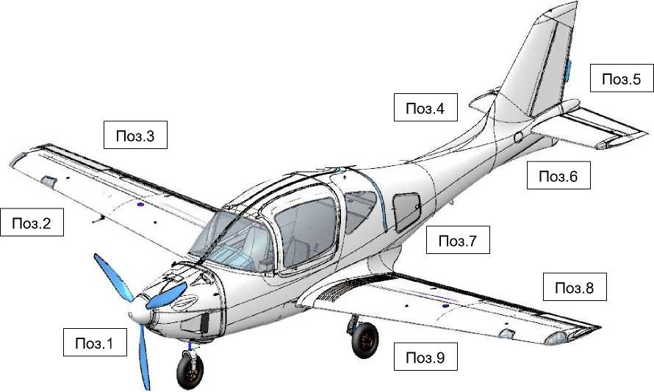
STANDARD PROCEDURES
Pose. Subject of the review |  | Pay attention to
1 | Air screw Hoods  Front chassis support  Frontal glazing | No backlash, cracked or nicked blades, polyurethane peeling at the edge. There are no signs of fuel or oil leaks, FC damage, fuel injection pumps are closed, hoods are on the locks, plugs are removed, and the battery is properly installed.  No backlash, no traces of grease leakage, the stem is clean, the wheel rim is crack-free, the pneumatic is inflated, there are no cuts or abrasions to the cord, the niche is clean.  There are no cracks, no "silvering", no clouding.
2 | Right wing console  The neck of the right tank | No play, no damage and FC, leading edge clean, headlight glazing, ANLs secured, their glazing free of cracks, no play in the Pitot tube, plug removed. No leakage, lock closed, drainage not contaminated.
3 | Right aileron Right flap Right landing gear support | No backlash, no damage to the FC.  No backlash, no damage to the FC.  No backlash, no traces of grease leakage, stem clean, wheel rim free of cracks, air inflated, no cuts or abrasions to the cord, brake hoses connected, niche clean, footrest released.
4 | Tail section of the fuselage (right) | No damage to the FC, no cracks, delaminations, or chips in the lining, stencils and serial number are applied, the surface is clean, and the control hatch is locked.
5 | Stabilizer  Height control  The steering wheel of direction | No FC damage, cracks, delaminations, or chips in the lining.  There are no cracks at the joints with the fuselage, the surface is clean.  There is no play between the left and right sections and the trimmer, the sections tilt synchronously without significant effort, and the trimmer is connected to the drive.  The backlash does not exceed 1 cm, the trimmer plate is set.
6 | Tail section of the fuselage (left) | No damage to the FC, no cracks, delaminations, or chips in the lining, stencils and registration number applied, surface clean, and control hatch secured.
7 | Luggage compartment | No fuel odor, luggage secured, hatch closed.
8 | Left aileron Left flap Left landing gear support | No backlash, no damage to the FC.  No backlash, no damage to the FC.  No backlash, no traces of grease leakage, stem clean, wheel rim free of cracks, air inflated, no cuts or abrasions to the cord, brake hoses connected, niche clean, footrest released, pad installed (at least on one strut).
9 | Left wing console  Neck of the left tank | No backlash, damage, or FC, leading edge clean, headlight glazing, ANLs secured, their glazing free of cracks.  No leaks, the lock is closed, and the drainage is not contaminated.

4.1.2 | Inspection of the cabin, | Checklist #2:
Pose. | Subject of the review | Pay attention to
1 | General overview | The pilot takes seat.  Make sure there are no foreign objects on the seats, floor, canopy, rear shelf behind the sofa, wires hanging under the dashboard, fuel odor, or burning wiring.  Ensure that the harnesses for all crew are in place and properly secured. Ensure that fire extinguishers and first aid kits are installed in their proper places.  Make sure that all instrumentation is installed and properly secured. Make sure the doors are securely locked in the open position and that the emergency checks are in place.
2 | Documentation | Ensure that the AFM is available and in the proper place.  The necessary flight documentation is located in the small luggage compartment as required (AMM, Aircraft and Engine Forms are not required).
3 | Power supply, remote controls | Make sure that all switches turned off and all CBs are turned on. Turn on the "MASTER SWICH" and "AVIONIC" switches.  Make sure that the VPP control panel is normally switched on: the VPP display shows 5800 rpm. Make sure that the flap control is normally switched on: the LEDs are green, without flickering, the actual flap position corresponds to the display. Make sure that the landing gear remote control is normally switched on (LEDs of the released position are green, without flickering, LEDs of the retracted position are off).  Make sure that the on-board radio remote control is turned on normally.
4 | Instrumentation equipment | Ensure that the Dynon SkyVieW SV1100 system is running normally.  Monitor the system's recognition of all sensors (list according to 2.8.1) and the correctness of system indicators.  Monitor the onboard power supply voltage of 12±0.5 V.  Monitor the compliance of geolocation with the actual location of the aircraft.  Monitor the operation of the warning lights (red before the engine starts).  Set the backup altimeter and speed indicators to "0": the barometric pressure must match the actual instruments of the airfield meteorological system.  Enter the flight route into the system (if necessary).
5 | Controls | Verify the normal operation of the aircraft control system by moving the ACKs in the longitudinal and lumbar channels to their limit positions: ACK "toward itself" deflects the ELV upward and vice versa, ACK to the left deflects the left aileron upward and the right aileron downward and vice versa. The ACK movement is smooth, without jerks, synchronized from the left and right control posts.  Check that the ELV trimmer is functioning properly: the position corresponds to the set position. Check the ECK for proper operation: the movement to the limit positions is smooth.
6 | Crew accommodation | The rest of the crew members take their seats according to the weight and centering calculation.  Fasten and adjust the seat belts.  For pilots, set the seats to a comfortable position, ensuring that the ACK and pedals are within reach of the pilots.
7 | Radio communication | The crew should use their headsets to connect to the subscriber intercom node.  Everyone should check the availability and quality of internal communication.  Pilots should set the frequency of the radio node (if available at the airfield).  Pilots should check the availability and quality of external communication.
ATTENTION 1. If at least one check according to the available Checklists No. 1 and No. 2 is not performed, or the result of the check does not correspond to the result specified in the checklists result, do not perform the flight until the following problems are eliminated
inconsistencies.
2. Flying without successfully and fully executed available Checklists can lead to serious aviation accidents.
STANDARD PROCEDURES

  - Starting and shutting down the engine
    - Turn the engine shaft three times by the blades (lubrication of engine components after parking for more than 1 hour).
    - Set the ECK to the "Low gas" position (fully "on").
STANDARD PROCEDURES
    - Request permission to launch from ground services (if available at the airfield/site).
    - Ensure that there are no people, animals, or obstacles in the plane of rotation of the propeller and in front of the aircraft at a distance of at least 5 meters.
    - Turn on the "MASTER SWITCH" switch.
4.2.6 Turn on the "AVIONIC" switch. Wait until the DYNON displays show the information.
4.2.7 Turn the "MAIN BATTERY" switch to the up position. It should be within 12+ 1.5 V.
4.2.8 Check that the actual fueling corresponds to the data of the Dynon SkyVieW SV1100 system.
NOTE A difference of up to 5 liters is allowed
4.2.9 Set the VPP to 1800 rpm on the remote control. Make sure that the pitch control switch is set to "CONSTANT SPEED".
4.2.10 Turn on the "FUEL PUMP" switches of the fuel pumps of the fuel tank (main, reserve). Make sure that the fuel pressure shown on the DYNON display is at least 0.3 bar.
4.2.11 Turn on the ignition switches "IGN A" and "IGN B".
4.2.12 Press the brake pedals, give the command "FROM THE ROTARY", press and hold the "START" button with ONE MOVEMENT until the engine starts steadily, then release the button.
WARNING If the engine does not start after 10 seconds, the process is interrupted. Restart the process
after at least 2 minutes.
4.2.13 Make sure that the circuit warning lights are green and that both ignition circuits are functioning properly.
4.2.14 Increase the speed to 2900 rpm by moving the ECK. Warm up for at least 1 minute.
4.2.15 Turn the "MAIN BATTERY" switch to the down position. It should be within 12 + 2.5 V.
4.2.16 Check the readings displayed on the DYNON displays. The temperature of the lubricating oil is not more than 110°C. Coolant temperature no more than 110 °C. Fuel pressure not less than 0.3 bar. Oil pressure not less than 2.0 bar. The fuel level does not drop
WARNING. If the oil pressure does not reach 2 bar or higher, a burning smell is detected, or the parameters of other indicators do not reach or exceed the specified values, immediately shut down the engine by turning off all switches. Restarting is possible only after all the deficiencies that led to the emergency shutdown have been eliminated.
4.2.16 Set the ESC to the position at which the speed of 2500 rpm is reached and continue warming up until the temperature of the lubricating oil reaches 70°C and the coolant reaches 40°C.
4.2.17 Upon reaching the temperatures specified above, at 2500 rpm, alternately turn off and on the "IGN A" and "IGN B" switches. When switched off, the engine speed should not decrease to less than 300 rpm.
4.2.18 Evaluate the engine's acceptability by setting the propeller to 5500 rpm on the remote control and smoothly moving the ECK to 50% "away from you" and back. If necessary, repeat at a higher rate.
STANDARD PROCEDURES
ATTENTION At ECK 50% on unpaved RW or precipitation-covered RW, a yaw may occur. With ECK position greater than 70%, yaw or wheel spin is possible even on dry RW. Ensure that the airplane is parked on the pads and that there are no obstacles 20 meters in front of the airplane.
4.2.19 Engine shutdown on the ground
Shut down the engine at the pilot's discretion by pressing the "FUEL PUMP" switch, the "IGN A" and "IGN B" ignition circuits again.
    - Emergency engine shutdown on the ground
Perform immediately in cases:
- engine fire;
- significant engine and aircraft vibration;
- danger to people or animals;
- danger of collision with obstacles;
- the smell of fuel or burnt wiring in the cab;
- inoperability of VPP management;
- drop in fuel pressure;
- oil or EGT temperature outside the operating limits;
- impossibility of switching the power supply from the engine generator.
other external reasons at the discretion of the pilot.

4.3 Steering
    - Request permission to taxi from ground services (if available at the airfield/site).
    - Ensure that there are no people, animals, or obstacles in the direction of travel for at least 20 meters.
    - Start moving the airplane by gradually releasing the brakes and increasing the engine speed by moving the ECK. The recommended taxiing speed is 5...15 km/h.
STANDARD PROCEDURES
    - U-turns are performed by proportionally and smoothly depressing the appropriate RDR pedal and, if necessary, asymmetric braking.
NOTE 1. For effective control of the nose support, deflect the ACK "away from you" halfway.
- In case of a crosswind of more than 5 m/s, deflect ACK to the wind.
- Take into account side obstacles based on a turning radius of 10 m along the console.
WARNING If taxiing on unpaved RW or RW with precipitation requires an engine power level greater than 50%, do not fly (surface resistance during acceleration on takeoff will critically increase the run-up length).
    - Set the flaps to the "10°" position.
    - Ensure that there are no aircraft approaching or on the RW and that there are no obstacles on the RW.
    - Request permission to engage in RW activities from ground services (if available at the airfield/site).
    - Set the airplane to RW nose on the selected takeoff course, set the ESC "Low Throttle", and apply the brakes.
    - Verify the magnetic heading RW (if known) with the one determined by the Dynon SkyVieW SV1100 system and the backup compass.
    - 4.3.10 Remove the protective check from the handle of the lifeline.
  - Takeoff
No special features, no atypical piloting methods are required, and it is accessible to pilots with below average skills.
Use the flaps in the "10°" position.
Calculate the flight weight, characteristic speeds, and required distances for normal and aborted takeoffs using the nomograms in section 7.2.
    - Check the selected flap position.
    - Request takeoff clearance from ground services (if available at the airfield/site).
STANDARD PROCEDURES
    - Release the brakes and at the same time, smoothly set the ECK all the way to the "away" stop (takeoff mode).
NOTE It is recommended to set the takeoff mode in 2...3 seconds on dry RW and in 3...5 seconds on ground RW or covered with precipitation RW.
    - During acceleration, control the engine speed (as the speed increases, it will increase from 5200 to 5500 rpm) until the characteristic nose gear lift speed of 75...90 km/h is reached (VR for the aircraft weight of 550...950 kg, respectively).
    - Create a takeoff angle of attack of 3...5° by smoothly moving ACK "toward you" and maintain it until the aircraft separates from RW.
    - The initial climb should be performed with acceleration to a characteristic safe takeoff speed of at least 95...120 km/h (V2 for an aircraft mass of 550...950 kgf, respectively) with virtually no climb and then with a climb without changing this speed.
    - Retract the landing gear at an altitude of 30...50 meters by switching the toggle switch on the landing gear remote control (the process takes 15...35 seconds). It is allowed not to retract the landing gear during a flight lasting up to 30 minutes or at an altitude of more than 150 meters.
    - Remove the flaps at an altitude of 50...70 m, controlling the process from the flap console.
NOTE Parrying of disturbances caused by crosswinds,
perform RDR deflection with the pedals and ACK on the roll. As a rule, in a side wind of more than 5 m/s, immediately after the airplane leaves the RW, a drift away from the RW axis occurs, which leads to a side entry within the RW width.
  - Setting the height
    - Set the VPP to 5200 rpm and ECK to 80% (nominal RPM) at an altitude of at least 100 m.
    - Climb to the desired altitude at a speed of 140...150 km/h (at which the maximum vertical speed is ensured). If necessary, perform turns without sliding, with a bank angle of up to 30°. Remove the force on ACK with a trimmer.
NOTE 1: The vertical rate of climb will be 5, 4, 3 m/s (in ISA, for 550, 750, 950 kg of airplane weight, respectively).
STANDARD PROCEDURES
- Climb 7.4.characteristics (time, fuel consumption, distance) depending on the aircraft weight and set altitude are given in the nomogram in Section
WARNING In exceptional cases, at the discretion of the pilot, it is allowed to perform a takeoff mode (5500 rpm, ECK 100%) for up to 5 minutes. In this case, the vertical speed increases by 2 m/s. Monitor the temperature and pressure of the oil, coolant, and EGT to ensure that they do not exceed operating limits.
CAUTION Do not reduce the speed to less than 130 km/h (1.3VS), which is a risk of rollover.
  - Horizontal flight
It is performed mainly when flying along the route, with the wings removed and the landing gear removed, in the range of EOM from cruising to nominal, which, all other things being equal, will provide:
- Flight for the maximum duration at a speed of 230 km/h and EOM below cruise (4200 rpm, 60% ECK);
- Flight to the maximum range along the traveled path to
speed of 280 km/h and cruising EOM (4800 rpm, 80% ECK);
- Flight for the minimum time along the traveled path, i.e. for
STANDARD PROCEDURES
maximum speed (depending on the weight of the aircraft) of 300...320 km/h and nominal EOM (5200 rpm, 100% ECK).
Perform turns along the route without slipping more than one diameter of the inclinometer ball, with a roll of up to 45°.
CAUTION 1. Do not reduce the speed to less than 130 km/h (1.4VS), which is dangerous for the machine to fall over.
- Keep in mind that flying with the landing gear out reduces the maximum speed by 50 km/h and the range by 15%.
Climbs 4.5 and descents, if a variable altitude flight profile is expected, shall be performed in accordance with Sections and 4.8, respectively.
The calculation of the range depending on the amount of fuel, weight of the aircraft, and wind speed is provided in the nomogram in Section 7.6.
  - Performing a pilotage
    - Pilotage maneuvers are allowed:
- Turns
- Spirals
- Roll overlays
- Sliding
- Diving
- "Slides"
- Flat eights
STANDARD PROCEDURES
- Steep reversals
- Dumping
WARNING Dumping is permitted for educational purposes only, at an altitude of at least 500 m.
    - The minimum piloting speed is 150 km/h.
    - Aircraft behavior during stalling
Stalling is safe, it is possible in case of gross piloting errors, occurs at full ACK and manifests itself in the involuntary lowering of the nose of the aircraft without roll and yaw, with acceleration, even if the pilot does not take any action. To prevent a stall, all you need to do is not make any sudden movements of the ACK and pedals.
WARNING 1. Stalling is felt by noticeable shaking of the airplane at 100 km/h.
- To output, you need to deflect ACK "away from you" for neutral, maintaining neutral in roll and pedals and not changing the EOM.
- When accelerating up to 100 km/h, set pitch and roll ACK and EOM to maintain horizontal flight.
NOTE 1. Roll and yaw control is provided by direct action of the ACK and pedals before the dumping starts.
- Height loss during dumping max. 150 m.
- When pulling out of a dump, it is possible to prevent rolling or yawing at angles greater than 15° with the usual ACK and pedal actions.
  - Decrease
It is allowed to operate at any speed and roll within the operating range.
Set the screw speed to 5500 rpm.
Descent in a straight line is usually performed at the speed of the previous horizontal flight.
Descent in the zone is usually performed using the downward spiral method at a speed of 140...150 km/h with a roll of up to 30° and a vertical speed of -2...-5 m/s.
STANDARD PROCEDURES
The maximum planning speed is 180 km/h.
For descent characteristics (time, fuel consumption, distance) depending on the aircraft weight, wind, and altitude, see the nomogram in the section . 7.5.
WARNING Do not allow the propeller to exceed 5800 rpm. Monitor the temperature of the matrix and EGT, preventing overcooling below operating limits.
ATTENTION Do not exceed a speed of 320 km/h (VNO), which is dangerous due to the risk of rudder flutter (VD= 340 km/h).
  - Landing
No special features, no atypical piloting methods are required, and it is accessible to pilots with below average skills.
Use the flaps in the "20°" position when landing with a headwind and crosswind of more than 5 m/s, otherwise the flaps in the "30°" position are recommended.
Calculate the flight weight, characteristic speeds, and required landing distance using section nomograms 7.3.
STANDARD PROCEDURES
ATTENTION If the calculated landing distance exceeds the actual length of the RW, landing at this airfield (site) is PROHIBITED.
    - Request permission to land from ground services (if available at the airfield/site).
    - Establish visual contact with the RW, make sure there are no obstacles on it and in the approach area.
    - Set the VPP to 5500 rpm (for fast creation of
maximum thrust in case of entering the second lap).
    - If the flight was performed with the landing gear removed, perform a routine landing gear release at a distance of 1.5...2 km from RW and an altitude of 120...150 m, at a speed of up to 130 km/h (lasts 15...45 seconds). In any case, control the released state of all landing gear supports by the indication on the central armrest.
ATTENTION Check the green LEDs for the released position of ALL chassis supports. Absence of green light
signals that the support has not been released or has not locked in the released position. In this case, interrupt the event and perform actions according to section 6.10.
    - Release the flaps to the selected landing position, control the green LED of the corresponding flap position on the remote control, if necessary, check the released position visually. If not released, approach and landing shall be performed with 0° flaps in accordance with the recommendations of Section 6.9.
    - Execute the approach to the landing course or at an altitude of 100...120 m (if the approach is from a straight line), set and maintain the approach speed
100...115 km/h (VREF for a mass of 550...950 kg, respectively) and a vertical speed of VY=-3...-5 m/s (corresponds to a gentle and normal glide path). If necessary, at the discretion of the pilot, an approach with a vertical speed of 6...8 m/s (steep glide path) is allowed.
    - Perform the leveling at a height of 3±1 m (for gentle glissade), 6±1 m (for normal glissade) or 9±1 m (for steep glissade). Perform in a smooth ACK in a smooth "toward you" motion, creating a
landing pitch angle of 3...5°. At the same time, set the throttle to "Low Throttle" (ECK to the maximum "on" position). As a result, reduce the speed by 5...10 km/h and VY to -1...-1.5 m/s.
STANDARD PROCEDURES
WARNING 1. At zero or negative pitch angle on touchdown, the airplane may re-separate from RW. In this case, do not change the RRD, act ACK smoothly, ensuring re-landing.
- At a large positive pitch angle on touchdown (more than 10°), the RW may touch the underfuselage ridge, which can cause damage to the aircraft.
    - Perform a hold at a height of 1...1.5 m, reducing VY with ACK control until it touches, without changing EOM.
    - Immediately after touching, lower and press the nose support with a smooth ACK "away from you" movement (for confident course control at low speeds where directional control is ineffective).
    - Brake the wheels with intensity depending on the condition and length of the RW. Parry the lateral inputs with asymmetric braking.
NOTE On snow-covered RW or unpaved RW, apply pulse braking, i.e. pressing and releasing the brake pedals at intervals of approximately 1 second, for more effective deceleration.
WARNING Parry disturbances caused by crosswinds by coordinated deflection of the RDR and ailerons (create a drift, fly the airplane into the wind and "hide" behind the roll of the opposite sign).
Just before touching down, deviate the RDR to eliminate the drift by setting the airplane on a RW heading and removing the roll.
In strong side winds (more than 5 m/s), if
eliminate the wear earlier, a large slip will occur.

4.10 Entering the second circle
No special features, no atypical piloting methods are required, and it is accessible to pilots with below average skills.
It is allowed from any height.
    - Report the execution of the second lap approach (if ground services are available at the airfield/site).
    - Set the takeoff EOM immediately after the decision is made by smoothly moving the ECK all the way "away from you", control the speed (should be 5500 rpm).
STANDARD PROCEDURES
    - At the same time, transfer the airplane to climb, creating an angle of attack of 3...5° with a smooth ACK movement "toward you" and maintaining a speed not lower than the approach speed (VREF).
NOTE 1: Height loss of 3...6 m.
- The distance from the beginning of the care to a height of 50 m is 250...300 m.
    - With a steady set (VY not lower than 3...5 m/s), perform routine chassis cleaning if necessary.
    - At an altitude of 30...50 m, perform routine flap cleaning.
WARNING Generally, in case of side winds of more than 5 m/s, wear occurs, resulting in a lateral deflection within the RW width.
    - Fly in a circle or to another airfield (at the pilot's discretion, depending the situation).

4.11 After the flight
    - Report the release of RW (if ground services are available at the airfield/site).
    - Taxi according to the procedure in section 4.3.
    - Stop the airplane at the parking lot, using the brakes. If necessary, report the end of the flight to ground services.
    - Turn off the engine and all aircraft systems (all switches, the last one being "MASTER SWICH"), and set the check in the rescue system start handle.
STANDARD PROCEDURES
    - All crew members to take off their headsets, unfasten their seat belts and leave the aircraft.

STANDARD PROCEDURES
The page is intentionally left blank

SECTION 5. ACTIONS IN EMERGENCY SITUATIONS
TABLE OF CONTENTS
  - Use of the rescue system 49
  - Failure of the of the engine on the ground 50
  - Failure of the engine failure at low altitude 50
  - Failure of the engine failure at high altitude 50
  - The fire in the engine compartment on the ground 51
  - The fire in the engine compartment in flight 51
  - Fire in the cabin 51
  - Unintentional entry into the corkscrew 52

Introduction
The section defines all ANG-01 procedures necessary for the safe completion of the flight in case of emergency, critical aircraft system failure or fire on board.
EMERGENCY SITUATIONS
WARNING 1. In the event of an emergency, you must strictly follow the procedures in this section as they are described and memorize them.
- In any emergency situation, the pilot's primary task is to maintain control of the aircraft and fly it to a safe landing.
- Failure to follow these procedures will result in serious aviation accidents.
  - Use of the rescue system
In case of engine failure, stalling, if the flight altitude is more than 80 meters, use the rescue system, and why:
    - Turn off the the engine.
    - Turn off the toggle switch "FUEL PUMP" SWITCH.
    - Turn off the toggle switch "MASTER SWICH".
    - Tighten seat belts and group body parts (all persons on board).
    - Activate the rescue system by pulling the handle of the system with a sharp "toward you" movement.
NOTE The system is allowed to be used in the entire range of airplane speeds and weights, but at an altitude of at least 80 meters. The system is mechanically operated, fully autonomous and does not require an electrical power source.
    - Unlock the emergency exit and throw the door open (in the air).
NOTE: Unlocking the emergency exit involves removing the lock and checking the door from the required side, or both doors if there is more than 1 person on the aircraft.
EMERGENCY SITUATIONS
    - Transmit an alarm signal at a frequency of 121.5 MHz.
    - Leave the airplane after landing.
ATTENTION 1. The parachute of the rescue system provides landing with a vertical speed of up to 7 m/s.
- In the presence of wind, the horizontal speed is up to 5 m/s.
- All of this can cause partial destruction of the aircraft structure and injuries to the crew and those on board, but with a guarantee of their lives.
  - Engine failure on the ground
To interrupt the takeoff, why?
    - Apply the chassis brakes to the full stop.
    - Turn off the "FUEL PUMP" switch.
    - Turn off the "MASTER SWICH" switch.
    - After stopping, unblock the emergency exit (depending on the danger of the situation), open or close the doors (depending on the danger of the situation) and leave the aircraft.
  - Engine failure at low altitude
In case of engine failure at an altitude below 80 m, land "in front of you", for which purpose:
    - Set the speed to 100...110 km/h.
    - Turn off the "FUEL PUMP" switch.
    - Turn off the "MASTER SWICH" switch.
    - Unlock the emergency exit.
EMERGENCY SITUATIONS
    - If possible, transmit an emergency signal at a frequency of 121.5 MHz.
    - After stopping, open the door and leave the aircraft.
ATTENTION 1. Land with the actual position of flaps and landing gear at the time of engine failure, avoiding obstacles with gentle maneuvers if possible.
- DO NOT ATTEMPT TO RETURN TO THE AIRFIELD.
  - Engine failure at high altitude
If the engine fails at an altitude above 80 m, set the speed to 120...130 km/h and make three attempts to start from the "START" button.
NOTE 1. At a speed of 125 km/h, the maximum planning range is achieved (in calm conditions, 4.5 km from a height of 300 m, 3 km from 200 m, 1.5 km from 100 m) at a vertical descent rate of 5...7 m/s.
If it is impossible to start the engine in flight, perform an emergency landing, either by activating the rescue system (see Section 5.1) or by performing an aircraft landing (see Section 6.1).
  - Fire in the engine compartment on the ground
    - Close the ventilation flap to prevent smoke from entering the cab.
    - Turn off the "FUEL PUMP" switch.
    - Turn off the "MASTER SWICH" switch.
    - Leave the aircraft with the onboard fire extinguisher.
    - If possible, call for help from ground services.
    - Start extinguishing the fire using the onboard fire extinguisher.
ATTENTION Depending on the situation, at the discretion of the pilot, decide to stop extinguishing and evacuate people beyond a radius of 50...100 meters.
  - Fire in the engine compartment in flight
    - Close the ventilation flap to prevent smoke from entering the cab.
EMERGENCY SITUATIONS
    - Turn off the "FUEL PUMP" switch.
    - Turn off the "MASTER SWICH" switch.
    - Transmit an alarm signal at a frequency of 121.5 MHz.
    - Unlock the emergency exit
    - Perform an emergency landing, either by activating the rescue system (see Section 5.1) or by landing in the airplane manner (see Section 6.1).
    - Leave the aircraft with the onboard fire extinguisher.
    - If possible, call for help from ground services.
  - Fire in the cabin
    - Extinguish the fire using the onboard fire extinguisher.
    - Transmit an alarm signal at a frequency of 121.5 MHz.
    - Unlock the emergency exit, open the door (in flight).
    - Perform an emergency landing, either by activating the rescue system (see Section 5.1) or by performing an airplane landing (see Section 6.1).
    - If possible, call for help from ground services.
  - Unintentional entry into the corkscrew
Putting an airplane into a spin requires special and conscious actions by the pilot.
It is necessary to provoke the corkscrew by sharp deviations of the ACK roll or RDR pedals. This way, an unintentional stall is virtually impossible.
If you do get caught in a corkscrew, follow these :
    - Set the ACK to pitch "on itself" all the way to the stop, roll
neutral, RDR pedals against aircraft rotation.
    - After the aircraft stops rotating, sharply reject ACK "from
itself" to neutral and, after accelerating to a speed of 130...160 km/h, smoothly take over ACK and gradually increase the EOM to enter horizontal flight.
NOTE 1. The maximum roll will be 80°, vertical overload 2.2...2.6, negative pitch angle on average -50°.
- The maximum height loss for exiting the corkscrew is up to 200 m, exiting in one incomplete turn.
EMERGENCY SITUATIONS
- The performance of the engine, control system, and fuel system is not affected.
- There are no significant forces from aerodynamic forces that
try to tilt the ACK to the pilot.
- The rotation development of the aircraft in the left and right corkscrew is predictable, with an angular velocity of 60...80 °/s in
in the lumbar canal and 20...30 °/s in the pathway canal.
- The operating speed (VNO), rolls, and vertical overload are not exaggerated at the corkscrew output.
If the specified actions fail to bring the aircraft out of the stall5.1), perform an emergency landing and activate the rescue system (see Section .

EMERGENCY SITUATIONS
The page is intentionally left blank

SECTION 6. ACTIONS IN DIFFICULT SITUATIONS
TABLE OF CONTENTS
  - Forced landing 55
  - Getting into a zone of significant turbulence 56
  - Impaired visibility 56
  - Icing 56
  - Malfunction of the pitot tube 57
  - Failure of the main flight and navigation system 57
  - Power failure 57
  - Trimmer control failure ELV 57
  - Failure of flaps 58
  - Failure to release the chassis 58

Introduction
The section defines all ANG-01 procedures necessary for the safe completion of the flight in case of difficult flight conditions or in case of failures of the aircraft systems that are not considered emergency, i.e., do not require immediate crew intervention.
Difficult situations caused by malfunctions of the aircraft, its systems or engine are rare if the aircraft is properly maintained.
DIFFICULT SITUATIONS
WARNING 1. In the event of a difficult situation, you must strictly follow the procedures in this section in the order they are presented.
- In any difficult situation, the pilot's primary task is to maintain control of the aircraft and fly it to a safe landing.
- Failure to follow these procedures can lead to serious aviation accidents.
  - Forced landing
Perform in case of difficult meteorological conditions that make it impossible to continue the flight, or for other reasons as determined by the crew.
A forced landing is defined as an airplane approach and landing without the use of a rescue system (the procedure for its use is provided in Section 5.1).
    - Identify a visually flat area of the earth's surface.
NOTE 1. Preferably paved road sections and always with low traffic.
- Locations for a dirt pad: pasture, land after mowing (stubble). Avoid irrigated fields, sandy spits, ice on water bodies. The condition of the soil can be assessed by the depth of the ground transportation track.
    - Estimate the size of the site: it should be 500...600 m long, there should be no obstacles 300 m before the landing point along the landing course with a height of 5 m.
    - Estimate the wind direction and speed at the ground.
NOTE 1. Estimate the wind direction visually by smoke, plant bending, and water surface waves (on the windward side of the shore, the water surface will be smooth).
DIFFICULT SITUATIONS
- Estimate wind speed by the difference between CAS and GS during the flight along the landing course. Alternative method: visually: a wind of 5...6 m/s tilts the tops of deciduous trees.
    - Transmit an emergency signal at a frequency of 121.5 MHz, indicating the location.
    - Maintain a speed of at least 100 km/h and a vertical velocity of VY=2...3 m/s before landing.
    - Release the 30° flaps at an altitude of 100 m, unlock the emergency exit, depending on the causes and danger of the reasons for the forced landing (door locks and checks on the required side, or both doors if there is more than 1 person on the aircraft), release the landing gear at an altitude of 50 m.
    - After lowering the nose support on the run, apply the brakes.
    - After stopping, turn off the engine, de-energize and leave the aircraft.
  - Getting into a zone of significant turbulence
    - When encountering localized thunderstorms and powerful cumulonimbus clouds, fly no closer than 1 km.
    - When flying between storm clouds, the distance between them should be at least 2 km.
    - Withstand speeds of 140...180 km/h.
    - Make turns with a bank angle of no more than 20°.
    - When landing in wind shear conditions, perform a second lap approach if
to reduce it, you need to increase the EOM to the nominal value or a VY drop of more than 2 m/s per second.
  - Impaired visibility
In case of deterioration of visibility in flight caused by the onset of evening time or a sudden change in weather conditions, land at the nearest airfield (site) or, by the crew's decision, make an emergency landing in accordance with 6.1.
  - Icing
Due to the absence of airframe de-icing and glazing (only Pitot tube heating is available), flights in icy conditions are prohibited.
DIFFICULT SITUATIONS
WARNING Flying in icy conditions is dangerous: loss of load-bearing properties is possible of the wings and blades
of the propeller (impaired flow), increased vibration from the propeller (uneven ice formation on the blades), and impaired visibility of the space outside the cockpit.
In case of unintentional exposure to icing conditions:
    - Reverse course or altitude change for the fastest possible exit from the icing zone.
    - Set the nominal EOM.
    - Land at the nearest airfield (site) or, if the crew decides, make an emergency landing in accordance with 6.1.
  - Malfunction of the pitot tube
This can be caused by blockage of the inlet due to foreign objects, dirt or insects, as well as due to a failure of the heating controller if it is unintentionally exposed to the icing zone.
    - Do not use altitude, speed, or variometer readings
of the main system and backup devices.
    - Maintain a ground speed of GS=180 km/h. Indirectly, the airspeed with a sufficient margin for stalling is estimated by the airspeed (3...5°).
    - Land at the nearest airfield (site) or, if the crew decides, make an emergency landing in accordance with 6.1.
  - Failure of the main flight and navigation system
    - Use the altitude, speed, and variometer readings of the backup instruments.
    - Set the speed to 120...160 km/h.
    - Set the average EOM (ECK 30...70%, VPP setpoint no more than 5000 rpm), and be guided by the sound of the engine.
    - Restart the system by switching the "AVIONIC" switch.
    - Land at the nearest airfield (site) or, if the crew decides, make an emergency landing in accordance with 6.1.
DIFFICULT SITUATIONS
  - Power failure
It is signaled by the red light of the corresponding warning lamp, which indicates that all onboard consumers are powered by the battery, except for engine control and main flight equipment (they have their own emergency power sources).
Continue the flight for no more than 30 minutes or land at the nearest airfield (site) or, at the crew's decision, make an emergency landing in accordance with 6.1.
  - Trimmer control failure
There is a noticeable increase in ACK forces in the longitudinal channel. Continue the flight.
  - Failure of flaps
It is determined by the absence of LED lighting of the flap position after setting the appropriate position.
    - Visually assess the position of the flaps.
    - If the flaps are not retracted after takeoff, it is not recommended to fly for more than 30 minutes (increased fuel consumption).
    - If the flaps are not released before landing, perform the landing according to the usual procedure (see Section 49)., but at a speed 10 km/h higher than VREF.
  - Chassis failure
It is determined by the absence of the green position LED of each chassis support after setting the corresponding position (retracted or released) and the red position LED of the adjacent position is on. The failure has a mechanical or electrical cause.
If the landing gear has not been removed after takeoff, it is not recommended to fly for more than 30 minutes (increased fuel consumption).
If the landing gear is not released before landing, do the following:
    - To interrupt event, set in horizontal flight
DIFFICULT SITUATIONS
speed 120...130 km/h.
    - Set the three-position chassis emergency release valve (in the armrest) to the emergency release position.
NOTE The carbon dioxide cylinder fitting (in the cylinder above the tap) opens, and the pressure of this gas moves the spool, closing the hydraulic power plant pressure line and pressurizing the discharge cavity of each cylinder.
    - Control the released position of all supports by the display.
    - If the green LED of the released position of any support is not lit, install a spare carbon dioxide cylinder (located in the armrest next to the tap) and repeat p.6.10.2.
    - Perform the landing according to the usual procedure (see Section 49)..

DIFFICULT SITUATIONS
The page is intentionally left blank

SECTION 7. FLIGHT CHARACTERISTICS
TABLE OF CONTENTS
  - Introduction 61
  - Takeoff 62
  - Landing 64
  - Setting the height 65
  - Decrease 66
  - The range and flight duration 67

Introduction
The nomograms provided in this section are necessary for calculating the characteristics of the aircraft at all major stages of flight: takeoff, climb, horizontal flight, descent, and landing.
SUMMER
DATA
  - Introduction
The nomograms provided in this section take into account the impact:
- operational speed limits;
- the actual weight of the aircraft;
- RW parameters (size, type, and condition);
- weather conditions (pressure, temperature, wind direction and speed).
It is advisable to calculate the nomograms in preparation for EVERY flight.
It is permitted to perform the calculation once at the beginning of the flight day if takeoff and landing are at the same aerodrome (site), if a series of flights with similar (within 10%) aircraft weight, meteorological conditions, condition and type of RW are planned.
ATTENTION 1. If the calculated distances exceed the actual length
RW (aborted takeoff) flight is PROHIBITED.
- If it is not possible to provide the amount of fuel for the flight of the desired range and duration, the flight is PROHIBITED.
In these cases, there are options:
- Reduce the weight of the aircraft by reducing the number of crew, people on board, or baggage;
- re-plan the flight route (if possible);
- expect more favorable meteorological conditions, which will ensure the specified range, duration and required RW.
SUMMER
DATA
These nomograms are calculated for the extreme front centering (worst case).
The general principle of using nomograms is simple: at the input of each "mat" (bottom or left), set the value of the initial parameter along the axes and, moving visually or with a pencil along the lines of the nomograms to the lines of the footnote, move to the right to the line of the next "mat".

7.2 Takeoff
7.2.1 Takeoff distance, run-up length, characteristic speeds
>-<  о  и |  |  |  |  | - О ю о § о ю о ю о о  2 Ю ^ ^ so so 04 04 X- X- yuz о
 |  |  |  |  | -1 |  |  |  |  |  |  |  |  |  |  |  | 4~ |  |  |  |  |  | - | ..{... |  |  | those |  | "Н |  | І |  | "Ґ |  | ,|.... | т-|
 |  |  |  |  |  |  |  |  |  |  |  |  |  |  | -г4- |  |  |  | -т |  |  |  | g- g-^ | -4-. |  | Г-1- | -г--!- |  | -GT |  | -Г |  | т- |  | ..р .. | d-:-:-
 |  |  |  |  |  |  |  |  |  |  |  |  |  |  |  |  | -4-і |  |  | 4-! | 4- |  | г-4- |  | -1-І- |  | -І-4 |  |  | 4-і- | -4- | 4-і | 4- | 4-і- |  | -і-4
 |  |  |  |  |  |  |  |  |  |  |  |  |  |  | -г-4- |  |  |  | -у |  |  |  |  | .4... |  |  | -г-!- | -Г- !- | -Н- |  | -г |  | т- |  | .4.... | gt-G
 |  |  |  |  |  |  |  |  |  |  |  |  |  | к * | *х^ |  |  |  |  |  |  |  |  |  |  |  |  |  | -GT |  |  |  | т- |  | .4- -
 |  |  |  |  |  |  |  |  |  |  |  |  |  |  |  | V
н |  |  |  |  |  |  |  |  |  |  |  |  |  |  |  |  |  | 'х | I |  |  |  | XX. |  |  |  |  | , Г" | -Gt | tt⁻ |  |  |  | Т". |  |  | ^{Г(-)}' | 2
 |  |  |  |  |  |  |  |  |  |  |  |  |  |  |  |  |  |  |  |  |  |  |  |  |  |  |  |  |  |  |  |  |  |  |  |  |  | EG
Ц
 |  |  |  |  |  |  |  | р
 |  |  |  |  |  |  |  | with |  |  |  |  |  |  |  |  |  |  |  |  |  |  |  |  |  | X |  |  |  |  |  |  |  |  |  |  |  | о
 |  |  |  |  |  |  |  | о |  |  |  |  |  |  |  |  |  |  |  |  |  |  |  |  |  |  |  |  |  |  |  |  |  |  |  |  |  | with
 |  |  |  |  |  |  |  | 2
 |  |  |  |  |  |  |  |  |  |  |  |  |  |  |  |  |  |  | у
 |  |  |  |  |  |  |  |  |  |  |  |  |  |  |  |  |  |  |  |  |  |  |  |  |  |  |  |  | ^{h}x^
 |  |  |  |  |  |  |  | X |  |  |  |  |  |  |  |  |  |  | 0 |  |  |  |  |  |  |  |  |  |  | *Х |  |  |  |  |  |  |  | о
 |  |  |  |  |  |  |  |  |  |  |  |  |  |  |  |  |  |  |  |  |  |  |  |  |  |  |  |  |  |  |  |  |  |  |  |  |  | OZ
 |  |  |  |  |  |  |  | о |  |  |  |  |  |  |  |  |  | і
 |  |  |  |  |  |  |  | 04 |  |  |  |  |  |  | -¹-}- |  | -Н | 1 1 |  |  | -и- | - | i.1.i | -4-. | -С.!.. |  | ._£_□. |  | -GT |  | -Т | т-¹ | - > |  |  | '-*-< | *--
 |  |  |  |  |  |  |  | 4-
 |  |  |  |  |  |  |  | т
az 1- =O |  |  |  |  |  |  |  | 2 |  |  | 5 | 1 |  |  |  |  |  |  |  |  | ■у |  |  |  |  |  |  | TT" |  | TT" |  |  |  | that
s t  и; | O N |  |  |  |  |  |  | O II  I |  | 0 о | о | ■XI  s
С  O) and; | О  и  ^  -0 о |  |  |  |  |  |  | о  a and o O  GC |  | 0 0 | 5  3  4 | 1  X) II e-o  Ч |  |  |  |  |  |  |  |  |  |  |  | Ч- |  |  |  |  |  |  |  |  |  |  |  | and and /and/  /  * |  | ф  with
azz  1- о | ±: az go |  |  |  |  |  |  | :ф  OH OH  ф |  |  |  | = |  |  |  |  | -4 |  |  |  |  |  |  |  |  | ✓ |  |  |  |  |  |  |  |  | / |  |  | о  Е  X  3)
 |  |  |  |  |  |  |  |  |  |  |  |  |  |  |  |  | -.-4- | - |  |  |  |  |  |  | - |  |  |  |  | -г-4- |  |  | / | Н- |  | -g-,-g
 |  |  |  |  |  |  |  |  |  |  |  |  |  |  |  |  |  |  |  |  |  |  |  |  |  |  |  | - |  |  | / / | / |  |  |  |  |  | s O s
 |  |  |  |  |  |  |  |  |  |  |  |  | о
 |  |  |  |  |  |  |  |  |  |  |  |  |  | 'Г | GG | ....{. | -н- | 4- | 4 | н | 4- |  | 4' |  |  |  |  | н- | "NN |  | "Г | GT | .у | 4-і- |  | 44-
 |  |  |  |  |  |  | 1
 |  |  |  |  |  |  |  |  |  |  |  |  | о |  |  |  |  |  |  |  |  |  |  |  |  |  |  |  |  |  |  |  |  |  |  |  |  | о
 |  |  |  |  |  |  |  |  |  |  |  |  | st |  |  |  |  |  |  |  |  |  |  |  |  |  |  |  |  |  |  |  |  |  |  |  |  | о
 |  |  |  |  |  |  |  |  |  |  |  |  |  |  |  |  |  |  |  |  |  |  |  |  |  | у
 |  |  |  |  |  |  |  | ^
 |  |  |  |  |  |  |  |  |  |  |  |  |  |  |  |  |  |  |  |  |  |  |  |  |  |  | К
 |  |  |  |  |  |  |  | т |  |  |  |  | § |  |  |  |  |  |  |  |  |  |  |  |  |  |  |  |  |  |  |  |  |  |  |  |  | Ooh.
 |  |  |  |  |  |  |  | 1 |  |  |  |  |  |  |  |  | 8 _п_ |  |  |  |  |  |  |  |  |  |  | л |  |  |  |  |  |  |  |  |  | ^  О
 |  |  |  |  |  |  |  |  | 1 |  |  |  |  |  |  | 1- |  |  |  |  |  |  |  |  |  |  |  |  | ч
 |  |  |  |  |  |  |  |  |  |  |  |  |  |  |  |  |  |  |  |  |  |  |  |  |  |  |  |  | ч \
 |  |  |  |  |  |  | 1 |  | т |  |  |  |  |  |  |  |  |  |  |  |  |  |  |  |  |  |  |  | 5
 |  |  |  |  |  |  |  | V
 |  |  |  |  |  |  |  |  |  |  |  |  |  |  |  |  | 1
\!
1
 |  |  | н |  |  |  |  |  |  | V
 |  |  | > |  |  |  |  |  |  | 4 |  |  |  | 1 |  | I |  |  |  |  |  |  |  |  |  |  |  |  |  |  |  | X
 |  |  | 1 |  |  |  |  |  |  | А |  |  | with |  |  |  |  |  |  |  |  |  |  |  |  |  |  |  |  |  |  |  |  |  |  |  |  | <о
 |  |  | 1
 |  |  |  |  |  |  |  |  |  |  | V' |  |  |  |  |  |  |  |  |  |  |  |  |  |  |  |  |  |  |  |  |  | \
> С
 |  |  |  |  |  |  |  |  |  |  |  |  |  |  |  |  |  |  |  |  |  |  |  |  |  |  |  |  |  |  |  |  |  |  |  |  |  | о
 |  |  |  |  |  |  |  | о | 0

SUMMER
DATA

7.2.2 Distance of aborted takeoff
о  й | о  о о о о о о  о о о о о  ^ CO 00 Г"- CO CO |  |  |  |  |  |  |  |  |  |  | O ^{k} о о о  о о о о  ^ with ss ^ о  о
ф  & о  т  о  2  cc her  . X |  |  |  |  |  |  |  |  |  |  |  |  | і- |  |  | н | ■н | 'her' | 7 | 4-ь | -і- | t f  н  03  - ю  о  - о  ь  o s
 |  |  |  |  |  |  |  |  |  |  |  |  |  |  |  |  |  | /
 |  |  |  |  |  |  |  |  |  |  |  |  |  |  |  |  | EL
 |  |  |  |  |  |  |  |  |  |  |  |  |  |  |  |  | /
 |  |  |  |  |  |  |  |  |  |  |  |  |  |  |  | /
 |  |  |  |  |  |  |  |  |  |  |  |  |  |  | ! IN THE IX
 |  |  |  |  |  |  |  |  |  |  |  | ' ' No ⁻ ⁴ |  |  | /
 |  |  |  |  |  |  |  |  |  |  |  |  |  | 'і 1
-" о  о і-  І о о  ¹о  о 1  Ш ■₽- CO  □ 1 5 §  Ю і  о. ^{с}  с |  |  |  |  |  |  |  |  |  |  |  | о
 |  |  |  |  |  |  |  |  |  |  |  |  |  |  |  |  |  |  |  |  |  | Oh, oh
 |  |  |  |  |  |  |  |  |  | 1 %
 |  |  |  |  |  |  |  |  |  |  |  |  |  |  |  |  |  |  |  |  |  | о
Oh, oh
00
X
OH OH
Oh, oh
Oh, oh
with
о
 |  |  |  |  |  | -
 |  |  |  |  |  |  | о |  |  |  | ⁵
o g
О
o y
 |  |  |  |  |  |  |  |  |  |  |  | THEM! !
 |  |  |  |  |  | 1 | 1
 |  |  |  |  |  |  | 1
 |  | - | - |  |  |  | 1
 |  |  |  |  |  |  |  |  |  |  |  | III 41
 |  |  |  |  |  |  |  |  |  |  |  |  |  |  |  |  |  |  |  |  |  | io

SUMMER
DATA

7.3 Landing
i-n o  Н |  |  |  | ⁵  5 &  X th  So a:  X f o  . о |  |  |  |  |  |  |  |  | 3 ю о й о 5  о ^г ^г so s cm |  |  |  |  |  |  |  | о й о  SM ^ ^ | о о
 |  |  |  |  |  |  |  |  |  |  |  |  |  |  |  |  | ! |  |  | Л4 | 1-І-, ^ ^^н |  | with
 |  |  |  |  |  |  |  |  |  |  |  |  | ■4 | 44 | 4- | 44 | 44--4 | 444 |  |  | 4-444-- -44-44- -4-444- - | 44-4-4---444-4 | ► °
 |  |  |  |  |  |  |  |  |  |  |  |  | 1 1 1
 |  |  |  |  |  |  |  |  |  |  |  |  |  |  | "і |  |  |  |  |  | \  UM  ^г..] |  | 5
Ф ш  & ф  5 5  о ga  = і  Ч 00  Г 1 GO II  У Я  ga so - ^"  ⁰⁰-а ^  с  JV li °  10 CO & & 5  Ф о >  О GO -  Н е  О & ё ^{с}  ¹5 ^  О- ф |  |  |  |  |  |  |  |  |  |  |  |  |  |  |  |  | go"  1 я  SM co  I, !k  п | ha |  |  | -Ь-4-|\.-> X--1- -.-Ь-.-Ь- -  --nh^hh
 |  |  |  |  |  |  |  |  |  |  |  |  |  |  |  |  |  | Э  °?  І. |  |  |  | ...^..iD....^..1.1
 |  |  |  |  |  |  |  |  |  |  |  |  | -4 |  |  |  |  | 1  1 |  |  |  |  | cm
 |  |  |  |  |  |  |  |  |  |  |  |  |  |  |  |  |  |  |  | T N' | ...,..^..4^4. -p-r-g--
ф
ь
JV
о
1 х" □
 |  |  |  |  |  |  |  |  |  |  |  |  |  |  |  |  |  | _х |  | their |  |  | s o s
 |  |  |  |  |  |  |  |  |  |  |  | о |  |  |  |  |  |  |  |  | о
5 |  |  |  |  |  |  | 1  1 |  |  |  |  |  |  |  |  |  | 41... | - - |  | 1 | 44,-44,-...-.4......
 |  |  |  | \ |  |  |  |  |  |  |  |  |  |  |  |  |  |  |  |  |  |  | JV  az  X  0
 |  |  |  |  |  |  | X | V |  |  |  |  |  |  |  |  | 1 I^{i} |  |  | Л.. | -4- ...,...,... .._...-.
 |  |  |  |  |  |  |  | л  - | X |  |  |  |  |  |  | 0 and GO  5 | 1  and l
 |  |  |  |  |  |  | 1 |  | .1  -4 | X | -4- |  | -г | T "P |  |  | 1к | N-N  ^-p-g-
 |  |  | 1  1 |  | £
 |  |  |  |  |  |  |  |  | ___ |  | V- |  |  |  |  |  |  | 1  1 "V
 | 3 о § с |  |  |  |  |  |  |  |  |  |  |  |  |  |  |  |  |  |  |  |  |  | ю

SUMMER
DATA

  - Height dial
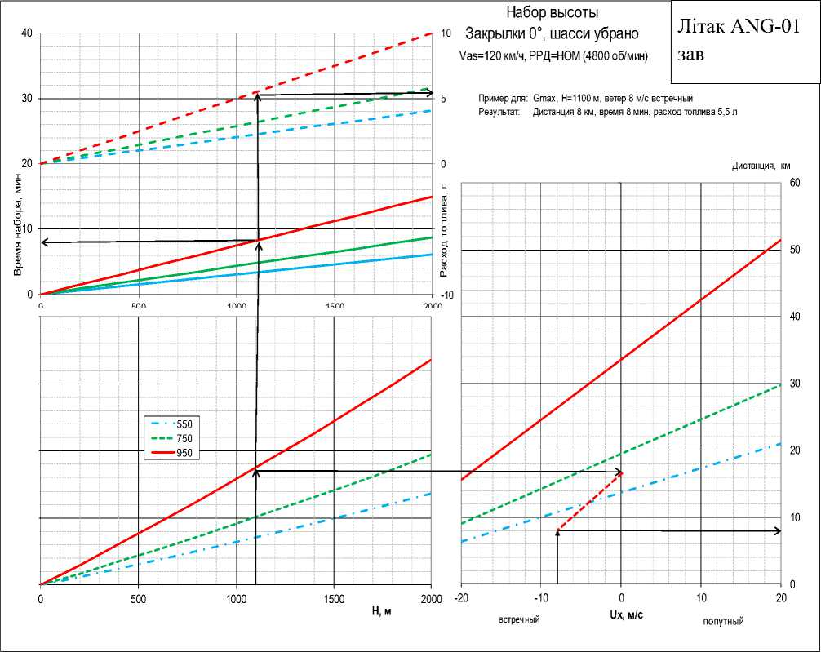

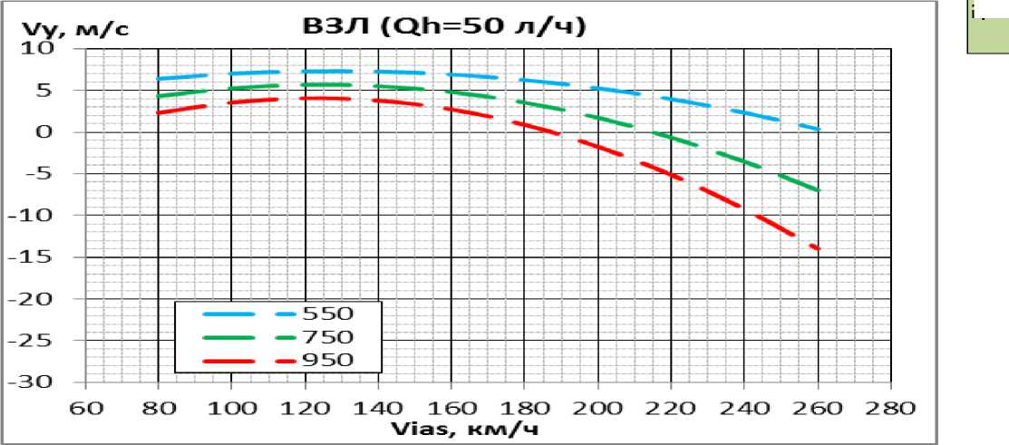
SUMMER
DATA
Additionally, the dependence of vertical velocity on CAS at the nominal EOM is provided.
  - Decrease
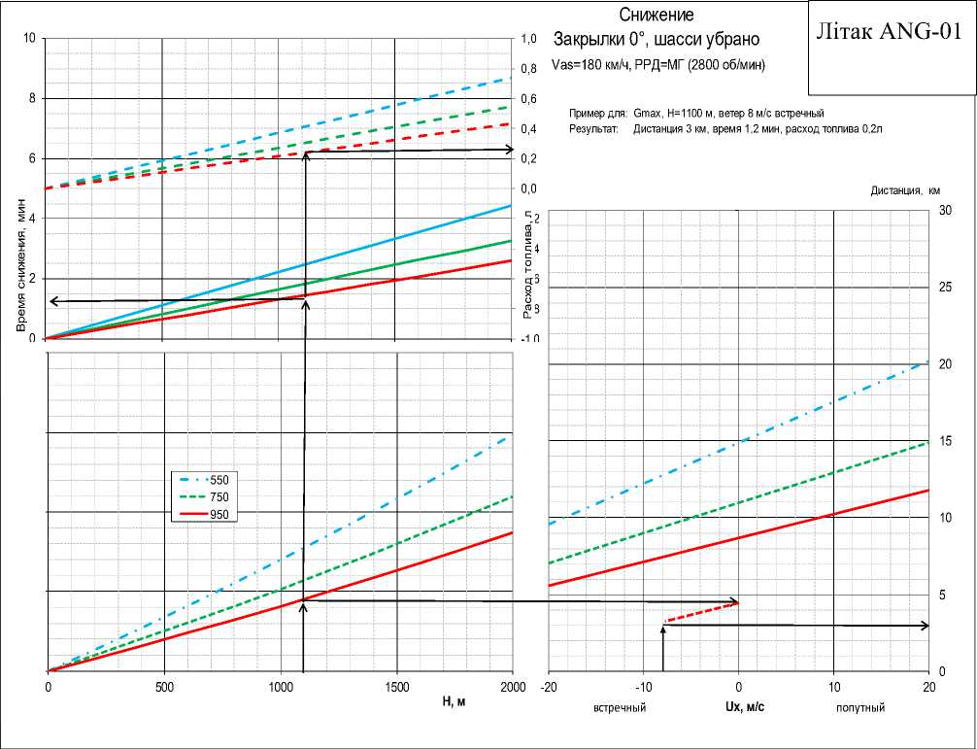
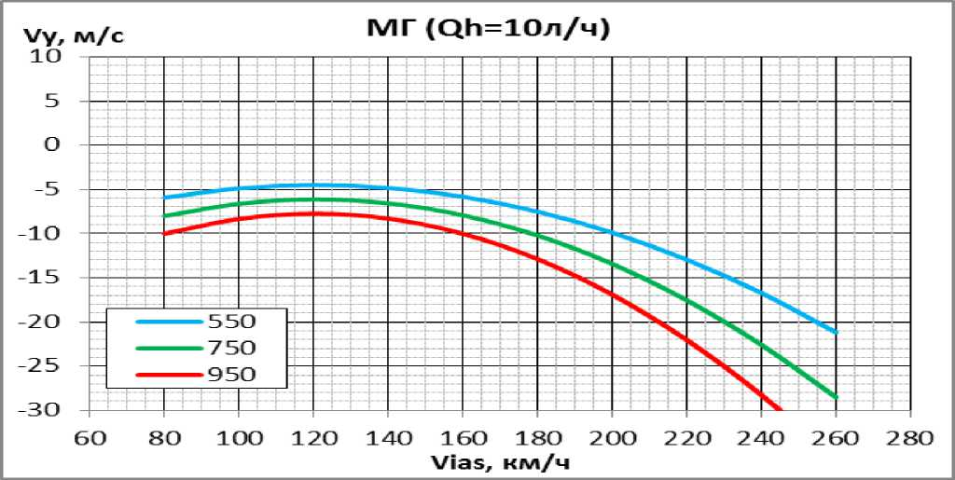
SUMMER
DATA
Additionally, the dependence of vertical velocity on CAS for EOM small gas is presented.
  - Range and duration of flight
Range, fuel consumption
Flaps 0°, landing gear retracted
Aircraft ANG-01
The released chassis increases fuel consumption or reduces speed by 15%.
Correction of travel speed + 10 km/h for every 1 km of altitude
Aeronautical fuel reserve 10% of refueling
Gc=890 kgf, altitude 1200 m, Instrument speed 165 km/h, Wind 6 m/s headwind
Example for: Result:
Fuel consumption 18 l/h
Road speed 152 km/h (140 km/h for altitude 0 + 12 km/h altitude correction) With 90 liters of fuel, a range of 684 km is provided (=152*(90-9)/18)
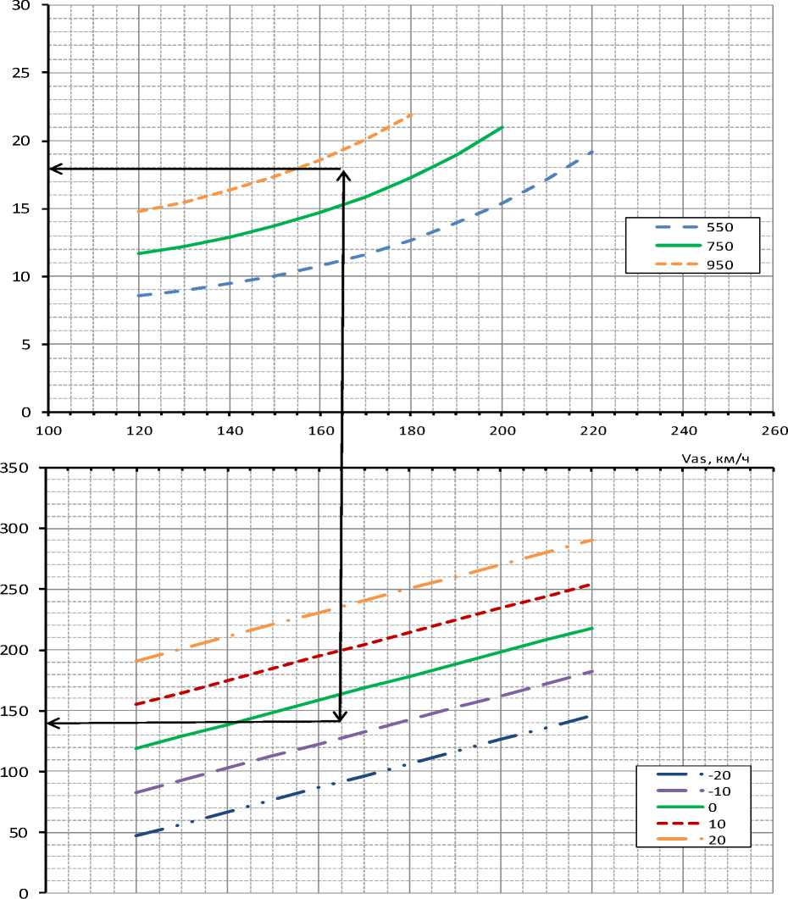
SUMMER
DATA
APPENDIX 1
BEFORE STARTING THE ENGINE
Airplane | PREPARED
Cold cranking of the engine | DONE
The crew | ON THE GROUND
Pilots' seats | ADJUSTED
Seat belts for all crew members | BUCKLE UP
Covers and plugs | CUT TO.
Doors, hatches | CLOSED
Operational documentation | TESTED
Rescue system fuse | CUT TO.
Aircraft control system | TESTED
Chassis backup release crane | TESTED
GAS STATION | TESTED
Main switch | ON
Dynon displays | ON
Battery charge | 12V
Flight route | ON TASK
Signal lamps "CN A" "CN B" | Burning red
WARN EMS "PITOT HEAT" warning light is green

Chassis out position indicator lights
Main fuel pump, backup fuel pump
Autopilot
Pitot heating
BANO, STROBE, Headlights
Refueling
Engine speed 1800 rpm
Motor control knob 10 % of the time
Transponder frequency
Radio communication frequency
Radio communication
Airfield pressure on backup instruments
Parking place
Lights up green ON
BY TASK ENABLED
INSTALLED INSTALLED INSTALLED CHECKED INSTALLED INSTALLED WITHOUT OBSTACLES
CHECKLISTS
Brake pedals  Permission to start the engine | PRESSED  RECEIVED
Parking pads
REMOVED
Write the "START" button of the engine

BEFORE STEERING
Oil temperature, coolant temperature Engine speed 2900 rpm
Signal lamps "CN A" "CN B"
Flaps in the "10°" position
Permission to steer

BEFORE TAKOFF
RECEIVED
INSTALLED
Burning green
RECEIVED ESTABLISHED
Permission to occupy the runway
Engine speed 5500 rpm
All light signaling lamps
Permission to take off
Motor control knob 100 % of the time
NORM
INSTALLED
Burning green
INSTALLED
RECEIVED

CHECKLISTS

RECEIVED INSTALLED RECEIVED INSTALLED MISSING ISSUED Glowing green
INSTALLED INSTALLED INSTALLED
REPORT SET DEFINED DISABLED OFF DISABLED OFF DISABLED OFF OPEN SET

BEFORE THE LANDING APPROACH
Landing permit
pressure
Weather conditions of the airfield
Visual contact with the runway
Obstacles on the runway
Chassis
Chassis out position indicator lights
Flaps in the 20°/30° position
Engine speed setpoint 5500 rpm
ESC to the position required for the glide path

AFTER BREAKING IN
Release of the runway
Flaps position "0"
remaining л
Engine.
Candle master
All toggle switches
Dynon displays
Door
Rescue system fuse

CHECKLISTS

