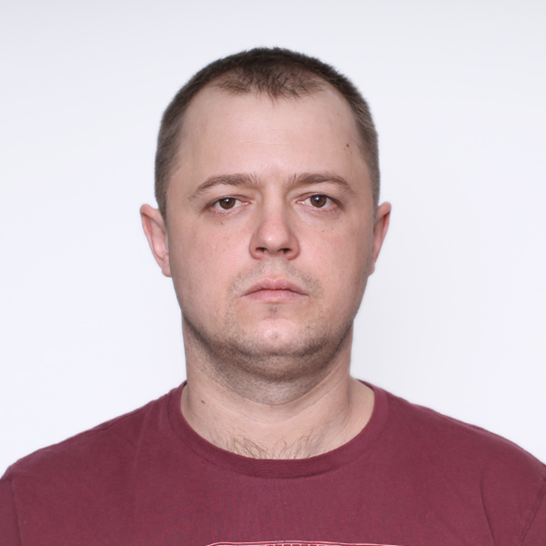
Dmitriy Skazhukin Almaty

E-mail: daiman4444@gmail.com
Calls: +7 707 878 33 94

Briefly about yourself:
• Engineer, designer, tester to the core

I am looking for a job where I can realize my ambitions and abilities: as a design engineer in mechanical engineering, construction, metal processing technologies, machine tool building. I am also considering working as an operator of a plasma/oxygen/laser metal cutting machine.

Work Experience
Owner/Manager
PlasmaCUT - Almaty September 2019 to Present
In 2018, it was decided to implement the accumulated experience in designing machines and metals and materials and all the creative potential. The development and assembly of the project lasted about 6 months. All components and elements of the machine were calculated and selected. In September 2019, my sheet metal cutting services business officially launched. Skills used in the process:
• LinuxCNC: OS for CNC machines.Working field of the machine 2000x6000 mm.
• Python, GTK, QT;
• Cutting technology: plasma and oxygen.
• ProNest: cutting of any complexity and any thickness of metal.
• Development of a post-processor for the parameters of a specific machine

Leading Design Engineer
UNIVERSALSTROYPROEKT - Almaty August 2016 to February 2018
• Development of project documentation.
• Calculation of metal load-bearing and enclosing structures;
• Travel to the construction site to carry out author's inspection of the facility under construction.

Design engineer category 2
PSI ENGINEERING - Almaty January 2014 to July 2016
Main responsibilities:
• development of design documentation;
• coordination of developed proposals with the customer;
• development, reconstruction and modernization of technological lines and equipment;
• control of installation of technological equipment;
• control of commissioning work at the construction site;
• control of the development of a working draft;

Junior Engineer
KCTrade - Almaty March 2013 to December 2013
Carier start.
• Development of MSD drawings (metal structures, detailing)
• Development of drawings in 2D graphics programs: AutoCAD (any version)
• Development of drawings in 3D graphics programs: AutoCAD (any version), Advance Steel 2013. • Support and control during the production of projects
• Project management for the development of drawings and structures
• Reception and author's control: control of compliance of the finished product with the drawing.

Education

Bachelor's in Civil Engineering Technology - KazGASA - Almaty September 2015 to May 2017

Master's degree in transport and transport technology - KazALT - Almaty September 2011 to March 2013

Skills
• Case Management (4 years)
• AutoCAD (10+ years)
• Drafting (10+ years)
• SolidWorks (5 years)
• Construction (10+ years)
• Tekla tructures 2017-2020 (8 years)
• ProNest (4 years)
• LinuxCNC (4 years)
• CNC plasma cutting (4 years)
• Python (2 years)

Links
https://www.instagram.com/plasmacut_almaty/ https://www.youtube.com/channel/UCv22xgeww0FIzS9n4VrT2TA

Additional Information
1. CNC plasma cutting machine design from 0
2. Design and refine LinuxCNC configuration for plasma cutting machine
3. Designing and finalizing a graphical interface for a plasma cutting machine using GTK and Python
4. Setting up and editing the ProNest post processor for a plasma cutting machine
5. Creating nests for plasma and oxygen cutting on a CNC machine in ProNest
6. Development of drawings for plasma cutting in AutoCAD, SolidWorks, etc.

