Department of Computer Science
Forman Christian College University

COMP360: Introduction to AI
Spring 2024



Name: Daim Bin Khalid
Roll No: 251686775

Task 1 (5) | Task 2 (5) | Task 3 (5) | Task 4 (5) | Total (20)

Lab 1: FIFO and LIFO Implementation
Lab Instruction:
- Rename your solution file in the template (LabNo_RollNo_Name.py) i.e “lab1_Farhan_24111123.py”
- Get your attendance marked before leaving the classroom.
- This is an individual Lab assignment. Each student must submit their own work.
- Plagiarism will not be tolerated in any case.

FIFO Queue:
Introduction:
A FIFO Queue is a linear First-In-First-Out data structure. In this data structure, first element is added to the queue and the same is the first to be removed.
A queue supports the following standard operations:
- enqueue: Inserts an element at the rear (right side) of the queue.
- dequeue: Removes the element from the front (left side) of the queue and returns it.
- peek: Returns the element at the front of the queue without removing it.
- isEmpty: Checks whether the queue is empty.
- size: Returns the total number of elements present in the queue.
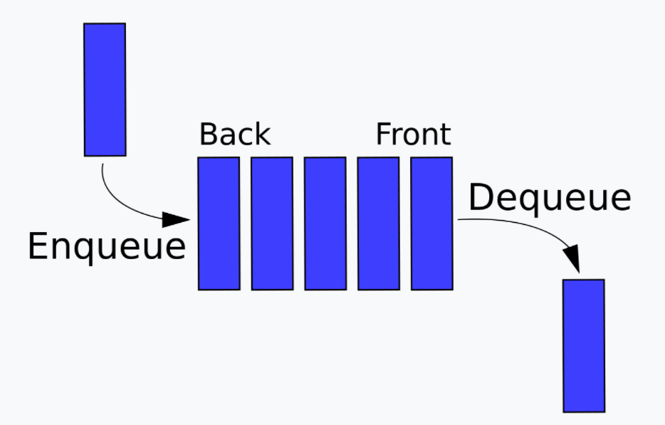

Task 1: Implementation of the FIFO Queue:
Observe the following FIFO_Queue Class it contains the variables necessary for the implementation of the FIFO Queue. You need to complete the empty functions in a way that when you run those functions they should give the correct output.
# Custom queue implementation in Python  class FIFO_Queue:  # Initialize queue  def __init__(self, size=1000):  # list to store queue elements  self.q = [None] * size  # maximum capacity of the queue  self.capacity = size  # front points to the front element in the queue  self.front = 0  # rear points to the last element in the queue  self.rear = -1  # current size of the queue  self.count = 0  # Function to dequeue the front element  def dequeue(self):  # check for queue underflow  if self.isEmpty():  print('Queue Underflow!! Terminating process.')  exit(-1)  x = self.q[self.front]  print('Removing element…', x)  self.front = (self.front + 1) % self.capacity  self.count = self.count - 1  return x  # Function to check if the queue is empty or not  def isEmpty(self): | # Function to add an element to the queue  def enqueue(self, value):  # check for queue overflow  if self.isFull():  print('Overflow!! Terminating process.')  exit(-1)  print('Inserting element…', value)  self.rear = (self.rear + 1) % self.capacity  self.q[self.rear] = value  self.count = self.count + 1  # Function to return the front element of the queue  def peek(self):  # Function to return the size of the queue  def size(self):  # Function to check if the queue is full or not  def isFull(self):

Task 2: Run the following function main() and record the observations and note down the exact results under the output.
if __name__ == '__main__':  # create a queue of capacity 5  q = Queue(5)  q.enqueue(1)  q.enqueue(2)  q.enqueue(3)  print('The queue size is', q.size())  print('The front element is', q.peek())  q.dequeue()  print('The front element is', q.peek())  q.dequeue()  q.dequeue()  if q.isEmpty():  print('The queue is empty')  else:  print('The queue is not empty') | OUTPUT:  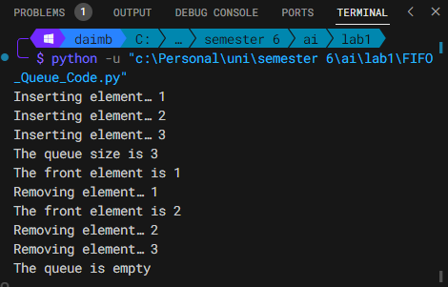

LIFO Stack:
Introduction:
A stack is a linear data structure that follows the LIFO (Last–In, First–Out) order, i.e., items can be inserted or removed only at one end of it.

The stack supports the following standard operations:
- push: Pushes an item at the top of the stack.
- pop: Remove and return the item from the top of the stack.
- peek: Returns the item at the top of the stack without removing it.
- size: Returns the total number of items in the stack.
- isEmpty: Checks whether the stack is empty.
- isFull: Checks whether the stack is full.
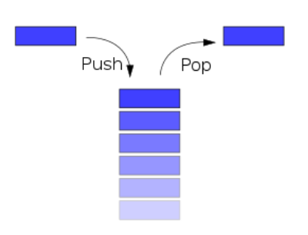
Task 3: Implementation of the LIFO Stack
Observe the following LIFO_Stack class. You need to complete the empty functions in a way that when you run those functions they should give the correct output.
# Custom stack implementation in Python  class LIFO_Stack:  # Constructor to initialize the stack  def __init__(self, size):  self.arr = [None] * size  self.capacity = size  self.top = -1  # Function to add an element `val` to the stack  def push(self, val):  if self.isFull():  print('Stack Overflow!! Calling exit()…')  exit(-1)  print(f'Inserting {val} into the stack…')  self.top = self.top + 1  self.arr[self.top] = val  # Function to pop a top element from the stack  def pop(self):  # check for stack underflow  if self.isEmpty():  print('Stack Underflow!! Calling exit()…')  exit(-1)  print(f'Removing {self.peek()} from the stack')  # decrease stack size by 1 and (optionally) return the popped element  top = self.arr[self.top]  self.top = self.top - 1 | # Function to return the top element of the stack  def peek(self):  # Function to return the size of the stack  def size(self):  # Function to check if the stack is empty or not  def isEmpty(self):  # Function to check if the stack is full or not  def isFull(self):

Task 4: Run the following function main(), observe the output, and note it down under the output.
if __name__ == '__main__':  stack = Stack(3)  stack.push(1) # Inserting 1 in the stack  stack.push(2) # Inserting 2 in the stack  stack.pop() # removing the top element (2)  stack.pop() # removing the top element (1)  stack.push(3) # Inserting 3 in the stack  print('Top element is', stack.peek())  print('The stack size is', stack.size())  stack.pop() # removing the top element (3)  # check if the stack is empty  if stack.isEmpty():  print('The stack is empty')  else:  print('The stack is not empty') | Output: 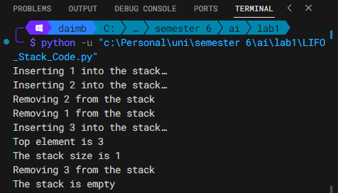

Note: This is an individual Lab and Groups are not allowed. No need to search on the internet, treat it like a lab exam. There could be errors in the above code you need to fix to perform successful execution.

