Department of Computer Science
Forman Christian College University

COMP360: Introduction to AI
Spring 2024

Lab 2



Task 1 (10) | Task 2 (10) | Total (20)

BFS Implementations

This lab is aimed to give you the opportunity to practice and observe the practical implementation of Graph and Breadth-First-Search (BFS).

Important Instructions:
- Lab Manual is self-explanatory so read through this lab manual before starting the lab.
- You can use any of the Programming Language that you think works better for you in this Lab (Python is preferred).
- Remember Copy and Pasting of the code is prohibited and is not a good practice.
- Every question asked in the viva will have marks, so make sure you understand what you write and should be able to explain the code.
- No marks will be given without viva even if you have submitted the lab.
- Late submission will not be accepted.

Expected Deliverable:
- The Code Files: 2 File having the implementations of Graph and BFS.

Submission Instruction:
You need to submit the following files along with the specified file names on moodle.
- Graph file “lab2_graph_name_roll.py”
- BFS file “lab2_BFS_name_roll.py”

Experimental Tasks:
You need to perform the following tasks in order to qualify this Lab.
Use the provided python files.

Task 1: Observe the following Tree. Consider that node having “1” is the root node.

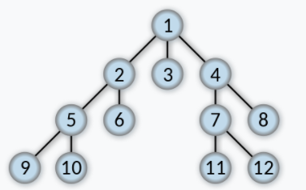

Task 2: Write the code for BFS, try the above tree node’s numbers as inputs and write down the results you observed.

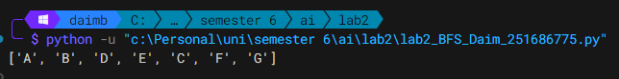

Note: This is an individual Lab and Groups are not allowed.

