Department of Computer Science
Forman Christian College University

COMP360: Introduction to AI
Spring 2024

Lab 3



Total
(20 Marks)

UCS: Uniform Cost Search
Lab Instructions:
- Get your attendance marked before leaving the classroom.
- This is an individual Lab assignment. Each student must submit their own work.
- IMPORTANT: Run the lab#_name_roll#.py file and make sure it runs without any errors.
- Then populate the below mentioned files with your implementation.
- After you’re done with your implementation, change the python file “lab#_name_roll.py” and replace your “lab number”, “name” and “roll_no”.
- Finally upload them on tmoodle.

Task 1:
Using UCS Find the path to reach from S to G search.
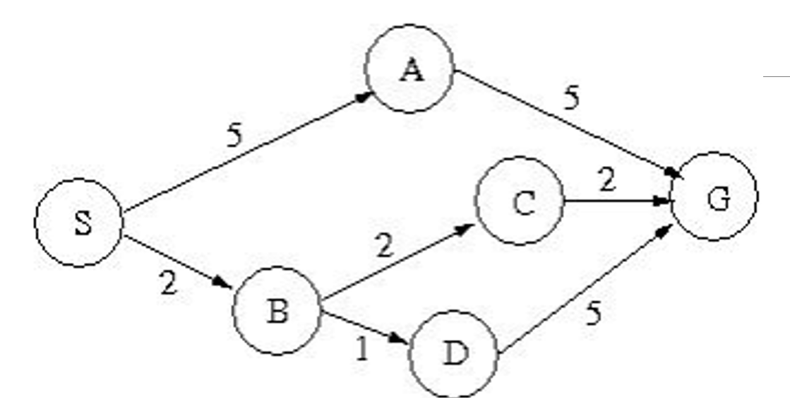

- You are provided with three files that are “graph.py”, “custom_queue.py” and “lab#_name_roll#.py”.
- Read the given code in the files.
- Fill in the function in the file “lab#_name_roll#.py”

